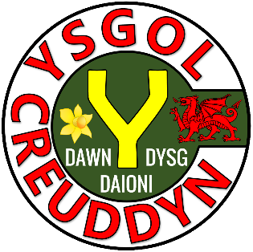





|  |  |
| --- | --- |
| Activity | Page |
| Quiz 1 | 3 |
| Example–Problem Pair 1 | 4–5 |
| Quiz 2 | 6 |
| Venn Diagram Challenge 1 | 7 |
| Example–Problem Pair 2 | 8–9 |
| Quiz 3 | 10 |
| Mobile Phones | 11 |
| Example–Problem Pair 3 | 12–13 |
| Quiz 4 | 14 |
| Venn Diagram Challenge 2 | 15 |
| Example–Problem Pair 4 | 16–17 |
| Quiz 5 | 18 |
| Quiz 6 | 19 |





10 cm

6 cm

|  |  |  |
| --- | --- | --- |
| 1) | 2) List all the factors of 9. | 3) Write 18 in index form. |
| 4) Simplify | 5) Solve | 6) Substitute  into the expression |
| 7) The total internal angles in any quadrilateral sum to ______° | 8) What is the perimeter of the shape below? | 9) What is the name of the shape below? |





Draw a pictogram for the following data that shows a group of people’s favourite colour. Use the key = 2 people.

|  |  |
| --- | --- |
| Colour | Frequency |
| Blue | 8 |
| Purple | 4 |
| Red | 5 |
| Pink | 7 |

|  |  |  |  |  |  |  |  |  |  |  |  |
| --- | --- | --- | --- | --- | --- | --- | --- | --- | --- | --- | --- |
|  |  |  |  |  |  |  |  |  |  |  |  |
|  |  |  |  |  |  |  |  |  |  |  |  |
|  |  |  |  |  |  |  |  |  |  |  |  |
|  |  |  |  |  |  |  |  |  |  |  |  |
|  |  |  |  |  |  |  |  |  |  |  |  |
|  |  |  |  |  |  |  |  |  |  |  |  |
|  |  |  |  |  |  |  |  |  |  |  |  |
|  |  |  |  |  |  |  |  |  |  |  |  |
|  |  |  |  |  |  |  |  |  |  |  |  |
|  |  |  |  |  |  |  |  |  |  |  |  |
|  |  |  |  |  |  |  |  |  |  |  |  |
|  |  |  |  |  |  |  |  |  |  |  |  |
|  |  |  |  |  |  |  |  |  |  |  |  |
|  |  |  |  |  |  |  |  |  |  |  |  |
|  |  |  |  |  |  |  |  |  |  |  |  |

  


Draw a pictogram for the following data that shows a group of people’s favourite colour. Use the key = 4 people.

|  |  |
| --- | --- |
| Colour | Frequency |
| Red | 16 |
| Blue | 10 |
| Green | 5 |
| Pink | 15 |

|  |  |  |  |  |  |  |  |  |  |  |  |
| --- | --- | --- | --- | --- | --- | --- | --- | --- | --- | --- | --- |
|  |  |  |  |  |  |  |  |  |  |  |  |
|  |  |  |  |  |  |  |  |  |  |  |  |
|  |  |  |  |  |  |  |  |  |  |  |  |
|  |  |  |  |  |  |  |  |  |  |  |  |
|  |  |  |  |  |  |  |  |  |  |  |  |
|  |  |  |  |  |  |  |  |  |  |  |  |
|  |  |  |  |  |  |  |  |  |  |  |  |
|  |  |  |  |  |  |  |  |  |  |  |  |
|  |  |  |  |  |  |  |  |  |  |  |  |
|  |  |  |  |  |  |  |  |  |  |  |  |
|  |  |  |  |  |  |  |  |  |  |  |  |
|  |  |  |  |  |  |  |  |  |  |  |  |
|  |  |  |  |  |  |  |  |  |  |  |  |
|  |  |  |  |  |  |  |  |  |  |  |  |

  
  


|  |  |  |
| --- | --- | --- |
| 1)   2 kg = ______ g  4 m = ______ cm  3 litres = _____ ml  3 cm = _____ mm  4 cl = ______ ml | 2) Name a quadrilateral that includes a reflex angle. | 3) Is 17 a prime number? |
| 4) Shade . | 5) The mode of 17, 11, 14, 13, 15 | 6) What is the probability that the next baby born is a girl? |
| 7) How many vertices does a tetrahedron have? | 8) How many edges does a cuboid have? | 9) How many faces does a cylinder have? |



Think of **three numbers** that could fit into each region.  
If you think a region is impossible to fill, explain why!

Mean = 3

Mode = 3

**A**

**B**

**C**

**D**

**C**

**A**

**D**

**B**



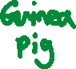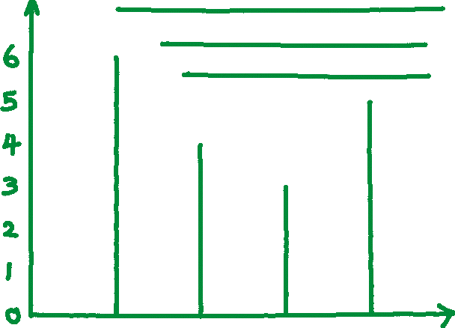

Draw a vertical line diagram for the following data that shows the favourite pet of a group of people.

|  |  |
| --- | --- |
| Pet | Frequency |
| Dog | 6 |
| Cat | 4 |
| Guinea Pig | 3 |
| Rabbit | 5 |

|  |  |  |  |  |  |  |  |  |  |  |  |
| --- | --- | --- | --- | --- | --- | --- | --- | --- | --- | --- | --- |
|  |  |  |  |  |  |  |  |  |  |  |  |
|  |  |  |  |  |  |  |  |  |  |  |  |
|  |  |  |  |  |  |  |  |  |  |  |  |
|  |  |  |  |  |  |  |  |  |  |  |  |
|  |  |  |  |  |  |  |  |  |  |  |  |
|  |  |  |  |  |  |  |  |  |  |  |  |
|  |  |  |  |  |  |  |  |  |  |  |  |
|  |  |  |  |  |  |  |  |  |  |  |  |
|  |  |  |  |  |  |  |  |  |  |  |  |
|  |  |  |  |  |  |  |  |  |  |  |  |
|  |  |  |  |  |  |  |  |  |  |  |  |
|  |  |  |  |  |  |  |  |  |  |  |  |
|  |  |  |  |  |  |  |  |  |  |  |  |
|  |  |  |  |  |  |  |  |  |  |  |  |
|  |  |  |  |  |  |  |  |  |  |  |  |



Draw a vertical line diagram for the following data that shows the favourite soft drink of a group of people.

|  |  |
| --- | --- |
| Soft Drink | Frequency |
| Coca-cola | 5 |
| Orange juice | 6 |
| Ribena | 4 |
| Vimto | 2 |

|  |  |  |  |  |  |  |  |  |  |  |  |
| --- | --- | --- | --- | --- | --- | --- | --- | --- | --- | --- | --- |
|  |  |  |  |  |  |  |  |  |  |  |  |
|  |  |  |  |  |  |  |  |  |  |  |  |
|  |  |  |  |  |  |  |  |  |  |  |  |
|  |  |  |  |  |  |  |  |  |  |  |  |
|  |  |  |  |  |  |  |  |  |  |  |  |
|  |  |  |  |  |  |  |  |  |  |  |  |
|  |  |  |  |  |  |  |  |  |  |  |  |
|  |  |  |  |  |  |  |  |  |  |  |  |
|  |  |  |  |  |  |  |  |  |  |  |  |
|  |  |  |  |  |  |  |  |  |  |  |  |
|  |  |  |  |  |  |  |  |  |  |  |  |
|  |  |  |  |  |  |  |  |  |  |  |  |
|  |  |  |  |  |  |  |  |  |  |  |  |
|  |  |  |  |  |  |  |  |  |  |  |  |

  
  
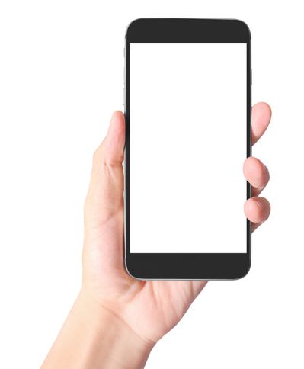 

7 m

8 km

3 km

3 cm

5 cm

6 cm

8 m

|  |  |  |
| --- | --- | --- |
| 1) What is the area of the shape below? | 2) What is the area of the shape below? | 3) What is the area of the shape below? |
| 4) | 5) Is the number   a square number? | 6) 3 inches ≈ ________ cm |
| 7) Which word is used for a probability of 1? | 8) Solve the equation | 9) Circle the prime numbers.  21 22 23 24  25 26 27 28 |

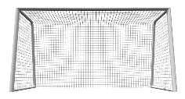

Mr. Jones asked everybody in his registration class to record how many times they used their mobile phone last Saturday.

Here are the results for the boys:  
8, 10, 8, 9, 7, 13, 8, 13, 14.

Here are the results for the girls:  
6, 8, 9, 9, 9, 10, 14, 15.

What can you calculate from this information?

|  |  |  |  |  |  |  |  |  |  |  |  |
| --- | --- | --- | --- | --- | --- | --- | --- | --- | --- | --- | --- |
|  |  |  |  |  |  |  |  |  |  |  |  |
|  |  |  |  |  |  |  |  |  |  |  |  |
|  |  |  |  |  |  |  |  |  |  |  |  |
|  |  |  |  |  |  |  |  |  |  |  |  |
|  |  |  |  |  |  |  |  |  |  |  |  |
|  |  |  |  |  |  |  |  |  |  |  |  |
|  |  |  |  |  |  |  |  |  |  |  |  |
|  |  |  |  |  |  |  |  |  |  |  |  |
|  |  |  |  |  |  |  |  |  |  |  |  |
|  |  |  |  |  |  |  |  |  |  |  |  |
|  |  |  |  |  |  |  |  |  |  |  |  |
|  |  |  |  |  |  |  |  |  |  |  |  |
|  |  |  |  |  |  |  |  |  |  |  |  |
|  |  |  |  |  |  |  |  |  |  |  |  |
|  |  |  |  |  |  |  |  |  |  |  |  |



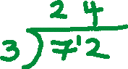

List all the factors of 72.

|  |  |  |  |  |  |  |  |  |  |  |  |
| --- | --- | --- | --- | --- | --- | --- | --- | --- | --- | --- | --- |
|  |  |  |  |  |  |  |  |  |  |  |  |
|  |  |  |  |  |  |  |  |  |  |  |  |
|  |  |  |  |  |  |  |  |  |  |  |  |
|  |  |  |  |  |  |  |  |  |  |  |  |
|  |  |  |  |  |  |  |  |  |  |  |  |
|  |  |  |  |  |  |  |  |  |  |  |  |
|  |  |  |  |  |  |  |  |  |  |  |  |
|  |  |  |  |  |  |  |  |  |  |  |  |
|  |  |  |  |  |  |  |  |  |  |  |  |
|  |  |  |  |  |  |  |  |  |  |  |  |
|  |  |  |  |  |  |  |  |  |  |  |  |
|  |  |  |  |  |  |  |  |  |  |  |  |
|  |  |  |  |  |  |  |  |  |  |  |  |
|  |  |  |  |  |  |  |  |  |  |  |  |
|  |  |  |  |  |  |  |  |  |  |  |  |



List all the factors of 56.

|  |  |  |  |  |  |  |  |  |  |  |  |
| --- | --- | --- | --- | --- | --- | --- | --- | --- | --- | --- | --- |
|  |  |  |  |  |  |  |  |  |  |  |  |
|  |  |  |  |  |  |  |  |  |  |  |  |
|  |  |  |  |  |  |  |  |  |  |  |  |
|  |  |  |  |  |  |  |  |  |  |  |  |
|  |  |  |  |  |  |  |  |  |  |  |  |
|  |  |  |  |  |  |  |  |  |  |  |  |
|  |  |  |  |  |  |  |  |  |  |  |  |
|  |  |  |  |  |  |  |  |  |  |  |  |
|  |  |  |  |  |  |  |  |  |  |  |  |
|  |  |  |  |  |  |  |  |  |  |  |  |
|  |  |  |  |  |  |  |  |  |  |  |  |
|  |  |  |  |  |  |  |  |  |  |  |  |
|  |  |  |  |  |  |  |  |  |  |  |  |
|  |  |  |  |  |  |  |  |  |  |  |  |

  


0

60

|  |  |  |
| --- | --- | --- |
| 1) Solve the equation | 2) | 3) What is the formula for calculating the area of a parallelogram? |
| 4) What is the first prime number after 31? | 5) How many edges does a triangular prism have? | 6) Substitute  into the expression . |
| 7) The arrow points towards...? | 8) What is the volume of a cuboid measuring 2 cm by 2 cm by  3 cm? | 9) The following net folds to give which solid? |



The answer ends in 4

The answer is negative

One number is –1

**E**

**F**

**H**

**D**

**G**

**CF**

**B**

**A**

Think of a **multiplication sum with two numbers** that could fit into each region. If you think a region is impossible to fill, explain why!

**A**

**B**

**CF**

**D**

**E**

**F**

**G**

**H**





Using the following grid, draw a kite where

* the length of the longest diagonal is 8 units;
* the length of the sides are 3 units and 6 units.

|  |  |  |  |  |  |  |  |  |  |  |  |
| --- | --- | --- | --- | --- | --- | --- | --- | --- | --- | --- | --- |
|  |  |  |  |  |  |  |  |  |  |  |  |
|  |  |  |  |  |  |  |  |  |  |  |  |
|  |  |  |  |  |  |  |  |  |  |  |  |
|  |  |  |  |  |  |  |  |  |  |  |  |
|  |  |  |  |  |  |  |  |  |  |  |  |
|  |  |  |  |  |  |  |  |  |  |  |  |
|  |  |  |  |  |  |  |  |  |  |  |  |
|  |  |  |  |  |  |  |  |  |  |  |  |
|  |  |  |  |  |  |  |  |  |  |  |  |
|  |  |  |  |  |  |  |  |  |  |  |  |
|  |  |  |  |  |  |  |  |  |  |  |  |
|  |  |  |  |  |  |  |  |  |  |  |  |
|  |  |  |  |  |  |  |  |  |  |  |  |
|  |  |  |  |  |  |  |  |  |  |  |  |
|  |  |  |  |  |  |  |  |  |  |  |  |

 

|  |  |  |  |  |  |  |  |  |  |  |  |
| --- | --- | --- | --- | --- | --- | --- | --- | --- | --- | --- | --- |
|  |  |  |  |  |  |  |  |  |  |  |  |
|  |  |  |  |  |  |  |  |  |  |  |  |
|  |  |  |  |  |  |  |  |  |  |  |  |
|  |  |  |  |  |  |  |  |  |  |  |  |
|  |  |  |  |  |  |  |  |  |  |  |  |
|  |  |  |  |  |  |  |  |  |  |  |  |
|  |  |  |  |  |  |  |  |  |  |  |  |
|  |  |  |  |  |  |  |  |  |  |  |  |
|  |  |  |  |  |  |  |  |  |  |  |  |
|  |  |  |  |  |  |  |  |  |  |  |  |
|  |  |  |  |  |  |  |  |  |  |  |  |
|  |  |  |  |  |  |  |  |  |  |  |  |
|  |  |  |  |  |  |  |  |  |  |  |  |
|  |  |  |  |  |  |  |  |  |  |  |  |

Using the following grid, draw a kite where

* the length of the longest diagonal is 7 units;
* the length of the sides are 4 units and 5 units.



|  |  |  |
| --- | --- | --- |
| 1) 9² | 2) Write the best metric unit to measure the height of a person. | 3) Which number comes next?  10, 6, 2, –2, _____ |
| 4) Simplify | 5) How many vertices does a cone have? | 6) Solve the equation |
| 7) Calculate the size of the red angle. | 8) | 9) 4.2 litres = ________ ml |

57°

108°

126°

**Siart cylch i ddangos hoff flas creision dysgwyr Ysgol B**

◼ Plaen

◼ Halen a Finegr

◼ Caws a Nionyn

◼ Coctel Corgimwch

4) Dywedodd Dion “*Mae mwy o bobl yn hoffi creision caws a nionyn yn Ysgol A nac yn Ysgol B*”. Ydy Dion yn gywir? Eglurwch eich ateb.





|  |  |  |
| --- | --- | --- |
| 1) 5 + –3 | 2) 5 – –3 | 3) 5 × –3 |
| 4) 2.64 × 6 | 5) Write 64% as a decimal. | 6) Write 0.03 as a percentage. |
| 7) Round off 7.3259 to one decimal place. | 8) Round off 7.3259 to two decimal places. | 9) Round off 7.3259 to three decimal places. |

108°

126°

**Siart cylch i ddangos hoff flas creision dysgwyr Ysgol B**

◼ Plaen

◼ Halen a Finegr

◼ Caws a Nionyn

◼ Coctel Corgimwch

4) Dywedodd Dion “*Mae mwy o bobl yn hoffi creision caws a nionyn yn Ysgol A nac yn Ysgol B*”. Ydy Dion yn gywir? Eglurwch eich ateb.



Evaluating the Workbook







Notes



@mathemateg /adolygumathemateg

/mathscreuddyn www.mathemateg.com