Ysgol y Creuddyn | Yr Adran Fathemateg
Hen Gwestiynau Arholiad
Motion on an Inclined Plane
(Gaeaf 2007)
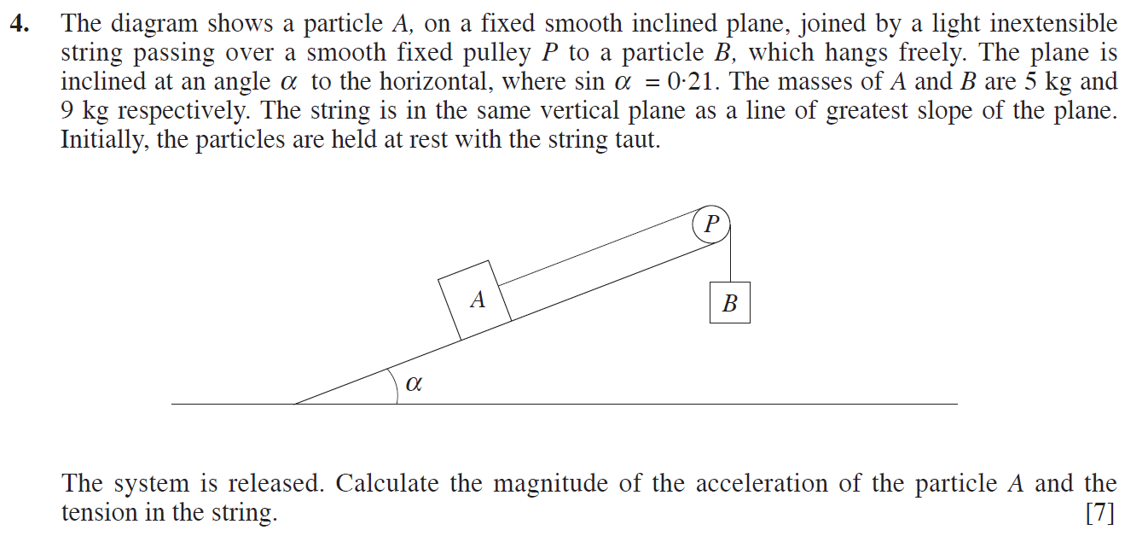
(Haf 2007)
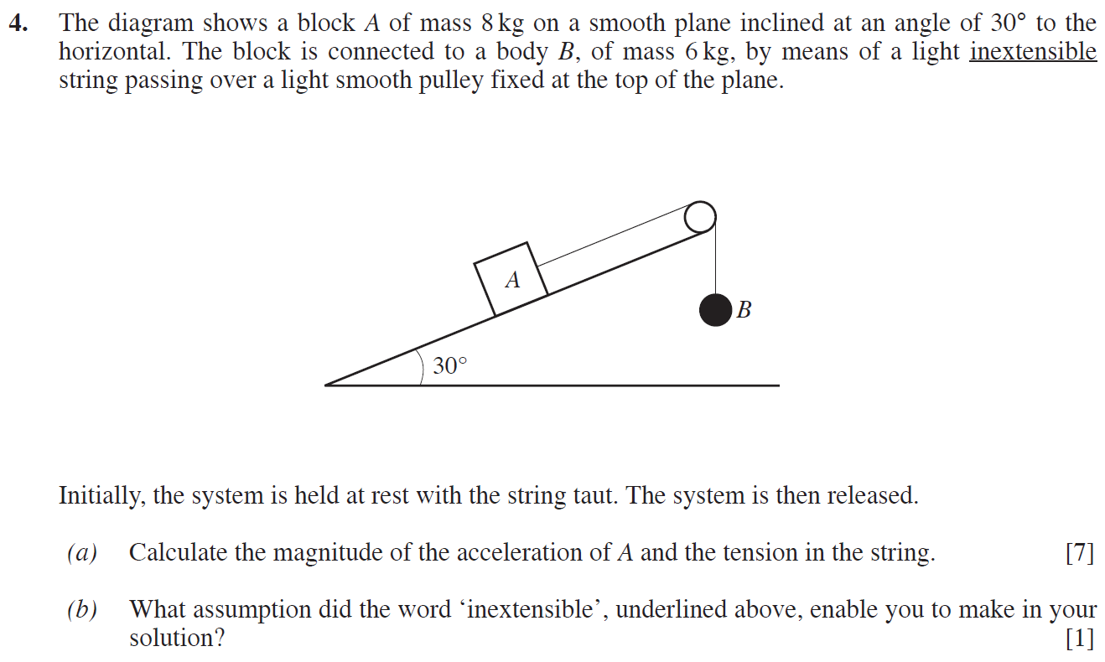

(Gaeaf 2008)
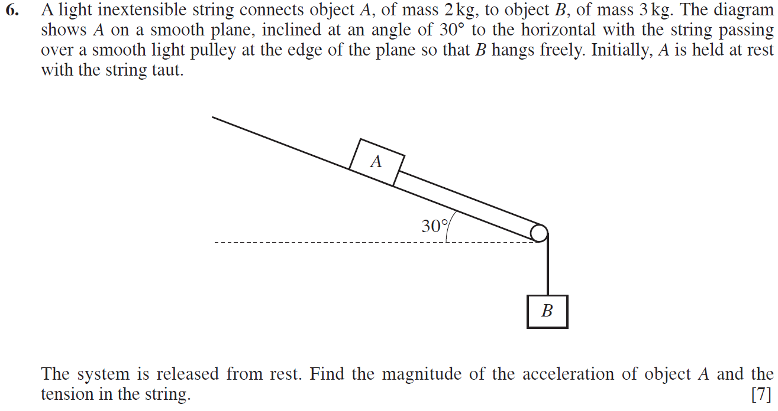
(Gaeaf 2010)
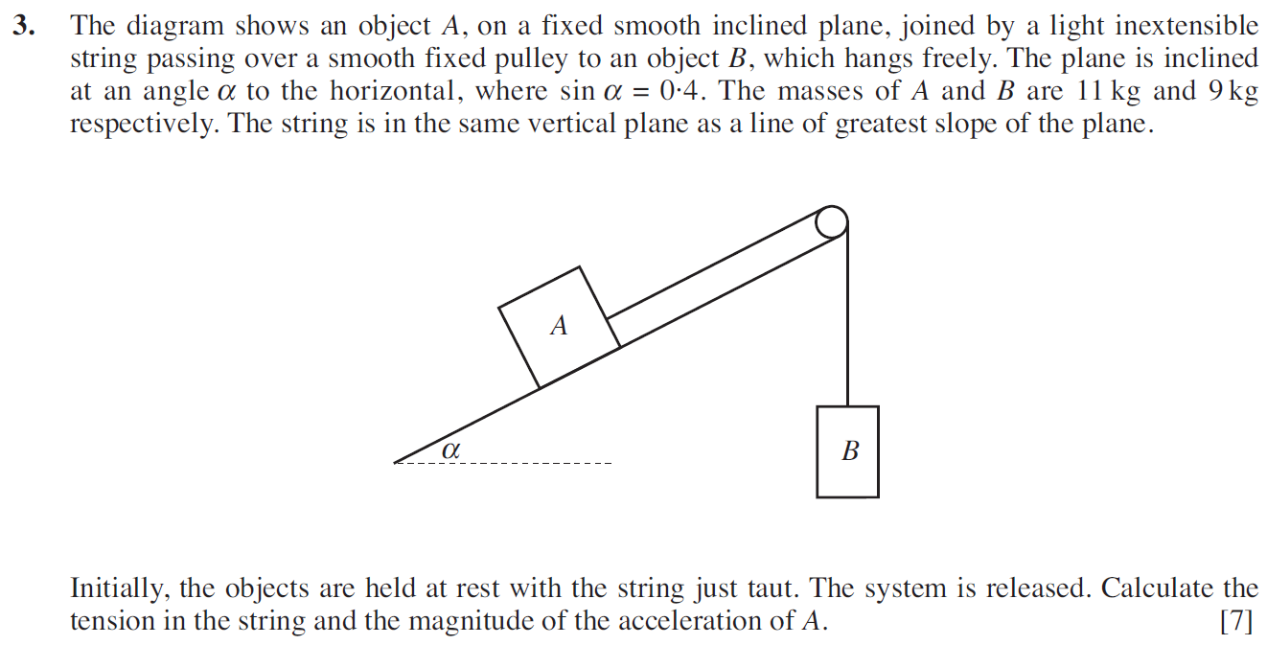

(Haf 2011)
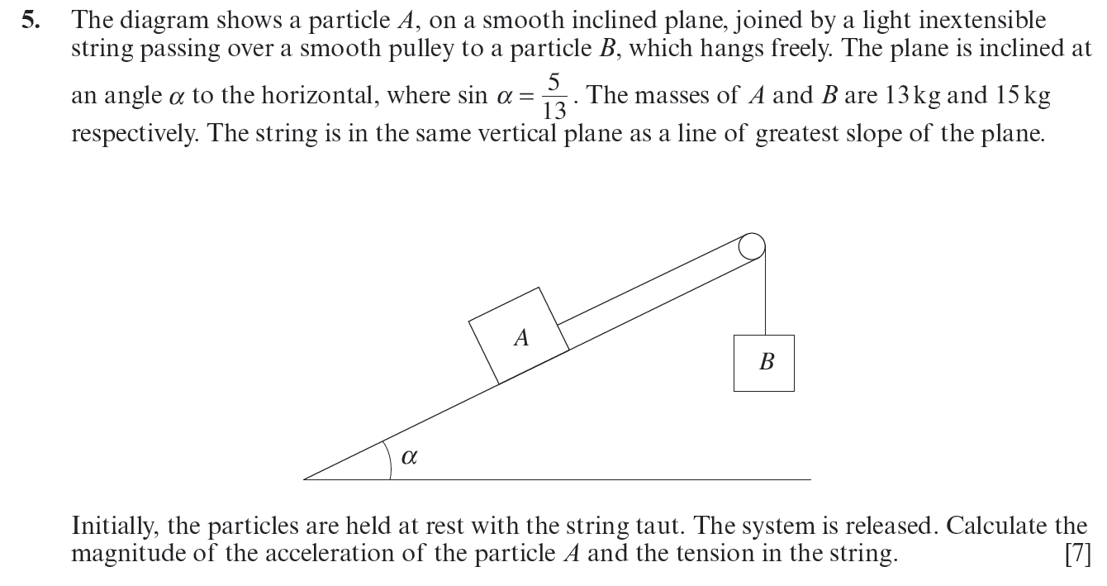
(Gaeaf 2014)
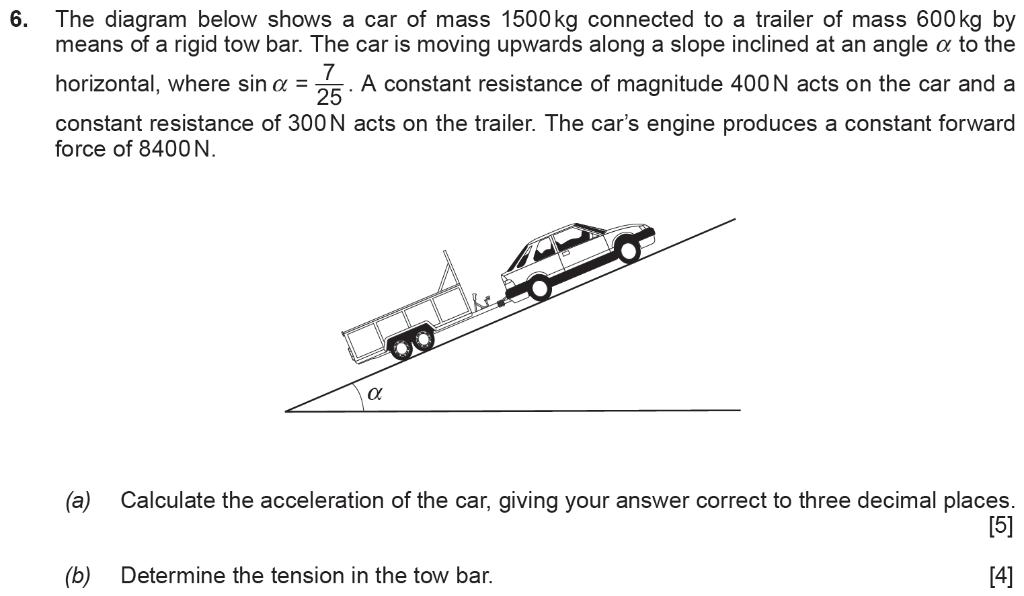

(Haf 2017)
