Ysgol y Creuddyn | Yr Adran Fathemateg
Hen Gwestiynau Arholiad
Cwestiynau Eraill
(Gaeaf 2014)
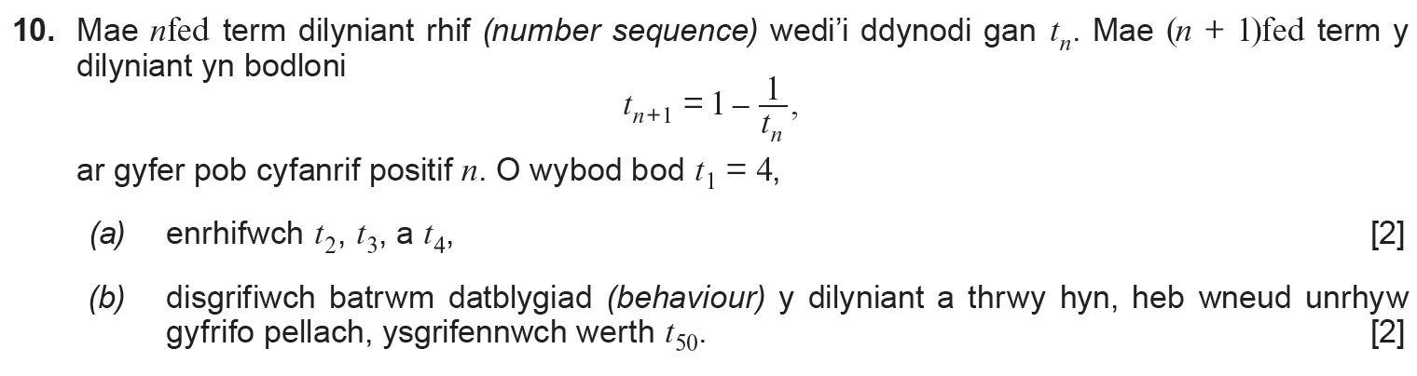
(Haf 2017)
