


Version
3.0
08/2025

Chapter | Mathematics | Page Number
Relative Frequency | Revision. Relative Frequency. | 3
Combined Events | Independent events. Mutually exclusive events.  Venn diagrams. | 8
Tree Diagrams | Displaying combinations of two or more events. Independent events. | 13
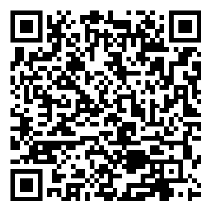

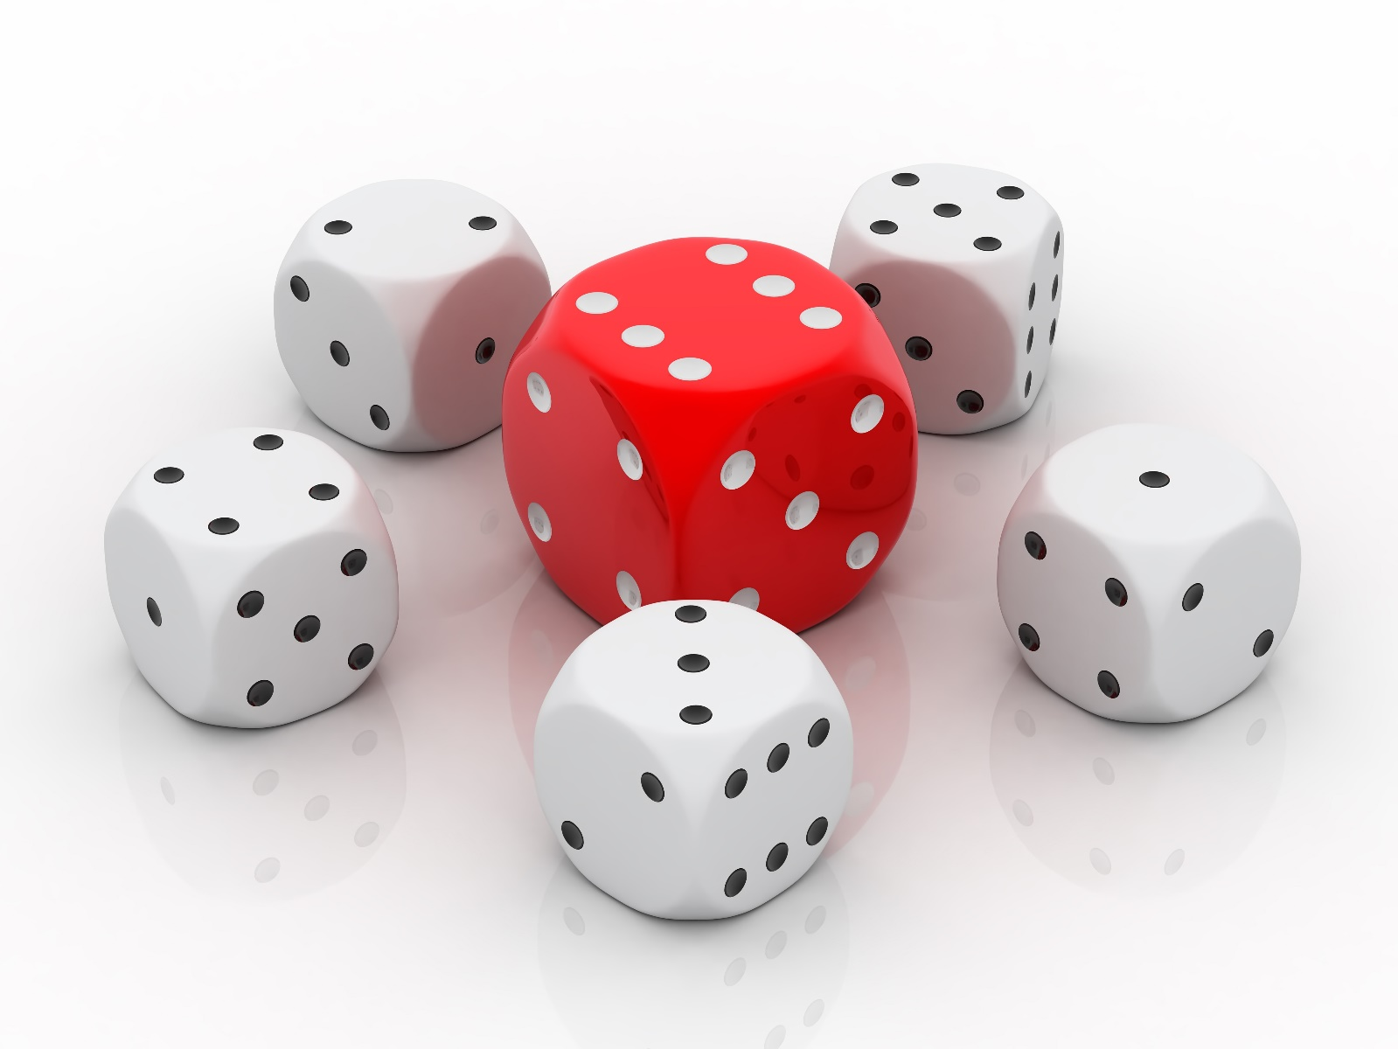
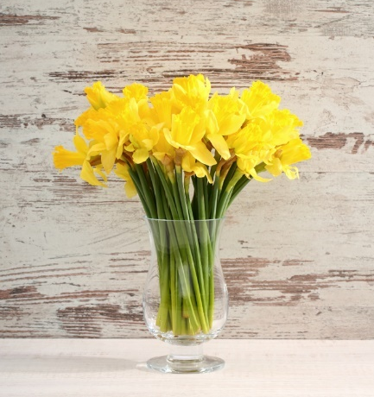
Exercise 1 (Revision of previous work on probability)
2
(a) Use “no chance”; “low chance”; “even chance”;
“good chance” or “certain” to describe the probability of the following events.
(i) You land on “tails” when throwing a fair coin.
(ii) The next person you meet writes with their left hand.
(iii) You obtain a number less than 5 when rolling a normal fair die.
(iv) St. David’s Day will be on March 1st next year.
(v) You will obtain 101% in your end of year mathematics examination.
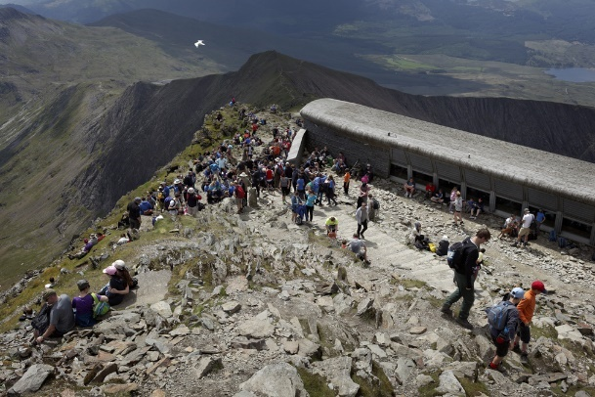
(b) Draw a probability scale. Mark the points i, ii, iii, iv in order to show how probable, in your opinion, the following events are.
(i) A man will be driving the next car you see.
(ii) It will snow during the day tomorrow.
(iii) A story about politics will feature on the news tonight.
(iv) Germany will win the next football world cup.
(c) Answer with a number between 0 and 1: what is the probability that someone will walk to the top of Snowdon tomorrow?
(d) Answer the following questions using fractions.
What is the probability of obtaining…
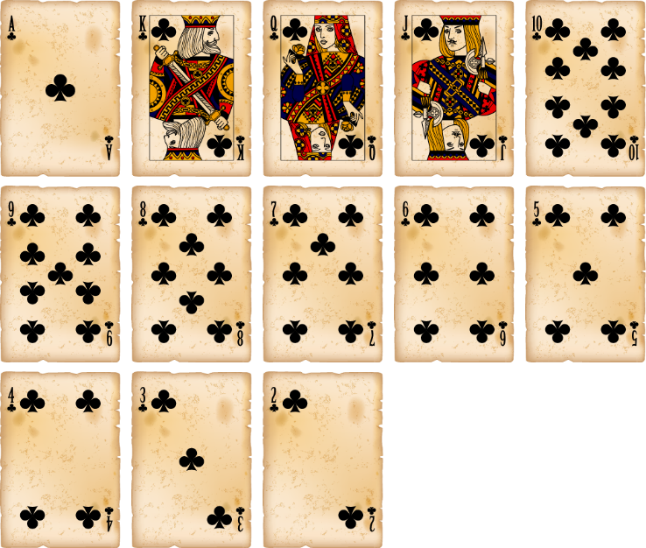
(i) The number 4 when rolling a normal fair die?
(ii) “Heads” when throwing a fair coin?
(iii) A square number when spinning a spinner showing the numbers 1 to 8?
(e) Rheinallt shuffles the 52 cards in a standard deck of playing cards and chooses one card randomly from the deck. What is the probability that the chosen card is:
(i) a diamond?
(ii) 6?
(iii) a face card?
(iv) a spade showing an even number?
(v) a red card less than 5?
(f) The probability that Meira goes to the shop to buy a loaf of bread tomorrow is 0.4. What is the probability that Meira does not go to the shop to buy a loaf of bread tomorrow?
(g) A red die and a blue die are labelled from 1 to 6.
Gethin rolls both dice and adds the scores obtained.
(i) Use a sample space diagram to list all the possible outcomes.
(ii) What is the probability that the sum of both numbers is 12?
(iii) What is the probability that the sum of both numbers is a one-digit number?
(h) The probability that Ellie goes on a training run on any day is 0.7.
There are 30 days in April. On how many days can you expect Ellie to go running?
Relative Frequency

The frequency of an event refers to how many times the event has occurred during a number of trials.
The relative frequency of an event compares the frequency to the number of trials.
Relative frequency of an event $=\frac{\text{How many times the event has occurred}}{\text{Number of trials}}$
It is possible to use relative frequency to estimate the probability of an event.
Exercise 2
2
You will need a coin for this exercise.
(a) Throw the coin 100 times, recording in the following table, after each set of 10 throws, how many times the coin has landed showing ‘heads’.
Total number  of trials | Number of heads in these 10 throws | Total number of heads so far | Relative frequency of the number of heads, as a fraction | Relative frequency of the number of heads, as a decimal
10 |  |  | $\frac{ }{10}$
20 |  |  | $\frac{ }{20}$
30 |  |  | $\frac{ }{30}$
40
50
60
70
80
90
100
(b) Plot, on the following graph paper, a line graph showing what happens to the relative frequency as the number of trials increases.
Relative frequency

Number of trials

(c) If a great many more trials were held, how would you expect the graph to change?
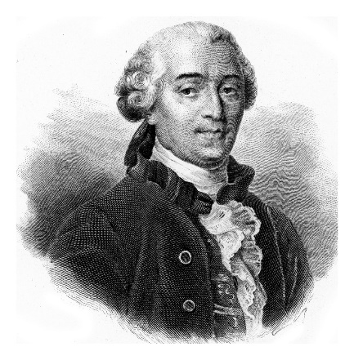
Exercise 3 (Buffon’s Needle Experiment)
2
For this exercise, you will need a plastic straw of length 3 cm, and lined paper where the lines are separated by 6 cm.
In 1777, a Frenchman called Georges-Louis Leclerc (Comte de Buffon) devised an experiment that can be used to estimate the value of $π$.
In each trial, a straw is dropped on a piece of paper. The straw should be dropped above the centre of the paper, from arm height. You should record whether or not the straw crosses (or meets) one of the lines.
(a) Perform the experiment 100 times. Record, after each set of 10 trials, how many times the straw crosses (or meets) one of the lines.
Total number  of trials | Number of times the straw has crossed a line in these 10 trials | Total number of crossings so far | Relative frequency of the number of crossings, as a fraction | Relative frequency of the number of crossings, as a decimal
10 |  |  | $\frac{ }{10}$
20 |  |  | $\frac{ }{20}$
30 |  |  | $\frac{ }{30}$
40
50
60
70
80
90
100
(b) Plot, on the graph paper below, a line graph showing what happens to the relative frequency as the number of trials increases.
Relative frequency

Number of trials

(c) Calculate the reciprocal of your final relative frequency. How close is this value to $π$?
In any experiment,
The more trials are held, the better the relative frequency is as an estimate of the probability.
Exercise 4
2
A factory produces mobile phones. The manager holds a survey to investigate the probability that the factory produces a defective mobile phone.
The relative frequency of defective mobile phones is recorded after testing a total of 1,000, 2,000,
3,000, 4,000 and 5,000 mobile phones. The results are shown in the following graph.
Relative frequency

Number of trials

(a) How many of the first 2,000 mobile phones tested were defective?
(b) Write the best estimate for the probability that a randomly selected mobile phone is defective.
You must give a reason for your answer.
Exercise 5
2
(a) Fred throws a die 200 times and records how many times each score occurs.
Score | 1 | 2 | 3 | 4 | 5 | 6
Frequency | 29 | 34 | 35 | 32 | 34 | 36
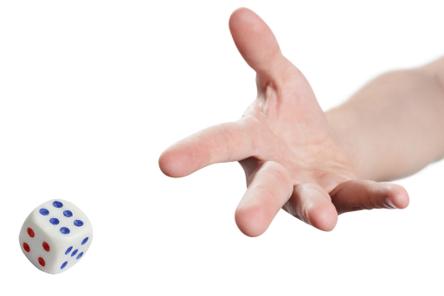
(i) Calculate the relative frequency of each score.
(ii) In your opinion, is Fred’s die fair? Give a reason for your answer.
(b) Rhys recorded the results of his favourite football team.
Win | Draw | Lose
32 | 11 | 7
(i) Calculate the relative frequency of each of the three possible results.
(ii) Are your answers to part (i) a good estimate for the probability of the result of the next game?
Explain your answer.
(c) A petrol station owner noticed that 287 customers out of a total of 340 customers spent more than £30 filling up their cars. Use these figures to estimate the probability that the next customer spends
(i) more than £30, (ii) £30 or less.
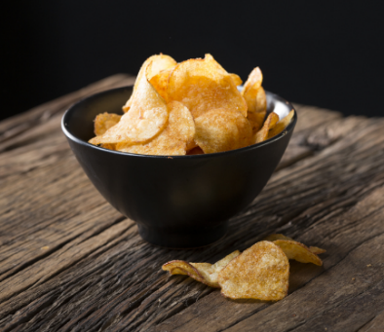
(d) In a survey, 600 people were asked about their favourite crisp flavour.
The following table shows the results.
Flavour | Frequency
Ready Salted | 166
Salt & Vinegar | 130
Cheese & Onion | 228
Other | 76
(i) Calculate the relative frequency of each flavour. Give your answers correct to 2 decimal places.
(ii) Explain why it is reasonable to use these figures to estimate the probability of the favourite crisp flavour of the next person to be asked.
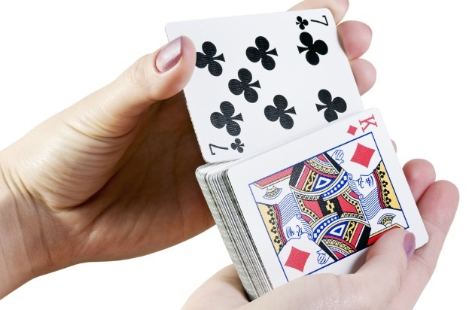
(e) A card was picked from a standard pack of cards, and its suit was noted. The card was put back and the pack was shuffled. This was repeated 250 times. The results are shown in the following table.
Suit | Frequency
Spades | 52
Hearts | 67
Diamonds | 61
Clubs | 70
Find the relative frequency of
(i) Spades (ii) Hearts (iii) Diamonds (iv) Clubs.
(v) What is the sum of all the relative frequencies?
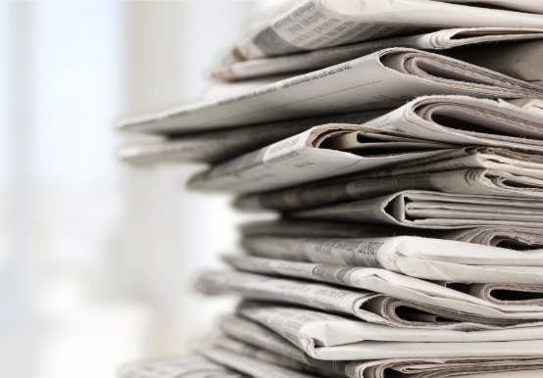
(f) The following table shows the number of pictures on each page of a newspaper.
Number of pictures | Tally Marks | Frequency
0 | |||| |||| | 10
1 | |||| || | 7
2 | |||| |||| | 9
3 | |||| | | 6
4 | |||| | | 6
5 | |||| | 4
6 | |||| | | 6
(i) How many pages does the newspaper have?
(ii) Find the relative frequency of one picture appearing on a page of the newspaper.
Key words | Corrections | I am happy with... | I need to revise...

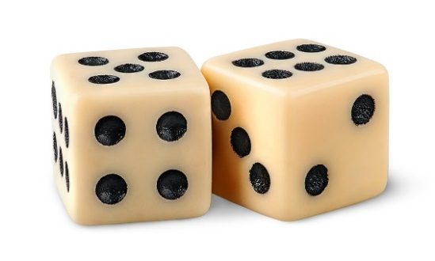
Combined events involve two or more events that occur together.
For example,
- Throwing a penny and rolling a die at the same time;
- Rolling a die and then rolling it again;
- Spinning a spinner that shows the numbers 1-8, and then randomly choosing a card from a standard deck of playing cards.
Independent Events
Two events are independent if the result of the first event does not affect the probability of the second event.
For example, when throwing the same die twice, the fact that the die has landed on 6 the first time does not affect the probability of obtaining a 6 the second time.
The multiplication rule for independent events
For independent events $A$ and $B$,
$$P\left(A∩B\right)=P(A)×P(B)$$
This means the probability of $A$ and $B$ occurring is the product of $A$’s probability and $B$’s probability.
For example, the probability of obtaining heads when throwing a coin and 4 when rolling a die is $\frac{1}{2}×\frac{1}{6}=\frac{1}{12}$.
Dependent Events (Higher Tier only)
Two events are dependent if the result of the first event does affect the probability of the second event.
For example, when choosing two cards from a standard deck of playing cards, without replacement, the first card chosen affects the probability of the second card chosen. If the first card is a king, then the probability of the second card being a king is $\frac{3}{51}$, not $\frac{4}{52}$ as for the first card.
The multiplication rule for dependent events

For dependent events $A$ and $B$,
$$P\left(A∩B\right)=P(A)×P(B|A)$$
This means the probability of $A$ and $B$ occurring is the product of $A$’s probability with the probability of $B$ occurring, given that $A$ has already occurred. (The probability $P(B|A)$ is a conditional probability.)
For example, the probability of choosing two kings from a standard deck of playing cards is $\frac{4}{52}×\frac{3}{51}=\frac{12}{2652}$, or $\frac{1}{221}$.
Mutually Exclusive Events
Two events are mutually exclusive if they cannot happen at the same time. For example, when rolling a normal fair die, the events “landing on an odd number” and “landing on 6” are mutually exclusive, because 6 is not an odd number. On the other hand, the events “landing on an odd number” and “landing on a prime number” are not mutually exclusive, because the numbers 3 and 5 are both odd and prime.
The addition rule for mutually exclusive events
For mutually exclusive events $A$ and $B$,
$$P\left(A∪B\right)=P\left(A\right)+P(B)$$
This means the probability of $A$ or $B$ occurring is the sum of $A$’s probability and $B$’s probability.
For example, the probability of obtaining an odd number or a 6 when rolling a normal fair die is $\frac{3}{6}+\frac{1}{6}=\frac{4}{6}$, or $\frac{2}{3}$.

Exercise 6
For the following pairs of events, decide whether the events are independent
or dependent.
2
(a) Obtaining ‘heads’ when throwing a coin and obtaining ‘6’ when rolling a normal
fair die.
(b) Choosing two queens when choosing two cards from a standard deck of playing cards, without replacement.
(c) Choosing two queens when choosing a card from a standard deck of playing cards, returning the card to the deck, and then choosing another card.
(d) Choosing two red balls when one ball is chosen from a bag containing 4 red balls and 5 blue balls, and the other is chosen from a bag containing 5 red balls and 4 blue balls.
(e) Choosing two red balls from a bag containing 4 red balls and 5 blue balls, without replacement.
Exercise 7
2
For the following pairs of events, decide whether the events are mutually exclusive or not.
(a) Obtaining ‘heads’ when throwing a coin and obtaining ‘6’ when rolling a normal fair die.
(b) When rolling a normal fair die, obtaining
(i) a number less than 3 and a number greater than 3.
(ii) an even number and a number greater than 4.
(iii) an odd number and a square number.
(iv) an even number and a cube number.
(v) an even number and a prime number.
(c) Obtaining ‘heads’ when throwing a coin and ‘heads’ when throwing another coin.
(d) On a spinner showing the numbers 1-10, landing on a multiple of 3 and landing on a multiple of 4.
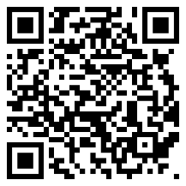
(e) On a spinner showing the numbers 1-12, landing on a multiple of 3 and landing on a multiple of 4.
Example
Christine has a normal fair die. She rolls the die twice.
Calculate the probability that the die lands on 3 each time.
Answer: The result of the first roll does not affect the second roll, so the events are independent.
We can therefore use the multiplication rule for independent events.
2
$$P(\text{3 the first time, 3 the second time)}$$ | $$=$$ | $$P(\text{3 the first time)}×P(\text{3 the second time)}$$
 | $$=$$ | $\frac{1}{6}×\frac{1}{6}$
 | $$=$$ | $\frac{1}{36}$
Exercise 8
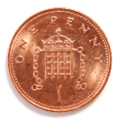
(a) David has a normal fair die. He rolls it twice.
Calculate the probability that he rolls 5 the first time and 1 the second time.
(b) Fiona has a fair coin. She throws it 3 times.
Calculate the probability that she obtains 3 ‘tails’.
(c) Rachel has a normal fair die and a fair coin. She rolls the die and throws the coin.
Calculate the probability that the die lands on 4 and the coin lands on ‘tails’.
(d) A game is played where the two spinners below are spun at the same time.
6
1
4
1
5
2
4
3
3
2

(i) What is the probability that the spinner on the left stops at 4 and the spinner on the right stops at 3?
(ii) What is the probability that the spinner on the left stops at an even number and the spinner on the right stops at an odd number?
(iii) What is the probability that both spinners stop at the same number?
(e) A bag contains 12 counters. 3 are red, 4 are blue and the rest are green. Another bag contains 15 counters.
7 are red, 2 are blue and rest are green. What is the probability of choosing
(i) A red counter from the first bag and a blue counter from the second bag?
(ii) A blue counter from the first bag and a red counter from the second bag?
(iii) Two green counters?

Exercise 9
2
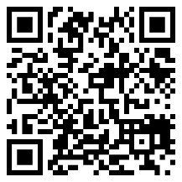
(a) Mariel rolls a normal fair die. What is the probability that Mariel’s die lands on
(i) 2 or 3?
(ii) An even number or 5?
(iii) A number less than 3 or a number greater than 4?
(iv) A prime number or a square number?
(b) Heulwen shuffles a standard deck of playing cards before randoomly choosing one card from the pack.
What is the probability that Heulwen chooses
(i) Hearts or spades?
(ii) 3 or 5?
(iii) A face card or a card less than 6?
(iv) A black card or a red card?
1 | 2 | 3 | 4 | 5
6 | 7 | 8 | 9 | 10
11 | 12 | 13 | 14 | 15
16 | 17 | 18 | 19 | 20

(c) One number is chosen at random from the grid on the right. What is the probability that the number is:
(i) 4 or 5?
(ii) A multiple of 5 or a multiple of 7?
(iii) A factor of 8 or a two-digit number?
(iv) A cube number or a prime number?
(d) Gareth rolls a fair die with 12 faces.
What is the probability that the die lands on
(i) 1 or 12?
(ii) An odd number or a multiple of 4?
(iii) A square number or 7?
(iv) A multiple of 3 or a factor of 11?
(e) A bag contains 10 counters. 3 are red, 2 are blue and the rest are purple. One counter is chosen at random from the bag. What is the probability that the chosen counter is red or purple?
Venn Diagrams
Example
In a class of 24 learners, 8 own a dog, 9 own a cat and 3 own both a dog and a cat. One learner is chosen at random from the class. What is the probability that the chosen learner does not own either a dog or a cat?
Answer: To begin, let us draw a Venn diagram to illustrate the situation.
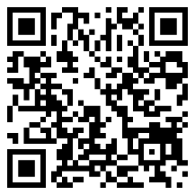
Dog
10
5 3 6
Cat
$$ε$$

We see from the Venn diagram that 10 learners in the class do not own either a dog or a cat. Therefore, the probability of choosing a learner that does not own either a dog or a cat is $\frac{10}{24}$, or $\frac{5}{12}$.
Exercise 10
2

(a) In a survey someone asked 40 pupis whether they liked football or rugby.
32 pupils liked football.
25 pupils liked rugby.
22 pupils liked both sports.
(i) Draw a Venn diagram to illustrate this information.
(ii) What is the probability that a randomly chosen pupil from this group likes rugby only?
(b) (i) Place the numbers 1, 2, 3, 4, 5, 6, 7, 8, 9 and 10 into the correct positions in the following Venn diagram.
Odd
numbers
Square numbers
$$ε$$
(ii) A number is chosen at random from the set {1, 2, 3, 4, 5, 6, 7, 8, 9, 10}.
Find the probability that the chosen number
(I) is an odd number; (II) is an odd number and a square number; (III) is neither odd nor a square number.
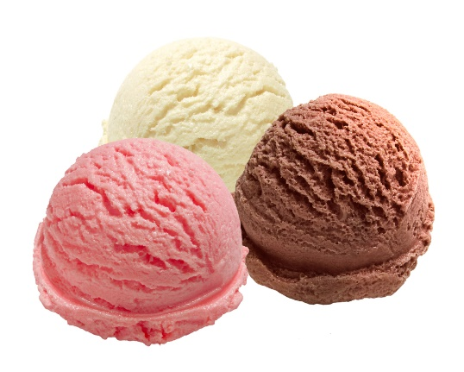
(c) An ice cream company conducted a taste test in a supermarket. 110 people took part in the survey, where they were asked to taste strawberry, vanilla and chocolate ice creams.
65 people stated that they liked the strawberry ice cream.
80 people stated that they liked the vanilla ice cream.
60 people stated that they liked the chocolate ice cream.
55 people stated that they liked both the strawberry and vanilla flavours.
50 people stated that they liked both the vanilla and chocolate flavours.
45 people stated that they liked both the strawberry and chocolate flavours.
40 people stated that they liked all 3 flavours.
(i) Draw a Venn diagram to illustrate this information.
(ii) What is the probability that a randomly selected person from this group liked
(I) Vanilla only; (II) None of the three flavours; (III) Vanilla or Strawberry?
(d) (i) Place the numbers 1, 2, 3, 4, 5, 6, 7, 8, 9 and 10 into the correct positions in the following Venn diagram.
(ii) A number is chosen at random from the set {1, 2, 3, 4, 5, 6, 7, 8, 9, 10}.
Find the probability that the chosen number is
(I) an even number; (II) a prime number and a factor of 12; (III) a prime number but not an even number.
Factors of 12
Prime numbers
Even numbers
$$ε$$

Key words | Corrections | I am happy with... | I need to revise...

Tree diagrams are used to show combinations of two or more events.
Each branch is labelled on the right with the result and in the middle with the probability.
It is possible to use tree diagrams to show independent events (intermediate tier)
or dependent events (higher tier).
Example
A bag contains ten balls that are indentical apart from their colour. Three of the balls are yellow and the rest red.
A ball is selected at random from the bag, its colour noted and returned to the bag. A second ball is chosen and its colour is also noted.
Use a tree diagram to calculate the probability that
(a) the two selected balls are yellow;
(b) the two selected balls have different colours;
(c) the two selected balls are not both yellow.
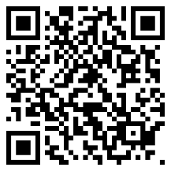
Answer: Step 1: Draw a tree diagram to illustrate the situation.
1st Ball 2nd Ball Combination
Result
$\frac{3}{10}$

Yellow Yellow, Yellow
Branch
$\frac{3}{10}×\frac{3}{10}=\frac{9}{100}$

Yellow
$\frac{7}{10}$

$\frac{3}{10}$
Red Yellow, Red
$\frac{3}{10}×\frac{7}{10}=\frac{21}{100}$

$\frac{3}{10}$

$\frac{7}{10}$

Yellow Red, Yellow
$\frac{7}{10}×\frac{3}{10}=\frac{21}{100}$

Red
Probability
$\frac{7}{10}$

Red Red, Red
$\frac{7}{10}×\frac{7}{10}=\frac{49}{100}$

Multiply when going along the branches, as selecting the first ball and selecting the second ball are independent events.

Step 2: Consider which paths in the tree diagram need to be considered in order to answer the questions.
(a) The first path in the tree diagram (yellow, yellow) shows the situation in which both selected balls are yellow.
The probability for this is $\frac{9}{100}$.
(b) The paths that show balls of different colours are the second path (yellow, red) or the third path (red, yellow). Because these paths are mutually exclusive, it is possible to add the probabilities to obtain the final answer:
$\frac{21}{100}+\frac{21}{100}=\frac{42}{100}$. Note that it would be possible to simplify this fraction to obtain $\frac{21}{50}$ but, unless the question notes otherwise, fractions do not have to be simplified in questions on probability.
(c) There are two ways of answering this question:
(i) Consider all paths in the tree diagram that do not give two yellow balls: $\frac{21}{100}+\frac{21}{100}+\frac{49}{100}=\frac{91}{100}$;
(ii) Consider the probability of selecting two yellow balls ($\frac{9}{100}$, the answer to part (a)) and subtract from 1:
$1-\frac{9}{100}=\frac{91}{100}$.
Exercise 11
Whenever Geraint and Siôn play a game of ‘FIFA’ on a games console, the probability
that Gerains wins is 0.4.
2
(a) Complete the following tree diagram to show the probabilities of what can happen when
Geraint and Siôn play two games of ‘FIFA’.
Game 1 Game 2 Combination
........
Geraint wins
Geraint wins
........
Siôn wins
........
........
Geraint wins
........
Siôn wins
Siôn wins
........
(b) Calculate the probability that Siôn wins both games.
(c) Calculate the probability that Siôn wins exactly one of the games.
(d) Calculate the probability that Siôn wins neither of the games.
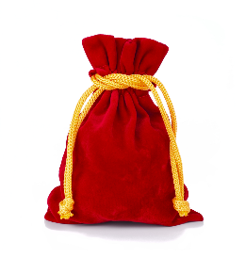
Exercise 12
2
There are two bags in a game, and both bags contain coloured balls.
Bag A contains 2 red balls and 5 yellow balls.
Bag B contains 3 red balls and 2 yellow balls.
A player randomly chooses one ball from each bag.
A
B
(a) Complete the following tree diagram.
Bag A Bag B Combination
........
Red
Red
$\frac{2}{7}$
Yellow
........
........
Red
........
Yellow
Yellow
........
(b) Find the probability of choosing two red balls.
(c) Find the probability of choosing a ball of each colour.
(d) Find the probability of not choosing two red balls.
Exercise 13
2
Two biased coins are thrown. The probability of obtaining heads with the first coin is 70%.
The probability of obtaining heads with the second coin is 60%.
(a) Complete the following tree diagram.
First Coin Second Coin Combination
........
Heads
Heads
........
Tails
........
........
Heads
........
Tails
Tails
........
(b) Calculate the probability that one coin shows ‘Heads’ and the other coin shows ‘Tails’.
Example
The probability that Elin posts a picture on Instagram over the weekend is 0.4
The probability that Elin goes shopping over the weekend is independent of her posting a picture on Instagram over the weekend. The probability of Elin posting a picture on Instagram over the weekend, and going shopping over the weekend, is 0.12.
(a) Complete the following tree diagram.
(b) Find the probability that Elin posts a picture on Instagram over the weekend but does not go shopping over the weekend.
Answer: (a) The red text is the text that has been added.
Note in this example that the probability of one of the combinations has been given, so we must perform a division sum in order to calculate the probability of shopping over the weekend.
Instagram Shopping Combination
0.3
0.12 ÷ 0.4 = 0.3
Shops Posts a picture, shops
Posts a picture 0.12
0.7
0.4
Does not shop Posts a picture, does not shop
0.4 × 0.7 = 0.28
0.3
Shops No picture, shops
0.6
No picture 0.6 × 0.3 = 0.18
0.7
Does not shop No picture, does not shop
0.6 × 0.7 = 0.42
(b) 0.4 × 0.7 = 0.28 (the second path).

Exercise 14
2
Megan lives 5 miles from her work, and either cycles or drives to work.
The probability that she cycles to work is 0.3.
The probability that she cycles to work and has a sandwich for lunch is 0.24.
In Megan’s case, her method of transport to work is independent of what she has for lunch.
(a) Find the probability that Megan has a sandwich for lunch.
(b) Complete the following tree diagram.
Method of Transport to Work Lunch Combination
........
Sandwich
Cycle
........
Something else
........
........
Sandwich
........
Drive
Something else
........
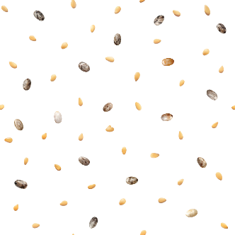
(c) Find the probability that Megan drives to work and eats something apart from a sandwich for lunch.
2
Exercise 15
A bag contains a large number of two types of seed, namely sesame and chia.
Two seeds are randomly chosen from the bag.
The probability that two sesame seeds are chosen is 0.49.
(a) Complete the following tree diagram.
1st Seed 2nd Seed Combination
........
Sesame
Sesame
........
........
Chia
........
Sesame
........
Chia
Chia
........
(b) Calculate the probability that one seed of each type is selected.
(c) Calculate the probability that two chia seeds are chosen.
(d) Why are the words “large number” needed at the start of the question?
(e) If three seeds were chosen from the bag, what would be the probability of choosing 3 sesame seeds?

Name: ............................................  Percentage in the test: .................. |   I know this. |   I need to revise this. | Question in the test: | Correct in the test?
I have revised the previous work on probability, e.g. sample space diagrams, expected frequency. |  |  | 1, 3, 7
I know how to calculate relative frequency from experimental data. |  |  | 2
I know how to draw a graph showing relative frequency against the number of trials. |  |  | 2
I understand the more trials are held, the better the relative frequency is as an estimate of the probability. |  |  | 2
I can tell the difference between independent events and dependent events. |  |  | 4
I can tell the difference between mutually exclusive events and events that are not mutually exclusive. |  |  | 4
I can use the multiplication rule for independent events. |  |  | 4
I can use the addition rule for mutually exclusive events. |  |  | 5
I can answer questions on probability that involve Venn diagrams. |  |  | 6
I can draw and use tree diagrams. |  |  | 8
Given the probability of one of the combinations in a tree diagram, I can work backwards to fill in all the probabilities of the tree diagram. |  |  | 9

