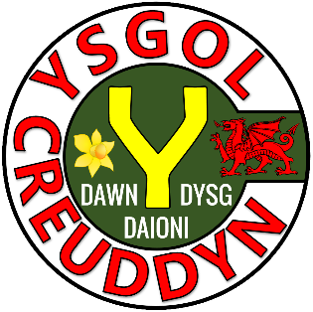
Activity | Page
Quiz 1 | 3
Example–Problem Pair 1 | 4–5
Quiz 2 | 6
Venn Diagram Challenge 1 | 7
Example–Problem Pair 2 | 8–9
Quiz 3 | 10
Angle Chase | 11
Example–Problem Pair 3 | 12–13
Quiz 4 | 14
Venn Diagram Challenge 2 | 15
Example–Problem Pair 4 | 16–17
Quiz 5 | 18
Triangle in a Circle | 19

1) 180 – 56 | 2) 360 – 125 – 67 | 3) 90 – 46
4) 4 × 180 | 5) 540 ÷ 5 | 6) 360 – 3 × 70
7) List all the factors of 24 | 8) 9² | 9) 6³

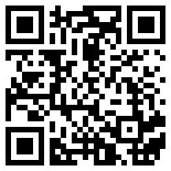
Translate the triangle $A$ below 4 units to the left,
5 units up.
$$A$$

Translate the triangle $A$ below 3 units to the right, 6 units down.

$$A$$

Solve the following inequalities.
1) $x+3>8$ | 2) $x-5≤9$ | 3) $\frac{x}{2}≥8$
4) $4x>20$ | 5) $-4x>20$ | 6) $4x>-20$
7) $2x-1>21$ | 8) $20<3x+5$ | 9) $3-2x<13$

Think of a number that could go into each region.
If you think a region is impossible to fill, explain why!
$$x≤8$$
$$x>4$$
D
D
C
B
A
C
A
B
$$ε$$
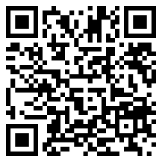
$$A$$
Reflect the triangle $A$ in the line $y=2$.

$$A$$
Reflect the triangle $A$ in the line $x=1$.

1) $\frac{2}{9}+\frac{4}{9}$ | 2) $\frac{7}{8}-\frac{3}{8}$ | 3) $\frac{2}{5}+\frac{1}{3}$
4) $\frac{2}{5}-\frac{1}{3}$ | 5) $\frac{2}{5}×\frac{1}{3}$ | 6) $\frac{2}{5}÷\frac{1}{3}$
7) $3\frac{2}{7}$ as a top-heavy fraction | 8) $\frac{7}{2}$ as a mixed number | 9) $\frac{5}{6}$ of £42

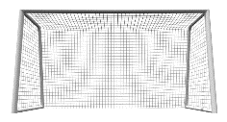
62°

38°

Which angles can be found in this diagram?


$$A$$
Rotate the triangle $A$ 90° clockwise around the point
(–1, 1).

$$A$$
Rotate the triangle $A$ 90° anticlockwise around the point (1, 2).

1) 10% of £54 | 2) 25% of £40 | 3) 20% of $9
4) 3.4 + 2.48 | 5) 3.4 – 2.48 | 6) 3 ÷ 0.5
7) Find the mode of 5, 2, 8, 4, 5, 6 | 8) Find the median of 5, 2, 8, 4, 5, 6 | 9) Find the mean of 5, 2, 8, 4, 5, 6

Write an equation of the form $y=mx+c$ that could go into each region. If you think a region is impossible to fill, explain why!
Negative $y$-intercept
D
Positive Gradient
D
C
B
A
C
A
B
$$ε$$
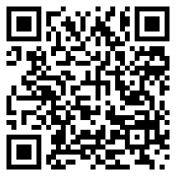
$$A$$
$$B$$
Enlarge the triangle $A$ using scale factor 2 and centre of enlargement $B$.

$$B$$
Enlarge the triangle $A$ using scale factor 2 and centre of enlargement $B$.

Sketch the following shapes.
1) Rectangle | 2) Triangle | 3) Parallelogram
4) Trapezium | 5) Kite | 6) Arrowhead
7) Cuboid | 8) Sphere | 9) Tetrahedron

108°
126°
Siart cylch i ddangos hoff flas creision dysgwyr Ysgol B
Plaen
Halen a Finegr
Caws a Nionyn
Coctel Corgimwch
4) Dywedodd Dion “Mae mwy o bobl yn hoffi creision caws a nionyn yn Ysgol A nac yn Ysgol B”. Ydy Dion yn gywir? Eglurwch eich ateb.



1) What is the size of the angle $A\hat{B}C$? | 2) What is the size of the angle $B\hat{C}A$?
3) What is the length of the circumference of the circle? | 4) What is the length of the line $BC$?

$$C$$
$$B$$
$$A$$
36.9°
12 cm
15 cm

Evaluating the Workbook

Notes




@minutemaths314 /adolygumathemateg
/mathscreuddyn www.mathemateg.com

