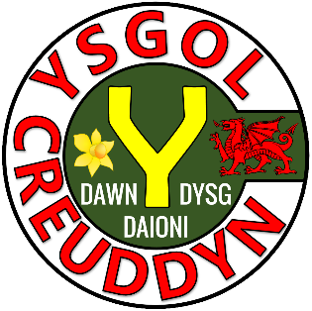
Activity | Page
Quiz 1 | 3
Example–Problem Pair 1 | 4–5
Quiz 2 | 6
Venn Diagram Challenge 1 | 7
Example–Problem Pair 2 | 8–9
Quiz 3 | 10
The Triangle and the Rectangle | 11
Example–Problem Pair 3 | 12–13
Quiz 4 | 14
Venn Diagram Challenge 2 | 15
Example–Problem Pair 4 | 16–17
Quiz 5 | 18
Pancakes | 19

1) 2.4 + 5.89 | 2) $\frac{2}{3}+\frac{1}{2}$ | 3) 20% of £60
4) The median of  6, 2, 4, 9, 1, 8 | 5) Solve  $x-4=6$ | 6) What is the area of the rectangle?
7) What is the formula for calculating the circumference of a circle? | 8) Sketch a frequency diagram. | 9) Simplify  $3x+9y+4x-2y$

3 cm
6 cm

What is the $n$th term of the following sequence?
14, 18, 22, 26, 30, .....

What is the $n$th term of the following sequence?
14, 17, 20, 23, 26, .....

Solve the following equations.
1) $x+3=10$ | 2) $3x=24$ | 3) $\frac{x}{2}=6$
4) $y-4=15$ | 5) $2z=1$ | 6) $\frac{12}{x}=4$
7) $2x+1=13$ | 8) $3y-2=19$ | 9) $\frac{x}{3}+2=11$

Think of a number that could go into each region.
If you think a region is impossible to fill, explain why!
Square Number
Triangular Number
D
D
C
B
A
C
A
B
$$ε$$

Plot a graph for the equation $y=2x-3$.

Plot a graph for the equation $y=-3x+4$.

Consider the numbers in the following list.
21, 22, 23, 24, 25, 26, 27, 28, 29, 30.
Using only numbers from the above list, write
1) The multiples of 4 | 2) A square number | 3) A factor of 60
4) A cube number | 5) All the prime numbers | 6) A multiple of both 2 and 3
7) The even numbers | 8) Two numbers with a difference of 8 | 9) Half of 58

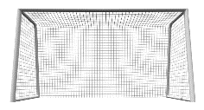
$x+2$ cm
6 cm
7 cm
8 cm
$x$ cm
A triangle and a rectangle are shown below.

The diagrams are not drawn to scale
The perimeter of the triangle is 18 cm.
What can you work out using this information?


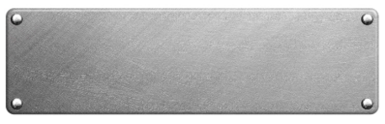
The density of a piece of metal is 2.8 g/cm³.
If the piece of metal has volume
40 cm³, what is its mass?

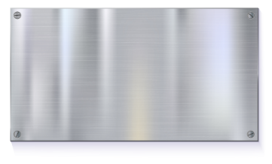
The density of a piece of metal is 2.5 g/cm³.
If the piece of metal has volume
58 cm³, what is its mass?

1) Expand  $4(x+2)$ | 2) Expand  $(x+3)(x+5)$ | 3) Solve  $7x-3=25$
4) Make $g$ the subject of the formula  $f=2-3g$ | 5) Simplify  $8a-2a+3a$ | 6) Substitute  $x=3$ into $3x-4$
7) Solve  $\frac{y}{4}=8$ | 8) Factorise  $12x-16$ | 9) Factorise  $x^{2}-5x$

Think of a number for $x$ that could go into each region.
If you think a region is impossible to fill, explain why!
$$x<4$$
$$x>4$$
D
D
C
B
A
C
A
B
$$ε$$

7 cm
4 cm
The measurements of the following rectangle are given correct to the nearest centimetre. Calculate the largest possible perimeter of the rectangle.

3 cm
8 cm
The measurements of the following rectangle are given correct to the nearest centimetre. Calculate the least possible area of the rectangle.

Solve the following inequalities.
1) $x+4>8$ | 2) $3x≤27$ | 3) $y-3<10$
4) $\frac{z}{2}≥6$ | 5) $-2x>10$ | 6) $\frac{x}{-3}≤-2$
7) $4x-2<18$ | 8) $2-4x≥18$ | 9) $\frac{x+3}{5}<5$

108°
126°
Siart cylch i ddangos hoff flas creision dysgwyr Ysgol B
Plaen
Halen a Finegr
Caws a Nionyn
Coctel Corgimwch
4) Dywedodd Dion “Mae mwy o bobl yn hoffi creision caws a nionyn yn Ysgol A nac yn Ysgol B”. Ydy Dion yn gywir? Eglurwch eich ateb.



1) How much plain flour is needed to make 36 pancakes? | 2) How much milk is needed to make 6 pancakes?
3) What is the greatest number of pancakes you can make with 3 eggs? | 4) Ceri has half a pint of milk left in the fridge. Is this enough to make 12 pancakes?

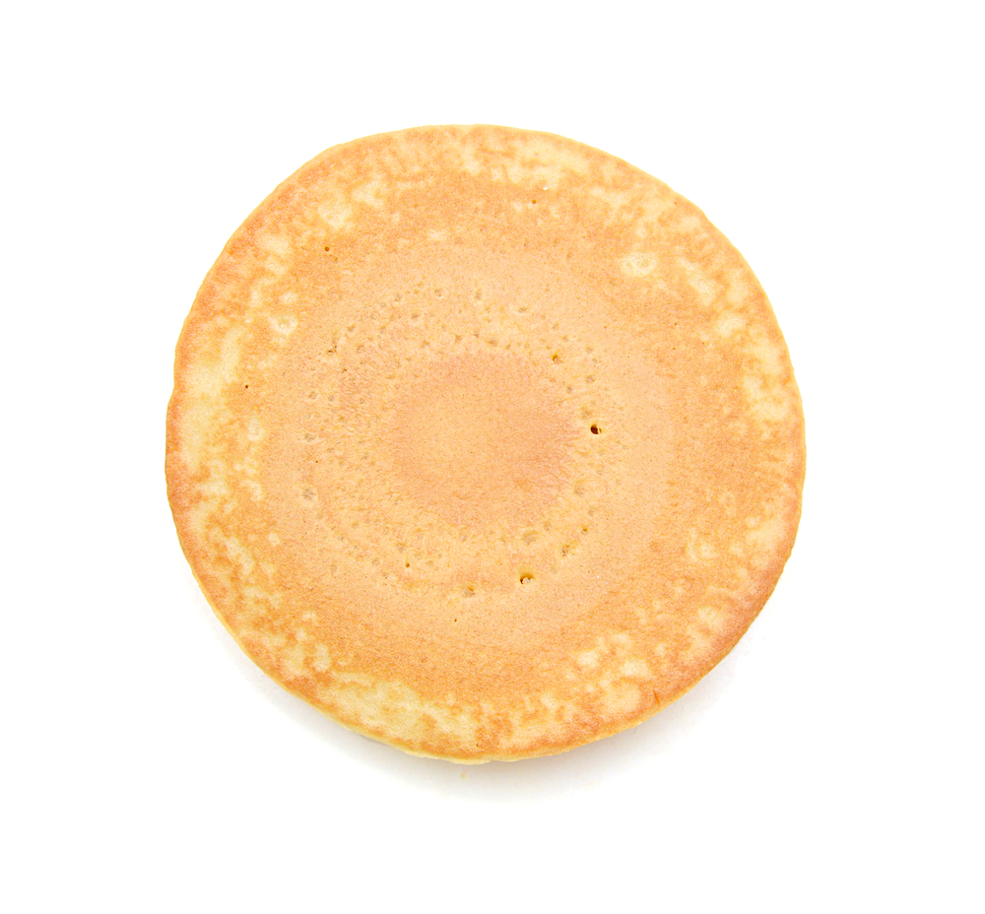
To make 12 pancakes, you need:
120 g plain flour
2 eggs
200 ml milk

Evaluating the Workbook

Notes




@minutemaths314 /adolygumathemateg
/mathscreuddyn www.mathemateg.com

