THE UNKNOWN

NAME:
REGISTRATION
CLASS:
YEAR 10
NUMERACY
CONTENTS

Activity | Page
Algebra Skills | 3
Sessions 1–5 | 4–8
Quiz 1: Roswell | 9
Sessions 6–11 | 10–15
Quiz 2: Rendelsham Forest | 16
Sessions 12–16 | 17–21
Quiz 3: The Berwyn Mountains | 22
Sessions 17–20 | 23–26
Quiz 4 | 27
Space for calculations | 28

ALGEBRA SKILLS
Substituting
Writing a number in place of a variable, and calculating the sum that is
formed, e.g.
Substitute $x=4$ into
$$5x+3$$
Substitute $4$ for$x$ to obtain
$$5×4+3 \\ =20+3 \\ =23$$
Solving
Finding the value of the variable, e.g.
$3x+5=32$
$3x=27$ [Subtract 5 from both sides]
$x=9$ [Divide both sides by 3]
Writing an Expression
Writing a piece of algebra to represent a situation, e.g.
Write an expression for four less than $y$
Answer: $y-4$
Expanding
Multiplying to remove brackets, e.g.
$$4(2x-6) \\ =8x-24$$
Simplifying
Collecting like terms, e.g.
$$7x+3y-2x-9y \\ =5x-6y$$
SESSION 01
NUMBER
1) 8 × 6 | 2) 482 + 8379 | 3) 30% of £130
4) $\frac{2}{3}+\frac{1}{4}$ | 5) 4 ÷ 0.5 | 6) 5.3 – 2.47

$$\frac{ }{\text{6}}$$

ALGEBRA
7) Simplify  $$5x+2x+3x$$ | 8) Solve  $$x+5=9$$ | 9) Expand  $$4(x+3)$$
10) Substitute  $x=2$ into $3x+5$ | 11) Write an expression for four less than $x$ | 12) Solve  $$4x=32$$

$$\frac{ }{\text{6}}$$

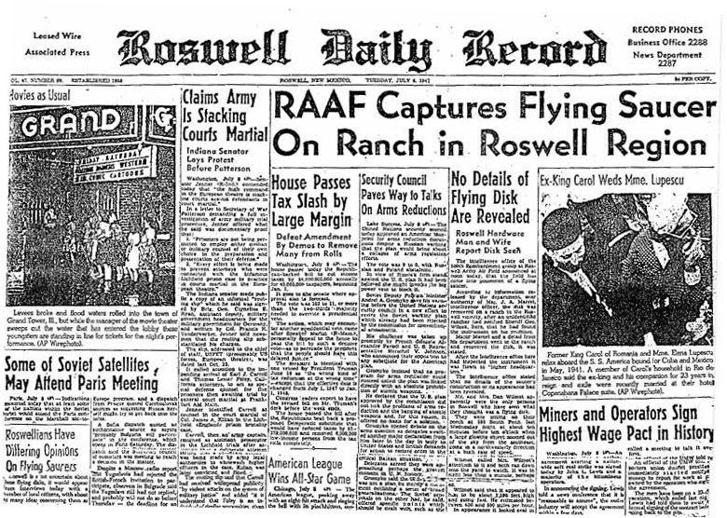
ROSWELL
In 1947, the Roswell Daily Record announced that the Roswell Army Air Field (RAAF) had captured a flying saucer.
According to the report, a farmer had found the saucer in the Roswell area. The military were contacted, and the saucer went to a nearby base. An eyewitness reported seeing the saucer flying above Roswell, travelling at a speed between 400 and 500 miles per hour.
SESSION 02
SHAPE
Name the shapes below.
1) | 2) | 3)
4) | 5) | 6)

$$\frac{ }{\text{6}}$$

ALGEBRA
7) Simplify  $$5a+3b-2a+4b$$ | 8) Solve  $$y-4=2$$ | 9) Expand  $$y(y-2)$$
10) Substitute  $x=4$ into $2-4x$ | 11) Write an expression for seven greater than $x$ | 12) Solve  $$\frac{x}{2}=6$$

$$\frac{ }{\text{6}}$$

ROSWELL (PART 2)
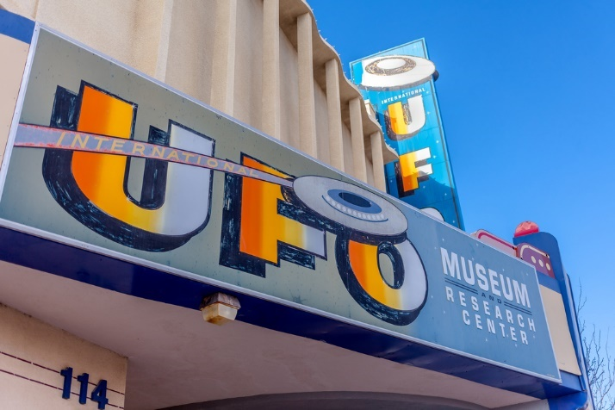
The eyewitness, Dan Wilmot, stated than the unidentified flying object, or UFO, was oval in shape and glowed light in every direction. Mr Wilmot heard no sound but his wife reported hearing swishing noises for a short period.
The newspaper report ended by stating that Mr Wilmot had at first decided to keep the story quiet but went to the newspaper when no one else had reported the story. The information that the saucer had arrived at the military base came a few minutes after Wilmot spoke to the newspaper.
SESSION 03
DATA
1) Find the mode of  7, 2, 1, 7, 3, 4 | 2) Find the median of  7, 2, 1, 7, 3, 4 | 3) Find the mean of  7, 2, 1, 7, 3, 4
4) What is the probability of rolling a 4 on a normal fair die? | 5) What is the probability of rolling an even number on a normal fair die? | 6) What is the probability of rolling a square number on a normal fair die?

$$\frac{ }{\text{6}}$$

ALGEBRA
7) Simplify  $$6r+2r-5r+r$$ | 8) Solve  $$z+0.5=6.5$$ | 9) Expand  $$6(z+5)$$
10) Substitute  $x=8$ into $3x+9$ | 11) Write an expression for nine less than $x$ | 12) Solve  $$3x=42$$

$$\frac{ }{\text{6}}$$

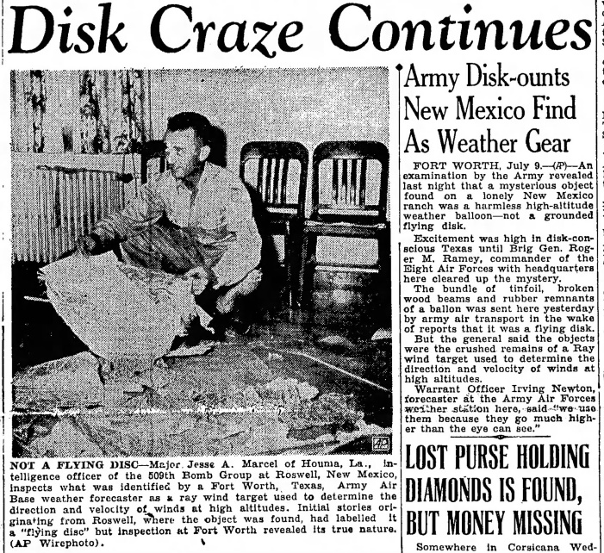
ROSWELL (PART 3)
Following the publication of the newspaper report, there was great interest in the flying saucer. What was its size? From what materials was it made? Were there aliens within?
Soon after an announcement was made stating that a mistake had been made: the ‘saucer’ was a weather balloon! The picture on the right shows Jesse Marcel, who initially stated that a flying saucer had been found, holding some of the remains of the weather balloon.

SESSION 04
NUMBER
1) 9 × 4 | 2) 3827 – 493 | 3) 25% of £34
4) $\frac{5}{6}-\frac{2}{3}$ | 5) 2.6 + 3.48 | 6) 5.83 × 4

$$\frac{ }{\text{6}}$$

ALGEBRA
7) Simplify  $$-3g+2f+7f+8g$$ | 8) Solve  $$2x+1=9$$ | 9) Expand  $$-3(x+2)$$
10) Substitute  $x=-4$ into $2x+10$ | 11) Write an expression for seven multiplied by $x$ | 12) Solve  $$\sqrt{x}=3$$

$$\frac{ }{\text{6}}$$

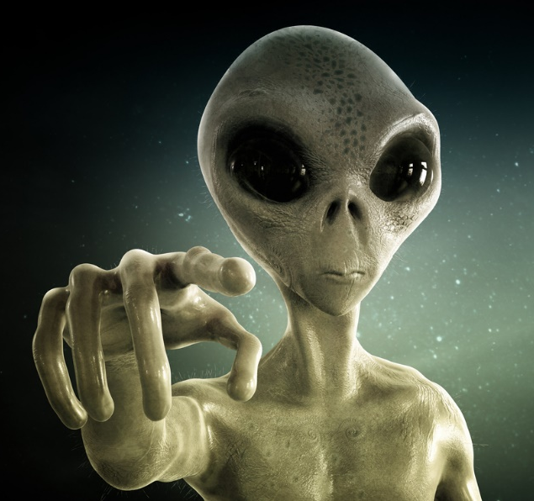
ROSWELL (PART 4)
At the end of the 1970s, the interest in Roswell increased again, as a number of books and documents were released. There was an allegation that the government had created the story about the weather balloon to hide the truth, that a spaceship had fallen from the sky and aliens had been found.
In 1995, Ray Santilli, a film producer from London, announced that he had found a film of the aliens being examined. The 17-minute film was broadcast on the Fox network in America, to great commotion.

SESSION 05
SHAPE
1) What is the perimeter of a rectangle measuring 4 cm by 7 cm? | 2) What is the area of a rectangle measuring  4 cm by 7 cm? | 3) How many edges does a pentagon have?
4) How many centimetres are in  3 metres? | 5) How many millilitres are in 2 litres? | 6) How many grams are in 2.5 kilograms?

$$\frac{ }{\text{6}}$$

ALGEBRA
7) Simplify  $$8x+3y-2x-9y$$ | 8) Solve  $$4z=12$$ | 9) Expand  $$x(3-x)$$
10) Substitute  $x=2$ into $3x+7$ | 11) Write an expression for five less than double $x$ | 12) Solve  $$\frac{24}{x}=4$$

$$\frac{ }{\text{6}}$$

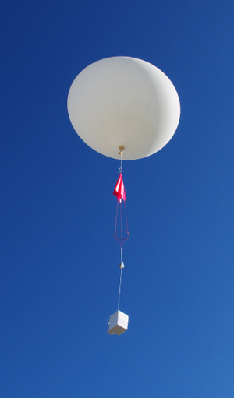
ROSWELL (PART 5)
In 2006, Ray Santilli confessed that the film from 1995 was not the original, but rather a re-enactment of the film he had seen in 1992. By the time he could afford to buy the original reels from 1992, they had degraded so much (due to humidity and heat) that they could not be viewed. The story of Santilli’s film was adapted into a movie shown in theatres, “Alien Autopsy” starring Ant and Dec!
The argument over what happened at Roswell continues to this day. Some still believe that aliens fell to earth, whilst others believe the explanation that a weather balloon was responsible for the whole saga. Who do you believe?
Roswell QUIZ
1) In which year did the Roswell incident take place?
..........................................................................................................................................................................
2) According to the eyewitness Dan Wilmot, what was the shape of the UFO?
..........................................................................................................................................................................
3) According to the government, what was responsible for the incident?
..........................................................................................................................................................................
4) How many minutes long was Ray Santilli’s film showing the examination of the aliens?
..........................................................................................................................................................................
5) Who were the stars of the film “Alien Autopsy”?
..........................................................................................................................................................................
PUZZLE

How many aliens are in the picture?

Answer: _______

How many eyes are in the picture?

Answer: _______
SESSION 06
DATA
For the numbers 6, 2, 9, 1, 6, 7, 4, calculate the...
1) Mode | 2) Median | 3) Mean
4) Range | 5) Interquartile Range

$$\frac{ }{\text{5}}$$

ALGEBRA
6) True or False?  $$a+b=b+a$$for any numbers  $a$ and $b.$ | 7) Which number comes next?  4, 7, 10, 13, 16, ...... | 8) Solve the equation  $$x-4=-2$$
9) Simplify  $$-3a+4b+a-b$$ | 10) Expand  $$5(a+b)$$ | 11) Substitute  $x=8$ into $7x+3$

$$\frac{ }{\text{6}}$$

Rendelsham FOREST
In December 1980, a series of strange events took place near the Brentwaters and Woodbridge military bases in the east of England. These were bases owned by the United States of America, with some claiming that nuclear weapons were kept at the sites.
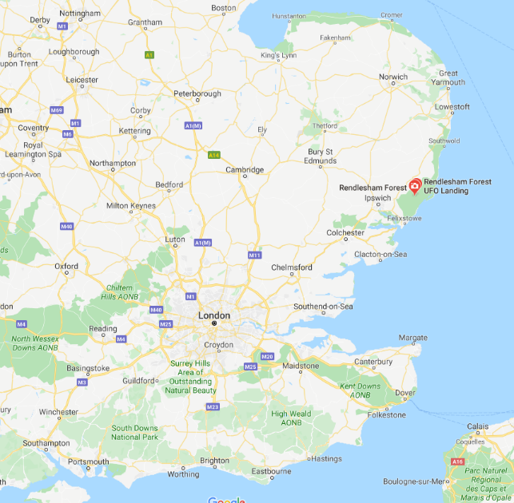
On the night of December 26th, members of the US Air Force, including John Burroughs and Jim Penniston, were sent to investigate an aeroplane that had fallen to earth in Rendelsham forest...
SESSION 07
NUMBER
1) 6 × 7 | 2) 267 + 9865 | 3) 20% of £15
4) $\frac{2}{5}×\frac{3}{4}$ | 5) 1 – 0.65 | 6) 5 × 0.3

$$\frac{ }{\text{6}}$$

ALGEBRA
7) True or False?  $$a-b=b-a$$for any numbers  $a$ and $b.$ | 8) Which number comes next?  73, 64, 55, 46, 37, ...... | 9) Solve the equation  $$4x=-20$$
10) Simplify  $$8x+6z+x+z+x$$ | 11) Write an expression for half of $x$ | 12) Substitute  $x=3$ into $9-2x$

$$\frac{ }{\text{6}}$$

Rendelsham Forest (PART 2)
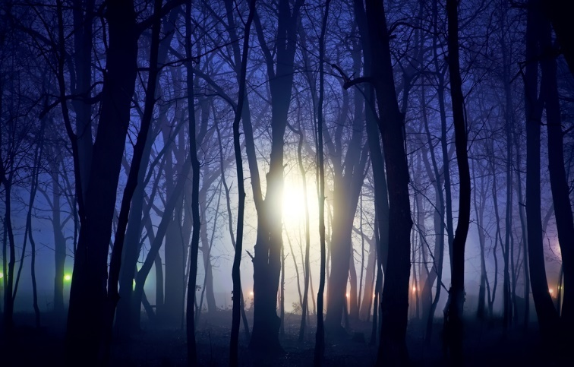
When Burroughs and Penniston reached the area, they didn’t find pieces of an aeroplane, but rather a landed alien spaceship. Penniston managed to get close enough to the spaceship to see hieroglyphic symbols on it, and indeed to touch it.
After a short while, the spaceship ascended slowly above the trees, before accelerating off at a high speed. When the site was subsequently examined, triangle-shaped depressions could be seen in the earth, evidence of burnt trees was found, and higher than normal levels of radiation were recorded.
SESSION 08
SHAPE
Sketch the following solids.
1) Cuboid | 2) Cylinder | 3) Cone
4) Sphere | 5) Tetrahedron | 6) Triangular Prism

$$\frac{ }{\text{6}}$$

ALGEBRA
7) True or False?  $$ab=ba$$for any numbers  $a$ and $b.$ | 8) Which number comes next?  4, 8, 16, 32, 64, 128, ...... | 9) Solve the equation  $$x-5=-10$$
10) Simplify  $$-7y+5y-2y+11y$$ | 11) Expand  $$8y(y+4)$$ | 12) If $x=4$, which is the greatest: $3x$, $x^{2}$ or $x+10$?

$$\frac{ }{\text{6}}$$

Rendelsham Forest (PART 3)
On December 28th, the spaceship returned, shooting light rays towards Woodbridge military base and towards some of the soldiers sent to investigate.
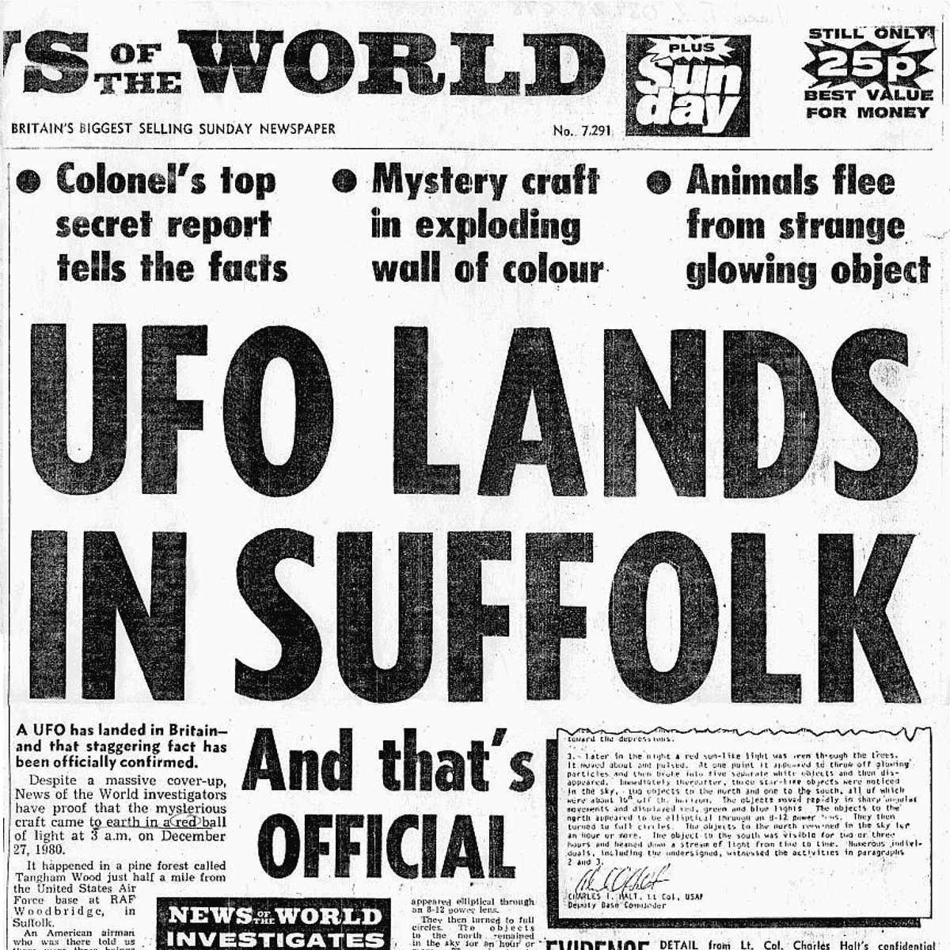
General Gabriel, from the headquarters of the US Air Force in Rammstein, Germany, was sent to examine the events. It is said that he took evidence back to Germany – something that reportedly irked this country’s Ministry of Defence as they also tried to investigate.

SESSION 09
DATA
1) Find the mean of  6, 2, 8, 1, 0, 2, 3, 4, 1, 3 | 2) Find the median of  6, 2, 8, 1, 0, 2, 3, 4, 1, 3 | 3) Find the mode of  6, 2, 8, 1, 0, 2, 3, 4, 1, 3
4) Is “the eye colour of learners in 10C” qualitative data or quantitative data? | 5) Is “the height of learners in 10R” qualitative data or quantitative data? | 6) Is “the shoe size of learners in 10E” qualitative data or quantitative data?

$$\frac{ }{\text{6}}$$

7) True or False?  $$a÷b=b÷a$$for any numbers  $a$ and $b.$ | 8) Which number comes next?  1, 4, 9, 16, 25, 36, ...... | 9) Solve the equation  $$x+3=-4$$
10) Simplify  $$7r-3s+8s-r$$ | 11) Expand  $$(x+6)(x+2)$$ | 12) If $x=7$, which is the greatest $9x$, $x^{2}$  or $5x+20$?

ALGEBRA

$$\frac{ }{\text{6}}$$

Rendelsham Forest (PART 4)

In 2010, Jim Penniston stated that he had received information from the spaceship whilst touching it in the forest. The next day, he started to see in his mind’s eye patterns of zeroes and ones. He took out a notepad and started to record the patterns. These vanished from his mind’s eye once he had finished writing them down.
When Jim showed the patterns to an investigator, the investigator recognised the patterns as binary numbers. The investigator went on to find whether there was a meaning to the numbers…
SESSION 10
NUMBER
1) 3 × 12 | 2) 79 + 80 + 81 | 3) 60% of £120
4) $\frac{5}{6}÷\frac{2}{7}$ | 5) 7 ÷ 0.5 | 6) 9²

$$\frac{ }{\text{6}}$$

ALGEBRA
7) True or False?  $a^{2}>2a$ for any number $a$. | 8) Which number comes next? 1, 1, 2, 3, 5, 8, 13, 21, 34, 55, ...... | 9) Solve the equation  $$2x-3=7$$
10) Simplify  $$4a+9a+a^{2}$$ | 11) Expand  $$-5(2-3a)$$ | 12) Solve the equation  $$x^{2}=25$$

$$\frac{ }{\text{6}}$$

Rendelsham Forest (PART 5)

Incredibly, there was a meaning to the numbers
Jim Penniston had written down. Here is part of the output (green = corrections; red = unable to decipher):
EXPLORATION OF HUMANITY 666 8100
52.0942532N 13.131269W
CONTINUOUS FOR PLANETARY ADVAN???
EYES OF YOUR EYES
ORIGIN 52.0942532N 13.131269W
ORIGIN YEAR 8100
What do you think is the meaning of the message?
SESSION 11
SHAPE
1) Draw a horizontal line. | 2) Draw a vertical line. | 3) Draw a pair of parallel lines.
4) Draw a pair of perpendicular lines. | 5) Draw an isosceles triangle. | 6) Draw an equilateral triangle.

$$\frac{ }{\text{6}}$$

ALGEBRA
7) True or False?  $a^{3}≥a^{2}$ for any number $a$. | 8) Which number comes next?  1, 3, 6, 10, 15, 21, .... | 9) Solve the equation  $$x-2=19$$
10) Simplify  $$a+c+b+c+a+b \\ + a+c+b+a$$ | 11) Expand  $$2x(3x+4)$$ | 12) Solve the equation  $$\frac{x}{3}=6$$

$$\frac{ }{\text{6}}$$

Rendelsham FOrest (PART 6)

Many people have tried to explain what really happened in Rendelsham forest in 1980. One theory is that the eyewitnesses saw light rays from a nearby lighthouse and mistook them for something otherworldly. Another story is that the SAS were caught parachuting into Brentwaters base to test its security. After being imprisoned there for 18 hours, all the time being called ‘aliens’, the SAS took their revenge by using lights, flares, balloons and kites to imitate the landing and escape of a group of aliens.
Rendelsham QUIZ
1) Which two military bases did the United States have in eastern England?
..........................................................................................................................................................................
2) During the investigation, which shape were the depressions seen in the earth?
..........................................................................................................................................................................
3) Who came from Rammstein, Germany to investigate the events?
..........................................................................................................................................................................
4) What type of numbers did Jim Penniston write in his notebook?
..........................................................................................................................................................................
5) Which year was referred to as the origin of the message?
..........................................................................................................................................................................
6) For how many hours were the SAS imprisoned at Brentwaters?
..........................................................................................................................................................................

PUZZLE

Help the alien return to its spaceship. It can move in four directions (up, down, left, right) and can only stop when meeting an obstacle.
Use no more than 18 commands.
INSTRUCTIONS;

SESSION 12
DATA
1) Find the mean of  6, 2, 10, 4, 8 | 2) Find the median of  6, 2, 10, 4, 8 | 3) Find the mode of  6, 2, 10, 4, 8
4) What is the probability of landing on ‘heads’ when throwing a fair coin? | 5) What is the probability of landing on ‘tails’ when throwing a fair coin? | 6) What is the probability of landing on ‘heads’ or ‘tails’ when throwing a fair coin?

$$\frac{ }{\text{6}}$$

ALGEBRA
7) In which quadrant is the co-ordinate (7, –4)? | 8) Expand  $$6(2-x)$$ | 9) Solve  $$x-7=18$$
10) Simplify  $$8r+5v+2v+2r$$ | 11) Substitute  $x=4$ into $2x^{2}$ | 12) Solve  $$2x=28$$

$$\frac{ }{\text{6}}$$

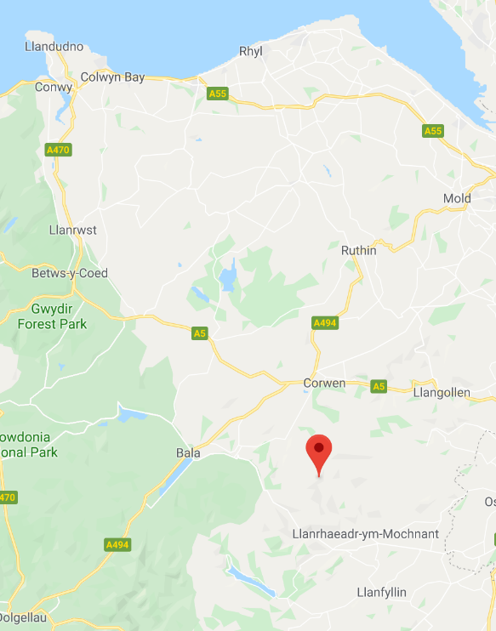
The Berwyn MountaIns
The Berwyn mountains run across the middle of North Wales, from the south-west to the north-east. They separate Snowdonia National Park from Shropshire.
The highest peak is Cadair Berwyn, which reaches a height of 832 metres.
Over the years, many aeroplanes have struck Cadair Berwyn whilst trying to navigate during poor weather. Some believe that an alien spaceship struck the mountain on the night of January 23rd, 1974…
Cadair Berwyn

SESSION 13
NUMBER
1) 2 – 1.3 | 2) 623 + 7219 | 3) $\frac{2}{7}+\frac{3}{7}$
4) 63 ÷ 7 | 5) 90% of $40 | 6) $\frac{2}{5}$ of 35 cm

$$\frac{ }{\text{6}}$$

ALGEBRA
7) In which quadrant is the co-ordinate (–3, 2)? | 8) Expand  $$y(y+7)$$ | 9) Solve  $$x+4=15$$
10) Simplify  $$3x+4+9x-6$$ | 11) Substitute  $x=-1$ into $x^{3}$ | 12) Solve  $$\frac{y}{4}=20$$

$$\frac{ }{\text{6}}$$

The Berwyn MountaIns (PART 2)
Shortly after 8:30pm on Wednesday 23rd January 1974, thousands of people in the area heard at least one explosion, possibly two. This was followed immediately by loud rumblings, lasting around 5 seconds. As people went to look out their windows, some saw lights racing across the sky. Looking up towards Cadair Berwyn, a mysterious white light was seen glowing for several seconds.
Many local people contacted the emergency services, believing some sort of accident had happened. After speaking with the police, one nurse was sure an aeroplane had fallen, and went towards the mountain in her car, fearing what she might see…

SESSION 14
SHAPE
1) How many vertices does a cuboid have? | 2) How many edges does a cuboid have? | 3) How many faces does a cuboid have?
4) What would be the perimeter of a rectangle measuring 7 cm by  8 cm? | 5) What would be the area of a rectangle measuring 7 cm by  8 cm? | 6) Sketch a tetrahedron

$$\frac{ }{\text{6}}$$

ALGEBRA
7) In which quadrant is the co-ordinate (7, 9)? | 8) Expand  $$-2(x+9)$$ | 9) Solve  $$6x=18$$
10) Simplify  $$2w+3u+5u-7w$$ | 11) Substitute  $x=4$ into $3x+7$ | 12) Solve  $$\frac{16}{x}=8$$

$$\frac{ }{\text{6}}$$

The Berwyn MountaIns (PART 3)
After climbing higher than the tree level, the nurse stopped her car, unable to believe what she was seeing. She described seeing a large sphere on the side of the mountain, glowing alternately from red to yellow to white. It was not possible to reach the sphere in her car, so she decided to drive back to the village. As she did this, she was stopped by a large group of police officers and soldiers, sending her away from the mountain, saying that it was now ‘closed’.

SESSION 15
DATA
For the numbers –3, 3, –2, 4, 3, calculate the...
1) Mode | 2) Median | 3) Mean
4) Range | 5) Interquartile Range

$$\frac{ }{\text{5}}$$

ALGEBRA
6) In which quadrant is the co-ordinate  (–5, –12)? | 7) Expand  $$z(z+7)$$ | 8) Solve  $$2x=4$$
9) Simplify  $$5x×2x$$ | 10) Substitute  $x=-7$ into $5-x$ | 11) Solve  $$3x-2=19$$

$$\frac{ }{\text{6}}$$


The Berwyn MountaIns (PART 4)
During the next few days, the area saw the unusual presence of a large number of patrolling military personnel. The roads around the mountain were closed, and farmers were stopped from tending to their animals. Military aeroplanes and helicopters were seen in the skies, and a number of ‘official’ people were seen making enquiries in the nearby villages.
The local paper reported the events, as did the television bulletins. One newspaper was sure something was taken from the mountain, as a military vehicle was said to have transported a large box from the mountain, protected by motorcycles.
SESSION 16
NUMBER
1) 6.3 – 2.5 | 2) 4370 – 1849 | 3) $\frac{9}{11}-\frac{2}{11}$
4) 108 ÷ 4 | 5) 75% of $64 | 6) $\frac{3}{4}$ of 24 ml

$$\frac{ }{\text{6}}$$

ALGEBRA
7) In which quadrant is the co-ordinate (9, –6)? | 8) Expand  $$2x(3x+5)$$ | 9) Solve  $$x-3=-3$$
10) Simplify  $$5x+9z-x+z$$ | 11) Substitute  $x=10$ into $5x+3$ | 12) Solve  $$\frac{x}{2}+5=9$$

$$\frac{ }{\text{6}}$$

The Berwyn MountaIns (PART 5)
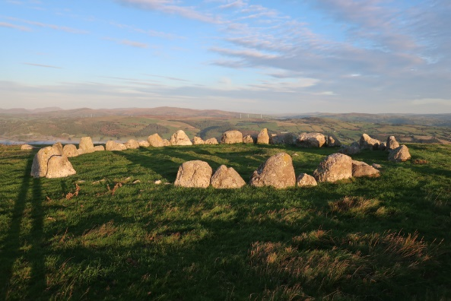
There are many theories regarding what actually happened on Cadair Berwyn on January 23rd, 1974.
The official explanation notes that an earthquake was responsible for the loud rumblings, and this is confirmed by evidence about earth tremors on the night in question. The lights were explained as meteors, and the more unrealistic aspects of the story were blamed on the imagination of local residents. What then about the presence of the military? Some believe that an experimental military aircraft fell to earth, with the military coming to the area to try to hide the fact that the aircraft had failed. Others, however, still believe that an alien spaceship arrived at the mountain, a spaceship that was then transported to a secret location in England.
Berwyn QUIZ
1) What is the height of Cadair Berwyn?
..........................................................................................................................................................................
2) For how long were the loud rumblings heard?
..........................................................................................................................................................................
3) Which colours were shown by the large sphere on the side of the mountain?
..........................................................................................................................................................................
4) What was protecting the military vehicle taking the large box from the mountain?
..........................................................................................................................................................................
5) What was the official explanation for the loud rumblings?
..........................................................................................................................................................................
Puzzle 1
Find the 10 differences between the pictures
on the left
Puzzle 2
Complete the picture below

SESSION 17
SHAPE
1) What type of angle is the angle 63°? | 2) What type of angle is the angle 289°? | 3) What type of angle is the angle 180°?
4) What type of angle is the angle 175°? | 5) What type of angle is the angle 90°? | 6) What type of angle is the angle 360°?

$$\frac{ }{\text{6}}$$

ALGEBRA
7) Simplify  $$4x+9z+3x+12z$$ | 8) Solve  $$x-3=17$$ | 9) Expand  $$5(y+7)$$
10) Substitute  $x=5$ into $7x-2$ | 11) Write an expression for seven less than $x$ | 12) Solve  $$3x=21$$

$$\frac{ }{\text{6}}$$

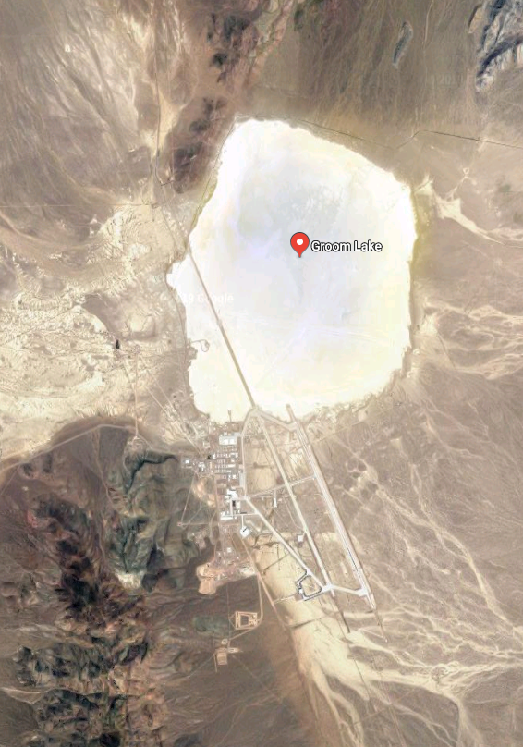
Area 51
Area 51 is a secret base belonging to the United States Air Force in the state of Nevada. The official name for the base is Groom Lake, named after the salt flats beside the base.
Some believe that the remains of the Roswell accident were transported to Area 51, and work has been done to modify the technology for military purposes. In July 2019, over two million people responded to a request on facebook to assault Area 51 to ‘see the aliens within’. Despite this, on the day in question only 150 completed the journey to the gates… only to be sent away again.
SESSION 18
DATA
1) Find the mode of  –4, –2, –4, –3, –2 | 2) Find the median of  –4, –2, –4, –3, –2 | 3) Find the mean of  –4, –2, –4, –3, –2
4) Which number would be best suited to describe the probabillity ‘certain’? | 5) Which number would be best suited to describe the probability ‘even chance’? | 6) Which number would be best suited to describe the probability ‘impossible’?

$$\frac{ }{\text{6}}$$

ALGEBRA
7) In which quadrant is the co-ordinate (–8, 5)? | 8) Expand  $$7x(-4+x)$$ | 9) Solve  $$\frac{x}{4}=20$$
10) Simplify  $$\frac{x^{3}}{x}$$ | 11) Substitute  $y=4$ into $23-2y$ | 12) Solve  $$2x+3=25$$

$$\frac{ }{\text{6}}$$

SETI
The SETI (Search for Extra-Terrestrial Intelligence) project searches for evidence that humanity is not alone in the universe.
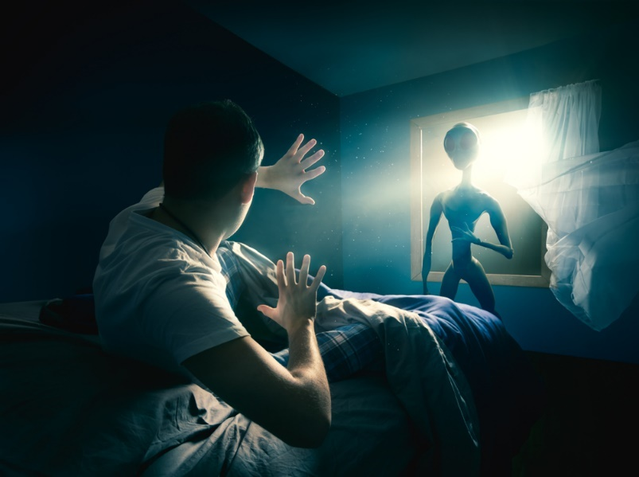
The software SETI@home uses computers from across the world to examine whether radio signals from the universe show signs of intelligence. Clear evidence has not yet been found, but locations from across the universe have been selected for further study.
SESSION 19
NUMBER
1) 9.34 × 7 | 2) 30% of £50 | 3) $\frac{2}{3}×\frac{5}{6}$
4) £2.40 – 67c | 5) 0.1 × 54 | 6) –4 + –2

$$\frac{ }{\text{6}}$$

ALGEBRA
7) Simplify  $$-x+3y+2y+4x$$ | 8) Solve  $$z+5=13$$ | 9) Expand  $$z(2z+3)$$
10) Substitute  $z=2$ into $z^{2}+5$ | 11) Write an expression for three more than eight times $x$ | 12) Solve  $$0.5x=6$$

$$\frac{ }{\text{6}}$$

The TIc-tac Mystery
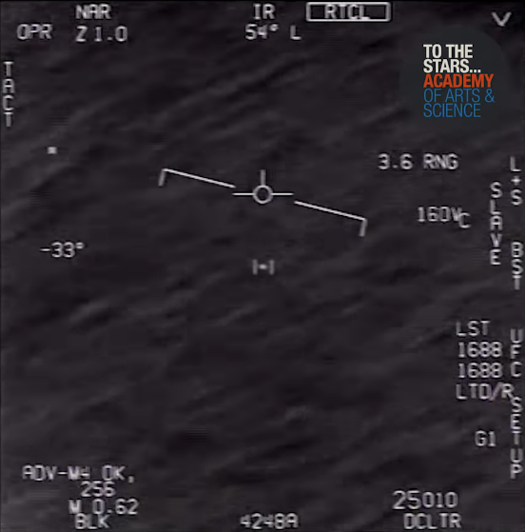
In 2004, there was a series of incidents near the coastline of California where the aircraft carrier USS Princeton was sailing. An unidentified flying object (UFO) was seen on several occasions descending “in seconds” from a height of 60,000 feet to a height of just 50 feet. Two F/A-18F jets were sent to chase the object, and one of them managed to film it (see the video clip https://www.youtube.com/watch?v=wxVRg7LLaQA). The object was described as being “white” with a “Tic-Tac” shape and “no obvious edges”. The jet did not manage to catch up with the object; in fact, the object was careful to avoid the jet.
SESSION 20
SHAPE
What is the order of rotational symmetry of the following shapes?
1) | 2) | 3)
4) | 5) | 6)

$$\frac{ }{\text{6}}$$

ALGEBRA
7) In which quadrant is the co-ordinate  (–4, –4)? | 8) Expand  $$5(x+y)$$ | 9) Solve  $$-2x=18$$
10) Simplify  $$7u+w-2u-w$$ | 11) Substitute  $x=-4$ into $2x^{2}$ | 12) Solve  $$\frac{2x-1}{3}=7$$

$$\frac{ }{\text{6}}$$

The Battle of Los Angeles
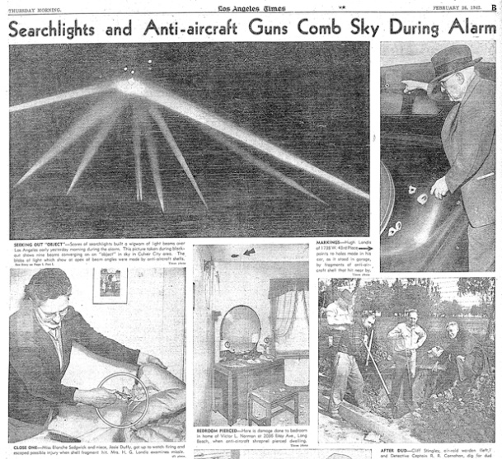
During the second world war, the United States was expecting an attack from Japan on their western side. On the night of February 24th, 1942, a warning was issued stating that an attack from Japan was expected within the next 10 hours. When lights were seen in the sky, guns were fired for several hours, in an attempt to shoot the Japanese aircraft down. Japan however did not send a single aircraft (a fact that was confirmed by them at the end of the war). What was therefore responsible for the lights? Some argue that a weather balloon was to blame, but others say that an unidentified flying object was seen.
QUIZ 4
1) What is the name of the salt flats beside Area 51?
..........................................................................................................................................................................
2) What type of signals does the software SETI@home investigate?
..........................................................................................................................................................................
3) From which height did the Tic-Tac descend?
..........................................................................................................................................................................
4) How many searchlights point towards the sky in the picture from the newspaper report?
..........................................................................................................................................................................
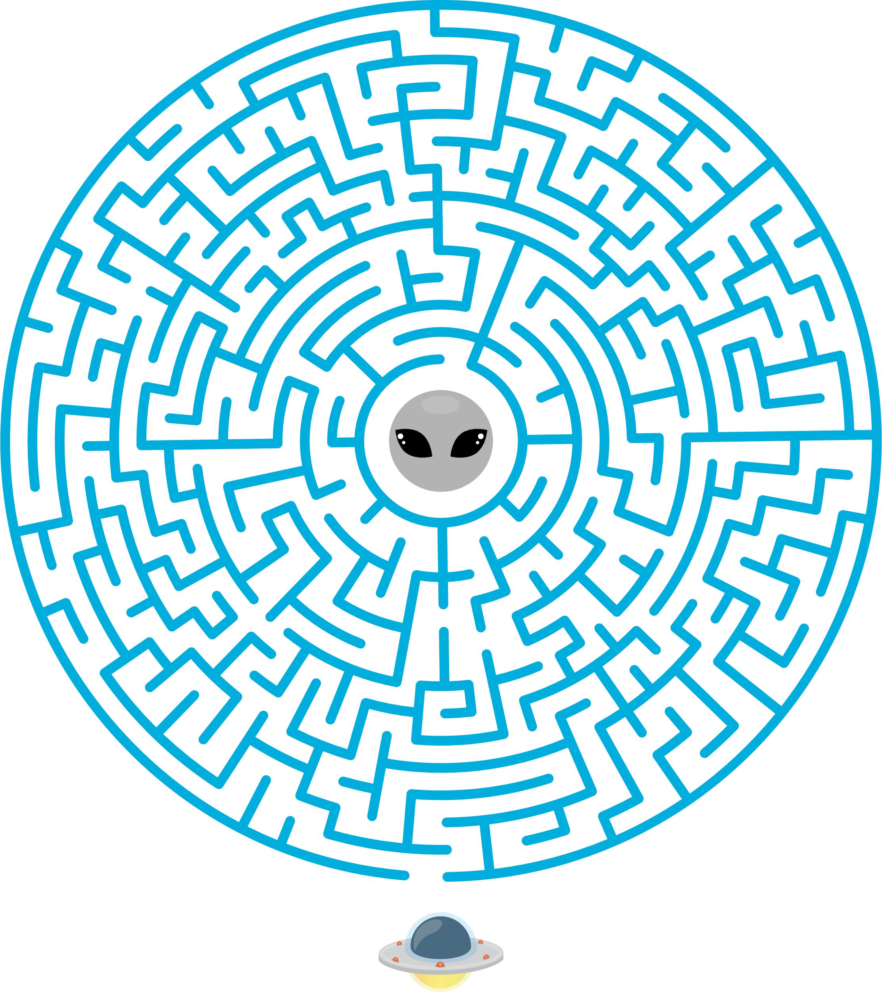
PUZZLE
Help the alien find its way back to its spaceship.

