


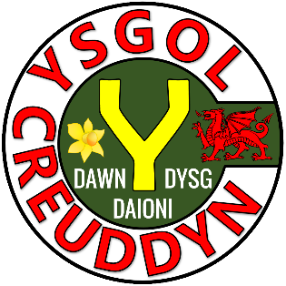
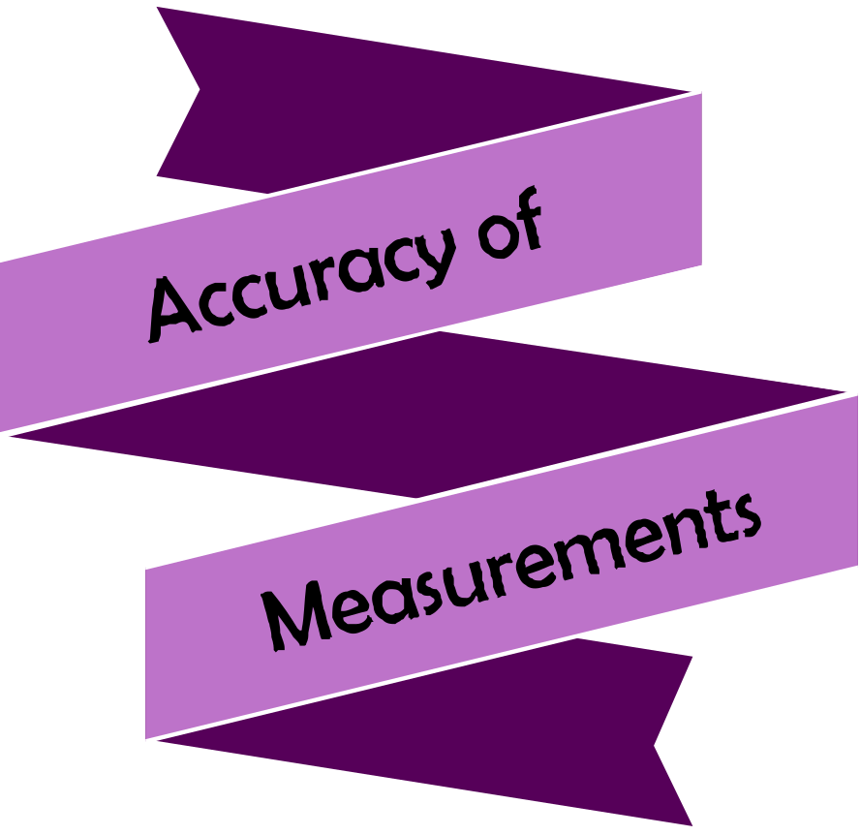

Activity | Page
Quiz 1 | 3
Example–Problem Pair 1 | 4–5
Quiz 2 | 6
Venn Diagram Challenge 1 | 7
Example–Problem Pair 2 | 8–9
Quiz 3 | 10
The Photograph | 11
Example–Problem Pair 3 | 12–13
Quiz 4 | 14
Venn Diagram Challenge 2 | 15
Example–Problem Pair 4 | 16–17
Quiz 5 | 18
The Piece of Cheese | 19



1) Evaluate $2^{4}$ | 2) Write 40% as a decimal. | 3) Complete the ratio:  $$\sin{θ} \\ =\frac{ }{ }$$
4) The mean of  8, 2, 6, 8 | 5) Solve the equation  $$2x-3=9$$ | 6) Sketch a tetrahedron.
7) 25% of £50 | 8) Simplify  $y^{4}×y^{3}$ | 9) Evaluate $6^{0}$



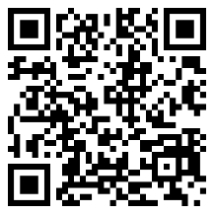

3 cm
2 cm
8 cm
What is the surface area
of the cuboid?




4 cm
10 cm
6 cm
What is the surface area
of the cuboid?


1) Round off  7,280 to the nearest 100. | 2) Round off 43.283 to 2 decimal places. | 3) Round off  735 to one significant figure.
4) Round off  7,386 to the nearest 10. | 5) Round off  98.45 to one decimal place. | 6) Round off  8,478 to two significant figures.
7) Round off  87.28 to the nearest unit. | 8) Round off 835,928.4 to the nearest 1,000. | 9) Round off  8.39 to the nearest 100.




Think of measurements for a cuboid that could fit into each region. If you think a region is impossible to fill, explain why!
Volume = Surface Area
Surface Area
< 250 cm²
D
D
C
B
A
C
A
B
$$ε$$
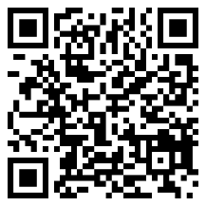

1.8 cm
8 cm
Calculate the volume of
the cylinder.


2.4 m
12 m
Calculate the volume of
the cylinder.


1) (2 + 3) × 4 | 2) 2 + (3 × 4) | 3) 2 + 3 × 4
4) (6 + 10) ÷ 2 | 5) 6 + (10 ÷ 2) | 6) 6 + 10 ÷ 2
7) (5 – 3) + 1 | 8) 5 – (3 + 1) | 9) 5 – 3 + 1

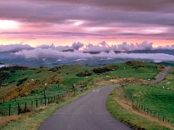
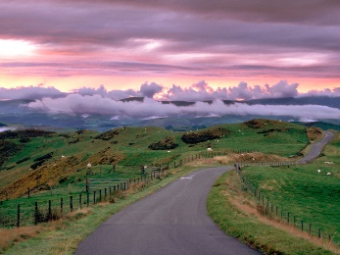
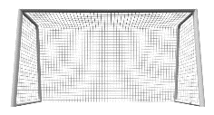

New Photograph (not to scale)
Original
Photograph
3 cm
4 cm
15 cm
Ceinwen enlarges a photograph in a local shop.

What can you find from this information?

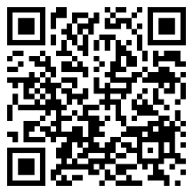

20 cm
15 cm
25 cm
4 cm
3 cm
5 cm
Prove whether the following triangles are similar triangles.



12 cm
24 cm
4 cm
40 cm
5 cm
2 cm
Prove whether the following triangles are similar triangles.


1) What is the lower bound of the measurement 34 cm, measured to the nearest cm? | 2) What is the upper bound of the measurement 35 m, measured to the nearest 5 m? | 3) What is the lower bound of the measurement 700 ml, measured to the nearest 100 ml?
4) Simplify  $$\frac{x^{8}}{x^{2}}$$ | 5) How many days are in November? | 6) Sketch a sphere.
7) Write $\frac{2}{5}$ as a decimal. | 8) 3 + 4 × 5 | 9) Which is longer:  2 inches or 4 cm?



Write down a subtraction sum (using two numbers) that could fit into each region. If you think a region is impossible to fill, explain why!
One number is –4
D
The answer is positive
D
C
B
A
C
A
B
$$ε$$
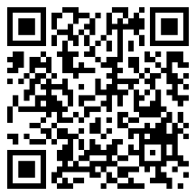
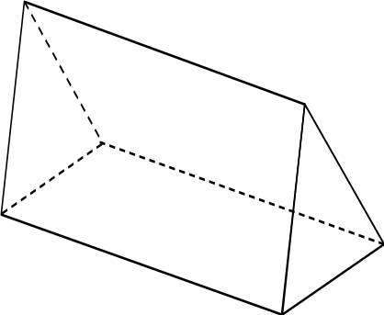

Calculate the volume of
the triangular prism.

12 cm
4 cm
5 cm



10 cm
6 cm
15 cm
Calculate the volume of
the triangular prism.


1) 10 + –4 | 2) 10 – –4 | 3) 10 × –4
4) 10 ÷ –4 | 5) Write 42% as a decimal. | 6) Write 42% as a fraction, in its simplest form.
7) Evaluate $π^{0}$ | 8) Evaluate $7^{3}$ | 9) Evaluate  $1^{2}+2^{2}×3^{2}$

108°
126°
Siart cylch i ddangos hoff flas creision dysgwyr Ysgol B
Plaen
Halen a Finegr
Caws a Nionyn
Coctel Corgimwch
4) Dywedodd Dion “Mae mwy o bobl yn hoffi creision caws a nionyn yn Ysgol A nac yn Ysgol B”. Ydy Dion yn gywir? Eglurwch eich ateb.




1) Calculate the area of the triangle that is the cheese’s cross-section. | 2) Calculate the volume of the piece of cheese.
3) Calculate the surface area of the piece of cheese. | 4) If the cheese’s mass is  150 g, what is its density?

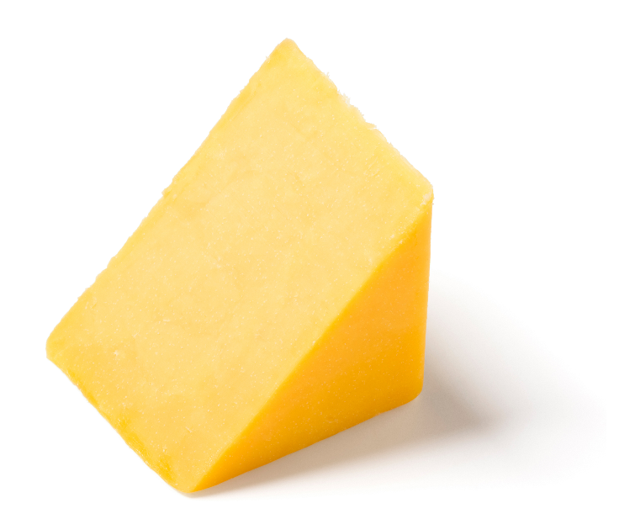

8 cm
10 cm
5 cm
6 cm

Evaluating the Workbook



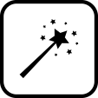

Notes





@minutemaths314 /adolygumathemateg
/mathscreuddyn www.mathemateg.com

