
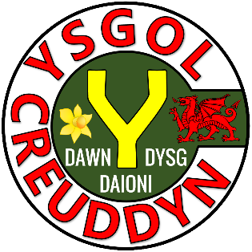
Activity | Page
Quiz 1 | 3
Example–Problem Pair 1 | 4–5
Quiz 2 | 6
Venn Diagram Challenge 1 | 7
Example–Problem Pair 2 | 8–9
Quiz 3 | 10
The Cylinder | 11
Example–Problem Pair 3 | 12–13
Quiz 4 | 14
Venn Diagram Challenge 2 | 15
Example–Problem Pair 4 | 16–17
Quiz 5 | 18
The Gold Bar | 19

Calculate the area of the following shapes.
1) | 2) | 3)
4) | 5) | 6)
7) | 8) | 9)

6 cm
6 cm
6 cm
8 cm
12 cm
5 cm
3 cm
5 cm
10 cm
6 cm
5 cm
7 cm
6 cm
6 cm
9 cm
6 m
2.5 m
2 cm
5 cm
6 cm
9 km
5 km
6 km


2.9 cm
What is the circumference
and area of the circle?

6.2 cm
What is the circumference
and area of the circle?

What are the names of the following solids?
1) | 2) | 3)
4) | 5) | 6)
7) | 8) | 9)

Think of a solid that could fit into each region.
If you think a region is impossible to fill, explain why!
At least one square face
It is a prism
D
C
B
A
C
A
D
B
$$ε$$

Solve the equation $x^{2}+3x-28=0$

Solve the equation $x^{2}+6x-27=0$.

1) $\sqrt{64}$ | 2) 6 × –4 | 3) Simplify  $$4x+5y-2x+y$$
4) Draw a kite. | 5) The mode of  4, 7, 2, 6, 7, 3, 2, 5 | 6) What is the probability of obtaining a prime number when rolling a normal fair die?
7) Write down all the factors of 22. | 8) Does this net fold to make a cube? | 9) Evaluate $2^{4}$

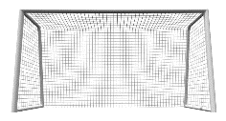
6
4
The diagram shows a cylinder.
The measurements are given
in centimetres.
What can you find from this
information?


Make $x$ the subject of the formula $y=4x-7$.

Make $x$ the subject of the formula $y=3+5x$.

What is the formula?
1) Area of a rectangle = | 2) Circumference of a circle = | 3) Volume of a cuboid =
4) Area of a triangle = | 5) Area of a circle = | 6) Volume of a prism =
7) Area of a parallelogram = | 8) Area of a trapezium = | 9) Volume of a cylinder =

Write down the dimensions of a cuboid that could fit into each region. If you think a region is impossible to fill, explain why!
Surface area > 240 m²
Volume =
240 m³
D
D
C
B
A
C
A
B
$$ε$$


Solve the following simultaneous equations.
$$3x+7y=46 \\ 2x+6y=36$$

Solve the following simultaneous equations.
$$4x+3y=49 \\ 2x+4y=32$$

1) 2 hours = ______ minutes | 2) May =  _____ days | 3) 1 Century = _____ years
4) 8:34pm in the 24-hour clock = | 5) 200 minutes = _____ hours  _____ minutes | 6) 3 hours before 1:30am =  ______
7) 1 Fortnight = _____ days | 8) November = _____ days | 9) 2 hours  50 minutes +  1 hour 30 minutes = _____ hours  _____ minutes

108°
126°
Siart cylch i ddangos hoff flas creision dysgwyr Ysgol B
Plaen
Halen a Finegr
Caws a Nionyn
Coctel Corgimwch
4) Dywedodd Dion “Mae mwy o bobl yn hoffi creision caws a nionyn yn Ysgol A nac yn Ysgol B”. Ydy Dion yn gywir? Eglurwch eich ateb.



1) Calculate the volume of the gold bar. | 2) Calculate the surface area of the gold bar.
3) The value of gold is £12,000 per cubic inch.  What is the value of the gold bar above? | 4) Calculate the length of the diagonal of the front of the gold bar.

1.75 inches
3.5 inches
7 inches

Evaluating the Workbook

Notes




@minutemaths314 /adolygumathemateg
/mathscreuddyn www.mathemateg.com

