

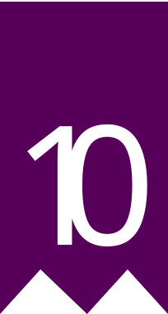
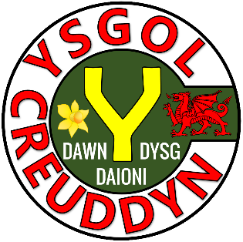

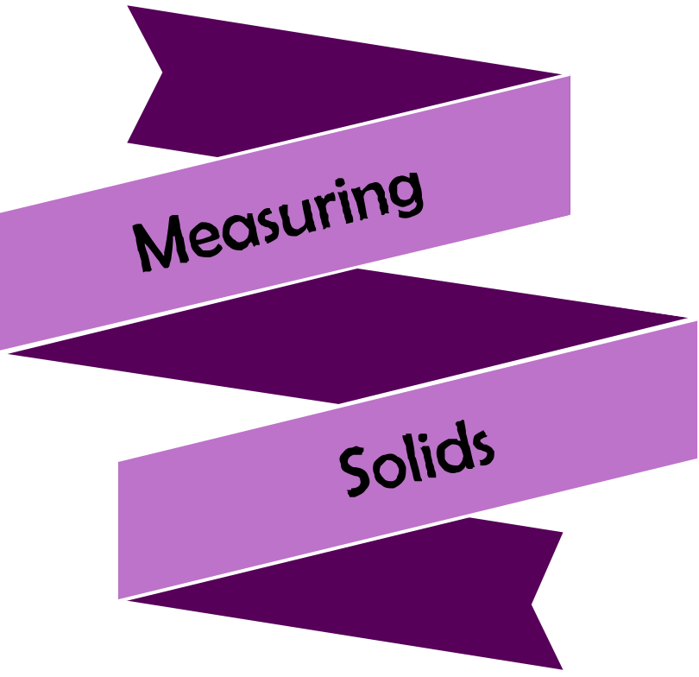




Version
3.0
08/2025


Chapter | Mathematics | Page Number
Solids | Volume and surface area of a cuboid. Volume of a prism. Volume of a cylinder. | 3
Composite Solids | Volume of composite solids. | 9
Similar Shapes | Calculating the scale factor. Calculating missing lengths. Similar or not? | 11
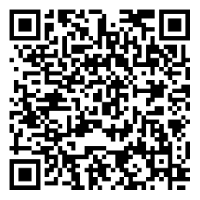
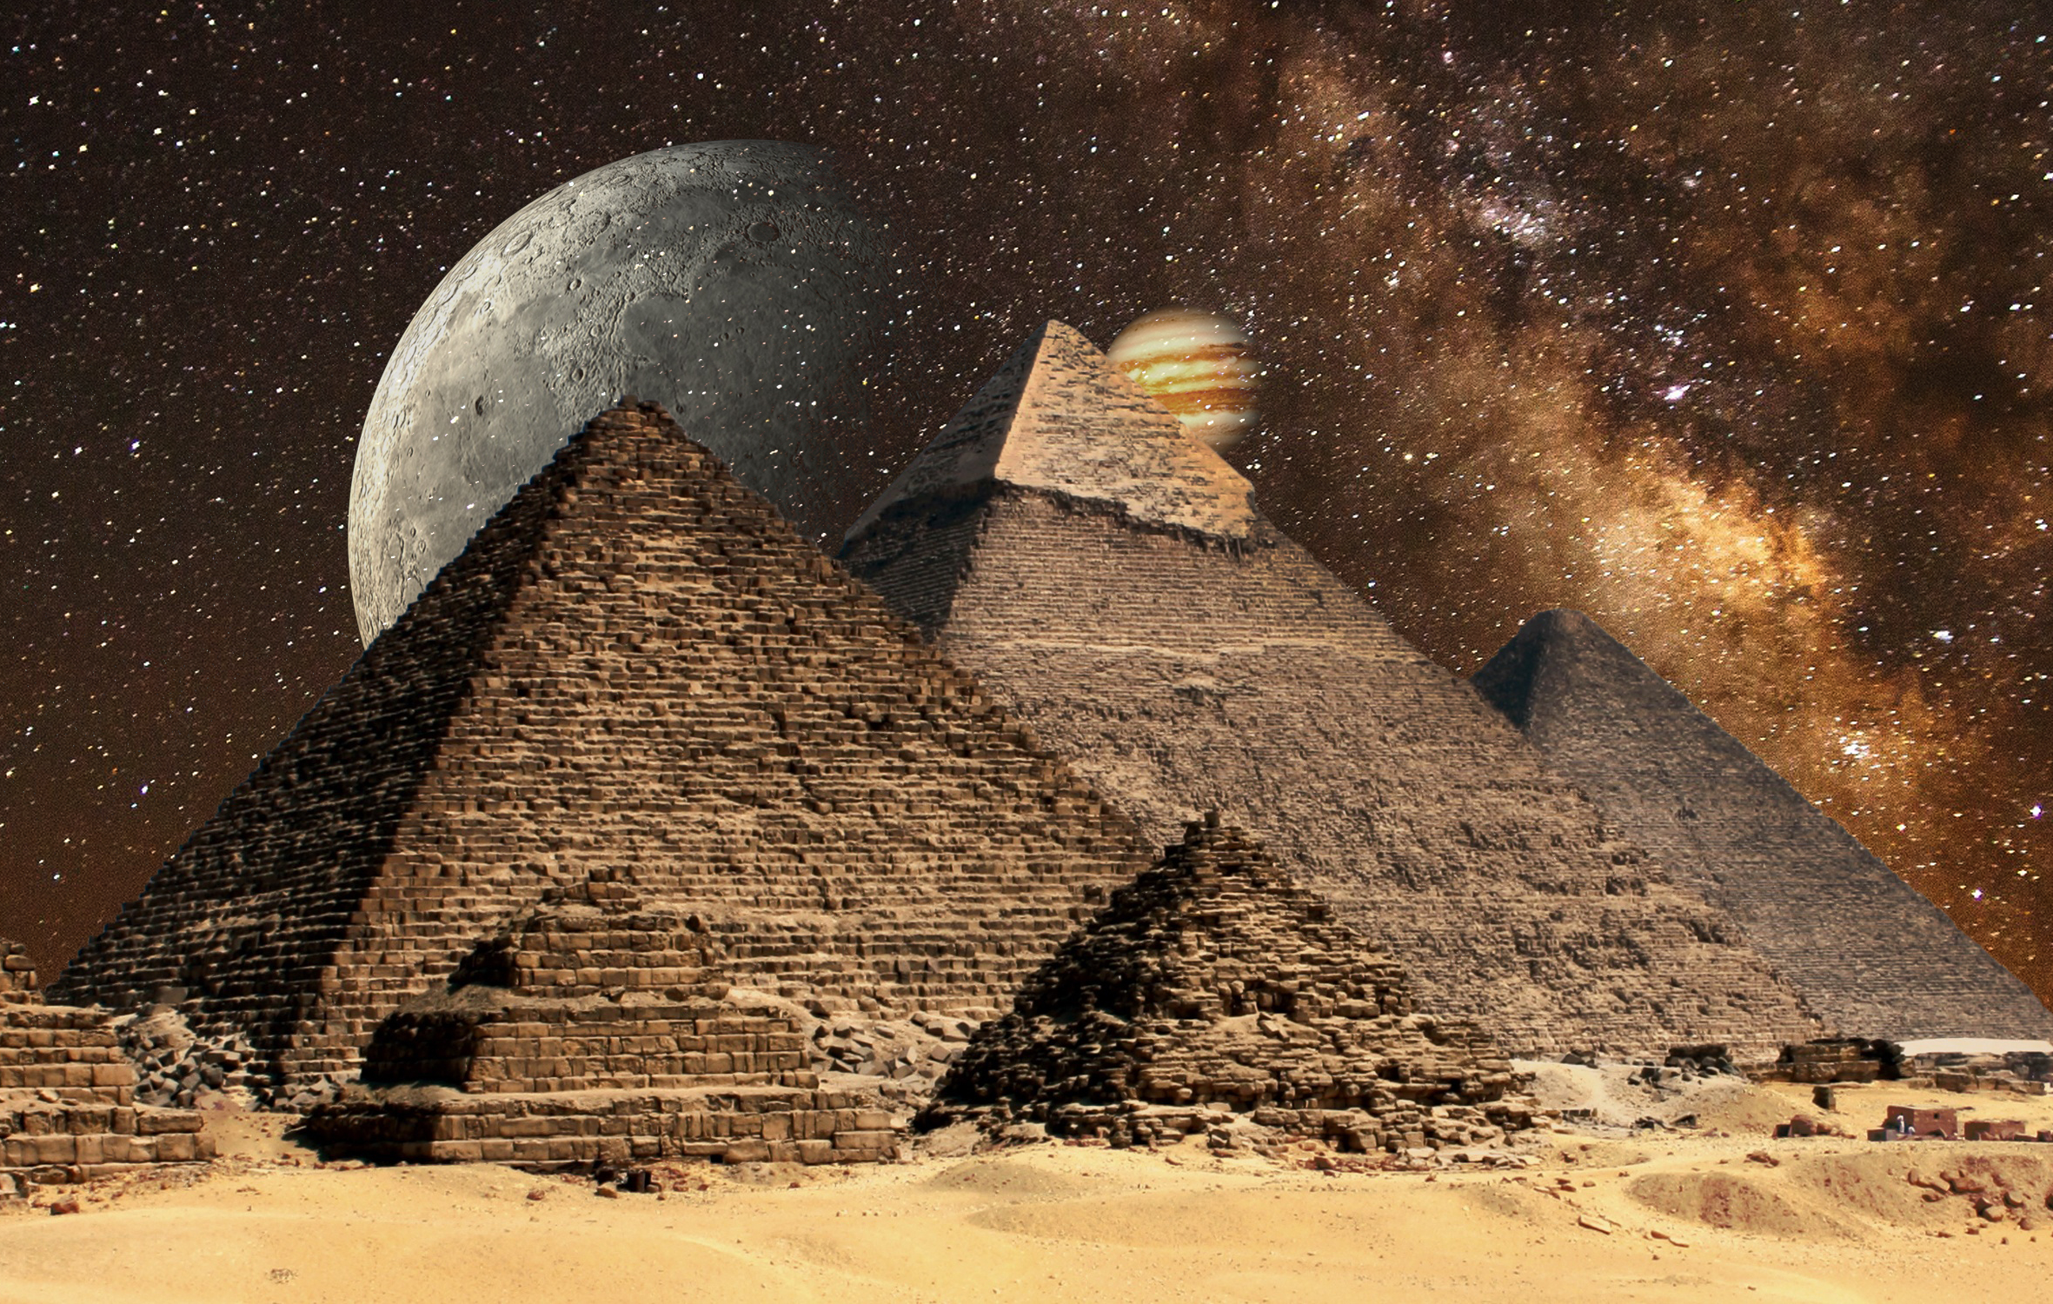



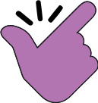
Exercise 1
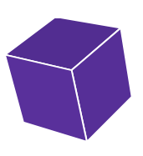
Pair the solid with its matching net. Write the name of the solid underneath it.
3
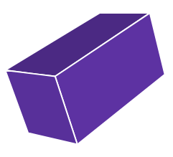
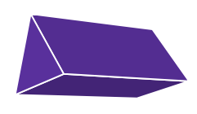
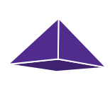

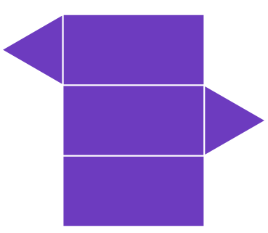

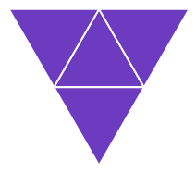
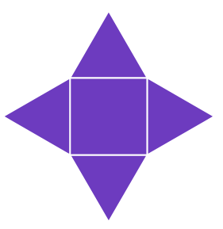
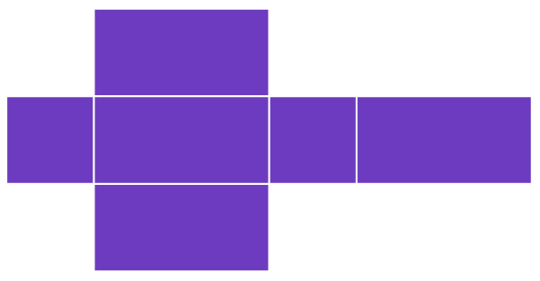
In this chapter, we will discuss how to calculate the volume and surface area of a variety of different solids.
The volume measures how much space a solid occupies or uses. It’s measured in cube units, e.g. cm³. | The surface area measures the area of the outside of the solid. We can think of the surface area as how much paper you would need to wrap the solid. Surface area is measured in square units, e.g. m².
Cuboid

We’ve previously seen the formula to calculate the volume of a cuboid in the “Measuring Shapes 1” workbook.

Volume of a Cuboid = Length × Width × Height

To calculate the surface area of a cuboid, we must add the areas of each of the six faces.
Back
Top
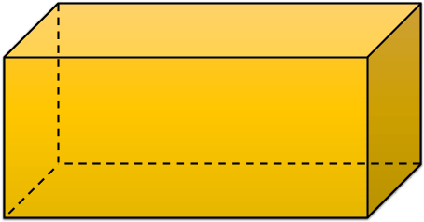
Left
4 cm
Right
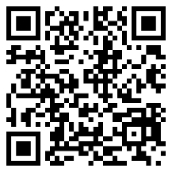
3 cm
10 cm
Bottom
Front

Example
The volume of the above cuboid is 10 × 3 × 4 = 120 cm³.
Notice that some of the areas are the same so we do not need to calculate them.
The surface area of the cuboid is the total area of the six faces.
Front | 10 × 4 = 40
Back | 40
Left | 3 × 4 = 12
Right | 12
Top | 10 × 3 = 30
Bottom | 30
Total | 164 cm²
Exercise 2
Calculate the volume and surface area of the following cuboids.
13
(a) (b) (c)
8 cm
3 cm
7 cm
4 cm
2 cm
2 cm
4 cm

6 cm
4 cm



Exercise 3
13
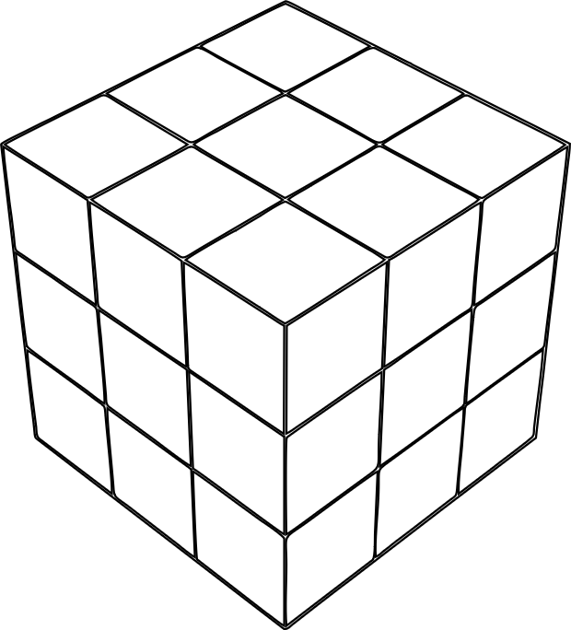
The diagram shows a Rubik’s cube before adding the coloured stickers.
The dimensions of one of the small cubes is 2 cm × 2 cm × 2 cm.
(a) What is the volume of one of the small cubes?
(b) How many small cubes form the Rubik’s cube?
(c) What is the volume of the Rubik’s cube?
(d) What is the surface area of the Rubik’s cube?
(e) How many small 2 cm × 2 cm stickers are needed to be stuck on the Rubik’s cube?
Exercise 4
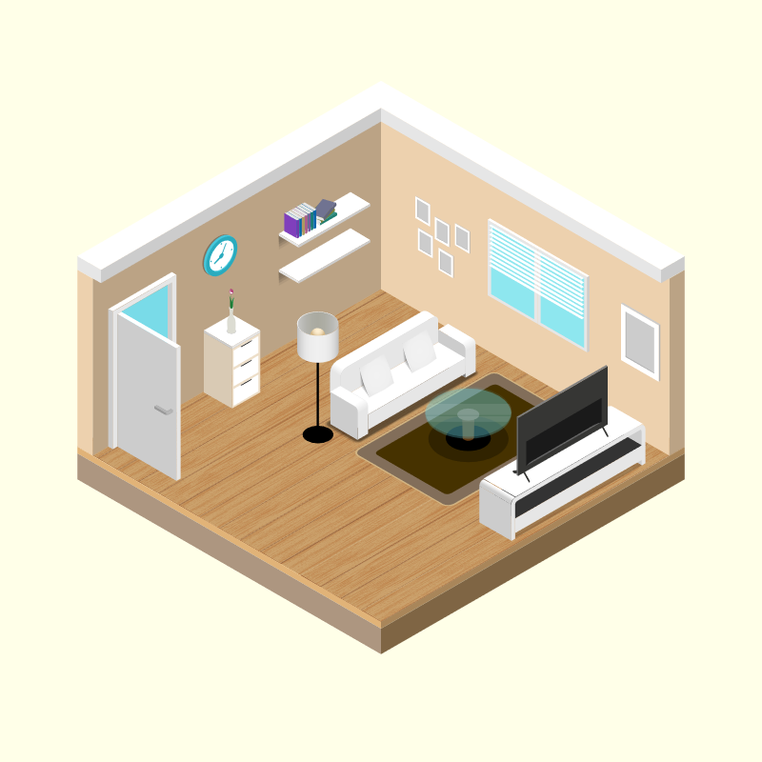
The diagram on the right shows a floor plan for a living room.
2.5 m cm
4 m
5 m
(a) What is the volume of the living room?
(b) What is the area of the floor?
(c) The wood for the floor costs £14 per square metre. What was the cost of the wood for the whole floor?
(d) Cerys wishes to repaint the wall on which the clock hangs. Given that the door measures 75 cm by
2 m, what area will need repainting?
(e) To repaint the wall, Cerys buys a 2.5 litre tin of paint. The tin states that the paint covers up to 10 m² of area for each litre of paint. Will Cerys have enough paint to give the wall two coats of paint?
Prism
A prism is a solid in which both ends are identical and the cross-section at any point is identical to the two ends. The shape of the two ends gives the prism its name. For example, the diagram below shows a triangular prism.
15 cm
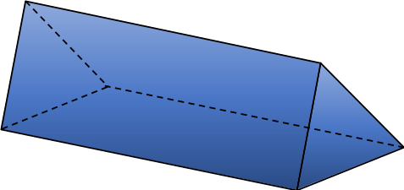
This formula is on page 2 of units 1 and 3.
3 cm
4 cm
Cross-section

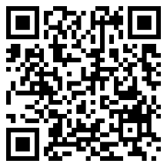
Length
Volume of a Prism = Area of Cross-section × Length
Example
For the above triangular prism, the area of the cross-section is the area of the triangle, which is $\frac{3×4}{2}=6$ cm².
Therefore the volume of the prism is 6 × 15 = 90 cm³.
Exercise 5
A
Circle the solids below that are prisms.
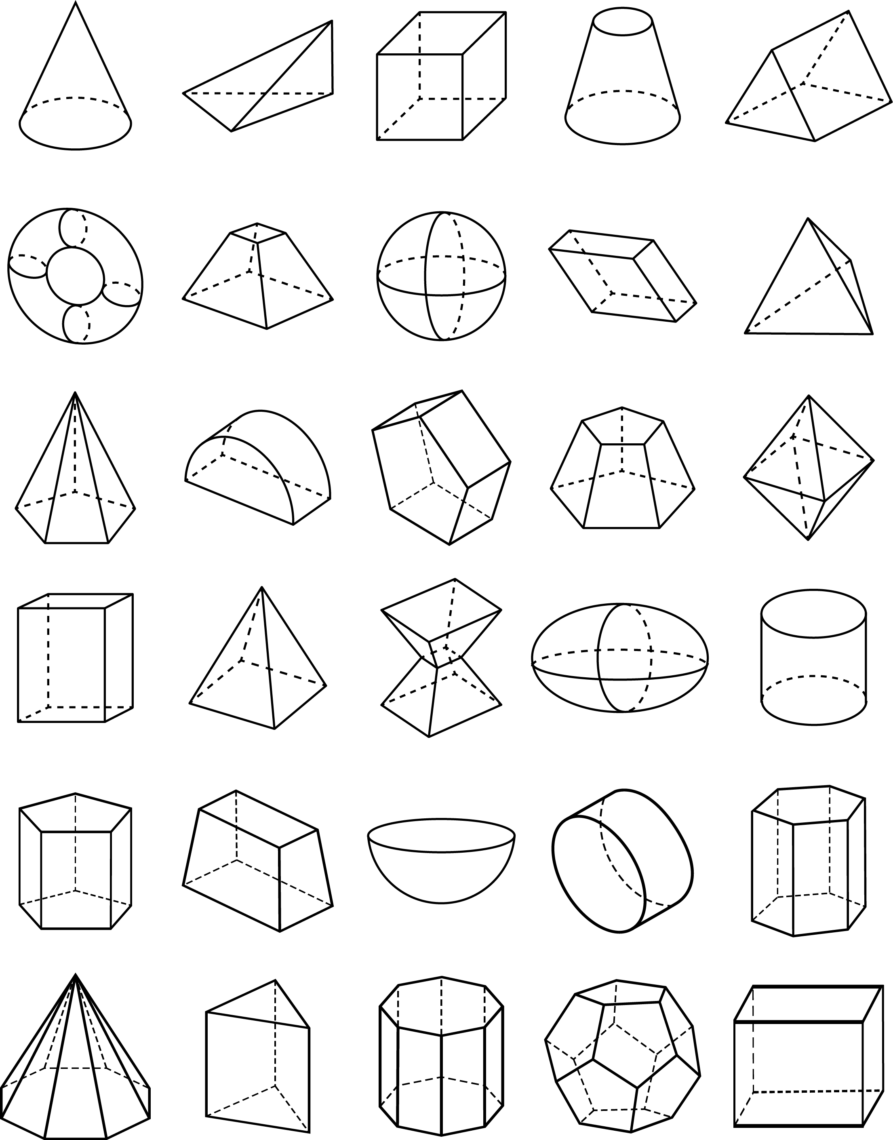

Exercise 6
Calculate the volume of the following prisms.
13
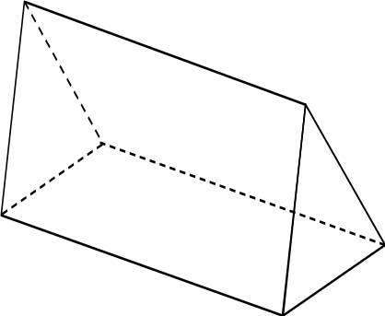
(a) (b) (c)
12 cm
10 cm
9 m
8 m
20 m
6 cm
5 cm
3 cm
2 cm

Area of cross-section = 40 mm²
(d) (e) (f)

11 cm
7 mm

4 cm
8 cm
3 cm
Area of cross-section = 50 cm²

Challenge!
Calculate the surface area of the prism in question (b) above. Give your answer to 1 decimal place.
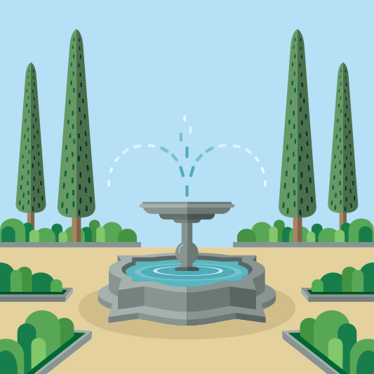
Exercise 7
The picture on the right shows a water fountain.
13
The depth of the water in the lower part of the fountain is 40 cm.
The area of the cross-section of the water is 38,000 cm².
(a) What is the volume of the water in the fountain, in cm³?
(b) What is the volume of the water in the fountain, in ml?
(c) What is the volume of the water in the fountain, to the nearest litre?
(d) Buddug wants to empty the water fountain so that it can be cleaned. The water pump that Buddug uses to empty the fountain works at a rate of 100 litres per minute. To the nearest minute, how long will it take for the pump to empty the fountain?
Exercise 8
What is the name of the prism that has the following shapes forming the cross-section?
A
(a) Rectangle (b) Square (c) Circle

Cylinder
A cylinder is a special type of prism where the cross-sectional shape is a circle.
Radius

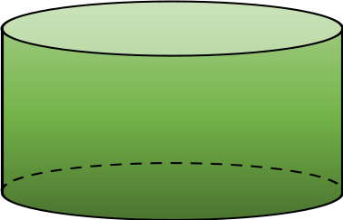
5 cm
6 cm
Height
Volume of a Cylinder = Area of the circle × Height or width of the cylinder
Volume of a Cylinder = $π$ × Radius² × Height
Example
The volume of the above cylinder is $π$ × 6² × 5 = 565.49 cm³, correct to two decimal places.
Exercise 9
13
Calculate the volume of the following cylinders.
(a) (b) (c)
5 cm
8 cm
2.4 m
9 cm
7 cm

3 m

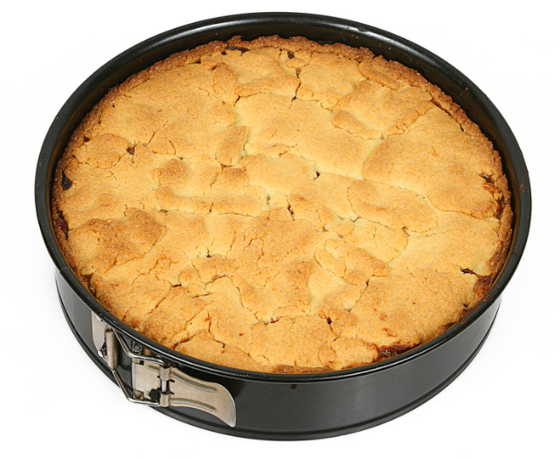
Exercise 10
13
The picture on the right shows an apple cake that has been baked
in a baking tin.
(a) Given that the radius of the tin is 10 cm and its height is 6 cm, calculate the volume of the cake in the tin.
(b) The cake weighs 1.2 kg. Gwenda wants to cut the cake into equal pieces so that each piece weighs 150 g.
How many equal pieces will Gwenda need to cut?
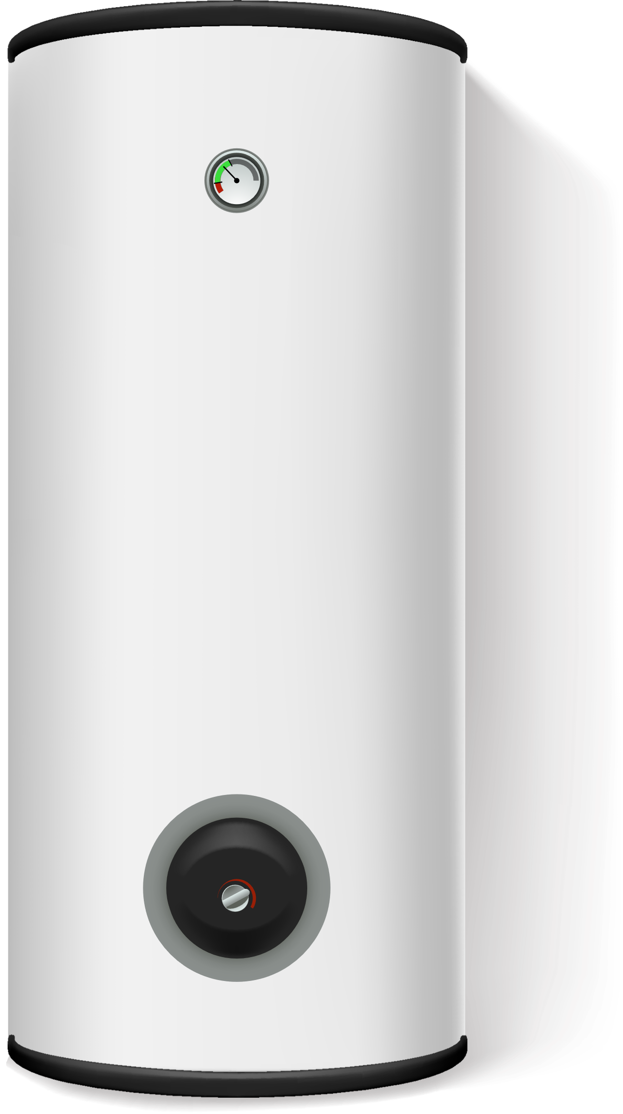
(c) What is the volume of each of the pieces of cake from part (b)?
Exercise 11
13
A hot water tank is in the shape of a cylinder. The height of the tank is 90 cm,
and its diameter is 45 cm.
The manufacturer estimates that the tank holds 140 litres of water.
Has the manufacturer provided an overestimate or an underestimate?

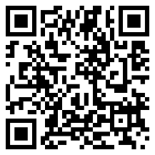

A composite solid is a solid we can split into simpler solids, like the solids considered
in the first chapter of this workbook.
Example
It is possible to split the composite solid on the right into a cuboid (on the left) and a triangular prism (on the right).
4 cm
5 cm
8 cm
6 cm
8 cm
Cuboid
Volume = Length × Width × Height
Volume = 4 × 6 × 8
Colume = 192 cm³
Triangular Prism
Volume = Area of Cross-section × Length
Volume = $\left(\frac{4×3}{2}\right)×6$
Volume = 36 cm³
It is also possible to treat this solid as one large prism.
Composite Solid
Volume = 192 + 36
Volume = 228 cm³
Exercise 12
Calculate the volume of the following composite solids.
13

(a) (b)
3 cm
4 cm
3 cm
5 cm
4 cm
3 cm
6 cm
8 cm

8 cm
9 cm
(c) (d)
1.6 cm
3 cm
8 m

9 m
6 m
6.4 cm
2.7 cm
8.5 cm
10 m

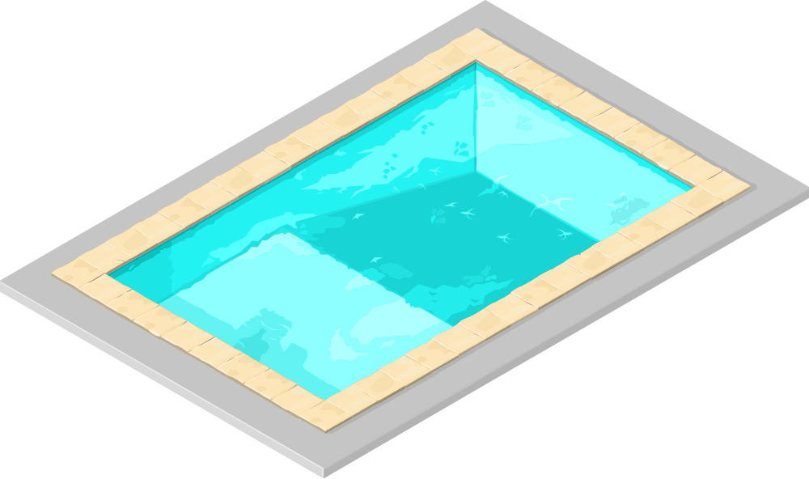
Exercise 13
A picture of a swimming pool is shown on the right.
13
The length and width of the swimming pool are
10 m and 20 m, respectively.
The depth of the water at the shallow
end is 1 m.
The depth of the water
at the deep end is
2.5 m.
The floor of the swimming
pool starts to descend 8 m
into the pool, and continues to
descend for a total of 12 m.
(a) Calculate the cross-sectional area of the swimming pool.
(b) Calculate the volume of the swimming pool, in m³.
(c) Given that there is 1,000 litres of water for every 1 m³ of volume, calculate how much water is in the pool.
(d) An ordinary hose pipe supplies water at a rate of 10 litres a minute. How long would it take for one hose pipe to fill the swimming pool? Give your answer correct to the nearest day.
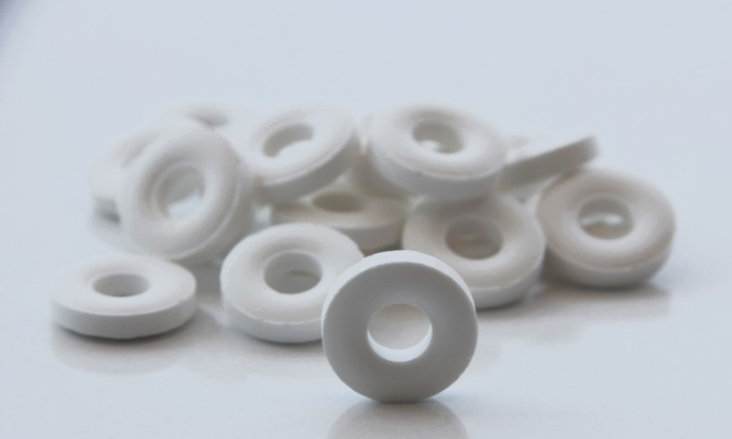
Exercise 14
The picture on the right shows some Polo Mint sweets.
- The diameter of each Polo Mint is 1.9 cm.
- The diameter of the hole in the middle is
0.8 cm.
- The thickness of each Polo Mint is 0.4 cm.
(a) Calculate the cross-sectional area of one Polo Mint.
(b) Calculate the volume of one Polo Mint.
(c) Usually, there are 23 Polo Mints in a packet.
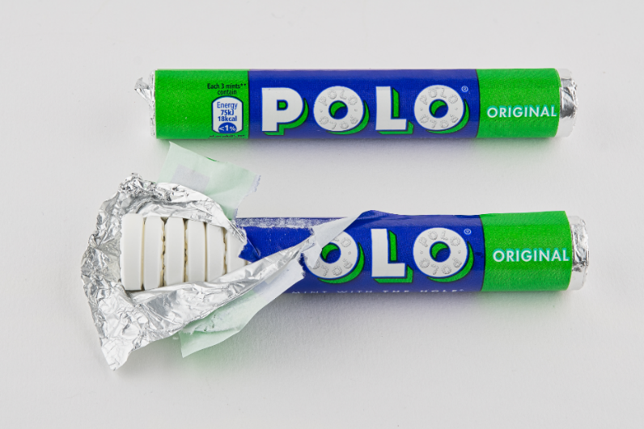
(i) What is the volume of sweets in a whole packet?
(ii) What is the volume of the hole in the middle of a packet?
(d) What is the minimum amount of paper needed to make the label around the packet?
(e) What is the minimum amount of foil needed for each packet?


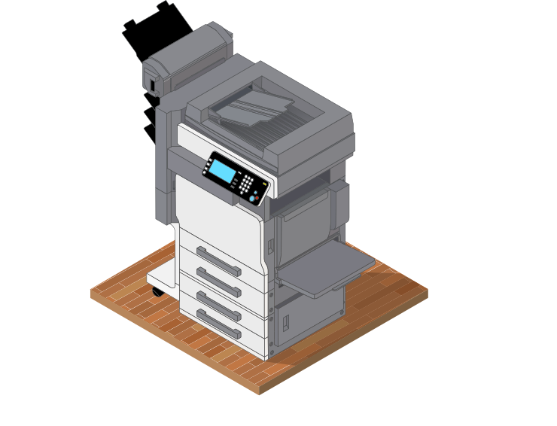
Imagine using a photocopier to enlarge a diagram drawn on a piece of paper. If the original paper is A4 sized and the paper that comes out of the photocopier is A3 sized, then you have created a copy of the diagram twice the size.
In mathematics, we say that the new diagram is similar to the original diagram. This means that the new diagram has the same shape, but the size has changed. Since the new diagram is twice as big, we can say that the scale factor is 2.
Similar shapes are the exact same shape, but of different sizes.
Given two shapes that are similar, we can use the measurements on the shapes either to find the scale factor or to find some missing lengths on the shapes.
Example
The two shapes shown below are similar shapes. Use the measurements on the shapes to find the lengths $x$ and $y$.
6 cm
9 cm
$$x$$

2 cm
1.5 cm
$$y$$

Answer: The first step is to find the scale factor. To do this, we need to consider how much bigger the large shape is compared to the small shape. We see that the horizontal lengths at the top of both shapes are given. We can use these two lengths to find the scale factor, by calculating 6 ÷ 2 = 3. Therefore, the large shape is three times bigger than the small shape.
Having found the scale factor of 3, we can now use it to find the lengths $x$ and $y$.
The edge that corresponds to the $x$ edge in the small shape is 1.5 cm. We must multiply 1.5 cm by the scale factor to find the length of $x$, since we are going from the small shape to the large shape. Therefore
$$x=1.5×3$$$x=4.5$ cm
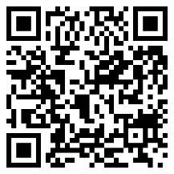

The edge that corresponds to the $y$ edge in the large shape is 9 cm. We must divide 9 cm by the scale factor to find the length of $y$, since we are going from the large shape to the small shape. Therefore
$$y=9÷3$$$y=3$ cm

Exercise 15
3
The following pairs of shapes are similar shapes. Use the measurements on the shapes to find the scale factor.
(a) (b)
8 cm
15 cm
4 cm

5 cm

(c) (d)

20 cm
5 cm
12 cm
2 cm
3 cm
5 cm
16 cm
4 cm
Exercise 16
3
The following pairs of shapes are similar shapes. Use the measurements on the shapes to find the lengths $x$ and $y$.
(a) (b)
$$x$$
14 cm
$$x$$

3 cm
7 cm
24 cm
5 cm
$$y$$
5 cm
$$y$$
18 cm
6 cm

(c) (d)
$$y$$
$$x$$
9 cm
4 cm
$$y$$
3 cm
8 cm
$$x$$
2 cm
3 cm
32 cm
8 cm

(e) (f)
$$x$$
1.8 cm
8 cm
5 cm
$$y$$
$y$ = circumference of the circle

$$x$$
3 cm
5.5 cm

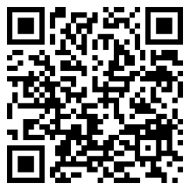
5 cm
10 cm
Similar or not?
If two shapes are similar, then the corresponding edges are in the same ratio.
This means that if we divide a pair of corresponding edges, we will always obtain the same answer.
Example
(a) (b)
16 cm
30 cm
16 cm
8 cm
8 cm
15 cm

10 cm
22 cm
28 cm
14 cm
For the two triangles above, the corresponding For the two rectangles above, the corresponding edges are
edges are in the same ratio. not in the same ratio.
30 ÷ 15 = 2 16 ÷ 8 = 2
28 ÷ 14 = 2 22 ÷ 10 = 2.2
16 ÷ 8 = 2 Therefore, the two rectangles are not similar.
Therefore the two triangles are similar.
Exercise 17
3
Decide whether the following pairs of shapes are similar or not.
14 cm
(a) (b)
6 cm
7 cm
2.8 cm
2 cm
8 cm
16 cm
1 cm

(c) (d)
7 cm
6 cm
7.5 cm
4.5 cm
2.8 cm
3 cm
5 cm
3 cm
5 cm
2.5 cm
6 cm
4 cm

Name: ............................................  Percentage in the test: .................. |   I know this. | 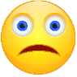  I need to revise this. | Question in the test | Correct in the test?
I know how to calculate the volume and surface area of a cuboid. |  |  | 1
I know how to calculate the volume of a prism. |  |  | 2, 7
I know how to calculate the volume of a cylinder. |  |  | 3, 7
I can calculate the volume of composite solids. |  |  | 4
Given two similar shapes, I can calculate the scale factor. |  |  | 5
Given two similar shapes, I can calculate missing lengths. |  |  | 5
I can recognise whether two triangles are similar. |  |  | 6

