




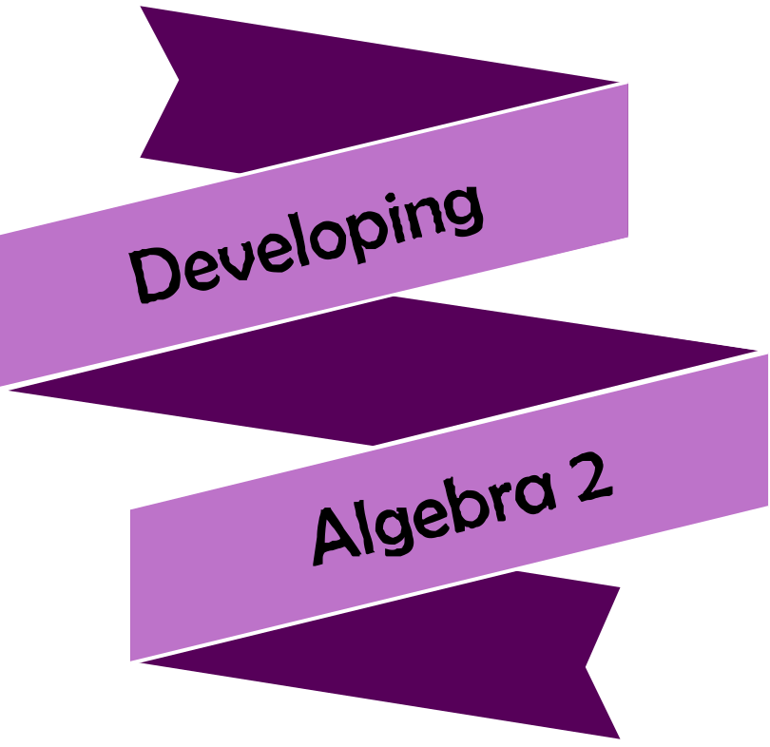





Version
3.0
08/2025


Chapter | Mathematics | Page Number
Simple Factorising | Reversing Expansion. Simple Factorising.  More than one Variable. | 3
Changing the Subject | Re-arranging formulae. | 6
Expression, Equation, Formula | Recognising expressions, equations and formulae. | 8

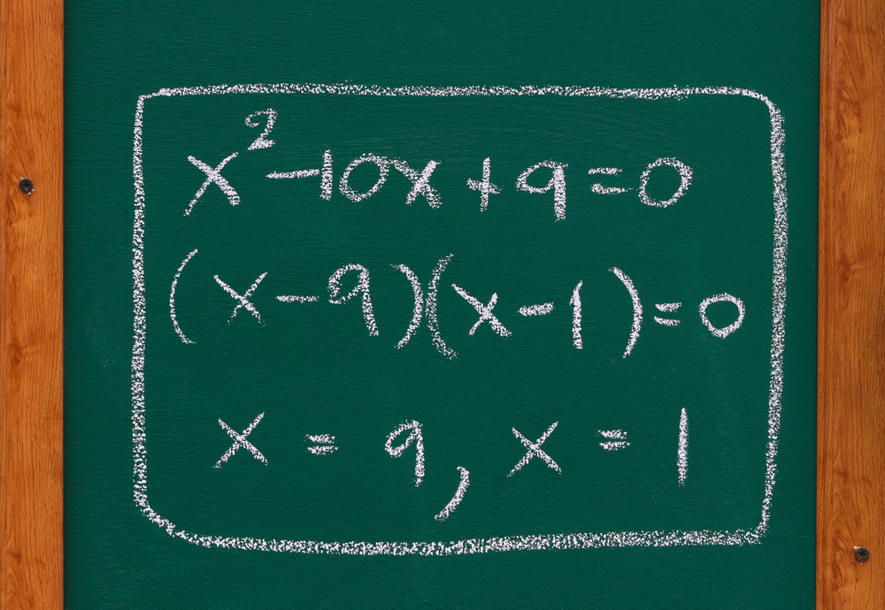



Reversing Expansion

Like subtraction reverses addition, and division reverses multiplication, factorising reverses
expanding brackets, a technique seen previously in the Developing Algebra workbook.
Exercise 1
A
Expand the following algebraic expressions.

(a) $2(x+3)$ (b) $5(x+3)$ (c) $5(x-3)$
(d) $5(3-x)$ (e) $2(y+3)$ (f) $2(x+3+y)$
(g) $x(x+3)$ (h) $x(3+x)$ (i) $2x(x+3)$
(j) $5x(x+3)$ (k) $5x(2x+3)$ (l) $2x(5x-3)$
(m) $4(x-7)$ (n) $y(y+9)$ (o) $2z(z+4)$
(p) $7x(3x+4)$ (q) $-7x(3x+4)$ (r) $-7x(3x-4)$
Expanding gets rid of brackets, whereas factorising reintroduces brackets. Also, whilst expanding using multiplication sums, factorising uses division sums. To this intent, an important skill when factorising is to recognise the highest common factor of a set of numbers, which is the largest number that divides into the list of numbers.
Exercise 2
What is the highest common factor of the following numbers?
(a) 6 and 8 (b) 12 and 15 (c) 20 and 30 (d) 20 and 40 (e) 18 and 24
(f) 16 and 40 (g) 22 and 33 (h) 24 and 36 (i) 35 and 56 (j) 36 and 54
(k) 12, 14 and 16 (l) 12, 16 and 20 (m) 25, 35 and 45 (n) 30, 45 and 60 (o) 7, 11 and 13

In order to factorise an algebraic expression such as $12x+18$, we start by considering the highest common factor of the terms $12x$ and $18$ in the expression.
Example
Factorise $12x+18$.
1. “What is the highest common factor of $12x$ and $18$?” The answer is $6$, therefore we write $6$ followed by a pair of brackets. | 2. “$6$ multiplied by what gives $12x$?” $6$ multiplied by $2x$ is $12x$, therefore we write $2x$ inside the brackets. | 3. “$6$ multiplied by what gives $18$?” $6$ multiplied by $3$ gives $18$, therefore we write $+ 3$ inside the brackets.
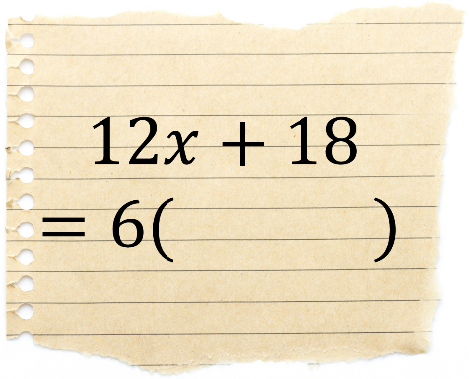 | 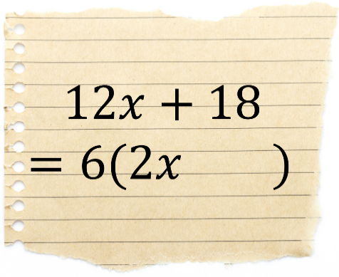 | 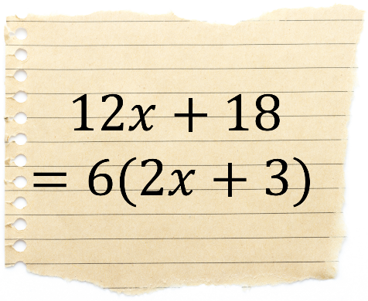


Exercise 3
2
Factorise the following algebraic expressions.
(a) $4x+6$ (b) $6+4x$ (c) $4x-6$
(d) $6-4x$ (e) $4x+8$ (f) $4z+8$
(g) $6x+8$ (h) $6x+12$ (i) $12-6x$
(j) $9x+21$ (k) $25x+30$ (l) $18x+30$
(m) $14x+21$ (n) $28+14x$ (o) $30x-40$
(p) $24y+36$ (q) $60x+80$ (r) $36x+45$
(s) $36x+54$ (t) $33y-55$ (u) $33y-66$
(v) $45+30x$ (w) $300x+500$ (x) $80z-240$
(y) $2x+4y+6$ (z) $5x+10y+20$ (α) $12x-20y+24$
Not all algebraic expressions can be factorised. For example, $5x+7$ cannot be factorised since the highest common factor of $5x$ and $7$ is $1$. (We don’t factorise $5x+7$ as $1(5x+7)$.)

Exercise 4
Factorise all of the algebraic expressions that do factorise, and note which expressions do not factorise.
(a) $5x+10$ (b) $5x+11$ (c) $5x+5$
(d) $16x$ (e) $16x+2$ (f) $16x+9$
(g) $8y-12$ (h) $8y-13$ (i) $8y-14$
When factorising, it’s not just numbers that can appear before the first bracket – we can include variables like $x$ too.
Example
Factorise $6x^{2}+14x$.
1. “What is the highest common factor of $6x^{2}$ and $14x$?” The answer is $2x$, therefore we write $2x$ followed by a pair of brackets. | 2. “$2x$ multiplied by what gives $6x^{2}$?” $2x$ multiplied by $3x$ is $6x^{2}$, therefore we write $3x$ inside the brackets. | 3. “$2x$ multiplied by what gives $14x$?” $2x$ multiplied by $7$ gives $14x$, therefore we write $+ 7$ inside the brackets.
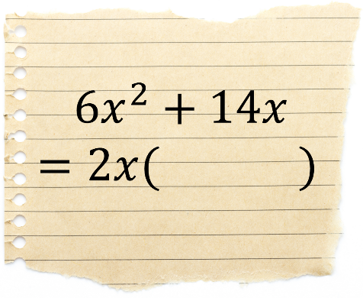 | 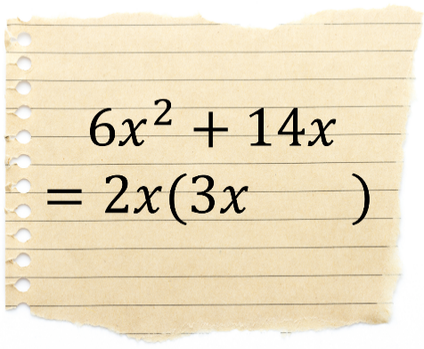 | 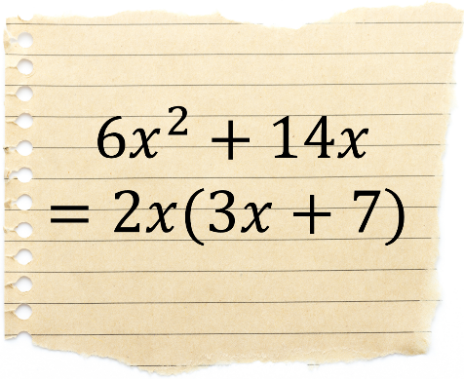
Exercise 5
What is the highest common factor of the following terms?
(a) $4x^{2}$ and $18x$ (b) $4x^{2}$ and $16x$ (c) 5$x^{2}$ and $20x$ (d) $5x^{2}$ and $7x$ (e) $18x^{2}$ and $24x$
(f) $x^{2}$ and $x$ (g) $x^{3}$ and $x^{2}$ (h) $4x^{3}$ and $18x^{2}$ (i) $9x^{4}$ and $3x^{2}$ (j) $12x^{4}$ and $15x^{3}$
Exercise 6
2
Factorise the following algebraic expressions.
(a) $3x^{2}+6x$ (b) $6x+3x^{2}$ (c) $3x^{2}-6x$
(d) $x^{2}+x$ (e) $x^{3}+x$ (f) $x^{3}+x^{2}$
(g) $4x^{2}+2x$ (h) $2x^{3}-6x$ (i) $2x^{3}+8x^{2}$
(j) $12x^{2}+4x$ (k) $4x-12x^{2}$ (l) $10x^{2}+15x$
(m) $6x^{4}+9x^{2}$ (n) $24y^{3}-16$ (o) $21z^{2}+14z$
(p) $3x^{2}+5x$ (q) $7y-11y^{2}$ (r) $4z^{3}+17z^{2}$
(s) $22x^{2}+33x^{5}$ (t) $12n-4n^{2}$ (u) $2a+a^{2}$
(v) $x^{6}+6x$ (w) $x^{6}+6x^{2}$ (x) $6x^{6}+4x^{4}$
(y) $2x^{3}+4x^{2}+6x$ (z) $2x^{2}+4x+6$ (α) $42x^{4}-30x^{2}+12x^{3}$
Exercise 7

What is the highest common factor of the following terms?
(a) $x^{2}$ and $xy$ (b) $4x^{2}$ and $6xy$ (c) 12$x^{2}y$ and $16xy$ (d) $5x^{2}y^{2}$ and $9y^{2}$ (e) $18x^{3}y$ and $12x^{2}y$
Example
$2x^{2}y+4x=2x(xy+2)$ $30y^{3}z^{2}-24y^{2}z=6y^{2}z(5yz-4)$
Exercise 8
Factorise the following algebraic expressions.
(a) $xy+x$ (b) $4xy+10y$ (c) $x^{2}y+5xy$
(d) $2x^{2}y+6xy$ (e) $10yz+5{yz}^{2}$ (f) $12x^{2}y-4x$
(g) $x^{2}+xy^{2}$ (h) $16x^{3}z-12z^{2}$ (i) $15x^{4}y+25x^{2}y^{2}$
(j) $x^{2}yz+4xyz$ (k) $8ab^{2}c^{3}-18abc^{2}$ (l) $26πx^{2}+65πx$

Key words | Corrections | I am happy with... | I need to revise...



The purpose of changing the subject is to re-arrange formulae so that a particular variable appears on its own on the left-hand side of the formula. For example, consider the formula $p=3w+d$, a formula to calculate the number of points ($p$) a football team has given how many games they have won ($w$) and how many drawn games ($d$) they have had. We can re-arrange the formula to give the number of games won by a football team.
$p=3w+d$
$3w+d=p$ [Swap sides]
$3w=p-d$ [Subtract $d$ from both sides]
$w=\frac{p-d}{3}$ [Divide both sides by 3]
After re-arranging the formula as shown above, we say that $w$ is the subject of the formula.
There are a number of ‘movements’ we can perform to help re-arrange a formula to give a specific subject.
Here are some of the most common movements.
Add a number to both sides of the formula Subtract a number from both sides of the formula
E.g. $y-3=x$ E.g. $y+7=x$
$y-3=x+3$ [Add 3 to both sides] $y+7=x-7$ [Subtract 7 from both sides]
Multiply both sides of the formula by a number Divide both sides of the formula by a number
E.g. $\frac{y}{2}=5x$ E.g. $4y=x-3$
$y=10x$ [Multiply both sides by 2] $4y=\frac{x-3}{4}$ [Divide both sides by 4]
Square both sides of the formula Take the square root of both sides of the formula
E.g. $\sqrt{y}=4x+5$ E.g. $y^{2}=2x-9$
$y ={(4x+5)}^{2}$ [Square both sides] $y =\sqrt{2x-9}$ [Square root both sides]
Swap sides Expand brackets
E.g. $5x+3=y$ E.g. $4\left(y+2\right)=5x$
$y=5x+3$ [Swap sides] $4y+8 =5x$ [Expand brackets]
Let us reconsider the example at the top of this page. The question in the example can be set as follows.

Make $w$ the subject of the formula $p=3w+d$.
The aim in this question is to re-arrange the formula to leave only the variable $w$ on the left-hand side of the formula. As the variable $w$ initially appears on the right-hand side of the formula, it makes sense to start by swapping the sides of the formula, so that $w$ appears on the left-hand side of the formula.
$p=3w+d$
$3w+d=p$ [Swap sides]
There are several ways to proceed. You can think of the formula as an equation, and ‘solve’ to leave $w$ on its own.
Or you can think of how to calculate the left-hand side of the formula, if you start with the variable $w$.
$$×3$$
$$+ d$$
Input:
$w$
Output:
$3w+d$
By working backwards through the function machine, we can see the steps required to proceed, namely subtracting $d$ from both sides of the formula, and then dividing both sides by 3.
Exercise 9
2
(a) Make $e$ the subject of the formula $p=2e+c$. (b) Make $c$ the subject of the formula $p=2e+c$.
(c) Make $c$ the subject of the formula $y=mx+c$. (d) Make $m$ the subject of the formula $y=mx+c$.
(e) Make $p$ the subject of the formula $c=p-3t$. (f) Make $t$ the subject of the formula $c=p-3t$.
(g) Make $p$ the subject of the formula $A=p(q+r)$. (h) Make $q$ the subject of the formula $A=p(q+r)$.
(i) Make $t$ the subject of the formula $F=\frac{m+4n}{t}$. (j) Make $m$ the subject of the formula $F=\frac{m+4n}{t}.$
(k) Make $n$ the subject of the formula $F=\frac{m+4n}{t}$. (l) Make $r$ the subject of the formula $A=πr^{2}$.
(m) Make $R$ the subject of the formula $I=\frac{PRT}{100}$. (n) Make $s$ the subject of the formula $A=\frac{su}{2}$.
(o) Make $u$ the subject of the formula $C=\frac{1}{3}πr^{2}u$. (p) Make $r$ the subject of the formula $C=\frac{1}{3}πr^{2}u$.
(q) Make $u$ the subject of the formula $A=\frac{1}{2}\left(a+b\right)u$. (r) Make $b$ the subject of the formula $A=\frac{1}{2}\left(a+b\right)u$.
Exercise 10
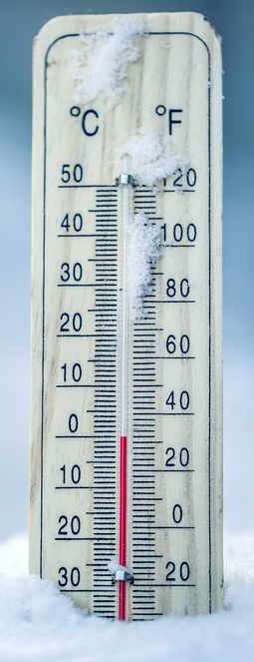
The following formula was used by festival planners to calculate the parking fee for mini buses.

Parking Fee = Number of Passengers × 30p + £5
(a) What was the parking fee for a mini bus with 12 passengers?
(b) The parking fee for another mini bus was £7.40. How many passengers were on this
mini bus?

Exercise 11

To change from degrees Celsius (°C) to degrees Fahrenheit (°F), you can use the following
formula.
$$F=\frac{9}{5}\left(C+40\right)-40$$
(a) The temperature is 60°C. What is this in °F?
(b) Re-arrange the formula to find $C$ in terms of $F$.
Key words | Corrections | I am happy with... | I need to revise...


In algebra, what’s the difference between expressions, equations and formulae?
Expression  An expression is a collection of terms (e.g. $5x$ or $7)$  and operators (e.g. $+$ or $×$).  $4x+2$ and $\sqrt{6y-4z}$ are examples of expressions.  There are no equal signs ($=$) in expressions. | Equation  An equation notes that two terms or expressions are equal. Two sides of an equation are separated by an equal sign ($=$). Sometimes, it is possible to solve an equation to find the value of a variable. | Formula  A formula is a special type of equation which shows the connection between different variables.  $P=2a+2b$ is an example of a formula, one which is used to calculate the perimeter of a rectangle with length $a$and width $b$.
Example
$$\boxed{\text{Expression}}$$
$$\boxed{\text{Equation}}$$
$$\boxed{\text{Formula}}$$
$5x+1=31$ | $3x+10$
$A=\frac{1}{2}\left(a+b\right)u$ | $\frac{y}{2}=6$
$2x+7z$ | $y=2x+5$
$x^{2}+7x+10=0$ | $C=πd$
Exercise 12
A
Add arrows pointing to the correct descriptions.
$$\boxed{\text{Expression}}$$
$$\boxed{\text{Equation}}$$
$$\boxed{\text{Formula}}$$
$4x+3=2x+27$ | $w=8u+17v$
$E=mc^{2}$ | $z-3=8$
$21x+8$ | $\sqrt{\frac{2x-3}{y}}$
$f=e-v+2$ | $4x^{2}+2x-6$
 | $\left(2x-4\right)\left(x+3\right)=0$

Puzzle
Can you find the mirrored copy of each picture?
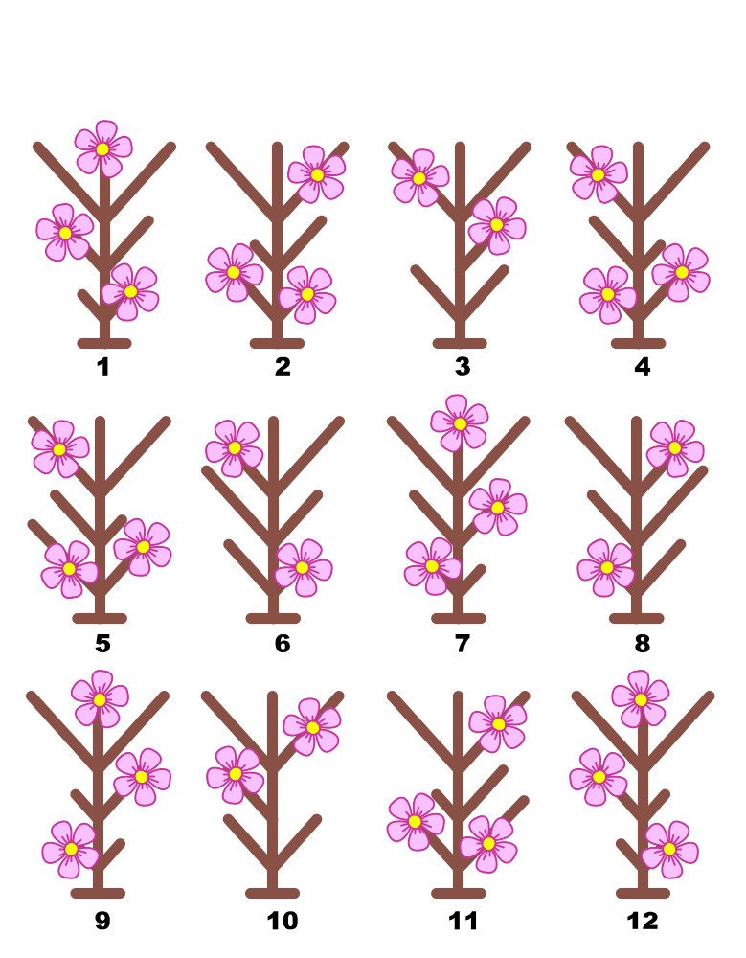


Name: ............................................  Percentage in the test: .................. |   I know this. |   I need to revise this. | Question in the test | Correct in the test?
I can factorise simple expressions such as $8x+12$ or  $15x^{2}-10$. |  |  | 1
I can re-arrange a formula in order to make a specific variable (e.g. $x$) the subject of the formula. |  |  | 3, 4
I can recognise expressions, equations and formulae. |  |  | 2

