
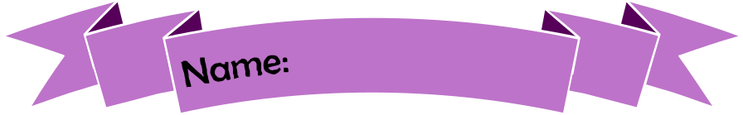
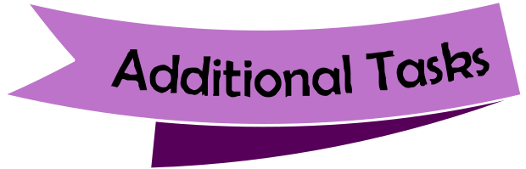
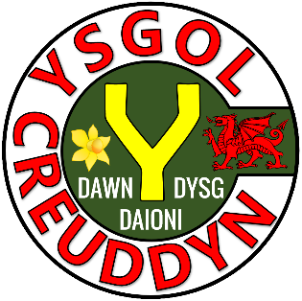
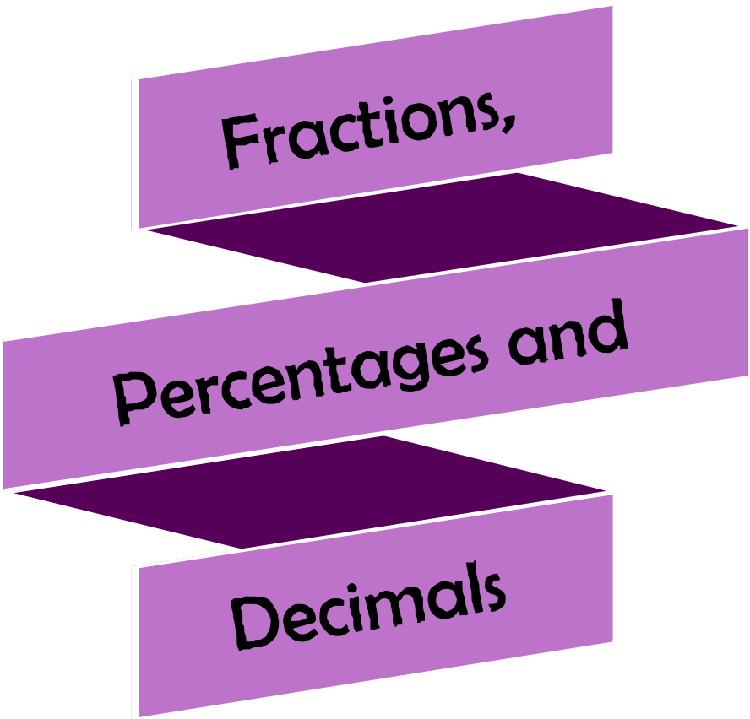
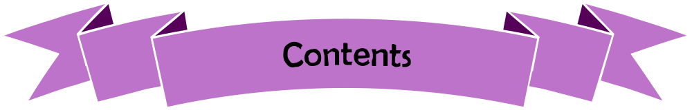
Activity | Page
Quiz 1 | 3
Example–Problem Pair 1 | 4–5
Quiz 2 | 6
Venn Diagram Challenge 1 | 7
Example–Problem Pair 2 | 8–9
Quiz 3 | 10
Ffion’s Bags | 11
Example–Problem Pair 3 | 12–13
Quiz 4 | 14
Venn Diagram Challenge 2 | 15
Example–Problem Pair 4 | 16–17
Quiz 5 | 18
The Restaurant Voucher | 19

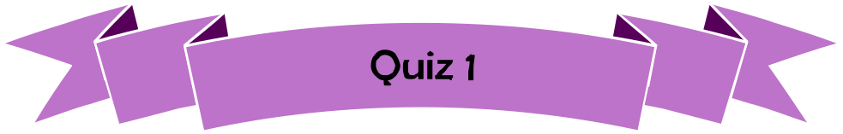

2 × 7 = | 6 × 5 = | 9 × 3 = | 24 ÷ 4 = | 11 × 8 =
3 × 5 = | 45 ÷ 5 = | 7 × 7 = | 8 × 4 = | 12 × 3 =
8 × 7 = | 10 × 6 = | 1 × 15 = | 5 × 4 = | 44 ÷ 4 =
72 ÷ 8 = | 7 × 9 = | 15 × 4 = | 2 × 0 = | 7 × 6 =
9 × 12 = | 2 × 26 = | 7 ÷ 2 = | 5 × 8 = | 9 × 9 =


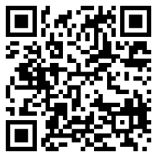
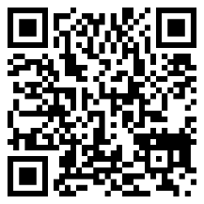
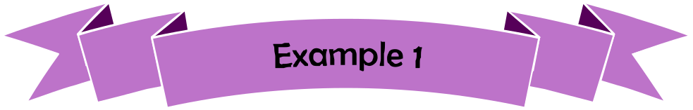
Calculate $\frac{3}{5}+\frac{7}{15}$. Write your answer as a mixed number.

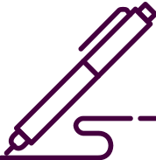

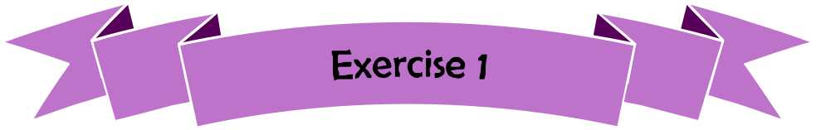
Calculate $\frac{7}{12}+\frac{2}{3}$. Write your answer as a mixed number.


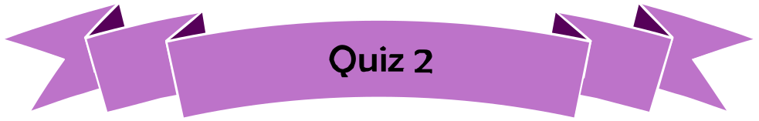
1) 24 + 395 | 2) 2.4 × 10 | 3) 10% of £54
4) $1-\frac{1}{3}$ | 5) 3 ÷ 0.5 | 6) $\frac{4}{5}×\frac{1}{2}$
7) $\frac{3}{7}$ of £28 | 8) 0.1 × 0.5 | 9) 4 – 2.46

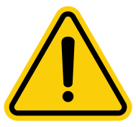
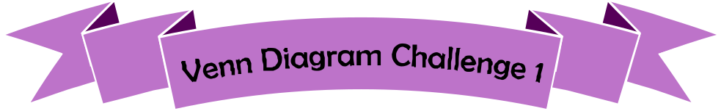

Think of a fraction that could fit into each region.
If you think a region is impossible to fill, explain why!
Less than 30%
More than 0.2
D
C
B
A
C
A
D
B
$$ε$$

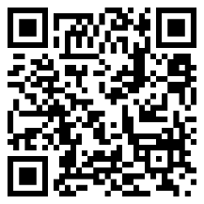
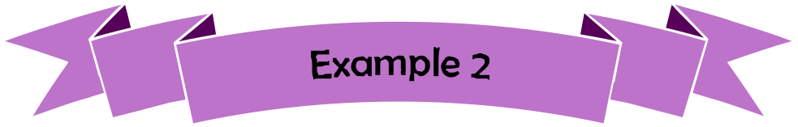

Without a calculator, calculate 64% of £76.


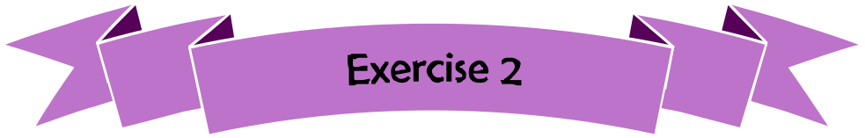
Without a calculator, calculate 37% of £82.

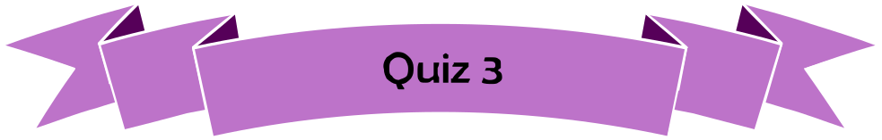
1) $\frac{2}{9}+\frac{5}{9}$ | 2) 34 × 8 | 3) 10% of £145
4) 0.6 × 0.2 | 5) 0.026 × 100 | 6) 360 ÷ 24
7) $\frac{6}{11}$ of £88 | 8) 5 ÷ 0.25 | 9) $\frac{5}{6}-\frac{1}{3}$

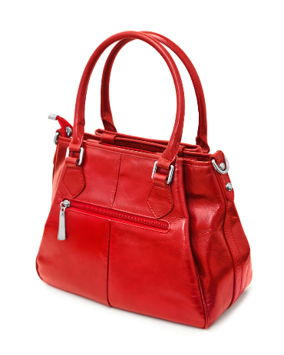
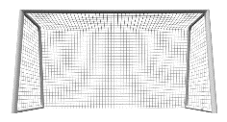
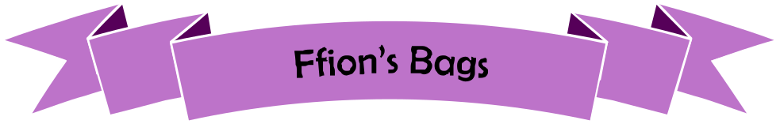
Ffion buys 60 bags to sell on a stall in a market.
She pays £3 per bag.
She sells $\frac{1}{2}$ of the bags for £5 each.
She sells $\frac{1}{3}$ of the bags for £4 each.
What can you calculate from this
information?

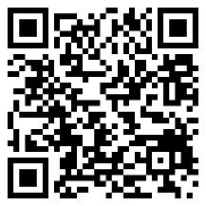
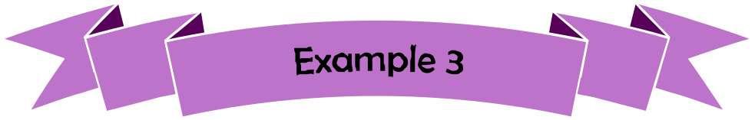
Calculate $\frac{4}{5}÷\frac{2}{7}$. Write your answer as a mixed number.

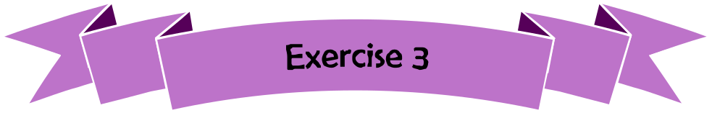
Calculate $\frac{2}{3}÷\frac{6}{11}$. Write your answer as a mixed number.

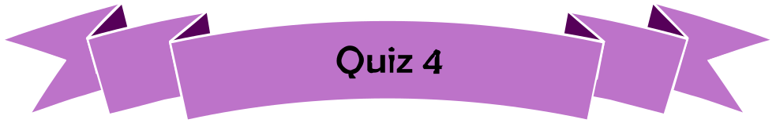
1) 43 × 57 | 2) 54.8 × 100 | 3) $\frac{7}{8}-\frac{3}{8}$
4) 4.2 – 2.18 | 5) $\frac{2}{3}×\frac{1}{4}$ | 6) 21 + 4298
7) $1-\frac{4}{13}$ | 8) 2 ÷ 0.5 | 9) 3.45 × 6

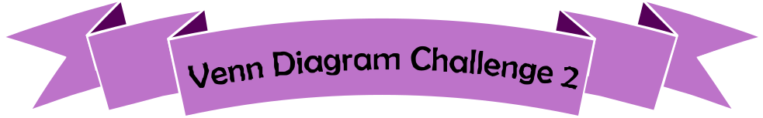

Ends in a 2
Less than $\frac{4}{5}$
More than 0.7
$$ε$$
E
F
H
D
G
CF
B
A

Think of a percentage that could fit into each region.
If you think a region is impossible to fill, explain why!
A
B
CF
D
E
F
G
H
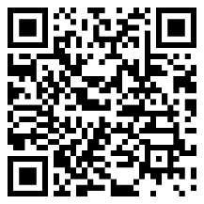
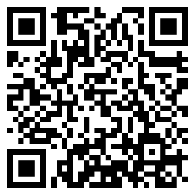
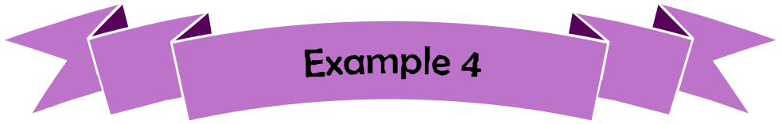
Calculate 434 ÷ 27.

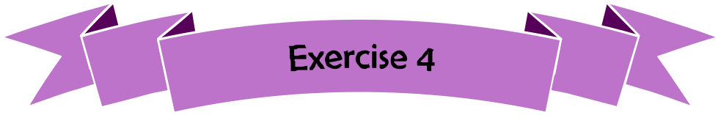

Calculate 549 ÷ 32.

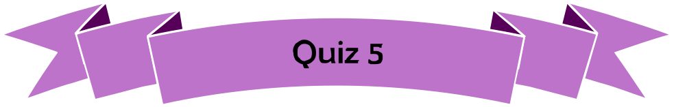
1) Change 24% to be a decimal. | 2) Change 24% to be a fraction. | 3) Change 0.04 to be a percentage.
4) Change 0.04 to be a fraction. | 5) Change $\frac{14}{25}$ to be a decimal. | 6) Change $\frac{14}{25}$to be a percentage.
7) Write $0.8777…$ using dot notation. | 8) Write $2.3656565…$ using dot notation. | 9) Write $0.32865865865…$ using dot  notation.

108°
126°
Siart cylch i ddangos hoff flas creision dysgwyr Ysgol B
Plaen
Halen a Finegr
Caws a Nionyn
Coctel Corgimwch
4) Dywedodd Dion “Mae mwy o bobl yn hoffi creision caws a nionyn yn Ysgol A nac yn Ysgol B”. Ydy Dion yn gywir? Eglurwch eich ateb.

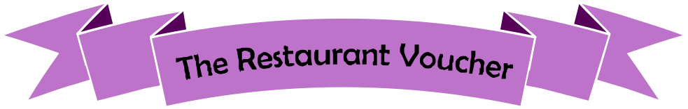
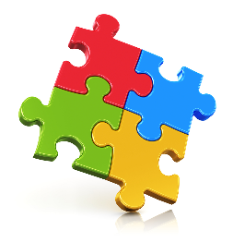
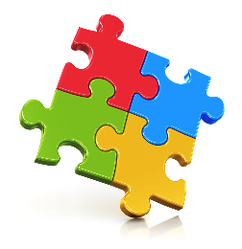
1) Before using the voucher the bill was £34. How much needs to be paid after using the voucher? | 2) After using the voucher the bill was £34. What was the original bill?
3) After using the voucher, what fraction of the original bill must be paid? Give your answer in its simplest form. | 4) After using the voucher,  I divide the bill between myself and three friends. What fraction of the original bill do I pay?


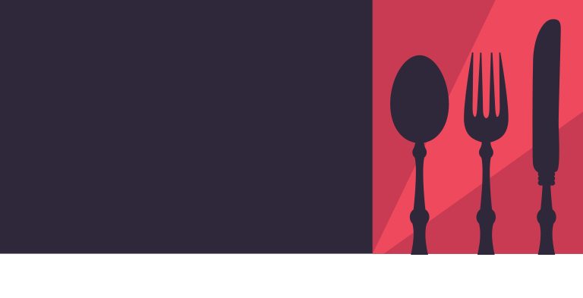
VOUCHER
15% off

Evaluating the Workbook



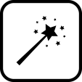

Notes





@minutemaths314 /adolygumathemateg
/mathscreuddyn www.mathemateg.com

