




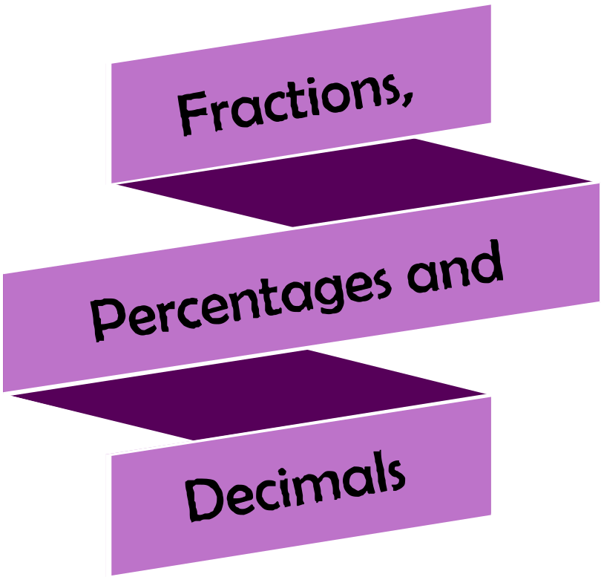






Version
3.0
08/2025


Chapter | Mathematics | Page Number
Calculating | Mastering the techniques. Problem solving. | 3
Recurring Decimals | Changing fractions to decimals. Terminating and recurring decimals. | 9
Converting | Converting between fractions, decimals and percentages. Starting with a percentage. Starting with a fraction. Starting with a terminating decimal. | 12
Efficient Percentage Changes | Repeated percentage changes. Calculating compound interest efficiently. Fractional changes. | 15
Exam Technique | Summary. Assessing written communication.  Mark schemes. Timing. | 19

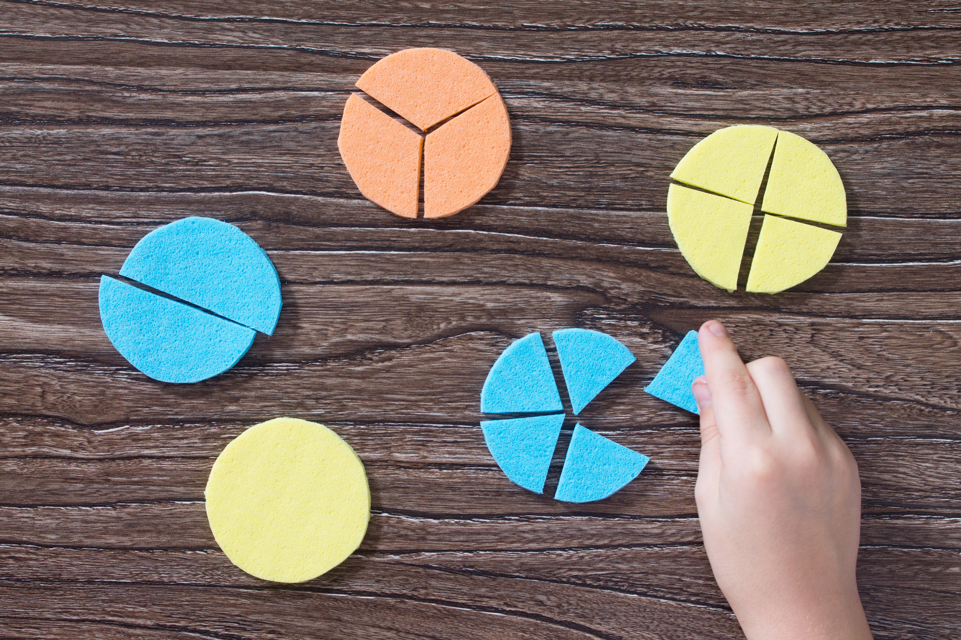


Mastering the Techniques

When working with fractions, decimals and percentages, we must develop fluency with many techniques.
Try the following questions, before going back and revising the techniques if you got the answer wrong.

Exercise 1
A

(a) 398 + 4829 |  |  |  |  |  | (b) 693 – 246 |  |  |  |  |  | (c) 372 × 68
(d) 925 ÷ 37 |  |  |  |  |  | (e) 2.6 × 10 |  |  |  |  |  | (f) 63 ÷ 100
(g) 0.0247 × 1000 |  |  |  |  |  | (h) 46.27 × 8 |  |  |  |  |  | (i) 29.3 + 2.43
(j) 52.6 × 7.84 |  |  |  |  |  | (k) 14.7 ÷ 6 |  |  |  |  |  | (l) 0.3 × 0.2

(m) 4 ÷ 0.5 |  |  |  |  |  | (n) 50% o 80 |  |  |  |  |  | (o) 10% o 72
(p) 36% o £84 |  |  |  |  |  | (q) $\frac{3}{5}$ o £35 |  |  |  |  |  | (r) $1-\frac{3}{7}$
 |  |  |  |  |  | (s) $\frac{5}{9}+\frac{2}{9}$ |  |  |  |  |  | (t) $\frac{5}{9}-\frac{2}{9}$
 |  |  |  |  |  | (u) $\frac{2}{3}+\frac{3}{5}$ |  |  |  |  |  | (v) $\frac{2}{3}-\frac{3}{5}$
 |  |  |  |  |  | (w) $\frac{2}{3}×\frac{3}{5}$ |  |  |  |  |  | (x) $\frac{2}{3}÷\frac{3}{5}$

Exercise 2
Check that you are able to use your calculator to find the correct answers to the questions in Exercise 1.




Exercise 3
Use the clues on the cards to solve the problem.
A
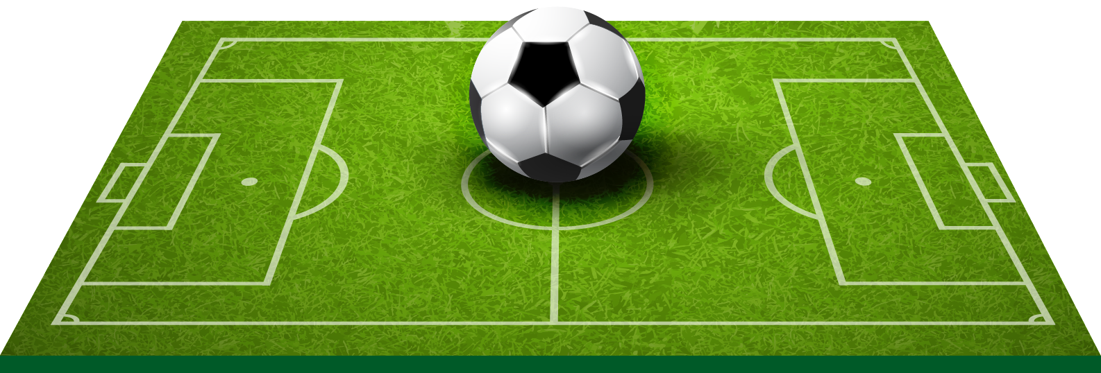
(3) The wage of Number 10 is $\frac{6}{7}$ of the wage of Number 7.

(1) The wage of Number 6 is half the wage of Number 3.
(2) Number 9 has the highest wage in the team.
(8) If the goalie doesn’t conceed a goal in a game, he gets a bonus of £5,000.

(10) There’s a bonus of 40% for any player who scores a hat-trick in a game.

(11) This week the team won 2–0.

(24) During this week’s game, Number 4 and Number 9 scored.

(21) The crowd for the recent game was 34,500.

(23) The word “wage” means “weekly wage” in this task.

(18) There’s a difference of £2,000 between the wages of Number 10 and Number 11.

(15) Number 9’s usual wage is double the goalie’s usual wage.

(14) Number 11 has the third highest wage in the team.

(17) One of the players in the team has the same wage as the goalie’s usual wage.

(20) Number 2’s wage is £6,000 higher than the lowest wage.

(13) Number 5 earns £200 per hour.

(16) Number 4’s usual wage is $\frac{5}{6}$ of Number 3’s usual wage.

(19) The team only played one game this week.

(22) Number 1’s wage is $\frac{5}{8}$ of Number 10’s usual wage.

(6) Number 7 earns £8,000 per day.

(4) There’s a 15% bonus for every player who scores a goal in a game.

(9) The wage of Number 3 is 48% of the wage of Number 11.

(7) There are 11 players in a football team.

(12) Your task is to calculate this week’s wage for the manager and every player who started the game this week.

(5) The manager’s wage is the mean wage of Number 8 and Number 11.

You will need to use the following timetable to answer Exercises 4 and 5…
Summary of North Wales to South Wales train services  Crynodeb o wasanaethau rhwng Gogledd Cymru a De Cymru |  |  |  |  |  |  | Saturdays  Dydd Sadwrn
 |  | ◊ 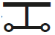 | ◊ | ◊ | R | ◊  L |  | ◊ | ◊
Holyhead / Caergybi | d | 0425 | 0635 | 0820 | 1033 | 1238 |  | 1423 | 1650
Valley / Y Fali | d | 0432x | 0641x | 0826x | 1039x
Rhosneigr | d |  |  | 0832x
Ty Croes | d |  |  | 0835x
Bodorgan | d |  |  | 0840x
Llanfairpwll | d | 0449x | 0658x | 0849x | 1056x
Bangor | d | 0457 | 0707 | 0902 | 1105 | 1307 |  | 1453 | 1718
Llanfairfechan | d |  |  | 0909x |  |  |  | 1500x
Penmaenmawr | d |  |  | 0913x |  |  |  | 1504x
Conwy | d |  |  | 0919x |  |  |  | 1510x
Llandudno Junction / Cyffordd Llandudno | a | 0513 | 0723 | 0923 | 1121 | 1323 |  | 1515 | 1734
Llandudno Junction / Cyffordd Llandudno | d | 0515 | 0725 | 0925 | 1125 | 1325 |  | 1516 | 1736
Colwyn Bay / Bae Colwyn | d | 0521 | 0731 | 0931 | 1131 | 1331 |  | 1522 | 1742
Abergele & Pensarn | d
Rhyl | d | 0531 | 0741 | 0941 | 1141 | 1341 |  | 1533 | 1752
Prestatyn | d | 0537 | 0747 | 0947 | 1147 | 1347 |  | 1538 | 1758
Flint / Y Fflint | d | 0550 | 0800 | 1000 | 1200 | 1400 |  | 1552 | 1811
Shotton | d
Chester / Caer | a | 0604 | 0816 | 1016 | 1216 | 1414 |  | 1605 | 1825
Chester / Caer | d | 0612 | 0819 | 1019 | 1219 | 1419 |  | 1619 | 1829
Wrexham General / Wrecsam Cyffredinol | d | 0638 | 0834 | 1035 | 1234 | 1434 |  | 1635 | 1845
Ruabon / Rhiwabon | d | 0645 | 0841 | 1042 | 1241 | 1441 |  | 1642 | 1852
Chirk / Y Waun | d | 0651 | 0847 | 1048 | 1247 | 1447 |  | 1648 | 1858
Gobowen | d | 0657 | 0853 | 1054 | 1253 | 1453 |  | 1654 | 1904
Shrewsbury / Yr Amwythig | a | 0717 | 0913 | 1114 | 1313 | 1513 |  | 1714 | 1924
Shrewsbury / Yr Amwythig | d | 0719 | 0915 | 1115 | 1315 | 1515 |  | 1716 | 1926
Church Stretton | d |  |  |  | 1330
Craven Arms | d |  |  |  | 1338
Ludlow | d | 0745 | 0942 | 1141 | 1344 | 1541 |  | 1742 | 1951
Leominster | d | 0755
Hereford / Henffordd 7 | d | 0812 | 1007 | 1206 | 1410 | 1606 |  | 1807 | 2017
Abergavenny / Y Fenni | d | 0835 | 1030 | 1229 | 1432 | 1629 |  | 1830 | 2040
Pontypool & New Inn / Pontypwl | d | 0845 | 1040 | 1239 | 1443 | 1639 |  | 1840
Cwmbran | d | 0850 | 1045 | 1244 | 1448 | 1644 |  | 1845 | 2052
Newport / Casnewydd | d | 0902 | 1057 | 1256 | 1506 | 1656 |  | 1857 | 2117
Cardiff Central / Caerdydd Canolog 7 | a | 0924 | 1115 | 1317 | 1526 | 1708 |  | 1915 | 2142
Notes Nodiadau
a Arrival time a Amser cyrraedd
d Departure time d Amser gadael
x Service stops on request x Yn aros ar gais
7 Recommended connecting time 7 Amser cysylltu argymelledig
L To Maesteg L I Faesteg
◊ Seat reservations available ◊ Seddi cadw ar gael
R Seat reservations recommended R Argymhellir seddi cadw
At seat service Gwasanaeth troli

Exercise 4
A
Use the timetable on the previous page to answer the following questions.
(a) How much time does the 0425 train from Holyhead take to reach Llandudno Junction?
(b) For how many minutes does the 1423 train from Holyhead wait in Chester?
(c) In minutes, what is the fastest journey between Chester and Shrewsbury?
(d) Out of the seven trains, how many trains stop in Pontypool?
(e) On the train that recommends seat reservations, how long does it take to travel from Prestatyn to Cwmbran?
(f) Which train waits the longest in Llandudno Junction?

Exercise 5


Use the timetable on the previous page to solve the following problem.

David lives in Holyhead and wants to visit his Aunt in Cardiff. Write a travelling schedule for David based on the information around this travel ticket. Remember to include the cost of the journey in your instructions.
David wants to travel to Cardiff on a Saturday.
David can’t leave Holyhead before 7:30am.
David wants to stop at Chester to shop for 3 hours.
David can purchase the train ticket two weeks before the journey.

The cost of an “anytime” ticket from Holyhead to Cardiff is £96.
By purchasing a ticket before hand, it’s possible to save 70% off the “anytime” price.
A young person’s rail card offers $\frac{1}{3}$ off any train ticket.
David must arrive in Cardiff before 8:00pm.
Mae gan David gerdyn person ifanc.

Exercise 6
(a) A man gave $\frac{1}{4}$ of the money in his will to his eldest son; $\frac{1}{4}$ of the rest to his second son; and so on until there was only £40,500 left for his only daughter. The value of his will was £128,000. How many sons did he have?
(b) How much is 30% of 40% of 50% of £60?
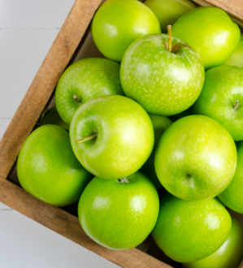
(c) Gwen’s necklace broke. $\frac{1}{3}$ of the beads went on the floor. $\frac{1}{5}$went down the side of the chair. Gwen found $\frac{1}{6}$of the beads on the table and her Mum found the rest, which was $\frac{1}{10}$. 12 were still on the string.
How many beads were on the string before it broke?
(d) In the sequence $\left(1-\frac{1}{2}\right)$, $\left(\frac{1}{2}-\frac{1}{3}\right)$, $\left(\frac{1}{3}-\frac{1}{4}\right)$, ... what is the sum of the first hundred terms?
(e) I bought a number of apples from a local market. On the way home, I saw William and
gave him $\frac{2}{3}$of the apples. Then I ate one apple before visiting Beth. She had $\frac{3}{4}$ of the remaining
apples. I arrived home with only 4 apples. How many apples did I have originally?
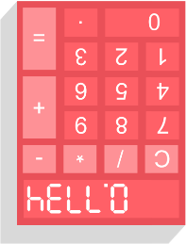
Exercise 7: Upside-down calculator story: the golf tournament.
13
Use the yellow and green clues to complete the story.
Key: 1 = I, 2 = Z, 3 = E, 4 = H, 5 = S, 6 = G, 7 = L, 8 = B, 9 = b, 0 = O.
Ignore decimal points in your answers.
It was the final of the $8^{3}+106$ golf tournament. $\frac{202×4096}{16×64}$ was in second place with only one $7^{4}+434×3+1$ to go. $192\frac{3}{4}×2\frac{2}{3}$ bitter rival $\sin\left(30\right)+0.201$ had already finished, and had $5^{5}+580$ possession of first place. The final ${13719616}^{0.5}$ was a par 3. A $170683\frac{1}{5}÷5\frac{2}{5}$ would mean that $\sqrt{0.040401}+\frac{1}{2}$ was champion; a birdie would see $9^{2}-\frac{\frac{1}{10}}{\frac{1}{2}}$ win. On the tee $7!×\frac{1}{8}+178$’s $7!+(9^{3}-132)$ were shaking like jelly and the club felt as slippery as an $\frac{{38}^{2}}{2}+11$. “Here $\sqrt{281536.36}$ nothing”, $({10}^{2}+1)×8$ thought to himself, before striking the ball $\sqrt{\sqrt[3]{15625}}×923-1$ and straight onto the green – a great shot!
$$\begin{matrix} & & & & & \frac{1}{1} & & & & & \\ & & & & \frac{1}{2} & & \frac{1}{2} & & & & \\ & & & \frac{1}{3} & & \frac{1}{6} & & \frac{1}{3} & & & \\ & & \frac{1}{4} & & \frac{1}{12} & & \frac{1}{12} & & \frac{1}{4} & & \\ & \frac{1}{5} & & \frac{1}{20} & & \frac{1}{30} & & \frac{1}{20} & & \frac{1}{5} & \\ \frac{1}{6} & & \frac{1}{30} & & \frac{1}{60} & & \frac{1}{60} & & \frac{1}{30} & & \frac{1}{6}\end{matrix}$$

This year had been one $8^{2}-3+\frac{\frac{2}{5}}{\frac{1}{2}}$ $\frac{\cos{(45)}×12150}{\sqrt{2}}$ for $\frac{16×101}{9^{2}}×40\frac{1}{2}$. $2×e^{0}×17$ hated to $5555+{(-2)}^{11}$, but this year the feeling had become familiar; $405\frac{3}{4}+402\frac{1}{4}$ had more $2142028×25\%$ to ${\left(\frac{1000}{701}\right)}^{-1}$ than he could remember. Today was $\frac{20200×4}{{10}^{2}}$’s final chance to $\frac{7×2267}{2^{2}×5^{3}}$ the critics and feel the $31610\frac{4}{5}+23567\frac{1}{5}$ of victory.
On reaching the green $8+\frac{1}{10}-\frac{2}{100}$ tried not to notice the $3^{6}×4+(300-1)$ of the crowd watching on.
He could $\tan\left(45\right)+2×167$ that the ball was around 10 feet from the $463×2÷\frac{1}{4}$, up a slight
$6^{5}-5^{4}+4^{3}-3^{2}+2^{1}-1^{0}+507$. “${1032658225}^{0.5}$ the day”, $\sqrt{2^{6}×{101}^{2}}$ thought, before putting the ball straight – and into the middle of the $7!-167×2^{3}$! Victory at last – $\frac{4×211}{5^{2}}$ for $404×20\%$, and at last a dent to $\sqrt{\frac{1}{2}-0.008599}$’s $\frac{3^{2}×7}{4×25}$!
Challenge!
The name of the triangle on the right is the Leibniz Harmonic Triangle.
What patterns can you see?
Write down the next row in the pattern.


Key words | Corrections | I am happy with... | I need to revise...





Changing Fractions to Decimals

If the denominator of a fraction is a power of 10, for example 10, 100 or 1,000,
then it is easy to convert the fraction to a decimal.
Example
$\frac{3}{10}=0.3$ $\frac{12}{100}=0.12$ $\frac{6}{100}=0.06$ $\frac{427}{1000}=0.427$ $\frac{31}{1000}=0.031$

Exercise 8
A
Convert the following fractions to decimals.
(a) $\frac{7}{10}$ (b) $\frac{5}{10}$ (c) $\frac{17}{100}$ (d) $\frac{7}{100}$ (e) $\frac{95}{100}$ (f) $\frac{1}{10}$ (g) $\frac{93}{100}$
(h) $\frac{731}{1000}$ (i) $\frac{402}{1000}$ (j) $\frac{32}{1000}$ (k) $\frac{86}{1000}$ (l) $\frac{4}{1000}$ (m) $\frac{200}{1000}$ (n) $\frac{760}{1000}$
(o) $\frac{4237}{10000}$ (p) $\frac{29}{10000}$ (q) $\frac{3}{100000}$ (r) $\frac{17}{10}$ (s) $\frac{40}{100}$ (t) $\frac{329}{10}$ (u) $\frac{2053}{100}$

Using Equivalent Fractions
With some fractions, it is possible to find an equivalent fraction whose denominator is a power of 10, which then allows us to change the original fraction to a decimal.
Example
× 5
× 4
× 2
$\frac{3}{5} \frac{6}{10}=0.6$ $\frac{11}{25} \frac{44}{100}=0.44$ $\frac{143}{200} \frac{715}{1000}=0.715$
Exercise 9
Convert the following fractions to decimals.
(a) $\frac{2}{5}$ (b) $\frac{4}{5}$ (c) $\frac{1}{5}$ (d) $\frac{1}{2}$ (e) $\frac{6}{25}$ (f) $\frac{21}{25}$ (g) $\frac{1}{25}$
(h) $\frac{3}{20}$ (i) $\frac{19}{20}$ (j) $\frac{11}{20}$ (k) $\frac{43}{50}$ (l) $\frac{9}{50}$ (m) $\frac{55}{50}$ (n) $\frac{304}{500}$
(o) $\frac{1}{200}$ (p) $\frac{64}{200}$ (q) $\frac{136}{200}$ (r) $\frac{31}{250}$ (s) $\frac{147}{250}$ (t) $\frac{9}{250}$ (u) $\frac{53}{5000}$

Terminating and Recurring Decimals
The fractions we have seen so far convert to terminating decimals, which means that the decimals have a specific number of digits after the decimal point. For example, the fraction $\frac{11}{25}$ from the above example converted to the decimal 0.44, which is a decimal that has two digits appearing after the decimal point.
As we will see on the next page, some fractions convert to recurring decimals, which are decimals with an infinite number of digits appearing after the decimal point. The decimal $0.222…$ is an example of a recurring decimal, where the dots $…$ show that the digit 2 repeats forever. In mathematics, we have a special notation to write recurring decimals, which is the dot notation. We write the decimal $0.222…$ in dot notation as $0.\dot{2}$, where the dot on top of the digit 2 means the 2 repeats forever.


Example
$0.45222…=0.45\dot{2}$ $0.434343…=0.\dot{4}\dot{3}$ $0.243243243…=0.\dot{2}4\dot{3}$
Exercise 10
2
Write the following recurring decimals using dot notation.
(a) $0.777…$ (b) $0.444…$ (c) $0.5333…$ (d) $5.222…$ (e) $0.52888…$
(f) $0.737373…$ (g) $0.262626…$ (h) $0.909090…$ (i) $0.2454545…$ (j) $0.0818181…$
(k) $0.265265265…$ (l) $0.405405405…$ (m) $0.5274274274…$ (n) $0.47812812812…$ (o) $0.216737373…$

Converting fractions to recurring decimals
Not all fractions are equivalent to a fraction that has a denominator which is a power of 10.
With these fractions we need to use a division frame to convert the fraction to a recurring decimal.
We can add more zeroes to the 2.000, if needed.

Example

Convert the fraction $\frac{2}{3}$ to a recurring decimal.
1. Put the sum 2 ÷ 3 into a division frame, writing 2 as the equivalent decimal 2.000. | 2. “How many times does 3 fit into 2?” It’s too large, therefore it fits in 0 times, with 2 left over. | 3. Remember to add the decimal point in the correct place.
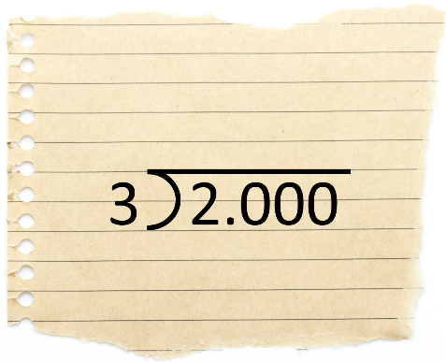 | 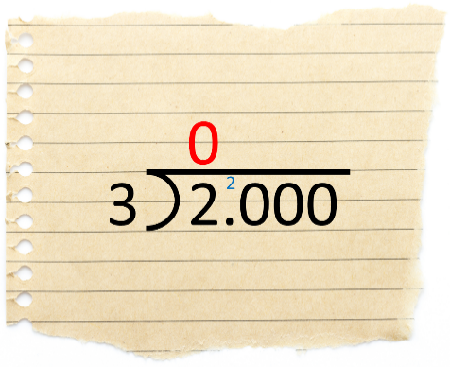 | 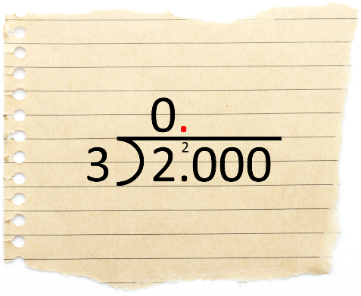
4. “How many times does 3 fit into 20?” It fits in 6 times, with 2 left over. | 5. “How many times does 3 fit into 20”? It fits in 6 times, with 2 left over. | 6. We notice the pattern in the calculations, writing $…$ to show that they repeat forever.
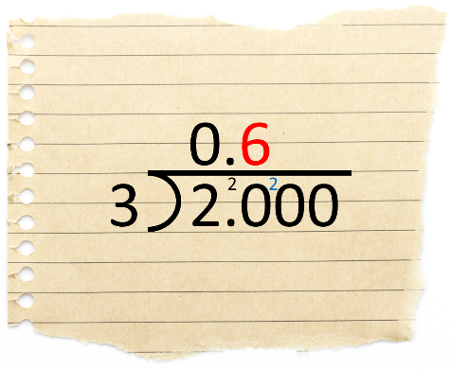 | 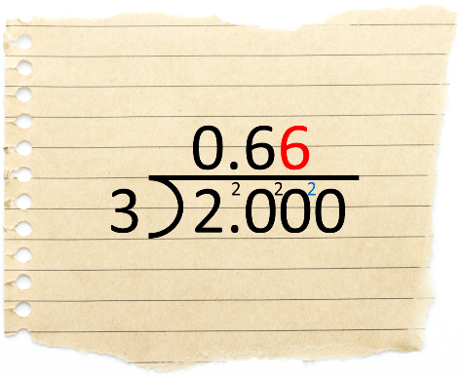 | 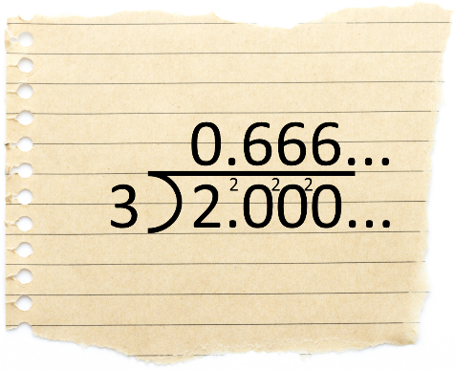
Answer: As a decimal, the fraction $\frac{2}{3}$ is equal to $0.666…$ or, in dot notation, $0.\dot{6}$.
Exercise 11
Use a division frame to write the following fractions as recurring decimals, using dot notation.
(a) $\frac{1}{3}$ (b) $\frac{2}{9}$ (c) $\frac{5}{9}$ (d) $\frac{1}{9}$ (e) $\frac{3}{11}$ (f) $\frac{8}{11}$ (g) $\frac{10}{11}$
(h) $\frac{1}{6}$ (i) $\frac{2}{6}$ (j) $\frac{5}{6}$ (k) $\frac{1}{7}$ (l) $\frac{5}{7}$ (m) $\frac{6}{7}$ (n) $\frac{4}{13}$
Exercise 12
Use a calculator to check your answers to Exercise 11.
Challenge!
Use a division frame to write the following fractions as recurring decimals.
(a) $\frac{13}{17}$ (b) $\frac{11}{19}$ (c) $\frac{2}{23}$


Terminating or recurring decimals?
It is possible to determine whether a fraction converts to a
terminating or a recurring decimal by following these steps.
- Simplify the fraction, if possible.
- Write the denominator of the fraction as a product of its prime factors.
- If the product of prime factors includes the numbers 2 and/or 5 only, then the fraction converts to a terminating decimal. If any other prime number appears, then the fraction converts to a recurring decimal.

Example

Determine whether the fraction $\frac{46}{80}$ converts to a terminating decimal or
to a recurring decimal.
÷ 2

40
20 2
2 10
2 5
- We can simplify the fraction by halving: $\frac{46}{80} \frac{23}{40}$.
- By using a factor tree (on the right), we see that 40, as a product of its prime factors, is 40 = 2 × 2 × 2 × 5.
- Since the product of prime factors for 40 includes the prime numbers 2 and 5 only (and no other primes), we can say that the fraction $\frac{46}{80}$ converts to a terminating decimal.
Exercise 13
2
Determine whether the following fractions convert to terminating decimals or to recurring decimals.
(a) $\frac{1}{2}$ (b) $\frac{2}{5}$ (c) $\frac{5}{6}$ (d) $\frac{7}{8}$ (e) $\frac{4}{9}$ (f) $\frac{6}{12}$ (g) $\frac{8}{12}$
(h) $\frac{11}{15}$ (i) $\frac{12}{15}$ (j) $\frac{3}{25}$ (k) $\frac{12}{30}$ (l) $\frac{29}{30}$ (m) $\frac{1}{80}$ (n) $\frac{87}{125}$
Exercise 14

Convert the fractions from Exercise 13 to decimals.
Investigation
The series of images on the right attempts to show that $0.\dot{9}=1$.
Can you think of a different way to show that $0.\dot{9}=1$?
Suggestion: Use the decimal for $\frac{1}{3}$.

In this chapter, we will discuss how to convert between fractions, decimals and percentages.
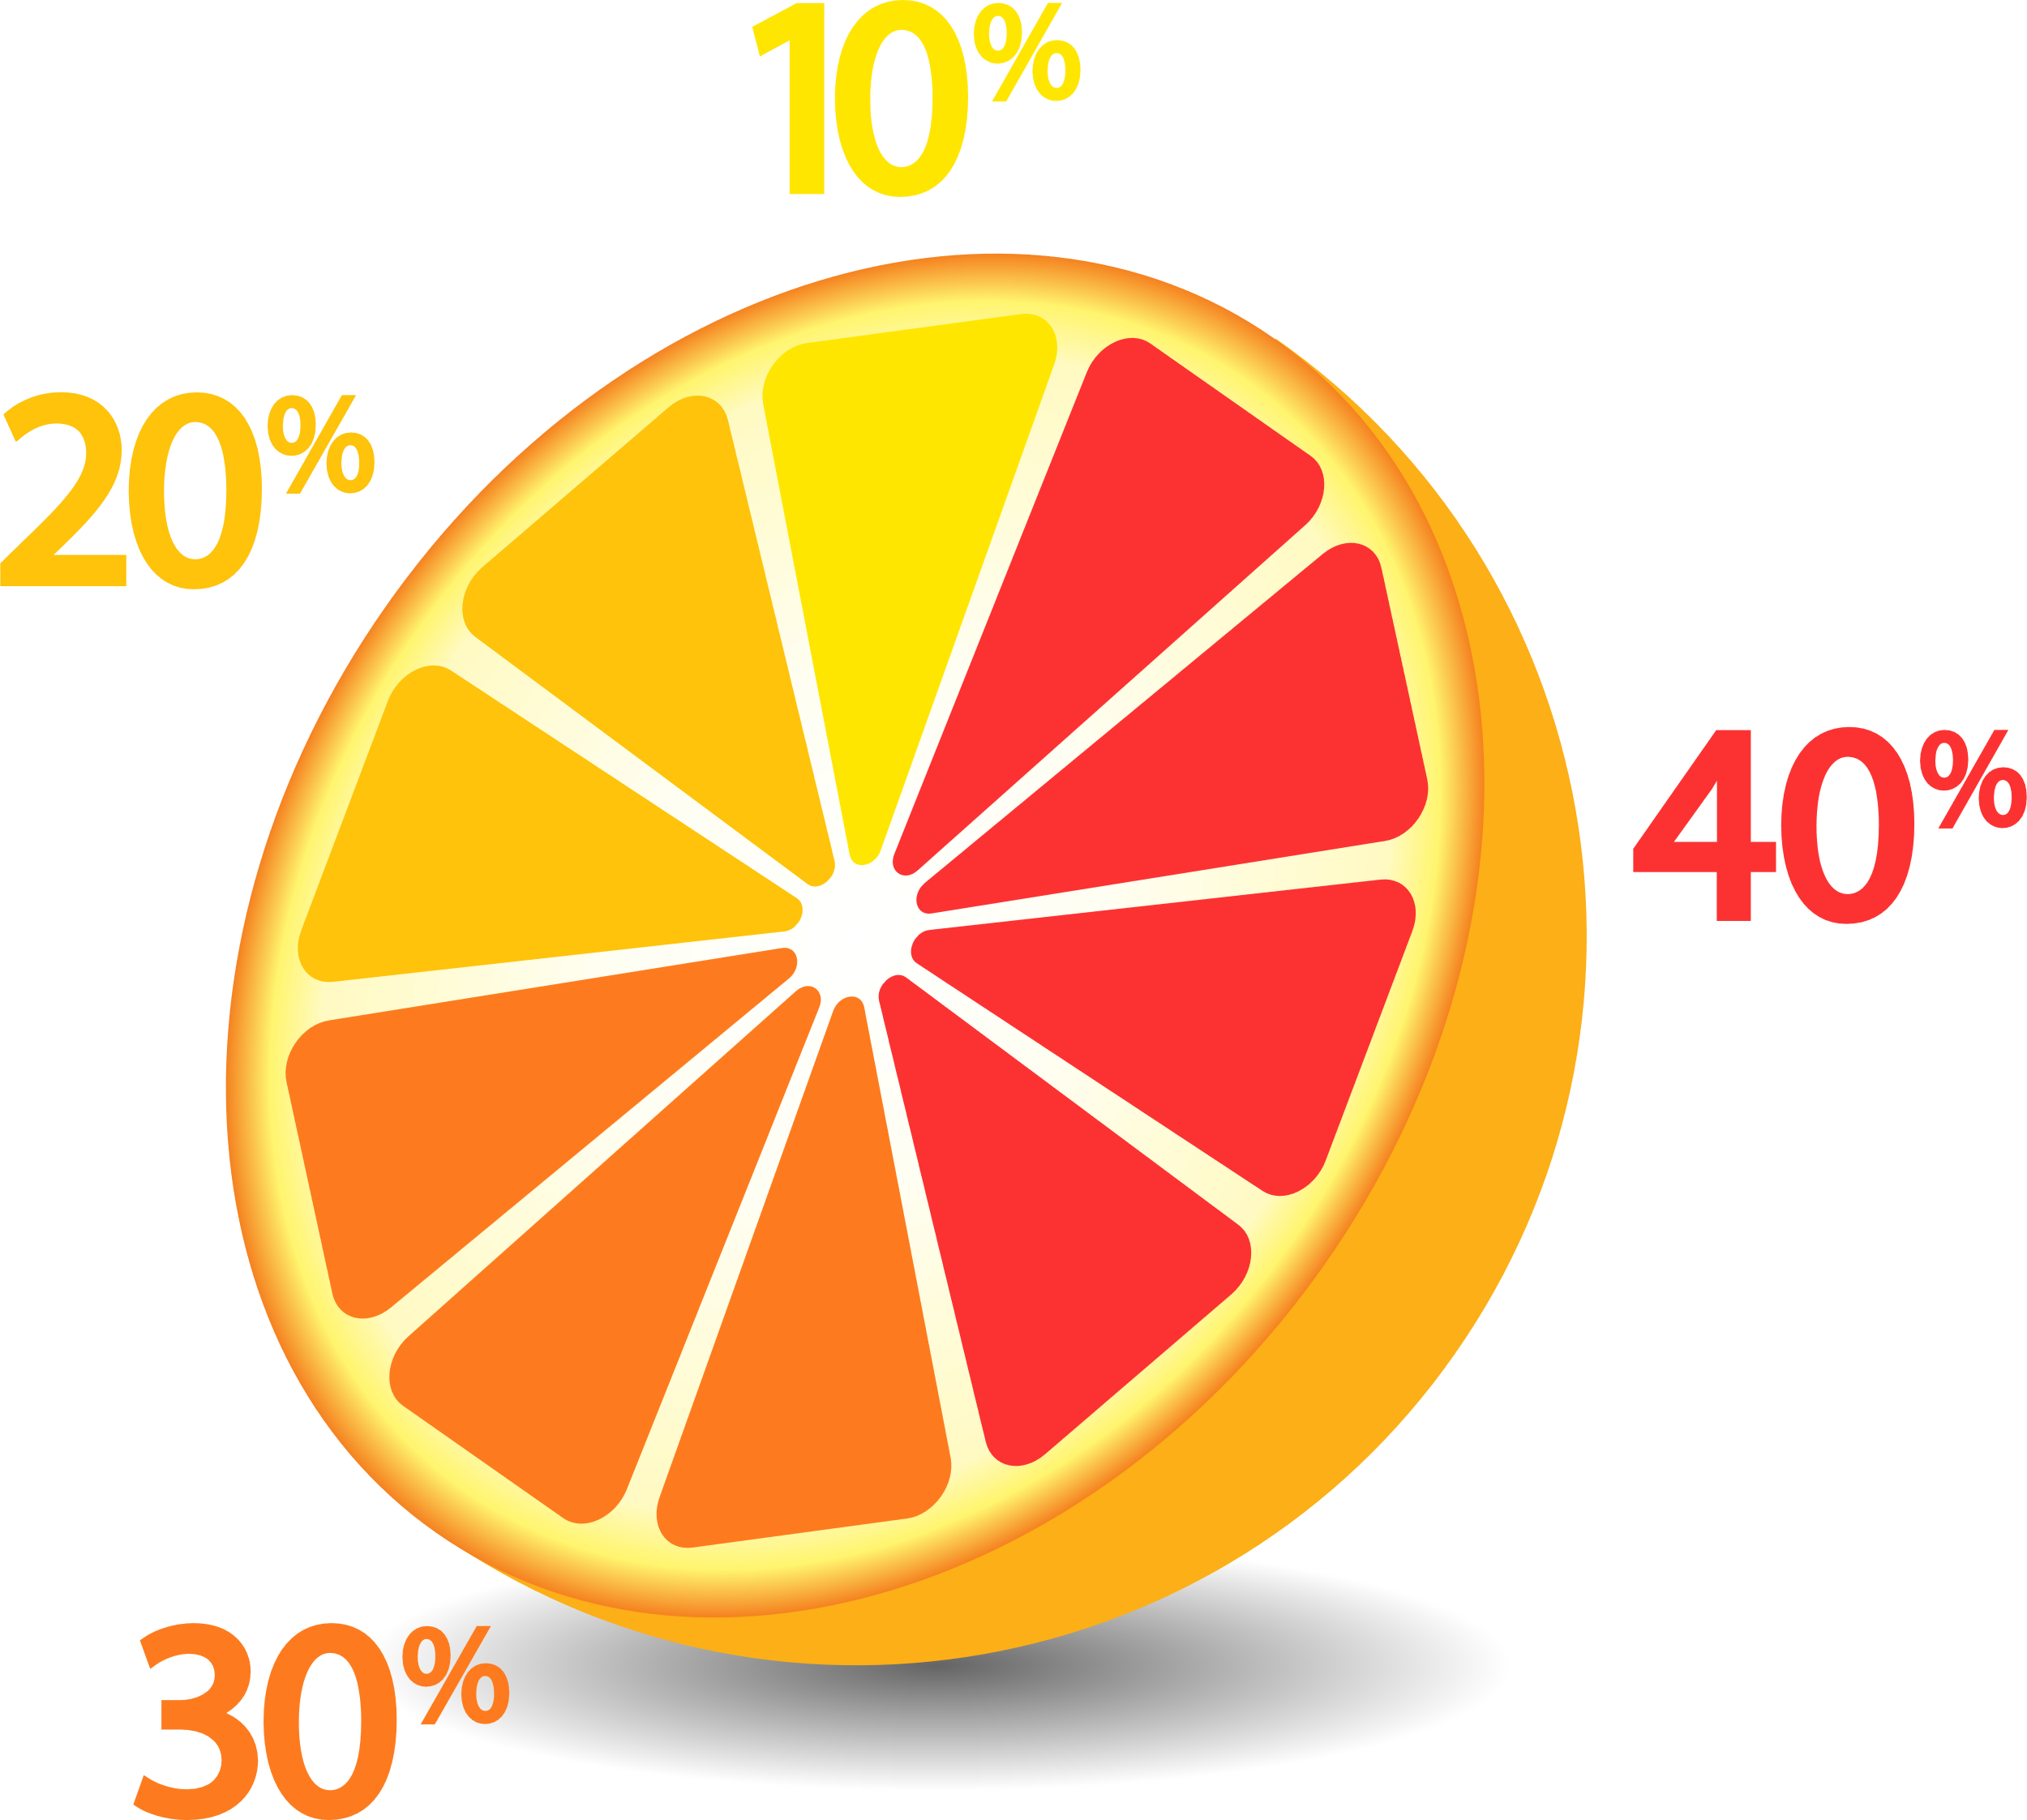
Starting with a percentage
Percentage
e.g. 36%
Remove the % symbol.
Write as a fraction over 100.
Simplify the fraction.
Fraction
e.g. $\frac{36}{100} \frac{9}{25}$
Remove the % symbol.
Divide by 100.
Decimal
e.g. 0.36


÷ 4
Exercise 15
A
Complete the following table.
Fraction | Percentage | Decimal
 | 27%
 | 68%
 | 93%
 | 4%
 | 7%
 | 100%
 | 150%
 | 400%
 | 1%
 | 0.5%
 | 0.2%
 | 0.05%
 | 3.1%
 | 10.2%
Exercise 16
Circle each number that has the same value as 40%.
0.04 $\frac{4}{10}$ 0.4 $\frac{10}{4}$ 0.40 $\frac{2}{5}$ 4%

Challenge!
If the length of a rectangle increases 10% but the area remains the same,
by what fraction must the width be reduced by?
Width
Length
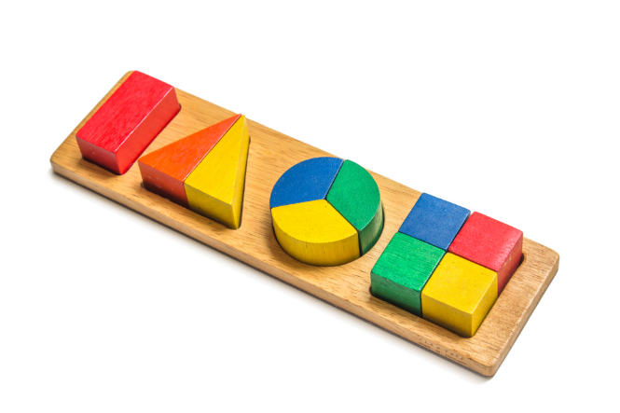
Starting with a fraction
Fraction
e.g. $\frac{2}{5}$
1) Try to find an equivalent fraction which has a denominator that is a power of 10.
Not possible? 2) Use a division frame.
Decimal
e.g. 0.4
Percentage
e.g. 40%
Multiply by 100.
Add a % symbol.

Exercise 17
A
Complete the following table.
Fraction | Percentage | Decimal
$\frac{87}{100}$
$\frac{4}{100}$
$\frac{7}{10}$
$\frac{3}{5}$
$\frac{13}{20}$
$\frac{18}{25}$
$\frac{184}{500}$
$\frac{4}{9}$
$\frac{3}{8}$
$\frac{3}{2}$
$\frac{4}{7}$
$\frac{5}{11}$
$\frac{12}{40}$
$\frac{43}{200}$
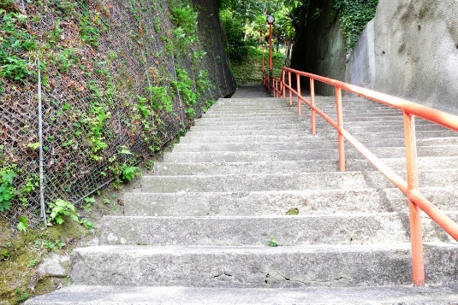
Exercise 18
(a) Write 13%, 0.2 and $\frac{3}{25}$ in ascending order.
(b) Write $\frac{3}{4}$, 77% and 0.73 in ascending order.
(c) Write $\frac{32}{50}$, 0.63 and 67% in descending order.
(d) In a mathematics test, Rachel scored $\frac{3}{5}$ of the highest possible mark.
Jimmy scored 62% and Susie’s mark was 0.58 of the highest possible mark.
State which student scored the most marks and which student scored the least marks.
$$B$$

Challenge!
$$A$$
In a triangle $ABC$, the angle $B$ is $\frac{3}{4}$ of the angle $C$ and $1\frac{1}{2}$ of the angle $A$.
What is the size of the angle $B$?
$$C$$

Starting with a terminating decimal
Write as a fraction over ${10}^{n}$, where $n$ is the
number of times you must multiply the decimal
by 10 for it to become a whole number.
Simplify the fraction.
Fraction
e.g. $\frac{236}{1000} \frac{59}{250}$
Decimal
e.g. 0.236
Multiply by 100.
Add a % symbol.
Percentage
e.g. 23.6%
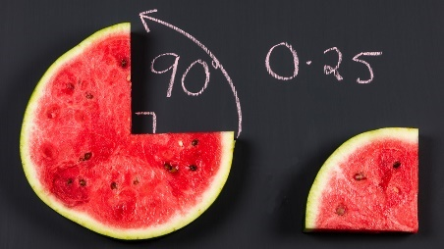
÷ 4

Exercise 19
A
Complete the following table.
Fraction | Percentage | Decimal
 |  | 0.99
 |  | 0.9
 |  | 0.5
 |  | 0.2
 |  | 0.14
 |  | 0.08
 |  | 0.01
 |  | 1.6
 |  | 2.4
 |  | 12.5
 |  | 1.09
 |  | 0.452
 |  | 1.452
 |  | 10.2
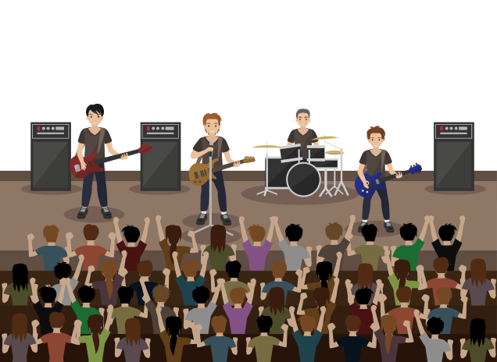
Exercise 20
A band hires a concert hall for two nights. They intend to hire the concert hall for a third night, but only if at least 0.9 of the tickets are sold, either for the first night or for the second night.
On the first night, 82% of the tickets were sold.
On the second night, $\frac{3}{4}$ of the tickets were sold.
Did the band hire the hall for the third night? You must show your method and explain how you made your decision.

Challenge!
Find the value of $x$, where $\frac{1}{2}-\frac{1}{4}+\frac{1}{8}-\frac{1}{16}+⋯-\frac{1}{1024}=\frac{x}{1024}$.


Consider how you would answer the following question.
Chris’ weekly wage is £480. If Chris is awarded a pay rise of 10%, what will his wage be next week?
One way to answer this question would be to calculate 10% of £480, which is £480 ÷ 10 = £48, and
then add the £48 onto the original wage: £480 + £48 = £528. On a calculator, it would be possible to type the following two calculations to find the correct answer.
480 × 10% = 48
480 + 48 = 528
It is possible however to reach the correct answer in one calculation, and therefore in a more efficient way. Since Chris’ wage is increasing 10%, it is growing from 100% of the original wage to 110% of the original wage. It would therefore be possible to find the new wage by finding 110% of the original wage. On a calculator, we can do this by typing the following calculation.
480 × 110% = 528
Exercise 21
13
Complete the following table.
Original Price | Original Percentage | Percentage Change | New Percentage | Sum to Find  the New Price | New Price
£480 | 100% | Increase 10% | 110% | £480 × 110% | £528
£54 | 100% | Decrease 20% | 80% | £54 × 80% | £43.20
£250 |  | Increase 25%
£1,700 |  | Increase 5%
£20 |  | Decrease 10%
$800 |  | Decrease 30%
€460 |  | Increase 2%
£7.50 |  | Decrease 30%
£2,500 |  | Increase 80%
£100,000 |  | Decrease 64%
$650 |  | Increase 16%
£82.50 |  | Decrease 26%
£1.87 |  | Increase 100%
£74.50 |  | Decrease 100%
€2,925 |  | Increase 250%
£74,000 |  | Decrease 99%
£5.68 |  | Increase 2.5%
£100 |  | Decrease 12.5%
£276.40 |  | Increase 0.4%
€9.99 |  | Decrease 60%
£2,000,000 |  | Decrease 1.4%

Repeated Percentage Changes
Depreciation means the value decreases.


Example
Geraint buys a second hand car for £6,500.
Every year, the value of the car depreciates 15%.
What value will the car have after three years?
Inefficient Method Better Method Efficient Method

Year 1 Every year, the value of the Every year, the value of the
£6,500 × 15% = £975 car decreases from 100% to 85%. car decreases from 100% to 85%.
£6,500 – £975 = £5,525 Year 1 This happens three times.
Year 2 £6,500 × 85% = £5,525 Answer
£5,525 × 15% = £828.75 Year 2 £6,500 × 85%³ = £3,991.81,
£5,525 – £828.75 = £4,696.25 £5,525 × 85% = £4,696.25 to the nearest penny.
Year 3 Year 3
£4,696.25 × 15% = £704.44, to the nearest penny. £4,696.25 × 85% = £3,991.81,
£4,696.25 – £704.44 = £3,991.81 to the nearest penny.
Exercise 22
1
Use an efficient method to answer the following questions.
(a) Megan buys a second-hand car for £8,000. Every year, the value of the car depreciates 12%.
What value will the car have after three years?
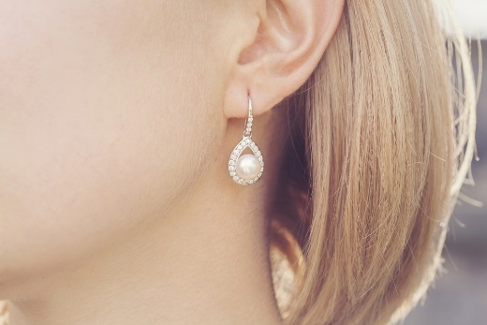
(b) Aled buys a second-hand car for £14,500. Every year, the value of the car depreciates 20%. What value will the car have after five years?
(c) Ffion buys a pair of earrings for £400. Every year, the value of the earrings increases 15%. What value will the earrings have after four years?
(d) Steffan buys antique furniture for £1,500. Every year, the value of the furniture increases 3%. What value will the furniture have after 6 years?
(e) A football team buys a player for £75,000,000. The value of the player increases 24% every year. The club sells the player after three years. What was the sale price of the player after three years?
(f) Steven buys a field for £7,500. For every one of the next 5 years the price increases 10%.
(i) What value will the field have after two years?
(ii) How much does the price increase between the end of the third year and the end of the fifth year?
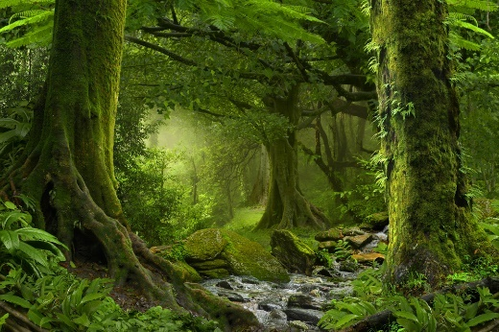
(g) A tropical rainforest loses 7% of its trees every year.
(i) What percentage of the rainforest will be left after a year?
(ii) What percentage of the rainforest will be left after two years?
(iii) After how many years will there be less than 50% of the current rainforest left?
(iv) How much of the rainforest will be left after 50 years?
(h) Five years ago, Mark bought a house for £180,000. For the first three years, the value of the house increased by 12% each year. For the next two years, the value of the house decreased by 7% each year. What is the value of the house today?

Calculating Compound Interest Efficiently

Example
Nia borrows £8,500 from NatWest Bank at a compound interest rate of 4% per year. Nia wants to pay back all the money after three years. How much money will Nia have to pay back after three years?
Inefficient method (Year 9) Better Method Efficient Method

Year 1 Every year, the value of the money Every year, the value of the money £8,500 × 4% = £340 increases from 100% to 104%. increases from 100% to 104%.
£8,500 + £340 = £8,840 Year 1 This happens three times.
Year 2 £8,500 × 104% = £8,840 Answer
£8,840 × 4% = £353.60 Year 2 £8,500 × 104%³ = £9,561.34,
£8,840 + £353.60 = £9,193.60 £8,840 × 104% = £9,193.60 to the nearest penny.
Year 3 Year 3
£9,193.60 × 4% = £367.74, £9,193.60 × 104% = £9,561.34,
to the nearest penny. to the nearest penny.
£9,193.60 + £367.74 = £9,561.34
Exercise 23
1
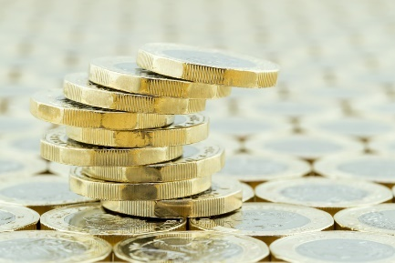
Use an efficient method to calculate the answer to the following questions.
(a) Sophie borrows £11,000 from Barclays Bank at a compound interest rate of 3% per year. Sophie wants to pay back all the money after three years. How much money will Sophie have to pay back after three years?
(b) Bryn borrows £6,700 from HSBC Bank at a compound interest rate of 6% per year. Bryn wants to pay back all the money after five years. How much money will Bryn have to pay back after five years?
(c) Owen wants to invest £4,000 into Lloyds Bank at a compound interest rate of 5% per year. Owen wants to withdraw all the money from the bank after three years. How much money will Owen be able to take out after three years?
(d) Lorraine wants to invest £25,000 into Barclays Bank at a compound interest rate of 3.4% per year. Lorraine wants to withdraw all the money from the bank after eight years. How much money will Lorraine be able to take out after eight years?
Exercise 24
The following table shows the compound interest rates for different sums of money invested into a
bank over a period of time. Complete the table.
 | Sum to invest | Compound interest rate per year | Time period for the investment | Calculation to calculate the sum of money at the end | Sum of money at the end | Compound interest earnt
 | £5,400 | 4% | 3 years | £5,400 × 104%³ | £6,074.27 | £674.27
(a) | £2,800 | 3% | 5 years
(b) | £19,000 | 2% | 4 years
(c) | £150,000 | 5% | 2 years
(d) | £8,500 | 7% | 3 years
(e) | £24,300 | 2.5% | 4 years
(f) | £100,000 | 4.8% | 5 years
(g) | £10,000 | 7.3% | 15 years
Fractional Changes
Exercise 25
13
Calculate the following. (It is not necessary to convert any improper fractions to mixed numbers.)

(a) $1-\frac{1}{3}$ (b) $1-\frac{1}{7}$ (c) $1-\frac{2}{5}$ (d) $1-\frac{3}{10}$(e) $1+\frac{1}{3}$ (f) $1+\frac{1}{7}$ (g) $1+\frac{2}{5}$ (h) $1+\frac{3}{10}$
(i) $1-\frac{1}{45}$ (j) $1+\frac{3}{45}$ (k) $1-\frac{14}{25}$ (l) $1+\frac{3}{50}$
Example
A radio station measures how many listeners are listening at least once per week to their morning show between 7am and 10am. Over the past two months, the number of listeners has decreased $\frac{1}{8}$ per month. If the number of listeners was 32,000 two months ago, what is the number of listeners today?
Inefficient method Better Method Efficient Method
Month 1 Instead of calculating $\frac{1}{8}$ of the number and then We can multiply by $\frac{7}{8}$ twice.
32,000 × $\frac{1}{8}$ = 4,000 taking away, we can multiply by $1-\frac{1}{8}=\frac{7}{8}$. $32,000×{\left(\frac{7}{8}\right)}^{2}=24,500$
32,000 – 4,000 = 28,000 Month 1
Month 2 32,000 × $\frac{7}{8}$ = 28,000
28,000 × $\frac{1}{8}$ = 3,500 Month 2
28,000 – 3,500 = 24,500 28,000 × $\frac{7}{8}$ = 24,500
Exercise 26
Use an efficient method to answer the following questions.
1

(a) Monthly sales for a magazine have dropped $\frac{1}{10}$ every month over the past three months. If the monthly sales were 60,000 three months ago, what are the monthly sales today?
(b) Boris decides to join a weight loss club. Boris accepts a target to lose $\frac{1}{80}$ of his weight every month, over a period of six months. If Boris weighs 90 kg today, how much weight does Boris need to lose over the next 6 months to reach his target? Write your answer to two decimal places.
(c) At the beginning of last year, 150,000 people visited a website every day. Over the year, the website saw a monthly increase of $\frac{1}{20}$ in their daily visitor numbers. How many people visited the website daily at the end of last year?

(d) A business saw a yearly increase of $\frac{2}{5}$ in product sales over a period of four years. If the yearly sales were £3,400,000 at the beginning of the period, what were the yearly sales at the end of the period?
(e) The number of people who visit a specific gallery in a month has reduced by $\frac{1}{200}$ every month over a period of 8 months. If 40,000 people visited the gallery eight months ago, how many people visited the gallery during the past month?

There are two tiers and three units in a GCSE mathematics examination:
Unit 1
Higher Tier: Grades A*–D
Foundation Tier: Grades C–G
Financial Mathematics and Other Applications of Numeracy
Higher Tier: 1 hour 45 minutes (80 marks)
Foundation Tier: 1 hour 30 minutes (65 marks)
30% of qualification
The purpose of this unit is to:
- Introduce and develop learners’ understanding of topics and concepts relating to finance and to develop their financial literacy.
- Allow learners to use their knowledge and apply mathematical methods to personal and other real-world contexts, including those related to money and the workplace.
Calculator will be allowed in this examination.
Unit 2
Non-calculator
Higher Tier: 1 hour 45 minutes (80 marks)
Foundation Tier: 1 hour 30 minutes (65 marks)
30% of qualification
The purpose of this unit is to explore mathematical topics and concepts that don’t require the use of a calculator. This unit contains all aspects of probability and has a significant focus on geometry.
Calculator will not be allowed in this examination.
Unit 3
Calculator-allowed
Higher Tier: 2 hours (90 marks)
Foundation Tier: 1 hour 45 minutes (75 marks)
40% of qualification
The purpose of this unit is to explore topics and concepts that:
- are more appropriately assessed with a calculator, or
- form the foundations for, or link to, topics that are more appropriately assessed with a calculator.
This unit contains the majority of topics covering the data handling aspects of statistics and has a significant focus on measures.
Calculator will be allowed in this examination.


Assessing Written Communication
There is one question in every exam paper where "the assessment will take into account the quality of your linguistic and mathematical organisation, communication and accuracy in writing". This means that you will get marks not just for the right answer, but for how you set out your answer.
For organisation and communication marks, you will be expected to:  - Present your answer in a structured way.  - Explain to the examiner what you are doing at each step of your answer.  - Set out your explanations and calculations in a way that is clear and logical.  - Write a conclusion that brings together the results and explains the meaning of the answer. | For accuracy in writing marks, you will be expected to:  - Show all of your calculation work.  - Make minimal spelling, punctuation and grammar mistakes.  - Use correct mathematical form in your calculations.  - Use appropriate terminology, appropriate units etc.

To make sure you obtain these marks (usually two marks in each examination paper), split the answer page in half, using the Sum and Explanation headings. On the left-hand side ("Sum"), write down any mathematical calculations you make. On the right-hand side ("Explanation"), explain why you have made that particular calculation. This needs to be done even if the sum is 1 + 1 = 2.

Example
Geraint has a Saturday job to save money for a holiday.
He earns £18 each week.
Geraint saves $\frac{5}{6}$ of the money that he earns each week and spends the rest.
How much money does he save in 11 weeks?
You must show all of your calculations.
Answer:
...................................................................................................................................................................................................................................................................
...................................................................................................................................................................................................................................................................
...................................................................................................................................................................................................................................................................
...................................................................................................................................................................................................................................................................
...................................................................................................................................................................................................................................................................
...................................................................................................................................................................................................................................................................
...................................................................................................................................................................................................................................................................
...................................................................................................................................................................................................................................................................
...................................................................................................................................................................................................................................................................
...................................................................................................................................................................................................................................................................

Exercise 27 (no calculator allowed)
In all of the following questions, you will be assessed on the quality of your
organisation, communication and accuracy in your writing.
A


(a) For her birthday, Casey received two gift vouchers for her favourite shop.
Gift Voucher
£25
Gift Voucher
£20

She bought a pair of jeans for £26 and two tops at £15.99 each.

Casey used her two gift vouchers to buy the jeans and tops. How much more did she have to pay?
You must show all of your calculations.
(b) A band was hired to play in the local hall.
The hall was hired for 4 hours at a rate of £20 per hour.
The band cost £150 to hire.
The price for a ticket to the event was £5 each. 128 tickets were sold.
Calculate how much money was spent, how much money was collected, and the profit or loss made on the event.
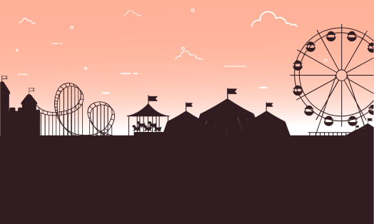
(c) A group of 14 Youth Club members want to go to a Theme Park.
Theme Park
Five of the members are 15 years old.
The rest of the members are younger than 15 years old.
How much money does the group save by going to the theme park on a weekend rather than on a weekday?
Tickets Monday–Friday:
15 years and over: £37
Under 15s: £25
15% off
on the weekend!
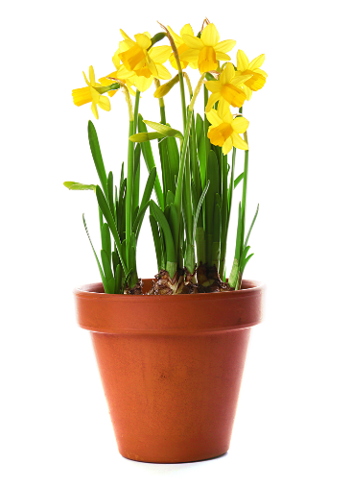

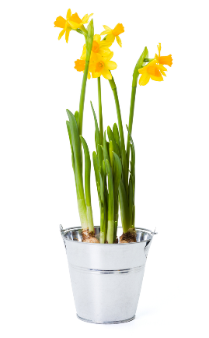
(d)
Marjorie spent £20 on daffodils. She received 50p in change.
She bought 10 small pots of daffodils.
The large pots of daffodils were 25% more expensive to buy than the small pots of daffodils.
How many large pots of daffodils did she buy?
You must show all of your calculations.
Large pot of daffodils
£
Small pot of daffodils
£1.20

Exercise 28 (calculator allowed)
13
In all of the following questions, you will be assessed on the quality of your organisation, communication and accuracy in your writing.
(a) Two car rental companies have the following deals available for renting the same model of car.
Just Go Cars
£32 per day
18p per mile
VAT of 20% to be added
Speedy Wheels
£68 per day
No charge for mileage
Includes VAT
Special offer: $\frac{1}{4}$ off
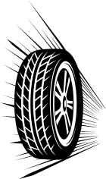



Dylan wants to rent a car for 7 days. He plans to drive 500 miles.
Which company should Dylan choose to get the cheapest bargain?
(b) Bethan’s current annual salary is £30,000. After tax and other deductions, she receives 70% of this salary. Over one year, her job means that she travels 8,000 miles. Her car travels at 40 miles per gallon, and a gallon of petrol costs £6.25.
Bethan is considering a new job, working from home. Her new salary would be $\frac{2}{3}$ of her current salary, with the same percentage of deductions.
Calculate the difference, in monetary terms, that changing job would have. You must show all of your calculations.
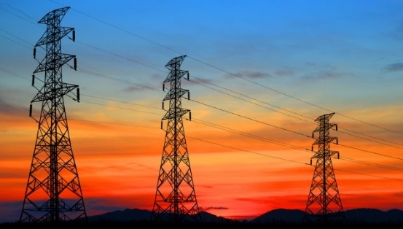
(c) Here is the cost of buying electricity from North Electricity.
- A fixed charge of 28p per day.
- An energy charge of 14p for every kWh used.
- VAT of 5% to pay on the total cost.
Evan uses 850 kWh of electricity over a period of 90 days. Calculate the total bill for Evan to purchase electricity from North Electricity.
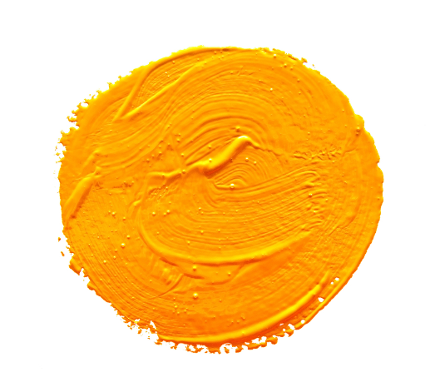
(d) A paint colour called ochre is made by using a recipe that includes white, red, blue and yellow paint. The percentages of each different colour used to create ochre paint is shown on the right.
Recipe for ochre paint
White 90%
Red 5%
Blue 3%
Yellow 2%
Catrin has already bought 2.5 litres of blue paint.
She decides to buy white, red and yellow paint to use with all of her blue paint to make as much ochre paint as possible.
The sizes of paint tins available are 1 litre, 2.5 litres and 10 litres.
Only full tins of paint can be purchased.
Catrin only has a small shed to store the paint, therefore she wants minimal white, red and yellow paint left over.
Calculate how much of each paint colour Catrin needs to buy. You must show all of your calculations.

Mark Schemes
After you complete your exam, the paper is sent away to be marked. The markers follow a mark scheme for the exam paper, which uses the following codes for the marks.
Code | Explanation
M | ‘M' marks are awarded for any correct method applied to appropriate working,  even though a numerical error may be involved. Once earned they cannot be lost.
m | ‘m’ marks are dependent method marks. They are only given if the relevant previous ‘M’ mark has been earned.
A | ‘A' marks are given for a numerically correct stage, for a correct result or for an answer lying within a specified range. They are only given if the relevant M/m mark has been earned either explicitly or by inference from the correct answer.
B | 'B' marks are independent of method and are usually awarded for an accurate result or statement.
S | ‘S’ marks are awarded for strategy.
E | ‘E’ marks are awarded for explanation.
U | ‘U’ marks are awarded for units.
P | ‘P’ marks are awarded for plotting points.
C | ‘C’ marks are awarded for drawing curves.
Exercise 29
A
Here is a past paper question together with its mark scheme.
Mark the four attempts using the mark scheme.

Question
Megan has some blocks. 10% of the blocks are white. $\frac{3}{5}$ of the blocks are red. The remaining blocks are green.
33 blocks are green. How many blocks are there in total? [5 marks]

Mark Scheme
White 10%  Red 60% OR 0.6 OR $\frac{6}{10}$  Green 100% – 10% – 60%  Green = 30% OR 0.3 OR $\frac{3}{10}$  30% of the blocks is 33 (blocks).  100% of the blocks is 110 (blocks). | B1  M1  A1  M1  A1 | Must use a common measure, i.e. percentages or fractions or decimals.  Follow through ‘their 30%’.
Candidate 1 Candidate 2
..................................................................................................................... ......................................................................................................................................
..................................................................................................................... ......................................................................................................................................
..................................................................................................................... ......................................................................................................................................
..................................................................................................................... ......................................................................................................................................
..................................................................................................................... ......................................................................................................................................
..................................................................................................................... ................. ....................................................................................................................
..................................................................................................................... ......................................................................................................................................
Candidate 3 Candidate 4
..................................................................................................................... ......................................................................................................................................
..................................................................................................................... ......................................................................................................................................
..................................................................................................................... ......................................................................................................................................
..................................................................................................................... ......................................................................................................................................
..................................................................................................................... ......................................................................................................................................
..................................................................................................................... ......................................................................................................................................
..................................................................................................................... ......................................................................................................................................

Timing
It’s a good idea to complete any maths exam paper at a rate of one mark per minute. This way, you will have time left over at the end to check your answers.
Foundation Tier | Higher Tier
Units 1 and 2: 65 marks in 90 minutes.  Unit 3: 75 marks in 105 minutes.  Working at a rate of one mark per minute, there will be 25-30 minutes left over at the end to check your answers. | Units 1 and 2: 80 marks in 105 minutes.  Unit 3: 90 marks in 120 minutes.  Working at a rate of one mark per minute, there will be 25-30 minutes left over at the end to check your answers.
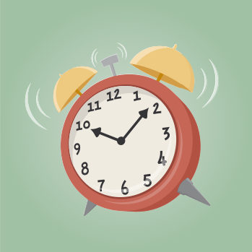
What should you do if you have time left over at the end of an exam?
- Check there are no gaps in your exam paper.
- Make sure you have included the correct units, e.g. £, cm², ml.
- Make sure you have shown enough method.
- Make sure you have used the correct equipment, e.g. a ruler for drawing diagrams.
- Attempt to redo the question, perhaps using a different method, to check your answer.

Exercise 30
A
The following six questions are worth a total of 20 marks. Attempt to complete these in
only 25 minutes. Mark the questions using the mark scheme provided by your teacher.
(1) What fraction of the following shape is shaded? Give your answer in its simplest form. [2]
(2) You will be assessed on the quality of your organisation, communication and [5]
accuracy in writing in this question.
Gwilym bought a camera for £150.
When he sold the camera, he made a loss of 6%.
How much did Gwilym sell his camera for?
(3) The number in the circle is equal to the two numbers in the squares on either side of the circle. [3]
Fill in the missing numbers.
4.5

7.3

1.9

(4) Evaluate $\frac{3}{8}+\frac{1}{2}$. [2]
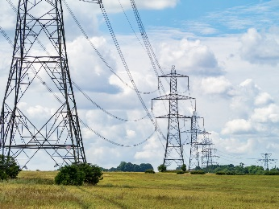
(5) New pylons are needed in an area in Wales. [3]

- The pylons are in a straight line.
- The distance between the first pylon and the last pylon is 9 km.
- The pylons must be 0.5 km apart from each other.
How many pylons, in total, are needed for a 9 km piece of land?
(6) Maria sells ribbon. [5]
The length of the ribbon she has is 400 cm.
Maria cuts off 30% of the ribbon and sells this piece to a customer.
She uses $\frac{2}{5}$ of the leftover ribbon to decorate a card.
Then, Maria cuts the leftover ribbon into three equal pieces.
What is the length of each of the three pieces that are left over?

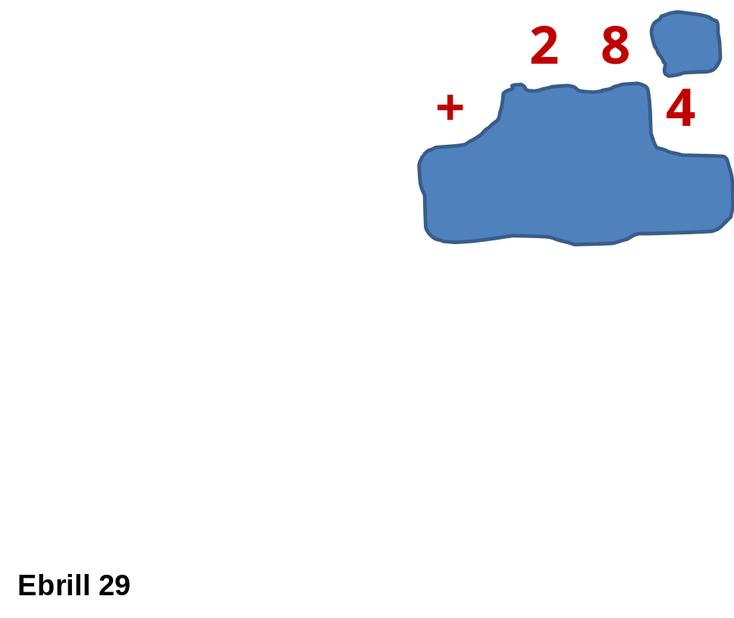
Challenge!
Ink is spilled onto a sum in a textbook.
All of the digits from 0 to 9 have been used in the sum.
Find the correct locations for the other 7 digits.
Key words | Corrections | I am happy with... | I need to revise...


Name: ............................................  Percentage in the test: .................. |   I know this. |   I need to revise this. | Question in the test  Without a calculator  With a calculator | Correct in the test?
I can calculate using fractions, e.g. $\frac{3}{11}+\frac{5}{11}$, $\frac{7}{9}-\frac{1}{3}$, $\frac{2}{3}×\frac{5}{7}$, $\frac{4}{5}÷\frac{2}{9}$. |  |  | 1
I can calculate using percentages, e.g. 10% of £75, 45% of 140. |  |  | 5
I can calculate using decimals, e.g. 6.5 + 2.79, 6 – 4.31,  0.4 × 0.3, 14.4 ÷ 6. |  |  | 1
I know how to use the dot notation for recurring decimals. |  |  | 2
I know how to decide whether a fraction is equivalent to a terminating decimal or to a recurring decimal.
I can convert a percentage to a decimal. |  |  | 3, 4
I can convert a percentage to a fraction. |  |  | 3, 4
I can convert a fraction to a decimal. |  |  | 2, 3, 4
I can convert a fraction to a percentage. |  |  | 3, 4
I can convert a decimal to a percentage. |  |  | 3, 4
I can convert a terminating decimal to a fraction. |  |  | 3, 4
I can calculate percentage changes efficiently.
I can calculate repeated percentage changes efficiently.
I can calculate compound interest efficiently.
I can calculate fractional changes efficiently.
I know how to answer a question where you are “assessed on the quality of your organisation, communication and accuracy in your writing”. |  |  | 6, 7

