


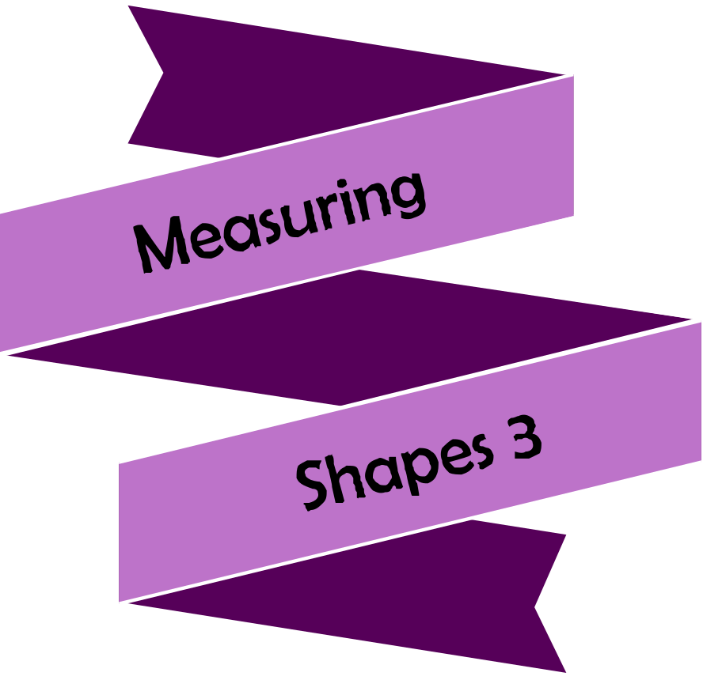


Activity | Page
Quiz 1 | 3
Example–Problem Pair 1 | 4–5
Quiz 2 | 6
Venn Diagram Challenge 1 | 7
Example–Problem Pair 2 | 8–9
Quiz 3 | 10
Looking for the Angles | 11
Example–Problem Pair 3 | 12–13
Quiz 4 | 14
Venn Diagram Challenge 2 | 15
Example–Problem Pair 4 | 16–17
Quiz 5 | 18
Enlarging the Triangle | 19



1) $6^{0}=$ | 2) $2^{5}×2^{8}=$ | 3) $\frac{3^{15}}{3^{5}}=$
4) $4^{-2}=$ | 5) ${25}^{\frac{1}{2}}=$ | 6) ${\left(6^{7}\right)}^{3}=$
7) $6a^{2}b^{3}×2a^{4}b^{5}$ $=$ | 8) $9c^{8}d^{6}÷3c^{2}d^{2}$ $=$ | 9) $9^{6}×9^{2}÷9^{4}=$





6 cm
7 cm
5 cm
Calculate the perimeter and area of the trapezium below.
8 cm
6 cm




5 cm
6 cm
4 cm
5 cm
9 cm
Calculate the perimeter and area of the trapezium below.


$$x$$
$$y$$
$$x$$
$$y$$
$$x$$
$$y$$
1) Round off 3.8257 to one decimal place. | 2) Round off 3.8257 to two decimal places. | 3) Round off 3.8257 to three decimal places.
4) How many pence are in £1? | 5) If £1 = €1.20 how much is £10 worth in Euros? | 6) If £1 = €1.20 how much is €6 worth in pounds?
7) Draw the line $x=2$. | 8) Draw the line $y=-2$. | 9) Draw the line $y=x$.




Think of a number of the form $p^{q}$ that could fit into each region. If you think a region is impossible to fill, explain why!
D
The answer is a whole number
The index $q$ is a fraction
D
C
B
A
C
A
B
$$ε$$


$$y$$
$$x$$

Draw the line $y=2x-3$.


$$y$$
$$x$$
Draw the line $y=3x-2$.



G
5 cm
5 cm
6 cm
8 cm
10 cm
6 cm
8 cm
10 cm
5 cm
5 cm
1) Calculate the area of the shape. | 2) Calculate the perimeter of the shape. | 3) What is the gradient of the line $y=5x+2$?
4) Calculate the area of the shape. | 5) Calculate the perimeter of the shape. | 6) What is the gradient of the line $y=-4x+6$?
7) Complete the formula:  Speed  = | 8) Add North-east to the compass. | 9) What is the $y$–intercept of the line  $y=-3x+5$?


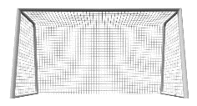
30°
72°

How many angles can you find in the following diagram?



Draw a frequency polygon for the following data showing the height of 18 plants.
Height, h cm | Frequency
0 ⩽ h < 10 | 3
10 ⩽ h < 20 | 5
20 ⩽ h < 30 | 6
30 ⩽ h < 40 | 4



Draw a frequency polygon for the following data showing the height of 18 plants.
Height, h cm | Frequency
0 ⩽ h < 10 | 5
10 ⩽ h < 20 | 4
20 ⩽ h < 30 | 6
30 ⩽ h < 40 | 3


$$x$$
$$y$$
$$x$$
$$y$$
$$x$$
$$y$$
1) Write the number 4,350,000 in standard form. | 2) Write the number 0.0002839 in standard form. | 3) ${36}^{\frac{1}{2}}=$
4) Write $4.3×{10}^{4}$ as an ordinary number. | 5) Write $7.25×{10}^{-2}$ as an ordinary number. | 6) $2^{-3}=$
7) What is the equation of the line? | 8) What is the equation of the line? | 9) What is the equation of the line?



Negative $x-$intercept

Positive gradient
Positive $y-$intercept
$$ε$$
E
F
H
D
G
CF
B
A

Think of an equation for a straight line that could fit into each region. If you think a region is impossible to fill, explain why!
A
B
CF
D
E
F
G
H


$$x$$
$$y$$
Plot the graph for $y=x^{2}-4x+3$.

$$x$$ | –5 | –4 | –3 | –2 | –1 | 0 | 1 | 2 | 3 | 4 | 5
$$y$$ | 48 | 35 | 24 |  | 8 | 3 | 0 | –1 | 0 |  | 8



$$x$$
$$y$$
$$x$$ | –5 | –4 | –3 | –2 | –1 | 0 | 1 | 2 | 3 | 4 | 5
$$y$$ | –4 | –8 | –10 |  | –8 | –4 | 2 | 10 | 20 |  | 46

Plot the graph for $y=x^{2}+5x-4$.


1) 4 – –6 | 2) Write the time 10:45pm in the 24-hour clock. | 3) What type of angle is the angle 95°?
4) The mean of  6, 1, 8, 5. | 5) The range of  6, 1, 8, 5. | 6) The median of  6, 1, 8, 5.
7) 8.9 ÷ 100 | 8) 20% of £90 | 9) Write the fraction $\frac{2}{5}$ as a decimal.

108°
126°
Siart cylch i ddangos hoff flas creision dysgwyr Ysgol B
Plaen
Halen a Finegr
Caws a Nionyn
Coctel Corgimwch
4) Dywedodd Dion “Mae mwy o bobl yn hoffi creision caws a nionyn yn Ysgol A nac yn Ysgol B”. Ydy Dion yn gywir? Eglurwch eich ateb.




1) The green triangle is an enlargement of the yellow triangle. What is the scale factor? | 2) Where is the centre of enlargement?
3) What is the area of the green triangle? | 4) Calculate the perimeter of the yellow triangle.


$$y$$
$$x$$

Evaluating the Workbook





Notes





@minutemaths314 /adolygumathemateg
/mathscreuddyn www.mathemateg.com

