




Version
3.0
08/2025

Chapter | Mathematics | Page Number
Simple Factorising | Reversing Expansion. Simple Factorising.  More than one Variable. | 3
Factorising Quadratic Expressions | Preparation. Factorising Quadratic Expressions of the form $x^{2}+ax+b$. Solving Quadratic Equations through Factorising. Factorising Quadratic Expressions of the form $ax^{2}+bx+c$. The Difference of Two Squares. | 6
Simultaneous Equations | Multiplying Equations. Subtracting Equations. Multiplying Equations to obtain Equal Coefficients. Solving Linear Equations. Solving Simultaneous Equations. | 14
Changing the Subject | Re-arranging formulae. | 19
Expression, Equation, Formula, Identity | Recognising expressions, equations, formulae and identities. Proving identities. | 21

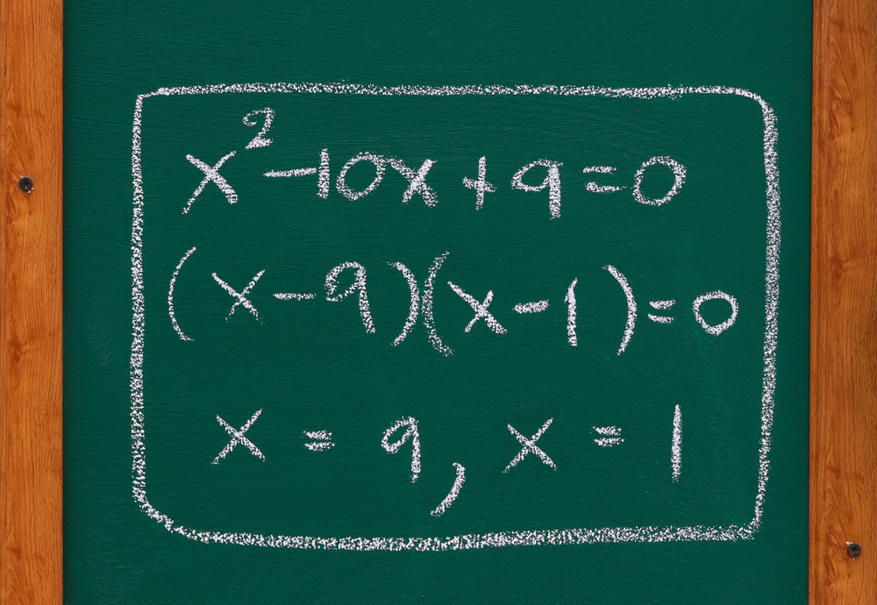


Reversing Expansion
Like subtraction reverses addition, and division reverses multiplication, factorising reverses
expanding brackets, a technique seen previously in the Developing Algebra workbook.
Exercise 1
A
Expand the following algebraic expressions.
(a) $2(x+3)$ (b) $5(x+3)$ (c) $5(x-3)$
(d) $5(3-x)$ (e) $2(y+3)$ (f) $2(x+3+y)$
(g) $x(x+3)$ (h) $x(3+x)$ (i) $2x(x+3)$
(j) $5x(x+3)$ (k) $5x(2x+3)$ (l) $2x(5x-3)$
(m) $4(x-7)$ (n) $y(y+9)$ (o) $2z(z+4)$
(p) $7x(3x+4)$ (q) $-7x(3x+4)$ (r) $-7x(3x-4)$
Expanding gets rid of brackets, whereas factorising reintroduces brackets. Also, whilst expanding using multiplication sums, factorising uses division sums. To this intent, an important skill when factorising is to recognise the highest common factor of a set of numbers, which is the largest number that divides into the list of numbers.
Exercise 2
What is the highest common factor of the following numbers?
(a) 6 and 8 (b) 12 and 15 (c) 20 and 30 (d) 20 and 40 (e) 18 and 24
(f) 16 and 40 (g) 22 and 33 (h) 24 and 36 (i) 35 and 56 (j) 36 and 54
(k) 12, 14 and 16 (l) 12, 16 and 20 (m) 25, 35 and 45 (n) 30, 45 and 60 (o) 7, 11 and 13
In order to factorise an algebraic expression such as $12x+18$, we start by considering the highest common factor of the terms $12x$ and $18$ in the expression.
Example
Factorise $12x+18$.
1. “What is the highest common factor of $12x$ and $18$?” The answer is $6$, therefore we write $6$ followed by a pair of brackets. | 2. “$6$ multiplied by what gives $12x$?” $6$ multiplied by $2x$ is $12x$, therefore we write $2x$ inside the brackets. | 3. “$6$ multiplied by what gives $18$?” $6$ multiplied by $3$ gives $18$, therefore we write $+ 3$ inside the brackets.
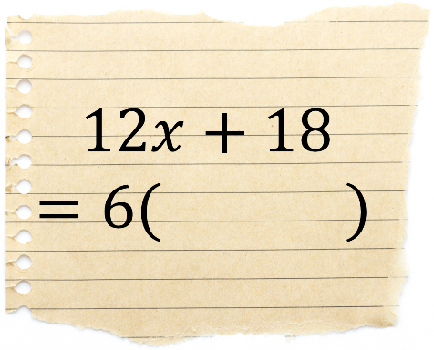 | 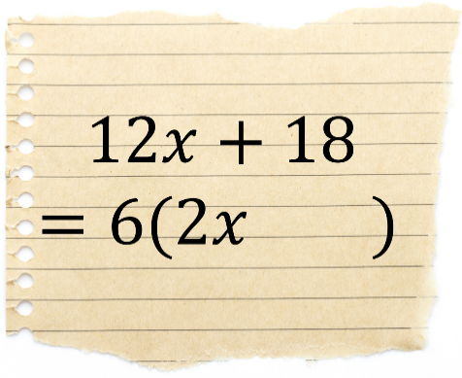 | 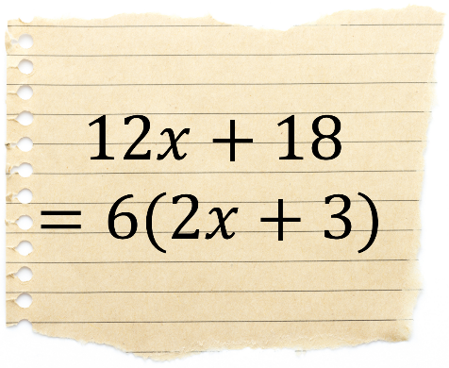

Exercise 3
2
Factorise the following algebraic expressions.
(a) $4x+6$ (b) $6+4x$ (c) $4x-6$
(d) $6-4x$ (e) $4x+8$ (f) $4z+8$
(g) $6x+8$ (h) $6x+12$ (i) $12-6x$
(j) $9x+21$ (k) $25x+30$ (l) $18x+30$
(m) $14x+21$ (n) $28+14x$ (o) $30x-40$
(p) $24y+36$ (q) $60x+80$ (r) $36x+45$
(s) $36x+54$ (t) $33y-55$ (u) $33y-66$
(v) $45+30x$ (w) $300x+500$ (x) $80z-240$
(y) $2x+4y+6$ (z) $5x+10y+20$ (α) $12x-20y+24$
Not all algebraic expressions can be factorised. For example, $5x+7$ cannot be factorised since the highest common factor of $5x$ and $7$ is $1$. (We don’t factorise $5x+7$ as $1(5x+7)$.)

Exercise 4
Factorise all of the algebraic expressions that do factorise, and note which expressions do not factorise.
(a) $5x+10$ (b) $5x+11$ (c) $5x+5$
(d) $16x$ (e) $16x+2$ (f) $16x+9$
(g) $8y-12$ (h) $8y-13$ (i) $8y-14$
When factorising, it’s not just numbers that can appear before the first bracket – we can include variables like $x$ too.
Example
Factorise $6x^{2}+14x$.
1. “What is the highest common factor of $6x^{2}$ and $14x$?” The answer is $2x$, therefore we write $2x$ followed by a pair of brackets. | 2. “$2x$ multiplied by what gives $6x^{2}$?” $2x$ multiplied by $3x$ is $6x^{2}$, therefore we write $3x$ inside the brackets. | 3. “$2x$ multiplied by what gives $14x$?” $2x$ multiplied by $7$ gives $14x$, therefore we write $+ 7$ inside the brackets.
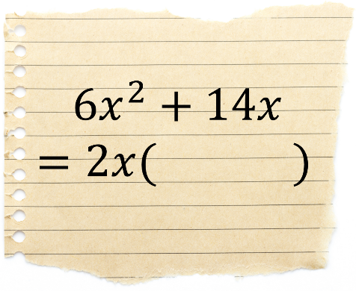 | 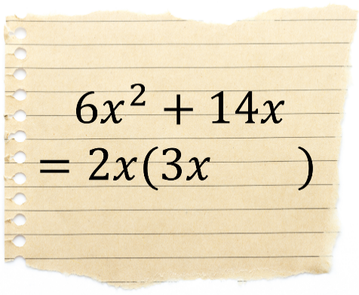 | 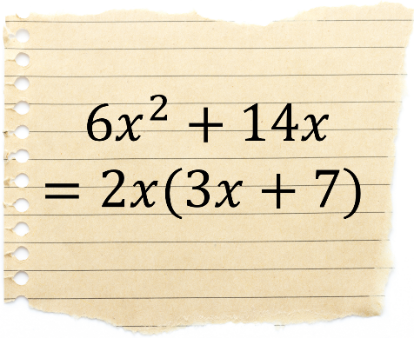
Exercise 5
What is the highest common factor of the following terms?
(a) $4x^{2}$ and $18x$ (b) $4x^{2}$ and $16x$ (c) 5$x^{2}$ and $20x$ (d) $5x^{2}$ and $7x$ (e) $18x^{2}$ and $24x$
(f) $x^{2}$ and $x$ (g) $x^{3}$ and $x^{2}$ (h) $4x^{3}$ and $18x^{2}$ (i) $9x^{4}$ and $3x^{2}$ (j) $12x^{4}$ and $15x^{3}$
Exercise 6
2
Factorise the following algebraic expressions.
(a) $3x^{2}+6x$ (b) $6x+3x^{2}$ (c) $3x^{2}-6x$
(d) $x^{2}+x$ (e) $x^{3}+x$ (f) $x^{3}+x^{2}$
(g) $4x^{2}+2x$ (h) $2x^{3}-6x$ (i) $2x^{3}+8x^{2}$
(j) $12x^{2}+4x$ (k) $4x-12x^{2}$ (l) $10x^{2}+15x$
(m) $6x^{4}+9x^{2}$ (n) $24y^{3}-16$ (o) $21z^{2}+14z$
(p) $3x^{2}+5x$ (q) $7y-11y^{2}$ (r) $4z^{3}+17z^{2}$
(s) $22x^{2}+33x^{5}$ (t) $12n-4n^{2}$ (u) $2a+a^{2}$
(v) $x^{6}+6x$ (w) $x^{6}+6x^{2}$ (x) $6x^{6}+4x^{4}$
(y) $2x^{3}+4x^{2}+6x$ (z) $2x^{2}+4x+6$ (α) $42x^{4}-30x^{2}+12x^{3}$
Exercise 7

What is the highest common factor of the following terms?
(a) $x^{2}$ and $xy$ (b) $4x^{2}$ and $6xy$ (c) 12$x^{2}y$ and $16xy$ (d) $5x^{2}y^{2}$ and $9y^{2}$ (e) $18x^{3}y$ and $12x^{2}y$
Example
$2x^{2}y+4x=2x(xy+2)$ $30y^{3}z^{2}-24y^{2}z=6y^{2}z(5yz-4)$
Exercise 8
Factorise the following algebraic expressions.
(a) $xy+x$ (b) $4xy+10y$ (c) $x^{2}y+5xy$
(d) $2x^{2}y+6xy$ (e) $10yz+5{yz}^{2}$ (f) $12x^{2}y-4x$
(g) $x^{2}+xy^{2}$ (h) $16x^{3}z-12z^{2}$ (i) $15x^{4}y+25x^{2}y^{2}$
(j) $x^{2}yz+4xyz$ (k) $8ab^{2}c^{3}-18abc^{2}$ (l) $26πx^{2}+65πx$
Key words | Corrections | I am happy with... | I need to revise...

As we saw in the previous chapter, factorising and expanding are two sides of the same coin.
$5(3x-7)$
Factorising

Expanding
$15x-35$

Our aim in this chapter is to develop our understanding of factorising to be able to factorise quadratic expressions.

Preparation
To be able to factorise quadratic expressions, we must develop the following skill: given two numbers, for example 7 and 10, is it possible to find two numbers that add to make 7 and multiply to make 10?
$\boxed{⋰} + \boxed{⋰} =7$
$\boxed{⋰} × \boxed{⋰} =10$
In this case, the numbers we are looking for are 2 and 5, since 2 + 5 = 7, and 2 × 5 = 10.
Exercise 9
A
Find a pair of numbers that satisfy the following calculations.
(a) $\boxed{⋰} + \boxed{⋰} =10$ (b) $\boxed{⋰} + \boxed{⋰} =11$ (c) $\boxed{⋰} + \boxed{⋰} =14$ (d) $\boxed{⋰} + \boxed{⋰} =25$
(a) $\boxed{⋰} × \boxed{⋰} =24$ (b) $\boxed{⋰} × \boxed{⋰} =24$ (c) $\boxed{⋰} × \boxed{⋰} =24$ (d) $\boxed{⋰} × \boxed{⋰} =24$
(e) $\boxed{⋰} + \boxed{⋰} =9$ (f) $\boxed{⋰} + \boxed{⋰} =11$ (g) $\boxed{⋰} + \boxed{⋰} =8$ (h) $\boxed{⋰} + \boxed{⋰} =17$
(e) $\boxed{⋰} × \boxed{⋰} =18$ (f) $\boxed{⋰} × \boxed{⋰} =18$ (g) $\boxed{⋰} × \boxed{⋰} =16$ (h) $\boxed{⋰} × \boxed{⋰} =16$
(i) $\boxed{⋰} + \boxed{⋰} =13$ (j) $\boxed{⋰} + \boxed{⋰} =17$ (k) $\boxed{⋰} + \boxed{⋰} =8$ (l) $\boxed{⋰} + \boxed{⋰} =7$
(i) $\boxed{⋰} × \boxed{⋰} =30$ (j) $\boxed{⋰} × \boxed{⋰} =30$ (k) $\boxed{⋰} × \boxed{⋰} =12$ (l) $\boxed{⋰} × \boxed{⋰} =12$
(m) $\boxed{⋰} + \boxed{⋰} =15$ (n) $\boxed{⋰} + \boxed{⋰} =11$ (o) $\boxed{⋰} + \boxed{⋰} =5$ (p) $\boxed{⋰} + \boxed{⋰} =2$
(m) $\boxed{⋰} × \boxed{⋰} =14$ (n) $\boxed{⋰} × \boxed{⋰} =28$ (o) $\boxed{⋰} × \boxed{⋰} =4$ (p) $\boxed{⋰} × \boxed{⋰} =1$
(q) $\boxed{⋰} + \boxed{⋰} =13$ (r) $\boxed{⋰} + \boxed{⋰} =23$ (s) $\boxed{⋰} + \boxed{⋰} =17$ (t) $\boxed{⋰} + \boxed{⋰} =43$
(q) $\boxed{⋰} × \boxed{⋰} =42$ (r) $\boxed{⋰} × \boxed{⋰} =42$ (s) $\boxed{⋰} × \boxed{⋰} =42$ (t) $\boxed{⋰} × \boxed{⋰} =42$
(u) $\boxed{⋰} + \boxed{⋰} =32$ (v) $\boxed{⋰} + \boxed{⋰} =16$ (w) $\boxed{⋰} + \boxed{⋰} =19$ (x) $\boxed{⋰} + \boxed{⋰} =17$
(u) $\boxed{⋰} × \boxed{⋰} =60$ (v) $\boxed{⋰} × \boxed{⋰} =60$ (w) $\boxed{⋰} × \boxed{⋰} =60$ (x) $\boxed{⋰} × \boxed{⋰} =60$

(y) $\boxed{⋰} + \boxed{⋰} =16$ (z) $\boxed{⋰} + \boxed{⋰} =24$ (α) $\boxed{⋰} + \boxed{⋰} =29$ (β) $\boxed{⋰} + \boxed{⋰} =36$
(y) $\boxed{⋰} × \boxed{⋰} =55$ (z) $\boxed{⋰} × \boxed{⋰} =80$ (α) $\boxed{⋰} × \boxed{⋰} =100$ (β) $\boxed{⋰} × \boxed{⋰} =99$
Challenge!
(a) $\boxed{⋰} + \boxed{⋰} =27$ (b) $\boxed{⋰} + \boxed{⋰} =19$ (c) $\boxed{⋰} + \boxed{⋰} =22$ (d) $\boxed{⋰} + \boxed{⋰} =39$
(a) $\boxed{⋰} × \boxed{⋰} =72$ (b) $\boxed{⋰} × \boxed{⋰} =84$ (c) $\boxed{⋰} × \boxed{⋰} =96$ (d) $\boxed{⋰} × \boxed{⋰} =360$
Factorising Quadratic Expressions of the form $x^{2}+ax+b$


In the previous Developing Algebra workbook, we saw how to expand double brackets, for example $(x+2)(x+5)$, using the acronym FOIL, or by using a multiplication grid.
Question: $(x+2)(x+5)$
 | $x$ | $2$
$x$ | $x^{2}$ | $2x$
$5$ | $5x$ | $10$
Answer: $x^{2}+2x+5x+10$Answer: $=x^{2}+7x+10$
$$(x+2)(x+5)$$
$$=x^{2}+5x+2x+10 \\ =x^{2}+7x+10$$
Exercise 10
Expand the following algebraic expressions.
2
(a) $(x+3)(x+5)$ (b) $(x+2)(x+8)$ (c) $(x-2)(x+6)$
(d) $(x-4)(x-5)$ (e) $(y+1)(y+3)$ (f) $(x+9)(x-3)$
Let us now look at the reverse process of factorising the quadratic expression $x^{2}+7x+10$, and
finishing with the double bracket $(x+2)(x+5)$.


Example
Factorise the quadratic expression $x^{2}+7x+10$.
Answer: We need to consider the following question: ‘Which two numbers add to make 7
(the coefficient of the $x$ term) and multiply to make 10 (the constant)?’.
Add | Multiply
7 | 10
The answer is 2 and 5, since 2 + 5 = 7, and 2 × 5 = 10. Therefore, $x^{2}+7x+10$ factorises to give $(x+2)(x+5)$.
Exercise 11
Factorise the following algebraic expressions.
(a) $x^{2}+6x+8$ (b) $x^{2}+7x+12$ (c) $x^{2}+8x+12$
(d) $x^{2}+8x+15$ (e) $x^{2}+16x+15$ (f) $x^{2}+2x+1$
(g) $x^{2}+11x+18$ (h) $x^{2}+9x+18$ (i) $x^{2}+19x+18$
(j) $x^{2}+12x+20$ (k) $x^{2}+9x+20$ (l) $x^{2}+21x+20$
(m) $x^{2}+18x+32$ (n) $x^{2}+12x+32$ (o) $x^{2}+33x+32$
(p) $x^{2}+11x+24$ (q) $x^{2}+25x+24$ (r) $x^{2}+10x+24$
(s) $x^{2}+14x+33$ (t) $x^{2}+15x+36$ (u) $x^{2}+16x+39$
(v) $x^{2}+17x+42$ (w) $x^{2}+26x+48$ (x) $x^{2}+15x+50$
(y) $x^{2}+16x+60$ (z) $x^{2}+19x+60$ (α) $x^{2}+23x+60$

Exercise 12
2
Factorise the following algebraic expressions.
(a) $x^{2}+10x+25$ (b) $x^{2}+25+10x$ (c) $25+10x+x^{2}$
(d) $x^{2}+40+14x$ (e) $40+13x+x^{2}$ (f) $22x+40+x^{2}$
Example
Factorise the following algebraic expressions.
(a) $x^{2}+2x-15$ (b) $x^{2}-2x-15$ (c) $x^{2}-8x+15$
Add | Multiply
2 | –15

Add | Multiply
–2 | –15

Add | Multiply
–8 | 15

(a) $\boxed{-3} + \boxed{5} =2$ (b) $\boxed{-5} + \boxed{3} =-2$ (c) $\boxed{-3} + \boxed{-5} =-8$
(a) $\boxed{-3} × \boxed{5} =-15$ (b) $\boxed{-5} × \boxed{3} =-15$ (c) $\boxed{-3} × \boxed{-5} =15$
(a) $x^{2}+2x-15=(x-3)(x+5)$ (b) $x^{2}-2x-15=(x-5)(x+3)$ (c) $x^{2}-8x+15=(x-3)(x-5)$
Exercise 13
Factorise the following algebraic expressions.
(a) $x^{2}+4x-12$ (b) $x^{2}-4x-12$ (c) $x^{2}+x-12$
(d) $x^{2}-x-12$ (e) $x^{2}+23x-24$ (f) $x^{2}-23x-24$
(g) $x^{2}+10x-24$ (h) $x^{2}-10x-24$ (i) $x^{2}+5x-24$
(j) $x^{2}-5x-24$ (k) $x^{2}+2x-24$ (l) $x^{2}-2x-24$
(m) $x^{2}+39x-40$ (n) $x^{2}-39x-40$ (o) $x^{2}+18x-40$
(p) $x^{2}-18x-40$ (q) $x^{2}+6x-40$ (r) $x^{2}-6x-40$
(s) $x^{2}+3x-40$ (t) $x^{2}-3x-40$ (u) $x^{2}+4x-32$
(v) $x^{2}-4x-32$ (w) $x^{2}-14x-32$ (x) $x^{2}+14x-32$
(y) $x^{2}-31x-32$ (z) $x^{2}+31x-32$ (α) $x^{2}-2x-8$
Exercise 14
Factorise the following algebraic expressions.
(a) $x^{2}-7x+12$ (b) $x^{2}-8x+12$ (c) $x^{2}-13x+12$
(d) $x^{2}-10x+24$ (e) $x^{2}-11x+24$ (f) $x^{2}-25x+24$
(g) $x^{2}-14x+40$ (h) $x^{2}-13x+40$ (i) $x^{2}-22x+40$
(j) $x^{2}-33x+32$ (k) $x^{2}-12x+32$ (l) $x^{2}-18x+32$
(m) $x^{2}-5x+6$ (n) $x^{2}-6x+9$ (o) $x^{2}-11x+18$
Challenge!
Factorise the following algebraic expressions.
(a) $x^{2}+4x-96$ (b) $x^{2}-5x-84$ (c) $x^{2}+x-240$
Exercise 15
2
Factorise the following algebraic expressions.
(a) $x^{2}+8x+16$ (b) $x^{2}-8x+16$ (c) $x^{2}+10x+16$
(d) $x^{2}-10x+16$ (e) $x^{2}+6x-16$ (f) $x^{2}-6x-16$
(g) $x^{2}+17x+16$ (h) $x^{2}+15x-16$ (i) $x^{2}-17x+16$
(j) $x^{2}+11x+28$ (k) $x^{2}+16x+28$ (l) $x^{2}+29x+28$
(m) $x^{2}-11x+28$ (n) $x^{2}-12x-28$ (o) $x^{2}+27x-28$
(p) $x^{2}-3x-28$ (q) $x^{2}-16x+28$ (r) $x^{2}-27x-28$
(s) $x^{2}+7x+10$ (t) $x^{2}+11x+10$ (u) $x^{2}-7x+10$
(v) $x^{2}+9x-10$ (w) $x^{2}-9x-10$ (x) $x^{2}-11x+10$
(y) $x^{2}+x-20$ (z) $x^{2}-8x-20$ (α) $x^{2}-21x+20$
Solving Quadratic Equations through Factorising
Example
Solve the quadratic equation $x^{2}+6x+8=0$.
Step 1: Factorise. Step 2: Solve.
$x^{2}+6x+8=0$
$\left(x+2\right)\left(x+4\right)=0$
Either $x+2=0$ or $x+4=0$
$x=-2$ $x=-4$
Add | Multiply
6 | 8


$\boxed{2} + \boxed{4} =6$
$\boxed{2} × \boxed{4} =8$
(a) $x^{2}+6x+8=\left(x+2\right)(x+4)$
Exercise 16
Solve the following quadratic equations.
(a) $x^{2}+5x+6=0$ (b) $x^{2}+9x+14=0$ (c) $x^{2}+12x+27=0$
(d) $x^{2}-5x+6=0$ (e) $x^{2}-9x+14=0$ (f) $x^{2}-12x+27=0$
(g) $x^{2}+x-6=0$ (h) $x^{2}-5x-14=0$ (i) $x^{2}+6x-27=0$
(j) $x^{2}-x-6=0$ (k) $x^{2}+5x-14=0$ (l) $x^{2}-6x-27=0$
(m) $x^{2}+7x+6=0$ (n) $x^{2}-15x+14=0$ (o) $x^{2}-26x-27=0$
(p) $x^{2}-5x-6=0$ (q) $x^{2}+13x-14=0$ (r) $x^{2}+26x-27=0$
Exercise 17
Wilf thinks of a number, $x$.
His sister says that if Wilf subtracts 6 from his number and then multiplies this new number with the number he first thought of, he will get an answer of –5.
Use this information to do the following.
(a) Form a quadratic equation of the form $x^{2}+ax+b=0$.
(b) Solve the equation to find the possible values of $x$.


Factorising Quadratic Expressions of the form $ax^{2}+bx+c$
Example
Factorise the quadratic expression $2x^{2}+11x+12$.

Method 1: The Splitting Method
1. Multiply $2$ (the coefficient of the $x^{2}$ term) by $12$ (the constant) to obtain $24$. We must look for a pair of numbers that add to give $11$ (the coefficient of the $x$ term) and multiply to give $24.$ | 2. The numbers which work are $3$ and $8$. We rewrite the question by splitting the $11x$ to be $3x$ add 8$x.$ | 3. We split the four terms into two halves and factorise the first half.
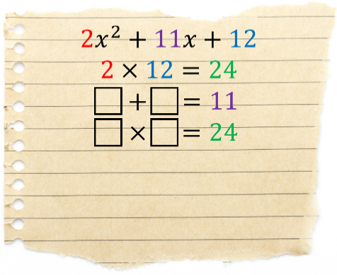 | 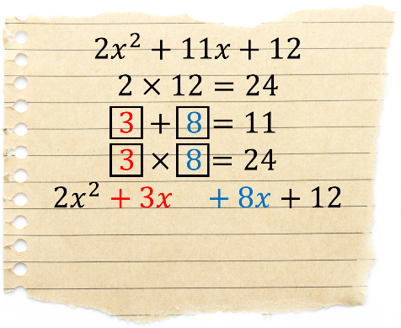 | 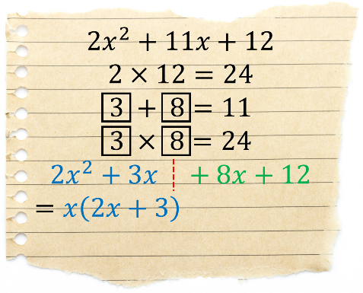
4. We copy the brackets, leaving a space between the old brackets and the new brackets. | 5. $+ 4$ must appear in the space, since $4$ multiplied by $2x$ is $8x,$and $4$ multiplied by $3$ is $12$. | 6. The expression has a common factor of $2x+3$, therefore we factorise this out to leave the final answer.
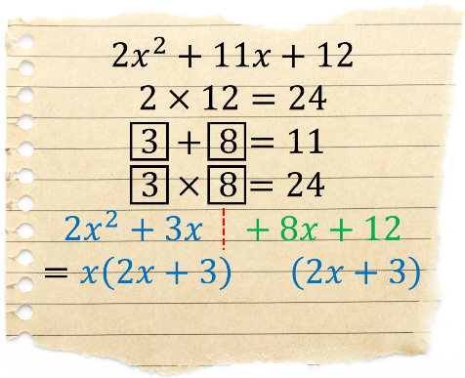 |  | 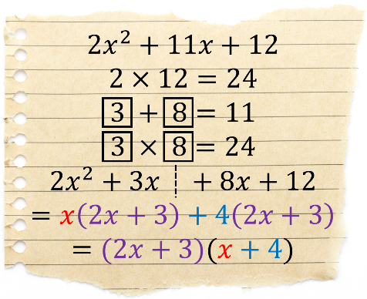
Method 2: The Detective Method
1. Write a pair of brackets. At the start of the brackets, write a pair of terms that multiply to give $2x^{2}.$ | 2. At the end of the brackets, write a pair of terms that multiply to give $12$. Use (e.g.) FOIL (in your head or on paper) to check your answer. | 3. If the answer is not correct, choose a different combination, repeating until you reach the correct answer.
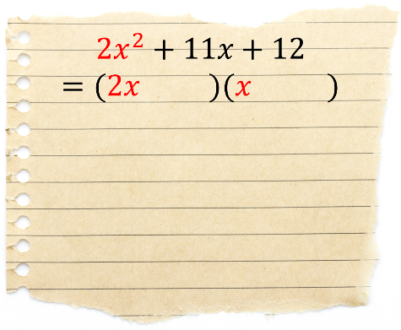 | 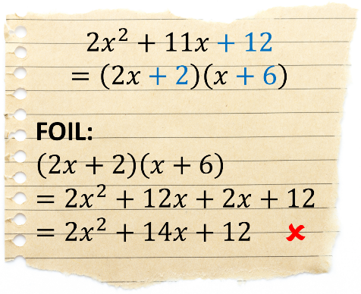 | 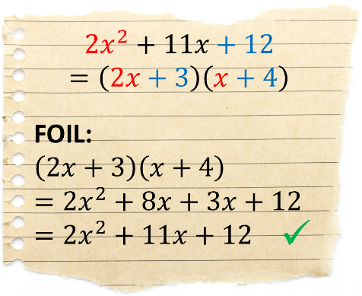

Exercise 18
Factorise the following quadratic expressions.
2
(a) $2x^{2}+11x+15$ (b) $2x^{2}+13x+15$ (c) $2x^{2}+7x+6$
(d) $3x^{2}+13x+4$ (e) $3x^{2}+11x+10$ (f) $3x^{2}+17x+20$
(g) $4x^{2}+21x+5$ (h) $4x^{2}+9x+5$ (i) $4x^{2}+12x+5$
(j) $5x^{2}+18x+9$ (k) ${5x}^{2}+8x+3$ (l) $6x^{2}+13x+6$
(m) $2x^{2}-x-15$ (n) $3x^{2}+x-14$ (o) $5x^{2}-17x-12$
(p) $3x^{2}-5x-12$ (q) $4x^{2}-3x-10$ (r) $2x^{2}-7x-15$
(s) $4x^{2}-7x-2$ (t) $3x^{2}-16x-12$ (u) $4x^{2}+21x-18$
(v) $3x^{2}-14x+8$ (w) $5x^{2}-19x+12$ (x) $3x^{2}-26x+35$
(y) $2x^{2}-21x+40$ (z) $2x^{2}-11x+12$ (α) $4x^{2}-11x+6$
Challenge!
Factorise the following quadratic expressions.
(a) $8x^{2}-2x-15$ (b) $8x^{2}-19x+6$ (c) $30x^{2}-42x+12$
Example
$$y$$
Solve the quadratic equation ${3x}^{2}+4x+1=0$.
Step 1: Factorise. Step 2: Solve.
$3x^{2}+4x+1=0$
$\left(3x+1\right)\left(x+1\right)=0$
Either $3x+1=0$ or $x+1=0$
$3x=-1$ $x=-1$
$x=-\frac{1}{3}$
$3×1=3$.
$\boxed{1} + \boxed{3} =4$
$\boxed{1} × \boxed{3} =3$
(a) $3x^{2}+4x+1$
$=3x^{2}+x+3x+1$
$=x\left(3x+1\right)+1(3x+1)$
$=(3x+1)(x+1)$
$$y=3x^{2}+4x+1$$
$$x$$
Exercise 19
Solve the following quadratic equations.
(a) $2x^{2}+3x+1=0$ (b) $2x^{2}+5x+2=0$ (c) $2x^{2}+13x+20=0$
(d) $2x^{2}-3x-20=0$ (e) $2x^{2}+3x-20=0$ (f) $2x^{2}-13x+20=0$
(g) ${3x}^{2}+10x+7=0$ (h) $3x^{2}+7x+2=0$ (i) $3x^{2}-11x+6=0$
(j) $2x^{2}-7x+3=0$ (k) $2x^{2}+3x-5=0$ (l) $2x^{2}-11x+5=0$
(m) $4x^{2}-4x+1=0$ (n) $4x^{2}-11x-3=0$ (o) $5x^{2}-24x-5=0$
(p) $6x^{2}+x-2=0$ (q) $6x^{2}-7x-5=0$ (r) $15x^{2}-4x-3=0$
Challenge!
Solve the following quadratic equations.
(a) $12x^{2}+28x-5=0$ (b) $28x^{2}+15x+2=0$ (c) $24x^{2}-2x-15=0$
Example
Factorise the following quadratic expressions.
(a) $2x^{2}+20x+42$ (b) ${(x+5)}^{2}+8(x+5)$ (c) $2x^{2}+8x$
Answer: $2x^{2}+20x+42$ Answer: ${(x+5)}^{2}+8(x+5)$ Answer: $2x^{2}+8x$
Answer: $=2(x^{2}+10x+21)$ Answer: $=\left(x+5\right)(\left(x+5\right)+8)$ Answer: $=2x(x+4)$
Answer: $=2(x+3)(x+7)$ Answer: $=(x+5)(x+13)$
Exercise 20
2
Factorise the following quadratic expressions.
(a) $2x^{2}+22x+56$ (b) ${(x+3)}^{2}+7(x+3)$ (c) $2x^{2}+20x$
(d) $3x^{2}+18x+24$ (e) ${(x-5)}^{2}+8(x-5)$ (f) $3x^{2}-12x$
(g) ${4x}^{2}+12x-40$ (h) ${(x-2)}^{2}-4(x-2)$ (i) $4x^{2}-18x$

(j) $4x^{2}+26x+30$ (k) $7{(x+4)}^{2}+3(x+4)$ (l) $5x^{2}+45x$
The Difference of Two Squares
An expression of the form $a^{2}-b^{2}$ factorises in a special way.
$$a^{2}-b^{2}=(a+b)(a-b)$$
Example
Factorise the following expressions.
(a) $x^{2}-9$ (b) $4x^{2}-49$ (c) $27x^{2}-75y^{2}$
Answer: $x^{2}-9$ Answer: $4x^{2}-49$ Answer: $27x^{2}-75y^{2}$
Answer: $=(x+3)(x-3)$ Answer: $=(2x+7)(2x-7)$ Answer: $=3(9x^{2}-25y^{2})$
Answer: $=3(3x+5y)(3x-5y)$
Exercise 21
2
Factorise the following expressions.
(a) $x^{2}-4$ (b) $x^{2}-16$ (c) $x^{2}-1$

(d) $x^{2}-144$ (e) $y^{2}-100$ (f) $z^{2}-36$
(g) $4x^{2}-25$ (h) $9x^{2}-4$ (i) $49x^{2}-81$
(j) $64x^{2}-1$ (k) $100y^{2}-9$ (l) $16z^{2}-121$
(m) $2x^{2}-18$ (n) $2x^{2}-50$ (o) $3x^{2}-48$
(p) 8$x^{2}-18$ (q) $6x^{2}-24$ (r) $5x^{2}-125$
(s) $x^{2}-y^{2}$ (t) 4$x^{2}-z^{2}$ (u) $x^{2}y^{2}-1$
(v) $16x^{2}-π^{2}$ (w) $8x^{2}-72z^{2}$ (x) $4x^{2}z^{2}-36y^{2}$
(y) $x^{4}-4$ (z) $9y^{4}-16$ (α) $32z^{6}-128y^{2}$

Exercise 22
2
Solve the following quadratic equations.
(a) $x^{2}-25=0$ (b) $y^{2}-64=0$ (c) $z^{2}-169=0$
(d) $4x^{2}-49=0$ (e) $9x^{2}-1=0$ (f) $4x^{2}-16=0$
Exercise 23
$(x-2)$ cm
The area of the rectangle on the right is 45 cm². Use the difference of
two squares method to calculate the height and width of the rectangle.
Exercise 24 (Revision)
$(x+2)$ cm
Solve the following quadratic equations.
(a) $x^{2}+15x+44=0$ (b) $x^{2}-15x+44=0$ (c) $x^{2}+7x-44=0$
(d) $4x^{2}+14x=0$ (e) $4x^{2}-14x=0$ (f) $14x-4x^{2}=0$
(g) $2x^{2}+13x+21=0$ (h) $2x^{2}-13x+21=0$ (i) $2x^{2}+x-21=0$
(j) $x^{2}-36=0$ (k) $9x^{2}-100=0$ (l) $4x^{2}-36=0$
Challenge!
The picture below shows Menai Bridge. We can model the cable between the two towers using the quadratic equation $y=\frac{43}{7744}x^{2}-\frac{43}{44}x$. Given that the origin is at the highest point of one of the towers, solve the equation $\frac{43}{7744}x^{2}-\frac{43}{44}x=0$ to calculate the horizontal distance (in metres) between the top of the two towers.
$$x$$
$$y$$
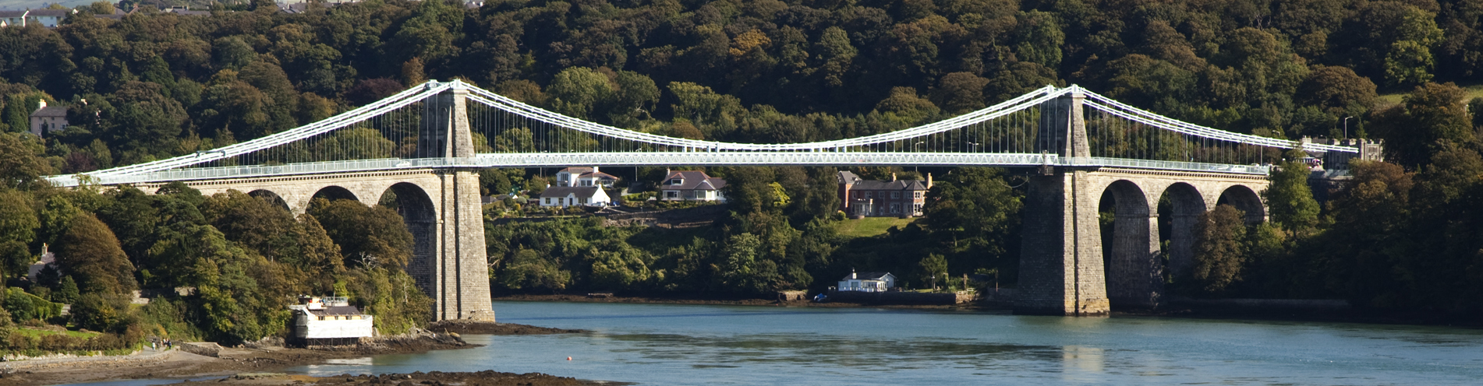
Key words | Corrections | I am happy with... | I need to revise...
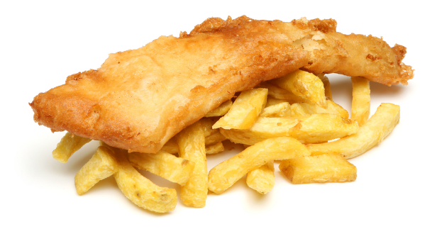
Our aim in this chapter is to solve problems similar to the one below.
“Deiniol buys 2 fish and 3 chips in the local fish & chips shop, and he pays £8. Awel buys 4 fish and 2 chips in the same shop, and pays £12. What is the cost of 1 fish and 1 chips in the shop?”
By using the variable $f$ to represent the cost of 1 fish, and $c$ to represent the cost of 1 chips, we can write the following equations to represent the problem.
$2f+3c=8$
$4f+2c=12$
To solve the above equations, which are simultaneous equations, we must develop a number of algebraic techniques for our algebraic toolbox …
ALGEBRA

Multiplying Equations

Example
Multiply the equation $3x+2y=5$ by 4.
Answer: We multiply every term in the equation by four to obtain the equation $12x+8y=20$.
Exercise 25
Multiply the following equations by the numbers in the boxes.
2
(a) $2x+6y=4$ $\boxed{×2}$ (b) $3x+4y=5$ $\boxed{×2}$ (c) $7x+2y=6$ $\boxed{×2}$
(d) $4x+3y=7$ $\boxed{×3}$ (e) $8x+11y=3$ $\boxed{×4}$ (f) $6x+3y=11$ $\boxed{×5}$
(g) $2x-5y=3$ $\boxed{×2}$ (h) $-5x+2y=4$ $\boxed{×2}$ (i) $3x-8y=-7$ $\boxed{×2}$
(j) $x+7y=3$ $\boxed{×6}$ (k) $8x+y=9$ $\boxed{×7}$ (l) $3x-4y=1$ $\boxed{×8}$
(m) $3x+6y=7$ $\boxed{×-2}$ (n) $5x-2y=10$ $\boxed{×-3}$ (o) $-3x+2y=-5$ $\boxed{×-4}$
Subtracting Equations
Example
$5x+8y=16$ $7x+9y=25$ $5x+6y=10$
$-$ $2x+3y=7$ $-$ $3x+9y=4$ $-$ $5x-2y=3$
$\overline{\underline{3x+5y=9 }}$ $\overline{\underline{4x+0y=21}}$ $\overline{\underline{0x+8y=7 }}$
Exercise 26
Subtract the second equation from the first equation.

(a) $7x+8y=20$ (b) $9x+5y=13$ (c) $15x+9y=14$
(a) $3x+4y=12$ (b) $3x+2y=5$ (c) $12x+4y=9$
(d) $6x+2y=31$ (e) $8x+3y=15$ (f) $19x-8y=8$
(d) $2x+7y=8$ (e) $2x+3y=10$ (f) $14x+4y=3$

Exercise 26 (continued)
2
(g) $8x+7y=15$ (h) $11x+4y=27$ (i) $20x+5y=-8$
(g) $2x+7y=6$ (h) $11x+2y=3$ (i) $18x-5y=4$
(j) $-4x+8y=18$ (k) $6x-4y=8$ (l) $8x-4y=15$
(j) $-4x+2y=4$ (k) $2x-4y=10$ (l) $8x-6y=2$
(m) $x+18y=12$ (n) $18x-2y=-5$ (o) $-4x+10y=8$
(m) $x+17y=2$ (n) $11x-9y=3$ (o) $-4x-2y=-3$
The coefficient of an algebraic term is the number which is part of the term. For example, the coefficient of $16x$ is $16$.

Multiplying Equations to Obtain Equal Coefficients
Example
Consider the following simultaneous equations.
$3x+10y=16$ $4x+15y=13$
By multiplying the first equation by 4, and the second equation by 3, we can ensure that the $x$ coefficients are equal.
$3x+10y=16$ $\boxed{×4}$ $12x+40y=644x+15y=13$ $\boxed{×3}$ $12x+15y=39$
On the other hand, by leaving the first equation as it is, and multiplying the second equation by 2, we can ensure that the $y$ coefficients are equal.
Try to use the smallest possible numbers that work.
$3x+10y=16$ $3x+10y=164x+15y=13$ $\boxed{×2}$ $8x+10y=26$
Exercise 27
Which numbers do we need to multiply the following equations by to obtain equal $x$ coefficients?
(a) $2x+4y=4$ (b) $2x+14y=4$ (c) $2x+4y=4$
(a) $3x+5y=7$ (b) $4x+12y=7$ (c) $5x+8y=7$
(d) $5x+7y=6$ (e) $5x+7y=6$ (f) $15x+17y=6$
(d) $2x+2y=8$ (e) $6x+3y=8$ (f) $15x+14y=8$
(g) $4x+8y=12$ (h) $4x+8y=12$ (i) $14x+18y=12$
(g) $5x+4y=5$ (h) $6x+3y=5$ (i) $12x+12y=5$
(j) $24x+32y=20$ (k) $24x+32y=20$ (l) $24x+32y=20$
(j) $28x+38y=20$ (k) $12x+64y=20$ (l) $16x+16y=20$
Exercise 28
Which numbers do we need to multiply the equations from Exercise 27 by to obtain equal $y$ coefficients?
Solving Linear Equations

The final part of the jigsaw is to be able to solve linear equations like the following ones.
Exercise 29
Solve the following equations.
A
(a) $4x=8$ (b) $4x=32$ (c) $7x=35$
(d) $4x=2$ (e) $3x=5$ (f) $8x=7$

Solving Simultaneous Equations
We now have enough tools in our algebraic toolbox to return to the fish & chips problem from the beginning of this chapter.
“Deiniol buys 2 fish and 3 chips in the local fish & chips shop, and he pays £8. Awel buys 4 fish and 2 chips in the same shop, and pays £12. What is the cost of 1 fish and 1 chips in the shop?”
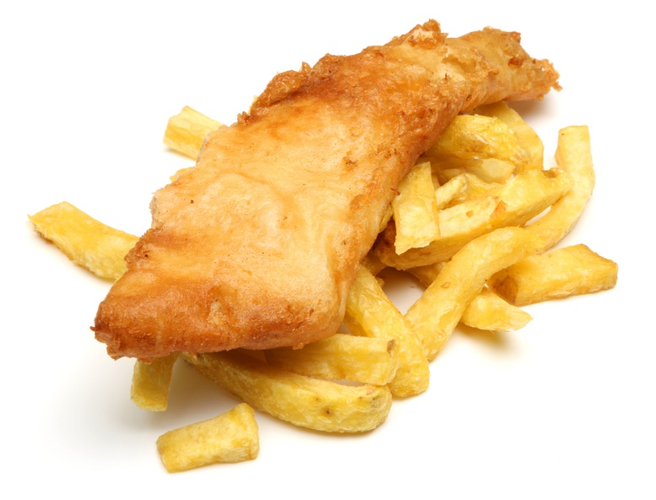
Step 1: Change the word problem into a pair of equations.
$2f+3c=8$
$4f+2c=12$
Step 2: Multiply the first equation by 2 so that the $f$ coefficients are equal.
$2f+3c=8$ $\boxed{×2}$ $4f+6c=164f+2c=12$ $4f+2c=12$
Step 3: Subtract the second equation from the first equation.
$2f+3c=8$ $\boxed{×2}$ $4f+6c=164f+2c=12$ $-$ $4f+2c=12$
$\overline{\underline{4f+4c=4 }}$
Step 4: Solve the equation $4c=4$ to obtain $c=1$.
Conclusion: The cost of 1 chips in the shop is £1.
To find the value of $f$ (and thus the cost of 1 fish), we can use any of the following methods.


Method A: Repeat steps 2–4 above, but this time making Method B: Substitute $c=1$ into one of the original
sure that the $c$ coefficients are equal. equations.
$2f+3c=8$ $\boxed{×2}$ $-14f+6c=16$ Substitute $c=1$ into the equation $2f+3c=8$:$4f+2c=12$ $\boxed{×3}$ $-$ $-12f+6c=36$ $2f+3×1=8$
$\overline{\underline{--8f+6c=-20 }}$ $2f+3=8$
$f=\frac{-20}{-8}$ $2f=5$
$f=\frac{5}{2}$ $f=\frac{5}{2}$
Conclusion: The cost of 1 fish is £2.50.
Note: You can check that the solutions are correct by substituting the values $c=1$, $f=2.5$ into the left-hand side of any of the original equations.
2
$2f+3c$ $4f+2c=2×2.5+3×1$ $=4×2.5+2×1$
$=5+3$ $=10+2$
$=£8$ $=£12$
Exercise 30
Two apples and two bananas costs £2.
Three apples and one banana costs £2.50.
Find the cost of one apple and one banana.
+ = £2 + = £2.50

Exercise 31
Solve the following simultaneous equations.
2
(a) $3x+4y=18$ (b) $2x+3y=9$ (c) $2x+4y=16$
(a) $2x+2y=10$ (b) $4x+3y=13$ (c) $2x+3y=14$
(d) $5x-2y=6$ (e) $-6x+3y=18$ (f) $-2x+3y=-2$
(d) $2x+2y=8$ (e) $-2x+2y=6$ (f) $-4x-3y=0$
(g) $2x+3y=3$ (h) $3x+2y=7$ (i) $2x+3y=14$
(g) $2x-3y=7$ (h) $3x-2y=-8$ (i) $3x+2y=16$
(j) $-3x+2y=0$ (k) $2x+5y=9$ (l) $5x-2y=19$
(j) $-3x-4y=6$ (k) $2x+3y=11$ (l) $3x+2y=18$
(m) $4x+3y=8$ (n) $2x-3y=8$ (o) $2x+6y=34$
(m) $7x+3y=9$ (n) $2x+2y=-10$ (o) $4x-2y=5$
(p) $2x+3y=10$ (q) $2x+3y=0$ (r) $7x+8y=19$
(p) $5x-6y=16$ (q) $8x+9y=-1$ (r) $3x-2y=-19$
(s) $3x+4y=15$ (t) $3x-4y=14$ (u) $3x+5y=21$
(s) $3x-6y=-6$ (t) $5x-8y=30$ (u) $4x+3y=17$
(v) $3x-2y=17$ (w) $5x-2y=26$ (x) $2x+4y=5$
(v) $2x+7y=3$ (w) $3x-5y=27$ (x) $5x+7y=8$
Exercise 32
(a) Aled buys 2 Cornish pasties and 3 sausage rolls in a shop, and pays £7. Ceinwen buys 4 Cornish pasties and 1 sausage roll in the same shop, and pays £9. What is the cost of 1 Cornish pasty and 1 sausage roll from the shop?
(b) A rectangle shape is made by using 12 square tiles with equal spaces
between them. The total length of the rectangle is 645 mm and the total
width of the rectangle is 475 mm. Find the dimensions of the tiles and the
width of the space in mm.
645 mm
475 mm

(c) Glyn employs two people, Ben and Ceri. Ben and Ceri are paid
at different hourly rates. Glyn has recorded how many hours both
Ben and Ceri have worked on Monday and Tuesday. He has also noted
the total he paid in wages.
Day | Number of hours worked |  | Total wages (£)
Day | Ben | Ceri | Total wages (£)
Monday | 6 | 5 | 116
Tuesday | 4 | 8 | 138
Use an algebraic method to calculate how much Ben and Ceri are paid per hour.
(d) Ysgol Trefswm organised a concert to raise money for a charity.
All of the 120 tickets were sold for a total of £1,210.
The price of an adult ticket was £12.
The price of a child ticket was £7.
How many adult tickets and how many child tickets
were sold?

Exercise 33: Old, Older, Oldest
Use the clues on the cards to solve the problem.
(1) 18 is the sum of Arwyn’s age and Bedwyr’s age.
(2) 47 is the sum of Rhodri’s age and Sali’s age.
(3) 38 is the sum of three times Gwen’s age add two times Heledd’s age.
(4) Three times Wil’s age subtract four times Tesni’s age is 33.
The information for these people has been shuffled. To begin you must form simultaneous equations and solve them. Every answer is a whole number.
(5) Three times Ynyr’s age add Penri’s age is 27.
(6) Arwyn’s age subtract Bedwyr’s age is 8.
Your job is to find everyone’s age and list them from oldest to youngest. There are two sets of twins.
(7) Two times Wil’s age add three times Tesni’s age is 107.
(8) Three times Iolo’s age add four times John’s age is 147.
(9) 20 is two times Cai’s age subtract Dewi’s age.
(10) 78 is two times Fred’s age subtract Elfyn’s age.
(11) Four times Kate’s age add three times Lora’s age is 40.
(12) The sum of Cai’s age and Dewi’s age is 73.

(15) Fred is older than Elfyn by thirteen years.
(13) 91 is two times Mali’s age add Nia’s age.

(14) 43 is five times Kate’s age add two times Lora’s age.
(18) Seven times Iolo’s age subtract three times John’s age is 10.
(19) Double of Gwen’s age add three times Heledd’s age gives 42.

(20) Mali is eight years older than Nia.
(17) Two times Rhodri’s age add Sali’s age is 76.

(16) By doubling Ynyr’s age and adding Penri’s age you get 25.
2

Key words | Corrections | I am happy with... | I need to revise...


The purpose of changing the subject is to re-arrange formulae so that a particular variable appears on its own on the left-hand side of the formula. For example, consider the formula $p=3w+d$, a formula to calculate the number of points ($p$) a football team has given how many games they have won ($w$) and how many drawn games ($d$) they have had. We can re-arrange the formula to give the number of games won by a football team.
$p=3w+d$
$3w+d=p$ [Swap sides]
$3w=p-d$ [Subtract $d$ from both sides]
$w=\frac{p-d}{3}$ [Divide both sides by 3]
After re-arranging the formula as shown above, we say that $w$ is the subject of the formula.
There are a number of ‘movements’ we can perform to help re-arrange a formula to give a specific subject.
Here are some of the most common movements.
Add a number to both sides of the formula Subtract a number from both sides of the formula
E.g. $y-3=x$ E.g. $y+7=x$
$y-3=x+3$ [Add 3 to both sides] $y+7=x-7$ [Subtract 7 from both sides]
Multiply both sides of the formula by a number Divide both sides of the formula by a number
E.g. $\frac{y}{2}=5x$ E.g. $4y=x-3$
$y=10x$ [Multiply both sides by 2] $4y=\frac{x-3}{4}$ [Divide both sides by 4]
Square both sides of the formula Take the square root of both sides of the formula
E.g. $\sqrt{y}=4x+5$ E.g. $y^{2}=2x-9$
$y ={(4x+5)}^{2}$ [Square both sides] $y =\sqrt{2x-9}$ [Square root both sides]
Swap sides Expand brackets
E.g. $5x+3=y$ E.g. $4\left(y+2\right)=5x$
$y=5x+3$ [Swap sides] $4y+8 =5x$ [Expand brackets]
Let us reconsider the example at the top of this page. The question in the example can be set as follows.

Make $w$ the subject of the formula $p=3w+d$.
The aim in this question is to re-arrange the formula to leave only the variable $w$ on the left-hand side of the formula. As the variable $w$ initially appears on the right-hand side of the formula, it makes sense to start by swapping the sides of the formula, so that $w$ appears on the left-hand side of the formula.
$p=3w+d$
$3w+d=p$ [Swap sides]
There are several ways to proceed. You can think of the formula as an equation, and ‘solve’ to leave $w$ on its own.
Or you can think of how to calculate the left-hand side of the formula, if you start with the variable $w$.
$$×3$$
$$+ d$$
Input:
$w$
Output:
$3w+d$
By working backwards through the function machine, we can see the steps required to proceed, namely subtracting $d$ from both sides of the formula, and then dividing both sides by 3.
Exercise 34
2
(a) Make $e$ the subject of the formula $p=2e+c$. (b) Make $c$ the subject of the formula $p=2e+c$.
(c) Make $c$ the subject of the formula $y=mx+c$. (d) Make $m$ the subject of the formula $y=mx+c$.
(e) Make $p$ the subject of the formula $c=p-3t$. (f) Make $t$ the subject of the formula $c=p-3t$.
(g) Make $p$ the subject of the formula $A=p(q+r)$. (h) Make $q$ the subject of the formula $A=p(q+r)$.
(i) Make $t$ the subject of the formula $F=\frac{m+4n}{t}$. (j) Make $m$ the subject of the formula $F=\frac{m+4n}{t}.$
(k) Make $n$ the subject of the formula $F=\frac{m+4n}{t}$. (l) Make $r$ the subject of the formula $A=πr^{2}$.
(m) Make $R$ the subject of the formula $I=\frac{PRT}{100}$. (n) Make $s$ the subject of the formula $A=\frac{su}{2}$.
(o) Make $u$ the subject of the formula $C=\frac{1}{3}πr^{2}u$. (p) Make $r$ the subject of the formula $C=\frac{1}{3}πr^{2}u$.
(q) Make $u$ the subject of the formula $A=\frac{1}{2}\left(a+b\right)u$. (r) Make $b$ the subject of the formula $A=\frac{1}{2}\left(a+b\right)u$.
Exercise 35
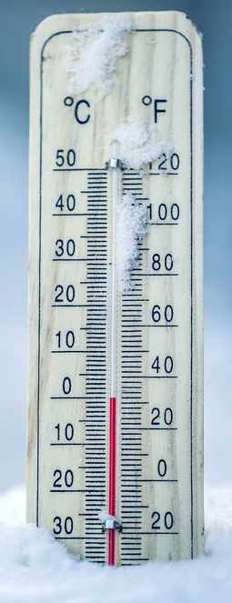
The following formula was used by festival planners to calculate the parking fee for mini buses.

Parking Fee = Number of Passengers × 30p + £5
(a) What was the parking fee for a mini bus with 12 passengers?
(b) The parking fee for another mini bus was £7.40. How many passengers were on this
mini bus?

Exercise 36
To change from degrees Celsius (°C) to degrees Fahrenheit (°F), you can use the following
formula.
$$F=\frac{9}{5}\left(C+40\right)-40$$
(a) The temperature is 60°C. What is this in °F?
(b) Re-arrange the formula to find $C$ in terms of $F$.
Key words | Corrections | I am happy with... | I need to revise...

In algebra, what’s the difference between expressions, equations, formulae and identities?
Expression  An expression is a collection of terms (e.g. $5x$ or $7)$  and operators (e.g. $+$ or $×$).  $4x+2$ and $\sqrt{6y-4z}$ are examples of expressions.  There are no equals signs ($=$) in expressions. | Equation  An equation notes that two terms or expressions are equal. Two sides of an equation are separated by an equals sign ($=$). Sometimes, it is possible to solve an equation to find the value of a variable.
Formula  A formula is a special type of equation which shows the connection between different variables.  $P=2a+2b$ is an example of a formula, one which is used to calculate the perimeter of a rectangle with length $a$and width $b$. | Identity  An identity is an equation which is always true, no matter what the values of the variables are.  $2\left(x+4\right)≡2x+8$ is an example of an identity. Two sides of an identity are separated by an equivalence sign ($≡)$.
Example
$$\boxed{\text{Expression}}$$
$$\boxed{\text{Equation}}$$
$$\boxed{\text{Formula}}$$
$$\boxed{\text{Identity}}$$
$5x+1=31$ | $3x+10$
$A=\frac{1}{2}\left(a+b\right)u$ | $x\left(x+2\right)≡x^{2}+2x$
$2x+7z$ | $\frac{y}{2}=6$
$x^{2}+7x+10=0$ | $y=2x+5$
$\left(x+2\right)\left(x+4\right)≡x^{2}+6x+8$ | $C=πd$
Exercise 37
A
Add arrows pointing to the correct descriptions.
$$\boxed{\text{Expression}}$$
$$\boxed{\text{Equation}}$$
$$\boxed{\text{Formula}}$$
$$\boxed{\text{Identity}}$$
$4x+3=2x+27$ | $w=8u+17v$
$E=mc^{2}$ | $z-3=8$
$4x^{2}+6x≡2x(2x+3)$ | $\sqrt{\frac{2x-3}{y}}$
$21x+8$ | $e^{iπ}+1≡0$
$f=e-v+2$ | $4x^{2}+2x-6$
$\frac{x^{3}}{x^{2}}≡\frac{x^{2}}{x}$ | $\left(2x-4\right)\left(x+3\right)=0$
Proving Identities

To prove an identity such as $\left(x+6\right)\left(x-2\right)-x\left(x+3\right)≡x-12$, we must use
algebraic steps to change the left-hand side to be the right-hand side.

Left-hand side $=\left(x+6\right)\left(x-2\right)-x(x+3)$
$=x^{2}-2x+6x-12-(x^{2}+3x)$ [Expand brackets]
$=x^{2}+4x-12-x^{2}-3x$ [Collect like terms]
$=x-12$ [Simplify]
$=$ Right-hand side
Exercise 38
233
Prove the following identities.
(a) $4\left(x+2\right)≡4x+8$ (b) $2\left(x+4\right)+5\left(x+8\right)≡7x+48$
(c) $\left(x+8\right)\left(x-3\right)≡x^{2}+5x-24$ (d) $6\left(x+8\right)-2\left(x-4\right)≡4(x+14)$
(e) $\left(x+5\right)\left(x+2\right)+\left(x+8\right)\left(x+8\right)≡2x^{2}+23x+74$ (f) $\left(x+6\right)\left(x-2\right)-\left(x+8\right)\left(x+2\right)≡-6x-28$
(g) $\left(y+4\right)\left(y-7\right)+3y\left(y-1\right)≡4y^{2}-6y-28$ (h) $\left(2x+1\right)\left(x+2\right)-2x\left(x+4\right)≡-3x+2$
Exercise 39

Three of the following identities are incorrect. Which ones?
(a) $3\left(x-4\right)≡3x-12$ (b) $\left(x+4\right)\left(x-2\right)≡x^{2}+2x-8$
(c) ${(x+3)}^{2}≡x^{2}+9$ (d) $7\left(x+3\right)+2\left(x-2\right)≡9x+17$
(e) $4\left(x+8\right)-2\left(x+8\right)≡2(x+8)$ (f) $\left(x+2\right)\left(x-2\right)≡x^{2}+4$
(g) $5\left(y-2\right)-2\left(y-3\right)≡3y-4$ (h) $\frac{x^{2}+6x+8}{x^{2}+5x+6}≡\frac{x+4}{x+3}$
(i) $\left(x+3\right)\left(x-3\right)-(x-4)(x+4)≡7$ (j) $4\left(x+2\right)+\left(x-4\right)\left(x+7\right)≡x^{2}-20$

Key words | Corrections | I am happy with... | I need to revise...

Puzzle
Can you find the mirrored copy of each picture?

Name: ............................................  Percentage in the test: .................. |   I know this. |   I need to revise this. | Question in the test | Correct in the test?
I can factorise simple expressions such as $8x+12$ or  $15x^{2}-10$. |  |  | 1
I can factorise quadratic expressions of the form $x^{2}+ax+b$. |  |  | 1
I can factorise quadratic expressions of the form  $ax^{2}+bx+c$. |  |  | 2, 3
I can factorise quadratic expressions of the form  $a^{2}-b^{2}$ (a difference of two squares). |  |  | 1
I can solve quadratic equations through factorisation. |  |  | 2, 3
I can solve simultaneous equations. |  |  | 4, 5
I can re-arrange a formula in order to make a specific variable (e.g. $x$) the subject of the formula. |  |  | 6, 7
I can recognise expressions, equations, formulae and identities. |  |  | 8
I can prove identities. |  |  | 9

