



Version
3.0
08/2025

Chapter | Mathematics | Page Number
Rules of Indices | The index form. Evaluating the index form. The multiplication rule. The division rule. The zeroth index rule. Raising a power to another index. The negative index rule. The reciprocal as a negative index. Unitary fraction index rule. Algebra and rules of indices. The general fraction index rule. | 3
Surds | Rational and irrational numbers. Surds.  Simplifying surds. Expanding with surds. | 12
Standard Form | Writing numbers $x≥1$ in standard form. Writing numbers $0<x<1$ in standard form. Changing from standard form to an ordinary number. Adding and subtracting in standard form. Almost in standard form. Multiplying and dividing in standard form. | 16
Graph Plotting | Quadratic graphs. Recognising and sketching graphs of the form $y=ax^{2}+b$. Graphical method of solving equations of the form $x^{2}+ax+b=0$. Other graphs. | 22
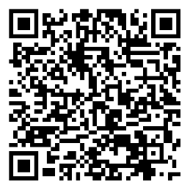
$$y$$
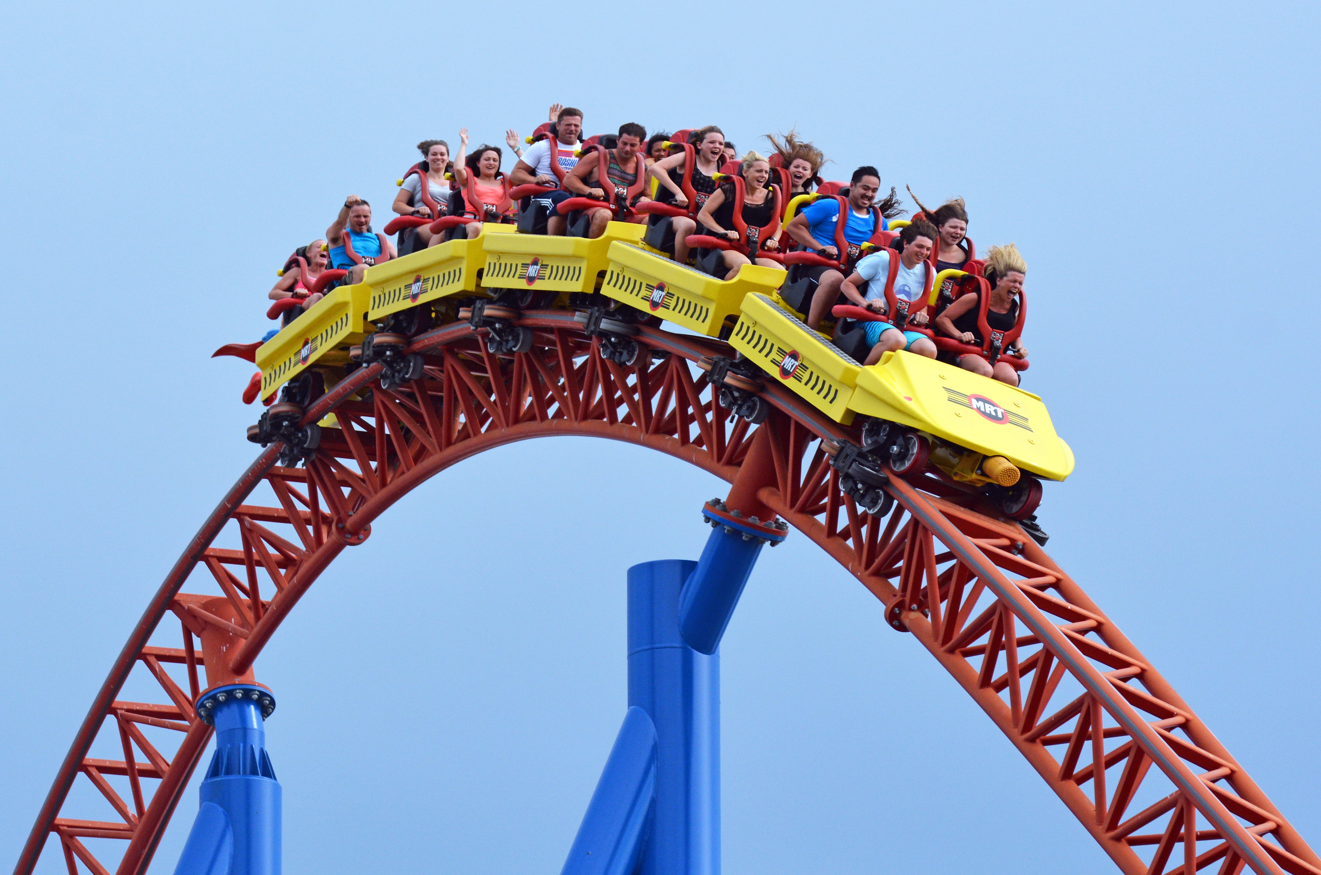
$$x$$
$$y=\frac{1}{10}x^{3}-\frac{1}{3}x^{2}+\frac{9}{4}x$$

The Index Form
In year 8, we considered how to write a number as a product of its prime factors, in index form.
For example, we can write 72 as a product of its prime factors, in index form, like this.
$72=2^{3}×3^{2}$.
The index form is a product of terms of the form $n^{a}.$ Each of these terms include a base and an index.
The base. This shows which number is getting multiplied in the term.
The index. This shows how many times the number $n$ appears in the multiplication sum.
$n^{a}$
For example, we can write $7×7×7×7×7×7×7×7×7×7$ as $7^{10}$.
The base is 7, since 7 is the number which is being multiplied. The index is 10, since 7 appears 10 times.

Other examples
$5×5×5×5×5×5×5=5^{7}$ $4×4×4×4×4×4=4^{6}$ $2×2×2×3×3=2^{3}×3^{2}$
The number 5 is being multiplied. The number 4 is being multiplied. The numbers 2 and 3 are being
It appears 7 times. It appears 6 times. multiplied. 2 appears 3 times, and
3 appears 2 times.
Exercise 1
A
Write the following in index form.
(a) $3×3×3×3×3$ (b) $3×3×3×3×3×3×3×3×3$ (c) $3×3×3×3×3×3×3×3$
(d) $3×3×3×5×5×5×5×5$ (e) $3×3×3×3×3×5×5×5$ (f) $3×3×3×3×3×5$
(g) $2×2×7×7×7×7×9×9×9$ (h) $8×8×8×33×33×33×33$ (i) $3×8×8×3×8×3×3×8$
(j) $3×5×5×5×3×3×7×7$ (k) $2×5×7×7×2×2×2×5$ (l) $13×11×7×7×11×7$
Exercise 2
Write the following as multiplication sums without indices.
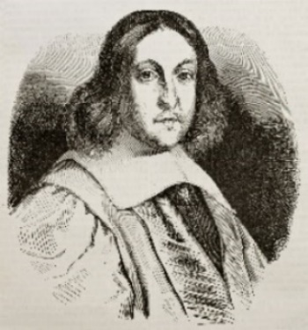
(a) $2^{5}$ (b) $2^{3}$ (c) $2^{1}$
(d) $4^{6}$ (e) ${17}^{8}$ (f) ${256}^{5}$
(g) ${\left(\frac{1}{3}\right)}^{4}$ (h) $2^{4}×5^{3}$ (i) $4^{4}×5^{5}$
(j) ${24}^{3}×{45}^{4}$ (k) ${\left(\frac{1}{5}\right)}^{3}×{\left(\frac{3}{4}\right)}^{3}$ (l) $5^{3}×{13}^{2}×{27}^{4}$
(m) $3^{2}×5^{4}×{10}^{2}×{14}^{3}$ (n) $2^{3}×{\left(\frac{1}{2}\right)}^{3}×4^{3}$ (o) ${\left(\frac{3}{7}\right)}^{2}×{\left(\frac{3}{4}\right)}^{4}×{\left(\frac{7}{9}\right)}^{3}$
Investigation
Who was Pierre de Fermat? What was his contribution to mathematics?
What was his last theorem? When was this theorem proved?
Are there other theorems connected to index form?

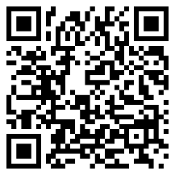
Evaluating the Index Form
Evaluating index form is the process of writing a number written in index form as an ordinary number.
For example, we can write $3^{4}$ as $3×3×3×3$, which is equal to 81.

Other examples
$4^{3}=4×4×4$ $5^{4}=5×5×5×5$ $2^{4}+7^{3}=\left(2×2×2×2\right)+\left(7×7×7\right)$
$4^{3}=64$ $5^{4}=625$ $2^{4}+7^{3}=16+343$
$2^{4}+7^{3}=359$
Exercise 3
P
Evaluate the following, without using a calculator.
(a) $3^{4}$ (b) $6^{3}$ (c) ${10}^{5}$ (d) $2^{9}$ (e) ${20}^{4}$
(f) $3^{2}+2^{5}$ (g) $6^{3}-3^{4}$ (h) $6^{3}×2^{2}$ (i) ${10}^{4}÷2^{2}$ (j) $5^{4}+4^{4}$
Exercise 4
Use your calculator to evaluate the following. If appropriate, write your answer correct to 2 decimal places.
(a) ${125}^{2}$ (b) ${17}^{4}$ (c) ${29}^{3}+5$ (d) $9^{3}+5$ (e) ${12}^{4}-5^{6}$
(f) ${12}^{3}+3^{7}$ (g) $3^{4}×4^{5}$ (h) $2^{3}×4^{2}+3^{2}$ (i) $(4^{3})^{4}$ (j) $4^{6}÷2^{6}+{10}^{3}$
(k) ${11}^{3}-4^{4}$ (l)$4^{5}-5^{6}$ (m) $3^{8}+4^{10}-5^{6}$ (n) $4^{6}-3^{2}×8^{3}$ (o) $3^{4}+8^{8}÷4^{10}$
(p) $\frac{5^{6}}{3^{7}}$ (q) $\frac{4^{4}+3^{6}}{2^{4}}$ (r) $\frac{{11}^{3}}{2^{5}×3^{5}}$ (s) $\frac{4^{3}+6^{4}×2^{3}}{{10}^{3}-5^{3}}$ (t) ${\left(\frac{4^{3}+6^{4}×2^{3}}{{10}^{3}-5^{3}}\right)}^{3}$
Exercise 5
(a) Without using a calculator, calculate the numbers which fill the following spaces.
(i) $2^{12}=4096$ (ii) $4^{6}=4096$ (iii) $3^{11}=177147$ (iv) $5^{5}=3125$ (v) $8^{3}=512$
$2^{11}=$ _____ $4^{7}=$ _____ $3^{12}=$ _______ $5^{4}=$ ____ $8^{4}=$ _____
(vi) $2^{8}=256$ (vii) $6^{4}=1296$ (viii) $3^{7}=2187$ (ix) $5^{9}=1953125$ (x) $7^{4}=2401$
$2^{10}=$ _______ $6^{6}=$ _______ $3^{9}=$ _______ $5^{7}=$ _______ $7^{6}=$ _____
(b) Put the numbers 1 to 6 into the following boxes to make:
+
+
(i) The largest possible number;
(ii) The smallest possible number;
(iii) A total of 147.
(c) Put the numbers 1 to 6 into the following boxes to make the calculation correct.
+
=
(d) Write any whole numbers in the following boxes to make the calculation correct.
(d) How many possible solutions are there?
= 64

Exercise 6 Exercise 7
P
1
2

Write the digits 1 to 9 in the grid on the right Complete the following
so that each row (reading across) is a crossnumber.
square number. You may use each digit
once only. Clues:
Can you prove that there is only one possible Across Down
solution? 1. Cube number 1. One less than a
2. Cube number 1. cube number

Rules of Indices
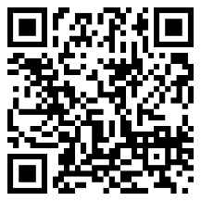
When performing calculations in index form, we notice several different patterns.
The rules of indices write these patterns in a convenient way.

The Multiplication Rule
$$n^{a}×n^{b}=n^{a+b}$$
When multiplying one number or variable to an index, by the same number or variable to another index, we must add the indices. We can see below why this is true.
$8^{4}×8^{3}$ $=8×8×8×8×8×8×8$
$8^{4}×8^{3}=8^{7}$.

Other examples
$4^{3}×4^{6}=4^{3+6}$ $8^{2}×8^{9}=8^{2+9}$ $a^{5}×a^{6}×a^{4}=a^{5+6+4}$ $7^{9}×7^{-3}=7^{9+-3}$
$4^{3}×4^{6}=4^{9}$ $8^{2}×8^{9}=8^{11}$ $a^{5}×a^{6}×a^{4}=a^{15}$ $7^{9}×7^{-3}=7^{6}$
Exercise 8
2
Simplify each of the following expressions.
(a) $7^{5}×7^{3}$ (b) $7^{3}×7^{5}$ (c) $8^{5}×8$ (d) $x^{5}×x^{3}$ (e) $7^{4}×7^{8}$
(f) $a^{5}×a^{3}$ (g) $a^{5}×a^{7}×a^{10}$ (h) $3^{2}×3^{9}×3^{4}$ (i) $5^{5}×5^{2}×5^{12}$ (j) $y^{3}×y^{13}×y^{16}$
(k) $7^{15}×7^{-4}$ (l) ${14}^{9}×{14}^{-6}$ (m) $8^{-10}×8^{3}$ (n) $d^{5}×d^{-8}$ (o) $f^{-4}×f^{-3}$
(p) $i^{-5}×i^{11}×i^{-3}$ (q) $p^{-9}×p^{-2}×p^{5}$ (r) $4^{-17}×4^{-7}×4^{31}$ (s) ${(-5)}^{5}×{(-5)}^{3}$ (t) ${(-5)}^{5}×{(-5)}^{-3}$
(u) ${(-5)}^{-5}×{(-5)}^{-3}$ (v)$a^{3}×a^{\frac{1}{2}}$ (w) $a^{\frac{3}{5}}×a^{\frac{1}{5}}$ (x) $a^{\frac{2}{3}}×a^{\frac{4}{7}}$ (y) $a^{\frac{8}{3}}×a^{\frac{5}{4}}$
Exercise 9
Find the missing numbers that go into the boxes in all of the following questions.

(a) $7^{5}×7^{\boxed{3}}=7^{8}$ (b) $7^{\boxed{2}}×7^{4}=7^{6}$ (c) $7^{13}×7^{\boxed{2}}=7^{11}$ (d) $7^{8}×7^{4}=7^{\boxed{2}}$ (e) $x^{2}×x^{\boxed{3}}=x^{14}$
(f) $5^{5}×5^{\boxed{3}}=5^{6}$ (g) $4^{9}×4^{\boxed{3}}=4^{8}$ (h) ${11}^{\boxed{2}}×{11}^{10}={11}^{7}$ (i) $2^{\boxed{2}}×2^{-5}=2^{9}$ (j) $8^{-2}×8^{\boxed{3}}=8^{-9}$

Challenge!
An Armstrong Number is a whole number where the sum of the digits, each raised to the number of digits, is equal to the original number.
For example, the number 371 is an Armstrong number since $3^{3}+7^{3}+1^{3}=371$.
1,634 is also an Armstrong number since $1^{4}+6^{4}+3^{4}+4^{4}=1,634$.
How many Armstrong numbers are there between 1 and 10,000?

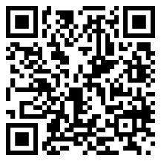
The Division Rule
$n^{a}÷n^{b}=n^{a-b}$ or $\frac{n^{a}}{n^{b}}=n^{a-b}$
When dividing one number or variable to an index, by the same number or variable to another index, we must subtract the indices. We can see below why this is true.
$$\frac{7^{8}}{7^{5}}=\frac{7×7×7×7×7×7×7×\text{7}}{7×7×7×7×7} \\ \frac{7^{8}}{7^{5}}=\frac{7×7×7×7×7×7×7×\text{7}}{7×7×7×7×7} \\ 7^{8}=7×7×7$$ $7^{8}=7^{3}$.
Other Examples
$4^{6}÷4^{3}=4^{6-3}$ $8^{9}÷8^{2}=8^{9-2}$ $\frac{a^{7}}{a^{4}}=a^{7-4}$ $6^{5}÷6^{-2}=6^{5--2}$
$4^{6}÷4^{3}=4^{3}$ $8^{9}÷8^{2}=8^{7}$ $a^{7}=a^{3}$ $6^{5}÷6^{-2}=6^{7}$
Exercise 10
Simplify each of the following expressions.
2
(a) $7^{5}÷7^{3}$ (b) $7^{3}÷7^{5}$ (c) $7^{11}÷7$ (d) $7^{8}÷7^{4}$ (e) $x^{5}÷x^{3}$
(f) $a^{5}÷a^{3}$ (g) $a^{5}÷a^{7}$ (h) $\frac{3^{9}}{3^{2}}$ (i) $\frac{5^{15}}{5^{12}}$ (j) $\frac{y^{3}}{y^{16}}$
(k) $7^{15}÷7^{-4}$ (l) ${14}^{9}÷{14}^{-6}$ (m) $8^{-10}÷8^{3}$ (n) $d÷d^{-8}$ (o) $f^{-4}÷f^{-3}$
(p) $i^{-5}÷i^{-3}$ (q) $p^{-9}÷p^{-2}÷p^{5}$ (r) $4^{-17}÷4^{-7}÷4^{31}$ (s) ${(-5)}^{5}÷{(-5)}^{3}$ (t) ${(-5)}^{5}÷{(-5)}^{-3}$
(u) ${(-5)}^{-5}÷{(-5)}^{-3}$ (v)$a^{3}÷a^{\frac{1}{2}}$ (w) $a^{\frac{3}{5}}÷a^{\frac{1}{5}}$ (x) $a^{\frac{2}{3}}÷a^{\frac{4}{7}}$ (y) $a^{\frac{8}{3}}÷a^{\frac{5}{4}}$
Exercise 11
Find the missing numbers that go into the boxes in all of the following questions.
(a) $7^{5}÷7^{\boxed{3}}=7^{2}$ (b) $7^{\boxed{2}}÷7^{4}=7^{6}$ (c) $7^{13}÷7^{\boxed{2}}=7^{11}$ (d) $7^{6}÷7^{4}=7^{\boxed{2}}$ (e) $x^{15}÷x^{\boxed{3}}=x^{7}$
(f) $5^{5}÷5^{\boxed{3}}=5^{7}$ (g) $\frac{4^{9}}{4^{\boxed{3}}}=4^{5}$ (h) $\frac{{11}^{30}}{{11}^{\boxed{2}}}={11}^{14}$ (i) $2^{\boxed{2}}÷2^{-5}=2^{-2}$ (j) $8^{-2}÷8^{\boxed{3}}=8^{-9}$
Example
$3^{7}×3^{5}÷3^{2}=3^{7+5}÷3^{2}$ $3^{9}÷3^{2}×3^{5}=3^{9-2}×3^{5}$ $\frac{y^{7}}{y^{4}}×y^{10}=y^{7-4}×y^{10}$
$3^{7}×3^{5}÷3^{2}=3^{12}÷3^{2}$ $3^{9}÷3^{2}×3^{5}=3^{7}×3^{5}$ $=y^{3}×y^{10}$
$3^{7}×3^{5}÷3^{2}=3^{12-2}$ $3^{9}÷3^{2}×3^{5}=3^{7+5}$ $=y^{3+10}$
$3^{7}×3^{5}÷3^{2}=3^{10}$ $3^{9}÷3^{2}×3^{5}=3^{12}$ $=y^{13}$
Exercise 12
Simplify each of the following expressions.
(a) $3^{5}×3^{6}÷3^{2}$ (b) $6^{8}×6^{6}÷6^{7}$ (c) $7^{11}×7^{5}÷7^{8}$ (d) $5^{8}×5^{3}÷5^{4}$ (e) $x^{9}×x^{3}÷x^{4}$
(f) $a^{5}×a^{4}÷a^{8}$ (g) $a^{10}×a^{-5}÷a^{7}$ (h) $2^{13}÷2^{3}×2^{4}$ (i) $5^{7}÷5^{2}×5^{4}$ (j) $8^{9}÷8×8^{3}$
(k) $5^{8}×5^{3}×5^{7}÷5^{4}$ (l) $4^{9}÷4^{2}×4^{3}÷4^{5}$ (m) $8^{-4}×8^{3}×8^{6}$ (n) $d^{5}÷d^{-8}×d^{4}$ (o)$u^{-3}÷u^{-3}×u^{-3}$
(p) $\frac{{10}^{6}}{{10}^{2}}×{10}^{8}$ (q) $\frac{7^{9}}{7^{3}}×7^{2}$ (r) ${19}^{4}×\frac{{19}^{12}}{{19}^{3}}$ (s) $4^{9}÷\frac{4^{6}}{4^{2}}$ (t) $e^{8}×\frac{e^{6}}{e^{3}}$
(u) $\frac{4^{5}×4^{7}}{4^{3}}$ (v)$\frac{{15}^{7}×15}{{15}^{2}}$ (w) $\frac{6^{10}}{6^{2}×6^{5}}$ (x) $\frac{r^{6}×r^{-1}}{r^{-2}}$ (y) $\frac{q^{-3}}{q^{4}×q^{-8}}×q^{3}$
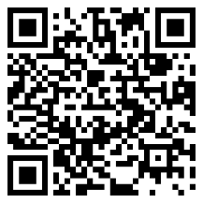
The Zeroth Index Rule
$$n^{0}=1$$
Any number or variable raised to a zero index gives the answer 1. Why? Let us consider the following calculations.
$\frac{3^{2}}{3^{2}}=\frac{9}{9}$ $\frac{7^{2}}{7^{2}}=\frac{49}{49}$ $\frac{{12}^{2}}{{12}^{2}}=\frac{144}{144}\frac{3^{2}}{3^{2}}=1$ $\frac{7^{2}}{7^{2}}=1$ $\frac{{12}^{2}}{{12}^{2}}=1$
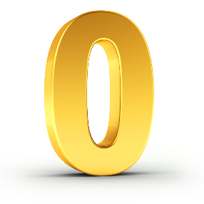
But the division rule states that
$\frac{3^{2}}{3^{2}}=3^{2-2}$ $\frac{7^{2}}{7^{2}}=7^{2-2}$ $\frac{{12}^{2}}{{12}^{2}}={12}^{2-2}\frac{3^{2}}{3^{2}}=3^{0}$ $\frac{7^{2}}{7^{2}}=7^{0}$ $\frac{{12}^{2}}{{12}^{2}}={12}^{0}$
So, we must have
$3^{0}=1$ $7^{0}=1$ ${12}^{0}=1$
This would work for any number or variable, not just 3 or 7 or 12.
Exercise 13
A
Evaluate the following.
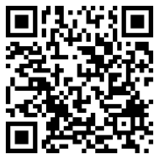
(a) $3^{0}$ (b) ${28}^{0}$ (c) ${37648}^{0}$ (d) ${19}^{0}×{27}^{0}$ (e) ${19}^{0}+{27}^{0}$
(f) $x^{0}$ (g) $π^{0}$ (h) $2^{3}×2^{0}$ (i) $3^{4}÷3^{0}$ (j) $\frac{7^{5}}{7^{5}}$
Raising a Power to Another Index
$${(n}^{a})^{b}=n^{a×b}$$
If a power of the form $n^{a}$ is raised to another index, then we need to multiply the indices.
We can see below why this is true.
$$\left\{\begin{matrix}\begin{matrix}1 \\ 1 \\ 1\end{matrix} \\ \begin{matrix}1 \\ \begin{matrix}1 \\ 1 \\ 1\end{matrix}\end{matrix}\end{matrix}\right.$$
4 times
${\left(5^{3}\right)}^{4}$ $=5^{3}×5^{3}×5^{3}×5^{3}$
${\left(5^{3}\right)}^{4}=5^{3+3+3+3}$
${\left(5^{3}\right)}^{4}=5^{12}$
${\left(5^{3}\right)}^{4}=5^{3×4}$.
Exercise 14
2
Simplify the following, giving your answers in index form.
(a) ${\left(5^{2}\right)}^{4}$ (b)${\left(5^{4}\right)}^{2}$ (c) ${\left(7^{2}\right)}^{4}$ (d)${\left(x^{2}\right)}^{4}$ (e) ${\left({(-5)}^{2}\right)}^{4}$
(f)${\left(5^{-2}\right)}^{4}$ (g)${\left(5^{2}\right)}^{-4}$ (h) ${\left(5^{-2}\right)}^{-4}$ (i)${\left({\left(\frac{1}{5}\right)}^{2}\right)}^{4}$ (j) ${\left(5^{2}\right)}^{0}$
(k) ${\left(6^{3}\right)}^{6}$ (l) ${\left({11}^{25}\right)}^{3}$ (m) ${\left(2^{7}\right)}^{8}$ (n) ${\left({43}^{5}\right)}^{-7}$ (o) ${\left({10}^{-3}\right)}^{-9}$
(p) ${\left(9^{0}\right)}^{6}$ (q) ${\left({0.3}^{6}\right)}^{9}$ (r) ${\left({11}^{-9}\right)}^{7}$ (s) ${\left({(-3)}^{-4}\right)}^{-3}$ (t) ${\left(y^{14}\right)}^{3}$
(u) ${\left(5^{2}\right)}^{4}×5^{6}$ (v) ${\left(3^{6}\right)}^{2}÷3^{4}$ (w) ${\left(8^{5}\right)}^{2}÷8^{10}$ (x) $6×{\left(6^{5}\right)}^{3}$ (y) ${\left(4^{12}\right)}^{5}×4^{0}$

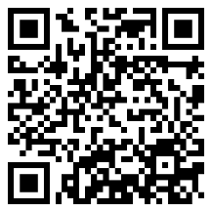
The Negative Index Rule
$$n^{-a}=\frac{1}{n^{a}}$$

Any number or variable raised to a negative index can be written as a fraction whose numerator is 1.
Why? Let us consider the following sequences.
$$÷15$$
$$÷7$$
$$÷15$$
$$÷15$$
$$÷7$$
$$÷7$$
$7^{3}=7×7×7$ ${15}^{3}=15×15×15$
$7^{2}=7×7$ ${15}^{2}=15×15$
$7^{1}=7$ ${15}^{1}=15$
$7^{0}=1$ ${15}^{0}=1$
What will appear next in these sequences?
$$÷15$$
$$÷7$$
$$÷7$$
$$÷15$$
$7^{0}=1$ ${15}^{0}=1$
$7^{-1}=\frac{1}{7}$ ${15}^{-1}=\frac{1}{15}$
$7^{-2}=\frac{1}{7×7}$ ${15}^{-2}=\frac{1}{15×15}$
Exercise 15
A
Complete the following table.
$$n$$ | 5 | 4 | 3 | 2 | 1 | 0 | –1 | –2 | –3 | –4 | –5
$$2^{n}$$ | 32
Exercise 16
Write the following as ordinary fractions, without using indices.
(a) $3^{-2}$ (b) $4^{-2}$ (c) $5^{-2}$ (d) $3^{-3}$ (e) $4^{-3}$
(f) $3^{-4}$ (g) $8^{-2}$ (h) $7^{-1}$ (i) ${10}^{-4}$ (j) ${11}^{-2}$
(k) $2^{-2}×3$ (l) $6^{-2}÷2$ (m) $8^{-1}×4$ (n) $9^{-2}×2^{-1}$ (o) $2^{-1}+2^{-3}$
The Reciprocal as a Negative Index
In year 9, we defined the reciprocal of a number as follows:
The reciprocal of a number is $\frac{1}{\text{the number}}$.
For example, the reciprocal of 4 is $\frac{1}{4}$ and the reciprocal of 15 is $\frac{1}{15}$. Because $n^{-1}=\frac{1}{n^{1}}=\frac{1}{n}$, we can now define the reciprocal of a number in an alternative way:
The reciprocal of a number $n$ is $n^{-1}$.
Exercise 17
23
Prove that multiplying a number $n$ by its reciprocal $n^{-1}$ always gives an answer of $1$.
(Clue: You will need to use the multiplication rule from page 5.)

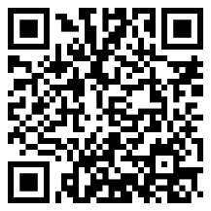
Unitary Fraction Index Rule
$$n^{\frac{1}{a}}=\sqrt[a]{n}$$
Any number or variable raised to an index that is a unitary fraction of the form $\frac{1}{a}$ can be written as the $a$–th root of $n$. For example, if $a=4$ then $n$ raised to a quarter $\left(n^{\frac{1}{4}}\right)$ can be written as the fourth root of $n$ $\left(\sqrt[4]{n}\right)$.
Why is this true? Consider the following application of the rule ${(n}^{a})^{b}=n^{a×b}$ from page 7.
${\left(n^{\frac{1}{2}}\right)}^{2}=n^{\frac{1}{2}×2}$ ${\left(n^{\frac{1}{3}}\right)}^{3}=n^{\frac{1}{3}×3}$
${\left(n^{\frac{1}{2}}\right)}^{2}=n^{1}$ ${\left(n^{\frac{1}{3}}\right)}^{3}=n^{1}$
${\left(n^{\frac{1}{2}}\right)}^{2}=n$ ${\left(n^{\frac{1}{3}}\right)}^{3}=n$
Because the square root of a number is a number that Because the cube root of a number is a number that
squares to give the original number, we have $n^{\frac{1}{2}}=\sqrt{n}$. cubes to give the original number, we have $n^{\frac{1}{3}}=\sqrt[3]{n}$.
Example
$$5^{4}=5×5×5×5$$$=625$ therefore $\sqrt[4]{625}=5$.
$9^{\frac{1}{2}}=\sqrt{9}$ ${216}^{\frac{1}{3}}=\sqrt[3]{216}$ ${625}^{\frac{1}{4}}=\sqrt[4]{625}$
$9^{\frac{1}{2}}=3$ ${216}^{\frac{1}{3}}=6$ ${625}^{\frac{1}{4}}=5$
Exercise 18
P
Evaluate the following.
(a) ${16}^{\frac{1}{2}}$ (b) ${25}^{\frac{1}{2}}$ (c) ${49}^{\frac{1}{2}}$ (d) $8^{\frac{1}{3}}$ (e) ${27}^{\frac{1}{3}}$
(f) ${16}^{\frac{1}{4}}$ (g) ${81}^{\frac{1}{4}}$ (h) ${64}^{\frac{1}{2}}$ (i) ${64}^{\frac{1}{3}}$ (j) ${64}^{\frac{1}{6}}$
(k) ${36}^{\frac{1}{2}}×9^{\frac{1}{2}}$ (l) ${125}^{\frac{1}{3}}+{81}^{\frac{1}{2}}$ (m) ${100}^{\frac{1}{2}}÷4^{\frac{1}{2}}$ (n) ${32}^{\frac{1}{5}}-1^{\frac{1}{3}}$ (o) ${121}^{\frac{1}{2}}×0^{\frac{1}{10}}$
Exercise 19 (Revision)
Simplify each of the following expressions.
(a) $2^{10}×2^{5}$ (b) $3^{5}×3$ (c) ${15}^{6}×{15}^{-2}$ (d) $x^{-4}×x^{9}$ (e) $4^{-3}×4^{-2}$
(f) $2^{10}÷2^{5}$ (g) $3^{5}÷3$ (h) ${15}^{6}÷{15}^{-2}$ (i) $x^{-4}÷x^{9}$ (j) $4^{-3}÷4^{-2}$
(k) $2^{0}$ (l) ${45}^{0}$ (m) ${\left(2^{10}\right)}^{5}$ (n) ${\left({15}^{6}\right)}^{-2}$ (o) ${\left(4^{-3}\right)}^{-2}$
(p) $7^{-2}$ (q) $5^{-3}$ (r) ${81}^{\frac{1}{2}}$ (s) ${343}^{\frac{1}{3}}$ (t) $\frac{{16}^{\frac{1}{2}}}{2^{-2}}$
Exercise 20
Complete the following pyramids, where each number is the product of the two numbers
in the boxes underneath.
(a) (b) (c)
$$2^{2}$$ |  | $$2^{1}$$ |  | $$2^{0}$$ |  | $$2^{-1}$$

3 |  | 2 |  | 1 |  | 0

$$4^{2}$$ |  | $$4^{1}$$ |  | $$4^{0}$$ |  | $$4^{\frac{1}{2}}$$

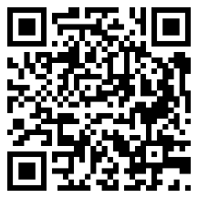
Algebra and Rules of Indices
Multiply the numbers, add the indices.

Divide the numbers, subtract the indices.

Divide the numbers, subtract the powers.

Example
$4x^{2}y^{3}×3x^{4}y^{5}=12x^{6}y^{8}$ $20a^{8}b^{6}÷4a^{2}b^{3}=5a^{6}b^{3}$ $\frac{42p^{12}q^{15}}{6p^{3}q^{5}}=7p^{9}q^{10}$
Exercise 21
Simplify the following algebraic expressions.
23
(a) $2x^{3}y^{4}×3x^{4}y^{2}$ (b) $8a^{5}b^{3}×4a^{3}b^{6}$ (c) $9p^{5}q^{3}×3p^{4}q$
(d) $16x^{10}y^{12}÷2x^{2}y^{4}$ (e) $24a^{6}b^{15}÷4a^{2}b^{3}$ (f) $80p^{32}q^{20}÷10p^{4}q^{10}$
(g) $\frac{8x^{14}y^{10}}{2x^{2}y^{2}}$ (h) $\frac{28a^{16}b^{4}}{7a^{4}b}$ (i) $\frac{100p^{4}q^{8}}{25p^{2}q^{4}}$
(j) $4g^{5}h^{3}×-2g^{5}h^{3}$ (k) $6s^{4}t^{6}×5s^{-2}t^{3}$ (l) $-3u^{-5}v^{7}×-9u^{3}v^{-2}$
(m) $25c^{8}d^{-12}÷5c^{2}d^{3}$ (n) $\frac{-32e^{-4}f^{10}}{2ef^{2}}$ (o) $\frac{84x^{5}y^{-14}z}{2x^{-2}y^{2}z^{-2}}$
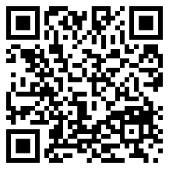
The General Fraction Index Rule
$${\left(\sqrt[b]{n}\right)}^{a}=n^{\frac{a}{b}}=\sqrt[b]{n^{a}}$$
There are two ways or writing any number or variable raised to a general fraction of the form $\frac{a}{b}$.
- Take the $b$–th root of $n$ to begin with, and then raise everything to the index $a$. ${\left(\sqrt[b]{n}\right)}^{a}$
- Raise $n$ to the index $a$ to begin with, and then take the $b$–th root of everything. $\sqrt[b]{n^{a}}$
Usually, method (1) is easier to calculate without a calculator.

Example
Evaluate ${27}^{\frac{2}{3}}$. Evaluate ${32}^{\frac{3}{5}}$.
Method (1) Method (2) Method (1) Method (2)
$\sqrt[3]{27}=3$ ${27}^{2}=729$ $\sqrt[5]{32}=2$ ${32}^{3}=32,768$
$3^{2}=9$ $\sqrt[3]{729}=9$ $2^{3}=8$ $\sqrt[5]{32,768}=8$
Exercise 22
A
Evaluate the following.
(a) $8^{\frac{2}{3}}$ (b) $8^{\frac{4}{3}}$ (c) ${125}^{\frac{2}{3}}$ (d) ${125}^{\frac{4}{3}}$ (e) ${81}^{\frac{3}{4}}$
(f) ${16}^{\frac{3}{2}}$ (g) ${32}^{\frac{2}{5}}$ (h) ${32}^{\frac{4}{5}}$ (i) ${49}^{\frac{3}{2}}$ (j) ${64}^{\frac{2}{3}}$
(k) ${16}^{\frac{3}{4}}$ (l) ${1024}^{\frac{2}{5}}$ (m) ${144}^{\frac{3}{2}}$ (n) ${3125}^{\frac{2}{5}}$ (o) ${1296}^{\frac{3}{4}}$
(p) ${625}^{\frac{3}{4}}$ (q) ${243}^{\frac{2}{5}}$ (r) ${36}^{\frac{3}{2}}$ (s) $4^{\frac{5}{2}}$ (t) ${729}^{\frac{2}{3}}$
Challenge!
(a) Given that $x$ is a number such that $x>1$, put $x$, $x^{2}$, $x^{-1}$ in ascending order.
(b) Given that $x$ is a number such that $0<x<1$, put $x$, $x^{2}$, $x^{-1}$ in ascending order.
(c) Given that $x$ is a number such that $0<x<1$, put $x$, $x^{0}$, $x^{\frac{1}{2}}$ in ascending order.
(d) Given that $x$ is a number such that $-1<x<0$, put $x$, $x^{2}$, $x^{0}$, $x^{-1}$, $x^{-3}$ in ascending order.

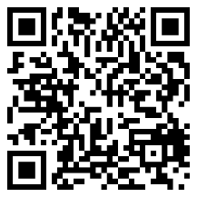
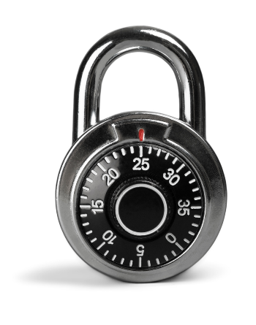
Combining the Rules
Example
$4^{-\frac{1}{2}}=\frac{1}{4^{\frac{1}{2}}}$ $8^{-\frac{2}{3}}=\frac{1}{8^{\frac{2}{3}}}$ The negative index gives a unitary fraction
$4^{-\frac{1}{2}}=\frac{1}{\sqrt{4}}$ $8^{-\frac{2}{3}}=\frac{1}{{\left(\sqrt[3]{8}\right)}^{2}}$ The fractional index gives a root
$4^{-\frac{1}{2}}=\frac{1}{2}$ $8^{-\frac{2}{3}}=\frac{1}{2^{2}}$ Evaluate the answer
$8^{-\frac{2}{3}}=\frac{1}{4}$
Exercise 23
Evaluate the following.
A
(a) ${25}^{-\frac{1}{2}}$ (b) ${36}^{-\frac{1}{2}}$ (c) ${64}^{-\frac{1}{2}}$ (d) ${64}^{-\frac{1}{3}}$ (e) ${27}^{-\frac{1}{3}}$
(f) ${16}^{-\frac{1}{4}}$ (g) ${1024}^{-\frac{1}{5}}$ (h) ${144}^{-\frac{1}{2}}$ (i) ${125}^{-\frac{1}{3}}$ (j) ${81}^{-\frac{1}{4}}$
(k) ${27}^{-\frac{2}{3}}$ (l) $4^{-\frac{3}{2}}$ (m) ${216}^{-\frac{2}{3}}$ (n) ${81}^{-\frac{3}{4}}$ (o) ${32}^{-\frac{3}{5}}$
(p) ${16}^{-\frac{3}{2}}$ (q) ${256}^{-\frac{3}{4}}$ (r) ${25}^{-\frac{3}{2}}$ (s) ${243}^{-\frac{3}{5}}$ (t) $8^{-\frac{4}{3}}$
Exercise 24
Evaluate the following.
(a) ${\left(\frac{9}{16}\right)}^{\frac{1}{2}}$ (b) ${\left(\frac{27}{125}\right)}^{\frac{1}{3}}$ (c) ${\left(\frac{1}{36}\right)}^{\frac{1}{2}}$ (d) ${\left(\frac{1}{16}\right)}^{\frac{1}{4}}$ (e) ${\left(\frac{36}{49}\right)}^{\frac{1}{2}}$
(f) ${\left(\frac{1}{4}\right)}^{-\frac{1}{2}}$ (g) ${\left(\frac{36}{121}\right)}^{-\frac{1}{2}}$ (h) ${\left(\frac{8}{27}\right)}^{-\frac{1}{3}}$ (i) ${\left(\frac{125}{343}\right)}^{-\frac{1}{3}}$ (j) ${\left(\frac{1}{81}\right)}^{-\frac{1}{4}}$
(k) ${\left(3\frac{1}{16}\right)}^{\frac{1}{2}}$ (l) ${\left(3\frac{3}{8}\right)}^{\frac{1}{3}}$ (m) ${\left(2\frac{1}{4}\right)}^{-\frac{1}{2}}$ (n) ${\left(2\frac{10}{27}\right)}^{-\frac{1}{3}}$ (o) ${\left(37\frac{1}{27}\right)}^{-\frac{1}{3}}$
Challenge!
What is the answer to $\sqrt{9}$? One answer is 3, as 3² = 9. But –3 is also an answer, as (–3)² = 9.
How many different answers do the following calculations have?
(a) $\sqrt{16}$ (b) $\sqrt[3]{27}$ (c) $\sqrt[4]{16}$ (d) $9^{\frac{1}{2}}$ (e) ${3125}^{\frac{1}{5}}$
Key words | Corrections | I am happy with... | I need to revise...

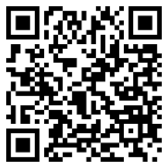
Rational and Irrational Numbers
A number is a rational number if it can be written in the form of a fraction $\frac{a}{b}$, where $a$ and $b$ are integers, and $b≠0$. For example, $\frac{4}{5}$, $6=\frac{6}{1}$, $3\frac{1}{2}=\frac{7}{2}$ and $0.\dot{3}=\frac{1}{3}$ are rational numbers.
A number is an irrational number if it cannot be written in the form of a fraction $\frac{a}{b}$, where $a$ and $b$ are integers, and $b≠0$. For example, $π$, $\sqrt{2}$ and 0.202002000200002.... are irrational numbers.
Exercise 25
2
Circle the rational numbers below.
8 $\sqrt{3}$ $\frac{5}{6}$ $\sqrt{4}$ $π$ $0.\dot{4}5\dot{2}$ 0.45445444544445...
$\sqrt[3]{2}$ $4\frac{2}{3}$ $\sqrt[3]{27}$ $π^{2}$ ${\left(\sqrt{2}\right)}^{2}$ $\frac{2}{0}$ 0.27277277727777
Surds
A surd is a number that contains a root that does not correspond to a rational number. Here are some examples.
$\sqrt{2}$ Surd (it is not possible to write $\sqrt{2}$ as a fraction $\frac{a}{b}$).
$3\sqrt{2}$ Surd (a multiple of the surd $\sqrt{2}$).
$\sqrt{9}$ Not a surd (corresponds to 3).
$\sqrt[3]{4}$ Surd (it is not possible to write $\sqrt[3]{4}$ as a fraction $\frac{a}{b}$).
$\sqrt[3]{64}$ Not a surd (corresponds to 4).
Exercise 26
2
Circle the surds below.
$\sqrt{5}$ $\sqrt{16}$ $\sqrt{49}$ $\sqrt{32}$ $\sqrt[3]{4}$ $\sqrt[3]{1}$ $\sqrt[3]{25}$
$\sqrt[4]{2}$ $\sqrt[4]{16}$ $9\sqrt{2}$ $2\sqrt{4}$ $3\sqrt{10}$ $6\sqrt[3]{8}$ $4\sqrt[3]{36}$
Working with surds
It is possible to collect like surds together, exactly as we can collect like terms in algebra.
Example
$2\sqrt{3}+4\sqrt{3}=6\sqrt{3}$ $7\sqrt{2}-\sqrt{2}=6\sqrt{2}$
$4\sqrt[3]{5}+2\sqrt{5}+6\sqrt[3]{5}+7\sqrt{5}=10\sqrt[3]{5}+9\sqrt{5}$ $5\sqrt{6}+\sqrt{16}-2\sqrt{6}-1=3\sqrt{6}+3$
Exercise 27
2
Simplify the following.
(a) $5\sqrt{2}+3\sqrt{2}$ (b) $7\sqrt{2}+\sqrt{2}$ (c) $6\sqrt{2}-2\sqrt{2}$
(d) $8\sqrt[3]{7}+2\sqrt[3]{7}$ (e) $10\sqrt[4]{2}-3\sqrt[4]{2}$ (f) $\sqrt{3}+2+\sqrt{3}+9$
(g) $5\sqrt{7}+2\sqrt[3]{4}+2\sqrt{7}+6\sqrt[3]{4}$ (h) $7\sqrt[3]{5}+\sqrt{11}-4\sqrt[3]{5}+2\sqrt{11}$ (i) $3\sqrt{4}+2\sqrt{6}+8$
(j) $\sqrt{10}+3\sqrt[4]{3}-3\sqrt{10}+\sqrt[4]{3}$ (k) $\sqrt{7}+\sqrt[3]{7}-\sqrt{7}+\sqrt[3]{7}$ (l) $\sqrt[100]{10}+\sqrt[100]{1}$
A Venn diagram showing different types of numbers

Irrational numbers
Rational numbers
$$φ$$
$$π$$
9.51
$\frac{3}{7}$
$$4$$
Surds
$$\sqrt{5}$$
$$e$$
$$4\sqrt[3]{11}$$
$$-8$$
$$0.3\dot{7}$$
$$ε$$
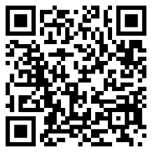
Simplifying Surds
It is possible to use the following rules to simplify surds.
$\sqrt{a}×\sqrt{a}=a$, $\sqrt{ab}=\sqrt{a}×\sqrt{b}$
Example
$\sqrt{3}×\sqrt{3}=3$ $\sqrt{8}=\sqrt{4×2}$ $\sqrt{15}×\sqrt{12}=\sqrt{5×3}×\sqrt{3×4}$
$\sqrt{8}=\sqrt{4}×\sqrt{2}$ $\sqrt{15}×\sqrt{12}=\sqrt{5}×\sqrt{3}×\sqrt{3}×\sqrt{4}$
$\sqrt{8}=2×\sqrt{2}$ $\sqrt{15}×\sqrt{12}=\sqrt{5}×3×2$
$\sqrt{8}=2\sqrt{2}$ $\sqrt{15}×\sqrt{12}=6\sqrt{5}$
Exercise 28
2
Complete the following table to show the surds in their simplest form.
(Hint: look for a factor that is a square number.)
$$\sqrt{1}$$ | $$\sqrt{2}$$ | $$\sqrt{3}$$ | $$\sqrt{4}$$ | $$\sqrt{5}$$ | $$\sqrt{6}$$ | $$\sqrt{7}$$ | $$\sqrt{8} \\ =2\sqrt{2}$$ | $$\sqrt{9} \\ =3$$ | $$\sqrt{10}$$
$$\sqrt{11}$$ | $$\sqrt{12}$$ | $$\sqrt{13}$$ | $$\sqrt{14}$$ | $$\sqrt{15}$$ | $$\sqrt{16}$$ | $$\sqrt{17}$$ | $$\sqrt{18}$$ | $$\sqrt{19}$$ | $$\sqrt{20}$$
$$\sqrt{21}$$ | $$\sqrt{22}$$ | $$\sqrt{23}$$ | $$\sqrt{24}$$ | $$\sqrt{25}$$ | $$\sqrt{26}$$ | $$\sqrt{27}$$ | $$\sqrt{28}$$ | $$\sqrt{29}$$ | $$\sqrt{30}$$
$$\sqrt{31}$$ | $$\sqrt{32}$$ | $$\sqrt{33}$$ | $$\sqrt{34}$$ | $$\sqrt{35}$$ | $$\sqrt{36}$$ | $$\sqrt{37}$$ | $$\sqrt{38}$$ | $$\sqrt{39}$$ | $$\sqrt{40}$$
$$\sqrt{41}$$ | $$\sqrt{42}$$ | $$\sqrt{43}$$ | $$\sqrt{44}$$ | $$\sqrt{45}$$ | $$\sqrt{46}$$ | $$\sqrt{47}$$ | $$\sqrt{48}$$ | $$\sqrt{49}$$ | $$\sqrt{50}$$
$$\sqrt{51}$$ | $$\sqrt{52}$$ | $$\sqrt{53}$$ | $$\sqrt{54}$$ | $$\sqrt{55}$$ | $$\sqrt{56}$$ | $$\sqrt{57}$$ | $$\sqrt{58}$$ | $$\sqrt{59}$$ | $$\sqrt{60}$$
$$\sqrt{61}$$ | $$\sqrt{62}$$ | $$\sqrt{63}$$ | $$\sqrt{64}$$ | $$\sqrt{65}$$ | $$\sqrt{66}$$ | $$\sqrt{67}$$ | $$\sqrt{68}$$ | $$\sqrt{69}$$ | $$\sqrt{70}$$
$$\sqrt{71}$$ | $$\sqrt{72}$$ | $$\sqrt{73}$$ | $$\sqrt{74}$$ | $$\sqrt{75}$$ | $$\sqrt{76}$$ | $$\sqrt{77}$$ | $$\sqrt{78}$$ | $$\sqrt{79}$$ | $$\sqrt{80}$$
$$\sqrt{81}$$ | $$\sqrt{82}$$ | $$\sqrt{83}$$ | $$\sqrt{84}$$ | $$\sqrt{85}$$ | $$\sqrt{86}$$ | $$\sqrt{87}$$ | $$\sqrt{88}$$ | $$\sqrt{89}$$ | $$\sqrt{90}$$
$$\sqrt{91}$$ | $$\sqrt{92}$$ | $$\sqrt{93}$$ | $$\sqrt{94}$$ | $$\sqrt{95}$$ | $$\sqrt{96}$$ | $$\sqrt{97}$$ | $$\sqrt{98}$$ | $$\sqrt{99}$$ | $$\sqrt{100}$$
Exercise 29
2
Simplify the following.
(a) $\sqrt{2}×5\sqrt{2}$ (b) $4\sqrt{2}×\sqrt{8}$ (c) $\sqrt{125}$
(d) $5\sqrt{32}$ (e) $\sqrt{12}+4\sqrt{3}$ (f) $7\sqrt{5}-\sqrt{45}$
(g) $\sqrt{60}×2\sqrt{3}$ (h) $\sqrt{300}$ (i) $\sqrt{32}×\sqrt{18}$
(j) $5\sqrt{30}×\sqrt{60}$ (k) $6\sqrt{5}-\sqrt{20}$ (l) $\sqrt{48}+4\sqrt{3}$
(m) $\sqrt{18}+8\sqrt{2}$ (n) $\sqrt{8}×\sqrt{24}$ (o) $5\sqrt{15}×\sqrt{3}$
Exercise 30
2
Simplify the following.
(a) $\frac{\sqrt{2}×\sqrt{2}×\sqrt{5}}{\sqrt{5}}$ (b) $\frac{\sqrt{12}×\sqrt{3}}{2}$ (c) $\frac{3×\sqrt{7}×\sqrt{2}×\sqrt{7}}{7\sqrt{2}}$
(d) $\sqrt{7}×7^{\frac{1}{2}}$ (e) ${(4\sqrt{2})}^{2}$ (f) ${(\sqrt{3})}^{5}$
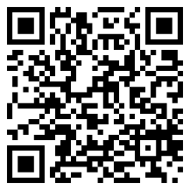
Expanding with surds
Example
Use the acronym FOIL
$\sqrt{5}\left(4+\sqrt{5}\right)=\sqrt{5}×4+\sqrt{5}×\sqrt{5}$ $2\sqrt{3}\left(5\sqrt{3}-4\right)=2×\sqrt{3}×5×\sqrt{3}-2×\sqrt{3}×4$
$\sqrt{5}\left(4+\sqrt{5}\right)=4\sqrt{5}+5$ $2\sqrt{3}\left(5\sqrt{3}-4\right)=10×3-8×\sqrt{3}$ $2\sqrt{3}\left(5\sqrt{3}-4\right)=30-8\sqrt{3}$
$\left(\sqrt{3}+2\right)\left(\sqrt{7}-5\right)=\sqrt{3}×\sqrt{7}-\sqrt{3}×5+2×\sqrt{7}-2×5$
$\left(\sqrt{3}+2\right)\left(\sqrt{7}-5\right)=\sqrt{21}-5\sqrt{3}+2\sqrt{7}-10$
${(4-2\sqrt{3})}^{2}=(4-2\sqrt{3})(4-2\sqrt{3})$
${(4-2\sqrt{3})}^{2}=4×4-4×2×\sqrt{3}-2×\sqrt{3}×4+2×\sqrt{3}×2×\sqrt{3}$
${(4-2\sqrt{3})}^{2}=16-8\sqrt{3}-8\sqrt{3}+4×3$
${(4-2\sqrt{3})}^{2}=28-16\sqrt{3}$
Exercise 31
2
Expand and simplify the following.
(a) $\sqrt{2}(3+\sqrt{2})$ (b) $4\sqrt{2}(3+\sqrt{2})$ (c) $4\sqrt{2}(3+2\sqrt{2})$
(d) $\sqrt{3}(\sqrt{5}+\sqrt{3})$ (e) $2\sqrt{5}(\sqrt{2}+\sqrt{5})$ (f) $4\sqrt{7}(3+\sqrt{14})$
(g) $5\sqrt{2}(\sqrt{8}+\sqrt{6})$ (h) $2\sqrt{11}(1+\sqrt{22})$ (i) $3\sqrt{3}(\sqrt{6}+\sqrt{12})$
Exercise 32
2
Expand and simplify the following.
(a) $(2+\sqrt{3})(4+\sqrt{2})$ (b) $(2+\sqrt{3})(4+\sqrt{3})$ (c) $(2+3\sqrt{3})(4+\sqrt{3})$
(d) $(2+\sqrt{3})(4-\sqrt{2})$ (e) $(4-\sqrt{2})(1+\sqrt{2})$ (f) $(4-3\sqrt{5})(1+\sqrt{5})$
(g) $(\sqrt{7}+5)(\sqrt{7}-5)$ (h) $(2+3\sqrt{7})(3\sqrt{2}-5)$ (i) $(10-5\sqrt{7})(\sqrt{7}+4)$
(j) ${(3+\sqrt{5})}^{2}$ (k) ${(5-\sqrt{2})}^{2}$ (l) ${(4+9\sqrt{5})}^{2}$
Exercise 33
2
(a) Given that $a=\sqrt{2}$, $b=\sqrt{3}$ and $c=\sqrt{12}$, find the value of $abc$. Write your answer in the form $n\sqrt{2}$ where $n$ is a whole number.
(b) Given that $p=\sqrt{5}$, $q=\sqrt{10}$, $r=\sqrt{50}$, find the value of the following. Note clearly whether your answers are rational or irrational.
(i) $pr$ (ii) $\frac{pq}{r}$ (iii) $pq+r$
(c) Evaluate $\frac{(3+\sqrt{5})(3-\sqrt{5})}{2}$. Note clearly whether your answer is rational or irrational.
(d) Simplify $\frac{{(2\sqrt{5})}^{2}-\frac{3\sqrt{12}}{\sqrt{3}}}{2}$ and note whether your answer is rational or irrational.
(e) Simplify ${(π\sqrt{24}-π\sqrt{6})}^{2}$, leaving your answer in terms of $π$.
(f) Write a value for $x$ (with $x>1)$ so that $x^{\frac{3}{2}}$ is rational.
Challenge!
Patterns are produced as shown in the following diagrams.
1 cm
1 cm
1 cm
1 cm
1 cm
1 cm

1 cm
1 cm
1 cm
1 cm

1 cm
1 cm
1 cm
1 cm
Pattern 1 Pattern 2 Pattern 3 Pattern 4
The diagrams are not drawn to scale.
Find the perimeter of Pattern 6 in the form $a+\sqrt{b}$, where $a$ and $b$ are whole numbers. Show all your working.
Key words | Corrections | I am happy with... | I need to revise...

The standard form is a special way to write numbers, usually very large or very small numbers.

A number is written in standard form if it has the form
$a×{10}^{n}$,
where $a$ is a number between 1 and 10 ($1≤a<10)$ and $n$ is an integer.
Example
0.2 is not an integer.
Circle the numbers below that are written in standard form.
$3.2×{10}^{5}$ $14.2×{10}^{9}$ $7.2×{10}^{-6}$ $6.21×{10}^{0.2}$
Division, not multiplication.
Not a number between 1 and 10.

$0.34×{10}^{23}$ $-3.2×{10}^{-5}$ $1×{10}^{7}$ $8.7÷{10}^{8}$
Exercise 34
Circle the numbers below that are written in standard form.
A
(a) $6.7×{10}^{5}$ (b) $5.4÷{10}^{9}$ (c) $9×{10}^{-3}$ (d) $14.3×{10}^{12}$
(e) $0.38×{10}^{6}$ (f) $9.3×{10}^{0}$ (g) $-3.2×{10}^{6}$ (h) $10×{10}^{4}$
(i) $4.5×5^{5}$ (j) $3×{10}^{189}$ (k) $6×{10}^{1.4}$ (l) $5.6721×{10}^{-9}$

Writing Numbers $x≥1$ in Standard Form
Given a number that is greater than or equal to one, this is how we write it in standard form.
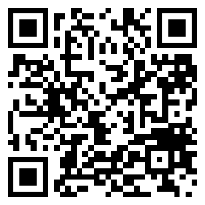
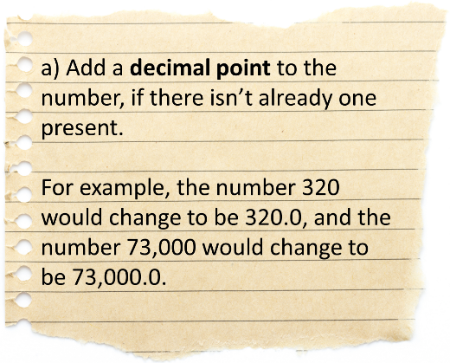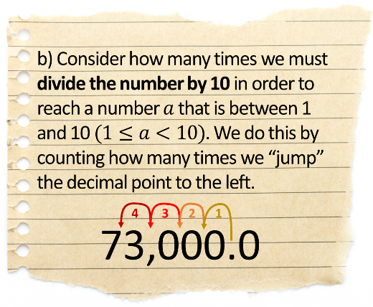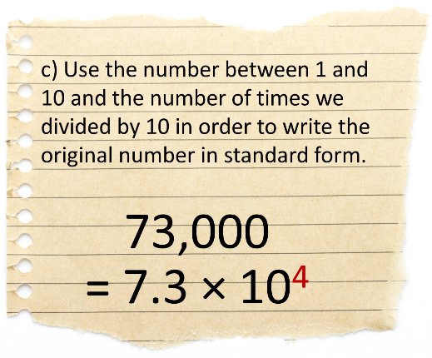
Exercise 35
Write the following numbers in standard form.
(a) 54,000 (b) 234,000 (c) 8,000 (d) 3,000,000
(e) 340 (f) 43,000,000 (g) 4,328,000,000 (h) 7
(i) 98,000,000,000 (j) 823,240,000,000 (k) 10 (l) 1

Writing Numbers $0<x<1$ in Standard Form
Remember that
${10}^{-3}=\frac{1}{{10}^{3}}$, therefore multiplying by ${10}^{-3}$ is the same as dividing by ${10}^{3}$.

Given a number between 0 and 1, this is how we write it in standard form.
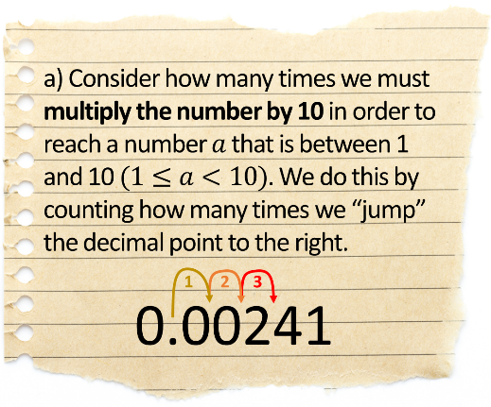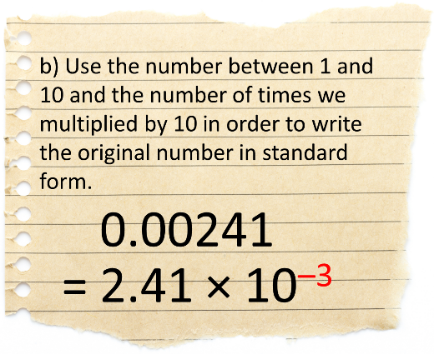
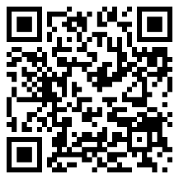
Exercise 36
A
Write the following numbers in standard form.
(a) 0.00428 (b) 0.000027 (c) 0.021 (d) 0.87
(e) 0.00000689 (f) 0.4 (g) 0.0009873 (h) 0.0901
(i) 0.00000000728 (j) 0.000000429 (k) 0.0000502 (l) 0.999999999
Exercise 37
Write the following numbers in standard form.
(a) 84,200 (b) 0.000647 (c) 5,000,000 (d) 0.005183
(e) 502,050 (f) 0.0000004 (g) 0.98 (h) 852,000,000,000
(i) 0.000201 (j) 2,384,900,000 (k) 1.03 (l) 0.03
Changing from Standard Form to an Ordinary Number
Example
(a) Write $6.962×{10}^{6}$ as an ordinary number. (b) Write $9.62×{10}^{-5}$ as an ordinary number.
We must multiply 6.962 by 10 six times. We must divide 9.62 by 10 five times.
69.62 1 time 0.962 1 time
696.2 2 times 0.0962 2 times
6962 3 times 0.00962 3 times
69620 4 times 0.000962 4 times
696200 5 times 0.0000962 5 times
6962000 6 times
The answer is 6,962,000. The answer is 0.0000962.
Exercise 38
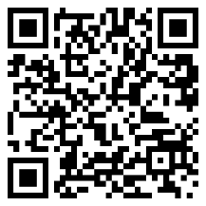
Write the following numbers, which are in standard form, as ordinary numbers.
(a) $8.243×{10}^{6}$ (b) $4.2×{10}^{4}$ (c) $8×{10}^{5}$ (d) $3.704×{10}^{8}$(e) $6.25×{10}^{-5}$ (f) $1.75×{10}^{-2}$ (g) $8.02×{10}^{-3}$ (h) $6.2829×{10}^{-7}$(i) $7×{10}^{-2}$ (j) $9.2×{10}^{1}$ (k) $3.504×{10}^{-1}$ (l) $8.6284×{10}^{-6}$
(m) $4×{10}^{0}$ (n) $5.289×{10}^{8}$ (o) $8.2×{10}^{-9}$ (p) $8.28465×{10}^{10}$
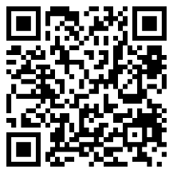
Almost in Standard Form
In order to multiply and divide numbers given in standard form, we must first learn how to change numbers that are almost in standard form to be in standard form.
Example
Change the following numbers, that are almost in standard form, to be in standard form.
(a) $45×{10}^{7}$ (b) $0.4×{10}^{3}$ (c) $68×{10}^{-4}$ (d) $0.064×{10}^{-7}$
÷10 +1 ×10 –1 ÷10 +1 ×100 –2
$=4.5×{10}^{8}$ $=4×{10}^{2}$ $=6.8×{10}^{-3}$ $=6.4×{10}^{-9}$
Divide the number / move decimal point to the left: increase the index. Multiply the number / move decimal point to the right: decrease the index.

Exercise 39
Change the following numbers, that are almost in standard form, to be in standard form.
(a) $61×{10}^{7}$ (b) $532×{10}^{7}$ (c) $0.61×{10}^{7}$ (d) $0.54×{10}^{7}$(e) $61×{10}^{-7}$ (f) $532×{10}^{-7}$ (g) $0.61×{10}^{-7}$ (h) $0.54×{10}^{-7}$(i) $83×{10}^{9}$ (j) $0.325×{10}^{14}$ (k) $7324×{10}^{-5}$ (l) $53×{10}^{-14}$
(m) $0.025×{10}^{8}$ (n) $0.0024×{10}^{-16}$ (o) $10×{10}^{5}$ (p) $0.63×{10}^{-43}$
Adding and Subtracting Numbers in Standard Form
Method 1: Equal Indices
Calculate the following, giving your answer in standard form.
(a) $\left(3×{10}^{15}\right)+\left(8×{10}^{15}\right)$(a) $=11×{10}^{15}$ The indices are equal so we can add the 8 to the 3.
(a) $=1.1×{10}^{16}$ Change the answer to be in standard form.
(b) $\left(7.2×{10}^{24}\right)-\left(5×{10}^{23}\right)$
(b) $=\left(7.2×{10}^{24}\right)-\left(0.5×{10}^{24}\right)$ Change the second number so that its index is also 24.
(b) $=6.7×{10}^{24}$ The indices are equal so we can subtract the 0.5 from the 7.2.
Exercise 40
A
Calculate the following, giving your answer in standard form.
(a) $\left(5×{10}^{12}\right)+\left(2×{10}^{12}\right)$ (b)$\left(5×{10}^{27}\right)+\left(2×{10}^{27}\right)$ (c) $\left(2×{10}^{27}\right)+\left(5×{10}^{27}\right)$
(d) $\left(7×{10}^{27}\right)+\left(5×{10}^{27}\right)$ (e)$\left(7×{10}^{27}\right)-\left(5×{10}^{27}\right)$ (f) $\left(7×{10}^{-7}\right)-\left(5×{10}^{-7}\right)$
(g) $\left(6×{10}^{8}\right)+\left(2×{10}^{8}\right)$ (h)$\left(6×{10}^{8}\right)+\left(2×{10}^{7}\right)$ (i) $\left(6×{10}^{7}\right)+\left(2×{10}^{8}\right)$
(j) $\left(6×{10}^{6}\right)+\left(2×{10}^{8}\right)$ (k)$\left(6×{10}^{6}\right)-\left(2×{10}^{5}\right)$ (l) $\left(6×{10}^{6}\right)-\left(2×{10}^{4}\right)$
(m) $\left(9×{10}^{-5}\right)-\left(3×{10}^{-5}\right)$ (n)$\left(9×{10}^{-5}\right)+\left(3×{10}^{-5}\right)$ (o) $\left(9×{10}^{-5}\right)+\left(3×{10}^{-6}\right)$
(p) $\left(9×{10}^{-6}\right)+\left(3×{10}^{-5}\right)$ (q)$\left(9×{10}^{-5}\right)-\left(3×{10}^{-7}\right)$ (r) $\left(9×{10}^{-4}\right)+\left(3×{10}^{-6}\right)$
(s) $\left(7.3×{10}^{8}\right)+\left(2.6×{10}^{8}\right)$ (t)$\left(7.4×{10}^{8}\right)+\left(2.6×{10}^{8}\right)$ (u) $\left(7.3×{10}^{8}\right)+\left(2.6×{10}^{7}\right)$
(v) $\left(7.3×{10}^{108}\right)+\left(2.6×{10}^{107}\right)$ (w)$\left(7.3×{10}^{-108}\right)+\left(2.6×{10}^{-107}\right)$ (x) $\left(7.3×{10}^{0}\right)+\left(2.6×{10}^{-1}\right)$

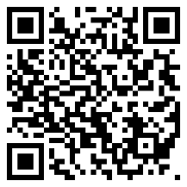
Method 2: Change to ordinary numbers
Calculate the following, giving your answer in standard form.
(a) $\left(3.4×{10}^{5}\right)+\left(7.18×{10}^{4}\right)$ (b) $\left(7.36×{10}^{-3}\right)-\left(1.9×{10}^{-4}\right)$
Answer: $4.118×{10}^{5}$ Answer: $7.17×{10}^{-3}$
Exercise 41
A
Calculate the following, giving your answers in standard form.
(a) $\left(2.7×{10}^{3}\right)+\left(5.26×{10}^{2}\right)$ (b)$\left(6.152×{10}^{5}\right)+\left(7.64×{10}^{4}\right)$ (c) $\left(2.09×{10}^{4}\right)+\left(4×{10}^{3}\right)$
(d) $\left(6.29×{10}^{6}\right)+\left(3.283×{10}^{5}\right)$ (e)$\left(5×{10}^{4}\right)+\left(8.024×{10}^{6}\right)$ (f) $\left(4.2×{10}^{7}\right)+\left(1.59×{10}^{8}\right)$
(g) $\left(2.7×{10}^{3}\right)-\left(5.26×{10}^{2}\right)$ (h)$\left(6.152×{10}^{5}\right)-\left(7.64×{10}^{4}\right)$ (i) $\left(2.09×{10}^{4}\right)-\left(4×{10}^{3}\right)$
(j) $\left(8×{10}^{6}\right)-\left(4.6×{10}^{3}\right)$ (k)$\left(2.07×{10}^{4}\right)-\left(9.442×{10}^{3}\right)$ (l) $\left(1.4×{10}^{2}\right)-\left(4.6×{10}^{1}\right)$
(m) $\left(2.7×{10}^{-3}\right)+\left(5.26×{10}^{-2}\right)$ (n)$\left(6.152×{10}^{-5}\right)+\left(7.64×{10}^{-4}\right)$ (o) $\left(2.09×{10}^{-4}\right)+\left(4×{10}^{-3}\right)$
(p) $\left(6.4×{10}^{-1}\right)+\left(7.28×{10}^{-2}\right)$ (q)$\left(8×{10}^{-4}\right)+\left(7.4×{10}^{-3}\right)$ (r) $\left(1.02×{10}^{-7}\right)+\left(7.32×{10}^{-6}\right)$
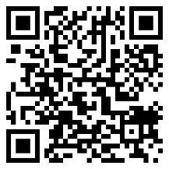
(s) $\left(5.26×{10}^{-2}\right)-\left(2.7×{10}^{-3}\right)$ (t)$\left(7.64×{10}^{-4}\right)-\left(6.152×{10}^{-5}\right)$ (u) $\left(4×{10}^{-3}\right)-\left(2.09×{10}^{-4}\right)$
(v) $\left(6.43×{10}^{-4}\right)-\left(3.82×{10}^{-5}\right)$ (w)$\left(4.6×{10}^{-7}\right)-\left(6×{10}^{-10}\right)$ (x) $\left(3.814×{10}^{2}\right)-\left(4.76×{10}^{-2}\right)$
Multiplying Numbers in Standard Form

Example
Calculate $\left(2.5×{10}^{5}\right)×\left(6×{10}^{3}\right)$, giving your answer in standard form.
Answer: $\left(2.5×{10}^{5}\right)×\left(6×{10}^{3}\right)$
$=(2.5×6)×{(10}^{5}×{10}^{3})$ Rearrange (the order in multiplication sums doesn’t matter).
$=15×{10}^{5+3}$ Multiply the numbers; use rules of indices to add the indices.
$=15×{10}^{8}$ This is almost in standard form; we must divide the 15 by 10 to correct...
$=1.5×{10}^{9}$ Final answer (divide by 10 so add 1 to the index).

Exercise 42
A
Calculate the following, giving your answer in standard form.
(a) $\left(2×{10}^{5}\right)×\left(4×{10}^{3}\right)$ (b)$\left(2×{10}^{5}\right)×\left(8×{10}^{3}\right)$ (c) $\left(2×{10}^{5}\right)×\left(4×{10}^{-3}\right)$
(d) $\left(1.3×{10}^{6}\right)×\left(2×{10}^{8}\right)$ (e)$\left(4×{10}^{9}\right)×\left(3×{10}^{4}\right)$ (f) $\left(7×{10}^{14}\right)×\left(6×{10}^{2}\right)$(g) $\left(4.6×{10}^{7}\right)×\left(3×{10}^{4}\right)$ (h)$\left(7.5×{10}^{14}\right)×\left(8×{10}^{23}\right)$ (i) $\left(7×{10}^{7}\right)×\left(3.8×{10}^{9}\right)$
(j) $\left(6×{10}^{-4}\right)×\left(6×{10}^{14}\right)$ (k)$\left(3×{10}^{6}\right)×\left(2×{10}^{-2}\right)$ (l) $\left(1×{10}^{-4}\right)×\left(8×{10}^{-3}\right)$
(m) $\left(2.4×{10}^{4}\right)×\left(1.5×{10}^{7}\right)$ (n)$\left(5.3×{10}^{14}\right)×\left(6.2×{10}^{3}\right)$ (o) $\left(5.13×{10}^{-6}\right)×\left(7.4×{10}^{2}\right)$

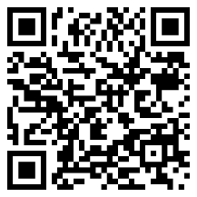
Dividing Numbers in Standard Form

Example
Calculate $\left(4×{10}^{8}\right)÷\left(5×{10}^{2}\right)$, giving your answer in standard form.
Answer: $\left(4×{10}^{8}\right)÷\left(5×{10}^{2}\right)$
$=(4÷5)×{(10}^{8}÷{10}^{2})$ Rearrange
$=0.8×{10}^{8-2}$ Divide the numbers; use rules of indices to subtract the indices.
$=0.8×{10}^{6}$ This is almost in standard form; we must multiply the 0.8 by 10 to correct...
$=8×{10}^{5}$ Final answer (multiply by 10 so subtract 1 from the index).
Exercise 43
A
Calculate the following, giving your answer in standard form.
(a) $\left(8×{10}^{8}\right)÷\left(4×{10}^{2}\right)$ (b)$\left(4×{10}^{8}\right)÷\left(8×{10}^{2}\right)$ (c) $\left(8×{10}^{8}\right)÷\left(4×{10}^{-2}\right)$
(d) $\left(3.6×{10}^{6}\right)÷\left(3×{10}^{3}\right)$ (e)$\left(6.4×{10}^{12}\right)÷\left(4×{10}^{3}\right)$ (f) $\left(9.3×{10}^{5}\right)÷\left(3×{10}^{5}\right)$(g) $\left(8.6×{10}^{7}\right)÷\left(2×{10}^{2}\right)$ (h)$\left(7.5×{10}^{14}\right)÷\left(5×{10}^{20}\right)$ (i) $\left(1×{10}^{8}\right)÷\left(3×{10}^{4}\right)$
(j) $\left(4.2×{10}^{-3}\right)÷\left(3×{10}^{4}\right)$ (k)$\left(2×{10}^{5}\right)÷\left(5×{10}^{-2}\right)$ (l) $\left(1×{10}^{-4}\right)÷\left(8×{10}^{-2}\right)$
(m) $\left(2.4×{10}^{8}\right)÷\left(4×{10}^{3}\right)$ (n)$\left(5.25×{10}^{50}\right)÷\left(1.5×{10}^{10}\right)$ (o) $\left(2×{10}^{-5}\right)÷\left(8×{10}^{-15}\right)$
Exercise 44
Calculate the following, giving your answer in standard form.
(a) $\left(6×{10}^{4}\right)+\left(4×{10}^{3}\right)$ (b) $\left(6×{10}^{4}\right)-\left(4×{10}^{3}\right)$ (c) $\left(6×{10}^{4}\right)×\left(4×{10}^{3}\right)$
(d) $\left(6×{10}^{4}\right)÷\left(4×{10}^{3}\right)$ (e)$\frac{6×{10}^{4}}{4×{10}^{3}}$ (f) $\frac{\left(6×{10}^{4}\right)+\left(4×{10}^{3}\right)}{4×{10}^{3}}$(g) $\left(8.4×{10}^{6}\right)+\left(2×{10}^{2}\right)$ (h) $\left(8.4×{10}^{6}\right)-\left(2×{10}^{2}\right)$ (i) $\left(8.4×{10}^{6}\right)×\left(2×{10}^{2}\right)$
(j) $\left(8.4×{10}^{6}\right)÷\left(2×{10}^{2}\right)$ (k)$\left(8.4×{10}^{6}\right)×5$ (l) $\left(8.4×{10}^{6}\right)+\left(2×{10}^{-2}\right)$
Challenge!
Use your calculator to check your answers to Exercise 44, making sure that your calculator shows the answer in standard form.
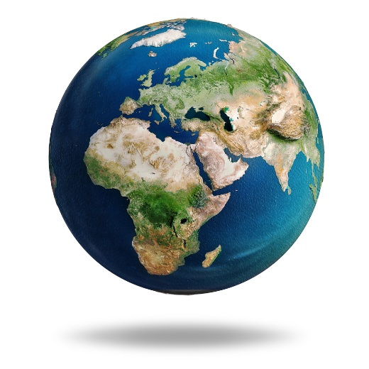
Exercise 45
The Earth is more or less spherical.
A
(a) The radius of the Earth is 6,378.1 km. Calculate the circumference of the Earth, writing your answer in standard form correct to 3 significant figures.
(b) The surface area of the whole Earth is approximately $5.112×{10}^{8}$ km². The oceans cover approximately $3.618×{10}^{8}$ km² of surface area and the rest of the surface area is covered by land. Calculate the amount of surface area of the Earth covered by land, giving your answer in standard form.
Investigation
In the standard form $a×{10}^{n}$, the number $a$ must be between 1 and 10 ($1≤a<10)$ and $n$ is an integer.
Is it therefore possible to write negative numbers using standard form? Use the internet to investigate the answer to this question.

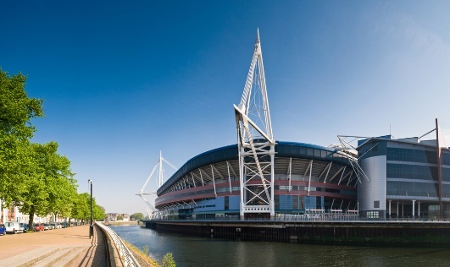
Exercise 46
A
The Millennium Stadium in Cardiff has enough seats for 74,500 people.
The population of Wales would fill the Millennium Stadium 41 times.
Use this information to calculate the approximate population of Wales.
Give your answer in standard form correct to 3 significant figures.

Exercise 47

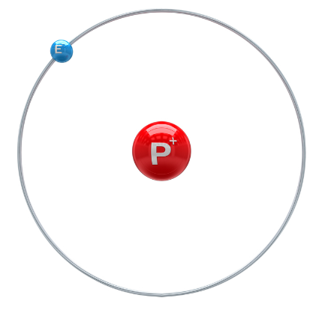
The mass of one hydrogen atom is about
$1.66×{10}^{-24}$ kg.
One litre of air contains approximately $2.51×{10}^{22}$ hydrogen atoms.
(a) What is the mass of hydrogen in one litre of air?
Give your answer in standard form.
(b) Express your answer to (a) without using standard form.
Exercise 48
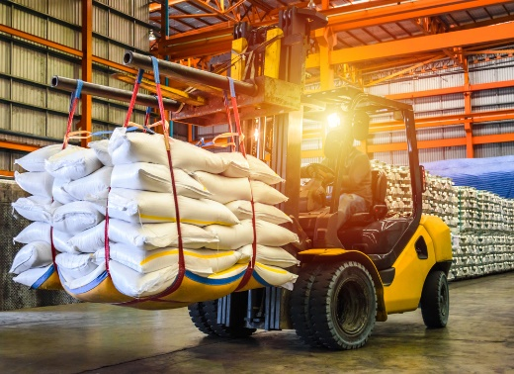
Currently, Mr. Ben’s rice store contains 2,700 kg of basmati rice.
(a) Write 2,700 kg in grams.
Give your answer in standard form.
(b) One grain of rice has mass 0.03 g.
Write the mass of one grain of rice in standard form.
(c) How many grains of rice are in 2,700 kg of rice?
Write your answer in standard form.

Challenge!
Investigate using the internet the meaning of the word googol.
Use your findings to write the number 50 googol in standard form.

Key words | Corrections | I am happy with... | I need to revise...

In year 9, you learnt how to plot linear equations of the form $y=mx+c$. In this chapter, we will learn how to plot equations that have different forms.
$$y$$
Exercise 49
2
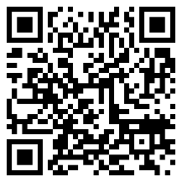
On the graph paper on the right, plot the equation
$y=2x-3$.
$$x$$
$$x$$ | 0 | 1 | 2 | 3
$$y$$

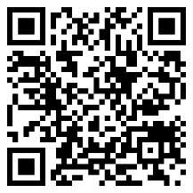
Quadratic Graphs
Equations of the form $y=ax^{2}+bx+c$ are quadratic equations.
The word quadratic refers to the $x^{2}$ term in the equation, a squared term.
Quadratic graphs have a U or shape.
U
Exercise 50
2
Complete the following table to note whether each equation is linear or quadratic.
Equation | Type | Equation | Type
$y=4x-2$ | Linear | $y=3x^{2}-4x+2$ | Quadratic
$y=2x^{2}+4x+7$ |  | $y=5x^{2}-4x+6$
$y=2x+5$ |  | $y=-4x+2$
$y=4x+7x^{2}-3$ |  | $y=2+6x+3x^{2}$
$y=3+4x$ |  | $y=6x$
$y=5$ |  | $y=4+3x^{2}$
$y=-3x^{2}+3$ |  | $y=x(x+2)$
Exercise 51
(a) 4 × 4 (b) –4 × –4 (c) 4 × –4 (d) –4 × 4
A
(e) 4 + 2 (f) 4 + –2 (g) –4 + 2 (h) –4 + –2
(i) 4 – 2 (j) –4 – 2 (k) 4 – –2 (l) –4 – –2
(m) 7² (n) (–7)² (o) 7² + 2 × 7 (p) (–7)² + 2 × –7

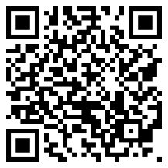
Substitution
To plot a quadratic graph, we can substitute values into the associated equation.
Exercise 52
2
Complete the following tables by substitution, before plotting a smooth curve on the graph paper.
(No calculators are allowed.)
$$x$$ | –5 | –4 | –3 | –2 | –1 | 0 | 1 | 2 | 3 | 4 | 5
$$x^{2}$$
$$x^{2}-5$$
(a) $y=x^{2}$ (b) $y=x^{2}-5$
$$y$$
$$y$$

$$x$$
$$x$$

$$x$$ | –5 | –4 | –3 | –2 | –1 | 0 | 1 | 2 | 3 | 4 | 5
$$x^{2}$$
$$2x$$
$$x^{2}+2x-8$$
$$x^{2}$$
$$2x^{2}$$
$$2x^{2}-x-28$$

(c) $y=x^{2}+2x-8$ (d) $y=2x^{2}-x-28$
$$y$$
$$y$$

$$x$$
$$x$$

Exercise 53
Fill the blanks in the tables below. Then, in your books, plot suitable graphs for the equations.
(a)
  $x$ | –5 | –4 | –3 | –2 | –1 | 0 | 1 | 2 | 3 | 4 | 5
  $y=x^{2}+4$ | 29 | 20 |  | 8 | 5 | 4 | 5 | 8 | 13 |  | 29
(b)
  $x$ | –5 | –4 | –3 | –2 | –1 | 0 | 1 | 2 | 3 | 4 | 5
  $y={3x}^{2}-10$ | 65 | 38 | 17 |  | –7 | –10 | –7 |  | 17 | 38 | 65
(c)
  $x$ | –5 | –4 | –3 | –2 | –1 | 0 | 1 | 2 | 3 | 4 | 5
  $y={4x}^{2}+x-7$ | 88 |  | 26 | 7 | –4 | –7 | –2 | 11 |  | 61 | 98
Exercise 54
2
Plot appropriate graphs for the following equations.
(a) $y=x^{2}-4x$ (b) $y=x^{2}-3x+4$ (c) $y=3x-x^{2}$
(d) $y=x^{2}-x-5$ (e) $y=5-2x^{2}$ (f) $y=3x^{2}+4x+2$
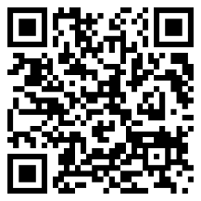
(g) $y=15-x^{2}+3x$ (h) $y=4x^{2}-x+7$ (i) $y=-2x^{2}+5x-6$

Recognising and sketching graphs of the form $y=ax^{2}+b$
Exercise 55
You will need to use the website www.desmos.com/calculator to complete this exercise.
Type $y=ax^{2}+b$ into the box. When the “add slider” option appears click “all”.
What effect does changing the values of $a$ and $b$ have on the graph?
Exercise 56
Pair the graphs and the equations.
$$y$$
$$y$$

$$y=-5x^{2}+30$$
$$y=5x^{2}-30$$
$$y=-2x^{2}+30$$
$$y=2x^{2}-30$$

$$x$$
$$x$$

$$y$$
$$y$$

$$x$$
$$x$$

Graphical method of solving equations of the form $x^{2}+ax+b=0$
$$y$$
Consider the graph shown on the right for the equation $y=x^{2}+2x-8$. To solve the equation
$x^{2}+2x-8=0$, we can use the graph to see where the graph crosses the $x$–axis (this is where the function $x^{2}+2x-8$ is zero). We see that the graph crosses the $x$–axis at the points where $x=-4$ and $x=2$, therefore the solutions to the equation
$x^{2}+2x-8=0$ are $x=-4$ and $x=2$.
$$y=x^{2}+2x-8$$
$$x$$
Exercise 57
2
(a) Use the graph below to solve the equation (b) Use the graph below to solve the equation
$x^{2}-x-6=0$. $-x^{2}+5x-4=0$.
$$y$$
$$y$$
$$y=x^{2}-x-6$$
$$x$$

$$x$$
$$y={-x}^{2}+5x-4$$

(c) Use the graph above to solve the equation
$x^{2}-x-6=10$.
Give your answers correct to one decimal place.
(d) Use the graph below to solve the equation (e) Use the graph below to solve the equation
$-x^{2}-x+6=0$. $x^{2}-3x=0$.
$$y$$
$$y$$

$$x$$

$$y=x^{2}-3x$$
$$y=-x^{2}-x+6$$
$$y=x^{2}-3x$$
$$y={-x}^{2}-x+6$$

$$x$$

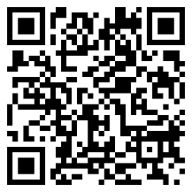
(f) Use the graph above to solve the equation
$-x^{2}-x+6=-10$.
Give your answers correct to one decimal place. (g) Use the graph above to solve the equation
$x^{2}-3x=4$.
(h) (i) By drawing a suitable graph, solve the equation $x^{2}+3x-4=0$.
(h) (ii) Use your graph from part (i) to solve the equation $x^{2}+3x-4=5$.
(h) (ii) Give your answers correct to one decimal place.

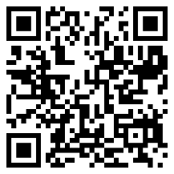
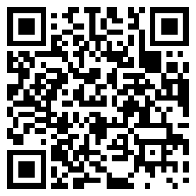
Other Graphs
For the higher tier, you must be able to…
- recognise and sketch quadratic graphs of the form $y=(ax+b)(cx+d)$,
- recognise and sketch reciprocal graphs of the form $y=\frac{a}{x}$;
- recognise and sketch cubic graphs of the form $y=ax^{3}$;
- draw and interpret cubic graphs of the form $y=ax^{3}+bx^{2}+cx+d$;
- solve $ax^{2}+bx+c=dx+e$ or $ax^{3}+bx^{2}+cx+d=ex+f$.
Exercise 58
2
Fill in the blanks in the following tables. Then, on the graph paper at the bottom of the page, plot appropriate graphs for the equations.
(a)
$x$ | –5 | –4 | –3 | –2 | –1 | 0 | 1 | 2 | 3 | 4 | 5
$y=\frac{1}{x}$
(b)
$x$ | –5 | –4 | –3 | –2 | –1 | 0 | 1 | 2 | 3 | 4 | 5
$y=x^{3}$
(c)
$x$ | –5 | –4 | –3 | –2 | –1 | 0 | 1 | 2 | 3 | 4 | 5
$y=(2x+3)(x-2)$
(a) (b) (c)
$$y$$
$$y$$
$$y$$

$$x$$
$$x$$

$$x$$

Plot additional points between –1 and 1 for a more accurate graph.

Exercise 59
2
Plot suitable graphs for the following equations.
(i) $y=x^{3}-4x$ (ii) $y=x^{3}+5x^{2}-2x+5$ (iii) $y=-x^{3}$
(b) Use your graphs from part (a) to solve the following equations.
Where necessary, write your answers correct to one decimal place.
(i) $x^{3}-4x=0$ (ii) $x^{3}+5x^{2}-2x+5=20$ (iii) $-x^{3}=0$
Exercise 60
Use the Desmos website (www.desmos.com/calculator) to investigate the graphs for the equations on the top of the previous page. Write a paragraph summarising your findings. Remember to discuss the general shape of each graph, and describe what happens as you change the parameters.
$$y$$
Example
In order to solve $2x^{2}-x-8=2x+1$,
(a) Plot $y=2x^{2}-x-8$ and $y=2x+1$ on the same graph, as shown on the right.
$$x$$
$$x$$
(b) Consider where the graphs intersect. The interections occur when
$x=-1.5$ and $x=3$, so these are the solutions to the original equation.
$$y$$
Exercise 61
The graphs for $y=2x^{2}+x+1$ and $y=4x+3$ are shown on the left. Use the graphs to solve the equation
$2x^{2}+x+1=4x+3$.
Exercise 62
Use your graph from Exercise 59 to solve the equation
$x^{3}+5x^{2}-2x+5=x+10$.
Give your solutions correct to one decimal place.
$$x$$

Key words | Corrections | I am happy with... | I need to revise...

Name: ............................................  Percentage in the test: .................. |   I know this. |   I need to revise this. | Question in the test | Correct in the test?
I know how to change between ordinary numbers and numbers written in index form. |  |  | 1
I know how to use the multiplication rule $n^{a}×n^{b}=n^{a+b}$ . |  |  | 2
I know how to use the division rule $n^{a}÷n^{b}=n^{a-b}.$ |  |  | 2
I know how to use the zeroth index rule $n^{0}=1$. |  |  | 2
I know how to use the rule where a power is raised to another index, ${(n}^{a})^{b}=n^{a×b}$. |  |  | 2
I know how to use the negative index rule $n^{-a}=\frac{1}{n^{a}}$. |  |  | 2
I know how to use the unitary fraction index rule $n^{\frac{1}{a}}=\sqrt[a]{n}$. |  |  | 2
I can simplify algebraic expressions using the rules of indices. |  |  | 3
I know how to use the general fraction index rule  ${\left(\sqrt[b]{n}\right)}^{a}=n^{\frac{a}{b}}=\sqrt[b]{n^{a}}.$ |  |  | 2
I can combine the rules of indices. |  |  | 2
I can differentiate between rational numbers and irrational numbers. |  |  | 6, 9
I can collect like surd terms, e.g. $3\sqrt{2}+7\sqrt{2}$. |  |  | 7
I can simplify surds, e.g. $\sqrt{32}$, $\frac{\sqrt{8}×\sqrt{2}}{2}$. |  |  | 7, 9
I can expand using surds, e.g. $4\sqrt{7}(\sqrt{7}+3)$,  $(4+\sqrt{5})(\sqrt{5}-2)$. |  |  | 8
I can write numbers in standard form. |  |  | 4
I can add and subtract numbers written in standard form. |  |  | 5
I can multiply and divide numbers written in standard form. |  |  | 5
I can solve problems using standard form.
I can plot quadratic graphs. |  |  | 10
I know how to recognise and sketch quadratic graphs. |  |  | 11
I know how to use a graphical method to solve quadratic equations. |  |  | 10
I know how to recognise and sketch other graphs, e.g. reciprocal graphs; cubic graphs. |  |  | 11

