

This workbook will help you prepare for the national numeracy tests:
- The procedural test without a calculator;
- The reasoning test with a calculator.
Each week there will be a set of “bread & butter” questions practicing procedural skills, and a “reasoning” question practicing reasoning skills.
Space for rough work:

Registration
Class:
Name:
Mathematics Teacher:
Half Term 2: Evaluation
Half Term 1: Evaluation
Room:
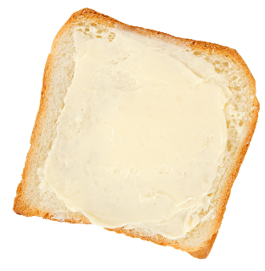
1) Add 4.62 to 14.7. | 2) Subtract 4.62 from 14.7. | 3) What is 75% of £180?
4) How many minutes are there between 14:43 and 16:29? | 5) 4.3 m = ____ cm | 6) 0.4 × 9
7) Calculate $\frac{2}{7}$ of £35. | 8) 284 × 67 | 9) What is 5 cubed?

Bread & Butter

Reasoning

The larger parcel weighs
twice as much as the
smaller parcel. Together,
the two parcels weigh
1200 grams. Calculate
the weight of each
individual parcel.
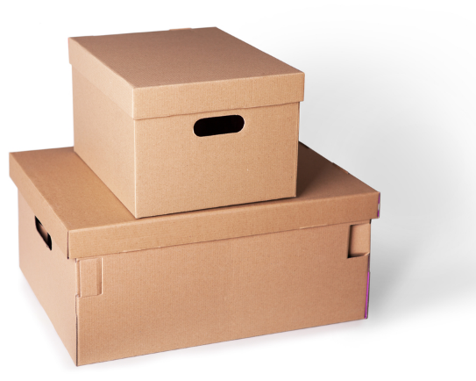
1) 12 × 9 | 2) 4.2 – 2.32 | 3) 840 g = ____ kg
4) Round off 8359 to the nearest hundred. | 5) Write down 0.6 as a percentage. | 6) Calculate $\sqrt{3^{2}+4^{2}}$.
7) Increase 60 by 20%. | 8) 2 m² = ____ cm² | 9) Round off 7,628 to one significant figure.

Bread & Butter

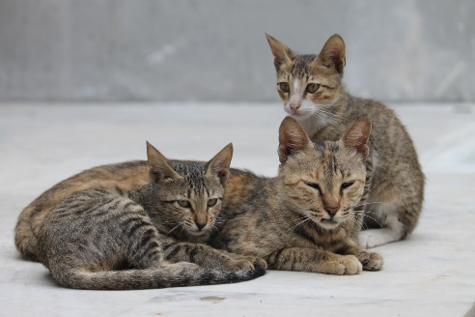

Reasoning

The age of each of these
cats is different.
The sum of their age, in
years, is 11.
The product of their age, in years, is 36.
What is the age of each cat?

1) 0.25 + 0.26 + 0.27 | 2) 9² | 3) How many halves are in $6\frac{1}{2}$?
4) Round off 26.546 to two decimal places. | 5) Subtract 0.08 from 0.1. | 6) 60 × _____ = 0.6
7) 8 × 6 ÷ (4 × 4) | 8) $\frac{2}{5}+\frac{3}{7}$ | 9) 17 × 13

Bread & Butter

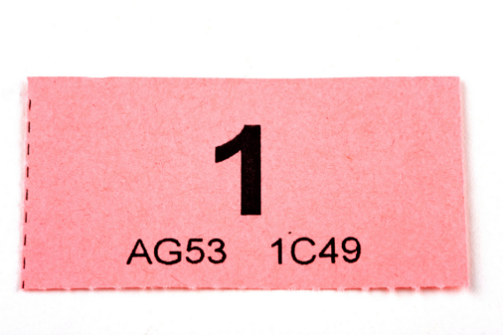

Reasoning

In a raffle, Huw buys the
first ticket and then every
sixth ticket:
1, 7, 13, 19, ...
There is a total of 100 tickets in the raffle. Each ticket costs 20p. How much money has Huw spent on raffle tickets?

1) 17 × 11 | 2) 762 – 389 | 3) 7 + 2 × 3
4) Decrease £90 by 10%. | 5) What is the median of 9, 2, 4, 7? | 6) Calculate the volume of a cube that has 4 cm sides.
7) The reciprocal of $\frac{4}{5}$ is | 8) 4³ – 4² | 9) 552 ÷ 23

Bread & Butter

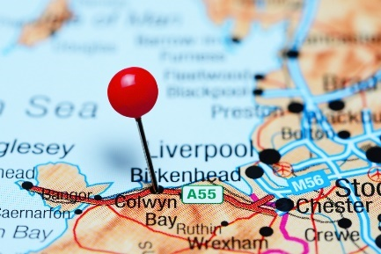

Reasoning

Jenny lives in Bangor and has
a meeting at Colwyn Bay at
11:55am. The 11:07 train
from Bangor takes 23 minutes
to reach Colwyn Bay. How many
minutes does Jenny have to walk from the train station to her meeting?

1) Add 2.76 to 29. | 2) Subtract 2.76 from 29. | 3) What is the mode of  8, 2, 4, 2, 9, 8?
4) 2000 – 847 | 5) Write down the square root of 64. | 6) $\frac{1}{5}$ minute = ____ seconds.
7) Simplify the fraction $\frac{48}{72}$. | 8) 4 × 0.3 + 6 × 0.3 | 9) What percentage of 240 is 48?

Bread & Butter

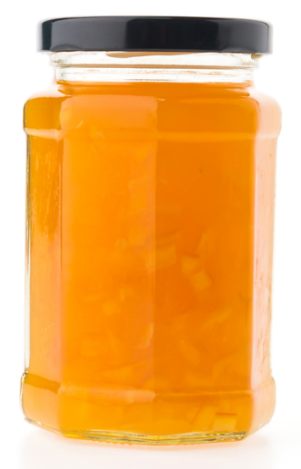

Reasoning

An empty jar weighs 150 g.
When Eleri fills the entire jar with
marmalade, it weighs 400 g.
What will be the weight of the
jar when it is half-full with
marmalade?

1) 82 + 8.2 + 0.82 | 2) 82 – 8.2 – 0.82 | 3) What is 11 squared?
4) Round off 7,298 to one significant figure. | 5) 3.6 ÷ 3 | 6) $\frac{1}{10}$ of Awel’s number is 20. What is $\frac{1}{5}$ of Awel’s number?
7) How many minutes are there between 09:45 and 14:23? | 8) Divide £80 between Ann and Bob according to the ratio 3:5. | 9) 0.4 × 0.1

Bread & Butter

Reasoning

Consider the pattern shown
on the right. Which statement
is correct? (a) The perimeter of
the black shape is biggest.
(b) The perimeter of the white
shape is biggest. (c) The two
shapes have equal perimeter.


1) _____ + 2.4 = 10 | 2) ______ + 298 = 1000 | 3) Calculate $\frac{2}{9}$ of £108.
4) 8 × 0.9 | 5) $2^{5}$ | 6) 154 × 23
7) 40.2 – 2.07 | 8) $\frac{1}{7}+\frac{3}{4}$ | 9) $3\frac{1}{2}$ km = ___ cm

Bread & Butter



Reasoning

The black ink cartridge in Dewi’s printer
can print 800 pages if each page
contains 5% black ink.
Dewi wishes to print 2,000 pages,
each of which contain 10% black ink. How many black ink cartridges must Dewi buy to do this?

1) 2000 – 1234 | 2) Add 7.3 to 92.05. | 3) 9.6 ÷ 6
4) Decrease 145 by 40%. | 5) $\frac{1}{8}$ m = _____ cm | 6) Round off 142,736 to two significant figures.
7) What is the mean of  8, 4, 0, 3, 5? | 8) 65 × 97 | 9) What is the reciprocal of 8?

Bread & Butter



Reasoning

Tokyo is 9 hours ahead of London.
It takes 12 hours 50 minutes to fly from Tokyo to London. An aeroplane leaves Tokyo at 14:00 on Friday (Tokyo time). On which day and at which time will the aeroplane reach London?
Give your answer in London time.

1) Increase 70 by 10%. | 2) Write down 42% as a decimal. | 3) Round off 25.2927 to two decimal places.
4) 100 g of cherries cost £1.30. What is the cost of 2 kg of cherries? | 5) 14² | 6) 8 – 2.16
7) Divide £120 between Arwyn and Bertie according to the ratio 19:5. | 8) Calculate 2.5% of £150. | 9) $\frac{3}{4}-\frac{2}{3}$

Bread & Butter

Reasoning

Dylan wishes to buy apple juice for a party.
Small bottle Medium bottle Large bottle
300 ml 400 ml 500 ml
72p 88p £1.25
Which bottle of apple juice provides the
best value for money?

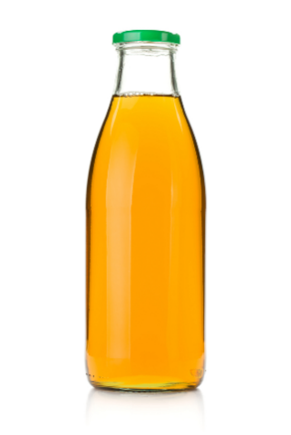
1) Add 81.2 to 9.06. | 2) How many quarters are in $3\frac{3}{4}$? | 3) Calculate 7 cubed.
4) Increase 2 m by 15%. Give your answer in cm. | 5) Write down, in its simplest form, 60% as a fraction. | 6) What is the median of  9, 14, 0, 5, 6?
7) 603 × 75 | 8) The reciprocal of $\frac{1}{14}$ is | 9) Round off 0.0254 to one significant figure.

Bread & Butter

Reasoning

The following rectangle and triangle have the same area. What is the height of the triangle?

9 cm
6 cm
3 cm
1) _____ + 8.2 = 20 | 2) 1000 – _____ = 827 | 3) Calculate 45% of £90.
4) 0.4 × 0.2 | 5) Round off 9.258 to one decimal place. | 6) 83 × 9
7) What is $\frac{1}{2}$ of $\frac{1}{4}$? | 8) Simplify the ratio 15:20. | 9) $4\frac{1}{4}$ kg = _____ g

Bread & Butter

Reasoning

How many squares (of
any size) can be seen in
this picture?

1) 87 + 2918 + 382 | 2) Subtract 0.24 from 2. | 3) Calculate $\frac{5}{8}$ of £72.
4) 7 × 0.5 | 5) Round off 89,002 to one significant figure. | 6) Decrease 60 by 30%.
7) $\frac{1}{4}$ of Jim’s number is 8. What is $\frac{1}{8}$ of Jim’s number? | 8) 723 × 64 | 9) Write down 0.1% as a decimal.

Bread & Butter



Reasoning
To make a glass of orange squash,
$\frac{1}{20}$ of a bottle of cordial is needed.
$\frac{5}{8}$ of a bottle of cordial remains.
How many glasses of orange squash
can be made from this bottle?

Rough Work:




@minutemaths314 /adolygumathemateg
/mathscreuddyn www.mathemateg.com

