

This workbook will help you prepare for the national numeracy tests:
- The procedural test without a calculator;
- The reasoning test with a calculator.
Each week there will be a set of “bread & butter” questions practicing procedural skills, and a “reasoning” question practicing reasoning skills.
Space for rough work:

Registration
Class:
Name:
Mathematics Teacher:
Half Term 2: Evaluation
Half Term 1: Evaluation
Room:
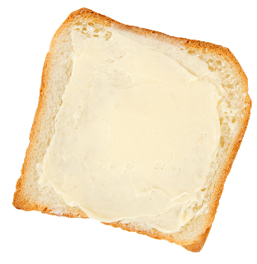
1) £10.54 – £6.99 | 2) 18 × 0.5 | 3) Write down 20% as a decimal, in its simplest form.
4) 8² | 5) 10% of £84 | 6) 177 ÷ 3
7) What is the area of a rectangle measuring 5 cm by 7 cm? | 8) 1.4 × 9 | 9) 2 + 7 × 3

Bread & Butter

Reasoning

Rhys is arranging a raffle for a
school fair. The tickets cost
50p each.
The main prize of the raffle is
£20. The second prize is £5.
How much profit will Rhys make if he manages to sell 140 tickets?
1) 248 – 120 – 36 | 2) Write down $\frac{3}{10}$ as a percentage. | 3) £45.23 – £20.45
4) Which number is two less than one million? | 5) What is 285 cm in metres? | 6) 7 × ___ = 2 × 28
7) Estimate the cost of buying six books costing £11.99 each. | 8) What time is 53 minutes after 07:46? | 9) Which number is half way between –7 and 9?

Bread & Butter

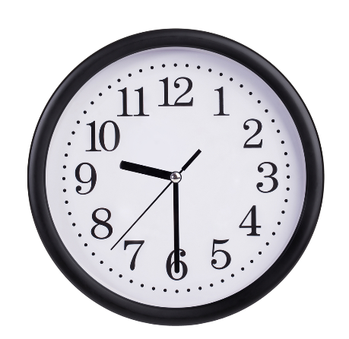

Reasoning

If it is 3pm in London, then it is
2am (the next day) in Sydney,
Australia. Christine lives in
Sydney and wishes to phone her
sister in London, when it is
9:30am in London. What time (in Sydney) should Christine phone her sister?

1) 10% of £60 | 2) 874 – 249 | 3) 5.4 × 8
4) 12 – 8 ÷ 2 | 5) $\sqrt{81}+\sqrt{4}$ | 6) What is the mean of the numbers 2, 11, 8?
7) Which is greater: $\frac{4}{5}$ or 70%? | 8) 2.5 – 1.37 | 9) What is the perimeter of a rectangle measuring 8 cm by 2 cm?

Bread & Butter

Jane’s Café
Tea £1.40
Coffee £1.55
Apple Juice
£0.90
Orange Juice £0.85
Water £0.70

Reasoning

The drinks menu of Jane’s Café is
shown on the right.
Tomos and his family go the
café and order 2 coffees, 3 teas
and 4 orange juices. How much
change will Tomos receive from
a £20 note?

1) 276 + 787 | 2) £5 – £1.35 | 3) Write down a quarter of a million in figures.
4) 380 ÷ ___ = 19 | 5) What is 3.4 kg in grams? | 6) Write down 26% as a decimal.
7) Calculate 30% of £75. | 8) The square root of a number is 9. What is that number? | 9) Which day is five days before October 3rd?

Bread & Butter

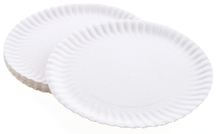

Reasoning

Elsi wants to buy 225 paper plates
for a big party. Three local shops
sell paper plates:
SHOP 1 SHOP 2 SHOP 3
20 for 35p 50 for 90p 25 for 49p
From which shop should Elsi buy the plates?

1) 823 – 284 | 2) Write down all the factors of 20. | 3) Write down half of four hundred thousand in figures.
4) £120 – £21.99 | 5) 0.16 + _____ = 1 | 6) 7 × 2 + 4 × 2
7) Round off 3.791 to one decimal place. | 8) How many minutes are there in $3\frac{1}{4}$ hours? | 9) 2 ÷ 0.2

Bread & Butter

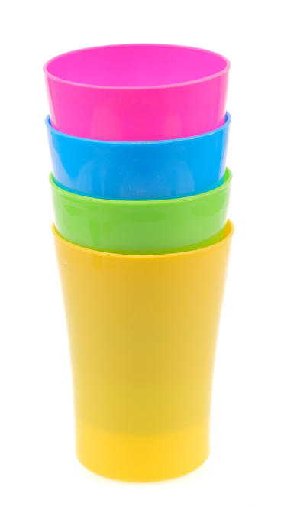

Reasoning

The height of 4 cups (stacked as
shown on the right) is 11.6 cm.
A similar stack of 8 cups has height
16.4 cm.
What would be the height of a similar
stack of 10 cups?

1) 9 × 8 | 2) Calculate 25% of £60. | 3) 4³
4) 6.4 × 5 | 5) 872 – 299 | 6) Simplify the fraction $\frac{16}{48}$.
7) 42 ÷ ___ = 7 | 8) 352 ÷ 16 | 9) 9.2 + 17.82

Bread & Butter

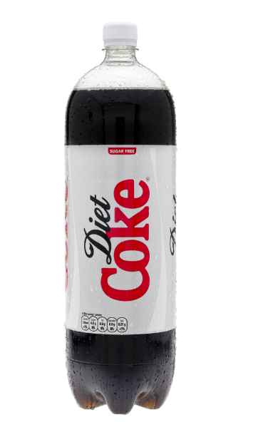

Reasoning

Dewi buys a 2-litre bottle of Diet Coke.
Ian drinks a quarter of the bottle.
Siwan and Eleri drink half of the
remainder of the bottle.
Dafydd then drinks 300 ml of the bottle.
How much of the bottle remains?

1) 1% of £75 | 2) Write down 40% as a fraction, in its simplest form. | 3) £32.78 – £9.59
4) 0.4 × 0.3 | 5) What is 6.8 cm in millimetres? | 6) 6 × ___ = 8 × 9
7) 5 × 0 | 8) 221 ÷ 13 | 9) Write down $2\frac{1}{5}$ as a decimal.

Bread & Butter



Reasoning

The score at the end of
the football game was
5–2 to the home team.
How many possible
answers are there to
the question “What was
the score at half-time”?

1) 9 × 6 | 2) 6 ÷ 0.25 | 3) Round off 765 to the nearest ten.
4) Take away 84p from £2.17. | 5) $\sqrt{64}-\sqrt[3]{64}$ | 6) Write down 31% as a decimal.
7) The number of sides in a heptagon = | 8) Write down $0.\dot{3}$ as a fraction. | 9) 1 + 2 × 3 – 4

Bread & Butter

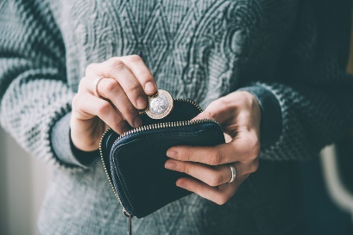

Reasoning

Usually, Seren works a 30 hour
week, earning £8.20 an hour.
She pays one-tenth of her
weekly earnings as tax and
National Insurance.
How much money does Seren have left over to spend each week?

1) 10% of $84 | 2) 823 + 2937 + 83 | 3) 9 × 12.4
4) Round off 630,824 to the nearest thousand. | 5) 5² + 2³ | 6) What is the range of the numbers 90, 40, 20, 60?
7) Which is larger: $\frac{2}{3}$ or 66%? | 8) 9 – 2.14 | 9) Write down half of seven hundred thousand in figures.

Bread & Butter

Reasoning

The dimensions of a cuboid-shaped gold bar are 10 cm by 4 cm by 3 cm.
The bar is melted down and
re-cast to make small cubes with
dimensions 2 cm. How many of the
small cubes can be made from the gold bar?
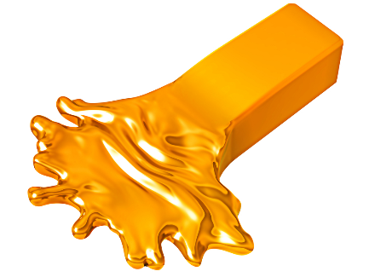
1) 2856 – 1574 | 2) £10 – £5.67 | 3) Calculate $\frac{4}{9}$ of 36.
4) 100 ÷ ___ = 25 | 5) What is 890 g in kilograms? | 6) Write down 0.86 as a percentage.
7) Calculate 40% of £150. | 8) Rhys squared a number to get 64. What was Rhys’ original number? | 9) Which day is six days after May 26th?

Bread & Butter

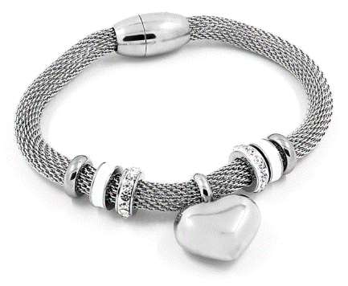

Reasoning

A fashion shop buys 100 bracelets
for £6.20 each. The shop sells
60% of the bracelets for £10
each. The rest of the bracelets
are sold at a discounted rate of £4 each.
How much profit or loss did the fashion shop make?

1) 3.6 + 7.5 | 2) Write down all the factors of 36. | 3) Write down double of seventy-six in figures.
4) £120 ÷ 5 | 5) 1 – _____ = 0.19 | 6) 15 – 12 ÷ 3
7) Round off 928.492 to one decimal place. | 8) How many seconds are there in $5\frac{1}{2}$ minutes? | 9) 4 ÷ 0.1

Bread & Butter

Reasoning

Sali wishes to buy a mobile phone from one
of two companies.
COMPANY 1: A one-off payment of £600.
COMPANY 2: A 2-year contract for
£26 a month.
From which company should Sali buy the
phone?

1) 5 × 15 | 2) Calculate 30% of £90. | 3) 6³
4) 2.14 × 2 | 5) 263 – 149 | 6) Simplify the fraction $\frac{27}{36}$.
7) What is the area of a rectangle measuring 5 cm by 2.2 cm? | 8) 209 ÷ 19 | 9) 239.2 + 5.63

Bread & Butter

Reasoning
Carwyn travelled in a taxi which displayed the following information.
Taxi Journey Cost = Number of
miles travelled × £2 + £3.
Carwyn paid £35 for his journey.
How far did Carwyn travel?

Rough Work:




@minutemaths314 /adolygumathemateg
/mathscreuddyn www.mathemateg.com

