



Ffion wants to buy a new mobile phone on the internet. The cost of the mobile phone is £500.
Ffion has a ‘10% off’ code for the website,
and also a £50 voucher.
Should Ffion enter the ‘10% off’ code first, and then use the £50 voucher, or enter the £50 voucher first, and then use the ‘10% off’ code?

What is the work? |  | How to combine two or more functions into a composite function.
What is required before starting? |  | GCSE Work: Substitution; solving equations; solving inequalities; changing the subject.
Where does this lead to? |  | Applications: Any situation where a series of calculations is required, and the result of one calculation directly affects the input of the next calculation.
$$y$$
$$x$$
$$y=x^{2}-7$$
$$y=\frac{1}{\sqrt{x-3}}$$
$$y$$
$$x$$
$$y=2x-3$$
$$y=x^{2}$$
$$y$$
$$x$$
$$y=\left|x\right|$$
A function $f$ maps elements from the set $X$ (the domain) to elements of the set $Y$ (the range). The input $x∈X$ maps to one (and only one) output $y∈Y$.
For $f\left(x\right)=x^{2}-7$,
the domain is $(-∞,∞)$ and the range is $[-7,∞)$.
For $f\left(x\right)=\frac{1}{\sqrt{x-3}}$,
the domain is $(3,∞)$ and the range is $\left(0,∞\right).$
Theory
Notation
$∈$ ‘is an element of’
$[2, 5)$ All numbers between $2$ and $5$,
including $2$ but not including $5$.

In a one-to-one function, every element of the range corresponds to exactly one element of the domain.
Example 1
$f\left(x\right)=2x-3$.

In a many-to-one function, each element of the range can correspond to more than one element of the domain.
Example 2
$f\left(x\right)=x^{2}$.

Composite Functions
A composite function combines two or more functions.
Given functions $f(x)$ and $g\left(x\right)$, the composite function $fg(x)$ means ‘apply $f$ to the results of $g(x)$’.
The composite function $gf(x)$ means ‘apply $g$ to the results of $f(x)$’.
The order is important. $fg(x)$ is not necessarily the same as $gf(x)$.
Example 3
If $f\left(x\right)=x^{2}$, $g\left(x\right)=5x+3$, calculate
(a) $f(4)$ (b) $g(4)$ (c) $fg(4)$ (d) $gf(4)$
Answer:
(a) $f\left(4\right)=4^{2}$ (b) $g\left(4\right)=5×4+3$ (c) $fg\left(4\right)=f(g\left(4\right))$ (d) $gf\left(4\right)=g(f\left(4\right))$
(a) $f\left(4\right)=16$ (b) $g\left(4\right)=20+3$ (c) $fg\left(4\right)=f(23)$ (d) $gf\left(4\right)=g(16)$
(b) $g\left(4\right)=23$ (c) $fg\left(4\right)={23}^{2}$ (d) $gf\left(4\right)=5×16+3$
(c) $fg\left(4\right)=529$ (d) $gf\left(4\right)=80+3$
(d) $gf\left(4\right)=83$
Exercise 1
If $f\left(x\right)=3x+1$, $g\left(x\right)=\sqrt{x}$, calculate
(a) $f(16)$ (b) $g(16)$ (c) $fg(16)$ (d) $gf(16)$
......................................................... ......................................................... .......................................................... .........................................................................
......................................................... ......................................................... .......................................................... .........................................................................
......................................................... ......................................................... .......................................................... .........................................................................
......................................................... ......................................................... .......................................................... .........................................................................
......................................................... ......................................................... .......................................................... .........................................................................
......................................................... ......................................................... .......................................................... .........................................................................
Example 4 (C3 Summer 2005)
The functions $f$ and $g$ have domains $(0, ∞)$ and $(5, ∞)$ respectively, and are defined by
$$y$$
$$x$$
$$y=f(x)$$
$$y=g(x)$$
$$f\left(x\right)=x^{2}+1 \\ g\left(x\right)=2x-3$$
(a) Write down the ranges of $f$ and $g$.
(b) Give the reason why $gf(1)$ cannot be formed.
(c) Solve the equation $fg\left(x\right)=3x^{2}-6x+17$.
Answer: (a) Considering that $f(x)$ and $g(x)$
(a) are increasing functions throughout their domain,
(a) Range of $f\left(x\right)=(1, ∞)$
(a) Range of $g\left(x\right)=(7, ∞)$
(b) $gf\left(1\right)=g(f\left(1\right))$
(b) $gf\left(1\right)=g(1^{2}+1)$
(b) $gf\left(1\right)=g(1+1)$
(b) $gf\left(1\right)=g(2)$
(b) $gf(1)$ cannot be formed as 2 is not in the
(b) $gf\left(1\right)$ domain of $g(x)$.
(c) $fg\left(x\right)=3x^{2}-6x+17$
(c) $f\left(g\left(x\right)\right)=3x^{2}-6x+17$
(c) $f\left(2x-3\right)=3x^{2}-6x+17$
(c) ${\left(2x-3\right)}^{2}+1=3x^{2}-6x+17$
(c) $\left(2x-3\right)\left(2x-3\right)+1=3x^{2}-6x+17$
(c) $4x^{2}-6x-6x+9+1=3x^{2}-6x+17$
(c) $4x^{2}-12x+10=3x^{2}-6x+17$
(c) $x^{2}-6x-7=0$
(c) $\left(x-7\right)\left(x+1\right)=0$
(c) Either $x-7=0$ or $x+1=0$
(c) $x=7$ $x=-1$
(c) But $-1$ is not in the domain of $g(x)$, so the only solution is $x=7$.
This is difficult to explain in words! It is easier to understand by considering the following two examples...
The domain of $fg(x)$
Which numbers can be input to $fg(x)$?
- Find the domain of $g$ and the domain of $f$.
- Find all values of$x$ from the domain of $g$ such that $g(x)$ is in the domain of $f$.
- The domain of $fg(x)$ is all the values from step (2) such that the function $fg(x)$ is defined.
$$y$$
$$x$$
$$y=f(x)$$
$$y=g(x)$$
$$y=fg(x)$$
Example 3
$f\left(x\right)=\sqrt{x+2}$, $g\left(x\right)=x^{2}+3$
Function | Domain | Range
$$f(x)$$ | $$[-2, ∞)$$ | $$[0, ∞)$$
$$g(x)$$ | $$(-∞, ∞)$$ | $$[3, ∞)$$
$$fg(x)$$ | $$(-∞, ∞)$$ | $$[\sqrt{5}, ∞)$$
$fg\left(x\right)=\sqrt{g(x)+2}$
$fg\left(x\right)=\sqrt{\left(x^{2}+3\right)+2}$
$fg\left(x\right)=\sqrt{x^{2}+5}$

$$y$$
$$x$$
$$y=f(x)$$
$$y=g(x)$$
$$y=fg(x)$$
Example 4
$f\left(x\right)=\sqrt{x+2}$, $g\left(x\right)=x^{2}-3$
Function | Domain | Range
$$f(x)$$ | $$[-2, ∞)$$ | $$[0, ∞)$$
$$g(x)$$ | $$(-∞, ∞)$$ | $$[-3, ∞)$$
$$fg(x)$$ | $$\left(-∞, -1\right]∪[1, ∞)$$ | $$[0, ∞)$$
$fg\left(x\right)=\sqrt{g(x)+2}$
$fg\left(x\right)=\sqrt{\left(x^{2}-3\right)+2}$
$fg\left(x\right)=\sqrt{x^{2}-1}$
$fg(x)$ is not defined for $(-1, 1)$

(C3 Winter 2010)
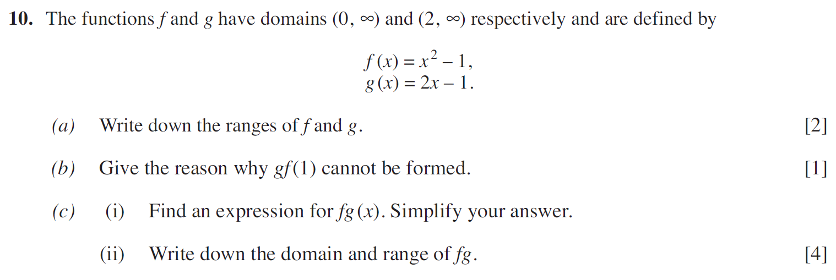
..........................................................................................................................................................................................................................................................................................................
..........................................................................................................................................................................................................................................................................................................
..........................................................................................................................................................................................................................................................................................................
..........................................................................................................................................................................................................................................................................................................
..........................................................................................................................................................................................................................................................................................................
..........................................................................................................................................................................................................................................................................................................
..........................................................................................................................................................................................................................................................................................................
..........................................................................................................................................................................................................................................................................................................
..........................................................................................................................................................................................................................................................................................................
..........................................................................................................................................................................................................................................................................................................
..........................................................................................................................................................................................................................................................................................................
..........................................................................................................................................................................................................................................................................................................
..........................................................................................................................................................................................................................................................................................................
..........................................................................................................................................................................................................................................................................................................
..........................................................................................................................................................................................................................................................................................................
..........................................................................................................................................................................................................................................................................................................
..........................................................................................................................................................................................................................................................................................................
..........................................................................................................................................................................................................................................................................................................
..........................................................................................................................................................................................................................................................................................................
..........................................................................................................................................................................................................................................................................................................
..........................................................................................................................................................................................................................................................................................................
..........................................................................................................................................................................................................................................................................................................
..........................................................................................................................................................................................................................................................................................................
..........................................................................................................................................................................................................................................................................................................
..........................................................................................................................................................................................................................................................................................................
..........................................................................................................................................................................................................................................................................................................
..........................................................................................................................................................................................................................................................................................................
(C3 Summer 2011)
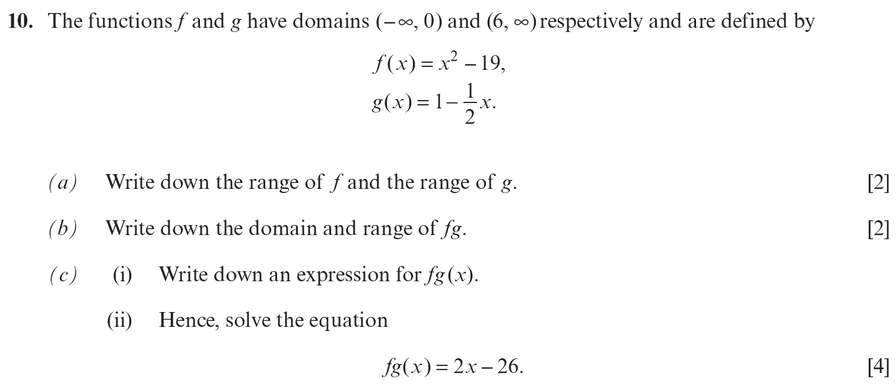
..........................................................................................................................................................................................................................................................................................................
..........................................................................................................................................................................................................................................................................................................
..........................................................................................................................................................................................................................................................................................................
..........................................................................................................................................................................................................................................................................................................
..........................................................................................................................................................................................................................................................................................................
..........................................................................................................................................................................................................................................................................................................
..........................................................................................................................................................................................................................................................................................................
..........................................................................................................................................................................................................................................................................................................
..........................................................................................................................................................................................................................................................................................................
..........................................................................................................................................................................................................................................................................................................
..........................................................................................................................................................................................................................................................................................................
..........................................................................................................................................................................................................................................................................................................
..........................................................................................................................................................................................................................................................................................................
..........................................................................................................................................................................................................................................................................................................
..........................................................................................................................................................................................................................................................................................................
..........................................................................................................................................................................................................................................................................................................
..........................................................................................................................................................................................................................................................................................................
..........................................................................................................................................................................................................................................................................................................
..........................................................................................................................................................................................................................................................................................................
..........................................................................................................................................................................................................................................................................................................
..........................................................................................................................................................................................................................................................................................................
..........................................................................................................................................................................................................................................................................................................
..........................................................................................................................................................................................................................................................................................................
..........................................................................................................................................................................................................................................................................................................
..........................................................................................................................................................................................................................................................................................................
..........................................................................................................................................................................................................................................................................................................
..........................................................................................................................................................................................................................................................................................................
(C3 Summer 2012)
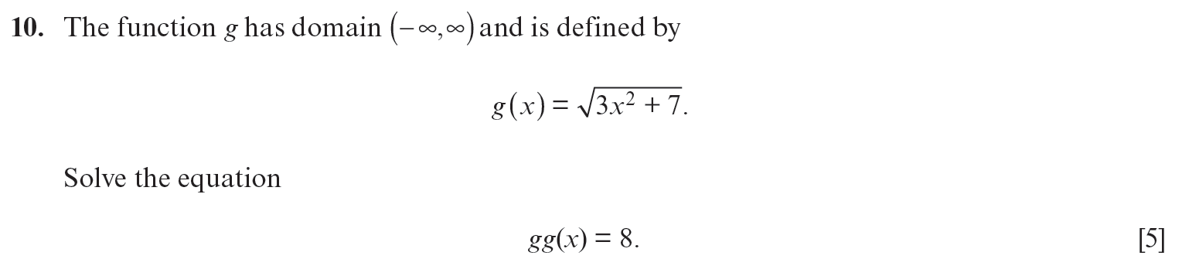
..........................................................................................................................................................................................................................................................................................................
..........................................................................................................................................................................................................................................................................................................
..........................................................................................................................................................................................................................................................................................................
..........................................................................................................................................................................................................................................................................................................
..........................................................................................................................................................................................................................................................................................................
..........................................................................................................................................................................................................................................................................................................
..........................................................................................................................................................................................................................................................................................................
..........................................................................................................................................................................................................................................................................................................
..........................................................................................................................................................................................................................................................................................................
..........................................................................................................................................................................................................................................................................................................
..........................................................................................................................................................................................................................................................................................................
..........................................................................................................................................................................................................................................................................................................
..........................................................................................................................................................................................................................................................................................................
..........................................................................................................................................................................................................................................................................................................
..........................................................................................................................................................................................................................................................................................................
..........................................................................................................................................................................................................................................................................................................
..........................................................................................................................................................................................................................................................................................................
..........................................................................................................................................................................................................................................................................................................
..........................................................................................................................................................................................................................................................................................................
..........................................................................................................................................................................................................................................................................................................
..........................................................................................................................................................................................................................................................................................................
..........................................................................................................................................................................................................................................................................................................
..........................................................................................................................................................................................................................................................................................................
..........................................................................................................................................................................................................................................................................................................
..........................................................................................................................................................................................................................................................................................................
..........................................................................................................................................................................................................................................................................................................
..........................................................................................................................................................................................................................................................................................................
..........................................................................................................................................................................................................................................................................................................
..........................................................................................................................................................................................................................................................................................................
..........................................................................................................................................................................................................................................................................................................
..........................................................................................................................................................................................................................................................................................................
..........................................................................................................................................................................................................................................................................................................
..........................................................................................................................................................................................................................................................................................................
(C3 Winter 2011)
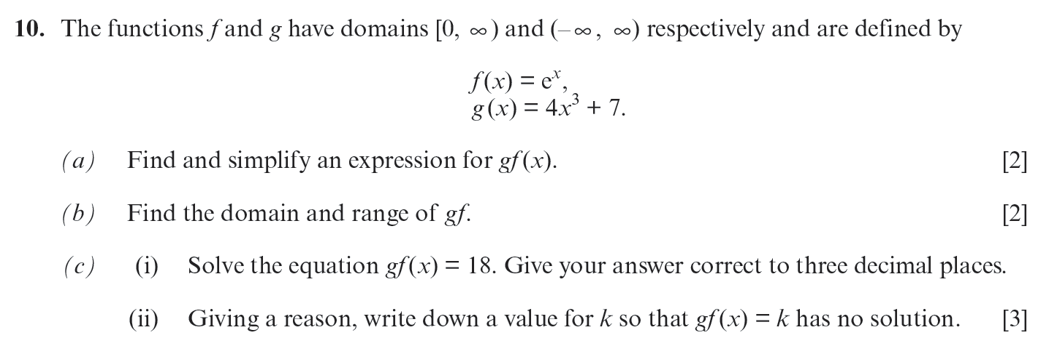
..........................................................................................................................................................................................................................................................................................................
..........................................................................................................................................................................................................................................................................................................
..........................................................................................................................................................................................................................................................................................................
..........................................................................................................................................................................................................................................................................................................
..........................................................................................................................................................................................................................................................................................................
..........................................................................................................................................................................................................................................................................................................
..........................................................................................................................................................................................................................................................................................................
..........................................................................................................................................................................................................................................................................................................
..........................................................................................................................................................................................................................................................................................................
..........................................................................................................................................................................................................................................................................................................
..........................................................................................................................................................................................................................................................................................................
..........................................................................................................................................................................................................................................................................................................
..........................................................................................................................................................................................................................................................................................................
..........................................................................................................................................................................................................................................................................................................
..........................................................................................................................................................................................................................................................................................................
..........................................................................................................................................................................................................................................................................................................
..........................................................................................................................................................................................................................................................................................................
..........................................................................................................................................................................................................................................................................................................
..........................................................................................................................................................................................................................................................................................................
..........................................................................................................................................................................................................................................................................................................
..........................................................................................................................................................................................................................................................................................................
..........................................................................................................................................................................................................................................................................................................
..........................................................................................................................................................................................................................................................................................................
..........................................................................................................................................................................................................................................................................................................
..........................................................................................................................................................................................................................................................................................................
..........................................................................................................................................................................................................................................................................................................
..........................................................................................................................................................................................................................................................................................................
..........................................................................................................................................................................................................................................................................................................
..........................................................................................................................................................................................................................................................................................................

(C3 Summer 2017)
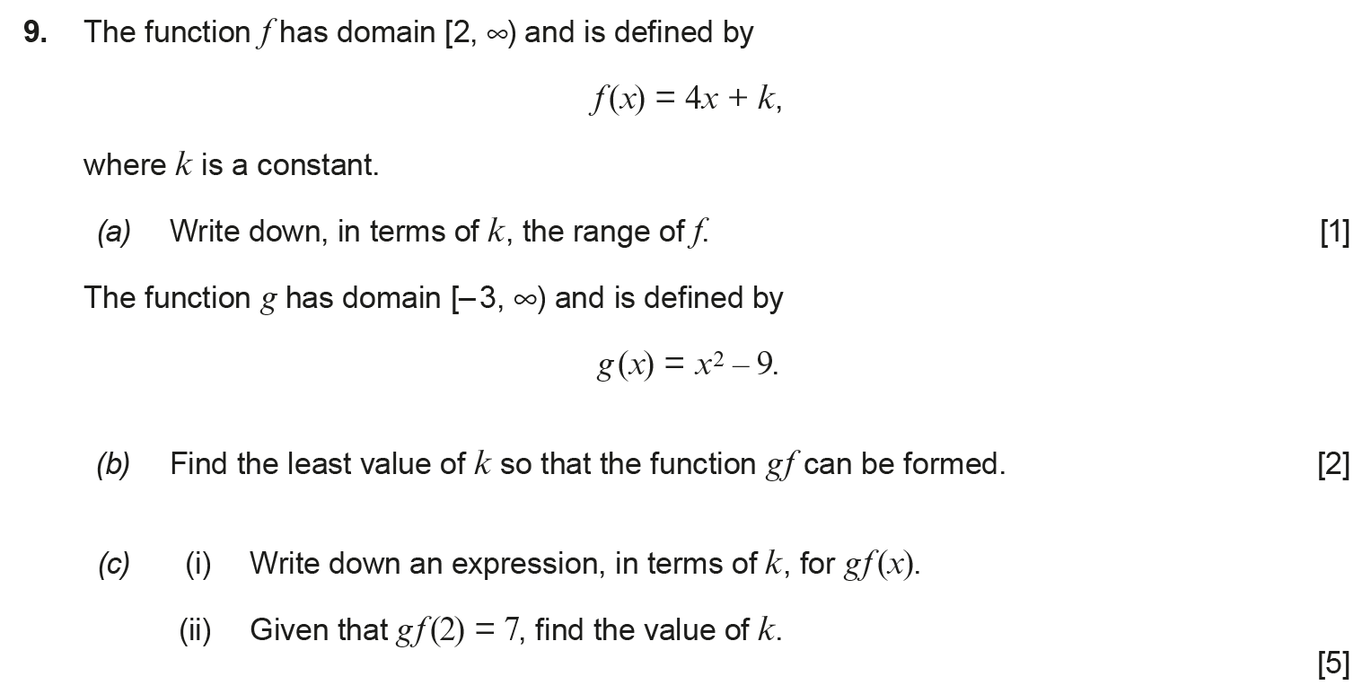
..........................................................................................................................................................................................................................................................................................................
..........................................................................................................................................................................................................................................................................................................
..........................................................................................................................................................................................................................................................................................................
..........................................................................................................................................................................................................................................................................................................
..........................................................................................................................................................................................................................................................................................................
..........................................................................................................................................................................................................................................................................................................
..........................................................................................................................................................................................................................................................................................................
..........................................................................................................................................................................................................................................................................................................
..........................................................................................................................................................................................................................................................................................................
..........................................................................................................................................................................................................................................................................................................
..........................................................................................................................................................................................................................................................................................................
..........................................................................................................................................................................................................................................................................................................
..........................................................................................................................................................................................................................................................................................................
..........................................................................................................................................................................................................................................................................................................
..........................................................................................................................................................................................................................................................................................................
..........................................................................................................................................................................................................................................................................................................
..........................................................................................................................................................................................................................................................................................................
..........................................................................................................................................................................................................................................................................................................
..........................................................................................................................................................................................................................................................................................................
..........................................................................................................................................................................................................................................................................................................
..........................................................................................................................................................................................................................................................................................................
..........................................................................................................................................................................................................................................................................................................
..........................................................................................................................................................................................................................................................................................................
..........................................................................................................................................................................................................................................................................................................
..........................................................................................................................................................................................................................................................................................................
..........................................................................................................................................................................................................................................................................................................
..........................................................................................................................................................................................................................................................................................................
..........................................................................................................................................................................................................................................................................................................
..........................................................................................................................................................................................................................................................................................................
..........................................................................................................................................................................................................................................................................................................
..........................................................................................................................................................................................................................................................................................................
..........................................................................................................................................................................................................................................................................................................
..........................................................................................................................................................................................................................................................................................................
..........................................................................................................................................................................................................................................................................................................
..........................................................................................................................................................................................................................................................................................................
..........................................................................................................................................................................................................................................................................................................
..........................................................................................................................................................................................................................................................................................................
..........................................................................................................................................................................................................................................................................................................
..........................................................................................................................................................................................................................................................................................................
..........................................................................................................................................................................................................................................................................................................
..........................................................................................................................................................................................................................................................................................................
..........................................................................................................................................................................................................................................................................................................
..........................................................................................................................................................................................................................................................................................................
..........................................................................................................................................................................................................................................................................................................
..........................................................................................................................................................................................................................................................................................................
..........................................................................................................................................................................................................................................................................................................
..........................................................................................................................................................................................................................................................................................................
..........................................................................................................................................................................................................................................................................................................
..........................................................................................................................................................................................................................................................................................................
..........................................................................................................................................................................................................................................................................................................
..........................................................................................................................................................................................................................................................................................................
..........................................................................................................................................................................................................................................................................................................
..........................................................................................................................................................................................................................................................................................................
..........................................................................................................................................................................................................................................................................................................
..........................................................................................................................................................................................................................................................................................................
..........................................................................................................................................................................................................................................................................................................
..........................................................................................................................................................................................................................................................................................................
..........................................................................................................................................................................................................................................................................................................
..........................................................................................................................................................................................................................................................................................................
..........................................................................................................................................................................................................................................................................................................
..........................................................................................................................................................................................................................................................................................................
..........................................................................................................................................................................................................................................................................................................
..........................................................................................................................................................................................................................................................................................................
..........................................................................................................................................................................................................................................................................................................
..........................................................................................................................................................................................................................................................................................................
..........................................................................................................................................................................................................................................................................................................
(C3 Summer 2009)
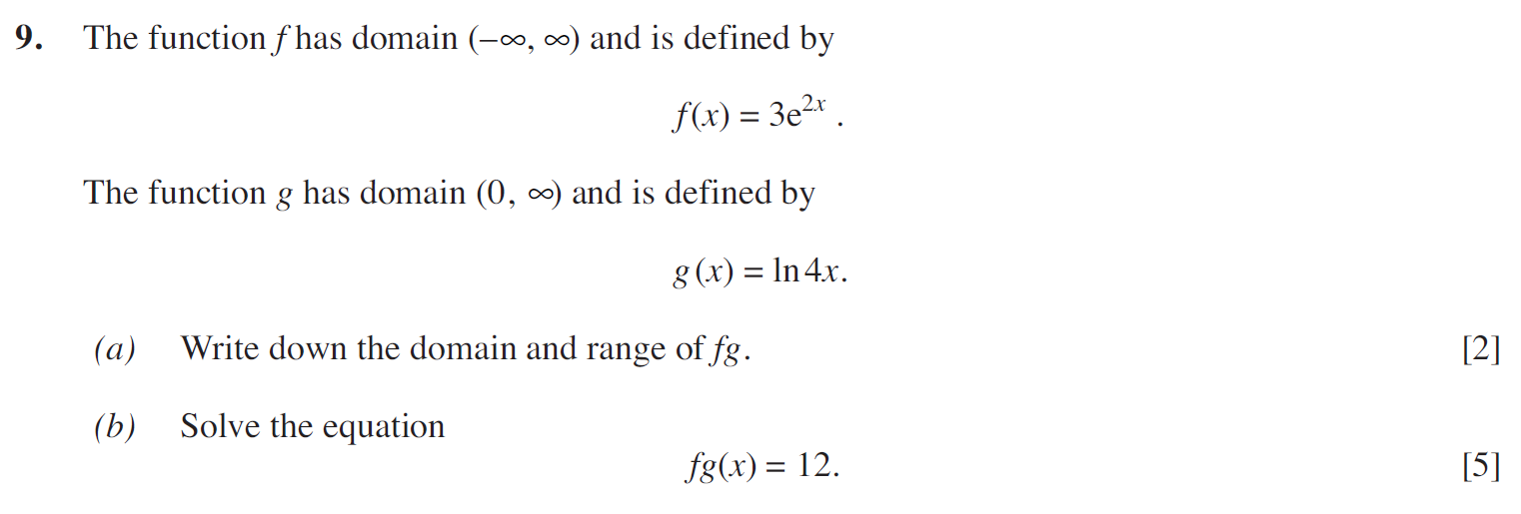
..........................................................................................................................................................................................................................................................................................................
..........................................................................................................................................................................................................................................................................................................
..........................................................................................................................................................................................................................................................................................................
..........................................................................................................................................................................................................................................................................................................
..........................................................................................................................................................................................................................................................................................................
..........................................................................................................................................................................................................................................................................................................
..........................................................................................................................................................................................................................................................................................................
..........................................................................................................................................................................................................................................................................................................
..........................................................................................................................................................................................................................................................................................................
..........................................................................................................................................................................................................................................................................................................
..........................................................................................................................................................................................................................................................................................................
..........................................................................................................................................................................................................................................................................................................
..........................................................................................................................................................................................................................................................................................................
..........................................................................................................................................................................................................................................................................................................
..........................................................................................................................................................................................................................................................................................................
..........................................................................................................................................................................................................................................................................................................
..........................................................................................................................................................................................................................................................................................................
..........................................................................................................................................................................................................................................................................................................
..........................................................................................................................................................................................................................................................................................................
..........................................................................................................................................................................................................................................................................................................
..........................................................................................................................................................................................................................................................................................................
..........................................................................................................................................................................................................................................................................................................
..........................................................................................................................................................................................................................................................................................................
..........................................................................................................................................................................................................................................................................................................
..........................................................................................................................................................................................................................................................................................................
..........................................................................................................................................................................................................................................................................................................
..........................................................................................................................................................................................................................................................................................................
..........................................................................................................................................................................................................................................................................................................
..........................................................................................................................................................................................................................................................................................................
..........................................................................................................................................................................................................................................................................................................
(C3 Winter 2007)
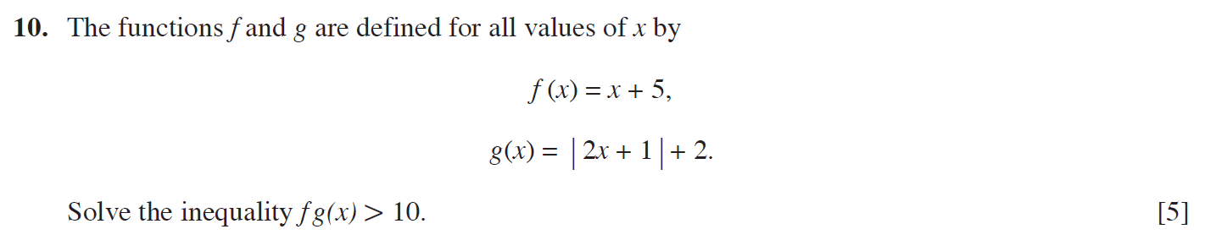
..........................................................................................................................................................................................................................................................................................................
..........................................................................................................................................................................................................................................................................................................
..........................................................................................................................................................................................................................................................................................................
..........................................................................................................................................................................................................................................................................................................
..........................................................................................................................................................................................................................................................................................................
..........................................................................................................................................................................................................................................................................................................
..........................................................................................................................................................................................................................................................................................................
..........................................................................................................................................................................................................................................................................................................
..........................................................................................................................................................................................................................................................................................................
..........................................................................................................................................................................................................................................................................................................
..........................................................................................................................................................................................................................................................................................................
..........................................................................................................................................................................................................................................................................................................
..........................................................................................................................................................................................................................................................................................................
..........................................................................................................................................................................................................................................................................................................
..........................................................................................................................................................................................................................................................................................................
..........................................................................................................................................................................................................................................................................................................
..........................................................................................................................................................................................................................................................................................................
..........................................................................................................................................................................................................................................................................................................
..........................................................................................................................................................................................................................................................................................................
..........................................................................................................................................................................................................................................................................................................
..........................................................................................................................................................................................................................................................................................................
..........................................................................................................................................................................................................................................................................................................
..........................................................................................................................................................................................................................................................................................................
..........................................................................................................................................................................................................................................................................................................
..........................................................................................................................................................................................................................................................................................................
..........................................................................................................................................................................................................................................................................................................
..........................................................................................................................................................................................................................................................................................................
..........................................................................................................................................................................................................................................................................................................
..........................................................................................................................................................................................................................................................................................................
..........................................................................................................................................................................................................................................................................................................
..........................................................................................................................................................................................................................................................................................................
..........................................................................................................................................................................................................................................................................................................
..........................................................................................................................................................................................................................................................................................................
..........................................................................................................................................................................................................................................................................................................
(C3 Summer 2007)
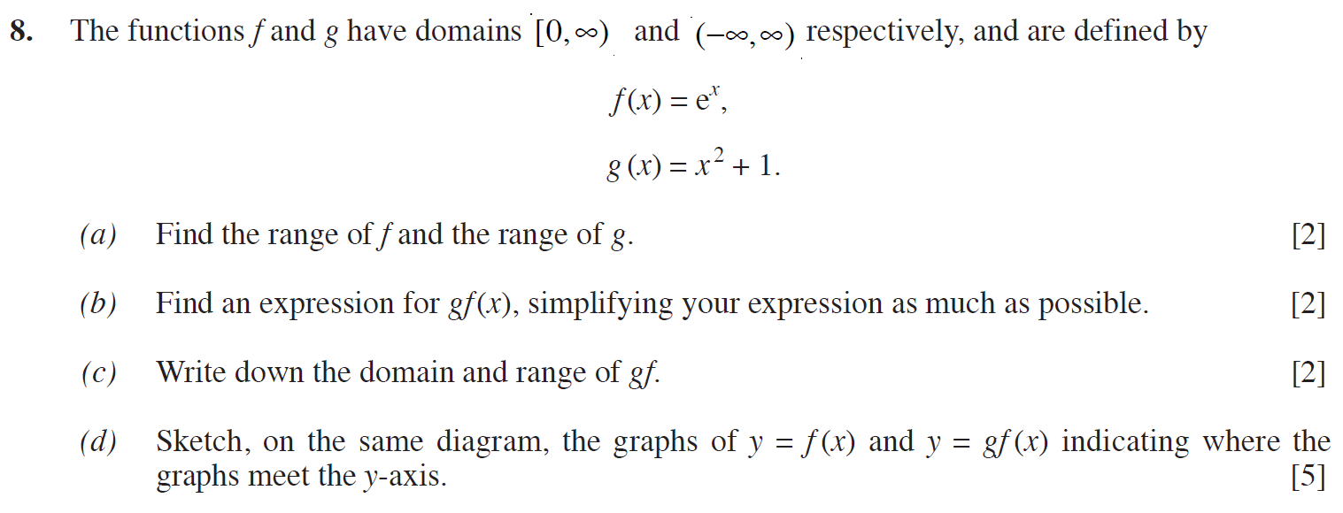
..........................................................................................................................................................................................................................................................................................................
..........................................................................................................................................................................................................................................................................................................
..........................................................................................................................................................................................................................................................................................................
..........................................................................................................................................................................................................................................................................................................
..........................................................................................................................................................................................................................................................................................................
..........................................................................................................................................................................................................................................................................................................
..........................................................................................................................................................................................................................................................................................................
..........................................................................................................................................................................................................................................................................................................
..........................................................................................................................................................................................................................................................................................................
..........................................................................................................................................................................................................................................................................................................
..........................................................................................................................................................................................................................................................................................................
..........................................................................................................................................................................................................................................................................................................
..........................................................................................................................................................................................................................................................................................................
..........................................................................................................................................................................................................................................................................................................
..........................................................................................................................................................................................................................................................................................................

(C3 Winter 2014)
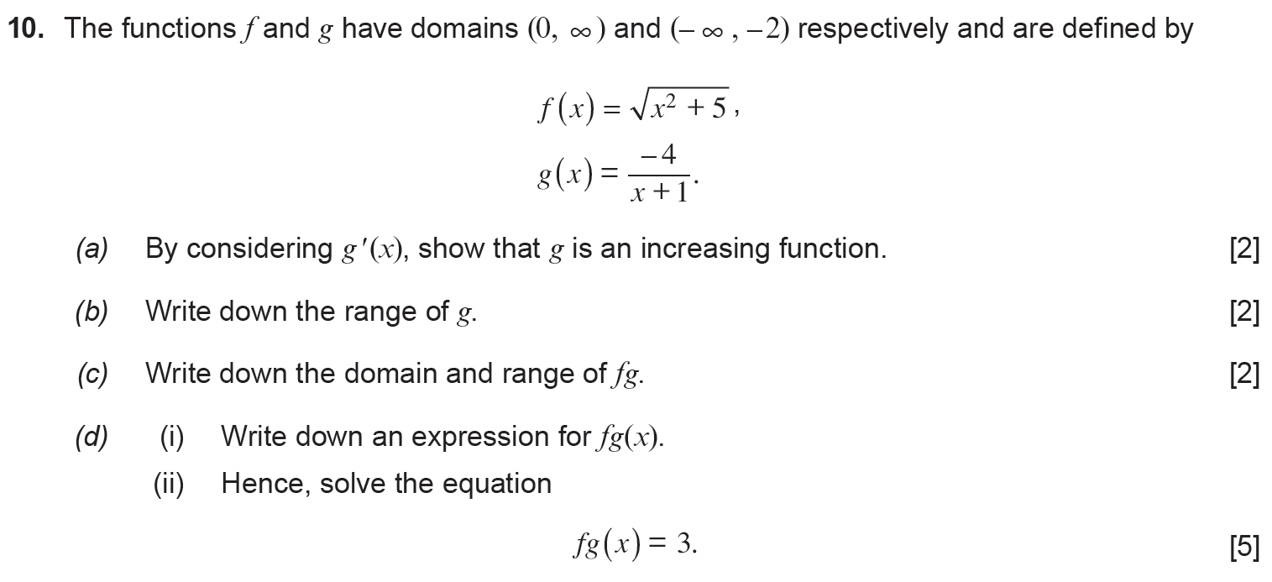
..........................................................................................................................................................................................................................................................................................................
..........................................................................................................................................................................................................................................................................................................
..........................................................................................................................................................................................................................................................................................................
..........................................................................................................................................................................................................................................................................................................
..........................................................................................................................................................................................................................................................................................................
..........................................................................................................................................................................................................................................................................................................
..........................................................................................................................................................................................................................................................................................................
..........................................................................................................................................................................................................................................................................................................
..........................................................................................................................................................................................................................................................................................................
..........................................................................................................................................................................................................................................................................................................
..........................................................................................................................................................................................................................................................................................................
..........................................................................................................................................................................................................................................................................................................
..........................................................................................................................................................................................................................................................................................................
..........................................................................................................................................................................................................................................................................................................
..........................................................................................................................................................................................................................................................................................................
..........................................................................................................................................................................................................................................................................................................
..........................................................................................................................................................................................................................................................................................................
..........................................................................................................................................................................................................................................................................................................
..........................................................................................................................................................................................................................................................................................................
..........................................................................................................................................................................................................................................................................................................
..........................................................................................................................................................................................................................................................................................................
..........................................................................................................................................................................................................................................................................................................
..........................................................................................................................................................................................................................................................................................................
..........................................................................................................................................................................................................................................................................................................
..........................................................................................................................................................................................................................................................................................................
..........................................................................................................................................................................................................................................................................................................
..........................................................................................................................................................................................................................................................................................................
..........................................................................................................................................................................................................................................................................................................
..........................................................................................................................................................................................................................................................................................................
..........................................................................................................................................................................................................................................................................................................
..........................................................................................................................................................................................................................................................................................................
..........................................................................................................................................................................................................................................................................................................
..........................................................................................................................................................................................................................................................................................................
..........................................................................................................................................................................................................................................................................................................
..........................................................................................................................................................................................................................................................................................................
..........................................................................................................................................................................................................................................................................................................
..........................................................................................................................................................................................................................................................................................................
..........................................................................................................................................................................................................................................................................................................
..........................................................................................................................................................................................................................................................................................................
..........................................................................................................................................................................................................................................................................................................
..........................................................................................................................................................................................................................................................................................................
..........................................................................................................................................................................................................................................................................................................
..........................................................................................................................................................................................................................................................................................................
..........................................................................................................................................................................................................................................................................................................
..........................................................................................................................................................................................................................................................................................................
..........................................................................................................................................................................................................................................................................................................
..........................................................................................................................................................................................................................................................................................................
..........................................................................................................................................................................................................................................................................................................
..........................................................................................................................................................................................................................................................................................................
..........................................................................................................................................................................................................................................................................................................
..........................................................................................................................................................................................................................................................................................................
..........................................................................................................................................................................................................................................................................................................
..........................................................................................................................................................................................................................................................................................................
..........................................................................................................................................................................................................................................................................................................
..........................................................................................................................................................................................................................................................................................................
..........................................................................................................................................................................................................................................................................................................
..........................................................................................................................................................................................................................................................................................................
..........................................................................................................................................................................................................................................................................................................
..........................................................................................................................................................................................................................................................................................................
..........................................................................................................................................................................................................................................................................................................
..........................................................................................................................................................................................................................................................................................................
..........................................................................................................................................................................................................................................................................................................
..........................................................................................................................................................................................................................................................................................................
..........................................................................................................................................................................................................................................................................................................
..........................................................................................................................................................................................................................................................................................................
..........................................................................................................................................................................................................................................................................................................
..........................................................................................................................................................................................................................................................................................................
(C3 Winter 2013)
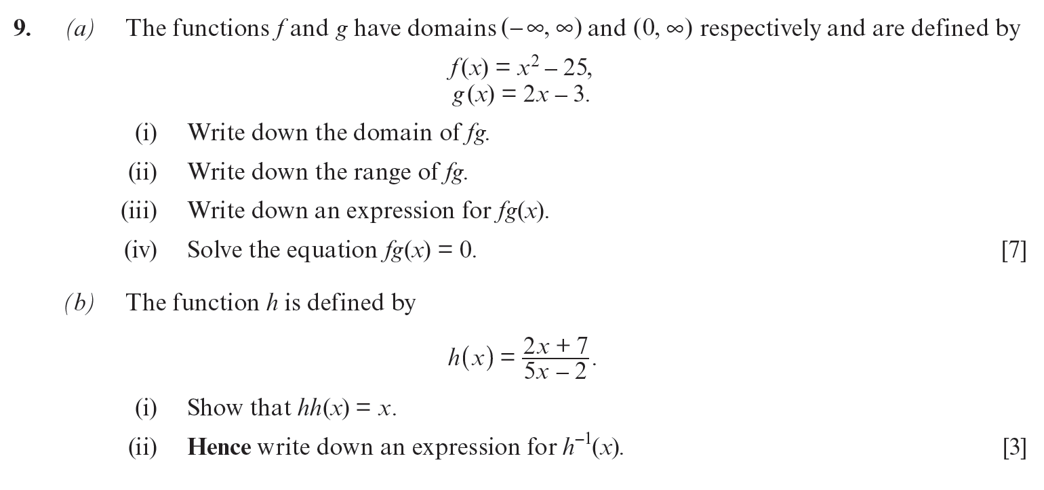
..........................................................................................................................................................................................................................................................................................................
..........................................................................................................................................................................................................................................................................................................
..........................................................................................................................................................................................................................................................................................................
..........................................................................................................................................................................................................................................................................................................
..........................................................................................................................................................................................................................................................................................................
..........................................................................................................................................................................................................................................................................................................
..........................................................................................................................................................................................................................................................................................................
..........................................................................................................................................................................................................................................................................................................
..........................................................................................................................................................................................................................................................................................................
..........................................................................................................................................................................................................................................................................................................
..........................................................................................................................................................................................................................................................................................................
..........................................................................................................................................................................................................................................................................................................
..........................................................................................................................................................................................................................................................................................................
..........................................................................................................................................................................................................................................................................................................
..........................................................................................................................................................................................................................................................................................................
..........................................................................................................................................................................................................................................................................................................
..........................................................................................................................................................................................................................................................................................................
..........................................................................................................................................................................................................................................................................................................
..........................................................................................................................................................................................................................................................................................................
..........................................................................................................................................................................................................................................................................................................
..........................................................................................................................................................................................................................................................................................................
..........................................................................................................................................................................................................................................................................................................
..........................................................................................................................................................................................................................................................................................................
..........................................................................................................................................................................................................................................................................................................
..........................................................................................................................................................................................................................................................................................................
..........................................................................................................................................................................................................................................................................................................
..........................................................................................................................................................................................................................................................................................................
..........................................................................................................................................................................................................................................................................................................
..........................................................................................................................................................................................................................................................................................................
..........................................................................................................................................................................................................................................................................................................
..........................................................................................................................................................................................................................................................................................................
..........................................................................................................................................................................................................................................................................................................
..........................................................................................................................................................................................................................................................................................................
..........................................................................................................................................................................................................................................................................................................
..........................................................................................................................................................................................................................................................................................................
..........................................................................................................................................................................................................................................................................................................
..........................................................................................................................................................................................................................................................................................................
..........................................................................................................................................................................................................................................................................................................
..........................................................................................................................................................................................................................................................................................................
..........................................................................................................................................................................................................................................................................................................
..........................................................................................................................................................................................................................................................................................................
..........................................................................................................................................................................................................................................................................................................
..........................................................................................................................................................................................................................................................................................................
..........................................................................................................................................................................................................................................................................................................
..........................................................................................................................................................................................................................................................................................................
..........................................................................................................................................................................................................................................................................................................
..........................................................................................................................................................................................................................................................................................................
..........................................................................................................................................................................................................................................................................................................
..........................................................................................................................................................................................................................................................................................................
..........................................................................................................................................................................................................................................................................................................
..........................................................................................................................................................................................................................................................................................................
..........................................................................................................................................................................................................................................................................................................
..........................................................................................................................................................................................................................................................................................................
..........................................................................................................................................................................................................................................................................................................
..........................................................................................................................................................................................................................................................................................................
..........................................................................................................................................................................................................................................................................................................
..........................................................................................................................................................................................................................................................................................................
..........................................................................................................................................................................................................................................................................................................
..........................................................................................................................................................................................................................................................................................................
..........................................................................................................................................................................................................................................................................................................
..........................................................................................................................................................................................................................................................................................................
..........................................................................................................................................................................................................................................................................................................
..........................................................................................................................................................................................................................................................................................................
..........................................................................................................................................................................................................................................................................................................
..........................................................................................................................................................................................................................................................................................................
..........................................................................................................................................................................................................................................................................................................
..........................................................................................................................................................................................................................................................................................................
(C3 Summer 2010)





























