



$$x$$ | $$1$$ | $$2$$ | $$3$$ | $$4$$ | $$5$$
$$y$$ | $$3$$ | $$12$$ | $$27$$ | $$48$$ | $$75$$

$$y$$
$$x$$
$$log⁡(x)$$ | $$0$$ | $$0.301$$ | $$0.477$$ | $$0.602$$ | $$0.699$$
$$log⁡(y)$$ | $$0.477$$ | $$1.079$$ | $$1.431$$ | $$1.681$$ | $$1.875$$

$$log⁡(y)$$
$$log⁡(x)$$
$$0.699$$
$$1.398$$
$$y={10}^{0.477}x^{\frac{1.398}{0.699}} \\ y=3x^{2}$$
What is the work? |  | Consider when and how to use exponential models.  Fitting a polynomial or exponential curve to data.
What is required before starting? |  | GCSE Work: Nth term; graph plotting; rules of indices.  A Level Unit 1: Introducing logarithms.
Where does this lead to? |  | Applications: Calculating the compound interest on a loan; radioactive decay; the decay of a drug in the body; modelling population growth.

Consider the following sequence of numbers.
$$4, 7, 10, 13, 16, 19, …$$
We see that we add three each time to obtain the next number in the sequence.
From GCSE work, the $n$th term is
$$3n+1$$
or
$$4+3(n-1)$$
Next, consider the following sequence of numbers.
$$4, 12, 36, 108, 324, 972, …$$
We see that we multiply by three each time to obtain the next number in the sequence. The $n$th term is
$$4×3^{n-1}$$
This is an example of an exponential function. We use these in sequences where we multiply by the same number each time, to obtain the next number in the sequence.
Example 1
Consider investing $£1,000$ into a bank that pays yearly compound interest at a rate of 3%.
After one year, the amount of money we have will be
Or we can multiply by $103\%$
$$£1,000×1.03=£1,030$$
After two years:
$$£1,000×{1.03}^{2}=£1,060.90$$
After $n$ years:
$$£1,000×{1.03}^{n}$$

Plotting exponential graphs
What happens if $a$ is negative?
You need to know how to plot a graph of the exponential function $y=a^{x}$,
where $a$ is positive.
Example 2
$$x$$ | $$-5$$ | $$-4$$ | $$-3$$ | $$-2$$ | $$-1$$ | $$0$$ | $$1$$ | $$2$$ | $$3$$ | $$4$$ | $$5$$
$$y=2^{x}$$ | $$\frac{1}{32}$$ | $$\frac{1}{16}$$ | $$\frac{1}{8}$$ | $$\frac{1}{4}$$ | $$\frac{1}{2}$$ | $$1$$ | $$2$$ | $$4$$ | $$8$$ | $$16$$ | $$32$$
$$y={\left(\frac{1}{2}\right)}^{x}$$ | $$32$$ | $$16$$ | $$8$$ | $$4$$ | $$2$$ | $$1$$ | $$\frac{1}{2}$$ | $$\frac{1}{4}$$ | $$\frac{1}{8}$$ | $$\frac{1}{16}$$ | $$\frac{1}{32}$$
Note that $y=2^{x}$ doubles each time, whilst $y={\left(\frac{1}{2}\right)}^{x}$ halves each time.
$$y$$
Note: ${\left(\frac{1}{2}\right)}^{x}=\frac{1^{x}}{2^{x}}=\frac{1}{2^{x}}=2^{-x}.$ In general, $a^{-x}={\left(\frac{1}{a}\right)}^{x}$.

$$y=2^{x}$$
$$y={\left(\frac{1}{2}\right)}^{x}$$

$$x$$

Exercise 1
Complete the following table, before plotting the graphs for $y=3^{x}$ and $y={\left(\frac{1}{3}\right)}^{x}$.
$$x$$ | $$-5$$ | $$-4$$ | $$-3$$ | $$-2$$ | $$-1$$ | $$0$$ | $$1$$ | $$2$$ | $$3$$ | $$4$$ | $$5$$
$$y=3^{x}$$
$$y={\left(\frac{1}{3}\right)}^{x}$$
$$y$$

Experiment with a graphical calculator, or use the Desmos website, to investigate the shape of
$y=a^{x}$ for different values of $a$. What happens if $a=1$?
$$x$$
Euler’s Number

Consider investing £1 into a bank that pays a yearly interest rate of 100%. How much money will you have at the end of the year? This depends on the number of instalments over the year.
Instalments | Money after one year
1 ($100\%$ after one year) | $$1×2^{1}=£2$$
2 ($50\%$ every six months) | $$1×{1.5}^{2}=£2.25$$
3 ($33.\dot{3}\%$ every four months) | $$1×{1.\dot{3}}^{3}=£2.37$$
4 ($25\%$ every three months) | $$1×{1.25}^{4}=£2.44$$
$$n$$ | $${\left(1+\frac{1}{n}\right)}^{n}$$
As $n$ increases, the money increases, but not forever. By modelling (for example using an Excel spreadsheet), we see that the money settles down to the value $£2.71…$ This is a special number in mathematics, known as Euler’s number, $e$. To five decimal places, $e=2.71828$.
$$e=\lim_{n→∞}{{\left(1+\frac{1}{n}\right)}^{n}}$$
The exponential function $y=e^{x}$ is special: its gradient is equal to the value of $e^{x}$ at any point on the graph.
In other words, $\frac{d}{dx}\left(e^{x}\right)=e^{x}$.
Exercise 2
Complete the following table, giving your answers correct to one decimal place, before plotting the graph $y=e^{x}.$
$$x$$ | $$-5$$ | $$-4$$ | $$-3$$ | $$-2$$ | $$-1$$ | $$0$$ | $$1$$ | $$2$$ | $$3$$ | $$4$$ | $$5$$
$$y=e^{x}$$
$$y$$
Extension: Given that $\frac{d}{dx}\left(a^{x}\right)=\ln{(a)×a^{x}}$, experiment with plotting the graphs $y=a^{x}$ and
$y=\ln{(a)}×a^{x}$ for different values of $a.$

Any function of the form
$y=a^{x}$ is an exponential function, but the function $y=e^{x}$ is known as the exponential function.
$$x$$
Exponential Models
$$y$$
$$x$$
$$y=e^{x}$$
$$y=e^{2x}$$
Starting with the curve for the function $y=e^{x}$, it is possible to compress it along the $x$–axis, with scale factor $\frac{1}{k}$, to give the curve for the function $y=e^{kx}$.
The gradient of the function $y=e^{kx}$ is $ke^{kx}$. That is,
$\frac{dy}{dx}=ke^{kx}$ or $\frac{dy}{dx}∝e^{kx}$. This is an excellent model for events in the natural world such as radioactive decay or population growth.
In general, an equation of the form $y=Ae^{kt}$, where $t$ represents a specific time, will give an exponential function, where $A$ and $k$ are constants.
If $y=Ae^{kt}$, then $\frac{dy}{dt}=kAe^{kt}$.
Exponential growth: $k$ is positive Exponential decay: $k$ is negative
$$y$$
$$y$$
$A$ is the initial value
$$y={Ae}^{kt}$$
$$A$$
$$y={Ae}^{kt}$$

$$A$$
$$t$$
$$t$$

Example 3
The population of a country at the start of a specific year, $P$ million, grows exponentially such that $P=13e^{0.07t}$, where $t$ represents the time in years after 2020. Calculate
(a) The size of the population at the start of 2026.
(b) The rate of change of the population at the start of 2026.
(c) The average rate of change between the start of 2020 and the start of 2026.
Answer: (a) At the start of 2026, we have $t=6$. So, $P=13e^{0.07×6}=19.79$ million, to 2 decimal places.
(b) $\frac{dP}{dt}=0.07×13e^{0.07t}=0.91e^{0.07t}$. When $t=6$, we have $\frac{dP}{dt}=0.91e^{0.07×6}=1.38$ million per year,
(b) to 2 decimal places.
(c) The change in population between 2020 and 2026 is $19.79-13=6.79$ million, to 2 decimal places.
(c) The average rate of change is $6.79÷6=1.13$ million per year, to 2 decimal places.
Exercise 3
A drug decays exponentially. Its concentration, $C$ mg per ml, after $t$ hours, is $C=2×e^{-0.35t}$.
(a) What is its initial concentration?
(b) What is the concentration after 3 hours?
(c) What is the rate of change of the drug when (i) $t=0$, (ii) $t=3$?
(d) What is the average rate of decrease during the first 3 hours?
..........................................................................................................................................................................................................................................................................................................
..........................................................................................................................................................................................................................................................................................................
..........................................................................................................................................................................................................................................................................................................
..........................................................................................................................................................................................................................................................................................................
..........................................................................................................................................................................................................................................................................................................
..........................................................................................................................................................................................................................................................................................................
..........................................................................................................................................................................................................................................................................................................
..........................................................................................................................................................................................................................................................................................................
..........................................................................................................................................................................................................................................................................................................
..........................................................................................................................................................................................................................................................................................................
..........................................................................................................................................................................................................................................................................................................
..........................................................................................................................................................................................................................................................................................................

Logarithmic Functions
The inverse of an exponential function is a logarithmic function.
$y=a^{x}$
$\log_{a}{(y)}=\log_{a}{(a^{x})}$ Take logarithm base $a$ of each side.
$\log_{a}{(y)}=x\log_{a}{(a)}$ The power rule.
$\log_{a}{(y)}=x$ The definition of a logarithm.
The inverse of the exponential function $y=a^{x}$ is the logarithmic function $y=\log_{a}{(x)}.$
$$y={1.5}^{x}$$
$$y$$
$y=a^{x}$
is always positive
$$y=x$$
Always passes through $(1, 0)$
Always passes through $(0, 1)$
$\log_{a}{(x)}$ does not exist for negative values of $x$.
$$y=\log_{2}{(x)}$$
$$y=\log_{1.5}{(x)}$$
$$y=2^{x}$$
$$x$$
Natural Logarithm
The inverse of $y=e^{x}$ is $y=\log_{e}{(x)}$ which is written as $y=\ln{(x)}$.
This is known as the natural logarithm.
$$y=x$$
$$y$$
The $y$–axis is an asymptote
The $x$–axis is an asymptote
$$y=\ln{(x)}$$
$$y=e^{x}$$
$$x$$
Example 4
Solve the following equations.
(a) $\ln\left(3x-1\right)=5$ (b) $\log_{4}{(x+5)}=7$
Answer: (a) $\ln\left(3x-1\right)=5$ (b) $\log_{4}\left(x+5\right)=7$
(a) $3x-1=e^{5}$ (b) $x+5=4^{7}$
(a) $3x=e^{5}+1$ (b) $x=4^{7}-5$
(a) $x=\frac{e^{5}+1}{3}$ (b) $x=16379$
(a) $x=49.80$ to 2 decimal places
The inverse of $\log_{4}{(x)}$ is $4^{x}$
The inverse of $ln⁡(x)$ is $e^{x}$
Exercise 4
Solve the following equations.
(a) $\ln\left(2x+5\right)=3$ (b) $\log_{8}\left(x-10\right)=3$
..................................................................................................................................... ..........................................................................................................................................................
..................................................................................................................................... ..........................................................................................................................................................
..................................................................................................................................... ..........................................................................................................................................................
..................................................................................................................................... ..........................................................................................................................................................
..................................................................................................................................... ..........................................................................................................................................................
..................................................................................................................................... ..........................................................................................................................................................
..................................................................................................................................... ..........................................................................................................................................................
..................................................................................................................................... ..........................................................................................................................................................
..................................................................................................................................... ..........................................................................................................................................................
(Unit 1 Summer 2018)
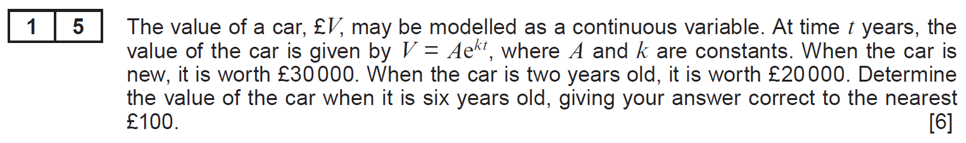
..........................................................................................................................................................................................................................................................................................................
..........................................................................................................................................................................................................................................................................................................
..........................................................................................................................................................................................................................................................................................................
..........................................................................................................................................................................................................................................................................................................
..........................................................................................................................................................................................................................................................................................................
..........................................................................................................................................................................................................................................................................................................
..........................................................................................................................................................................................................................................................................................................
..........................................................................................................................................................................................................................................................................................................
..........................................................................................................................................................................................................................................................................................................
..........................................................................................................................................................................................................................................................................................................
..........................................................................................................................................................................................................................................................................................................
..........................................................................................................................................................................................................................................................................................................
..........................................................................................................................................................................................................................................................................................................
..........................................................................................................................................................................................................................................................................................................
..........................................................................................................................................................................................................................................................................................................
..........................................................................................................................................................................................................................................................................................................
..........................................................................................................................................................................................................................................................................................................
..........................................................................................................................................................................................................................................................................................................
..........................................................................................................................................................................................................................................................................................................
..........................................................................................................................................................................................................................................................................................................
..........................................................................................................................................................................................................................................................................................................
..........................................................................................................................................................................................................................................................................................................
..........................................................................................................................................................................................................................................................................................................
..........................................................................................................................................................................................................................................................................................................
.........................................................................................................................................................................................................................................................................................................
..........................................................................................................................................................................................................................................................................................................
..........................................................................................................................................................................................................................................................................................................
..........................................................................................................................................................................................................................................................................................................
..........................................................................................................................................................................................................................................................................................................
..........................................................................................................................................................................................................................................................................................................
..........................................................................................................................................................................................................................................................................................................
..........................................................................................................................................................................................................................................................................................................
(Sample Assessment Materials)
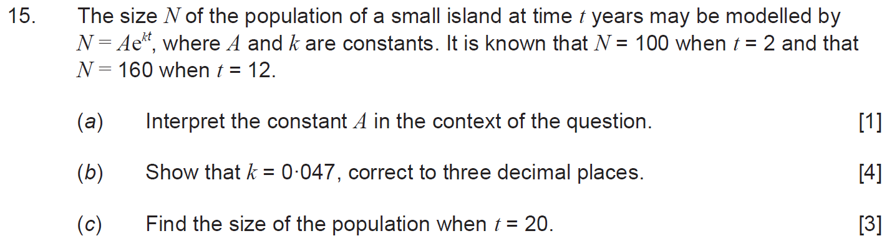
..........................................................................................................................................................................................................................................................................................................
..........................................................................................................................................................................................................................................................................................................
..........................................................................................................................................................................................................................................................................................................
..........................................................................................................................................................................................................................................................................................................
..........................................................................................................................................................................................................................................................................................................
..........................................................................................................................................................................................................................................................................................................
..........................................................................................................................................................................................................................................................................................................
..........................................................................................................................................................................................................................................................................................................
..........................................................................................................................................................................................................................................................................................................
..........................................................................................................................................................................................................................................................................................................
..........................................................................................................................................................................................................................................................................................................
..........................................................................................................................................................................................................................................................................................................
..........................................................................................................................................................................................................................................................................................................
..........................................................................................................................................................................................................................................................................................................
..........................................................................................................................................................................................................................................................................................................
..........................................................................................................................................................................................................................................................................................................
..........................................................................................................................................................................................................................................................................................................
..........................................................................................................................................................................................................................................................................................................
..........................................................................................................................................................................................................................................................................................................
..........................................................................................................................................................................................................................................................................................................
..........................................................................................................................................................................................................................................................................................................
..........................................................................................................................................................................................................................................................................................................
..........................................................................................................................................................................................................................................................................................................
..........................................................................................................................................................................................................................................................................................................
..........................................................................................................................................................................................................................................................................................................
..........................................................................................................................................................................................................................................................................................................
..........................................................................................................................................................................................................................................................................................................
..........................................................................................................................................................................................................................................................................................................
..........................................................................................................................................................................................................................................................................................................
..........................................................................................................................................................................................................................................................................................................
..........................................................................................................................................................................................................................................................................................................
..........................................................................................................................................................................................................................................................................................................
..........................................................................................................................................................................................................................................................................................................
..........................................................................................................................................................................................................................................................................................................
..........................................................................................................................................................................................................................................................................................................
..........................................................................................................................................................................................................................................................................................................
..........................................................................................................................................................................................................................................................................................................
..........................................................................................................................................................................................................................................................................................................
..........................................................................................................................................................................................................................................................................................................
..........................................................................................................................................................................................................................................................................................................
..........................................................................................................................................................................................................................................................................................................
..........................................................................................................................................................................................................................................................................................................
..........................................................................................................................................................................................................................................................................................................
..........................................................................................................................................................................................................................................................................................................
..........................................................................................................................................................................................................................................................................................................
..........................................................................................................................................................................................................................................................................................................
..........................................................................................................................................................................................................................................................................................................
..........................................................................................................................................................................................................................................................................................................
..........................................................................................................................................................................................................................................................................................................
..........................................................................................................................................................................................................................................................................................................
..........................................................................................................................................................................................................................................................................................................
..........................................................................................................................................................................................................................................................................................................
..........................................................................................................................................................................................................................................................................................................
..........................................................................................................................................................................................................................................................................................................
..........................................................................................................................................................................................................................................................................................................
..........................................................................................................................................................................................................................................................................................................
..........................................................................................................................................................................................................................................................................................................
..........................................................................................................................................................................................................................................................................................................
..........................................................................................................................................................................................................................................................................................................
..........................................................................................................................................................................................................................................................................................................
..........................................................................................................................................................................................................................................................................................................
..........................................................................................................................................................................................................................................................................................................
..........................................................................................................................................................................................................................................................................................................
..........................................................................................................................................................................................................................................................................................................
..........................................................................................................................................................................................................................................................................................................
..........................................................................................................................................................................................................................................................................................................
..........................................................................................................................................................................................................................................................................................................
..........................................................................................................................................................................................................................................................................................................
..........................................................................................................................................................................................................................................................................................................
..........................................................................................................................................................................................................................................................................................................
..........................................................................................................................................................................................................................................................................................................
..........................................................................................................................................................................................................................................................................................................
..........................................................................................................................................................................................................................................................................................................
(Unit 1 Summer 2022)
..........................................................................................................................................................................................................................................................................................................
..........................................................................................................................................................................................................................................................................................................
..........................................................................................................................................................................................................................................................................................................
..........................................................................................................................................................................................................................................................................................................

(Unit 1 Summer 2023)
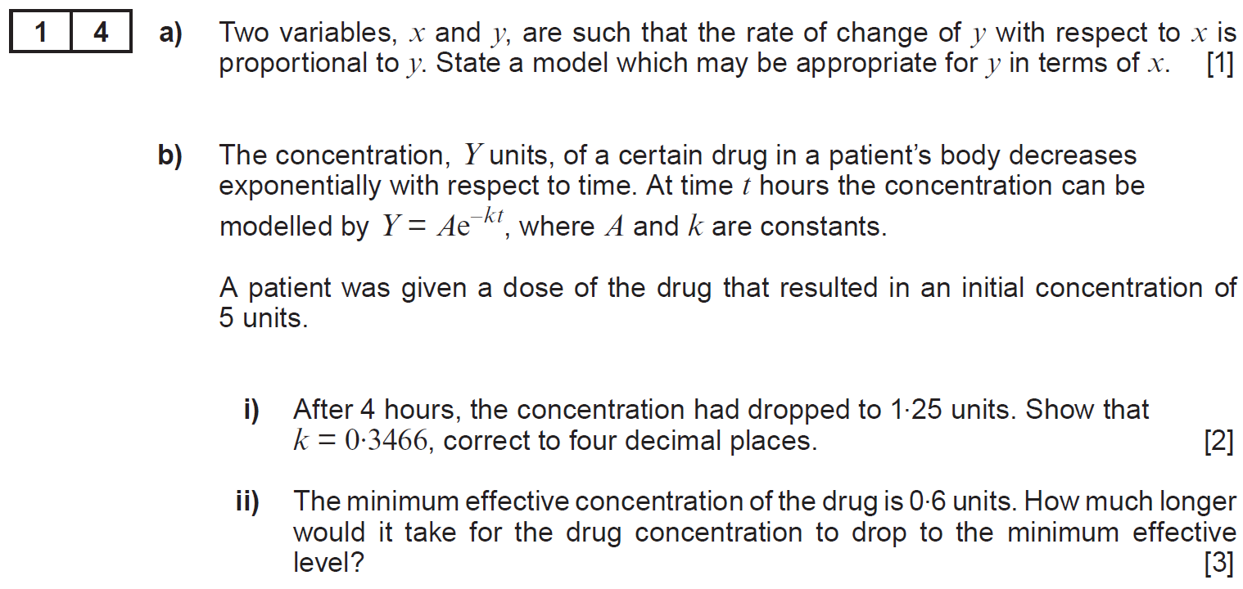
..........................................................................................................................................................................................................................................................................................................
..........................................................................................................................................................................................................................................................................................................
..........................................................................................................................................................................................................................................................................................................
..........................................................................................................................................................................................................................................................................................................
..........................................................................................................................................................................................................................................................................................................
..........................................................................................................................................................................................................................................................................................................
..........................................................................................................................................................................................................................................................................................................
..........................................................................................................................................................................................................................................................................................................
..........................................................................................................................................................................................................................................................................................................
..........................................................................................................................................................................................................................................................................................................
..........................................................................................................................................................................................................................................................................................................
..........................................................................................................................................................................................................................................................................................................
..........................................................................................................................................................................................................................................................................................................
..........................................................................................................................................................................................................................................................................................................
..........................................................................................................................................................................................................................................................................................................
..........................................................................................................................................................................................................................................................................................................
..........................................................................................................................................................................................................................................................................................................
..........................................................................................................................................................................................................................................................................................................
..........................................................................................................................................................................................................................................................................................................
..........................................................................................................................................................................................................................................................................................................
..........................................................................................................................................................................................................................................................................................................
..........................................................................................................................................................................................................................................................................................................
..........................................................................................................................................................................................................................................................................................................
..........................................................................................................................................................................................................................................................................................................
..........................................................................................................................................................................................................................................................................................................
..........................................................................................................................................................................................................................................................................................................
..........................................................................................................................................................................................................................................................................................................
..........................................................................................................................................................................................................................................................................................................
..........................................................................................................................................................................................................................................................................................................
..........................................................................................................................................................................................................................................................................................................
..........................................................................................................................................................................................................................................................................................................
..........................................................................................................................................................................................................................................................................................................
..........................................................................................................................................................................................................................................................................................................
..........................................................................................................................................................................................................................................................................................................
..........................................................................................................................................................................................................................................................................................................
..........................................................................................................................................................................................................................................................................................................
..........................................................................................................................................................................................................................................................................................................
..........................................................................................................................................................................................................................................................................................................
..........................................................................................................................................................................................................................................................................................................
..........................................................................................................................................................................................................................................................................................................
..........................................................................................................................................................................................................................................................................................................
..........................................................................................................................................................................................................................................................................................................
..........................................................................................................................................................................................................................................................................................................
..........................................................................................................................................................................................................................................................................................................
..........................................................................................................................................................................................................................................................................................................
..........................................................................................................................................................................................................................................................................................................
..........................................................................................................................................................................................................................................................................................................
..........................................................................................................................................................................................................................................................................................................
..........................................................................................................................................................................................................................................................................................................
..........................................................................................................................................................................................................................................................................................................
..........................................................................................................................................................................................................................................................................................................
..........................................................................................................................................................................................................................................................................................................
..........................................................................................................................................................................................................................................................................................................
..........................................................................................................................................................................................................................................................................................................
..........................................................................................................................................................................................................................................................................................................
..........................................................................................................................................................................................................................................................................................................
..........................................................................................................................................................................................................................................................................................................
..........................................................................................................................................................................................................................................................................................................
..........................................................................................................................................................................................................................................................................................................
..........................................................................................................................................................................................................................................................................................................
..........................................................................................................................................................................................................................................................................................................
..........................................................................................................................................................................................................................................................................................................
..........................................................................................................................................................................................................................................................................................................
..........................................................................................................................................................................................................................................................................................................
..........................................................................................................................................................................................................................................................................................................
..........................................................................................................................................................................................................................................................................................................
..........................................................................................................................................................................................................................................................................................................
(Unit 1 Summer 2024)
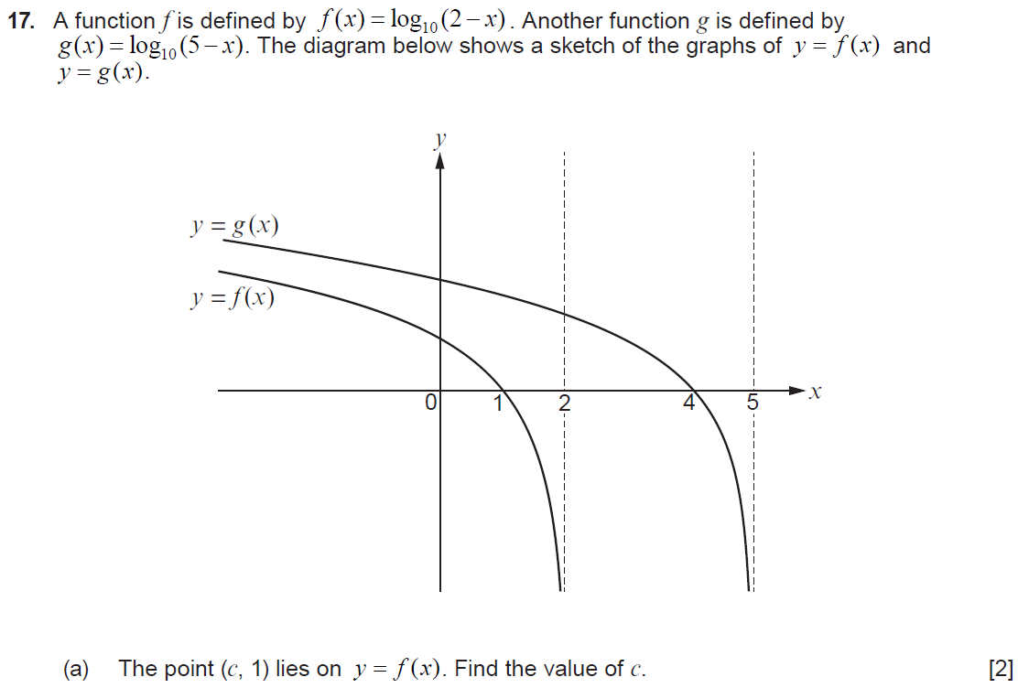
..........................................................................................................................................................................................................................................................................................................
..........................................................................................................................................................................................................................................................................................................
..........................................................................................................................................................................................................................................................................................................
..........................................................................................................................................................................................................................................................................................................
..........................................................................................................................................................................................................................................................................................................
..........................................................................................................................................................................................................................................................................................................
..........................................................................................................................................................................................................................................................................................................

..........................................................................................................................................................................................................................................................................................................
..........................................................................................................................................................................................................................................................................................................
..........................................................................................................................................................................................................................................................................................................
..........................................................................................................................................................................................................................................................................................................
..........................................................................................................................................................................................................................................................................................................
..........................................................................................................................................................................................................................................................................................................
..........................................................................................................................................................................................................................................................................................................
..........................................................................................................................................................................................................................................................................................................
..........................................................................................................................................................................................................................................................................................................
..........................................................................................................................................................................................................................................................................................................
..........................................................................................................................................................................................................................................................................................................
..........................................................................................................................................................................................................................................................................................................
..........................................................................................................................................................................................................................................................................................................
..........................................................................................................................................................................................................................................................................................................
..........................................................................................................................................................................................................................................................................................................
..........................................................................................................................................................................................................................................................................................................
..........................................................................................................................................................................................................................................................................................................
..........................................................................................................................................................................................................................................................................................................
..........................................................................................................................................................................................................................................................................................................
..........................................................................................................................................................................................................................................................................................................
..........................................................................................................................................................................................................................................................................................................
..........................................................................................................................................................................................................................................................................................................
..........................................................................................................................................................................................................................................................................................................
..........................................................................................................................................................................................................................................................................................................
..........................................................................................................................................................................................................................................................................................................
..........................................................................................................................................................................................................................................................................................................
..........................................................................................................................................................................................................................................................................................................
..........................................................................................................................................................................................................................................................................................................
..........................................................................................................................................................................................................................................................................................................
..........................................................................................................................................................................................................................................................................................................
..........................................................................................................................................................................................................................................................................................................
..........................................................................................................................................................................................................................................................................................................
..........................................................................................................................................................................................................................................................................................................
..........................................................................................................................................................................................................................................................................................................
..........................................................................................................................................................................................................................................................................................................
..........................................................................................................................................................................................................................................................................................................
..........................................................................................................................................................................................................................................................................................................
..........................................................................................................................................................................................................................................................................................................

Given values for $x$ and $y$, perhaps from an experiment, it is possible to use logarithms to see if the
data fits a relationship of the form $y=ax^{n}$ or $y=kb^{x}$.
(1) Is the data of the form $y=ax^{n}$ (a polynomial model)?
$y=ax^{n}$
$\log\left(y\right)=\log{(ax^{n})}$ Take logarithm base 10 of each side
$\log{(y)}=\log{(a)}+\log{(x^{n})}$ The multiplication rule
$\log{(y)}=\log{(a)}+n\log{(x)}$ The power rule
$\log{(y)}=n\log{(x)}+\log{(a)}$ Re-arranging
Comparing with $y=mx+c$, plotting $\log{(x)}$ against $\log{(y)}$ would give a straight line with gradient $n$ and $y$–intercept $\log{(a)}$.
Example 5
Data was collected in an experiment about the variables $x$ and $y$.
Use the values in the table to write the relationship between $x$ and $y$ in the form $y=ax^{n}$.
$$x$$ | $$10$$ | $$20$$ | $$30$$ | $$40$$ | $$50$$
$$y$$ | $$158$$ | $$549$$ | $$1140$$ | $$1913$$ | $$2858$$
We can form the following table to show the values of $\log{(x)}$ and $\log{(y)}$, and then plot them on a scatter diagram.
$$log⁡(x)$$ | $$1$$ | $$1.3010$$ | $$1.4771$$ | $$1.6021$$ | $$1.6990$$
$$log⁡(y)$$ | $$2.1987$$ | $$2.7396$$ | $$3.0569$$ | $$3.2817$$ | $$3.4561$$
The gradient of the graph is approximately$3.6÷2=1.8$.
$$log⁡(y)$$
The $y$–intercept of the graph is approximately $0.4$.
Comparing with
$\log{(y)}=n\log{(x)}+\log{(a)}$
we have
$\log{(y)}=1.8\log\left(x\right)+0.4$.
Line of best fit
$$4-0.4=3.6$$
So, $a={10}^{0.4}$
$a=2.51$ to 2 decimal places.
Comparing with $y=ax^{n}$, our model is
$$2-0=2$$
$$log⁡(x)$$
$$y=2.51x^{1.8}$$

(2) Is the data of the form $y=kb^{x}$ (an exponential model)?
$y=kb^{x}$
$\log\left(y\right)=\log{(kb^{x})}$ Take logarithm base 10 of each side
$\log{(y)}=\log{(k)}+\log{(b^{x})}$ The multiplication rule
$\log{(y)}=\log{(k)}+x\log{(b)}$ The power rule
$\log{(y)}=\log{(b)}x+\log{(k)}$ Re-arranging
Compring with $y=mx+c$, plotting $x$ against $\log{(y)}$ would give a straight line with gradient $\log{(b)}$ and $y$–intercept $\log{(k)}$.
Example 6
Data was collected in an experiment about the variables $x$ and $y$.
Use the values in the table to write the relationship between $x$ and $y$ in the form $y=kb^{x}$.
$$x$$ | $$2$$ | $$4$$ | $$6$$ | $$8$$ | $$10$$
$$y$$ | $$9$$ | $$53$$ | $$306$$ | $$1,761$$ | $$10,145$$
We can form the following table to show the values of $x$and $\log{(y)}$, and then plot them on a scatter diagram.
$$x$$ | $$2$$ | $$4$$ | $$6$$ | $$8$$ | $$10$$
$$log⁡(y)$$ | $$0.9542$$ | $$1.7243$$ | $$2.4857$$ | $$3.2458$$ | $$4.0063$$
The gradient of the graph is approximately$3.8÷10=0.38$.
The $y$– intercept of the graph is approximately$0.2$.
$$log⁡(y)$$
Comparing with $\log{(y)}=\log{(b)}x+\log{(k)}$
we have
$\log{(y)}=0.38x+0.2.$
Line of best fit
So, $b={10}^{0.38}$ $k={10}^{0.2}$
$b=2.40$ to 2 d.p. $k=1.58$ to 2 d.p.
$$4-0.2=3.8$$
Comaparing with $y=kb^{x}$, our model is
$$10-0=10$$
$$y=1.58{×2.4}^{x}$$
Exercise 5
$$x$$
A pipe empties water into a lake. The table shows the volume of water, $y$ m³, that leaves the pipe each second, for different depths of water, $x$ m, in the pipe. Engineers expect a relationship of the form $y=ax^{n}$ between $x$ and $y$.
$$x$$ | $$1.1$$ | $$1.2$$ | $$1.3$$ | $$1.4$$ | $$1.5$$
$$y$$ | $$4.73$$ | $$5.78$$ | $$6.95$$ | $$8.24$$ | $$9.66$$
(a) Show, by drawing a line of best fit on suitable axes, that the engineers are correct.
Find the values of the constants $a$ and $n$.
(b) What volume of water (in m³) would you expect to leave the pipe each second when the depth of water is
(i) 1.45 metres; (ii) 3.5 metres?
(c) Which one of your answers to part (b) is most reliable? Explain your answer.
$$log⁡(x)$$
$$log⁡(y)$$
................................................................................................................................................
$$log⁡(y)$$
................................................................................................................................................
................................................................................................................................................
................................................................................................................................................
................................................................................................................................................
................................................................................................................................................
................................................................................................................................................
................................................................................................................................................
................................................................................................................................................
................................................................................................................................................
................................................................................................................................................
$$log⁡(x)$$
................................................................................................................................................
................................................................................................................................................
................................................................................................................................................
................................................................................................................................................
Exercise 6
The population of Mathdref has been increasing since 1990.
Year | 1990 | 1995 | 2005 | 2010
Time, $t$ | $$0$$ | $$5$$ | $$15$$ | $$20$$
Population, $p$ | $$3170$$ | $$4242$$ | $$7597$$ | $$10167$$
(a) Show that the population since 1990 can be modelled using $p=k×b^{t}$, where you are required to find the value of the constants $k$ and $b$.
(b) Estimate the population of Mathdref in 2000 and in 2020. Which one of your answers gives the best estimate? Explain why.
$$log⁡(y)$$
$$t$$
$$log⁡(y)$$
..................................................................................................................................................
..................................................................................................................................................
..................................................................................................................................................
..................................................................................................................................................
..................................................................................................................................................
..................................................................................................................................................
..................................................................................................................................................
..................................................................................................................................................
$$t$$
$$0$$
..................................................................................................................................................
..................................................................................................................................................
(Edexcel Paper 1 Summer 2023 [9MA0/01])
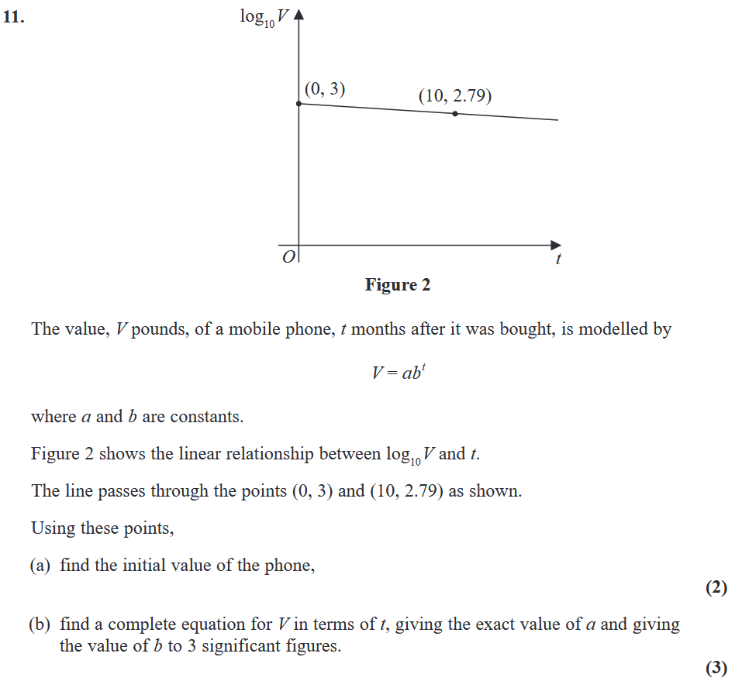
..........................................................................................................................................................................................................................................................................................................
..........................................................................................................................................................................................................................................................................................................
..........................................................................................................................................................................................................................................................................................................
..........................................................................................................................................................................................................................................................................................................
..........................................................................................................................................................................................................................................................................................................
..........................................................................................................................................................................................................................................................................................................
..........................................................................................................................................................................................................................................................................................................
..........................................................................................................................................................................................................................................................................................................
..........................................................................................................................................................................................................................................................................................................
..........................................................................................................................................................................................................................................................................................................
..........................................................................................................................................................................................................................................................................................................
..........................................................................................................................................................................................................................................................................................................
..........................................................................................................................................................................................................................................................................................................
..........................................................................................................................................................................................................................................................................................................
..........................................................................................................................................................................................................................................................................................................
..........................................................................................................................................................................................................................................................................................................
..........................................................................................................................................................................................................................................................................................................
..........................................................................................................................................................................................................................................................................................................
..........................................................................................................................................................................................................................................................................................................
..........................................................................................................................................................................................................................................................................................................
..........................................................................................................................................................................................................................................................................................................
..........................................................................................................................................................................................................................................................................................................
..........................................................................................................................................................................................................................................................................................................
..........................................................................................................................................................................................................................................................................................................
..........................................................................................................................................................................................................................................................................................................
(Unit 1 Summer 2019)






















