



“Let us prove that
this is true...”
What is the work? |  | Proving that something is true by showing that the opposite cannot be true.
What is required before starting? |  | GCSE: Solving equations and inequalities.  A Level Unit 1: Proof.
Where does this lead to? |  | Applications: Showing that there is an infinite number of prime numbers; showing that $\sqrt{2}$ cannot be written in the form $\frac{a}{b}$.

Theory
Proof by contradiction
We can show that something is true by showing that the opposite can never be true.
Example 1 (C4 Summer 2005)
Complete the following proof by contradiction to show that $x+\frac{25}{x}≥10$ when $x$ is real and positive.
Assume that $x+\frac{25}{x}<10$, where $x$ is real and positive.
Since $x$ is positive, multiplication of both sides of the inequality by $x$ gives $x^{2}+25<10x$.
Answer: By subtracting $10x$ from both sides, we obtain $x^{2}-10x+25<0$.
By factorising, $\left(x-5\right)\left(x-5\right)<0$.
${\left(x-5\right)}^{2}<0$.
Squaring any real number gives a number that is greater than or equal to $0$, so there is no real and positive value of $x$ such that ${\left(x-5\right)}^{2}$ is less than zero. This contradicts the assumption that $x$ is real, so we must have $x+\frac{25}{x}≥10$ if $x$ is real and positive.
Example 2 (C4 Summer 2006)
Complete the following proof by contradiction to show that $\sqrt{2}$ is irrational.
Assume that $\sqrt{2}$ is rational. Then $\sqrt{2}$ may be written in the form $\frac{a}{b}$, where $a$ and $b$ are positive integers having no common factor.
$∴$ is ‘therefore’
$∴a^{2}=2b^{2}.$
$∴a^{2}$ has a factor of $2$.
$∴a$ has a factor of $2$ so that $a=2k$, where $k$ is an integer.
Answer: Substituting $a=2k$ into $a^{2}=2b^{2}$, we obtain
${\left(2k\right)}^{2}=2b^{2}$.
$4k^{2}=2b^{2}$.
$2k^{2}=b^{2}$.
$∴ b^{2}$ has a factor of $2$.
$∴ b$ has a factor of $2$.
If $2$ is a factor of both $a$ and $b$, then this contradicts the earlier assumption that $a$ and $b$ were positive integers having no common factors. (We have found a common factor, namely $2$.)
So, $\sqrt{2}$ is not rational.
Example 3
Use proof by contradiction to show that there is an infinite number of prime numbers.
Answer: Assume, to the contrary, that a finite number $n$ of prime numbers exist.
We can list the prime numbers like this: $2, 3, 5, 7, …, p_{n}$.
Let $x$ be the product of all of these prime numbers, and then add one.
$x=\left(2×3×5×7×⋯×p_{n}\right)+1$.
$2$ is not a factor of $x$ as it has a remainder of $1$ when we divide $x$ by $2$.
We can use the same argument to show that all the other prime numbers, up to $p_{n}$, are also not factors of $x$.
So, $x$ must be a prime number that is greater than $p_{n}$.
This contradicts the earlier assumption that the greatest prime number is $p_{n}$.
So, there must be an infinite number of prime numbers.
Example 4 (C4 Summer 2014)
Complete the following proof by contradiction to show that
$$\sin{θ}+\cos{θ}≤\sqrt{2}$$
for all values of $θ$.
Assume that there is a value of $θ$ for which $\sin{θ}+\cos{θ}>\sqrt{2}$.
Then squaring both sides, we have:
Answer: ${(\sin{θ}+\cos{θ})}^{2}>2$
$\left(\sin{θ}+\cos{θ}\right)\left(\sin{θ}+\cos{θ}\right)>2$
$\sin^{2}{θ}+\sin{θ}\cos{θ}+\cos{θ}\sin{θ}+\cos^{2}{θ}>2$
$\sin^{2}{θ}+2\sin{θ}\cos{θ}+\cos^{2}{θ}>2$
$\sin^{2}{θ}+\cos^{2}{θ}+2\sin{θ}\cos{θ}>2$
$1+2\sin{θ}\cos{θ}>2$ (using $\sin^{2}{θ}+\cos^{2}{θ}=1$)
$2\sin{θ}\cos{θ}>1$
$\sin{2θ}>1$ (using $2\sin{θ}\cos{θ}=\sin{2θ}$)
The graph of $\sin{θ}$ varies between $-1$ and $1$, so the graph of $\sin{2θ}$ will also vary between $-1$ and $1$.
$$y=\sin{2θ}$$
$$y$$
$$y$$
$$x$$
$$x$$
$$y=\sin{θ}$$

It is therefore impossible to find a value of $θ$ so that $\sin{2θ}>1$.
This contradicts the earlier assumption that $\sin{θ}+\cos{θ}>\sqrt{2}$.
So, we must have $\sin{θ}+\cos{θ}≤\sqrt{2}$ for all values of $θ$.
(C4 Summer 2008)
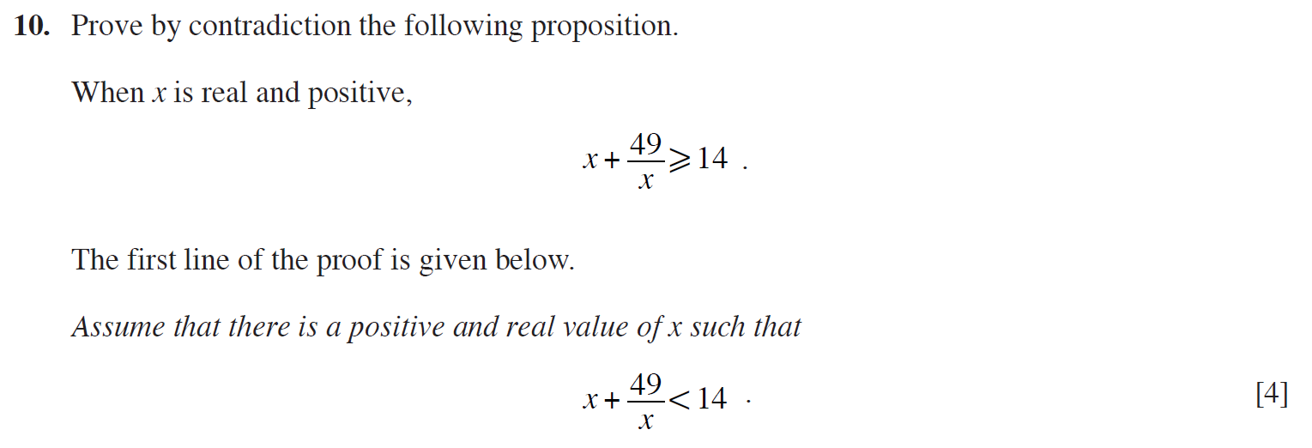
..........................................................................................................................................................................................................................................................................................................
..........................................................................................................................................................................................................................................................................................................
..........................................................................................................................................................................................................................................................................................................
..........................................................................................................................................................................................................................................................................................................
..........................................................................................................................................................................................................................................................................................................
..........................................................................................................................................................................................................................................................................................................
..........................................................................................................................................................................................................................................................................................................
..........................................................................................................................................................................................................................................................................................................
..........................................................................................................................................................................................................................................................................................................
..........................................................................................................................................................................................................................................................................................................
..........................................................................................................................................................................................................................................................................................................
..........................................................................................................................................................................................................................................................................................................
..........................................................................................................................................................................................................................................................................................................
..........................................................................................................................................................................................................................................................................................................
..........................................................................................................................................................................................................................................................................................................
..........................................................................................................................................................................................................................................................................................................
..........................................................................................................................................................................................................................................................................................................
..........................................................................................................................................................................................................................................................................................................
..........................................................................................................................................................................................................................................................................................................
..........................................................................................................................................................................................................................................................................................................
..........................................................................................................................................................................................................................................................................................................
..........................................................................................................................................................................................................................................................................................................
..........................................................................................................................................................................................................................................................................................................
..........................................................................................................................................................................................................................................................................................................
..........................................................................................................................................................................................................................................................................................................
..........................................................................................................................................................................................................................................................................................................
..........................................................................................................................................................................................................................................................................................................
(C4 Summer 2010)
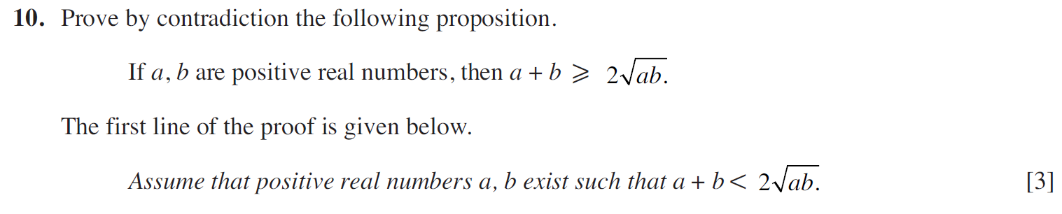
..........................................................................................................................................................................................................................................................................................................
..........................................................................................................................................................................................................................................................................................................
..........................................................................................................................................................................................................................................................................................................
..........................................................................................................................................................................................................................................................................................................
..........................................................................................................................................................................................................................................................................................................
..........................................................................................................................................................................................................................................................................................................
..........................................................................................................................................................................................................................................................................................................
..........................................................................................................................................................................................................................................................................................................
..........................................................................................................................................................................................................................................................................................................
..........................................................................................................................................................................................................................................................................................................
..........................................................................................................................................................................................................................................................................................................
..........................................................................................................................................................................................................................................................................................................
..........................................................................................................................................................................................................................................................................................................
..........................................................................................................................................................................................................................................................................................................
..........................................................................................................................................................................................................................................................................................................
..........................................................................................................................................................................................................................................................................................................
..........................................................................................................................................................................................................................................................................................................
..........................................................................................................................................................................................................................................................................................................
..........................................................................................................................................................................................................................................................................................................
..........................................................................................................................................................................................................................................................................................................
..........................................................................................................................................................................................................................................................................................................
..........................................................................................................................................................................................................................................................................................................
..........................................................................................................................................................................................................................................................................................................
..........................................................................................................................................................................................................................................................................................................
..........................................................................................................................................................................................................................................................................................................
..........................................................................................................................................................................................................................................................................................................
..........................................................................................................................................................................................................................................................................................................
..........................................................................................................................................................................................................................................................................................................
..........................................................................................................................................................................................................................................................................................................
..........................................................................................................................................................................................................................................................................................................
..........................................................................................................................................................................................................................................................................................................
..........................................................................................................................................................................................................................................................................................................
..........................................................................................................................................................................................................................................................................................................
..........................................................................................................................................................................................................................................................................................................
(C4 Summer 2013)
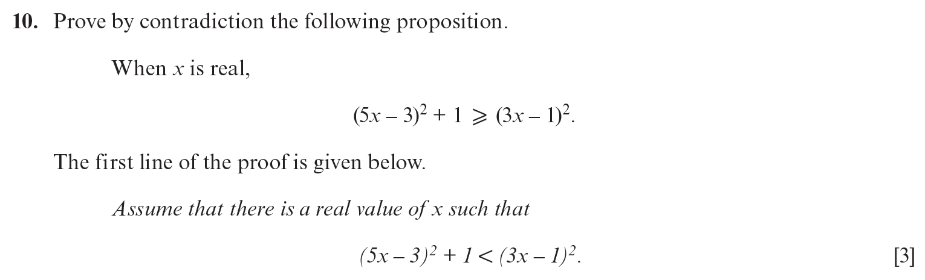
..........................................................................................................................................................................................................................................................................................................
..........................................................................................................................................................................................................................................................................................................
..........................................................................................................................................................................................................................................................................................................
..........................................................................................................................................................................................................................................................................................................
..........................................................................................................................................................................................................................................................................................................
..........................................................................................................................................................................................................................................................................................................
..........................................................................................................................................................................................................................................................................................................
..........................................................................................................................................................................................................................................................................................................
..........................................................................................................................................................................................................................................................................................................
..........................................................................................................................................................................................................................................................................................................
..........................................................................................................................................................................................................................................................................................................
..........................................................................................................................................................................................................................................................................................................
..........................................................................................................................................................................................................................................................................................................
..........................................................................................................................................................................................................................................................................................................
..........................................................................................................................................................................................................................................................................................................
..........................................................................................................................................................................................................................................................................................................
..........................................................................................................................................................................................................................................................................................................
..........................................................................................................................................................................................................................................................................................................
..........................................................................................................................................................................................................................................................................................................
..........................................................................................................................................................................................................................................................................................................
..........................................................................................................................................................................................................................................................................................................
..........................................................................................................................................................................................................................................................................................................
..........................................................................................................................................................................................................................................................................................................
..........................................................................................................................................................................................................................................................................................................
..........................................................................................................................................................................................................................................................................................................
..........................................................................................................................................................................................................................................................................................................
..........................................................................................................................................................................................................................................................................................................
..........................................................................................................................................................................................................................................................................................................
..........................................................................................................................................................................................................................................................................................................
..........................................................................................................................................................................................................................................................................................................
..........................................................................................................................................................................................................................................................................................................
(Unit 3 Summer 2024)
..........................................................................................................................................................................................................................................................................................................
..........................................................................................................................................................................................................................................................................................................
..........................................................................................................................................................................................................................................................................................................
..........................................................................................................................................................................................................................................................................................................
..........................................................................................................................................................................................................................................................................................................
..........................................................................................................................................................................................................................................................................................................
..........................................................................................................................................................................................................................................................................................................
..........................................................................................................................................................................................................................................................................................................
..........................................................................................................................................................................................................................................................................................................
..........................................................................................................................................................................................................................................................................................................
..........................................................................................................................................................................................................................................................................................................
..........................................................................................................................................................................................................................................................................................................
..........................................................................................................................................................................................................................................................................................................
..........................................................................................................................................................................................................................................................................................................
..........................................................................................................................................................................................................................................................................................................
..........................................................................................................................................................................................................................................................................................................
..........................................................................................................................................................................................................................................................................................................
..........................................................................................................................................................................................................................................................................................................
..........................................................................................................................................................................................................................................................................................................
..........................................................................................................................................................................................................................................................................................................
..........................................................................................................................................................................................................................................................................................................
..........................................................................................................................................................................................................................................................................................................
..........................................................................................................................................................................................................................................................................................................
..........................................................................................................................................................................................................................................................................................................
..........................................................................................................................................................................................................................................................................................................
..........................................................................................................................................................................................................................................................................................................
..........................................................................................................................................................................................................................................................................................................
..........................................................................................................................................................................................................................................................................................................
..........................................................................................................................................................................................................................................................................................................
..........................................................................................................................................................................................................................................................................................................
..........................................................................................................................................................................................................................................................................................................
..........................................................................................................................................................................................................................................................................................................
..........................................................................................................................................................................................................................................................................................................
..........................................................................................................................................................................................................................................................................................................
..........................................................................................................................................................................................................................................................................................................
..........................................................................................................................................................................................................................................................................................................
..........................................................................................................................................................................................................................................................................................................
(C4 Summer 2009)
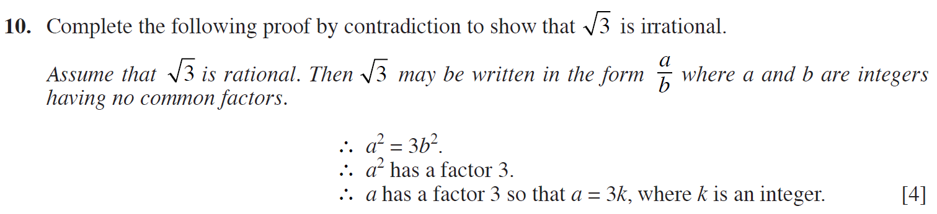
..........................................................................................................................................................................................................................................................................................................
..........................................................................................................................................................................................................................................................................................................
..........................................................................................................................................................................................................................................................................................................
..........................................................................................................................................................................................................................................................................................................
..........................................................................................................................................................................................................................................................................................................
..........................................................................................................................................................................................................................................................................................................
..........................................................................................................................................................................................................................................................................................................
..........................................................................................................................................................................................................................................................................................................
..........................................................................................................................................................................................................................................................................................................
..........................................................................................................................................................................................................................................................................................................
..........................................................................................................................................................................................................................................................................................................
..........................................................................................................................................................................................................................................................................................................
..........................................................................................................................................................................................................................................................................................................
..........................................................................................................................................................................................................................................................................................................
..........................................................................................................................................................................................................................................................................................................
..........................................................................................................................................................................................................................................................................................................
..........................................................................................................................................................................................................................................................................................................
..........................................................................................................................................................................................................................................................................................................
..........................................................................................................................................................................................................................................................................................................
..........................................................................................................................................................................................................................................................................................................
..........................................................................................................................................................................................................................................................................................................
..........................................................................................................................................................................................................................................................................................................
..........................................................................................................................................................................................................................................................................................................
..........................................................................................................................................................................................................................................................................................................
..........................................................................................................................................................................................................................................................................................................
..........................................................................................................................................................................................................................................................................................................
..........................................................................................................................................................................................................................................................................................................
..........................................................................................................................................................................................................................................................................................................
..........................................................................................................................................................................................................................................................................................................
..........................................................................................................................................................................................................................................................................................................
..........................................................................................................................................................................................................................................................................................................
..........................................................................................................................................................................................................................................................................................................
..........................................................................................................................................................................................................................................................................................................
(Unit 3 Summer 2019)
..........................................................................................................................................................................................................................................................................................................
..........................................................................................................................................................................................................................................................................................................
..........................................................................................................................................................................................................................................................................................................
..........................................................................................................................................................................................................................................................................................................
..........................................................................................................................................................................................................................................................................................................
..........................................................................................................................................................................................................................................................................................................
..........................................................................................................................................................................................................................................................................................................
..........................................................................................................................................................................................................................................................................................................
..........................................................................................................................................................................................................................................................................................................
..........................................................................................................................................................................................................................................................................................................
..........................................................................................................................................................................................................................................................................................................
..........................................................................................................................................................................................................................................................................................................
..........................................................................................................................................................................................................................................................................................................
..........................................................................................................................................................................................................................................................................................................
..........................................................................................................................................................................................................................................................................................................
..........................................................................................................................................................................................................................................................................................................
..........................................................................................................................................................................................................................................................................................................
..........................................................................................................................................................................................................................................................................................................
..........................................................................................................................................................................................................................................................................................................
..........................................................................................................................................................................................................................................................................................................
..........................................................................................................................................................................................................................................................................................................
..........................................................................................................................................................................................................................................................................................................
..........................................................................................................................................................................................................................................................................................................
..........................................................................................................................................................................................................................................................................................................
..........................................................................................................................................................................................................................................................................................................
..........................................................................................................................................................................................................................................................................................................
..........................................................................................................................................................................................................................................................................................................
..........................................................................................................................................................................................................................................................................................................
..........................................................................................................................................................................................................................................................................................................
..........................................................................................................................................................................................................................................................................................................
..........................................................................................................................................................................................................................................................................................................
..........................................................................................................................................................................................................................................................................................................
..........................................................................................................................................................................................................................................................................................................
..........................................................................................................................................................................................................................................................................................................
..........................................................................................................................................................................................................................................................................................................
..........................................................................................................................................................................................................................................................................................................
..........................................................................................................................................................................................................................................................................................................
..........................................................................................................................................................................................................................................................................................................
(Unit 3 Summer 2018)
..........................................................................................................................................................................................................................................................................................................
..........................................................................................................................................................................................................................................................................................................
..........................................................................................................................................................................................................................................................................................................
..........................................................................................................................................................................................................................................................................................................
..........................................................................................................................................................................................................................................................................................................
..........................................................................................................................................................................................................................................................................................................
..........................................................................................................................................................................................................................................................................................................
..........................................................................................................................................................................................................................................................................................................
..........................................................................................................................................................................................................................................................................................................
..........................................................................................................................................................................................................................................................................................................
..........................................................................................................................................................................................................................................................................................................
..........................................................................................................................................................................................................................................................................................................
..........................................................................................................................................................................................................................................................................................................
..........................................................................................................................................................................................................................................................................................................
..........................................................................................................................................................................................................................................................................................................
..........................................................................................................................................................................................................................................................................................................
..........................................................................................................................................................................................................................................................................................................
..........................................................................................................................................................................................................................................................................................................
..........................................................................................................................................................................................................................................................................................................
..........................................................................................................................................................................................................................................................................................................
..........................................................................................................................................................................................................................................................................................................
..........................................................................................................................................................................................................................................................................................................
..........................................................................................................................................................................................................................................................................................................
..........................................................................................................................................................................................................................................................................................................
..........................................................................................................................................................................................................................................................................................................
..........................................................................................................................................................................................................................................................................................................
..........................................................................................................................................................................................................................................................................................................
..........................................................................................................................................................................................................................................................................................................
..........................................................................................................................................................................................................................................................................................................
..........................................................................................................................................................................................................................................................................................................
..........................................................................................................................................................................................................................................................................................................
..........................................................................................................................................................................................................................................................................................................
..........................................................................................................................................................................................................................................................................................................
..........................................................................................................................................................................................................................................................................................................
..........................................................................................................................................................................................................................................................................................................
..........................................................................................................................................................................................................................................................................................................
..........................................................................................................................................................................................................................................................................................................
(C4 Summer 2007)
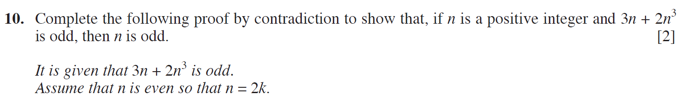
..........................................................................................................................................................................................................................................................................................................
..........................................................................................................................................................................................................................................................................................................
..........................................................................................................................................................................................................................................................................................................
..........................................................................................................................................................................................................................................................................................................
..........................................................................................................................................................................................................................................................................................................
..........................................................................................................................................................................................................................................................................................................
..........................................................................................................................................................................................................................................................................................................
..........................................................................................................................................................................................................................................................................................................
..........................................................................................................................................................................................................................................................................................................
..........................................................................................................................................................................................................................................................................................................
..........................................................................................................................................................................................................................................................................................................
..........................................................................................................................................................................................................................................................................................................
..........................................................................................................................................................................................................................................................................................................
..........................................................................................................................................................................................................................................................................................................
..........................................................................................................................................................................................................................................................................................................
..........................................................................................................................................................................................................................................................................................................
..........................................................................................................................................................................................................................................................................................................
..........................................................................................................................................................................................................................................................................................................
..........................................................................................................................................................................................................................................................................................................
..........................................................................................................................................................................................................................................................................................................
..........................................................................................................................................................................................................................................................................................................
..........................................................................................................................................................................................................................................................................................................
..........................................................................................................................................................................................................................................................................................................
..........................................................................................................................................................................................................................................................................................................
..........................................................................................................................................................................................................................................................................................................
..........................................................................................................................................................................................................................................................................................................
..........................................................................................................................................................................................................................................................................................................
..........................................................................................................................................................................................................................................................................................................
..........................................................................................................................................................................................................................................................................................................
..........................................................................................................................................................................................................................................................................................................
..........................................................................................................................................................................................................................................................................................................
..........................................................................................................................................................................................................................................................................................................
..........................................................................................................................................................................................................................................................................................................
..........................................................................................................................................................................................................................................................................................................
..........................................................................................................................................................................................................................................................................................................
(C4 Summer 2015)
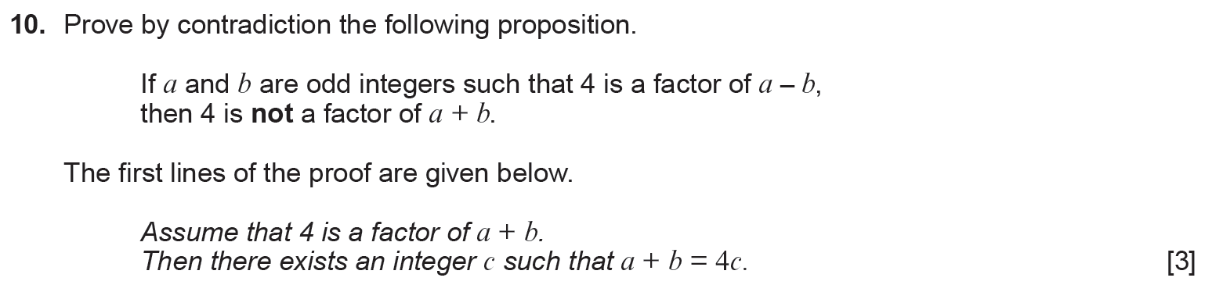
..........................................................................................................................................................................................................................................................................................................
..........................................................................................................................................................................................................................................................................................................
..........................................................................................................................................................................................................................................................................................................
..........................................................................................................................................................................................................................................................................................................
..........................................................................................................................................................................................................................................................................................................
..........................................................................................................................................................................................................................................................................................................
..........................................................................................................................................................................................................................................................................................................
..........................................................................................................................................................................................................................................................................................................
..........................................................................................................................................................................................................................................................................................................
..........................................................................................................................................................................................................................................................................................................
..........................................................................................................................................................................................................................................................................................................
..........................................................................................................................................................................................................................................................................................................
..........................................................................................................................................................................................................................................................................................................
..........................................................................................................................................................................................................................................................................................................
..........................................................................................................................................................................................................................................................................................................
..........................................................................................................................................................................................................................................................................................................
..........................................................................................................................................................................................................................................................................................................
..........................................................................................................................................................................................................................................................................................................
..........................................................................................................................................................................................................................................................................................................
..........................................................................................................................................................................................................................................................................................................
..........................................................................................................................................................................................................................................................................................................
..........................................................................................................................................................................................................................................................................................................
..........................................................................................................................................................................................................................................................................................................
..........................................................................................................................................................................................................................................................................................................
..........................................................................................................................................................................................................................................................................................................
..........................................................................................................................................................................................................................................................................................................
..........................................................................................................................................................................................................................................................................................................
..........................................................................................................................................................................................................................................................................................................
..........................................................................................................................................................................................................................................................................................................
..........................................................................................................................................................................................................................................................................................................
..........................................................................................................................................................................................................................................................................................................
..........................................................................................................................................................................................................................................................................................................
..........................................................................................................................................................................................................................................................................................................
(Unit 3 Summer 2022)
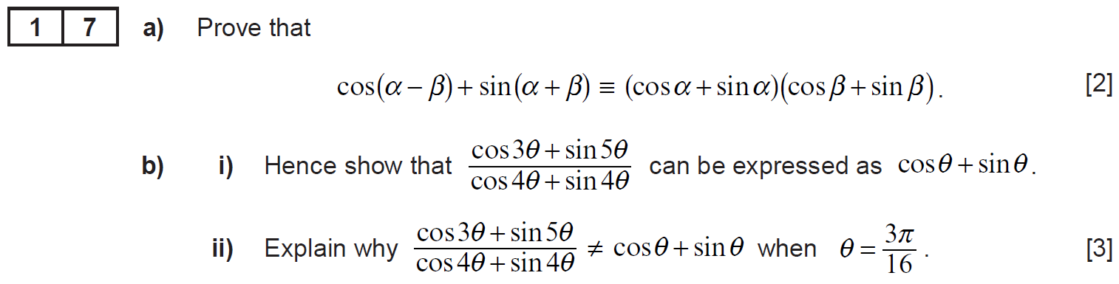
..........................................................................................................................................................................................................................................................................................................
..........................................................................................................................................................................................................................................................................................................
..........................................................................................................................................................................................................................................................................................................
..........................................................................................................................................................................................................................................................................................................
..........................................................................................................................................................................................................................................................................................................
..........................................................................................................................................................................................................................................................................................................
..........................................................................................................................................................................................................................................................................................................
..........................................................................................................................................................................................................................................................................................................
..........................................................................................................................................................................................................................................................................................................
..........................................................................................................................................................................................................................................................................................................
..........................................................................................................................................................................................................................................................................................................
..........................................................................................................................................................................................................................................................................................................
..........................................................................................................................................................................................................................................................................................................
..........................................................................................................................................................................................................................................................................................................
..........................................................................................................................................................................................................................................................................................................
..........................................................................................................................................................................................................................................................................................................
..........................................................................................................................................................................................................................................................................................................
..........................................................................................................................................................................................................................................................................................................
..........................................................................................................................................................................................................................................................................................................
..........................................................................................................................................................................................................................................................................................................
..........................................................................................................................................................................................................................................................................................................
..........................................................................................................................................................................................................................................................................................................
..........................................................................................................................................................................................................................................................................................................
..........................................................................................................................................................................................................................................................................................................
..........................................................................................................................................................................................................................................................................................................
..........................................................................................................................................................................................................................................................................................................
..........................................................................................................................................................................................................................................................................................................
..........................................................................................................................................................................................................................................................................................................
..........................................................................................................................................................................................................................................................................................................
..........................................................................................................................................................................................................................................................................................................
..........................................................................................................................................................................................................................................................................................................
..........................................................................................................................................................................................................................................................................................................
..........................................................................................................................................................................................................................................................................................................
..........................................................................................................................................................................................................................................................................................................
..........................................................................................................................................................................................................................................................................................................
..........................................................................................................................................................................................................................................................................................................
..........................................................................................................................................................................................................................................................................................................
..........................................................................................................................................................................................................................................................................................................
..........................................................................................................................................................................................................................................................................................................
..........................................................................................................................................................................................................................................................................................................
..........................................................................................................................................................................................................................................................................................................
..........................................................................................................................................................................................................................................................................................................
..........................................................................................................................................................................................................................................................................................................
..........................................................................................................................................................................................................................................................................................................
..........................................................................................................................................................................................................................................................................................................
..........................................................................................................................................................................................................................................................................................................
..........................................................................................................................................................................................................................................................................................................
..........................................................................................................................................................................................................................................................................................................
..........................................................................................................................................................................................................................................................................................................
..........................................................................................................................................................................................................................................................................................................
..........................................................................................................................................................................................................................................................................................................
..........................................................................................................................................................................................................................................................................................................
..........................................................................................................................................................................................................................................................................................................
..........................................................................................................................................................................................................................................................................................................
..........................................................................................................................................................................................................................................................................................................
..........................................................................................................................................................................................................................................................................................................
..........................................................................................................................................................................................................................................................................................................
..........................................................................................................................................................................................................................................................................................................
..........................................................................................................................................................................................................................................................................................................
..........................................................................................................................................................................................................................................................................................................
..........................................................................................................................................................................................................................................................................................................
..........................................................................................................................................................................................................................................................................................................
..........................................................................................................................................................................................................................................................................................................
..........................................................................................................................................................................................................................................................................................................
..........................................................................................................................................................................................................................................................................................................
..........................................................................................................................................................................................................................................................................................................
..........................................................................................................................................................................................................................................................................................................
..........................................................................................................................................................................................................................................................................................................
..........................................................................................................................................................................................................................................................................................................
..........................................................................................................................................................................................................................................................................................................
..........................................................................................................................................................................................................................................................................................................
..........................................................................................................................................................................................................................................................................................................
..........................................................................................................................................................................................................................................................................................................
(C4 Summer 2017)
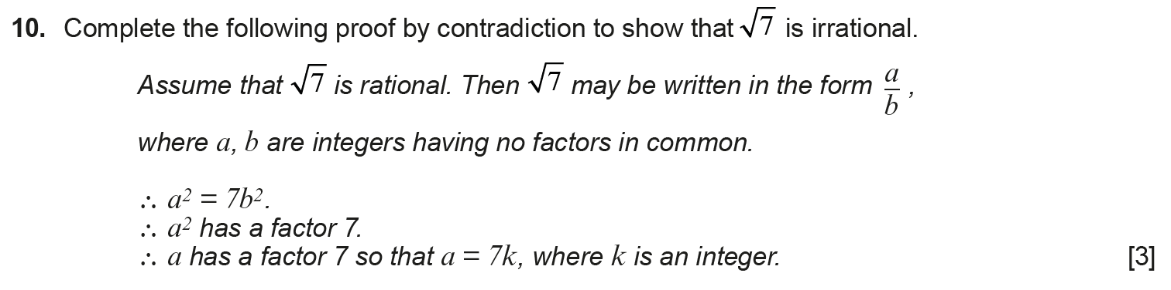
..........................................................................................................................................................................................................................................................................................................
..........................................................................................................................................................................................................................................................................................................
..........................................................................................................................................................................................................................................................................................................
..........................................................................................................................................................................................................................................................................................................
..........................................................................................................................................................................................................................................................................................................
..........................................................................................................................................................................................................................................................................................................
..........................................................................................................................................................................................................................................................................................................
..........................................................................................................................................................................................................................................................................................................
..........................................................................................................................................................................................................................................................................................................
..........................................................................................................................................................................................................................................................................................................
..........................................................................................................................................................................................................................................................................................................
..........................................................................................................................................................................................................................................................................................................
..........................................................................................................................................................................................................................................................................................................
..........................................................................................................................................................................................................................................................................................................
..........................................................................................................................................................................................................................................................................................................
..........................................................................................................................................................................................................................................................................................................
..........................................................................................................................................................................................................................................................................................................
..........................................................................................................................................................................................................................................................................................................
..........................................................................................................................................................................................................................................................................................................
..........................................................................................................................................................................................................................................................................................................
..........................................................................................................................................................................................................................................................................................................
..........................................................................................................................................................................................................................................................................................................
..........................................................................................................................................................................................................................................................................................................
..........................................................................................................................................................................................................................................................................................................
..........................................................................................................................................................................................................................................................................................................
..........................................................................................................................................................................................................................................................................................................
..........................................................................................................................................................................................................................................................................................................
..........................................................................................................................................................................................................................................................................................................
..........................................................................................................................................................................................................................................................................................................
(C4 Summer 2019)






























