


Rational Function | Partial Fractions
$$\frac{px+q}{\left(ax+b\right)\left(cx+d\right)}$$ | $$\frac{A}{ax+b}+\frac{B}{cx+d}$$
$$\frac{px+q}{{(ax+b)}^{2}}$$ | $$\frac{A}{ax+b}+\frac{B}{{(ax+b)}^{2}}$$
$$\frac{px^{2}+qx+r}{(ax+b)(cx+d)(ex+f)}$$ | $$\frac{A}{ax+b}+\frac{B}{cx+d}+\frac{C}{ex+f}$$
$$\frac{px^{2}+qx+r}{{\left(ax+b\right)}^{2}(cx+d)}$$ | $$\frac{A}{ax+b}+\frac{B}{{(ax+b)}^{2}}+\frac{C}{cx+d}$$

What is the work? |  | Separating an algebraic fraction into a fraction sum with linear denominators. Using this work to integrate algebraic fractions.
What is required before starting? |  | A Level Unit 1: Differentiation and integration.  A Level Unit 3: Further integration.
Where does this lead to? |  | Applications: Reducing the noise in an audio clip; compressing computer files; studying how a drug decays in the body.

Simplifying Rational Expressions
Before using the techniques for partial fractions that follow, it is important to check whether an algebraic expression can be simplified using previous techniques.
Example 1 Example 2
Simplify $\frac{15x+20}{(3x+4)(2x-3)}$. Simplify $\frac{x^{2}+8x+15}{x^{2}+2x-15}$.
Answer: $\frac{15x+20}{(3x+4)(2x-3)}=\frac{5(3x+4)}{(3x+4)(2x-3)}$ Answer: $\frac{x^{2}+8x+15}{x^{2}+2x-15}=\frac{(x+5)(x+3)}{(x+5)(x-3)}$
$\frac{15x+20}{(3x+4)(2x-3)}=\frac{5}{(2x-3)}$ $\frac{x^{2}+8x+15}{x^{2}+2x-15}=\frac{x+3}{x-3}$
Example 3 Example 4
Simplify $\frac{6x^{3}-5x^{2}+2x+3}{2x+1}$. Simplify $\frac{6x^{3}-5x^{2}+2x+5}{2x+1}$.
Answer: By using a division frame, Answer: By using a division frame,
$$3x^{2}-4x+3$$
$$3x^{2}-4x+3$$

$2x+1$ $6x^{3}-5x^{2}+2x+3$ $2x+1$ $6x^{3}-5x^{2}+2x+5$
$6x^{3}+3x^{2}$ $6x^{3}+3x^{2}$
$-8x^{2}+2x+3$ $-8x^{2}+2x+5$
$-8x^{2}-4x$ $-8x^{2}-4x$
$6x+3$ $6x+5$
$6x+3$ $6x+3$
$2$
So, $\frac{6x^{3}-5x^{2}+2x+3}{2x+1}=3x^{2}-4x+3$. So, $\frac{6x^{3}-5x^{2}+2x+5}{2x+1}=3x^{2}-4x+3+\frac{2}{2x+1}$.

Exercise 1 Exercise 2
Simplify $\frac{12x-8}{(2x+5)(3x-2)}$. Simplify $\frac{x^{2}+7x+12}{x^{2}-2x-15}$.
..................................................................................................................................... .........................................................................................................................................................
..................................................................................................................................... .........................................................................................................................................................
..................................................................................................................................... .........................................................................................................................................................
..................................................................................................................................... .........................................................................................................................................................
..................................................................................................................................... .........................................................................................................................................................
Exercise 3 Exercise 4
Simplify $\frac{6x^{3}+19x^{2}+37x+18}{3x+2}$. Simplify $\frac{6x^{3}+19x^{2}+37x+15}{3x+2}$.

..................................................................................................................................... .........................................................................................................................................................
..................................................................................................................................... .........................................................................................................................................................
..................................................................................................................................... .........................................................................................................................................................
..................................................................................................................................... .........................................................................................................................................................
..................................................................................................................................... .........................................................................................................................................................
..................................................................................................................................... .........................................................................................................................................................
..................................................................................................................................... .........................................................................................................................................................
..................................................................................................................................... .........................................................................................................................................................
..................................................................................................................................... .........................................................................................................................................................
Exercise 5 Exercise 6
Solve the equation $\frac{2x^{2}-3x-20}{x-4}=0$. Solve the equation $\frac{6x^{6}+11x^{5}-4x^{4}-4x^{3}}{2x+1}=0$.

..................................................................................................................................... .........................................................................................................................................................
..................................................................................................................................... .........................................................................................................................................................
..................................................................................................................................... .........................................................................................................................................................
..................................................................................................................................... .........................................................................................................................................................
..................................................................................................................................... .........................................................................................................................................................
..................................................................................................................................... .........................................................................................................................................................
..................................................................................................................................... .........................................................................................................................................................
..................................................................................................................................... .........................................................................................................................................................
..................................................................................................................................... .........................................................................................................................................................
..................................................................................................................................... .........................................................................................................................................................
..................................................................................................................................... .........................................................................................................................................................
..................................................................................................................................... .........................................................................................................................................................
..................................................................................................................................... .........................................................................................................................................................
..................................................................................................................................... .........................................................................................................................................................
..................................................................................................................................... .........................................................................................................................................................
..................................................................................................................................... .........................................................................................................................................................


Partial Fractions
Given a fraction whose denominator is a product of linear factors, we can decompose the fraction into its partial fractions.
Example 5
Express the fraction $\frac{7x-10}{(x+2)(x-6)}$ in terms of partial fractions.
Answer: It is possible to write the fraction in the form $\frac{A}{x+2}+\frac{B}{x-6}$, where $A$ and $B$ are numbers to be found.
Multiply by $$(x+2)(x-6)$$
$$\frac{7x-10}{(x+2)(x-6)}≡\frac{A}{x+2}+\frac{B}{x-6} \\ 7x-10≡\frac{A\left(x+2\right)\left(x-6\right)}{x+2}+\frac{B(x+2)(x-6)}{x-6} \\ 7x-10≡A\left(x-6\right)+B(x+2)$$
There are two techniques for finding the values of $A$ and $B$:
- Substitute values into the identity, usually values that eliminate some of the terms;
- Compare coefficients, e.g. the coefficients of $x$.
By substituting $x=6$ into the identity, the term with the $A$ vanishes, and we can calculate the value of $B$.
$$7\left(6\right)-10≡A\left(6-6\right)+B(6+2) \\ 42-10≡A\left(0\right)+B(8) \\ 32≡8B \\ B≡4$$
By substituting $x=-2$ into the identity, the term with the $B$ vanishes, and we can calculate the value of $A$.
$$7\left(-2\right)-10≡A\left(-2-6\right)+B(-2+2) \\ -14-10≡A\left(-8\right)+B(0) \\ -24≡-8A \\ A≡3$$
So, $\frac{2x}{(x+2)(x-6)}=\frac{3}{x+2}+\frac{4}{x-6}$.
Exercise 7
Express the fraction $\frac{13x-1}{(x+3)(x-7)}$ in terms of partial fractions.
..........................................................................................................................................................................................................................................................................................................
..........................................................................................................................................................................................................................................................................................................
..........................................................................................................................................................................................................................................................................................................
..........................................................................................................................................................................................................................................................................................................
..........................................................................................................................................................................................................................................................................................................
..........................................................................................................................................................................................................................................................................................................
..........................................................................................................................................................................................................................................................................................................
..........................................................................................................................................................................................................................................................................................................
..........................................................................................................................................................................................................................................................................................................
..........................................................................................................................................................................................................................................................................................................
..........................................................................................................................................................................................................................................................................................................
..........................................................................................................................................................................................................................................................................................................
If the denominator contains a squared factor, we must consider the factor both individually and squared.
Example 6 (C4 Summer 2005)
(a) Express the fraction $\frac{8x^{2}+x-5}{{\left(2x-1\right)}^{2}(x+2)}$ in terms of partial fractions.
(b) Find $\int{\frac{8x^{2}+x-5}{{\left(2x-1\right)}^{2}(x+2)}dx}.$
Answer: (a) It is possible to write the fraction in the form $\frac{A}{2x-1}+\frac{B}{{(2x-1)}^{2}}+\frac{C}{x+2}$, where $A$, $B$ and $C$ are numbers to be found.
Multiply by $${\left(2x-1\right)}^{2}\left(x+2\right)$$
$$\frac{8x^{2}+x-5}{{\left(2x-1\right)}^{2}(x+2)}≡\frac{A}{2x-1}+\frac{B}{{(2x-1)}^{2}}+\frac{C}{x+2} \\ 8x^{2}+x-5≡\frac{A{\left(2x-1\right)}^{2}\left(x+2\right)}{2x-1}+\frac{B{\left(2x-1\right)}^{2}\left(x+2\right)}{{\left(2x-1\right)}^{2}}+\frac{C{\left(2x-1\right)}^{2}\left(x+2\right)}{x+2} \\ 8x^{2}+x-5≡A\left(2x-1\right)\left(x+2\right)+B\left(x+2\right)+C{(2x-1)}^{2}$$
By substituting $x=-2$ into the identity, the terms containing $A$ and $B$ will disappear, and we can calculate the value of $C$.
$$8{\left(-2\right)}^{2}+\left(-2\right)-5≡A\left(2\left(-2\right)-1)(-2+2\right)+B\left(-2+2\right)+C{\left(2\left(-2\right)-1\right)}^{2} \\ 32-2-5≡A\left(0\right)+B\left(0\right)+C(25) \\ 25≡25C \\ C≡1$$
By substituting $x=0.5$ into the identity, the terms containing $A$ and $C$ will disappear, and we can calculate the value of $B$.
$\left(2x-1\right)\left(x+2\right)=2x^{2}+3x-2$,
$${\left(2x-1\right)}^{2}= \\ 4x^{2}-4x+1$$
$$8{\left(0.5\right)}^{2}+0.5-5≡A\left(2\left(0.5\right)-1)(0.5+2\right)+B\left(0.5+2\right)+C{\left(2\left(0.5\right)-1\right)}^{2} \\ 2+0.5-5≡A\left(0\right)+B\left(2.5\right)+C(0) \\ -2.5≡25B \\ B≡-1$$
By comparing the coefficients of $x^{2}$, we can calculate the value of $A$.
$$8≡2A+0B+4C \\ 8≡2A+4(1) \\ 4≡2A \\ A≡2$$
So, $\frac{8x^{2}+x-5}{{\left(2x-1\right)}^{2}(x+2)}=\frac{2}{2x-1}-\frac{1}{{(2x-1)}^{2}}+\frac{1}{x+2}$.
Which other methods could be used to find the value of $A?$
(b) $\int{\frac{8x^{2}+x-5}{{\left(2x-1\right)}^{2}\left(x+2\right)}dx}=\int{\frac{2}{2x-1}-\frac{1}{{\left(2x-1\right)}^{2}}+\frac{1}{x+2}}dx$(b) $\int{\frac{8x^{2}+x-5}{{\left(2x-1\right)}^{2}\left(x+2\right)}dx}=\int{\frac{2}{2x-1}dx-\int{{\left(2x-1\right)}^{-2}}dx+\int{\frac{1}{x+2}}}dx$
(b) $\int{\frac{8x^{2}+x-5}{{\left(2x-1\right)}^{2}\left(x+2\right)}dx}=\ln\left|2x-1\right|+\frac{1}{2}{\left(2x-1\right)}^{-1}+\ln\left|x+2\right|+c$(b) $\int{\frac{8x^{2}+x-5}{{\left(2x-1\right)}^{2}(x+2)}dx}=\ln{|(2x-1)(x+2)|}+\frac{1}{2(2x-1)}+c$

(C4 Summer 2011)
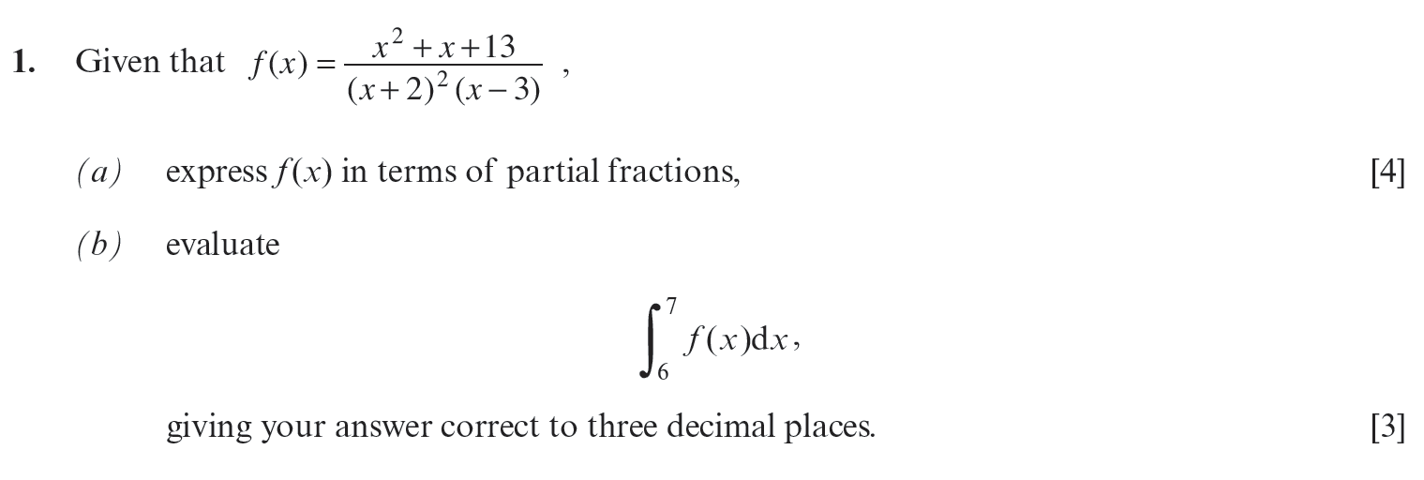
..........................................................................................................................................................................................................................................................................................................
..........................................................................................................................................................................................................................................................................................................
..........................................................................................................................................................................................................................................................................................................
..........................................................................................................................................................................................................................................................................................................
..........................................................................................................................................................................................................................................................................................................
..........................................................................................................................................................................................................................................................................................................
..........................................................................................................................................................................................................................................................................................................
..........................................................................................................................................................................................................................................................................................................
..........................................................................................................................................................................................................................................................................................................
..........................................................................................................................................................................................................................................................................................................
..........................................................................................................................................................................................................................................................................................................
..........................................................................................................................................................................................................................................................................................................
..........................................................................................................................................................................................................................................................................................................
..........................................................................................................................................................................................................................................................................................................
..........................................................................................................................................................................................................................................................................................................
..........................................................................................................................................................................................................................................................................................................
..........................................................................................................................................................................................................................................................................................................
..........................................................................................................................................................................................................................................................................................................
..........................................................................................................................................................................................................................................................................................................
..........................................................................................................................................................................................................................................................................................................
..........................................................................................................................................................................................................................................................................................................
..........................................................................................................................................................................................................................................................................................................
..........................................................................................................................................................................................................................................................................................................
..........................................................................................................................................................................................................................................................................................................
..........................................................................................................................................................................................................................................................................................................
..........................................................................................................................................................................................................................................................................................................
..........................................................................................................................................................................................................................................................................................................
..........................................................................................................................................................................................................................................................................................................
..........................................................................................................................................................................................................................................................................................................
..........................................................................................................................................................................................................................................................................................................
..........................................................................................................................................................................................................................................................................................................
..........................................................................................................................................................................................................................................................................................................
..........................................................................................................................................................................................................................................................................................................
..........................................................................................................................................................................................................................................................................................................
..........................................................................................................................................................................................................................................................................................................
..........................................................................................................................................................................................................................................................................................................
..........................................................................................................................................................................................................................................................................................................
..........................................................................................................................................................................................................................................................................................................
..........................................................................................................................................................................................................................................................................................................
..........................................................................................................................................................................................................................................................................................................
..........................................................................................................................................................................................................................................................................................................
..........................................................................................................................................................................................................................................................................................................
..........................................................................................................................................................................................................................................................................................................
..........................................................................................................................................................................................................................................................................................................
..........................................................................................................................................................................................................................................................................................................
..........................................................................................................................................................................................................................................................................................................
..........................................................................................................................................................................................................................................................................................................
..........................................................................................................................................................................................................................................................................................................
..........................................................................................................................................................................................................................................................................................................
..........................................................................................................................................................................................................................................................................................................
..........................................................................................................................................................................................................................................................................................................
..........................................................................................................................................................................................................................................................................................................
..........................................................................................................................................................................................................................................................................................................
..........................................................................................................................................................................................................................................................................................................
..........................................................................................................................................................................................................................................................................................................
..........................................................................................................................................................................................................................................................................................................
..........................................................................................................................................................................................................................................................................................................
..........................................................................................................................................................................................................................................................................................................
..........................................................................................................................................................................................................................................................................................................
..........................................................................................................................................................................................................................................................................................................
..........................................................................................................................................................................................................................................................................................................
..........................................................................................................................................................................................................................................................................................................
..........................................................................................................................................................................................................................................................................................................
..........................................................................................................................................................................................................................................................................................................
..........................................................................................................................................................................................................................................................................................................
..........................................................................................................................................................................................................................................................................................................
..........................................................................................................................................................................................................................................................................................................
..........................................................................................................................................................................................................................................................................................................
(C4 Summer 2018)
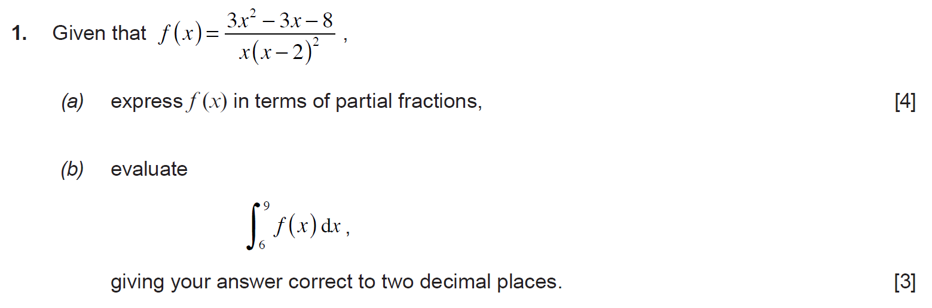
..........................................................................................................................................................................................................................................................................................................
..........................................................................................................................................................................................................................................................................................................
..........................................................................................................................................................................................................................................................................................................
..........................................................................................................................................................................................................................................................................................................
..........................................................................................................................................................................................................................................................................................................
..........................................................................................................................................................................................................................................................................................................
..........................................................................................................................................................................................................................................................................................................
..........................................................................................................................................................................................................................................................................................................
..........................................................................................................................................................................................................................................................................................................
..........................................................................................................................................................................................................................................................................................................
..........................................................................................................................................................................................................................................................................................................
..........................................................................................................................................................................................................................................................................................................
..........................................................................................................................................................................................................................................................................................................
..........................................................................................................................................................................................................................................................................................................
..........................................................................................................................................................................................................................................................................................................
..........................................................................................................................................................................................................................................................................................................
..........................................................................................................................................................................................................................................................................................................
..........................................................................................................................................................................................................................................................................................................
..........................................................................................................................................................................................................................................................................................................
..........................................................................................................................................................................................................................................................................................................
..........................................................................................................................................................................................................................................................................................................
..........................................................................................................................................................................................................................................................................................................
..........................................................................................................................................................................................................................................................................................................
..........................................................................................................................................................................................................................................................................................................
..........................................................................................................................................................................................................................................................................................................
..........................................................................................................................................................................................................................................................................................................
..........................................................................................................................................................................................................................................................................................................
..........................................................................................................................................................................................................................................................................................................
..........................................................................................................................................................................................................................................................................................................
..........................................................................................................................................................................................................................................................................................................
..........................................................................................................................................................................................................................................................................................................
..........................................................................................................................................................................................................................................................................................................
..........................................................................................................................................................................................................................................................................................................
..........................................................................................................................................................................................................................................................................................................
..........................................................................................................................................................................................................................................................................................................
..........................................................................................................................................................................................................................................................................................................
..........................................................................................................................................................................................................................................................................................................
..........................................................................................................................................................................................................................................................................................................
..........................................................................................................................................................................................................................................................................................................
..........................................................................................................................................................................................................................................................................................................
..........................................................................................................................................................................................................................................................................................................
..........................................................................................................................................................................................................................................................................................................
..........................................................................................................................................................................................................................................................................................................
..........................................................................................................................................................................................................................................................................................................
..........................................................................................................................................................................................................................................................................................................
..........................................................................................................................................................................................................................................................................................................
..........................................................................................................................................................................................................................................................................................................
..........................................................................................................................................................................................................................................................................................................
..........................................................................................................................................................................................................................................................................................................
..........................................................................................................................................................................................................................................................................................................
..........................................................................................................................................................................................................................................................................................................
..........................................................................................................................................................................................................................................................................................................
..........................................................................................................................................................................................................................................................................................................
..........................................................................................................................................................................................................................................................................................................
..........................................................................................................................................................................................................................................................................................................
..........................................................................................................................................................................................................................................................................................................
..........................................................................................................................................................................................................................................................................................................
..........................................................................................................................................................................................................................................................................................................
..........................................................................................................................................................................................................................................................................................................
..........................................................................................................................................................................................................................................................................................................
..........................................................................................................................................................................................................................................................................................................
..........................................................................................................................................................................................................................................................................................................
..........................................................................................................................................................................................................................................................................................................
..........................................................................................................................................................................................................................................................................................................
..........................................................................................................................................................................................................................................................................................................
..........................................................................................................................................................................................................................................................................................................
..........................................................................................................................................................................................................................................................................................................
..........................................................................................................................................................................................................................................................................................................
..........................................................................................................................................................................................................................................................................................................
..........................................................................................................................................................................................................................................................................................................
..........................................................................................................................................................................................................................................................................................................
(C4 Summer 2007)
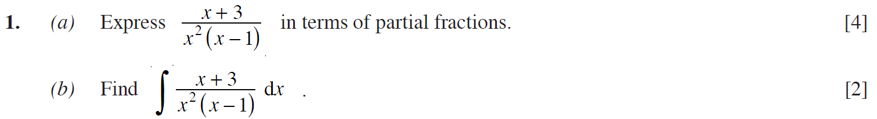
..........................................................................................................................................................................................................................................................................................................
..........................................................................................................................................................................................................................................................................................................
..........................................................................................................................................................................................................................................................................................................
..........................................................................................................................................................................................................................................................................................................
..........................................................................................................................................................................................................................................................................................................
..........................................................................................................................................................................................................................................................................................................
..........................................................................................................................................................................................................................................................................................................
..........................................................................................................................................................................................................................................................................................................
..........................................................................................................................................................................................................................................................................................................
..........................................................................................................................................................................................................................................................................................................
..........................................................................................................................................................................................................................................................................................................
..........................................................................................................................................................................................................................................................................................................
..........................................................................................................................................................................................................................................................................................................
..........................................................................................................................................................................................................................................................................................................
..........................................................................................................................................................................................................................................................................................................
..........................................................................................................................................................................................................................................................................................................
..........................................................................................................................................................................................................................................................................................................
..........................................................................................................................................................................................................................................................................................................
..........................................................................................................................................................................................................................................................................................................
..........................................................................................................................................................................................................................................................................................................
..........................................................................................................................................................................................................................................................................................................
..........................................................................................................................................................................................................................................................................................................
..........................................................................................................................................................................................................................................................................................................
..........................................................................................................................................................................................................................................................................................................
..........................................................................................................................................................................................................................................................................................................
..........................................................................................................................................................................................................................................................................................................
..........................................................................................................................................................................................................................................................................................................
..........................................................................................................................................................................................................................................................................................................
..........................................................................................................................................................................................................................................................................................................
..........................................................................................................................................................................................................................................................................................................
..........................................................................................................................................................................................................................................................................................................
..........................................................................................................................................................................................................................................................................................................
..........................................................................................................................................................................................................................................................................................................
..........................................................................................................................................................................................................................................................................................................
..........................................................................................................................................................................................................................................................................................................
..........................................................................................................................................................................................................................................................................................................
..........................................................................................................................................................................................................................................................................................................
..........................................................................................................................................................................................................................................................................................................
..........................................................................................................................................................................................................................................................................................................
..........................................................................................................................................................................................................................................................................................................
..........................................................................................................................................................................................................................................................................................................
..........................................................................................................................................................................................................................................................................................................
..........................................................................................................................................................................................................................................................................................................
..........................................................................................................................................................................................................................................................................................................
..........................................................................................................................................................................................................................................................................................................
..........................................................................................................................................................................................................................................................................................................
..........................................................................................................................................................................................................................................................................................................
..........................................................................................................................................................................................................................................................................................................
..........................................................................................................................................................................................................................................................................................................
..........................................................................................................................................................................................................................................................................................................
..........................................................................................................................................................................................................................................................................................................
..........................................................................................................................................................................................................................................................................................................
..........................................................................................................................................................................................................................................................................................................
..........................................................................................................................................................................................................................................................................................................
..........................................................................................................................................................................................................................................................................................................
..........................................................................................................................................................................................................................................................................................................
..........................................................................................................................................................................................................................................................................................................
..........................................................................................................................................................................................................................................................................................................
..........................................................................................................................................................................................................................................................................................................
..........................................................................................................................................................................................................................................................................................................
..........................................................................................................................................................................................................................................................................................................
..........................................................................................................................................................................................................................................................................................................
..........................................................................................................................................................................................................................................................................................................
..........................................................................................................................................................................................................................................................................................................
..........................................................................................................................................................................................................................................................................................................
..........................................................................................................................................................................................................................................................................................................
..........................................................................................................................................................................................................................................................................................................
..........................................................................................................................................................................................................................................................................................................
..........................................................................................................................................................................................................................................................................................................
..........................................................................................................................................................................................................................................................................................................
..........................................................................................................................................................................................................................................................................................................
..........................................................................................................................................................................................................................................................................................................
..........................................................................................................................................................................................................................................................................................................
..........................................................................................................................................................................................................................................................................................................
..........................................................................................................................................................................................................................................................................................................
..........................................................................................................................................................................................................................................................................................................
..........................................................................................................................................................................................................................................................................................................
(C4 Summer 2016)
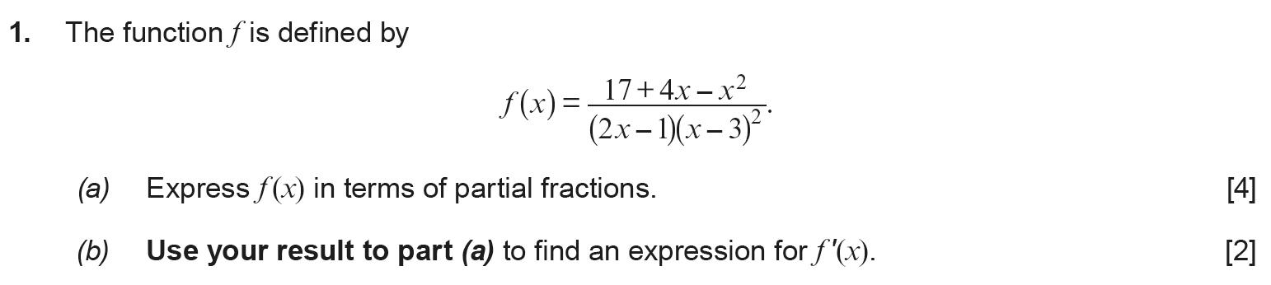
..........................................................................................................................................................................................................................................................................................................
..........................................................................................................................................................................................................................................................................................................
..........................................................................................................................................................................................................................................................................................................
..........................................................................................................................................................................................................................................................................................................
..........................................................................................................................................................................................................................................................................................................
..........................................................................................................................................................................................................................................................................................................
..........................................................................................................................................................................................................................................................................................................
..........................................................................................................................................................................................................................................................................................................
..........................................................................................................................................................................................................................................................................................................
..........................................................................................................................................................................................................................................................................................................
..........................................................................................................................................................................................................................................................................................................
..........................................................................................................................................................................................................................................................................................................
..........................................................................................................................................................................................................................................................................................................
..........................................................................................................................................................................................................................................................................................................
..........................................................................................................................................................................................................................................................................................................
..........................................................................................................................................................................................................................................................................................................
..........................................................................................................................................................................................................................................................................................................
..........................................................................................................................................................................................................................................................................................................
..........................................................................................................................................................................................................................................................................................................
..........................................................................................................................................................................................................................................................................................................
..........................................................................................................................................................................................................................................................................................................
..........................................................................................................................................................................................................................................................................................................
..........................................................................................................................................................................................................................................................................................................
..........................................................................................................................................................................................................................................................................................................
..........................................................................................................................................................................................................................................................................................................
..........................................................................................................................................................................................................................................................................................................
..........................................................................................................................................................................................................................................................................................................
..........................................................................................................................................................................................................................................................................................................
..........................................................................................................................................................................................................................................................................................................
..........................................................................................................................................................................................................................................................................................................
..........................................................................................................................................................................................................................................................................................................
..........................................................................................................................................................................................................................................................................................................
..........................................................................................................................................................................................................................................................................................................
..........................................................................................................................................................................................................................................................................................................
..........................................................................................................................................................................................................................................................................................................
..........................................................................................................................................................................................................................................................................................................
..........................................................................................................................................................................................................................................................................................................
..........................................................................................................................................................................................................................................................................................................
..........................................................................................................................................................................................................................................................................................................
..........................................................................................................................................................................................................................................................................................................
..........................................................................................................................................................................................................................................................................................................
..........................................................................................................................................................................................................................................................................................................
..........................................................................................................................................................................................................................................................................................................
..........................................................................................................................................................................................................................................................................................................
..........................................................................................................................................................................................................................................................................................................
..........................................................................................................................................................................................................................................................................................................
..........................................................................................................................................................................................................................................................................................................
..........................................................................................................................................................................................................................................................................................................
..........................................................................................................................................................................................................................................................................................................
..........................................................................................................................................................................................................................................................................................................
..........................................................................................................................................................................................................................................................................................................
..........................................................................................................................................................................................................................................................................................................
..........................................................................................................................................................................................................................................................................................................
..........................................................................................................................................................................................................................................................................................................
..........................................................................................................................................................................................................................................................................................................
..........................................................................................................................................................................................................................................................................................................
..........................................................................................................................................................................................................................................................................................................
..........................................................................................................................................................................................................................................................................................................
..........................................................................................................................................................................................................................................................................................................
..........................................................................................................................................................................................................................................................................................................
..........................................................................................................................................................................................................................................................................................................
..........................................................................................................................................................................................................................................................................................................
..........................................................................................................................................................................................................................................................................................................
..........................................................................................................................................................................................................................................................................................................
..........................................................................................................................................................................................................................................................................................................
..........................................................................................................................................................................................................................................................................................................
..........................................................................................................................................................................................................................................................................................................
..........................................................................................................................................................................................................................................................................................................
..........................................................................................................................................................................................................................................................................................................
..........................................................................................................................................................................................................................................................................................................
..........................................................................................................................................................................................................................................................................................................
..........................................................................................................................................................................................................................................................................................................
..........................................................................................................................................................................................................................................................................................................
..........................................................................................................................................................................................................................................................................................................
(C4 Summer 2010)
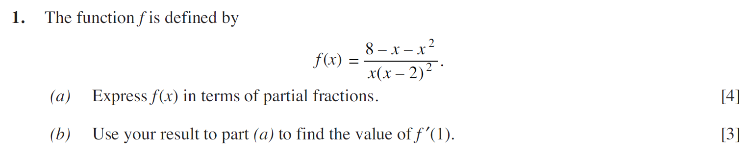
..........................................................................................................................................................................................................................................................................................................
..........................................................................................................................................................................................................................................................................................................
..........................................................................................................................................................................................................................................................................................................
..........................................................................................................................................................................................................................................................................................................
..........................................................................................................................................................................................................................................................................................................
..........................................................................................................................................................................................................................................................................................................
..........................................................................................................................................................................................................................................................................................................
..........................................................................................................................................................................................................................................................................................................
..........................................................................................................................................................................................................................................................................................................
..........................................................................................................................................................................................................................................................................................................
..........................................................................................................................................................................................................................................................................................................
..........................................................................................................................................................................................................................................................................................................
..........................................................................................................................................................................................................................................................................................................
..........................................................................................................................................................................................................................................................................................................
..........................................................................................................................................................................................................................................................................................................
..........................................................................................................................................................................................................................................................................................................
..........................................................................................................................................................................................................................................................................................................
..........................................................................................................................................................................................................................................................................................................
..........................................................................................................................................................................................................................................................................................................
..........................................................................................................................................................................................................................................................................................................
..........................................................................................................................................................................................................................................................................................................
..........................................................................................................................................................................................................................................................................................................
..........................................................................................................................................................................................................................................................................................................
..........................................................................................................................................................................................................................................................................................................
..........................................................................................................................................................................................................................................................................................................
..........................................................................................................................................................................................................................................................................................................
..........................................................................................................................................................................................................................................................................................................
..........................................................................................................................................................................................................................................................................................................
..........................................................................................................................................................................................................................................................................................................
..........................................................................................................................................................................................................................................................................................................
..........................................................................................................................................................................................................................................................................................................
..........................................................................................................................................................................................................................................................................................................
..........................................................................................................................................................................................................................................................................................................
..........................................................................................................................................................................................................................................................................................................
..........................................................................................................................................................................................................................................................................................................
..........................................................................................................................................................................................................................................................................................................
..........................................................................................................................................................................................................................................................................................................
..........................................................................................................................................................................................................................................................................................................
..........................................................................................................................................................................................................................................................................................................
..........................................................................................................................................................................................................................................................................................................
..........................................................................................................................................................................................................................................................................................................
..........................................................................................................................................................................................................................................................................................................
..........................................................................................................................................................................................................................................................................................................
..........................................................................................................................................................................................................................................................................................................
..........................................................................................................................................................................................................................................................................................................
..........................................................................................................................................................................................................................................................................................................
..........................................................................................................................................................................................................................................................................................................
..........................................................................................................................................................................................................................................................................................................
..........................................................................................................................................................................................................................................................................................................
..........................................................................................................................................................................................................................................................................................................
..........................................................................................................................................................................................................................................................................................................
..........................................................................................................................................................................................................................................................................................................
..........................................................................................................................................................................................................................................................................................................
..........................................................................................................................................................................................................................................................................................................
..........................................................................................................................................................................................................................................................................................................
..........................................................................................................................................................................................................................................................................................................
..........................................................................................................................................................................................................................................................................................................
..........................................................................................................................................................................................................................................................................................................
..........................................................................................................................................................................................................................................................................................................
..........................................................................................................................................................................................................................................................................................................
..........................................................................................................................................................................................................................................................................................................
..........................................................................................................................................................................................................................................................................................................
..........................................................................................................................................................................................................................................................................................................
..........................................................................................................................................................................................................................................................................................................
..........................................................................................................................................................................................................................................................................................................
..........................................................................................................................................................................................................................................................................................................
..........................................................................................................................................................................................................................................................................................................
..........................................................................................................................................................................................................................................................................................................
..........................................................................................................................................................................................................................................................................................................
..........................................................................................................................................................................................................................................................................................................
..........................................................................................................................................................................................................................................................................................................
..........................................................................................................................................................................................................................................................................................................
..........................................................................................................................................................................................................................................................................................................
..........................................................................................................................................................................................................................................................................................................
..........................................................................................................................................................................................................................................................................................................
(C4 Summer 2013)
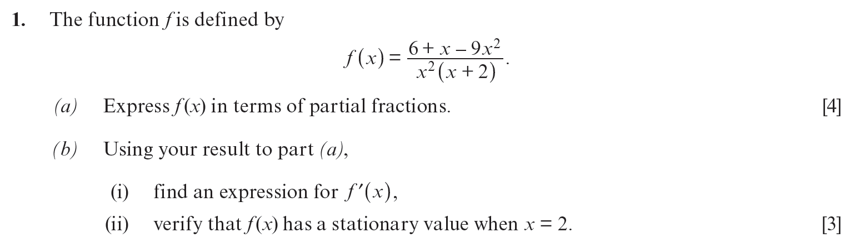
..........................................................................................................................................................................................................................................................................................................
..........................................................................................................................................................................................................................................................................................................
..........................................................................................................................................................................................................................................................................................................
..........................................................................................................................................................................................................................................................................................................
..........................................................................................................................................................................................................................................................................................................
..........................................................................................................................................................................................................................................................................................................
..........................................................................................................................................................................................................................................................................................................
..........................................................................................................................................................................................................................................................................................................
..........................................................................................................................................................................................................................................................................................................
..........................................................................................................................................................................................................................................................................................................
..........................................................................................................................................................................................................................................................................................................
..........................................................................................................................................................................................................................................................................................................
..........................................................................................................................................................................................................................................................................................................
..........................................................................................................................................................................................................................................................................................................
..........................................................................................................................................................................................................................................................................................................
..........................................................................................................................................................................................................................................................................................................
..........................................................................................................................................................................................................................................................................................................
..........................................................................................................................................................................................................................................................................................................
..........................................................................................................................................................................................................................................................................................................
..........................................................................................................................................................................................................................................................................................................
..........................................................................................................................................................................................................................................................................................................
..........................................................................................................................................................................................................................................................................................................
..........................................................................................................................................................................................................................................................................................................
..........................................................................................................................................................................................................................................................................................................
..........................................................................................................................................................................................................................................................................................................
..........................................................................................................................................................................................................................................................................................................
..........................................................................................................................................................................................................................................................................................................
..........................................................................................................................................................................................................................................................................................................
..........................................................................................................................................................................................................................................................................................................
..........................................................................................................................................................................................................................................................................................................
..........................................................................................................................................................................................................................................................................................................
..........................................................................................................................................................................................................................................................................................................
..........................................................................................................................................................................................................................................................................................................
..........................................................................................................................................................................................................................................................................................................
..........................................................................................................................................................................................................................................................................................................
..........................................................................................................................................................................................................................................................................................................
..........................................................................................................................................................................................................................................................................................................
..........................................................................................................................................................................................................................................................................................................
..........................................................................................................................................................................................................................................................................................................
..........................................................................................................................................................................................................................................................................................................
..........................................................................................................................................................................................................................................................................................................
..........................................................................................................................................................................................................................................................................................................
..........................................................................................................................................................................................................................................................................................................
..........................................................................................................................................................................................................................................................................................................
..........................................................................................................................................................................................................................................................................................................
..........................................................................................................................................................................................................................................................................................................
..........................................................................................................................................................................................................................................................................................................
..........................................................................................................................................................................................................................................................................................................
..........................................................................................................................................................................................................................................................................................................
..........................................................................................................................................................................................................................................................................................................
..........................................................................................................................................................................................................................................................................................................
..........................................................................................................................................................................................................................................................................................................
..........................................................................................................................................................................................................................................................................................................
..........................................................................................................................................................................................................................................................................................................
..........................................................................................................................................................................................................................................................................................................
..........................................................................................................................................................................................................................................................................................................
..........................................................................................................................................................................................................................................................................................................
..........................................................................................................................................................................................................................................................................................................
..........................................................................................................................................................................................................................................................................................................
..........................................................................................................................................................................................................................................................................................................
..........................................................................................................................................................................................................................................................................................................
..........................................................................................................................................................................................................................................................................................................
..........................................................................................................................................................................................................................................................................................................
..........................................................................................................................................................................................................................................................................................................
..........................................................................................................................................................................................................................................................................................................
..........................................................................................................................................................................................................................................................................................................
..........................................................................................................................................................................................................................................................................................................
..........................................................................................................................................................................................................................................................................................................
..........................................................................................................................................................................................................................................................................................................
..........................................................................................................................................................................................................................................................................................................
..........................................................................................................................................................................................................................................................................................................
..........................................................................................................................................................................................................................................................................................................
(C4 Summer 2014)
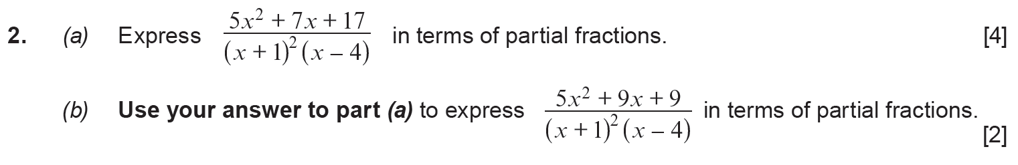
..........................................................................................................................................................................................................................................................................................................
..........................................................................................................................................................................................................................................................................................................
..........................................................................................................................................................................................................................................................................................................
..........................................................................................................................................................................................................................................................................................................
..........................................................................................................................................................................................................................................................................................................
..........................................................................................................................................................................................................................................................................................................
..........................................................................................................................................................................................................................................................................................................
..........................................................................................................................................................................................................................................................................................................
..........................................................................................................................................................................................................................................................................................................
..........................................................................................................................................................................................................................................................................................................
..........................................................................................................................................................................................................................................................................................................
..........................................................................................................................................................................................................................................................................................................
..........................................................................................................................................................................................................................................................................................................
..........................................................................................................................................................................................................................................................................................................
..........................................................................................................................................................................................................................................................................................................
..........................................................................................................................................................................................................................................................................................................
..........................................................................................................................................................................................................................................................................................................
..........................................................................................................................................................................................................................................................................................................
..........................................................................................................................................................................................................................................................................................................
..........................................................................................................................................................................................................................................................................................................
..........................................................................................................................................................................................................................................................................................................
..........................................................................................................................................................................................................................................................................................................
..........................................................................................................................................................................................................................................................................................................
..........................................................................................................................................................................................................................................................................................................
..........................................................................................................................................................................................................................................................................................................
..........................................................................................................................................................................................................................................................................................................
..........................................................................................................................................................................................................................................................................................................
..........................................................................................................................................................................................................................................................................................................
..........................................................................................................................................................................................................................................................................................................
..........................................................................................................................................................................................................................................................................................................
..........................................................................................................................................................................................................................................................................................................
..........................................................................................................................................................................................................................................................................................................
..........................................................................................................................................................................................................................................................................................................
..........................................................................................................................................................................................................................................................................................................
..........................................................................................................................................................................................................................................................................................................
..........................................................................................................................................................................................................................................................................................................
..........................................................................................................................................................................................................................................................................................................
..........................................................................................................................................................................................................................................................................................................
..........................................................................................................................................................................................................................................................................................................
..........................................................................................................................................................................................................................................................................................................
..........................................................................................................................................................................................................................................................................................................
..........................................................................................................................................................................................................................................................................................................
..........................................................................................................................................................................................................................................................................................................
..........................................................................................................................................................................................................................................................................................................
..........................................................................................................................................................................................................................................................................................................
..........................................................................................................................................................................................................................................................................................................
..........................................................................................................................................................................................................................................................................................................
..........................................................................................................................................................................................................................................................................................................
..........................................................................................................................................................................................................................................................................................................
..........................................................................................................................................................................................................................................................................................................
..........................................................................................................................................................................................................................................................................................................
..........................................................................................................................................................................................................................................................................................................
..........................................................................................................................................................................................................................................................................................................
..........................................................................................................................................................................................................................................................................................................
..........................................................................................................................................................................................................................................................................................................
..........................................................................................................................................................................................................................................................................................................
..........................................................................................................................................................................................................................................................................................................
..........................................................................................................................................................................................................................................................................................................
..........................................................................................................................................................................................................................................................................................................
..........................................................................................................................................................................................................................................................................................................
..........................................................................................................................................................................................................................................................................................................
..........................................................................................................................................................................................................................................................................................................
..........................................................................................................................................................................................................................................................................................................
..........................................................................................................................................................................................................................................................................................................
..........................................................................................................................................................................................................................................................................................................
..........................................................................................................................................................................................................................................................................................................
..........................................................................................................................................................................................................................................................................................................
..........................................................................................................................................................................................................................................................................................................
..........................................................................................................................................................................................................................................................................................................
..........................................................................................................................................................................................................................................................................................................
..........................................................................................................................................................................................................................................................................................................
..........................................................................................................................................................................................................................................................................................................
..........................................................................................................................................................................................................................................................................................................
..........................................................................................................................................................................................................................................................................................................
..........................................................................................................................................................................................................................................................................................................
..........................................................................................................................................................................................................................................................................................................
(C4 Summer 2017)
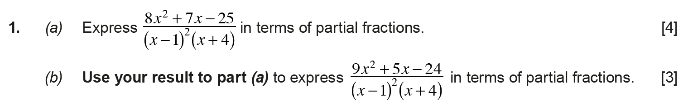
..........................................................................................................................................................................................................................................................................................................
..........................................................................................................................................................................................................................................................................................................
..........................................................................................................................................................................................................................................................................................................
..........................................................................................................................................................................................................................................................................................................
..........................................................................................................................................................................................................................................................................................................
..........................................................................................................................................................................................................................................................................................................
..........................................................................................................................................................................................................................................................................................................
..........................................................................................................................................................................................................................................................................................................
..........................................................................................................................................................................................................................................................................................................
..........................................................................................................................................................................................................................................................................................................
..........................................................................................................................................................................................................................................................................................................
..........................................................................................................................................................................................................................................................................................................
..........................................................................................................................................................................................................................................................................................................
..........................................................................................................................................................................................................................................................................................................
..........................................................................................................................................................................................................................................................................................................
..........................................................................................................................................................................................................................................................................................................
..........................................................................................................................................................................................................................................................................................................
..........................................................................................................................................................................................................................................................................................................
..........................................................................................................................................................................................................................................................................................................
..........................................................................................................................................................................................................................................................................................................
..........................................................................................................................................................................................................................................................................................................
..........................................................................................................................................................................................................................................................................................................
..........................................................................................................................................................................................................................................................................................................
..........................................................................................................................................................................................................................................................................................................
..........................................................................................................................................................................................................................................................................................................
..........................................................................................................................................................................................................................................................................................................
..........................................................................................................................................................................................................................................................................................................
..........................................................................................................................................................................................................................................................................................................
..........................................................................................................................................................................................................................................................................................................
..........................................................................................................................................................................................................................................................................................................
..........................................................................................................................................................................................................................................................................................................
..........................................................................................................................................................................................................................................................................................................
..........................................................................................................................................................................................................................................................................................................
..........................................................................................................................................................................................................................................................................................................
..........................................................................................................................................................................................................................................................................................................
..........................................................................................................................................................................................................................................................................................................
..........................................................................................................................................................................................................................................................................................................
..........................................................................................................................................................................................................................................................................................................
..........................................................................................................................................................................................................................................................................................................
..........................................................................................................................................................................................................................................................................................................
..........................................................................................................................................................................................................................................................................................................
..........................................................................................................................................................................................................................................................................................................
..........................................................................................................................................................................................................................................................................................................
..........................................................................................................................................................................................................................................................................................................
..........................................................................................................................................................................................................................................................................................................
..........................................................................................................................................................................................................................................................................................................
..........................................................................................................................................................................................................................................................................................................
..........................................................................................................................................................................................................................................................................................................
..........................................................................................................................................................................................................................................................................................................
..........................................................................................................................................................................................................................................................................................................
..........................................................................................................................................................................................................................................................................................................
..........................................................................................................................................................................................................................................................................................................
..........................................................................................................................................................................................................................................................................................................
..........................................................................................................................................................................................................................................................................................................
..........................................................................................................................................................................................................................................................................................................
..........................................................................................................................................................................................................................................................................................................
..........................................................................................................................................................................................................................................................................................................
..........................................................................................................................................................................................................................................................................................................
..........................................................................................................................................................................................................................................................................................................
..........................................................................................................................................................................................................................................................................................................
..........................................................................................................................................................................................................................................................................................................
..........................................................................................................................................................................................................................................................................................................
..........................................................................................................................................................................................................................................................................................................
..........................................................................................................................................................................................................................................................................................................
..........................................................................................................................................................................................................................................................................................................
..........................................................................................................................................................................................................................................................................................................
..........................................................................................................................................................................................................................................................................................................
..........................................................................................................................................................................................................................................................................................................
..........................................................................................................................................................................................................................................................................................................
..........................................................................................................................................................................................................................................................................................................
..........................................................................................................................................................................................................................................................................................................
..........................................................................................................................................................................................................................................................................................................
..........................................................................................................................................................................................................................................................................................................
..........................................................................................................................................................................................................................................................................................................
..........................................................................................................................................................................................................................................................................................................
..........................................................................................................................................................................................................................................................................................................
(Unit 3 Summer 2022)
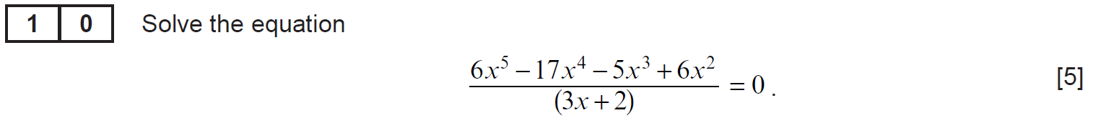
..........................................................................................................................................................................................................................................................................................................
..........................................................................................................................................................................................................................................................................................................
..........................................................................................................................................................................................................................................................................................................
..........................................................................................................................................................................................................................................................................................................
..........................................................................................................................................................................................................................................................................................................
..........................................................................................................................................................................................................................................................................................................
..........................................................................................................................................................................................................................................................................................................
..........................................................................................................................................................................................................................................................................................................
..........................................................................................................................................................................................................................................................................................................
..........................................................................................................................................................................................................................................................................................................
..........................................................................................................................................................................................................................................................................................................
..........................................................................................................................................................................................................................................................................................................
..........................................................................................................................................................................................................................................................................................................
..........................................................................................................................................................................................................................................................................................................
..........................................................................................................................................................................................................................................................................................................
..........................................................................................................................................................................................................................................................................................................
..........................................................................................................................................................................................................................................................................................................
..........................................................................................................................................................................................................................................................................................................
..........................................................................................................................................................................................................................................................................................................
..........................................................................................................................................................................................................................................................................................................
..........................................................................................................................................................................................................................................................................................................
..........................................................................................................................................................................................................................................................................................................
..........................................................................................................................................................................................................................................................................................................
..........................................................................................................................................................................................................................................................................................................
..........................................................................................................................................................................................................................................................................................................
..........................................................................................................................................................................................................................................................................................................
..........................................................................................................................................................................................................................................................................................................
..........................................................................................................................................................................................................................................................................................................
..........................................................................................................................................................................................................................................................................................................
..........................................................................................................................................................................................................................................................................................................
..........................................................................................................................................................................................................................................................................................................
..........................................................................................................................................................................................................................................................................................................
..........................................................................................................................................................................................................................................................................................................
..........................................................................................................................................................................................................................................................................................................
..........................................................................................................................................................................................................................................................................................................
..........................................................................................................................................................................................................................................................................................................
(Unit 3 Summer 2023)
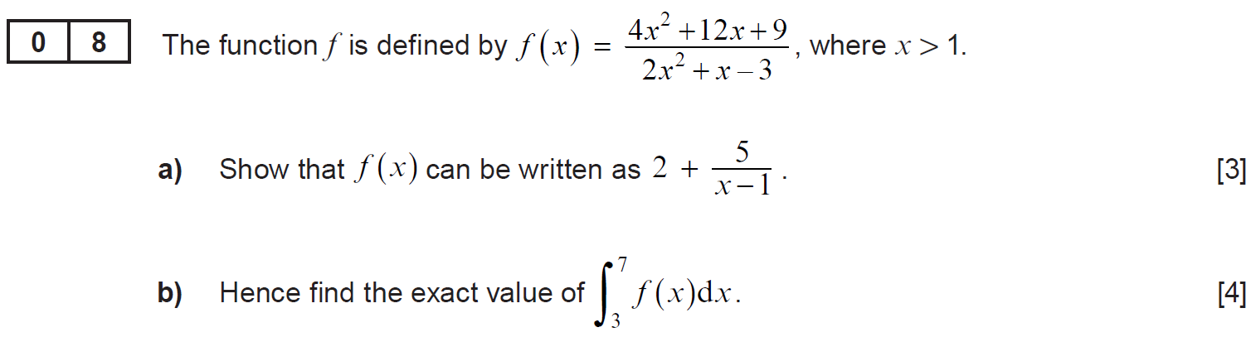
..........................................................................................................................................................................................................................................................................................................
..........................................................................................................................................................................................................................................................................................................
..........................................................................................................................................................................................................................................................................................................
..........................................................................................................................................................................................................................................................................................................
..........................................................................................................................................................................................................................................................................................................
..........................................................................................................................................................................................................................................................................................................
..........................................................................................................................................................................................................................................................................................................
..........................................................................................................................................................................................................................................................................................................
..........................................................................................................................................................................................................................................................................................................
..........................................................................................................................................................................................................................................................................................................
..........................................................................................................................................................................................................................................................................................................
..........................................................................................................................................................................................................................................................................................................
..........................................................................................................................................................................................................................................................................................................
..........................................................................................................................................................................................................................................................................................................
..........................................................................................................................................................................................................................................................................................................
..........................................................................................................................................................................................................................................................................................................
..........................................................................................................................................................................................................................................................................................................
..........................................................................................................................................................................................................................................................................................................
..........................................................................................................................................................................................................................................................................................................
..........................................................................................................................................................................................................................................................................................................
..........................................................................................................................................................................................................................................................................................................
..........................................................................................................................................................................................................................................................................................................
..........................................................................................................................................................................................................................................................................................................
..........................................................................................................................................................................................................................................................................................................
..........................................................................................................................................................................................................................................................................................................
..........................................................................................................................................................................................................................................................................................................
..........................................................................................................................................................................................................................................................................................................
..........................................................................................................................................................................................................................................................................................................
..........................................................................................................................................................................................................................................................................................................
..........................................................................................................................................................................................................................................................................................................
..........................................................................................................................................................................................................................................................................................................
..........................................................................................................................................................................................................................................................................................................
..........................................................................................................................................................................................................................................................................................................
..........................................................................................................................................................................................................................................................................................................
..........................................................................................................................................................................................................................................................................................................
..........................................................................................................................................................................................................................................................................................................
..........................................................................................................................................................................................................................................................................................................
..........................................................................................................................................................................................................................................................................................................
..........................................................................................................................................................................................................................................................................................................
..........................................................................................................................................................................................................................................................................................................
..........................................................................................................................................................................................................................................................................................................
..........................................................................................................................................................................................................................................................................................................
..........................................................................................................................................................................................................................................................................................................
..........................................................................................................................................................................................................................................................................................................
..........................................................................................................................................................................................................................................................................................................
..........................................................................................................................................................................................................................................................................................................
..........................................................................................................................................................................................................................................................................................................
..........................................................................................................................................................................................................................................................................................................
..........................................................................................................................................................................................................................................................................................................
..........................................................................................................................................................................................................................................................................................................
..........................................................................................................................................................................................................................................................................................................
..........................................................................................................................................................................................................................................................................................................
..........................................................................................................................................................................................................................................................................................................
..........................................................................................................................................................................................................................................................................................................
..........................................................................................................................................................................................................................................................................................................
..........................................................................................................................................................................................................................................................................................................
..........................................................................................................................................................................................................................................................................................................
..........................................................................................................................................................................................................................................................................................................
..........................................................................................................................................................................................................................................................................................................
..........................................................................................................................................................................................................................................................................................................
..........................................................................................................................................................................................................................................................................................................
..........................................................................................................................................................................................................................................................................................................
..........................................................................................................................................................................................................................................................................................................
..........................................................................................................................................................................................................................................................................................................
..........................................................................................................................................................................................................................................................................................................
..........................................................................................................................................................................................................................................................................................................
..........................................................................................................................................................................................................................................................................................................
..........................................................................................................................................................................................................................................................................................................
..........................................................................................................................................................................................................................................................................................................
..........................................................................................................................................................................................................................................................................................................
..........................................................................................................................................................................................................................................................................................................
..........................................................................................................................................................................................................................................................................................................
..........................................................................................................................................................................................................................................................................................................
(Unit 3 Summer 2024)
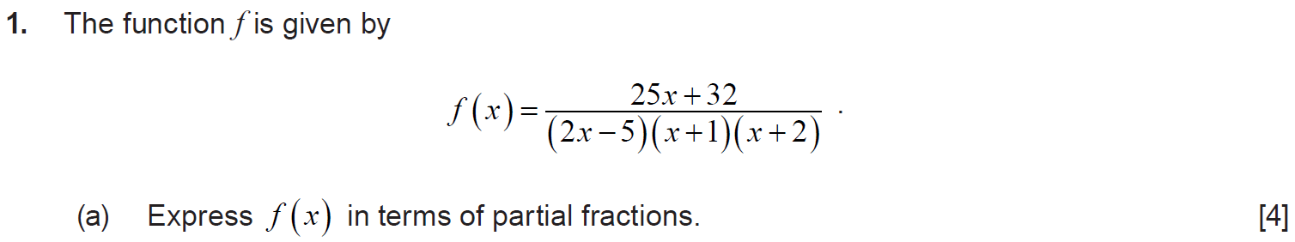
..........................................................................................................................................................................................................................................................................................................
..........................................................................................................................................................................................................................................................................................................
..........................................................................................................................................................................................................................................................................................................
..........................................................................................................................................................................................................................................................................................................
..........................................................................................................................................................................................................................................................................................................
..........................................................................................................................................................................................................................................................................................................
..........................................................................................................................................................................................................................................................................................................
..........................................................................................................................................................................................................................................................................................................
..........................................................................................................................................................................................................................................................................................................
..........................................................................................................................................................................................................................................................................................................
..........................................................................................................................................................................................................................................................................................................
..........................................................................................................................................................................................................................................................................................................
..........................................................................................................................................................................................................................................................................................................
..........................................................................................................................................................................................................................................................................................................
..........................................................................................................................................................................................................................................................................................................
..........................................................................................................................................................................................................................................................................................................
..........................................................................................................................................................................................................................................................................................................
..........................................................................................................................................................................................................................................................................................................
..........................................................................................................................................................................................................................................................................................................
..........................................................................................................................................................................................................................................................................................................
..........................................................................................................................................................................................................................................................................................................
..........................................................................................................................................................................................................................................................................................................
..........................................................................................................................................................................................................................................................................................................
..........................................................................................................................................................................................................................................................................................................
..........................................................................................................................................................................................................................................................................................................
..........................................................................................................................................................................................................................................................................................................
..........................................................................................................................................................................................................................................................................................................
..........................................................................................................................................................................................................................................................................................................
..........................................................................................................................................................................................................................................................................................................
..........................................................................................................................................................................................................................................................................................................
..........................................................................................................................................................................................................................................................................................................
..........................................................................................................................................................................................................................................................................................................
..........................................................................................................................................................................................................................................................................................................
..........................................................................................................................................................................................................................................................................................................
..........................................................................................................................................................................................................................................................................................................
..........................................................................................................................................................................................................................................................................................................
..........................................................................................................................................................................................................................................................................................................
..........................................................................................................................................................................................................................................................................................................
..........................................................................................................................................................................................................................................................................................................
..........................................................................................................................................................................................................................................................................................................
..........................................................................................................................................................................................................................................................................................................
..........................................................................................................................................................................................................................................................................................................
..........................................................................................................................................................................................................................................................................................................
..........................................................................................................................................................................................................................................................................................................
..........................................................................................................................................................................................................................................................................................................
..........................................................................................................................................................................................................................................................................................................
..........................................................................................................................................................................................................................................................................................................
..........................................................................................................................................................................................................................................................................................................
..........................................................................................................................................................................................................................................................................................................
..........................................................................................................................................................................................................................................................................................................
..........................................................................................................................................................................................................................................................................................................
..........................................................................................................................................................................................................................................................................................................
..........................................................................................................................................................................................................................................................................................................
..........................................................................................................................................................................................................................................................................................................
..........................................................................................................................................................................................................................................................................................................
..........................................................................................................................................................................................................................................................................................................
..........................................................................................................................................................................................................................................................................................................
..........................................................................................................................................................................................................................................................................................................
..........................................................................................................................................................................................................................................................................................................
..........................................................................................................................................................................................................................................................................................................
..........................................................................................................................................................................................................................................................................................................
..........................................................................................................................................................................................................................................................................................................
..........................................................................................................................................................................................................................................................................................................
..........................................................................................................................................................................................................................................................................................................
..........................................................................................................................................................................................................................................................................................................
..........................................................................................................................................................................................................................................................................................................
We can use integration to find the area bounded by the curve $y=f(x)$, the $x$–axis, the line $x=a$ and the line
$x=b$.
$$\int_{a}^{b}{ydx}$$
It would be possible to estimate this area by splitting it into rectangles of constant width $δx$.
Example 7
The following diagram shows the curve $y=x^{2}+4$ between $x=-1$ and $x=5$.
$$y$$
$$4$$
$$5$$
$$8$$
$$13$$
$$y=x^{2}+4$$
$$x$$
We can estimate the value of $\int_{0}^{4}{x^{2}+4}dx$ by using the green rectangles above, all of width 1 unit.
The height of each rectangle is the value of the function to the left of the rectangle.
$$\int_{0}^{4}{x^{2}+4}dx≈\left(1×4\right)+\left(1×5\right)+\left(1×8\right)+(1×13) \\ \int_{0}^{4}{x^{2}+4}dx≈30$$
We see from the diagram that the estimate is an underestimate, as the red curve lies above the rectangle. In reality, we have
$$\int_{0}^{4}{x^{2}+4}dx={\left[\frac{x^{3}}{3}+4x\right]}_{0}^{4} \\ \int_{0}^{4}{x^{2}+4}dx=\left[\frac{4^{3}}{3}+4×4\right]-\left[\frac{0^{3}}{3}+4×0\right] \\ \int_{0}^{4}{x^{2}+4}dx=\frac{112}{3}$$
So, our estimate is $\frac{112}{3}-30=\frac{22}{3}$ square units too small. It would be possible to improve the estimate by using more rectangles, of smaller width.
In general, if we have $n$ rectangles, each of width $δx$, then the estimate of the area $A$ is
$$A≈y_{1}δx+y_{2}δx+…+y_{n}δx$$
We can write the above sum using sigma notation:
$$A≈\sum_{i=1}^{n}{y_{i}δx}$$
If we increase the number $n$ of rectangles, the width $δx$ of each rectangle decreases, and the sum gives a better estimate of the area. Taking the limit,
$$\lim_{n→∞}{\sum_{i=1}^{n}{y_{i}δx}}=\int_{a}^{b}{y}dx$$
Because the values of $y_{i}$ come from the function $y=f(x)$, we can write
$$\lim_{δx→0}{\sum_{x=a}^{b}{f(x)δx}}=\int_{a}^{b}{y}dx$$
Exercise 8
The following diagram shows the curve $y=-x^{2}+20$ between $x=-1$ and $x=5$.
$$y$$
$$y=-x^{2}+20$$
$$x$$
Find an estimate for $\int_{0}^{4}{-x^{2}+20}dx$ using the four green rectangles in the diagram.
Is your estimate an underestimate or an overestimate?
..........................................................................................................................................................................................................................................................................................................
..........................................................................................................................................................................................................................................................................................................
..........................................................................................................................................................................................................................................................................................................
..........................................................................................................................................................................................................................................................................................................
..........................................................................................................................................................................................................................................................................................................
..........................................................................................................................................................................................................................................................................................................
..........................................................................................................................................................................................................................................................................................................
..........................................................................................................................................................................................................................................................................................................
..........................................................................................................................................................................................................................................................................................................
..........................................................................................................................................................................................................................................................................................................
..........................................................................................................................................................................................................................................................................................................
..........................................................................................................................................................................................................................................................................................................
..........................................................................................................................................................................................................................................................................................................

