



$$y$$
$$x$$
$$y=3x^{2}-5x-7$$
Tangent at $(-0.5,-3.75)$
Normal at $(1.5,-7.75)$

What is the work? |  | Differentiating a function without having to go from first principles, and using this technique to find the equation of tangents and normals.
What is required before starting? |  | GCSE Work: Solving linear equations.  A Level Unit 1: Solving quadratic equations.
Where does this lead to? |  | Units 1–4: Differentiating and integrating various functions.
In the previous workbook, the technique of differentiating from first principles was introduced. Did you notice, in this work, the connection between each question and its answer?
For example, we can differentiate from first principles to obtain the following answers.

Theory

$$y$$ | $$\frac{dy}{dx}$$
$$3x^{2}+8x$$ | $$6x+8$$
$$5x^{2}-9x$$ | $$10x-9$$
$$4x^{2}+11x+3$$ | $$8x+11$$
$$7x^{3}$$ | $$21x^{2}$$
$$26x+18$$ | $$26$$
We can use the following rule to quickly differentiate a function without having to go from first principles:
If $y=ax^{n}$, then $\frac{dy}{dx}=nax^{n-1}$.
Example 1
$$y$$ | $$a$$ | $$n$$ | $$\frac{dy}{dx}=nax^{n-1}$$
$$6x^{2}$$ | $$6$$ | $$2$$ | $$2×6×x^{1}=12x$$
$$4x^{3}$$ | $$4$$ | $$3$$ | $$3×4×x^{2}=12x^{2}$$
$$-14x$$ | $$-14$$ | $$1$$ | $$1×-14×x^{0}=-14$$
$$23$$ | $$23$$ | $$0$$ | $$0×23×x^{-1}=0$$
$$4x^{-6}$$ | $$4$$ | $$-6$$ | $$-6×4×x^{-7}=-24x^{-7}$$
$$-643x^{215}$$ | $$-643$$ | $$215$$ | $$215×-643×x^{214}=-138245x^{214}$$
Given a function that is a sum or difference of a series of terms, we can differentiate the terms individually to differentiate the function.
Example 2
$$y$$ | $$\frac{dy}{dx}$$
$$7x^{4}+8x^{2}-4$$ | $$28x^{3}+16x$$
$$10x^{5}+8x^{\frac{1}{2}}-7x^{-3}$$ | $$50x^{4}+4x^{-\frac{1}{2}}+21x^{-4}$$
Exercise 1
Complete the following table.

Theory

$$y$$ | $$\frac{dy}{dx}$$
$$11x^{3}$$
$$5x^{2}+3$$
$$18x^{3}-24x^{2}+18x-2$$
$$28x^{\frac{1}{2}}$$
$$6+2x^{-1}$$
$$19x^{3}-3+4x^{2}-19x$$
$$24x^{-\frac{3}{4}}$$
$$8$$
$$\sqrt{x}+\frac{4}{x^{2}}$$
We can use the process of differentiation to find the equation of the tangent or normal
to a curve at a particular point.
$$y$$
Example 3
The curve for $y=2x^{3}-3x$ is shown on the right.
(a) Find the equation of the tangent to the curve at the point where $x=1$.
(b) Find the equation of the normal to the curve at the point where $x=-1$.
Answer: (a) If $y=2x^{3}-3x$, then $\frac{dy}{dx}=6x^{2}-3$.
When $x=1$, we have $y=2\left(1^{3}\right)-3\left(1\right)=-1$, and
$\frac{dy}{dx}=6\left(1^{2}\right)-3=3$.
We can use $y-y_{1}=m(x-x_{1})$ to find the equation of the tangent to the curve:
$$x$$
$y-\left(-1\right)=3(x-1)$
$y+1=3x-3$
$y=3x-4$
(b) When $x=-1$, we have $y=2{\left(-1\right)}^{3}-3\left(-1\right)=1$, and $\frac{dy}{dx}=6{\left(-1\right)}^{2}-3=3$. Given that the normal is always perpendicular to the tangent, we can say that the gradient of the normal is $-\frac{1}{3}$ (which is the negative of the reciprocal of $3$). We can use $y-y_{1}=m(x-x_{1})$ to find the equation of the normal to the curve:
$y-1=-\frac{1}{3}(x-\left(-1\right))$
$y-1=-\frac{1}{3}\left(x+1\right)$
$y-1=-\frac{1}{3}x-\frac{1}{3}$
$y=-\frac{1}{3}x+\frac{2}{3}$
Exercise 2
$$y$$
The curve for $y=x^{3}-6x^{2}+3x+10$ is shown on the right.
(a) Find the equation of the tangent to the curve at the point where $x=-1$.
(b) Find the equation of the normal to the curve at the point where $x=3$.
...................................................................................................................................
$$x$$
...................................................................................................................................
...................................................................................................................................
...................................................................................................................................
...................................................................................................................................
...................................................................................................................................
...................................................................................................................................
...................................................................................................................................
...................................................................................................................................
..........................................................................................................................................................................................................................................................................................................
..........................................................................................................................................................................................................................................................................................................
..........................................................................................................................................................................................................................................................................................................
..........................................................................................................................................................................................................................................................................................................
..........................................................................................................................................................................................................................................................................................................
..........................................................................................................................................................................................................................................................................................................
..........................................................................................................................................................................................................................................................................................................
..........................................................................................................................................................................................................................................................................................................
..........................................................................................................................................................................................................................................................................................................
..........................................................................................................................................................................................................................................................................................................
..........................................................................................................................................................................................................................................................................................................
..........................................................................................................................................................................................................................................................................................................
..........................................................................................................................................................................................................................................................................................................
..........................................................................................................................................................................................................................................................................................................
..........................................................................................................................................................................................................................................................................................................
..........................................................................................................................................................................................................................................................................................................
..........................................................................................................................................................................................................................................................................................................
(C1 Summer 2006, Question 7)
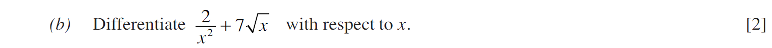
..........................................................................................................................................................................................................................................................................................................
..........................................................................................................................................................................................................................................................................................................
..........................................................................................................................................................................................................................................................................................................
..........................................................................................................................................................................................................................................................................................................
..........................................................................................................................................................................................................................................................................................................
..........................................................................................................................................................................................................................................................................................................
..........................................................................................................................................................................................................................................................................................................
..........................................................................................................................................................................................................................................................................................................
..........................................................................................................................................................................................................................................................................................................
(C1 Winter 2010, Question 6)
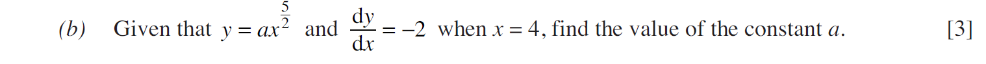
..........................................................................................................................................................................................................................................................................................................
..........................................................................................................................................................................................................................................................................................................
..........................................................................................................................................................................................................................................................................................................
..........................................................................................................................................................................................................................................................................................................
..........................................................................................................................................................................................................................................................................................................
..........................................................................................................................................................................................................................................................................................................
..........................................................................................................................................................................................................................................................................................................
..........................................................................................................................................................................................................................................................................................................
..........................................................................................................................................................................................................................................................................................................
..........................................................................................................................................................................................................................................................................................................
..........................................................................................................................................................................................................................................................................................................
..........................................................................................................................................................................................................................................................................................................
..........................................................................................................................................................................................................................................................................................................
..........................................................................................................................................................................................................................................................................................................
..........................................................................................................................................................................................................................................................................................................
..........................................................................................................................................................................................................................................................................................................
..........................................................................................................................................................................................................................................................................................................
..........................................................................................................................................................................................................................................................................................................
..........................................................................................................................................................................................................................................................................................................
..........................................................................................................................................................................................................................................................................................................
..........................................................................................................................................................................................................................................................................................................
..........................................................................................................................................................................................................................................................................................................
(C1 Summer 2016, Question 8)
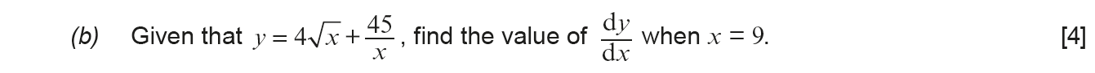
..........................................................................................................................................................................................................................................................................................................
..........................................................................................................................................................................................................................................................................................................
..........................................................................................................................................................................................................................................................................................................
..........................................................................................................................................................................................................................................................................................................
..........................................................................................................................................................................................................................................................................................................
..........................................................................................................................................................................................................................................................................................................
..........................................................................................................................................................................................................................................................................................................
..........................................................................................................................................................................................................................................................................................................
..........................................................................................................................................................................................................................................................................................................
..........................................................................................................................................................................................................................................................................................................
..........................................................................................................................................................................................................................................................................................................
..........................................................................................................................................................................................................................................................................................................
..........................................................................................................................................................................................................................................................................................................
..........................................................................................................................................................................................................................................................................................................
(C1 Winter 2008)
..........................................................................................................................................................................................................................................................................................................
..........................................................................................................................................................................................................................................................................................................
..........................................................................................................................................................................................................................................................................................................
..........................................................................................................................................................................................................................................................................................................
..........................................................................................................................................................................................................................................................................................................
..........................................................................................................................................................................................................................................................................................................
..........................................................................................................................................................................................................................................................................................................
..........................................................................................................................................................................................................................................................................................................
..........................................................................................................................................................................................................................................................................................................
..........................................................................................................................................................................................................................................................................................................
..........................................................................................................................................................................................................................................................................................................
..........................................................................................................................................................................................................................................................................................................
..........................................................................................................................................................................................................................................................................................................
..........................................................................................................................................................................................................................................................................................................
..........................................................................................................................................................................................................................................................................................................
..........................................................................................................................................................................................................................................................................................................
..........................................................................................................................................................................................................................................................................................................
..........................................................................................................................................................................................................................................................................................................
..........................................................................................................................................................................................................................................................................................................
..........................................................................................................................................................................................................................................................................................................
(C1 Winter 2005)
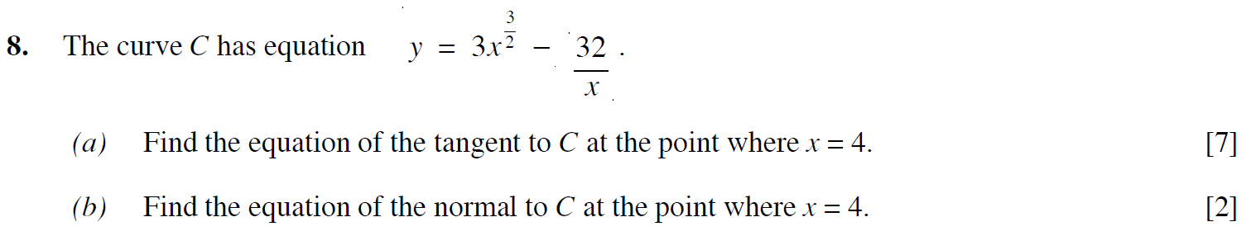
..........................................................................................................................................................................................................................................................................................................
..........................................................................................................................................................................................................................................................................................................
..........................................................................................................................................................................................................................................................................................................
..........................................................................................................................................................................................................................................................................................................
..........................................................................................................................................................................................................................................................................................................
..........................................................................................................................................................................................................................................................................................................
..........................................................................................................................................................................................................................................................................................................
..........................................................................................................................................................................................................................................................................................................
..........................................................................................................................................................................................................................................................................................................
..........................................................................................................................................................................................................................................................................................................
..........................................................................................................................................................................................................................................................................................................
..........................................................................................................................................................................................................................................................................................................
..........................................................................................................................................................................................................................................................................................................
..........................................................................................................................................................................................................................................................................................................
..........................................................................................................................................................................................................................................................................................................
..........................................................................................................................................................................................................................................................................................................
..........................................................................................................................................................................................................................................................................................................
..........................................................................................................................................................................................................................................................................................................
..........................................................................................................................................................................................................................................................................................................
..........................................................................................................................................................................................................................................................................................................
..........................................................................................................................................................................................................................................................................................................
..........................................................................................................................................................................................................................................................................................................
..........................................................................................................................................................................................................................................................................................................
..........................................................................................................................................................................................................................................................................................................
..........................................................................................................................................................................................................................................................................................................
..........................................................................................................................................................................................................................................................................................................
..........................................................................................................................................................................................................................................................................................................
..........................................................................................................................................................................................................................................................................................................
..........................................................................................................................................................................................................................................................................................................
..........................................................................................................................................................................................................................................................................................................
..........................................................................................................................................................................................................................................................................................................
..........................................................................................................................................................................................................................................................................................................
..........................................................................................................................................................................................................................................................................................................
..........................................................................................................................................................................................................................................................................................................
(C1 Winter 2009)
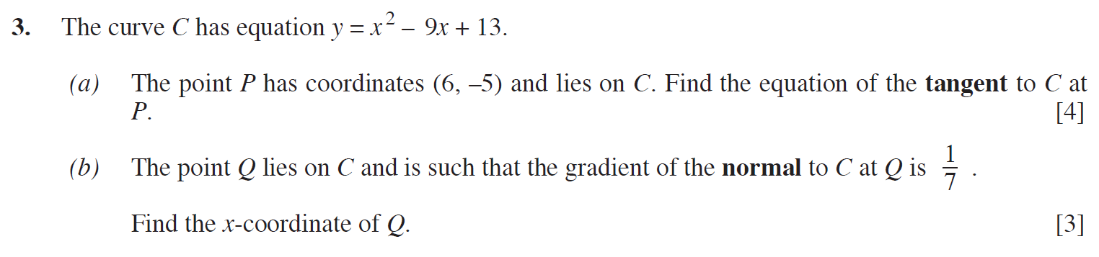
..........................................................................................................................................................................................................................................................................................................
..........................................................................................................................................................................................................................................................................................................
..........................................................................................................................................................................................................................................................................................................
..........................................................................................................................................................................................................................................................................................................
..........................................................................................................................................................................................................................................................................................................
..........................................................................................................................................................................................................................................................................................................
..........................................................................................................................................................................................................................................................................................................
..........................................................................................................................................................................................................................................................................................................
..........................................................................................................................................................................................................................................................................................................
..........................................................................................................................................................................................................................................................................................................
..........................................................................................................................................................................................................................................................................................................
..........................................................................................................................................................................................................................................................................................................
..........................................................................................................................................................................................................................................................................................................
..........................................................................................................................................................................................................................................................................................................
..........................................................................................................................................................................................................................................................................................................
..........................................................................................................................................................................................................................................................................................................
..........................................................................................................................................................................................................................................................................................................
..........................................................................................................................................................................................................................................................................................................
..........................................................................................................................................................................................................................................................................................................
..........................................................................................................................................................................................................................................................................................................
..........................................................................................................................................................................................................................................................................................................
..........................................................................................................................................................................................................................................................................................................
..........................................................................................................................................................................................................................................................................................................
..........................................................................................................................................................................................................................................................................................................
..........................................................................................................................................................................................................................................................................................................
..........................................................................................................................................................................................................................................................................................................
..........................................................................................................................................................................................................................................................................................................
..........................................................................................................................................................................................................................................................................................................
..........................................................................................................................................................................................................................................................................................................
..........................................................................................................................................................................................................................................................................................................
..........................................................................................................................................................................................................................................................................................................
..........................................................................................................................................................................................................................................................................................................
..........................................................................................................................................................................................................................................................................................................
(C1 Summer 2013)
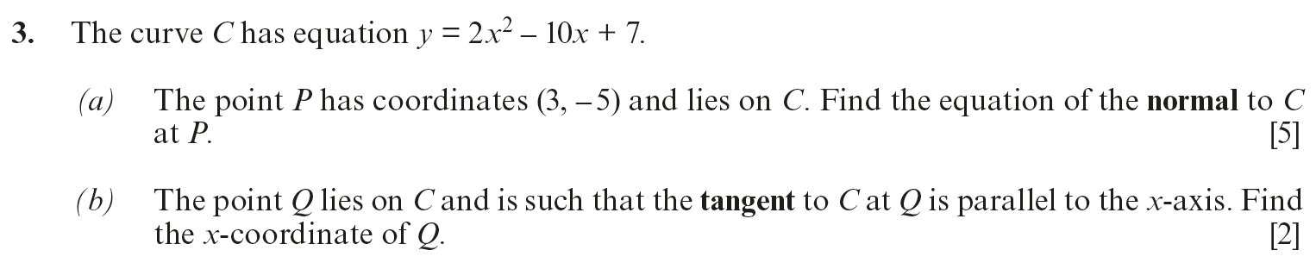
..........................................................................................................................................................................................................................................................................................................
..........................................................................................................................................................................................................................................................................................................
..........................................................................................................................................................................................................................................................................................................
..........................................................................................................................................................................................................................................................................................................
..........................................................................................................................................................................................................................................................................................................
..........................................................................................................................................................................................................................................................................................................
..........................................................................................................................................................................................................................................................................................................
..........................................................................................................................................................................................................................................................................................................
..........................................................................................................................................................................................................................................................................................................
..........................................................................................................................................................................................................................................................................................................
..........................................................................................................................................................................................................................................................................................................
..........................................................................................................................................................................................................................................................................................................
..........................................................................................................................................................................................................................................................................................................
..........................................................................................................................................................................................................................................................................................................
..........................................................................................................................................................................................................................................................................................................
..........................................................................................................................................................................................................................................................................................................
..........................................................................................................................................................................................................................................................................................................
..........................................................................................................................................................................................................................................................................................................
..........................................................................................................................................................................................................................................................................................................
..........................................................................................................................................................................................................................................................................................................
..........................................................................................................................................................................................................................................................................................................
..........................................................................................................................................................................................................................................................................................................
..........................................................................................................................................................................................................................................................................................................
..........................................................................................................................................................................................................................................................................................................
..........................................................................................................................................................................................................................................................................................................
..........................................................................................................................................................................................................................................................................................................
..........................................................................................................................................................................................................................................................................................................
..........................................................................................................................................................................................................................................................................................................
..........................................................................................................................................................................................................................................................................................................
..........................................................................................................................................................................................................................................................................................................
..........................................................................................................................................................................................................................................................................................................
..........................................................................................................................................................................................................................................................................................................
..........................................................................................................................................................................................................................................................................................................
..........................................................................................................................................................................................................................................................................................................
(C1 Summer 2010)
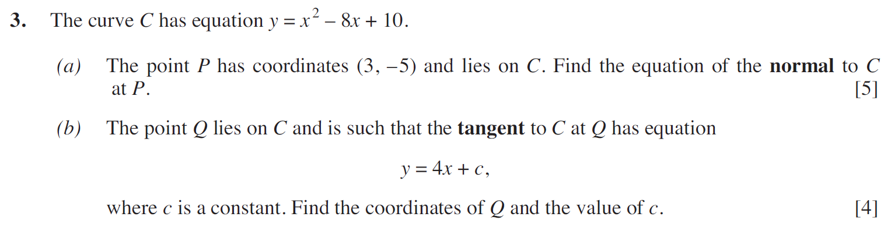
..........................................................................................................................................................................................................................................................................................................
..........................................................................................................................................................................................................................................................................................................
..........................................................................................................................................................................................................................................................................................................
..........................................................................................................................................................................................................................................................................................................
..........................................................................................................................................................................................................................................................................................................
..........................................................................................................................................................................................................................................................................................................
..........................................................................................................................................................................................................................................................................................................
..........................................................................................................................................................................................................................................................................................................
..........................................................................................................................................................................................................................................................................................................
..........................................................................................................................................................................................................................................................................................................
..........................................................................................................................................................................................................................................................................................................
..........................................................................................................................................................................................................................................................................................................
..........................................................................................................................................................................................................................................................................................................
..........................................................................................................................................................................................................................................................................................................
..........................................................................................................................................................................................................................................................................................................
..........................................................................................................................................................................................................................................................................................................
..........................................................................................................................................................................................................................................................................................................
..........................................................................................................................................................................................................................................................................................................
..........................................................................................................................................................................................................................................................................................................
..........................................................................................................................................................................................................................................................................................................
..........................................................................................................................................................................................................................................................................................................
..........................................................................................................................................................................................................................................................................................................
..........................................................................................................................................................................................................................................................................................................
..........................................................................................................................................................................................................................................................................................................
..........................................................................................................................................................................................................................................................................................................
..........................................................................................................................................................................................................................................................................................................
..........................................................................................................................................................................................................................................................................................................
..........................................................................................................................................................................................................................................................................................................
..........................................................................................................................................................................................................................................................................................................
..........................................................................................................................................................................................................................................................................................................
..........................................................................................................................................................................................................................................................................................................
..........................................................................................................................................................................................................................................................................................................
(C1 Winter 2011)
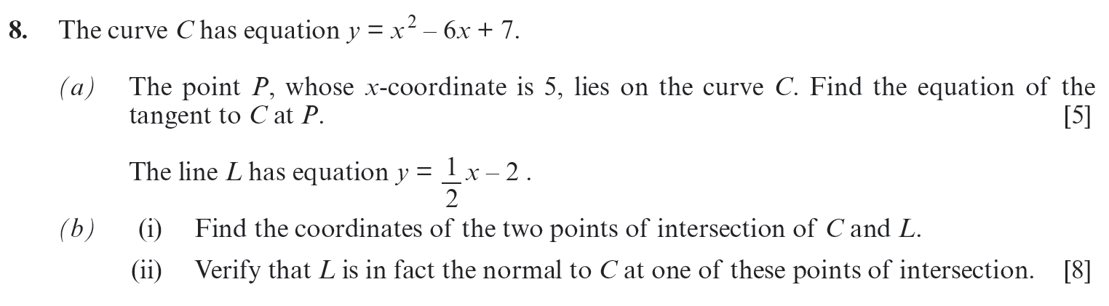
..........................................................................................................................................................................................................................................................................................................
..........................................................................................................................................................................................................................................................................................................
..........................................................................................................................................................................................................................................................................................................
..........................................................................................................................................................................................................................................................................................................
..........................................................................................................................................................................................................................................................................................................
..........................................................................................................................................................................................................................................................................................................
..........................................................................................................................................................................................................................................................................................................
..........................................................................................................................................................................................................................................................................................................
..........................................................................................................................................................................................................................................................................................................
..........................................................................................................................................................................................................................................................................................................
..........................................................................................................................................................................................................................................................................................................
..........................................................................................................................................................................................................................................................................................................
..........................................................................................................................................................................................................................................................................................................
..........................................................................................................................................................................................................................................................................................................
..........................................................................................................................................................................................................................................................................................................
..........................................................................................................................................................................................................................................................................................................
..........................................................................................................................................................................................................................................................................................................
..........................................................................................................................................................................................................................................................................................................
..........................................................................................................................................................................................................................................................................................................
..........................................................................................................................................................................................................................................................................................................
..........................................................................................................................................................................................................................................................................................................
..........................................................................................................................................................................................................................................................................................................
..........................................................................................................................................................................................................................................................................................................
..........................................................................................................................................................................................................................................................................................................
..........................................................................................................................................................................................................................................................................................................
..........................................................................................................................................................................................................................................................................................................
..........................................................................................................................................................................................................................................................................................................
..........................................................................................................................................................................................................................................................................................................
..........................................................................................................................................................................................................................................................................................................
..........................................................................................................................................................................................................................................................................................................
..........................................................................................................................................................................................................................................................................................................
..........................................................................................................................................................................................................................................................................................................
..........................................................................................................................................................................................................................................................................................................
..........................................................................................................................................................................................................................................................................................................
..........................................................................................................................................................................................................................................................................................................
..........................................................................................................................................................................................................................................................................................................
..........................................................................................................................................................................................................................................................................................................
..........................................................................................................................................................................................................................................................................................................
..........................................................................................................................................................................................................................................................................................................
..........................................................................................................................................................................................................................................................................................................
..........................................................................................................................................................................................................................................................................................................
..........................................................................................................................................................................................................................................................................................................
..........................................................................................................................................................................................................................................................................................................
..........................................................................................................................................................................................................................................................................................................
..........................................................................................................................................................................................................................................................................................................
..........................................................................................................................................................................................................................................................................................................
..........................................................................................................................................................................................................................................................................................................
..........................................................................................................................................................................................................................................................................................................
..........................................................................................................................................................................................................................................................................................................
..........................................................................................................................................................................................................................................................................................................
..........................................................................................................................................................................................................................................................................................................
..........................................................................................................................................................................................................................................................................................................
..........................................................................................................................................................................................................................................................................................................
..........................................................................................................................................................................................................................................................................................................
..........................................................................................................................................................................................................................................................................................................
..........................................................................................................................................................................................................................................................................................................
..........................................................................................................................................................................................................................................................................................................
..........................................................................................................................................................................................................................................................................................................
..........................................................................................................................................................................................................................................................................................................
..........................................................................................................................................................................................................................................................................................................
..........................................................................................................................................................................................................................................................................................................
..........................................................................................................................................................................................................................................................................................................
..........................................................................................................................................................................................................................................................................................................
..........................................................................................................................................................................................................................................................................................................
..........................................................................................................................................................................................................................................................................................................
..........................................................................................................................................................................................................................................................................................................
..........................................................................................................................................................................................................................................................................................................
..........................................................................................................................................................................................................................................................................................................
..........................................................................................................................................................................................................................................................................................................
..........................................................................................................................................................................................................................................................................................................
..........................................................................................................................................................................................................................................................................................................
..........................................................................................................................................................................................................................................................................................................
..........................................................................................................................................................................................................................................................................................................
(Unit 1 Summer 2023, Question 9)
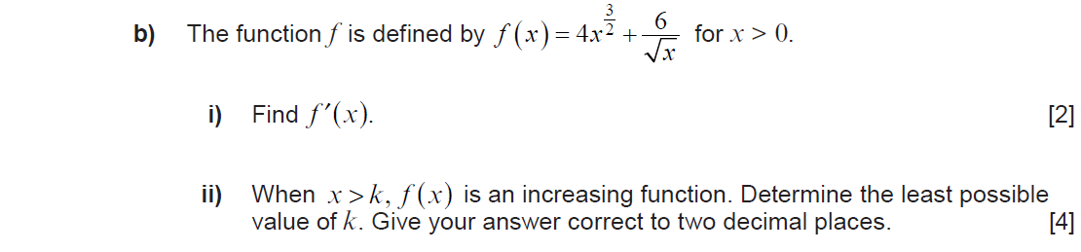
..........................................................................................................................................................................................................................................................................................................
..........................................................................................................................................................................................................................................................................................................
..........................................................................................................................................................................................................................................................................................................
..........................................................................................................................................................................................................................................................................................................
..........................................................................................................................................................................................................................................................................................................
..........................................................................................................................................................................................................................................................................................................
..........................................................................................................................................................................................................................................................................................................
..........................................................................................................................................................................................................................................................................................................
..........................................................................................................................................................................................................................................................................................................
..........................................................................................................................................................................................................................................................................................................
..........................................................................................................................................................................................................................................................................................................
..........................................................................................................................................................................................................................................................................................................
..........................................................................................................................................................................................................................................................................................................
..........................................................................................................................................................................................................................................................................................................
..........................................................................................................................................................................................................................................................................................................
..........................................................................................................................................................................................................................................................................................................
..........................................................................................................................................................................................................................................................................................................
..........................................................................................................................................................................................................................................................................................................
..........................................................................................................................................................................................................................................................................................................
..........................................................................................................................................................................................................................................................................................................
..........................................................................................................................................................................................................................................................................................................
..........................................................................................................................................................................................................................................................................................................
..........................................................................................................................................................................................................................................................................................................
..........................................................................................................................................................................................................................................................................................................
..........................................................................................................................................................................................................................................................................................................
..........................................................................................................................................................................................................................................................................................................
..........................................................................................................................................................................................................................................................................................................
..........................................................................................................................................................................................................................................................................................................
..........................................................................................................................................................................................................................................................................................................
..........................................................................................................................................................................................................................................................................................................
..........................................................................................................................................................................................................................................................................................................
..........................................................................................................................................................................................................................................................................................................
..........................................................................................................................................................................................................................................................................................................
(Unit 1 Summer 2018)
..........................................................................................................................................................................................................................................................................................................
..........................................................................................................................................................................................................................................................................................................
..........................................................................................................................................................................................................................................................................................................
..........................................................................................................................................................................................................................................................................................................
..........................................................................................................................................................................................................................................................................................................
..........................................................................................................................................................................................................................................................................................................
..........................................................................................................................................................................................................................................................................................................
..........................................................................................................................................................................................................................................................................................................
..........................................................................................................................................................................................................................................................................................................
..........................................................................................................................................................................................................................................................................................................
..........................................................................................................................................................................................................................................................................................................
..........................................................................................................................................................................................................................................................................................................
..........................................................................................................................................................................................................................................................................................................
..........................................................................................................................................................................................................................................................................................................
..........................................................................................................................................................................................................................................................................................................
..........................................................................................................................................................................................................................................................................................................
..........................................................................................................................................................................................................................................................................................................
..........................................................................................................................................................................................................................................................................................................
..........................................................................................................................................................................................................................................................................................................
..........................................................................................................................................................................................................................................................................................................
..........................................................................................................................................................................................................................................................................................................
..........................................................................................................................................................................................................................................................................................................
..........................................................................................................................................................................................................................................................................................................
..........................................................................................................................................................................................................................................................................................................
..........................................................................................................................................................................................................................................................................................................
..........................................................................................................................................................................................................................................................................................................
..........................................................................................................................................................................................................................................................................................................
..........................................................................................................................................................................................................................................................................................................
..........................................................................................................................................................................................................................................................................................................
..........................................................................................................................................................................................................................................................................................................
..........................................................................................................................................................................................................................................................................................................
..........................................................................................................................................................................................................................................................................................................
..........................................................................................................................................................................................................................................................................................................
..........................................................................................................................................................................................................................................................................................................

