



An infinite number of mathematicians walk into a bar. The first one orders a drink, the second one orders half a drink, the third one wants a quarter of a drink, and the next one wants just $\frac{1}{8}$th. The bartender sees where this is going, and stops them before anyone else can order. The bartender pours two drinks, hands them over, and says “you mathematicians should really know your limits”.
Beth yw’r gwaith? |  | O gael dilyniant geometrig ble rydym yn lluosi’r un rhif i gael y rhif nesaf, sut mae’n bosib darganfod yr $n$fed term, neu swm yr $n$ term cyntaf?
Beth sydd ei angen cyn cychwyn? |  | Gwaith TGAU: Datrys hafaliadau, $n$fed term.  Lefel A Uned 1: Datrys hafaliadau cydamserol, logarithmau.
I ble mae’n arwain? |  | Cymwysiadau:  - Cyfradd ehangiad y bydysawd.  - Dadfeiliad ymbelydrol.  - Adlog.
Mae cyfres o rifau yn gyfres geometrig os ydym yn lluosi efo’r un cysonyn i gael y rhif nesaf yn y gyfres.
Er enghraifft, mae’r gyfres 3, 6, 12, 24, 48, ... yn gyfres geometrig ble mae’r term cyntaf yn 3 ac mae’r gymhareb gyffredin yn 2.
Theori
Terminoleg
$a$ Term cyntaf y gyfres
$r$ Y gymhareb gyffredin
$l$ Term olaf y gyfres, os oes un yn bodoli
$t_{n}$ $n$fed term y gyfres
Ar gyfer cyfres geometrig efo term cyntaf $a$ a chymhareb gyffredin $r$:
Term cyntaf: $t_{1}=a$
Ail derm: $t_{2}=ar$
Trydydd term: $t_{3}=ar^{2}$
Pedwerydd term: $t_{4}=ar^{3}$
Nfed term: $t_{n}=ar^{n-1}$
Ar gyfer pob cyfanrif $n$,
$r=\frac{t_{n+1}}{t_{n}}$
Ymarfer 1
Ar gyfer y gyfres geometrig 2, 6, 18, 54, 162, ..., ysgrifennwch
(a) $a$ .................................................................................... (b) $r$ ...............................................................................
(c) $t_{7}$ ................................................................................... (ch) $t_{n}$ ............................................................................
Mae’n bosib ystyried cyfanswm yr $n$ term cyntaf mewn cyfres geometrig, sy’n cael ei ysgrifennu fel $S_{n}$.
Ar gyfer y gyfres geometrig 3, 6, 12, 24, 48, ...
$$S_{3}=3+6+12=21 \\ S_{6}=3+6+12+24+48+96=189$$
Mae angen dysgu’r prawf ar gyfer cyfrifo $S_{n}$.
Profwch mai swm $n$ term cyntaf cyfres geometrig efo term cyntaf $a$ a chymhareb gyffredin $r$ yw
$$S_{n}=\frac{a\left(1-r^{n}\right)}{1-r}.$$
Prawf
Term 1af: $t_{1}=a$
2il Derm: $t_{2}=ar$
Nfed Term: $t_{n}=ar^{n-1}$
Swm yr $n$ term cyntaf: $S_{n}=t_{1}+t_{2}+⋯+t_{n-1}+t_{n}$ $S_{n}=a+ar+⋯+ar^{n-2}+ar^{n-1}$ –––––
Lluosi efo $r$: $rS_{n}=ar+ar^{2}+⋯+ar^{n-1}+ar^{n}$ –––––
Yn gwneud – : $S_{n}-rS_{n}=a-ar^{n}$ $S_{n}\left(1-r\right)=a\left(1-r^{n}\right)$ $S_{n}=\frac{a\left(1-r^{n}\right)}{1-r}$ QED
Swm i Anfeidredd
Os yw $\left|r\right|<1$, yna mae’n bosib ystyried cyfanswm $S_{∞}$ holl dermau cyfres geometrig.
Prawf
Os yw $\left|r\right|<1$ (fel bod $-1<r<1$), yna bydd $r^{n}$ yn dod yn fwy ac yn fwy agos at 0 wrth i $n$ gynyddu.
Dywedwn bod $r^{n}→0$ fel mae $n→∞$.
Felly, os yw $\left|r\right|<1$, mae
Mae $r^{n}$ yn tueddu at 0 fel mae $n$ yn tueddu at $∞$.
$$S_{n}=\frac{a\left(1-r^{n}\right)}{1-r}$$
$$S_{n}→\frac{a\left(1-0\right)}{1-r}$$
$$S_{∞}=\frac{a}{1-r}.$$
Ymarfer 2
Darllenwch y jôc ar glawr y pecyn.
Mae’r jôc yn disgrifio cyfres geometrig ble mae $a=1$ ac $r=\frac{1}{2}$. Ysgrifennwch
(a) $t_{6}$ .............................................................................................................................................................................................................
(b) $S_{6}$ ............................................................................................................................................................................................................
........................................................................................................................................................................................................................
(c) $S_{∞}$ ............................................................................................................................................................................................................
........................................................................................................................................................................................................................
........................................................................................................................................................................................................................
........................................................................................................................................................................................................................

(C2 Haf 2005)
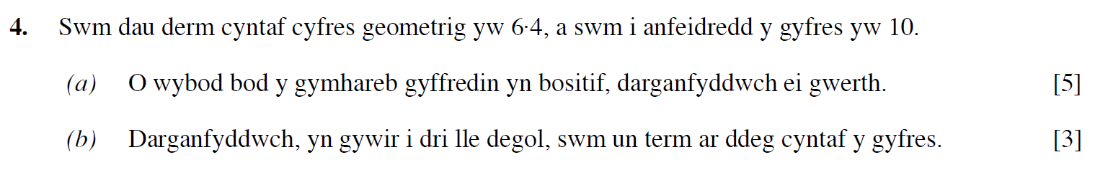
..........................................................................................................................................................................................................................................................................................................
..........................................................................................................................................................................................................................................................................................................
..........................................................................................................................................................................................................................................................................................................
..........................................................................................................................................................................................................................................................................................................
..........................................................................................................................................................................................................................................................................................................
..........................................................................................................................................................................................................................................................................................................
..........................................................................................................................................................................................................................................................................................................
..........................................................................................................................................................................................................................................................................................................
..........................................................................................................................................................................................................................................................................................................
..........................................................................................................................................................................................................................................................................................................
..........................................................................................................................................................................................................................................................................................................
..........................................................................................................................................................................................................................................................................................................
..........................................................................................................................................................................................................................................................................................................
..........................................................................................................................................................................................................................................................................................................
..........................................................................................................................................................................................................................................................................................................
..........................................................................................................................................................................................................................................................................................................
..........................................................................................................................................................................................................................................................................................................
..........................................................................................................................................................................................................................................................................................................
..........................................................................................................................................................................................................................................................................................................
..........................................................................................................................................................................................................................................................................................................
..........................................................................................................................................................................................................................................................................................................
..........................................................................................................................................................................................................................................................................................................
..........................................................................................................................................................................................................................................................................................................
..........................................................................................................................................................................................................................................................................................................
..........................................................................................................................................................................................................................................................................................................
..........................................................................................................................................................................................................................................................................................................
..........................................................................................................................................................................................................................................................................................................
..........................................................................................................................................................................................................................................................................................................
..........................................................................................................................................................................................................................................................................................................
..........................................................................................................................................................................................................................................................................................................
..........................................................................................................................................................................................................................................................................................................
..........................................................................................................................................................................................................................................................................................................
(C2 Gaeaf 2011)
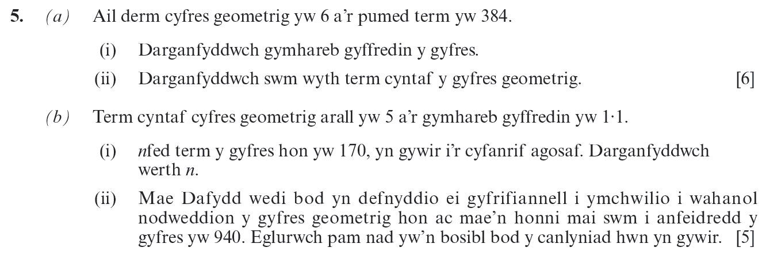
..........................................................................................................................................................................................................................................................................................................
..........................................................................................................................................................................................................................................................................................................
..........................................................................................................................................................................................................................................................................................................
..........................................................................................................................................................................................................................................................................................................
..........................................................................................................................................................................................................................................................................................................
..........................................................................................................................................................................................................................................................................................................
..........................................................................................................................................................................................................................................................................................................
..........................................................................................................................................................................................................................................................................................................
..........................................................................................................................................................................................................................................................................................................
..........................................................................................................................................................................................................................................................................................................
..........................................................................................................................................................................................................................................................................................................
..........................................................................................................................................................................................................................................................................................................
..........................................................................................................................................................................................................................................................................................................
..........................................................................................................................................................................................................................................................................................................
..........................................................................................................................................................................................................................................................................................................
..........................................................................................................................................................................................................................................................................................................
..........................................................................................................................................................................................................................................................................................................
..........................................................................................................................................................................................................................................................................................................
..........................................................................................................................................................................................................................................................................................................
..........................................................................................................................................................................................................................................................................................................
..........................................................................................................................................................................................................................................................................................................
..........................................................................................................................................................................................................................................................................................................
..........................................................................................................................................................................................................................................................................................................
..........................................................................................................................................................................................................................................................................................................
..........................................................................................................................................................................................................................................................................................................
..........................................................................................................................................................................................................................................................................................................
..........................................................................................................................................................................................................................................................................................................
..........................................................................................................................................................................................................................................................................................................
..........................................................................................................................................................................................................................................................................................................
..........................................................................................................................................................................................................................................................................................................
..........................................................................................................................................................................................................................................................................................................
..........................................................................................................................................................................................................................................................................................................
..........................................................................................................................................................................................................................................................................................................
..........................................................................................................................................................................................................................................................................................................
..........................................................................................................................................................................................................................................................................................................
..........................................................................................................................................................................................................................................................................................................
..........................................................................................................................................................................................................................................................................................................
..........................................................................................................................................................................................................................................................................................................
..........................................................................................................................................................................................................................................................................................................
..........................................................................................................................................................................................................................................................................................................
..........................................................................................................................................................................................................................................................................................................
..........................................................................................................................................................................................................................................................................................................
..........................................................................................................................................................................................................................................................................................................
..........................................................................................................................................................................................................................................................................................................
..........................................................................................................................................................................................................................................................................................................
..........................................................................................................................................................................................................................................................................................................
..........................................................................................................................................................................................................................................................................................................
..........................................................................................................................................................................................................................................................................................................
..........................................................................................................................................................................................................................................................................................................
..........................................................................................................................................................................................................................................................................................................
..........................................................................................................................................................................................................................................................................................................
..........................................................................................................................................................................................................................................................................................................
..........................................................................................................................................................................................................................................................................................................
..........................................................................................................................................................................................................................................................................................................
..........................................................................................................................................................................................................................................................................................................
..........................................................................................................................................................................................................................................................................................................
..........................................................................................................................................................................................................................................................................................................
..........................................................................................................................................................................................................................................................................................................
..........................................................................................................................................................................................................................................................................................................
..........................................................................................................................................................................................................................................................................................................
..........................................................................................................................................................................................................................................................................................................
..........................................................................................................................................................................................................................................................................................................
..........................................................................................................................................................................................................................................................................................................
..........................................................................................................................................................................................................................................................................................................
..........................................................................................................................................................................................................................................................................................................
..........................................................................................................................................................................................................................................................................................................
..........................................................................................................................................................................................................................................................................................................
..........................................................................................................................................................................................................................................................................................................
..........................................................................................................................................................................................................................................................................................................
..........................................................................................................................................................................................................................................................................................................
..........................................................................................................................................................................................................................................................................................................
(C2 Haf 2006)
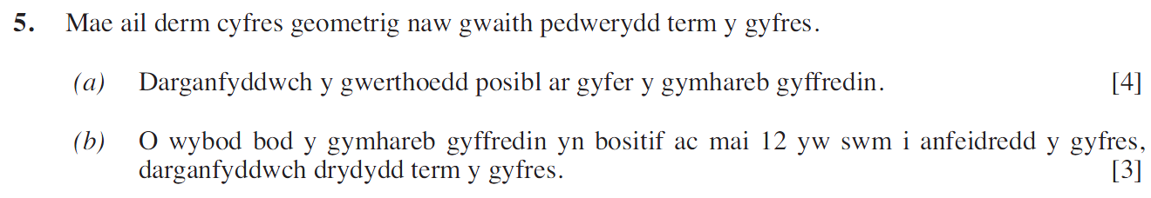
..........................................................................................................................................................................................................................................................................................................
..........................................................................................................................................................................................................................................................................................................
..........................................................................................................................................................................................................................................................................................................
..........................................................................................................................................................................................................................................................................................................
..........................................................................................................................................................................................................................................................................................................
..........................................................................................................................................................................................................................................................................................................
..........................................................................................................................................................................................................................................................................................................
..........................................................................................................................................................................................................................................................................................................
..........................................................................................................................................................................................................................................................................................................
..........................................................................................................................................................................................................................................................................................................
..........................................................................................................................................................................................................................................................................................................
..........................................................................................................................................................................................................................................................................................................
..........................................................................................................................................................................................................................................................................................................
..........................................................................................................................................................................................................................................................................................................
..........................................................................................................................................................................................................................................................................................................
..........................................................................................................................................................................................................................................................................................................
..........................................................................................................................................................................................................................................................................................................
..........................................................................................................................................................................................................................................................................................................
..........................................................................................................................................................................................................................................................................................................
..........................................................................................................................................................................................................................................................................................................
..........................................................................................................................................................................................................................................................................................................
..........................................................................................................................................................................................................................................................................................................
..........................................................................................................................................................................................................................................................................................................
..........................................................................................................................................................................................................................................................................................................
..........................................................................................................................................................................................................................................................................................................
..........................................................................................................................................................................................................................................................................................................
..........................................................................................................................................................................................................................................................................................................
..........................................................................................................................................................................................................................................................................................................
..........................................................................................................................................................................................................................................................................................................
..........................................................................................................................................................................................................................................................................................................
..........................................................................................................................................................................................................................................................................................................
..........................................................................................................................................................................................................................................................................................................
(C2 Gaeaf 2008)
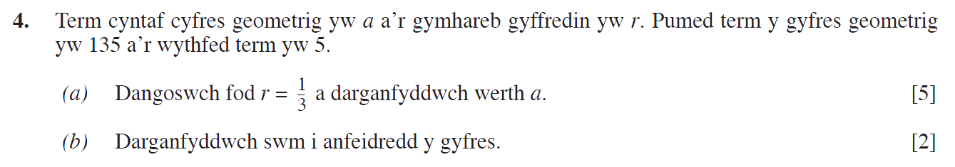
..........................................................................................................................................................................................................................................................................................................
..........................................................................................................................................................................................................................................................................................................
..........................................................................................................................................................................................................................................................................................................
..........................................................................................................................................................................................................................................................................................................
..........................................................................................................................................................................................................................................................................................................
..........................................................................................................................................................................................................................................................................................................
..........................................................................................................................................................................................................................................................................................................
..........................................................................................................................................................................................................................................................................................................
..........................................................................................................................................................................................................................................................................................................
..........................................................................................................................................................................................................................................................................................................
..........................................................................................................................................................................................................................................................................................................
..........................................................................................................................................................................................................................................................................................................
..........................................................................................................................................................................................................................................................................................................
..........................................................................................................................................................................................................................................................................................................
..........................................................................................................................................................................................................................................................................................................
..........................................................................................................................................................................................................................................................................................................
..........................................................................................................................................................................................................................................................................................................
..........................................................................................................................................................................................................................................................................................................
..........................................................................................................................................................................................................................................................................................................
..........................................................................................................................................................................................................................................................................................................
..........................................................................................................................................................................................................................................................................................................
..........................................................................................................................................................................................................................................................................................................
..........................................................................................................................................................................................................................................................................................................
..........................................................................................................................................................................................................................................................................................................
..........................................................................................................................................................................................................................................................................................................
..........................................................................................................................................................................................................................................................................................................
..........................................................................................................................................................................................................................................................................................................
..........................................................................................................................................................................................................................................................................................................
..........................................................................................................................................................................................................................................................................................................
..........................................................................................................................................................................................................................................................................................................
..........................................................................................................................................................................................................................................................................................................
..........................................................................................................................................................................................................................................................................................................
..........................................................................................................................................................................................................................................................................................................
..........................................................................................................................................................................................................................................................................................................
(C2 Gaeaf 2007)
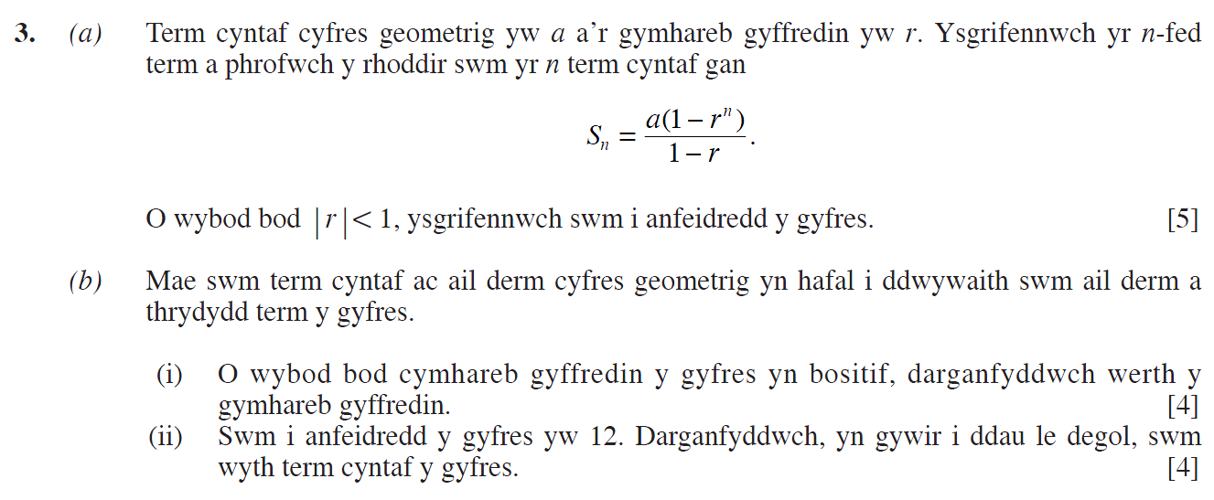
..........................................................................................................................................................................................................................................................................................................
..........................................................................................................................................................................................................................................................................................................
..........................................................................................................................................................................................................................................................................................................
..........................................................................................................................................................................................................................................................................................................
..........................................................................................................................................................................................................................................................................................................
..........................................................................................................................................................................................................................................................................................................
..........................................................................................................................................................................................................................................................................................................
..........................................................................................................................................................................................................................................................................................................
..........................................................................................................................................................................................................................................................................................................
..........................................................................................................................................................................................................................................................................................................
..........................................................................................................................................................................................................................................................................................................
..........................................................................................................................................................................................................................................................................................................
..........................................................................................................................................................................................................................................................................................................
..........................................................................................................................................................................................................................................................................................................
..........................................................................................................................................................................................................................................................................................................
..........................................................................................................................................................................................................................................................................................................
..........................................................................................................................................................................................................................................................................................................
..........................................................................................................................................................................................................................................................................................................
..........................................................................................................................................................................................................................................................................................................
..........................................................................................................................................................................................................................................................................................................
..........................................................................................................................................................................................................................................................................................................
..........................................................................................................................................................................................................................................................................................................
..........................................................................................................................................................................................................................................................................................................
..........................................................................................................................................................................................................................................................................................................
..........................................................................................................................................................................................................................................................................................................
..........................................................................................................................................................................................................................................................................................................
..........................................................................................................................................................................................................................................................................................................
..........................................................................................................................................................................................................................................................................................................
..........................................................................................................................................................................................................................................................................................................
..........................................................................................................................................................................................................................................................................................................
..........................................................................................................................................................................................................................................................................................................
..........................................................................................................................................................................................................................................................................................................
..........................................................................................................................................................................................................................................................................................................
..........................................................................................................................................................................................................................................................................................................
..........................................................................................................................................................................................................................................................................................................
..........................................................................................................................................................................................................................................................................................................
..........................................................................................................................................................................................................................................................................................................
..........................................................................................................................................................................................................................................................................................................
..........................................................................................................................................................................................................................................................................................................
..........................................................................................................................................................................................................................................................................................................
..........................................................................................................................................................................................................................................................................................................
..........................................................................................................................................................................................................................................................................................................
..........................................................................................................................................................................................................................................................................................................
..........................................................................................................................................................................................................................................................................................................
..........................................................................................................................................................................................................................................................................................................
..........................................................................................................................................................................................................................................................................................................
..........................................................................................................................................................................................................................................................................................................
..........................................................................................................................................................................................................................................................................................................
..........................................................................................................................................................................................................................................................................................................
..........................................................................................................................................................................................................................................................................................................
..........................................................................................................................................................................................................................................................................................................
..........................................................................................................................................................................................................................................................................................................
..........................................................................................................................................................................................................................................................................................................
..........................................................................................................................................................................................................................................................................................................
..........................................................................................................................................................................................................................................................................................................
..........................................................................................................................................................................................................................................................................................................
..........................................................................................................................................................................................................................................................................................................
..........................................................................................................................................................................................................................................................................................................
..........................................................................................................................................................................................................................................................................................................
..........................................................................................................................................................................................................................................................................................................
..........................................................................................................................................................................................................................................................................................................
..........................................................................................................................................................................................................................................................................................................
..........................................................................................................................................................................................................................................................................................................
..........................................................................................................................................................................................................................................................................................................
..........................................................................................................................................................................................................................................................................................................
..........................................................................................................................................................................................................................................................................................................
..........................................................................................................................................................................................................................................................................................................
..........................................................................................................................................................................................................................................................................................................
..........................................................................................................................................................................................................................................................................................................
(C2 Haf 2017)
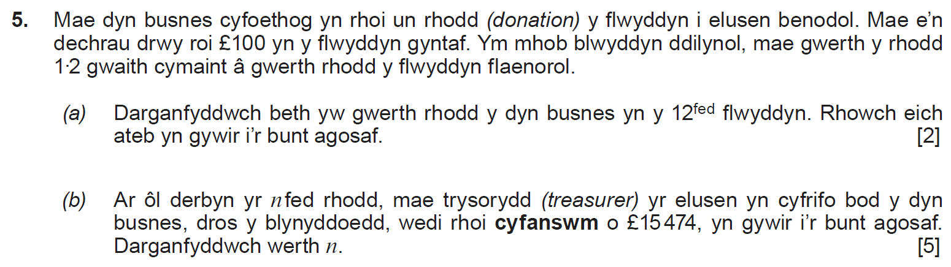
..........................................................................................................................................................................................................................................................................................................
..........................................................................................................................................................................................................................................................................................................
..........................................................................................................................................................................................................................................................................................................
..........................................................................................................................................................................................................................................................................................................
..........................................................................................................................................................................................................................................................................................................
..........................................................................................................................................................................................................................................................................................................
..........................................................................................................................................................................................................................................................................................................
..........................................................................................................................................................................................................................................................................................................
..........................................................................................................................................................................................................................................................................................................
..........................................................................................................................................................................................................................................................................................................
..........................................................................................................................................................................................................................................................................................................
..........................................................................................................................................................................................................................................................................................................
..........................................................................................................................................................................................................................................................................................................
..........................................................................................................................................................................................................................................................................................................
..........................................................................................................................................................................................................................................................................................................
..........................................................................................................................................................................................................................................................................................................
..........................................................................................................................................................................................................................................................................................................
..........................................................................................................................................................................................................................................................................................................
..........................................................................................................................................................................................................................................................................................................
..........................................................................................................................................................................................................................................................................................................
..........................................................................................................................................................................................................................................................................................................
..........................................................................................................................................................................................................................................................................................................
..........................................................................................................................................................................................................................................................................................................
..........................................................................................................................................................................................................................................................................................................
..........................................................................................................................................................................................................................................................................................................
..........................................................................................................................................................................................................................................................................................................
..........................................................................................................................................................................................................................................................................................................
..........................................................................................................................................................................................................................................................................................................
..........................................................................................................................................................................................................................................................................................................
..........................................................................................................................................................................................................................................................................................................
..........................................................................................................................................................................................................................................................................................................
(C2 Gaeaf 2013)
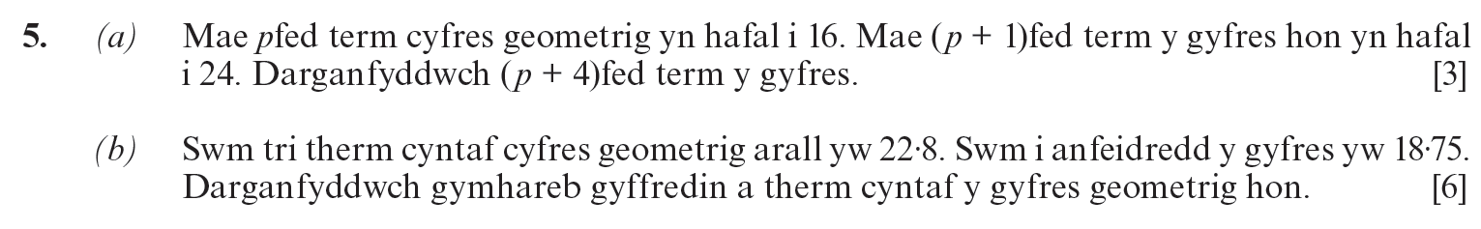
..........................................................................................................................................................................................................................................................................................................
..........................................................................................................................................................................................................................................................................................................
..........................................................................................................................................................................................................................................................................................................
..........................................................................................................................................................................................................................................................................................................
..........................................................................................................................................................................................................................................................................................................
..........................................................................................................................................................................................................................................................................................................
..........................................................................................................................................................................................................................................................................................................
..........................................................................................................................................................................................................................................................................................................
..........................................................................................................................................................................................................................................................................................................
..........................................................................................................................................................................................................................................................................................................
..........................................................................................................................................................................................................................................................................................................
..........................................................................................................................................................................................................................................................................................................
..........................................................................................................................................................................................................................................................................................................
..........................................................................................................................................................................................................................................................................................................
..........................................................................................................................................................................................................................................................................................................
..........................................................................................................................................................................................................................................................................................................
..........................................................................................................................................................................................................................................................................................................
..........................................................................................................................................................................................................................................................................................................
..........................................................................................................................................................................................................................................................................................................
..........................................................................................................................................................................................................................................................................................................
..........................................................................................................................................................................................................................................................................................................
..........................................................................................................................................................................................................................................................................................................
..........................................................................................................................................................................................................................................................................................................
..........................................................................................................................................................................................................................................................................................................
..........................................................................................................................................................................................................................................................................................................
..........................................................................................................................................................................................................................................................................................................
..........................................................................................................................................................................................................................................................................................................
..........................................................................................................................................................................................................................................................................................................
..........................................................................................................................................................................................................................................................................................................
..........................................................................................................................................................................................................................................................................................................
..........................................................................................................................................................................................................................................................................................................
..........................................................................................................................................................................................................................................................................................................
..........................................................................................................................................................................................................................................................................................................
..........................................................................................................................................................................................................................................................................................................
..........................................................................................................................................................................................................................................................................................................
..........................................................................................................................................................................................................................................................................................................
..........................................................................................................................................................................................................................................................................................................
..........................................................................................................................................................................................................................................................................................................
..........................................................................................................................................................................................................................................................................................................
..........................................................................................................................................................................................................................................................................................................
..........................................................................................................................................................................................................................................................................................................
..........................................................................................................................................................................................................................................................................................................
..........................................................................................................................................................................................................................................................................................................
..........................................................................................................................................................................................................................................................................................................
..........................................................................................................................................................................................................................................................................................................
..........................................................................................................................................................................................................................................................................................................
..........................................................................................................................................................................................................................................................................................................
..........................................................................................................................................................................................................................................................................................................
..........................................................................................................................................................................................................................................................................................................
..........................................................................................................................................................................................................................................................................................................
..........................................................................................................................................................................................................................................................................................................
..........................................................................................................................................................................................................................................................................................................
..........................................................................................................................................................................................................................................................................................................
..........................................................................................................................................................................................................................................................................................................
..........................................................................................................................................................................................................................................................................................................
..........................................................................................................................................................................................................................................................................................................
..........................................................................................................................................................................................................................................................................................................
..........................................................................................................................................................................................................................................................................................................
..........................................................................................................................................................................................................................................................................................................
..........................................................................................................................................................................................................................................................................................................
..........................................................................................................................................................................................................................................................................................................
..........................................................................................................................................................................................................................................................................................................
..........................................................................................................................................................................................................................................................................................................
..........................................................................................................................................................................................................................................................................................................
..........................................................................................................................................................................................................................................................................................................
..........................................................................................................................................................................................................................................................................................................
..........................................................................................................................................................................................................................................................................................................
..........................................................................................................................................................................................................................................................................................................
..........................................................................................................................................................................................................................................................................................................
..........................................................................................................................................................................................................................................................................................................
..........................................................................................................................................................................................................................................................................................................
..........................................................................................................................................................................................................................................................................................................
..........................................................................................................................................................................................................................................................................................................
..........................................................................................................................................................................................................................................................................................................
..........................................................................................................................................................................................................................................................................................................
..........................................................................................................................................................................................................................................................................................................
(C2 Gaeaf 2006)
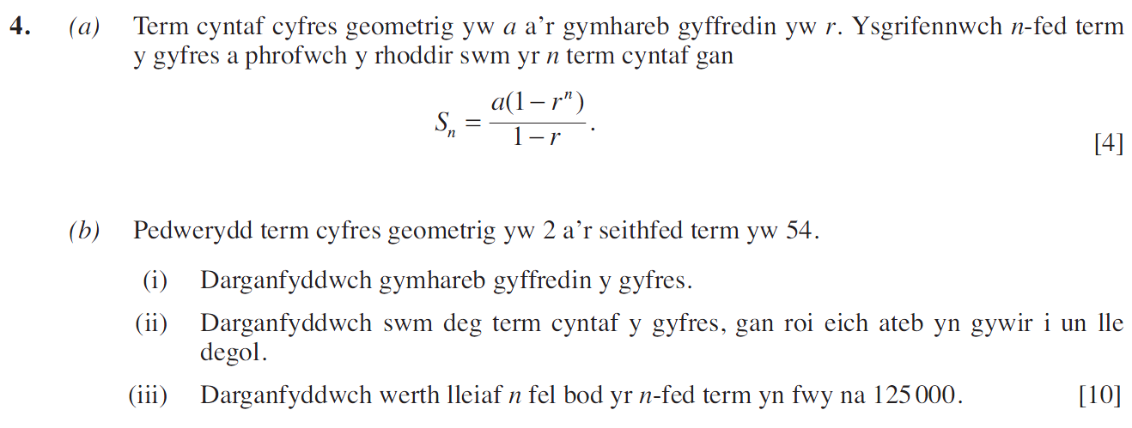
..........................................................................................................................................................................................................................................................................................................
..........................................................................................................................................................................................................................................................................................................
..........................................................................................................................................................................................................................................................................................................
..........................................................................................................................................................................................................................................................................................................
..........................................................................................................................................................................................................................................................................................................
..........................................................................................................................................................................................................................................................................................................
..........................................................................................................................................................................................................................................................................................................
..........................................................................................................................................................................................................................................................................................................
..........................................................................................................................................................................................................................................................................................................
..........................................................................................................................................................................................................................................................................................................
..........................................................................................................................................................................................................................................................................................................
..........................................................................................................................................................................................................................................................................................................
..........................................................................................................................................................................................................................................................................................................
..........................................................................................................................................................................................................................................................................................................
..........................................................................................................................................................................................................................................................................................................
..........................................................................................................................................................................................................................................................................................................
..........................................................................................................................................................................................................................................................................................................
..........................................................................................................................................................................................................................................................................................................
..........................................................................................................................................................................................................................................................................................................
..........................................................................................................................................................................................................................................................................................................
..........................................................................................................................................................................................................................................................................................................
..........................................................................................................................................................................................................................................................................................................
..........................................................................................................................................................................................................................................................................................................
..........................................................................................................................................................................................................................................................................................................
..........................................................................................................................................................................................................................................................................................................
..........................................................................................................................................................................................................................................................................................................
..........................................................................................................................................................................................................................................................................................................
..........................................................................................................................................................................................................................................................................................................
..........................................................................................................................................................................................................................................................................................................
..........................................................................................................................................................................................................................................................................................................
..........................................................................................................................................................................................................................................................................................................
..........................................................................................................................................................................................................................................................................................................
..........................................................................................................................................................................................................................................................................................................
..........................................................................................................................................................................................................................................................................................................
..........................................................................................................................................................................................................................................................................................................
..........................................................................................................................................................................................................................................................................................................
..........................................................................................................................................................................................................................................................................................................
..........................................................................................................................................................................................................................................................................................................
..........................................................................................................................................................................................................................................................................................................
..........................................................................................................................................................................................................................................................................................................
..........................................................................................................................................................................................................................................................................................................
..........................................................................................................................................................................................................................................................................................................
..........................................................................................................................................................................................................................................................................................................
..........................................................................................................................................................................................................................................................................................................
..........................................................................................................................................................................................................................................................................................................
..........................................................................................................................................................................................................................................................................................................
..........................................................................................................................................................................................................................................................................................................
..........................................................................................................................................................................................................................................................................................................
..........................................................................................................................................................................................................................................................................................................
..........................................................................................................................................................................................................................................................................................................
..........................................................................................................................................................................................................................................................................................................
..........................................................................................................................................................................................................................................................................................................
..........................................................................................................................................................................................................................................................................................................
..........................................................................................................................................................................................................................................................................................................
..........................................................................................................................................................................................................................................................................................................
..........................................................................................................................................................................................................................................................................................................
..........................................................................................................................................................................................................................................................................................................
..........................................................................................................................................................................................................................................................................................................
..........................................................................................................................................................................................................................................................................................................
..........................................................................................................................................................................................................................................................................................................
..........................................................................................................................................................................................................................................................................................................
..........................................................................................................................................................................................................................................................................................................
..........................................................................................................................................................................................................................................................................................................
..........................................................................................................................................................................................................................................................................................................
..........................................................................................................................................................................................................................................................................................................
..........................................................................................................................................................................................................................................................................................................
..........................................................................................................................................................................................................................................................................................................
..........................................................................................................................................................................................................................................................................................................
..........................................................................................................................................................................................................................................................................................................
..........................................................................................................................................................................................................................................................................................................
(C2 Gaeaf 2010)
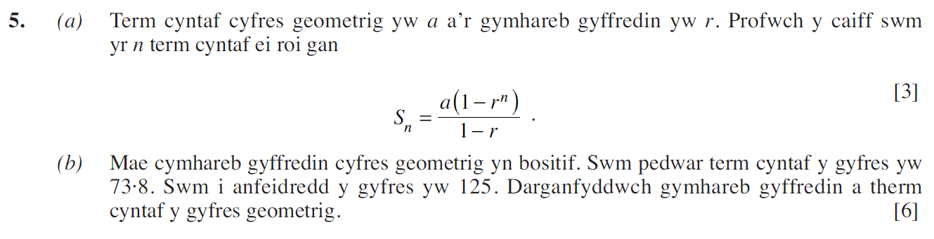
..........................................................................................................................................................................................................................................................................................................
..........................................................................................................................................................................................................................................................................................................
..........................................................................................................................................................................................................................................................................................................
..........................................................................................................................................................................................................................................................................................................
..........................................................................................................................................................................................................................................................................................................
..........................................................................................................................................................................................................................................................................................................
..........................................................................................................................................................................................................................................................................................................
..........................................................................................................................................................................................................................................................................................................
..........................................................................................................................................................................................................................................................................................................
..........................................................................................................................................................................................................................................................................................................
..........................................................................................................................................................................................................................................................................................................
..........................................................................................................................................................................................................................................................................................................
..........................................................................................................................................................................................................................................................................................................
..........................................................................................................................................................................................................................................................................................................
..........................................................................................................................................................................................................................................................................................................
..........................................................................................................................................................................................................................................................................................................
..........................................................................................................................................................................................................................................................................................................
..........................................................................................................................................................................................................................................................................................................
..........................................................................................................................................................................................................................................................................................................
..........................................................................................................................................................................................................................................................................................................
..........................................................................................................................................................................................................................................................................................................
..........................................................................................................................................................................................................................................................................................................
..........................................................................................................................................................................................................................................................................................................
..........................................................................................................................................................................................................................................................................................................
..........................................................................................................................................................................................................................................................................................................
..........................................................................................................................................................................................................................................................................................................
..........................................................................................................................................................................................................................................................................................................
..........................................................................................................................................................................................................................................................................................................
..........................................................................................................................................................................................................................................................................................................
..........................................................................................................................................................................................................................................................................................................
..........................................................................................................................................................................................................................................................................................................
..........................................................................................................................................................................................................................................................................................................
..........................................................................................................................................................................................................................................................................................................
..........................................................................................................................................................................................................................................................................................................
..........................................................................................................................................................................................................................................................................................................
..........................................................................................................................................................................................................................................................................................................
..........................................................................................................................................................................................................................................................................................................
..........................................................................................................................................................................................................................................................................................................
..........................................................................................................................................................................................................................................................................................................
..........................................................................................................................................................................................................................................................................................................
..........................................................................................................................................................................................................................................................................................................
..........................................................................................................................................................................................................................................................................................................
..........................................................................................................................................................................................................................................................................................................
..........................................................................................................................................................................................................................................................................................................
..........................................................................................................................................................................................................................................................................................................
..........................................................................................................................................................................................................................................................................................................
..........................................................................................................................................................................................................................................................................................................
..........................................................................................................................................................................................................................................................................................................
..........................................................................................................................................................................................................................................................................................................
..........................................................................................................................................................................................................................................................................................................
..........................................................................................................................................................................................................................................................................................................
..........................................................................................................................................................................................................................................................................................................
..........................................................................................................................................................................................................................................................................................................
..........................................................................................................................................................................................................................................................................................................
..........................................................................................................................................................................................................................................................................................................
..........................................................................................................................................................................................................................................................................................................
..........................................................................................................................................................................................................................................................................................................
..........................................................................................................................................................................................................................................................................................................
..........................................................................................................................................................................................................................................................................................................
..........................................................................................................................................................................................................................................................................................................
..........................................................................................................................................................................................................................................................................................................
..........................................................................................................................................................................................................................................................................................................
..........................................................................................................................................................................................................................................................................................................
..........................................................................................................................................................................................................................................................................................................
..........................................................................................................................................................................................................................................................................................................
..........................................................................................................................................................................................................................................................................................................
..........................................................................................................................................................................................................................................................................................................
..........................................................................................................................................................................................................................................................................................................
..........................................................................................................................................................................................................................................................................................................
..........................................................................................................................................................................................................................................................................................................
..........................................................................................................................................................................................................................................................................................................
..........................................................................................................................................................................................................................................................................................................
..........................................................................................................................................................................................................................................................................................................
(C2 Haf 2010)
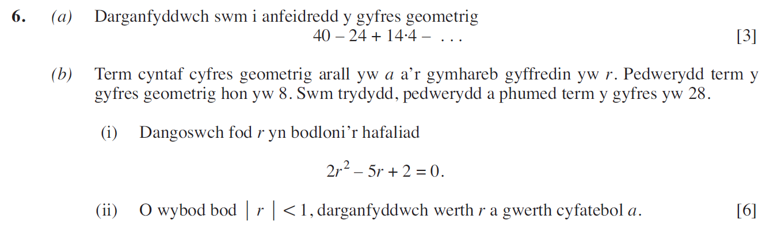
..........................................................................................................................................................................................................................................................................................................
..........................................................................................................................................................................................................................................................................................................
..........................................................................................................................................................................................................................................................................................................
..........................................................................................................................................................................................................................................................................................................
..........................................................................................................................................................................................................................................................................................................
..........................................................................................................................................................................................................................................................................................................
..........................................................................................................................................................................................................................................................................................................
..........................................................................................................................................................................................................................................................................................................
..........................................................................................................................................................................................................................................................................................................
..........................................................................................................................................................................................................................................................................................................
..........................................................................................................................................................................................................................................................................................................
..........................................................................................................................................................................................................................................................................................................
..........................................................................................................................................................................................................................................................................................................
..........................................................................................................................................................................................................................................................................................................
..........................................................................................................................................................................................................................................................................................................
..........................................................................................................................................................................................................................................................................................................
..........................................................................................................................................................................................................................................................................................................
..........................................................................................................................................................................................................................................................................................................
..........................................................................................................................................................................................................................................................................................................
..........................................................................................................................................................................................................................................................................................................
..........................................................................................................................................................................................................................................................................................................
..........................................................................................................................................................................................................................................................................................................
..........................................................................................................................................................................................................................................................................................................
..........................................................................................................................................................................................................................................................................................................
..........................................................................................................................................................................................................................................................................................................
..........................................................................................................................................................................................................................................................................................................
..........................................................................................................................................................................................................................................................................................................
..........................................................................................................................................................................................................................................................................................................
..........................................................................................................................................................................................................................................................................................................
..........................................................................................................................................................................................................................................................................................................
..........................................................................................................................................................................................................................................................................................................
..........................................................................................................................................................................................................................................................................................................
..........................................................................................................................................................................................................................................................................................................
..........................................................................................................................................................................................................................................................................................................
..........................................................................................................................................................................................................................................................................................................
..........................................................................................................................................................................................................................................................................................................
..........................................................................................................................................................................................................................................................................................................
..........................................................................................................................................................................................................................................................................................................
..........................................................................................................................................................................................................................................................................................................
..........................................................................................................................................................................................................................................................................................................
..........................................................................................................................................................................................................................................................................................................
..........................................................................................................................................................................................................................................................................................................
..........................................................................................................................................................................................................................................................................................................
..........................................................................................................................................................................................................................................................................................................
..........................................................................................................................................................................................................................................................................................................
..........................................................................................................................................................................................................................................................................................................
..........................................................................................................................................................................................................................................................................................................
..........................................................................................................................................................................................................................................................................................................
..........................................................................................................................................................................................................................................................................................................
..........................................................................................................................................................................................................................................................................................................
..........................................................................................................................................................................................................................................................................................................
..........................................................................................................................................................................................................................................................................................................
..........................................................................................................................................................................................................................................................................................................
..........................................................................................................................................................................................................................................................................................................
..........................................................................................................................................................................................................................................................................................................
..........................................................................................................................................................................................................................................................................................................
..........................................................................................................................................................................................................................................................................................................
..........................................................................................................................................................................................................................................................................................................
..........................................................................................................................................................................................................................................................................................................
..........................................................................................................................................................................................................................................................................................................
..........................................................................................................................................................................................................................................................................................................
..........................................................................................................................................................................................................................................................................................................
..........................................................................................................................................................................................................................................................................................................
..........................................................................................................................................................................................................................................................................................................
..........................................................................................................................................................................................................................................................................................................
..........................................................................................................................................................................................................................................................................................................
..........................................................................................................................................................................................................................................................................................................
..........................................................................................................................................................................................................................................................................................................
..........................................................................................................................................................................................................................................................................................................
..........................................................................................................................................................................................................................................................................................................
..........................................................................................................................................................................................................................................................................................................
..........................................................................................................................................................................................................................................................................................................
(Uned 3 Haf 2023)
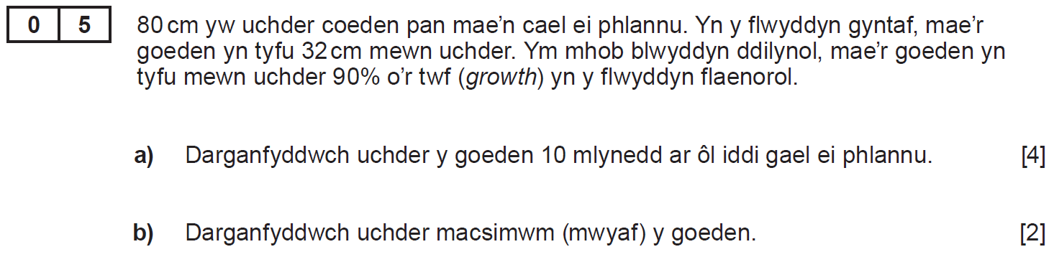
..........................................................................................................................................................................................................................................................................................................
..........................................................................................................................................................................................................................................................................................................
..........................................................................................................................................................................................................................................................................................................
..........................................................................................................................................................................................................................................................................................................
..........................................................................................................................................................................................................................................................................................................
..........................................................................................................................................................................................................................................................................................................
..........................................................................................................................................................................................................................................................................................................
..........................................................................................................................................................................................................................................................................................................
..........................................................................................................................................................................................................................................................................................................
..........................................................................................................................................................................................................................................................................................................
..........................................................................................................................................................................................................................................................................................................
..........................................................................................................................................................................................................................................................................................................
..........................................................................................................................................................................................................................................................................................................
..........................................................................................................................................................................................................................................................................................................
..........................................................................................................................................................................................................................................................................................................
..........................................................................................................................................................................................................................................................................................................
..........................................................................................................................................................................................................................................................................................................
..........................................................................................................................................................................................................................................................................................................
..........................................................................................................................................................................................................................................................................................................
..........................................................................................................................................................................................................................................................................................................
..........................................................................................................................................................................................................................................................................................................
..........................................................................................................................................................................................................................................................................................................
..........................................................................................................................................................................................................................................................................................................
..........................................................................................................................................................................................................................................................................................................
..........................................................................................................................................................................................................................................................................................................
..........................................................................................................................................................................................................................................................................................................
..........................................................................................................................................................................................................................................................................................................
..........................................................................................................................................................................................................................................................................................................
..........................................................................................................................................................................................................................................................................................................
..........................................................................................................................................................................................................................................................................................................
..........................................................................................................................................................................................................................................................................................................
..........................................................................................................................................................................................................................................................................................................
(Uned 3 Haf 2024)
..........................................................................................................................................................................................................................................................................................................
..........................................................................................................................................................................................................................................................................................................
..........................................................................................................................................................................................................................................................................................................
..........................................................................................................................................................................................................................................................................................................
..........................................................................................................................................................................................................................................................................................................
..........................................................................................................................................................................................................................................................................................................
..........................................................................................................................................................................................................................................................................................................
..........................................................................................................................................................................................................................................................................................................
..........................................................................................................................................................................................................................................................................................................
..........................................................................................................................................................................................................................................................................................................
..........................................................................................................................................................................................................................................................................................................
..........................................................................................................................................................................................................................................................................................................
..........................................................................................................................................................................................................................................................................................................
..........................................................................................................................................................................................................................................................................................................
..........................................................................................................................................................................................................................................................................................................
..........................................................................................................................................................................................................................................................................................................
..........................................................................................................................................................................................................................................................................................................
..........................................................................................................................................................................................................................................................................................................
..........................................................................................................................................................................................................................................................................................................
..........................................................................................................................................................................................................................................................................................................
..........................................................................................................................................................................................................................................................................................................
..........................................................................................................................................................................................................................................................................................................
..........................................................................................................................................................................................................................................................................................................
..........................................................................................................................................................................................................................................................................................................
..........................................................................................................................................................................................................................................................................................................
..........................................................................................................................................................................................................................................................................................................
..........................................................................................................................................................................................................................................................................................................
..........................................................................................................................................................................................................................................................................................................
..........................................................................................................................................................................................................................................................................................................
..........................................................................................................................................................................................................................................................................................................
..........................................................................................................................................................................................................................................................................................................
..........................................................................................................................................................................................................................................................................................................
..........................................................................................................................................................................................................................................................................................................
..........................................................................................................................................................................................................................................................................................................
..........................................................................................................................................................................................................................................................................................................
..........................................................................................................................................................................................................................................................................................................
(Uned 3 Haf 2019)
..........................................................................................................................................................................................................................................................................................................
..........................................................................................................................................................................................................................................................................................................
..........................................................................................................................................................................................................................................................................................................
..........................................................................................................................................................................................................................................................................................................
..........................................................................................................................................................................................................................................................................................................
..........................................................................................................................................................................................................................................................................................................
..........................................................................................................................................................................................................................................................................................................
..........................................................................................................................................................................................................................................................................................................
..........................................................................................................................................................................................................................................................................................................
..........................................................................................................................................................................................................................................................................................................
..........................................................................................................................................................................................................................................................................................................
..........................................................................................................................................................................................................................................................................................................
..........................................................................................................................................................................................................................................................................................................
..........................................................................................................................................................................................................................................................................................................
..........................................................................................................................................................................................................................................................................................................
..........................................................................................................................................................................................................................................................................................................
..........................................................................................................................................................................................................................................................................................................
..........................................................................................................................................................................................................................................................................................................
..........................................................................................................................................................................................................................................................................................................
..........................................................................................................................................................................................................................................................................................................
..........................................................................................................................................................................................................................................................................................................
..........................................................................................................................................................................................................................................................................................................
..........................................................................................................................................................................................................................................................................................................
..........................................................................................................................................................................................................................................................................................................
..........................................................................................................................................................................................................................................................................................................
..........................................................................................................................................................................................................................................................................................................
..........................................................................................................................................................................................................................................................................................................
..........................................................................................................................................................................................................................................................................................................
..........................................................................................................................................................................................................................................................................................................
..........................................................................................................................................................................................................................................................................................................
..........................................................................................................................................................................................................................................................................................................
..........................................................................................................................................................................................................................................................................................................
..........................................................................................................................................................................................................................................................................................................
..........................................................................................................................................................................................................................................................................................................
(Uned 3 Haf 2018)








































































