



René Descartes was born on the 15th of March, 1596, in France. He used graphs in order to connect algebra to geometry. Graphs that use $x$ and $y$ axes are named Cartesian graphs.
What is the work? |  | Imagine a straight line connecting two different coordinates.  This work allows us to find things such as the equation of the straight line; the mid-point of the two coordinates; the gradient of the straight line; and the distance between the two coordinates.
What is required before starting? |  | GCSE Work: Mean; coordinates; solving equations; substitution; solving equations; area; the reciprocal; Pythagoras’ Theorem; gradient; equation of a straight line; trigonometry; changing the subject; surds.
Where does this lead to? |  | Unit 1: Equation of a circle; equation of the tangent and normal.  Unit 3: Equation of the tangent and normal.  Applications: GPS; creating and viewing PDF files.

Length of $AB$
Gradient of $AB$
Equation of $AB$

Parallel and Perpendicular Gradients
Consider any two points $A=(x_{1}, y_{1})$ and $B=(x_{2}, y_{2})$ in a plane.
$$y$$
$A=(x_{1},y_{1}$)
$B=(x_{2},y_{2}$)
$$x_{2}-x_{1}$$
$$y_{2}-y_{1}$$
$$x$$
We can use the mean to find the mid-point of $AB$: $\left(\frac{x_{1}+x_{2}}{2},\frac{y_{1}+y_{2}}{2}\right)$.
We can use Pythagoras’ Theorem to find the length of $AB$: $\sqrt{{(x_{2}-x_{1})}^{2}+{(y_{2}-y_{1})}^{2}}$.
The gradient of the line $AB$ is $\frac{y_{2}-y_{1}}{x_{2}-x_{1}}$.
The equation of the line $AB$ is $y-y_{1}=m(x-x_{1})$, where $m$ represents the gradient of the line,
and $(x_{1},y_{1})$ represents any point on the line. We can re-arrange this equation to give the forms
$y=mx+c$ or $ax+by+c=0$, as required.
Two straight lines are parallel if their gradients are equal. Two straight lines are perpendicular
if the product of their gradients is $-1$, or one gradient is the negative reciprocal of the other.
Exercise 1
For the points $A=(2, 1)$ and $B=(6, 4)$, find (a) the mid-point of the two points; (b) the distance between the two points; (c) the gradient of the straight line connecting the two points; (d) the equation of the straight line connecting the two points, in the form $ax+by+c=0$.
..........................................................................................................................................................................................................................................................................................................
..........................................................................................................................................................................................................................................................................................................
..........................................................................................................................................................................................................................................................................................................
..........................................................................................................................................................................................................................................................................................................
..........................................................................................................................................................................................................................................................................................................
..........................................................................................................................................................................................................................................................................................................
..........................................................................................................................................................................................................................................................................................................
..........................................................................................................................................................................................................................................................................................................
..........................................................................................................................................................................................................................................................................................................
..........................................................................................................................................................................................................................................................................................................
..........................................................................................................................................................................................................................................................................................................
..........................................................................................................................................................................................................................................................................................................
..........................................................................................................................................................................................................................................................................................................
..........................................................................................................................................................................................................................................................................................................
..........................................................................................................................................................................................................................................................................................................
..........................................................................................................................................................................................................................................................................................................
..........................................................................................................................................................................................................................................................................................................
..........................................................................................................................................................................................................................................................................................................
Exericse 2
For the following points, find (i) the mid-point of the two points; (ii) the distance between the two points; (iii) the gradient of the straight line connecting the two points; (iv) the equation of the straight line connecting the two points, in the form $ax+by+c=0$.
(a) $A=(3, 1)$, $B=(4, 6)$. (b) $A=(-3, 2)$, $B=(9, 4)$.
(c) $A=(2, 5)$, $B=(-5,-3)$. (d) $A=(-10,-1)$, $B=(-2,-5)$.
Exercise 3
Complete the following table.
$$A$$ | $$B$$ | Mid-point of $AB$
(2, 8) | (8, 14)
(6, 8) |  | (10, 12)
 | (20, 14) | (10, 5)
(–2, 5) |  | (5, 3)
 | (7, –8) | (14, –16)
(–8, –5) |  | (–3, 4)
 | (–5, 1) | (13, –2)
Exercise 4
The following diagram shows the three points $A=(1, 3)$, $B=(3, 0)$, $C=(-2, 1)$.
$$y$$
$$C$$
$$A$$
$$B$$
$$x$$
(a) Find the gradient of the line $AB$. (b) Find the gradient of the line $AC$.
(c) Show that the lines $AB$ and $AC$ are perpendicular to each other.
(d) Find the length of the line $AB$. (e) Find the length of the line $AC$.
(f) Find the area of the triangle $ABC$. (g) Find the value of $\tan{A\hat{B}C}$.
(h) Find the mid-point of the line $AB$. (i) Find the equation of the line $AB$.
(j) Find the equation of the straight line passing through the mid-point of $AB$ and perpendicular to $AB$.
..........................................................................................................................................................................................................................................................................................................
..........................................................................................................................................................................................................................................................................................................
..........................................................................................................................................................................................................................................................................................................
..........................................................................................................................................................................................................................................................................................................
..........................................................................................................................................................................................................................................................................................................
..........................................................................................................................................................................................................................................................................................................
..........................................................................................................................................................................................................................................................................................................
..........................................................................................................................................................................................................................................................................................................
..........................................................................................................................................................................................................................................................................................................
..........................................................................................................................................................................................................................................................................................................
..........................................................................................................................................................................................................................................................................................................
..........................................................................................................................................................................................................................................................................................................
..........................................................................................................................................................................................................................................................................................................
..........................................................................................................................................................................................................................................................................................................
..........................................................................................................................................................................................................................................................................................................
..........................................................................................................................................................................................................................................................................................................
..........................................................................................................................................................................................................................................................................................................
..........................................................................................................................................................................................................................................................................................................
..........................................................................................................................................................................................................................................................................................................
..........................................................................................................................................................................................................................................................................................................
..........................................................................................................................................................................................................................................................................................................
..........................................................................................................................................................................................................................................................................................................
..........................................................................................................................................................................................................................................................................................................
..........................................................................................................................................................................................................................................................................................................
..........................................................................................................................................................................................................................................................................................................
..........................................................................................................................................................................................................................................................................................................
..........................................................................................................................................................................................................................................................................................................
..........................................................................................................................................................................................................................................................................................................
..........................................................................................................................................................................................................................................................................................................
..........................................................................................................................................................................................................................................................................................................
..........................................................................................................................................................................................................................................................................................................
..........................................................................................................................................................................................................................................................................................................
..........................................................................................................................................................................................................................................................................................................
..........................................................................................................................................................................................................................................................................................................
..........................................................................................................................................................................................................................................................................................................
..........................................................................................................................................................................................................................................................................................................
..........................................................................................................................................................................................................................................................................................................
..........................................................................................................................................................................................................................................................................................................
..........................................................................................................................................................................................................................................................................................................
..........................................................................................................................................................................................................................................................................................................
..........................................................................................................................................................................................................................................................................................................
..........................................................................................................................................................................................................................................................................................................
..........................................................................................................................................................................................................................................................................................................
..........................................................................................................................................................................................................................................................................................................
..........................................................................................................................................................................................................................................................................................................
..........................................................................................................................................................................................................................................................................................................
..........................................................................................................................................................................................................................................................................................................
..........................................................................................................................................................................................................................................................................................................
..........................................................................................................................................................................................................................................................................................................
..........................................................................................................................................................................................................................................................................................................
..........................................................................................................................................................................................................................................................................................................
..........................................................................................................................................................................................................................................................................................................
..........................................................................................................................................................................................................................................................................................................
..........................................................................................................................................................................................................................................................................................................
..........................................................................................................................................................................................................................................................................................................
..........................................................................................................................................................................................................................................................................................................
..........................................................................................................................................................................................................................................................................................................
..........................................................................................................................................................................................................................................................................................................
..........................................................................................................................................................................................................................................................................................................
(C1 Summer 2006)
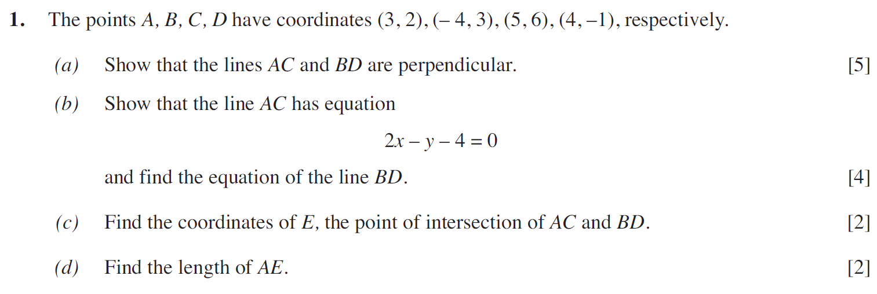
..........................................................................................................................................................................................................................................................................................................
..........................................................................................................................................................................................................................................................................................................
..........................................................................................................................................................................................................................................................................................................
..........................................................................................................................................................................................................................................................................................................
..........................................................................................................................................................................................................................................................................................................
..........................................................................................................................................................................................................................................................................................................
..........................................................................................................................................................................................................................................................................................................
..........................................................................................................................................................................................................................................................................................................
..........................................................................................................................................................................................................................................................................................................
..........................................................................................................................................................................................................................................................................................................
..........................................................................................................................................................................................................................................................................................................
..........................................................................................................................................................................................................................................................................................................
..........................................................................................................................................................................................................................................................................................................
..........................................................................................................................................................................................................................................................................................................
..........................................................................................................................................................................................................................................................................................................
..........................................................................................................................................................................................................................................................................................................
..........................................................................................................................................................................................................................................................................................................
..........................................................................................................................................................................................................................................................................................................
..........................................................................................................................................................................................................................................................................................................
..........................................................................................................................................................................................................................................................................................................
..........................................................................................................................................................................................................................................................................................................
..........................................................................................................................................................................................................................................................................................................
..........................................................................................................................................................................................................................................................................................................
..........................................................................................................................................................................................................................................................................................................
..........................................................................................................................................................................................................................................................................................................
..........................................................................................................................................................................................................................................................................................................
..........................................................................................................................................................................................................................................................................................................
..........................................................................................................................................................................................................................................................................................................
..........................................................................................................................................................................................................................................................................................................
..........................................................................................................................................................................................................................................................................................................
..........................................................................................................................................................................................................................................................................................................
..........................................................................................................................................................................................................................................................................................................
..........................................................................................................................................................................................................................................................................................................
..........................................................................................................................................................................................................................................................................................................
..........................................................................................................................................................................................................................................................................................................
..........................................................................................................................................................................................................................................................................................................
..........................................................................................................................................................................................................................................................................................................
..........................................................................................................................................................................................................................................................................................................
..........................................................................................................................................................................................................................................................................................................
..........................................................................................................................................................................................................................................................................................................
..........................................................................................................................................................................................................................................................................................................
..........................................................................................................................................................................................................................................................................................................
..........................................................................................................................................................................................................................................................................................................
..........................................................................................................................................................................................................................................................................................................
..........................................................................................................................................................................................................................................................................................................
..........................................................................................................................................................................................................................................................................................................
..........................................................................................................................................................................................................................................................................................................
..........................................................................................................................................................................................................................................................................................................
..........................................................................................................................................................................................................................................................................................................
..........................................................................................................................................................................................................................................................................................................
..........................................................................................................................................................................................................................................................................................................
..........................................................................................................................................................................................................................................................................................................
..........................................................................................................................................................................................................................................................................................................
..........................................................................................................................................................................................................................................................................................................
..........................................................................................................................................................................................................................................................................................................
..........................................................................................................................................................................................................................................................................................................
..........................................................................................................................................................................................................................................................................................................
..........................................................................................................................................................................................................................................................................................................
..........................................................................................................................................................................................................................................................................................................
..........................................................................................................................................................................................................................................................................................................
..........................................................................................................................................................................................................................................................................................................
..........................................................................................................................................................................................................................................................................................................
..........................................................................................................................................................................................................................................................................................................
..........................................................................................................................................................................................................................................................................................................
..........................................................................................................................................................................................................................................................................................................
..........................................................................................................................................................................................................................................................................................................
..........................................................................................................................................................................................................................................................................................................
..........................................................................................................................................................................................................................................................................................................
(C1 Summer 2007)
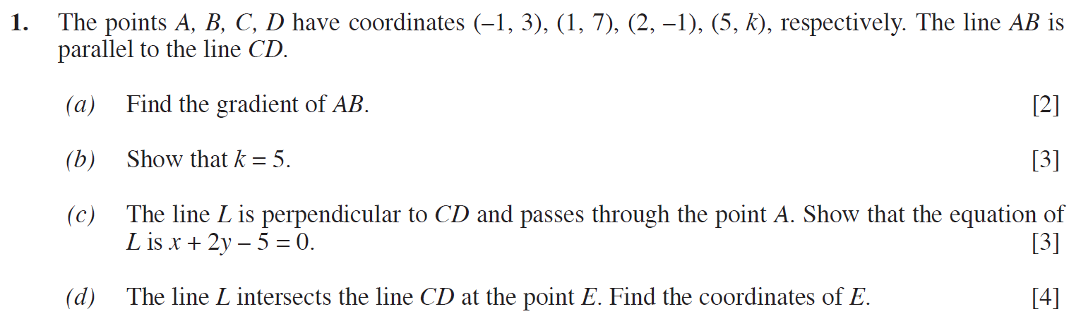
..........................................................................................................................................................................................................................................................................................................
..........................................................................................................................................................................................................................................................................................................
..........................................................................................................................................................................................................................................................................................................
..........................................................................................................................................................................................................................................................................................................
..........................................................................................................................................................................................................................................................................................................
..........................................................................................................................................................................................................................................................................................................
..........................................................................................................................................................................................................................................................................................................
..........................................................................................................................................................................................................................................................................................................
..........................................................................................................................................................................................................................................................................................................
..........................................................................................................................................................................................................................................................................................................
..........................................................................................................................................................................................................................................................................................................
..........................................................................................................................................................................................................................................................................................................
..........................................................................................................................................................................................................................................................................................................
..........................................................................................................................................................................................................................................................................................................
..........................................................................................................................................................................................................................................................................................................
..........................................................................................................................................................................................................................................................................................................
..........................................................................................................................................................................................................................................................................................................
..........................................................................................................................................................................................................................................................................................................
..........................................................................................................................................................................................................................................................................................................
..........................................................................................................................................................................................................................................................................................................
..........................................................................................................................................................................................................................................................................................................
..........................................................................................................................................................................................................................................................................................................
..........................................................................................................................................................................................................................................................................................................
..........................................................................................................................................................................................................................................................................................................
..........................................................................................................................................................................................................................................................................................................
..........................................................................................................................................................................................................................................................................................................
..........................................................................................................................................................................................................................................................................................................
..........................................................................................................................................................................................................................................................................................................
..........................................................................................................................................................................................................................................................................................................
..........................................................................................................................................................................................................................................................................................................
..........................................................................................................................................................................................................................................................................................................
..........................................................................................................................................................................................................................................................................................................
..........................................................................................................................................................................................................................................................................................................
..........................................................................................................................................................................................................................................................................................................
..........................................................................................................................................................................................................................................................................................................
..........................................................................................................................................................................................................................................................................................................
..........................................................................................................................................................................................................................................................................................................
..........................................................................................................................................................................................................................................................................................................
..........................................................................................................................................................................................................................................................................................................
..........................................................................................................................................................................................................................................................................................................
..........................................................................................................................................................................................................................................................................................................
..........................................................................................................................................................................................................................................................................................................
..........................................................................................................................................................................................................................................................................................................
..........................................................................................................................................................................................................................................................................................................
..........................................................................................................................................................................................................................................................................................................
..........................................................................................................................................................................................................................................................................................................
..........................................................................................................................................................................................................................................................................................................
..........................................................................................................................................................................................................................................................................................................
..........................................................................................................................................................................................................................................................................................................
..........................................................................................................................................................................................................................................................................................................
..........................................................................................................................................................................................................................................................................................................
..........................................................................................................................................................................................................................................................................................................
..........................................................................................................................................................................................................................................................................................................
..........................................................................................................................................................................................................................................................................................................
..........................................................................................................................................................................................................................................................................................................
..........................................................................................................................................................................................................................................................................................................
..........................................................................................................................................................................................................................................................................................................
..........................................................................................................................................................................................................................................................................................................
..........................................................................................................................................................................................................................................................................................................
..........................................................................................................................................................................................................................................................................................................
..........................................................................................................................................................................................................................................................................................................
..........................................................................................................................................................................................................................................................................................................
..........................................................................................................................................................................................................................................................................................................
..........................................................................................................................................................................................................................................................................................................
..........................................................................................................................................................................................................................................................................................................
..........................................................................................................................................................................................................................................................................................................
..........................................................................................................................................................................................................................................................................................................
..........................................................................................................................................................................................................................................................................................................
..........................................................................................................................................................................................................................................................................................................
..........................................................................................................................................................................................................................................................................................................
..........................................................................................................................................................................................................................................................................................................
..........................................................................................................................................................................................................................................................................................................
(C1 Winter 2009)
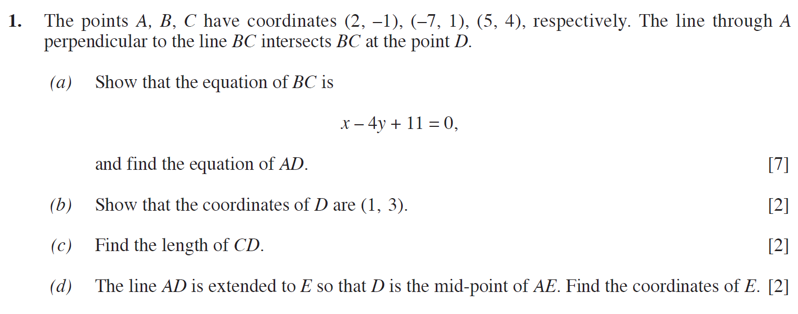
..........................................................................................................................................................................................................................................................................................................
..........................................................................................................................................................................................................................................................................................................
..........................................................................................................................................................................................................................................................................................................
..........................................................................................................................................................................................................................................................................................................
..........................................................................................................................................................................................................................................................................................................
..........................................................................................................................................................................................................................................................................................................
..........................................................................................................................................................................................................................................................................................................
..........................................................................................................................................................................................................................................................................................................
..........................................................................................................................................................................................................................................................................................................
..........................................................................................................................................................................................................................................................................................................
..........................................................................................................................................................................................................................................................................................................
..........................................................................................................................................................................................................................................................................................................
..........................................................................................................................................................................................................................................................................................................
..........................................................................................................................................................................................................................................................................................................
..........................................................................................................................................................................................................................................................................................................
..........................................................................................................................................................................................................................................................................................................
..........................................................................................................................................................................................................................................................................................................
..........................................................................................................................................................................................................................................................................................................
..........................................................................................................................................................................................................................................................................................................
..........................................................................................................................................................................................................................................................................................................
..........................................................................................................................................................................................................................................................................................................
..........................................................................................................................................................................................................................................................................................................
..........................................................................................................................................................................................................................................................................................................
..........................................................................................................................................................................................................................................................................................................
..........................................................................................................................................................................................................................................................................................................
..........................................................................................................................................................................................................................................................................................................
..........................................................................................................................................................................................................................................................................................................
..........................................................................................................................................................................................................................................................................................................
..........................................................................................................................................................................................................................................................................................................
..........................................................................................................................................................................................................................................................................................................
..........................................................................................................................................................................................................................................................................................................
..........................................................................................................................................................................................................................................................................................................
..........................................................................................................................................................................................................................................................................................................
..........................................................................................................................................................................................................................................................................................................
..........................................................................................................................................................................................................................................................................................................
..........................................................................................................................................................................................................................................................................................................
..........................................................................................................................................................................................................................................................................................................
..........................................................................................................................................................................................................................................................................................................
..........................................................................................................................................................................................................................................................................................................
..........................................................................................................................................................................................................................................................................................................
..........................................................................................................................................................................................................................................................................................................
..........................................................................................................................................................................................................................................................................................................
..........................................................................................................................................................................................................................................................................................................
..........................................................................................................................................................................................................................................................................................................
..........................................................................................................................................................................................................................................................................................................
..........................................................................................................................................................................................................................................................................................................
..........................................................................................................................................................................................................................................................................................................
..........................................................................................................................................................................................................................................................................................................
..........................................................................................................................................................................................................................................................................................................
..........................................................................................................................................................................................................................................................................................................
..........................................................................................................................................................................................................................................................................................................
..........................................................................................................................................................................................................................................................................................................
..........................................................................................................................................................................................................................................................................................................
..........................................................................................................................................................................................................................................................................................................
..........................................................................................................................................................................................................................................................................................................
..........................................................................................................................................................................................................................................................................................................
..........................................................................................................................................................................................................................................................................................................
..........................................................................................................................................................................................................................................................................................................
..........................................................................................................................................................................................................................................................................................................
..........................................................................................................................................................................................................................................................................................................
..........................................................................................................................................................................................................................................................................................................
..........................................................................................................................................................................................................................................................................................................
..........................................................................................................................................................................................................................................................................................................
..........................................................................................................................................................................................................................................................................................................
..........................................................................................................................................................................................................................................................................................................
..........................................................................................................................................................................................................................................................................................................
..........................................................................................................................................................................................................................................................................................................
..........................................................................................................................................................................................................................................................................................................
..........................................................................................................................................................................................................................................................................................................
(C1 Summer 2009)
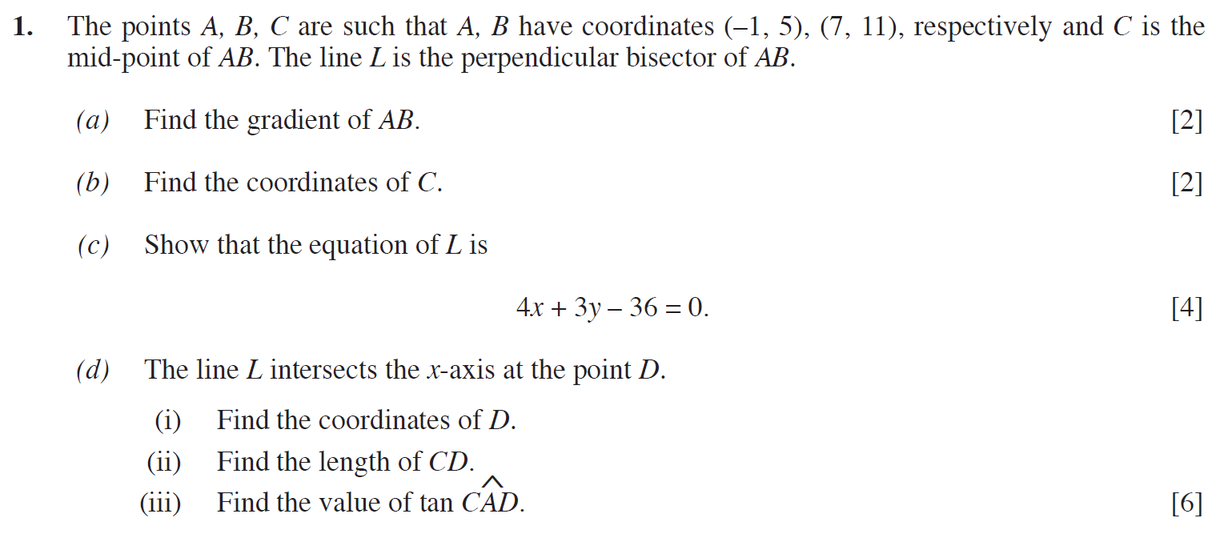
..........................................................................................................................................................................................................................................................................................................
..........................................................................................................................................................................................................................................................................................................
..........................................................................................................................................................................................................................................................................................................
..........................................................................................................................................................................................................................................................................................................
..........................................................................................................................................................................................................................................................................................................
..........................................................................................................................................................................................................................................................................................................
..........................................................................................................................................................................................................................................................................................................
..........................................................................................................................................................................................................................................................................................................
..........................................................................................................................................................................................................................................................................................................
..........................................................................................................................................................................................................................................................................................................
..........................................................................................................................................................................................................................................................................................................
..........................................................................................................................................................................................................................................................................................................
..........................................................................................................................................................................................................................................................................................................
..........................................................................................................................................................................................................................................................................................................
..........................................................................................................................................................................................................................................................................................................
..........................................................................................................................................................................................................................................................................................................
..........................................................................................................................................................................................................................................................................................................
..........................................................................................................................................................................................................................................................................................................
..........................................................................................................................................................................................................................................................................................................
..........................................................................................................................................................................................................................................................................................................
..........................................................................................................................................................................................................................................................................................................
..........................................................................................................................................................................................................................................................................................................
..........................................................................................................................................................................................................................................................................................................
..........................................................................................................................................................................................................................................................................................................
..........................................................................................................................................................................................................................................................................................................
..........................................................................................................................................................................................................................................................................................................
..........................................................................................................................................................................................................................................................................................................
..........................................................................................................................................................................................................................................................................................................
..........................................................................................................................................................................................................................................................................................................
..........................................................................................................................................................................................................................................................................................................
..........................................................................................................................................................................................................................................................................................................
..........................................................................................................................................................................................................................................................................................................
..........................................................................................................................................................................................................................................................................................................
..........................................................................................................................................................................................................................................................................................................
..........................................................................................................................................................................................................................................................................................................
..........................................................................................................................................................................................................................................................................................................
..........................................................................................................................................................................................................................................................................................................
..........................................................................................................................................................................................................................................................................................................
..........................................................................................................................................................................................................................................................................................................
..........................................................................................................................................................................................................................................................................................................
..........................................................................................................................................................................................................................................................................................................
..........................................................................................................................................................................................................................................................................................................
..........................................................................................................................................................................................................................................................................................................
..........................................................................................................................................................................................................................................................................................................
..........................................................................................................................................................................................................................................................................................................
..........................................................................................................................................................................................................................................................................................................
..........................................................................................................................................................................................................................................................................................................
..........................................................................................................................................................................................................................................................................................................
..........................................................................................................................................................................................................................................................................................................
..........................................................................................................................................................................................................................................................................................................
..........................................................................................................................................................................................................................................................................................................
..........................................................................................................................................................................................................................................................................................................
..........................................................................................................................................................................................................................................................................................................
..........................................................................................................................................................................................................................................................................................................
..........................................................................................................................................................................................................................................................................................................
..........................................................................................................................................................................................................................................................................................................
..........................................................................................................................................................................................................................................................................................................
..........................................................................................................................................................................................................................................................................................................
..........................................................................................................................................................................................................................................................................................................
..........................................................................................................................................................................................................................................................................................................
..........................................................................................................................................................................................................................................................................................................
..........................................................................................................................................................................................................................................................................................................
..........................................................................................................................................................................................................................................................................................................
..........................................................................................................................................................................................................................................................................................................
..........................................................................................................................................................................................................................................................................................................
..........................................................................................................................................................................................................................................................................................................
..........................................................................................................................................................................................................................................................................................................
..........................................................................................................................................................................................................................................................................................................
(C1 Summer 2011)
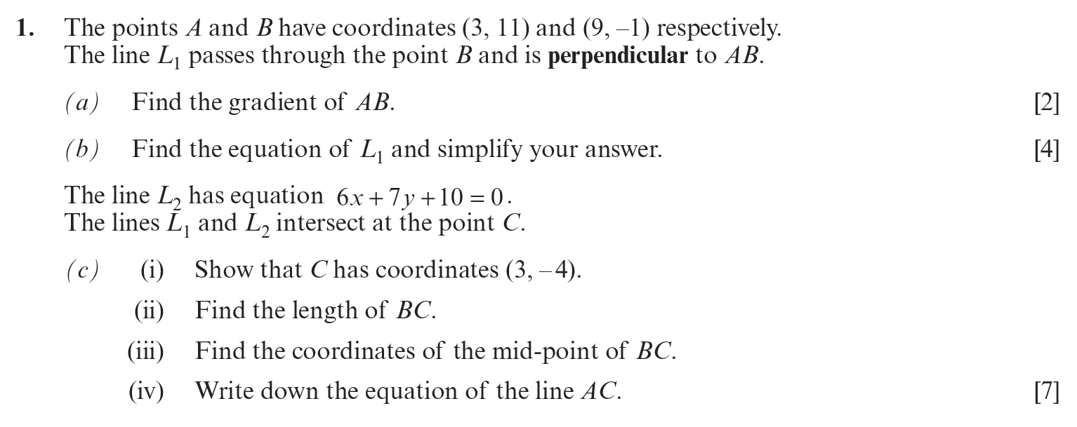
..........................................................................................................................................................................................................................................................................................................
..........................................................................................................................................................................................................................................................................................................
..........................................................................................................................................................................................................................................................................................................
..........................................................................................................................................................................................................................................................................................................
..........................................................................................................................................................................................................................................................................................................
..........................................................................................................................................................................................................................................................................................................
..........................................................................................................................................................................................................................................................................................................
..........................................................................................................................................................................................................................................................................................................
..........................................................................................................................................................................................................................................................................................................
..........................................................................................................................................................................................................................................................................................................
..........................................................................................................................................................................................................................................................................................................
..........................................................................................................................................................................................................................................................................................................
..........................................................................................................................................................................................................................................................................................................
..........................................................................................................................................................................................................................................................................................................
..........................................................................................................................................................................................................................................................................................................
..........................................................................................................................................................................................................................................................................................................
..........................................................................................................................................................................................................................................................................................................
..........................................................................................................................................................................................................................................................................................................
..........................................................................................................................................................................................................................................................................................................
..........................................................................................................................................................................................................................................................................................................
..........................................................................................................................................................................................................................................................................................................
..........................................................................................................................................................................................................................................................................................................
..........................................................................................................................................................................................................................................................................................................
..........................................................................................................................................................................................................................................................................................................
..........................................................................................................................................................................................................................................................................................................
..........................................................................................................................................................................................................................................................................................................
..........................................................................................................................................................................................................................................................................................................
..........................................................................................................................................................................................................................................................................................................
..........................................................................................................................................................................................................................................................................................................
..........................................................................................................................................................................................................................................................................................................
..........................................................................................................................................................................................................................................................................................................
..........................................................................................................................................................................................................................................................................................................
..........................................................................................................................................................................................................................................................................................................
..........................................................................................................................................................................................................................................................................................................
..........................................................................................................................................................................................................................................................................................................
..........................................................................................................................................................................................................................................................................................................
..........................................................................................................................................................................................................................................................................................................
..........................................................................................................................................................................................................................................................................................................
..........................................................................................................................................................................................................................................................................................................
..........................................................................................................................................................................................................................................................................................................
..........................................................................................................................................................................................................................................................................................................
..........................................................................................................................................................................................................................................................................................................
..........................................................................................................................................................................................................................................................................................................
..........................................................................................................................................................................................................................................................................................................
..........................................................................................................................................................................................................................................................................................................
..........................................................................................................................................................................................................................................................................................................
..........................................................................................................................................................................................................................................................................................................
..........................................................................................................................................................................................................................................................................................................
..........................................................................................................................................................................................................................................................................................................
..........................................................................................................................................................................................................................................................................................................
..........................................................................................................................................................................................................................................................................................................
..........................................................................................................................................................................................................................................................................................................
..........................................................................................................................................................................................................................................................................................................
..........................................................................................................................................................................................................................................................................................................
..........................................................................................................................................................................................................................................................................................................
..........................................................................................................................................................................................................................................................................................................
..........................................................................................................................................................................................................................................................................................................
..........................................................................................................................................................................................................................................................................................................
..........................................................................................................................................................................................................................................................................................................
..........................................................................................................................................................................................................................................................................................................
..........................................................................................................................................................................................................................................................................................................
..........................................................................................................................................................................................................................................................................................................
..........................................................................................................................................................................................................................................................................................................
..........................................................................................................................................................................................................................................................................................................
..........................................................................................................................................................................................................................................................................................................
..........................................................................................................................................................................................................................................................................................................
..........................................................................................................................................................................................................................................................................................................
..........................................................................................................................................................................................................................................................................................................
..........................................................................................................................................................................................................................................................................................................
(C1 Summer 2012)
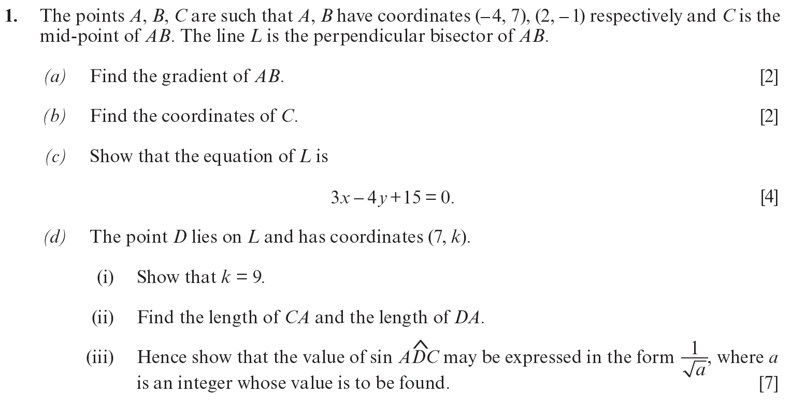
..........................................................................................................................................................................................................................................................................................................
..........................................................................................................................................................................................................................................................................................................
..........................................................................................................................................................................................................................................................................................................
..........................................................................................................................................................................................................................................................................................................
..........................................................................................................................................................................................................................................................................................................
..........................................................................................................................................................................................................................................................................................................
..........................................................................................................................................................................................................................................................................................................
..........................................................................................................................................................................................................................................................................................................
..........................................................................................................................................................................................................................................................................................................
..........................................................................................................................................................................................................................................................................................................
..........................................................................................................................................................................................................................................................................................................
..........................................................................................................................................................................................................................................................................................................
..........................................................................................................................................................................................................................................................................................................
..........................................................................................................................................................................................................................................................................................................
..........................................................................................................................................................................................................................................................................................................
..........................................................................................................................................................................................................................................................................................................
..........................................................................................................................................................................................................................................................................................................
..........................................................................................................................................................................................................................................................................................................
..........................................................................................................................................................................................................................................................................................................
..........................................................................................................................................................................................................................................................................................................
..........................................................................................................................................................................................................................................................................................................
..........................................................................................................................................................................................................................................................................................................
..........................................................................................................................................................................................................................................................................................................
..........................................................................................................................................................................................................................................................................................................
..........................................................................................................................................................................................................................................................................................................
..........................................................................................................................................................................................................................................................................................................
..........................................................................................................................................................................................................................................................................................................
..........................................................................................................................................................................................................................................................................................................
..........................................................................................................................................................................................................................................................................................................
..........................................................................................................................................................................................................................................................................................................
..........................................................................................................................................................................................................................................................................................................
..........................................................................................................................................................................................................................................................................................................
..........................................................................................................................................................................................................................................................................................................
..........................................................................................................................................................................................................................................................................................................
..........................................................................................................................................................................................................................................................................................................
..........................................................................................................................................................................................................................................................................................................
..........................................................................................................................................................................................................................................................................................................
..........................................................................................................................................................................................................................................................................................................
..........................................................................................................................................................................................................................................................................................................
..........................................................................................................................................................................................................................................................................................................
..........................................................................................................................................................................................................................................................................................................
..........................................................................................................................................................................................................................................................................................................
..........................................................................................................................................................................................................................................................................................................
..........................................................................................................................................................................................................................................................................................................
..........................................................................................................................................................................................................................................................................................................
..........................................................................................................................................................................................................................................................................................................
..........................................................................................................................................................................................................................................................................................................
..........................................................................................................................................................................................................................................................................................................
..........................................................................................................................................................................................................................................................................................................
..........................................................................................................................................................................................................................................................................................................
..........................................................................................................................................................................................................................................................................................................
..........................................................................................................................................................................................................................................................................................................
..........................................................................................................................................................................................................................................................................................................
..........................................................................................................................................................................................................................................................................................................
..........................................................................................................................................................................................................................................................................................................
..........................................................................................................................................................................................................................................................................................................
..........................................................................................................................................................................................................................................................................................................
..........................................................................................................................................................................................................................................................................................................
..........................................................................................................................................................................................................................................................................................................
..........................................................................................................................................................................................................................................................................................................
..........................................................................................................................................................................................................................................................................................................
..........................................................................................................................................................................................................................................................................................................
..........................................................................................................................................................................................................................................................................................................
..........................................................................................................................................................................................................................................................................................................
..........................................................................................................................................................................................................................................................................................................
(C1 Winter 2014)
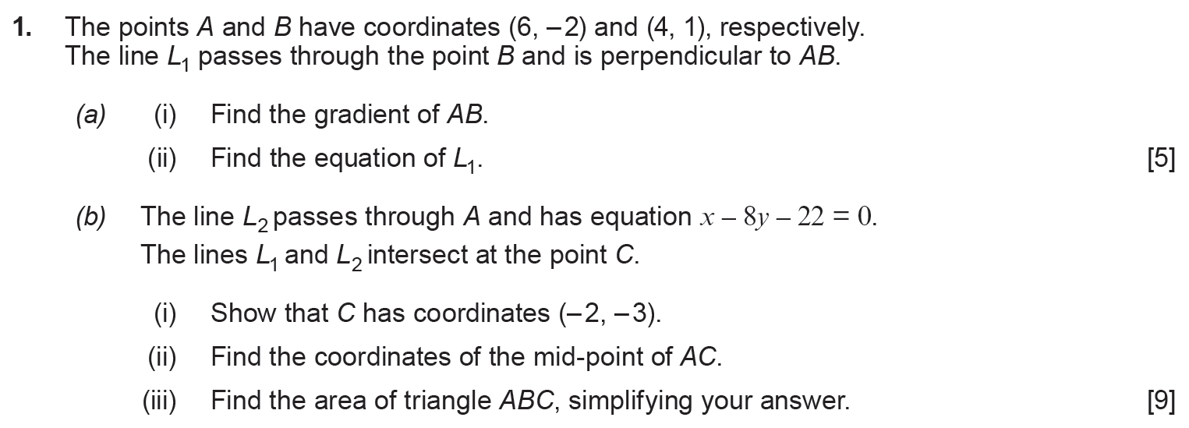
..........................................................................................................................................................................................................................................................................................................
..........................................................................................................................................................................................................................................................................................................
..........................................................................................................................................................................................................................................................................................................
..........................................................................................................................................................................................................................................................................................................
..........................................................................................................................................................................................................................................................................................................
..........................................................................................................................................................................................................................................................................................................
..........................................................................................................................................................................................................................................................................................................
..........................................................................................................................................................................................................................................................................................................
..........................................................................................................................................................................................................................................................................................................
..........................................................................................................................................................................................................................................................................................................
..........................................................................................................................................................................................................................................................................................................
..........................................................................................................................................................................................................................................................................................................
..........................................................................................................................................................................................................................................................................................................
..........................................................................................................................................................................................................................................................................................................
..........................................................................................................................................................................................................................................................................................................
..........................................................................................................................................................................................................................................................................................................
..........................................................................................................................................................................................................................................................................................................
..........................................................................................................................................................................................................................................................................................................
..........................................................................................................................................................................................................................................................................................................
..........................................................................................................................................................................................................................................................................................................
..........................................................................................................................................................................................................................................................................................................
..........................................................................................................................................................................................................................................................................................................
..........................................................................................................................................................................................................................................................................................................
..........................................................................................................................................................................................................................................................................................................
..........................................................................................................................................................................................................................................................................................................
..........................................................................................................................................................................................................................................................................................................
..........................................................................................................................................................................................................................................................................................................
..........................................................................................................................................................................................................................................................................................................
..........................................................................................................................................................................................................................................................................................................
..........................................................................................................................................................................................................................................................................................................
..........................................................................................................................................................................................................................................................................................................
..........................................................................................................................................................................................................................................................................................................
..........................................................................................................................................................................................................................................................................................................
..........................................................................................................................................................................................................................................................................................................
..........................................................................................................................................................................................................................................................................................................
..........................................................................................................................................................................................................................................................................................................
..........................................................................................................................................................................................................................................................................................................
..........................................................................................................................................................................................................................................................................................................
..........................................................................................................................................................................................................................................................................................................
..........................................................................................................................................................................................................................................................................................................
..........................................................................................................................................................................................................................................................................................................
..........................................................................................................................................................................................................................................................................................................
..........................................................................................................................................................................................................................................................................................................
..........................................................................................................................................................................................................................................................................................................
..........................................................................................................................................................................................................................................................................................................
..........................................................................................................................................................................................................................................................................................................
..........................................................................................................................................................................................................................................................................................................
..........................................................................................................................................................................................................................................................................................................
..........................................................................................................................................................................................................................................................................................................
..........................................................................................................................................................................................................................................................................................................
..........................................................................................................................................................................................................................................................................................................
..........................................................................................................................................................................................................................................................................................................
..........................................................................................................................................................................................................................................................................................................
..........................................................................................................................................................................................................................................................................................................
..........................................................................................................................................................................................................................................................................................................
..........................................................................................................................................................................................................................................................................................................
..........................................................................................................................................................................................................................................................................................................
..........................................................................................................................................................................................................................................................................................................
..........................................................................................................................................................................................................................................................................................................
..........................................................................................................................................................................................................................................................................................................
..........................................................................................................................................................................................................................................................................................................
..........................................................................................................................................................................................................................................................................................................
..........................................................................................................................................................................................................................................................................................................
..........................................................................................................................................................................................................................................................................................................
..........................................................................................................................................................................................................................................................................................................
..........................................................................................................................................................................................................................................................................................................
..........................................................................................................................................................................................................................................................................................................
..........................................................................................................................................................................................................................................................................................................
..........................................................................................................................................................................................................................................................................................................
..........................................................................................................................................................................................................................................................................................................
(C1 Summer 2017)
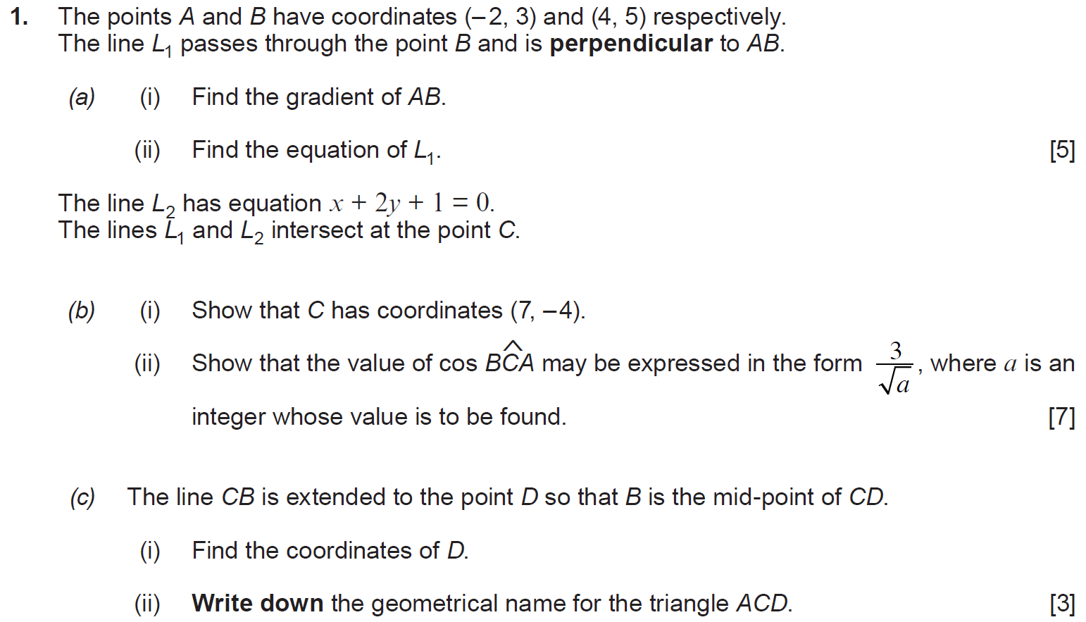
..........................................................................................................................................................................................................................................................................................................
..........................................................................................................................................................................................................................................................................................................
..........................................................................................................................................................................................................................................................................................................
..........................................................................................................................................................................................................................................................................................................
..........................................................................................................................................................................................................................................................................................................
..........................................................................................................................................................................................................................................................................................................
..........................................................................................................................................................................................................................................................................................................
..........................................................................................................................................................................................................................................................................................................
..........................................................................................................................................................................................................................................................................................................
..........................................................................................................................................................................................................................................................................................................
..........................................................................................................................................................................................................................................................................................................
..........................................................................................................................................................................................................................................................................................................
..........................................................................................................................................................................................................................................................................................................
..........................................................................................................................................................................................................................................................................................................
..........................................................................................................................................................................................................................................................................................................
..........................................................................................................................................................................................................................................................................................................
..........................................................................................................................................................................................................................................................................................................
..........................................................................................................................................................................................................................................................................................................
..........................................................................................................................................................................................................................................................................................................
..........................................................................................................................................................................................................................................................................................................
..........................................................................................................................................................................................................................................................................................................
..........................................................................................................................................................................................................................................................................................................
..........................................................................................................................................................................................................................................................................................................
..........................................................................................................................................................................................................................................................................................................
..........................................................................................................................................................................................................................................................................................................
..........................................................................................................................................................................................................................................................................................................
..........................................................................................................................................................................................................................................................................................................
..........................................................................................................................................................................................................................................................................................................
..........................................................................................................................................................................................................................................................................................................
..........................................................................................................................................................................................................................................................................................................
..........................................................................................................................................................................................................................................................................................................
..........................................................................................................................................................................................................................................................................................................
..........................................................................................................................................................................................................................................................................................................
..........................................................................................................................................................................................................................................................................................................
..........................................................................................................................................................................................................................................................................................................
..........................................................................................................................................................................................................................................................................................................
..........................................................................................................................................................................................................................................................................................................
..........................................................................................................................................................................................................................................................................................................
..........................................................................................................................................................................................................................................................................................................
..........................................................................................................................................................................................................................................................................................................
..........................................................................................................................................................................................................................................................................................................
..........................................................................................................................................................................................................................................................................................................
..........................................................................................................................................................................................................................................................................................................
..........................................................................................................................................................................................................................................................................................................
..........................................................................................................................................................................................................................................................................................................
..........................................................................................................................................................................................................................................................................................................
..........................................................................................................................................................................................................................................................................................................
..........................................................................................................................................................................................................................................................................................................
..........................................................................................................................................................................................................................................................................................................
..........................................................................................................................................................................................................................................................................................................
..........................................................................................................................................................................................................................................................................................................
..........................................................................................................................................................................................................................................................................................................
..........................................................................................................................................................................................................................................................................................................
..........................................................................................................................................................................................................................................................................................................
..........................................................................................................................................................................................................................................................................................................
..........................................................................................................................................................................................................................................................................................................
..........................................................................................................................................................................................................................................................................................................
..........................................................................................................................................................................................................................................................................................................
..........................................................................................................................................................................................................................................................................................................
..........................................................................................................................................................................................................................................................................................................
..........................................................................................................................................................................................................................................................................................................
..........................................................................................................................................................................................................................................................................................................
..........................................................................................................................................................................................................................................................................................................
..........................................................................................................................................................................................................................................................................................................
..........................................................................................................................................................................................................................................................................................................
..........................................................................................................................................................................................................................................................................................................
..........................................................................................................................................................................................................................................................................................................
..........................................................................................................................................................................................................................................................................................................
..........................................................................................................................................................................................................................................................................................................
..........................................................................................................................................................................................................................................................................................................
..........................................................................................................................................................................................................................................................................................................
..........................................................................................................................................................................................................................................................................................................
..........................................................................................................................................................................................................................................................................................................
..........................................................................................................................................................................................................................................................................................................
..........................................................................................................................................................................................................................................................................................................
..........................................................................................................................................................................................................................................................................................................
..........................................................................................................................................................................................................................................................................................................
..........................................................................................................................................................................................................................................................................................................
..........................................................................................................................................................................................................................................................................................................
..........................................................................................................................................................................................................................................................................................................
..........................................................................................................................................................................................................................................................................................................
..........................................................................................................................................................................................................................................................................................................
..........................................................................................................................................................................................................................................................................................................
..........................................................................................................................................................................................................................................................................................................
..........................................................................................................................................................................................................................................................................................................
..........................................................................................................................................................................................................................................................................................................
..........................................................................................................................................................................................................................................................................................................
..........................................................................................................................................................................................................................................................................................................
..........................................................................................................................................................................................................................................................................................................
..........................................................................................................................................................................................................................................................................................................
..........................................................................................................................................................................................................................................................................................................
..........................................................................................................................................................................................................................................................................................................
..........................................................................................................................................................................................................................................................................................................
..........................................................................................................................................................................................................................................................................................................
..........................................................................................................................................................................................................................................................................................................
..........................................................................................................................................................................................................................................................................................................
..........................................................................................................................................................................................................................................................................................................
..........................................................................................................................................................................................................................................................................................................
..........................................................................................................................................................................................................................................................................................................
..........................................................................................................................................................................................................................................................................................................
..........................................................................................................................................................................................................................................................................................................
..........................................................................................................................................................................................................................................................................................................
..........................................................................................................................................................................................................................................................................................................
..........................................................................................................................................................................................................................................................................................................
..........................................................................................................................................................................................................................................................................................................
(Unit 1 Summer 2018)
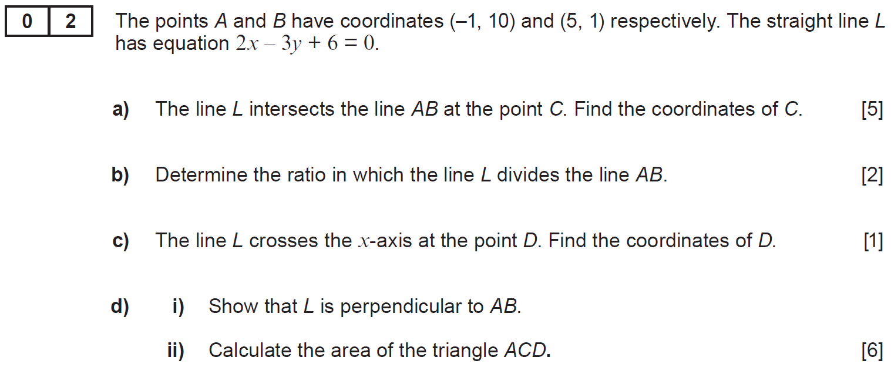
..........................................................................................................................................................................................................................................................................................................
..........................................................................................................................................................................................................................................................................................................
..........................................................................................................................................................................................................................................................................................................
..........................................................................................................................................................................................................................................................................................................
..........................................................................................................................................................................................................................................................................................................
..........................................................................................................................................................................................................................................................................................................
..........................................................................................................................................................................................................................................................................................................
..........................................................................................................................................................................................................................................................................................................
..........................................................................................................................................................................................................................................................................................................
..........................................................................................................................................................................................................................................................................................................
..........................................................................................................................................................................................................................................................................................................
..........................................................................................................................................................................................................................................................................................................
..........................................................................................................................................................................................................................................................................................................
..........................................................................................................................................................................................................................................................................................................
..........................................................................................................................................................................................................................................................................................................
..........................................................................................................................................................................................................................................................................................................
..........................................................................................................................................................................................................................................................................................................
..........................................................................................................................................................................................................................................................................................................
..........................................................................................................................................................................................................................................................................................................
..........................................................................................................................................................................................................................................................................................................
..........................................................................................................................................................................................................................................................................................................
..........................................................................................................................................................................................................................................................................................................
..........................................................................................................................................................................................................................................................................................................
..........................................................................................................................................................................................................................................................................................................
..........................................................................................................................................................................................................................................................................................................
..........................................................................................................................................................................................................................................................................................................
..........................................................................................................................................................................................................................................................................................................
..........................................................................................................................................................................................................................................................................................................
..........................................................................................................................................................................................................................................................................................................
..........................................................................................................................................................................................................................................................................................................
..........................................................................................................................................................................................................................................................................................................
..........................................................................................................................................................................................................................................................................................................
..........................................................................................................................................................................................................................................................................................................
..........................................................................................................................................................................................................................................................................................................
..........................................................................................................................................................................................................................................................................................................
..........................................................................................................................................................................................................................................................................................................
..........................................................................................................................................................................................................................................................................................................
..........................................................................................................................................................................................................................................................................................................
..........................................................................................................................................................................................................................................................................................................
..........................................................................................................................................................................................................................................................................................................
..........................................................................................................................................................................................................................................................................................................
..........................................................................................................................................................................................................................................................................................................
..........................................................................................................................................................................................................................................................................................................
..........................................................................................................................................................................................................................................................................................................
..........................................................................................................................................................................................................................................................................................................
..........................................................................................................................................................................................................................................................................................................
..........................................................................................................................................................................................................................................................................................................
..........................................................................................................................................................................................................................................................................................................
..........................................................................................................................................................................................................................................................................................................
..........................................................................................................................................................................................................................................................................................................
..........................................................................................................................................................................................................................................................................................................
..........................................................................................................................................................................................................................................................................................................
..........................................................................................................................................................................................................................................................................................................
..........................................................................................................................................................................................................................................................................................................
..........................................................................................................................................................................................................................................................................................................
..........................................................................................................................................................................................................................................................................................................
..........................................................................................................................................................................................................................................................................................................
..........................................................................................................................................................................................................................................................................................................
..........................................................................................................................................................................................................................................................................................................
..........................................................................................................................................................................................................................................................................................................
..........................................................................................................................................................................................................................................................................................................
..........................................................................................................................................................................................................................................................................................................
..........................................................................................................................................................................................................................................................................................................
..........................................................................................................................................................................................................................................................................................................
..........................................................................................................................................................................................................................................................................................................
..........................................................................................................................................................................................................................................................................................................
..........................................................................................................................................................................................................................................................................................................
..........................................................................................................................................................................................................................................................................................................
..........................................................................................................................................................................................................................................................................................................
(Unit 1 Summer 2019)
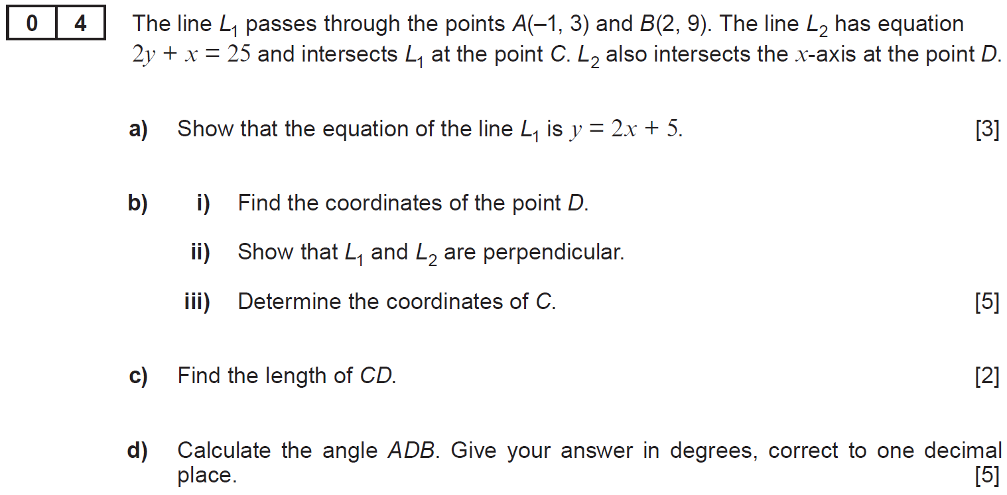
..........................................................................................................................................................................................................................................................................................................
..........................................................................................................................................................................................................................................................................................................
..........................................................................................................................................................................................................................................................................................................
..........................................................................................................................................................................................................................................................................................................
..........................................................................................................................................................................................................................................................................................................
..........................................................................................................................................................................................................................................................................................................
..........................................................................................................................................................................................................................................................................................................
..........................................................................................................................................................................................................................................................................................................
..........................................................................................................................................................................................................................................................................................................
..........................................................................................................................................................................................................................................................................................................
..........................................................................................................................................................................................................................................................................................................
..........................................................................................................................................................................................................................................................................................................
..........................................................................................................................................................................................................................................................................................................
..........................................................................................................................................................................................................................................................................................................
..........................................................................................................................................................................................................................................................................................................
..........................................................................................................................................................................................................................................................................................................
..........................................................................................................................................................................................................................................................................................................
..........................................................................................................................................................................................................................................................................................................
..........................................................................................................................................................................................................................................................................................................
..........................................................................................................................................................................................................................................................................................................
..........................................................................................................................................................................................................................................................................................................
..........................................................................................................................................................................................................................................................................................................
..........................................................................................................................................................................................................................................................................................................
..........................................................................................................................................................................................................................................................................................................
..........................................................................................................................................................................................................................................................................................................
..........................................................................................................................................................................................................................................................................................................
..........................................................................................................................................................................................................................................................................................................
..........................................................................................................................................................................................................................................................................................................
..........................................................................................................................................................................................................................................................................................................
..........................................................................................................................................................................................................................................................................................................
..........................................................................................................................................................................................................................................................................................................
..........................................................................................................................................................................................................................................................................................................
..........................................................................................................................................................................................................................................................................................................
..........................................................................................................................................................................................................................................................................................................
..........................................................................................................................................................................................................................................................................................................
..........................................................................................................................................................................................................................................................................................................
..........................................................................................................................................................................................................................................................................................................
..........................................................................................................................................................................................................................................................................................................
..........................................................................................................................................................................................................................................................................................................
..........................................................................................................................................................................................................................................................................................................
..........................................................................................................................................................................................................................................................................................................
..........................................................................................................................................................................................................................................................................................................
..........................................................................................................................................................................................................................................................................................................
..........................................................................................................................................................................................................................................................................................................
..........................................................................................................................................................................................................................................................................................................
..........................................................................................................................................................................................................................................................................................................
..........................................................................................................................................................................................................................................................................................................
..........................................................................................................................................................................................................................................................................................................
..........................................................................................................................................................................................................................................................................................................
..........................................................................................................................................................................................................................................................................................................
..........................................................................................................................................................................................................................................................................................................
..........................................................................................................................................................................................................................................................................................................
..........................................................................................................................................................................................................................................................................................................
..........................................................................................................................................................................................................................................................................................................
..........................................................................................................................................................................................................................................................................................................
..........................................................................................................................................................................................................................................................................................................
..........................................................................................................................................................................................................................................................................................................
..........................................................................................................................................................................................................................................................................................................
..........................................................................................................................................................................................................................................................................................................
..........................................................................................................................................................................................................................................................................................................
..........................................................................................................................................................................................................................................................................................................
..........................................................................................................................................................................................................................................................................................................
..........................................................................................................................................................................................................................................................................................................
..........................................................................................................................................................................................................................................................................................................
..........................................................................................................................................................................................................................................................................................................
..........................................................................................................................................................................................................................................................................................................
(Unit 1 Summer 2023)






































































