


$$\sin\left(θ\right)=θ-\frac{θ^{3}}{3!}+\frac{θ^{5}}{5!}-\frac{θ^{7}}{7!}+\frac{θ^{9}}{9!}-…$$
$$\cos\left(θ\right)=1-\frac{θ^{2}}{2!}+\frac{θ^{4}}{4!}-\frac{θ^{5}}{5!}+\frac{θ^{7}}{7!}-…$$
$$\tan\left(θ\right)=θ+\frac{2θ^{3}}{3!}+\frac{16θ^{5}}{5!}+\frac{272θ^{7}}{7!}+…$$

$$-2π$$ | $-\frac{3π}{2}$ | $$-π$$ | $-\frac{π}{2}$ | $$0$$ | $\frac{π}{2}$ | $$π$$ | $\frac{3π}{2}$ | $$2π$$

$$y=\sin{θ}$$
$$y=θ$$
$y=θ-\frac{θ^{3}}{3!}$
$y=θ-\frac{θ^{3}}{3!}+\frac{θ^{5}}{5!}$
$$y$$
$$θ$$

The small angle approximations use part of these Taylor series for sin, cos and tan.
What is the work? |  | If you have an angle $θ$ that is sufficiently small, then it is possible to use alternate expressions for $\sin{θ}$, $\cos{θ}$ and $\tan{θ}$, ones that do not require a calculator in order to calculate them.
What is required before starting? |  | GCSE Work: Trigonometry, area of a sector, inequalities.  A Level Unit 3: Measuring angles in radians, trigonometric addition formulae.
Where does this lead to? |  | A Level Unit 3:  - Differentiating $\sin{θ}$ and $\cos{θ}$ from first principles.  Applications:  - Measuring the distance to the stars.  - The “one in 60” rule when flying.
Theory
If we have a small angle measured in radians, then we can use the following approximations.
$$θ$$
$$r$$
$$r$$
$$O$$
$$A$$
$$B$$
$\sin{θ}≈θ$ $\cos{θ}≈1-\frac{θ^{2}}{2}$ $\tan{θ}≈θ$
The approximations are correct to three significant figures if –0.115 < $θ$ < 0.115 (around –6.6° < $θ$ < 6.6°), and are correct to two significant figures if –0.241 < $θ$ < 0.241 (around –13.8° < $θ$ < 13.8°). The approximation for cos is the most accurate, and the approximation for tan is the least accurate.
Sin Proof
$$θ$$
$$r$$
$$r$$
$$O$$
$$A$$
$$B$$
$$C$$
Let a small angle $θ$ form the sector $OAB$ of a circle. The area of the sector is $\frac{1}{2}r^{2}θ$.

Let us add the chord $AB$ and extend the radius $OA$ to reach the point $C$so that $OB$ and $BC$ are perpendicular.

GCSE Trigonometry
$OCB$ is a right-angled triangle with base $r$ and height $r\tan{θ}.$
The area of the triangle $OCB$ is $\frac{1}{2}r^{2}\tan{θ}.$
The area of the isosceles triangle $OAB$ is $\frac{1}{2}r^{2}\sin{θ}$.
Area of triangle $OAB$ < area of sector $OAB$ < area of triangle $OCB$
$$\frac{1}{2}r^{2}\text{sin}{θ}<\frac{1}{2}r^{2}θ<\frac{1}{2}r^{2}\text{tan}{θ}$$
We can divide by $\frac{1}{2}r^{2}$ as it is always positive.
$$\text{sin}{θ}<θ<\text{tan}{θ}$$
Because $θ$ is a small positive angle, $\sin{θ}$ is positive. We can therefore divide the inequality by $\sin{θ}$.
$$y$$
$$y$$
$$θ$$
$$θ$$
$$y=\sec{θ}$$
$$-2π$$ | $-\frac{3π}{2}$ | $$-π$$ | $-\frac{π}{2}$ | $$0$$ | $\frac{π}{2}$ | $$π$$ | $\frac{3π}{2}$ | $$2π$$

$$-2π$$ | $-\frac{3π}{2}$ | $$-π$$ | $-\frac{π}{2}$ | $$0$$ | $\frac{π}{2}$ | $$π$$ | $\frac{3π}{2}$ | $$2π$$

$$\frac{\sin{θ}}{\sin{θ}}<\frac{θ}{\sin{θ}}<\frac{\tan{θ}}{\sin{θ}}$$
$$1<\frac{θ}{\sin{θ}}<\frac{\sin{θ}}{\cos{θ}}×\frac{1}{\sin{θ}}$$
$$1<\frac{θ}{\sin{θ}}<\sec{θ}$$
As $θ$ approaches 0, $\sec{θ}$ approaches 1
(consider the graphs on the right).
$$y=\cos{θ}$$
Therefore, as $θ$ approaches 0, $\frac{θ}{\sin{θ}}$ lies between 1 and a number approaching 1.
Therefore, as $θ$ approaches 0, $\frac{θ}{\sin{θ}}$ approaches 1.
This means that $\sin{θ}≈θ$ for small values of $θ$.
Tan Proof
The proof for tan is very similar to the proof for sin. We use exactly the same steps until we reach the inequality
$$\text{sin}{θ}<θ<\text{tan}{θ}$$
Here, we divide by $\tan{θ}$ (instead of by $\sin{θ}$):
$$\frac{\sin{θ}}{\tan{θ}}<\frac{θ}{\tan{θ}}<\frac{\tan{θ}}{\tan{θ}}$$
$$\frac{\sin{θ}}{\frac{\sin{θ}}{\cos{θ}}}<\frac{θ}{\tan{θ}}<1$$
$$\cos{θ}<\frac{θ}{\tan{θ}}<1$$
As $θ$ approaches 0, $\cos{θ}$ approaches 1
(consider the graph on the right).
Therefore, as $θ$ approaches 0, $\frac{θ}{\tan{θ}}$ lies between a number approaching 1 and 1.
Therefore, as $θ$ approaches 0, $\frac{θ}{\tan{θ}}$ approaches 1.
This means that $\tan{θ}≈θ$ for small values of $θ$.

Cos Proof
We use the double angle identity $\cos{2θ}≡1-2{\text{sin}}^{2}θ$ to find the approximation for cos.
In the identity, we halve the angles, so that $2θ$ changes to be $θ$, and $θ$ changes to be $\frac{θ}{2}$.
$$\cos{θ}≡1-2{\text{sin}}^{2}\left(\frac{θ}{2}\right)$$
If $\frac{θ}{2}$ is a small angle, then we can use the approximation $\sin\left(\frac{θ}{2}\right)≈\frac{θ}{2}$, so that
$$\cos{θ}≈1-2{\left(\frac{θ}{2}\right)}^{2} \\ \cos{θ}≈1-\frac{θ^{2}}{2}$$
Summary
If $θ$ is a small angle, then
$$\sin{θ}≈θ$$
$$\cos{θ}≈1-\frac{θ^{2}}{2}$$
$$\tan{θ}≈θ$$

Exercise 1
If $θ$ is a small angle, find an approximation for the expression $\frac{\sin{3θ}}{1+\cos{2θ}}$.
..........................................................................................................................................................................................................................................................................................................
..........................................................................................................................................................................................................................................................................................................
..........................................................................................................................................................................................................................................................................................................
..........................................................................................................................................................................................................................................................................................................
..........................................................................................................................................................................................................................................................................................................
..........................................................................................................................................................................................................................................................................................................
..........................................................................................................................................................................................................................................................................................................
..........................................................................................................................................................................................................................................................................................................
..........................................................................................................................................................................................................................................................................................................
..........................................................................................................................................................................................................................................................................................................
..........................................................................................................................................................................................................................................................................................................
..........................................................................................................................................................................................................................................................................................................
..........................................................................................................................................................................................................................................................................................................
..........................................................................................................................................................................................................................................................................................................
..........................................................................................................................................................................................................................................................................................................
Exact Values
$\frac{π}{4}$
$\frac{π}{4}$
Consider a right-angled triangle where the length of the shortest sides are 1 unit.
It is possible to use this triangle to calculate the exact values of sin, cos and tan
for the angle $\frac{π}{4}$ (or 45°).
$$\text{opposite}$$
$$\text{hypotenuse}$$
$$\text{adjacent}$$
$$\sqrt{2}$$
$1$
$\sin\left(\frac{π}{4}\right)=\frac{\text{opposite}}{\text{hypotenuse}}$ $\cos\left(\frac{π}{4}\right)=\frac{\text{adjacent}}{\text{hypotenuse}}$ $\tan\left(\frac{π}{4}\right)=\frac{\text{opposite}}{\text{adjacent}}$
$\sin\left(\frac{π}{4}\right)=\frac{1}{\sqrt{2}}$ $\cos\left(\frac{π}{4}\right)=\frac{1}{\sqrt{2}}$ $\tan\left(\frac{π}{4}\right)=1$
$1$
Next, consider an equilateral triangle where the length of the sides are 2 units.
$\frac{π}{6}$
$\frac{π}{6}$
$\frac{π}{3}$
$\frac{π}{3}$
$2$
$2$
$1$
$1$
$$\text{opposite}$$
$$\text{hypotenuse}$$
$$\text{adjacent}$$
$$\text{opposite}$$
$$\text{hypotenuse}$$
$$\text{adjacent}$$
By splitting this triangle in half, it is possible to calculate the exact values of
sin, cos and tan for the angles $\frac{π}{6}$ (or 30°) and $\frac{π}{3}$ (or 60°).
$\sin\left(\frac{π}{6}\right)=\frac{\text{opposite}}{\text{hypotenuse}}$ $\cos\left(\frac{π}{6}\right)=\frac{\text{adjacent}}{\text{hypotenuse}}$ $\tan\left(\frac{π}{6}\right)=\frac{\text{opposite}}{\text{adjacent}}$
$$\sqrt{3}$$
$\sin\left(\frac{π}{6}\right)=\frac{1}{2}$ $\cos\left(\frac{π}{6}\right)=\frac{\sqrt{3}}{2}$ $\tan\left(\frac{π}{6}\right)=\frac{1}{\sqrt{3}}$
$\sin\left(\frac{π}{3}\right)=\frac{\text{opposite}}{\text{hypotenuse}}$ $\cos\left(\frac{π}{3}\right)=\frac{\text{adjacent}}{\text{hypotenuse}}$ $\tan\left(\frac{π}{3}\right)=\frac{\text{opposite}}{\text{adjacent}}$
$\sin\left(\frac{π}{3}\right)=\frac{\sqrt{3}}{2}$ $\cos\left(\frac{π}{3}\right)=\frac{1}{2}$ $\tan\left(\frac{π}{3}\right)=\sqrt{3}$
Summary
 | sin | cos | tan
$$0$$ | $$0$$ | $$1$$ | $$0$$
$\frac{π}{6}$ (or 30°) | $$\frac{1}{2}$$ | $$\frac{\sqrt{3}}{2}$$ | $$\frac{1}{\sqrt{3}}$$
$\frac{π}{4}$ (or 45°) | $$\frac{1}{\sqrt{2}}$$ | $$\frac{1}{\sqrt{2}}$$ | $$1$$
$\frac{π}{3}$ (or 60°) | $$\frac{\sqrt{3}}{2}$$ | $$\frac{1}{2}$$ | $$\sqrt{3}$$
$\frac{π}{2}$ (or 90°) | $$1$$ | $$0$$ | Not defined

We can find the value of sin, cos and tan for other multiplies of $\frac{π}{6}$ (or 30°) by using the symmetry in the graphs of sin, cos and tan.

Exercise 2
If $θ$ is a small angle, show that $\tan\left(\frac{π}{4}+θ\right)≈\frac{1+θ}{1-θ}$.
..........................................................................................................................................................................................................................................................................................................
..........................................................................................................................................................................................................................................................................................................
..........................................................................................................................................................................................................................................................................................................
..........................................................................................................................................................................................................................................................................................................
..........................................................................................................................................................................................................................................................................................................
..........................................................................................................................................................................................................................................................................................................
..........................................................................................................................................................................................................................................................................................................
..........................................................................................................................................................................................................................................................................................................
..........................................................................................................................................................................................................................................................................................................
..........................................................................................................................................................................................................................................................................................................
..........................................................................................................................................................................................................................................................................................................
..........................................................................................................................................................................................................................................................................................................
..........................................................................................................................................................................................................................................................................................................
..........................................................................................................................................................................................................................................................................................................
..........................................................................................................................................................................................................................................................................................................
..........................................................................................................................................................................................................................................................................................................
Exercise 3
If $θ$ is sufficiently small so that you can ignore $θ^{2}$, show that $4\sin\left(\frac{π}{4}-θ\right)≈2\sqrt{2}(1-θ)$.
..........................................................................................................................................................................................................................................................................................................
..........................................................................................................................................................................................................................................................................................................
..........................................................................................................................................................................................................................................................................................................
..........................................................................................................................................................................................................................................................................................................
..........................................................................................................................................................................................................................................................................................................
..........................................................................................................................................................................................................................................................................................................
..........................................................................................................................................................................................................................................................................................................
..........................................................................................................................................................................................................................................................................................................
..........................................................................................................................................................................................................................................................................................................
..........................................................................................................................................................................................................................................................................................................
..........................................................................................................................................................................................................................................................................................................
..........................................................................................................................................................................................................................................................................................................
..........................................................................................................................................................................................................................................................................................................
..........................................................................................................................................................................................................................................................................................................
..........................................................................................................................................................................................................................................................................................................
..........................................................................................................................................................................................................................................................................................................
..........................................................................................................................................................................................................................................................................................................
..........................................................................................................................................................................................................................................................................................................
..........................................................................................................................................................................................................................................................................................................
..........................................................................................................................................................................................................................................................................................................
Exericse 4
Given that $1°≈0.017$ radian, find values for each of the following without using the trigonometric functions on your calculator.
(a) $\tan{(61°)}$
..........................................................................................................................................................................................................................................................................................................
..........................................................................................................................................................................................................................................................................................................
..........................................................................................................................................................................................................................................................................................................
..........................................................................................................................................................................................................................................................................................................
..........................................................................................................................................................................................................................................................................................................
..........................................................................................................................................................................................................................................................................................................
..........................................................................................................................................................................................................................................................................................................
..........................................................................................................................................................................................................................................................................................................
..........................................................................................................................................................................................................................................................................................................
..........................................................................................................................................................................................................................................................................................................
..........................................................................................................................................................................................................................................................................................................
..........................................................................................................................................................................................................................................................................................................
..........................................................................................................................................................................................................................................................................................................
..........................................................................................................................................................................................................................................................................................................
..........................................................................................................................................................................................................................................................................................................
..........................................................................................................................................................................................................................................................................................................
(b) $\sin{(29°)}$
..........................................................................................................................................................................................................................................................................................................
..........................................................................................................................................................................................................................................................................................................
..........................................................................................................................................................................................................................................................................................................
..........................................................................................................................................................................................................................................................................................................
..........................................................................................................................................................................................................................................................................................................
..........................................................................................................................................................................................................................................................................................................
..........................................................................................................................................................................................................................................................................................................
..........................................................................................................................................................................................................................................................................................................
..........................................................................................................................................................................................................................................................................................................
..........................................................................................................................................................................................................................................................................................................
..........................................................................................................................................................................................................................................................................................................
..........................................................................................................................................................................................................................................................................................................
..........................................................................................................................................................................................................................................................................................................
..........................................................................................................................................................................................................................................................................................................
..........................................................................................................................................................................................................................................................................................................
..........................................................................................................................................................................................................................................................................................................
..........................................................................................................................................................................................................................................................................................................
..........................................................................................................................................................................................................................................................................................................
..........................................................................................................................................................................................................................................................................................................
..........................................................................................................................................................................................................................................................................................................
(Sample Assessment Materials)
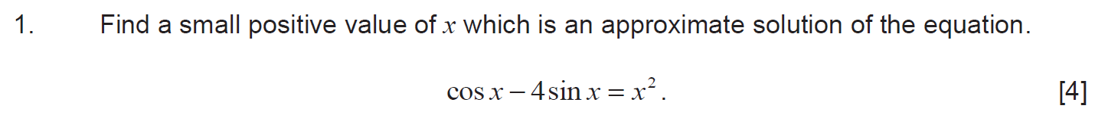
..........................................................................................................................................................................................................................................................................................................
..........................................................................................................................................................................................................................................................................................................
..........................................................................................................................................................................................................................................................................................................
..........................................................................................................................................................................................................................................................................................................
..........................................................................................................................................................................................................................................................................................................
..........................................................................................................................................................................................................................................................................................................
..........................................................................................................................................................................................................................................................................................................
..........................................................................................................................................................................................................................................................................................................
..........................................................................................................................................................................................................................................................................................................
..........................................................................................................................................................................................................................................................................................................
..........................................................................................................................................................................................................................................................................................................
..........................................................................................................................................................................................................................................................................................................
..........................................................................................................................................................................................................................................................................................................
..........................................................................................................................................................................................................................................................................................................
..........................................................................................................................................................................................................................................................................................................
..........................................................................................................................................................................................................................................................................................................
..........................................................................................................................................................................................................................................................................................................
..........................................................................................................................................................................................................................................................................................................
..........................................................................................................................................................................................................................................................................................................
..........................................................................................................................................................................................................................................................................................................
..........................................................................................................................................................................................................................................................................................................
..........................................................................................................................................................................................................................................................................................................
..........................................................................................................................................................................................................................................................................................................
..........................................................................................................................................................................................................................................................................................................
..........................................................................................................................................................................................................................................................................................................
..........................................................................................................................................................................................................................................................................................................
..........................................................................................................................................................................................................................................................................................................
..........................................................................................................................................................................................................................................................................................................
..........................................................................................................................................................................................................................................................................................................
..........................................................................................................................................................................................................................................................................................................
..........................................................................................................................................................................................................................................................................................................
..........................................................................................................................................................................................................................................................................................................
..........................................................................................................................................................................................................................................................................................................
..........................................................................................................................................................................................................................................................................................................
(Unit 3 Summer 2018)
..........................................................................................................................................................................................................................................................................................................
..........................................................................................................................................................................................................................................................................................................
..........................................................................................................................................................................................................................................................................................................
..........................................................................................................................................................................................................................................................................................................
..........................................................................................................................................................................................................................................................................................................
..........................................................................................................................................................................................................................................................................................................
..........................................................................................................................................................................................................................................................................................................
..........................................................................................................................................................................................................................................................................................................
..........................................................................................................................................................................................................................................................................................................
..........................................................................................................................................................................................................................................................................................................
..........................................................................................................................................................................................................................................................................................................
..........................................................................................................................................................................................................................................................................................................
..........................................................................................................................................................................................................................................................................................................
..........................................................................................................................................................................................................................................................................................................
..........................................................................................................................................................................................................................................................................................................
..........................................................................................................................................................................................................................................................................................................
..........................................................................................................................................................................................................................................................................................................
..........................................................................................................................................................................................................................................................................................................
..........................................................................................................................................................................................................................................................................................................
..........................................................................................................................................................................................................................................................................................................
..........................................................................................................................................................................................................................................................................................................
..........................................................................................................................................................................................................................................................................................................
..........................................................................................................................................................................................................................................................................................................
..........................................................................................................................................................................................................................................................................................................
..........................................................................................................................................................................................................................................................................................................
..........................................................................................................................................................................................................................................................................................................
..........................................................................................................................................................................................................................................................................................................
..........................................................................................................................................................................................................................................................................................................
..........................................................................................................................................................................................................................................................................................................
..........................................................................................................................................................................................................................................................................................................
..........................................................................................................................................................................................................................................................................................................
..........................................................................................................................................................................................................................................................................................................
..........................................................................................................................................................................................................................................................................................................
..........................................................................................................................................................................................................................................................................................................
..........................................................................................................................................................................................................................................................................................................
..........................................................................................................................................................................................................................................................................................................
..........................................................................................................................................................................................................................................................................................................
(Unit 3 Summer 2024)
..........................................................................................................................................................................................................................................................................................................
..........................................................................................................................................................................................................................................................................................................
..........................................................................................................................................................................................................................................................................................................
..........................................................................................................................................................................................................................................................................................................
..........................................................................................................................................................................................................................................................................................................
..........................................................................................................................................................................................................................................................................................................
..........................................................................................................................................................................................................................................................................................................
..........................................................................................................................................................................................................................................................................................................
..........................................................................................................................................................................................................................................................................................................
..........................................................................................................................................................................................................................................................................................................
..........................................................................................................................................................................................................................................................................................................
..........................................................................................................................................................................................................................................................................................................
(Edexcel Pure Mathematics 1 [9MA0/01] Summer 2018)
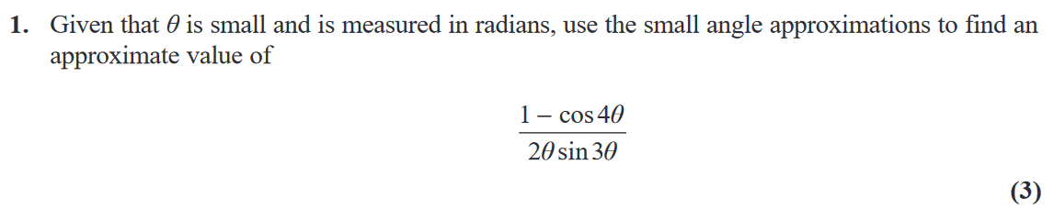
..........................................................................................................................................................................................................................................................................................................
..........................................................................................................................................................................................................................................................................................................
..........................................................................................................................................................................................................................................................................................................
..........................................................................................................................................................................................................................................................................................................
..........................................................................................................................................................................................................................................................................................................
..........................................................................................................................................................................................................................................................................................................
..........................................................................................................................................................................................................................................................................................................
..........................................................................................................................................................................................................................................................................................................
..........................................................................................................................................................................................................................................................................................................
..........................................................................................................................................................................................................................................................................................................
..........................................................................................................................................................................................................................................................................................................
..........................................................................................................................................................................................................................................................................................................
..........................................................................................................................................................................................................................................................................................................
..........................................................................................................................................................................................................................................................................................................
..........................................................................................................................................................................................................................................................................................................
..........................................................................................................................................................................................................................................................................................................
..........................................................................................................................................................................................................................................................................................................
..........................................................................................................................................................................................................................................................................................................
..........................................................................................................................................................................................................................................................................................................
(Edexcel Pure Mathematics 1 [9MA0/01] Summer 2023)
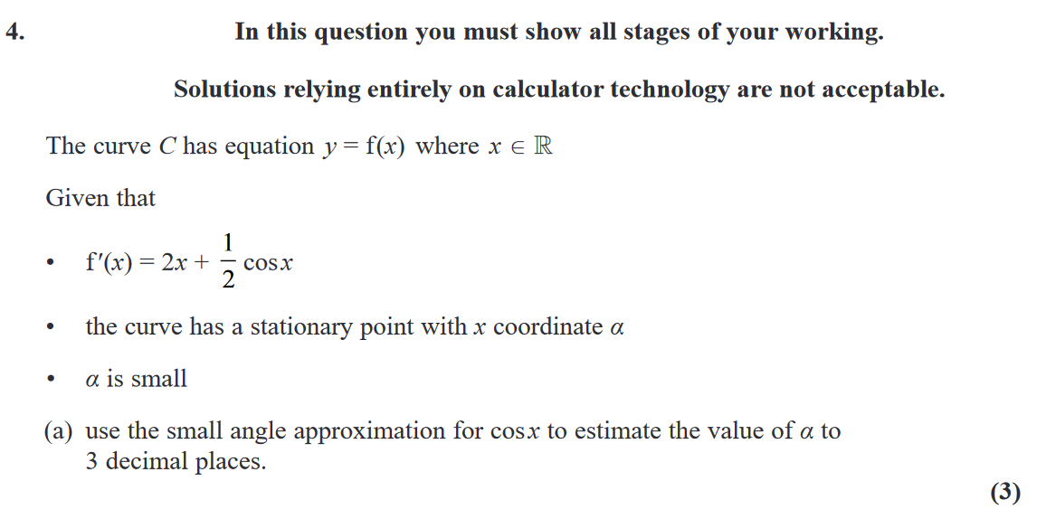
..........................................................................................................................................................................................................................................................................................................
..........................................................................................................................................................................................................................................................................................................
..........................................................................................................................................................................................................................................................................................................
..........................................................................................................................................................................................................................................................................................................
..........................................................................................................................................................................................................................................................................................................
..........................................................................................................................................................................................................................................................................................................
..........................................................................................................................................................................................................................................................................................................
..........................................................................................................................................................................................................................................................................................................
..........................................................................................................................................................................................................................................................................................................
..........................................................................................................................................................................................................................................................................................................
..........................................................................................................................................................................................................................................................................................................
..........................................................................................................................................................................................................................................................................................................
..........................................................................................................................................................................................................................................................................................................
..........................................................................................................................................................................................................................................................................................................
..........................................................................................................................................................................................................................................................................................................
..........................................................................................................................................................................................................................................................................................................
..........................................................................................................................................................................................................................................................................................................
..........................................................................................................................................................................................................................................................................................................
..........................................................................................................................................................................................................................................................................................................
..........................................................................................................................................................................................................................................................................................................
..........................................................................................................................................................................................................................................................................................................
..........................................................................................................................................................................................................................................................................................................
..........................................................................................................................................................................................................................................................................................................
..........................................................................................................................................................................................................................................................................................................
..........................................................................................................................................................................................................................................................................................................
(Unit 3 Summer 2019)
..........................................................................................................................................................................................................................................................................................................
..........................................................................................................................................................................................................................................................................................................
..........................................................................................................................................................................................................................................................................................................
..........................................................................................................................................................................................................................................................................................................
..........................................................................................................................................................................................................................................................................................................
..........................................................................................................................................................................................................................................................................................................
..........................................................................................................................................................................................................................................................................................................
..........................................................................................................................................................................................................................................................................................................
..........................................................................................................................................................................................................................................................................................................
..........................................................................................................................................................................................................................................................................................................
..........................................................................................................................................................................................................................................................................................................
..........................................................................................................................................................................................................................................................................................................
..........................................................................................................................................................................................................................................................................................................
..........................................................................................................................................................................................................................................................................................................
..........................................................................................................................................................................................................................................................................................................
..........................................................................................................................................................................................................................................................................................................
..........................................................................................................................................................................................................................................................................................................
..........................................................................................................................................................................................................................................................................................................
..........................................................................................................................................................................................................................................................................................................
..........................................................................................................................................................................................................................................................................................................
..........................................................................................................................................................................................................................................................................................................
..........................................................................................................................................................................................................................................................................................................
..........................................................................................................................................................................................................................................................................................................
..........................................................................................................................................................................................................................................................................................................
..........................................................................................................................................................................................................................................................................................................
..........................................................................................................................................................................................................................................................................................................
..........................................................................................................................................................................................................................................................................................................
..........................................................................................................................................................................................................................................................................................................
..........................................................................................................................................................................................................................................................................................................
..........................................................................................................................................................................................................................................................................................................
..........................................................................................................................................................................................................................................................................................................
..........................................................................................................................................................................................................................................................................................................
..........................................................................................................................................................................................................................................................................................................
..........................................................................................................................................................................................................................................................................................................
(Unit 3 Summer 2022)
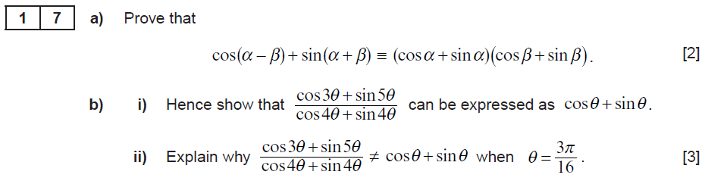
..........................................................................................................................................................................................................................................................................................................
..........................................................................................................................................................................................................................................................................................................
..........................................................................................................................................................................................................................................................................................................
..........................................................................................................................................................................................................................................................................................................
..........................................................................................................................................................................................................................................................................................................
..........................................................................................................................................................................................................................................................................................................
..........................................................................................................................................................................................................................................................................................................
..........................................................................................................................................................................................................................................................................................................
..........................................................................................................................................................................................................................................................................................................
..........................................................................................................................................................................................................................................................................................................
..........................................................................................................................................................................................................................................................................................................
..........................................................................................................................................................................................................................................................................................................
..........................................................................................................................................................................................................................................................................................................
..........................................................................................................................................................................................................................................................................................................
..........................................................................................................................................................................................................................................................................................................
..........................................................................................................................................................................................................................................................................................................
..........................................................................................................................................................................................................................................................................................................
..........................................................................................................................................................................................................................................................................................................
..........................................................................................................................................................................................................................................................................................................
..........................................................................................................................................................................................................................................................................................................
..........................................................................................................................................................................................................................................................................................................
..........................................................................................................................................................................................................................................................................................................
..........................................................................................................................................................................................................................................................................................................
..........................................................................................................................................................................................................................................................................................................
..........................................................................................................................................................................................................................................................................................................
..........................................................................................................................................................................................................................................................................................................
..........................................................................................................................................................................................................................................................................................................
..........................................................................................................................................................................................................................................................................................................
..........................................................................................................................................................................................................................................................................................................
..........................................................................................................................................................................................................................................................................................................
..........................................................................................................................................................................................................................................................................................................
..........................................................................................................................................................................................................................................................................................................
(Unit 3 Summer 2023)
..........................................................................................................................................................................................................................................................................................................
..........................................................................................................................................................................................................................................................................................................
..........................................................................................................................................................................................................................................................................................................
..........................................................................................................................................................................................................................................................................................................
..........................................................................................................................................................................................................................................................................................................
..........................................................................................................................................................................................................................................................................................................
..........................................................................................................................................................................................................................................................................................................
..........................................................................................................................................................................................................................................................................................................
..........................................................................................................................................................................................................................................................................................................
..........................................................................................................................................................................................................................................................................................................
..........................................................................................................................................................................................................................................................................................................
..........................................................................................................................................................................................................................................................................................................
..........................................................................................................................................................................................................................................................................................................
..........................................................................................................................................................................................................................................................................................................
..........................................................................................................................................................................................................................................................................................................
..........................................................................................................................................................................................................................................................................................................
..........................................................................................................................................................................................................................................................................................................
..........................................................................................................................................................................................................................................................................................................
..........................................................................................................................................................................................................................................................................................................
..........................................................................................................................................................................................................................................................................................................
..........................................................................................................................................................................................................................................................................................................
..........................................................................................................................................................................................................................................................................................................
..........................................................................................................................................................................................................................................................................................................
..........................................................................................................................................................................................................................................................................................................
..........................................................................................................................................................................................................................................................................................................
..........................................................................................................................................................................................................................................................................................................
..........................................................................................................................................................................................................................................................................................................
..........................................................................................................................................................................................................................................................................................................
..........................................................................................................................................................................................................................................................................................................
..........................................................................................................................................................................................................................................................................................................
..........................................................................................................................................................................................................................................................................................................
..........................................................................................................................................................................................................................................................................................................
..........................................................................................................................................................................................................................................................................................................
..........................................................................................................................................................................................................................................................................................................
..........................................................................................................................................................................................................................................................................................................
..........................................................................................................................................................................................................................................................................................................
(Edexcel Pure Mathematics 1 [9MA0/01] Summer 2022)




































































