


$$\sin\left(2A\right)=2\sin{A}\cos{A}$$
$$\cos\left(2A\right)={\text{cos}}^{2}\left(A\right)-{\text{sin}}^{2}\left(A\right) \\ \cos\left(2A\right)=1-2{\text{sin}}^{2}\left(A\right) \\ \cos\left(2A\right)=2{\text{cos}}^{2}\left(A\right)-1$$
$$\tan\left(2A\right)=\frac{2\tan{A}}{1-{\text{tan}}^{2}A}$$

What is the work? |  | This workbook considers the formulae for $\sin{(2A)}$, $\cos{(2A)}$ and $\tan{(2A)}$.
What is required before starting? |  | A Level Unit 1: Trigonometry.  A Level Unit 3: Trigonometric Addition Formulae.
Where does this lead to? |  | A Level Unit 3:  - Integration of functions that contain (e.g.) ${\text{sin}}^{2}(x)$.  Applications:  - Solving trigonometric equations by reducing the power of the equation.
Theory
In the previous workbook, the following formulae were introducted for trigonometric addition:
$$\sin\left(A+B\right)=\sin{A}\cos{B}+\cos{A}\sin{B}$$
$$\cos\left(A+B\right)=\cos{A}\cos{B}-\sin{A}\sin{B}$$
$$\tan{(A+B)}=\frac{\tan{A}+\tan{B}}{1-\tan{A}\tan{B}}$$
We will now consider what happens above when the angles $A$ and $B$ are equal.
$$\sin\left(A+A\right)=\sin{A}\cos{A}+\cos{A}\sin{A} \\ \sin{(2A)}=2\sin{A}\cos{A}$$
$$\cos\left(A+A\right)=\cos{A}\cos{A}-\sin{A}\sin{A} \\ \cos{(2A)}={\text{cos}}^{2}\left(A\right)-{\text{sin}}^{2}(A)$$
$$\tan{(A+A)}=\frac{\tan{A}+\tan{A}}{1-\tan{A}\tan{A}} \\ \tan\left(2A\right)=\frac{2\tan{A}}{1-{\text{tan}}^{2}A}$$
The above formulae are recognised as the formulae for double angles. In the case of the formula for $\cos{(2A)}$, it turns out that using the identity ${\text{sin}}^{2}A+{\text{cos}}^{2}A=1$ from the Unit 1 course makes the formula even more useful.
$\cos{(2A)}={\text{cos}}^{2}\left(A\right)-{\text{sin}}^{2}(A)$ $\cos{(2A)}={\text{cos}}^{2}\left(A\right)-{\text{sin}}^{2}(A)$
$\cos{(2A)}=(1-{\text{sin}}^{2}(A))-{\text{sin}}^{2}(A)$ $\cos{(2A)}={\text{cos}}^{2}\left(A\right)-(1-{\text{cos}}^{2}\left(A\right))$
$\cos{(2A)}=1-2{\text{sin}}^{2}(A)$ $\cos{(2A)}={\text{cos}}^{2}\left(A\right)-1+{\text{cos}}^{2}(A)$
$\cos{(2A)}=2{\text{cos}}^{2}\left(A\right)-1$

Here is a summary of the formulae for double angles. These need to be memorised.

$\sin\left(2A\right)=2\sin{A}\cos{A}$
$\cos\left(2A\right)={\text{cos}}^{2}\left(A\right)-{\text{sin}}^{2}\left(A\right)$
$\cos\left(2A\right)=1-2{\text{sin}}^{2}\left(A\right)$
$\cos\left(2A\right)=2{\text{cos}}^{2}\left(A\right)-1$
$\tan\left(2A\right)=\frac{2\tan{A}}{1-{\text{tan}}^{2}A}$

Challenge!
Show that it is possible to write (a) $\sin{(2A)}=\frac{2\tan{A}}{1+{\text{tan}}^{2}(A)}$, (b) $\cos{(2A)}=\frac{1-{\text{tan}}^{2}(A)}{1+{\text{tan}}^{2}(A)}$.
(C4 Summer 2010)
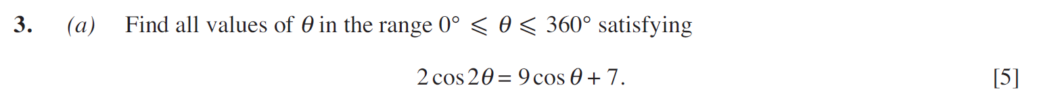
..........................................................................................................................................................................................................................................................................................................
..........................................................................................................................................................................................................................................................................................................
..........................................................................................................................................................................................................................................................................................................
..........................................................................................................................................................................................................................................................................................................
..........................................................................................................................................................................................................................................................................................................
..........................................................................................................................................................................................................................................................................................................
..........................................................................................................................................................................................................................................................................................................
..........................................................................................................................................................................................................................................................................................................
..........................................................................................................................................................................................................................................................................................................
..........................................................................................................................................................................................................................................................................................................
..........................................................................................................................................................................................................................................................................................................
..........................................................................................................................................................................................................................................................................................................
..........................................................................................................................................................................................................................................................................................................
..........................................................................................................................................................................................................................................................................................................
..........................................................................................................................................................................................................................................................................................................
..........................................................................................................................................................................................................................................................................................................
..........................................................................................................................................................................................................................................................................................................
..........................................................................................................................................................................................................................................................................................................
..........................................................................................................................................................................................................................................................................................................
..........................................................................................................................................................................................................................................................................................................
(C4 Summer 2011)
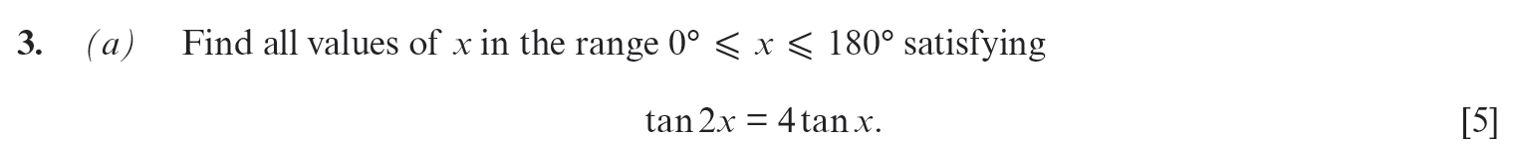
..........................................................................................................................................................................................................................................................................................................
..........................................................................................................................................................................................................................................................................................................
..........................................................................................................................................................................................................................................................................................................
..........................................................................................................................................................................................................................................................................................................
..........................................................................................................................................................................................................................................................................................................
..........................................................................................................................................................................................................................................................................................................
..........................................................................................................................................................................................................................................................................................................
..........................................................................................................................................................................................................................................................................................................
..........................................................................................................................................................................................................................................................................................................
..........................................................................................................................................................................................................................................................................................................
..........................................................................................................................................................................................................................................................................................................
..........................................................................................................................................................................................................................................................................................................
..........................................................................................................................................................................................................................................................................................................
..........................................................................................................................................................................................................................................................................................................
..........................................................................................................................................................................................................................................................................................................
..........................................................................................................................................................................................................................................................................................................
..........................................................................................................................................................................................................................................................................................................
..........................................................................................................................................................................................................................................................................................................
..........................................................................................................................................................................................................................................................................................................
..........................................................................................................................................................................................................................................................................................................
..........................................................................................................................................................................................................................................................................................................
..........................................................................................................................................................................................................................................................................................................
..........................................................................................................................................................................................................................................................................................................
..........................................................................................................................................................................................................................................................................................................
..........................................................................................................................................................................................................................................................................................................
..........................................................................................................................................................................................................................................................................................................
..........................................................................................................................................................................................................................................................................................................
..........................................................................................................................................................................................................................................................................................................
..........................................................................................................................................................................................................................................................................................................
..........................................................................................................................................................................................................................................................................................................
..........................................................................................................................................................................................................................................................................................................
..........................................................................................................................................................................................................................................................................................................
..........................................................................................................................................................................................................................................................................................................
..........................................................................................................................................................................................................................................................................................................
..........................................................................................................................................................................................................................................................................................................
..........................................................................................................................................................................................................................................................................................................
..........................................................................................................................................................................................................................................................................................................
(C4 Summer 2005)
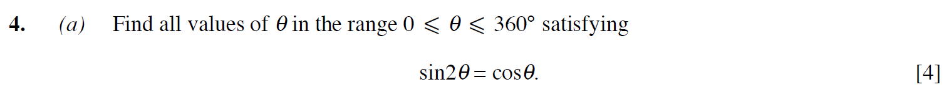
..........................................................................................................................................................................................................................................................................................................
..........................................................................................................................................................................................................................................................................................................
..........................................................................................................................................................................................................................................................................................................
..........................................................................................................................................................................................................................................................................................................
..........................................................................................................................................................................................................................................................................................................
..........................................................................................................................................................................................................................................................................................................
..........................................................................................................................................................................................................................................................................................................
..........................................................................................................................................................................................................................................................................................................
..........................................................................................................................................................................................................................................................................................................
..........................................................................................................................................................................................................................................................................................................
..........................................................................................................................................................................................................................................................................................................
..........................................................................................................................................................................................................................................................................................................
..........................................................................................................................................................................................................................................................................................................
..........................................................................................................................................................................................................................................................................................................
..........................................................................................................................................................................................................................................................................................................
..........................................................................................................................................................................................................................................................................................................
..........................................................................................................................................................................................................................................................................................................
..........................................................................................................................................................................................................................................................................................................
..........................................................................................................................................................................................................................................................................................................
..........................................................................................................................................................................................................................................................................................................
..........................................................................................................................................................................................................................................................................................................
..........................................................................................................................................................................................................................................................................................................
..........................................................................................................................................................................................................................................................................................................
..........................................................................................................................................................................................................................................................................................................
..........................................................................................................................................................................................................................................................................................................
..........................................................................................................................................................................................................................................................................................................
..........................................................................................................................................................................................................................................................................................................
..........................................................................................................................................................................................................................................................................................................
..........................................................................................................................................................................................................................................................................................................
..........................................................................................................................................................................................................................................................................................................
..........................................................................................................................................................................................................................................................................................................
..........................................................................................................................................................................................................................................................................................................
..........................................................................................................................................................................................................................................................................................................
..........................................................................................................................................................................................................................................................................................................
(C4 Summer 2009)
..........................................................................................................................................................................................................................................................................................................
..........................................................................................................................................................................................................................................................................................................
..........................................................................................................................................................................................................................................................................................................
..........................................................................................................................................................................................................................................................................................................
..........................................................................................................................................................................................................................................................................................................
..........................................................................................................................................................................................................................................................................................................
..........................................................................................................................................................................................................................................................................................................
..........................................................................................................................................................................................................................................................................................................
..........................................................................................................................................................................................................................................................................................................
..........................................................................................................................................................................................................................................................................................................
..........................................................................................................................................................................................................................................................................................................
..........................................................................................................................................................................................................................................................................................................
..........................................................................................................................................................................................................................................................................................................
..........................................................................................................................................................................................................................................................................................................
..........................................................................................................................................................................................................................................................................................................
..........................................................................................................................................................................................................................................................................................................
..........................................................................................................................................................................................................................................................................................................
..........................................................................................................................................................................................................................................................................................................
..........................................................................................................................................................................................................................................................................................................
..........................................................................................................................................................................................................................................................................................................
..........................................................................................................................................................................................................................................................................................................
..........................................................................................................................................................................................................................................................................................................
..........................................................................................................................................................................................................................................................................................................
..........................................................................................................................................................................................................................................................................................................
..........................................................................................................................................................................................................................................................................................................
..........................................................................................................................................................................................................................................................................................................
..........................................................................................................................................................................................................................................................................................................
..........................................................................................................................................................................................................................................................................................................
..........................................................................................................................................................................................................................................................................................................
..........................................................................................................................................................................................................................................................................................................
..........................................................................................................................................................................................................................................................................................................
..........................................................................................................................................................................................................................................................................................................
..........................................................................................................................................................................................................................................................................................................
..........................................................................................................................................................................................................................................................................................................
..........................................................................................................................................................................................................................................................................................................
..........................................................................................................................................................................................................................................................................................................
..........................................................................................................................................................................................................................................................................................................
..........................................................................................................................................................................................................................................................................................................
(C4 Summer 2006)
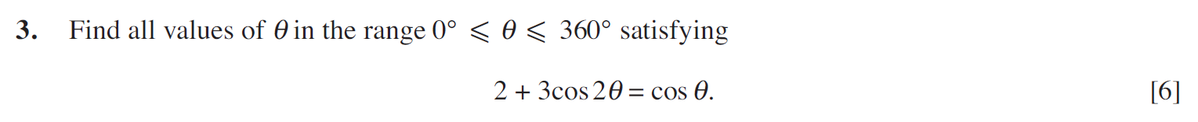
..........................................................................................................................................................................................................................................................................................................
..........................................................................................................................................................................................................................................................................................................
..........................................................................................................................................................................................................................................................................................................
..........................................................................................................................................................................................................................................................................................................
..........................................................................................................................................................................................................................................................................................................
..........................................................................................................................................................................................................................................................................................................
..........................................................................................................................................................................................................................................................................................................
..........................................................................................................................................................................................................................................................................................................
..........................................................................................................................................................................................................................................................................................................
..........................................................................................................................................................................................................................................................................................................
..........................................................................................................................................................................................................................................................................................................
..........................................................................................................................................................................................................................................................................................................
..........................................................................................................................................................................................................................................................................................................
..........................................................................................................................................................................................................................................................................................................
..........................................................................................................................................................................................................................................................................................................
..........................................................................................................................................................................................................................................................................................................
..........................................................................................................................................................................................................................................................................................................
..........................................................................................................................................................................................................................................................................................................
..........................................................................................................................................................................................................................................................................................................
..........................................................................................................................................................................................................................................................................................................
..........................................................................................................................................................................................................................................................................................................
..........................................................................................................................................................................................................................................................................................................
..........................................................................................................................................................................................................................................................................................................
..........................................................................................................................................................................................................................................................................................................
..........................................................................................................................................................................................................................................................................................................
..........................................................................................................................................................................................................................................................................................................
..........................................................................................................................................................................................................................................................................................................
..........................................................................................................................................................................................................................................................................................................
..........................................................................................................................................................................................................................................................................................................
..........................................................................................................................................................................................................................................................................................................
..........................................................................................................................................................................................................................................................................................................
..........................................................................................................................................................................................................................................................................................................
..........................................................................................................................................................................................................................................................................................................
..........................................................................................................................................................................................................................................................................................................
..........................................................................................................................................................................................................................................................................................................
..........................................................................................................................................................................................................................................................................................................
..........................................................................................................................................................................................................................................................................................................
(C4 Summer 2012)
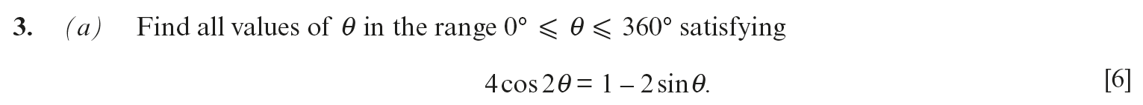
..........................................................................................................................................................................................................................................................................................................
..........................................................................................................................................................................................................................................................................................................
..........................................................................................................................................................................................................................................................................................................
..........................................................................................................................................................................................................................................................................................................
..........................................................................................................................................................................................................................................................................................................
..........................................................................................................................................................................................................................................................................................................
..........................................................................................................................................................................................................................................................................................................
..........................................................................................................................................................................................................................................................................................................
..........................................................................................................................................................................................................................................................................................................
..........................................................................................................................................................................................................................................................................................................
..........................................................................................................................................................................................................................................................................................................
..........................................................................................................................................................................................................................................................................................................
..........................................................................................................................................................................................................................................................................................................
..........................................................................................................................................................................................................................................................................................................
..........................................................................................................................................................................................................................................................................................................
..........................................................................................................................................................................................................................................................................................................
..........................................................................................................................................................................................................................................................................................................
..........................................................................................................................................................................................................................................................................................................
..........................................................................................................................................................................................................................................................................................................
..........................................................................................................................................................................................................................................................................................................
..........................................................................................................................................................................................................................................................................................................
..........................................................................................................................................................................................................................................................................................................
..........................................................................................................................................................................................................................................................................................................
..........................................................................................................................................................................................................................................................................................................
..........................................................................................................................................................................................................................................................................................................
..........................................................................................................................................................................................................................................................................................................
..........................................................................................................................................................................................................................................................................................................
..........................................................................................................................................................................................................................................................................................................
..........................................................................................................................................................................................................................................................................................................
..........................................................................................................................................................................................................................................................................................................
..........................................................................................................................................................................................................................................................................................................
..........................................................................................................................................................................................................................................................................................................
..........................................................................................................................................................................................................................................................................................................
..........................................................................................................................................................................................................................................................................................................
..........................................................................................................................................................................................................................................................................................................
..........................................................................................................................................................................................................................................................................................................
..........................................................................................................................................................................................................................................................................................................
(C4 Summer 2013)
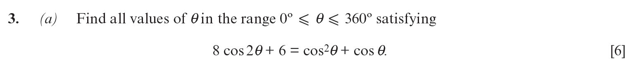
..........................................................................................................................................................................................................................................................................................................
..........................................................................................................................................................................................................................................................................................................
..........................................................................................................................................................................................................................................................................................................
..........................................................................................................................................................................................................................................................................................................
..........................................................................................................................................................................................................................................................................................................
..........................................................................................................................................................................................................................................................................................................
..........................................................................................................................................................................................................................................................................................................
..........................................................................................................................................................................................................................................................................................................
..........................................................................................................................................................................................................................................................................................................
..........................................................................................................................................................................................................................................................................................................
..........................................................................................................................................................................................................................................................................................................
..........................................................................................................................................................................................................................................................................................................
..........................................................................................................................................................................................................................................................................................................
..........................................................................................................................................................................................................................................................................................................
..........................................................................................................................................................................................................................................................................................................
..........................................................................................................................................................................................................................................................................................................
..........................................................................................................................................................................................................................................................................................................
..........................................................................................................................................................................................................................................................................................................
..........................................................................................................................................................................................................................................................................................................
..........................................................................................................................................................................................................................................................................................................
..........................................................................................................................................................................................................................................................................................................
..........................................................................................................................................................................................................................................................................................................
..........................................................................................................................................................................................................................................................................................................
..........................................................................................................................................................................................................................................................................................................
..........................................................................................................................................................................................................................................................................................................
..........................................................................................................................................................................................................................................................................................................
..........................................................................................................................................................................................................................................................................................................
..........................................................................................................................................................................................................................................................................................................
..........................................................................................................................................................................................................................................................................................................
..........................................................................................................................................................................................................................................................................................................
..........................................................................................................................................................................................................................................................................................................
..........................................................................................................................................................................................................................................................................................................
..........................................................................................................................................................................................................................................................................................................
..........................................................................................................................................................................................................................................................................................................
..........................................................................................................................................................................................................................................................................................................
..........................................................................................................................................................................................................................................................................................................
..........................................................................................................................................................................................................................................................................................................
(C4 Summer 2014)
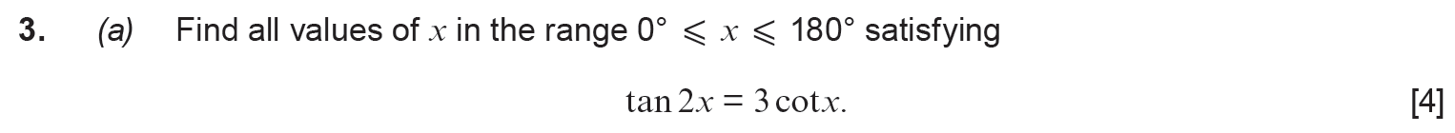
..........................................................................................................................................................................................................................................................................................................
..........................................................................................................................................................................................................................................................................................................
..........................................................................................................................................................................................................................................................................................................
..........................................................................................................................................................................................................................................................................................................
..........................................................................................................................................................................................................................................................................................................
..........................................................................................................................................................................................................................................................................................................
..........................................................................................................................................................................................................................................................................................................
..........................................................................................................................................................................................................................................................................................................
..........................................................................................................................................................................................................................................................................................................
..........................................................................................................................................................................................................................................................................................................
..........................................................................................................................................................................................................................................................................................................
..........................................................................................................................................................................................................................................................................................................
..........................................................................................................................................................................................................................................................................................................
..........................................................................................................................................................................................................................................................................................................
..........................................................................................................................................................................................................................................................................................................
..........................................................................................................................................................................................................................................................................................................
..........................................................................................................................................................................................................................................................................................................
..........................................................................................................................................................................................................................................................................................................
..........................................................................................................................................................................................................................................................................................................
..........................................................................................................................................................................................................................................................................................................
..........................................................................................................................................................................................................................................................................................................
..........................................................................................................................................................................................................................................................................................................
..........................................................................................................................................................................................................................................................................................................
..........................................................................................................................................................................................................................................................................................................
..........................................................................................................................................................................................................................................................................................................
..........................................................................................................................................................................................................................................................................................................
..........................................................................................................................................................................................................................................................................................................
..........................................................................................................................................................................................................................................................................................................
..........................................................................................................................................................................................................................................................................................................
..........................................................................................................................................................................................................................................................................................................
..........................................................................................................................................................................................................................................................................................................
..........................................................................................................................................................................................................................................................................................................
..........................................................................................................................................................................................................................................................................................................
..........................................................................................................................................................................................................................................................................................................
..........................................................................................................................................................................................................................................................................................................
..........................................................................................................................................................................................................................................................................................................
..........................................................................................................................................................................................................................................................................................................
(C4 Summer 2019)
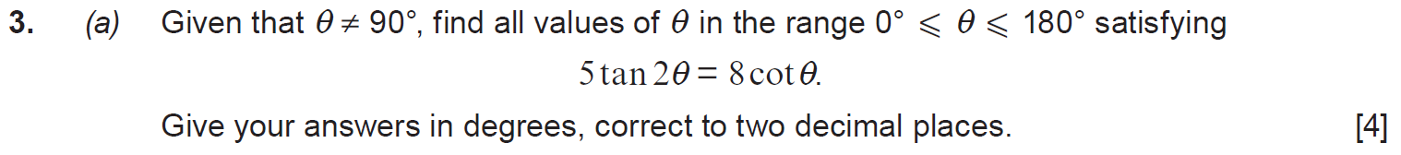
..........................................................................................................................................................................................................................................................................................................
..........................................................................................................................................................................................................................................................................................................
..........................................................................................................................................................................................................................................................................................................
..........................................................................................................................................................................................................................................................................................................
..........................................................................................................................................................................................................................................................................................................
..........................................................................................................................................................................................................................................................................................................
..........................................................................................................................................................................................................................................................................................................
..........................................................................................................................................................................................................................................................................................................
..........................................................................................................................................................................................................................................................................................................
..........................................................................................................................................................................................................................................................................................................
..........................................................................................................................................................................................................................................................................................................
..........................................................................................................................................................................................................................................................................................................
..........................................................................................................................................................................................................................................................................................................
..........................................................................................................................................................................................................................................................................................................
..........................................................................................................................................................................................................................................................................................................
..........................................................................................................................................................................................................................................................................................................
..........................................................................................................................................................................................................................................................................................................
..........................................................................................................................................................................................................................................................................................................
..........................................................................................................................................................................................................................................................................................................
..........................................................................................................................................................................................................................................................................................................
..........................................................................................................................................................................................................................................................................................................
..........................................................................................................................................................................................................................................................................................................
..........................................................................................................................................................................................................................................................................................................
..........................................................................................................................................................................................................................................................................................................
..........................................................................................................................................................................................................................................................................................................
..........................................................................................................................................................................................................................................................................................................
..........................................................................................................................................................................................................................................................................................................
..........................................................................................................................................................................................................................................................................................................
..........................................................................................................................................................................................................................................................................................................
..........................................................................................................................................................................................................................................................................................................
.........................................................................................................................................................................................................................................................................................................
..........................................................................................................................................................................................................................................................................................................
..........................................................................................................................................................................................................................................................................................................
..........................................................................................................................................................................................................................................................................................................
..........................................................................................................................................................................................................................................................................................................
.........................................................................................................................................................................................................................................................................................................
(C4 Summer 2018)
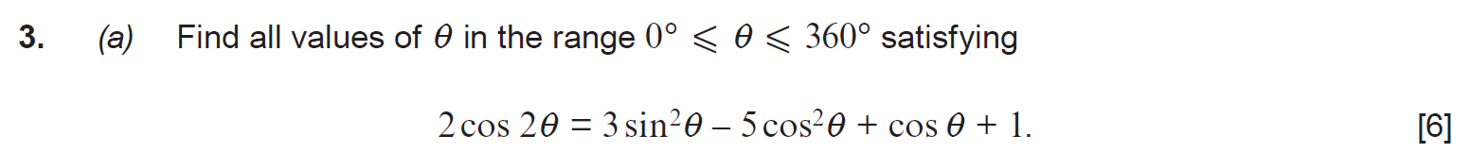
..........................................................................................................................................................................................................................................................................................................
..........................................................................................................................................................................................................................................................................................................
..........................................................................................................................................................................................................................................................................................................
..........................................................................................................................................................................................................................................................................................................
..........................................................................................................................................................................................................................................................................................................
..........................................................................................................................................................................................................................................................................................................
..........................................................................................................................................................................................................................................................................................................
..........................................................................................................................................................................................................................................................................................................
..........................................................................................................................................................................................................................................................................................................
..........................................................................................................................................................................................................................................................................................................
..........................................................................................................................................................................................................................................................................................................
..........................................................................................................................................................................................................................................................................................................
..........................................................................................................................................................................................................................................................................................................
..........................................................................................................................................................................................................................................................................................................
..........................................................................................................................................................................................................................................................................................................
..........................................................................................................................................................................................................................................................................................................
..........................................................................................................................................................................................................................................................................................................
..........................................................................................................................................................................................................................................................................................................
..........................................................................................................................................................................................................................................................................................................
..........................................................................................................................................................................................................................................................................................................
..........................................................................................................................................................................................................................................................................................................
..........................................................................................................................................................................................................................................................................................................
..........................................................................................................................................................................................................................................................................................................
..........................................................................................................................................................................................................................................................................................................
..........................................................................................................................................................................................................................................................................................................
..........................................................................................................................................................................................................................................................................................................
..........................................................................................................................................................................................................................................................................................................
..........................................................................................................................................................................................................................................................................................................
..........................................................................................................................................................................................................................................................................................................
..........................................................................................................................................................................................................................................................................................................
..........................................................................................................................................................................................................................................................................................................
..........................................................................................................................................................................................................................................................................................................
..........................................................................................................................................................................................................................................................................................................
..........................................................................................................................................................................................................................................................................................................
..........................................................................................................................................................................................................................................................................................................
..........................................................................................................................................................................................................................................................................................................
..........................................................................................................................................................................................................................................................................................................
(C4 Summer 2017)
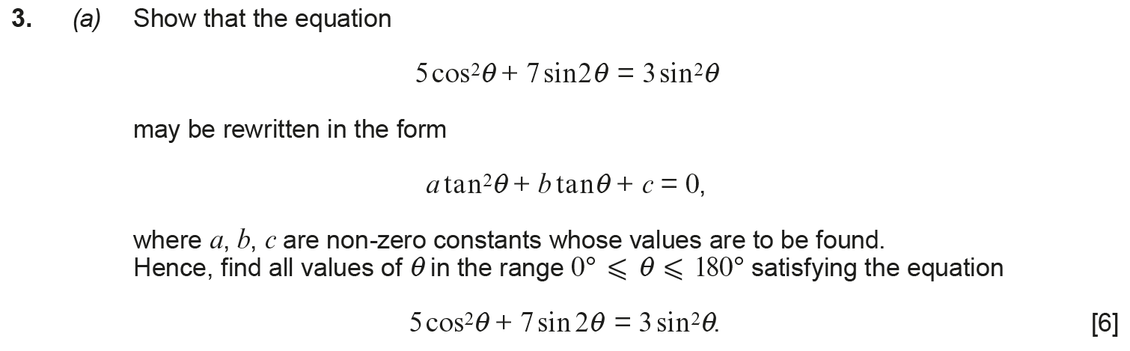
..........................................................................................................................................................................................................................................................................................................
..........................................................................................................................................................................................................................................................................................................
..........................................................................................................................................................................................................................................................................................................
..........................................................................................................................................................................................................................................................................................................
..........................................................................................................................................................................................................................................................................................................
..........................................................................................................................................................................................................................................................................................................
..........................................................................................................................................................................................................................................................................................................
..........................................................................................................................................................................................................................................................................................................
..........................................................................................................................................................................................................................................................................................................
..........................................................................................................................................................................................................................................................................................................
..........................................................................................................................................................................................................................................................................................................
..........................................................................................................................................................................................................................................................................................................
..........................................................................................................................................................................................................................................................................................................
..........................................................................................................................................................................................................................................................................................................
..........................................................................................................................................................................................................................................................................................................
..........................................................................................................................................................................................................................................................................................................
..........................................................................................................................................................................................................................................................................................................
..........................................................................................................................................................................................................................................................................................................
..........................................................................................................................................................................................................................................................................................................
..........................................................................................................................................................................................................................................................................................................
..........................................................................................................................................................................................................................................................................................................
..........................................................................................................................................................................................................................................................................................................
..........................................................................................................................................................................................................................................................................................................
..........................................................................................................................................................................................................................................................................................................
..........................................................................................................................................................................................................................................................................................................
..........................................................................................................................................................................................................................................................................................................
..........................................................................................................................................................................................................................................................................................................
..........................................................................................................................................................................................................................................................................................................
..........................................................................................................................................................................................................................................................................................................
..........................................................................................................................................................................................................................................................................................................
(C4 Summer 2016)
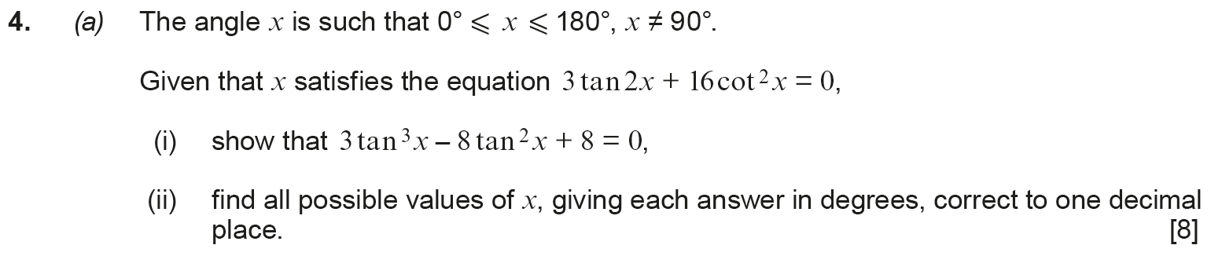
..........................................................................................................................................................................................................................................................................................................
..........................................................................................................................................................................................................................................................................................................
..........................................................................................................................................................................................................................................................................................................
..........................................................................................................................................................................................................................................................................................................
..........................................................................................................................................................................................................................................................................................................
..........................................................................................................................................................................................................................................................................................................
..........................................................................................................................................................................................................................................................................................................
..........................................................................................................................................................................................................................................................................................................
..........................................................................................................................................................................................................................................................................................................
..........................................................................................................................................................................................................................................................................................................
..........................................................................................................................................................................................................................................................................................................
..........................................................................................................................................................................................................................................................................................................
..........................................................................................................................................................................................................................................................................................................
..........................................................................................................................................................................................................................................................................................................
..........................................................................................................................................................................................................................................................................................................
..........................................................................................................................................................................................................................................................................................................
..........................................................................................................................................................................................................................................................................................................
..........................................................................................................................................................................................................................................................................................................
..........................................................................................................................................................................................................................................................................................................
..........................................................................................................................................................................................................................................................................................................
..........................................................................................................................................................................................................................................................................................................
..........................................................................................................................................................................................................................................................................................................
..........................................................................................................................................................................................................................................................................................................
..........................................................................................................................................................................................................................................................................................................
..........................................................................................................................................................................................................................................................................................................
..........................................................................................................................................................................................................................................................................................................
..........................................................................................................................................................................................................................................................................................................
..........................................................................................................................................................................................................................................................................................................
..........................................................................................................................................................................................................................................................................................................
..........................................................................................................................................................................................................................................................................................................
..........................................................................................................................................................................................................................................................................................................
..........................................................................................................................................................................................................................................................................................................
..........................................................................................................................................................................................................................................................................................................
..........................................................................................................................................................................................................................................................................................................
..........................................................................................................................................................................................................................................................................................................
..........................................................................................................................................................................................................................................................................................................
..........................................................................................................................................................................................................................................................................................................
..........................................................................................................................................................................................................................................................................................................
..........................................................................................................................................................................................................................................................................................................
..........................................................................................................................................................................................................................................................................................................
..........................................................................................................................................................................................................................................................................................................
..........................................................................................................................................................................................................................................................................................................
..........................................................................................................................................................................................................................................................................................................
..........................................................................................................................................................................................................................................................................................................
..........................................................................................................................................................................................................................................................................................................
..........................................................................................................................................................................................................................................................................................................
..........................................................................................................................................................................................................................................................................................................
..........................................................................................................................................................................................................................................................................................................
..........................................................................................................................................................................................................................................................................................................
..........................................................................................................................................................................................................................................................................................................
..........................................................................................................................................................................................................................................................................................................
..........................................................................................................................................................................................................................................................................................................
..........................................................................................................................................................................................................................................................................................................
..........................................................................................................................................................................................................................................................................................................
..........................................................................................................................................................................................................................................................................................................
..........................................................................................................................................................................................................................................................................................................
..........................................................................................................................................................................................................................................................................................................
..........................................................................................................................................................................................................................................................................................................
..........................................................................................................................................................................................................................................................................................................
..........................................................................................................................................................................................................................................................................................................
..........................................................................................................................................................................................................................................................................................................
..........................................................................................................................................................................................................................................................................................................
..........................................................................................................................................................................................................................................................................................................
..........................................................................................................................................................................................................................................................................................................
..........................................................................................................................................................................................................................................................................................................
..........................................................................................................................................................................................................................................................................................................
..........................................................................................................................................................................................................................................................................................................
..........................................................................................................................................................................................................................................................................................................
..........................................................................................................................................................................................................................................................................................................
..........................................................................................................................................................................................................................................................................................................
..........................................................................................................................................................................................................................................................................................................
..........................................................................................................................................................................................................................................................................................................
..........................................................................................................................................................................................................................................................................................................
..........................................................................................................................................................................................................................................................................................................
(Sample Assessment Materials, Question 8)





















































































































