


$$\sin\left(2A\right)=2\sin{A}\cos{A}$$
$$\cos\left(2A\right)={\text{cos}}^{2}\left(A\right)-{\text{sin}}^{2}\left(A\right) \\ \cos\left(2A\right)=1-2{\text{sin}}^{2}\left(A\right) \\ \cos\left(2A\right)=2{\text{cos}}^{2}\left(A\right)-1$$
$$\tan\left(2A\right)=\frac{2\tan{A}}{1-{\text{tan}}^{2}A}$$

Beth yw’r gwaith? |  | Mae’r pecyn gwaith yma’n ystyried beth yw’r fformiwlâu ar gyfer $\sin{(2A)}$, $\cos{(2A)}$ a $\tan{(2A)}$.
Beth sydd ei angen cyn cychwyn? |  | Lefel A Uned 1: Trigonometreg.  Lefel A Uned 3: Fformiwlâu Adiad Trigonometreg.
I ble mae’n arwain? |  | Lefel A Uned 3:  - Integru ffwythiannau sy’n cynnwys (e.e.) ${\text{sin}}^{2}(x)$.  Cymwysiadau:  - Datrys hafaliadau trigonometreg trwy ostwng pwerau’r hafaliad.
Yn y pecyn gynt, cyflwynwyd y fformiwlâu canlynol ar gyfer adiad trigonometreg:
Theori
$$\sin\left(A+B\right)=\sin{A}\cos{B}+\cos{A}\sin{B}$$
$$\cos\left(A+B\right)=\cos{A}\cos{B}-\sin{A}\sin{B}$$
$$\tan{(A+B)}=\frac{\tan{A}+\tan{B}}{1-\tan{A}\tan{B}}$$
Ystyriwn yn awr beth sy’n digwydd i’r fformiwlâu uchod os yw’r onglau $A$ a $B$ yn hafal.
$$\sin\left(A+A\right)=\sin{A}\cos{A}+\cos{A}\sin{A} \\ \sin{(2A)}=2\sin{A}\cos{A}$$
$$\cos\left(A+A\right)=\cos{A}\cos{A}-\sin{A}\sin{A} \\ \cos{(2A)}={\text{cos}}^{2}\left(A\right)-{\text{sin}}^{2}(A)$$
$$\tan{(A+A)}=\frac{\tan{A}+\tan{A}}{1-\tan{A}\tan{A}} \\ \tan\left(2A\right)=\frac{2\tan{A}}{1-{\text{tan}}^{2}A}$$
Mae’r fformiwlâu uchod yn cael eu hadnabod fel y fformiwlâu ar gyfer onglau dwbl. Yn achos y fformiwla ar gyfer $\cos{(2A)}$, mae’n troi allan bod defnyddio’r unfathiant ${\text{sin}}^{2}A+{\text{cos}}^{2}A=1$ o’r cwrs Uned 1 yn ein helpu i ysgrifennu’r fformiwla mewn dull mwy defnyddiol.
$\cos{(2A)}={\text{cos}}^{2}\left(A\right)-{\text{sin}}^{2}(A)$ $\cos{(2A)}={\text{cos}}^{2}\left(A\right)-{\text{sin}}^{2}(A)$
$\cos{(2A)}=(1-{\text{sin}}^{2}(A))-{\text{sin}}^{2}(A)$ $\cos{(2A)}={\text{cos}}^{2}\left(A\right)-(1-{\text{cos}}^{2}\left(A\right))$
$\cos{(2A)}=1-2{\text{sin}}^{2}(A)$ $\cos{(2A)}={\text{cos}}^{2}\left(A\right)-1+{\text{cos}}^{2}(A)$
$\cos{(2A)}=2{\text{cos}}^{2}\left(A\right)-1$

Dyma grynodeb o’r fformiwlâu ar gyfer onglau dwbl. Mae angen dysgu’r rhain.

$\sin\left(2A\right)=2\sin{A}\cos{A}$
$\cos\left(2A\right)={\text{cos}}^{2}\left(A\right)-{\text{sin}}^{2}\left(A\right)$
$\cos\left(2A\right)=1-2{\text{sin}}^{2}\left(A\right)$
$\cos\left(2A\right)=2{\text{cos}}^{2}\left(A\right)-1$
$\tan\left(2A\right)=\frac{2\tan{A}}{1-{\text{tan}}^{2}A}$

Sialens!
Dangoswch bod hi’n bosib ysgrifennu (a) $\sin{(2A)}=\frac{2\tan{A}}{1+{\text{tan}}^{2}(A)}$, (b) $\cos{(2A)}=\frac{1-{\text{tan}}^{2}(A)}{1+{\text{tan}}^{2}(A)}$.
(C4 Haf 2010)
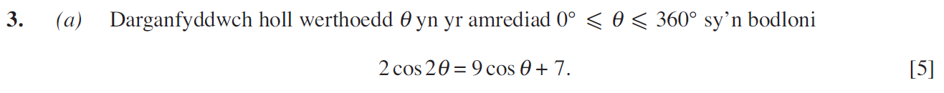
..........................................................................................................................................................................................................................................................................................................
..........................................................................................................................................................................................................................................................................................................
..........................................................................................................................................................................................................................................................................................................
..........................................................................................................................................................................................................................................................................................................
..........................................................................................................................................................................................................................................................................................................
..........................................................................................................................................................................................................................................................................................................
..........................................................................................................................................................................................................................................................................................................
..........................................................................................................................................................................................................................................................................................................
..........................................................................................................................................................................................................................................................................................................
..........................................................................................................................................................................................................................................................................................................
..........................................................................................................................................................................................................................................................................................................
..........................................................................................................................................................................................................................................................................................................
..........................................................................................................................................................................................................................................................................................................
..........................................................................................................................................................................................................................................................................................................
..........................................................................................................................................................................................................................................................................................................
..........................................................................................................................................................................................................................................................................................................
..........................................................................................................................................................................................................................................................................................................
..........................................................................................................................................................................................................................................................................................................
..........................................................................................................................................................................................................................................................................................................
..........................................................................................................................................................................................................................................................................................................
(C4 Haf 2011)
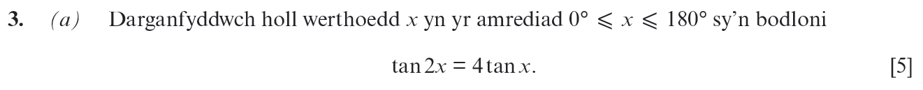
..........................................................................................................................................................................................................................................................................................................
..........................................................................................................................................................................................................................................................................................................
..........................................................................................................................................................................................................................................................................................................
..........................................................................................................................................................................................................................................................................................................
..........................................................................................................................................................................................................................................................................................................
..........................................................................................................................................................................................................................................................................................................
..........................................................................................................................................................................................................................................................................................................
..........................................................................................................................................................................................................................................................................................................
..........................................................................................................................................................................................................................................................................................................
..........................................................................................................................................................................................................................................................................................................
..........................................................................................................................................................................................................................................................................................................
..........................................................................................................................................................................................................................................................................................................
..........................................................................................................................................................................................................................................................................................................
..........................................................................................................................................................................................................................................................................................................
..........................................................................................................................................................................................................................................................................................................
..........................................................................................................................................................................................................................................................................................................
..........................................................................................................................................................................................................................................................................................................
..........................................................................................................................................................................................................................................................................................................
..........................................................................................................................................................................................................................................................................................................
..........................................................................................................................................................................................................................................................................................................
..........................................................................................................................................................................................................................................................................................................
..........................................................................................................................................................................................................................................................................................................
..........................................................................................................................................................................................................................................................................................................
..........................................................................................................................................................................................................................................................................................................
..........................................................................................................................................................................................................................................................................................................
..........................................................................................................................................................................................................................................................................................................
..........................................................................................................................................................................................................................................................................................................
..........................................................................................................................................................................................................................................................................................................
..........................................................................................................................................................................................................................................................................................................
..........................................................................................................................................................................................................................................................................................................
..........................................................................................................................................................................................................................................................................................................
..........................................................................................................................................................................................................................................................................................................
..........................................................................................................................................................................................................................................................................................................
..........................................................................................................................................................................................................................................................................................................
..........................................................................................................................................................................................................................................................................................................
..........................................................................................................................................................................................................................................................................................................
..........................................................................................................................................................................................................................................................................................................
(C4 Haf 2005)
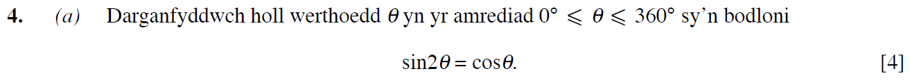
..........................................................................................................................................................................................................................................................................................................
..........................................................................................................................................................................................................................................................................................................
..........................................................................................................................................................................................................................................................................................................
..........................................................................................................................................................................................................................................................................................................
..........................................................................................................................................................................................................................................................................................................
..........................................................................................................................................................................................................................................................................................................
..........................................................................................................................................................................................................................................................................................................
..........................................................................................................................................................................................................................................................................................................
..........................................................................................................................................................................................................................................................................................................
..........................................................................................................................................................................................................................................................................................................
..........................................................................................................................................................................................................................................................................................................
..........................................................................................................................................................................................................................................................................................................
..........................................................................................................................................................................................................................................................................................................
..........................................................................................................................................................................................................................................................................................................
..........................................................................................................................................................................................................................................................................................................
..........................................................................................................................................................................................................................................................................................................
..........................................................................................................................................................................................................................................................................................................
..........................................................................................................................................................................................................................................................................................................
..........................................................................................................................................................................................................................................................................................................
..........................................................................................................................................................................................................................................................................................................
..........................................................................................................................................................................................................................................................................................................
..........................................................................................................................................................................................................................................................................................................
..........................................................................................................................................................................................................................................................................................................
..........................................................................................................................................................................................................................................................................................................
..........................................................................................................................................................................................................................................................................................................
..........................................................................................................................................................................................................................................................................................................
..........................................................................................................................................................................................................................................................................................................
..........................................................................................................................................................................................................................................................................................................
..........................................................................................................................................................................................................................................................................................................
..........................................................................................................................................................................................................................................................................................................
..........................................................................................................................................................................................................................................................................................................
..........................................................................................................................................................................................................................................................................................................
..........................................................................................................................................................................................................................................................................................................
..........................................................................................................................................................................................................................................................................................................
(C4 Haf 2009)
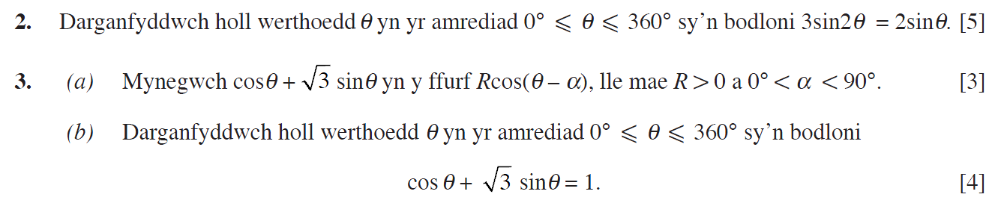
..........................................................................................................................................................................................................................................................................................................
..........................................................................................................................................................................................................................................................................................................
..........................................................................................................................................................................................................................................................................................................
..........................................................................................................................................................................................................................................................................................................
..........................................................................................................................................................................................................................................................................................................
..........................................................................................................................................................................................................................................................................................................
..........................................................................................................................................................................................................................................................................................................
..........................................................................................................................................................................................................................................................................................................
..........................................................................................................................................................................................................................................................................................................
..........................................................................................................................................................................................................................................................................................................
..........................................................................................................................................................................................................................................................................................................
..........................................................................................................................................................................................................................................................................................................
..........................................................................................................................................................................................................................................................................................................
..........................................................................................................................................................................................................................................................................................................
..........................................................................................................................................................................................................................................................................................................
..........................................................................................................................................................................................................................................................................................................
..........................................................................................................................................................................................................................................................................................................
..........................................................................................................................................................................................................................................................................................................
..........................................................................................................................................................................................................................................................................................................
..........................................................................................................................................................................................................................................................................................................
..........................................................................................................................................................................................................................................................................................................
..........................................................................................................................................................................................................................................................................................................
..........................................................................................................................................................................................................................................................................................................
..........................................................................................................................................................................................................................................................................................................
..........................................................................................................................................................................................................................................................................................................
..........................................................................................................................................................................................................................................................................................................
..........................................................................................................................................................................................................................................................................................................
..........................................................................................................................................................................................................................................................................................................
..........................................................................................................................................................................................................................................................................................................
..........................................................................................................................................................................................................................................................................................................
..........................................................................................................................................................................................................................................................................................................
..........................................................................................................................................................................................................................................................................................................
..........................................................................................................................................................................................................................................................................................................
..........................................................................................................................................................................................................................................................................................................
..........................................................................................................................................................................................................................................................................................................
..........................................................................................................................................................................................................................................................................................................
..........................................................................................................................................................................................................................................................................................................
..........................................................................................................................................................................................................................................................................................................
(C4 Haf 2006)
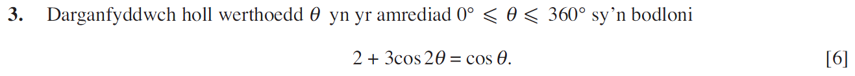
..........................................................................................................................................................................................................................................................................................................
..........................................................................................................................................................................................................................................................................................................
..........................................................................................................................................................................................................................................................................................................
..........................................................................................................................................................................................................................................................................................................
..........................................................................................................................................................................................................................................................................................................
..........................................................................................................................................................................................................................................................................................................
..........................................................................................................................................................................................................................................................................................................
..........................................................................................................................................................................................................................................................................................................
..........................................................................................................................................................................................................................................................................................................
..........................................................................................................................................................................................................................................................................................................
..........................................................................................................................................................................................................................................................................................................
..........................................................................................................................................................................................................................................................................................................
..........................................................................................................................................................................................................................................................................................................
..........................................................................................................................................................................................................................................................................................................
..........................................................................................................................................................................................................................................................................................................
..........................................................................................................................................................................................................................................................................................................
..........................................................................................................................................................................................................................................................................................................
..........................................................................................................................................................................................................................................................................................................
..........................................................................................................................................................................................................................................................................................................
..........................................................................................................................................................................................................................................................................................................
..........................................................................................................................................................................................................................................................................................................
..........................................................................................................................................................................................................................................................................................................
..........................................................................................................................................................................................................................................................................................................
..........................................................................................................................................................................................................................................................................................................
..........................................................................................................................................................................................................................................................................................................
..........................................................................................................................................................................................................................................................................................................
..........................................................................................................................................................................................................................................................................................................
..........................................................................................................................................................................................................................................................................................................
..........................................................................................................................................................................................................................................................................................................
..........................................................................................................................................................................................................................................................................................................
..........................................................................................................................................................................................................................................................................................................
..........................................................................................................................................................................................................................................................................................................
..........................................................................................................................................................................................................................................................................................................
..........................................................................................................................................................................................................................................................................................................
..........................................................................................................................................................................................................................................................................................................
..........................................................................................................................................................................................................................................................................................................
..........................................................................................................................................................................................................................................................................................................
(C4 Haf 2012)
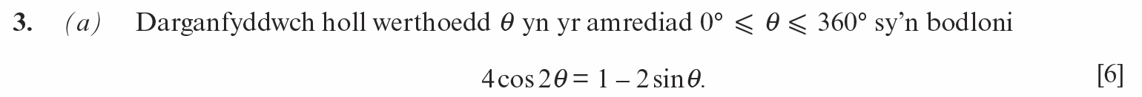
..........................................................................................................................................................................................................................................................................................................
..........................................................................................................................................................................................................................................................................................................
..........................................................................................................................................................................................................................................................................................................
..........................................................................................................................................................................................................................................................................................................
..........................................................................................................................................................................................................................................................................................................
..........................................................................................................................................................................................................................................................................................................
..........................................................................................................................................................................................................................................................................................................
..........................................................................................................................................................................................................................................................................................................
..........................................................................................................................................................................................................................................................................................................
..........................................................................................................................................................................................................................................................................................................
..........................................................................................................................................................................................................................................................................................................
..........................................................................................................................................................................................................................................................................................................
..........................................................................................................................................................................................................................................................................................................
..........................................................................................................................................................................................................................................................................................................
..........................................................................................................................................................................................................................................................................................................
..........................................................................................................................................................................................................................................................................................................
..........................................................................................................................................................................................................................................................................................................
..........................................................................................................................................................................................................................................................................................................
..........................................................................................................................................................................................................................................................................................................
..........................................................................................................................................................................................................................................................................................................
..........................................................................................................................................................................................................................................................................................................
..........................................................................................................................................................................................................................................................................................................
..........................................................................................................................................................................................................................................................................................................
..........................................................................................................................................................................................................................................................................................................
..........................................................................................................................................................................................................................................................................................................
..........................................................................................................................................................................................................................................................................................................
..........................................................................................................................................................................................................................................................................................................
..........................................................................................................................................................................................................................................................................................................
..........................................................................................................................................................................................................................................................................................................
..........................................................................................................................................................................................................................................................................................................
..........................................................................................................................................................................................................................................................................................................
..........................................................................................................................................................................................................................................................................................................
..........................................................................................................................................................................................................................................................................................................
..........................................................................................................................................................................................................................................................................................................
..........................................................................................................................................................................................................................................................................................................
..........................................................................................................................................................................................................................................................................................................
..........................................................................................................................................................................................................................................................................................................
(C4 Haf 2013)
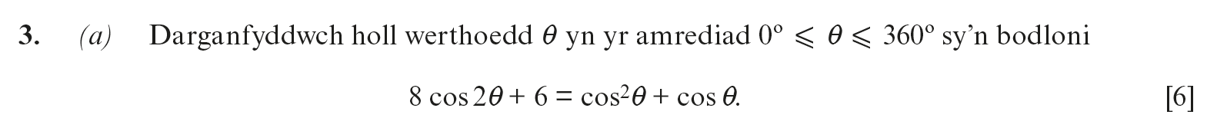
..........................................................................................................................................................................................................................................................................................................
..........................................................................................................................................................................................................................................................................................................
..........................................................................................................................................................................................................................................................................................................
..........................................................................................................................................................................................................................................................................................................
..........................................................................................................................................................................................................................................................................................................
..........................................................................................................................................................................................................................................................................................................
..........................................................................................................................................................................................................................................................................................................
..........................................................................................................................................................................................................................................................................................................
..........................................................................................................................................................................................................................................................................................................
..........................................................................................................................................................................................................................................................................................................
..........................................................................................................................................................................................................................................................................................................
..........................................................................................................................................................................................................................................................................................................
..........................................................................................................................................................................................................................................................................................................
..........................................................................................................................................................................................................................................................................................................
..........................................................................................................................................................................................................................................................................................................
..........................................................................................................................................................................................................................................................................................................
..........................................................................................................................................................................................................................................................................................................
..........................................................................................................................................................................................................................................................................................................
..........................................................................................................................................................................................................................................................................................................
..........................................................................................................................................................................................................................................................................................................
..........................................................................................................................................................................................................................................................................................................
..........................................................................................................................................................................................................................................................................................................
..........................................................................................................................................................................................................................................................................................................
..........................................................................................................................................................................................................................................................................................................
..........................................................................................................................................................................................................................................................................................................
..........................................................................................................................................................................................................................................................................................................
..........................................................................................................................................................................................................................................................................................................
..........................................................................................................................................................................................................................................................................................................
..........................................................................................................................................................................................................................................................................................................
..........................................................................................................................................................................................................................................................................................................
..........................................................................................................................................................................................................................................................................................................
..........................................................................................................................................................................................................................................................................................................
..........................................................................................................................................................................................................................................................................................................
..........................................................................................................................................................................................................................................................................................................
..........................................................................................................................................................................................................................................................................................................
..........................................................................................................................................................................................................................................................................................................
..........................................................................................................................................................................................................................................................................................................
(C4 Haf 2014)
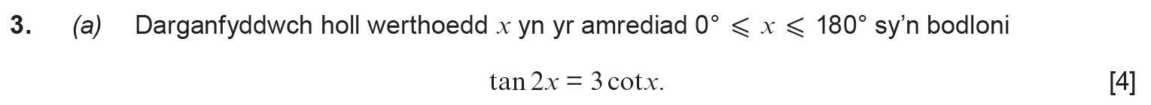
..........................................................................................................................................................................................................................................................................................................
..........................................................................................................................................................................................................................................................................................................
..........................................................................................................................................................................................................................................................................................................
..........................................................................................................................................................................................................................................................................................................
..........................................................................................................................................................................................................................................................................................................
..........................................................................................................................................................................................................................................................................................................
..........................................................................................................................................................................................................................................................................................................
..........................................................................................................................................................................................................................................................................................................
..........................................................................................................................................................................................................................................................................................................
..........................................................................................................................................................................................................................................................................................................
..........................................................................................................................................................................................................................................................................................................
..........................................................................................................................................................................................................................................................................................................
..........................................................................................................................................................................................................................................................................................................
..........................................................................................................................................................................................................................................................................................................
..........................................................................................................................................................................................................................................................................................................
..........................................................................................................................................................................................................................................................................................................
..........................................................................................................................................................................................................................................................................................................
..........................................................................................................................................................................................................................................................................................................
..........................................................................................................................................................................................................................................................................................................
..........................................................................................................................................................................................................................................................................................................
..........................................................................................................................................................................................................................................................................................................
..........................................................................................................................................................................................................................................................................................................
..........................................................................................................................................................................................................................................................................................................
..........................................................................................................................................................................................................................................................................................................
..........................................................................................................................................................................................................................................................................................................
..........................................................................................................................................................................................................................................................................................................
..........................................................................................................................................................................................................................................................................................................
..........................................................................................................................................................................................................................................................................................................
..........................................................................................................................................................................................................................................................................................................
..........................................................................................................................................................................................................................................................................................................
..........................................................................................................................................................................................................................................................................................................
..........................................................................................................................................................................................................................................................................................................
..........................................................................................................................................................................................................................................................................................................
..........................................................................................................................................................................................................................................................................................................
..........................................................................................................................................................................................................................................................................................................
..........................................................................................................................................................................................................................................................................................................
..........................................................................................................................................................................................................................................................................................................
(C4 Haf 2019)
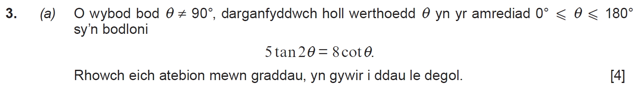
..........................................................................................................................................................................................................................................................................................................
..........................................................................................................................................................................................................................................................................................................
..........................................................................................................................................................................................................................................................................................................
..........................................................................................................................................................................................................................................................................................................
..........................................................................................................................................................................................................................................................................................................
..........................................................................................................................................................................................................................................................................................................
..........................................................................................................................................................................................................................................................................................................
..........................................................................................................................................................................................................................................................................................................
..........................................................................................................................................................................................................................................................................................................
..........................................................................................................................................................................................................................................................................................................
..........................................................................................................................................................................................................................................................................................................
..........................................................................................................................................................................................................................................................................................................
..........................................................................................................................................................................................................................................................................................................
..........................................................................................................................................................................................................................................................................................................
..........................................................................................................................................................................................................................................................................................................
..........................................................................................................................................................................................................................................................................................................
..........................................................................................................................................................................................................................................................................................................
..........................................................................................................................................................................................................................................................................................................
..........................................................................................................................................................................................................................................................................................................
..........................................................................................................................................................................................................................................................................................................
..........................................................................................................................................................................................................................................................................................................
..........................................................................................................................................................................................................................................................................................................
..........................................................................................................................................................................................................................................................................................................
..........................................................................................................................................................................................................................................................................................................
..........................................................................................................................................................................................................................................................................................................
..........................................................................................................................................................................................................................................................................................................
..........................................................................................................................................................................................................................................................................................................
..........................................................................................................................................................................................................................................................................................................
..........................................................................................................................................................................................................................................................................................................
..........................................................................................................................................................................................................................................................................................................
.........................................................................................................................................................................................................................................................................................................
..........................................................................................................................................................................................................................................................................................................
..........................................................................................................................................................................................................................................................................................................
..........................................................................................................................................................................................................................................................................................................
..........................................................................................................................................................................................................................................................................................................
(C4 Haf 2018)
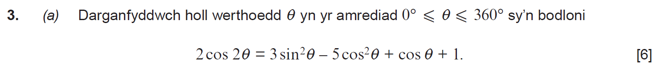
..........................................................................................................................................................................................................................................................................................................
..........................................................................................................................................................................................................................................................................................................
..........................................................................................................................................................................................................................................................................................................
..........................................................................................................................................................................................................................................................................................................
..........................................................................................................................................................................................................................................................................................................
..........................................................................................................................................................................................................................................................................................................
..........................................................................................................................................................................................................................................................................................................
..........................................................................................................................................................................................................................................................................................................
..........................................................................................................................................................................................................................................................................................................
..........................................................................................................................................................................................................................................................................................................
..........................................................................................................................................................................................................................................................................................................
..........................................................................................................................................................................................................................................................................................................
..........................................................................................................................................................................................................................................................................................................
..........................................................................................................................................................................................................................................................................................................
..........................................................................................................................................................................................................................................................................................................
..........................................................................................................................................................................................................................................................................................................
..........................................................................................................................................................................................................................................................................................................
..........................................................................................................................................................................................................................................................................................................
..........................................................................................................................................................................................................................................................................................................
..........................................................................................................................................................................................................................................................................................................
..........................................................................................................................................................................................................................................................................................................
..........................................................................................................................................................................................................................................................................................................
..........................................................................................................................................................................................................................................................................................................
..........................................................................................................................................................................................................................................................................................................
..........................................................................................................................................................................................................................................................................................................
..........................................................................................................................................................................................................................................................................................................
..........................................................................................................................................................................................................................................................................................................
..........................................................................................................................................................................................................................................................................................................
..........................................................................................................................................................................................................................................................................................................
..........................................................................................................................................................................................................................................................................................................
..........................................................................................................................................................................................................................................................................................................
..........................................................................................................................................................................................................................................................................................................
..........................................................................................................................................................................................................................................................................................................
..........................................................................................................................................................................................................................................................................................................
..........................................................................................................................................................................................................................................................................................................
..........................................................................................................................................................................................................................................................................................................
..........................................................................................................................................................................................................................................................................................................
(C4 Haf 2017)
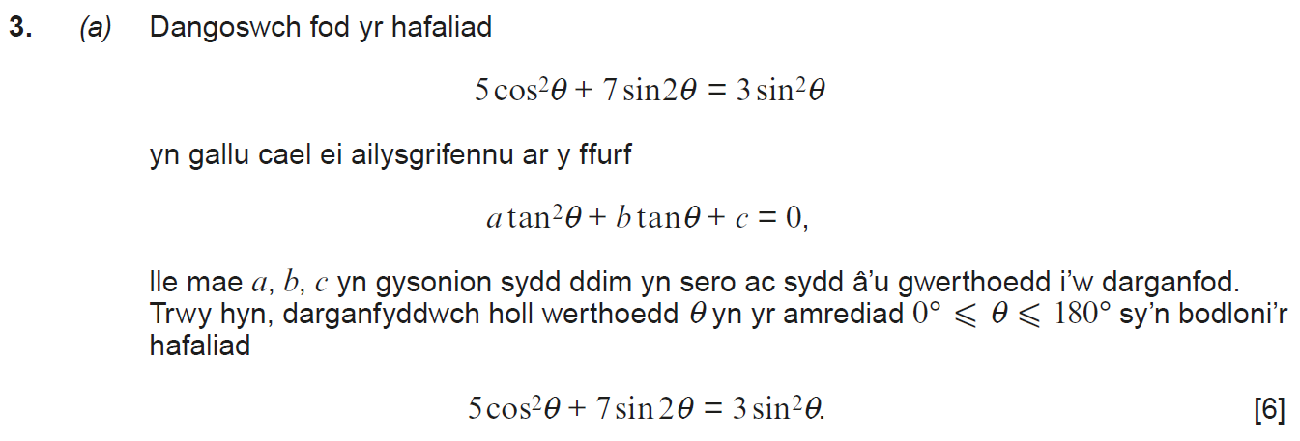
..........................................................................................................................................................................................................................................................................................................
..........................................................................................................................................................................................................................................................................................................
..........................................................................................................................................................................................................................................................................................................
..........................................................................................................................................................................................................................................................................................................
..........................................................................................................................................................................................................................................................................................................
..........................................................................................................................................................................................................................................................................................................
..........................................................................................................................................................................................................................................................................................................
..........................................................................................................................................................................................................................................................................................................
..........................................................................................................................................................................................................................................................................................................
..........................................................................................................................................................................................................................................................................................................
..........................................................................................................................................................................................................................................................................................................
..........................................................................................................................................................................................................................................................................................................
..........................................................................................................................................................................................................................................................................................................
..........................................................................................................................................................................................................................................................................................................
..........................................................................................................................................................................................................................................................................................................
..........................................................................................................................................................................................................................................................................................................
..........................................................................................................................................................................................................................................................................................................
..........................................................................................................................................................................................................................................................................................................
..........................................................................................................................................................................................................................................................................................................
..........................................................................................................................................................................................................................................................................................................
..........................................................................................................................................................................................................................................................................................................
..........................................................................................................................................................................................................................................................................................................
..........................................................................................................................................................................................................................................................................................................
..........................................................................................................................................................................................................................................................................................................
..........................................................................................................................................................................................................................................................................................................
..........................................................................................................................................................................................................................................................................................................
..........................................................................................................................................................................................................................................................................................................
..........................................................................................................................................................................................................................................................................................................
..........................................................................................................................................................................................................................................................................................................
..........................................................................................................................................................................................................................................................................................................
(C4 Haf 2016)
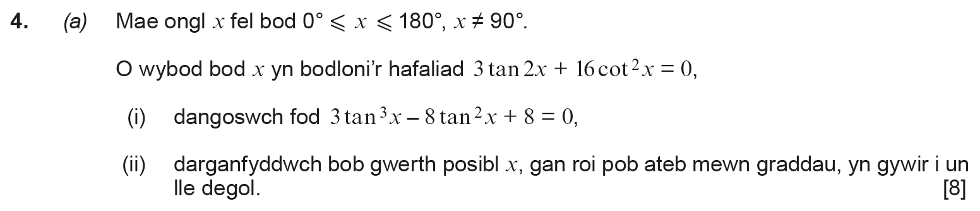
..........................................................................................................................................................................................................................................................................................................
..........................................................................................................................................................................................................................................................................................................
..........................................................................................................................................................................................................................................................................................................
..........................................................................................................................................................................................................................................................................................................
..........................................................................................................................................................................................................................................................................................................
..........................................................................................................................................................................................................................................................................................................
..........................................................................................................................................................................................................................................................................................................
..........................................................................................................................................................................................................................................................................................................
..........................................................................................................................................................................................................................................................................................................
..........................................................................................................................................................................................................................................................................................................
..........................................................................................................................................................................................................................................................................................................
..........................................................................................................................................................................................................................................................................................................
..........................................................................................................................................................................................................................................................................................................
..........................................................................................................................................................................................................................................................................................................
..........................................................................................................................................................................................................................................................................................................
..........................................................................................................................................................................................................................................................................................................
..........................................................................................................................................................................................................................................................................................................
..........................................................................................................................................................................................................................................................................................................
..........................................................................................................................................................................................................................................................................................................
..........................................................................................................................................................................................................................................................................................................
..........................................................................................................................................................................................................................................................................................................
..........................................................................................................................................................................................................................................................................................................
..........................................................................................................................................................................................................................................................................................................
..........................................................................................................................................................................................................................................................................................................
..........................................................................................................................................................................................................................................................................................................
..........................................................................................................................................................................................................................................................................................................
..........................................................................................................................................................................................................................................................................................................
..........................................................................................................................................................................................................................................................................................................
..........................................................................................................................................................................................................................................................................................................
..........................................................................................................................................................................................................................................................................................................
..........................................................................................................................................................................................................................................................................................................
..........................................................................................................................................................................................................................................................................................................
..........................................................................................................................................................................................................................................................................................................
..........................................................................................................................................................................................................................................................................................................
..........................................................................................................................................................................................................................................................................................................
..........................................................................................................................................................................................................................................................................................................
..........................................................................................................................................................................................................................................................................................................
..........................................................................................................................................................................................................................................................................................................
..........................................................................................................................................................................................................................................................................................................
..........................................................................................................................................................................................................................................................................................................
..........................................................................................................................................................................................................................................................................................................
..........................................................................................................................................................................................................................................................................................................
..........................................................................................................................................................................................................................................................................................................
..........................................................................................................................................................................................................................................................................................................
..........................................................................................................................................................................................................................................................................................................
..........................................................................................................................................................................................................................................................................................................
..........................................................................................................................................................................................................................................................................................................
..........................................................................................................................................................................................................................................................................................................
..........................................................................................................................................................................................................................................................................................................
..........................................................................................................................................................................................................................................................................................................
..........................................................................................................................................................................................................................................................................................................
..........................................................................................................................................................................................................................................................................................................
..........................................................................................................................................................................................................................................................................................................
..........................................................................................................................................................................................................................................................................................................
..........................................................................................................................................................................................................................................................................................................
..........................................................................................................................................................................................................................................................................................................
..........................................................................................................................................................................................................................................................................................................
..........................................................................................................................................................................................................................................................................................................
..........................................................................................................................................................................................................................................................................................................
..........................................................................................................................................................................................................................................................................................................
..........................................................................................................................................................................................................................................................................................................
..........................................................................................................................................................................................................................................................................................................
..........................................................................................................................................................................................................................................................................................................
..........................................................................................................................................................................................................................................................................................................
..........................................................................................................................................................................................................................................................................................................
..........................................................................................................................................................................................................................................................................................................
..........................................................................................................................................................................................................................................................................................................
..........................................................................................................................................................................................................................................................................................................
..........................................................................................................................................................................................................................................................................................................
..........................................................................................................................................................................................................................................................................................................
..........................................................................................................................................................................................................................................................................................................
..........................................................................................................................................................................................................................................................................................................
..........................................................................................................................................................................................................................................................................................................
..........................................................................................................................................................................................................................................................................................................
(Deunyddiau Asesu Enghreifftiol, Cwestiwn 8)




















































































































