

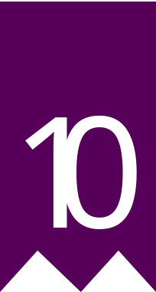
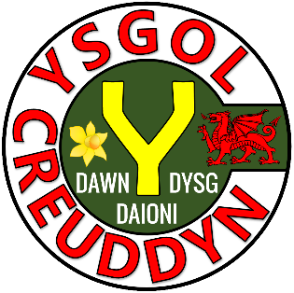

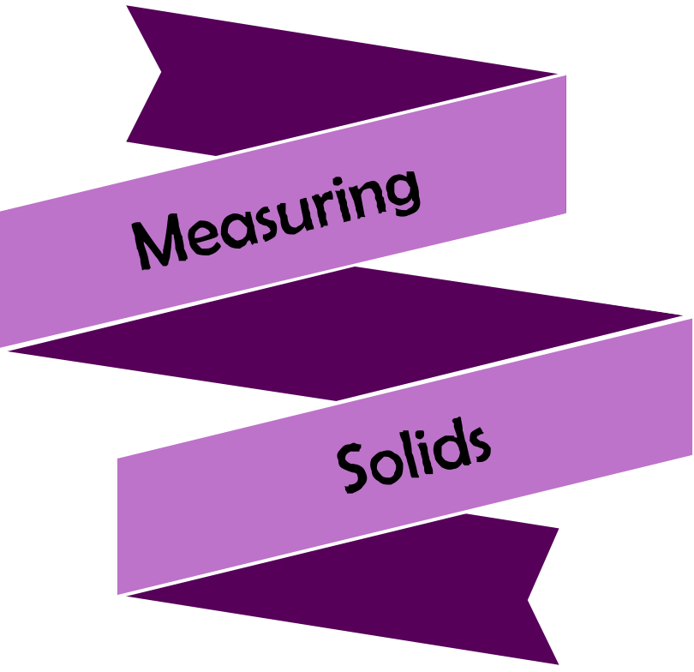





Chapter | Mathematics | Page Number
Solids | Volume and surface area of a cuboid. Volume of a prism. Volume and surface area of a cylinder. Volume of a pyramid. Surface area of a cone. Volume and surface area of a sphere. | 3
Composite Solids | Volume of composite solids. Frustum of a cone. Hemisphere. | 14
Similar Shapes | Calculating the scale factor. Calculating missing lengths. Similar or not? Similar triangles. Scale factor for length, area and volume. Using similar triangles to calculate the volume of a frustum of a cone. | 18
Pythagoras’ Theorem (3-D) | Calculating lengths in three-dimensional shapes. | 25
Dimensions | Length, area and volume. Nonsensical formulae. | 27

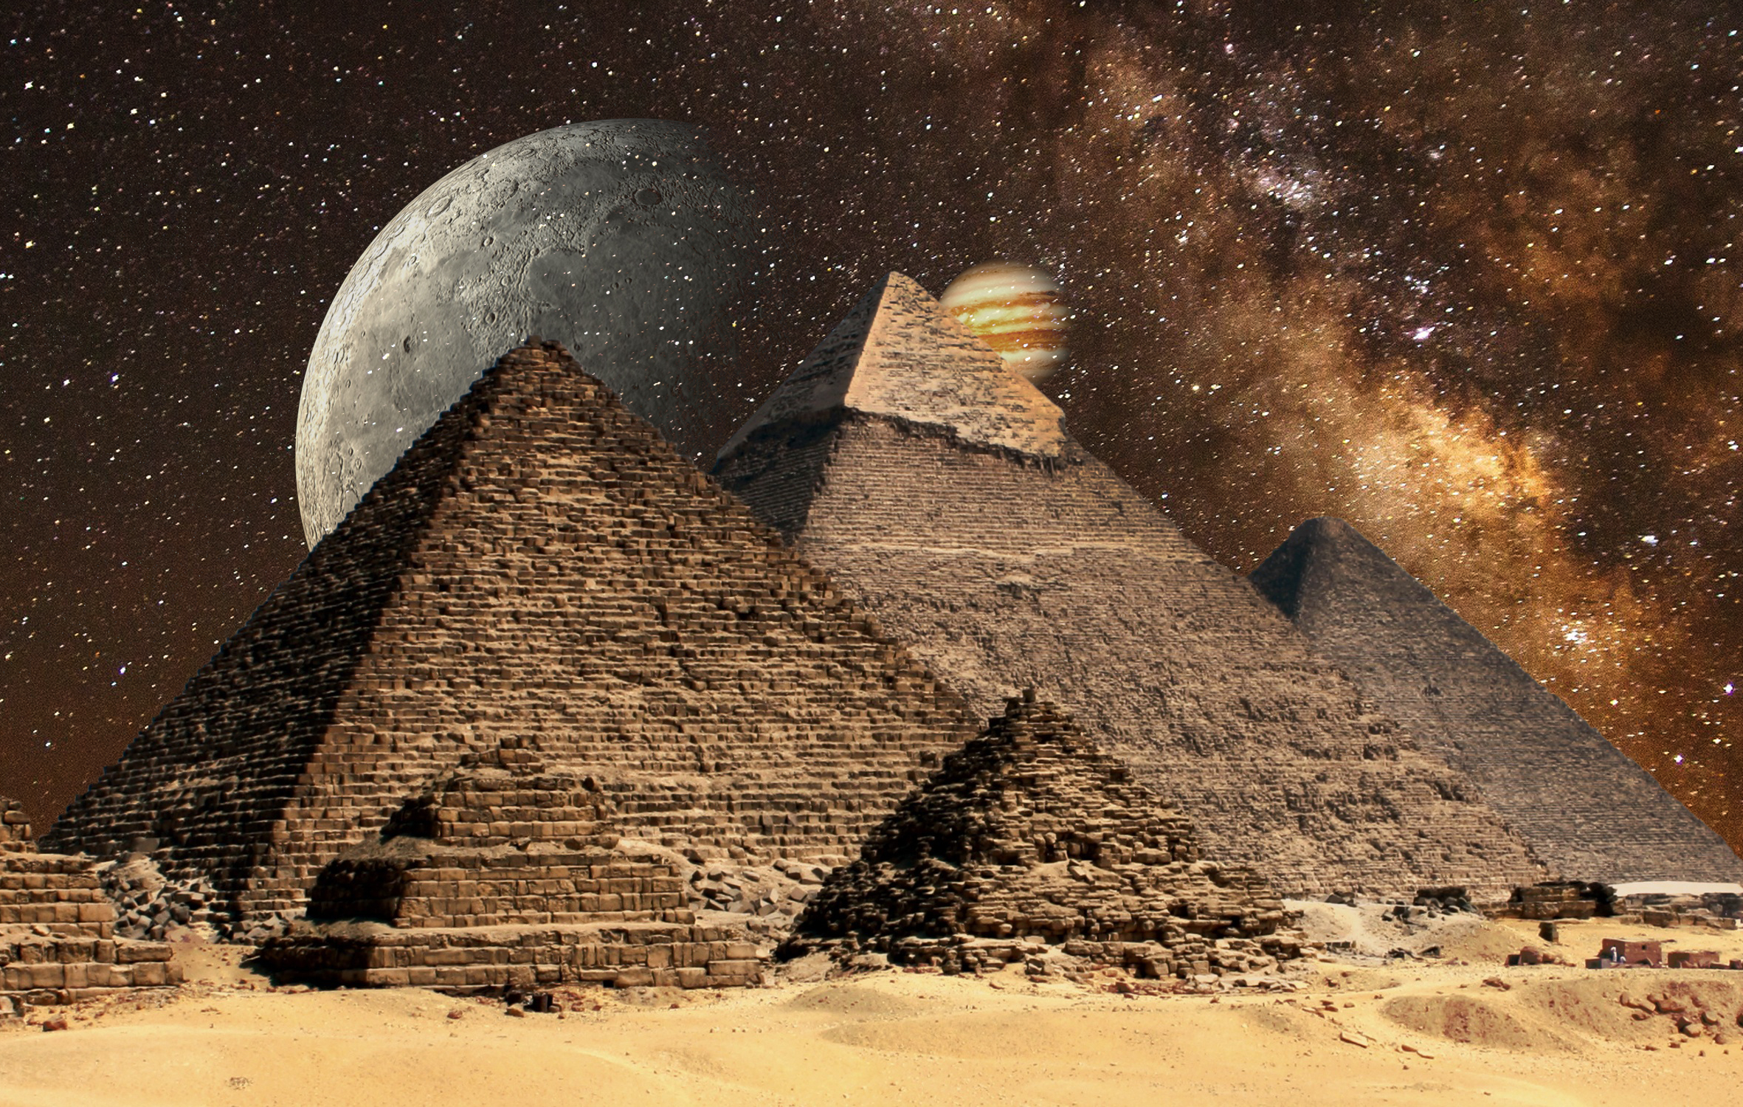




Exercise 1
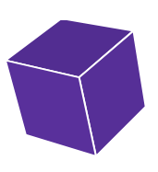
Pair the solid with its matching net. Write the name of the solid underneath it.
F
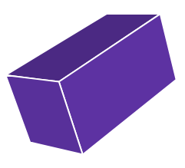
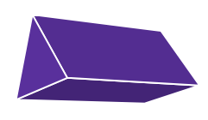
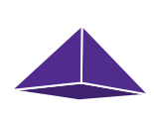

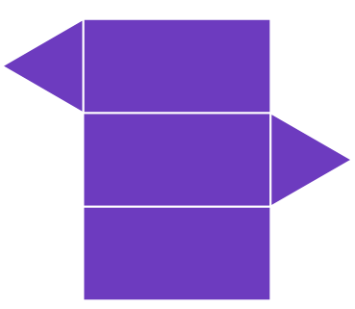

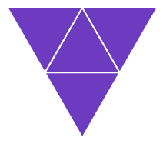
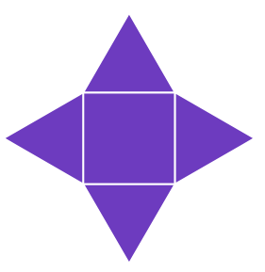
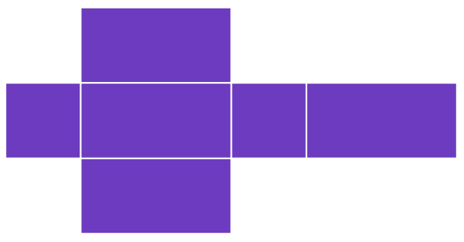
In this chapter, we will discuss how to calculate the volume and surface area of a variety of different solids.
The volume measures how much space a solid occupies or uses. It’s measured in cube units, e.g. cm³. | The surface area measures the area of the outside of the solid. We can think of the surface area as how much paper you would need to wrap the solid. Surface area is measured in square units, e.g. m².
Cuboid
We’ve previously seen the formula to calculate the volume of a cuboid in the “Measuring Shapes 1” workbook.

Volume of a Cuboid = Length × Width × Height

To calculate the surface area of a cuboid, we must add the areas of each of the six faces.
Back
Top
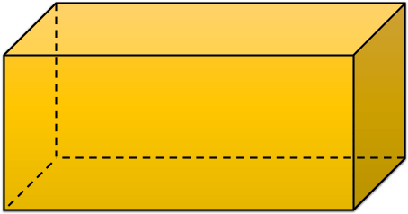
Left
4 cm

Right
3 cm
10 cm
Bottom
Front

Example
The volume of the above cuboid is 10 × 3 × 4 = 120 cm³.
Notice that some of the areas are the same so we do not need to calculate them.
The surface area of the cuboid is the total area of the six faces.
Front | 10 × 4 = 40
Back | 40
Left | 3 × 4 = 12
Right | 12
Top | 10 × 3 = 30
Bottom | 30
Total | 164 cm²
Exercise 2
Calculate the volume and surface area of the following cuboids.
F
(a) (b) (c)
8 cm
3 cm
7 cm
4 cm
2 cm
2 cm
4 cm

6 cm
4 cm



Exercise 3
F
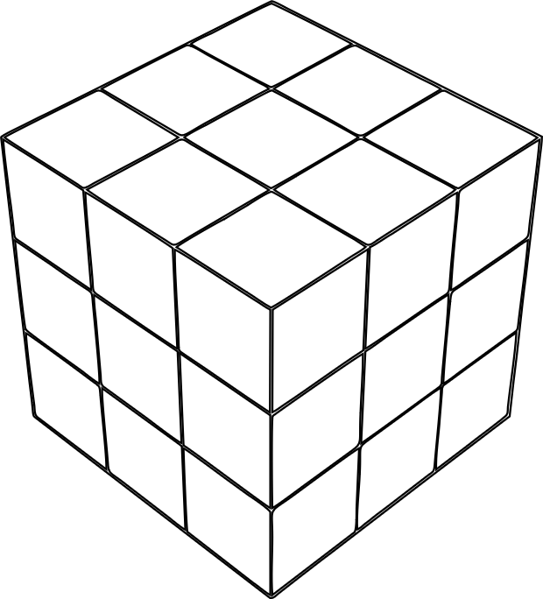
The diagram shows a Rubik’s cube before adding the coloured stickers.
The dimensions of one of the small cubes is 2 cm × 2 cm × 2 cm.
(a) What is the volume of one of the small cubes?
(b) How many small cubes form the Rubik’s cube?
(c) What is the volume of the Rubik’s cube?
(d) What is the surface area of the Rubik’s cube?
(e) How many small 2 cm × 2 cm stickers are needed to be stuck on the Rubik’s cube?
Exercise 4
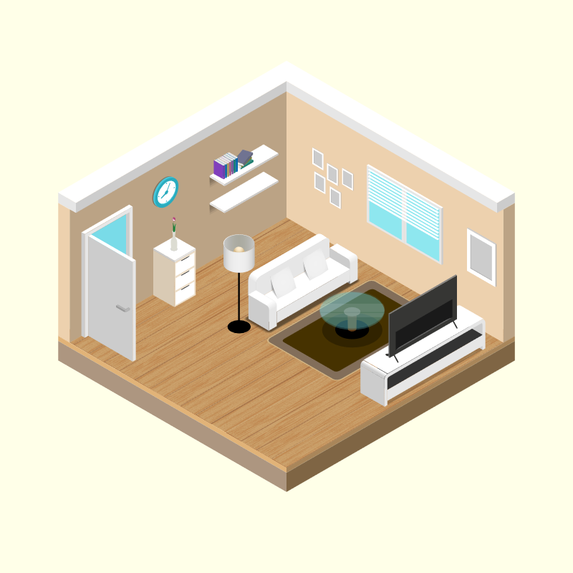
The diagram on the right shows a floor plan for a living room.
2.5 m cm
4 m
5 m
(a) What is the volume of the living room?
(b) What is the area of the floor?
(c) The wood for the floor costs £14 per square metre. What was the cost of the wood for the whole floor?
(d) Cerys wishes to repaint the wall on which the clock hangs. Given that the door measures 75 cm by
2 m, what area will need repainting?
(e) To repaint the wall, Cerys buys a 2.5 litre tin of paint. The tin states that the paint covers up to 10 m² of area for each litre of paint. Will Cerys have enough paint to give the wall two coats of paint?
Prism
A prism is a solid in which both ends are identical and the cross-section at any point is identical to the two ends. The shape of the two ends gives the prism its name. For example, the diagram below shows a triangular prism.
15 cm
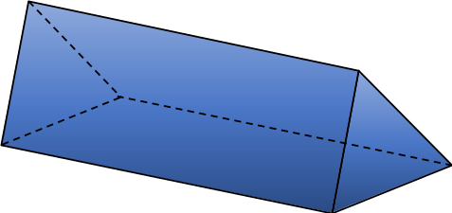
This formula is on page 2 of every GCSE exam paper.
3 cm
4 cm
Cross-section


Length
Volume of a Prism = Area of Cross-section × Length
Example
For the above triangular prism, the area of the cross-section is the area of the triangle, which is $\frac{3×4}{2}=6$ cm².
Therefore the volume of the prism is 6 × 15 = 90 cm³.
Exercise 5
F
Circle the solids below that are prisms.
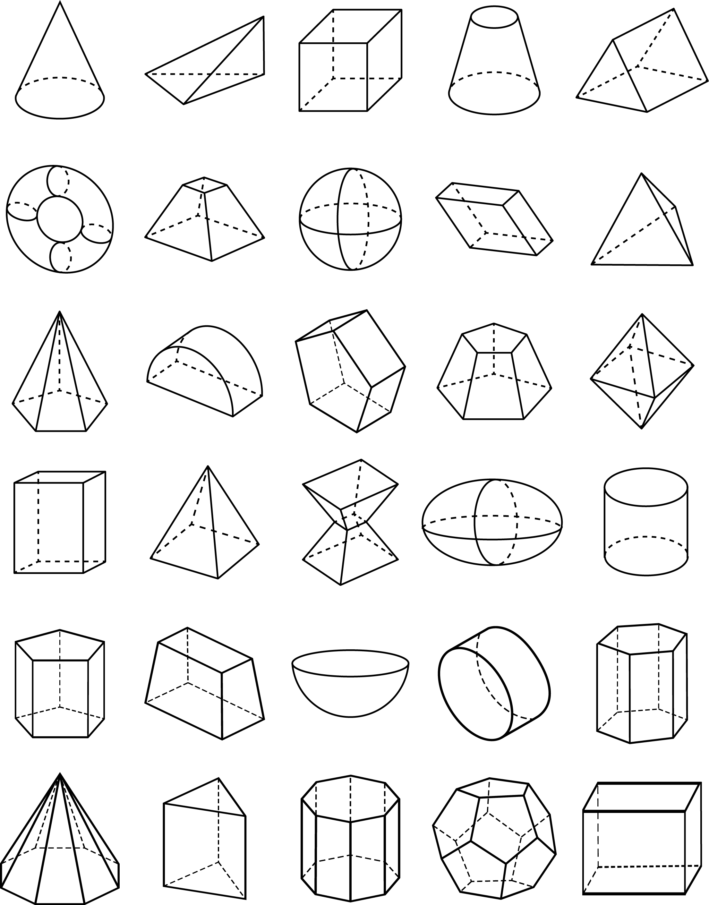

Exercise 6
Calculate the volume of the following prisms.
I
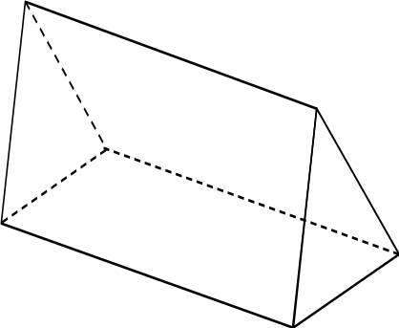
(a) (b) (c)
12 cm
10 cm
9 m
8 m
20 m
6 cm
5 cm
3 cm
2 cm

Area of cross-section = 40 mm²
(d) (e) (f)

11 cm
7 mm

4 cm
8 cm
3 cm
Area of cross-section = 50 cm²

Challenge!
Calculate the surface area of the prism in question (b) above. Give your answer to 1 decimal place.
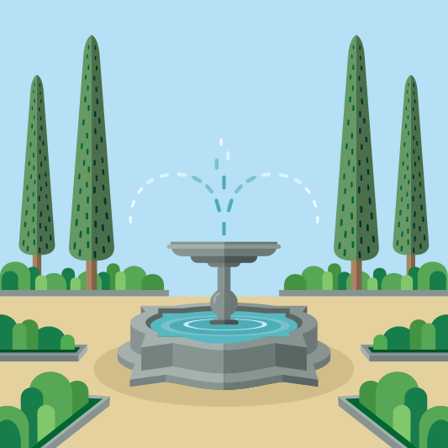
Exercise 7
The picture on the right shows a water fountain.
I
The depth of the water in the lower part of the fountain is 40 cm.
The area of the cross-section of the water is 38,000 cm².
(a) What is the volume of the water in the fountain, in cm³?
(b) What is the volume of the water in the fountain, in ml?
(c) What is the volume of the water in the fountain, to the nearest litre?
(d) Buddug wants to empty the water fountain so that it can be cleaned. The water pump that Buddug uses to empty the fountain works at a rate of 100 litres per minute. To the nearest minute, how long will it take for the pump to empty the fountain?
Exercise 8
What is the name of the prism that has the following shapes forming the cross-section?
I
(a) Rectangle (b) Square (c) Circle

Cylinder
A cylinder is a special type of prism where the cross-sectional shape is a circle.
Radius

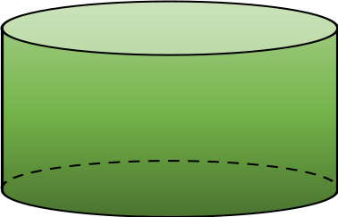
5 cm
6 cm
Height
Volume of a Cylinder = Area of the circle × Height or width of the cylinder
Volume of a Cylinder = $π$ × Radius² × Height
Example
The volume of the above cylinder is $π$ × 6² × 5 = 565.49 cm³, correct to two decimal places.
Exercise 9
I
Calculate the volume of the following cylinders.
(a) (b) (c)
5 cm
8 cm
2.4 m
9 cm
7 cm

3 m

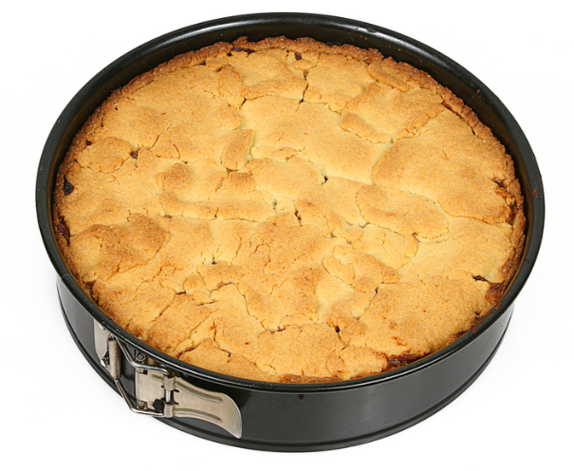
Exercise 10
I
The picture on the right shows an apple cake that has been baked
in a baking tin.
(a) Given that the radius of the tin is 10 cm and its height is 6 cm, calculate the volume of the cake in the tin.
(b) The cake weighs 1.2 kg. Gwenda wants to cut the cake into equal pieces so that each piece weighs 150 g.
How many equal pieces will Gwenda need to cut?
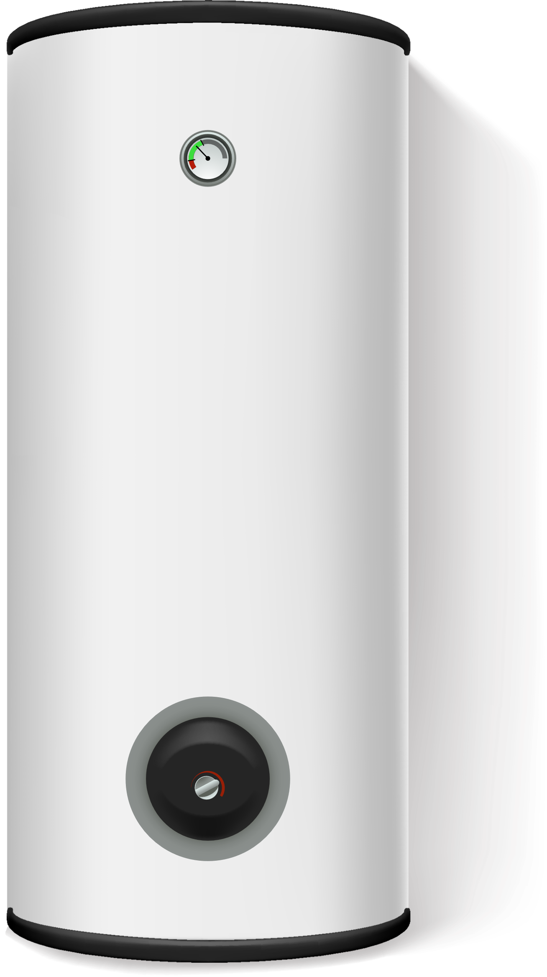
(c) What is the volume of each of the pieces of cake from part (b)?
Exercise 11
I
A hot water tank is in the shape of a cylinder. The height of the tank is 90 cm,
and its diameter is 45 cm.
The manufacturer estimates that the tank holds 140 litres of water.
Has the manufacturer provided an overestimate or an underestimate?

Surface Area of a Cylinder
For a closed cylinder, we must add the areas of the top, middle and bottom faces in order to find the surface area of the cylinder.

5 cm
Bottom
Top
Middle
6 cm
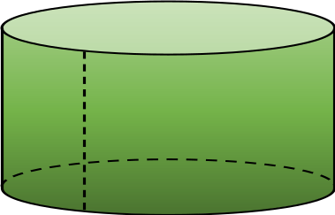
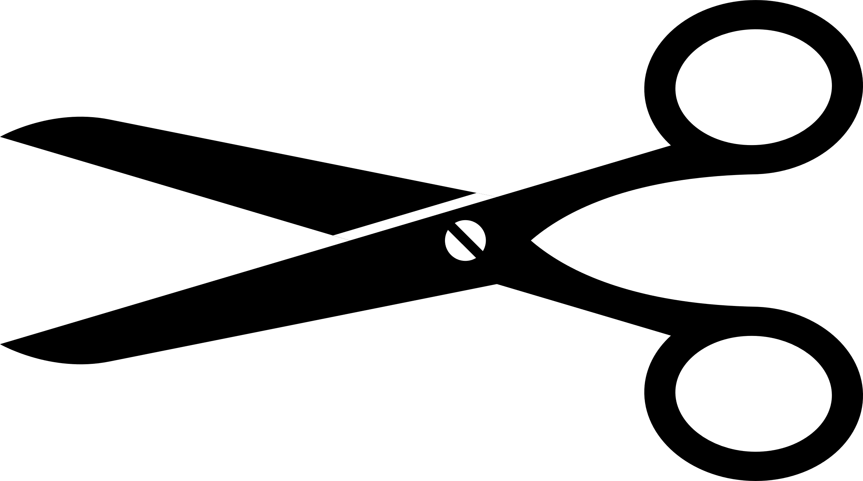
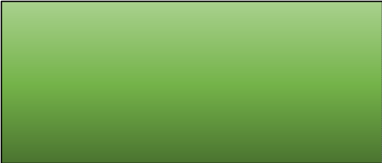
The top and bottom are obviously circle shaped, but what is the shape of the middle face? Imagine cutting the middle face with scissors, vertically, and stretching the shape out. You would be left with a rectangle, with height the same as the cylinder’s height and width equal to the circumference of the circle.
Circumference of the circle
Height of the cylinder

To find the area of this rectangle, we multiply the circumference of the circle ($π$ × diameter of the circle) by the height of the cylinder.

Example
The surface area of the above cylinder is the total of the top, middle and bottom faces.
 | Answer as a decimal | Answer in terms of $π$
Top | $π$ × 6² = 113.10 cm² | $π$ × 6² = 36$π$ cm²
Middle | ($π$ × 12) × 5 = 188.50 cm² | ($π$ × 12) × 5 = 60$π$ cm²
Bottom | 113.10 cm² | 36$π$ cm²
Total | 414.7 cm², to one decimal place | 132$π$ cm²
Exercise 12
Calculate the surface area of the following closed cylinders.
I
(a) (b) (c)
8 cm
2.4 m
5 cm
9 cm
7 cm

3 m

Exercise 13
Write your answers to Exercise 12 in terms of π.

Exercise 14
I
Complete the following table. State your answers correct to two decimal places.
Type of cylinder | Radius | Diameter | Height | Volume | Surface Area
Open | 14 cm |  | 6 cm
Closed |  | 6.8 m | 2.4 m
Closed | 9.3 mm |  | 12 mm
Open |  | 0.7 km | 0.3 km
Closed | 18 cm |  | 1.2 cm
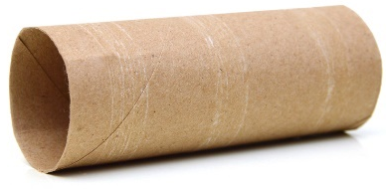
Exercise 15
I
The cardboard tube of a toilet roll has the shape of a cylinder.
The diameter of the tube is 4.4 cm and the length of the tube is 11 cm.
Calculate the area of the cardboard used to create the tube.
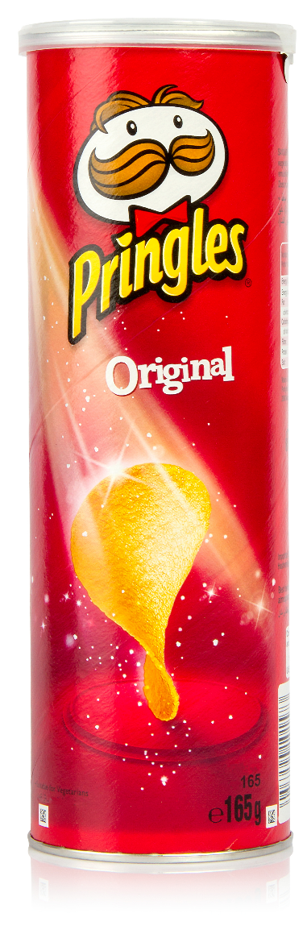
Exercise 16
I
Pringles are sold in cylindrical packaging.
The height of the cylinder is 26 cm, and the diameter of the cylinder is 8 cm.
There is a layer of foil on the top along with a plastic lid.
The bottom is metal.
The centre is made from cardboard.
(a) What is the area of the metal bottom?
(b) What is the area of the top layer made of foil?
(c) Given that the plastic lid has a vertical edge of 0.8 cm, how much plastic is needed to create the lid?
(d) How much cardboard is needed to create one tube?
(e) How much cardboard is needed to create 10,000 tubes?
I
Exercise 17
The manufacturer of Pringles wants to save money by changing the height of the cylinder to be 25.9 cm and the diameter to be 7.9 cm.
Consider how much cardboard is required to make 10,000 of the original tubes (height
26 cm, diameter 8 cm). How many additional new tubes will it be possible to make using the same amount of cardboard?
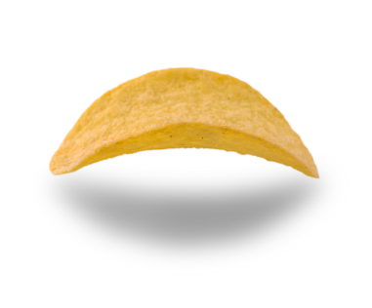
Challenge!
Use the internet to find the mathematical name for the shape of a single Pringle.
What is the general equation for this type of shape?
What is the “Pringles circle challenge”?


Pyramid
A pyramid is any solid with a flat base where the whole perimeter of the base raises up to meet at one point above the base, the apex of the pyramid.
There are a number of different types of pyramids, for example:
Square based pyramid | Tetrahedron  (triangle-based pyramid) | Cone  (circle-based pyramid)
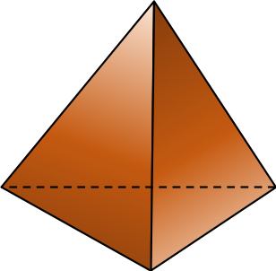
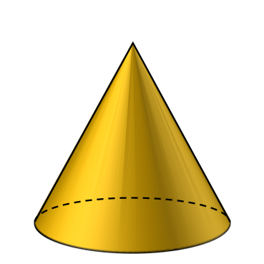
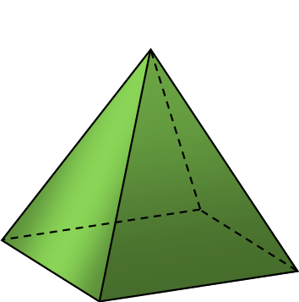
Base
Apex
Height
12 cm
6 m
8 cm

5 m
5 m
5 cm
5 cm
5 cm

Volume of a pyramid = $\frac{1}{3}$ × Area of the base × Height

Example
The volume of the above square based pyramid is  $\frac{1}{3}$ × Area of the square × Height  $=\frac{1}{3}$ × (5 × 5) × 8  $=66\frac{2}{3}$ cm³ | The volume of the above tetrahedron is  $\frac{1}{3}$ × Area of the triangle × Height  $=\frac{1}{3}×\left(\frac{5×5}{2}\right)×6$  $=25$ m³ | The volume of the above cone is  $\frac{1}{3}$× Area of the circle × Height  $=\frac{1}{3}×(π×5^{2})×12$  $=314.16$ cm³, correct to two decimal places.
Exercise 18
Calculate the volume of the following pyramids.
H
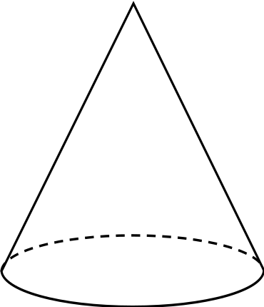
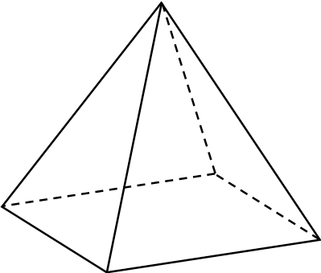
(a) (b) (c)

4 cm
9 cm
7 cm

2.6 cm
5 cm
4 cm
6 cm
6 cm

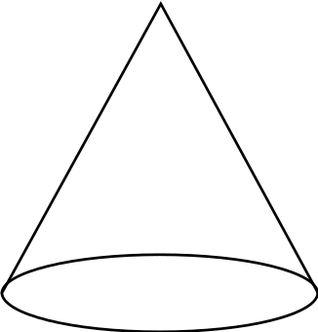
(d) (e) (f)
9 cm
4 cm
6 cm
7 m
25 mm
23 mm
3 m
11 m

Surface Area of a Cone
12 cm
5 cm
A cone has two faces, the base (circle shaped) and the curved face (sector shaped).
Slant height $l$
Surface Area of a Cone = $πr^{2}+πrl$
Example
By using Pythagoras’ Theorem, the slant height, $l$, for the cone on the right is 13 cm.
H

Therefore, the surface area of the cone is $π$ × 5² + $π$ × 5 × 13 = 90$π$
= 282.74 cm², correct to two decimal places.
Exercise 19
Calculate the surface area of the following solid cones. Give your answer to question (a) in terms of $π$.
(a) (b) (c)
2.7 mm
8 m
4 cm

9 m
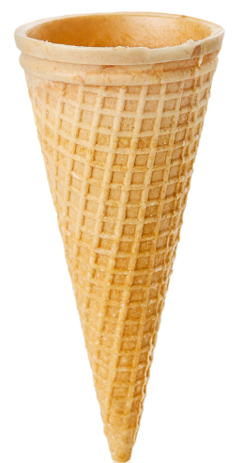
9.6 mm
3 cm

Exercise 20
H

The picture on the right shows an empty ice-cream cone.
The diameter of the top of the cone is 5 cm, and the height of the
cone is 10 cm. What is the surface area of the wafer?
Exercise 21
H
(a) The diagram below shows a cube with all vertices connected to the centre. How does the diagram explain the fraction $\frac{1}{3}$ in the formula for the volume of a pyramid? | (b) The diagram below shows the net of a cone. How does the diagram help to explain the formula $πrl$ for the surface area of the curved face of a cone?

$$l$$

$$r$$
$$u$$

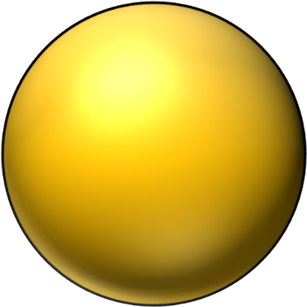
Sphere
Volume of a Sphere $=\frac{4}{3}πr^{3}$
Radius
17 cm
Surface Area of a Sphere $=4πr^{2}$
Example

The volume of the sphere on the right is $\frac{4}{3}×π×{17}^{3}=20,579.53$ cm³, correct to 2 decimal places. The surface area of the sphere is $4×π×{17}^{2}=3,631.68$ cm², correct to two decimal places.
Exercise 22
Calculate the volume and surface area of the following spheres.
H
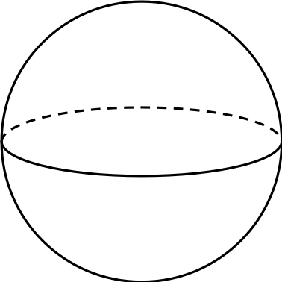
(a) (b) (c)
18.2 m
7.2 km
4.6 cm

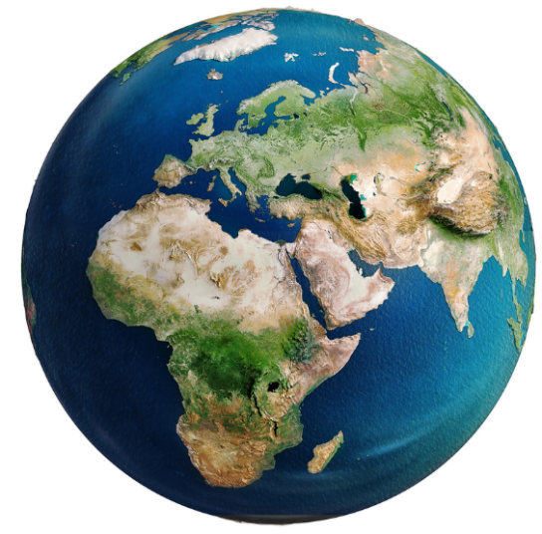
Exercise 23
It is possible to treat the Earth as a sphere of radius 6,371 km.
H
(a) What is the volume of the Earth? Give your answer to the nearest km³.
(b) What is the surface area of the Earth? Give your answer to the nearest km².
(c) About 71% of the surface of the Earth is covered by water. What is the surface area of the water that covers the Earth?

Key words | Corrections | I am happy with... | I need to revise...



A composite solid is a solid we can split into simpler solids, like the solids considered in the
first chapter of this workbook.
Example
It is possible to split the composite solid on the right into a cuboid (on the left) and a triangular prism (on the right).
4 cm
5 cm
8 cm
6 cm
8 cm
Cuboid
Volume = Length × Width × Height
Volume = 4 × 6 × 8
Colume = 192 cm³
Triangular Prism
Volume = Area of Cross-section × Length
Volume = $\left(\frac{4×3}{2}\right)×6$
Volume = 36 cm³
It is also possible to treat this solid as one large prism.
Composite Solid
Volume = 192 + 36
Volume = 228 cm³
Exercise 24
Calculate the volume of the following composite solids.
I
(a) (b)
3 cm
4 cm
3 cm
5 cm
4 cm
3 cm
6 cm
8 cm

8 cm
9 cm
(c) (d)
1.6 cm
3 cm
8 m

9 m
6 m
6.4 cm
2.7 cm
8.5 cm
10 m

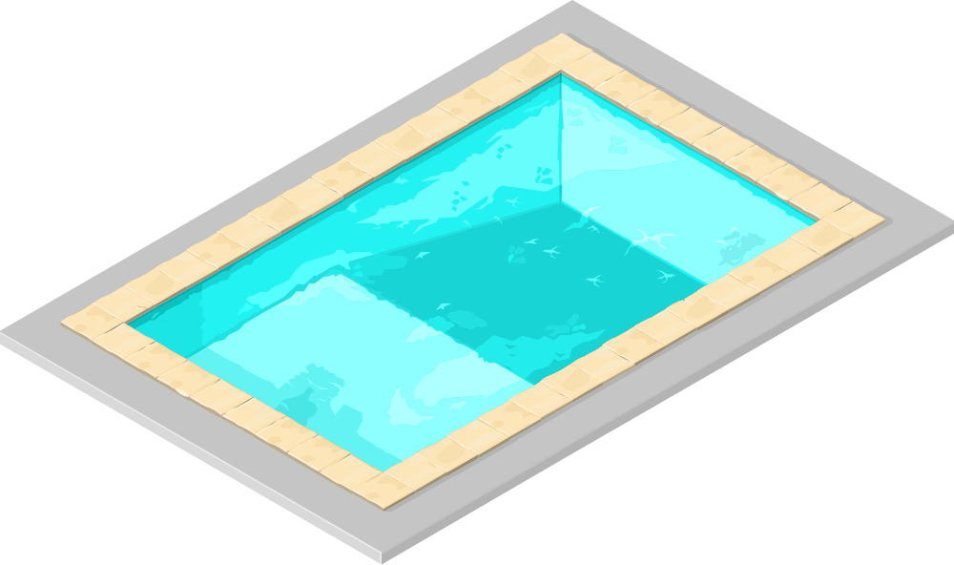
Exercise 25
A picture of a swimming pool is shown on the right.
I
The length and width of the swimming pool are
10 m and 20 m, respectively.
The depth of the water at the shallow
end is 1 m.
The depth of the water
at the deep end is
2.5 m.
The floor of the swimming
pool starts to descend 8 m
into the pool, and continues to
descend for a total of 12 m.
(a) Calculate the cross-sectional area of the swimming pool.
(b) Calculate the volume of the swimming pool, in m³.
(c) Given that there is 1,000 litres of water for every 1 m³ of volume, calculate how much water is in the pool.
(d) An ordinary hose pipe supplies water at a rate of 10 litres a minute. How long would it take for one hose pipe to fill the swimming pool? Give your answer correct to the nearest day.
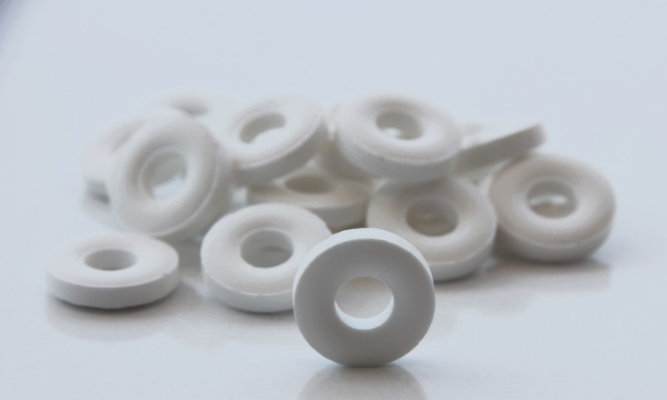
Exercise 26
The picture on the right shows some Polo Mint sweets.
- The diameter of each Polo Mint is 1.9 cm.
- The diameter of the hole in the middle is
0.8 cm.
- The thickness of each Polo Mint is 0.4 cm.
(a) Calculate the cross-sectional area of one Polo Mint.
(b) Calculate the volume of one Polo Mint.
(c) Usually, there are 23 Polo Mints in a packet.
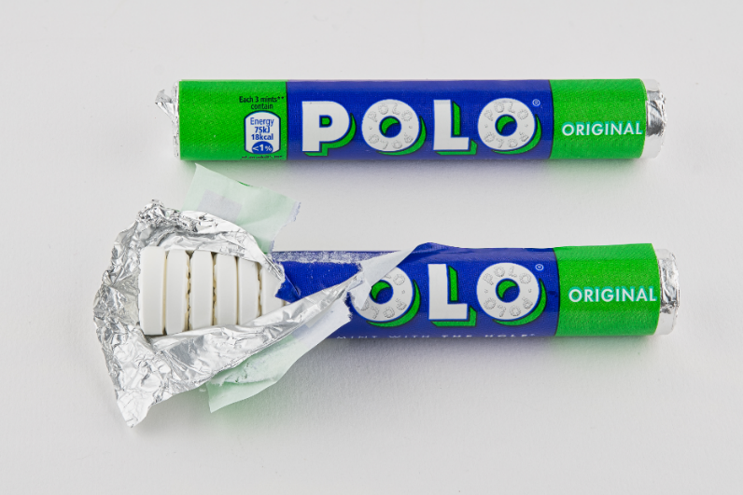
(i) What is the volume of sweets in a whole packet?
(ii) What is the volume of the hole in the middle of a packet?
(d) What is the minimum amount of paper needed to make the label around the packet?
(e) What is the minimum amount of foil needed for each packet?

Frustum of a Cone
A cone frustum is the shape left over after the top part of the cone is taken away.
Volume of the frustum = Volume of the whole cone – Volume of the missing cone
9 cm
3 cm
4 cm
6 cm
Example

Volume of the frustum (right) $=$ Volume of the whole cone – Volume of the missing cone
Volume of the frustum (right) $=\frac{1}{3}×π×6^{2}×9-\frac{1}{3}×π×4^{2}×6$
Volume of the frustum (right) $=238.76$ cm³, correct to two decimal places.
Exercise 27
H
Calculate the volume of the following frustums.
(a) (b) (c)
21 mm
6 mm
7 mm
9.8 mm
9 m
1.5 m
3 m
3.6 m
12 cm
4 cm
6 cm
9 cm

Challenge!
Half the surface of the sphere + area of the circle.
Calculate the surface area of the frustums in Exercise 27.
Hemisphere
A hemisphere is half a sphere.
14 cm
Volume of a hemisphere $=\frac{2}{3}πr^{3}$
Surface area of a hemisphere $=3πr^{2}$

Example
The volume of the hemisphere on the right is $\frac{2}{3}×π×{14}^{3}=5,747.02$ cm³, correct to 2 decimal places.
The surface area of the hemisphere is $3×π×{14}^{2}=1,847.26$ cm², correct to 2 decimal places.
2.6 m
Exercise 28
H
Calculate the volume and surface area of the following solid hemispheres.
7 cm
(a) (b) (c)
18.8 km

Exercise 29
H
Calculate the volume of the following composite solids.
(a) (b)
3.8 m

4.2 m
8.3 cm
5.1 m
9.4 cm

(c) A cuboid with a cylindrical hole in it. (d) A hemisphere with a cone shaped hole in it.
The radius of the hole is 2.3 m. The radius of the hemisphere is 3.5 cm.

5 m

9 m
3 m
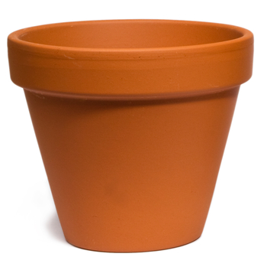
H
Exercise 30
The inside of a plant pot is in the shape of a frustum.
The radius of the highest part of the frustum is 10 cm.
The radius of the lowest part of the frustum is 7.5 cm.
The height of the plant pot is 10 cm.
Calculate how many litres of soil the plant pot can hold.
Key words | Corrections | I am happy with... | I need to revise...

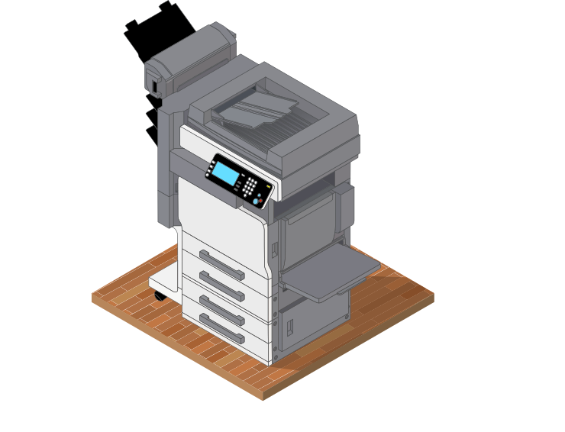
Imagine using a photocopier to enlarge a diagram drawn on a piece of paper. If the original paper is A4 sized and the paper that comes out of the photocopier is A3 sized, then you have created a copy of the diagram twice the size.
In mathematics, we say that the new diagram is similar to the original diagram. This means that the new diagram has the same shape, but the size has changed. Since the new diagram is twice as big, we can say that the scale factor is 2.
Similar shapes are the exact same shape, but of different sizes.
Given two shapes that are similar, we can use the measurements on the shapes either to find the scale factor or to find some missing lengths on the shapes.
Example
The two shapes shown below are similar shapes. Use the measurements on the shapes to find the lengths $x$ and $y$.
6 cm
9 cm
$$x$$

2 cm
1.5 cm
$$y$$

Answer: The first step is to find the scale factor. To do this, we need to consider how much bigger the large shape is compared to the small shape. We see that the horizontal lengths at the top of both shapes are given. We can use these two lengths to find the scale factor, by calculating 6 ÷ 2 = 3. Therefore, the large shape is three times bigger than the small shape.
Having found the scale factor of 3, we can now use it to find the lengths $x$ and $y$.
The edge that corresponds to the $x$ edge in the small shape is 1.5 cm. We must multiply 1.5 cm by the scale factor to find the length of $x$, since we are going from the small shape to the large shape. Therefore
$$x=1.5×3$$$x=4.5$ cm


The edge that corresponds to the $y$ edge in the large shape is 9 cm. We must divide 9 cm by the scale factor to find the length of $y$, since we are going from the large shape to the small shape. Therefore
$$y=9÷3$$$y=3$ cm

Exercise 31
I
The following pairs of shapes are similar shapes. Use the measurements on the shapes to find the scale factor.
(a) (b)
8 cm
15 cm
4 cm

5 cm

(c) (d)

20 cm
5 cm
12 cm
2 cm
3 cm
5 cm
16 cm
4 cm
Exercise 32
I
The following pairs of shapes are similar shapes. Use the measurements on the shapes to find the lengths $x$ and $y$.
(a) (b)
$$x$$
14 cm
$$x$$

3 cm
7 cm
24 cm
5 cm
$$y$$
5 cm
$$y$$
18 cm
6 cm

(c) (d)
$$y$$
$$x$$
9 cm
4 cm
$$y$$
3 cm
8 cm
$$x$$
2 cm
3 cm
32 cm
8 cm

(e) (f)
$$x$$
1.8 cm
8 cm
5 cm
$$y$$
$y$ = circumference of the circle

$$x$$
3 cm
5.5 cm


5 cm
10 cm
Similar or not?
If two shapes are similar, then the corresponding edges are in the same ratio.
This means that if we divide a pair of corresponding edges, we will always obtain the same answer.
Example
(a) (b)
16 cm
30 cm
16 cm
8 cm
8 cm
15 cm

10 cm
22 cm
28 cm
14 cm
For the two triangles above, the corresponding For the two rectangles above, the corresponding edges are
edges are in the same ratio. not in the same ratio.
30 ÷ 15 = 2 16 ÷ 8 = 2
28 ÷ 14 = 2 22 ÷ 10 = 2.2
16 ÷ 8 = 2 Therefore, the two rectangles are not similar.
Therefore the two triangles are similar.
Exercise 33
I
Decide whether the following pairs of shapes are similar or not.
14 cm
(a) (b)
6 cm
7 cm
2.8 cm
2 cm
8 cm
16 cm
1 cm

(c) (d)
7 cm
6 cm
7.5 cm
4.5 cm
2.8 cm
3 cm
5 cm
3 cm
5 cm
2.5 cm
6 cm
4 cm


Similar Triangles
Two triangles are similar:
3
5 cm
3 cm
3
1) If the corresponding edges are in the same ratio; | 2) if the corresponding angles are equal; | 3) if the ratio of two pairs of corresponding edges are the same and the angle between them is equal.
70°
4 cm
4 cm
30°
30°
70°
2 cm
10 cm
8 cm
3 cm
6 cm
70°
80°
80°
70°
6 cm
8 ÷ 4 = 2  6 ÷ 3 = 2  10 ÷ 5 = 2 | 70° = 70°  80° = 80°  30° = 30° | 6 ÷ 4 = 1.5  3 ÷ 2 = 1.5  70° = 70°
Exercise 34
H
Here are 13 triangles. 6 pairs are similar and 1 is the odd one out. Find the similar pairs.
10 cm
65°
40°

B
C
50°
9 cm
7 cm

6 cm
A
4 cm
75°
D
18 cm
5 cm
4.8 cm
60°
40°
14 cm
G
E
39 cm
15 cm
F
65°
75°
10 cm
3 cm
36 cm
I
H
25°
50°
J
2.4 cm
95°
5 cm
12 cm
60°
95°
13 cm
12 cm
5 cm
L
60°
M
K
2 cm
6 cm
10 cm

Scale factor for length, area and volume

Consider the two similar cuboids shown below, filling in the blanks as you go.

$y$ cm²
6 cm
3 cm
4 cm
$x$ cm
5 cm
The height of the small cuboid is ________ cm. The height of the large cuboid is ________ cm. So, the length scale factor is ________________. It follows that $x$, the width of the large cuboid, is ________________ cm.
The area of the front face of the small cuboid is ________________ cm². The area of the front face of the large cuboid is ________________ cm². So, the area scale factor is ________________. We can use the area scale factor to calculate corresponding areas. For example, the area of the right face of the small cuboid is 3 × 4 = 12 cm². By multiplying by the area scale factor, the area of the right face of the large cuboid, or $y$, is ________________ cm².
Lastly, consider the volume of the cuboids. For the small cuboid, the volume is 5 × 4 × 3 = ________ cm³. For the large cuboid, the volume is 10 × 8 × 6 = ________ cm³. It follows that the volume scale factor is ________________.
For any three-dimensional shape, the following relationship exists between the length, area and volume scale factors.
If $x$ is the length scale factor, then $x^{2}$ is the area scale factor and $x^{3}$ is the volume scale factor.
Exercise 35
H
Complete the following table.
Length Scale Factor | Area Scale Factor | Volume Scale Factor
2 | 2² = 4 | 2³ = 8
3
 | 16
 |  | 216
7
 | 25
 |  | 1,000
 | 81
12

Example
The diagram on the right shows two similar cylinders.
Given that the volume of the small cylinder is 40 cm³ and the volume of the large cylinder is 1,080 cm³, calculate the height of the large cylinder.
Answer: We can find the volume scale factor by dividing the volume of the
large cylinder by the volume of the small cylinder.
1,080 ÷ 40 = 27
Next, we can find the length scale factor by taking
the cube root of the volume scale factor.
2.1 cm
$\sqrt[3]{27}=3$
To calculate the height of the large cylinder, we must multiply the height of the small cylinder by the length scale factor.
2.1 × 3 = 6.3 cm.
Exercise 36
H
(a) The diagram below shows two similar cuboids. Given (b) The diagram below shows two similar cylinders. that the volume of the small cuboid is 30 cm³ and the volume Calculate the area of the top of the large cylinder.
of the large cuboid is 1,920 cm³, calculate the length $x$.
20 cm²
9 cm
6 cm
5 cm
$$x$$

(c) The diagram below shows two similar cones. Given (d) The diagram below shows two similar prisms. that the area of the base of the small cone is 40 cm² and the Given the volume of the large triangular prism is area of the base of the large cone is 48.4 cm², calculate the 60 cm³, calculate the volume of the small triangular
height of the small cone. prism.
(e) Eleri has two similar spheres. The surface area of the small sphere is 60 cm² and the surface area of the large sphere is 194.4 cm². How much bigger is the volume of the large sphere compared to the volume of the small sphere?
10 cm
6.6 cm
7 cm
(f) Dafydd has two similar pyramids. The volume of the large pyramid is 250 m³ and the volume of the small pyramid is 128 m³. How much taller is the large pyramid compared to the small pyramid?
Using similar triangles to calculate the volume of a frustum of a cone
2.5 cm
6 cm
8 cm
Example
Calculate the volume of the frustum shown on the right.
Answer: To start, let’s add right-angled triangles to the diagram, as shown below.
To calculate the height of the large cone we can use the fact that the two red triangles are similar (the corresponding angles are equal).
$\frac{\text{Base of the large triangle}}{\text{Base of the small triangle}}\text{=}\frac{\text{Height of the large triangle}}{\text{Height of the small triangle}}$
$\frac{4}{3}=\frac{x+2.5}{x}$
$4x=3(x+2.5)$
$4x=3x+7.5$
$x=7.5$ cm
Therefore the height of the large cone is 10 cm and the volume of the frustum is
Volume of the whole cone – Volume of the missing cone
$=\frac{1}{3}×π×4^{2}×10-\frac{1}{3}×π×3^{2}×7.5$
$=96.87$ cm³, correct to two decimal places.

$x$ cm
3 cm
4 cm


2.5 cm

Exercise 37
H
Calculate the volume of the following frustums of cones.
(a) (b) (c)
1.9 m
8.5 m
11.4 m
3 cm
7.6 cm
10 cm
2 cm
4 cm
6 cm

Key words | Corrections | I am happy with... | I need to revise...


It is possible to use Pythagoras’ Theorem to calculate lengths in three dimensional shapes.
7 cm
3 cm
4 cm
$$A$$
$$B$$
Example
For the cuboid shown on the right, calculate the length of the longest diagonal, which is the distance between $A$ and $B$.
Answer: To start, let us use Pythagoras’ Theorem to calculate the length of the diagonal on the base of the cuboid, which is the diagonal of this rectangle:
7 cm
3 cm
4 cm
$$A$$
$$B$$
7 cm
4 cm
$a^{2}$ $4^{2}=+ 16b^{2}$ $7^{2}=+ 49$
$c^{2}$ $5^{2}=+ 65$
$\sqrt{65}=8.06$ cm to 2 decimal places.
$\sqrt{65}$ cm
Next, we need to consider the red right-angled triangle
shown on the right.
3 cm
$a^{2}$ $3^{2}$ $=+ 69b^{2}$ ${\left(\sqrt{65}\right)}^{2}$ $=+ 65$
$c^{2}$ $=+ 74$
$\sqrt{74}=8.60$ cm to 2 decimal places.
Exercise 38
Calculate the length of the largest diagonal in the following cuboids.
H
(a) (b) (c)
4 cm
12 cm
5 cm
2.6 mm
9.4 mm
2.7 mm
5 m
15 m
6 m

$$A$$
$$B$$
$$C$$
$$D$$
$$E$$
$$F$$
$$G$$
$$H$$
Exercise 39
H
The diagram on the right shows a cuboid.
Calculate the shortest length between the following pairs of vertices. Write your answers as surds, in their simplest form.

(a) $AD$
(b) $AG$
(c) $AF$
(d) $AH$
(e) $BG$
9 cm
3.5 cm
12 cm
Exercise 40
H
(a) Calculate the shortest distance (b) What is the length of the longest (c) Calculate the shortest distance (a) between the vertices $A$ and $B$. (b) straw that can fit in this cylinder? (c) between the vertices $A$ and $B$.
$$A$$
18 cm
9 cm
8 cm
$$A$$
$$B$$
10 cm
6 cm
8 cm
6 cm
8 cm

$$B$$

Exercise 41
H
The diagram on the right shows the frustum of a cone.
The radius of the base of the frustum is 9 cm. The radius of the top of the frustum is 6 cm. The slant height of the frustum is 5 cm.
(a) Calculate the height of the frustum.
(b) Calculate the volume of the frustum.
H
Exercise 42
10 cm
The diagram on the right shows a hemisphere.
(a) What is the height of the hemisphere?
(b) What is the shortest distance from the top of the hemisphere to a point
on the circumference of the base of the hemisphere?
Challenge!
The length of the edge of a cube is $x$ cm.
Find a general expression for the longest diagonal in the cube.
Key words | Corrections | I am happy with... | I need to revise...


Length, Area and Volume

Given a particular formula, we need to be able to recognise, using dimensions, if the formula is for calculating a length, area, volume, or none of these.
Any formula for a length is a one-dimensional formula.
Any formula for an area is a two-dimensional formula.
Any formula for a volume is a three-dimensional formula.
Example
Formula | Purpose | Number of Dimensions
$P=2a+2b$ | Calculate the perimeter of a rectangle with length $a$ and width $b$ | 1
$A=πr^{2}$ | Calculate the area of a circle with radius $r$ | 2
$C=πr^{2}h$ | Calculate the volume of a cylinder of radius $r$ and height $h$ | 3
It is possible to consider the following rules when deciding how many dimensions a formula has (and therefore to decide whether a formula is used to find length, area or volume).
× Length
× Length
× Area
Length Area Volume
÷ Length
÷ Area
÷ Length

Exercise 43
In the following formulae, $a$, $b$ and $c$ represent lengths.
Decide whether each formula represents a length, an area or a volume.
I
(a) $M=a+b$ (b) $M=a-b$ (c) $M=3a$
(d) $M=ab$ (e) $M=8bc$ (f) $M=ab+ac$
(g) $M=abc$ (h) $M=4abc$ (i) $M=4abc-cab$
(j) $M=a+3c$ (k) $M=3ab+2ac$ (l) $M=7a-3c$
(m) $M=\frac{ab}{c}$ (n) $M=bc^{2}$ (o) $M=\frac{bc^{2}}{a}$
(p) $M=a(b+c)$ (q) $M=a^{2}(b+c)$ (r) $M=\frac{a^{2}}{b+c}$

(s) $M=πa$ (t) $M=3πa$ (u) $M=7πab$
(v) $M=4b^{2}-4ac$ (w) $M=ab-bc+ca$ (x) $M=\frac{abc}{4bc}$
(y) $M=10πc^{2}$ (z) $M=\frac{ab^{2}}{a+b+c}$ (α) $M=ab(4+π)$

Exercise 44
I
Each of the following quantities has a specific number of dimensions.
Write the number of dimensions for each quantity. The first has been completed for you.
Quantity | Number of dimensions
Capacity of a swimming pool | 3
Perimeter of a hexagon
Volume of a cylinder
Distance between Llandudno and Liverpool
Area of a trapezium
Length of the shoelaces in a pair of shoes
Nonsensical Formulae
It is possible to write a formula that doesn’t make sense. For example, it doesn’t make sense to add a volume to an area (there would be no meaning to the answer), therefore the formula $M=ab+abc$ doesn’t make sense. Here are some other combinations that lead to nonsensical formulae.
Length + Area Length + Volume Area + Volume
Length – Area Length – Volume Area – Volume
Length × Volume Area × Volume
Length ÷ Area Length ÷ Volume Area ÷ Volume
Exercise 45
I
In the following formulae, $p$, $q$ and $r$ represent lengths.
Decide which seven formulae do not make sense.
(a) $M=pq+rp$ (b) $M=3p+qr$ (c) $M=p^{2}-pq$
(d) $M=2r+3q$ (e) $M=pqr-6pr$ (f) $M=q-r^{3}$
(g) $M=\frac{pq}{r}$ (h) $M=\frac{p}{qr}$ (i) $M=\frac{5q}{p^{3}}$
(j) $M=2πr+q$ (k) $M=πr^{2}+pqr$ (l) $M=\frac{3pq}{r}+7π$
Exercise 46
I
In each of the following expressions, every letter represents a length. By considering the dimensions of the expressions write, for each one, what the expression may be describing: length, area, volume or none of these.
The first one has been completed for you.
The formula could be for
(a) $e^{2}+df$ Area
(b) $5d+8e+2f$ ..................................................
(c) $7de+2d^{2}f$ ..................................................
(d) $\left(d+e\right)f$ ..................................................
(e) $5def-2e^{3}$ ..................................................
(f) $πde+fde$ ..................................................
Exercise 47
I
The diagram on the right shows a solid.
The lengths $D$, $R$ and $H$ are noted on the diagram.
$$D$$
$$R$$
$$H$$
One of the following formulae can be used to estimate $C$,
the volume of the solid.
$C=3H+2R+5D$
$C=3R+5DR$
$C=3R^{2}H+2R^{2}D$
$C=3R(4D+5H)$
(a) Explain why we cannot use $C=3H+2R+5D$ to estimate the volume of the solid.
(b) Note, stating your reasons, which of the above formulae can be used to estimate the volume of the solid.
Exercise 48
I
$$U$$
$$D$$
$$L$$
A factory uses wire to make the frame for a plant cover, as shown in the diagram on the right.
Every frame has a width $L$, depth $D$ and upright height $U$.
One of the following formulae can be used to estimate $C$,
the total length of wire needed to make the frame.
Diagram not drawn to scale.

$C=5L+4D+4U$
$C=5L+4DU$
$C=5L(4D+4U)$
$C=5LDU$
(a) Explain why we cannot use the formula $C=5LDU$ to estimate the total length of wire required.
(b) Note, stating your reasons, which of the above formulae can be used to estimate the total length of wire required.

Key words | Corrections | I am happy with... | I need to revise...


Name: ............................................  Percentage in the test: .................. |   I know this. |   I need to revise this. | Question in the test | Correct in the test?
I know how to calculate the volume and surface area of a cuboid.
I know how to calculate the volume of a prism. |  |  | 3
I know how to calculate the volume and surface area of a cylinder. |  |  | 5
I know how to calculate the volume of a pyramid. |  |  | 1
I know how to calculate the surface area of a cone. |  |  | 2
I know how to calculate the volume and surface area of a sphere. |  |  | 1
I can calculate the volume of composite solids, including hemispheres and frustums. |  |  | 7
Given two similar shapes, I can calculate the scale factor. |  |  | 8
Given two similar shapes, I can calculate missing lengths. |  |  | 8
I can recognise whether two triangles are similar. |  |  | 9
I can work with length, area and volume scale factors. |  |  | 10
I can use similar triangles to calculate the volume of a frustum. |  |  | 10
I can use Pythagoras’ Theorem to find lengths in three dimensional shapes. |  |  | 7
I know how to recognise whether a formula represents a length, an area, a volume or none of these. |  |  | 6
I can recognise the number of dimensions for specific quantities. |  |  | 4

