


Version
3.0
08/2025

Chapter | Mathematics | Page Number
Foreign Money | Exchange rates. Exchanging money. | 3
Compound Interest | Revising simple interest. The compound interest method of borrowing and investing money. | 8
Household Bills | Electricity; gas; water; sewerage and mobile phone bills.  Income tax rates. | 11
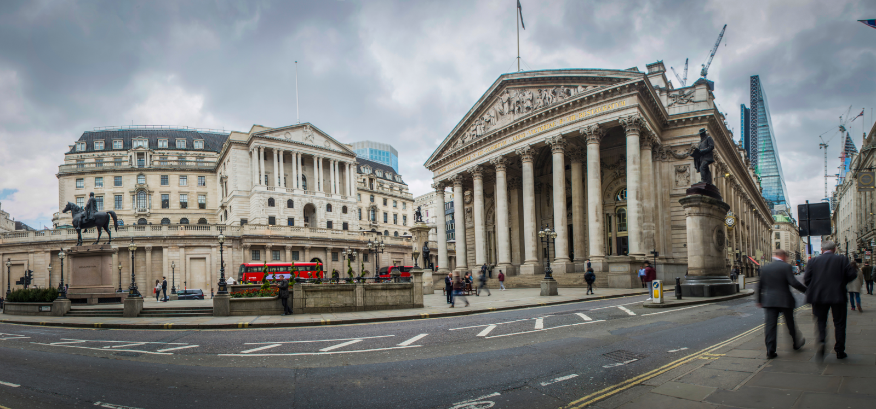
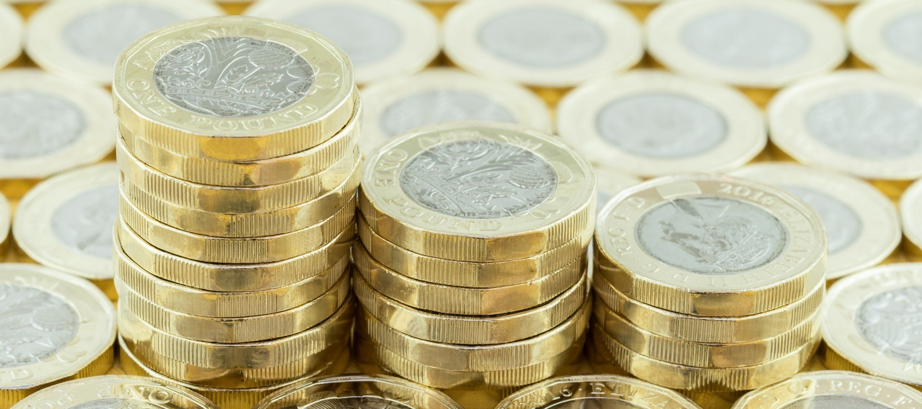

Exercise 1
Which countries use the following notes?
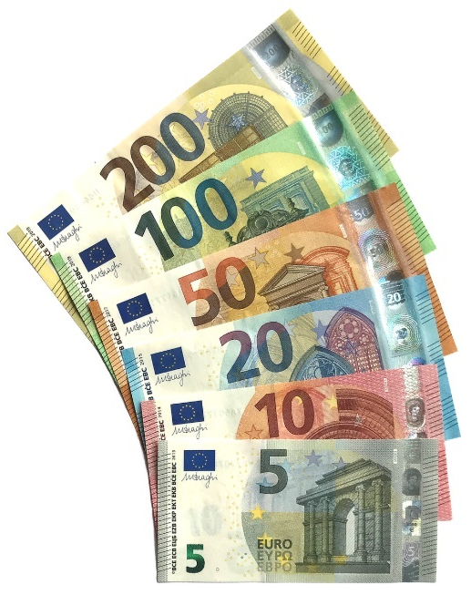
(a) (b) (c)


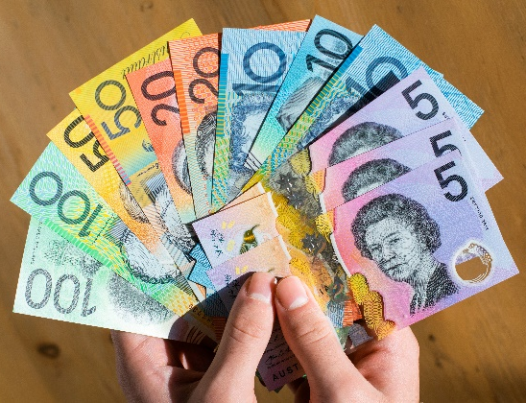
Exercise 2
1
Complete the following ratio tables.
Money in £ | Money in € |  | Money in £ | Money in $ |  | Money in £ | Money in ¥
£6 | €7 |  | £4 | $5 |  | £4 | ¥700
£12 |  |  | £8 |  |  | £8
£18 |  |  |  | $15 |  |  | ¥2100
£24 |  |  | £16 |  |  | £16
£30 |  |  |  | $25 |  |  | ¥3500
£60 |  |  | £40 |  |  |  | ¥7000
£600 |  |  | £60 |  |  |  | ¥10,500
£300 |  |  | £100 |  |  | £100
£150 |  |  | £10 |  |  |  | ¥1,750
£450 |  |  | £1 |  |  | £1
£3 |  |  | £2 |  |  | £2
£9 |  |  | £3 |  |  | £3
£90 |  |  | £5 |  |  | £5
£99 |  |  | £1,000 |  |  | £50
£15 |  |  | £1,100 |  |  |  | ¥87,500
£1.50 |  |  | £1,110 |  |  | £6
£7.50 |  |  | £1,111 |  |  |  | ¥1,225
Exchange Rates
As we have seen on the previous page, different countries use different currencies. In order to change between one type of currency and another, we need to know and use the exchange rate. It is possible to find current exchange rates on websites such as www.xe.com/currencyconverter. For example, the exchange rate for changing pounds into euros, on a particular day, is shown below.


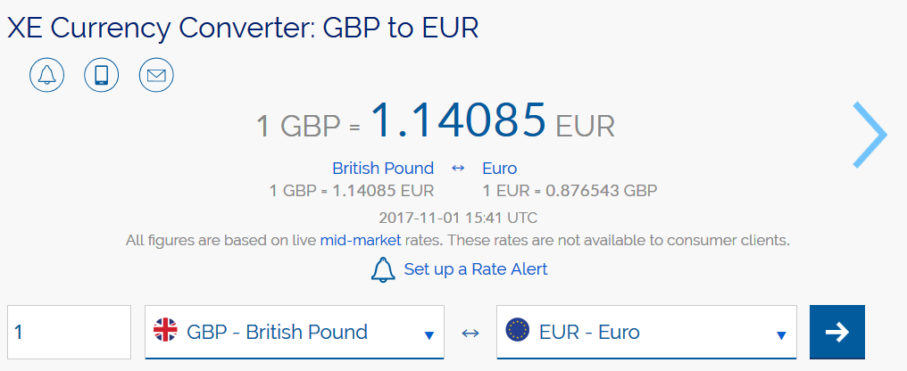
Example
(a) How many euros would a person get for £120? (b) How many pounds would a person get for €200?
Using the above exchange rate (£1 = €1.14085), Using the above exchange rate (£1 = €1.14085),
£120 would be worth £120 × 1.14085 = €136.90, €200 would be worth €200 ÷ 1.14085 = £175.31,
correct to the nearest cent. correct to the nearest penny.

Exercise 3
Use the exchange rate £1 = €1.14085 to complete the following table.
(Round off your answers correct to two decimal places.)
1
Money in £ | Money in € |  | Money in £ | Money in €
£100 |  |  |  | €40
£24 |  |  |  | €70.50
£85.40 |  |  |  | €4,000
£4,050 |  |  |  | €0.34
£10,824.56 |  |  |  | €14,530.38
Exercise 4
Use the internet to investigate the currencies used by different countries.
- Which countries use the same currency?
- In which country can you obtain the greatest numerical value for £1?
- Investigate an unfamiliar currency system.
- Who uses the currencies shown on the right?
Write a paragraph in your book summarising your findings.

Exercise 5
1
(a) Rachel went on holiday to Spain. She changed £300 to euros when the exchange rate was £1 = €1.13.
How many euros did Rachel receive?
(b) Dylan went on holiday to Singapore. He changed £250 to Singapore dollars when the exchange rate was
£1 = $1.78. How many Singapore dollars did Dylan receive?
(c) Coming back from a holiday in Sweden, Hannah had 945 Swedish krona. She changed this money to pounds when the exchange rate was £1 = 11.08 krona. How many pounds did Hannah receive?
(d) Coming back from a holiday in Australia, Deiniol had 232 Australian dollars. He changed this money back to pounds when the exchange rate was £1 = $1.72. How many pounds did Deiniol receive?
(e) Jürgen, who lives in Germany, went on holiday to England. He changed €240 to pounds when the exchange rate was €1 = £1.72. How many pounds did Jürgen receive?

Exchanging Money
Imagine that you are going on holiday to America. As part of the preparations, you go to the Post Office in order to change £175 into dollars. The sign at the Post Office shows the following information:
“We sell dollars at the rate £1 = $1.35”.
Using this exchange rate, £175 would be worth £175 × 1.35 = $236.25. It is unlikely, however, then the Post Office can give exactly this amount of dollars to you (small denominations of coins are not usually kept in stock). Assuming that a $5 note is the smallest amount of dollars kept in stock, then the Post Office could give you $235. This would cost $235 ÷ 1.35 = £174.07, to the nearest penny. Therefore, when handing £175 to the Post Office, you would receive back $235 in dollars, and £0.93 in change.
Exercise 6
(a) You are going on holiday to France. As part of the preparations, you go to the Post Office in order to change £90 to euros. The sign at the Post Office shows the following information:
1
“We sell euros at the rate £1 = €1.07”.
The smallest amount of euros available today at the Post Office is a €5 note. What is the maximum number of euros you can get today at the Post Office, and how much change (in pounds) would you receive?
(b) You are going on holiday to Japan. As part of the preparations, you go to the Post Office in order to change £150 into yen. The sign at the Post Office shows the following information:
“We sell yen at the rate £1 = ¥143.28”.
The smallest amount of yen available today at the Post Office is a ¥1,000 note. What is the maximum number of yen you can get today at the Post Office, and how much change (in pounds) would you receive?

(c) Carys went on holiday to Brazil. Before going, she went to a holiday money shop to buy Brazilian real.
Carys only had £250 to spend on buying real. She wanted to buy as much real as possible. Unfortunately, only 50 real notes were available to buy at the holiday money shop. The exchange rate to buy real was £1 = 3.92 real.
(i) How many real did Carys buy?
(ii) How much did she pay for the real?
(iii) During her stay in Brazil, Carys spent 754.25 real. After returning from her holiday, she changed the remaining real back to pounds. Unfortunately, the holiday money shop was only willing to buy back a whole number of real. The exchange rate used by the shop for changing real back to pounds was £1 = 3.98 real. Calculate how many pounds Carys received back from the holiday money shop. Give your answer correct to the nearest penny.
Exchanging between more than two types of money
Given one exchange rate, e.g. £1 = €1.14, we can divide or multiply to change between the two types of money. Given two exchange rates, we need to consider more carefully how to change between the different currencies.
Example
Looking on the internet, Dafydd found the following information about the currencies used in the U.K., America and Europe.
£1 = $1.35 and £1 = €1.14.

Use the above information to help Dafydd fill in the following blanks.
$1 = €_____ and €1 = $_____.

Answer: To begin, it is useful to draw a diagram representing the situation.
£
× 1.35 × 1.14
$ €
To change $1 to euros, we need to find a path in the above diagram that goes from dollars to euros. This would be possible by starting at the $ symbol, going against the arrow on the left to reach the £ symbol, and then following the arrow on the right to reach the € symbol. So, $1 is worth 1 ÷ 1.35 × 1.14 = €0.84, correct to the nearest cent.
To change €1 into dollars, we need to find a path in the above diagram going from euros to dollars. This would be possible by starting at the € symbol, going against the arrow on the right to reach the £ symbol, and then following the arrow on the left to reach the $ symbol. So, €1 is worth 1 ÷ 1.14 × 1.35 = $1.18, correct to the nearest cent.
Exercise 7
(a) Looking on the internet, Eryl found the following information about the currencies of the U.K., India and Russia.
£1 = 84.7 Indian rupees and £1 = 76.5 Russian roubles.
Use the above information to help Eryl fill in the following blanks.

1 Indian rupee = _____ Russian roubles and 1 Russian rouble = _____ Indian rupees.
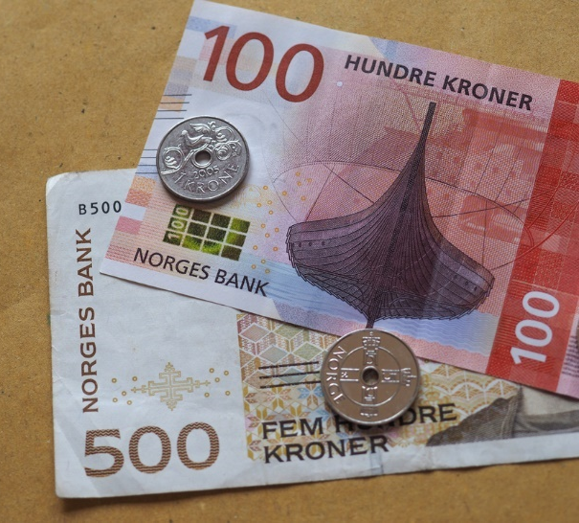
(b) Looking on the internet, Geraint found the following information about the currencies used in Europe, Australia and Norway.
€1 = 1.51 Australian dollars and €1 = 9.48 Norwegian krone.
Use the above information to help Geraint fill in the following blanks.
1 Australian dollar = _____ Norwegian krone and
1 Norwegian krone = _____ Australian dollars.
(c) Looking on the internet, Bethan found the following information about the currencies used in Japan, Turkey and Mexico.
¥1 = 0.033 Turkish lira and ¥1 = 0.167 Mexican peso.
Use the above information to help Bethan find how many Mexican peso would correspond to 2,000 Turkish lira. Give your answer correct to the nearest peso.

(d) Kate lives in London. She goes on holiday to Paris with her two friends, Janie who lives in America and Ami who lives in Japan. They meet in London for a few days before flying to Paris together. Janie exchanges 450 American dollars into pounds and Ami exchanges 30,000 Japanese yen into pounds.
In London, Janie and Ami spend £100 each and then exchange the remainder of their money into euros. Kate also exchanges £250 into euros.
£1 = 129.82 Japanese yen
£1 = 1.57 American dollars
£1 = 1.18 euros
Use the above exchange rates to calculate the total number of euros the three women take to Paris. Show all your working, explaining each step as you go.

Key words | Corrections | I am happy with... | I need to revise...


When borrowing money from a bank, the bank charges you interest. You must pay this interest to the bank as well as paying back all the money borrowed. On the other hand, if you invest money into a bank – which is to deposit money into a bank, then the bank pays you interest. The interest rate in both cases is usually given as a percentage.
There are several different types of interest. In year 7, we considered one type, namely simple interest. In this type of interest, the amount of interest added per year stays the same.
Exercise 8

(a) Arwyn borrows £15,000 from HSBC bank at a simple interest rate of 4% a year.
Arwyn wants to pay back all the money after three years.
How much money will Arwyn have to pay back after three years?
1
(b) Ellie wants to invest £9,000 in Barclays bank at a simple interest rate of 3% a year.
Ellie wants to withdraw all the money from the bank after four years.
How much money will Ellie be able to withdraw after four years?
Compound Interest
Let us now consider a more popular method of interest, namely compound interest. In this type of interest, the amount of interest added each year changes; it depends on the total amount of money at the start of the year.

Example
Nia borrows £8,500 from NatWest bank at a compound interest rate of 4% a year.
Nia wants to pay back all the money after three years.
How much money will Nia have to pay back after three years?
Answer (long method): We must work year-by-year, adding 4% to the sum each year.
Year 1 | Year 2 | Year 3
At the end of the three years, Nia must pay back £9,561.34 to the bank.
Answer (short method): Every year the debt increases 4%, from 100% (the value at the start of the year) to 104% (the value at the end of the year). This happens three times, so we need to multiply the £8,500 by 104% three times.
£8,500 × 104%³ = £9,561.34, to the nearest penny.
You can use the long method or the short method when answering the questions on the following page.

Exercise 9
(a) If NatWest has used a simple interest rate of 4% a year in the above example,
would Nia have had to pay back more money or less money to the bank?
1
(b) Calculate how much less or how much more money Nia pays back in the above example, comparing compound interest at 4% a year to simple interest at 4% a year.
Exercise 10
The following table shows the compound interest rate for borrowing different amounts of money over different periods of time. In each case, calculate how much money needs to be paid back to the bank at the end of the period of borrowing.
 | Amount to  borrow | Compound interest  rate per year | Period to borrow  the money | Sum (short method) | Answer
(a) | £10,000 | 4% | 3 years
(b) | £18,000 | 5% | 3 years
(c) | £9,500 | 2% | 2 years
(d) | £12,000 | 3% | 4 years
(e) | £2,500 | 7% | 3 years
(f) | £20,000 | 6% | 4 years
(g) | £16,750 | 3% | 2 years
(h) | £2,400 | 8% | 3 years
Investigation
Imagine that you want to borrow £15,000 to arrange a wedding. Go to the websites of five different banks to compare the offers available. Which bank would you choose and why?
Example
Owen wants to invest £4,000 into Lloyds bank at a compound interest rate of 5% a year.
Owen wants to withdraw all the money from the bank after three years.
How much money will Owen be able to withdraw after three years?
Answer (long method): We need to work year-by-year, adding 5% to the sum each year.
Year 1 | Year 2 | Year 3
At the end of the three years, Owen can withdraw £4,630.50 from the bank.
Answer (short method): Every year the value of the money increases 5%, from 100% (value at the start of the year) to 105% (value at the end of the year). This happens three times, so we need to multiply the £4,000 by 105% three times.
£4,000 × 105%³ = £4,630.50


Exercise 11
The following table shows the compound interest rate for investing different amounts of money into a bank over different periods of time. In each case, calculate how much money can be withdrawn at the end of the period of investment.
 | Sum to invest | Compound interest  rate per year | Period to invest  the money | Sum (short method) | Answer
(a) | £6,000 | 4% | 3 years
(b) | £9,500 | 6% | 2 years
(c) | £18,000 | 8% | 4 years
(d) | £1,200 | 5% | 3 years
(e) | £2,800 | 2% | 2 years
(f) | £100,000 | 7% | 3 years
(g) | £24,600 | 1% | 5 years
(h) | £6,540 | 3% | 3 years

Exercise 12
1
Cadi wants to invest £3,000 into a bank for two years. She sees the following options on the internet.
Which bank should Cadi choose?
City Bank
Compound interest 2% every six months
Vale Bank
Simple interest 4.1% a year

People’s Bank
Simple interest 2.06% every
six months
Bank of Wales
Compound
interest 4% a year

Key words | Corrections | I am happy with... | I need to revise...

A number of household bills arrive on a weekly; monthly or yearly basis.
Exercise 13
1
Discuss with a partner which bills arrive regularly at a typical home. Fill in the following chart with your ideas.


Household Bills
Terms
Here is an explanation of some of the terms that appear in common household bills.
Term | Explanation
Unit Cost | The cost of one unit of e.g. gas.
Standing Charge | This must be paid no matter how much of the service is used.
Value Added Tax | A tax on goods or services, collected by the government.  Usually, it is given as a percentage.
Reading | A number shown on a meter, e.g. electricity meter.
Quarter | Some bills arrive ‘quarterly’.  This means every quarter of a year, or every three months.
Rateable value | This depends on the type of house you live in.  It is used to help determine the value of your bill, e.g. your water bill.
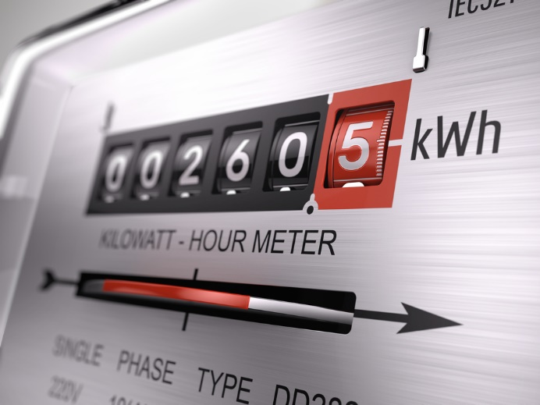
Example
At the end of one quarter, the reading on Mr. Smith’s electricity meter was 53,799, whilst the previous reading was 52,471.
The electricity company charges 17.4 pence per unit along with a standing charge of £35. On top of this, value added tax is charged at a rate of 5%.
Calculate the total of Mr. Smith’s electricity bill.
Answer: To begin, we must calculate how many units of electricity Mr. Smith has used during the quarter (or 3 months).
53,799 – 52,471 = 1,328.
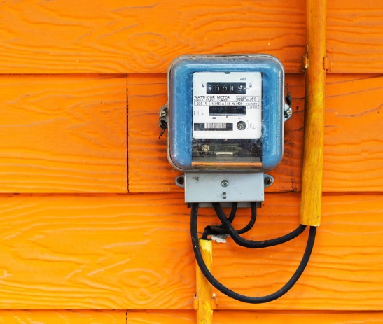
Each unit of electricity costs 17.4 pence, so the cost of all the electricity is
1,328 × 17.4 = 23,107.2 pence.
To change the above into pounds, we must divide by 100.
23,107.2 ÷ 100 = £231.07, to the nearest penny.
Next, we need to add the standing charge of £35.
£231.07 + £35 = £266.07.

To finish, we need to add the value added tax, which is 5% of the above total.
£266.07 × 5% = £13.30, to the nearest penny.
£266.07 + £13.30 = £279.37.
Therefore, Mr. Smith’s bill for the quarter is £279.37.
Exercise 14
1
(a) The electricity meter readings at the start and end of a 3-month period were:
6 | 5 | 1 | 9 | 7

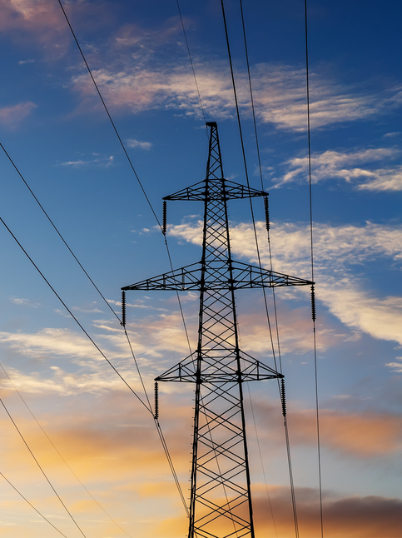
Reading at the start of the period:
6 | 4 | 9 | 4 | 7

Reading at the end of the period:
The cost of the electricity used was 30p per unit and there was a standing charge of £25.34 for the 3-month period.
Complete the following table to find the total cost.
Reading at the start of the period
Reading at the end of the period
Number of units used
Cost of the units, in £
Standing charge for the 3-month period
Total cost
(b) One quarter, Mrs. Roberts’ smart meter showed that she had used 950 units of electricity. The electricity company charges 18.6 pence per unit along with a standing charge of £32.50. On top of this, value added tax is charged at a rate of 5%. Calculate Mrs. Roberts’ total electricity bill.

(c) Samantha’s electricity bill for a particular quarter is calculated from the following information.
Previous meter reading: 42,764.
Current meter reading: 43,915.
Cost per unit: 18 pence.
Standing charge per quarter: £26
(i) Calculate Samantha’s total electricity bill, including value added tax at a rate of 5%.
(ii) Samantha saved £17 per week for 12 weeks to help pay off the bill.
How much more does she need to save in order to pay off the electricity bill?
(d) Mr. and Mrs. Hughes receive an electricity bill. The bill is shown below, with some of the entries missing.
Use the information given on the bill to complete the missing entries, and hence show the total that Mr. and Mrs. Hughes must pay.
Charge Electricity Company Bill for the period July 1st 2025 to September 30th 2025.
Mr. and Mrs. Hughes
3 Stryd y Wennol
Llandudno
LL30 1PX INVOICE
Meter Meter Units Price Sum
reading reading that have per unit
this time last time been used in pence £
4,703 3,425 Units that have been used ................ 18.5p ...................
V.A.T. at 5% ...................
Amount payable from the previous bill 12.46
Total to pay ...................

Example
The following information relates to Emlyn’s gas bill for the spring quarter.
Standing charge: 28 pence per day for 91 days.
Gas supplied: 6,458 kilowatt hours. Cost per kilowatt hour: 3.924 pence.
Calculate the total bill, including value added tax at a rate of 5%. Give your answer correct to the nearest penny.
Answer: The standing charge is 28 pence per day, so for the period of the bill (91 days), the standing charge is
91 × 28 = 2,548 pence.
To change this into pounds, we need to divide by 100.
2,548 ÷ 100 = £25.48.
Each unit of gas costs 3.924 pence, so the cost of all the gas is
6,458 × 3.924 = 25,341.192 pence.
To change this into pounds, we need to divide by 100.
25,341.192 ÷ 100 = £253.41, to the nearest penny.
The total bill (before tax) is
£25.48 + £253.41 = £278.89.
To finish, we need to add, at a rate of 5%, the value added tax.
£278.89 × 5% = £13.94, to the nearest penny.
£278.89 + £13.94 = £292.83.
So, Emlyn’s bill for the quarter is £292.83.

Exercise 15
1
(a) The following information relates to Mr. Williams’ gas bill for the winter quarter.
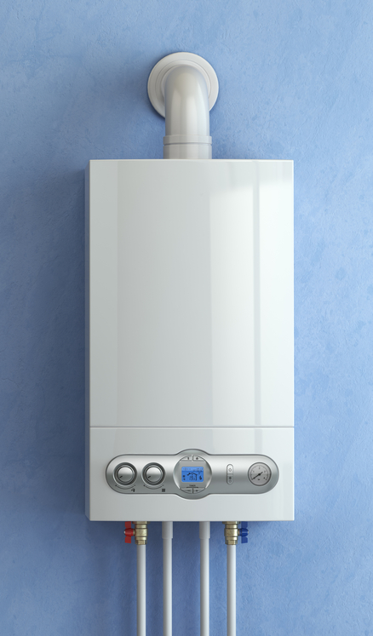
- Standing charge: 25 pence per day for 91 days.
- Gas supplied: 7,532 kilowatt hours.
- Cost per kilowatt hour: 3.67 pence.
Calculate the total bill, including value added tax at a rate of 5%.
Give your answer correct to the nearest penny.
(b) Gethin’s gas bill for a specific quarter is calculated using the following information.
- Number of kW hours used: 9,056.
- Cost per kW hour: 3.52 pence.
- Standing charge: 29 pence per day for 91 days.
- VAT rate: 8%.
Calculate Gethin’s gas bill (including the VAT) for the quarter.
(c) Nel has received has gas bill for the period from January to April.
The bill’s details are as follows.
- The number of units of gas used is 10,278.
- The cost of one unit of gas is 2.92 pence.
- The number of days for this period is 90.
- The standing charge is 32.4 pence per day.
- VAT at 5% is charged on the total gas bill.

Showing all of your method, calculate Nel’s gas bill, including the VAT.
Water and Sewerage
The type of water and sewerage bill a house receives depends upon the presence of a water meter in the house. If a water meter is present, then the bill depends upon how much water has been used. If no water meter is present, then the bill depends upon the rateable value of the house the bill is sent to.
Example
A water bill is calculated by adding the standing charge, the water charge and the sewerage charge. Here are the details for this year:
- Standing charge: 35p per day for the period of the bill.
- Water charge: £1.39 for each m³ of water that is used.
- Sewerage charge: £1.66 for each m³ of water that is used.
Calculate the total bill when 75 m³ of water is used during a period of 180 days.

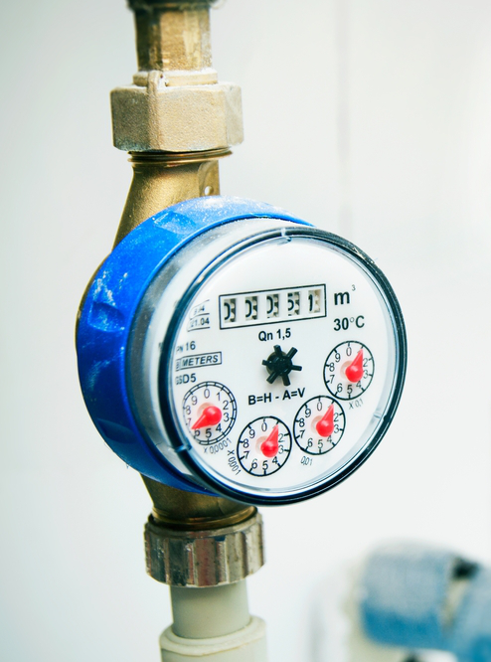
Answer: The standing charge is 35 pence per day, so over the period of the bill (180 days) the standing charge will be
180 × 35 = 6,300 pence.
To change the standing charge to be in pounds, we need to divide by 100.
6,300 ÷ 100 = £63.
Each unit of water costs £1.39 per cubic metre, so the cost of all the water is
75 × £1.39 = £104.25.
The sewerage charge is £1.66 per cubic metre, so the sewerage charge is
75 × £1.66 = £124.50.
The total bill is
£63 + £104.25 + £124.50 = £291.75.
1
Exercise 16
(a) A water bill is calculated by adding the standing charge, the water charge and the sewerage charge.
Here are the details for this year:
- A standing charge of 38p per day for the period of the bill.
- A water charge of £1.42 for each m³ of water that is used.
- A sewerage charge of £1.58 for each m³ of water that is used.
Calculate the total bill when 93 m³ of water is used during a period of 180 days.

(b) A water bill is calculated by adding the standing charge, the water charge and the sewerage charge. Here are the details for this year:
- A standing charge of 41p per day for the period of the bill.
- A water charge of £1.20 for each m³ of water that is used.
- A sewerage charge of £1.55 for each m³ of water that is used.
Calculate the total bill when 62 m³ of water is used during a period of 92 days.
(c) The following information relates to Mr. Edwards’ bill for water and sewerage. Mr. Edwards does not have a water meter, so the bill uses the rateable value of his house.
- Rateable Value: £275.
- Water: Standing charge of £126.43 and 80 pence for each £ of rateable value.
- Sewerage: Standing charge of £175.27 and £1.15 for each £ of rateable value.
Calculate the total of Mr. Edwards’ water and sewerage bill.
(d) Ben pays his bill from Welsh Water a year in advance using direct debit.
The bill is calculated for 2018–19 by using the following information.
- Rateable Value: £345.
- Discount for paying through direct debit: 2%.
- Water: Standing charge of £135 and £0.75 for each £ of rateable value.
- Sewerage: A standing charge of £180 and £1.09 for each £ of rateable value.
Calculate Ben’s bill.

Exercise 17
1
Aaron pays £25 a month for his mobile phone contract.
The contract gives a monthly allowance of 120 minutes of talk time plus 40Gb of data.
If Aaron goes over his allowance, then the following additional charges are incurred, on top of the £25 contract charge.
ADDITIONAL CHARGES
Additional talk time
35 pence per minute
Additional data
£1.50 per gigabyte
Last month, Aaron used 150 minutes of talk time and used 49Gb of data.
A new contract is offered to Aaron. This contains double the amount of talk time and double the data, but it costs £35 per month (not £25 per month).
Using only the information about last month, decide whether Aaron should accept the new contract.
Give reasons for your answer and show all of your calculations.
Exercise 18
Mrs. Owen requires £800 to buy a new sofa.
She already has £420 in a savings account.
Mrs. Owen earns £2,100 per month.
She invests 8% of her monthly wage into the savings account.
How many months will it take Mrs. Owen to save enough money in order to buy the sofa?
Show all of your calculations.
Exercise 19
Which one of the following two broadband offers is the cheapest, comparing the monthly cost?
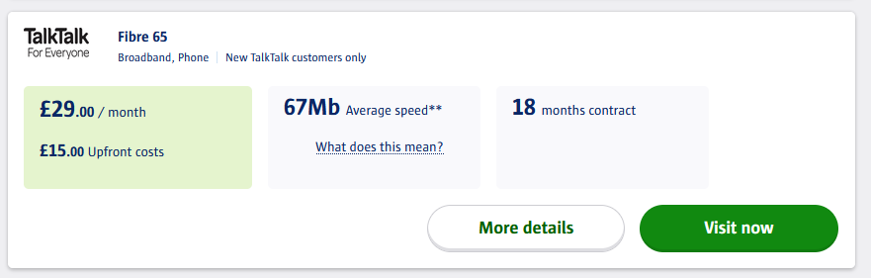
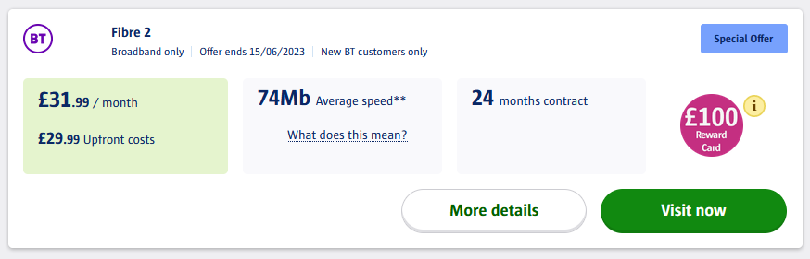

Exercise 20
1
Mr Roberts wants to buy a house in 6 months’ time.
Will Mr Roberts have enough money to pay the deposit on the mortgage?


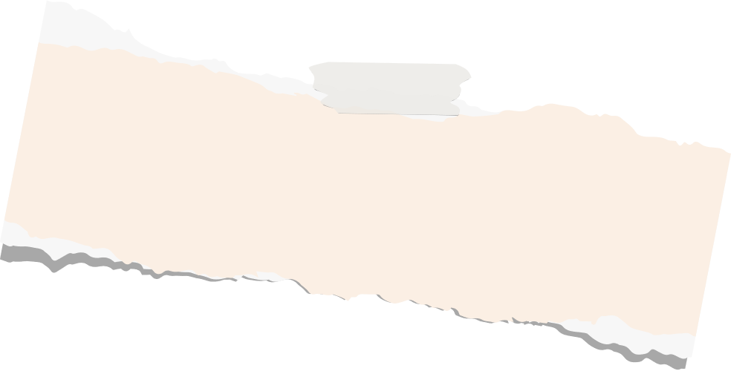

Exercise 21
Mr Roberts’ wage slip shows the following information:
WAGE SLIP
Hours worked: 160
Hourly rate: £31.88
Overtime: 0
Gross Pay: £5,100.80
Tax: £774.86
National Insurance: £269.52
Pension £544.18
Net Pay: £3,512.24
Mr Roberts has £42,900 in an ISA savings account. Over the next 6 months, these savings will appreciate by 2.5%.
Mr Roberts’ bank statement shows he spends the following each month:
Sky Broadband & TV: £94
Tesco: £360
Electricity & Gas: £310
Welsh Water: £25
TV Licence: £15
Vodafone: £35
Rent: £700
Running a car: £120
Insurance: £90
Interest on loans: £420
Other expenditure: £300

The cost of the house is £250,000.
Mr Roberts needs to arrange a mortgage to buy the house, with a deposit of 20%.
Mr Roberts is a first time buyer.
Mrs Reynolds wants to buy a new washing machine costing £450.
She wants to pay for the washing machine over a period of 18 months.
Which option below would be best for Mrs Reynolds?
Option 1 (the shop’s offer) Option 2
Pay the shop £50 today, then pay Pay the shop £450 today using a
£30 a month over the next 17 months. PayPal Credit loan. Simple interest of 10% every 6 months
will need to be paid to PayPal.

Exercise 22
1

Complete the yellow parts of the following bank statement.

Your transactions
Date
Description
Money out
Money in
Balance

 | Starting Balance |  |  | 2,223.96
10 Mar | Cash Machine Withdrawal at Cardtronics UK Ltd Shell Betws-Y-Coed  Timed at 07.24 On 10 Mar | 50.00
10 Mar | Card Payment to Spar On 07 Mar | 13.64 |  | 2,160.32
11 Mar |  Card Payment to Amznmktplace  On 10 Mar | 56.14
11 Mar | Card Payment to Co-Op Group 070228 On 10 Mar | 22.80
11 Mar | Card Payment to Shell Betws-Y-Coed On 10 Mar | 55.18
12 Mar | Card Payment to Paypal Online On 10 Mar | 45.64 |  | 1,980.56
13 Mar | Card Payment to Marks&Spencer PLC On 12 Mar | 53.20 |  | 1,927.36
14 Mar | Card Payment to Paypal  *Vodafoneve On 13 Mar |  |  | 1,897.36
17 Mar | Card Payment to Paypal *Royal Mail On 13 Mar | 1.55
17 Mar | Card Payment to Amazon  On 15 Mar | 36.99
17 Mar | Card Payment to Paypal  On 13 Mar | 39.80 |  | 1,819.02
18 Mar | Card Payment to Co-Op Group  On 17 Mar | 10.20 |  | 1,808.82
19 Mar | Card Payment to Kfc Llandudno Junc On 18 Mar
19 Mar | Card Payment to Tesco Stores 2836 On 18 Mar | 20.20 |  | 1,778.63
20 Mar | Card Payment to Co-Op Group On 19 Mar | 18.40 |  | 1,760.23
21 Mar | Card Payment to Shell Betws-Y-Coed On 20 Mar | 53.93
21 Mar | Received From Conwy County Borou  Ref: Monthly Salary |  |  | 4,073.17
24 Mar |   Direct Debit to TV Licence MBP | 15.00
 | End Balance

Exercise 23
1

Information about Mrs Davies’ salary and bills are shown below.
Can you help Mrs Davies find how much money she has left over to spend each month?
Mrs Davies pays income tax on her salary:
Between £0 and £12,570: 0%
(personal allowance)
Between £12,570 and £37,700: 20%
(basic rate)
Between £37,700 and £125,140: 40%
(higher rate)
More than £125,140: 45%
(highest rate)
Mrs Davies also pays national insurance (12% of her salary) and pension contributions (9.3% of her salary).
Mrs Davies works as a nurse.
Her yearly salary is £36,300.

Mrs Davies’ monthly electricity bill is £243.
Her monthly gas bill is £109.



Monthly subscriptions / costs:
BT Broadband: £32 Mobile phone contract: £35
Sky: £38 Rent: £650
Netflix: £15.99 Apps: £42

Other bills (yearly costs):
Council tax: £1,356 Welsh water: £410
Television license: £159 House insurance: £210
Amazon Prime: £95

Key words | Corrections | I am happy with... | I need to revise...

Name: ...........................................  Percentage in the test: ................. |   I know this. |   I need to revise this. | Question in the test: | Correct in the test?
I know how to use ratio tables and exchange rates to change one type of currency to another type of currency. |  |  | 2, 8
I know what to do when a restriction is placed on the type of money available at a currency exchange shop. |  |  | 3
I know how to change between more than two types of currency. |  |  | 2
I know how to calculate the compound interest on a sum of money over a specific period of time. |  |  | 1
I know how to calculate an electricity bill. |  |  | 4
I know how to calculate a gas bill. |  |  | 6
I know how to calculate a water and sewerage bill. |  |  | 5
I know how to use income tax rates. |  |  | 7

