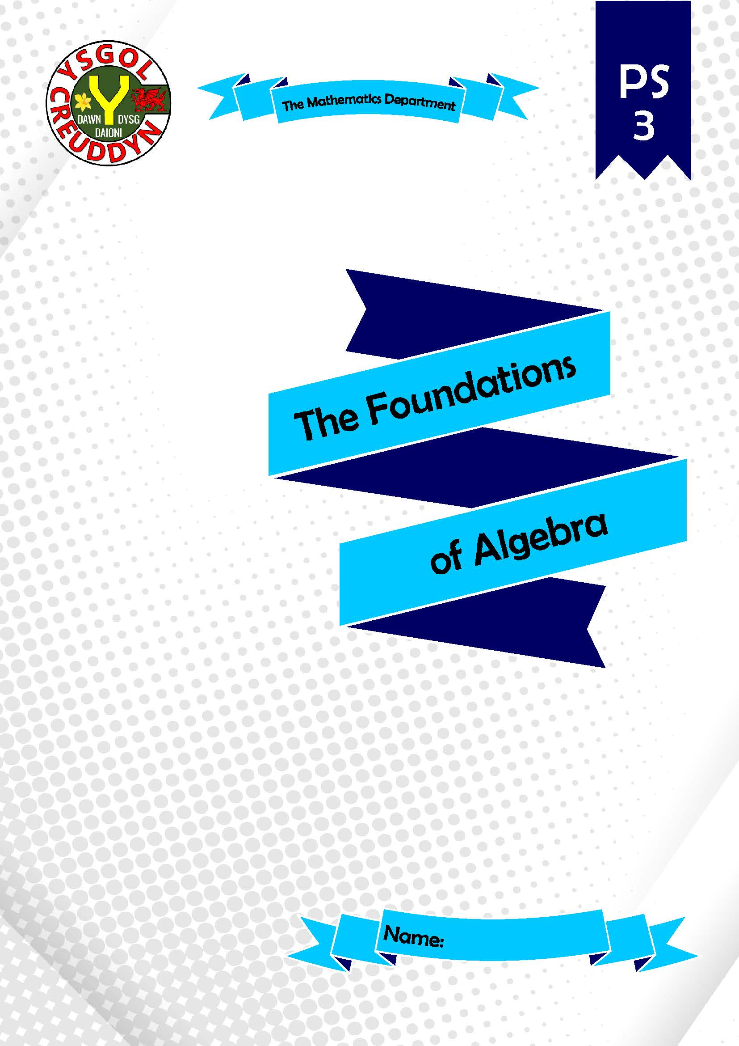
The Foundations of Number
A workbook for Curriculum for Wales
Mathematics and Numeracy Area of Learning and Experience
Progression Step 3
Teacher’s Guide
Version 1 (August 20th, 2021)
Authors:
- Dr Gareth Evans, www.mathemateg.com
- Teachers from the following primary schools, which took part in the Creuddyn Primary Cluster project during the first half of 2021: Ysgol Pencae, Ysgol Glan Morfa.

Mathematical proficiencies icons:
Conceptual understanding | Communication using symbols | Strategic competence | Logical reasoning | Fluency

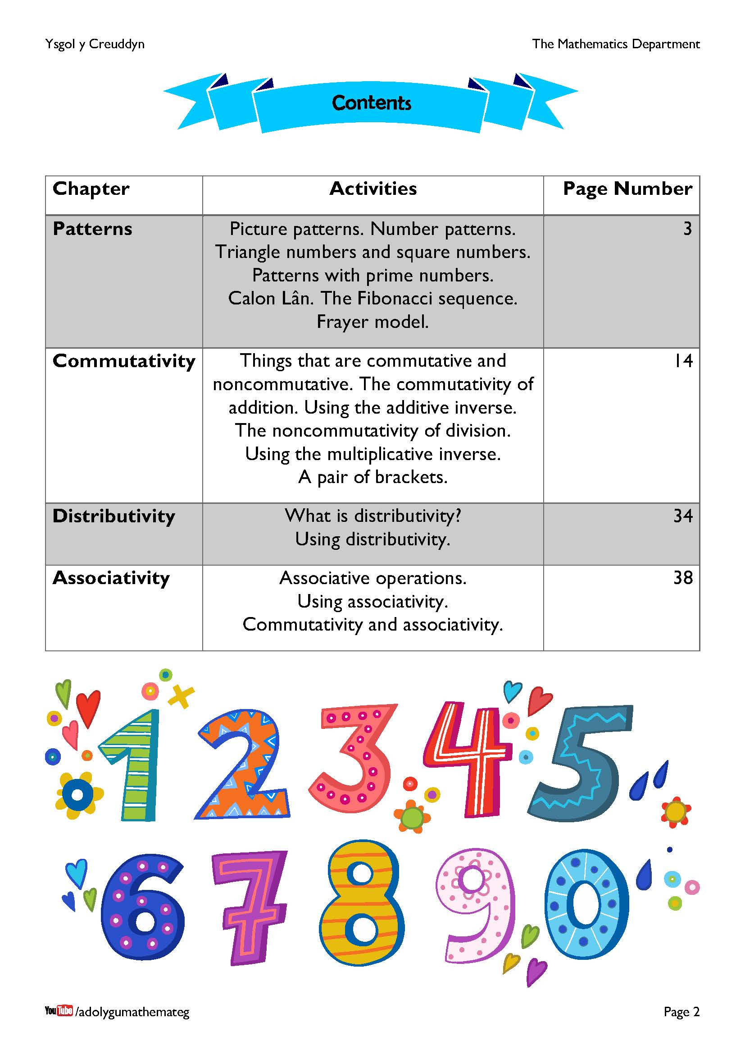
This workbook deals with the following descriptions of learning.
Algebra uses symbol systems to express the structure of mathematical relationships.
PATTERNS
- I can explore and create patterns of numbers and shapes. I can explain numerical sequences and spatial patterns in words and by generalising them.
FORMING
- I can use commutativity, distributivity and associativity to explore equality and inequality of expressions.
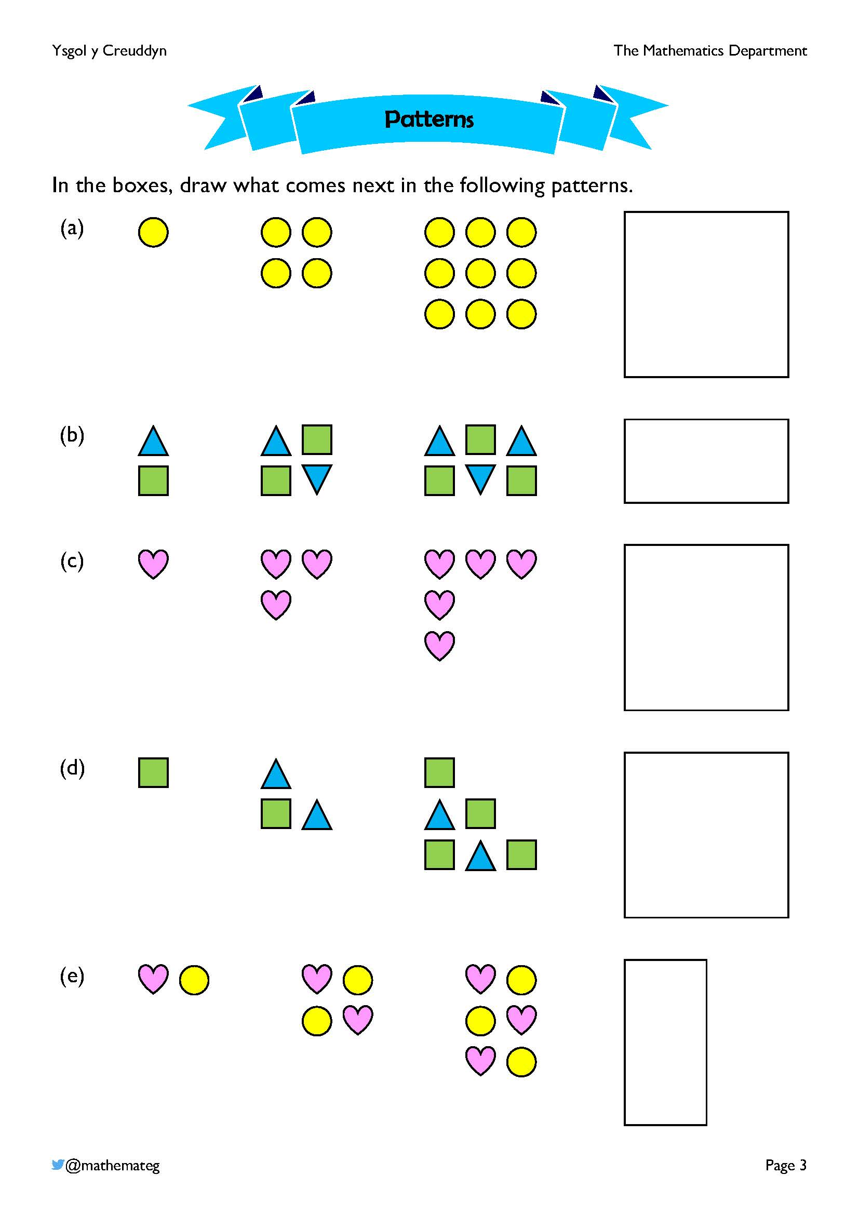
The learners reason how to complete the patterns.
(a) A pattern that forms the square numbers 1, 4, 9, 16, 25, … For the 10th picture, 100 yellow circles will be required, arranged into a 10 by 10 square.
(b) A pattern that forms the even numbers 2, 4, 6, 8, 10, … For the 10th picture, two rows and ten columns will be required, giving 20 symbols in total.
(c) A pattern that forms the odd numbers 1, 3, 5, 7, 9, … For the 10th picture, a total of 19 hearts will be required, with 10 in the horizontal row and 10 in the vertical column.
(d) A pattern that forms the triangle numbers 1, 3, 6, 10, 15, … For the 10th picture, we will require a total of 10 + 9 + 8 + 7 + 6 + 5 + 4 + 3 + 2 + 1 = 55 symbols.
(e) The same pattern as (b), but continuing downwards instead of to the right.
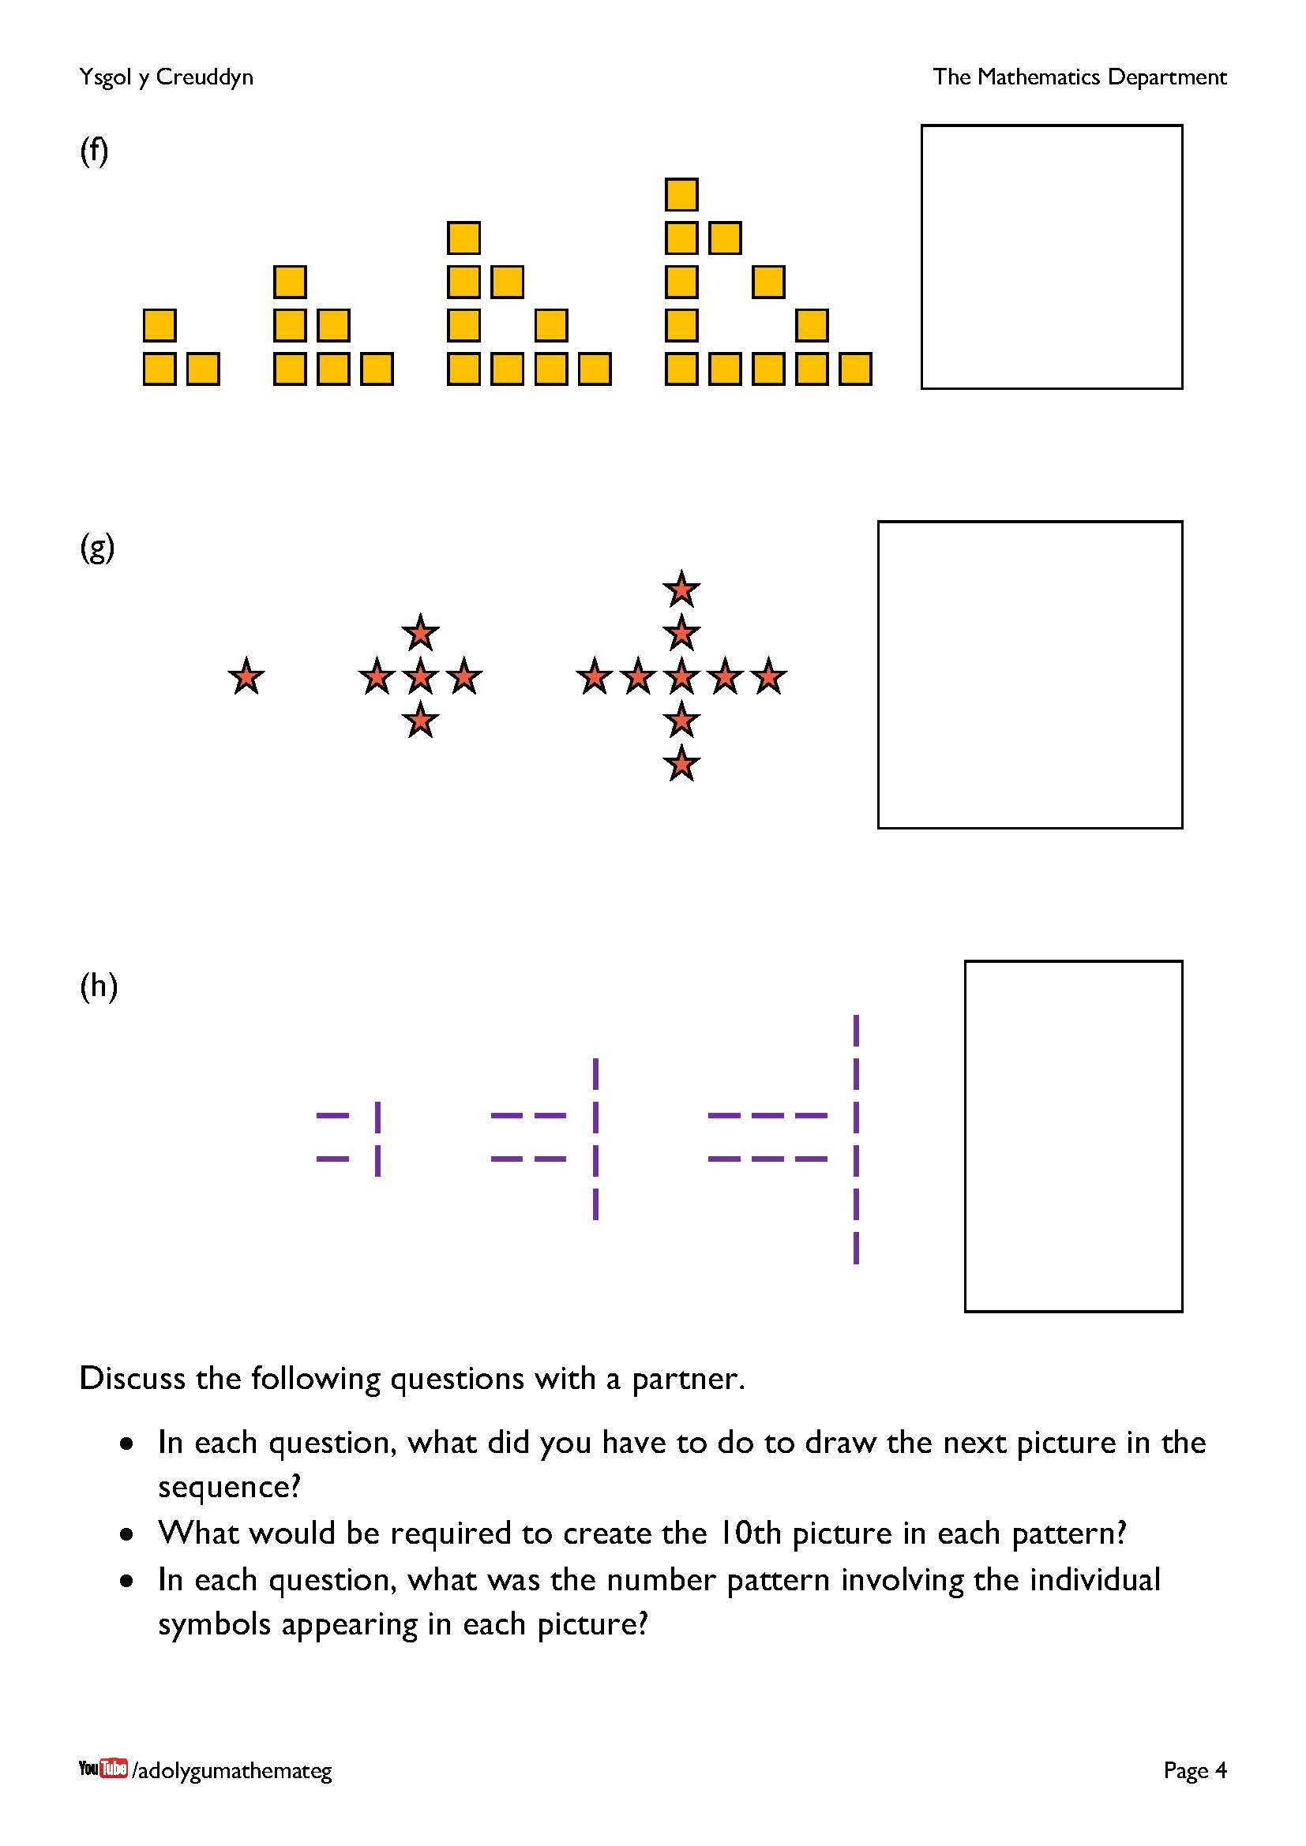
The learners reason how to complete the patterns.
(f) A pattern that forms the perimeter of a triangle, and that shows the multiples of 3 when considering the number of symbols: 3, 6, 9, 12, 15, … For the 10th picture, 30 little squares will be required, forming the perimeter of a triangle with a base of 11 little squares. We can also think of this pattern as the difference between two triangle numbers.
(g) A cross-shaped pattern that adds four new stars each time: 1, 5, 9, 13, 17, … For the 10th picture, we will require 37 stars in total, forming a row of 19 stars and a column of 19 stars.
(h) Another pattern that adds four each time: 4, 8, 12, 16, 20, … For the 10th picture, 40 lines will be required in total, with 11 symbols in each of the two rows, and 20 vertical lines in the column on the right.
During the discussions, listen out for (and encourage) connections between the spatial pattern and concepts such as even numbers, square numbers, multiples of 3, vertical lines, etc.

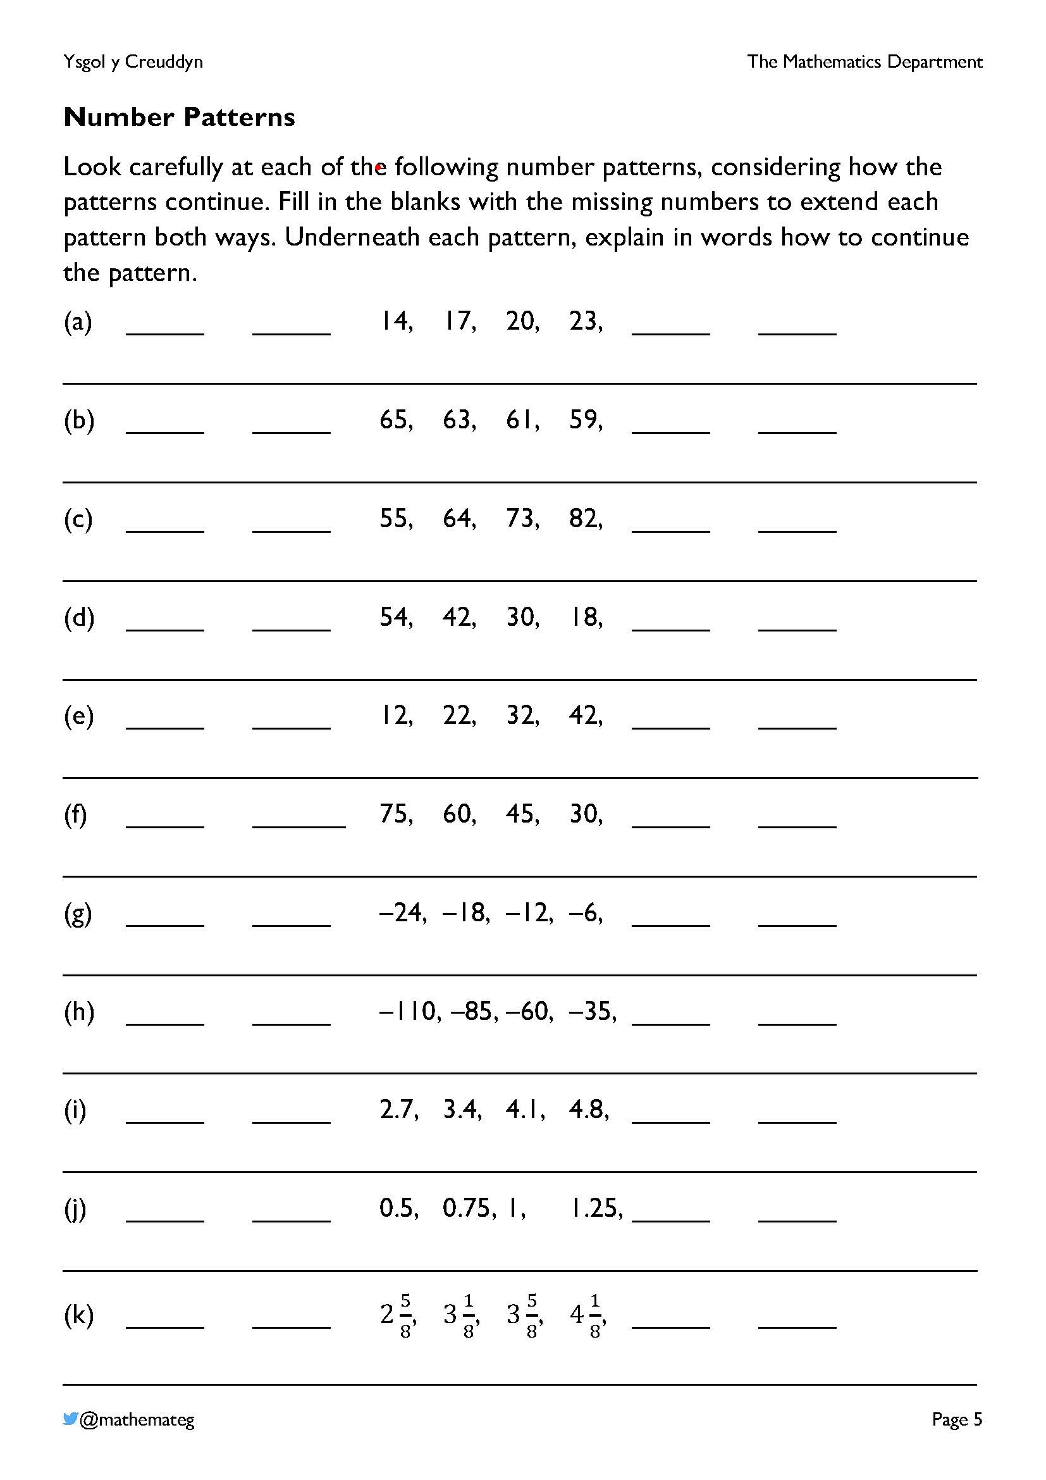
Reasoning must be used here to recognise the pattern to begin with, and then to continue the pattern.
Aspects of this exercise also touch on the following description of learning for number (progression step 2):
THE NUMBER SYSTEM
- I can order and sequence numbers, including odd and even numbers, and I can count on and back in step sizes of any whole number and simple unit fractions.
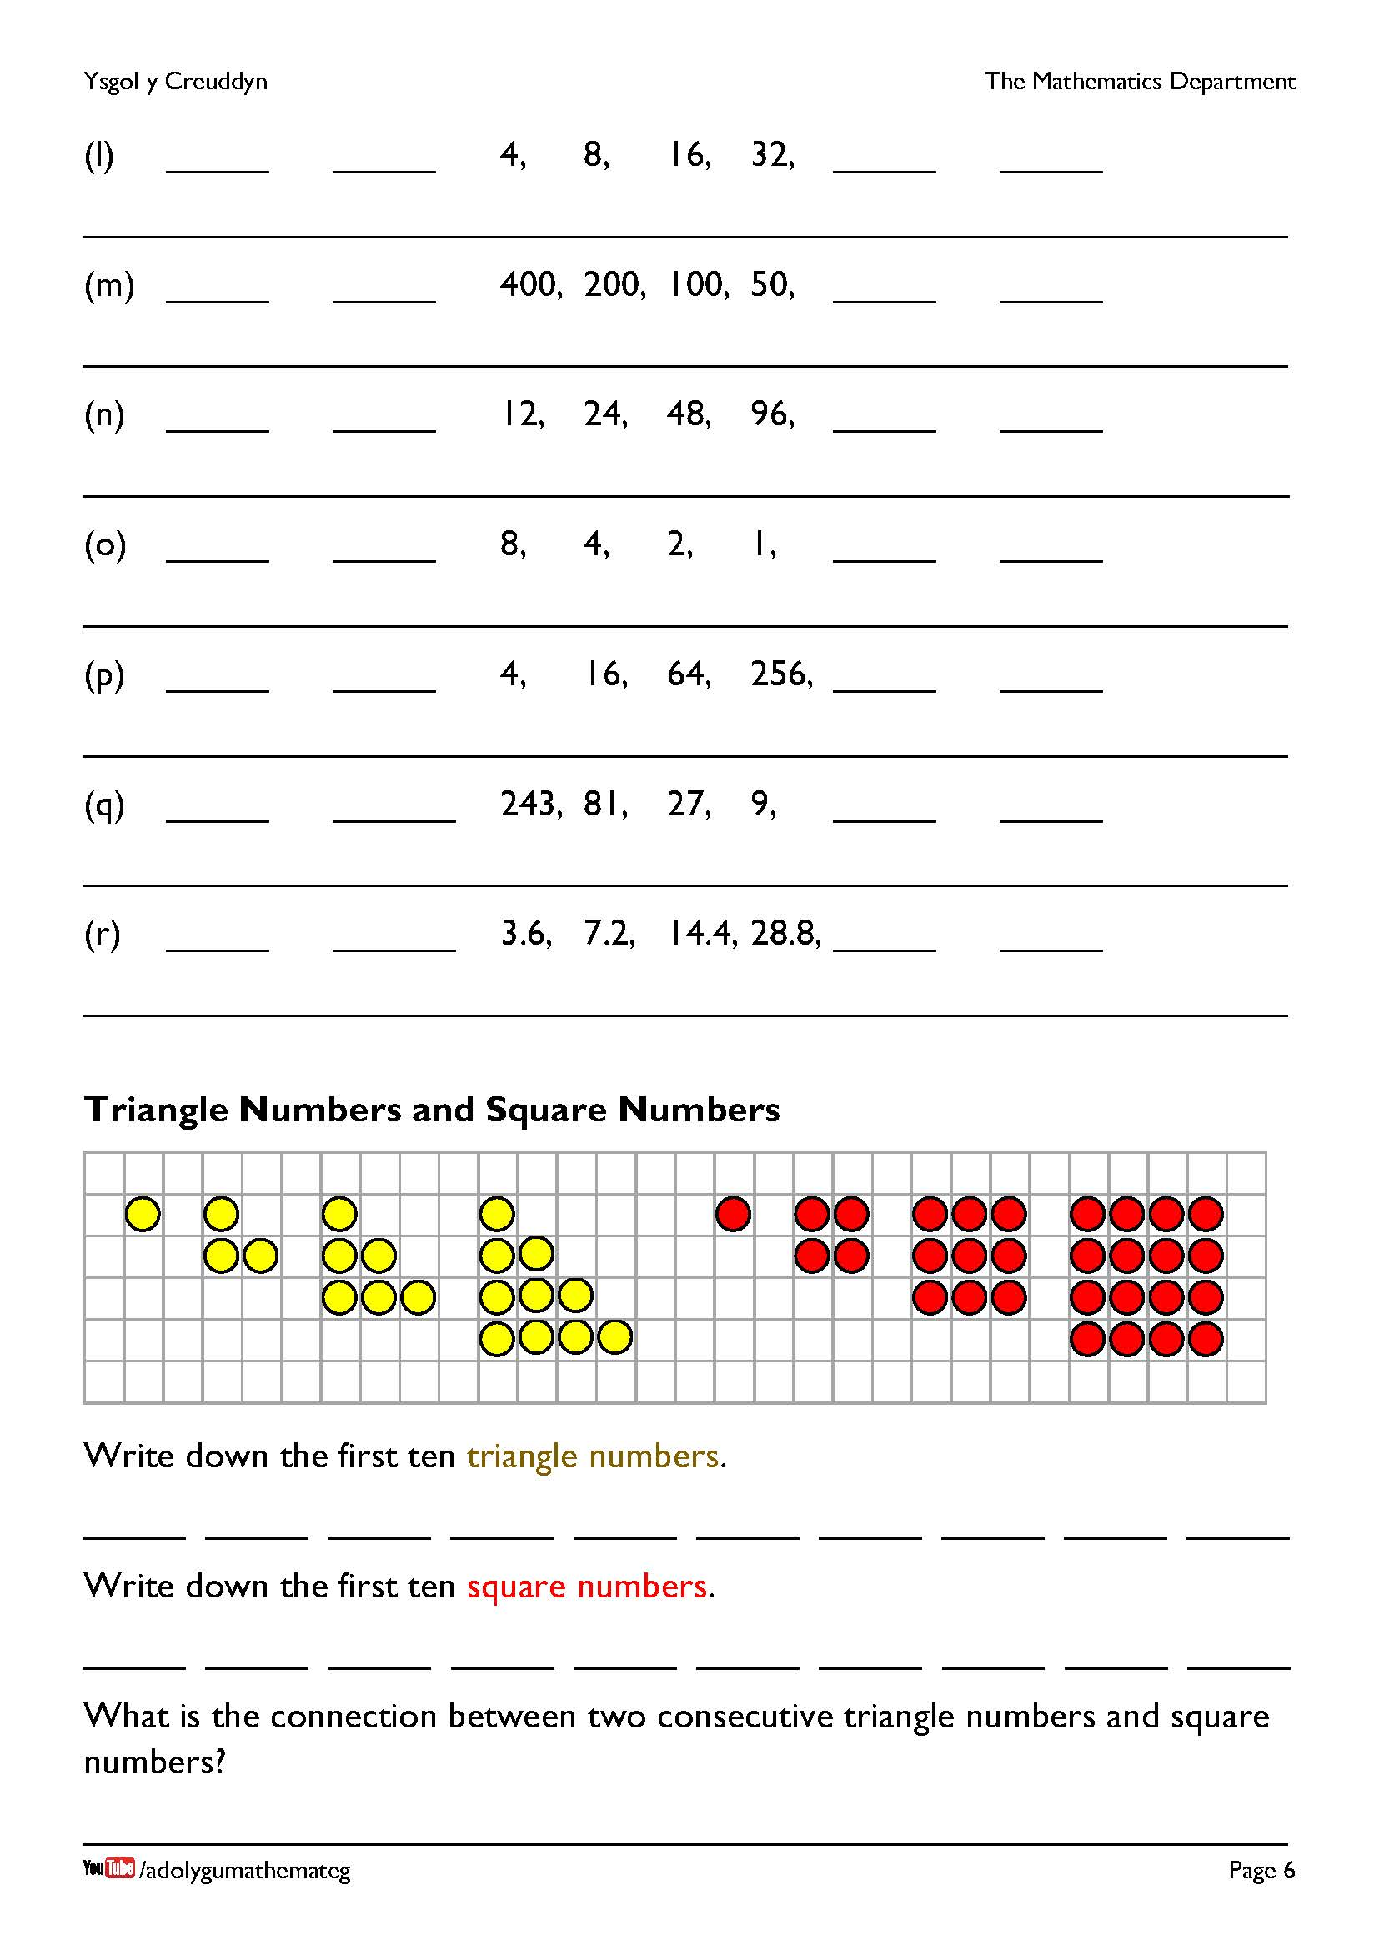
For your information: the exercises on the previous page are arithmetic sequences (where we need to add or subtract to obtain the next number), whilst the exercises on this page are geometric sequences (where we need to multiply or divide to obtain the next number).
The first ten triangle numbers are
1, 3, 6, 10, 15, 21, 28, 36, 45, 55. (Add one more each time.)
The first ten square numbers are
1, 4, 9, 16, 25, 36, 49, 64, 81, 100.
Adding two consecutive triangle numbers gives a square number. For example,
1 + 3 = 4
3 + 6 = 9
6 + 10 = 16
10 + 15 = 25
If you have double sided counters, it would be possible to arrange them to show how two triangle numbers combine to give a square number.
Digital counters: https://mathsbot.com/manipulatives/counters
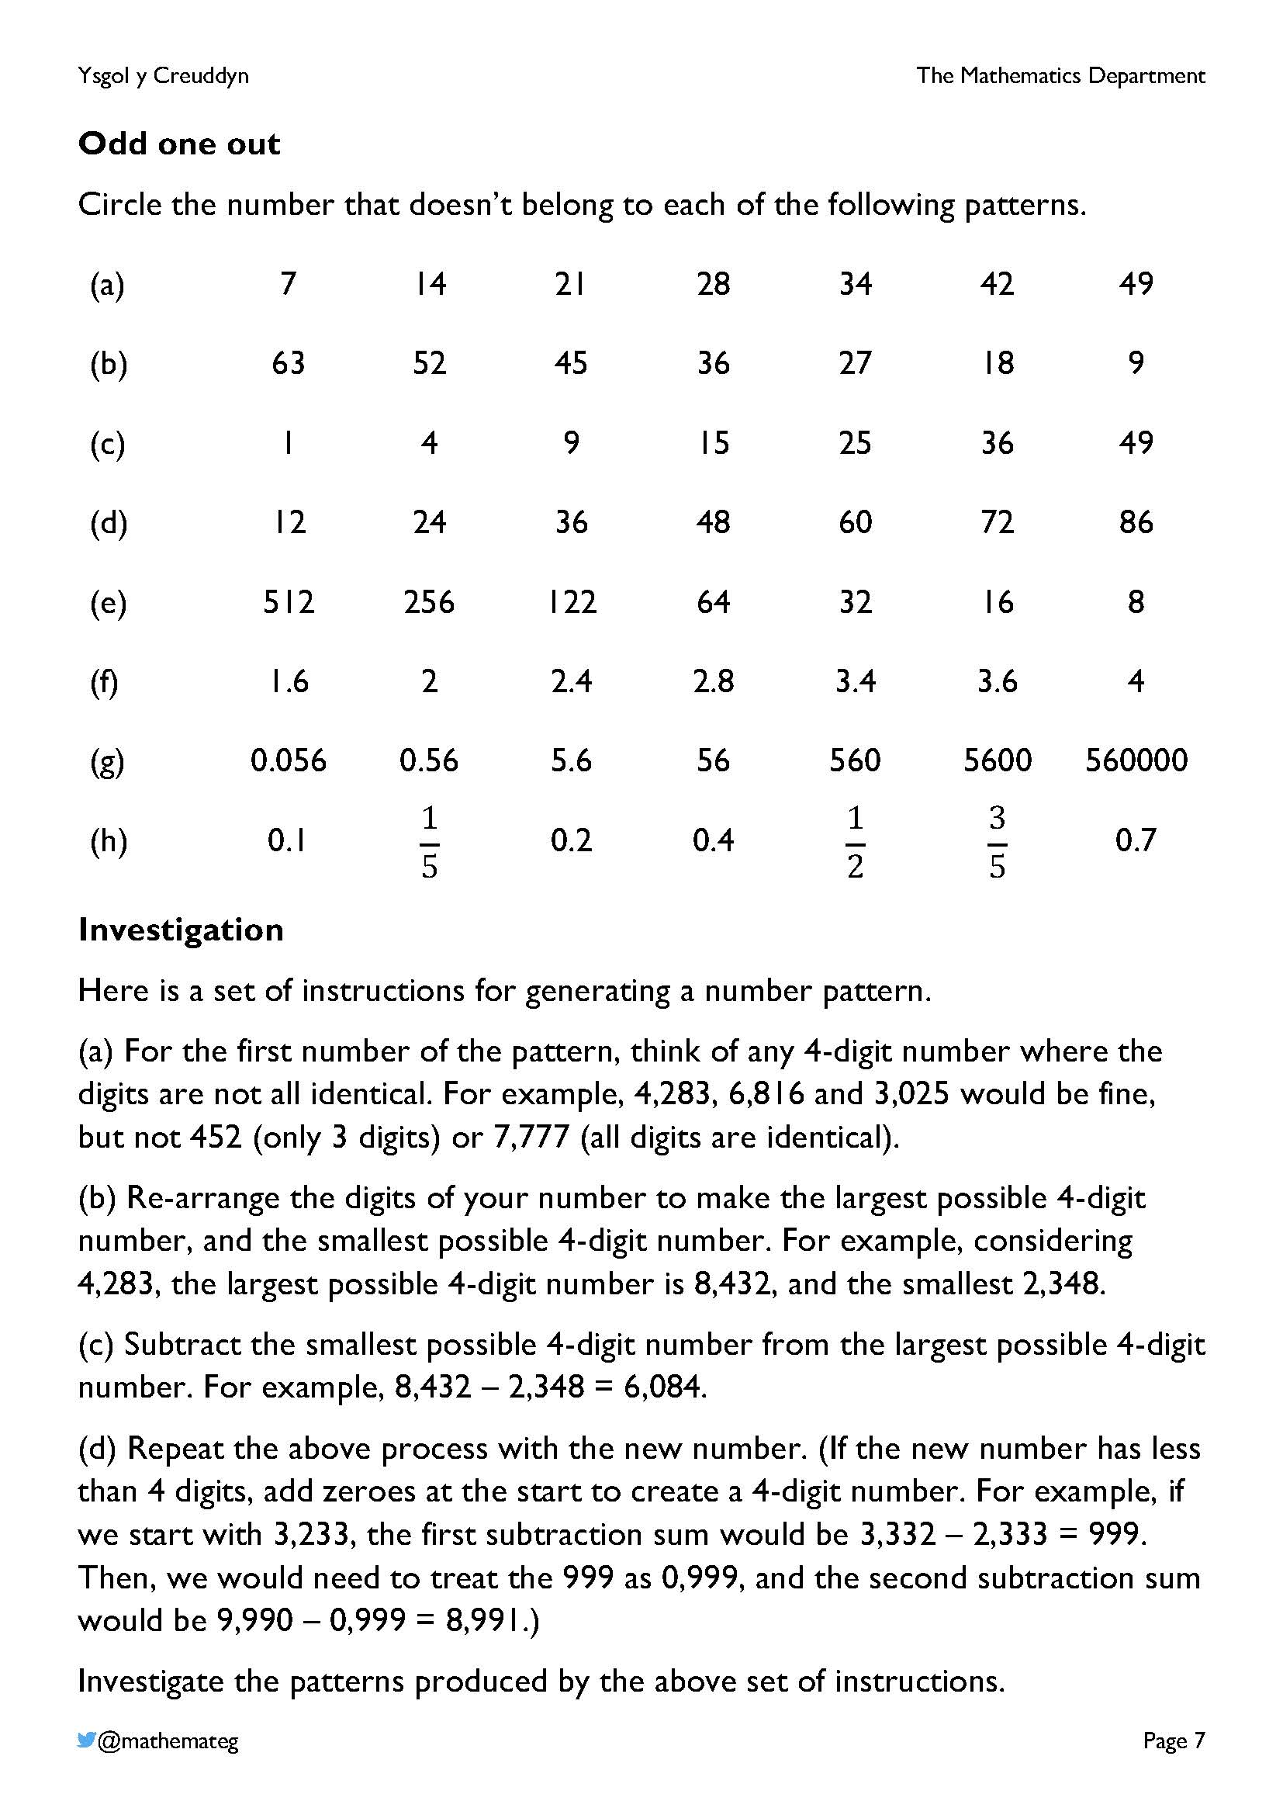
Reasoning must be used here to recognise the pattern to begin with, and then to recognise the number that doesn’t belong to the pattern.
More exercises on number sequences can be found on the page http://www.primaryresources.co.uk/maths/mathsB3.htm
In the investigation, learners must work systematically through the instructions in order to create the correct pattern. Starting with a 4-digit number (whose digits are not all identical), the pattern always reaches the number 6,174, and then stays at this number.
The number 6,174 is recognised as the Kaprekar constant, as the Indian mathematician Dattatreya Ramchandra Kaprekar discovered this pattern first. Every 4-digit number (whose digits are not all identical) reaches the number 6,174 in 8 steps or less. (What happens when you start with a 4-digit number whose digits are all identical?)
More information: https://math.hmc.edu/funfacts/kaprekars-constant/

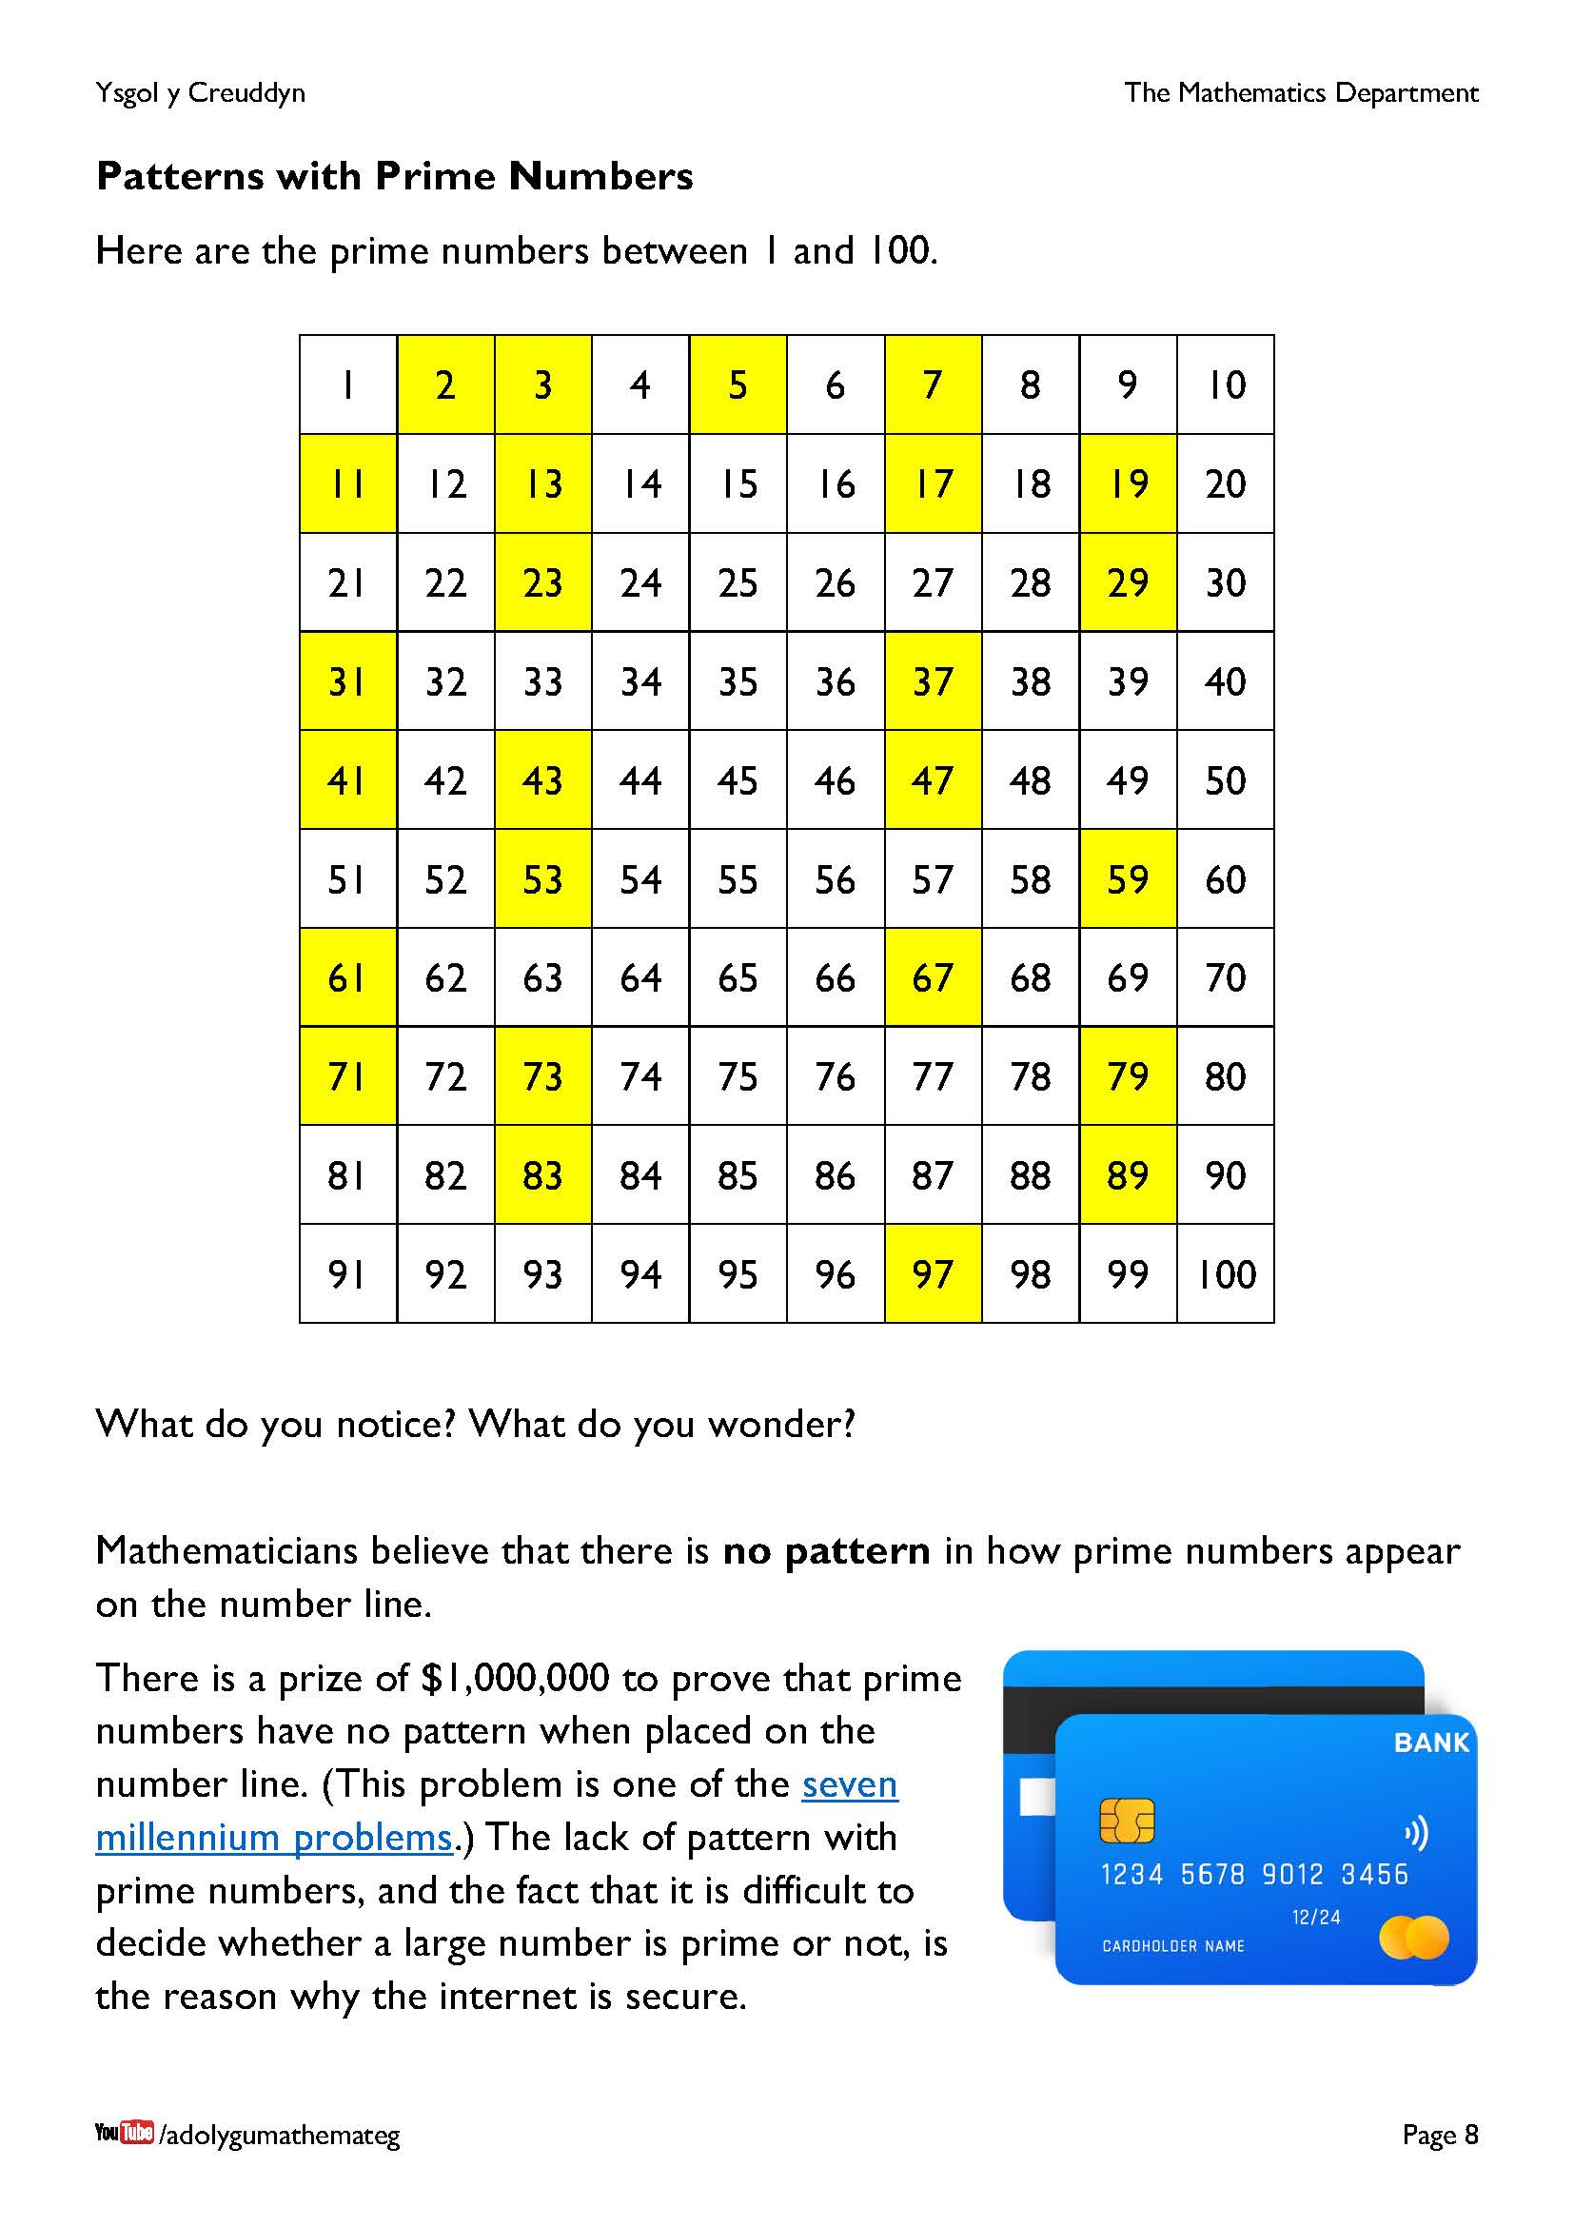
This page assumes that the learners have met prime numbers before (if not, you will need to discuss the concept).
What type of things will the learners perhaps notice?
- Only one even number is here, namely 2, All other prime numbers are odd numbers.
- Exactly a quarter of the numbers in the grid are prime numbers, as 25 numbers out of 100 have been coloured yellow. This means that there are 75 composite numbers (numbers that are not prime numbers) in the grid.
- Apart from the first row, every prime number ends in a 1, 3, 7 or 9. Challenge! There are 4 prime numbers between 11 and 20. In which row will this happen next (supposing that the grid can be continued down vertically)?
One of the seven millennium problems has been solved by a mathematician named Grigori Perelman – but he declined the prize of $1 million! https://en.wikipedia.org/wiki/Grigori_Perelman

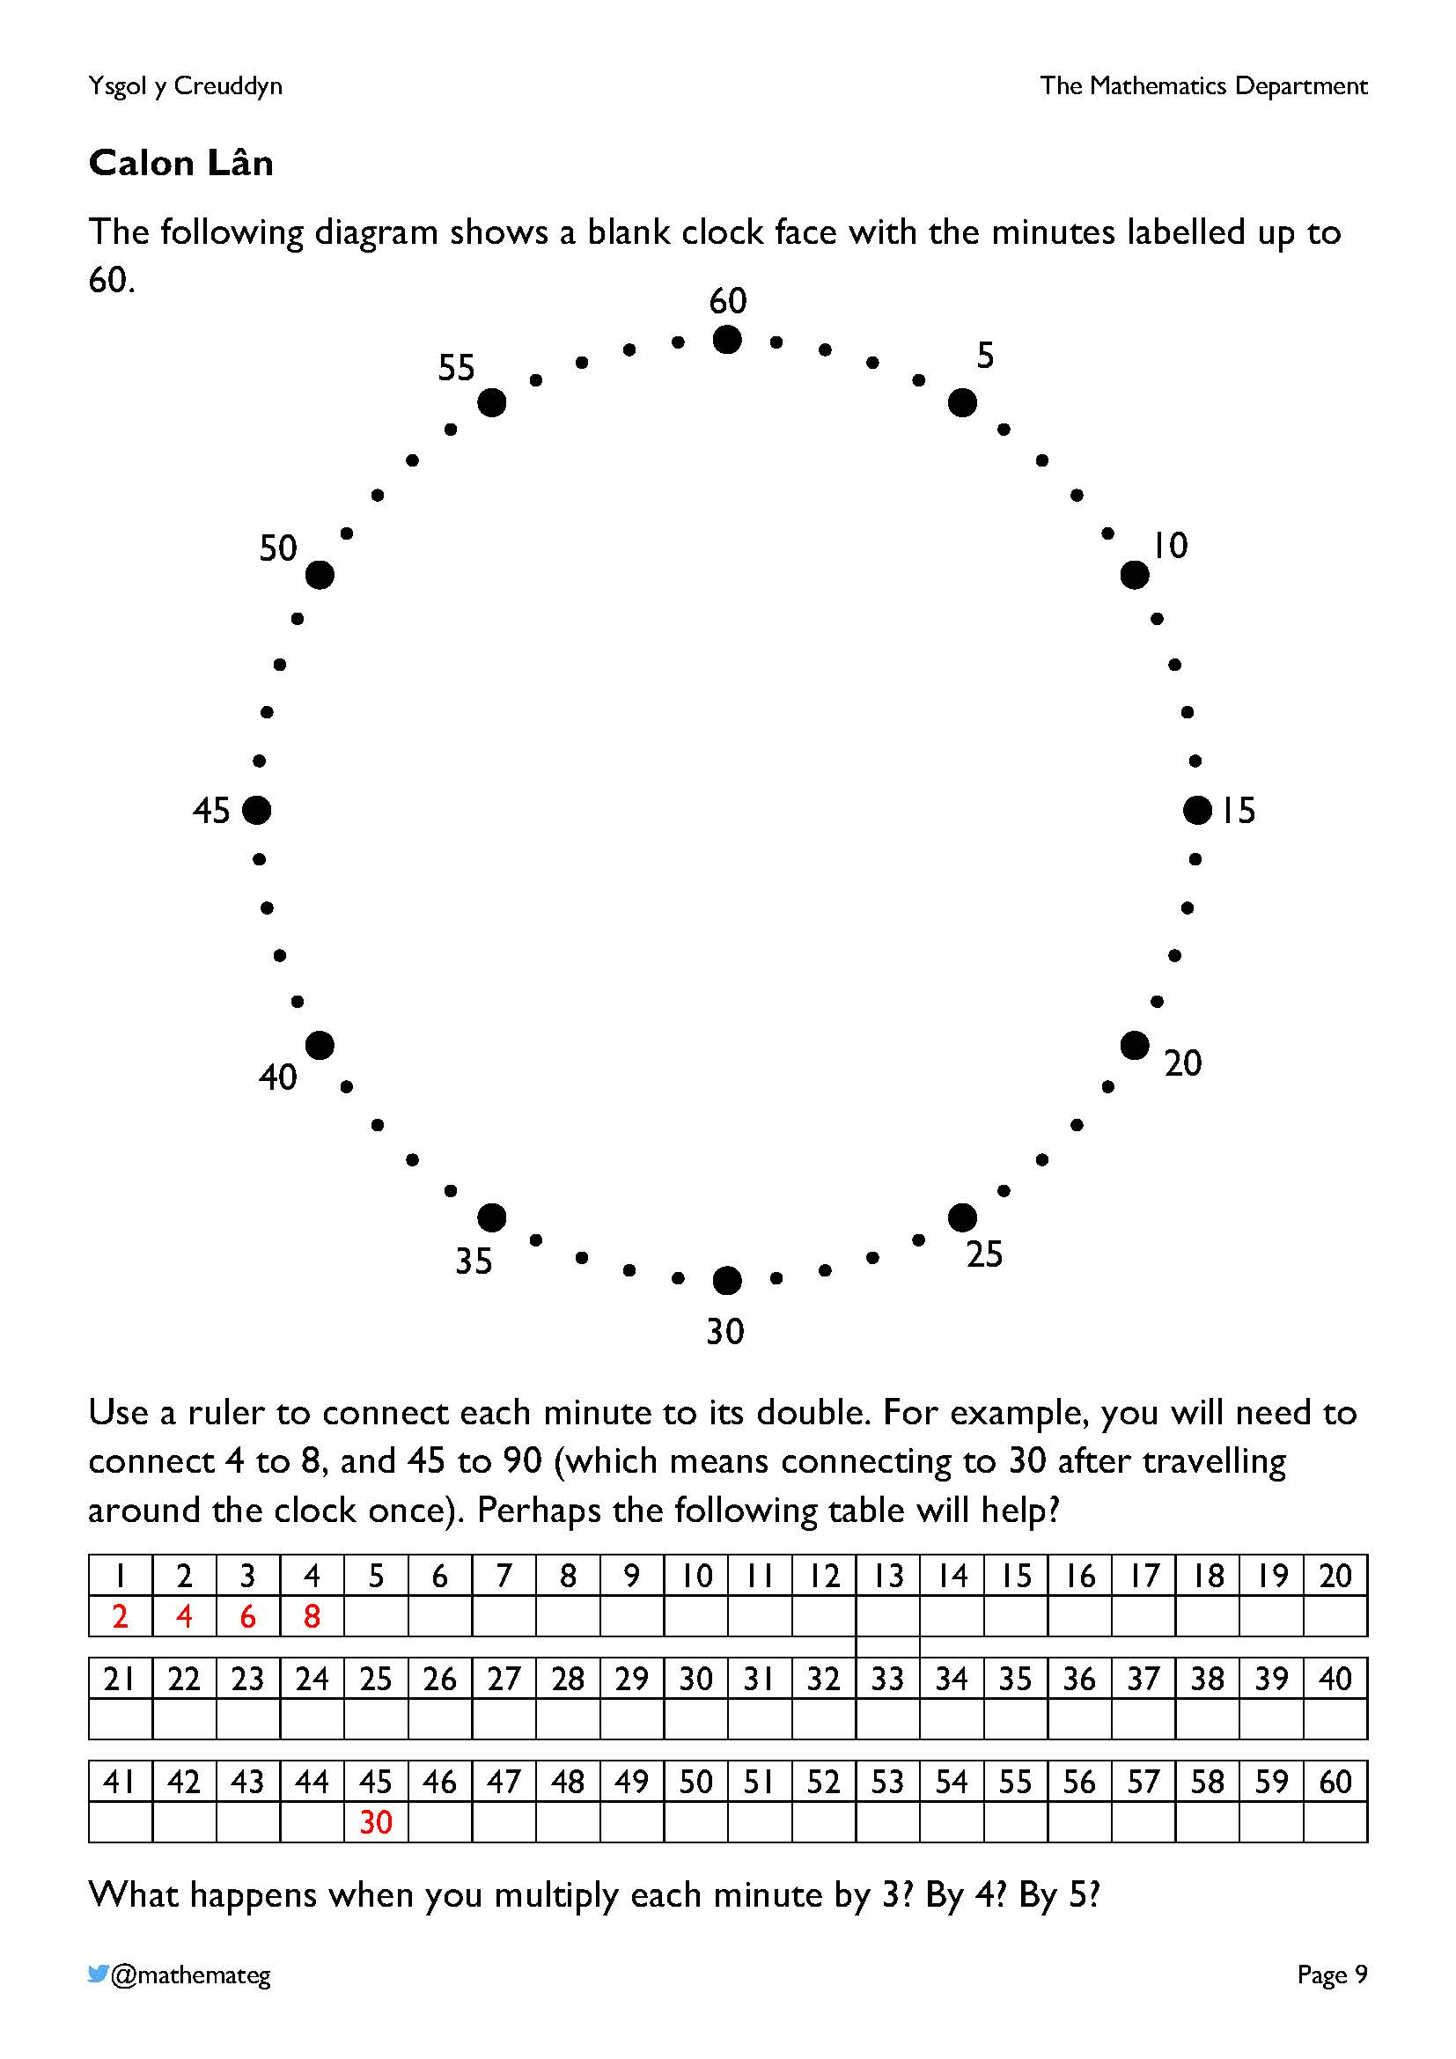
A shape known as a cardioid is formed on the clock face by completing the exercise correctly. Because it is similar to a heart shape, this explains the title of the page (heart = calon in Welsh).
Acknowledgement: This exercise is based upon one from the website https://www.artfulmaths.com/mathematical-art-lessons.html, where other exercises linking art to mathematics can also be found.
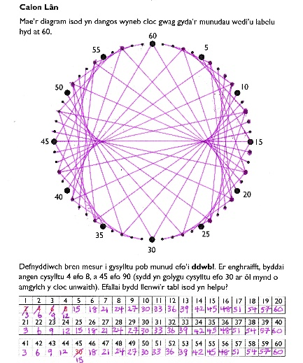
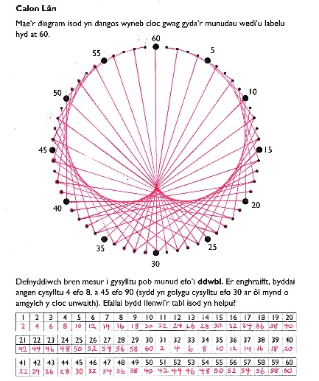
Answers: Multiplying by 2 Multiplying by 3

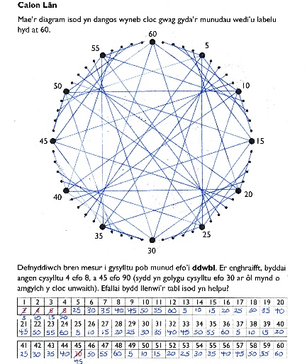
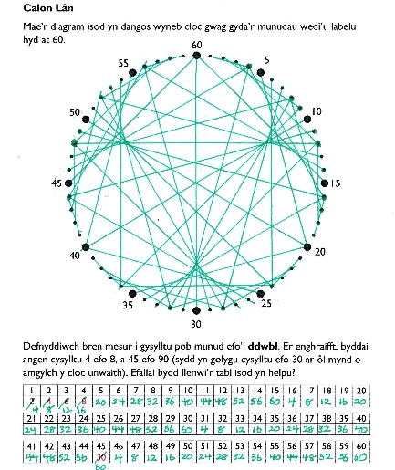
Multiplying by 4 Multiplying by 5

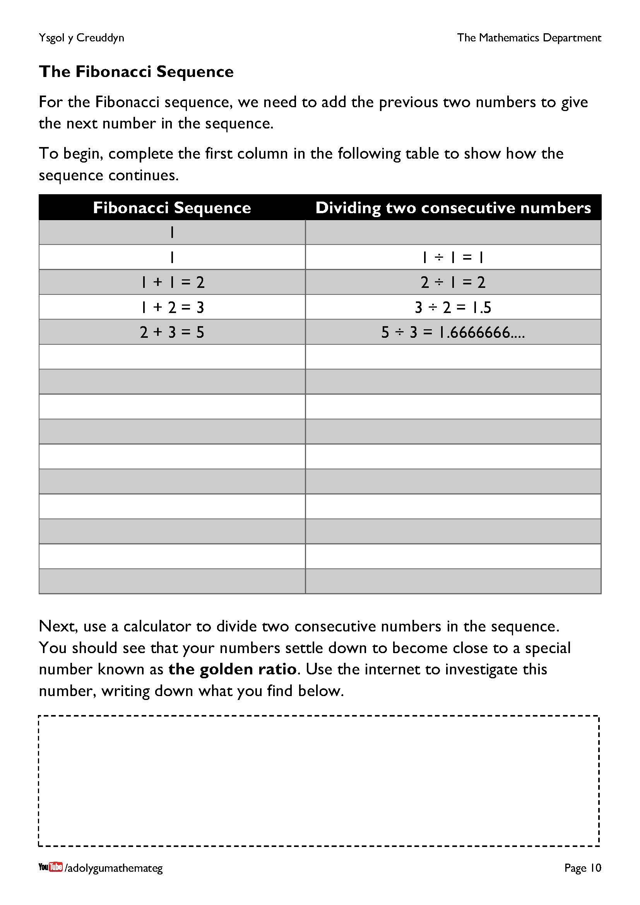
Learners must work systematically to complete the table, taking care to add or divide the correct two numbers each time.
More information about the Fibonacci sequence: https://www.mathsisfun.com/numbers/fibonacci-sequence.html

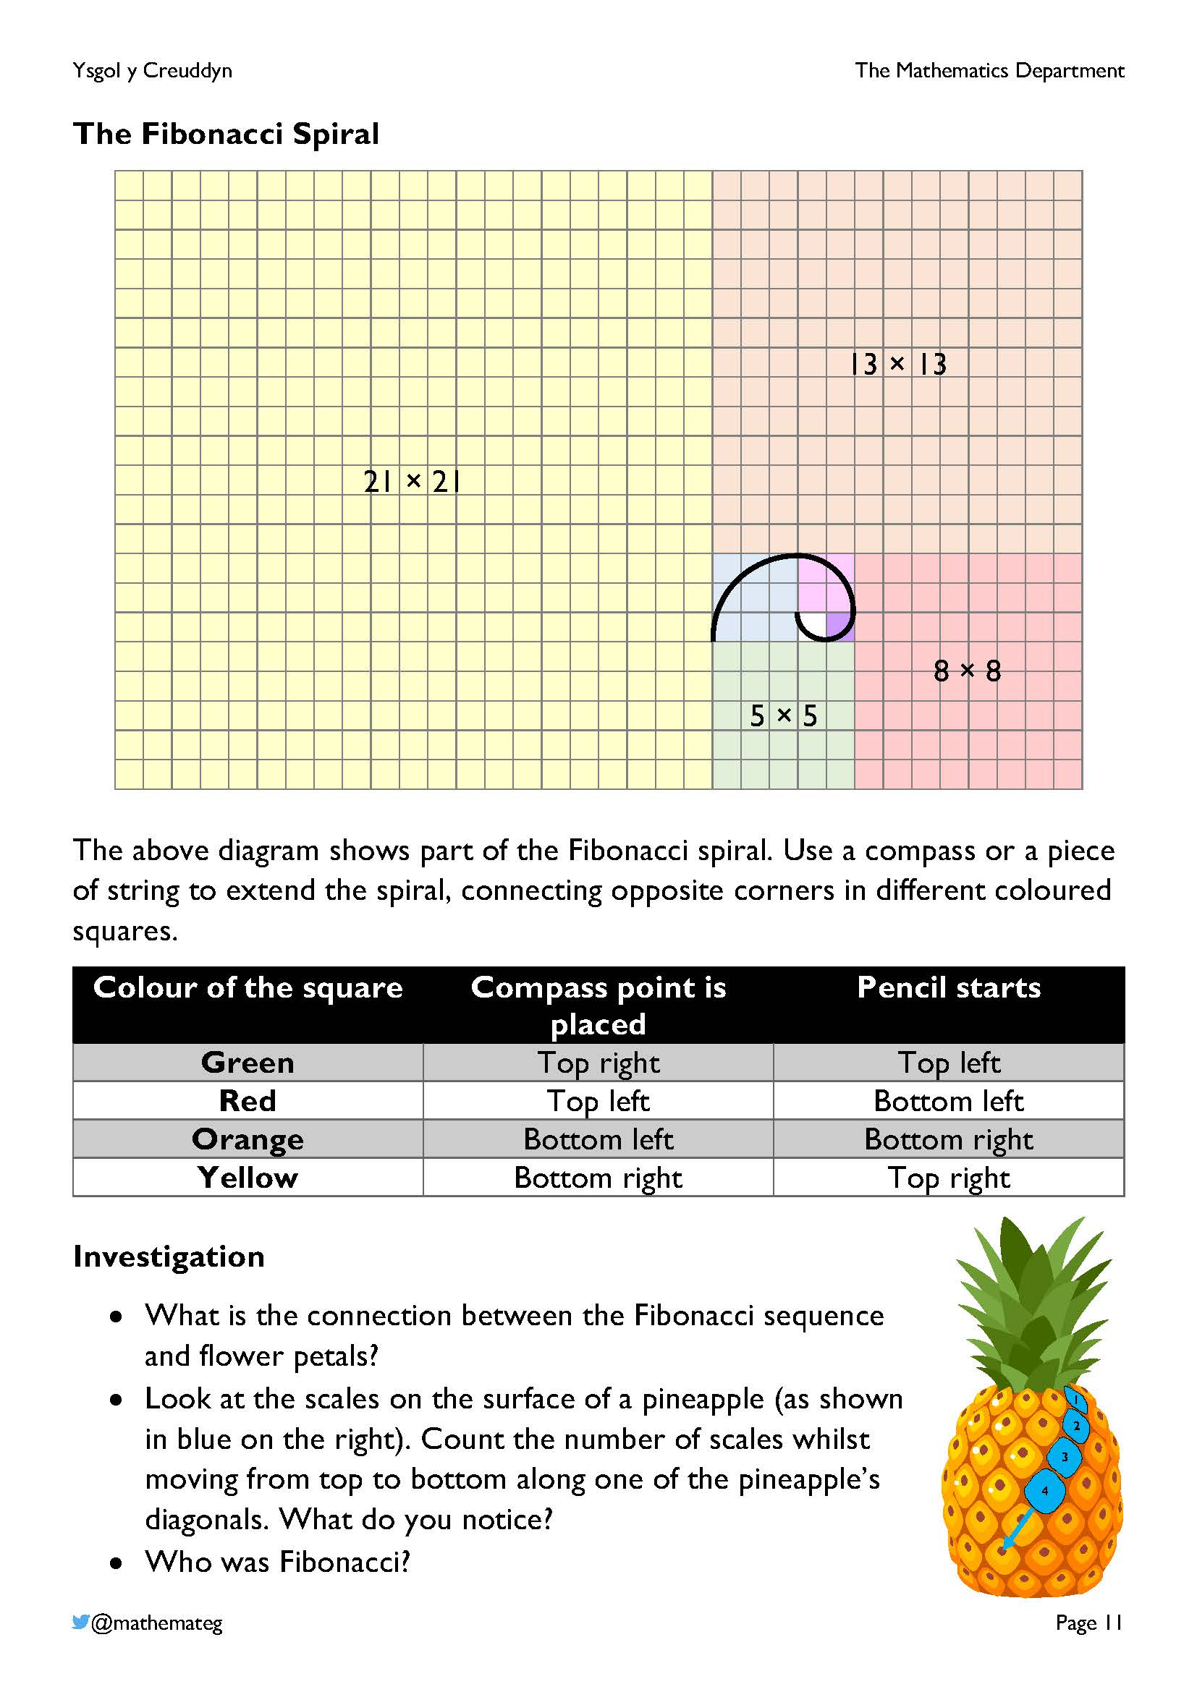
Completing the spiral enables learners to practice their fine motor skills, using either a compass or a piece of string tied to a pencil.
More information about the connection between Fibonacci numbers and nature can be found here: http://www.maths.surrey.ac.uk/hosted-sites/R.Knott/Fibonacci/fibnat.html

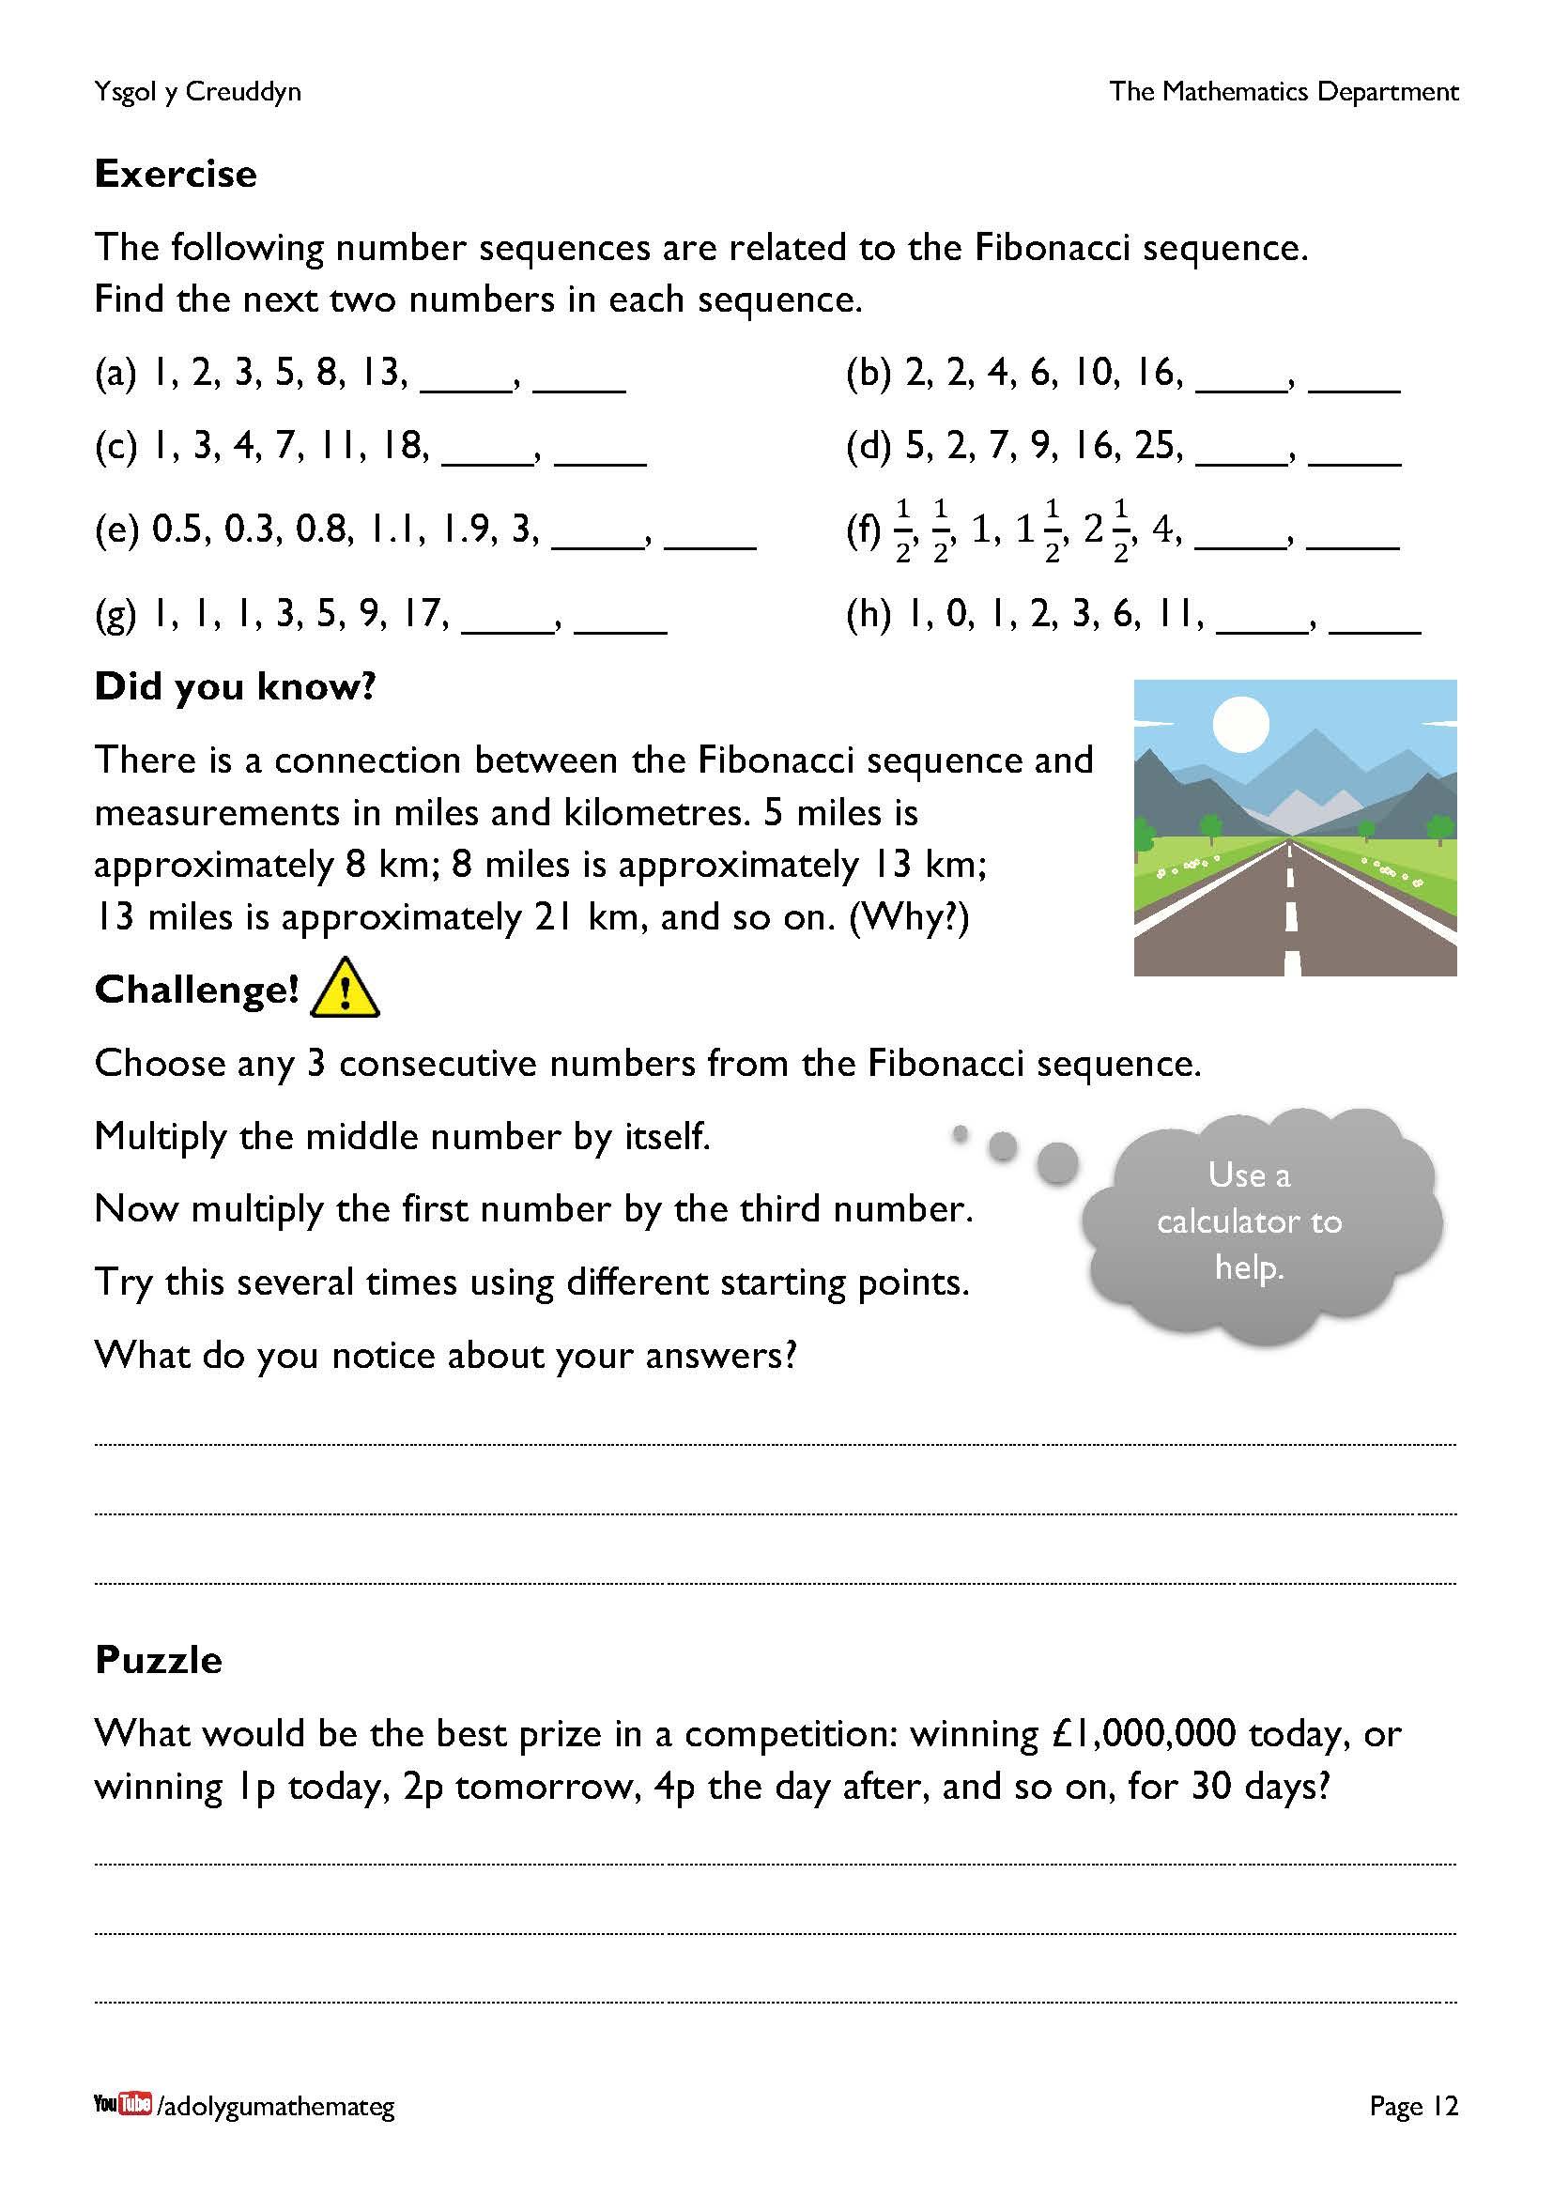
For the exercise on the top of the page, questions (a) to (f) are ones in which the previous two numbers must be added together to obtain the next number in the sequence, whereas questions (g) and (h) are ones where the previous three numbers must be added together to obtain the next number in the sequence.
1 mile is approximately 1.60934 kilometres, whereas the golden ratio is approximately 1.61803. Because these two numbers are close to each other, it is possible to use the Fibonacci sequence to estimate distances in miles that are Fibonacci numbers to be in kilometres.
For the challenge, there is always a difference of one between the two products. Sometimes the square of the middle number is one more, and sometimes one less; this alternates as we work through the Fibonacci numbers. It would be possible to model what is going on using a spreadsheet.
In the puzzle, the best option is to wait until the end of the 30 days: the prize on day 30 is £5,368,709.12, and the total amount of prizes from day 1 until day 30 is £10,737,418.23. Again, this situation could be modelled using a spreadsheet, or by using a calculator.

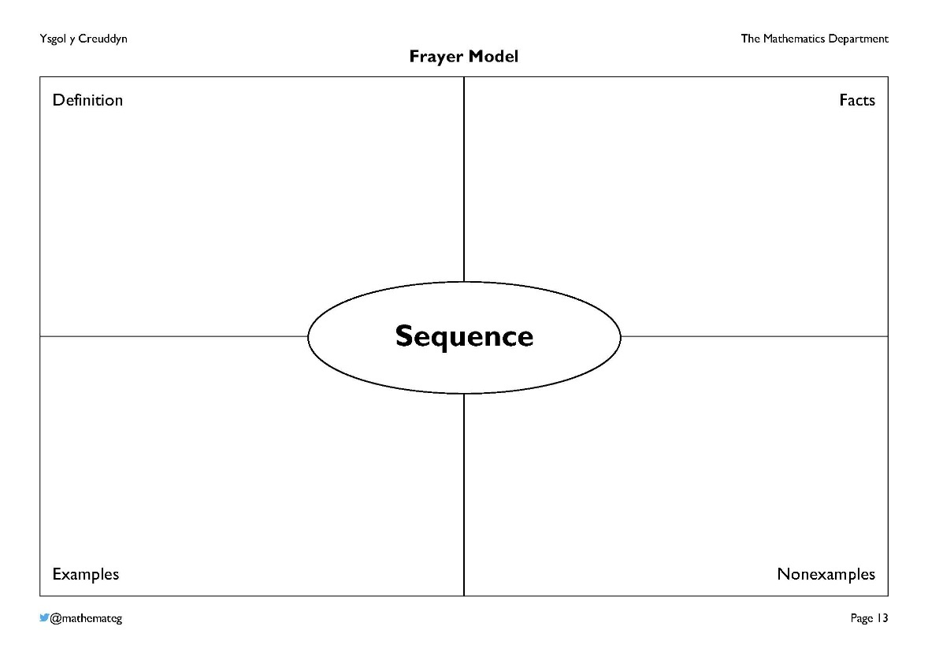

A Frayer model presents information about a particular term, here the term ‘Sequence’. Several further examples can be found on the website https://www.frayer-model.co.uk/.
Example responses:
Definition
‘A list of numbers or objects in a special order’.
‘A sequence is a collection of numbers or pictures with a rule to decide what is the next number or picture in the collection.’
Facts
‘In a sequence of numbers, the numbers are recognised as the terms of the sequence. For example, in the sequence 5, 8, 11, 14, …, the first term is 5, and the third term is 11’.
Examples
‘9, 11, 13, 15, 17, 19, ...’
‘1000, 500, 250, 125, 62.5, ...’
Nonexamples
‘2, 4, 6, 8, 11, 12, 14, 16, ...’
‘A, B, C, D, E, F, H, I, J, ...’
If you are not familiar with the idea of a nonexample, please visit the website https://nonexamples.com/compare for more information.
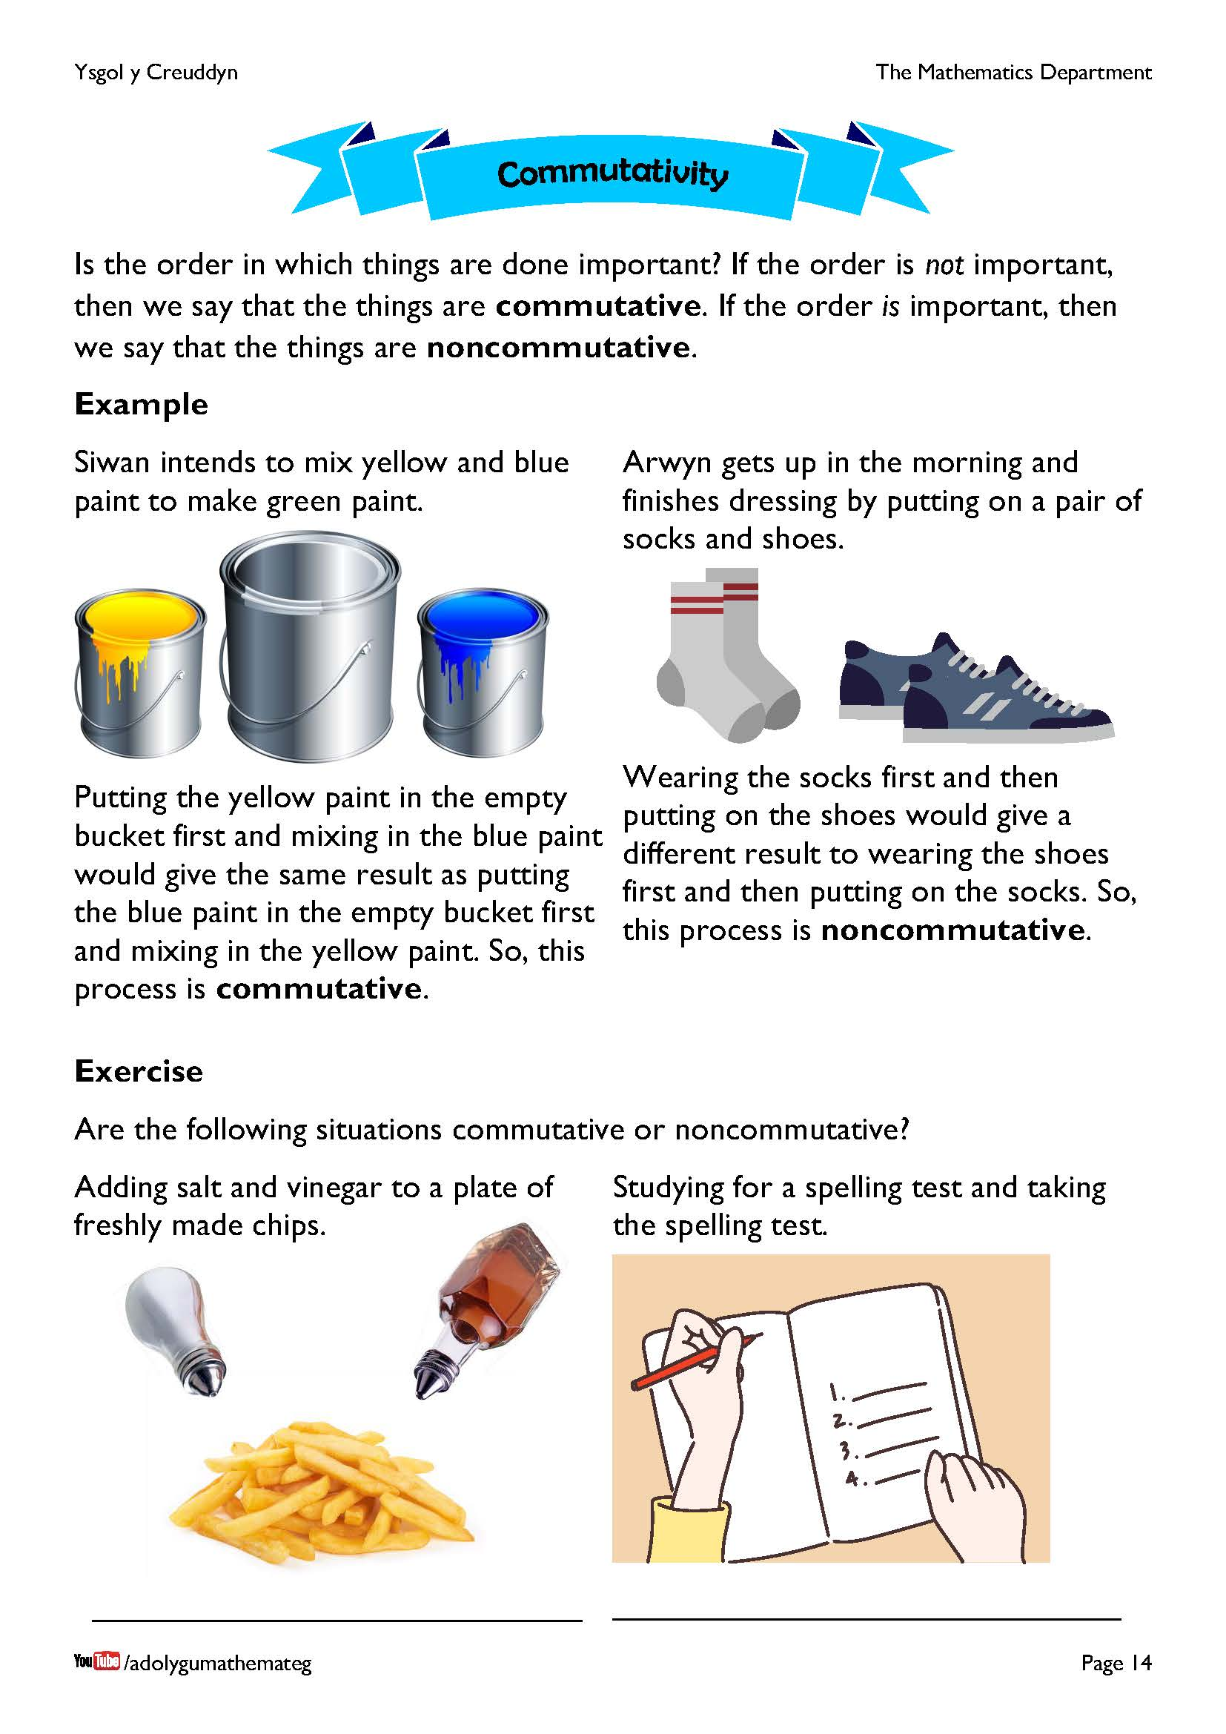
This page introduces the idea of commutativity, where we discuss whether the order in which things are done is important. In formal algebra, commutativity is written as $a+b=b+a$, but you do not need to refer to this equation in this work. Discuss with the learners the situations that are described, debating whether the results each time are the same (commutative) or different (noncommutative).

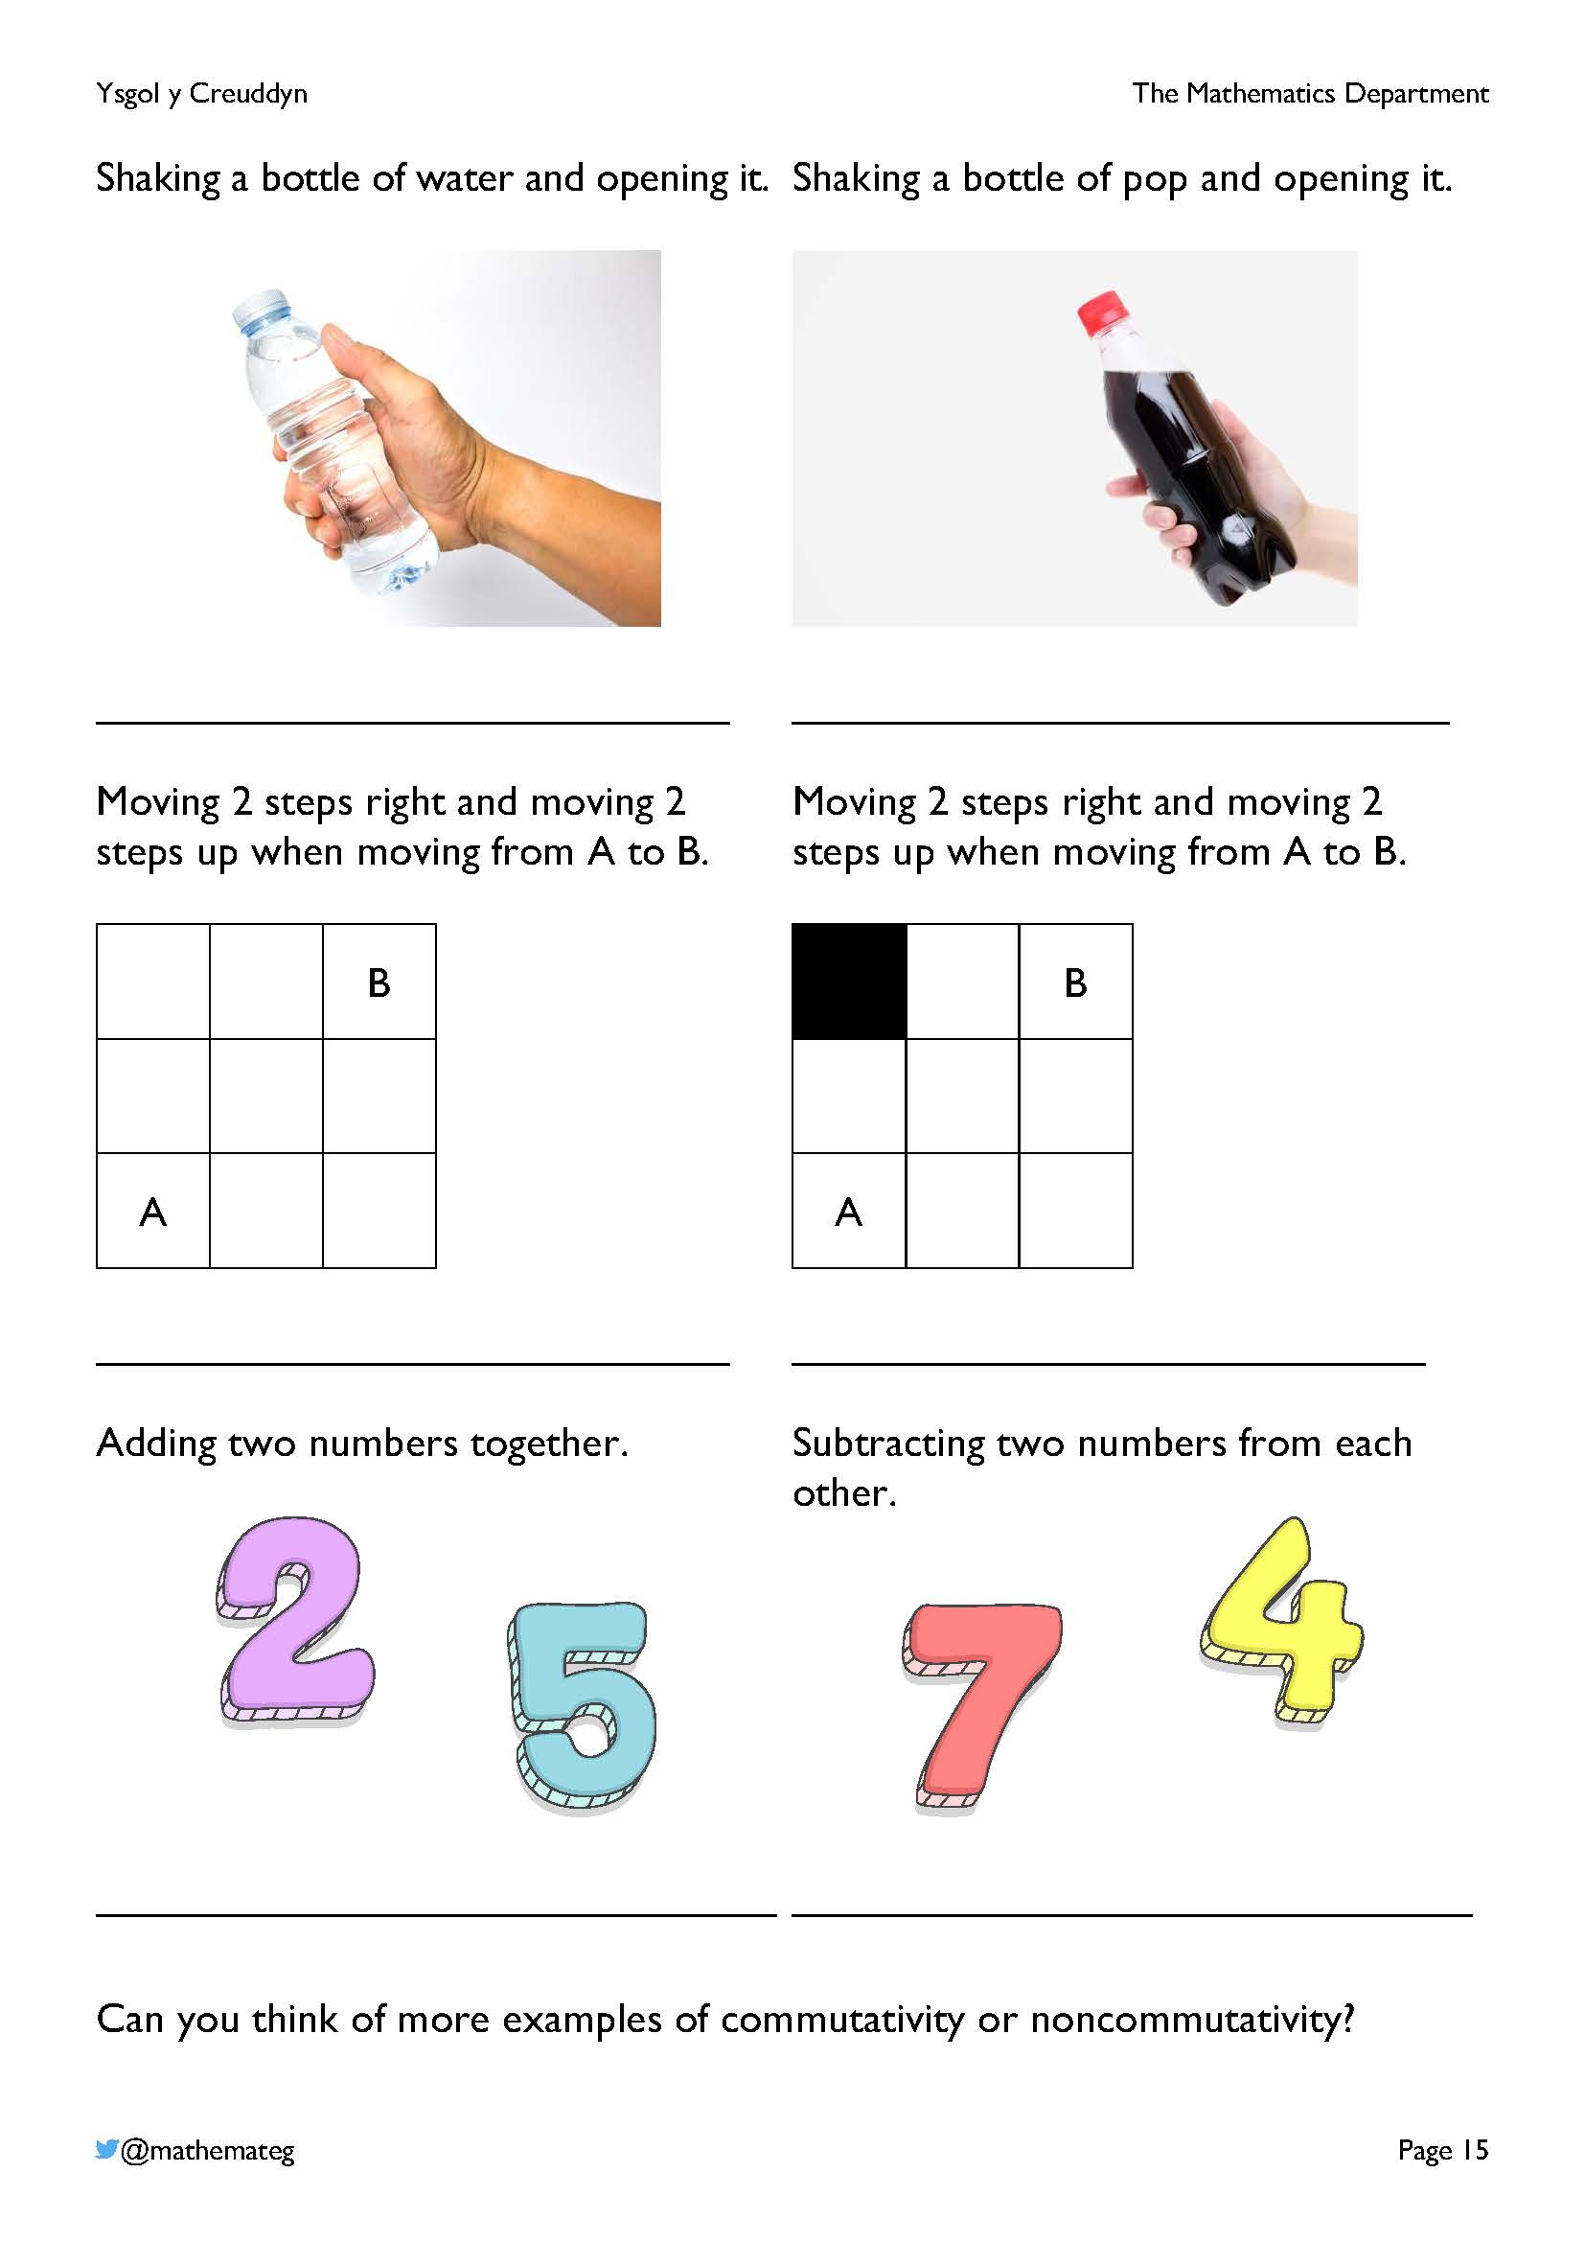
The purpose of this exercise is to help learners understand that the addition of numbers is commutative (the order in which two numbers are added together is unimportant), whereas the subtraction of numbers is noncommutative (it does matter in which order two numbers are subtracted from each other). Spend some time investigating this, if required, considering examples such as
5 + 3 and 3 + 5, or 5 – 3 and 3 – 5. (Use double sided counters to help with the modelling.) Once the learners are happy that addition is commutative, and that subtraction is noncommutative, move on.
Further examples of commutativity and noncommutativity:
- Making orange squash by mixing water with orange cordial.
- Brushing your teeth in the morning and eating toast with strawberry jam.
- Lighting the candles on a birthday cake and blowing on the candles.
- Walking three steps forwards and walking three steps backwards.
- Washing your hair and drying your hair.
- Blowing air into a balloon and putting a pin into the balloon.
- Measuring heart rate and running 100 m.

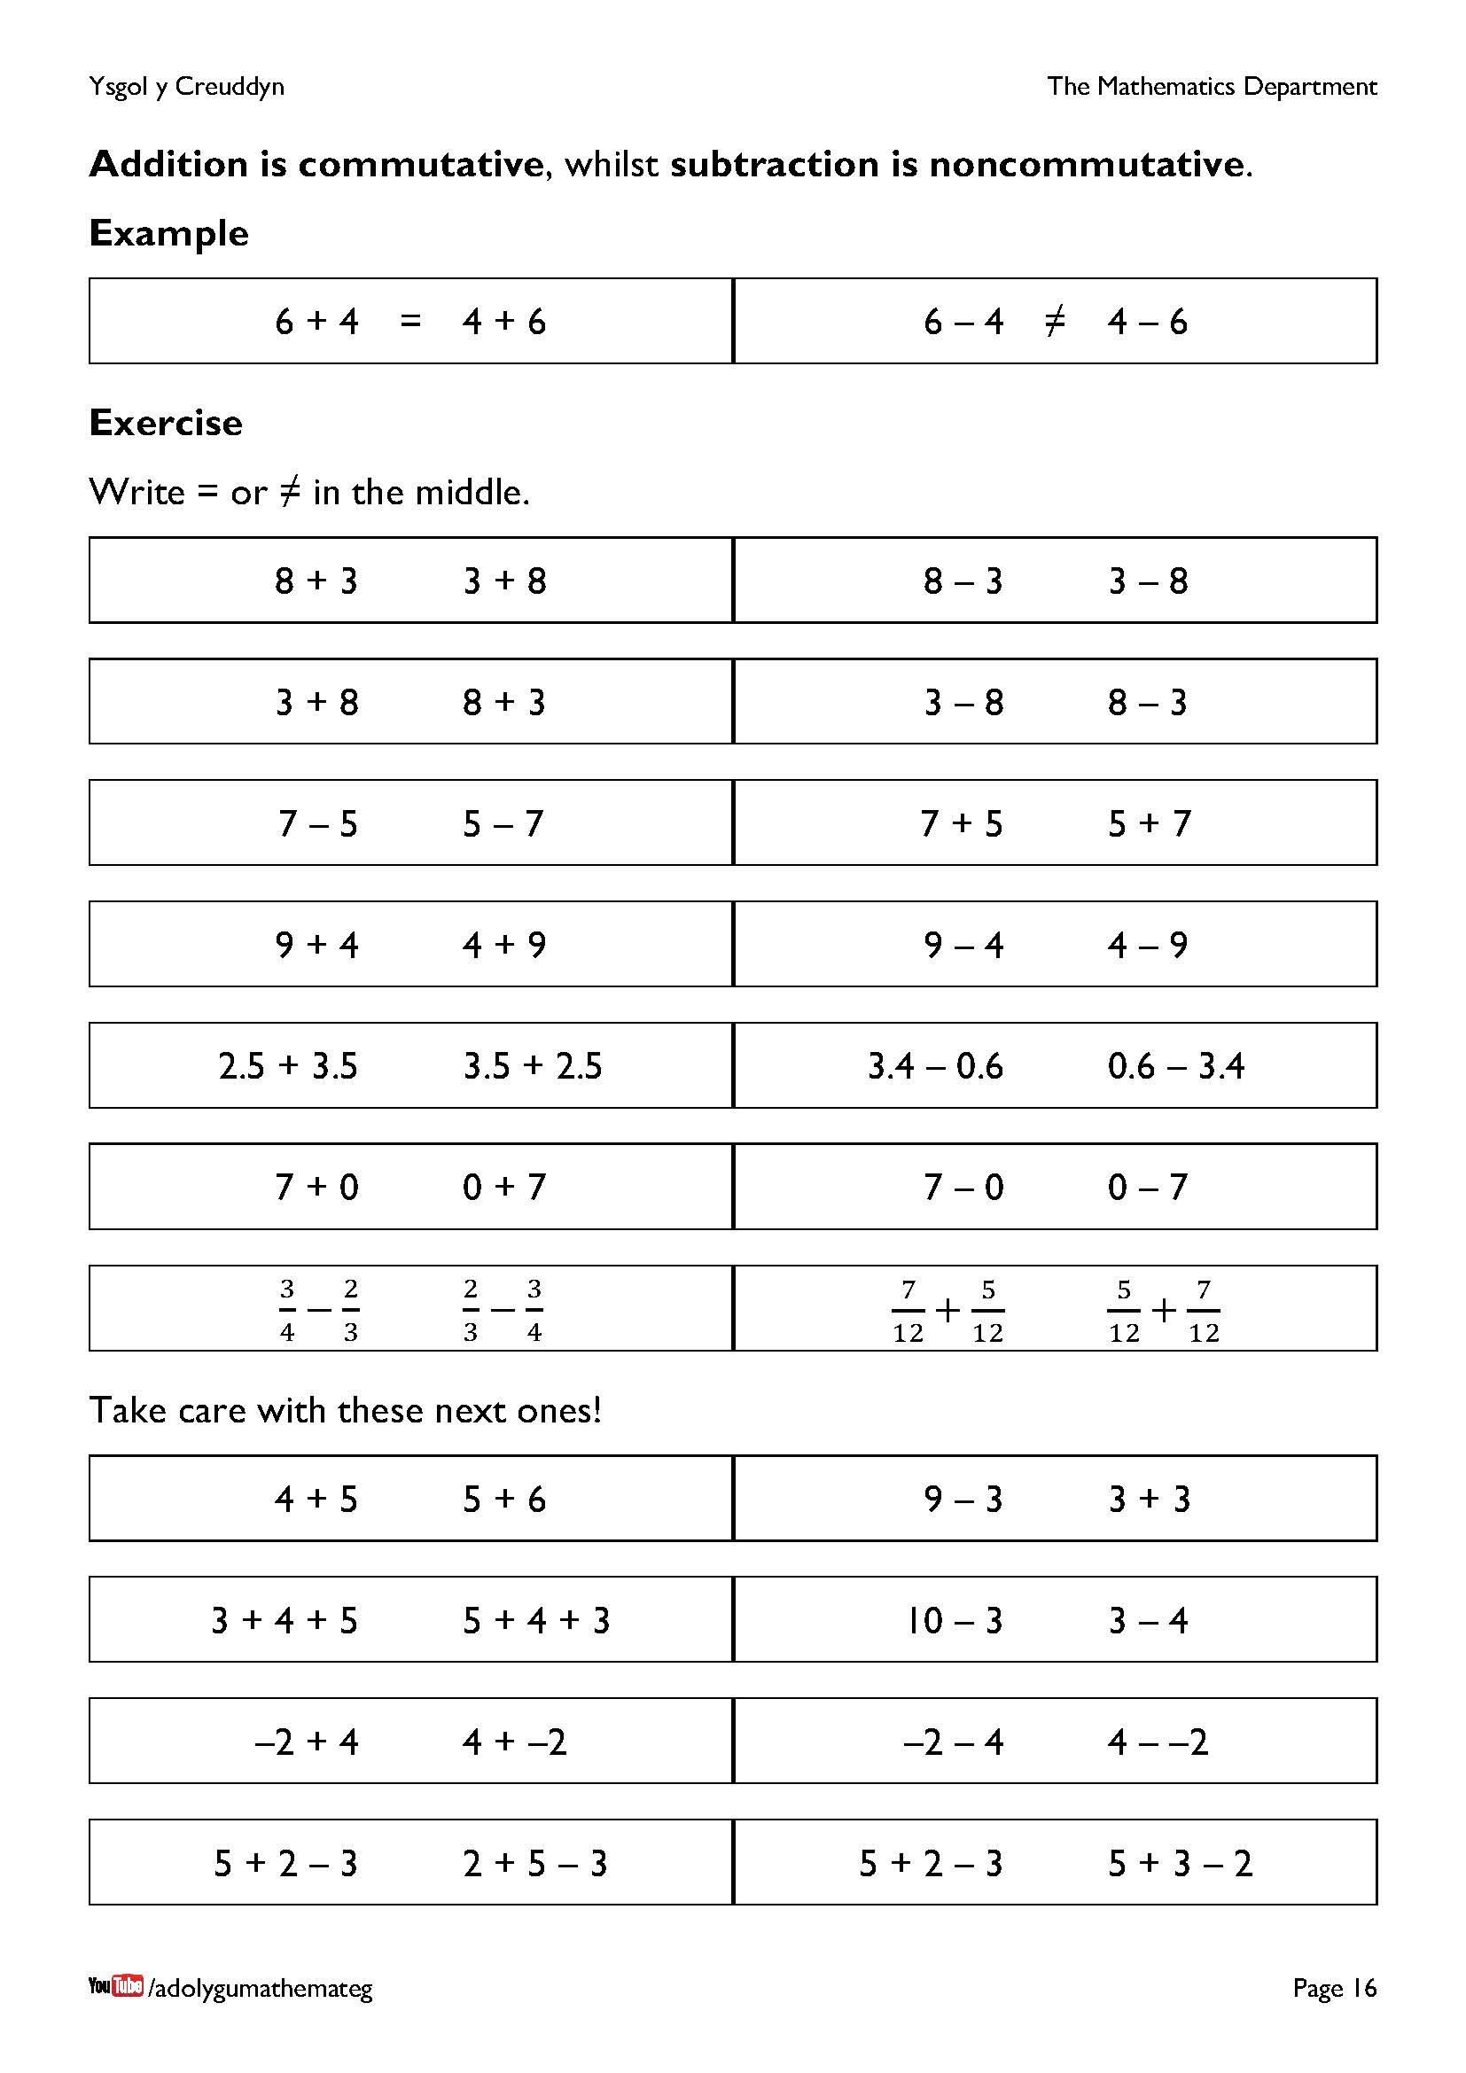
This exercise develops fluency in using commutativity.
- The first set of questions concentrates exclusively on reversing the order of the two numbers in the sum.
- The equality of the expressions needs to be considered in the second set of questions. Notice that the questions involving three numbers have been carefully chosen so that it does not matter in which order the sums are completed.

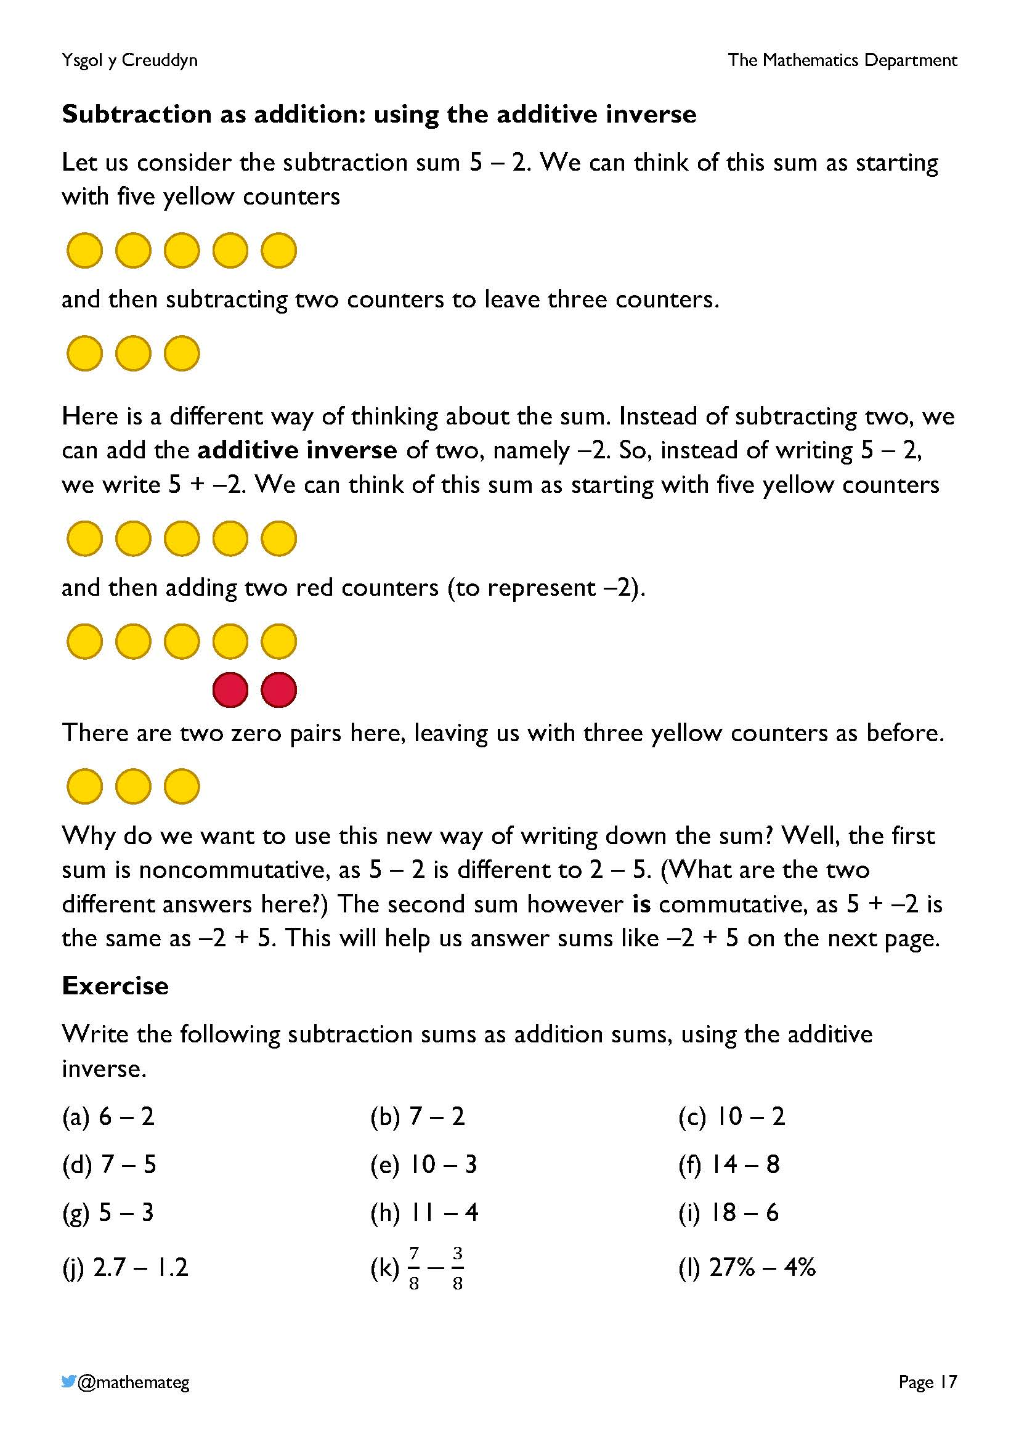
This page introduces the idea of the additive inverse, which allows any subtraction sum to be written as an addition sum.
The additive inverse of 1 is –1.
The additive inverse of 2 is –2.
The additive inverse of 3 is –3.
And so on...
Adding a number to its additive inverse always gives an answer of zero. For example,
1 + –1 = 0
2 + –2 = 0
3 + –3 = 0
The additive inverse will be used further on in this chapter to decide on the order of operations for addition and subtraction sums.
Take care when pronouncing the sum 5 + –2. The correct pronunciation is ‘five add negative two’, not ‘five add minus two’. (See the workbook Numbers: Diving Deeper for more information, or the document https://www.cambridgemaths.org/Images/espresso_15_introducing_negative_numbers.pdf.)

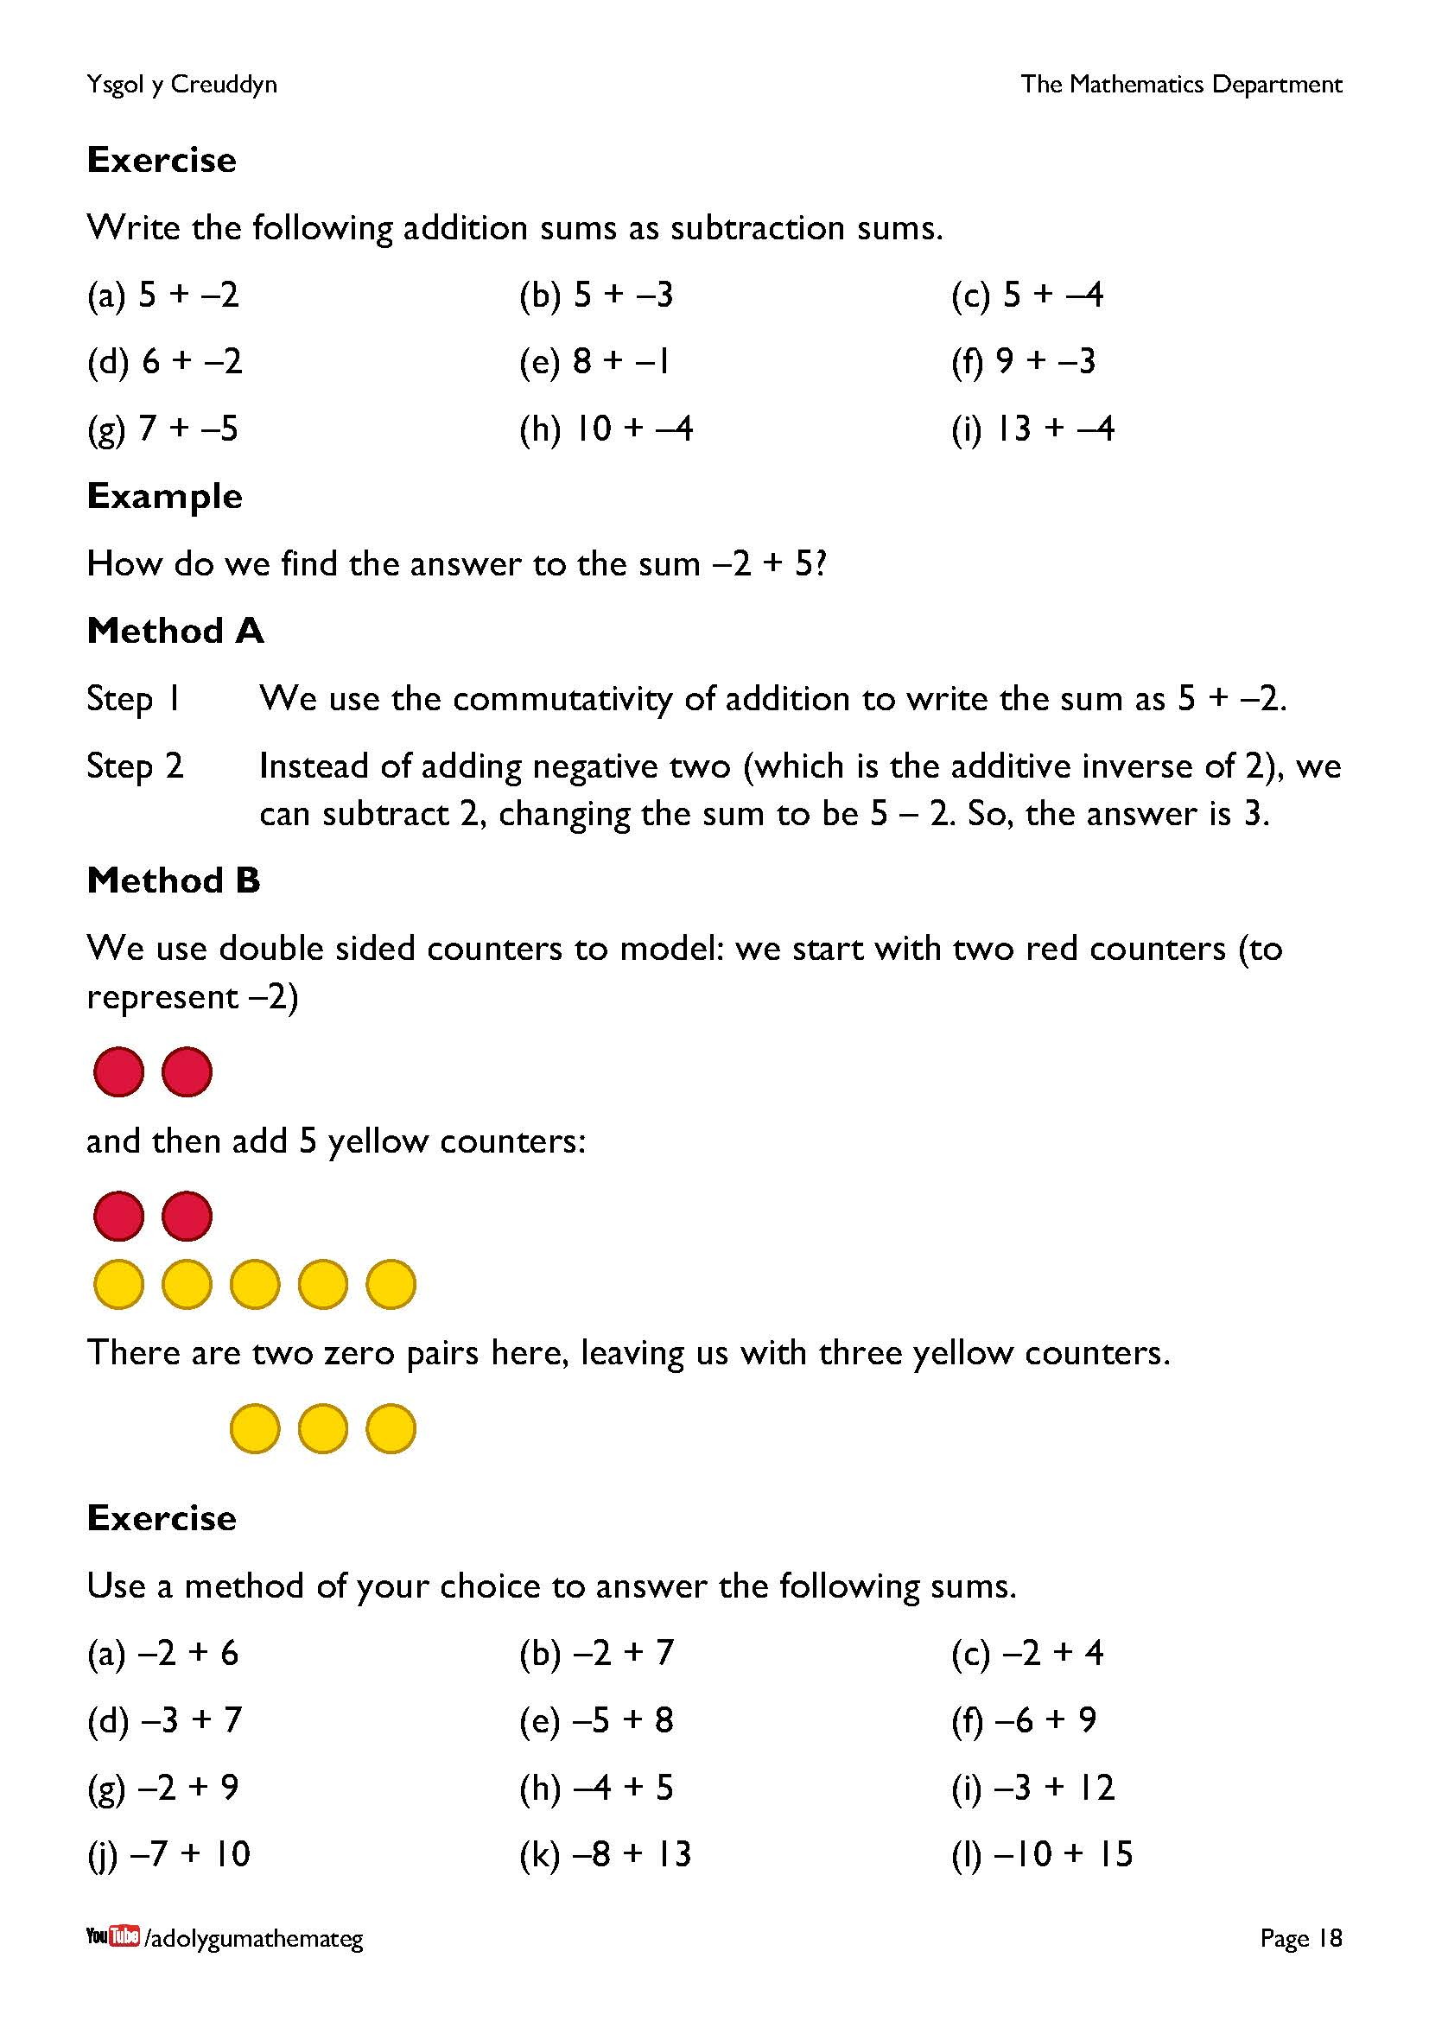
The exercise at the bottom of the page introduces a set of addition sums where we cross zero on the number line to go from the negative side to the positive side. Two methods for tacking these sums are given; “Method C” of using the number line to help would also be acceptable. (For –2 + 5, using the number line to help would mean locating –2 on the number line, and then moving 5 units in the positive direction to reach 3.)

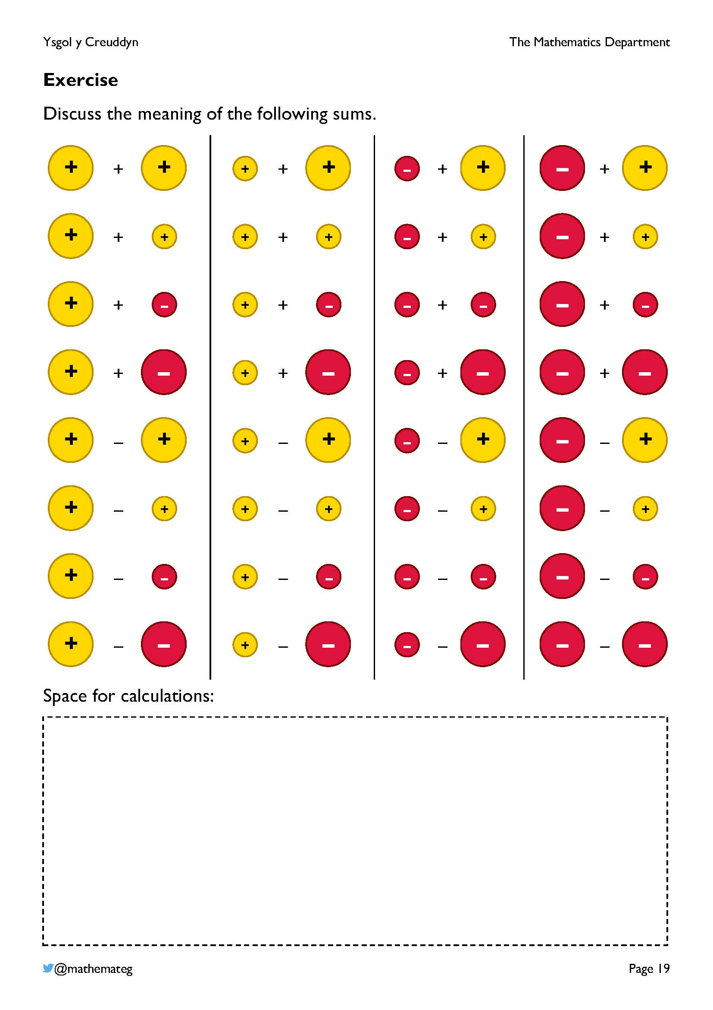
This task hopefully leads to some natural discussions amongst the learners.
Relative locations of the symbols on a number line:
–
–
+
+
0
The discussions should decide on the sign of each of the answers, in turn. Is the sign always positive, always negative, or is it impossible to conclude what the sign should be? Perhaps also some of the answers are zero, having decided that similar symbols have the same magnitude?
An example of possible sums for + :
–
+
–3 + 5 = 3 a positive answer
–3 + 3 = 0 zero
–3 + 1 = –2 a negative answer
So, it is impossible to conclude what the sign of the answer should be.
Acknowledgement: this task is based upon the work of Don Steward (https://donsteward.blogspot.com/2011/03/addingsubtracting-directed-numbers.html) and Chris McGrane (https://startingpointsmaths.com/2020/06/01/alternative-representation-of-integers/).
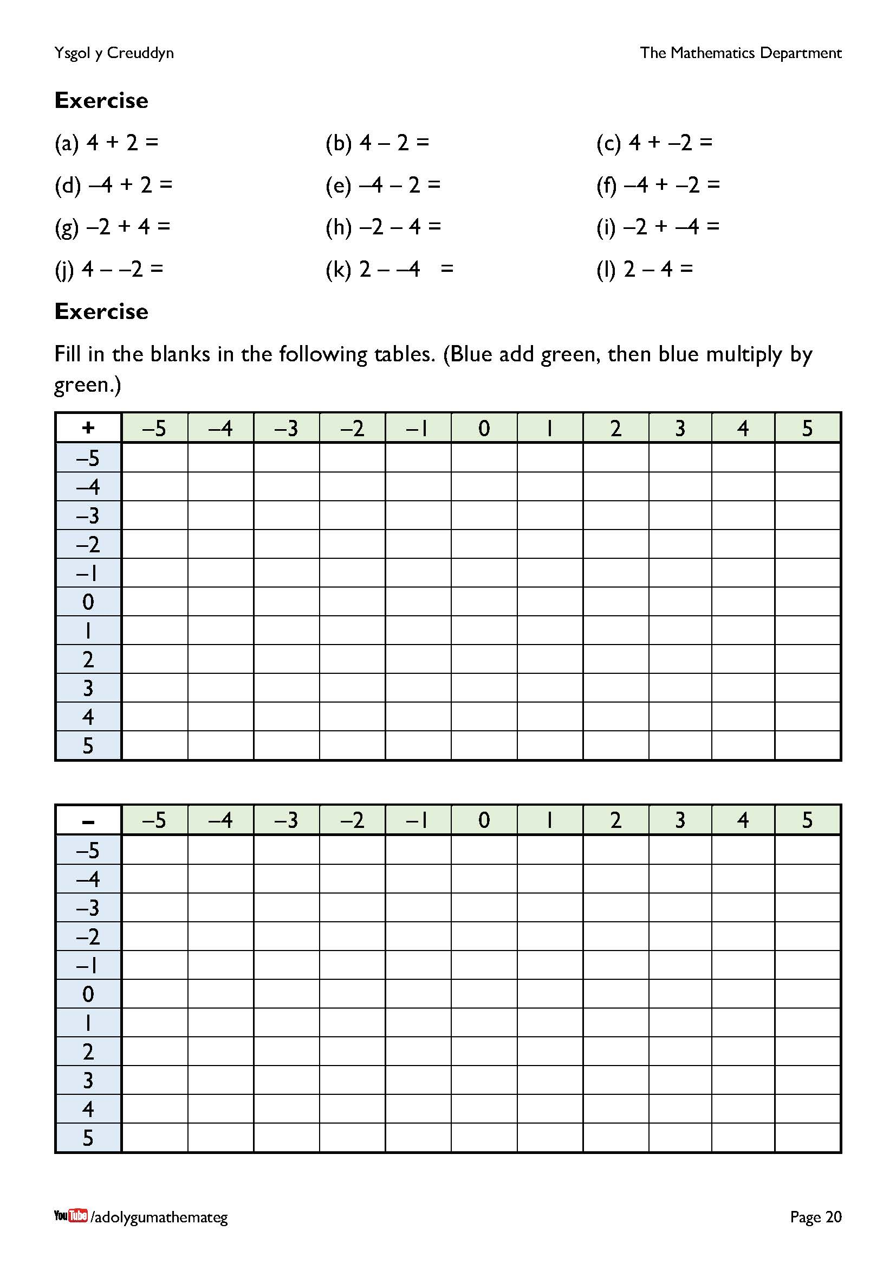
This exercise develops fluency in adding and subtracting directed numbers.
- The first exercise considers different combinations of the numbers 2 and 4. All the answers are either –6, –2, 2 or 6. (What about grouping the questions into ones that give these answers?)
- Patterns in the two tables should be recognised and used when filling in the blanks.

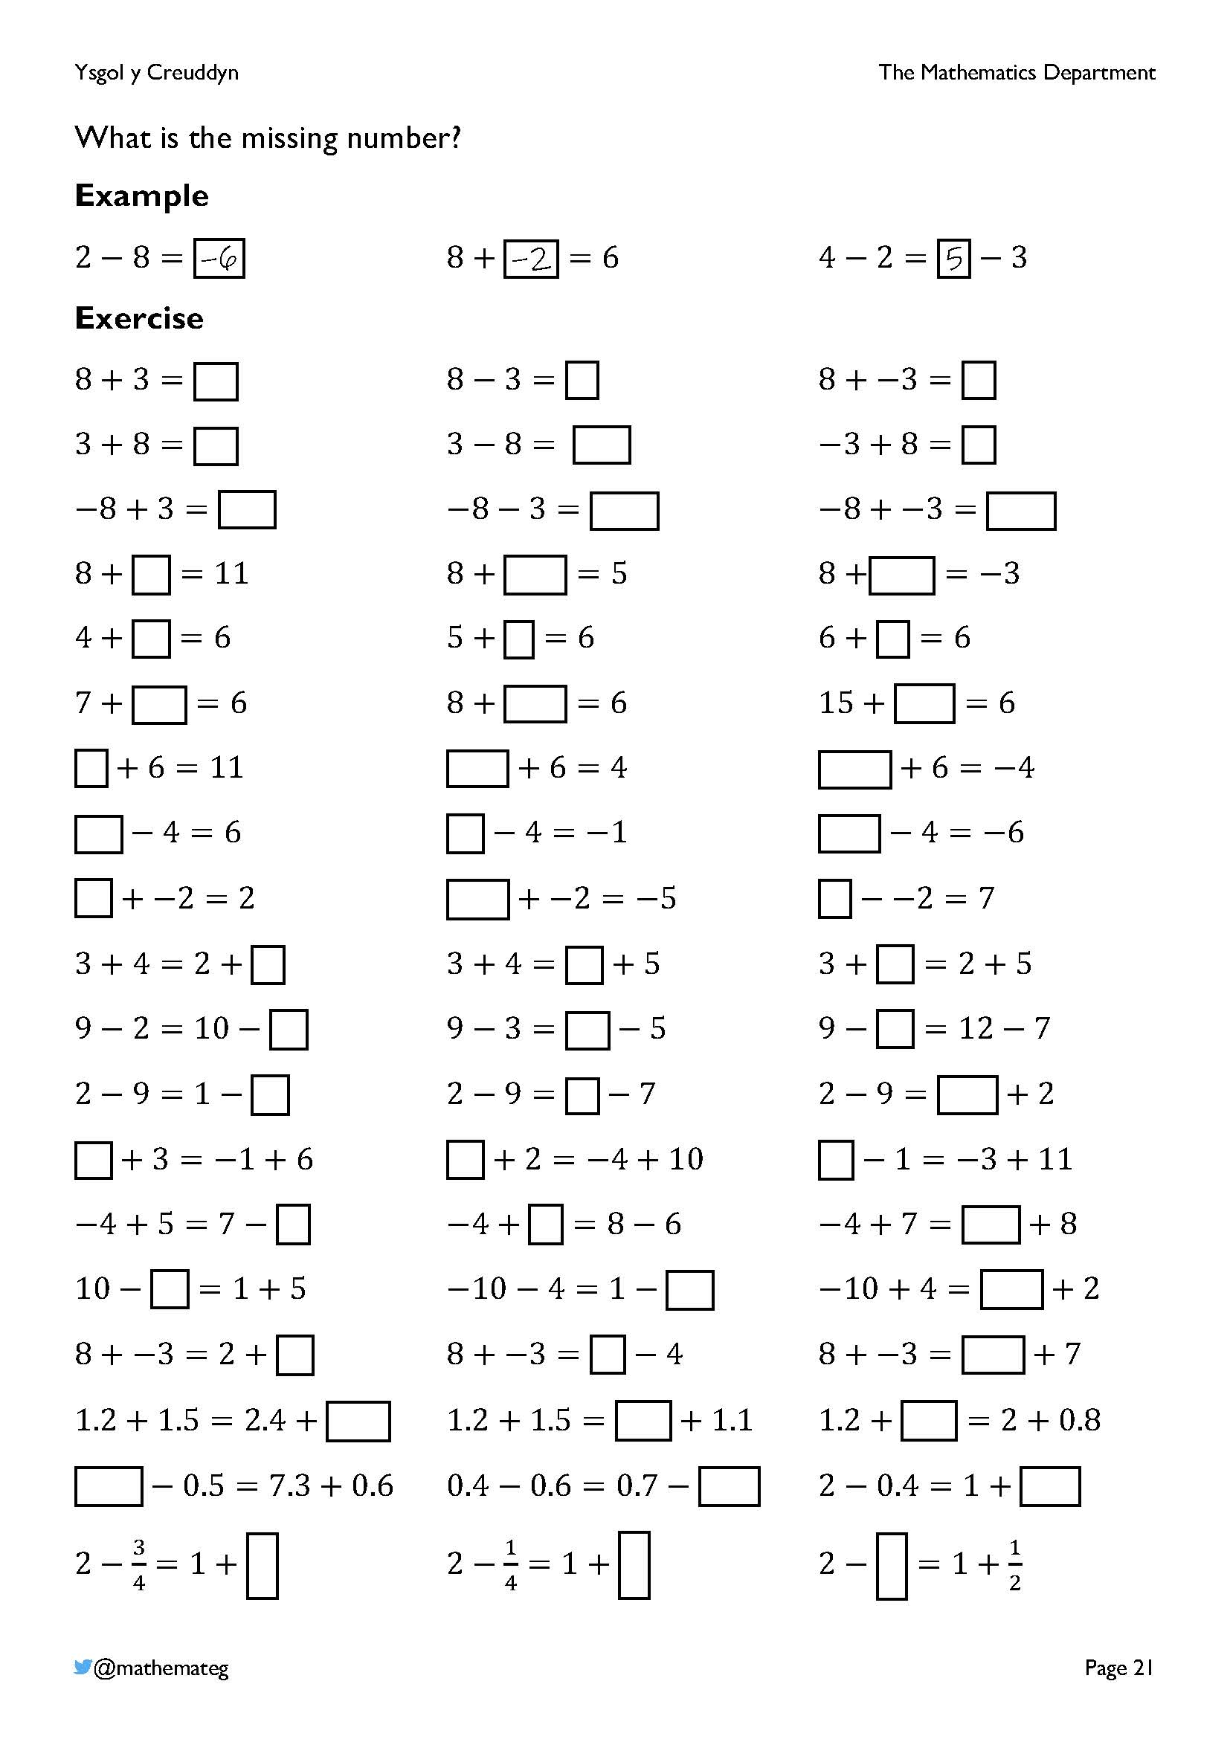
To complete this exercise, conceptual understanding of the equal sign is needed. Watch out for learners adding (or subtracting) all the numbers in a question to reach their answer. Model by using double sided counters if learners prove difficulty with a particular question.
Aspects of this exercise also touch on (and develop fluency in) the following description of learning for number (progression step 2):
CALCULATION
- I have explored additive relationships, using a range of representations. I can add and subtract whole numbers, using a variety of written and mental methods.

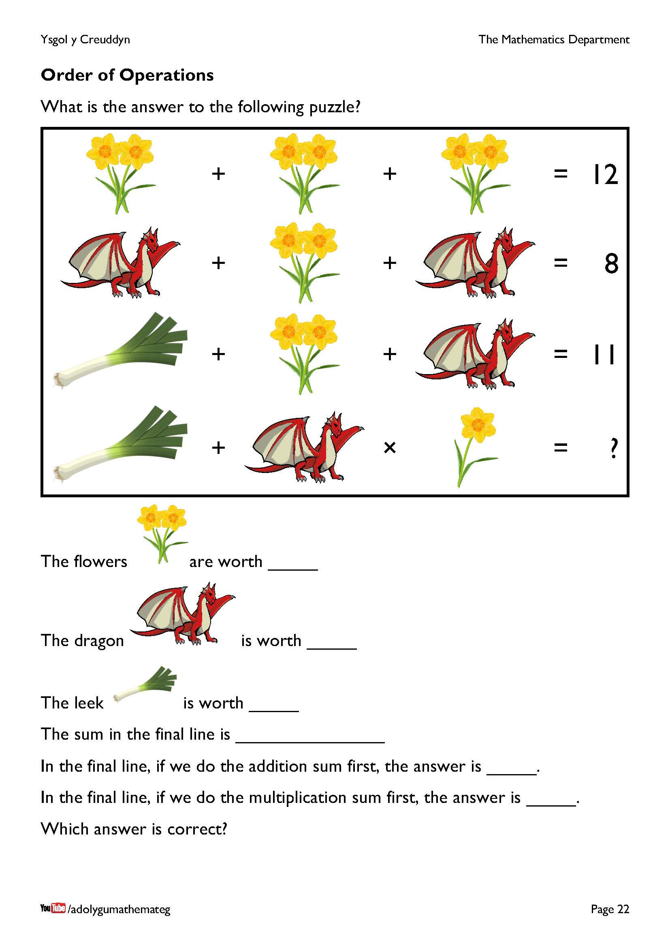
Reasoning is required here to decide on the value of each symbol in order to answer the puzzle. Watch out for the twist in the final row: one flower is shown, not two (so the sum for the final row is 5 + 2 × 2). I wonder if similar puzzles exist on the internet?...

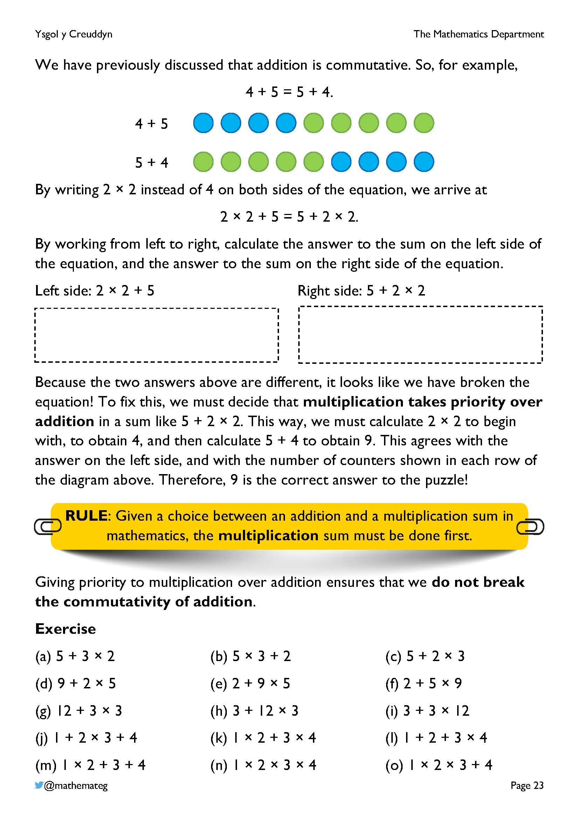
This page explains why multiplication takes priority over addition in mathematics.
- We start by accepting that the addition of numbers is commutative.
- Second, we must accept that 2 × 2 is equal to 4.
- If the sum 5 + 2 × 2 is to have an answer of 9, then we must choose multiplication to take priority over addition. (Otherwise, the answer to the sum would be 14, which is different to the intention at the top of the page.)
We should note here that the order of operations in mathematics is just a convention. Addition could have been chosen to take priority over multiplication, but then brackets would have had to be introduced in the sum 5 + 2 × 2, changing it to be 5 + (2 × 2). Further information about this, and on the order of operations in general, can be found on the blog https://www.mathemateg.com/mod/page/view.php?id=4162.

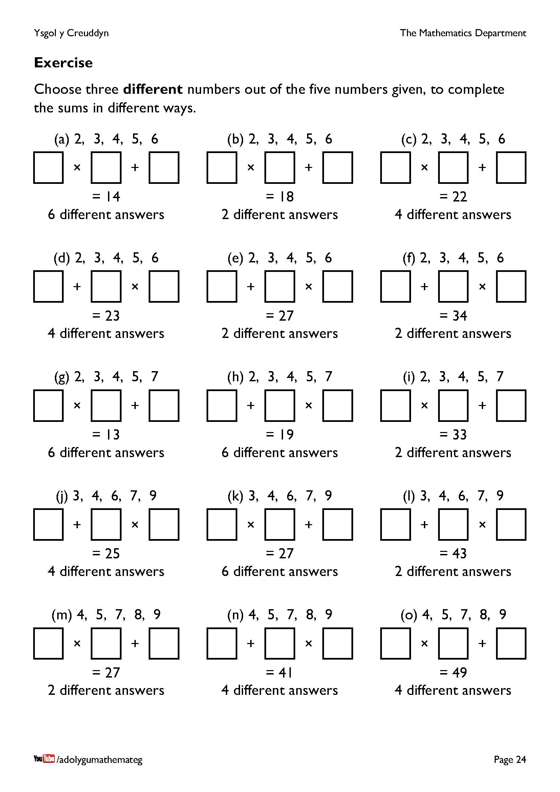
This page provides purposeful practice on multiplying and adding numbers together.
- Remember to consider the order of operations in questions where addition appears first.
- The answers appear in pairs. For example, on finding the answer 3 × 4 + 2 in question (a), by reversing the order of the numbers in the multiplication sum (using commutativity), another answer 4 × 3 + 2 appears.
Acknowledgement: this exercise is based upon one from the late Don Steward’s web site: https://donsteward.blogspot.com/2017/11/multiplication-problems.html
Answers:
(a) 2 × 4 + 6, 4 × 2 + 6, 2 × 5 + 4, 5 × 2 + 4, 3 × 4 + 2, 4 × 3 + 2.
(b) 3 × 4 + 6, 4 × 3 + 6.
(c) 3 × 6 + 4, 6 × 3 + 4, 4 × 5 + 2, 5 × 4 + 2.
(d) 3 + 4 × 5, 3 + 5 × 4, 5 + 3 × 6, 5 + 6 × 3.
(e) 3 + 4 × 6, 3 + 6 × 4
(f) 4 + 5 × 6, 4 + 6 × 5
(g) 2 × 3 + 7, 3 × 2 + 7, 2 × 4 + 5, 4 × 2 + 5, 2 × 5 + 3, 5 × 2 + 3.
(h) 4 + 3 × 5, 4 + 5 × 3, 5 + 2 × 7, 5 + 7 × 2, 7 + 3 × 4, 7 + 4 × 3.
(i) 4 × 7 + 5, 7 × 4 + 5.
(j) 4 + 3 × 7, 4 + 7 × 3, 7 + 3 × 6, 7 + 6 × 3.
(k) 3 × 6 + 9, 6 × 3 + 9, 3 × 7 + 6, 7 × 3 + 6, 4 × 6 + 3, 6 × 4 + 3.
(l) 7 + 4 × 9, 7 + 9 × 4.
(m) 4 × 5 + 7, 5 × 4 + 7.
(n) 5 + 4 × 9, 5 + 9 × 4, 9 + 4 × 8, 9 + 8 × 4.
(o) 5 × 8 + 9, 8 × 5 + 9, 5 × 9 + 4, 9 × 5 + 4.
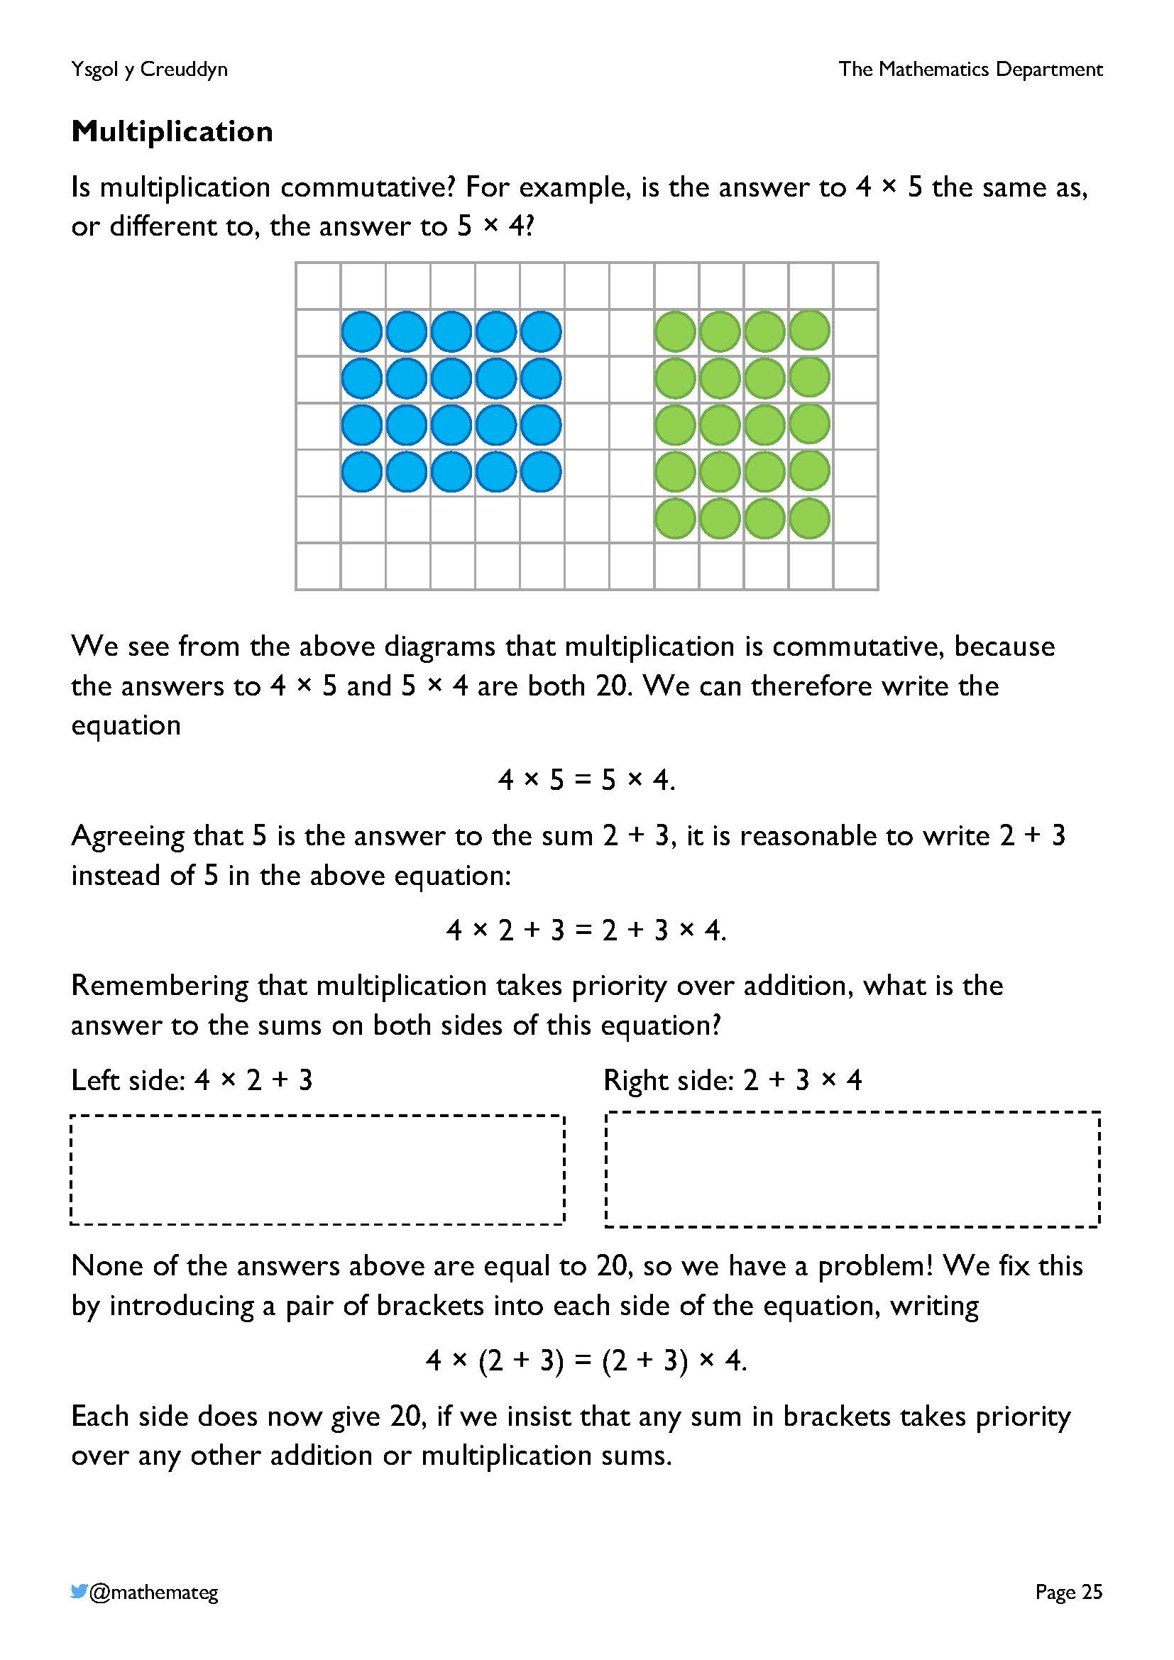
This page explains why brackets are used in mathematical sums to prioritise specific parts of the sum.
- We start by accepting that the multiplication of numbers is commutative.
- Second, we must accept that 2 + 3 is equal to 5.
- If the sums 4 × 2 + 3 and 2 + 3 × 4 are to have an answer of 20, then brackets must be introduced, to give 4 × (2 + 3) and (2 + 3) × 4, and sums in brackets need to be given priority. (Otherwise, the sums would have answers of 11 and 14, which is different to the intention at the top of the page.)

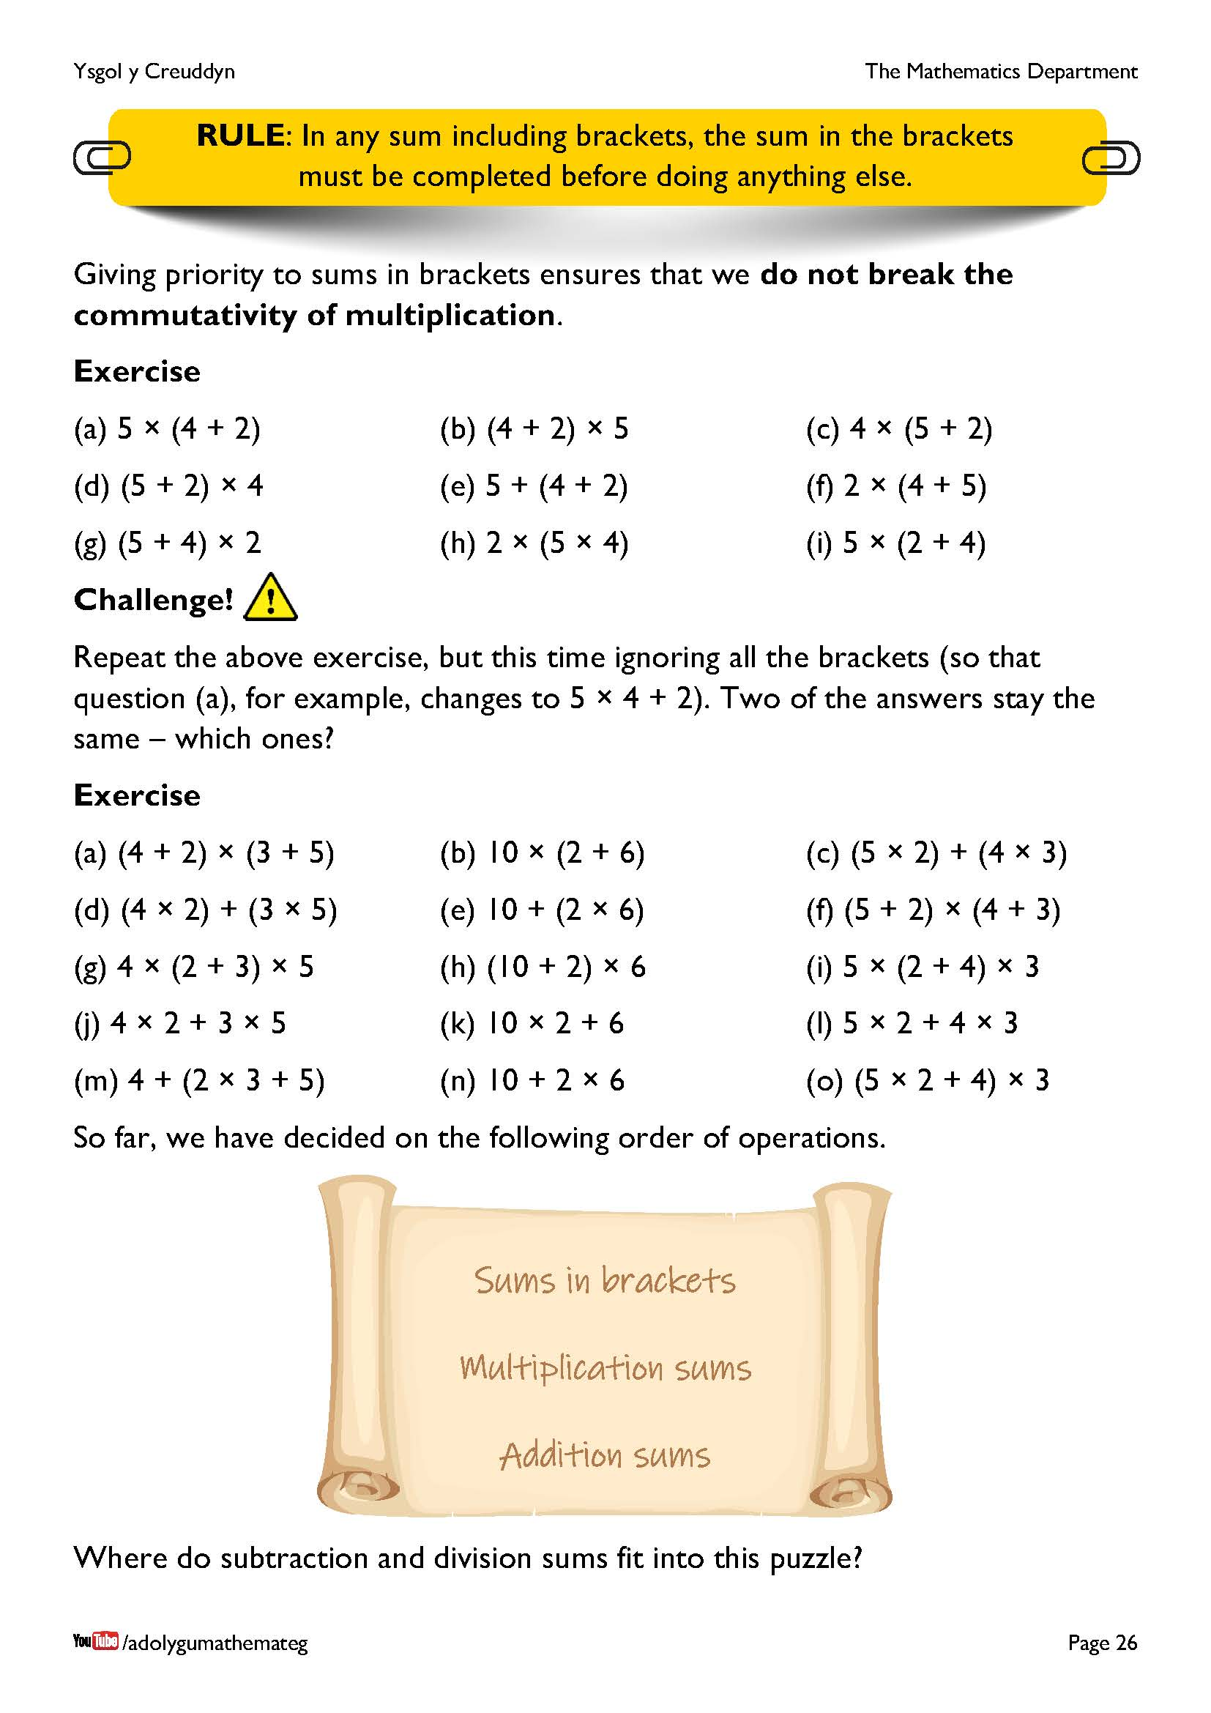
In the challenge, the answers to questions (e) and (h) stay the same, because it does not matter in which order the two sums in each question are completed. This hints at work to come in the final chapter, where we consider the associativity of addition and multiplication.
The scroll introduces our first list of how to prioritise operations in mathematics. At this current time, only brackets, multiplication and addition appear, as these are the only operations considered thus far in this section on the order of operations.
A final version will appear further on in this chapter.

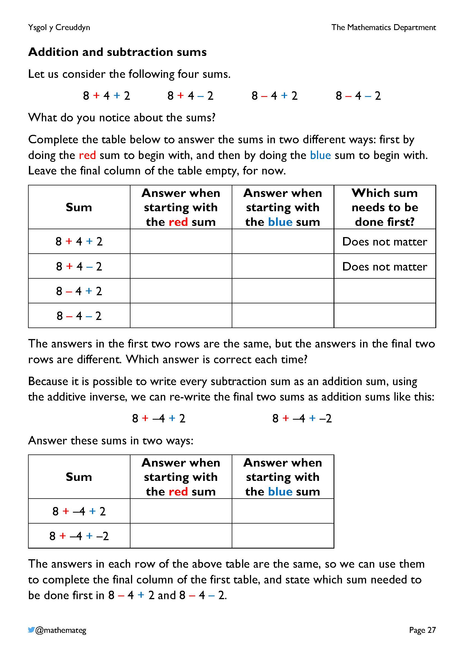
This page discusses why addition and subtraction sums must be completed from left to right in mathematics. For this purpose, we consider the four sums shown at the top of the page, where the numbers 8, 4 and 2 are used with every possible combination of addition and subtraction placed between them.
+, + +, – –, + –, –
With the first two sums in the first table, it does not matter in which order the sums are completed. The order is important however in the final two sums, so we re-write these sums using the additive inverse, to decide which answer is correct.
For 8 – 4 + 2, if we do the red sum first, the answer is 6, and if we do the blue sum first, the answer is 2. By re-writing the sum as
8 + –4 + 2, we see that an answer of 6 is calculated no matter which of the red or blue sums is completed first. This means that the red sum (the subtraction sum) is the one that must be completed first in the sum 8 – 4 + 2.
For 8 – 4 – 2, if we do the red sum first, the answer is 2, and if we do the blue sum first, the answer is 6. By re-writing the sum as
8 + –4 + –2, we see that an answer of 2 is calculated no matter which of the red or blue sums is completed first. This means that the red sum (the first subtraction sum) is the one that must be completed first in the sum 8 – 4 – 2.
All of the above means that working from left to right (completing the red sum first) ensures that any combination of addition or subtraction sums is completed correctly. This is the rule that is introduced on the next page.
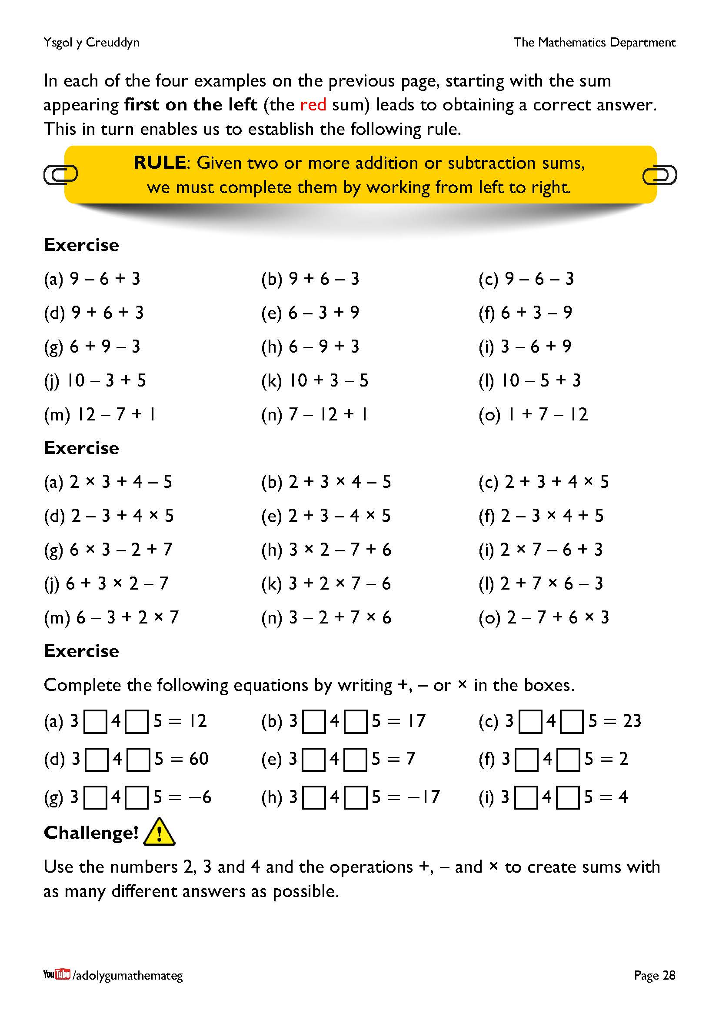
Technical note:
Often in materials on the order of operations, addition and subtraction are considered as being “on the same level”. This is not strictly true, as subtraction does take priority over addition. We saw this in the third sum on the previous page, 8 – 4 + 2. Here, if we complete the subtraction sum first, the correct answer is obtained, but if we complete the addition sum first, an incorrect answer appears. This means that addition and subtraction are not “on the same level” as there is not a free choice between completing the addition sum first or the subtraction sum first.
Why then does the rule not state “give priority to subtraction over addition”? The problem comes when we have two subtraction sums in the same sum, as in the sum 8 – 4 – 2. Here, we need to start by completing the first subtraction sum on the left (the red sum). It is therefore easier to talk about working from left to right, rather than prioritising subtraction over addition, and then having to deal with sums involving two subtraction sums. It is worth noting however that prioritising subtraction over addition would be a valid strategy. For example, consider the second sum on the previous page, 8 + 4 – 2. Here, we could start by completing the subtraction sum first (leading to 8 + 2 = 10), as well as following the usual strategy of working from left to right (12 – 2 = 10).

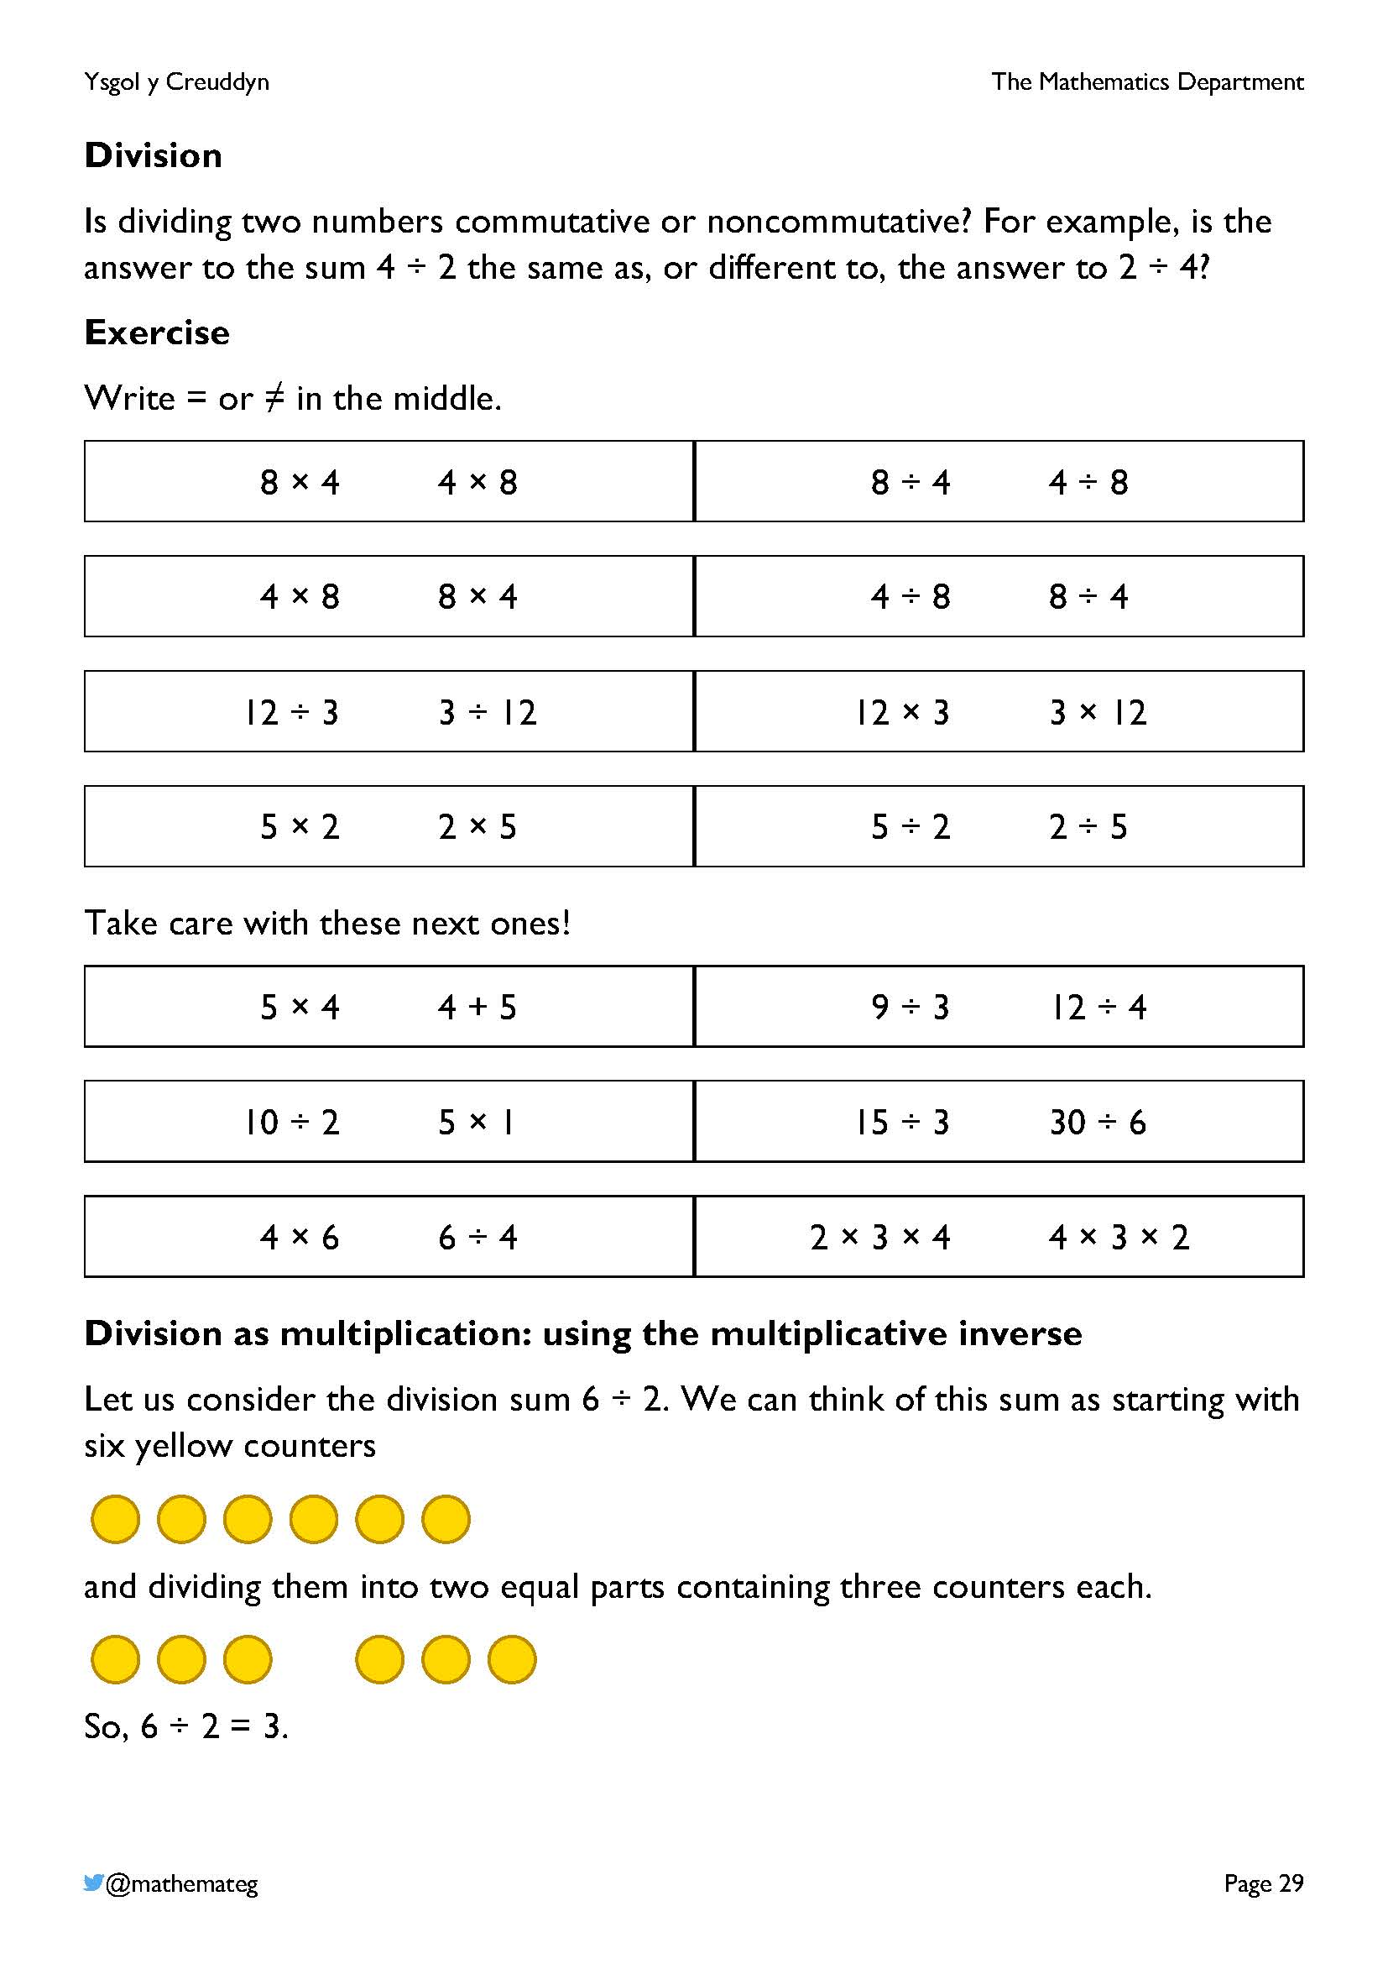
The division of two numbers is noncommutative. We can show this by considering the difference between the answers to the sums 4 ÷ 2 and 2 ÷ 4.
The first sum can be modelled by starting with four yellow counters
and dividing them into two equal parts containing two counters each.
So, 4 ÷ 2 = 2.
With the second sum, we start with two yellow counters
and divide them into four equal parts, shown by arranging four half counters separately in a row.
So, 2 ÷ 4 = $\frac{\text{1}}{\text{2}}$.
Because these two answers are different, it means that division is noncommutative.

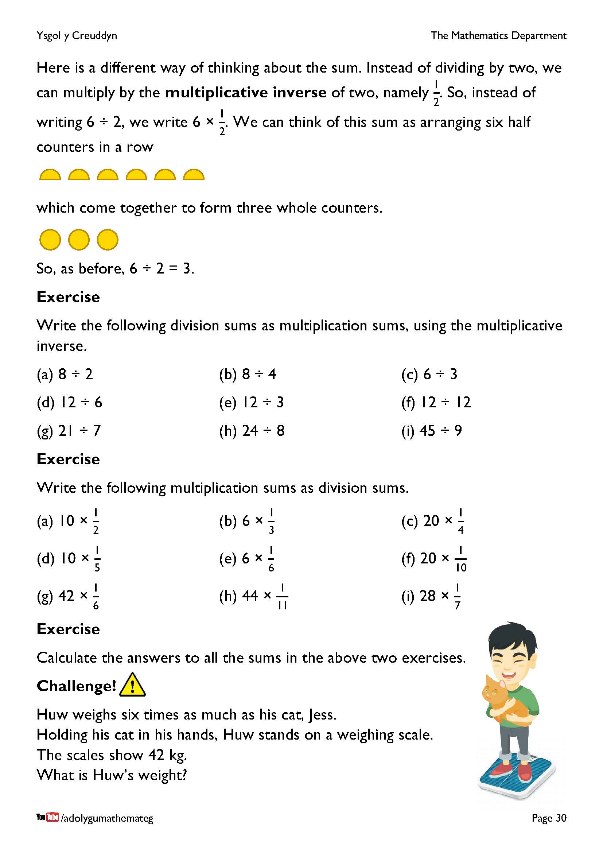
This page introduces the idea of the multiplicative inverse, which allows any division sum to be written as a multiplication sum.
The multiplicative inverse of 1 is $\frac{\text{1}}{\text{1}}$, or 1.
The multiplicative inverse of 2 is $\frac{\text{1}}{\text{2}}$.
The multiplicative inverse of 3 is $\frac{\text{1}}{\text{3}}$.
And so on...
Multiplying a number by its multiplicative inverse always gives an answer of one. For example,
1 × 1 = 1
2 × $\frac{\text{1}}{\text{2}}$ = 1
3 × $\frac{\text{1}}{\text{3}}$ = 1
The multiplicative inverse will be used further on in this chapter to decide on the order of operations for multiplication and division sums.
In the challenge, drawing a bar model to illustrate the situation would be a good idea.
42 kg

Jess
Huw
Each part of the bar model is worth 42 kg ÷ 7 = 6 kg, so that Huw’s weight is 6 kg × 6 = 36 kg.

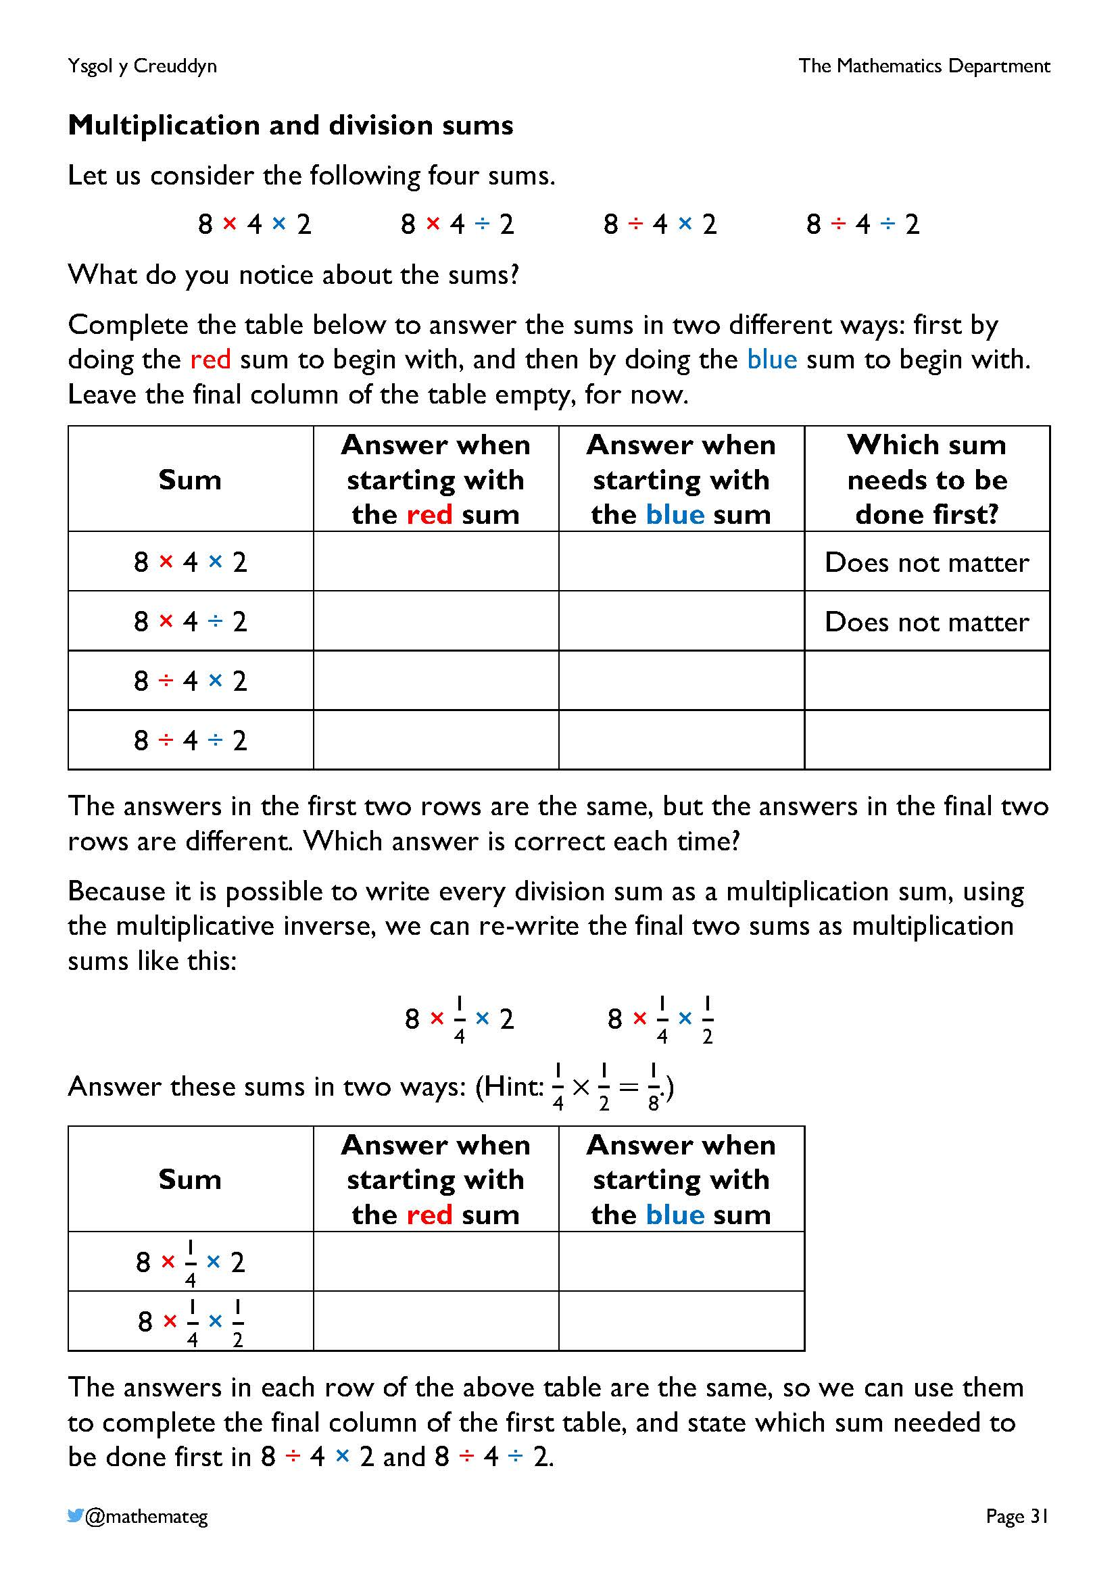
This page discusses why multiplication and division sums must be completed from left to right in mathematics. For this purpose, we consider the four sums shown at the top of the page, where the numbers 8, 4 and 2 are used with every possible combination of multiplication and division placed between them.
×, × ×, ÷ ÷, × ÷, ÷
With the first two sums in the first table, it does not matter in which order the sums are completed. The order is important however in the final two sums, so we re-write these sums using the multiplicative inverse, to decide which answer is correct.
For 8 ÷ 4 × 2, if we do the red sum first, the answer is 4, and if we do the blue sum first, the answer is 1. By re-writing the sum as
8 × $\frac{\text{1}}{\text{4}}$ × 2, we see that an answer of 4 is calculated no matter which of the red or blue sums is completed first. This means that the red sum (the division sum) is the one that must be completed first in the sum 8 ÷ 4 × 2.
For 8 ÷ 4 ÷ 2, if we do the red sum first, the answer is 1, and if we do the blue sum first, the answer is 4. By re-writing the sum as
8 × $\frac{\text{1}}{\text{4}}$ × $\frac{\text{1}}{\text{2}}$, we see that an answer of 1 is calculated no matter which of the red or blue sums is completed first. This means that the red sum (the first division sum) is the one that must be completed first in the sum 8 ÷ 4 ÷ 2.
All of the above means that working from left to right (completing the red sum first) ensures that any combination of multiplication or division sums is completed correctly. This is the rule that is introduced on the next page.

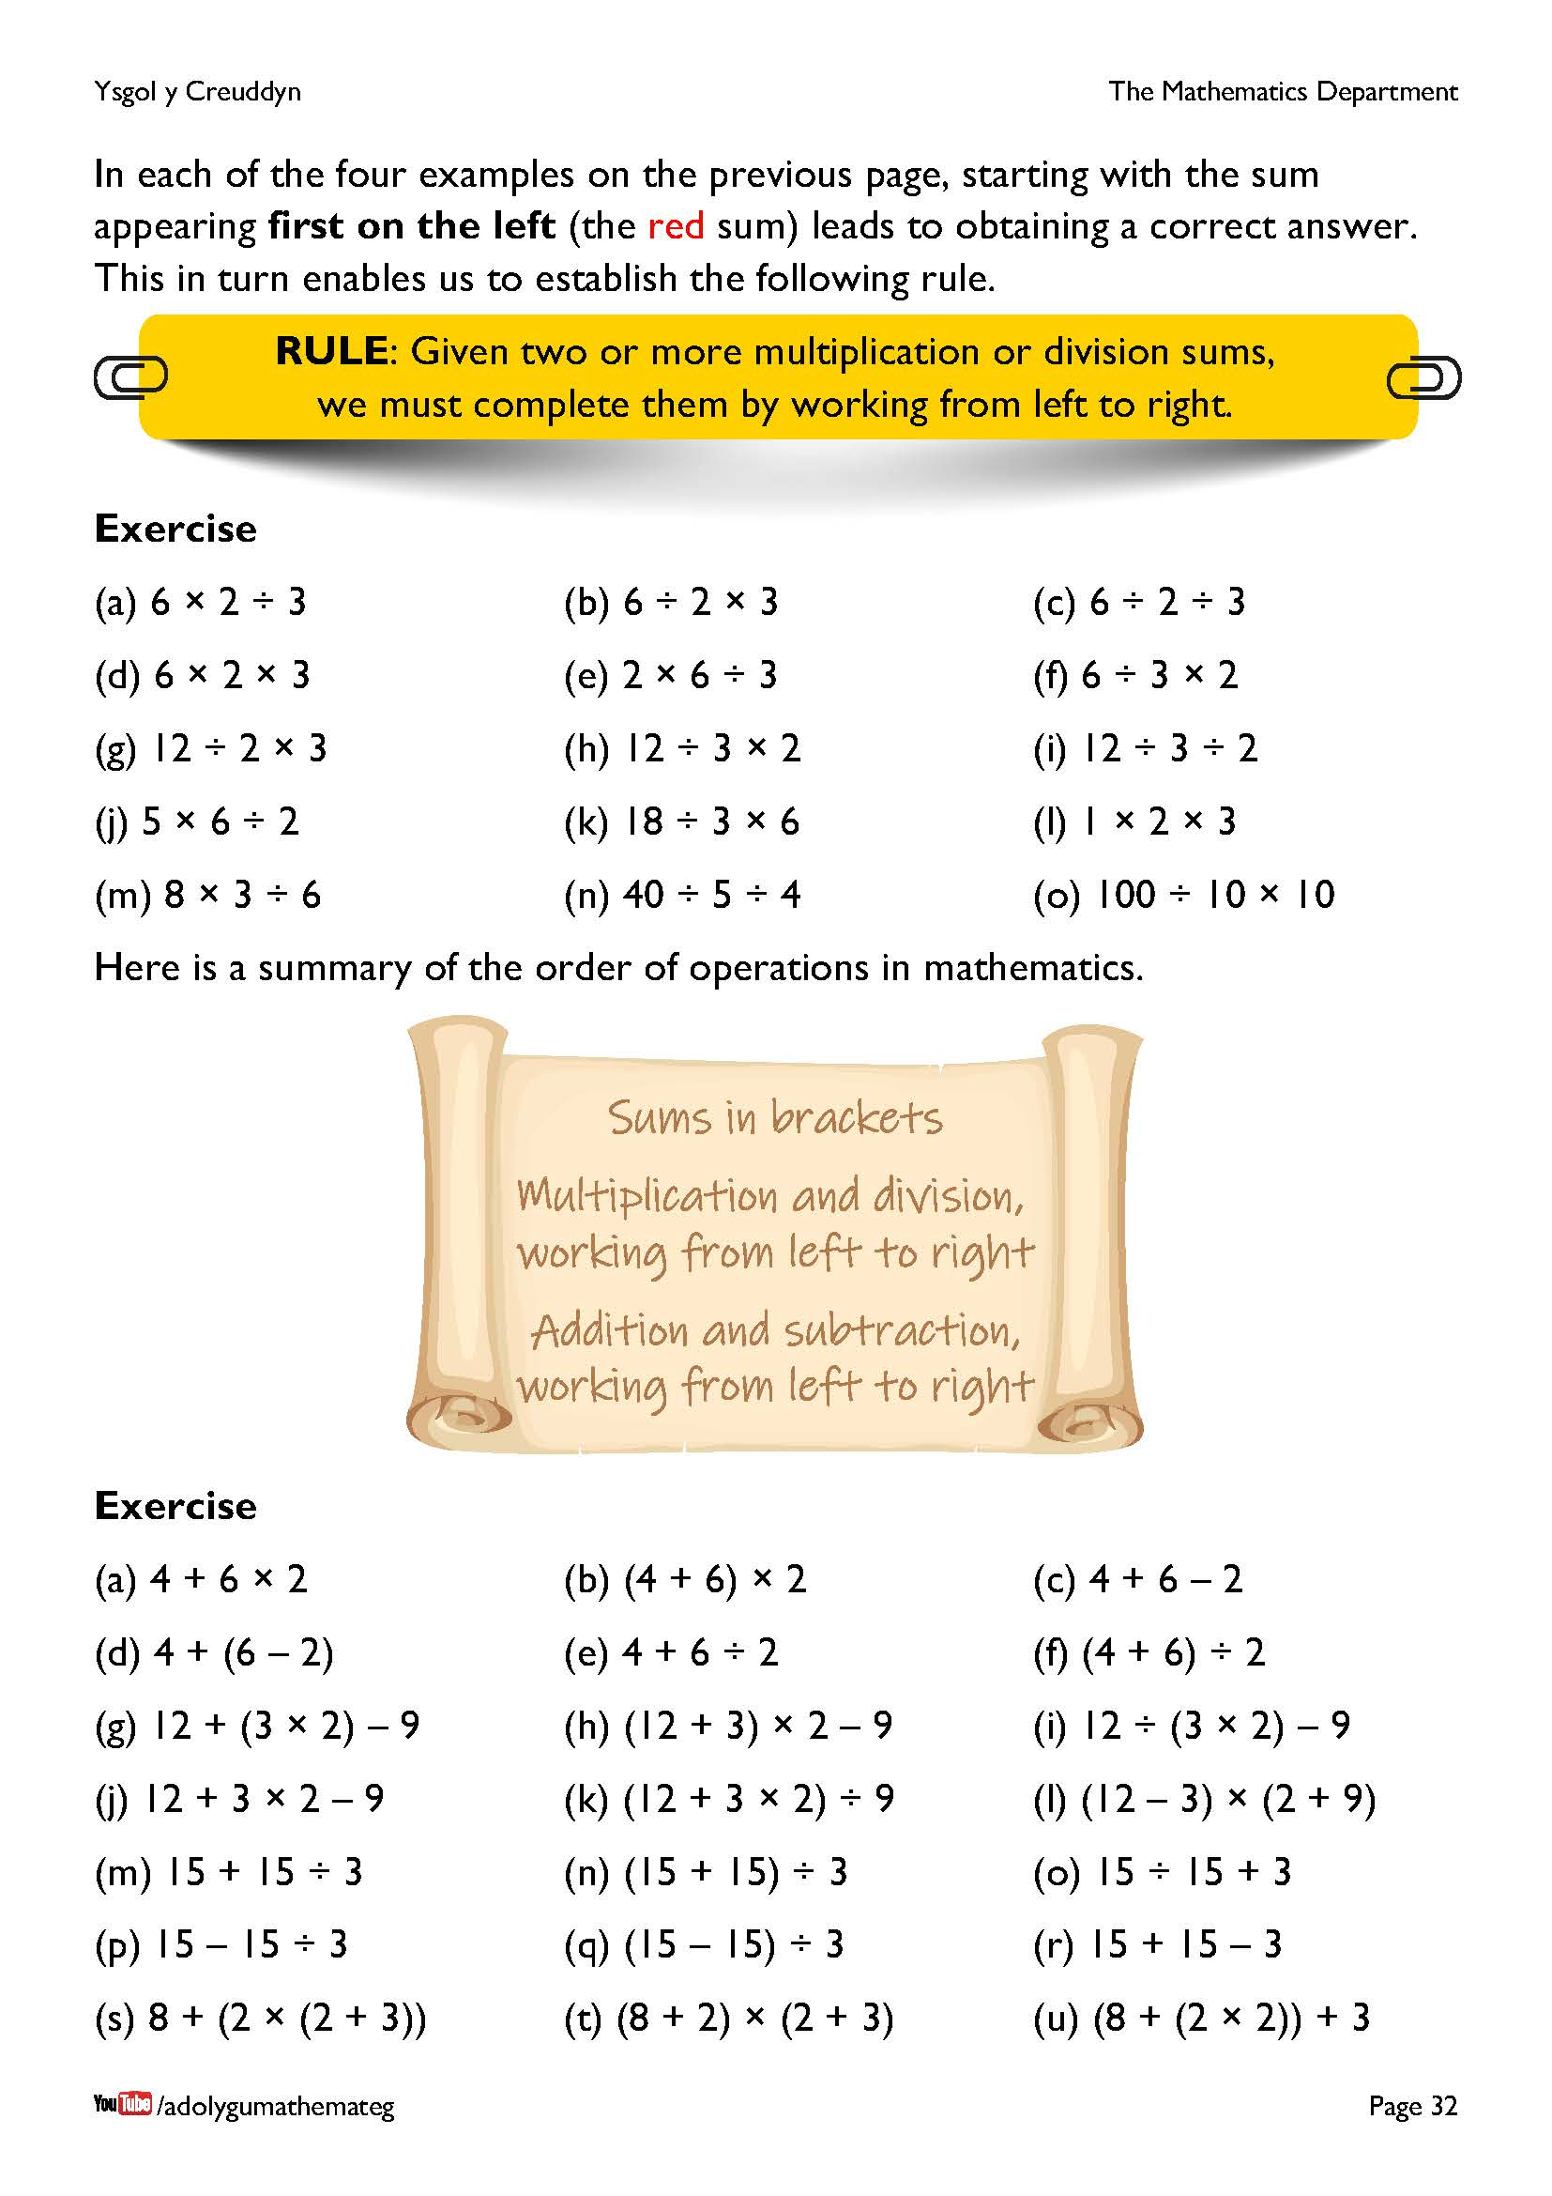
You have no doubt noticed the similarity between the previous page and the earlier material on addition and subtraction sums. This was intentional (with the numbers 8, 4 and 2 chosen carefully) to be able to see the connections between the two sections. The previous technical note could also be modified to note that multiplication and division are not “on the same level” (as is often stated), but that division takes priority over multiplication.
The scroll on the page presents our final list (in this workbook) for the order of operations in mathematics. Notice that we do not use an acronym (such as BODMAS) to describe the order, preferring instead to develop conceptual understanding of the order. See the following blog for a further discussion on using acronyms: https://jemmaths.wordpress.com/2018/12/06/thoughts-on-the-order-of-operations/
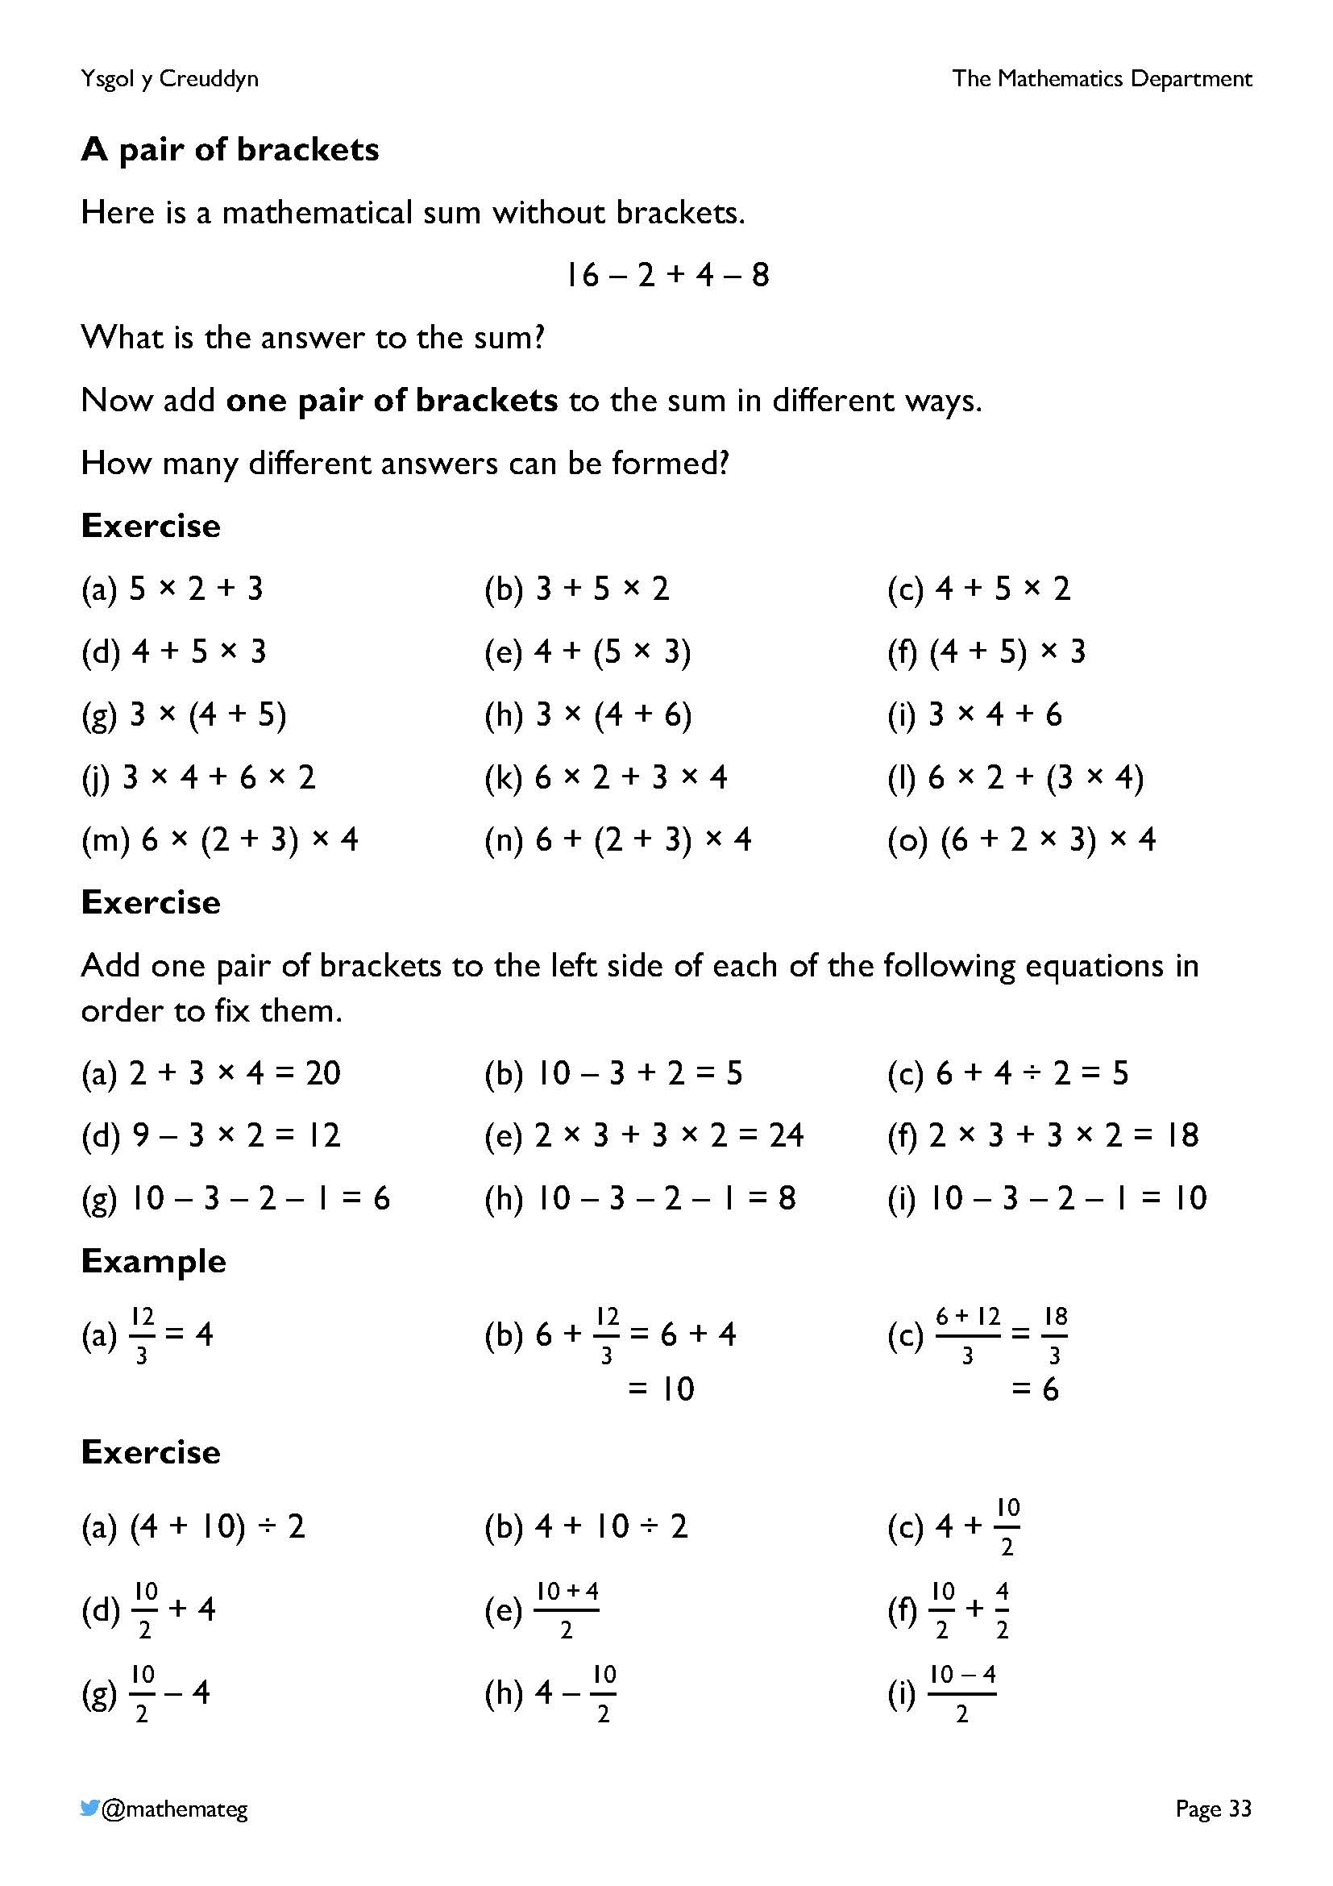
These exercises develop fluency in using the order of operations. Some of the questions are based upon exercises found on Craig Barton’s website, https://variationtheory.com/category/number/order-of-operations-bidmas/, where the questions have been carefully designed to promote discussions based upon the connection between one question and the next.
(a) 5 × 2 + 3
(b) 3 + 5 × 2 Using the commutativity of addition
(c) 4 + 5 × 2 Changing the 3 to be a 4
(d) 4 + 5 × 3 Changing the 2 to be a 3
(e) 4 + (5 × 3) Introducing brackets
(f) (4 + 5) × 3 Changing the location of the brackets
(g) 3 × (4 + 5) Using the commutativity of multiplication
and so on...
The final exercise introduces fraction notation to take the place of division sums. Brackets are implied by some of these questions, for example without using fraction notation $\frac{10+4}{2}$ would need to be written as (10 + 4) ÷ 2.

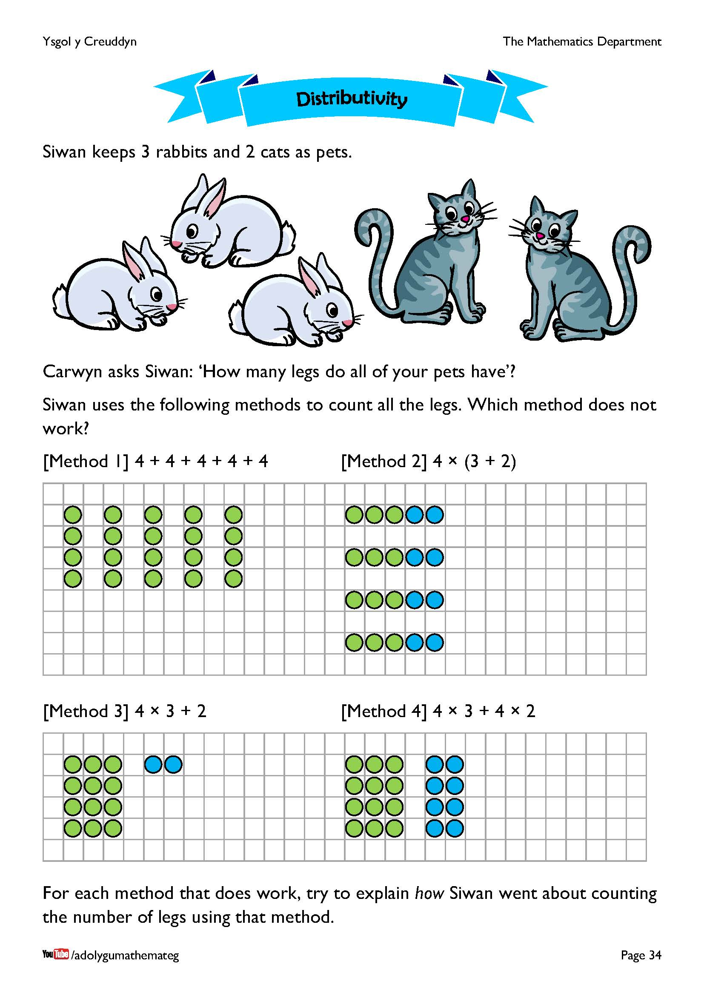
In formal algebra, the distributivity of multiplication over addition is written like this:
$a×\left(b+c\right)=a×b+a×c$.
(There is no need to discuss this formal algebra with learners.)
In the pets example, methods 1, 2 and 4 are valid.
- Method 1 treats each pet separately, counting the legs in fours.
- Method 2 counts how many pets there are in total, before multiplying by 4.
- Method 4 treats the rabbits and cats separately, counting the number of legs for the rabbits, the number of legs for the cats, and then adding them together.
Method 3 emphasises the need to include brackets in Method 2, as otherwise the order of operations means that an incorrect answer is obtained.

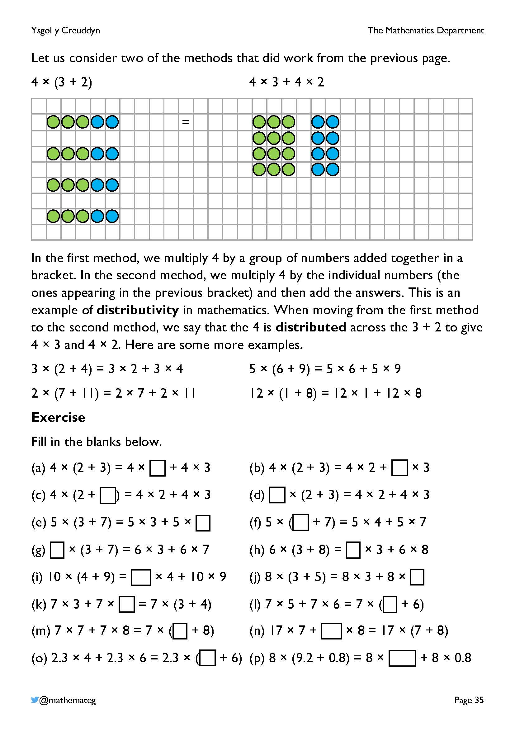
This page continues the example from the previous page to explain the meaning of distributivity in mathematics.
It should be verified that the two sums 4 × (3 + 2) and
4 × 3 + 4 × 2 have the same answer, either by calculating the answer to the sums directly or by counting the counters.
The exercise encourages learners to see the patterns that are formed when using distributivity.

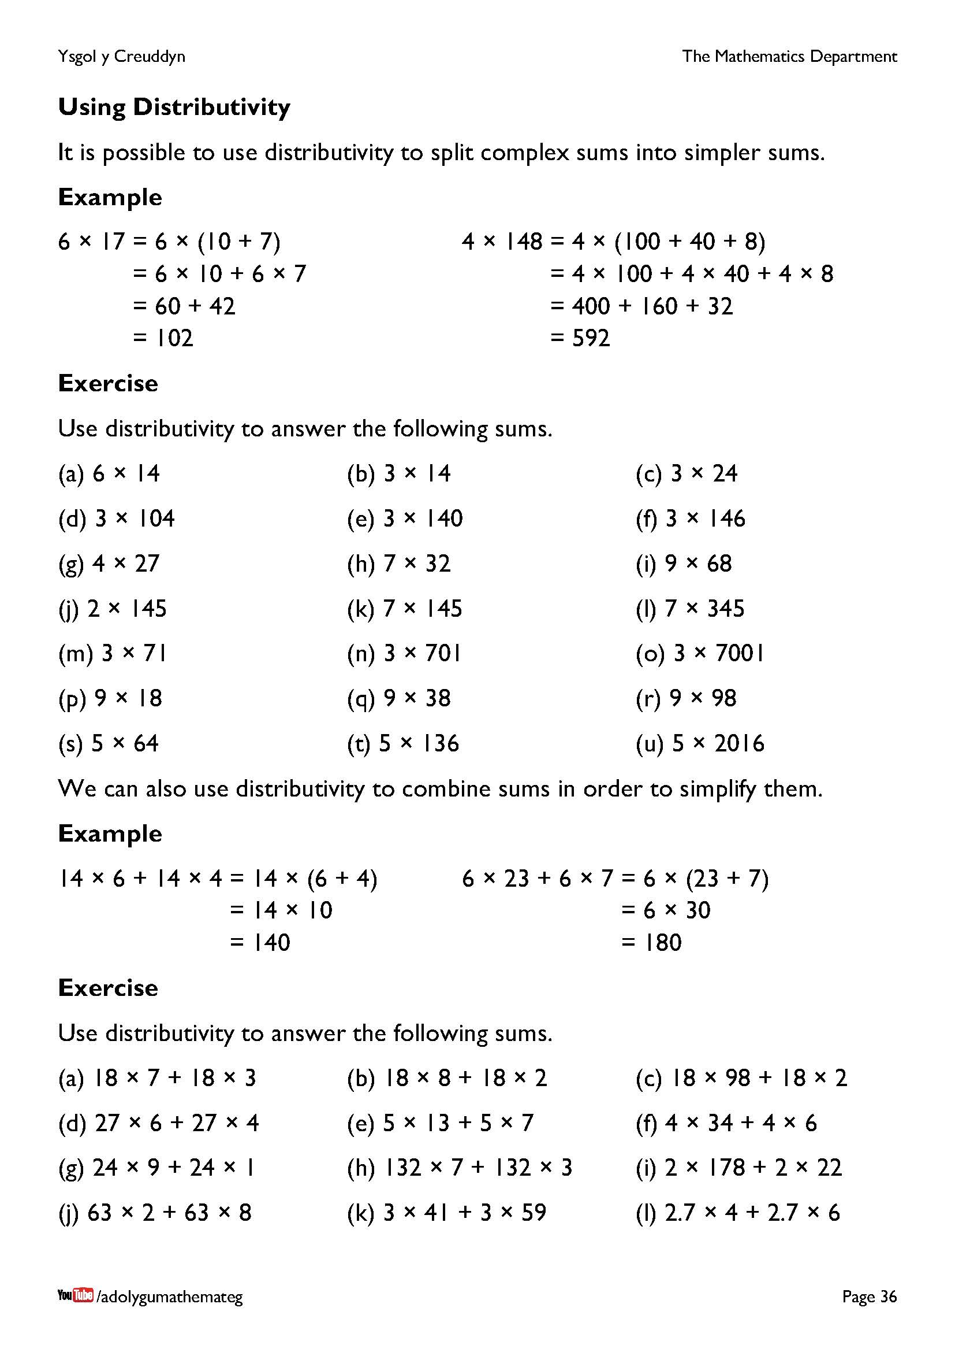
A calculator should not be used to complete the exercises on this page. Perhaps it would be appropriate, before starting, to discuss the connection between the following two multiplication tables, and similar ones.
1 × 4 = 4 10 × 4 = 40
2 × 4 = 8 20 × 4 = 80
3 × 4 = 12 30 × 4 = 120
4 × 4 = 16 40 × 4 = 160
5 × 4 = 20 50 × 4 = 200
6 × 4 = 24 60 × 4 = 240
7 × 4 = 28 70 × 4 = 280
8 × 4 = 32 80 × 4 = 320
9 × 4 = 36 90 × 4 = 360
10 × 4 = 40 100 × 4 = 400

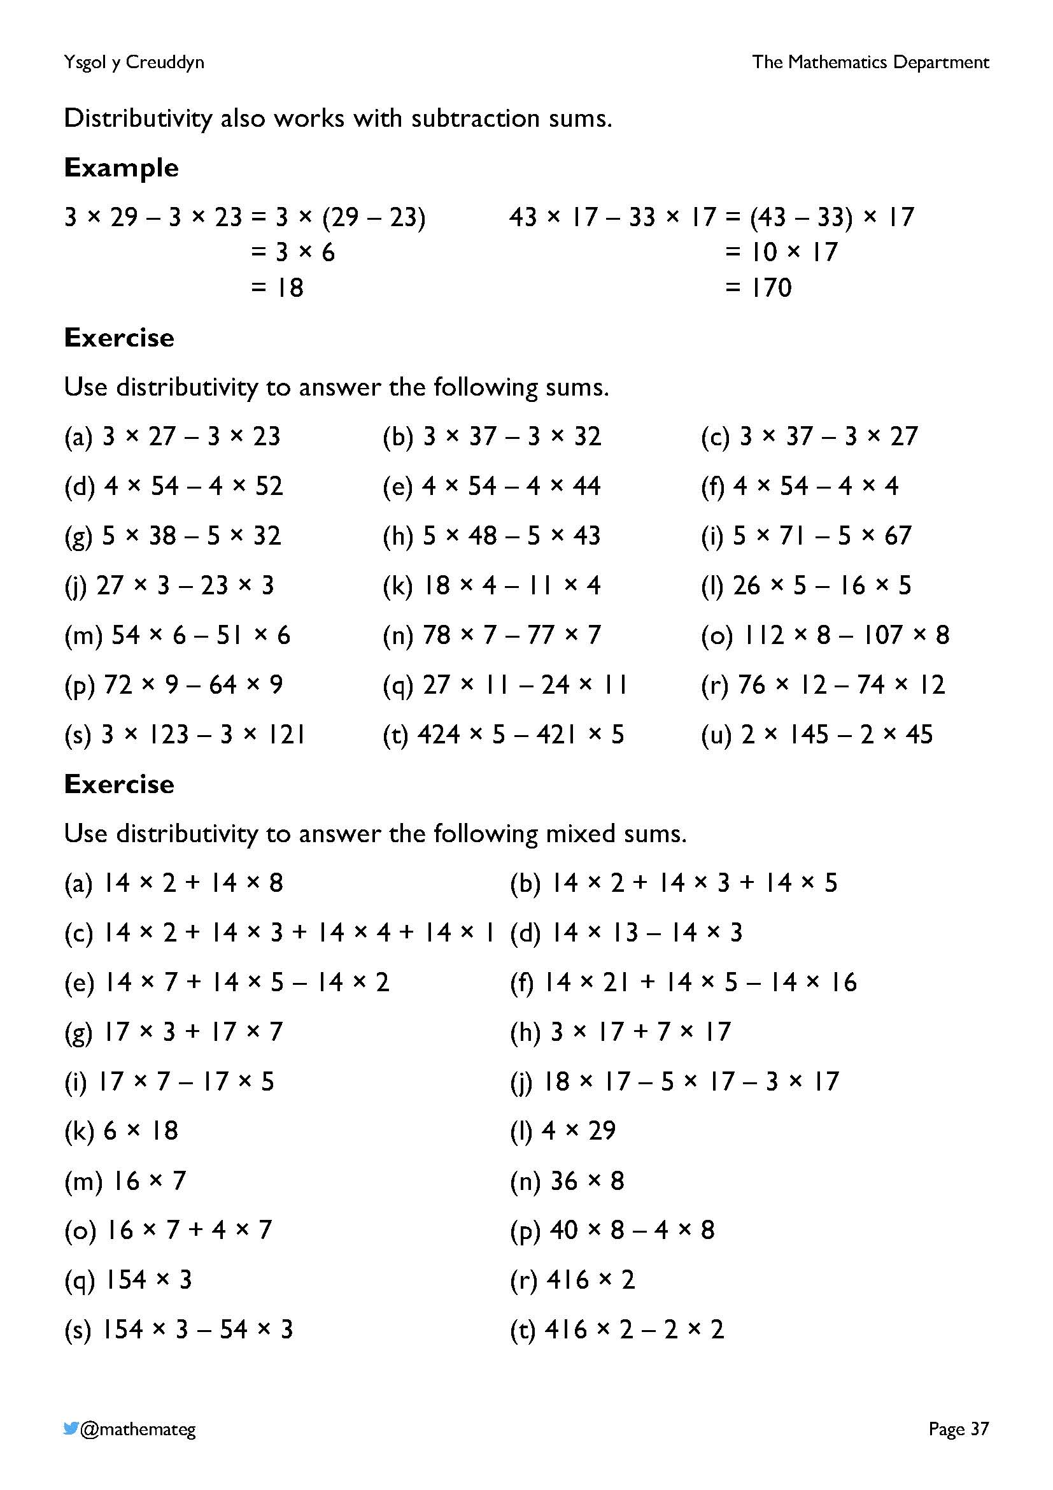
Note the subtle difference between the two examples: the first example uses
$$a×b-a×c=a×(b-c)$$
whilst the second example utilises
$b×a-c×a=(b-c)×a$.
This is an example of using the commutativity of multiplication:
$a×\left(b-c\right)=(b-c)×a$.
Introducing subtraction sums leads to the possibility of considering different strategies of answering the questions. For example, in question (l) of the final exercise, what is the most efficient way of finding the answer: using
4 × (20 + 9)
or
4 × (30 – 1)?
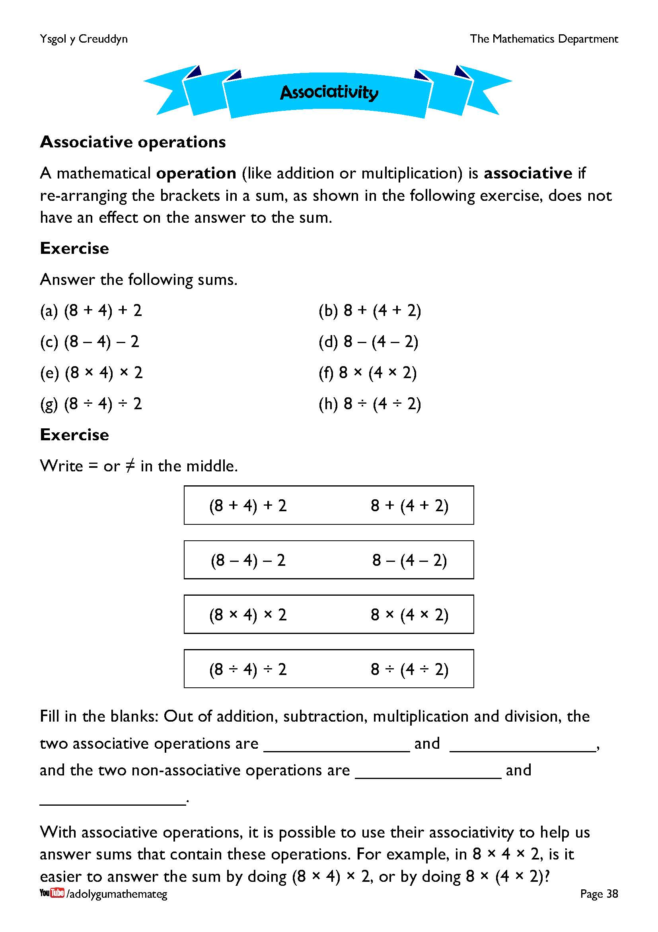
In formal algebra, a general operation * is associative if
$$\left(a*b\right)*c=a*(b*c)$$
for any values $a$, $b$ and $c$. (There is no need to discuss this formal algebra with learners.) The exercises lead learners to notice that addition and multiplication are associative, whilst subtraction and division are non-associative. Further information is available on the website https://www.mathsisfun.com/associative-commutative-distributive.html.
Addition, subtraction, multiplication and division are examples of operations in mathematics. The addition operation (for example) takes two numbers, the inputs of the operation, and adds them together to give the output of the operation.
For the discussion at the bottom of the page, perhaps some learners will argue that 32 × 2 is easier to calculate than 8 × 8, and others will argue the other way. The key point is that two different methods of calculating the same answer are available, and there is freedom to choose which one to complete.

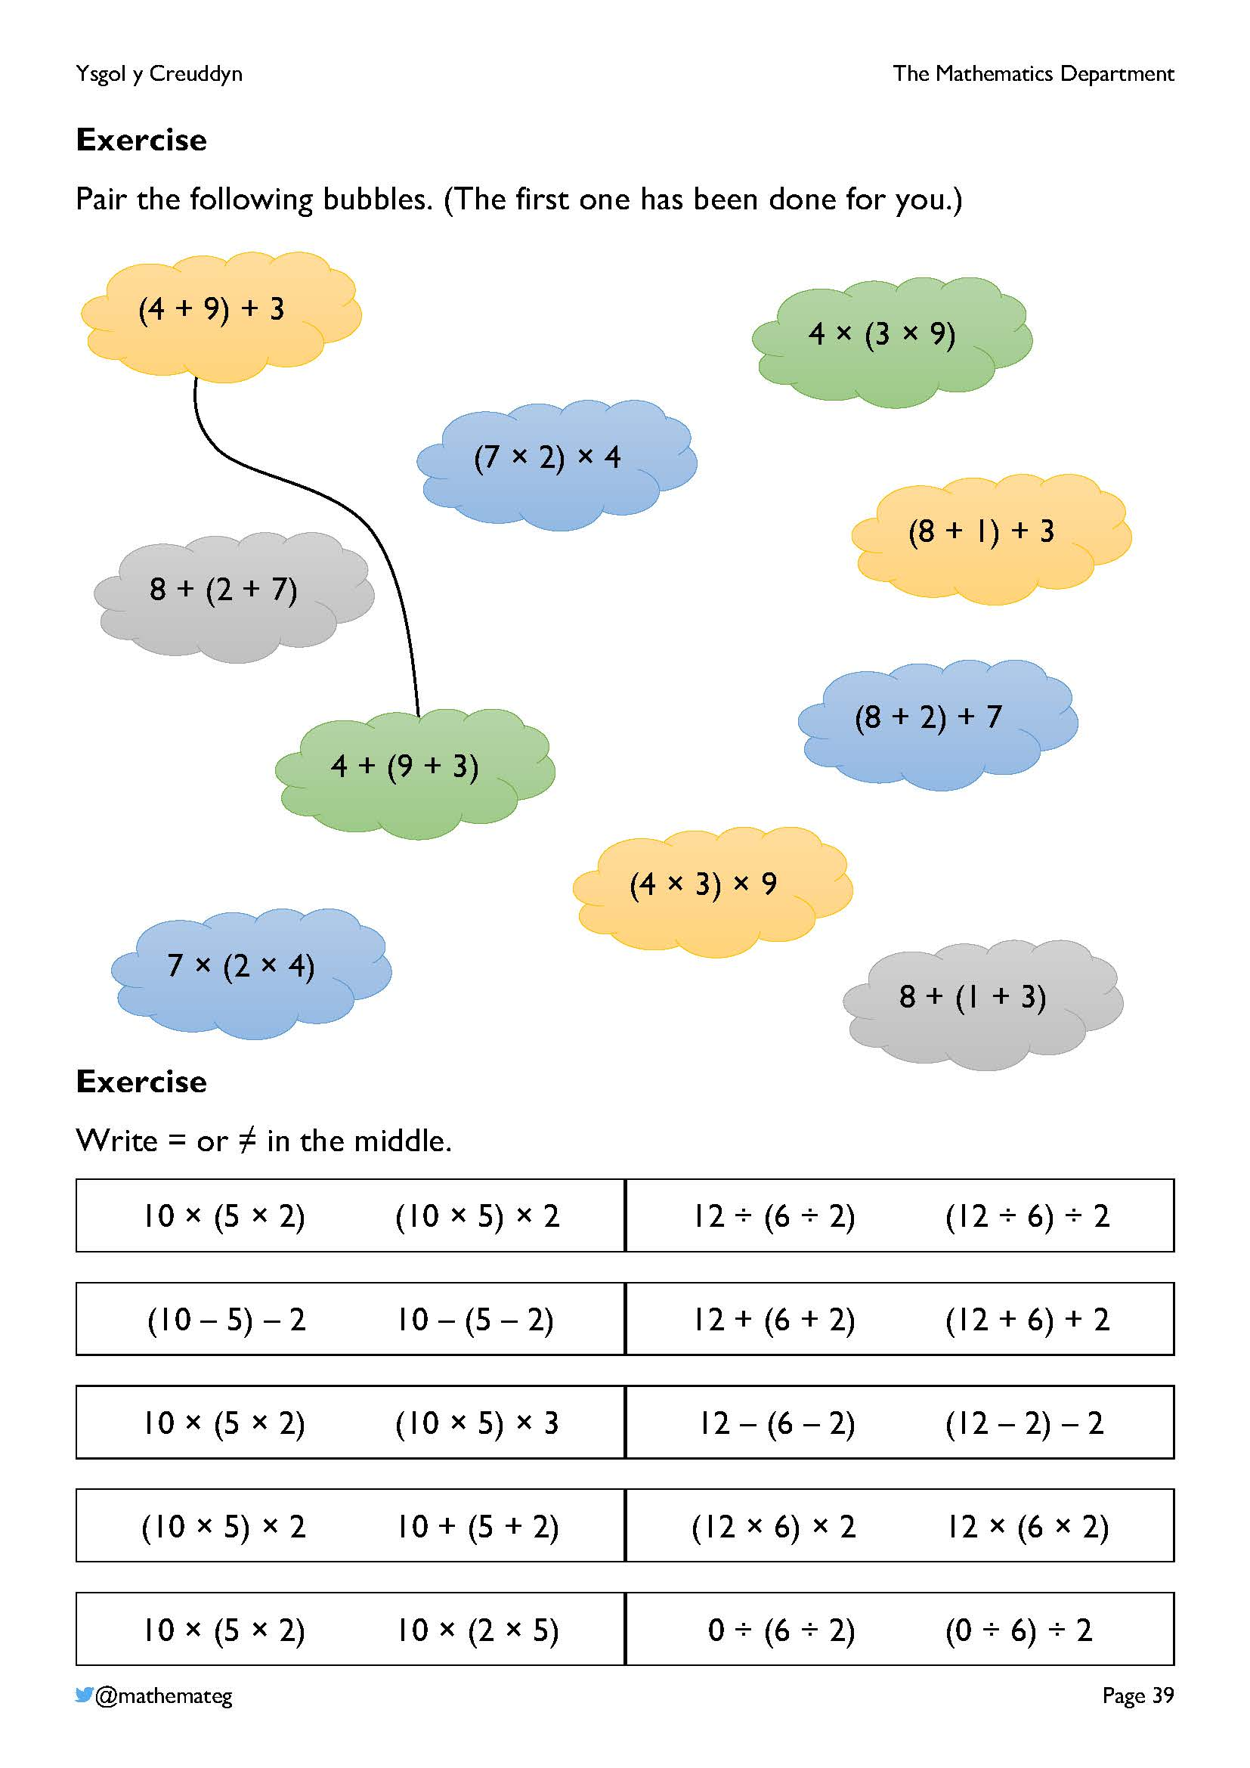
The first exercise develops fluency in recognising expressions that are equal to each other due to associativity.
Reasoning is required in the second exercise to decide on the equality or inequality of the expressions.
- In the first two rows, learners need to differentiate between associative operations (addition and multiplication) and non-associative operations (subtraction and division).
- In the third row, the equality (or inequality) of the expressions needs to be examined. An inequality sign is required on the left (due to the change from the 2 to the 3), whereas an equality sign is needed on the right (these expressions are equal even though subtraction is non-associative).
- In the fourth row, an inequality sign is needed on the left because two different operations are present.
- In the fifth row, an equality sign is needed on the left (this is an example of commutativity), and an equality sign is also needed on the right (starting with zero is a special case of division: zero divided by any other number is zero).

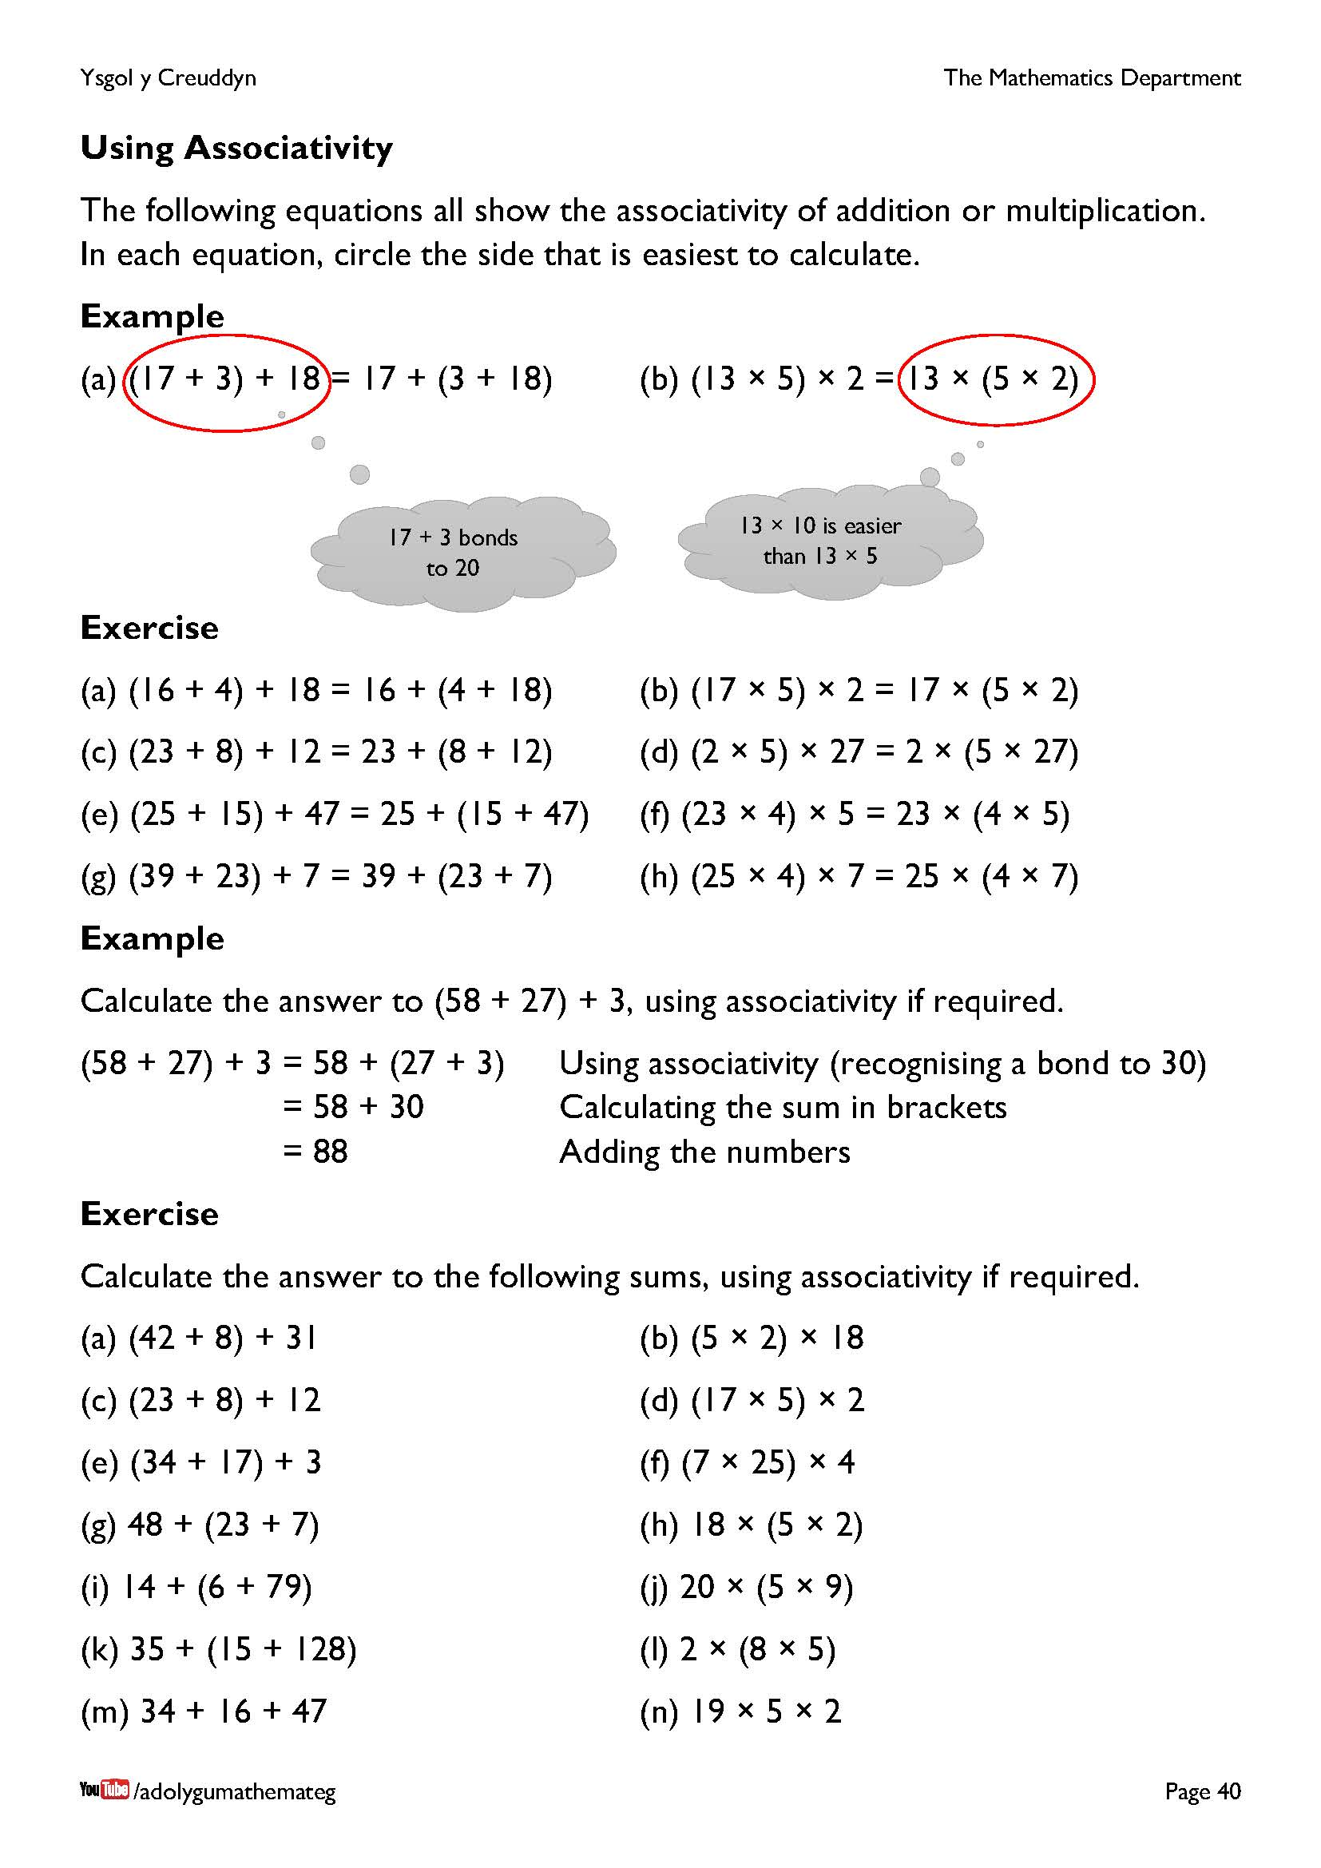
This page introduces the strategy of searching for a multiple of 10 (either as the answer to an addition sum, or as the answer to a multiplication sum) in order to make a calculation easier. In the first example, we circle the left side because the sum 20 + 18 is slightly easier than the sum 17 + 21. In the second example, we circle the right side because the sum 13 × 10 is easier than the sum 13 × 5 followed by doubling. The first exercise encourages learners to spot multiples of 10, whilst the second exercise encourages learners to use associativity to form a multiple of 10 and therefore make the sum easier.

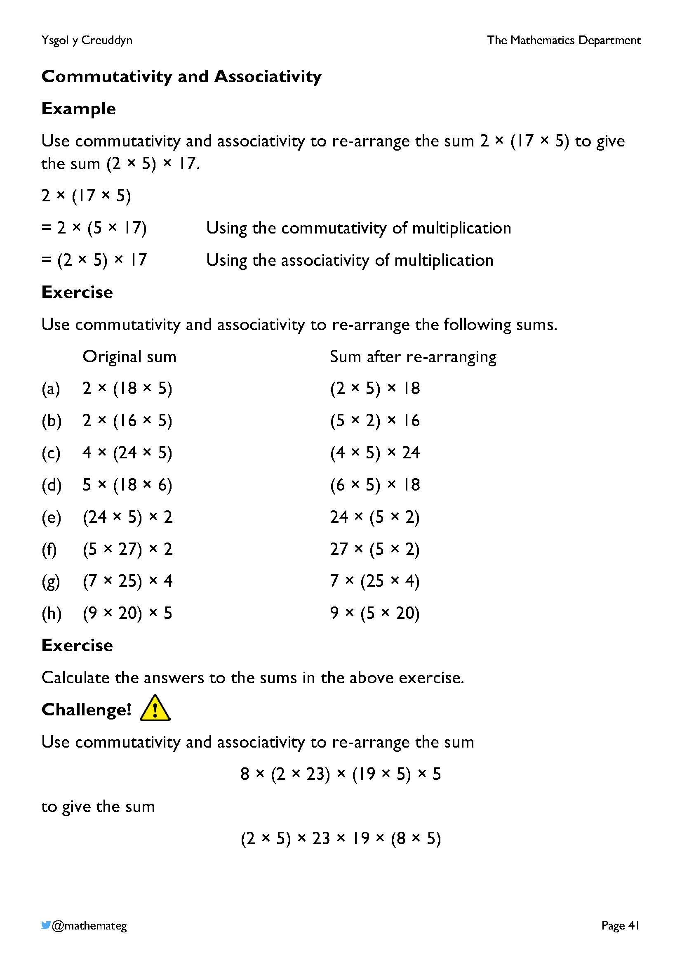
This page combines the work on the previous page with earlier work on commutativity. Notice that the sum after re-arranging is easier to calculate than the original sum, every time.
Encourage learners to set out their work as shown in the example, working through each question step-by-step in a logical manner. Only two ‘moves’ are available each time: either reversing the order of the numbers in the multiplication sum (using commutativity) or changing the location of the bracket (using associativity).

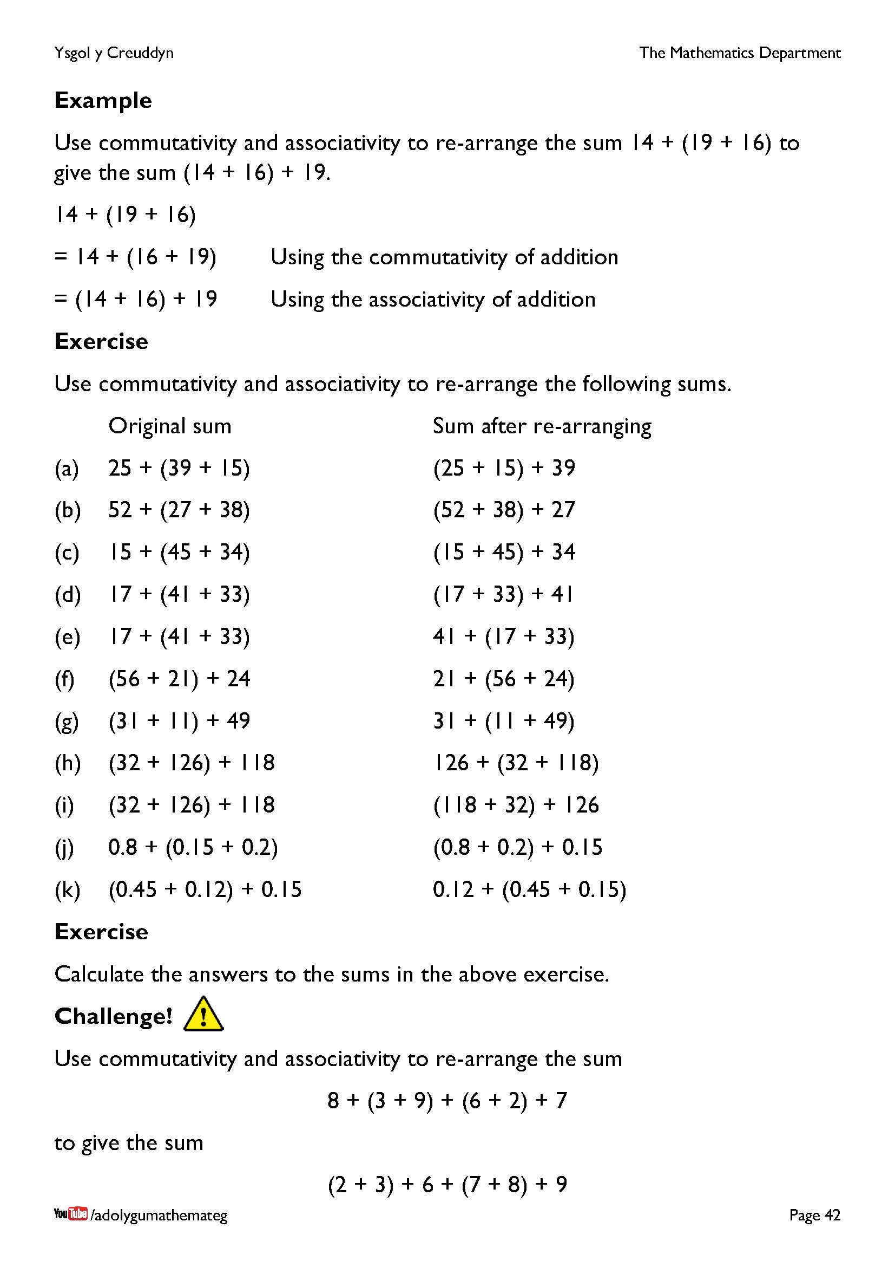
This page repeats the work on the previous page, but this time with addition sums instead of multiplication sums. Notice again that the sum after re-arranging is easier to calculate than the original sum, every time.

