

Chapter | Activities | Page Number
Place Value | Counting counters. Number, numeral and digit. Base ten. Dienes blocks. Base six (egg packing). Base eight (cartoon characters). Base two: binary numbers. Exploding dots. The 1089 problem. Other numerals. | 3
Negative Numbers | Double sided counters. Zero pairs. Addition with double sided counters. Subtraction with double sided counters. Directed numbers grids. Negative numbers in context. | 25
Fractions | Terminology. Fraction of a shape. Calculating a fraction of a number. Fractions and time. Fractions as a division sum. Comparing the size of fractions. The fraction wall. | 37
How many counters are shown below?

Circle the counters to show how you counted them.
Did other people count the counters in different ways? Discuss.

Number, numeral and digit
Hopefully you agree that twenty-nine counters were shown on the previous page. Usually, we write this number as the numeral 29, with the digit 2 showing two tens, and the digit 9 showing nine units.
2, 9
29

- Digits are used to form numerals.
- Numerals represent the idea of a number.

Exercise

Which numbers are shown in the pictures below? Circle the correct numeral.


(a) (b) (c)
(i) 8 (ii) 7 (iii) 6 (i) 15 (ii) 13 (iii) 11 (i) 14 (ii) 16 (iii) 18


(d) (e) (f)
(i) 8 (ii) 7 (iii) 6 (i) 5 (ii) 7 (iii) 8 (i) 100 (ii) 10 (iii) 50
Base ten
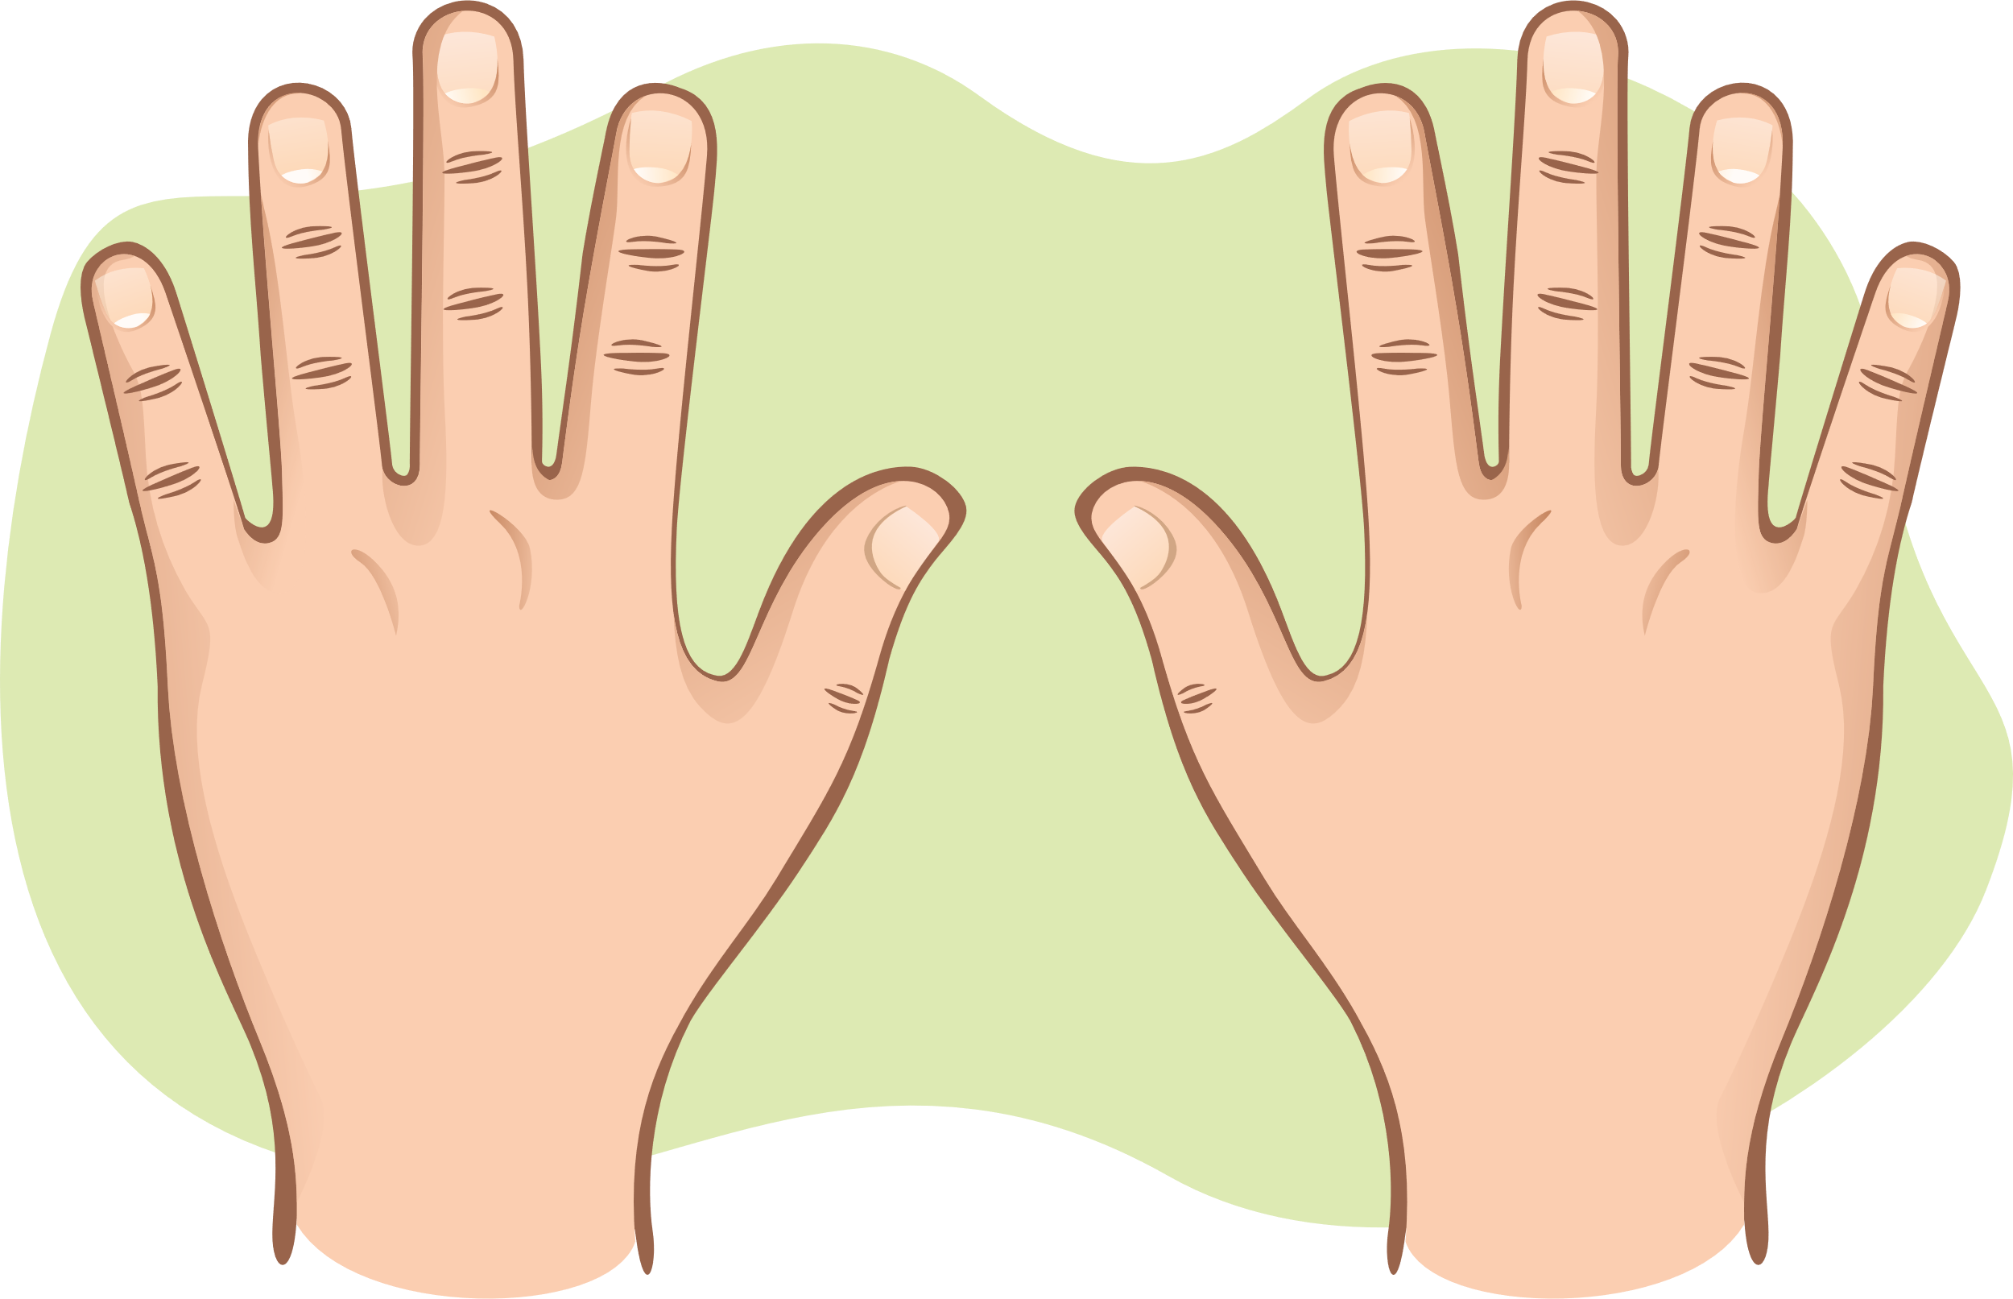
Usually, a person has ten fingers and thumbs on their hands, so humans have learnt to write numerals using a base ten system.
In this system, we place the ten digits 0 to 9 in columns to write different numerals. For example, it is possible to write the number three hundred and fifty-six as follows:
 | hundreds  3  10² = 100 | tens  5  10 | units  6  1
Numeral

356
Digit
Digit
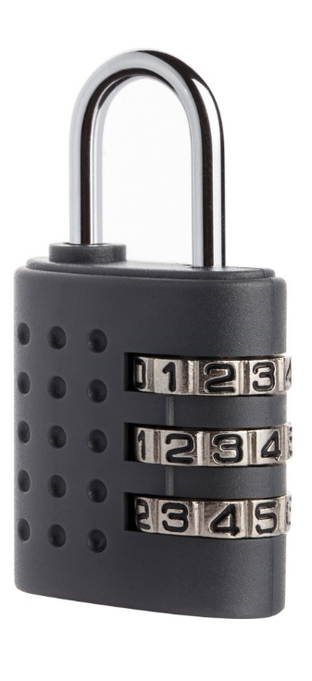
Exercise
Digit
A 3-digit code is used to open the lock shown on the right.
The 3-digit code must use all of the digits
2, 5 and 9.
Write down all the different numerals that could represent
the code.

Dienes blocks (base ten)
It is possible to use the following Dienes blocks to show numbers that have been written in base ten.

10³ = 1000, Thousand 10² = 100, Hundred 10, Ten 1, Unit
For example, here is one way of using the blocks to show the numeral 356:

Exercise
Use the Dienes blocks to show the following numerals.
(a) 3 (b) 30 (c) 300 (d) 3000
(e) 303 (f) 3030 (g) 33 (h) 3330
(i) 2 (j) 24 (k) 243 (l) 2431
(m) 2016 (n) 4007 (o) 280 (p) 5309

Exercise
Which numbers are shown below?
(a) (b)

___________________________ ______________________________
(c) (d)

___________________________ ______________________________
(e) (f)
___________________________ ______________________________

Other Bases
Base ten is not the only way of writing numbers. For example, base six uses the six digits 0, 1, 2, 3, 4, 5 to write numbers that have been grouped into sixes.
Counting in base six
1 One 20 Two sixes
2 Two 21 Two sixes and one
3 Three 22 Two sixes and two
4 Four 23 Two sixes and three
5 Five 24 Two sixes and four
10 Six 25 Two sixes and five
11 One six and one 30 Three sixes
12 One six and two 31 Three sixes and one
13 One six and three 32 Three sixes and two
14 One six and four 33 Three sixes and three
15 One six and five 34 Three sixes and four ....
Dienes Blocks (base six)

10³ = 1000, Six cubed 10² = 100, Six squared 10, Six 1, Unit
Egg boxes
Base six is useful when packing eggs, as boxes of the following shapes are used.

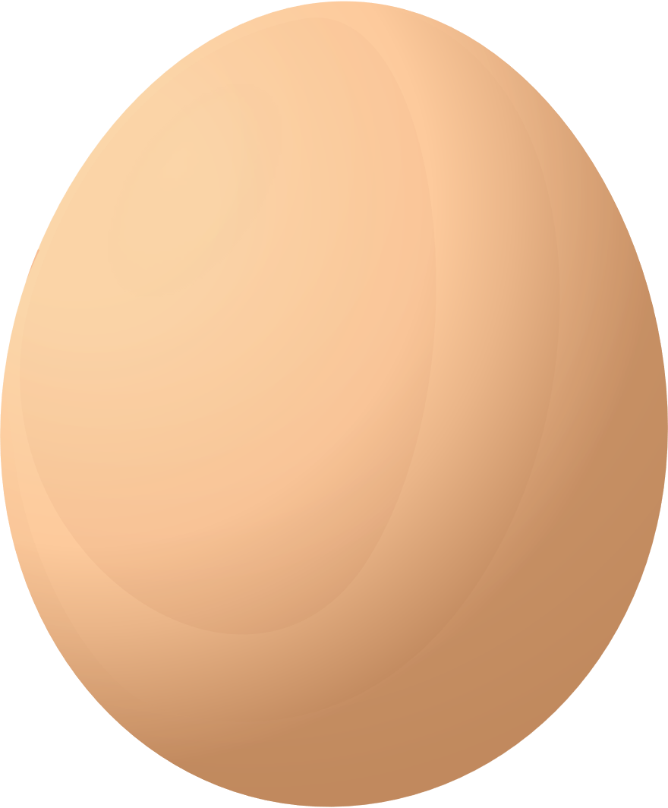
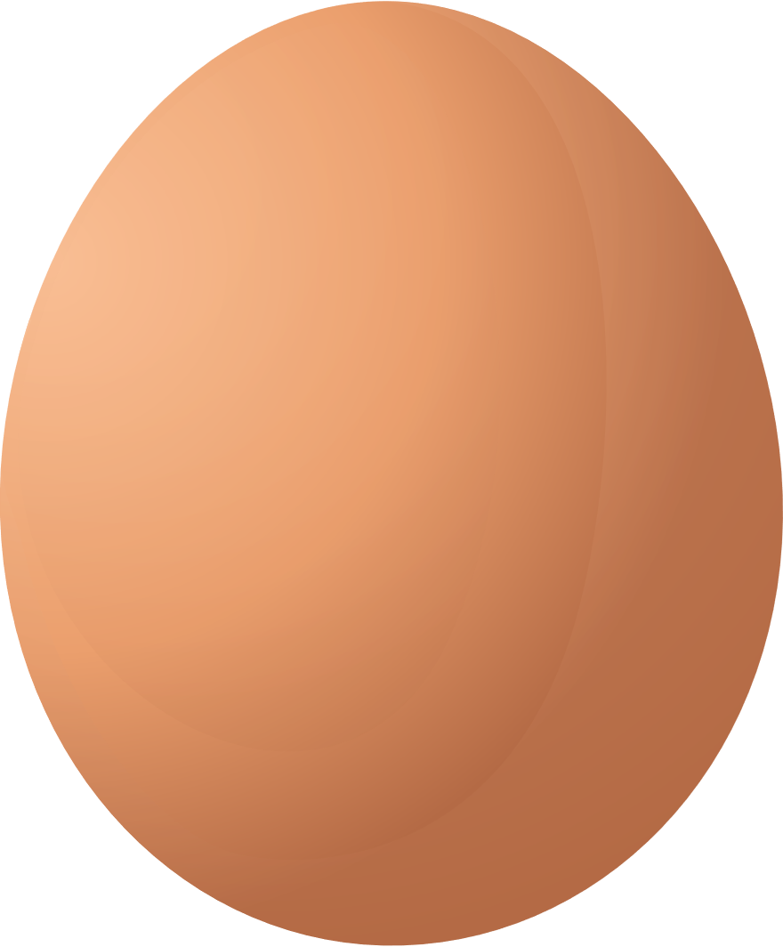
Egg packing

How many eggs are shown above?
To begin, write down your answer using base ten: __________
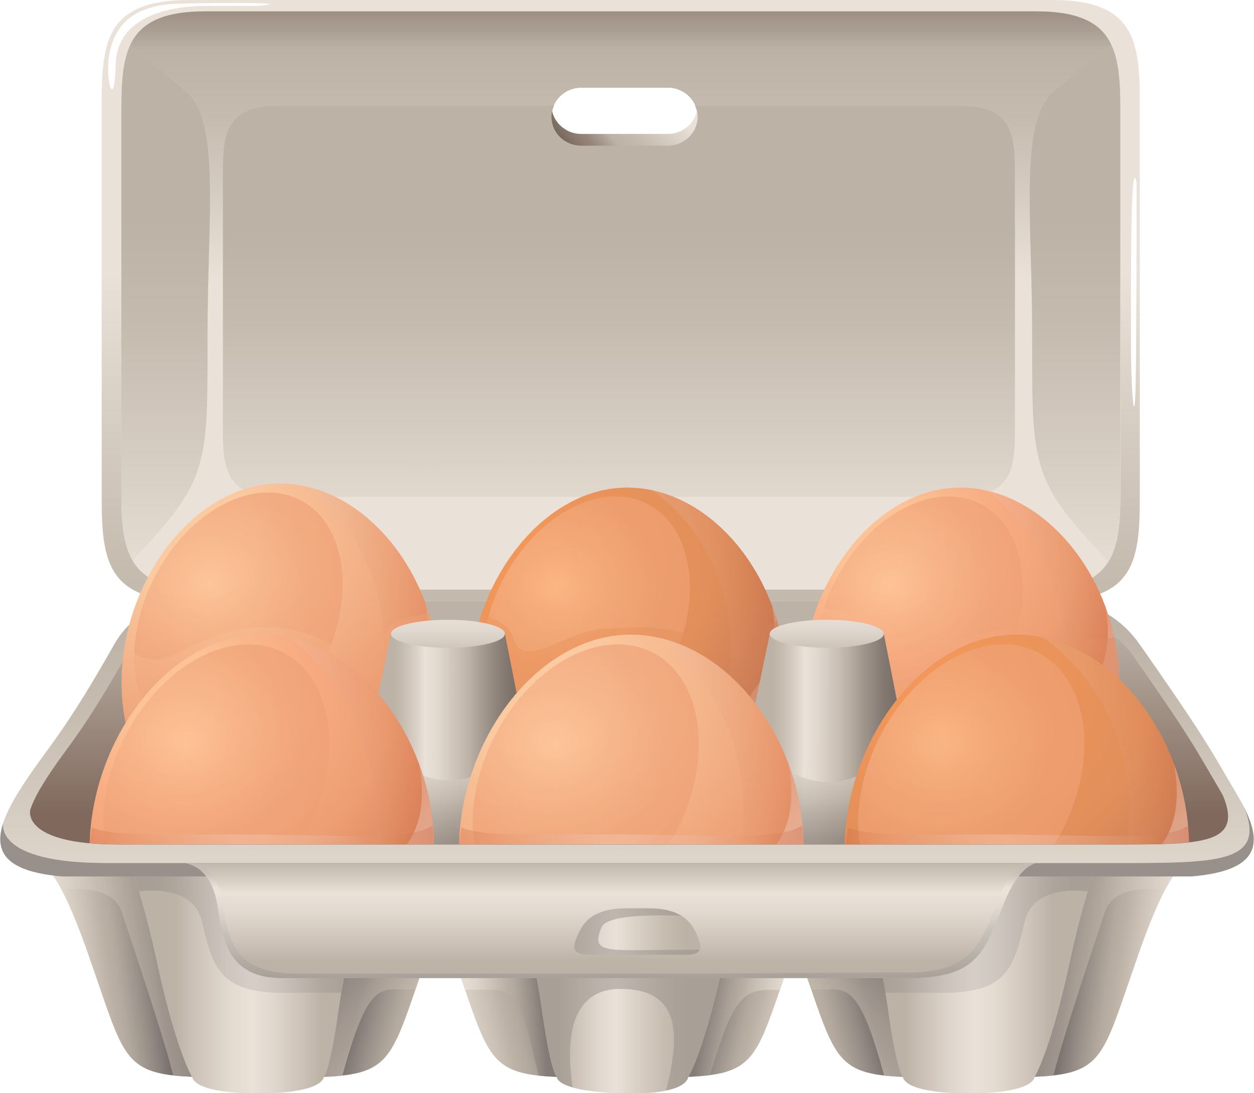
How many full boxes of 6 eggs would the above eggs fill? _______
How many eggs would be left over after filling the boxes? ______
How many eggs are shown above? This time, write down your
answer using base six: _________
What is the connection between your answer in base six and the previous two answers? ____________________________________________________
Complete the following table.
Eggs | Number of eggs in base ten | Number of eggs in base six



Egg packing in fours


How many eggs are shown above?
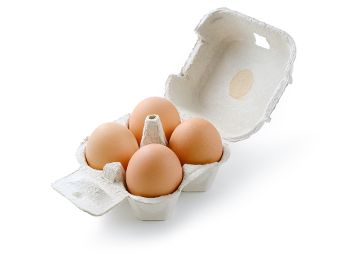
To begin, write down your answer using base ten: __________
How many full boxes of 4 eggs would the above eggs fill? _______
How many eggs would be left over after filling the boxes? ______
How many eggs are shown above? This time, write down your
answer using base four: __________
Complete the following table.
Eggs | Number of eggs in base ten | Number of eggs in base four
3 eggs are required to make one cheese and tomato omelette. Rhodri cooks 6 omelettes, one for each member of the family. How many boxes of 4 eggs does Rhodri need to buy?


Base eight
When watching cartoons, have you ever noticed that the characters very often have four fingers and thumbs on each hand? The reason for this is that it is quicker to animate a character with less fingers, but it does mean that Mickey Mouse, Spongebob Squarepants and
Mr Urdd need to count using base eight.
Counting in base eight
1 One 15 One eight and five
2 Two 16 One eight and six
3 Three 17 One eight and seven
4 Four 20 Two eights
5 Five 21 Two eights and one
6 Six 22 Two eights and two
7 Seven 23 Two eights and three
10 Eight 24 Two eights and four
11 One eight and one 25 Two eights and five
12 One eight and two 26 Two eights and six
13 One eight and three 27 Two eights and seven
14 One eight and four 30 Three eights ....
Dienes blocks (base eight)
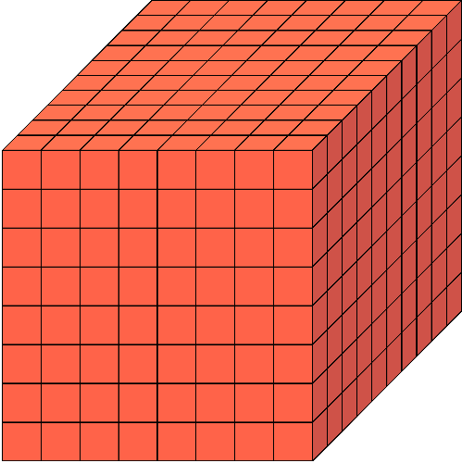
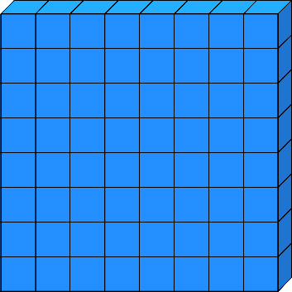
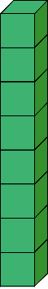

10³ = 1000, Eight cubed 10² = 100, Eight squared 10, Eight 1, Unit
Did you know?
The old American language Yuki used base eight to count as the spaces between the fingers were used to count, not the fingers themselves.
Biscuit packing

The company ‘Delicious Biscuits’ packs biscuits in packs of 8 biscuits.
On Monday, the baker bakes 30 delicious biscuits.
How many full packets of biscuits does this give? ______
How many biscuits are left over on Monday after filling the boxes? ______
Use the two previous answers to write 30 in base eight. ______
The baker bakes 35 fresh delicious biscuits on Tuesday. He adds the left-over biscuits from Monday to the pile of biscuits. How many full packets of biscuits will be ready to sell on Tuesday? ______
How many biscuits are left over on Tuesday? ______
For the rest of the week, here are the number of fresh biscuits baked each day. Complete the table to show how many fresh biscuits were baked each day.
Day | Fresh biscuits baked today | Number of biscuits in base ten | Number of biscuits in base eight
Wednesday
Thursday
Friday
Saturday
Addition in base eight
Example
 |  | 3 | 5 |  |  | 2 | 6 | 3 |  |  | 5 | 6 |  |  | 4 | 3
 | + |  | 6 |  | + | 3 | 4 | 7 |  | + | 3 | 7 |  | + | 1 | 5
 |  | 4 | 3 |  |  | 6 | 3 | 2 |  | 1 | 1 | 5 |  |  | 6 | 0
 |  | 1 |  |  |  | 1 | 1 |  |  |  | 1 |  |  |  | 1

Exercise
 |  | 2 |  |  | 2 |  |  | 2 |  |  | 2 |  |  | 3 | 2
 | + | 4 |  | + | 5 |  | + | 6 |  | + | 7 |  | + |  | 7
 |  | 4 | 3 |  |  | 4 | 3 |  |  | 4 | 3 |  |  | 4 | 3
 | + | 2 | 1 |  | + | 2 | 6 |  | + | 3 | 6 |  | + | 7 | 0
 |  | 3 | 4 |  |  | 2 | 6 | 4 |  |  | 2 | 7 | 3 | 4 | 2 | 4
 | + | 7 | 6 |  | + | 6 | 2 | 3 |  | + |  | 3 | 6 | 5 | 3 | 1
 |  | 3 | 0 | 4 | 5 |  |  |  | 3 | 2 | 5 |  |  |  | 1 | 2
 | + | 2 | 4 | 7 | 4 |  | + | 1 | 7 | 3 | 4 |  | + | 2 | 7 | 0

Subtraction in base eight
Example
 |  |  |  |  |  | 3 | 1 |  |  | 4 | 1 |  |  | 4 | 12 | 1
 |  | 6 |  |  | 7 | 4 | 3 |  |  | 5 | 2 |  |  | 5 | 3 | 6
 | – | 2 |  | – |  | 1 | 5 |  | – | 2 | 6 |  | – | 1 | 4 | 7
 |  | 4 |  |  | 7 | 2 | 6 |  |  | 2 | 4 |  |  | 3 | 6 | 7

Exercise
 |  | 4 | 5 |  |  | 4 | 5 |  |  | 4 | 5 |  |  | 4 | 5
 | – |  | 4 |  | – |  | 5 |  | – |  | 6 |  | – |  | 7
 |  | 3 | 4 |  |  | 3 | 4 |  |  | 3 | 4 |  |  | 3 | 4
 | – | 1 | 3 |  | – | 1 | 6 |  | – | 2 | 7 |  | – | 1 | 5
 |  | 3 | 4 | 2 |  |  | 3 | 4 | 2 |  |  | 3 | 4 | 2
 | – | 2 | 1 | 6 |  | – | 2 | 5 | 1 |  | – | 1 | 6 | 4
 |  | 3 | 1 | 5 |  |  | 4 | 1 | 3 | 2 | 5 |  |  | 4 | 0 | 3
 | – | 1 | 2 | 6 |  | – | 1 | 3 | 4 | 0 | 6 |  | – | 2 | 3 | 5

Base two: Binary Numbers
Binary numbers are the numerals that computers understand.
Only two digits are used in this system: 0 and 1. Simply put:
0 (zero) = off (no electrical current);
1 (one) = on (electrical current flowing).
Bitmaps
A bitmap uses binary numbers to represent simple black and white pictures.
A ‘0’ represents a white square and ‘1’ represents a black square.
 |  |  |  |  |  |  |  |  | 0 | 0 | 0 | 0 | 0 | 0 | 0 | 0
 |  |  |  |  |  |  |  |  | 0 | 0 | 0 | 1 | 1 | 1 | 0 | 0
 |  |  |  |  |  |  |  |  | 0 | 0 | 1 | 0 | 0 | 0 | 1 | 0
 |  |  |  |  |  |  |  |  | 0 | 1 | 0 | 0 | 0 | 0 | 0 | 1
 |  |  |  |  |  |  |  |  | 0 | 1 | 0 | 0 | 1 | 0 | 0 | 1
 |  |  |  |  |  |  |  |  | 0 | 1 | 0 | 0 | 0 | 0 | 0 | 1
 |  |  |  |  |  |  |  |  | 0 | 0 | 1 | 0 | 0 | 0 | 1 | 0
 |  |  |  |  |  |  |  |  | 0 | 0 | 0 | 1 | 1 | 1 | 0 | 0

Exercise
Write down the bitmap for the following picture.

Exercise
On the following grids, design your own pictures. Then, write down the bitmap for the picture. Remember to use ‘0’ to represent a white square and ‘1’ to represent a shaded square.

Exercise
Complete the picture for the following bitmap.
 |  |  |  |  |  |  |  |  | 0 | 0 | 1 | 0 | 0 | 1 | 0 | 0
 |  |  |  |  |  |  |  |  | 0 | 1 | 0 | 1 | 1 | 0 | 1 | 0
 |  |  |  |  |  |  |  |  | 1 | 0 | 0 | 0 | 0 | 0 | 0 | 1
 |  |  |  |  |  |  |  |  | 0 | 1 | 0 | 0 | 0 | 0 | 1 | 0
 |  |  |  |  |  |  |  |  | 0 | 0 | 1 | 0 | 0 | 1 | 0 | 0
 |  |  |  |  |  |  |  |  | 0 | 0 | 0 | 1 | 1 | 0 | 0 | 0
 |  |  |  |  |  |  |  |  | 0 | 0 | 1 | 0 | 0 | 1 | 0 | 0
 |  |  |  |  |  |  |  |  | 0 | 1 | 0 | 0 | 0 | 0 | 1 | 0

Changing between base ten and base two
In our usual base ten system, the value of each new column to the left is ten times greater than the previous column.
Ten thousand  10⁴ = 10000 | Thousand  10³ = 1000 | Hundred  10² = 100 | Ten  10 | Unit  1

× 10 × 10 × 10 × 10
In the base two system however, the value of each new column to the left is two times greater than the previous column.
Sixteen  10⁴ = 10000  (2⁴ = 16) | Eight  10³ = 1000  (2³ = 8) | Four  10² = 100  (2² = 4) | Two  10  (2) | Unit  1

× 2 × 2 × 2 × 2
This means that the base two numeral 10110 represents the base ten numeral 16 + 4 + 2 = 22.
Exercise
Change the following base two numerals to be in base ten.
Base two |  |  |  |  |  | Base ten | Base two |  |  |  |  |  | Base ten
 | 16 | 8 | 4 | 2 | 1 |  |  | 16 | 8 | 4 | 2 | 1
(a) | 0 | 1 | 0 | 1 | 0 |  | (g) | 0 | 1 | 1 | 1 | 0
(b) | 1 | 0 | 1 | 0 | 1 |  | (h) | 1 | 0 | 0 | 0 | 1
(c) | 1 | 1 | 0 | 0 | 1 |  | (i) | 1 | 1 | 1 | 0 | 1
(d) | 0 | 0 | 1 | 0 | 0 |  | (j) | 0 | 0 | 1 | 1 | 1
(e) | 0 | 0 | 1 | 0 | 1 |  | (k) | 0 | 0 | 0 | 1 | 1
(f) | 1 | 0 | 0 | 1 | 0 |  | (l) | 1 | 1 | 1 | 1 | 0

In order to write 9 in base two, we need to consider which columns can be used to give a total of 9.
16 8 4 2 1
0 1 0 0 1
Because 9 = 8 + 1, the base ten numeral 9 is written as 1001 in base two.
Exercise
Complete the following table.
Base ten | Base two |  |  |  |  | Base ten | Base two
Base ten | 16 | 8 | 4 | 2 | 1 | Base ten | 16 | 8 | 4 | 2 | 1
1 |  |  |  |  |  | 17
2 |  |  |  |  |  | 18
3 |  |  |  |  |  | 19
4 |  |  |  |  |  | 20
5 |  |  |  |  |  | 21
6 |  |  |  |  |  | 22
7 |  |  |  |  |  | 23
8 |  |  |  |  |  | 24
9 | 0 | 1 | 0 | 0 | 1 | 25
10 |  |  |  |  |  | 26
11 |  |  |  |  |  | 27
12 |  |  |  |  |  | 28
13 |  |  |  |  |  | 29
14 |  |  |  |  |  | 30
15 |  |  |  |  |  | 31
16

Learning more about bases: Exploding dots
Go to the website https://www.explodingdots.org/ and work your way through ISLAND 1 (MECHANIA).
Example
This is what happens in a 2 1 machine if 5 dots are placed in the box on the right.
 | 4 |  | 2 |  | 1

 | 4 |  | 2 |  | 1

 | 1 |  | 0 |  | 1
 | 4 |  | 2 |  | 1

Exercise
Use squared paper to show what happens if the following number of dots are placed in the box on the right.
(a) 1 (b) 2 (c) 3
(d) 4 (e) 6 (f) 7
Extension
Repeat the above exercise, but this time use a 3 1 machine.

Alien Invasion
5 aliens are shown below. Each one counts in a different way.






1st: Purple Peter counts in twos.

2nd: Blue Billie counts in threes.
3rd: Orange Ollie counts in fours.
4th: Pink Penny counts in fives.
5th: Yellow Yasmin counts in sixes.

The aliens have all just landed on Earth and want
to count the number of fingers and thumbs
shown below.
Write down their answers in the speech
bubbles.

Bases, bases, bases!
Complete the following table.
Base  ten | Base nine | Base eight | Base seven | Base six | Base five | Base four | Base  three | Base  two
1
2
3
4
5
6
7
8
9
10
11
12
13
14
15
16
17
18
19
20
21
22
23
24
25
26
27
28
29
30
31

The 1089 Problem
Here is a 3-digit number with decreasing digits: 742
Write the digits in reverse order: 247
Subtract: 495
Write the digits in reverse order: 594
Add: 1,089

What happens if you start with 832?
Here is a 3-digit number with decreasing digits: 832
Write the digits in reverse order:
Subtract:
Write the digits in reverse order:
Add:

Now start with a 3-digit number of your choice:
Here is a 3-digit number with decreasing digits:
Write the digits in reverse order:
Subtract:
Write the digits in reverse order:
Add:


Why is the answer always 1089?
Challenge!
Repeat the above process, but work in base eight, not base ten.
Hint: Be extra careful when ‘borrowing’ during the subtraction sum.
If the final total is 1089 for base ten, what is the final total for base eight? ________
Other Numerals
We are familiar with numerals such as 238 and 873, but other types of numerals exist.
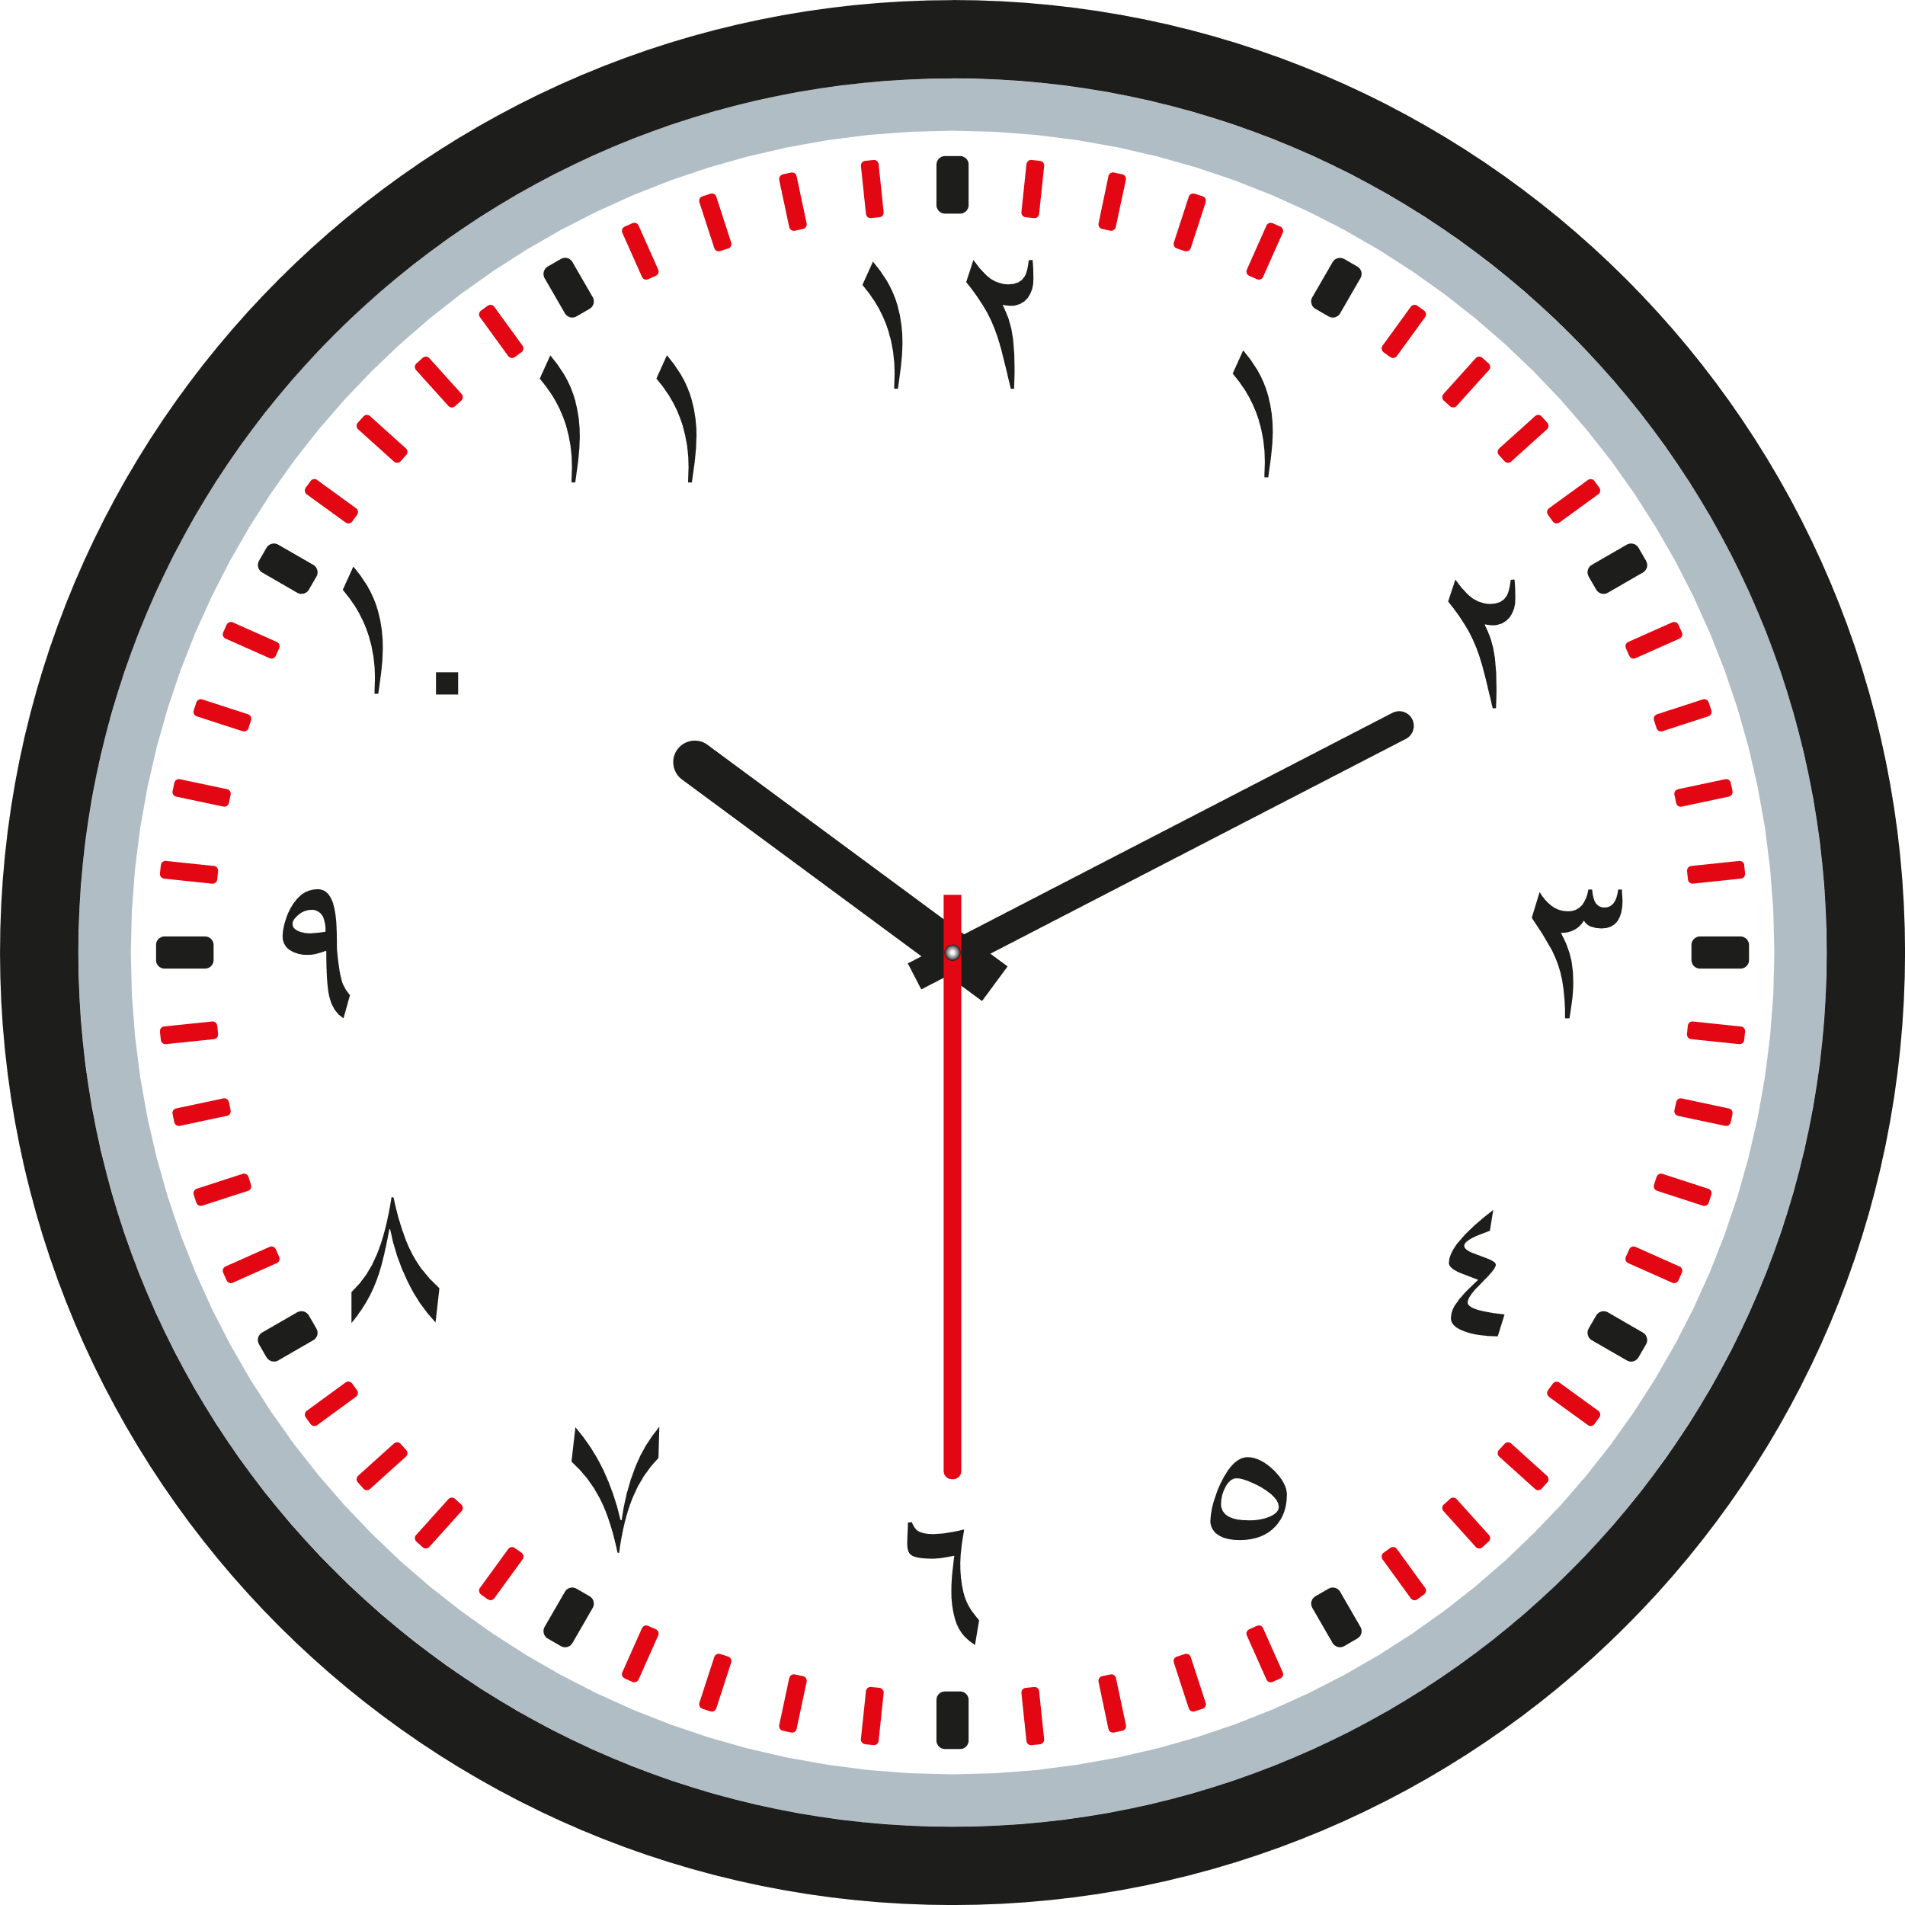
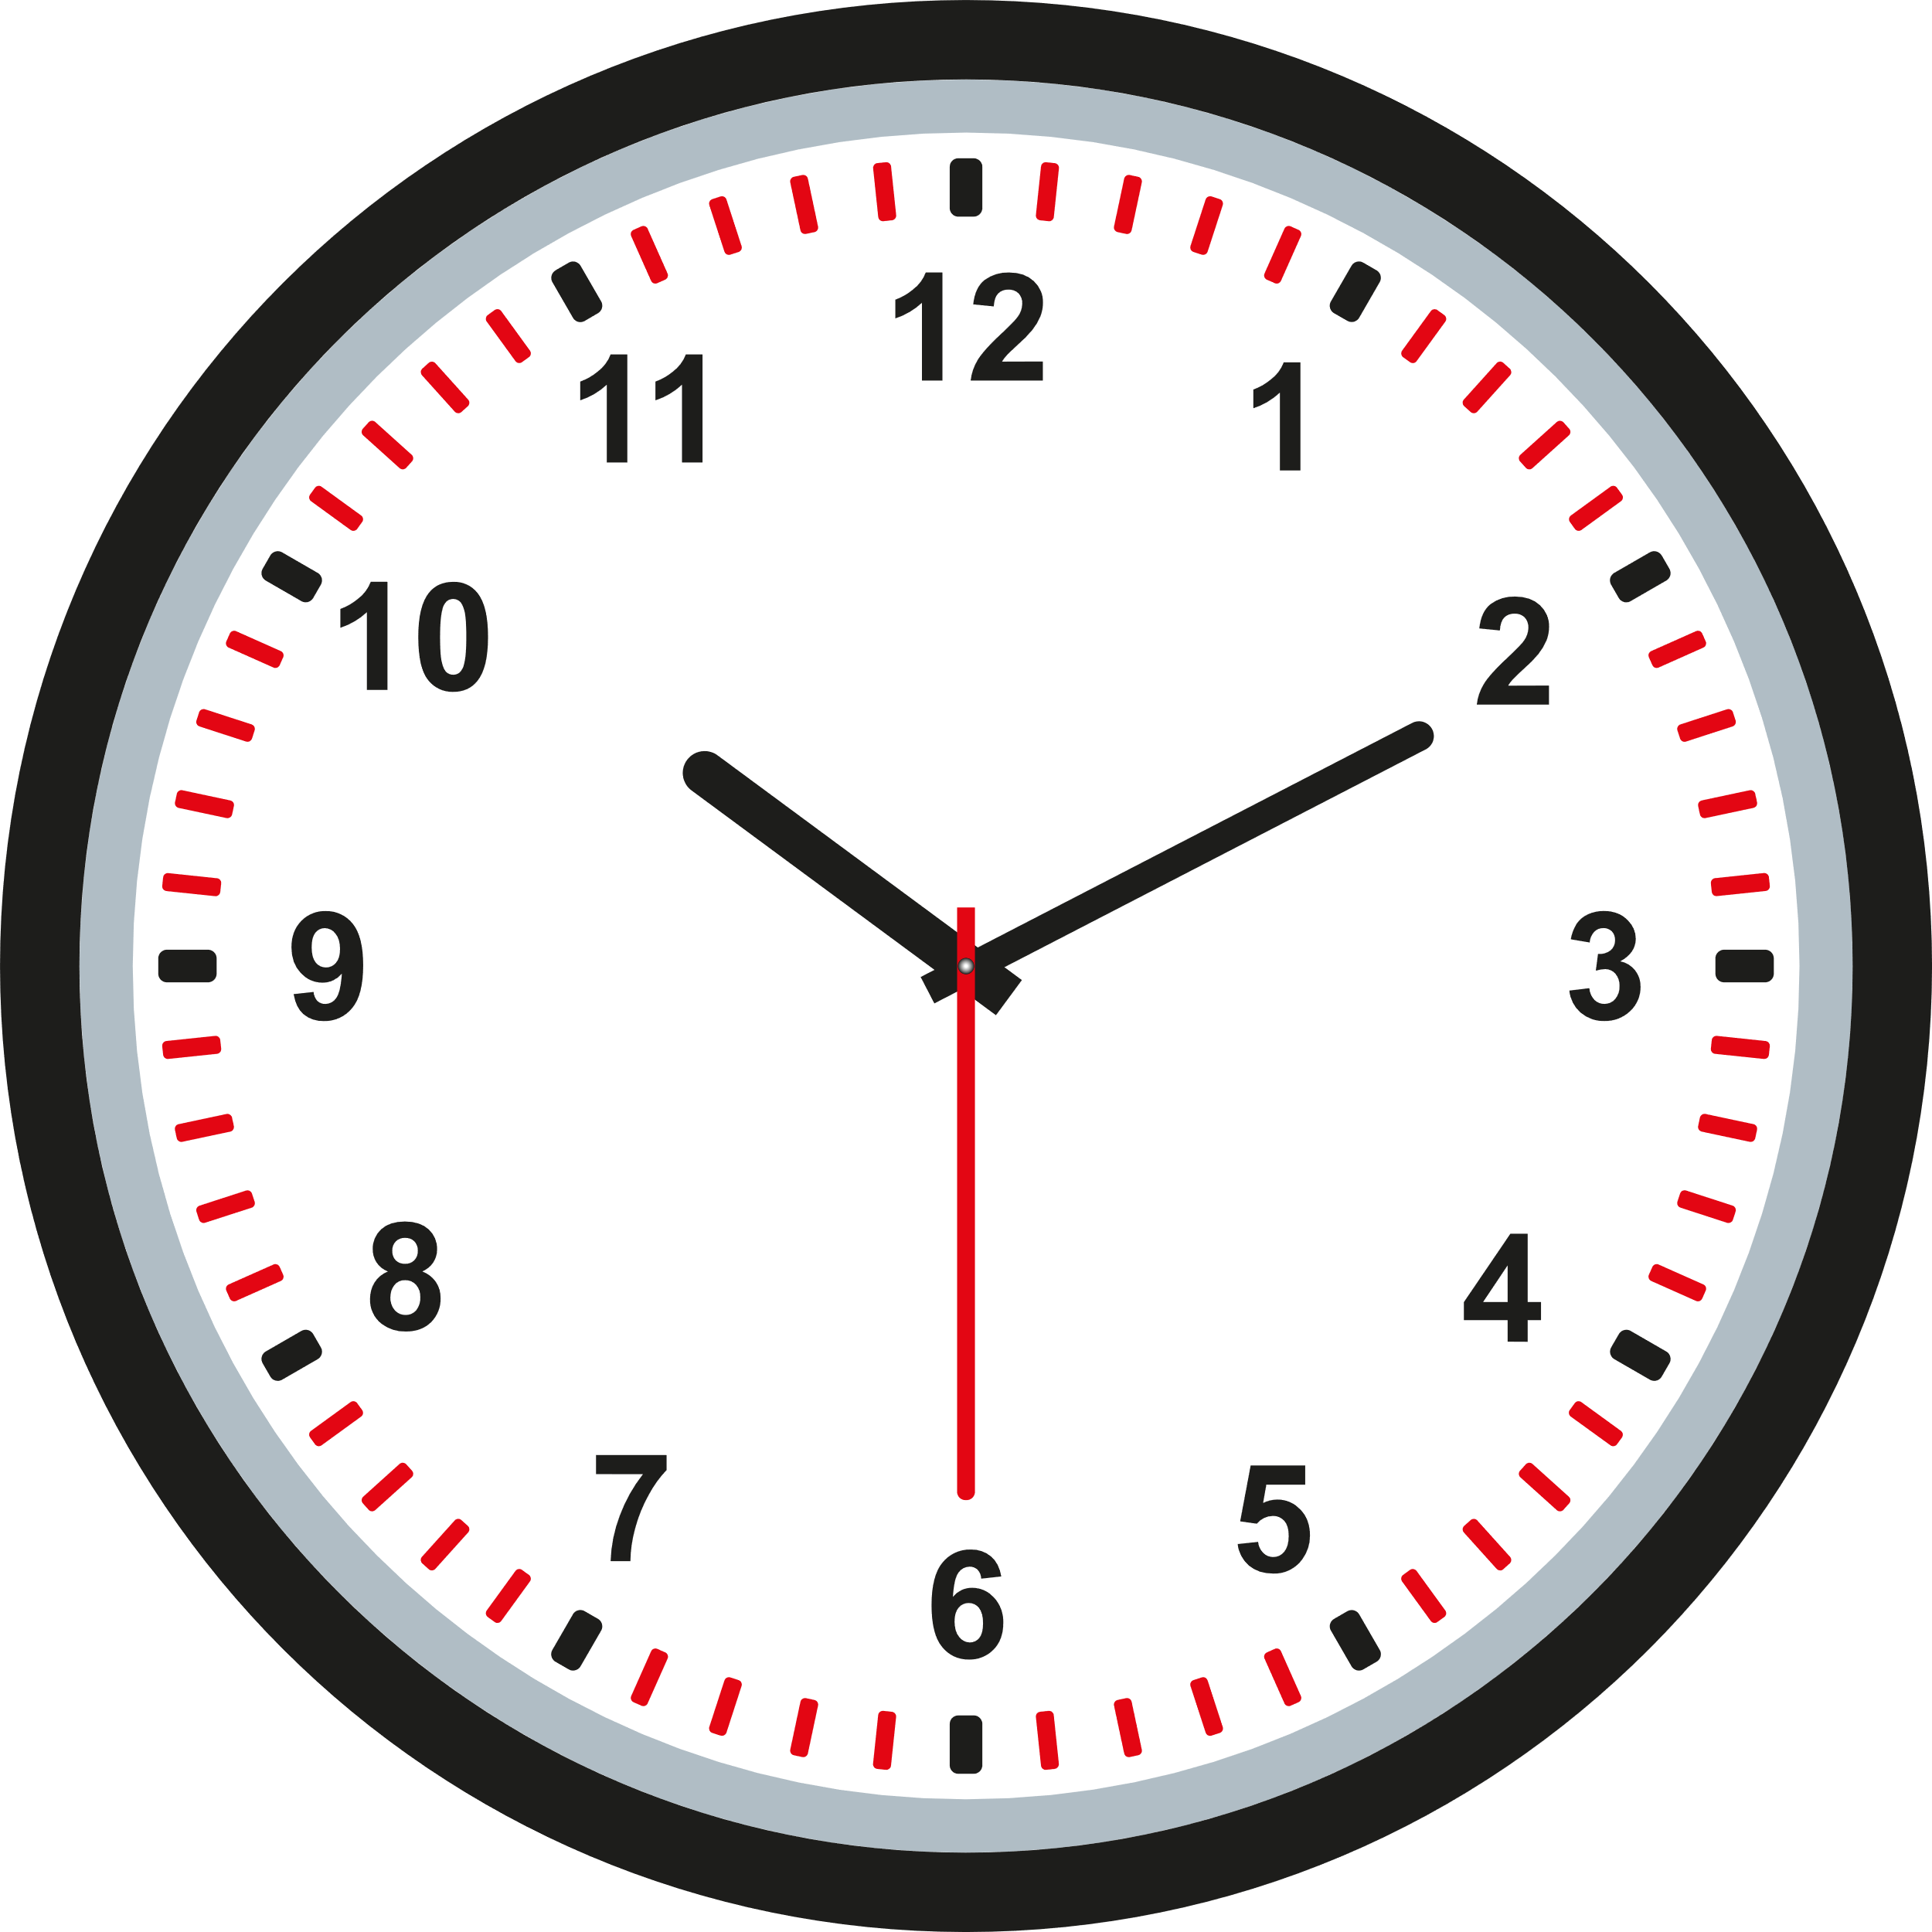
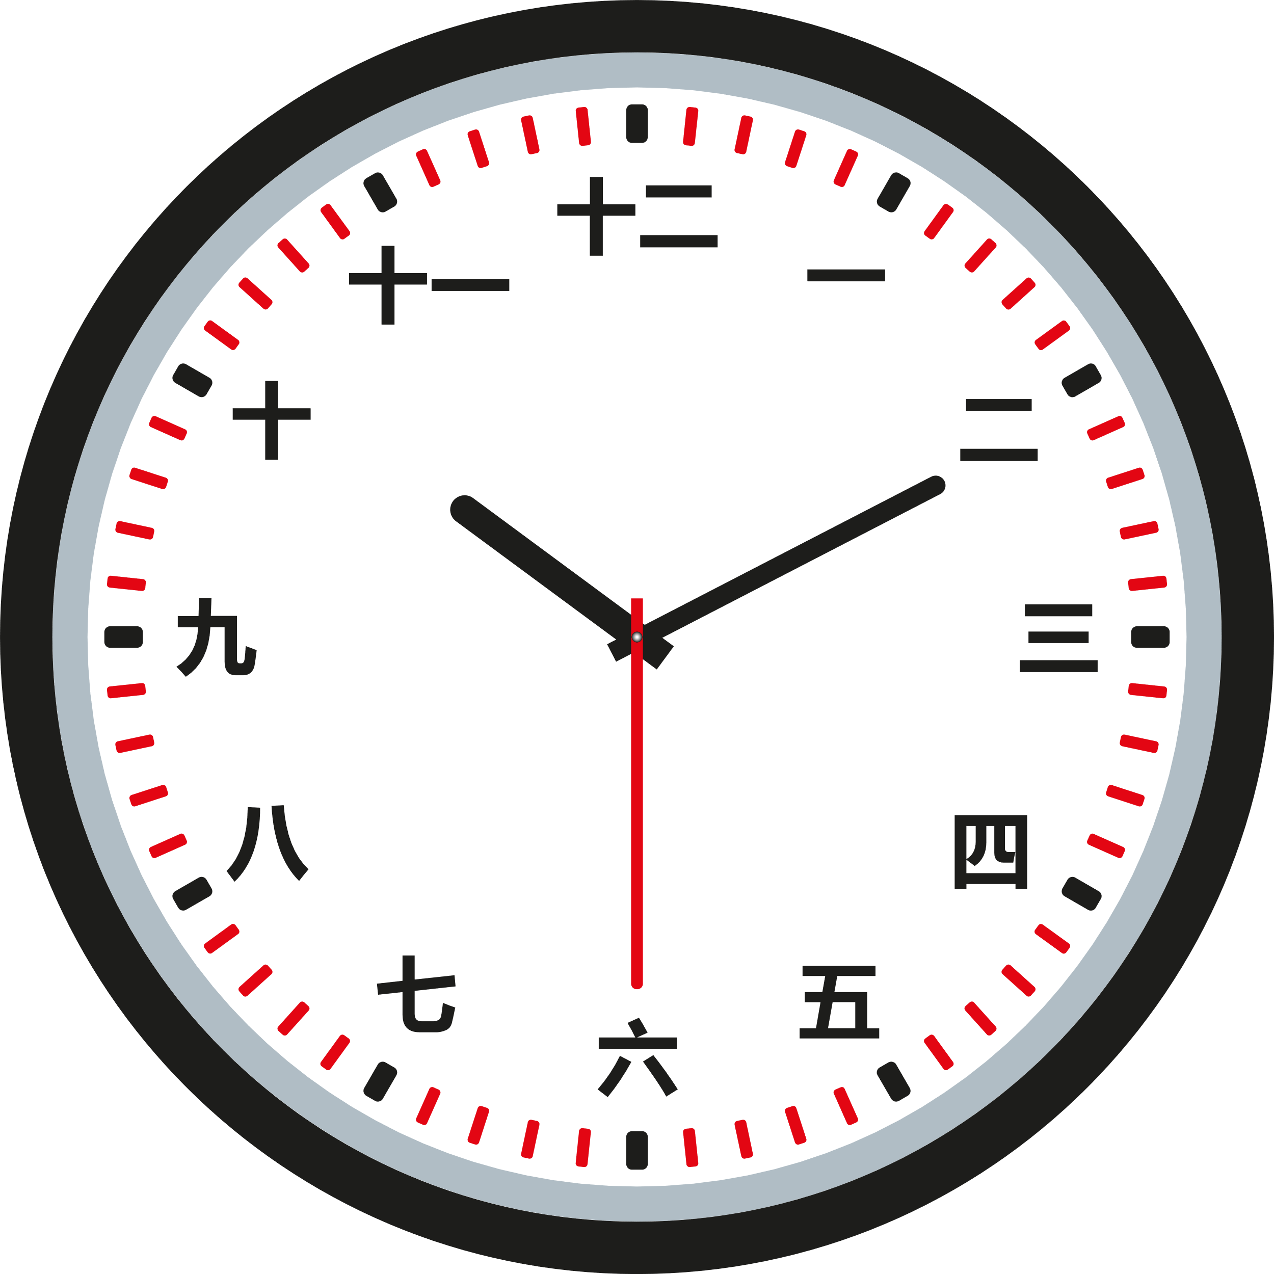

Western Arabic Numerals | Chinese Numerals | Eastern Arabic Numerals

Roman Numerals
The Romans had their own way of writing numbers: they used the following digits.
1 | 5 | 10 | 50 | 100 | 500 | 1,000
I | V | X | L | C | D | M
The above digits can be combined to form the following numerals.
1 | 2 | 3 | 4 | 5 | 6 | 7 | 8 | 9 | 10
I | II | III | IV | V | VI | VII | VIII | IX | X
Rule 1 Rule 2
If a digit appears after a greater (or If a digit appears before a greater
equal) digit, then the digit is added. digit, then the digit is subtracted
from that digit.
For example: For example:
VI = V + I or LXX = L + X + X IV = V – I or IX = X – I
VI = 5 + 1 LXX = 50 + 10 + 10 IV = 5 – 1 IX = 10 – 1
VI = 6 LXX = 70 IV = 4 IX = 9

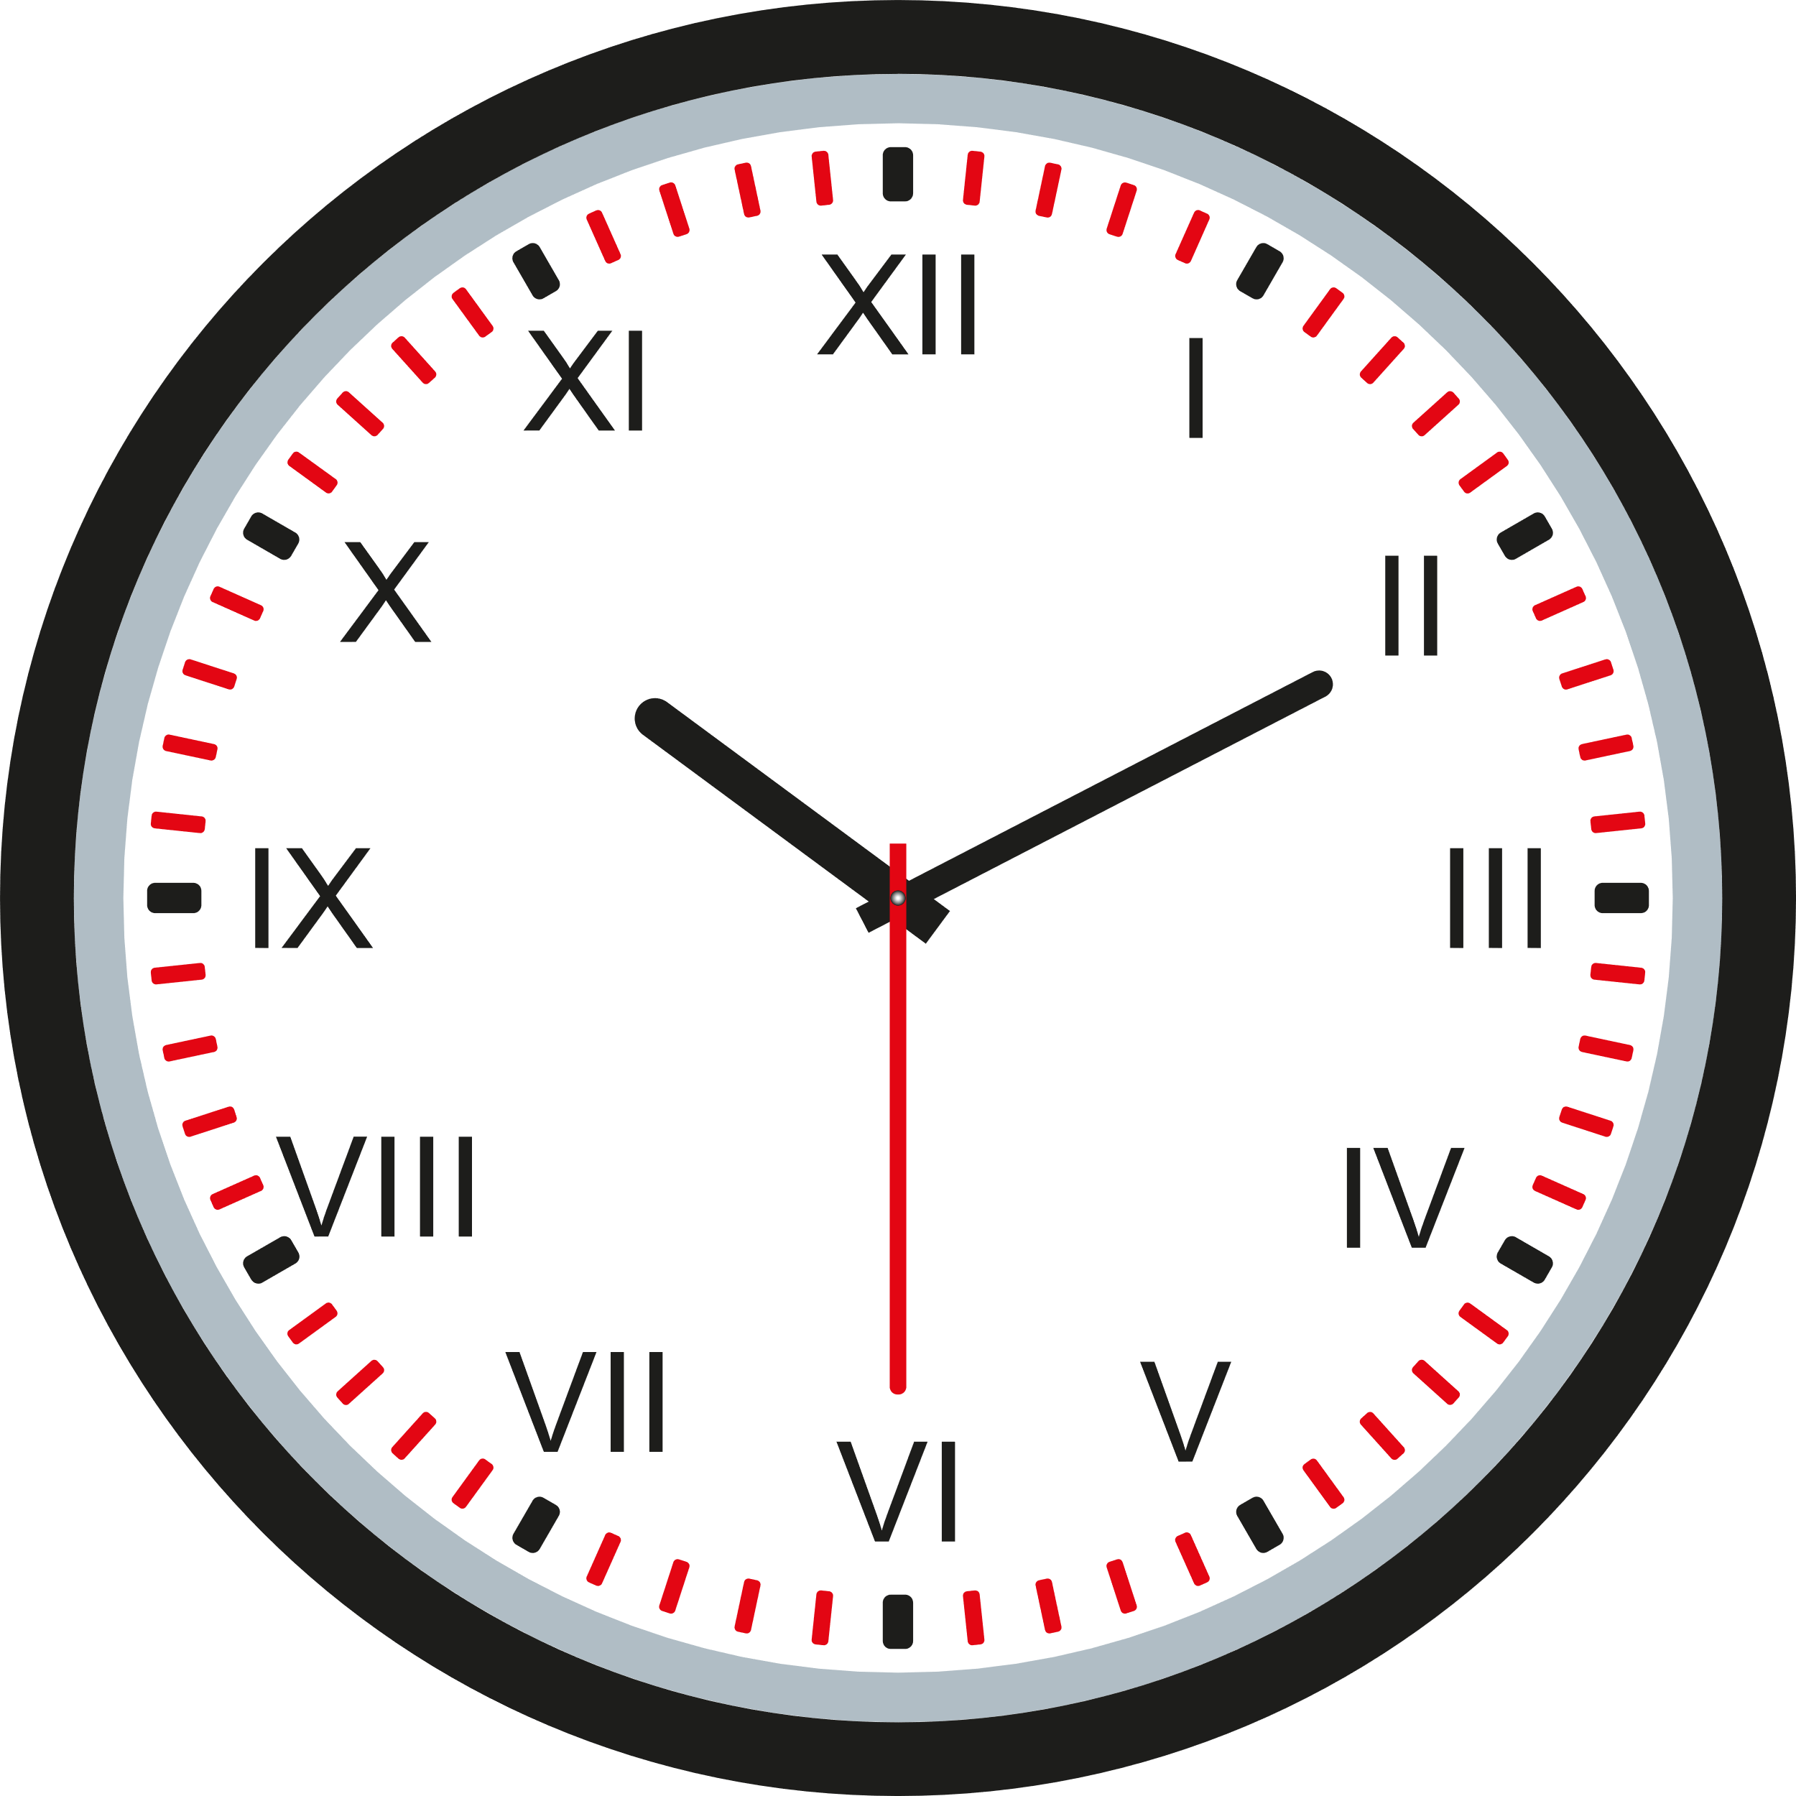
Exercise
Write the missing Roman numerals in the clock on the right.
Exercise
Change the following base ten numerals to be Roman numerals.
(a) 31 (b) 160
______________ ______________
(c) 1,530 (d) 2,025
______________ ______________
Exercise
Change the following Roman numerals to be base ten numerals.
(a) XXVI (b) CXVI (c) CDLII
__________________ __________________ __________________
(d) MMMCLXVII (e) MMDCCLXXIV (f) MCLXXVIII
__________________ __________________ __________________
Exercise
Here are two sets of digits from 0 to 9.
0 1 2 3 4 5 6 7 8 9
0 1 2 3 4 5 6 7 8 9
Use the above digits to create the following 4-digit numerals.
Use each digit at most once.
Greatest odd number __________ Greatest even number __________
Smallest multiple of 5 __________ Greatest multiple of 3 __________
Closest number to 5,000 ________ Closest multiple of 9 to 2,000 ________

Double sided counters
A yellow counter is worth +1 and a red counter is worth –1.
We say “one” for +1 and “negative one” for –1.
Example
(a) The diagram below shows 6. (b) The diagram below shows –4.
Exercise
Which numbers are shown in the following diagrams?
(a) |  |  |  |  |  |  |  |  | (b)
(c) |  |  |  |  |  |  |  |  | (d)
Exercise
Use double sided counters (physical or on-line) to show the following numbers.
(a) 5 (b) –2 (c) 9 (d) –6
Zero Pairs
One yellow counter and one red counter, together, represents zero.
(Discuss why this is true.)
We call a pair of yellow and red counters a “zero pair”. It is possible to add a zero pair to a set of counters, or (if possible) remove a zero pair from a set of counters, without affecting the value of the counters.

Example
(a) The diagram below shows 5. (b) The diagram below shows –3.
Exercise
Which numbers are shown in the following diagrams?
(a) |  |  |  |  |  |  |  |  | (b)
(c) |  |  |  |  |  |  |  |  | (d)
(e) |  |  |  |  |  |  |  |  | (f)
(g) |  |  |  |  |  |  |  |  | (h)
(i) |  |  |  |  |  |  |  |  | (j)
(k) |  |  |  |  |  |  |  |  | (l)

What’s the sum?
Below we show three ways of representing the same addition sum.
Fill in the blanks.
Example
4 + –2 |  |  |  |  |  |  |  |  | –6 + 3
Four add negative two |  |  |  |  |  |  |  |  | Negative six add three
Exercise
(a) |  |  |  |  |  |  |  |  |  | (b)
Five add negative two |  |  |  |  |  |  |  |  |  | Negative five add four
(c) |  |  |  |  |  |  |  |  |  | (d)
6 + –1 |  |  |  |  |  |  |  |  |  | –3 + 4
(e) |  |  |  |  |  |  |  |  |  | (f)
 |  |  |  |  |  |  |  |  |  | –2 + 5
(g) |  |  |  |  |  |  |  |  |  | (h)
Three add negative four |  |  |  |  |  |  |  |  |  | Negative one add seven

Addition with double sided counters
Example
4 + –2 –6 + 3
Step 1: Arrange the counters in a row to show the sum.
Step 2: Re-arrange the counters to identify any zero pairs.
Step 3: Remove any zero pairs and count what is left.
Answer: 2 Answer: –3
Exercise
Use double sided counters to find the answer to the following sums.
(a) 5 + –3 (b) 5 + –4 (c) 5 + –5
(d) 5 + –6 (e) 5 + –7 (f) 5 + –10
(g) –5 + 2 (h) –5 + 3 (i) –5 + 4
(j) –5 + 5 (k) –5 + 6 (l) –5 + 7
(m) 4 + –7 (n) –4 + –7 (o) –4 + 7
(p) 4 + 7 (q) 4 + –4 (r) –4 + 4
(s) –4 + –4 (t) –4 + 6 (u) –6 + 4
(v) –2 + –3 (w) 9 + –4 (x) –8 + –1
(y) 7 + –8 (z) –7 + 8 (α) –7 + –8
Challenge!
(a) 6 + –2 + 3 (b) –4 + –5 + 7 (c) –2 + 8 + –6
(d) –1 + –5 + 6 (e) 8 + –2 + –4 (f) –9 + 5 + –2 + 4

Subtraction with double sided counters
Example
To find the answer to the sum 8 – 2, we start with eight yellow counters...
...and subtract (remove) two of them to leave six yellow counters.
Therefore, 8 – 2 = 6.
Exercise
Use double sided counters to find the answers to the following sums.
(a) 7 – 2 (b) 7 – 4 (c) 7 – 6
(d) 6 – 1 (e) 5 – 5 (f) 12 – 7
Removing what isn’t there
How do you find the answer to the sum 5 – 7 using double sided counters?
Let us start with five yellow counters.
At the moment, we cannot subtract seven yellow counters (as we only have five of them), so we need to introduce two zero pairs.
Now it is possible to subtract seven yellow counters, and this leaves two red counters. Therefore, 5 – 7 = –2.
Exercise
Use double sided counters to find the answer to the following sums.
(a) 5 – 8 (b) 3 – 6 (c) 2 – 7
(d) 4 – 8 (e) 5 – 9 (f) 9 – 13
Subtracting a negative number
What is the meaning of the sum 4 – –3, ‘four subtract negative three’?
Let us start with four yellow counters.
We can add three zero pairs without affecting the value of the counters (four).
We can now subtract negative three by removing three red counters.
We see that seven yellow counters remain, so that 4 – –3 = 7.
Exercise
Use double sided counters to find the answer to the following sums.
(a) 4 – –2 (b) 4 – –1 (c) 4 – –4
(d) 5 – –2 (e) 5 – –1 (f) 5 – –4
(g) 6 – –3 (h) 6 – –2 (i) 6 – –5
(j) 3 – –2 (k) 3 – –4 (l) 3 – –6
(m) 8 – –3 (n) 8 – –1 (o) 8 – –5
(p) 7 – –4 (q) 7 – –2 (r) 7 – – 3
Starting with a negative number
Discuss how you would use double sided counters to find the answer to the sum –4 – –2.
Exercise
(a) –4 – –1 (b) –4 – –3 (c) –4 – –4
(d) –5 – –1 (e) –5 – –3 (f) –5 – –4
(g) –7 – –1 (h) –7 – –3 (i) –7 – –4

Directed Numbers Grids
How does the grid below work? What is the missing number?
4 | 5 | 9 | 14 | 23
6 | 7 | 13 | 20 | 33
10 | 12 | 22 | 34 | 56
16 | 19 | 35 | 54 | 89
26 | 31 | 57 | 88 | ?
Exercise
Fill in the numbers in the following grids.
1 | 1 |  |  |  |  |  | 1 | –1
1 | 2 |  |  |  |  |  | 0 | 1
 |  |  |  |  |  |  |  |  |  |  |  |  |  |  | 3 | 3
 |  |  |  |  |  |  |  |  |  |  |  |  |  |  | 3 | 1
 |  |  |  |  |  |  |  |  |  |  |  |  |  | 2 | –5
 |  |  |  |  |  |  |  |  |  |  |  |  |  | –4 | 7
 |  |  | 5 | 8 |  |  |  |  | 1 | 5
 |  |  | 6 | 13 |  |  |  |  | 3 | 5
–4 | –3 |  |  |  |  |  |  |  |  |  |  |  |  | 3 | 3
–2 | –1 |  |  |  |  |  |  |  |  |  |  |  |  | –7 | 1
 |  |  |  |  |  |  |  |  | 1 | 2
 |  |  |  |  |  |  |  |  | 3 | 4

Negative numbers in context
Golf
In a round of golf, players hit a ball into each of 18 different holes. Players need to do this using the least number of strokes possible; the person with the least score wins.
Here are the details of the famous golf course at the Celtic Manor hotel, located near Newport. This course was used during the Ryder Cup competition in 2010.
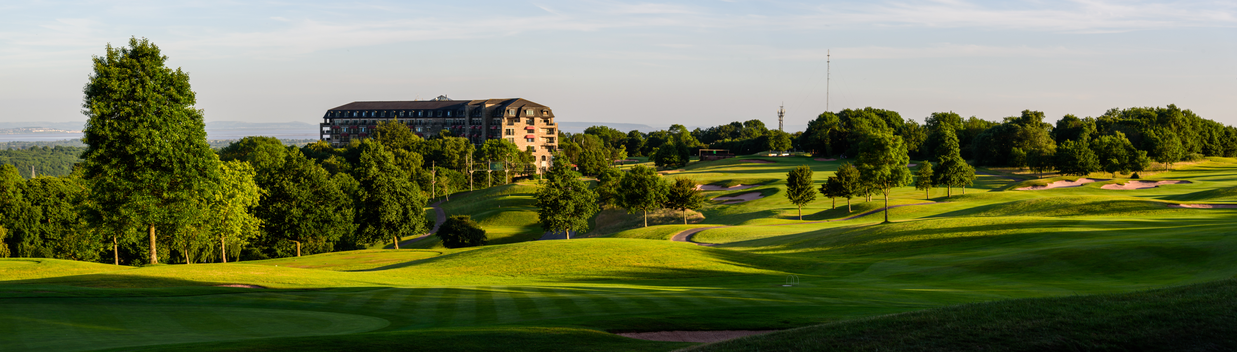
Hole | 1 | 2 | 3 | 4 | 5 | 6 | 7 | 8 | 9
Length (yards) | 461 | 605 | 189 | 458 | 447 | 436 | 212 | 437 | 614
Par | 4 | 5 | 3 | 4 | 4 | 4 | 3 | 4 | 5
Hole | 10 | 11 | 12 | 13 | 14 | 15 | 16 | 17 | 18
Length (yards) | 211 | 560 | 454 | 187 | 480 | 365 | 502 | 209 | 608
Par | 3 | 5 | 4 | 3 | 4 | 4 | 4 | 3 | 5
What do you notice? What do you wonder?
Exercise
(a) Which hole is the longest? (b) Which hole is the shortest?
(c) How many ‘par 3’ holes are there? (d) How many ‘par 4’ holes are there?
(e) How many ‘par 5’ holes are there? (f) What is the total par of the course?
Challenge! What is the total length of the course?

Scoring
A player receives a score for each completed hole of the golf course.
- If Peter uses 6 strokes to get the ball into hole 1, then his score for hole 1 is +2, as 6 is two more than the par for the hole (4).
- If Elen uses 2 strokes to get the ball into hole 7, then her score for hole 7 is –1, as 2 is one less than the par for the hole (3).
Here is Peter’s score card for a round of golf on the course.
Hole | 1 | 2 | 3 | 4 | 5 | 6 | 7 | 8 | 9
Peter’s strokes | 6 | 4 | 3 | 5 | 4 | 3 | 2 | 4 | 3
Par | 4 | 5 | 3 | 4 | 4 | 4 | 3 | 4 | 5
Score on the hole | +2 | +1 | 0 | –1 | 0 | –1 | –1 | 0 | –2
Score | +2 | +3 | +3 | +2 | +2 | +1 | 0 | 0 | –2
Hole | 10 | 11 | 12 | 13 | 14 | 15 | 16 | 17 | 18
Peter’s strokes | 3 | 6 | 4 | 5 | 4 | 3 | 5 | 2 | 4
Par | 3 | 5 | 4 | 3 | 4 | 4 | 4 | 3 | 5
Score on the hole | 0 | +1 | 0 | +2 | 0 | –1 | +1 | –1 | –1
Score | –2 | –1 | –1 | +1 | +1 | 0 | 1 | 0 | –1
Exercise
Complete Elen’s score card for a round of golf on the course.
Hole | 1 | 2 | 3 | 4 | 5 | 6 | 7 | 8 | 9
Elen’s strokes | 3 | 5 | 3 | 5 | 3 | 3 | 2 | 4 | 6
Par | 4 | 5 | 3 | 4 | 4 | 4 | 3 | 4 | 5
Score on the hole
Score
Hole | 10 | 11 | 12 | 13 | 14 | 15 | 16 | 17 | 18
Elen’s strokes | 3 | 7 | 4 | 3 | 5 | 4 | 3 | 3 | 3
Par | 3 | 5 | 4 | 3 | 4 | 4 | 4 | 3 | 5
Score on the hole
Score
Who had the better round of golf on the course: Peter or Elen?
Temperature

30°C

20°C

10°C

0°C

–10°C

–20°C

–30°C
Here is the temperature in 10 cities at 18:00 and 06:00 during January.
Paris (France): 10°C and 7°C.
New York (USA): 5°C and –2°C.
Tokyo (Japan): 10°C and 3°C.
Cardiff (Wales): 8°C and –1°C.
Buenos Aires (Argentina): 29°C and 21°C.
Oslo (Norway): –2°C and –7°C.
Sydney (Australia): 23°C and 18°C.
Delhi (India): 17°C and 14°C.
Moscow (Russia): –4°C and –10°C.
Berlin (Germany): 3°C and –3°C.
Exercise
The change in temperature for Paris was
10°C – 7°C = 3°C.
Write down the change in temperature for the other nine cities in a similar way.
Exercise
The temperature falls 7°C in the following cities. Fill in the blanks.
Los Angeles (USA): 18°C to _______. Beijing (China): _______ to –3°C.
Edinburgh (Scotland): 7°C to _______. Rome (Italy): _______ to 2°C.
Rio de Janeiro (Brazil): _______ to 24°C. Madrid (Spain): 9°C to _______.
Reykjavik (Iceland): _______ to –4°C. Seoul (South Korea): 2°C to ____.
Exercise
Explain what is happening to the temperature in the following sums.
(a) –5°C + 9°C (b) –8°C – 4°C
(c) 3°C – 4°C (d) –7°C + 3°C
Money
Many people use a current account in a bank to receive and pay money. Often the account allows an overdraft, which means that the account balance can be negative. (The account is said to be “in the red” when this happens.)
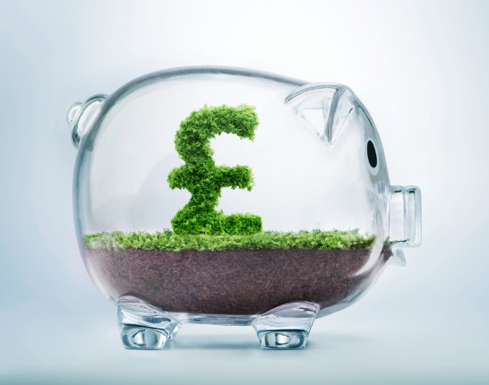
Here is an example of a bank statement, showing the payments and deposits for a particular month.
Mrs Meinir Jones  Current account statement  Sort code: 12-34-56  Account number: 21436587 |  | Banc Cymru  1 January – 31 January  Money in: £506.60  Money out: £476.22  Overdraft: £500
Date | Description | Money out | Money  in | Balance
01 Jan | Start balance |  |  | 305.00
04 Jan | Direct Debit:  Electricity Bill | 103.00 |  | 202.00
07 Jan | Card Payment to Tesco | 86.25 |  | 115.75
10 Jan | Card Payment to Amazon | 49.99 |  | 65.76
14 Jan | Card Payment to Paypal | 45.20 |  | 20.56
18 Jan | Card Payment to Lidl | 74.35 |  | –53.79
20 Jan | Direct Debit:  Water Bill | 55.00 |  | –108.79
24 Jan | Received from your employer |  | 506.60 | 397.81
30 Jan | Card Payment to Shell | 62.43 |  | 335.38
31 Jan | End balance |  |  | 335.38
What do you notice? What do you wonder?

Exercise
Fill in the blanks in the following bank statement.
Mrs Meinir Jones  Current account statement  Sort code: 12-34-56  Account number: 21436587 |  | Banc Cymru  1 February – 28 February  Money in: ________  Money out: ________  Overdraft: £500
Date | Description | Money out | Money  in | Balance
01 Feb | Start balance |  |  | 335.38
04 Feb | Direct Debit:  Electricity Bill | 103.00 |  | ______
05 Feb | Card Payment to Aldi | 72.48 |  | 159.90
07 Feb | Card Payment to Posh Restaurant | 48.52 |  | ______
10 Feb | Card Payment to Paypal | 34.50 |  | 76.88
12 Feb | Card Payment to Amazon | ______ |  | 52.48
17 Feb | Card Payment to Cinema | 12.50 |  | ______
20 Feb | Direct Debit:  Water Bill | 55.00 |  | ______
21 Feb | Card Payment to McDonalds | 5.40 |  | –20.42
21 Feb | Card Payment to Spar | 12.38 |  | ______
22 Feb | Card Payment to Primark | 39.96 |  | –72.76
24 Feb | Received from your employer |  | 541.36 | ______
25 Feb | Card Payment to Asda | 64.20 |  | 404.40
25 Feb | Card Payment to Boots | 8.42 |  | ______
27 Feb | Card Payment to Garej Gethin | ______ |  | 358.98
28 Feb | End balance |  |  | ______

Terminology
Here are the names for the different parts of any fraction.
Denominator
Numerator
Vinculum
$$\frac{\text{2}}{\text{5}}$$

- The vinculum is the horizontal line in the middle of the fraction.
- The numerator is the integer at the top of the fraction.
- The denominator is the integer at the bottom of the fraction.
Exercise
(a) Circle the fractions below with a numerator of 3.
$\frac{3}{4}$ $\frac{1}{3}$ $\frac{1}{2}$ $\frac{3}{5}$ $\frac{3}{7}$ $\frac{2}{3}$ $\frac{33}{34}$ $\frac{3}{7}$
(b) Circle the fractions below with a denominator of 4.
$\frac{4}{5}$ $\frac{1}{4}$ $\frac{4}{7}$ $\frac{3}{4}$ $\frac{1}{44}$ $\frac{5}{4}$ $\frac{4}{9}$ $\frac{4}{11}$
(c) Write down four fractions with a denominator of 7.
(d) Write down three fractions with a numerator of 5.
(e) Write down five fractions where the numerator is 2 less than the denominator.
(f) Write down four fractions where the denominator is double the numerator.
(g) Write down three fractions where the numerator is 1.
(h) Write down four fractions where the sum of the numerator and the denominator is seven.
(i) Write down three fractions where the difference between the numerator and the denominator is four.
(j) Write down two fractions where the denominator is four times the numerator.
Fraction of a Shape
To shade a fraction of a shape,
- Divide the shape into equal parts according to the number shown in the denominator;
- Shade the number of equal parts shown in the numerator.
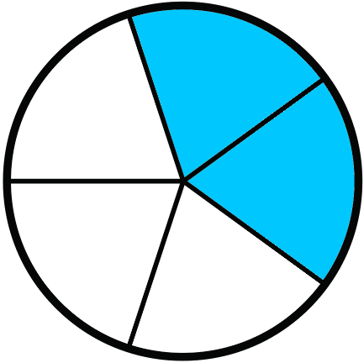
For example, to shade $\frac{2}{5}$ of a circle,
- Divide the circle into 5 equal parts;
- Shade 2 of the equal parts.
Notice that the parts must be equal parts.
Exercise
Which pictures below show $\frac{2}{5}$ of a shape being shaded?
(a) (b)
(c) (d)
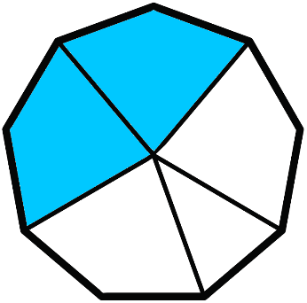
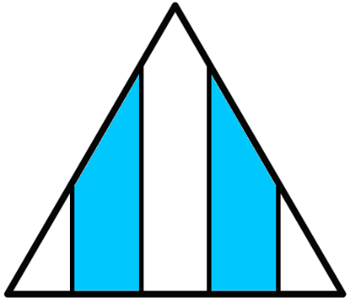

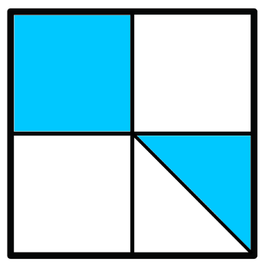
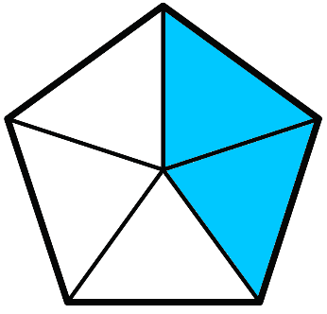
(e) (f) (g)
(h) (i) (j)

Recognising a Fraction of a Shape
Which fractions of the following shapes are shaded?
(a) 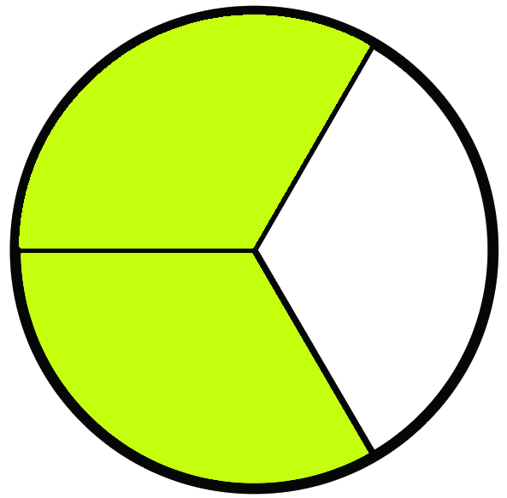 (b) 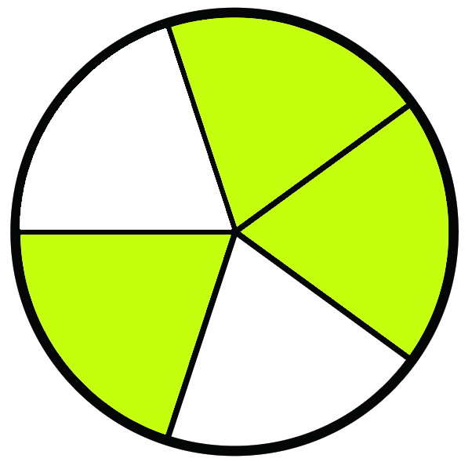 (c) 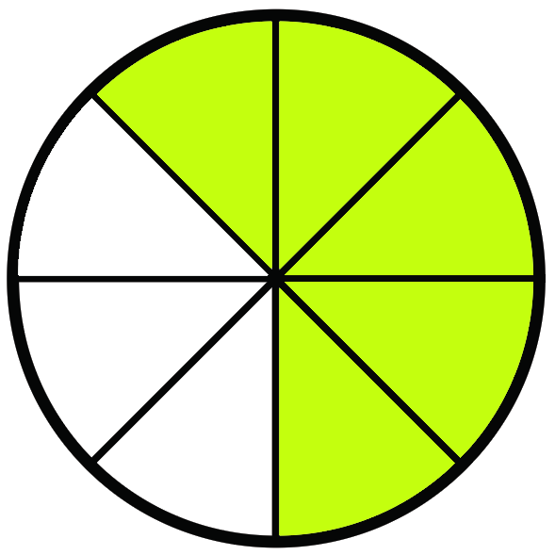
(d) 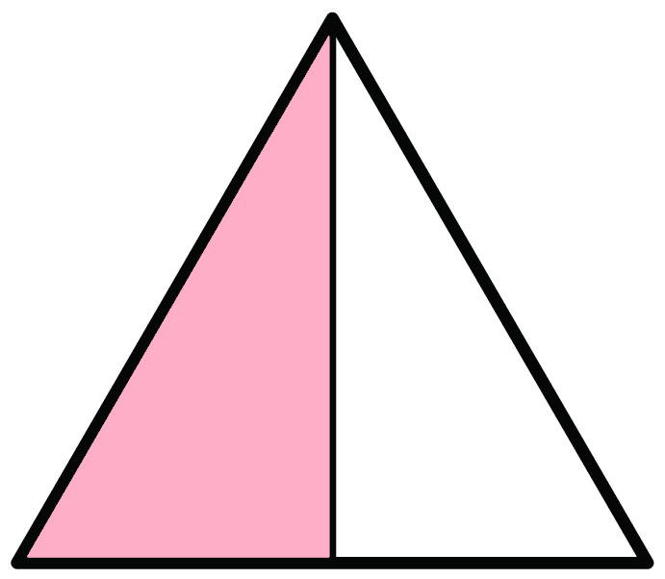 (e) 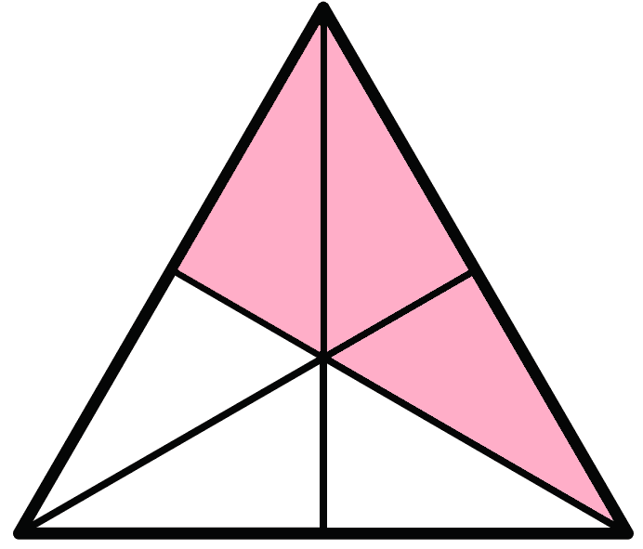 (f) 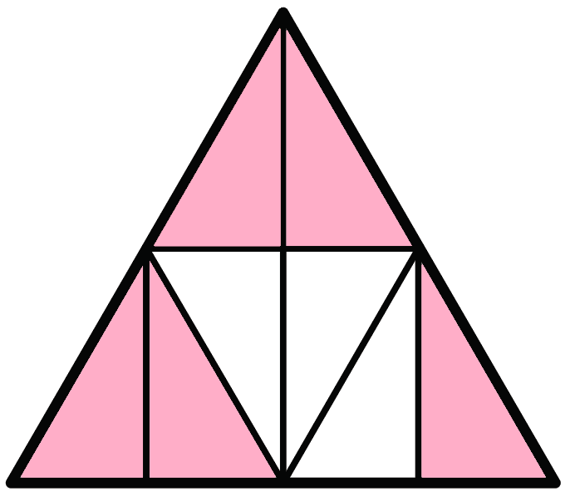
(g) 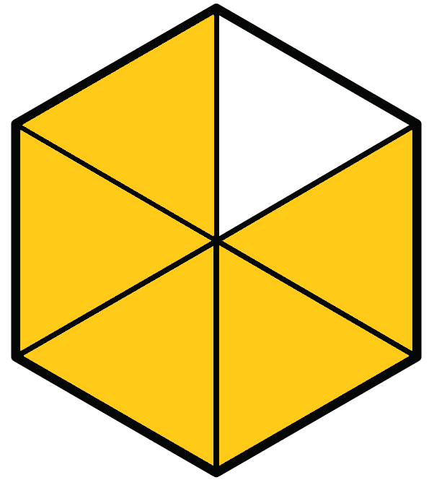 (h) 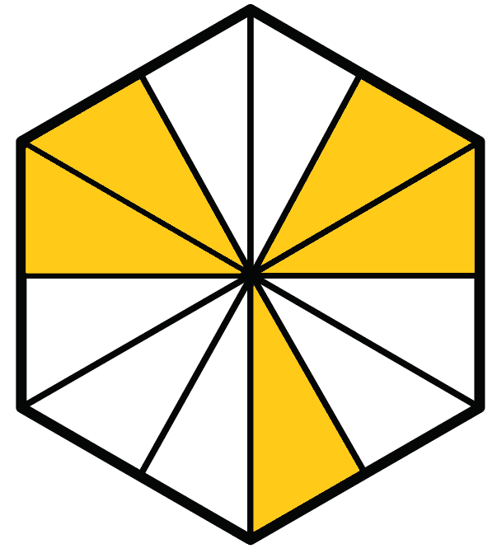 (i) 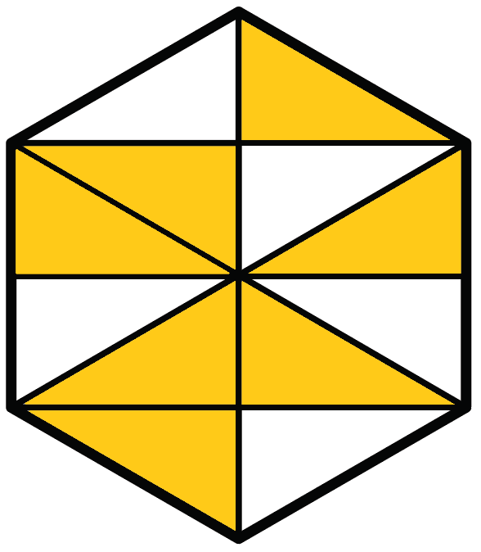
(j) 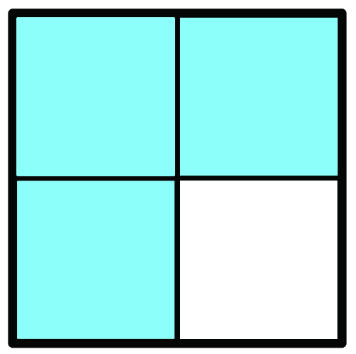 (k) 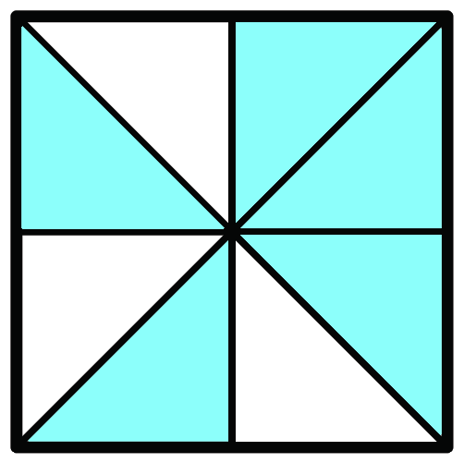 (l) 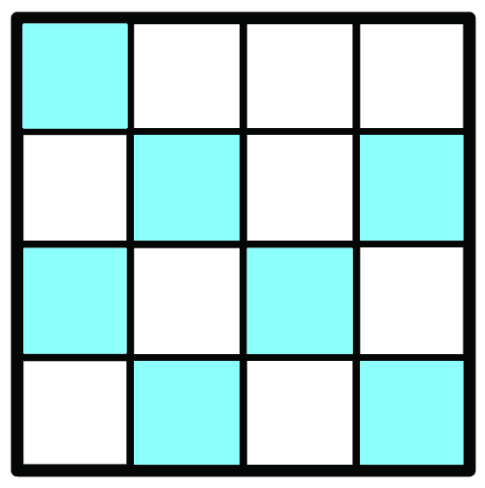
(m) 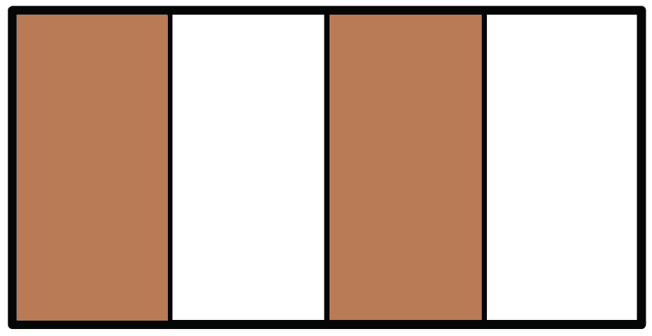 (n) 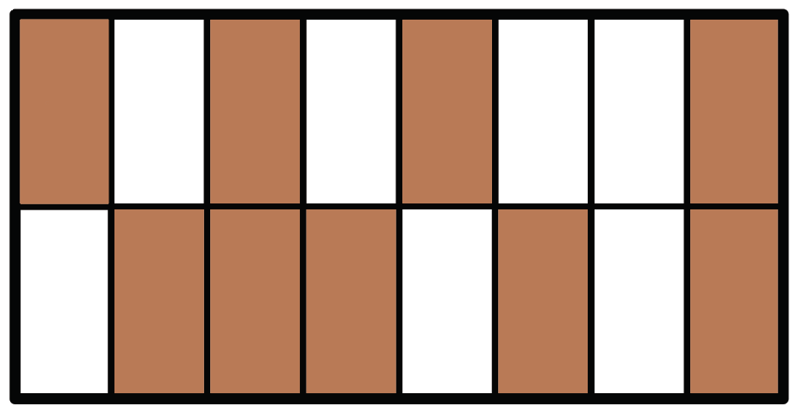

Exercise
Shade the fraction shown of each shape.

(a) $\frac{3}{10}$ (b) $\frac{5}{8}$ (c) $\frac{1}{4}$

(d) $\frac{2}{6}$ (e) $\frac{6}{6}$ (f) $\frac{7}{12}$

(g) $\frac{3}{5}$ (h) $\frac{7}{8}$ (i) $\frac{3}{8}$

(j) $\frac{9}{16}$ (k) $\frac{1}{2}$ (l) $\frac{1}{4}$

(m) $\frac{5}{8}$ (n) $\frac{11}{16}$
Exercise
By dividing each shape into parts of equal area, shade the fraction that is shown beside each shape.
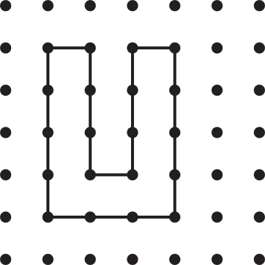
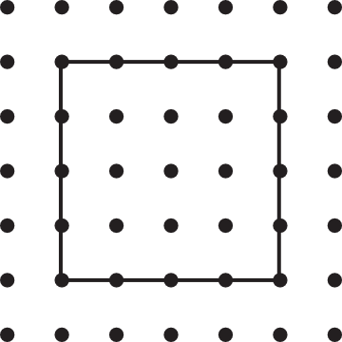
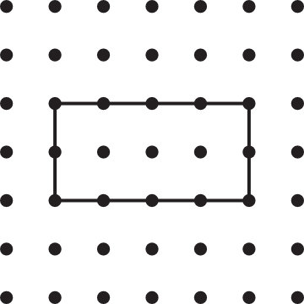

(a) $\frac{1}{2}$ (b) $\frac{1}{4}$ (c) $\frac{2}{3}$
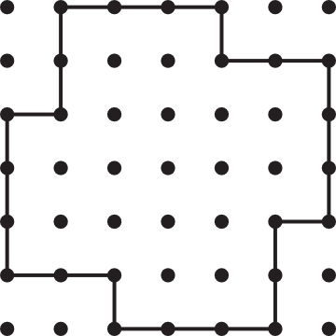
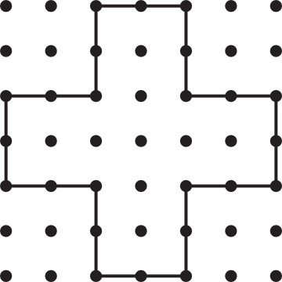

(d) $\frac{2}{5}$ (e) $\frac{3}{4}$ (f) $\frac{3}{4}$
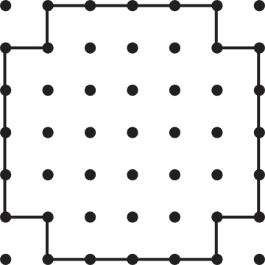
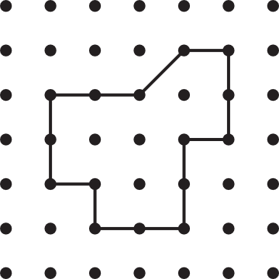
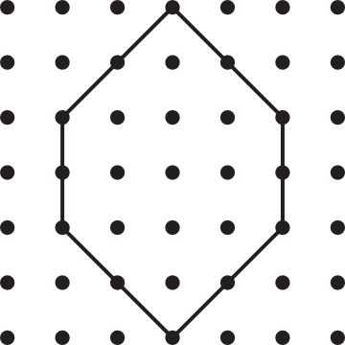

(g) $\frac{2}{3}$ (h) $\frac{5}{8}$ (i) $\frac{3}{8}$
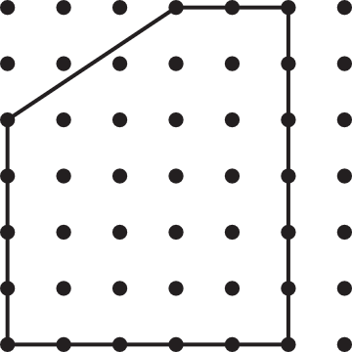
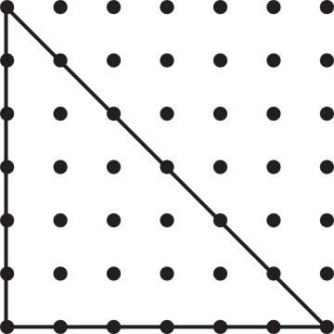
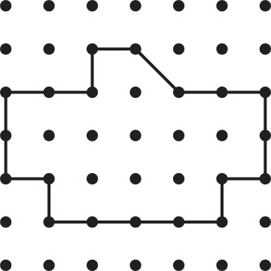

(j) $\frac{3}{5}$ (k) $\frac{5}{9}$ (l) $\frac{4}{9}$
Are there different ways of answering the above questions? Discuss.

Calculating a Fraction of a Number (fraction as an operator)
Example
Calculate $\frac{3}{7}$ of £42.
Because the denominator of the fraction is 7, we draw a bar model containing 7 blocks, to represent the £42.
£42
Next, we calculate the value of one block, by dividing the £42 equally between the 7 blocks: £42 ÷ 7 = £6.
£42

£6 | £6 | £6 | £6 | £6 | £6 | £6
The question asks for $\frac{3}{7}$ of £42, so we need to find the value of three of the blocks: 3 × £6 = £18. This is the answer to the question.
Exercise
Draw a suitable bar model to answer the following questions.
(a) $\frac{2}{3}$ of £12 (b) $\frac{3}{5}$ of £15 (c) $\frac{1}{4}$ of £12

(d) $\frac{5}{6}$ of £36 (e) $\frac{2}{7}$ of £21 (f) $\frac{7}{8}$ of £40

Exercise
Connect the following cards in groups of three.
$\frac{1}{2}$ of 30 |  |  |  | 16
  7 | 7 | 7 | 7 | 7 | 7 | 7
$\frac{2}{3}$ of 24 |  |  |  | 15
  5 | 5 | 5 | 5 | 5 | 5 | 5 | 5 | 5
$\frac{7}{9}$ of 45 |  |  |  | 28
  5 | 5 | 5 | 5 | 5 | 5
$\frac{4}{7}$ of 49 |  |  |  | 35
  15 | 15
$\frac{5}{6}$ of 30 |  |  |  | 25
  8 | 8 | 8
Exercise
(a) My dog has had 15 puppies, with $\frac{2}{3}$ of the puppies being sold. How many puppies have been sold, and how many puppies are left?
(b) John has 54 stickers. He gives $\frac{4}{9}$ of the stickers to Tom. How many stickers has he given to Tom, and how many stickers are left?
(c) Sam had £5 of pocket money. He spent $\frac{7}{10}$ of the money on a book. How much money did Sam spend, and how much money does he have left?
(d) In a game of cricket, Sali managed to hit $\frac{4}{5}$ of the balls being bowled towards her. If 40 balls in total were bowled towards Sali, how many balls did she manage to hit, and how many balls did she miss?
Fractions and Time

Exercise
(a) In ____ minutes, the minute hand of the clock goes $\frac{1}{4}$ of the way around the clock.
(b) In ____ minutes, the minute hand of the clock goes $\frac{1}{6}$ of the way around the clock.
(c) In 30 minutes, the minute hand of the clock goes _____ of the way around the clock.
(d) In 5 minutes, the minute hand of the clock goes _____ of the way around the clock.
(e) In ____ minutes, the minute hand of the clock goes $\frac{1}{3}$ of the way around the clock.
(f) In ____ minutes, the minute hand of the clock goes $\frac{2}{3}$ of the way around the clock.
(g) In ____ minutes, the minute hand of the clock goes $\frac{3}{4}$ of the way around the clock.
(h) In 50 minutes, the minute hand of the clock goes _____ of the way around the clock.
(i) In 35 minutes, the minute hand of the clock goes _____ of the way around the clock.
(j) In 1 minute, the minute hand of the clock goes _____ of the way around the clock.
(k) In 60 minutes, the hour hand of the clock goes _____ of the way around the clock.
(l) In 180 minutes, the hour hand of the clock goes _____ of the way around the clock.

Fraction as a Division Sum (fraction as a number)
It is possible to write the fraction $\frac{2}{5}$ as the division sum 2 ÷ 5.
The name of the symbol ÷ is the obelus, a symbol that looks like a fraction, with dots representing the numerator and the denominator.
Each fraction has a specific location on the number line. Here are two methods for finding the location of $\frac{2}{5}$ on the number line.
Method 1  (the division method, 2 ÷ 5)  Start with a bar model showing 2 on a number line.  Divide the bar into 5 equal parts.  The location of $\frac{2}{5}$ on the number line is where the first part of the bar finishes. | Method 2  (the unit method, finding $\frac{2}{5}$ of 1)  Start with a bar model showing 1 on a number line.  Divide the bar into 5 equal parts.  The location of $\frac{2}{5}$ on the number line is where the second part of the bar finishes.
  0 |  |  |  |  | 1 |  |  |  |  | 2
  0 |  |  |  |  | 1 |  |  |  |  | 2
  0 |  |  |  |  | 1 |  |  |  |  | 2
  0 |  |  |  |  | 1 |  |  |  |  | 2
  0 |  |  |  |  | 1 |  |  |  |  | 2
  0 |  |  |  |  | 1 |  |  |  |  | 2
Exercise
Discuss how the following two diagrams show the location of the fraction $\frac{3}{10}$ on the number line.
  0 |  |  |  |  |  |  |  |  |  | 1 |  |  |  |  |  |  |  |  |  | 2 |  |  |  |  |  |  |  |  |  | 3
  0 |  |  |  |  |  |  |  |  |  | 1 |  |  |  |  |  |  |  |  |  | 2 |  |  |  |  |  |  |  |  |  | 3

Exercise
Add arrows on the following number lines to show the location of the fractions.
(a) $\frac{3}{4}$
  0 |  |  |  | 1 |  |  |  | 2 |  |  |  | 3
  0 |  |  |  | 1 |  |  |  | 2 |  |  |  | 3

(b) $\frac{2}{7}$
  0 |  |  |  |  |  |  | 1 |  |  |  |  |  |  | 2
  0 |  |  |  |  |  |  | 1 |  |  |  |  |  |  | 2

(c) $\frac{4}{5}$
  0 |  |  |  |  | 1 |  |  |  |  | 2 |  |  |  |  | 3 |  |  |  |  | 4
  0 |  |  |  |  | 1 |  |  |  |  | 2 |  |  |  |  | 3 |  |  |  |  | 4

(d) $\frac{3}{2}$
  0 |  | 1 |  | 2 |  | 3
  0 |  | 1 |  | 2 |  | 3
Exercise
On a piece of squared paper, draw suitable diagrams to show the location of the following fractions on a number line.
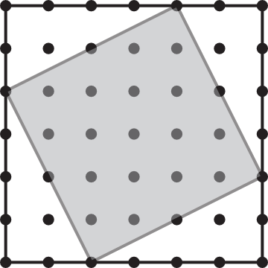
(a) $\frac{3}{5}$ (b) $\frac{1}{5}$ (c) $\frac{4}{5}$
(d) $\frac{5}{2}$ (e) $\frac{3}{3}$ (f) $\frac{3}{7}$
Challenge!
What fraction of the square on the right is shaded?

Comparing the Size of Fractions
Which fraction is the greatest: $\frac{2}{5}$ or $\frac{3}{7}$? Using the unit method, we can locate both fractions on a number line:
0 |  |  |  |  |  |  |  |  |  |  |  |  |  |  |  |  |  |  |  |  |  |  |  |  |  |  |  |  |  |  |  |  |  |  | 1

We can see from the diagram that $\frac{2}{5}$ is less than $\frac{3}{7}$, so we write $\frac{2}{5}<\frac{3}{7}$.
< ‘less than’ > ‘greater than’ = ‘equal to’
Exercise
Write the symbol <, > or = between the following pairs of fractions.
(a) $\frac{3}{4} \frac{5}{6}$
0 |  |  |  |  |  |  |  |  |  |  |  |  |  |  |  |  |  |  |  |  |  |  |  | 1
(b) $\frac{2}{8} \frac{1}{4}$
0 |  |  |  |  |  |  |  |  |  |  |  |  |  |  |  | 1
(c) $\frac{2}{3} \frac{1}{4}$
0 |  |  |  |  |  |  |  |  |  |  |  |  |  |  |  |  |  |  |  |  |  |  |  | 1
(d) $\frac{7}{10} \frac{4}{5}$
0 |  |  |  |  |  |  |  |  |  |  |  |  |  |  |  |  |  |  |  | 1
(e) $\frac{4}{10} \frac{2}{5}$
0 |  |  |  |  |  |  |  |  |  |  |  |  |  |  |  |  |  |  |  | 1
(f) $\frac{2}{5} \frac{1}{2}$
0 |  |  |  |  |  |  |  |  |  |  |  |  |  |  |  |  |  |  |  | 1
(g) $\frac{5}{9} \frac{2}{3}$
0 |  |  |  |  |  |  |  |  |  |  |  |  |  |  |  |  |  |  |  |  |  |  |  |  |  |  | 1
(h) $\frac{6}{9} \frac{2}{3}$
0 |  |  |  |  |  |  |  |  |  |  |  |  |  |  |  |  |  |  |  |  |  |  |  |  |  |  | 1
(i) $\frac{7}{12} \frac{3}{4}$
0 |  |  |  |  |  |  |  |  |  |  |  |  |  |  |  |  |  |  |  |  |  |  |  | 1
(j) $\frac{18}{24} \frac{3}{4}$
0 |  |  |  |  |  |  |  |  |  |  |  |  |  |  |  |  |  |  |  |  |  |  |  | 1

Changing the Numerator
What happens to the size of a fraction when the denominator is kept the same and the numerator is increased?
$\frac{1}{5}$
0 |  |  |  |  |  |  |  |  |  |  |  |  |  |  |  |  |  |  |  | 1

$\frac{2}{5}$
0 |  |  |  |  |  |  |  |  |  |  |  |  |  |  |  |  |  |  |  | 1

$\frac{3}{5}$
0 |  |  |  |  |  |  |  |  |  |  |  |  |  |  |  |  |  |  |  | 1

We see from the above diagrams that the size of a fraction increases when the denominator is kept the same and the numerator increases.
Exercise
Circle the greatest fraction in each of the following pairs of fractions.
(a) $\frac{2}{5}$ and $\frac{3}{5}$ (b) $\frac{3}{5}$ and $\frac{4}{5}$ (c) $\frac{2}{7}$ and $\frac{5}{7}$
(d) $\frac{6}{7}$ and $\frac{3}{7}$ (e) $\frac{3}{4}$ and $\frac{1}{4}$ (f) $\frac{7}{8}$ and $\frac{3}{8}$
(g) $\frac{4}{9}$ and $\frac{7}{9}$ (h) $\frac{4}{11}$ and $\frac{5}{11}$ (i) $\frac{10}{11}$ and $\frac{8}{11}$
(j) $\frac{3}{2}$ and $\frac{5}{2}$ (k) $\frac{5}{5}$ and $\frac{6}{5}$ (l) $\frac{76}{123}$ and $\frac{107}{123}$

Challenge!
Write a single digit between 1 and 9 in each of the boxes on the right to create the greatest fraction that is less than a half.

Changing the Denominator
What happens to the size of a fraction when the numerator is kept the same and the denominator is increased?
$\frac{2}{3}$
0 |  |  |  |  |  |  |  |  |  |  |  |  |  |  |  |  |  | 1

$\frac{2}{4}$
0 |  |  |  |  |  |  |  |  |  |  |  |  |  |  |  |  |  |  |  | 1

$\frac{2}{5}$
0 |  |  |  |  |  |  |  |  |  |  |  |  |  |  |  |  |  |  |  | 1

We can see from the above diagrams that the size of a fraction decreases when the numerator is kept the same and the denominator increases.
Exercise
Circle the greatest fraction in each of the following pairs of fractions.
(a) $\frac{2}{4}$ and $\frac{2}{5}$ (b) $\frac{3}{5}$ and $\frac{3}{4}$ (c) $\frac{2}{7}$ and $\frac{2}{5}$
(d) $\frac{6}{7}$ and $\frac{6}{11}$ (e) $\frac{3}{4}$ and $\frac{3}{2}$ (f) $\frac{7}{8}$ and $\frac{7}{9}$
(g) $\frac{2}{9}$ and $\frac{2}{7}$ (h) $\frac{4}{11}$ and $\frac{4}{13}$ (i) $\frac{10}{11}$ and $\frac{10}{7}$
(j) $\frac{4}{3}$ and $\frac{4}{5}$ (k) $\frac{5}{5}$ and $\frac{5}{8}$ (l) $\frac{76}{123}$ and $\frac{76}{122}$
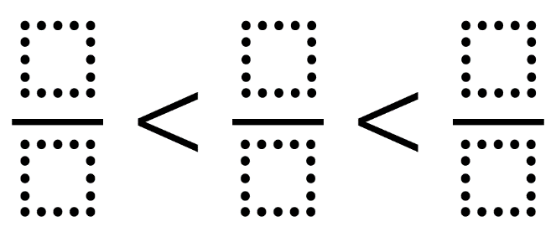
Challenge!
Write a different single digit between 1 and 9 in each of the boxes on the right to form a true statement.
The Fraction Wall
One whole
$\frac{1}{2}$ |  |  |  |  |  |  |  |  |  |  |  |  |  |  |  | $\frac{1}{2}$
$\frac{1}{3}$ |  |  |  |  |  |  |  |  |  |  | $\frac{1}{3}$ |  |  |  |  |  |  |  |  |  | $\frac{1}{3}$
$\frac{1}{4}$ |  |  |  |  |  |  |  | $\frac{1}{4}$ |  |  |  |  |  |  |  | $\frac{1}{4}$ |  |  |  |  |  |  |  | $\frac{1}{4}$
$\frac{1}{5}$ |  |  |  |  |  | $\frac{1}{5}$ |  |  |  |  |  |  | $\frac{1}{5}$ |  |  |  |  |  | $\frac{1}{5}$ |  |  |  |  |  |  | $\frac{1}{5}$
$\frac{1}{6}$ |  |  |  |  | $\frac{1}{6}$ |  |  |  |  |  | $\frac{1}{6}$ |  |  |  |  | $\frac{1}{6}$ |  |  |  |  | $\frac{1}{6}$ |  |  |  |  |  | $\frac{1}{6}$
$\frac{1}{7}$ |  |  |  | $\frac{1}{7}$ |  |  |  |  | $\frac{1}{7}$ |  |  |  |  | $\frac{1}{7}$ |  |  |  | $\frac{1}{7}$ |  |  |  |  | $\frac{1}{7}$ |  |  |  |  | $\frac{1}{7}$
$\frac{1}{8}$ |  |  | $\frac{1}{8}$ |  |  |  |  | $\frac{1}{8}$ |  |  |  | $\frac{1}{8}$ |  |  |  | $\frac{1}{8}$ |  |  |  | $\frac{1}{8}$ |  |  |  | $\frac{1}{8}$ |  |  |  |  | $\frac{1}{8}$
$\frac{1}{9}$ |  | $\frac{1}{9}$ |  |  |  |  | $\frac{1}{9}$ |  |  |  | $\frac{1}{9}$ |  |  |  | $\frac{1}{9}$ |  | $\frac{1}{9}$ |  |  |  | $\frac{1}{9}$ |  |  |  | $\frac{1}{9}$ |  |  |  |  | $\frac{1}{9}$
$\frac{1}{10}$ | $\frac{1}{10}$ |  |  |  |  | $\frac{1}{10}$ |  |  |  | $\frac{1}{10}$ |  |  | $\frac{1}{10}$ |  |  | $\frac{1}{10}$ |  |  | $\frac{1}{10}$ |  |  | $\frac{1}{10}$ |  |  |  | $\frac{1}{10}$ |  |  |  |  | $\frac{1}{10}$
What do you notice? What do you wonder?
Exercise
(a) Which two fractions add together to give $\frac{1}{2}$?
(b) Find two different ways of writing $\frac{1}{3}$.
(c) Find a different way of writing $\frac{3}{4}$.
(d) Which fraction is the greatest: $\frac{3}{8}$ or $\frac{4}{10}$?
(e) Which fraction is the least: $\frac{3}{5}$ or $\frac{5}{8}$?
(f) How many tenths should be added to $\frac{2}{5}$ to make one whole?
(g) Look at the following pattern of fractions: $\frac{1}{2}$, $\frac{2}{3}$, $\frac{3}{4}$, $\frac{4}{5}$, $\frac{5}{6}$, $\frac{6}{7}$, ...
(i) What is the next fraction in the pattern?
(ii) What happens to the value of the fractions as the pattern continues?
(iii) Will a fraction with a value of more than one appear in the pattern?

Venn Diagram Challenge

Greater than $\frac{1}{2}$
The numerator is 2
Less than $\frac{3}{4}$
E
F
H
D
G
CF
B
A
$$ε$$

Think of a fraction that could fit into each region.
If you think a region is impossible to fill, explain why!
A
B
CF
D
E
F
G
H
The Story of $\frac{2}{5}$
Shade $\frac{2}{5}$ of the shape. |  | Shade $\frac{2}{5}$ of the shape. |  | Shade $\frac{2}{5}$ of the shapes.
Write $\frac{2}{5}$ in words. |  | What is the numerator of $\frac{2}{5}$? |  | What is the denominator of $\frac{2}{5}$?
Locate $\frac{2}{5}$ on the number line. |  | Calculate $\frac{2}{5}$ of 35. |  | Calculate $\frac{2}{5}×15$.
  0 |  |  |  |  |  |  |  |  |  | 1
Which division sum does $\frac{2}{5}$ represent? |  | Write down a fraction that is equivalent to (the same as) the fraction $\frac{2}{5}$. |  | Write down two fractions that add to give $\frac{2}{5}$.
Catrin has 2 apples and 5 bananas. Fill in the missing fractions.

The number of apples is of the total fruit.
The number of bananas is of the total fruit.
The number of apples is of the bananas.
True or False?
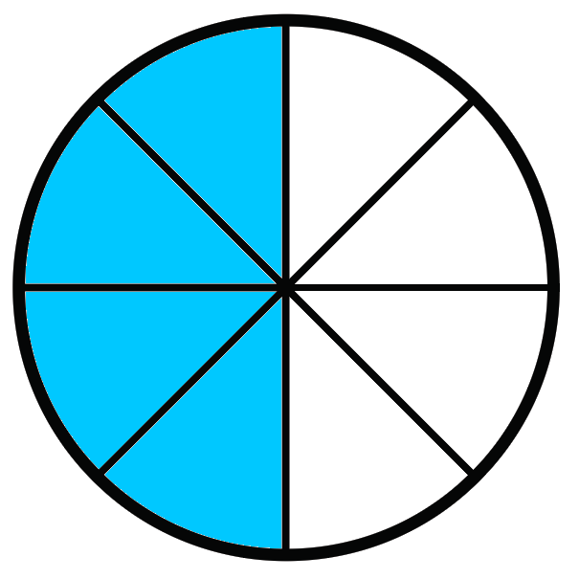  $\frac{3}{8}$ of the shape is shaded. | $$\frac{6}{12}$$  The denominator is double the numerator. | 48 children eat in the school’s refectory. If $\frac{1}{4}$ of the children eat sandwiches, 12 children each sandwiches. | $$\frac{3}{4} < \frac{3}{5}$$
In 10 minutes, the minute hand of the clock goes $\frac{1}{6}$ of the way around the clock. | $\frac{2}{3}$ of £24 is £16. | $$\frac{1}{3} < \frac{1}{10}$$ | $$\frac{8}{15}$$  The difference between the numerator and the denominator is seven.
There are 49 books in the library. If Nia has read $\frac{3}{7}$ of the books, she has read 14 of the books. | The arrow points towards the fraction $\frac{3}{4}$. | $\frac{5}{9}$ of the shape is shaded. | In 40 minutes, the minute hand of the clock goes $\frac{3}{4}$ of the way around the clock.
  0 |  |  |  |  | 1
$$\frac{4}{5}$$  The numerator of the fraction is 5. | $$\frac{4}{5} = \frac{12}{15}$$ | The arrow points towards the fraction $\frac{5}{8}$. | $\frac{3}{8}$ of 32 is 7.
  0 |  |  |  |  |  |  |  | 1
$\frac{2}{5}$ of the stars have been shaded. | $\frac{4}{6}$, when written in words, is ‘four sixths’. | $$\frac{6}{7} > \frac{5}{7}$$ | $$\frac{4}{7}$$  The denominator of the fraction is 7.

