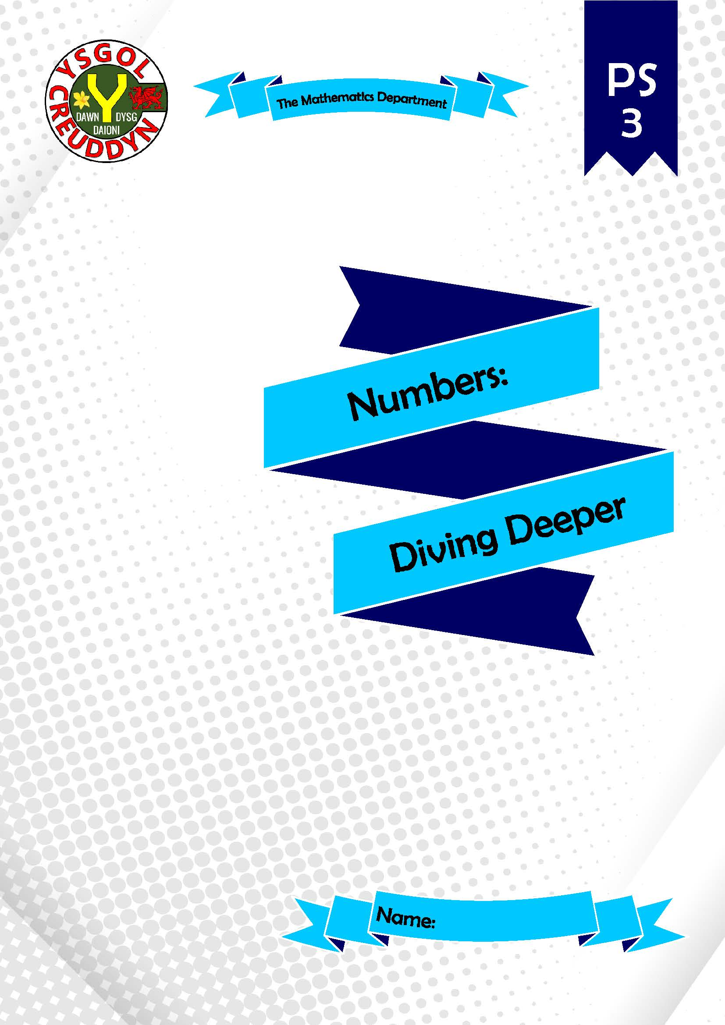
Numbers: Diving Deeper
A workbook for Curriculum for Wales
Mathematics and Numeracy Area of Learning and Experience
Progression Step 3
Teacher’s Guide
Version 1 (August 4th, 2021)
Authors:
- Dr Gareth Evans, www.mathemateg.com
- Teachers from the following primary schools, which took part in the Creuddyn Primary Cluster project during the first half of 2021: Ysgol Morfa Rhianedd, Ysgol Bod Alaw, Ysgol Betws yn Rhos.

Mathematical proficiencies icons:
Conceptual understanding | Communication using symbols | Strategic competence | Logical reasoning | Fluency

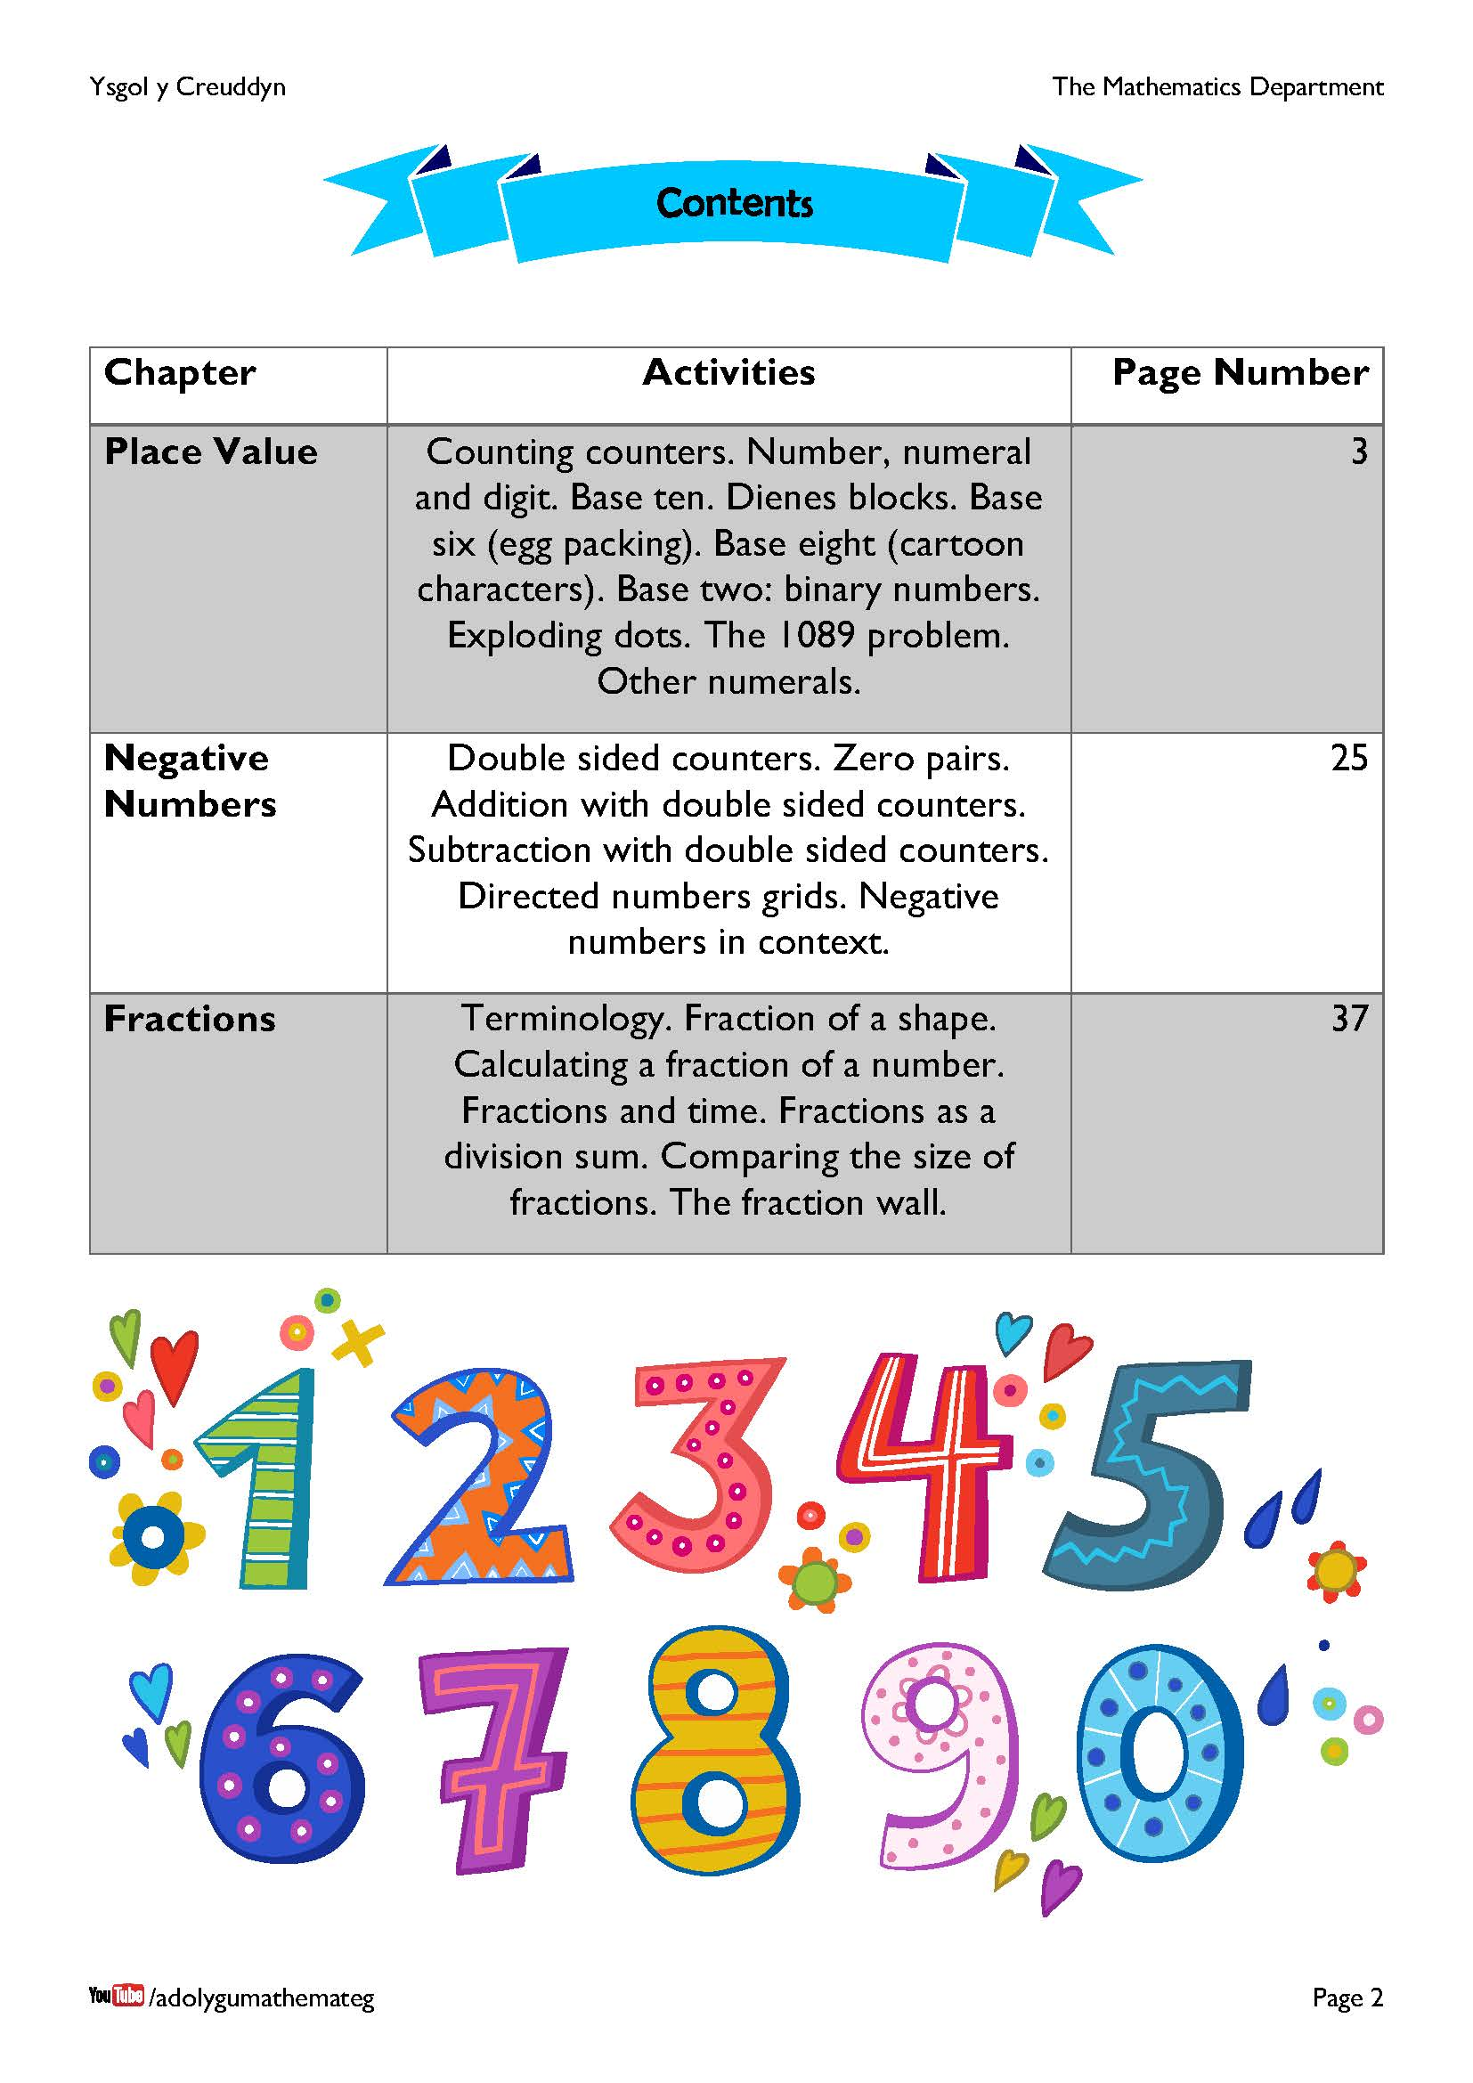
This workbook deals with the following descriptions of learning.
The number system is used to represent and compare relationships between numbers and quantities.
THE NUMBER SYSTEM
- I can use a range of representations to develop and secure my understanding that the value of a digit is related to its position.
- I can use a range of representations to extend my understanding of the number system to include negative values and fractions.
RELATIONSHIPS WITHIN THE NUMBER SYSTEM
- I can demonstrate my understanding that non-integer quantities can be represented using fractions (including fractions greater than 1). I can use my knowledge of equivalence to compare the size of simple fractions.
- I can demonstrate my understanding that a fraction can be used as an operator or to represent division. I can understand the inverse relation between the denominator of a fraction and its value.
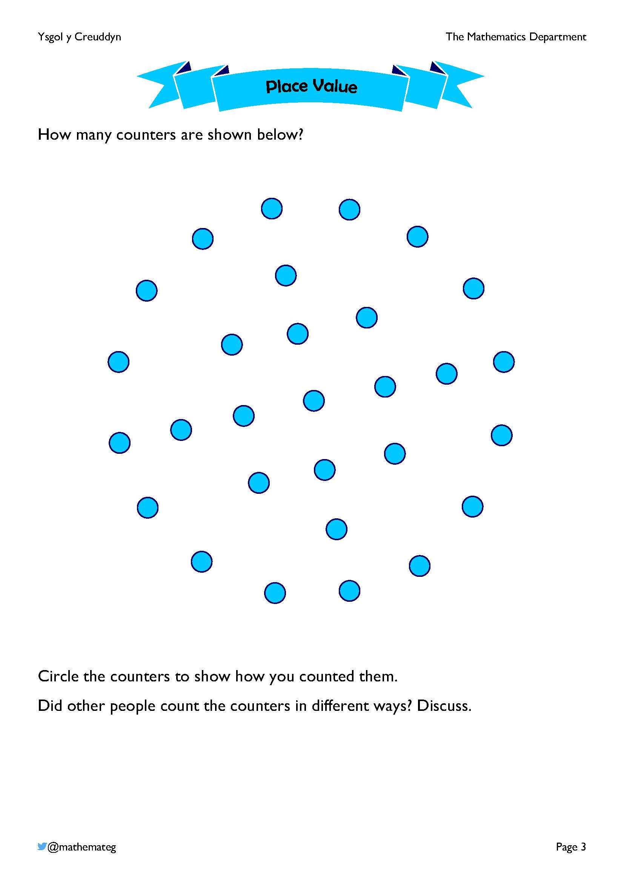
The purpose of this exercise is to discuss different strategies of counting the counters in the picture.
Do you start with the ‘9 square’ in the middle, or with the circle on the outside? If you start with the circle on the outside, how do you split it up?

It is likely that nobody grouped the counters in sets of ten, even though our usual number system is based on grouping in sets of ten. This workbook discusses different ways of counting, based on grouping not by ten, but by a different base number.
Encourage the learners to use appropriate mathematical language whilst discussing how to count the counters.
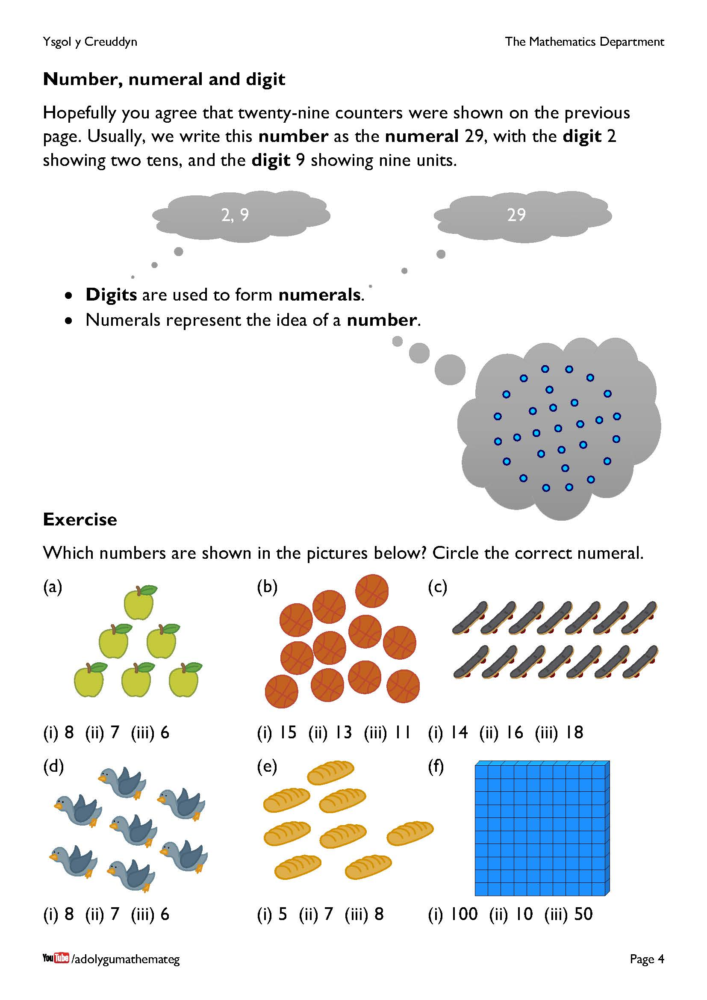
The following YouTube video discusses the terms number, numeral and digit: https://www.youtube.com/watch?v=jkWMJVBmYL0
In our usual system of writing numbers, we have ten different digits available:
0 1 2 3 4 5 6 7 8 9
It is possible to use these digits, either on their own or in combination with other digits, to form numerals, e.g.
3 7 16 72 109 167 267 926 1029 3928
Each numeral represents the idea of a particular number.
For example, the numeral 3 represents the idea of ‘three’, which could (for example) represent three hot air balloons flying together.


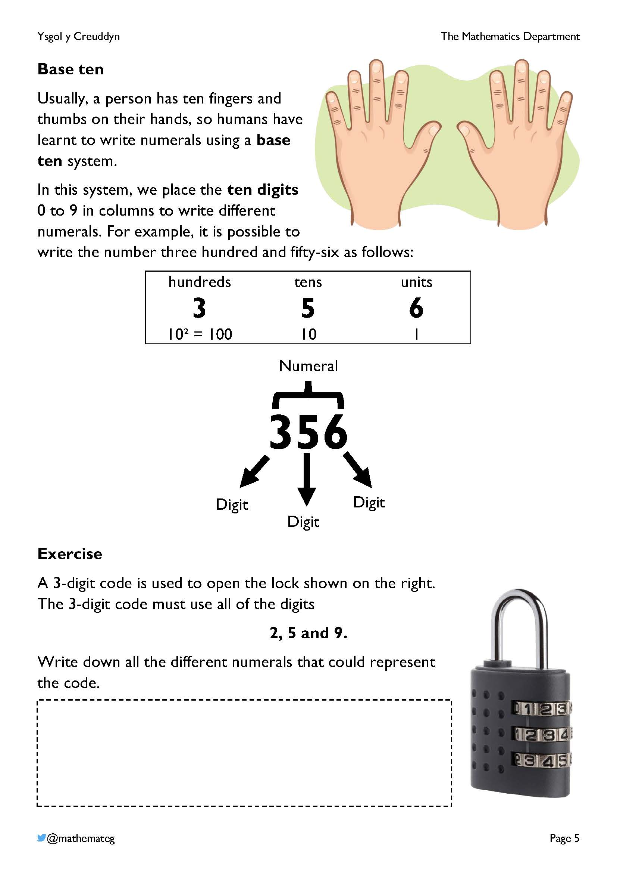
We are used to writing numerals in base ten, but is this the best base to use?
The factors of 10 are 1, 2, 5 and 10, which means that there are only four ways of arranging ten counters in the shape of a rectangle:
1 × 10 One row of ten
2 × 5 Two rows of five
5 × 2 Five rows of two
10 × 1 Ten rows of one
It is not straightforward to divide ten counters into three parts, or into four parts.
Base twelve would have been better, because 12 has more factors (1, 2, 3, 4, 6 and 12). Base twelve was not adopted of course because we do not have twelve fingers and thumbs on our hands. BUT! If you look at your fingers, you have 3 knuckles on each finger. So, it is possible to count in twelves using the four fingers on one of your hands. You can even use your thumb to count, touching each of the knuckles in turn.
Even though we do not write numbers in base twelve, counting in sets of twelve is used in different places. Twelve hours are shown on a standard clock; there are twelve inches in a foot; an old shilling was made up of twelve pennies; and there are twelve months in a year.
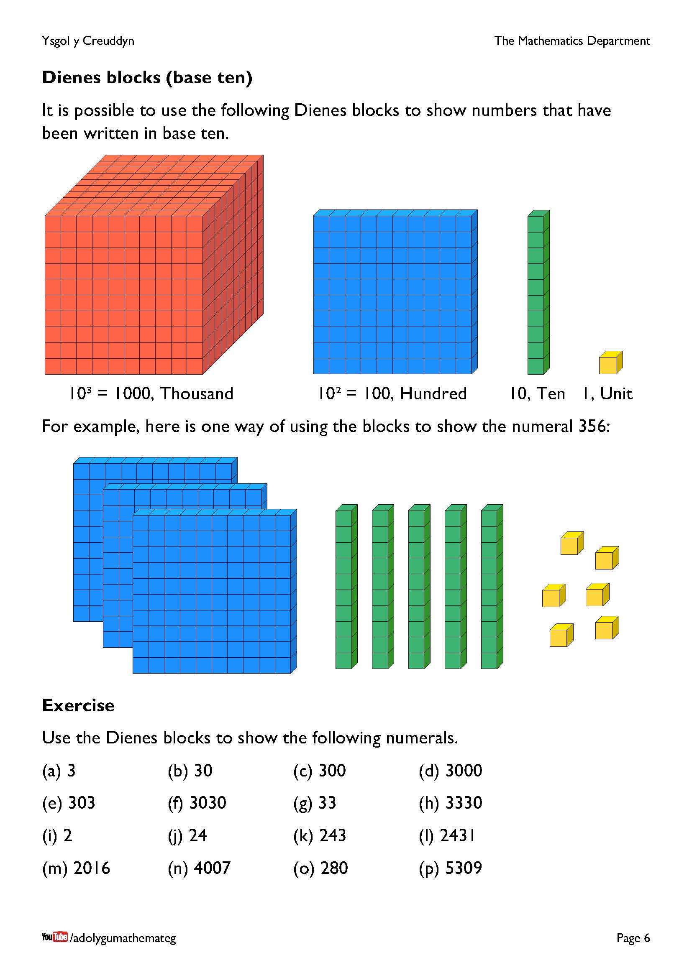
Dienes blocks provide a concrete way of showing that the value of a digit depends upon its location in a numeral.
Physical sets of these manipulatives can be purchased, or electronic versions are available on the following websites:
https://mathsbot.com/manipulatives/blocks
https://mathigon.org/polypad

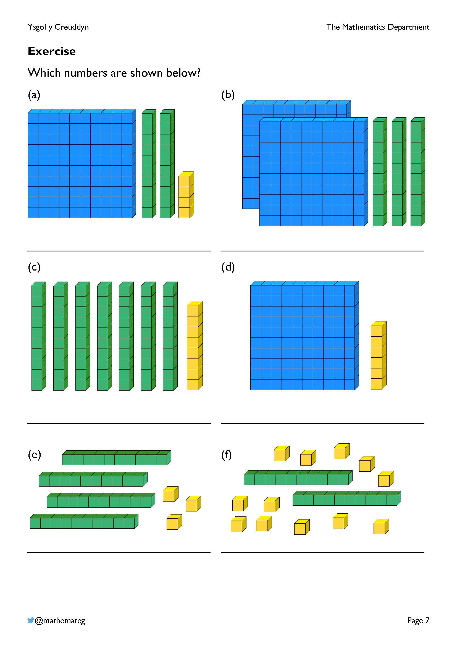
For the final question, (f), ask whether there is a better way of presenting the number under consideration.
- It would be easier to recognise the number if the yellow blocks were arranged better.
- It would be possible to exchange ten of the yellow blocks for one green rod.
Look out for not including/mis-placing the zero digit in the answers to (b) and (d). That is, correct the misconception that the answer to (b) is 23 or 203, and the answer to (d) is 16 or 160.
Do not move on to work with other bases until the learners are comfortable with the idea of place value in base ten.

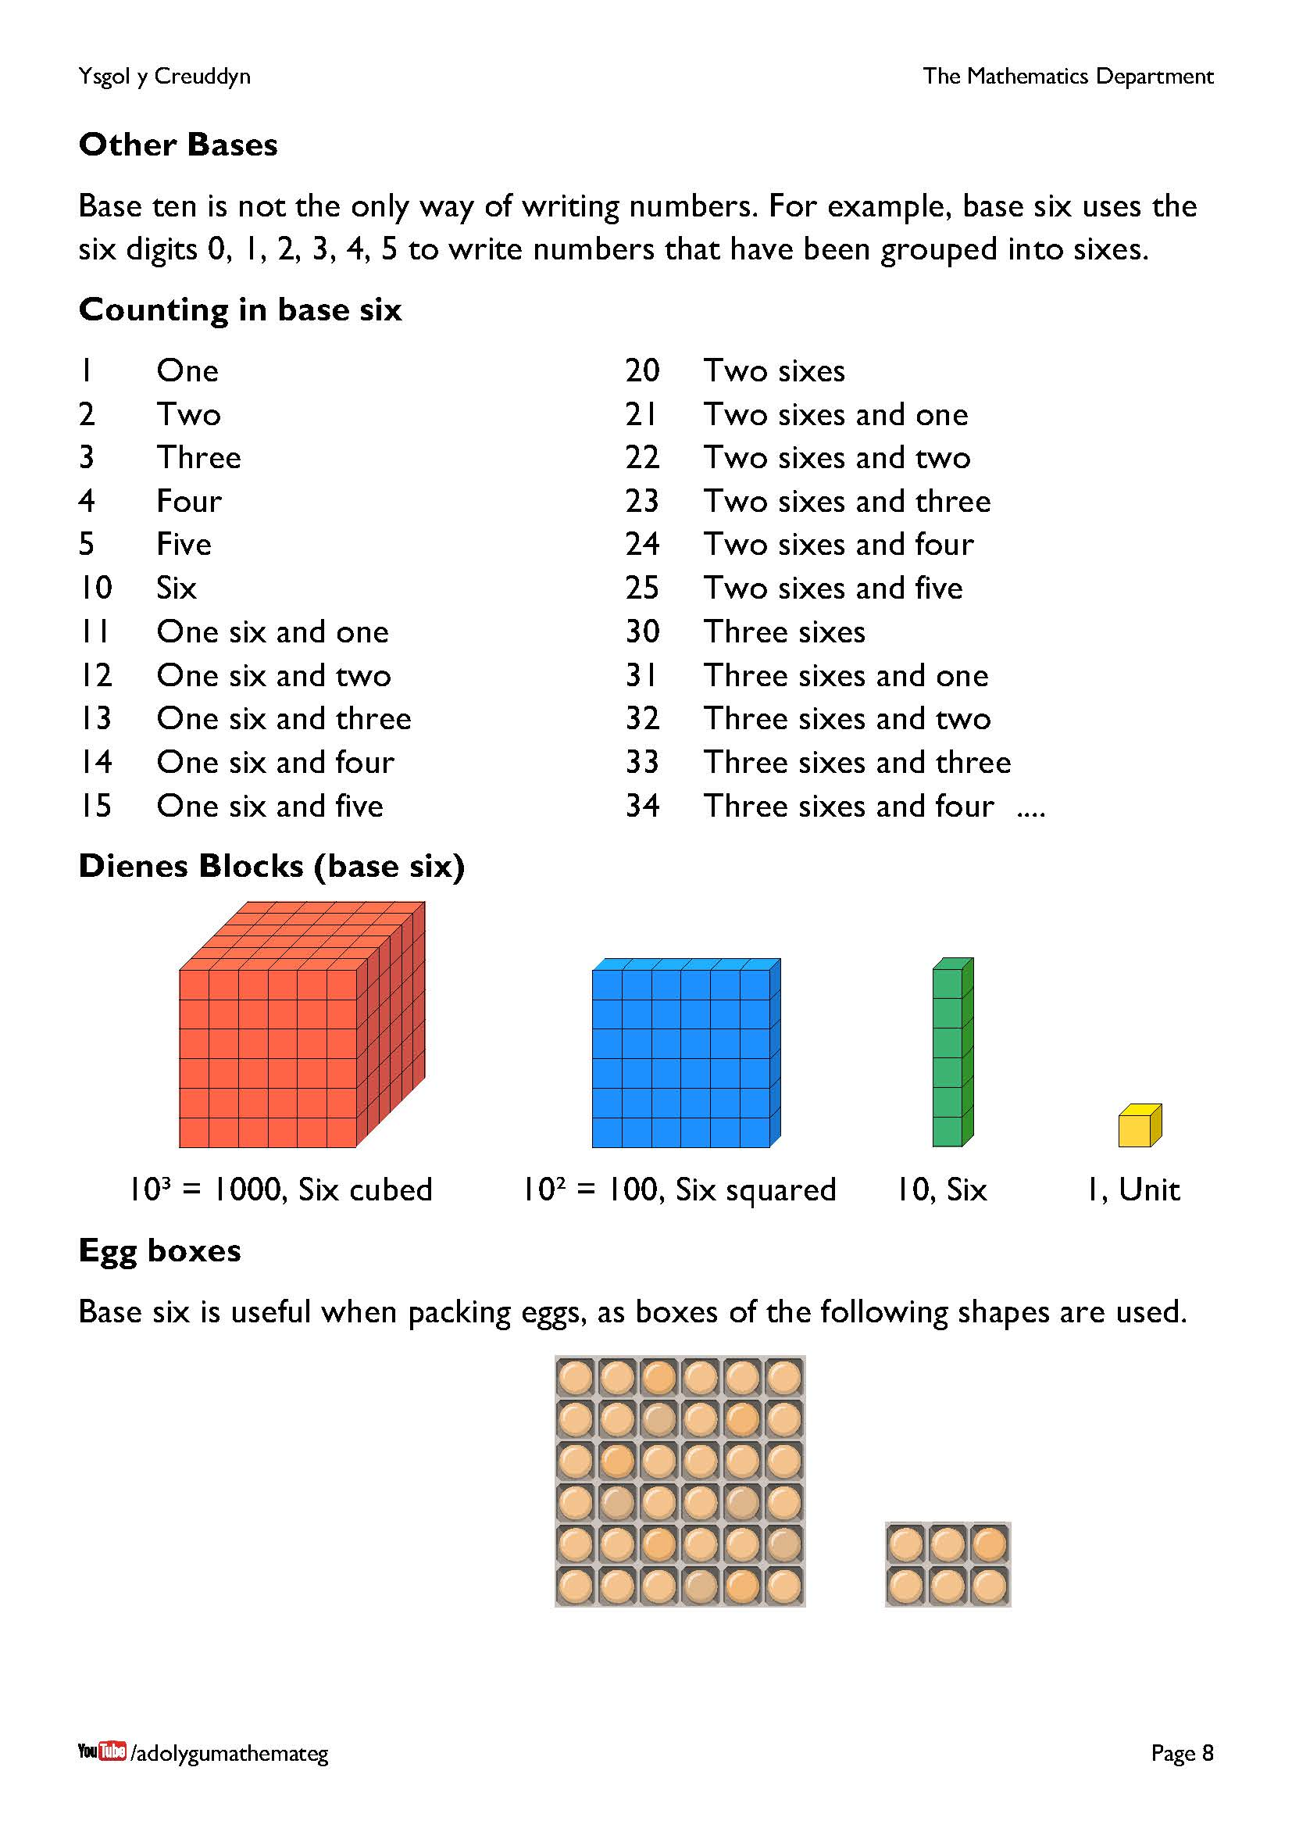
From this page onwards, the workbook starts to develop the idea of writing numbers in a different base to base ten.
To the teacher, this will look strange to begin with, and perhaps difficult to understand, but remember that this is the experience of learners when writing numbers in base ten for the first time. By studying numbers in different bases, learners will deepen their understanding of place value, leading to a better appreciation of numerals in base ten.
For base six, notice that the digits 6, 7, 8 or 9 do not appear. There is also not a special word for ‘six squared’ (like a ‘hundred’ is a special word for ‘ten squared’), so continuing to count in base six would look as follows.
35 Three sixes and five 52 Five sixes and two
40 Four sixes 53 Five sixes and three
41 Four sixes and one 54 Five sixes and four
42 Four sixes and two 55 Five sixes and five
43 Four sixes and three 100 Six squared
44 Four sixes and four 101 Six squared and one
45 Four sixes and five 102 Six squared and two
50 Five sixes 103 Six squared and three
51 Five sixes and one 104 Six squared and four
Be careful with your language when discussing numerals in base six. For example, you should not refer to 10 as ‘ten’.

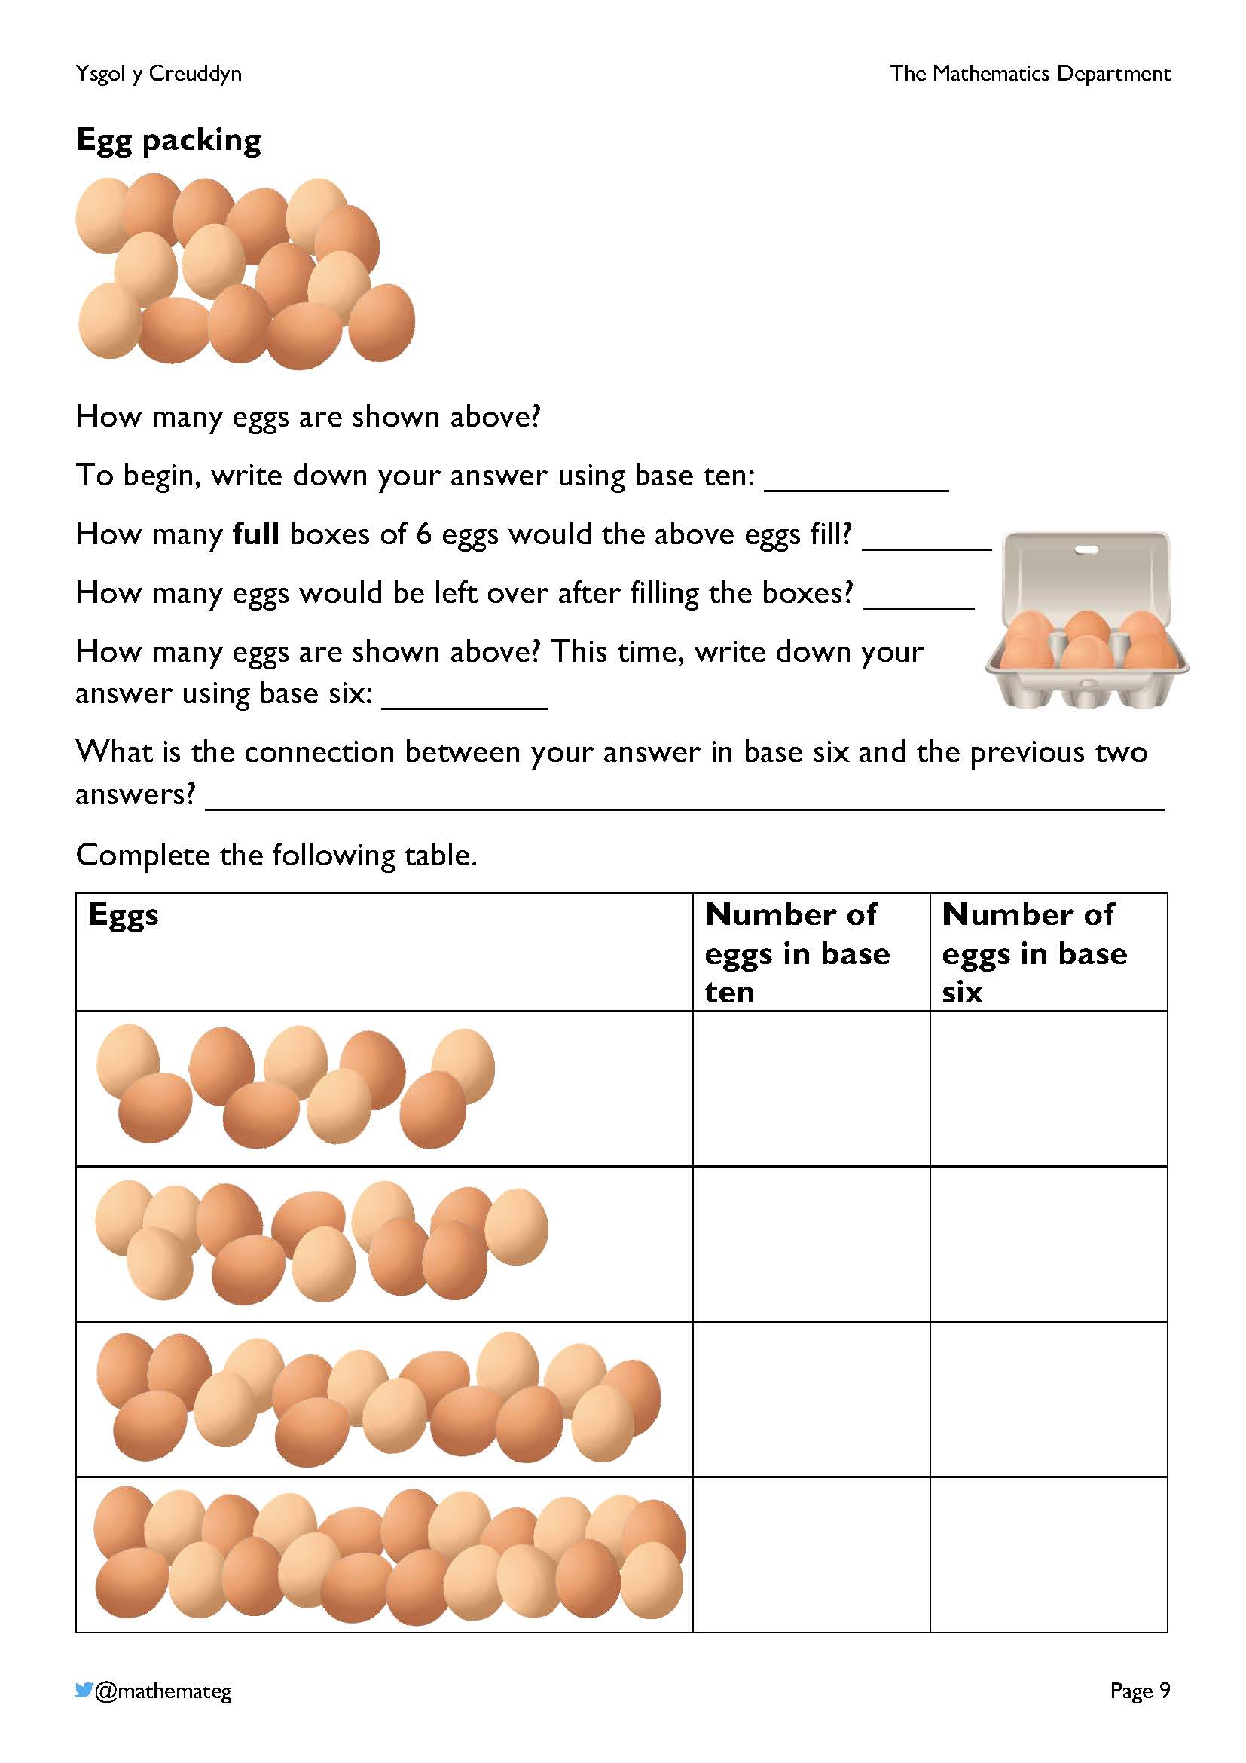
This exercise emphasises the connection between writing a number in base six and grouping a set of objects in sixes.
If there are physical manipulatives available, e.g., counters, use them to model grouping fifteen eggs in sixes.

There are two full boxes and three eggs left over, so 15 in base six is written as 23, ‘two sixes and three’.
Digital counters are available here: https://mathsbot.com/manipulatives/counters
To change a number from base ten into base six, it must be reasoned how many sixes fit into the base ten number, and how many are left over. There is therefore a natural connection with division by six.

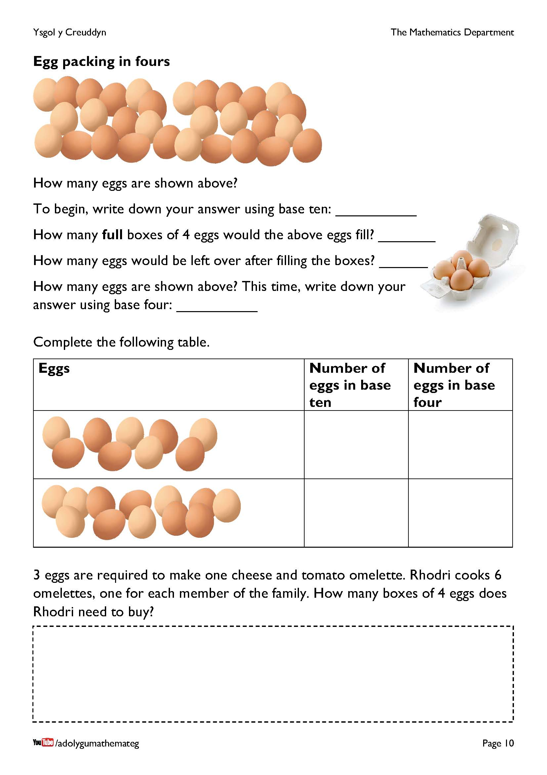
This page introduces base four for the first time, where the digits 0, 1, 2 and 3 are used.
Notice that there are 30 eggs in the picture at the top of the page. Grouping them in fours, we arrive at the following arrangement.

It is a temptation to write 30 in base four as 72, because we have 7 full boxes of eggs, and two eggs left over. Remember however that the digit 7 cannot appear in base four, so we must consider bigger groups of 16 eggs, or 4² eggs.

There is one group of 16 eggs, three groups of 4 eggs, and 2 left over, so the number 30 is written as 132 in base four. (This numeral would be read as ‘four squared, three fours and two’.)
It would be possible to show the above process using the website https://mathsbot.com/manipulatives/blocks, changing the Base to be 4, and exchanging four green rods to form one blue square.

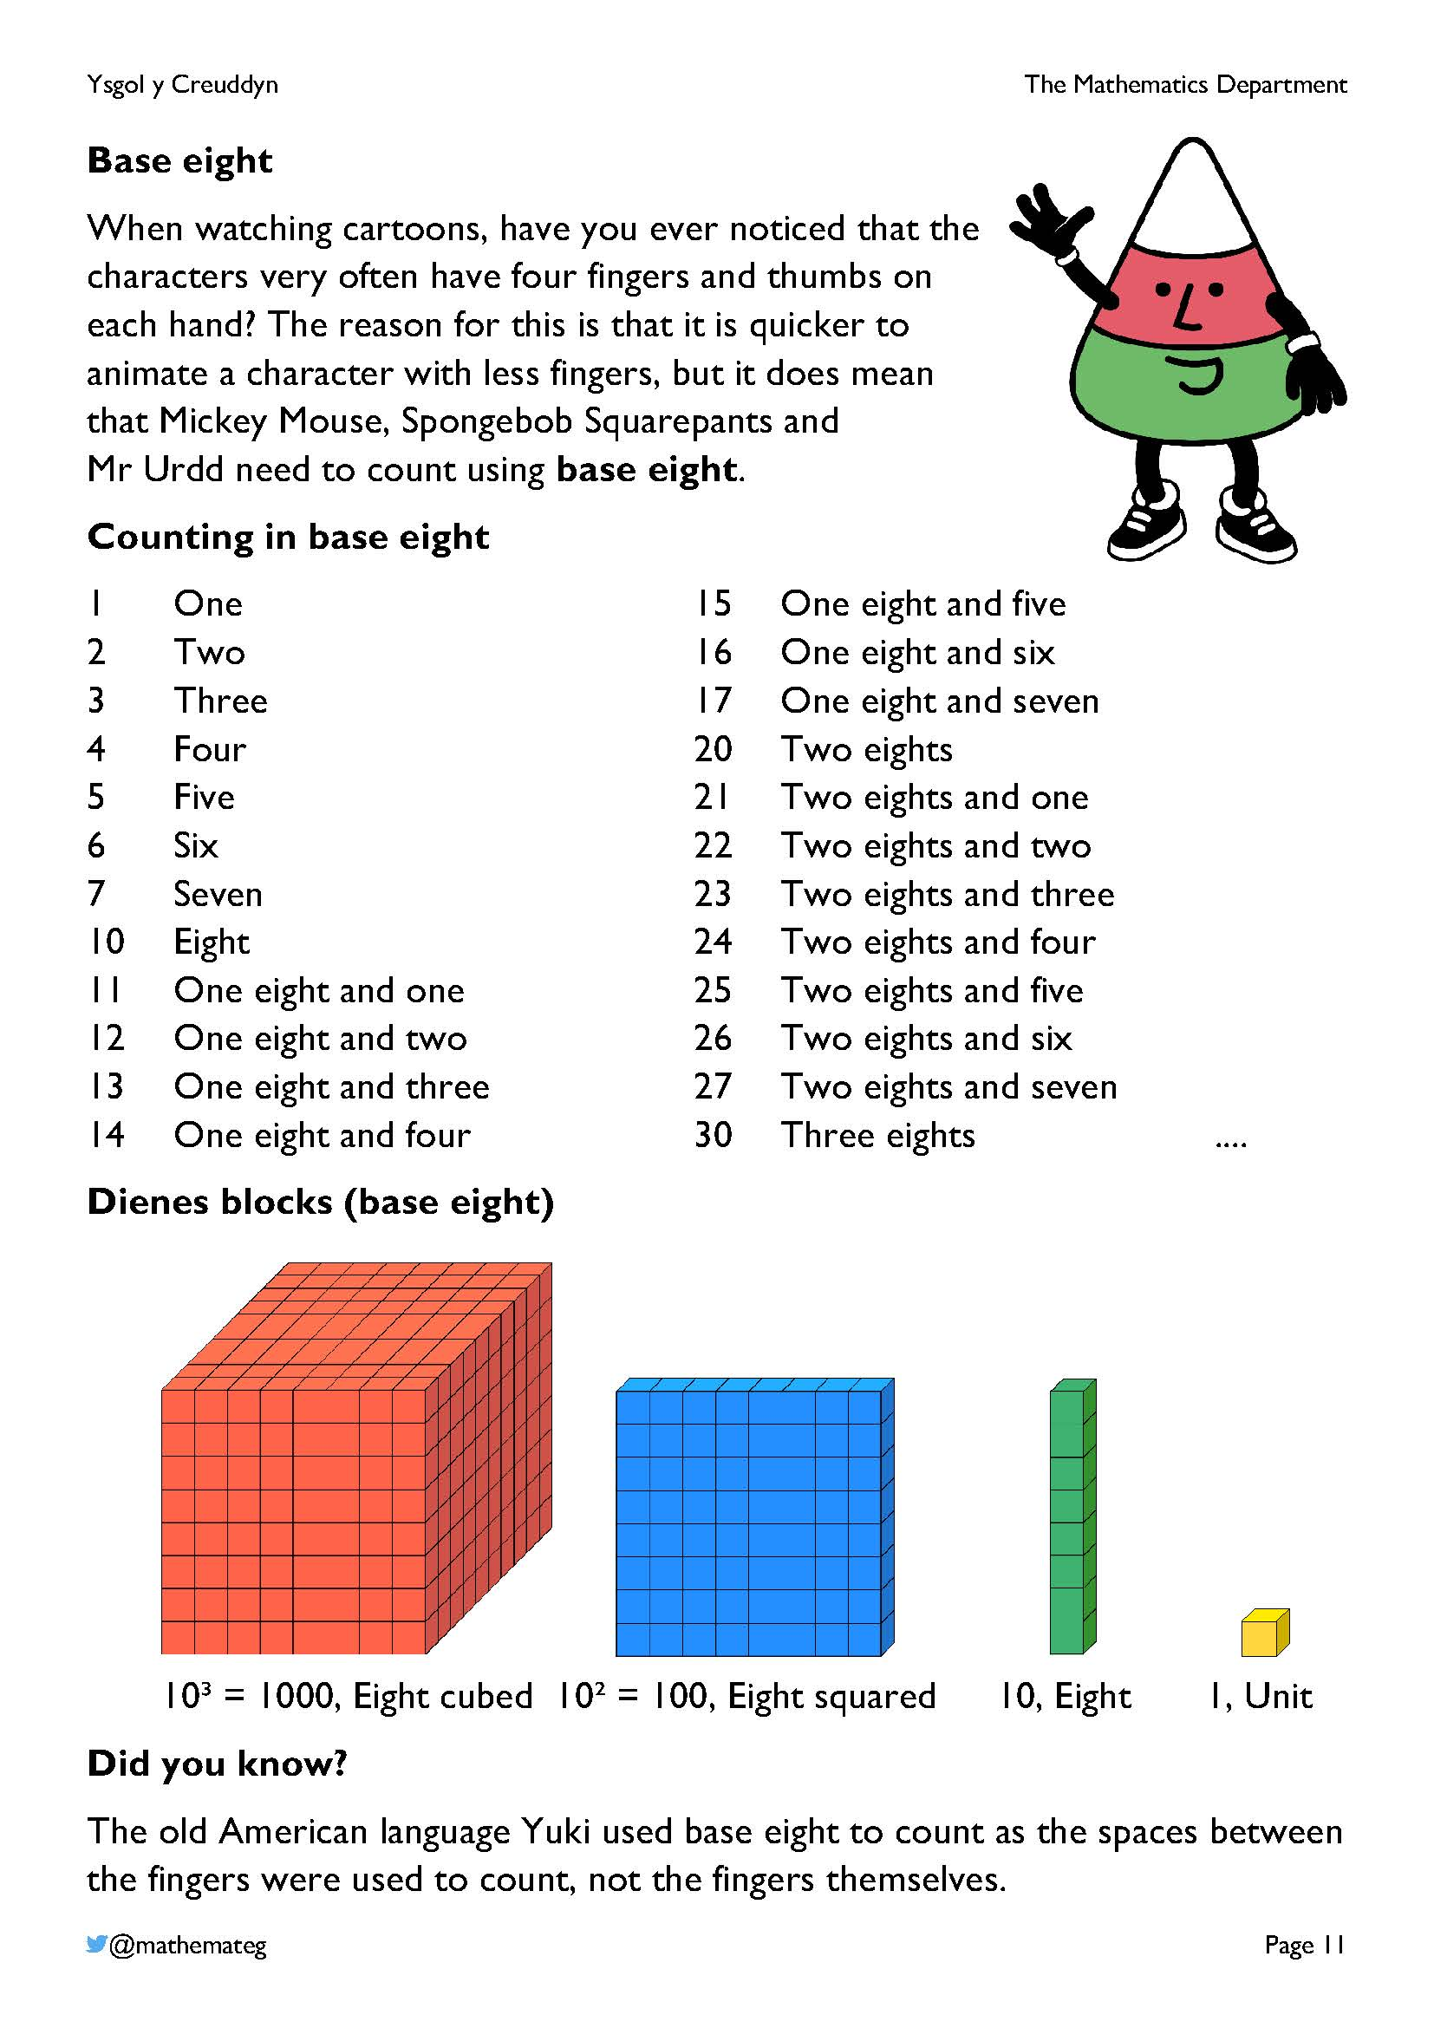
Here is a YouTube video showing the history behind using four fingers and thumbs in animation:
https://www.youtube.com/watch?v=0QZFQ3gbd6I
More information about the Yuki language can be found here:
https://en.wikipedia.org/wiki/Yuki_language
An alternative method of counting in eights would be to use the knuckles on a closed fist.

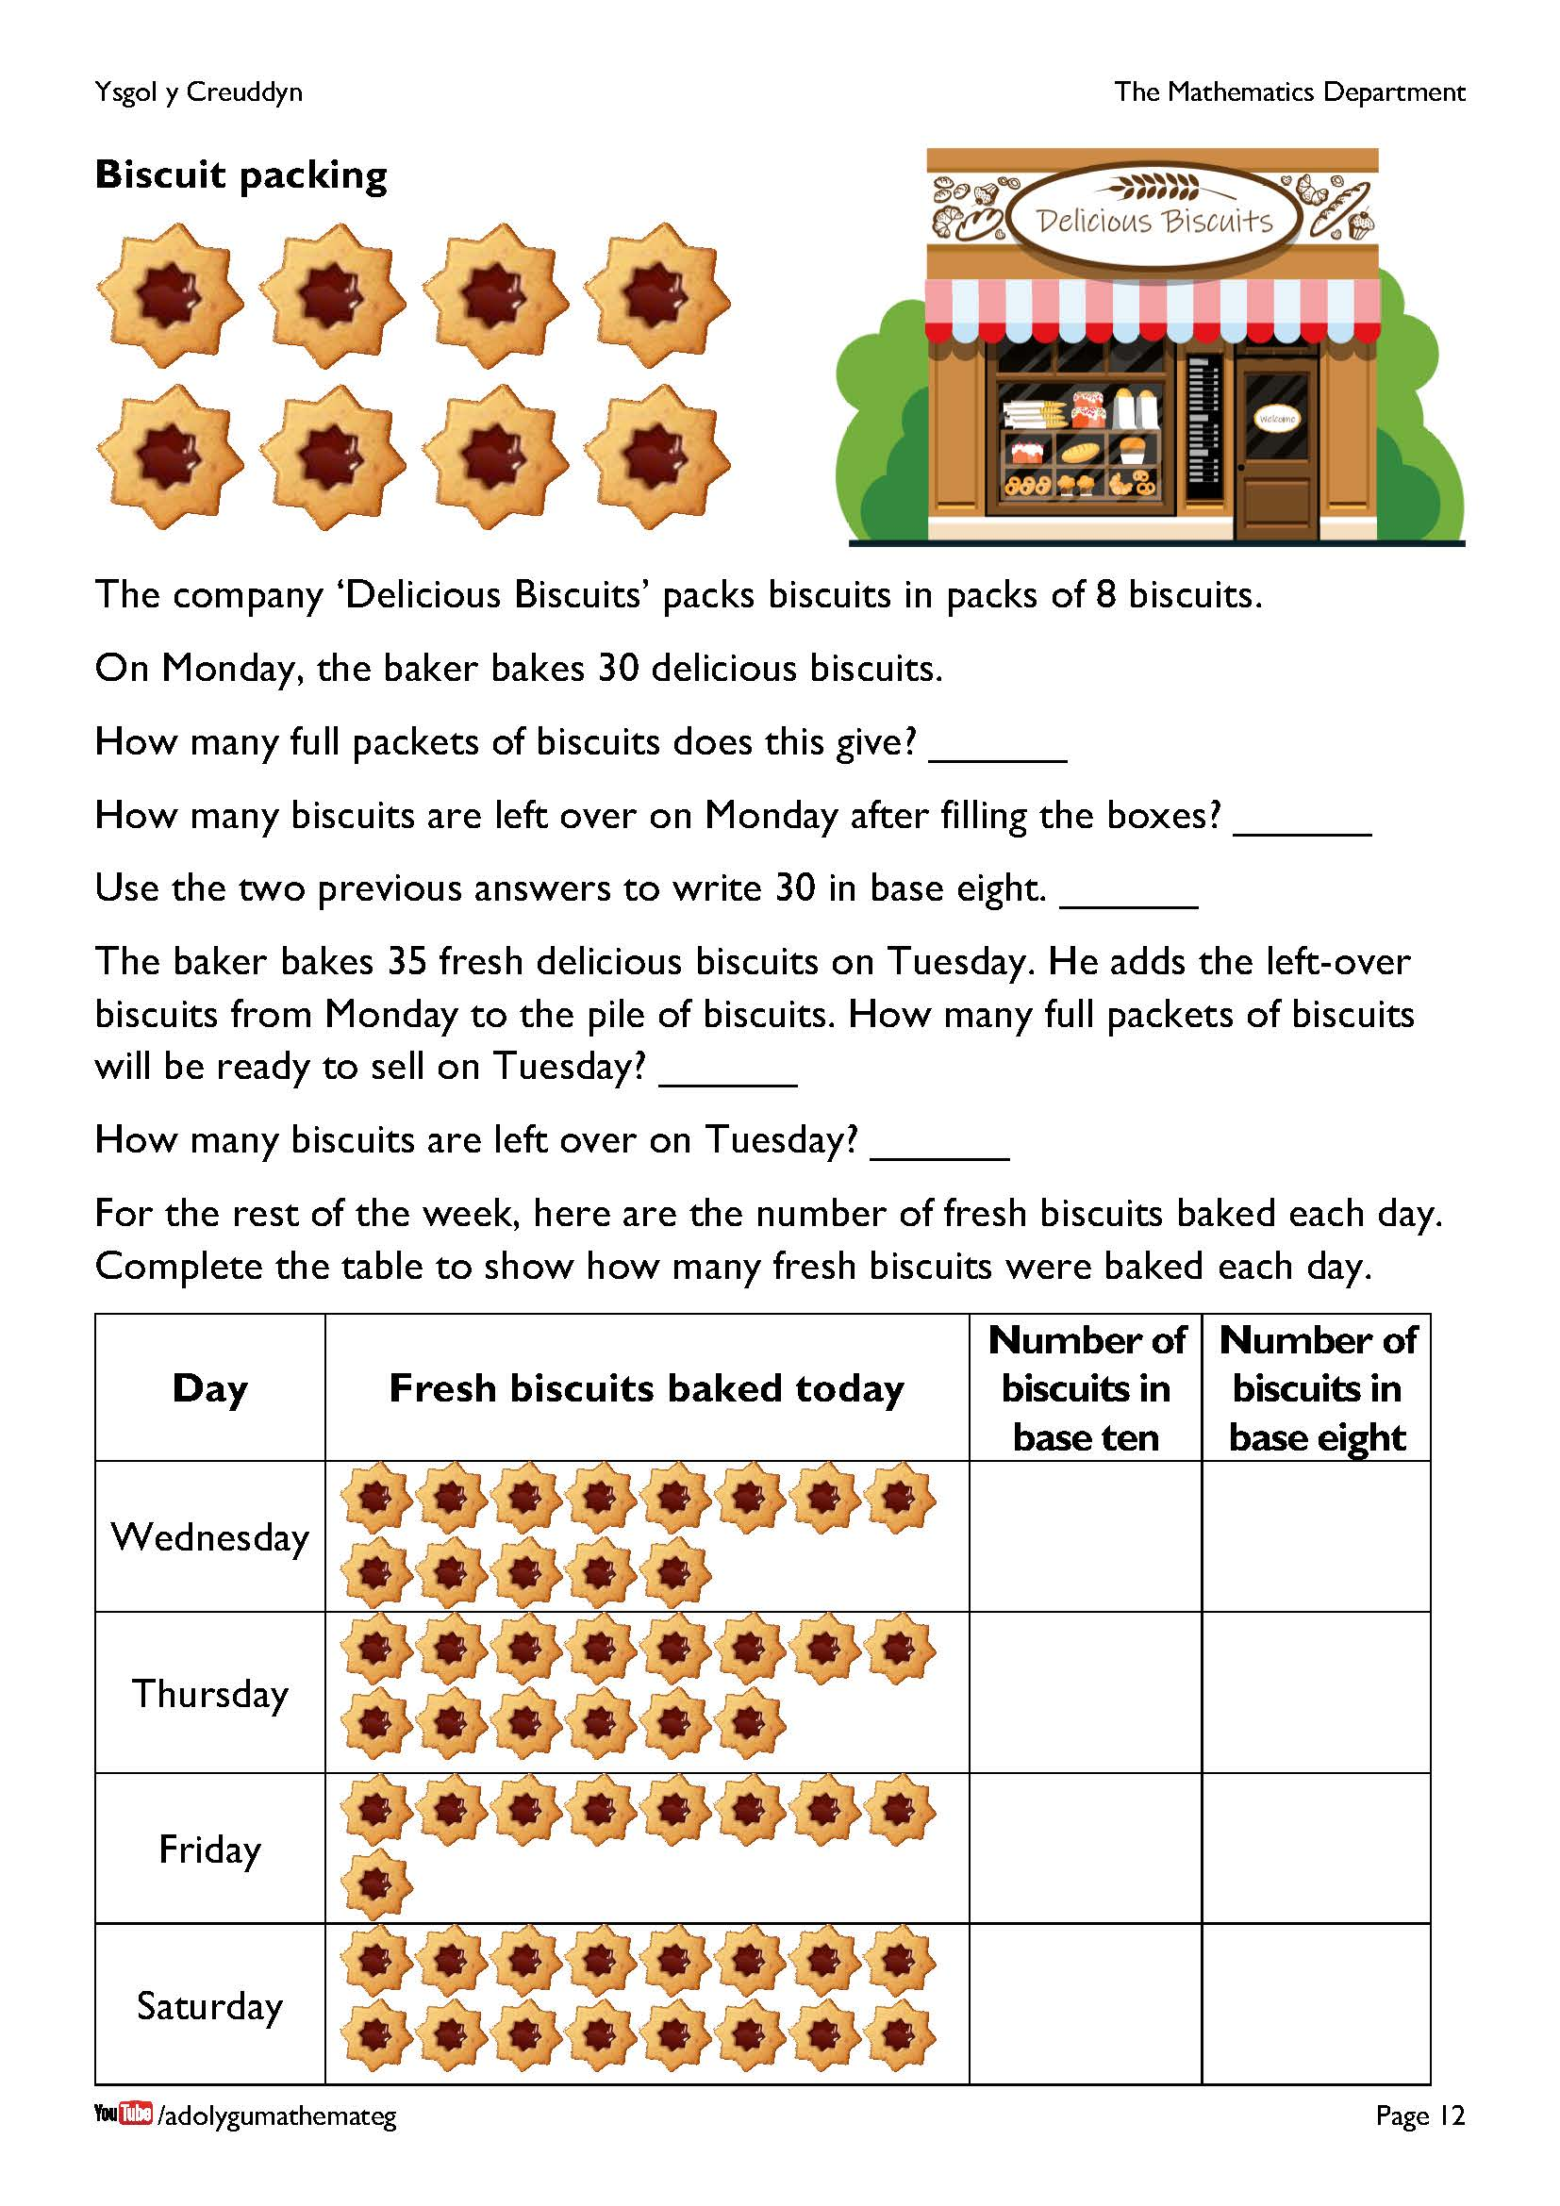
The name of the system of writing numbers in base eight is the octal system. This system was used by early computers, before the hexadecimal system took over, where the sixteen digits 0, 1, 2, 3, 4, 5, 6, 7, 8, 9, A, B, C, D, E, F are used.
An extension task here would be to repeat the exercise in the table, but allowing biscuits left over from the previous day to be added to the fresh biscuits baked each day.
Notice that the shape of the biscuit here has been carefully chosen to have a rotational symmetry of order 8. What order of rotational symmetry do other biscuits have?

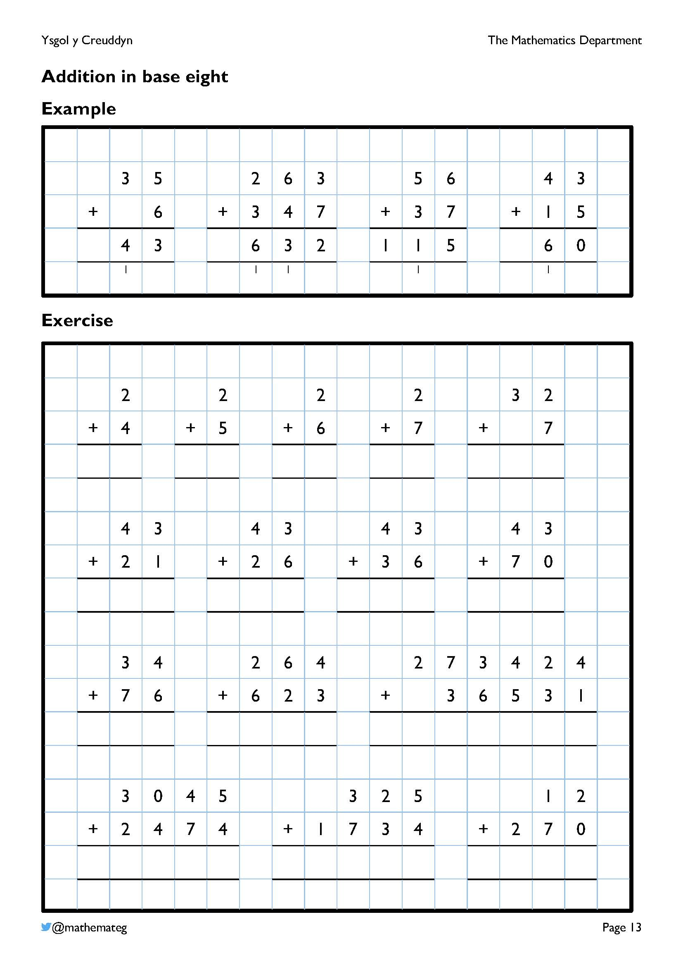
The aim of this page is to deepen learners’ understanding of what happens in column addition when carrying over to the next column.
Example 1
- We start with 5 + 6. Usually in base ten the answer would be eleven, but in base eight we need to think of the eleven as one eight and three units. We carry over the one eight to the eights column on the left, and write the 3 units in the units column.
- To finish, we add 3 to 1 to obtain 4.
Example 2
- We start with 3 + 7. Usually in base ten the answer would be ten, but in base eight we need to think of the ten as one eight and two units. We carry over the one eight to the eights column on the left, and write the 2 units in the units column.
- Next, we add 6 + 4 + 1. Usually in base ten the answer would be eleven, but in base eight we have one eight and three units (and, technically, this would be one eight squared and three eights). We carry over the 1 to the eight squared column on the left, and write the 3 in the eights column.
- To finish, we add 2, 3 and 1 to obtain 6.
More exercises of this type are available on the website https://mathsbot.com/doNows/addition by changing the Base to be 8. (The website allows you to attempt addition sums in any base from 2 to 16.)
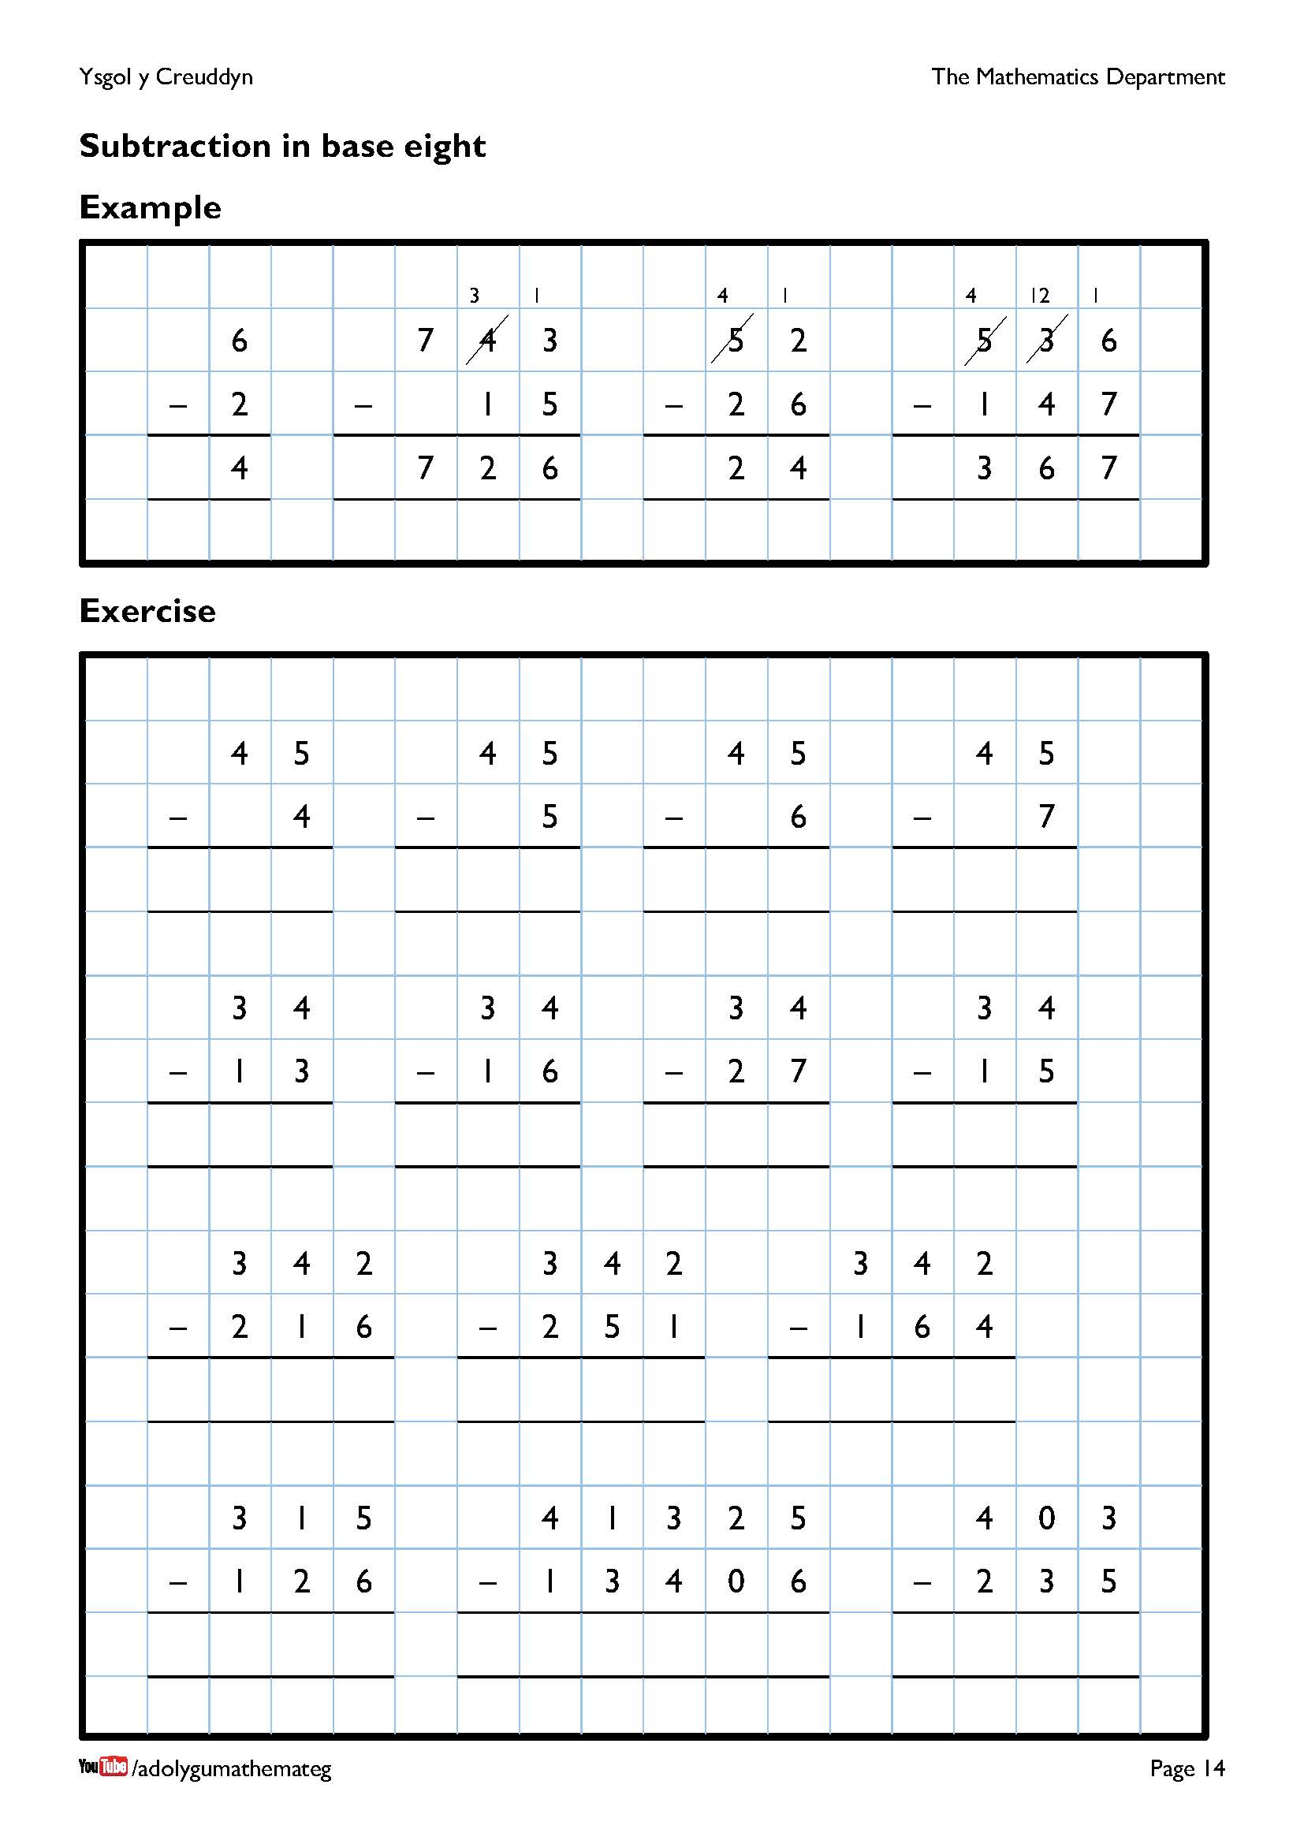
The aim of this page is to deepen learners’ understanding of what happens in column subtraction when ‘borrowing’ from the column to the left.
Example 2
- We start with 3 – 5. This is not possible without using negative numbers, so we borrow eight from the eights column. The original four eights changes to be three eights, and the original 3 units changes to be one eight three. We can then do one eight three subtract five, to leave six. (In base ten, this would be 8 + 3 – 5 = 6.)
- Second, we do 3 – 1 in the eights column to leave 2.
- To finish, we do 7 – 0 = 7.
Example 3
- We start with 2 – 6. This is not possible without using negative numbers, so we borrow eight from the eights column. The original five eights changes to be four eights, and the original 2 units changes to be one eight two. We can then do one eight two subtract six, to leave four. (In base ten, this would be 8 + 2 – 6 = 4.)
- To finish, we do 4 – 2 = 2 in the eights column.
More exercises of this type are available on the website https://mathsbot.com/doNows/subtraction by changing the Base to be 8. (The website allows you to attempt subtraction sums in any base from 2 to 16.)

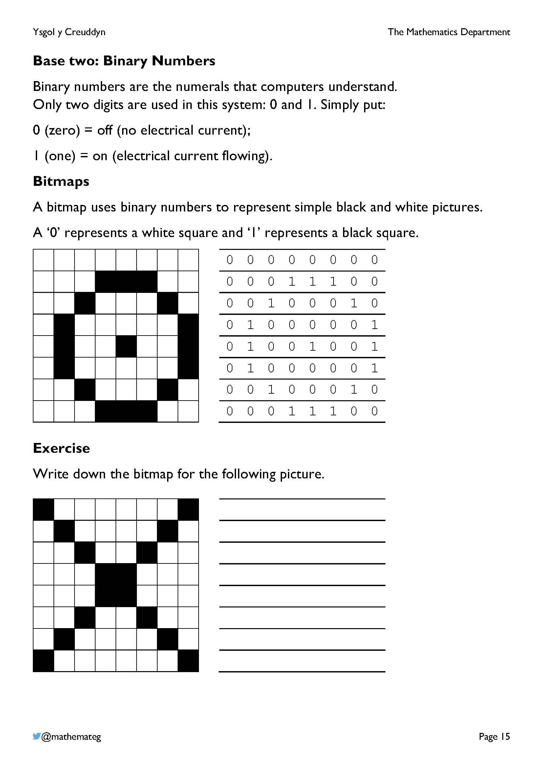
Because bitmaps provide one method of storing images on a computer, there is an opportunity here to link to the following Progression Step 3 description of learning for “Computation is the foundation of our digital world”:
- I can explain how data is stored and processed.
The examples on this page are examples of black and white bitmaps, but the bitmap format can also be used to store colour images on a computer. The disadvantage of this format is that file sizes are usually large, with no compression used. The advantage of the format is that a perfect (lossless) copy of the image is stored, which is not true of a format like JPEG, where some information about the image is lost.

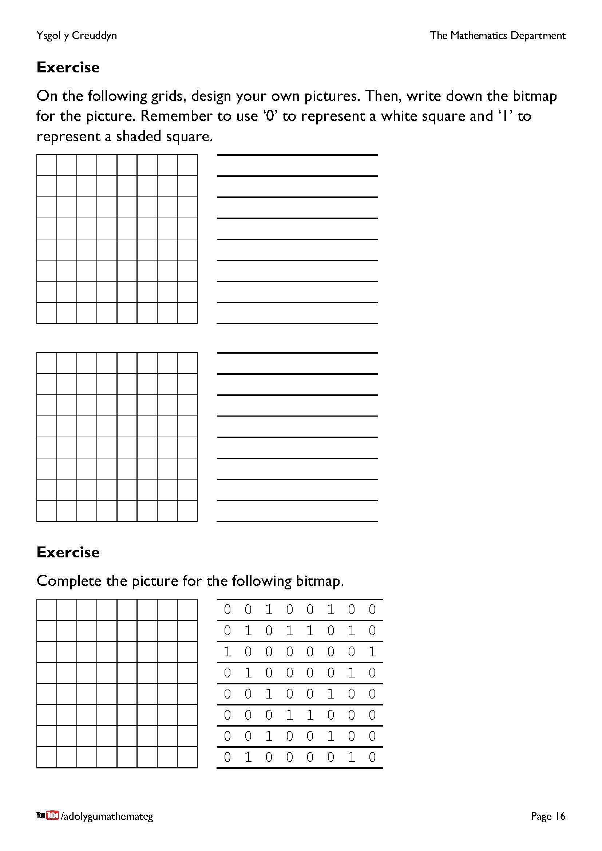
For your information…
- One digit (0 or 1) on a computer is called a bit.
- There are eight bits in a byte. This means that a computer requires one byte of storage to store one row of the bitmaps on the left.
- There are 1,024 bytes in a kilobyte. (Note that 2¹⁰ = 1,024.)
- There are 1,024 kilobytes in a megabyte.
- There are 1,024 megabytes in a gigabyte.
- There are 1,024 gigabytes in a terabyte.

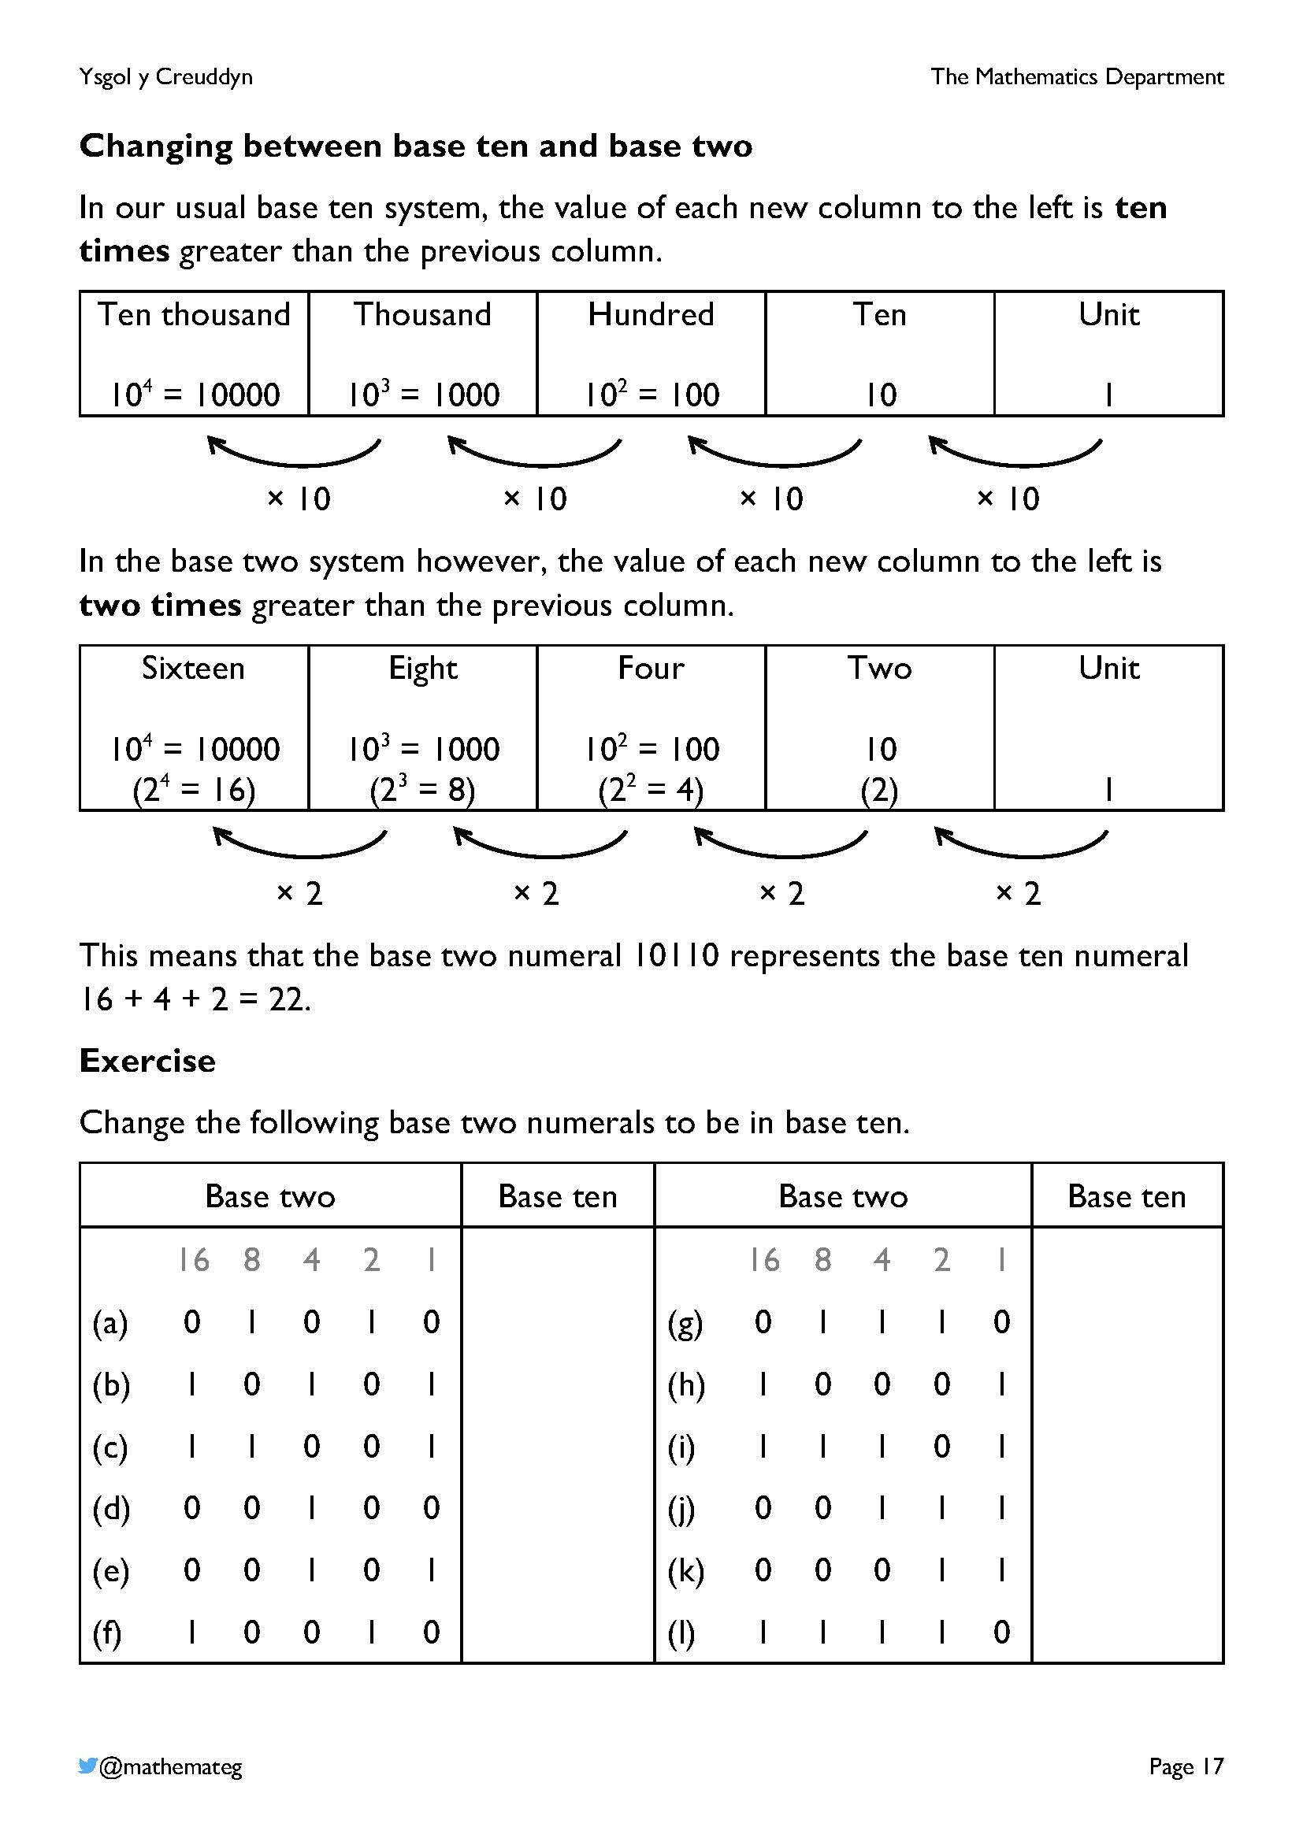
In general, in a base $n$ number system, the value of each column to the left would be $n$ times more than the previous column.
$$n^{4}$$  10⁴ = 10000 | $$n^{3}$$  10³ = 1000 | $$n^{2}$$  10² = 100 | $$n$$  10 | Unit  1

× $n$ × $n$ × $n$ × $n$

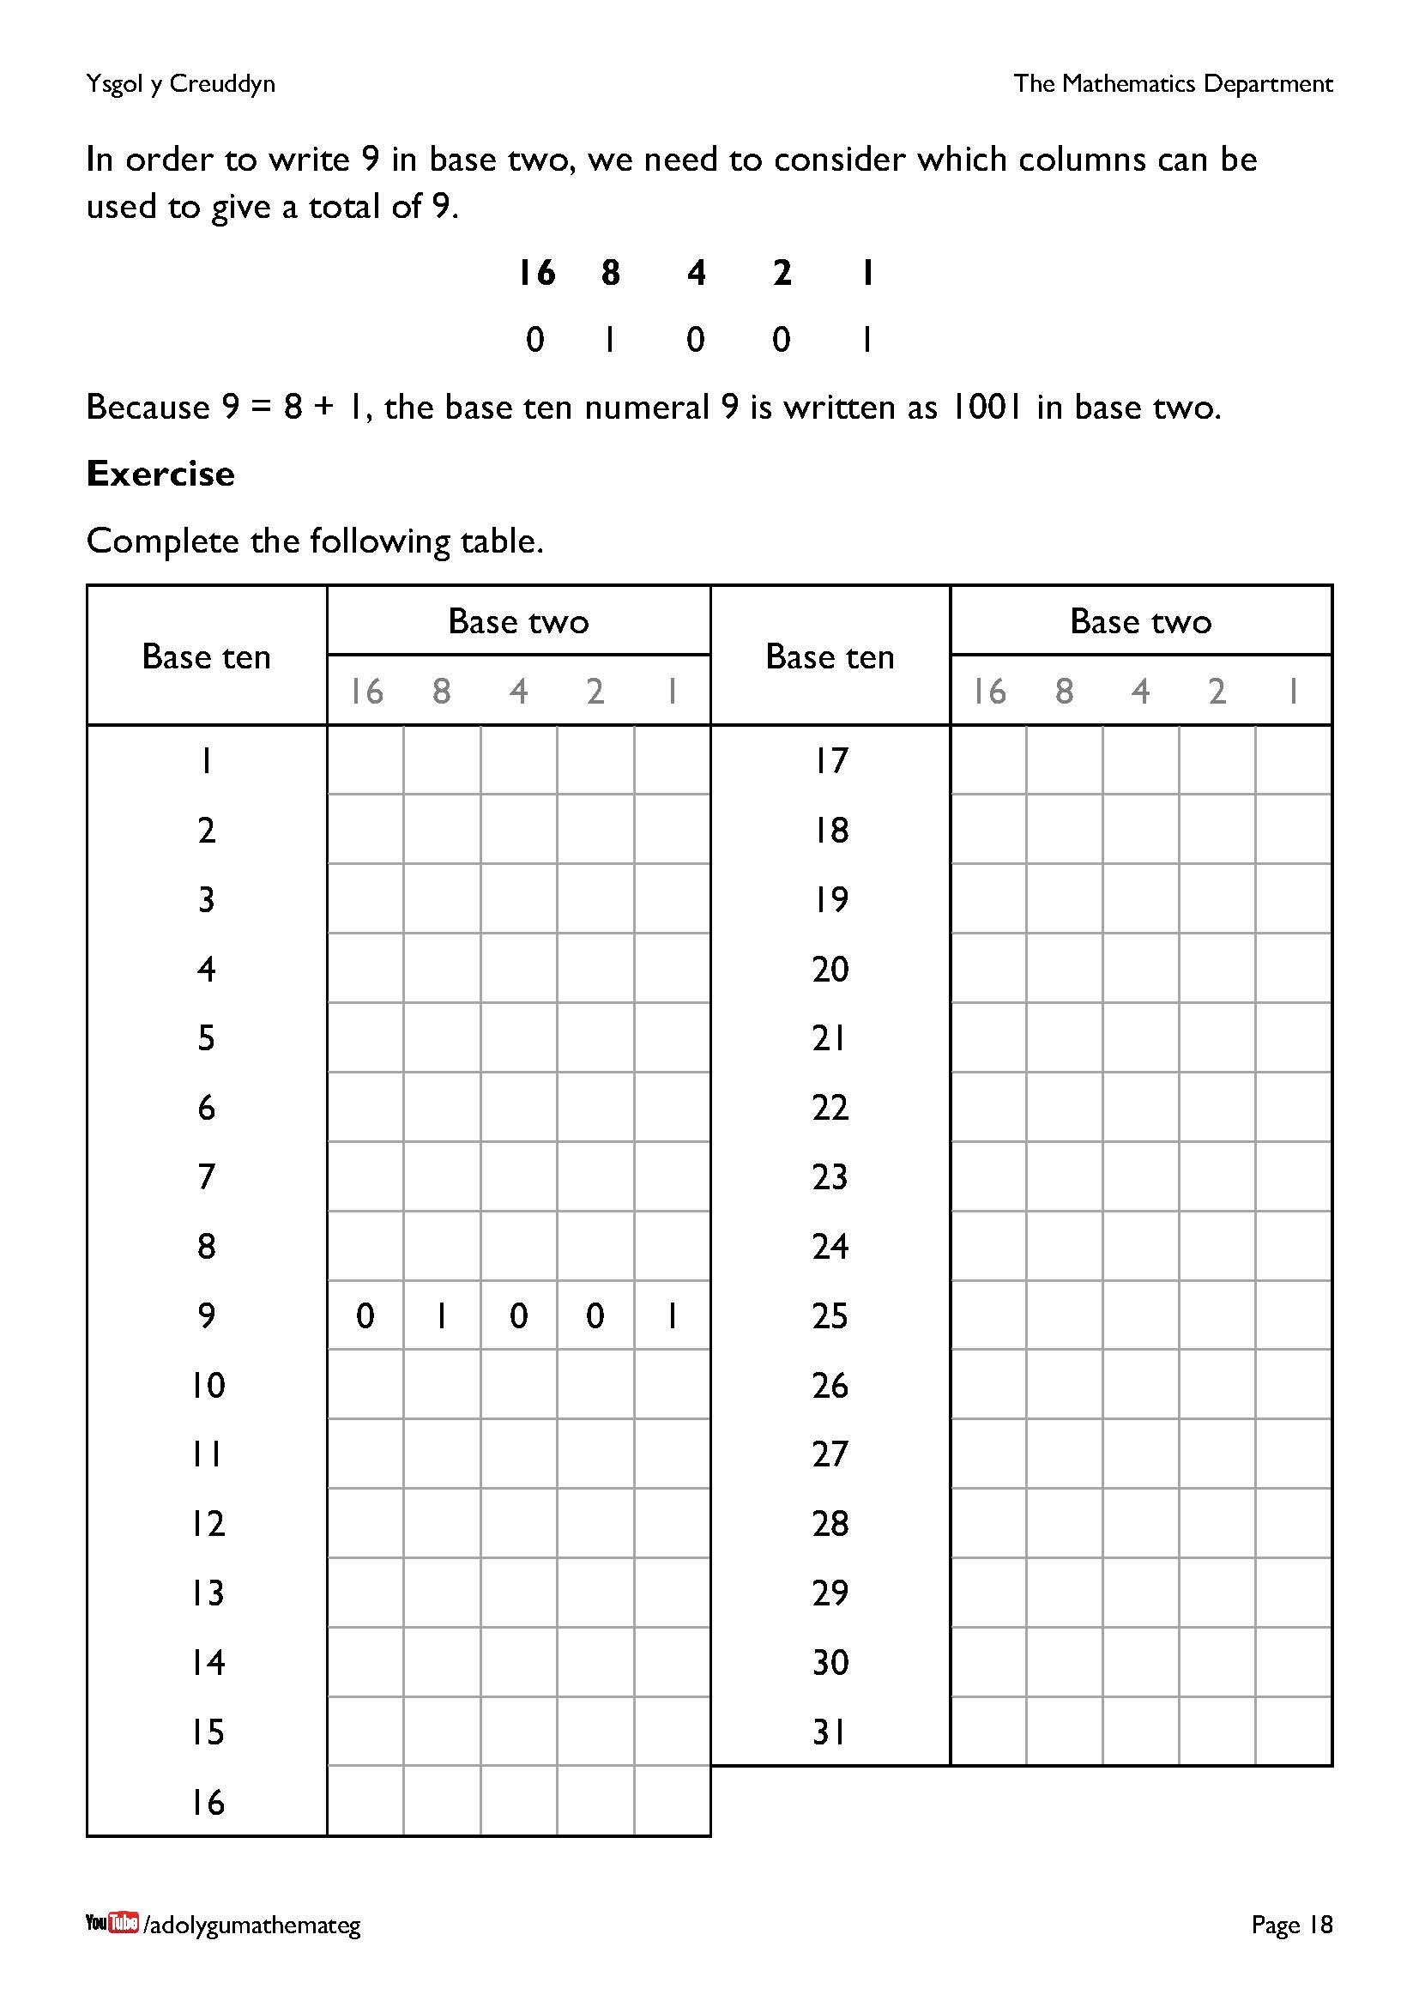
Take the opportunity to discuss which strategies could be used to complete the table.
- If the table was completed in order (1, 2, 3, …), were any patterns seen? For example, notice that the contents of the final two columns (2 and 1) repeat every 4 rows
(01, 10, 11, 00, ....).
- Which method did the learners use to change a base ten numeral to be in base two? For example, did they attempt to subtract (in order) 16, 8, 4, 2, 1 from the base ten numeral?
Extension 1: Consider how to write numbers greater than 31 in base two. To complete this, more columns to the left will be required, representing 32, 64, 128, etc. How far can the learners do the doubling in their heads?
Extension 2: Consider how to write decimals in different bases.
- Before starting, a visit to the website https://www.mathspad.co.uk/i2/teach.php?id=decimalBlocksTool would be useful, to revise how base ten decimals work.
- The ‘decimal point’ needs to be renamed, for example to the ‘binary point’.
- How can the fraction $\frac{1}{2}$ be expressed in different bases?

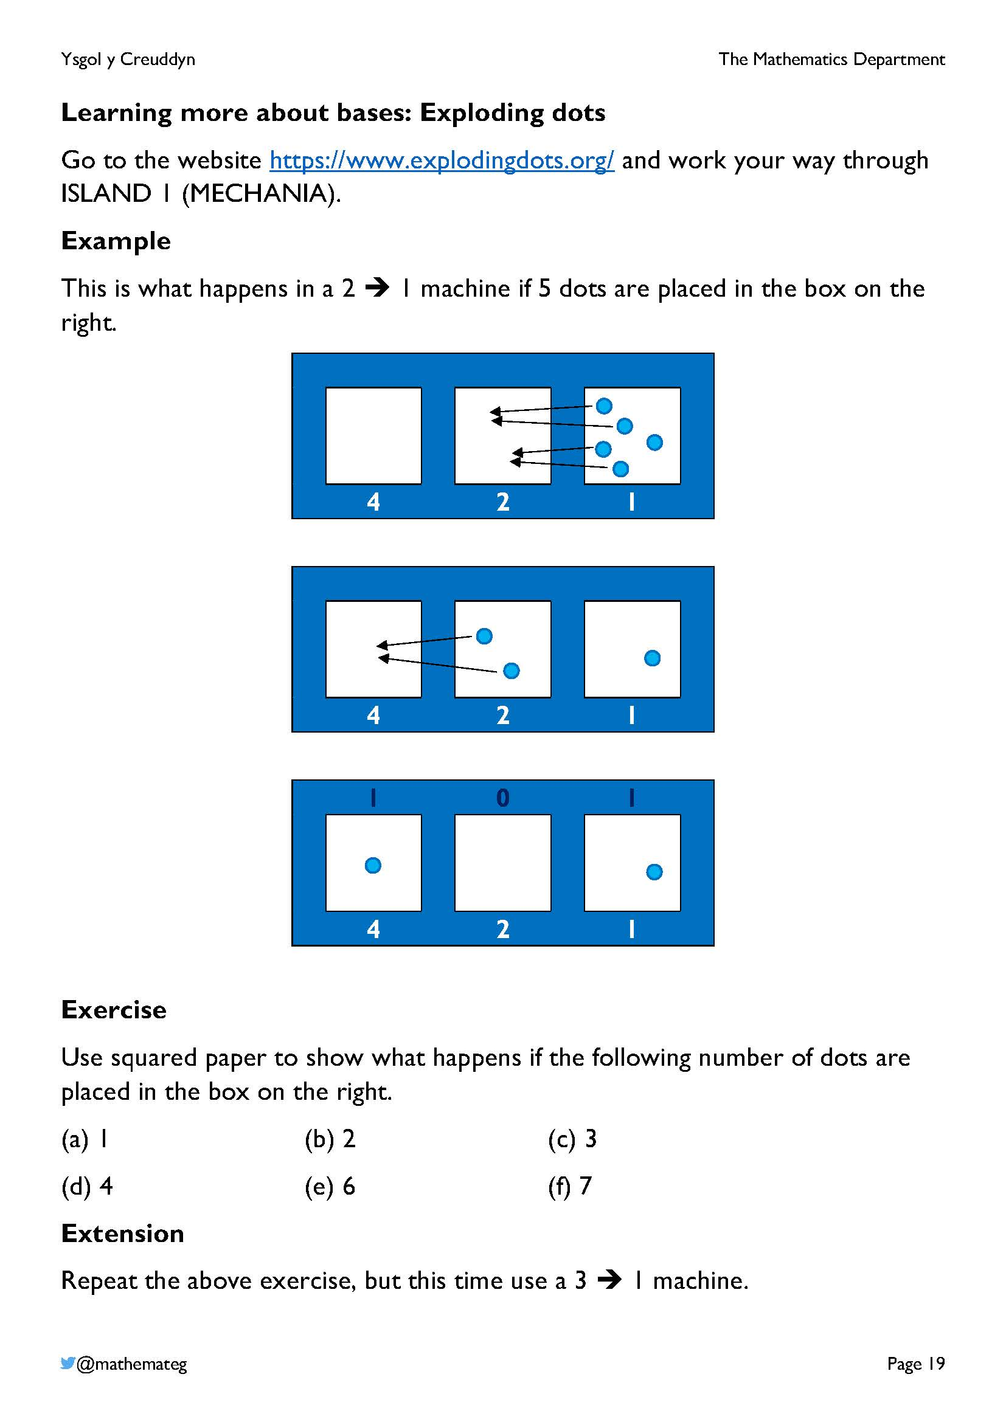
The website Exploding Dots (https://www.explodingdots.org/) introduces an alternative way of thinking about binary numbers (and numbers in other bases) by using dots to represent the numbers.
If you have access to a set of computers, it would be well worth spending a lesson looking at the website. It would be possible to complete the exercise on this page after completing the first part of the website, the ‘Mechania’ island.
Remember also that the website https://mathigon.org/polypad has an interactive version of the Exploding Dots system, under the “Numbers” section.

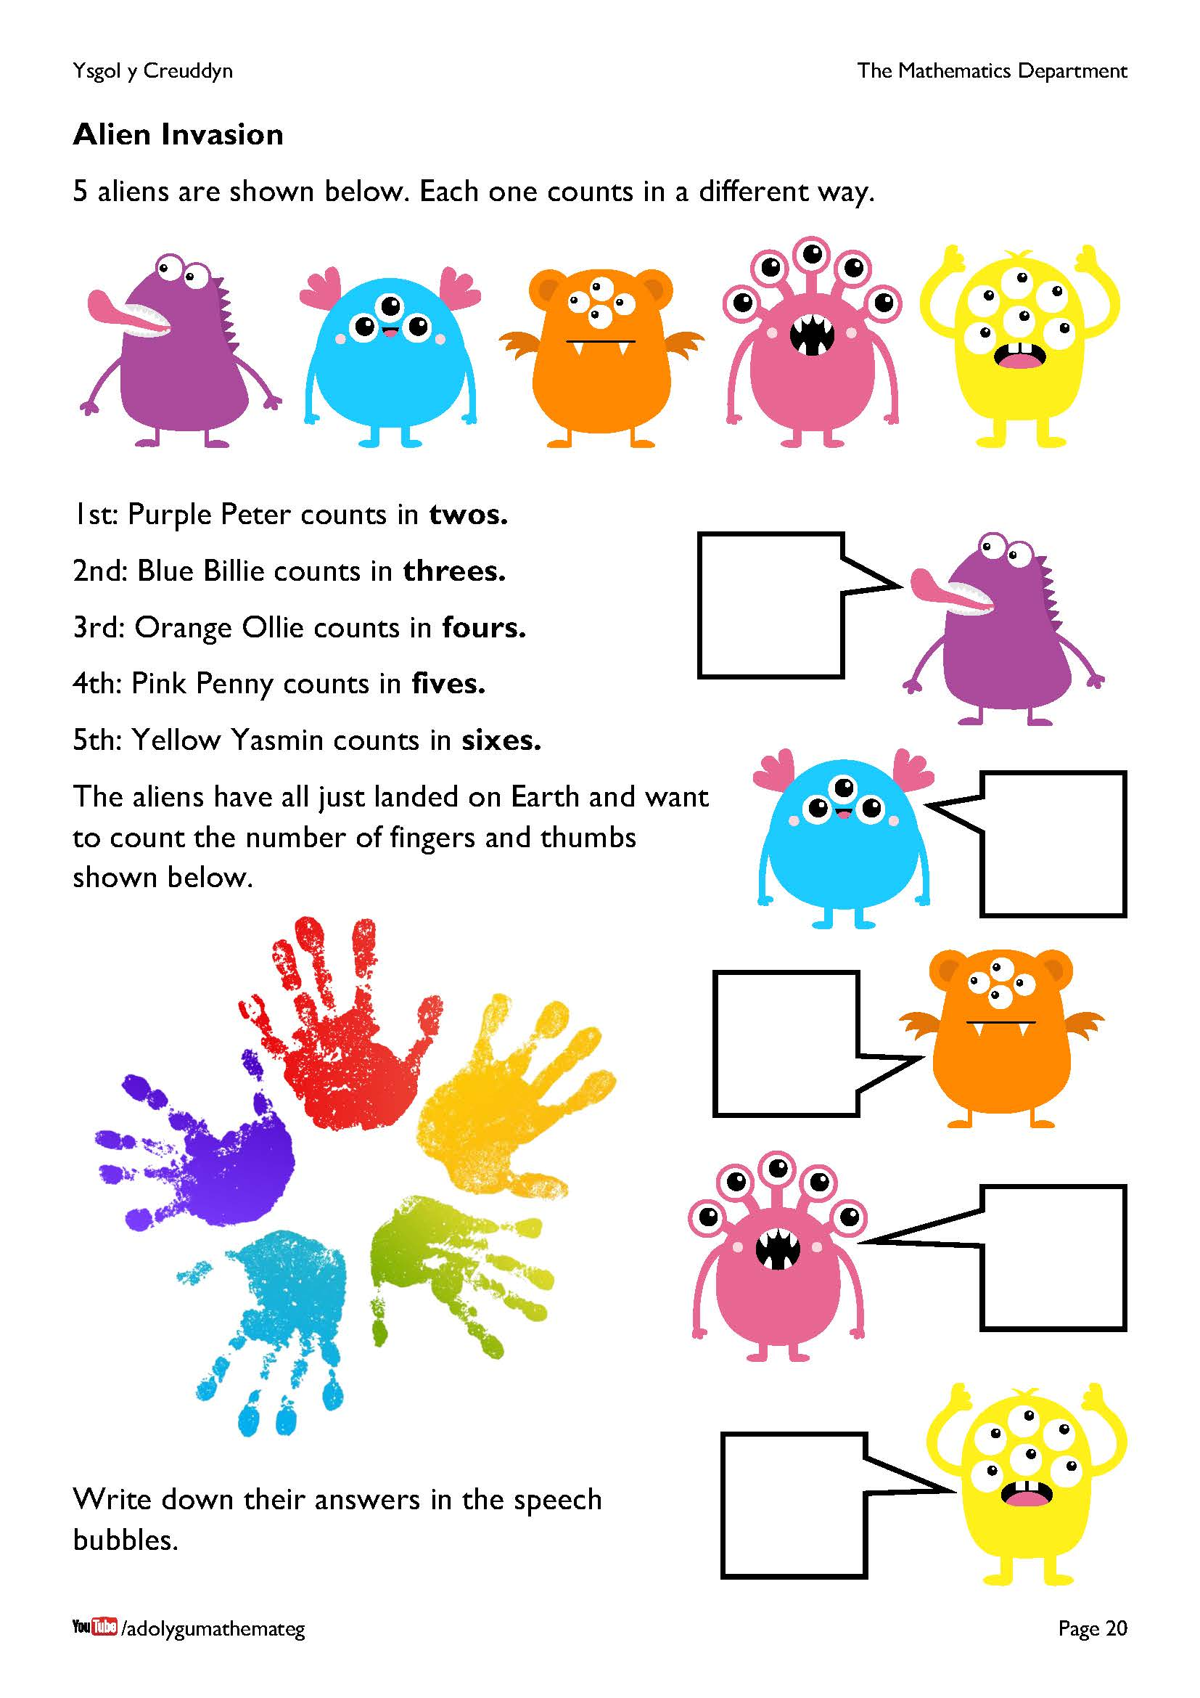
The aliens here count in different bases, based on the number of their eyes!
Purple Peter (Base 2)
16 8 4 2 1
1 1 0 0 1
Blue Billie (Base 3)
9 3 1
2 2 1
Orange Ollie (Base 4)
16 4 1
1 2 1
Pink Penny (Base 5)
25 5 1
1 0 0
Yellow Yasmin (Base 6)
6 1
4 1
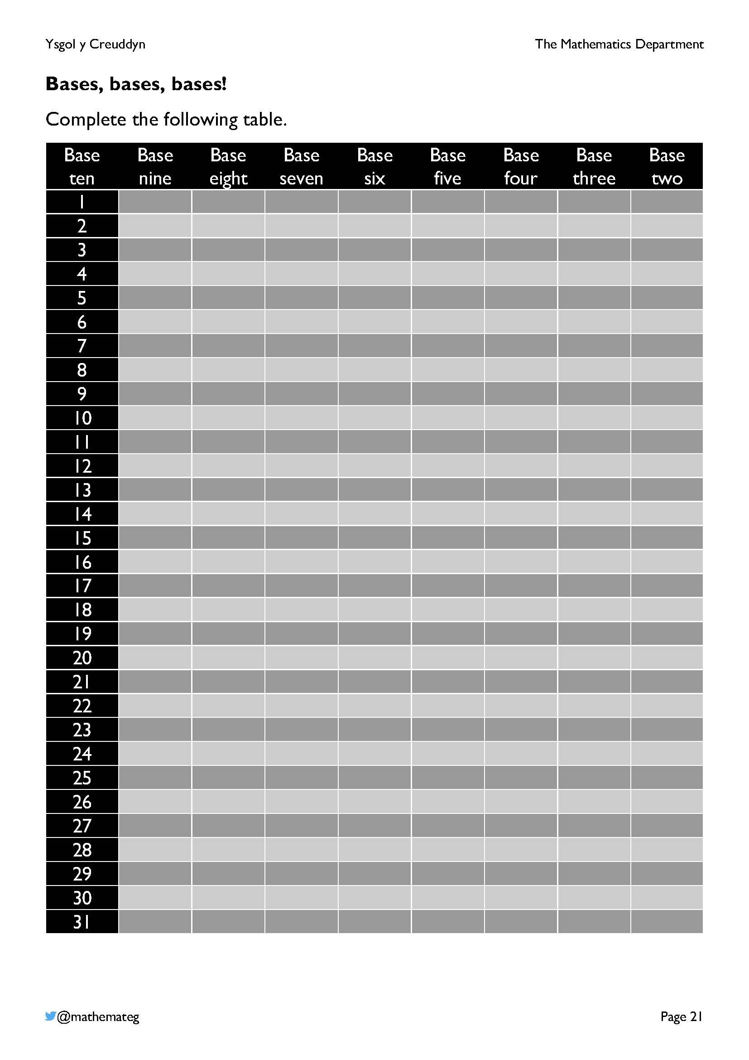
Answers:
Base ten | Base nine | Base eight | Base seven | Base  six | Base five | Base four | Base three | Base two
1 | 1 | 1 | 1 | 1 | 1 | 1 | 1 | 1
2 | 2 | 2 | 2 | 2 | 2 | 2 | 2 | 10
3 | 3 | 3 | 3 | 3 | 3 | 3 | 10 | 11
4 | 4 | 4 | 4 | 4 | 4 | 10 | 11 | 100
5 | 5 | 5 | 5 | 5 | 10 | 11 | 12 | 101
6 | 6 | 6 | 6 | 10 | 11 | 12 | 20 | 110
7 | 7 | 7 | 10 | 11 | 12 | 13 | 21 | 111
8 | 8 | 10 | 11 | 12 | 13 | 20 | 22 | 1000
9 | 10 | 11 | 12 | 13 | 14 | 21 | 100 | 1001
10 | 11 | 12 | 13 | 14 | 20 | 22 | 101 | 1010
11 | 12 | 13 | 14 | 15 | 21 | 23 | 102 | 1011
12 | 13 | 14 | 15 | 20 | 22 | 30 | 110 | 1100
13 | 14 | 15 | 16 | 21 | 23 | 31 | 111 | 1101
14 | 15 | 16 | 20 | 22 | 24 | 32 | 112 | 1110
15 | 16 | 17 | 21 | 23 | 30 | 33 | 120 | 1111
16 | 17 | 20 | 22 | 24 | 31 | 100 | 121 | 10000
17 | 18 | 21 | 23 | 25 | 32 | 101 | 122 | 10001
18 | 20 | 22 | 24 | 30 | 33 | 102 | 200 | 10010
19 | 21 | 23 | 25 | 31 | 34 | 103 | 201 | 10011
20 | 22 | 24 | 26 | 32 | 40 | 110 | 202 | 10100
21 | 23 | 25 | 30 | 33 | 41 | 111 | 210 | 10101
22 | 24 | 26 | 31 | 34 | 42 | 112 | 211 | 10110
23 | 25 | 27 | 32 | 35 | 43 | 113 | 212 | 10111
24 | 26 | 30 | 33 | 40 | 44 | 120 | 220 | 11000
25 | 27 | 31 | 34 | 41 | 100 | 121 | 221 | 11001
26 | 28 | 32 | 35 | 42 | 101 | 122 | 222 | 11010
27 | 30 | 33 | 36 | 43 | 102 | 123 | 300 | 11011
28 | 31 | 34 | 40 | 44 | 103 | 130 | 301 | 11100
29 | 32 | 35 | 41 | 45 | 104 | 131 | 302 | 11101
30 | 33 | 36 | 42 | 50 | 110 | 132 | 310 | 11110
31 | 34 | 37 | 43 | 51 | 111 | 133 | 311 | 11111
Further reading on different bases: https://sketchcpd.com/viewBlog?id=25

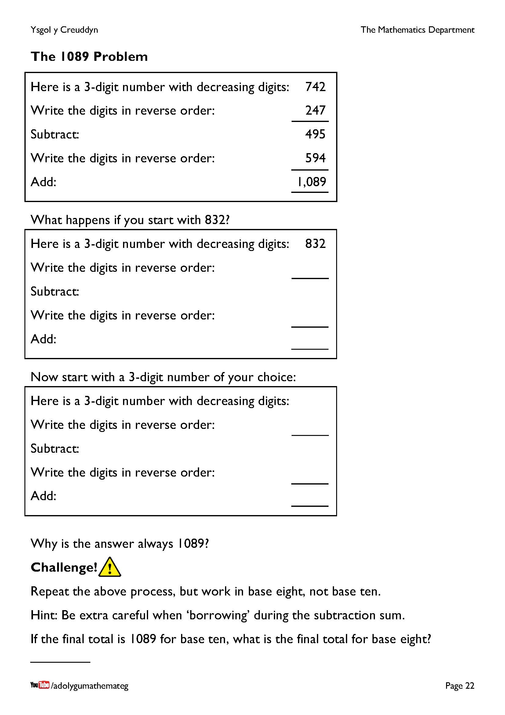
In base ten, why is the answer always 1089?
Let the initial number be $abc$, with $a>b>c$. We can write this number as $100a+10b+c$ so that writing the digits in reverse order gives the number $100c+10b+a$.
On subtraction, we obtain the number $\left(100a+10b+c\right)-\left(100c+10b+a\right)=99a-99c=99(a-c)$. Because the original number had decreasing digits, $a-c$ must be between 2 and 9. So, $99(a-c)$ must be one of 198, 297, 396, 495, 594, 693, 792, 891. The following table shows that the final total must always be 1089.
$$99(a-c)$$ | Reverse the digits | Add
198 | 891 | 1089
297 | 792 | 1089
396 | 693 | 1089
495 | 594 | 1089
594 | 495 | 1089
693 | 396 | 1089
792 | 297 | 1089
891 | 198 | 1089
So, what about base eight? For example, let us start with 542. Writing the digits in reverse order gives 245, and subtracting
542 – 245 in base eight gives 275. Reversing the digits gives 572, and adding 275 to 572 in base eight gives 1067. This is the total for any initial 3-digit number with decreasing digits; it would be possible to prove this by adapting the above proof for base eight.
So, 1089 for base 10; 1067 for base 8; is there a pattern here that continues in other bases?
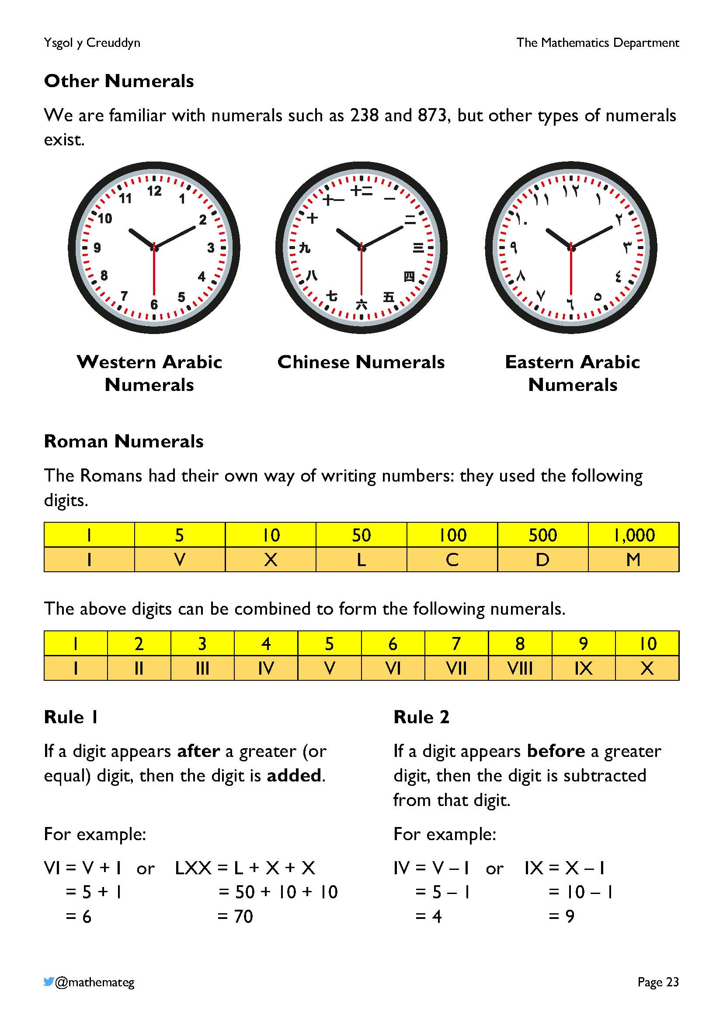
Further information about different numerals is available on the website https://en.wikipedia.org/wiki/Numeral_system
With Roman numerals, usually IV is used for 4, but on clocks IIII is often seen.
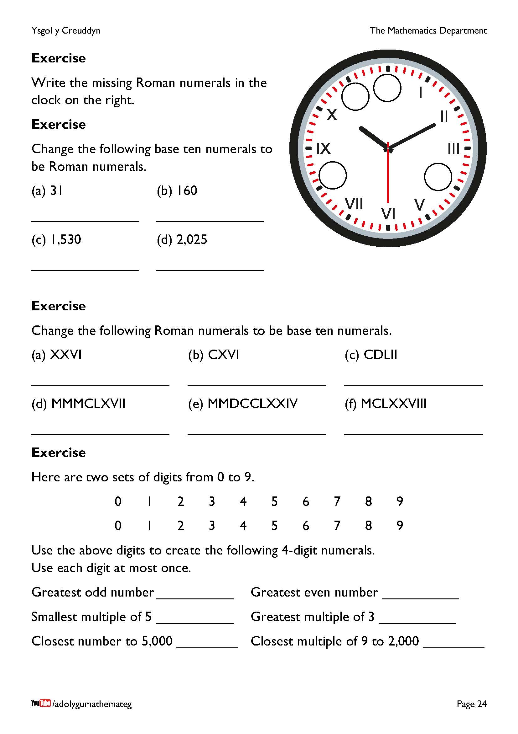
For the exercise on the bottom of the page, the answers must contain four digits, so that (e.g.) ‘5’ is not acceptable as the smallest multiple of 5. Similar problems to this one can be found on the website of the late Don Steward: https://donsteward.blogspot.com/

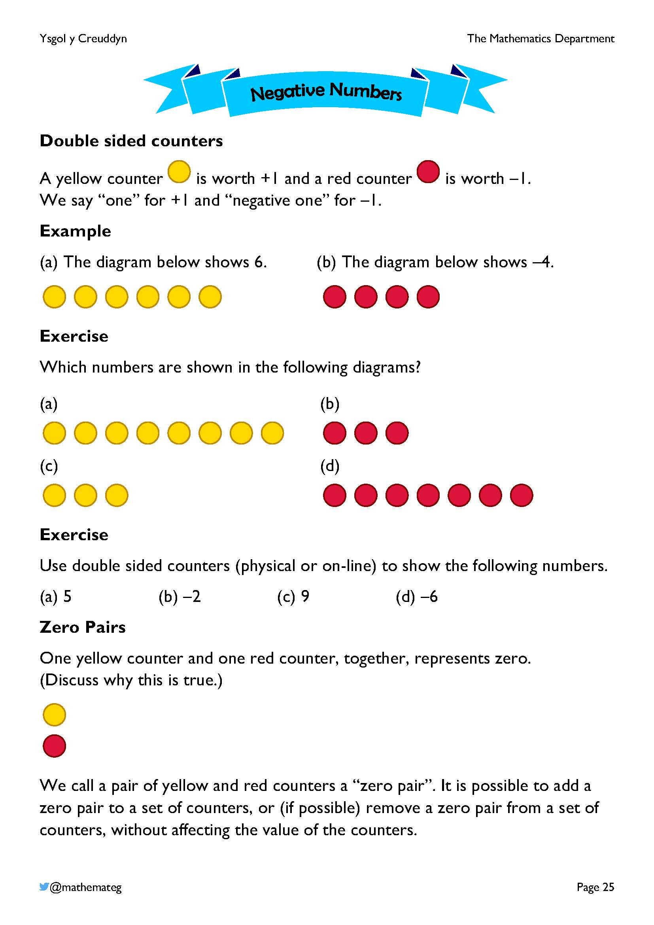
We use double sided counters here to represent directed numbers. Physical counters can be purchased, or the website https://mathsbot.com/manipulatives/doubleSidedCounters provides an electronic version of the counters.
The concept of a zero pair is an important one in this chapter. Show the learners different ways of arranging zero pairs, agreeing each time that zero is shown. For example:

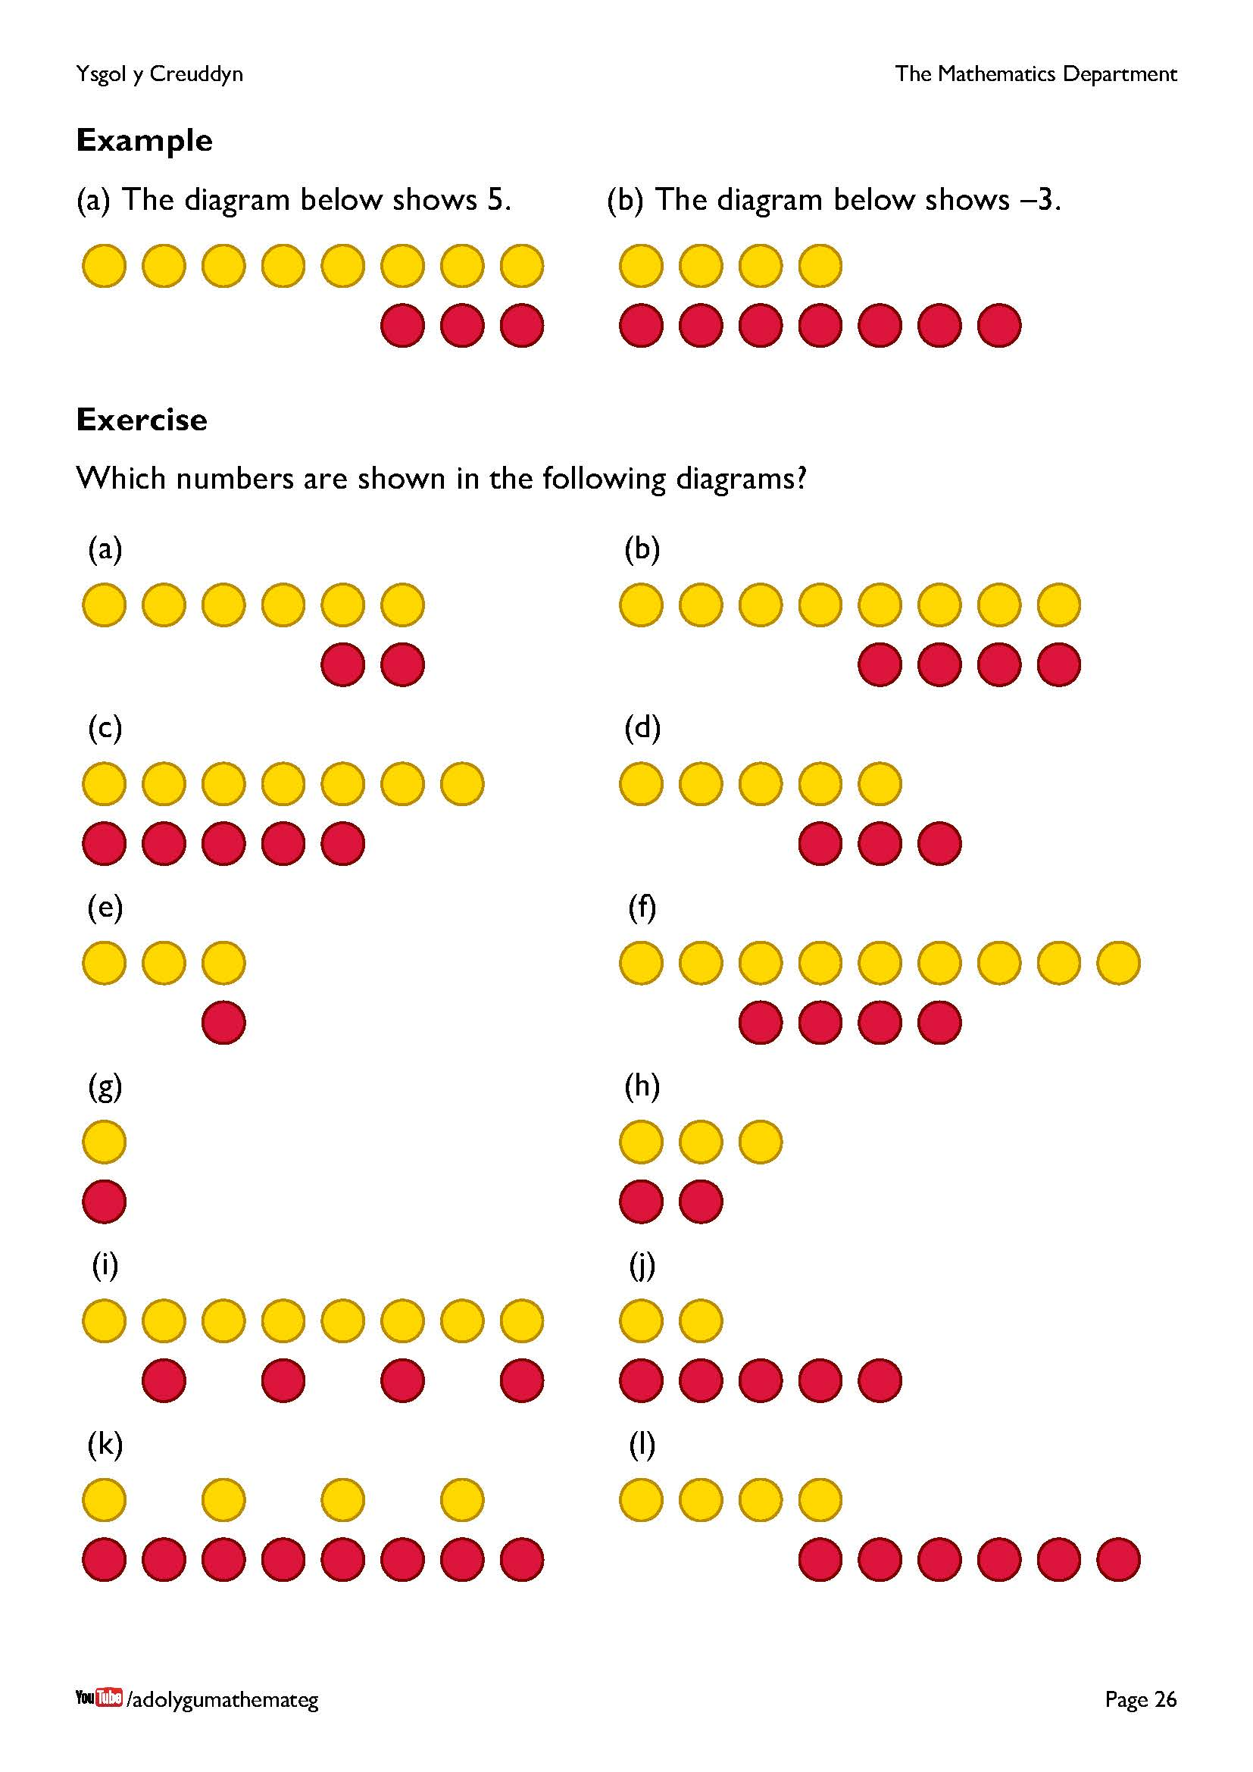
This page introduces the idea of recognising the value of a set of counters by identifying zero pairs, removing them, and counting what is left.
Notice that the counters in questions (d) and (l) must be re-arranged in order to identify the zero pairs.
On the website https://mathsbot.com/manipulatives/doubleSidedCounters, it is possible to drag a red counter on top of a yellow counter in order to remove a zero pair.
Further reading: 20 things to do with double sided counters: https://booleanmathshub.org.uk/files/4315/5845/2568/Abby_Cotton_-_20_Things_to_do_with_Double_Sided_Counters.pdf
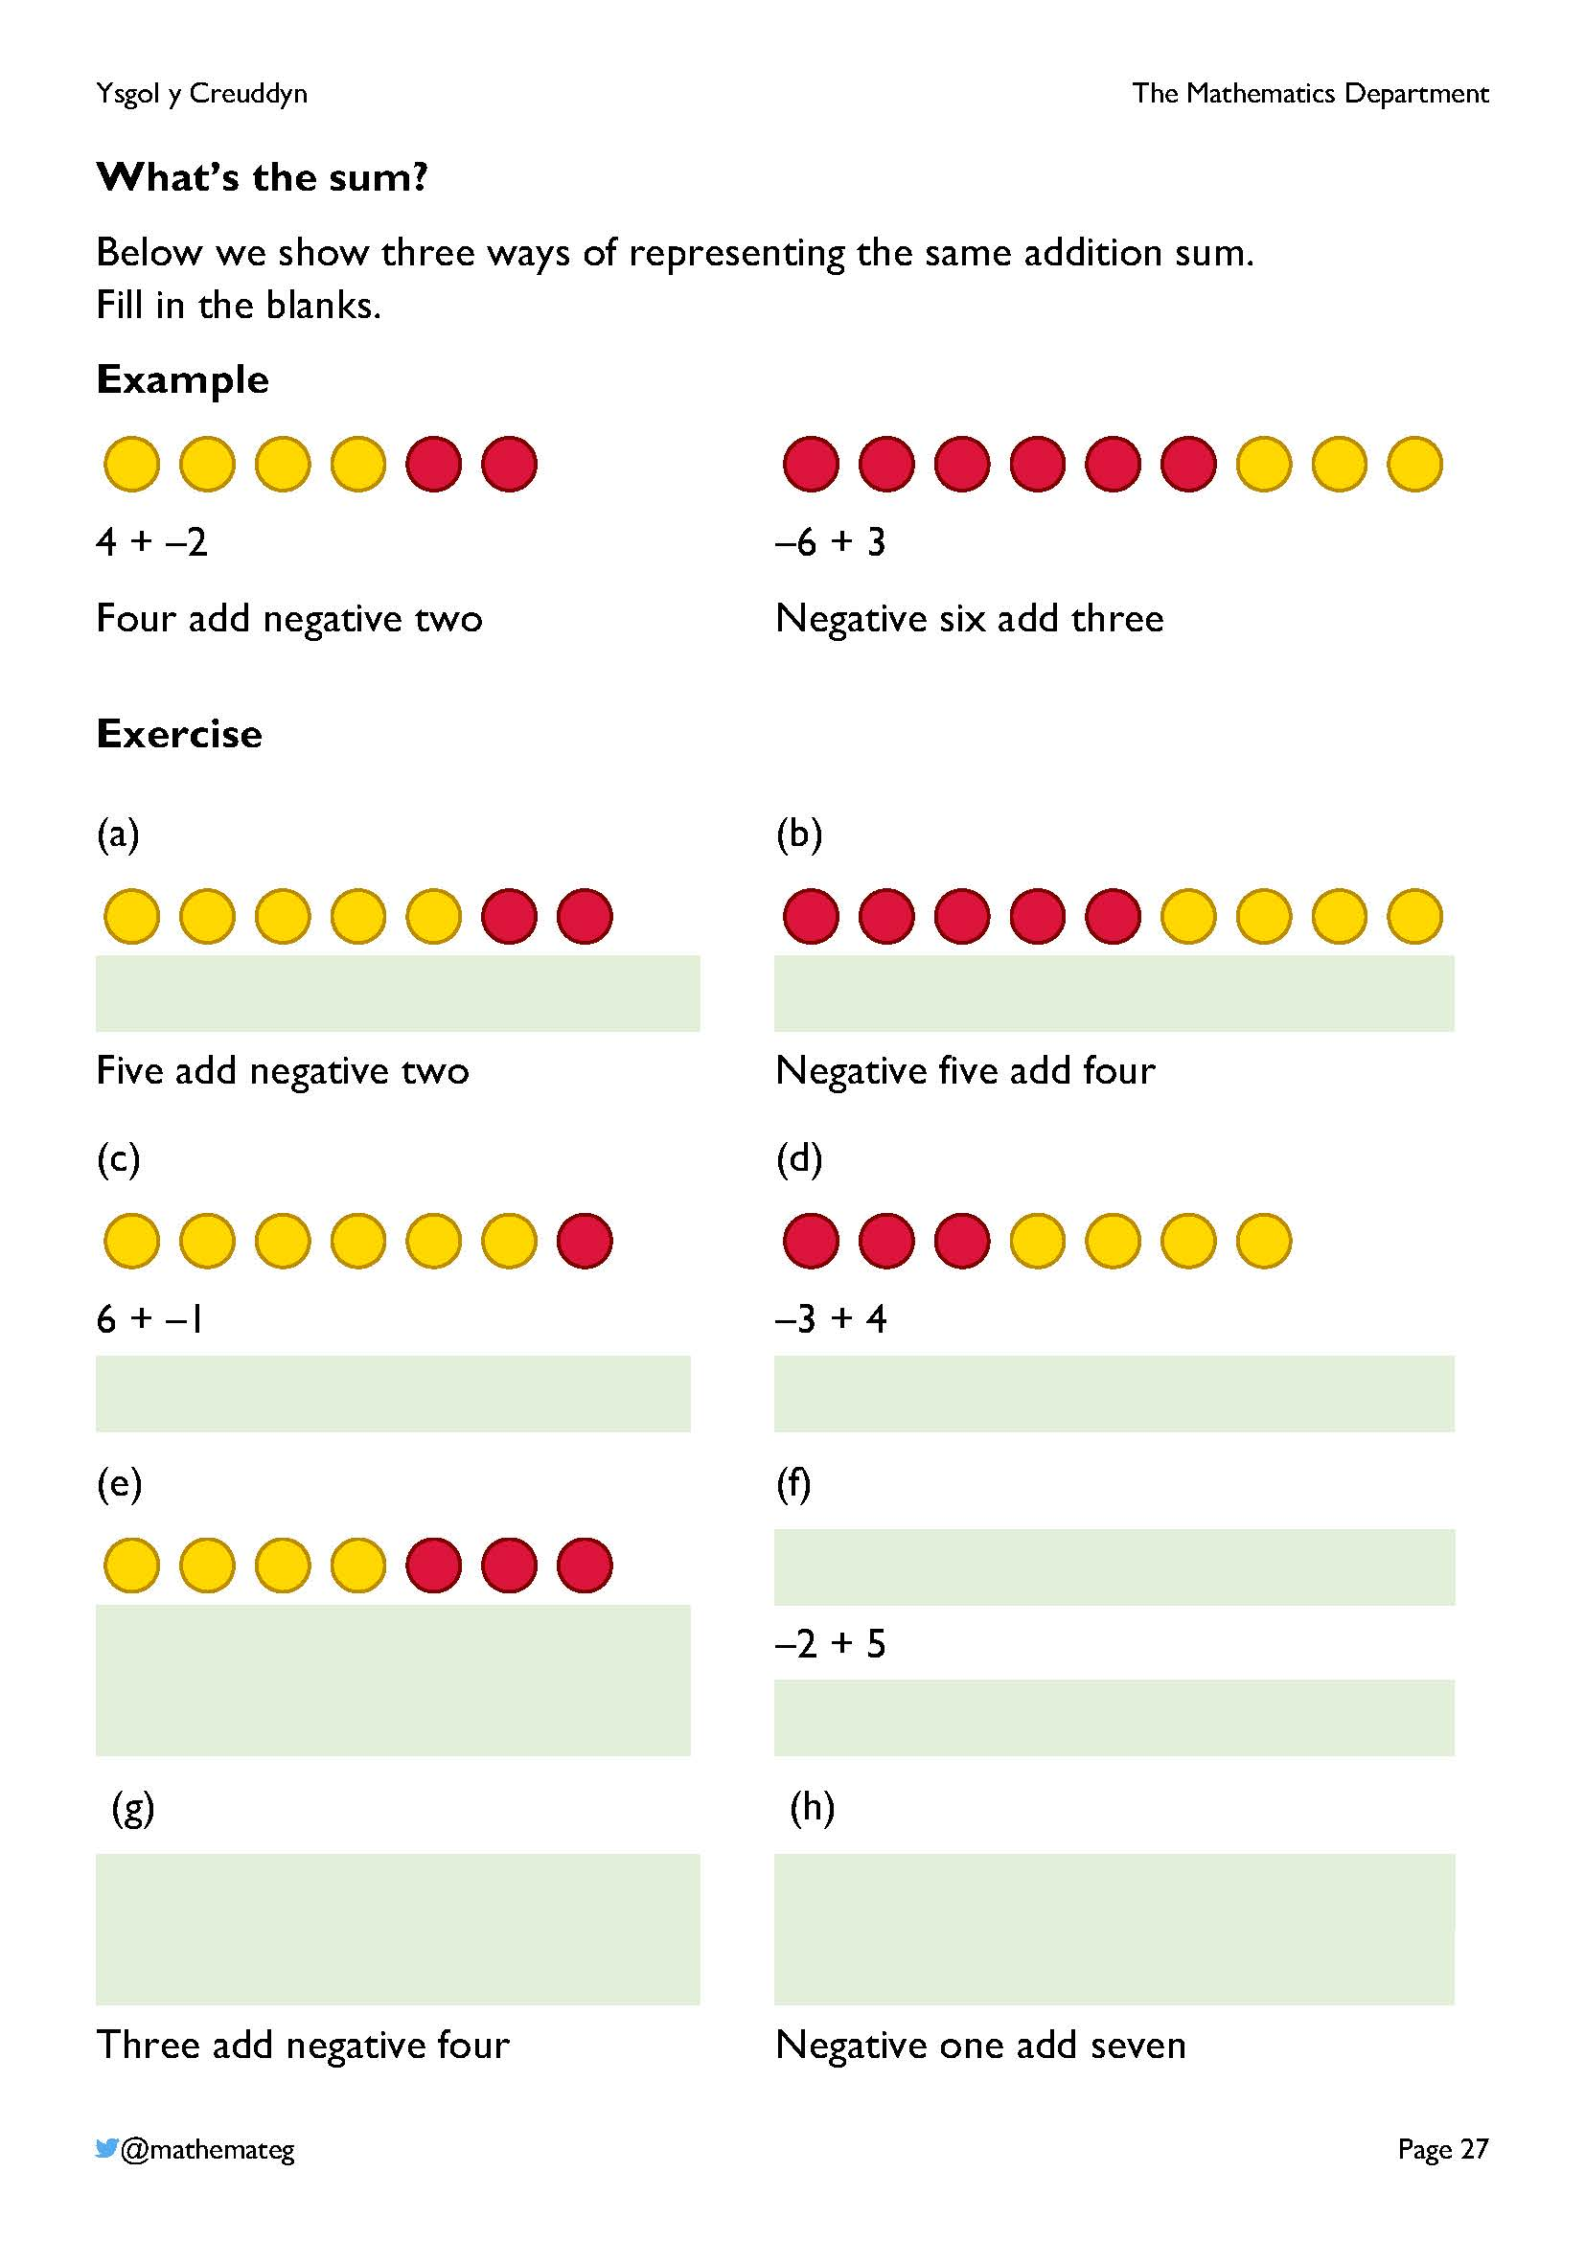
We represent the same addition sum in three different ways on this page:
- Using manipulatives, namely the double sided counters;
- Using symbols;
- Using words.
If red and yellow colours are not available to do the colouring, it is possible to label the counters with either “Y” and “R” or
“+1” and “–1”.
Emphasise the connection between the addition operation, +, and the process of adding more counters to a row.
Ensure that e.g., “negative three” is used for –3, and not “minus three”. This is because the word “minus” has two meanings:
- The sign of a number, e.g., “minus two” for –2;
- A subtraction sum, e.g., “nine minus three” for 9 – 3.
To avoid the confusion of having two meanings for the word “minus”, we avoid using it completely here and use
- “Negative” for the sign of a number, e.g., “negative two” for
–2;
- “Subtract” for a subtraction sum, e.g., “nine subtract three” for 9 – 3.

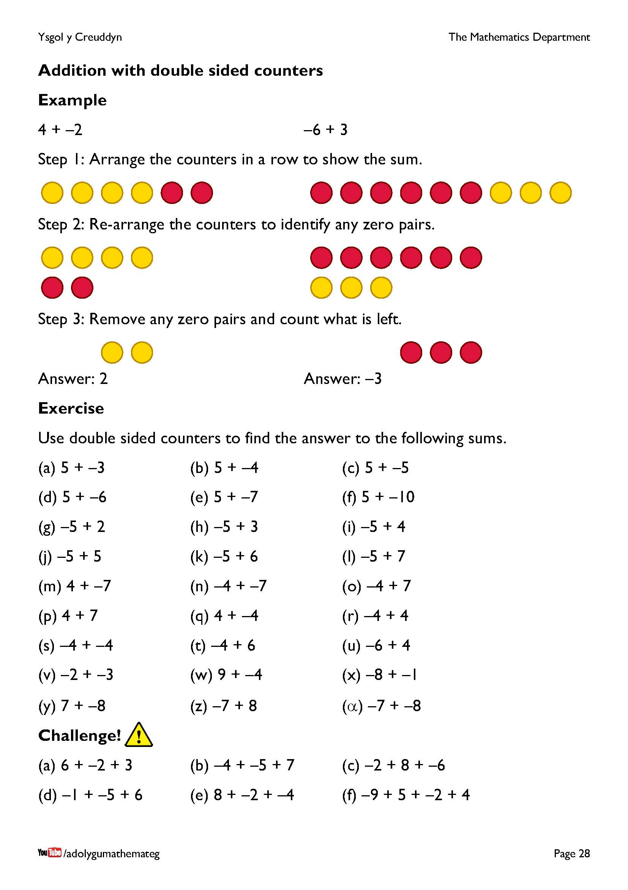
This page discusses how to add directed numbers using double sided counters.
Step 1 concentrates on the meaning of the addition sum, namely starting with a number (a set of counters) and adding another number (adding another set of counters at the end of the row).
Step 2 identifies any zero pairs by re-arranging the counters.
Step 3 removes any zero pairs and recognises the value of the remaining counters.
Confident learners may wish to start with step 2; this is acceptable! But insist that less confident learners start with step 1 in order to avoid doing two things at once (recognising the meaning of the sum and identifying the zero pairs).
Notice the patterns in the questions:
- The first 6 questions all start with 5 and change from having a positive answer to having a negative answer.
- The next 6 questions all start with –5 and change from having a negative answer to having a positive answer.
- The next 6 questions involve different combinations of the digits 4 and 7.
By completing more of this type of sum, learners will make the journey from the concrete (working with the physical counters) to the abstract (doing the sum mentally). In the middle, perhaps some learners will use a pictorial step (drawing pictures of counters on paper).
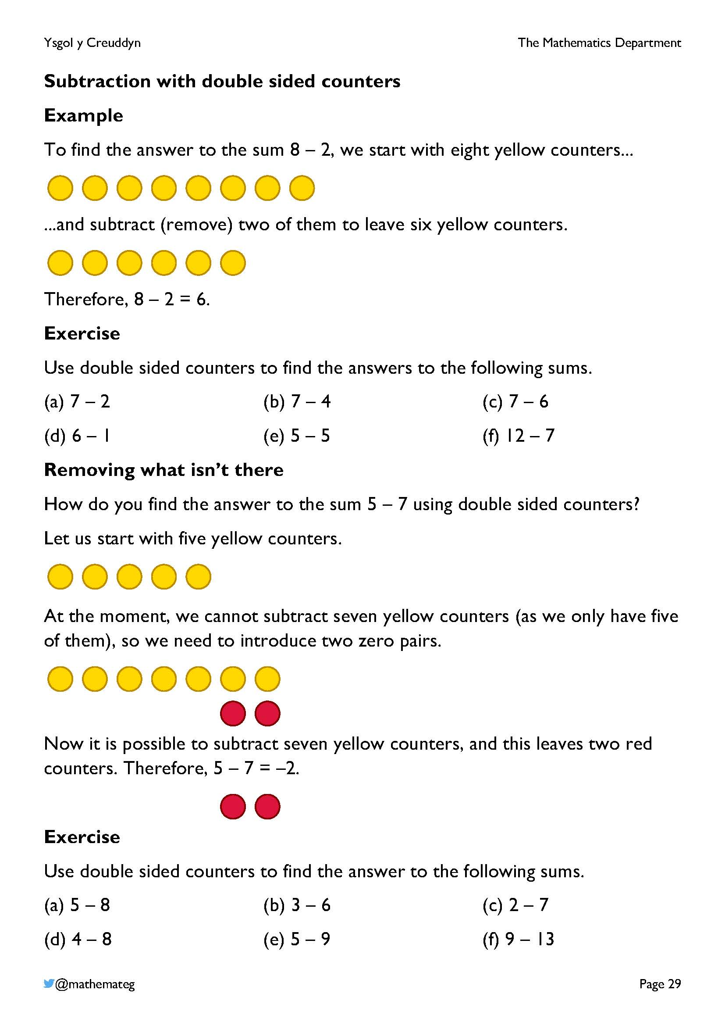
Regarding the double sided counters, the concept of subtraction in mathematics means removing a set of counters. This is simple if there are counters present to remove (the first half of this page), but if there aren’t enough counters physically present to remove, zero pairs must be introduced. It should be reinforced here that introducing a zero pair does not alter the value of a set of counters, and this then allows us to complete the subtraction sum with the counters.
Regarding how many zero pairs must be introduced to complete a subtraction sum, the order of the sum can be reversed to determine this. For example, with the sum 5 – 7, we obtain the sum 7 – 5 by reversing the order, which gives an answer of 2. So, we need to introduce two zero pairs in order to complete the sum 5 – 7 with double sided counters.
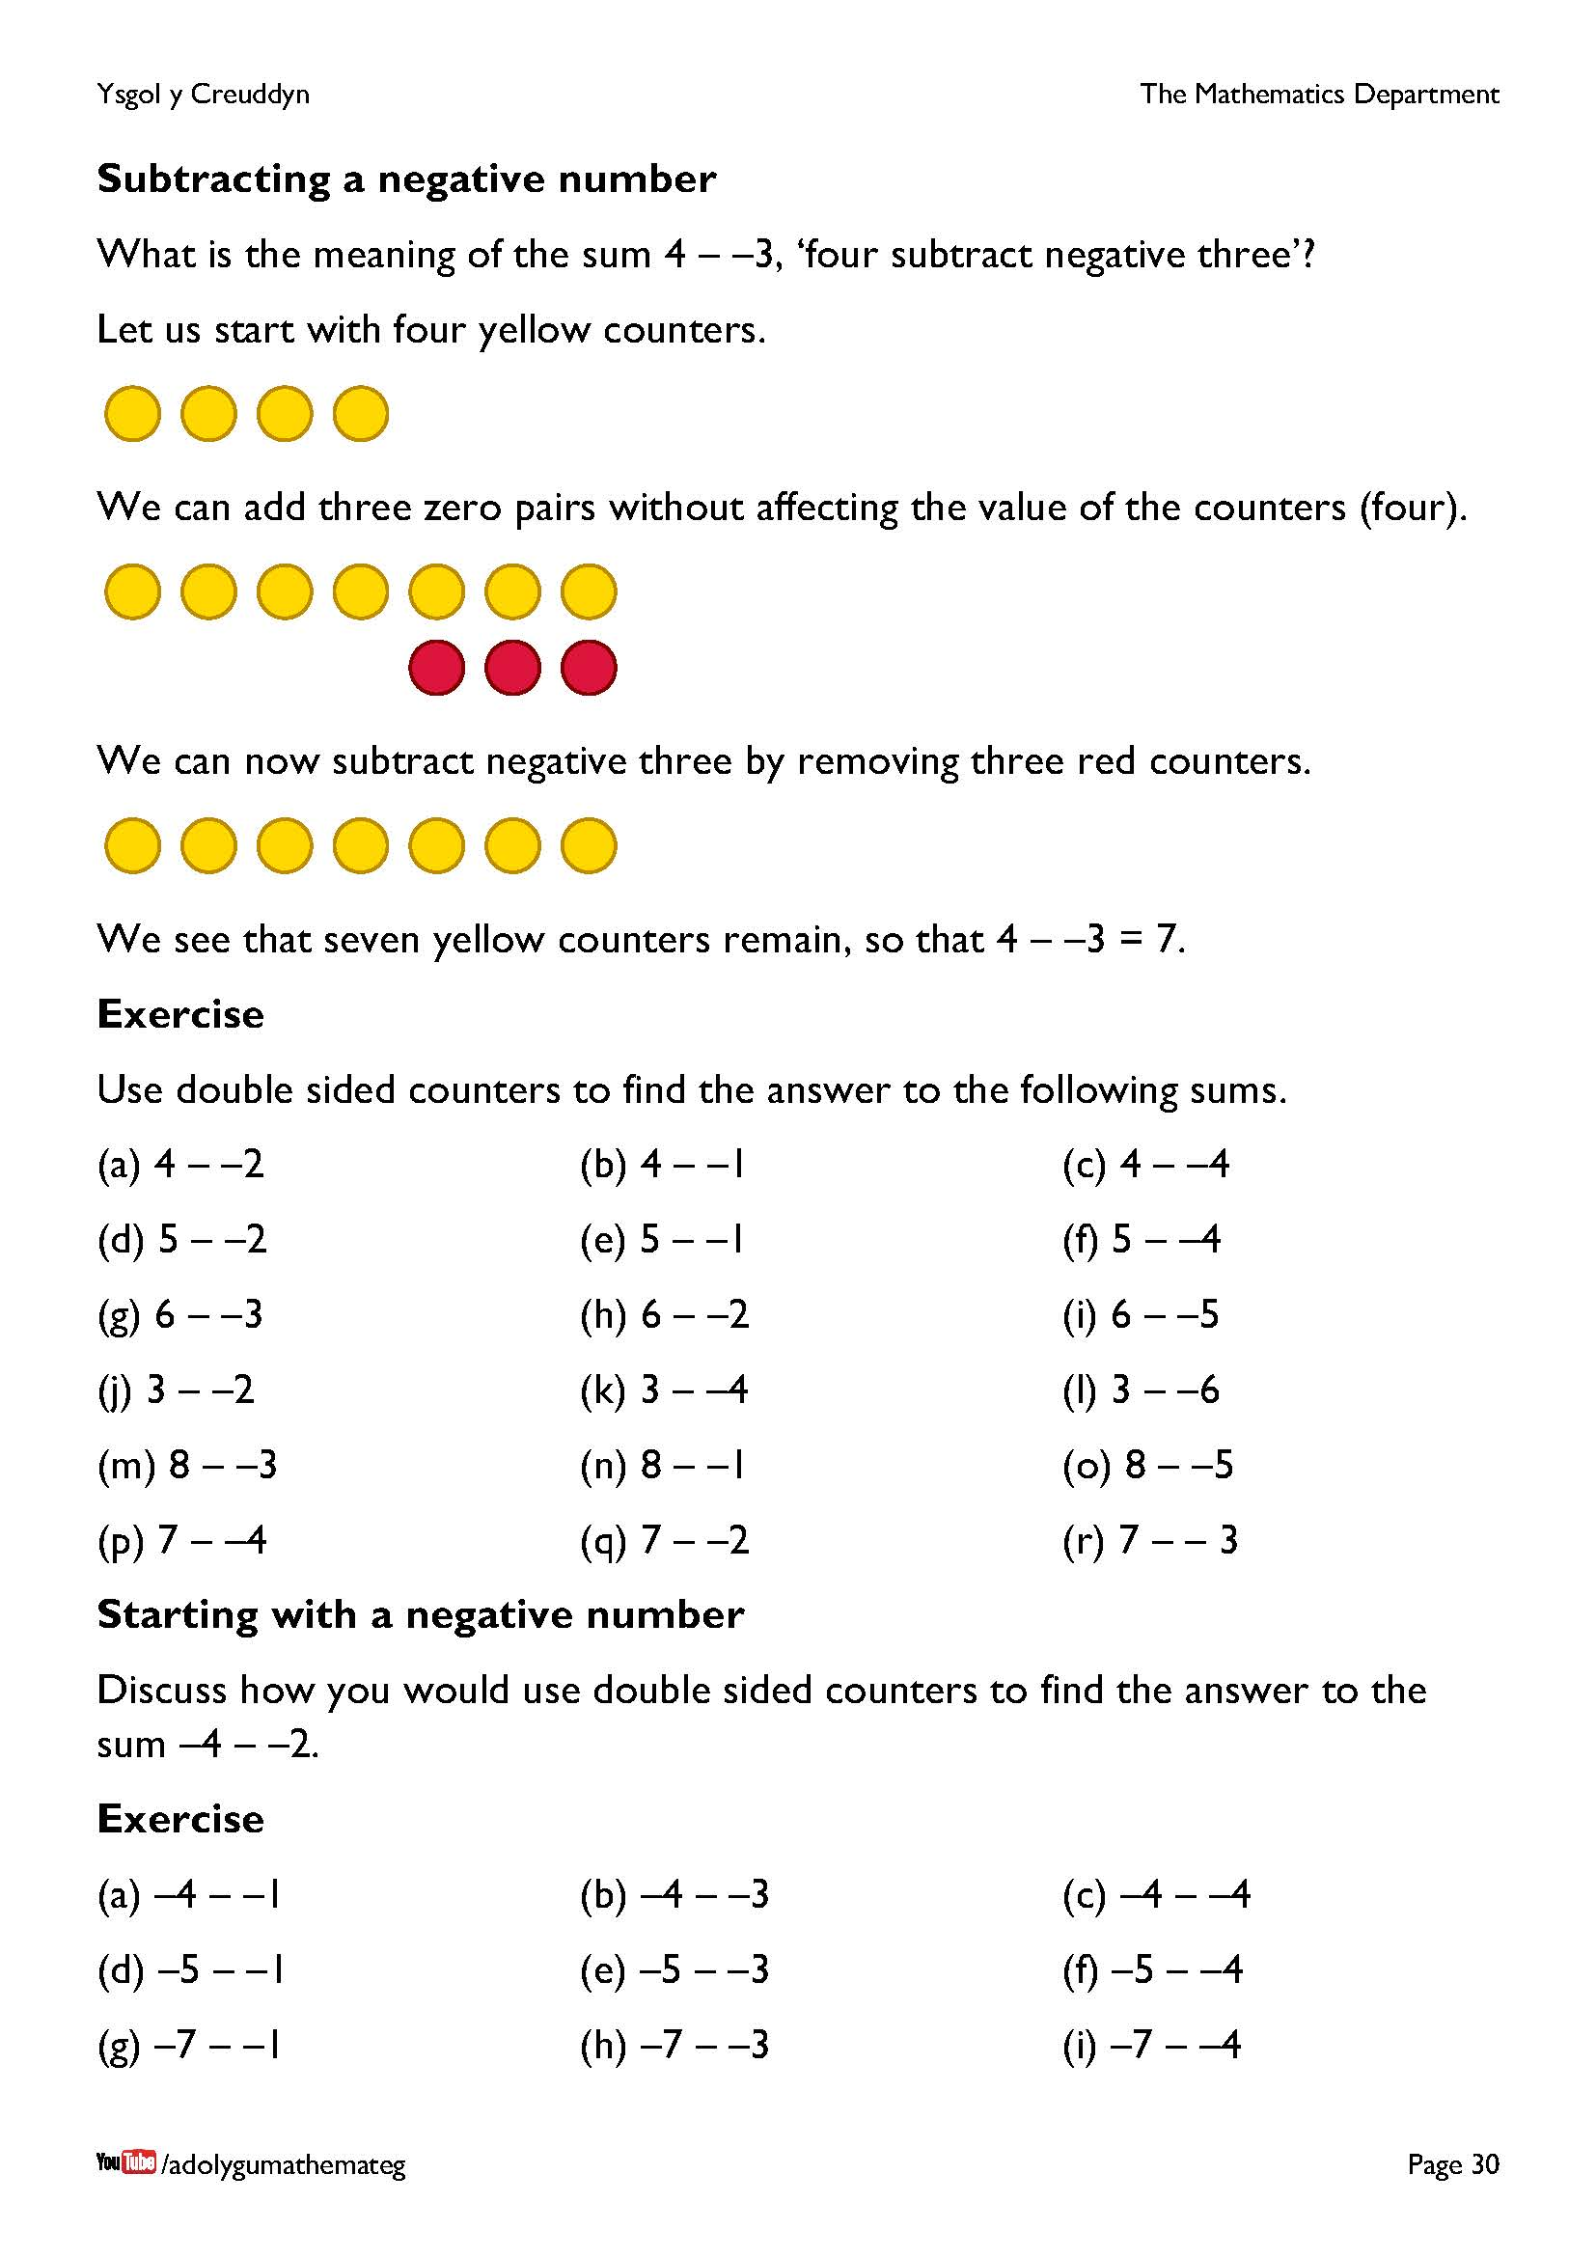
For the sum 4 – –3, three zero pairs must be introduced to be able to remove three red counters. So, when subtracting a negative number from a positive number, the negative number tells us how many zero pairs to introduce.
Extension work: Sums like –4 – –6, where we need to cross past zero.
We start with 4 red counters.
At the moment, we cannot remove six red counters (as only four red counters are present), so we need to introduce two zero pairs.
Now, it is possible to remove six red counters, and this leaves two yellow counters. Therefore, –4 – –6 = 2.
Further reading: some more ideas for adding and subtracting with directed numbers: http://ticktockmaths.co.uk/adding-and-subtracting-directed-numbers/
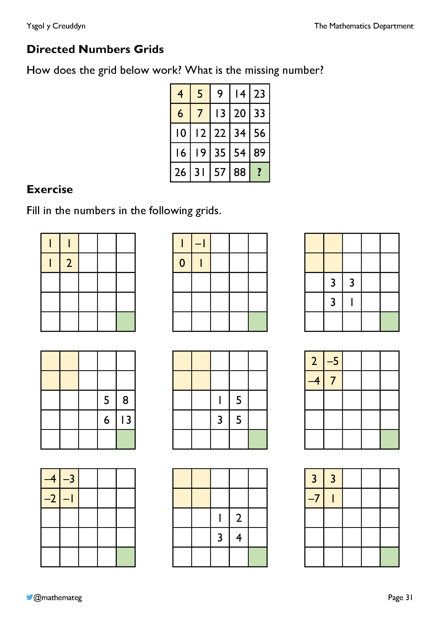
These exercises provide purposeful practice for addition and subtraction of directed numbers.
- In each row, two consecutive numbers are added to give the next number on the right.
- In each column, two consecutive numbers are added to give the next number below.
In order to complete the grids where the four yellow numbers are not given, reasoning must be used to find the numbers above and to the left (an assortment of subtraction sums must be completed).
Acknowledgement: This exercise is based upon one found on the late Don Steward’s web site: https://donsteward.blogspot.com/2020/03/directed-number-grid.html

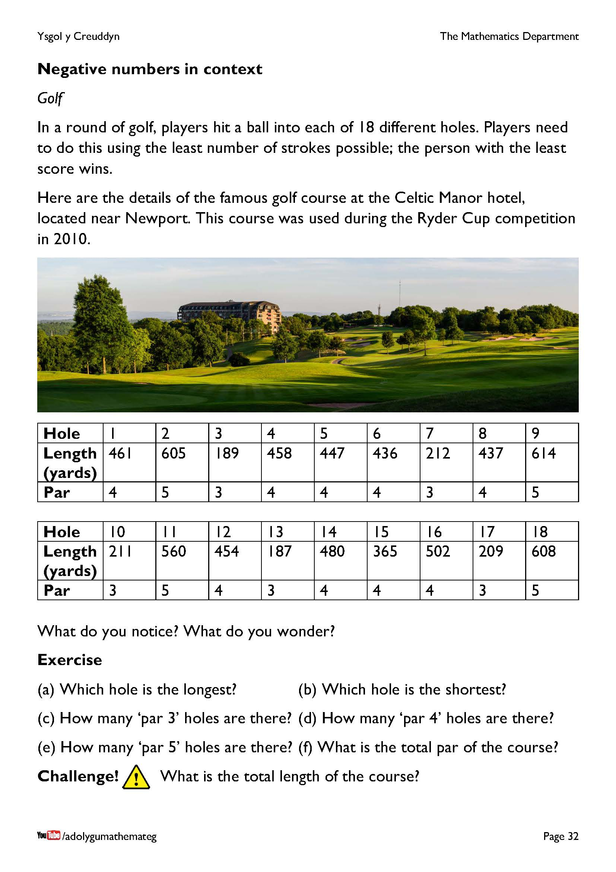
Encourage the learners to discuss the information that is given in the table. As well as the questions given in the exercise, what about discussing…
- The connection between the length of a hole and the par for the hole (the longer the hole, the greater the par).
- How much time would it take to walk along one of the holes? (Remember that 1 yard is similar to an adult’s stride when walking.)
- What type of clubs should be used on each hole? (Search for “golf club distances” on the internet.)
- How does the golf course closest to the school compare to the course at the Celtic Manor?

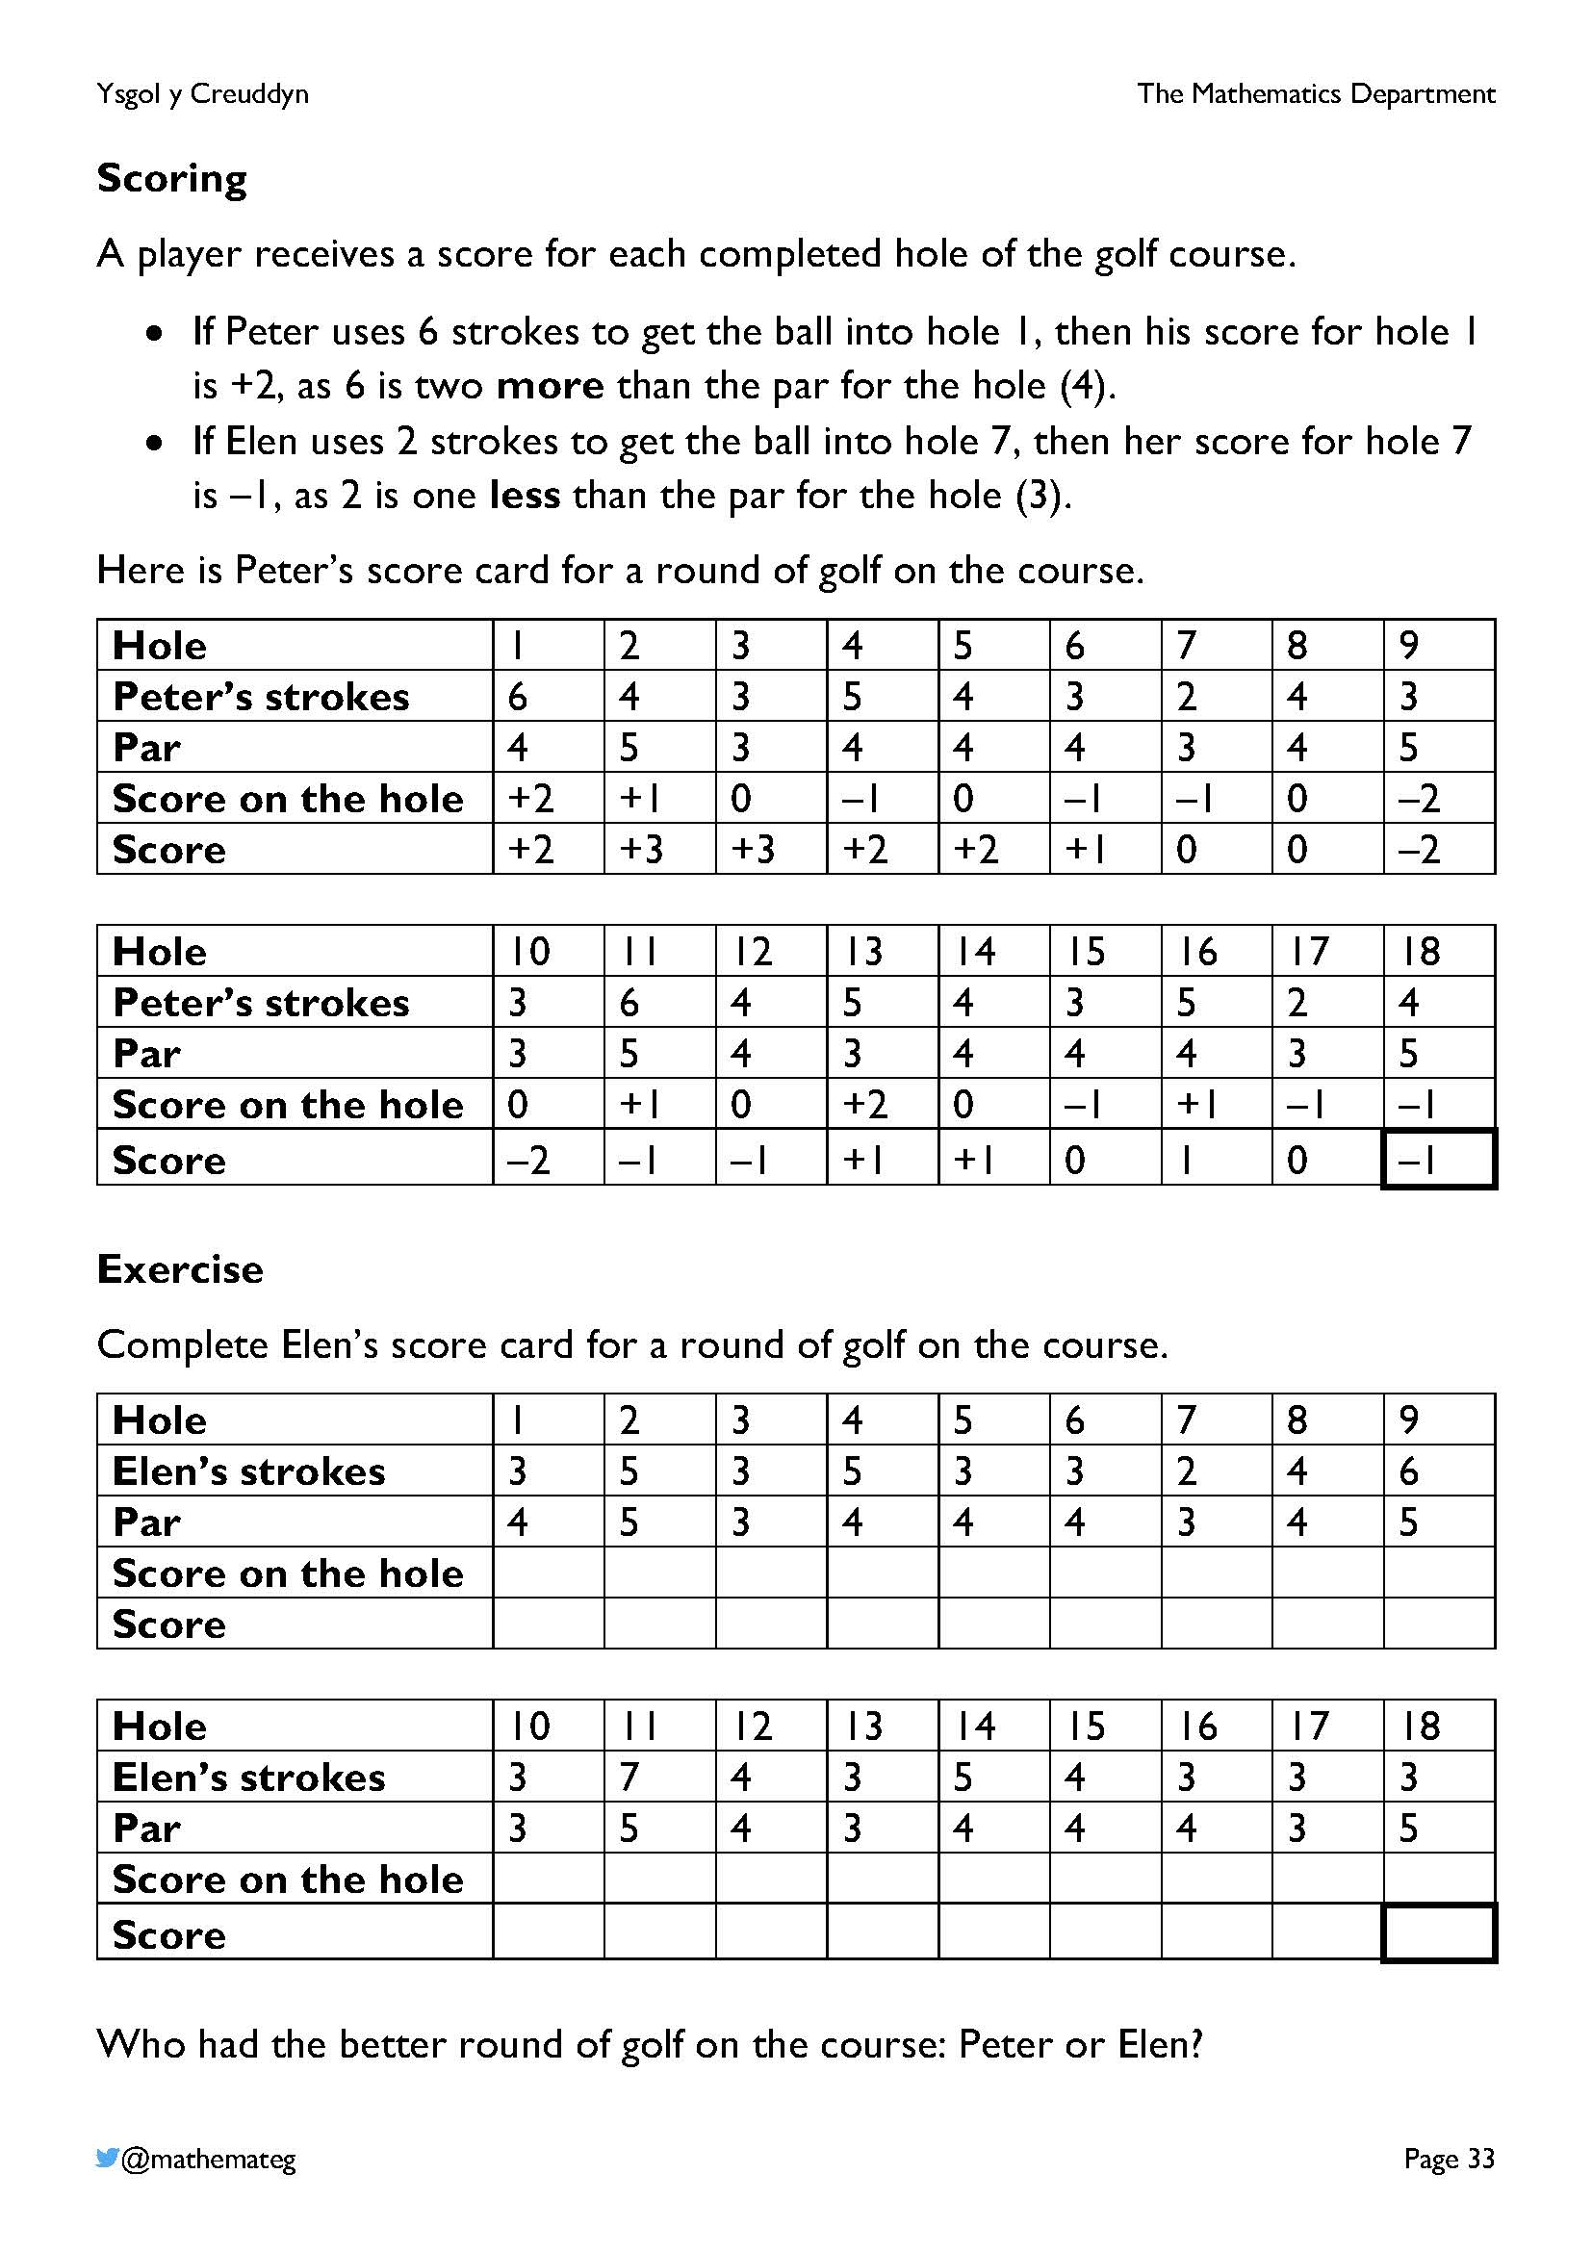
Golf lends itself well to discuss directed numbers in context as the players’ scores are often negative numbers. The least score is the best score in golf, which gives a good opportunity to compare the value of different negative numbers. For example, who would win in each row of the following table?
Score for player 1 Score for player 2
–8 –6
–12 –15
–4 2
8 –5
0 –3
If the learners are not familiar with golf, try to find a clip of a recent tournament on the internet, discussing the numbers that appear on screen. Alternatively, perhaps you have the resources to create a simple golf course on the school grounds?
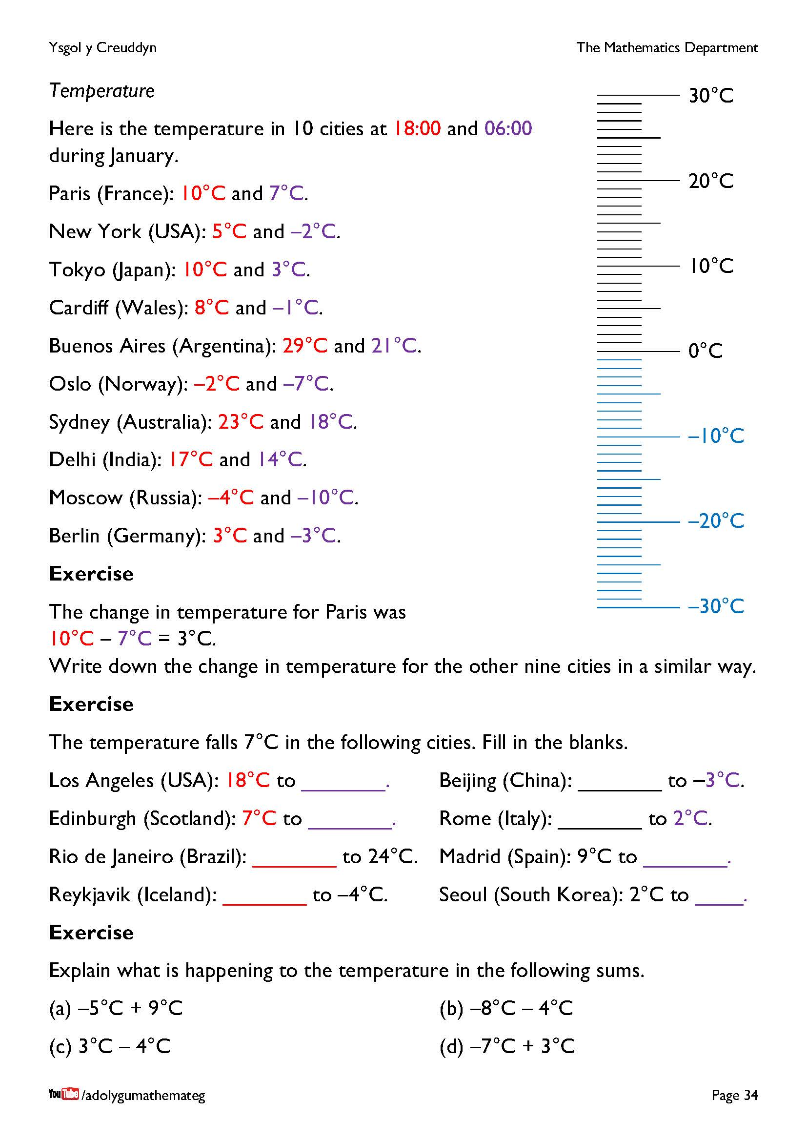
Take the opportunity here to highlight the connection between subtracting two numbers and finding the difference between the numbers. Use the thermometer on the page (which is a type of number line) to show the connection between the change in temperature and the difference between the two temperatures.
For the final exercise on the page, an explanation of the following type would work:
(a) The temperature rises 9°C from –5°C to 4°C.
If you have a weather station, perhaps you will have an opportunity to discuss negative numbers during the cold months of winter? (A weather station would also provide several other opportunities to collect and discuss mathematical data.)

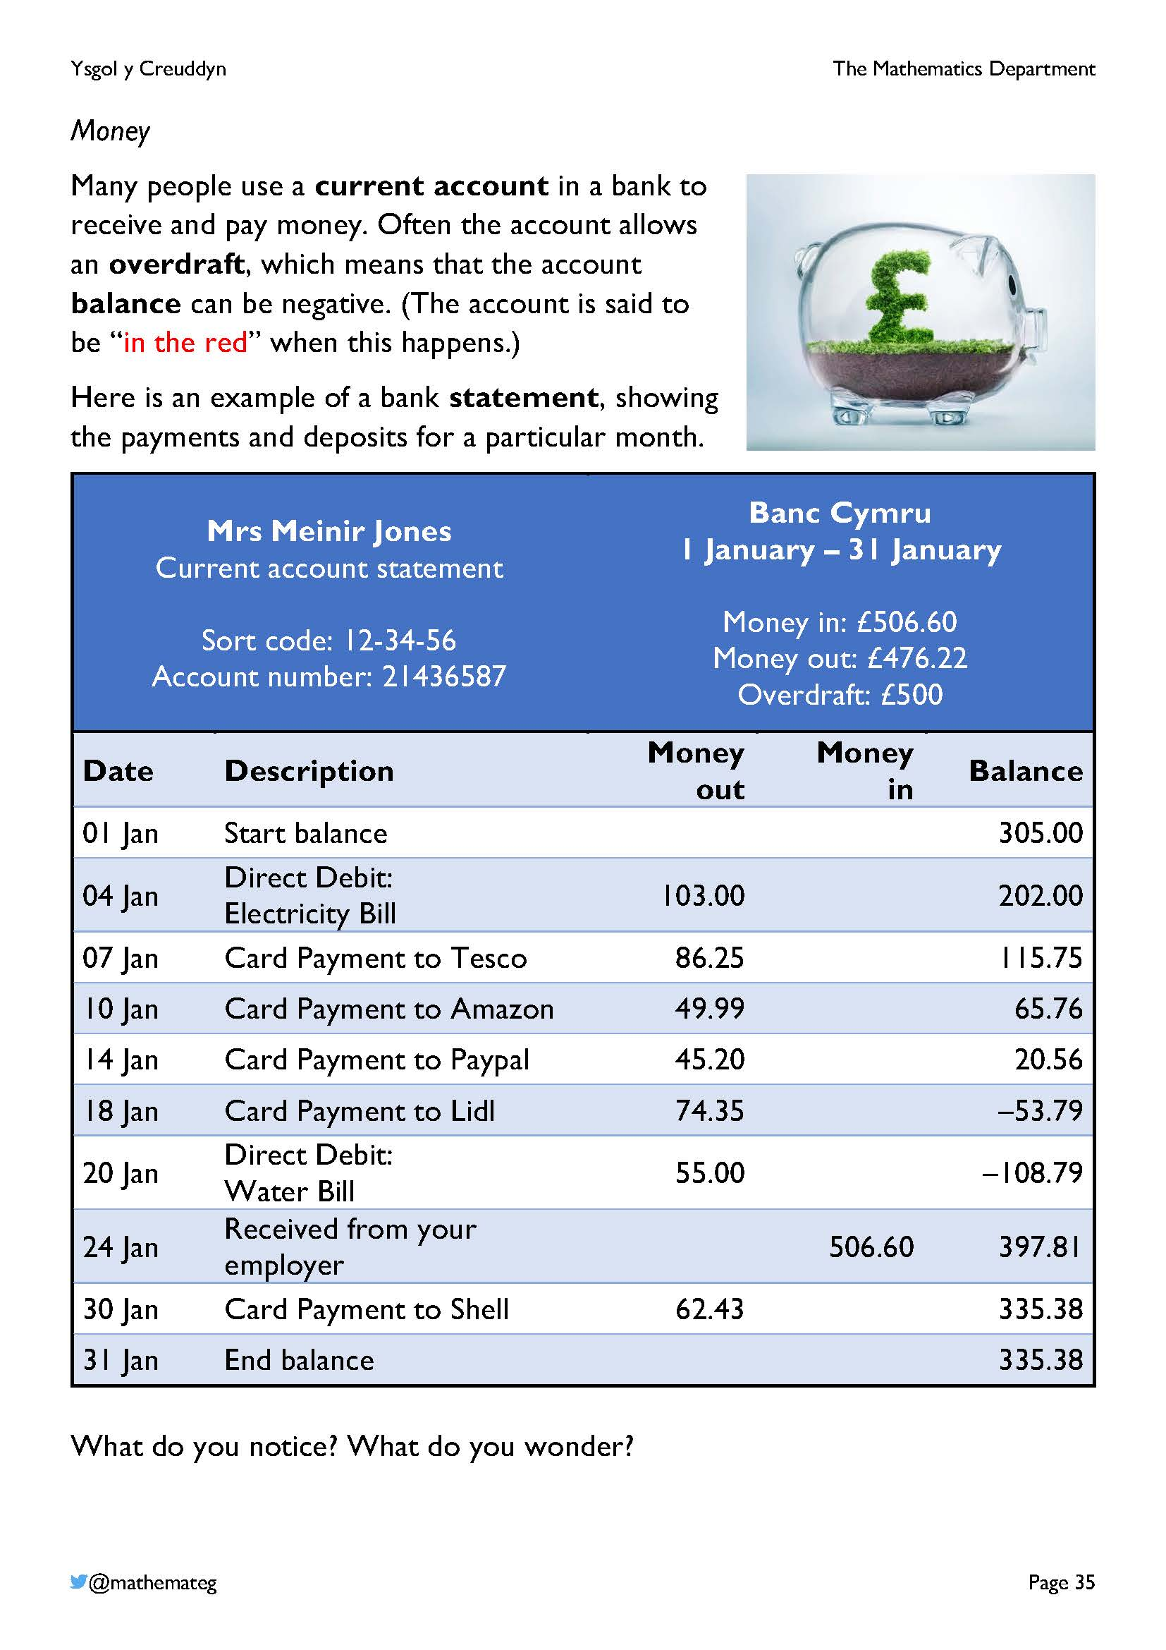
There are a number of potentially unfamiliar terms on this page – take the time to discuss them fully.
- Historically, negative numbers on a bank statement were printed with red ink, whilst positive numbers were printed with black ink. So, a person with a positive balance is “in the black” and a person with a negative balance is “in the red”.
- A bank account has a “balance” because if you add all the deposits and subtract all the payments, the number you end up with (positive or negative) is the number required to balance one side with the other side.
- A debit card for a bank account has 16 digits.
  - The first digit shows what type of card it is (for example, Visa cards start with a 4).
  - The final digit is the check digit, which is used to recognise errors when inputting the card number e.g., on a computer. (Challenge! Can you understand how the check digit is created? https://en.wikipedia.org/wiki/Luhn_algorithm)
Aspects of these two pages touch on the following description of learning for number:
FINANCIAL LITERACY
- I can demonstrate an understanding of income and expenditure, and I can apply calculations to explore profit and loss.

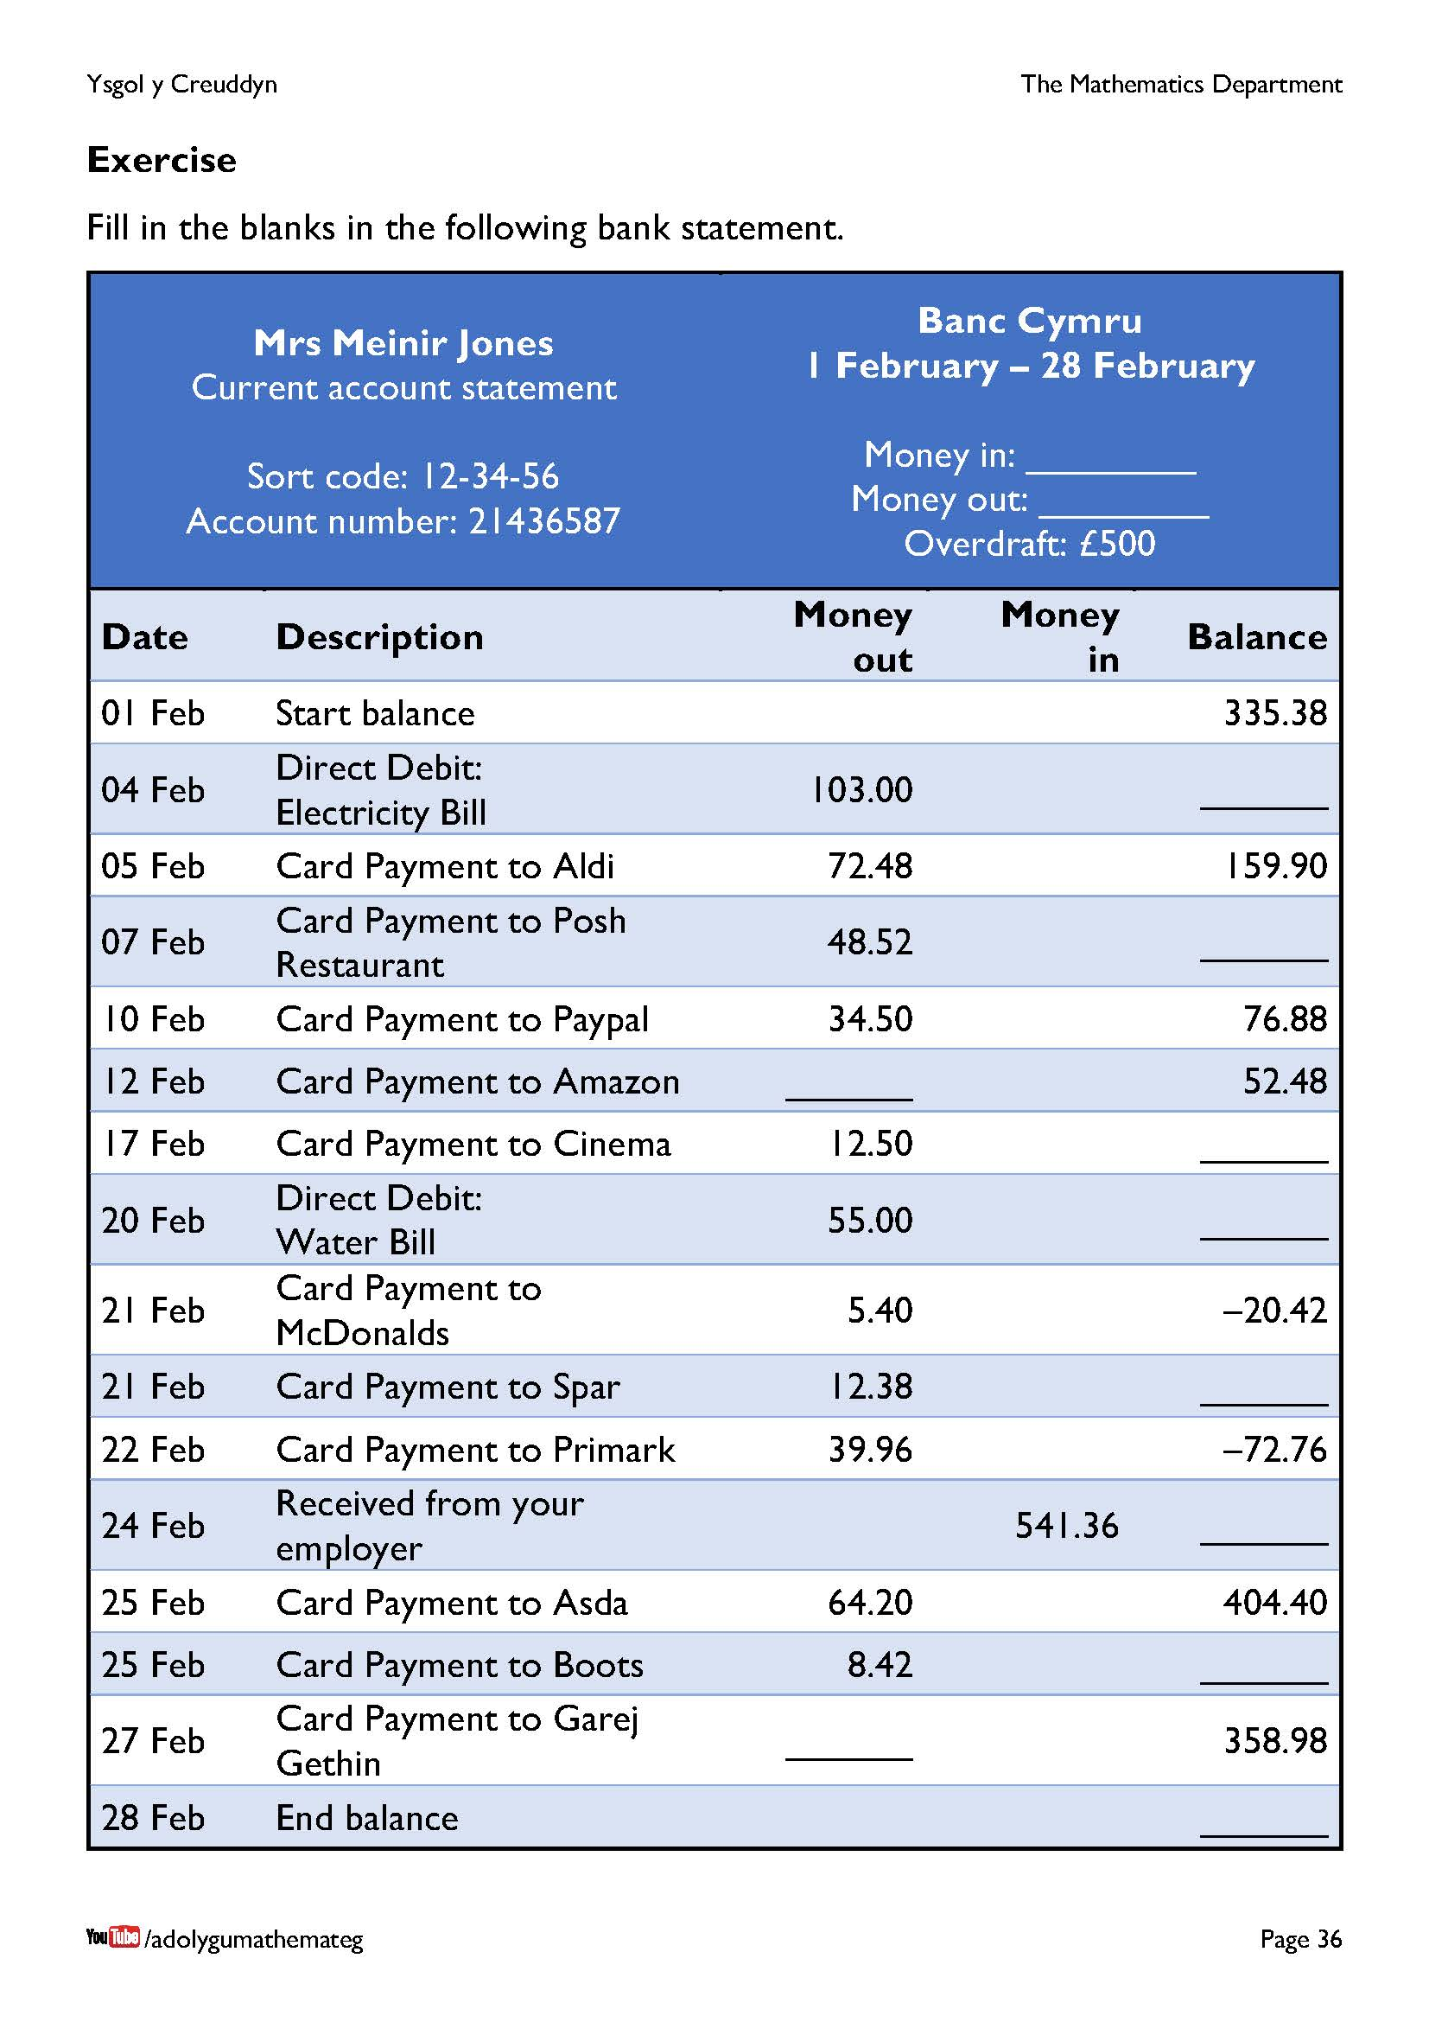
Perhaps it would be a good idea to allow the use of a calculator to complete this exercise? (And, therefore, a discussion on how to enter negative numbers on a calculator will be required?)
Notice that the start balance follows on from the end balance on the previous page. Extension work: Compare the statement shown on this page to the statement shown on the previous page. What is different? What is the same?
Further ideas for discussing directed numbers:
- Underground floors in a lift;
- Calculating the goal difference in sport;
- Distances above and below sea level.

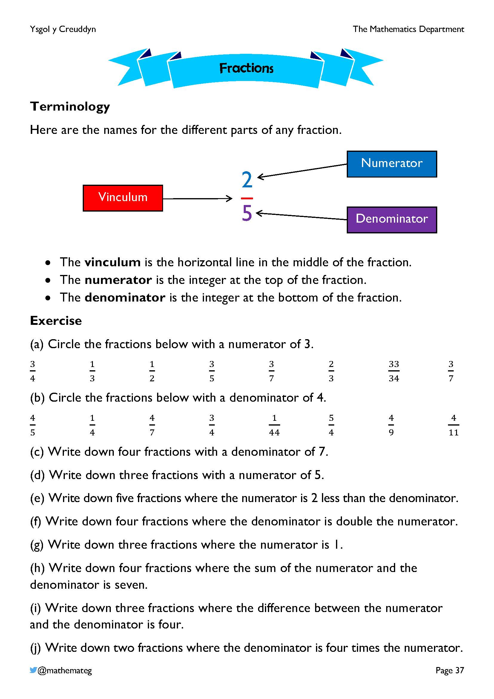
This chapter on fractions begins by considering the names for the different parts of a fraction.
- The word vinculum is used for any horizontal line in mathematical notation. For example, the vinculum forms part of the symbol for a square root, or forms part of a division frame.
- The name for a fraction where the numerator is 1 is a unit fraction.
The remainder of the chapter concentrates on different ways of using fractions, including
- Fraction of a shape, e.g., shading $\frac{3}{4}$ of a rectangle;
- Fraction of a number, e.g., calculating $\frac{3}{4}$ of £12;
- Fraction as a number, e.g., calculating 3 ÷ 4 to locate $\frac{3}{4}$ on the number line.

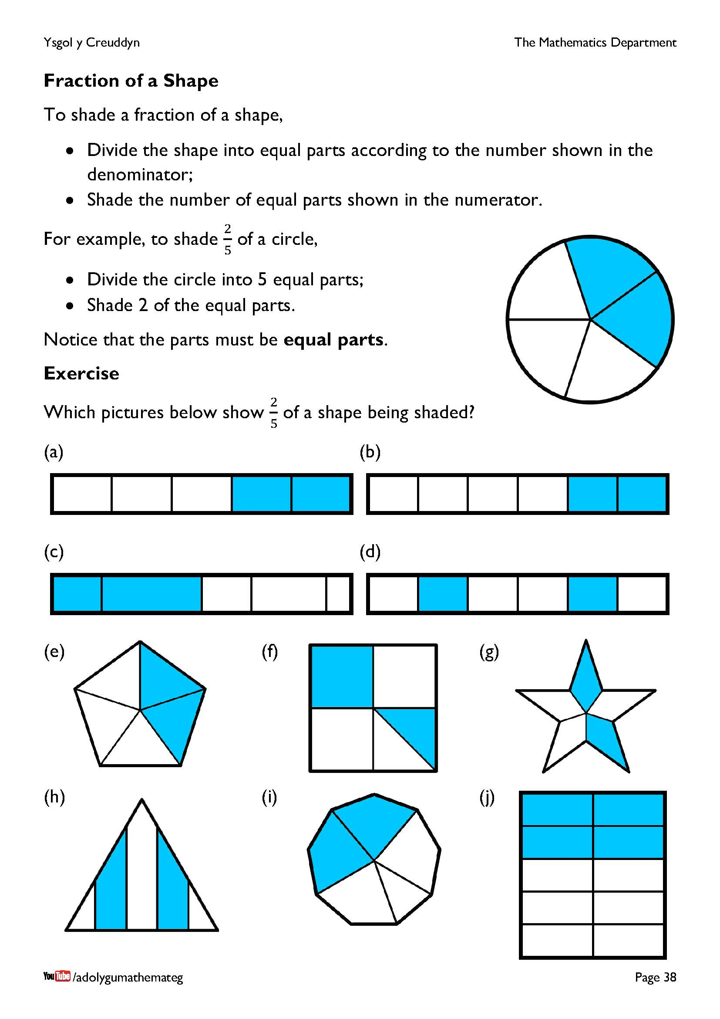
This page introduces a method for shading a particular fraction of a shape. The exercise provides examples and nonexamples of shading $\frac{2}{5}$ of a shape.
- Questions (a), (d), (e), (g) and (j) correctly show $\frac{2}{5}$ of the shape being shaded.
- Question (b) shows the incorrect number of parts (6 instead of 5).
- Questions (c), (f), (h) and (i) show parts that are not equal in size.
Extension work: For questions (b), (f) and (i), having agreed that $\frac{2}{5}$ of the shape is not shaded, what fraction of the shape is shaded?

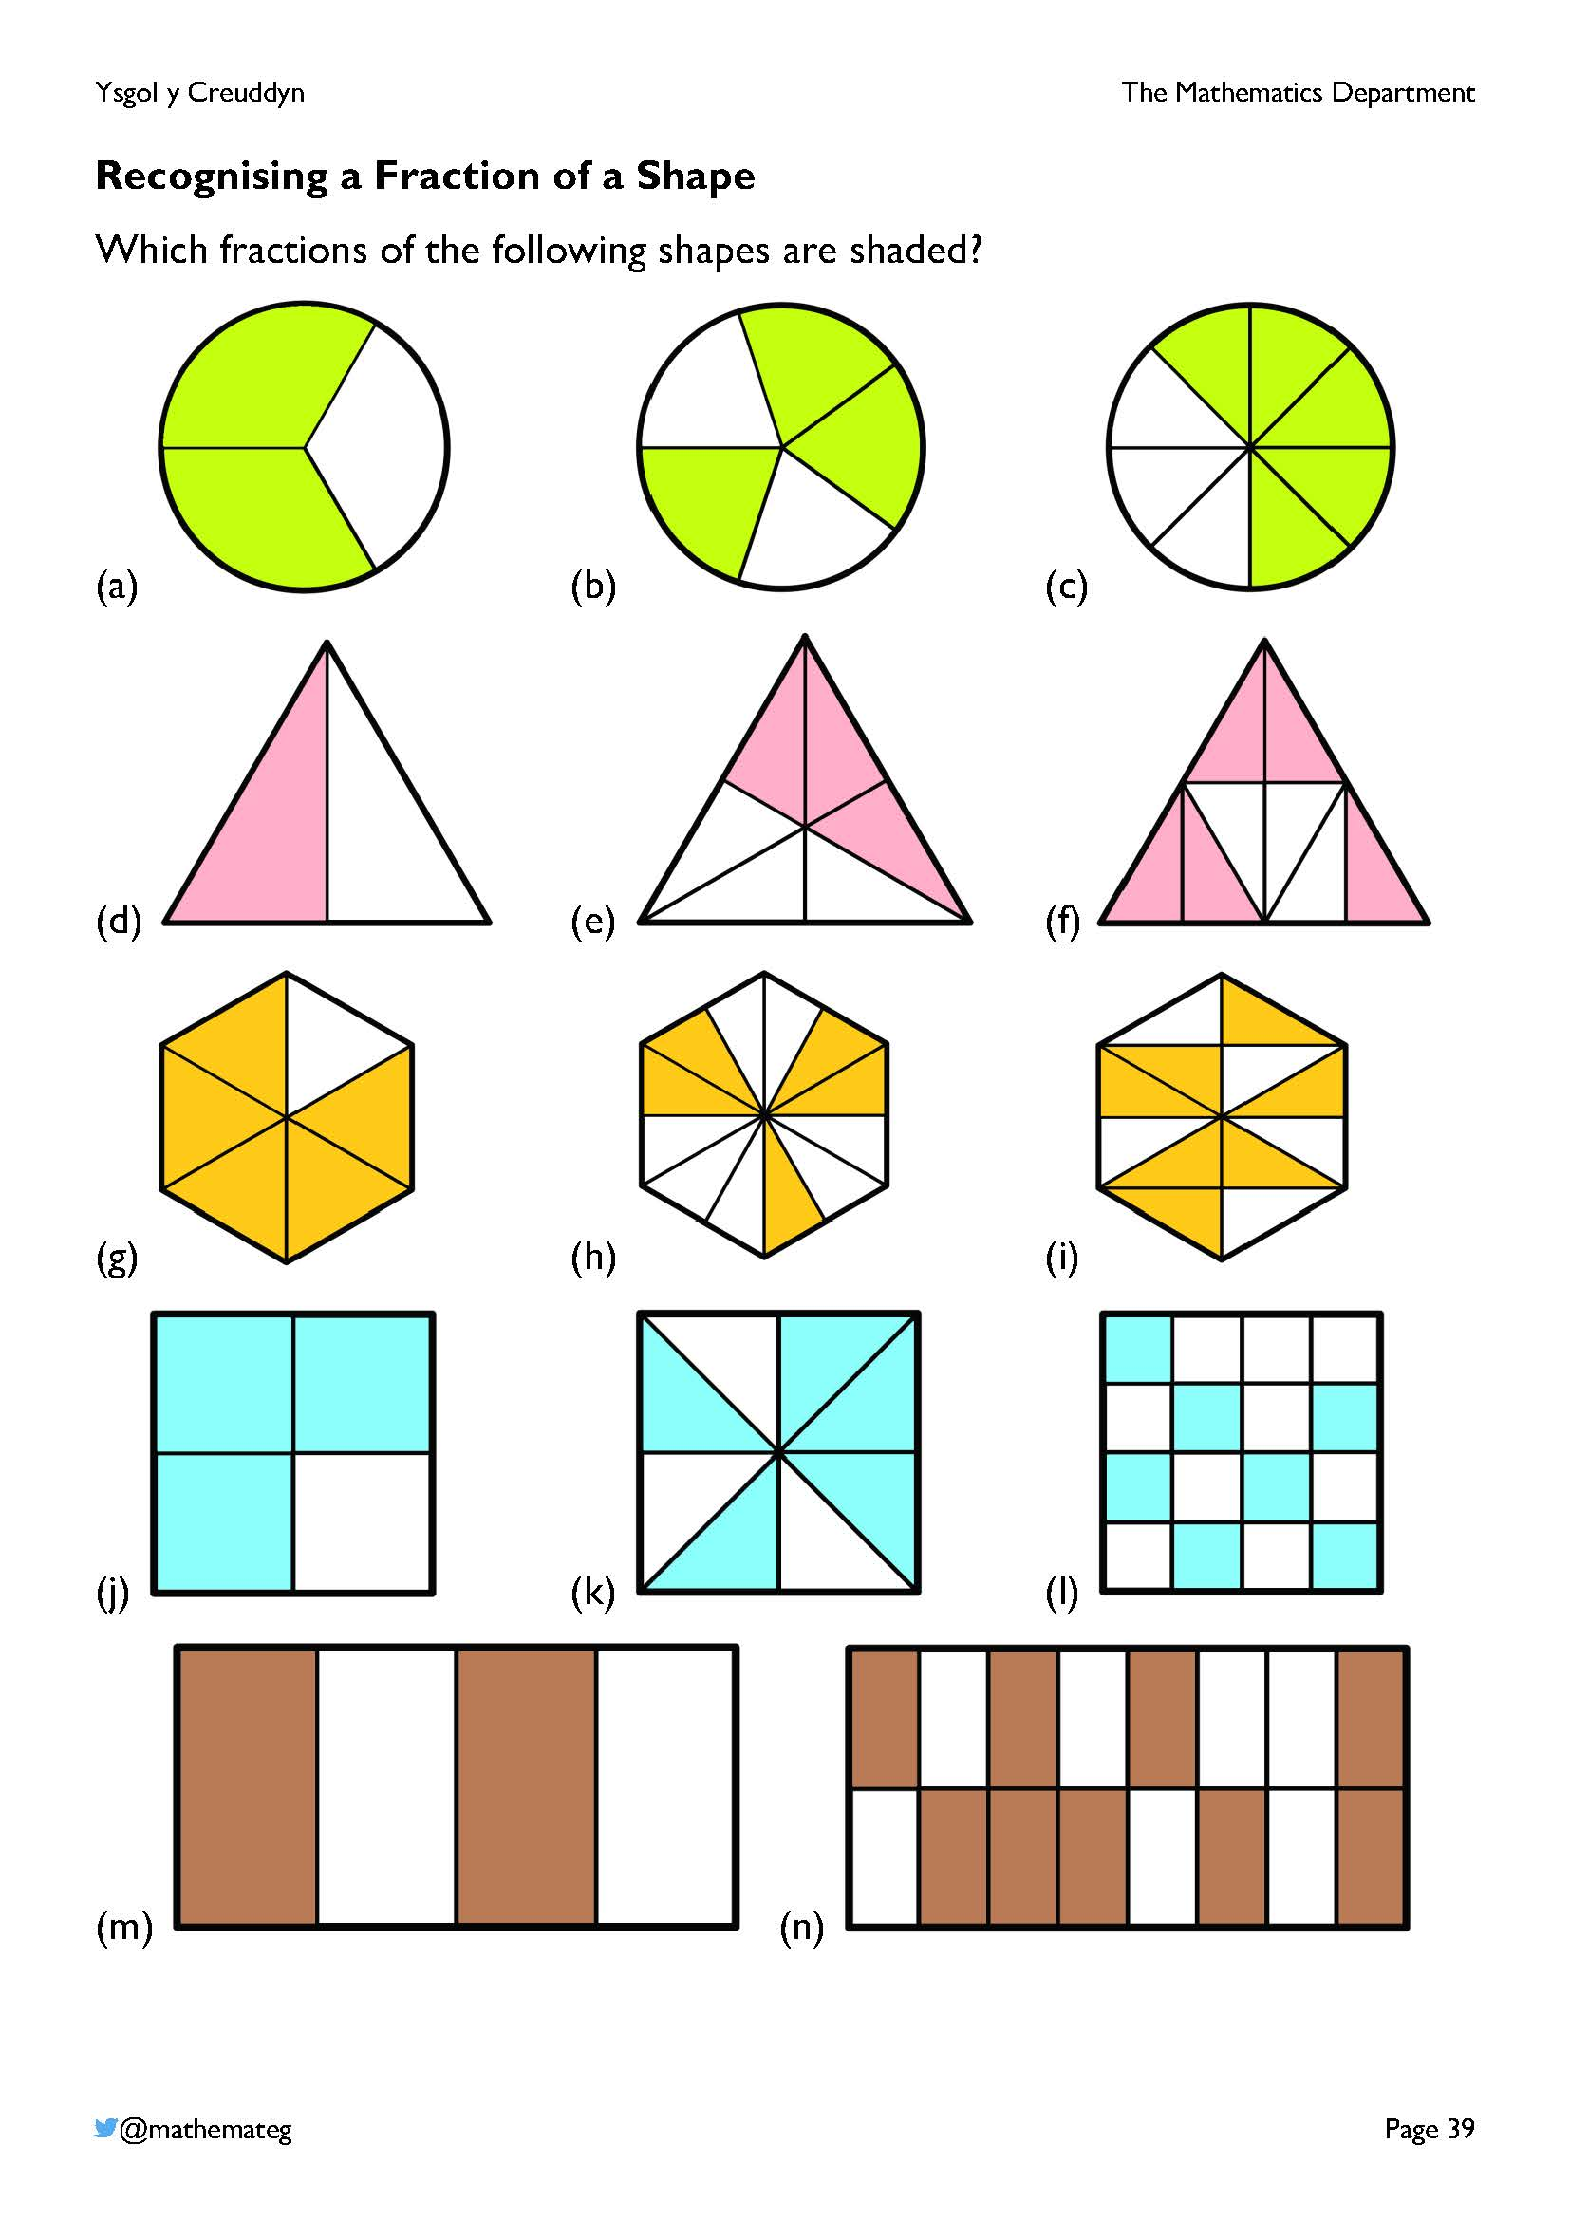
Each of these shapes have been split into equal parts, so an effective strategy for finding the answer would be to count the number of equal parts (the denominator of the fraction), and then count how many parts have been shaded (the numerator of the fraction).

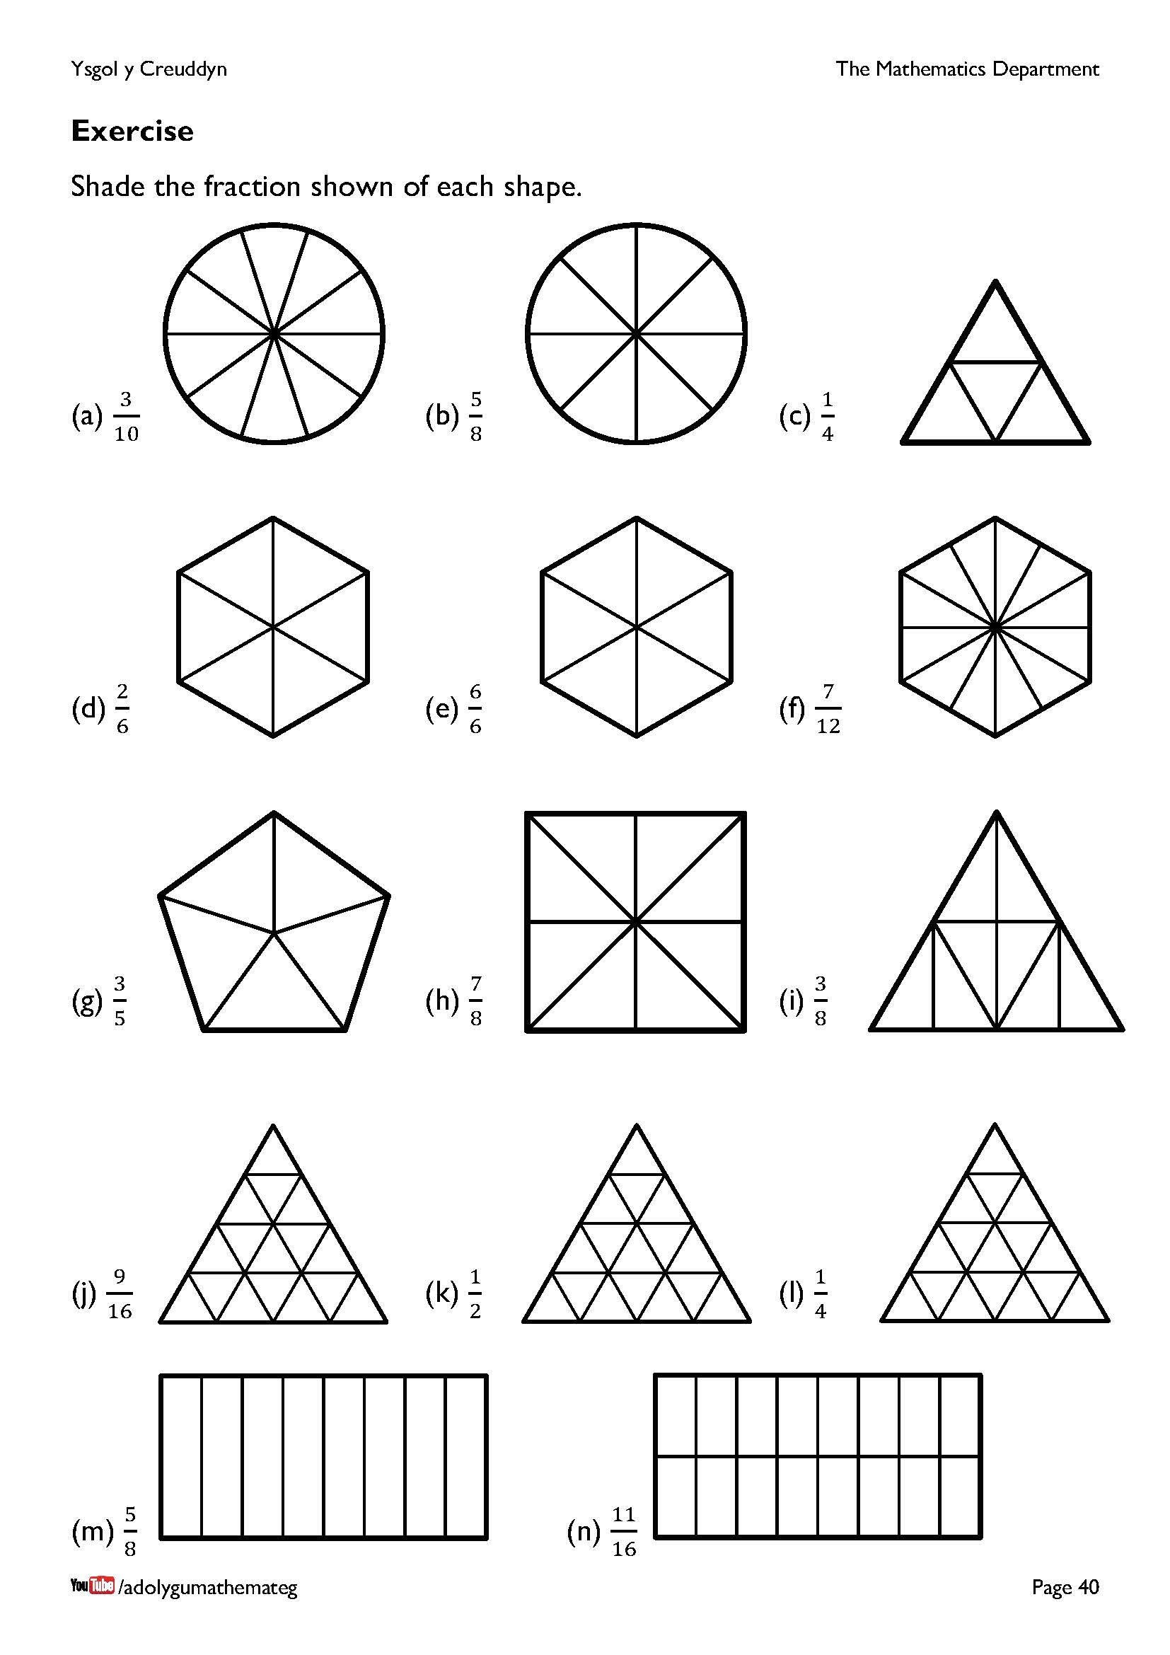
Each of these shapes have been split into equal parts. An extension task would be to complete a similar exercise where the shapes have not been split into equal parts to begin with.

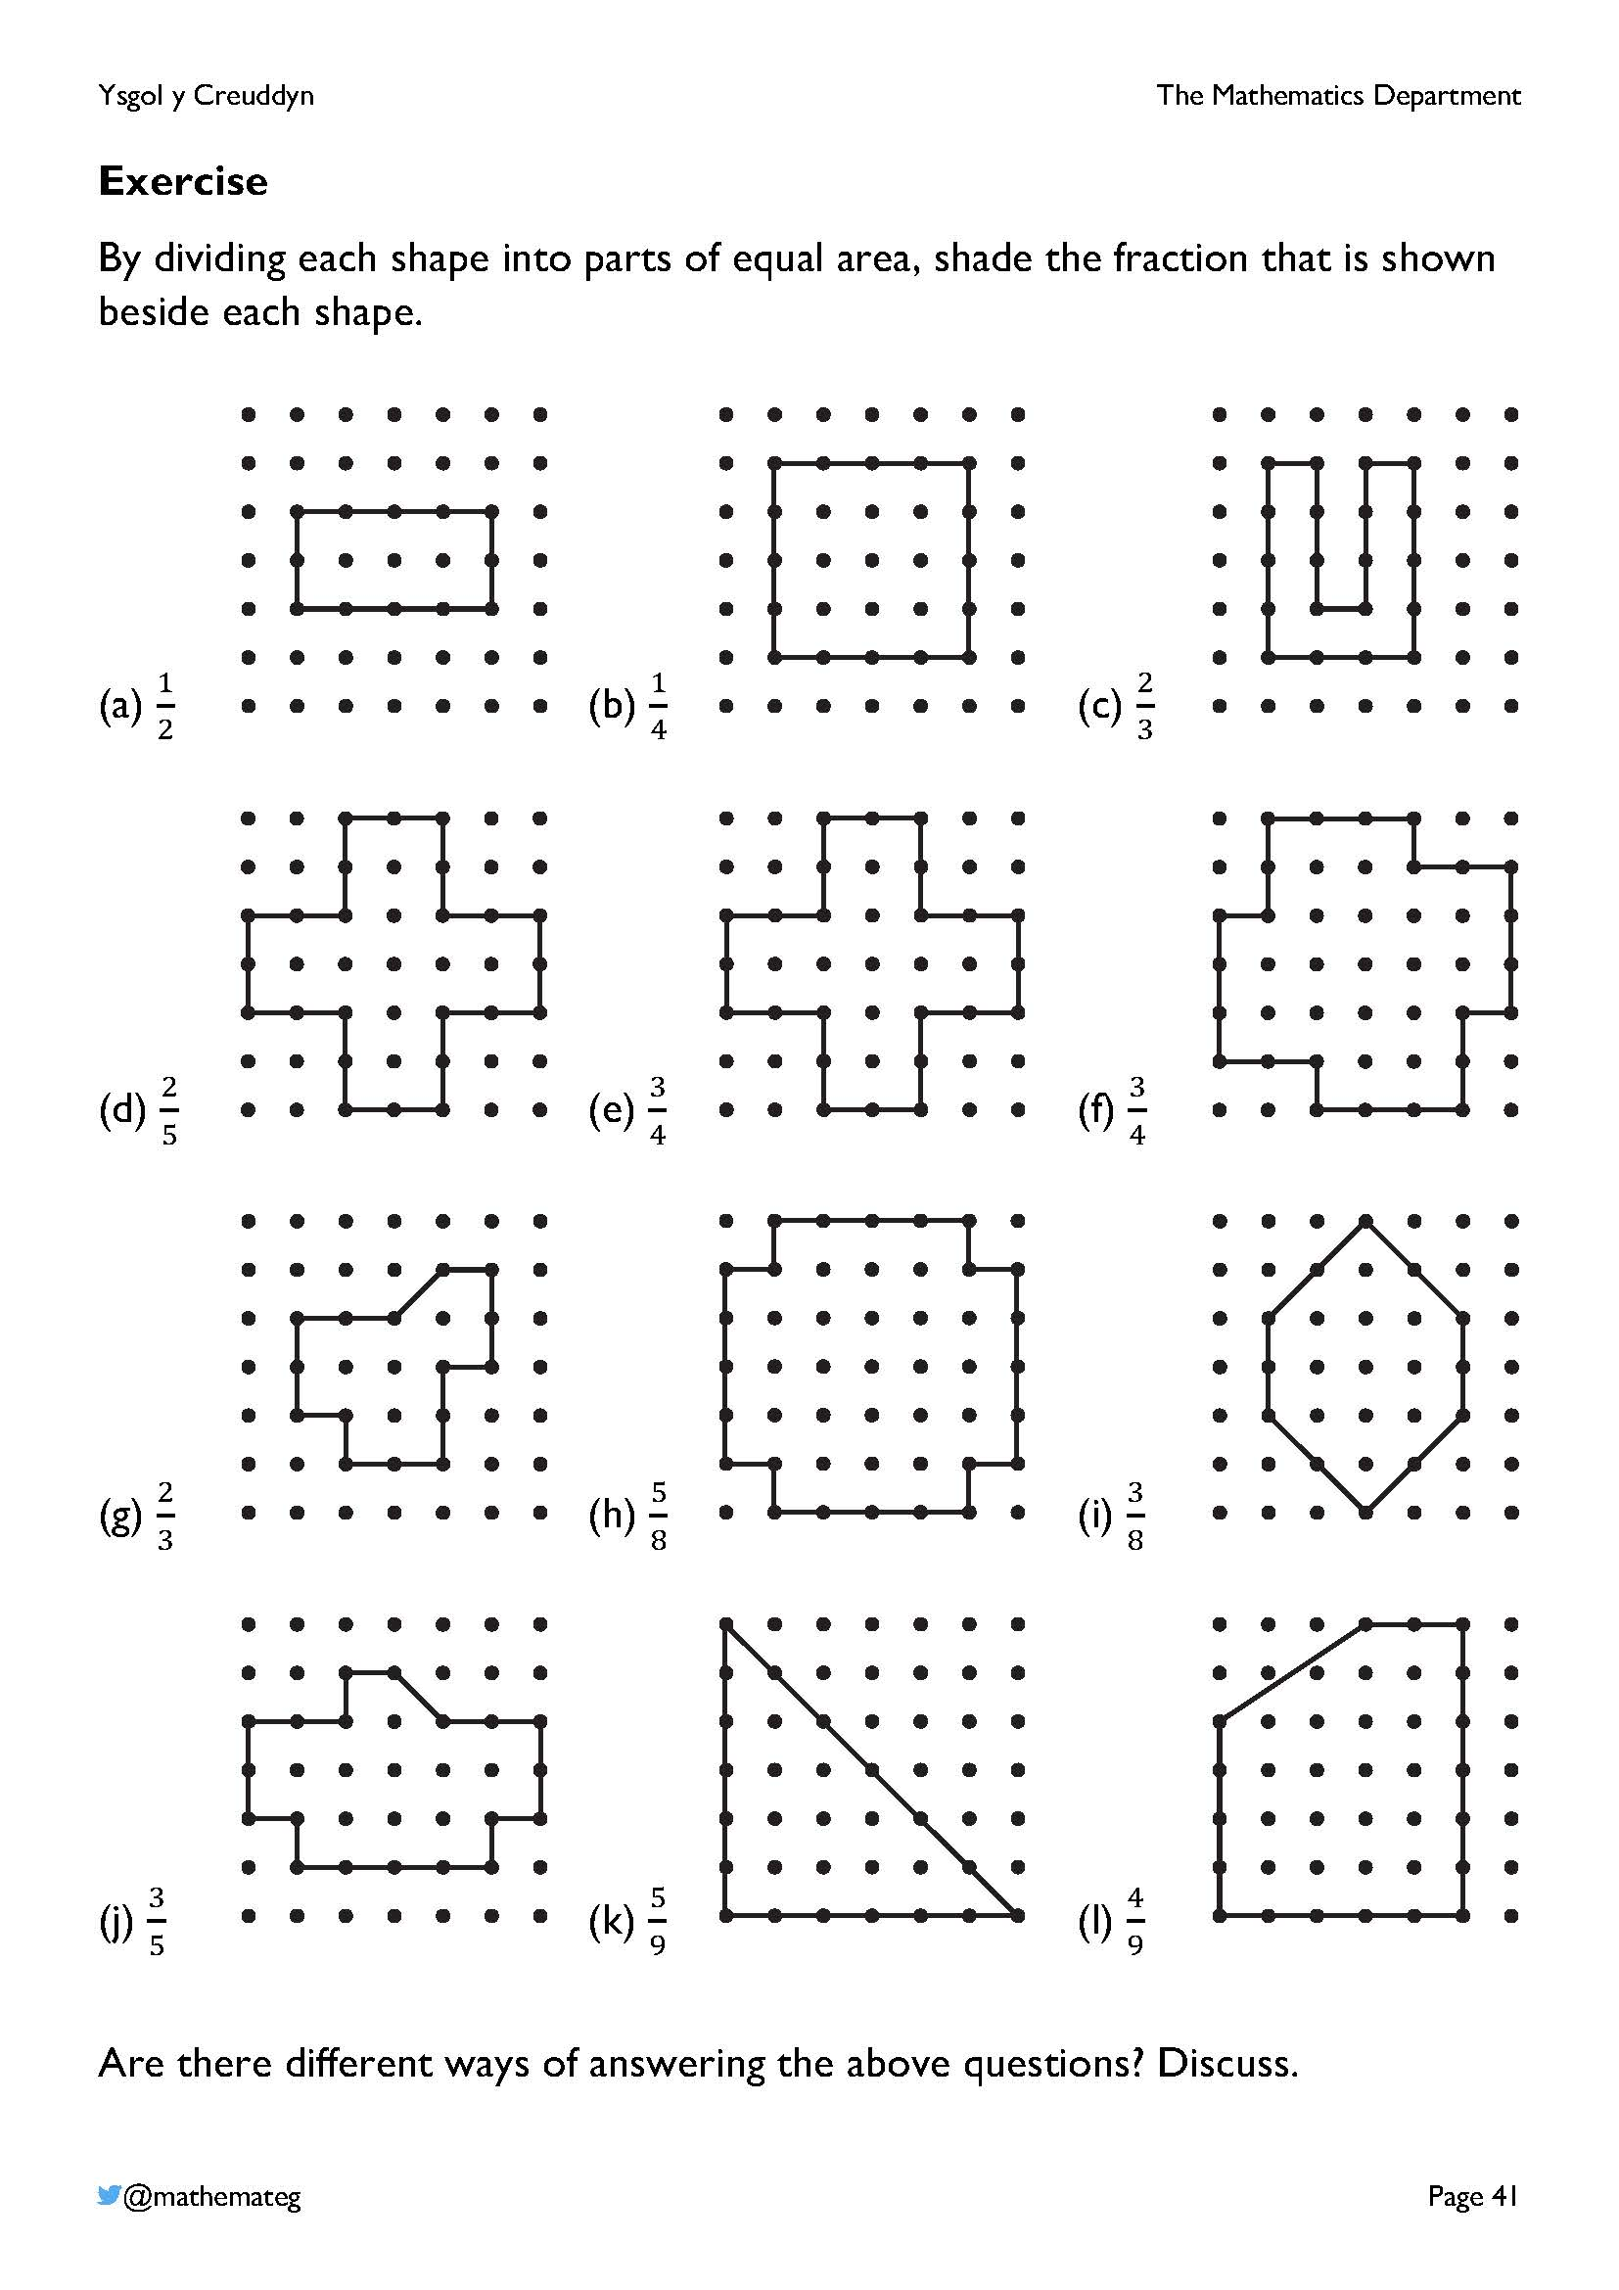
Learners must reason here how to split the shapes into the required number of equal parts. For example, the area of shape (g) is $10\frac{1}{2}$ square units (found by counting whole squares and the half square). This needs to be divided into three equal parts, so the parts need to have an area of $3\frac{1}{2}$ square units each.
This activity is based upon the one found on the page https://donsteward.blogspot.com/2017/12/fraction-shading.html
Aspects of this page touch upon the following description of learning for geometry:
SHAPE AND SPACE
- I can use efficient methods for finding the perimeter and area of two-dimensional shapes.

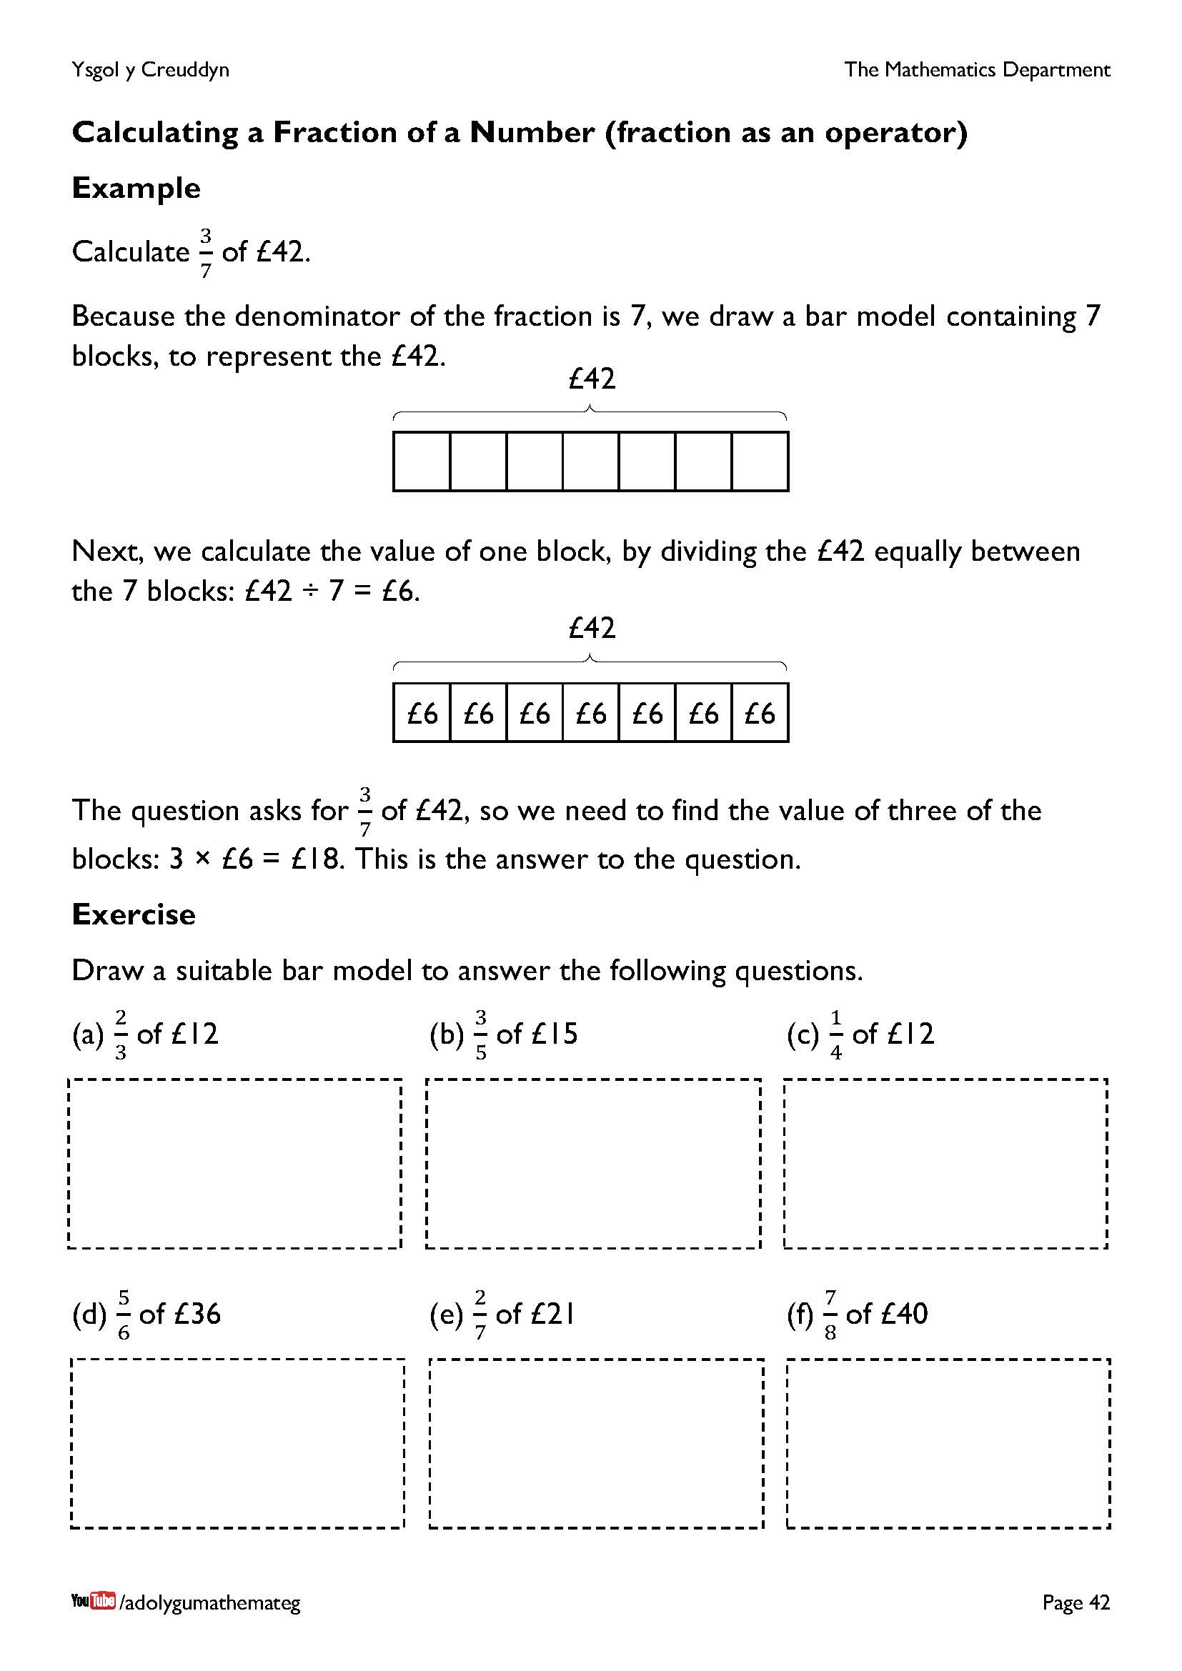
This page introduces using a fraction as an operator. This means that the fraction operates on a value, as opposed to representing a value itself (which is discussed further on in this chapter).
To see the difference between these two concepts, consider a number line going from 0 to 10.
0 |  | 1 |  | 2 |  | 3 |  | 4 |  | 5 |  | 6 |  | 7 |  | 8 |  | 9 |  | 10

Given the question ‘Add an arrow to show the location of $\frac{1}{2}$’, where would you place the arrow: in the red location below, or in the blue location below?
0 |  | 1 |  | 2 |  | 3 |  | 4 |  | 5 |  | 6 |  | 7 |  | 8 |  | 9 |  | 10
The blue location considers the fraction $\frac{1}{2}$ as an operator (finding $\frac{1}{2}$ of 10), whilst the red location considers the fraction $\frac{1}{2}$ as a number (finding the location of $\frac{1}{2}$ on the number line). For the question that was asked, the red location is correct. For the blue location, the question’s wording would need to change to ‘Add an arrow to show the location of $\frac{1}{2}$ of 10’.
Further information about bar models (as used on this page) is available here: https://thirdspacelearning.com/blog/teach-bar-model-method-arithmetic-maths-word-problems-ks1-ks2/

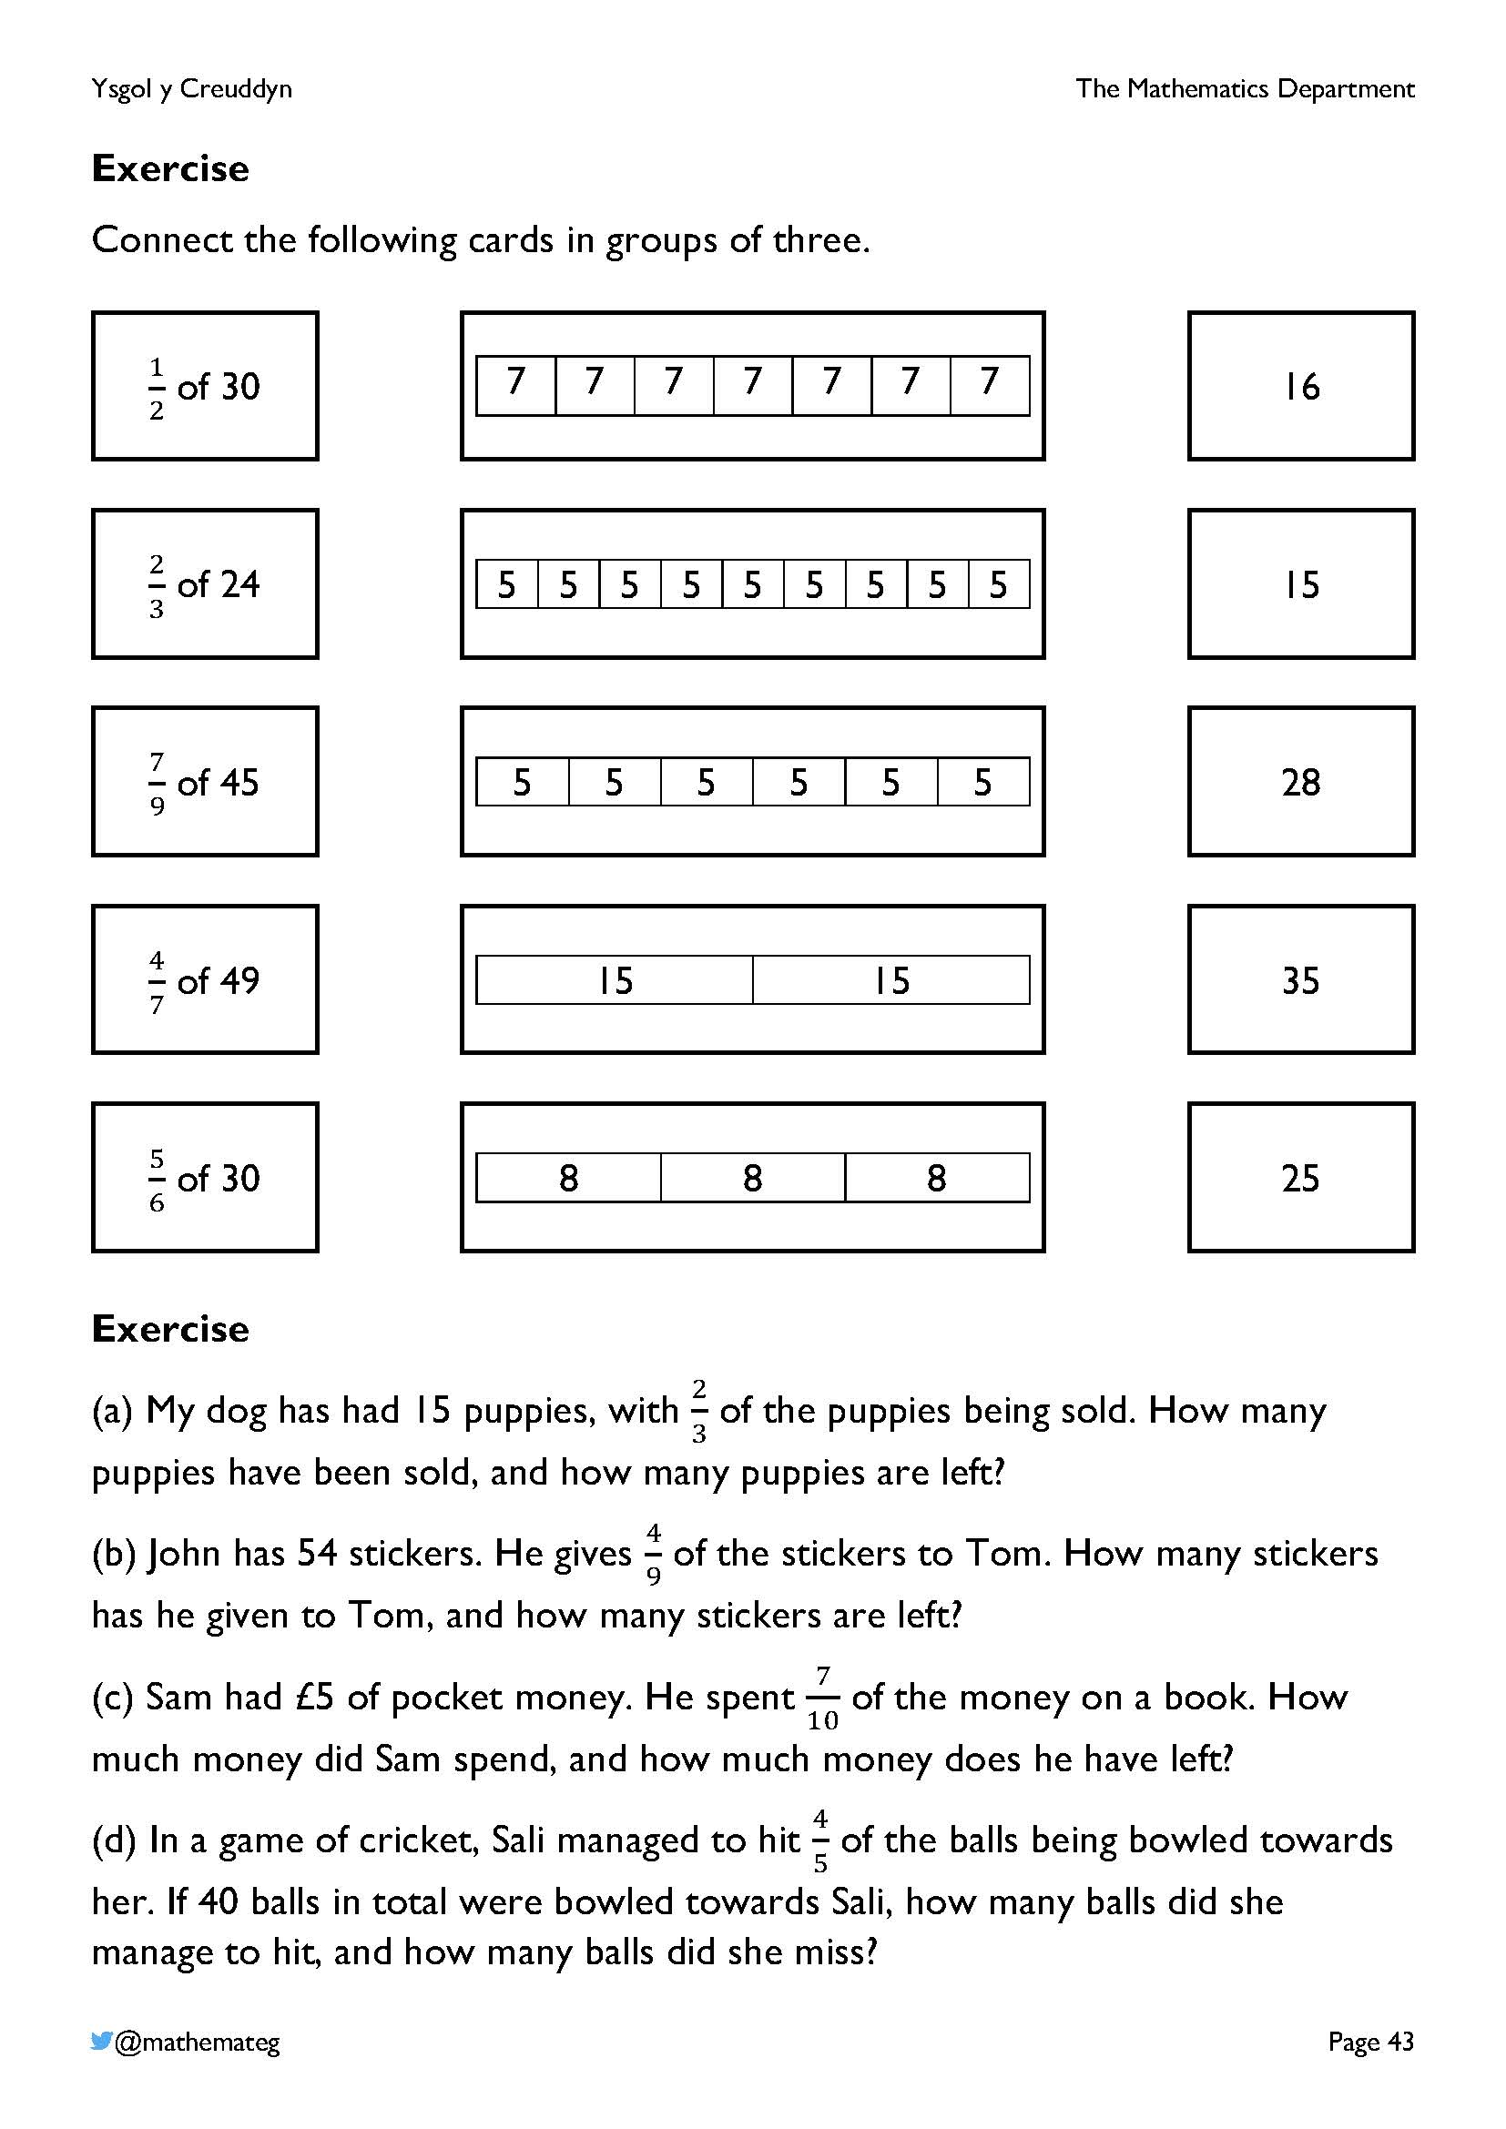
Encourage the learners to draw a bar model if they have difficulty with the second exercise on the page.

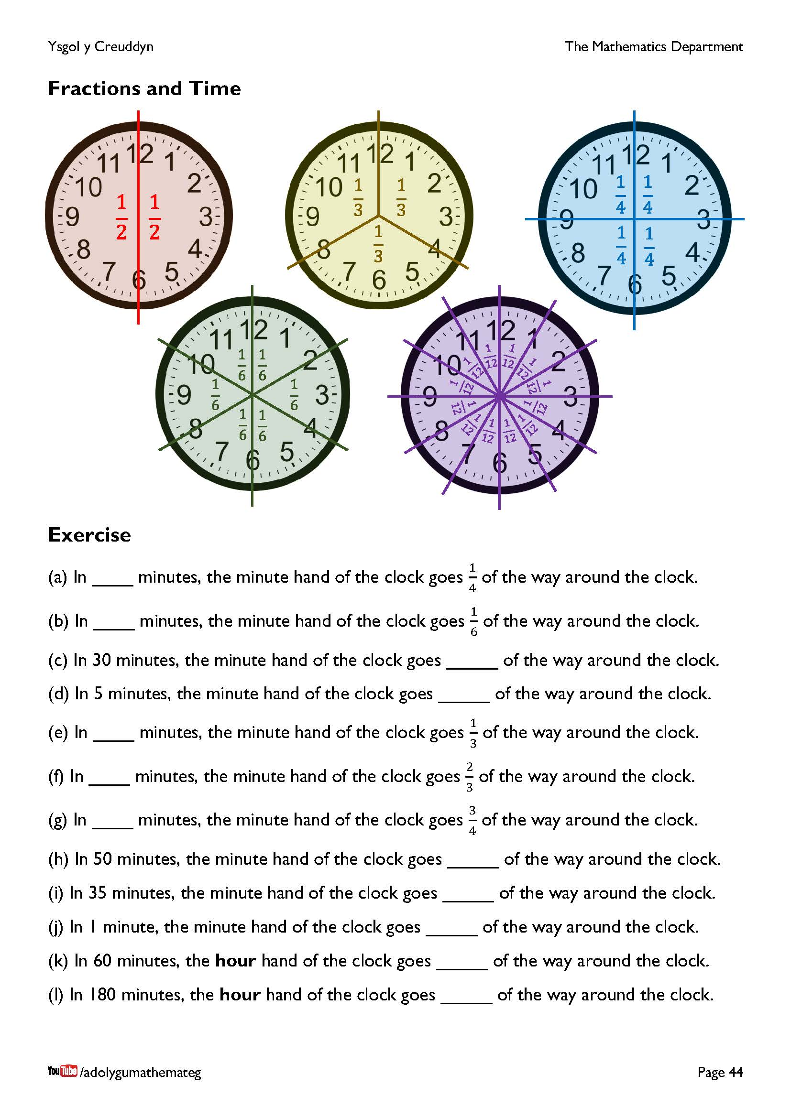
Reading the time provides many opportunities to discuss fractions, as an analogue clock is divided into 12 equal parts. The Babylonians were mainly responsible for how we tell the time today; they used base 60 numerals to form the system. This is why an hour is split into 60 minutes, and a minute is split into 60 seconds. The number 60 has a large number of factors, which makes dividing (e.g.) an hour into equal parts relatively easy.
60 ÷ 2 = 30
60 ÷ 3 = 20
60 ÷ 4 = 15
60 ÷ 5 = 12
60 ÷ 6 = 10
If an hour had been chosen to be 10 minutes instead of 60 minutes, it would not be possible to divide an hour so easily into 3 equal parts or 4 equal parts.

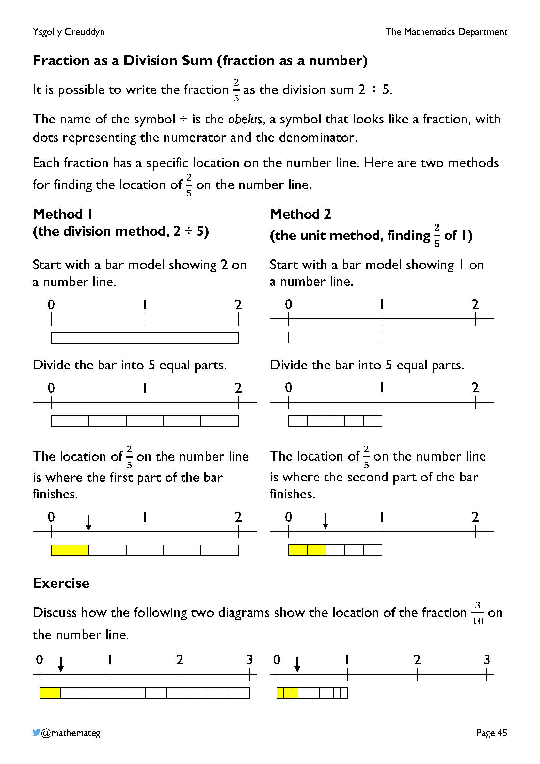
This page discusses two different methods of locating a fraction’s value on the number line.
- The first method (the division method) starts with the numerator and divides by the denominator. The length of one of the parts corresponds to the location of the fraction on the number line. This method is advantageous for discussing improper fractions that have a value exceeding one.
- The second method (the unit method) always starts with a single unit, and calculates a fraction of this unit. This method is advantageous for comparing the size of different fractions.
Encourage the use of the terms “unit”, “numerator” and “denominator” whilst completing the exercise at the bottom of the page.
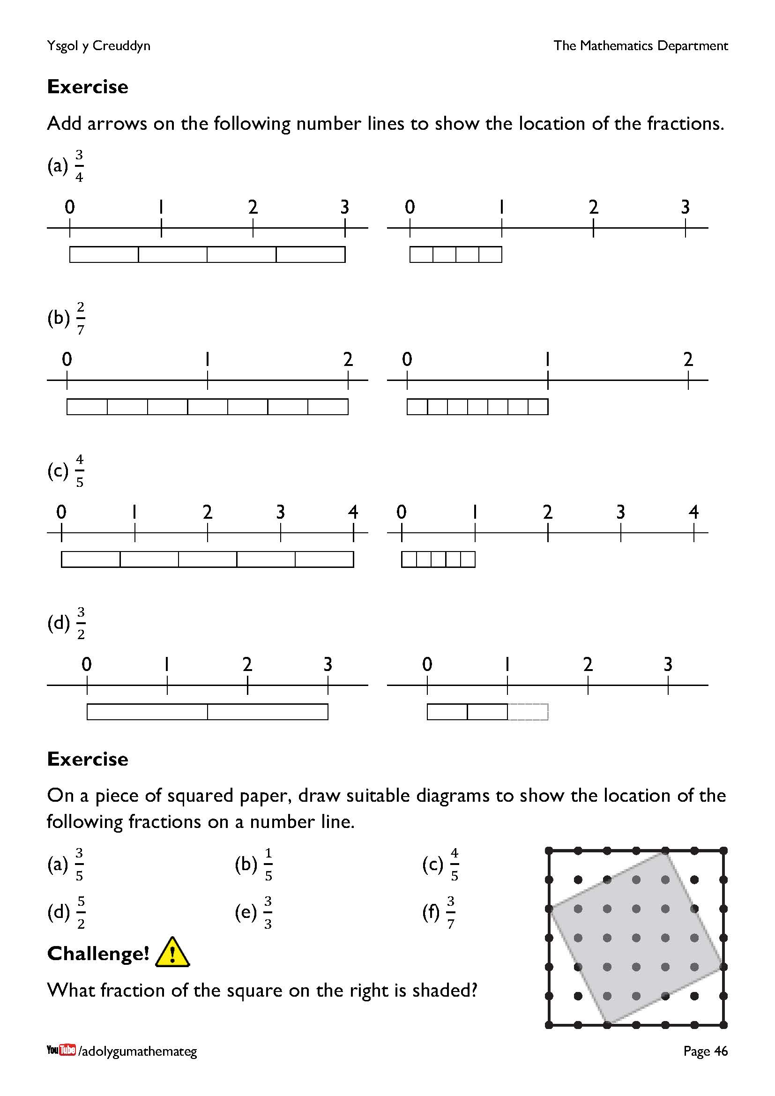
In the first exercise, note that one of the boxes for $\frac{3}{2}$ has been drawn using a dotted line, to show that this box did not belong to the original unit.
In the second exercise, reasoning must be used to determine how many squares of squared paper must be used to represent a single unit. The denominator influences this, of course, so that 5 squares for each unit is a wise choice for the first three questions.
In the challenge, visualising two of the white triangles coming together to form a rectangle would perhaps help with the solution?

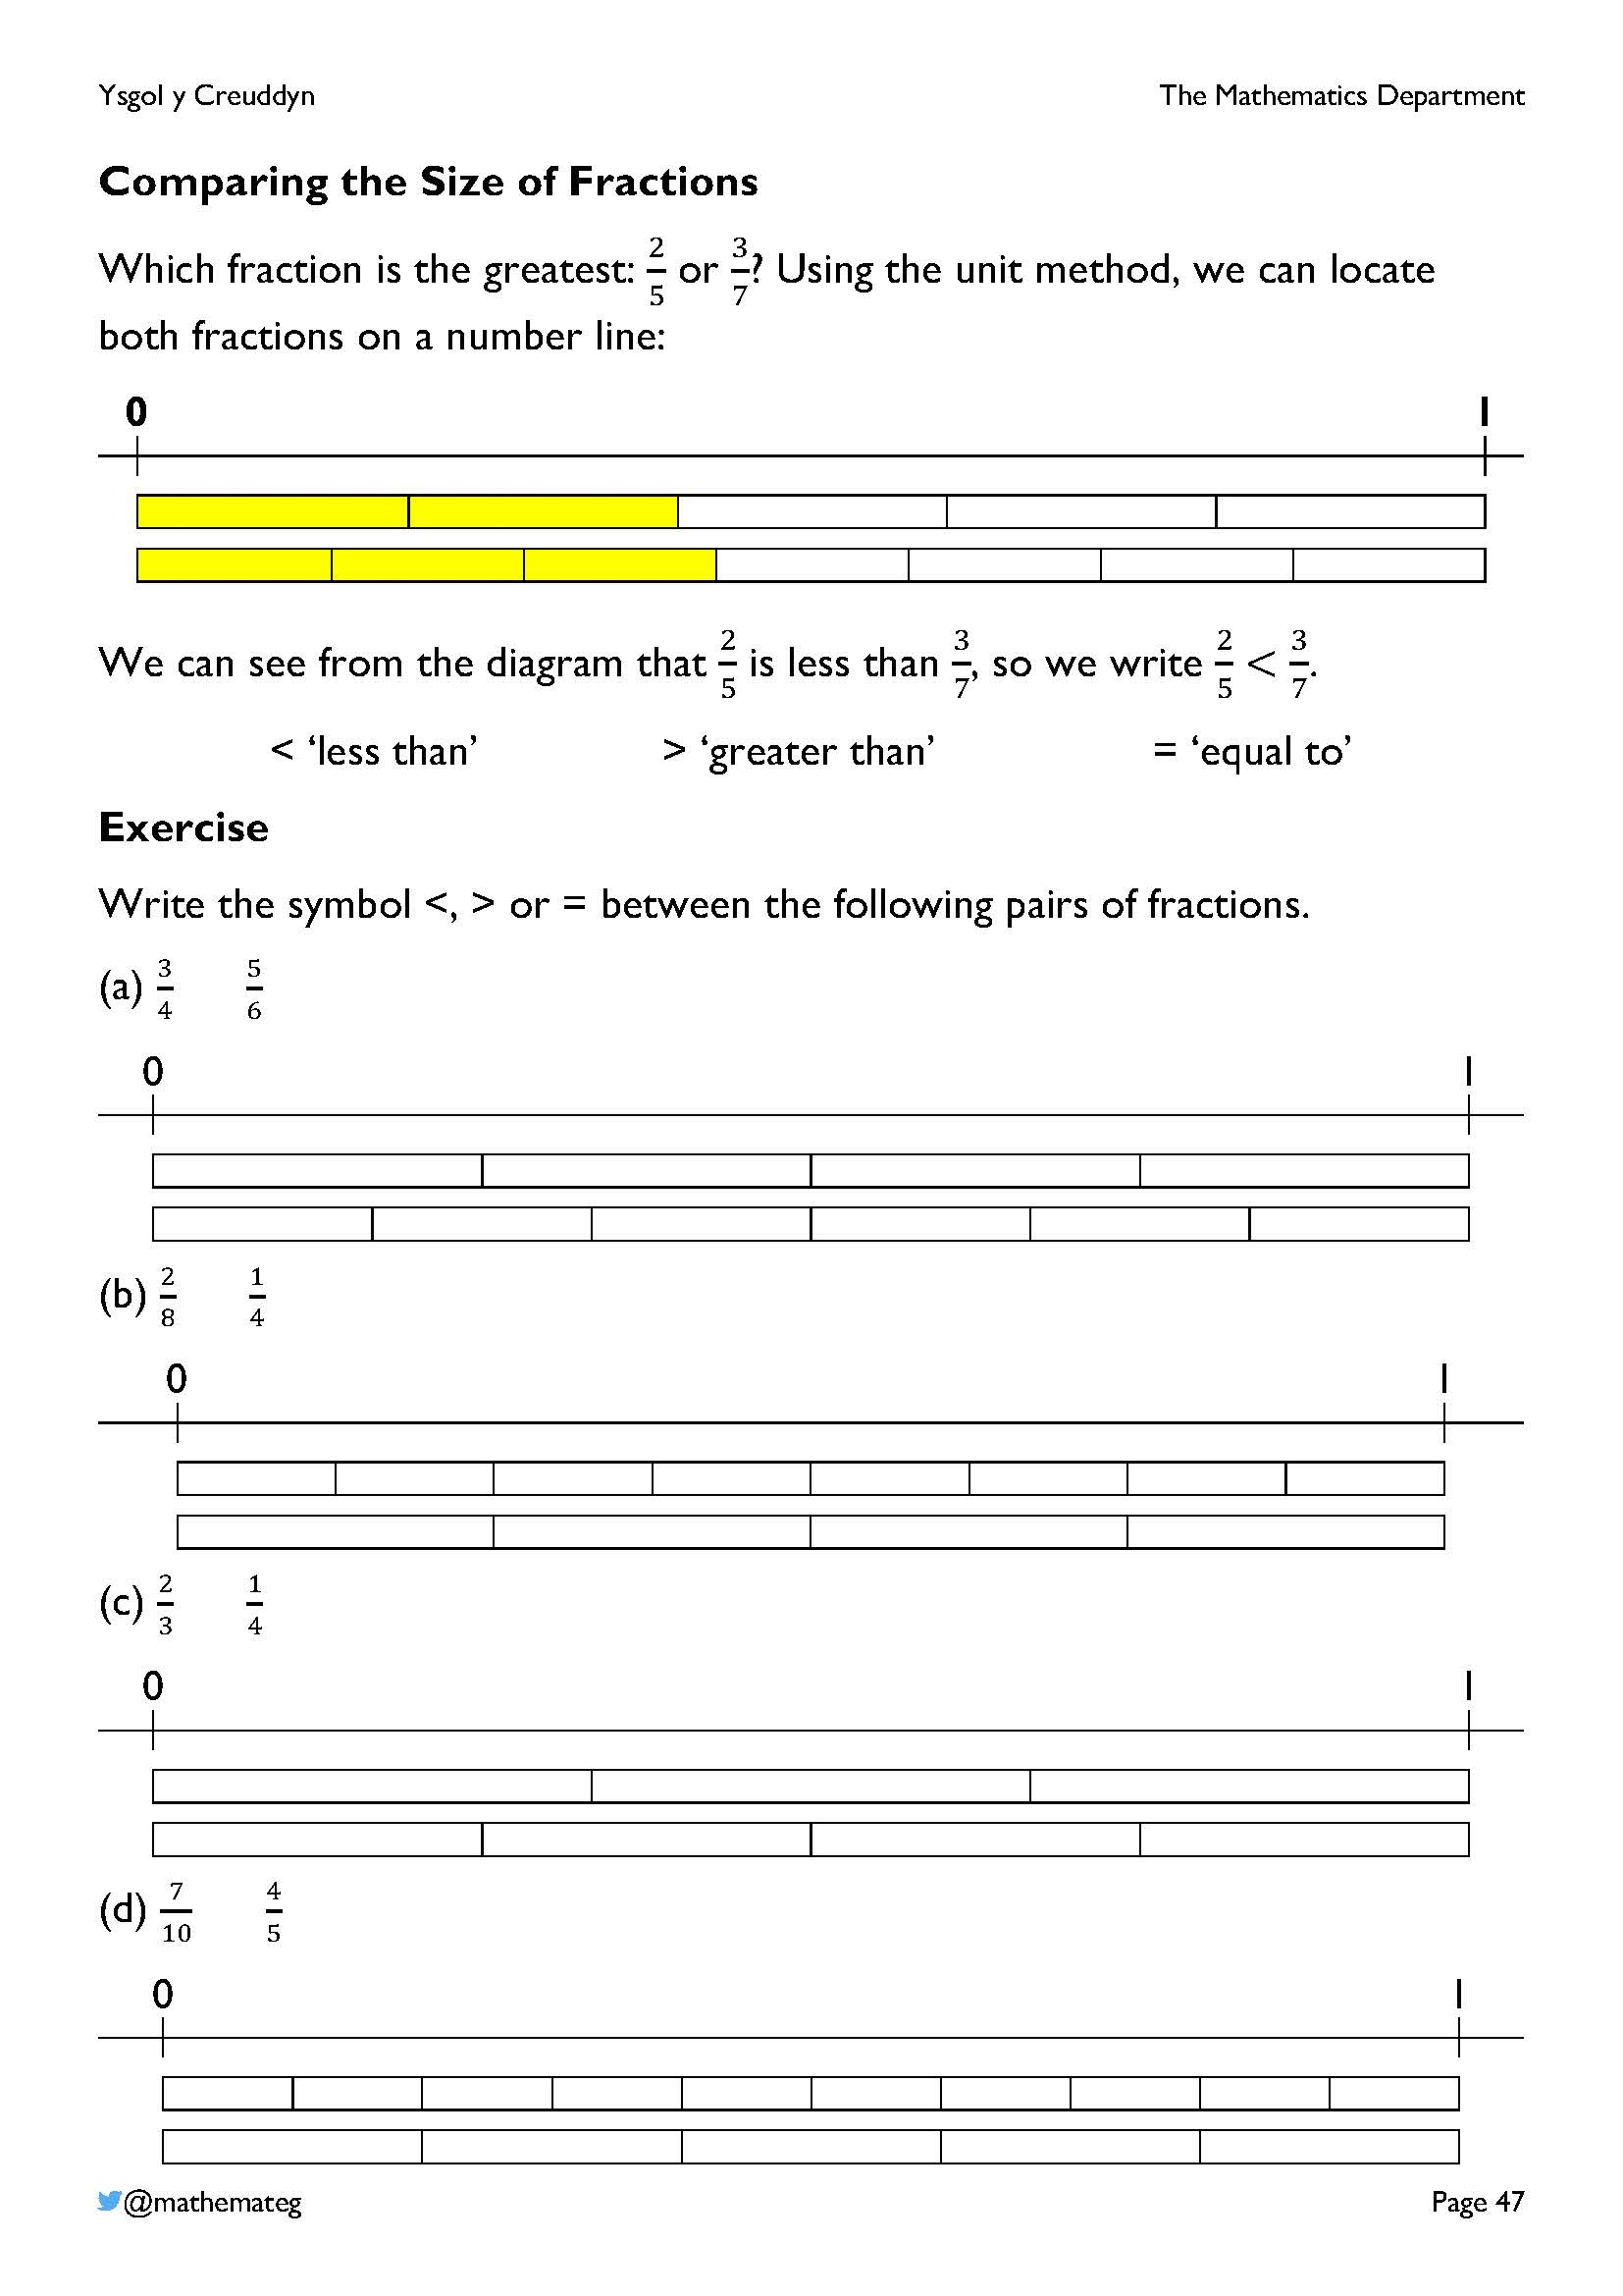
The unit method is convenient for comparing the size of two proper fractions (where the numerator is less than the denominator).
In follow-up work (not in this workbook), it would also be possible to compare the size of fractions using equivalent fractions. For example, considering the fractions $\frac{2}{5}$ and $\frac{3}{7}$, the equivalent fractions $\frac{14}{35}$ and $\frac{15}{35}$ would allow us to see that $\frac{3}{7}$ is the greatest fraction (because 15 is greater than 14).

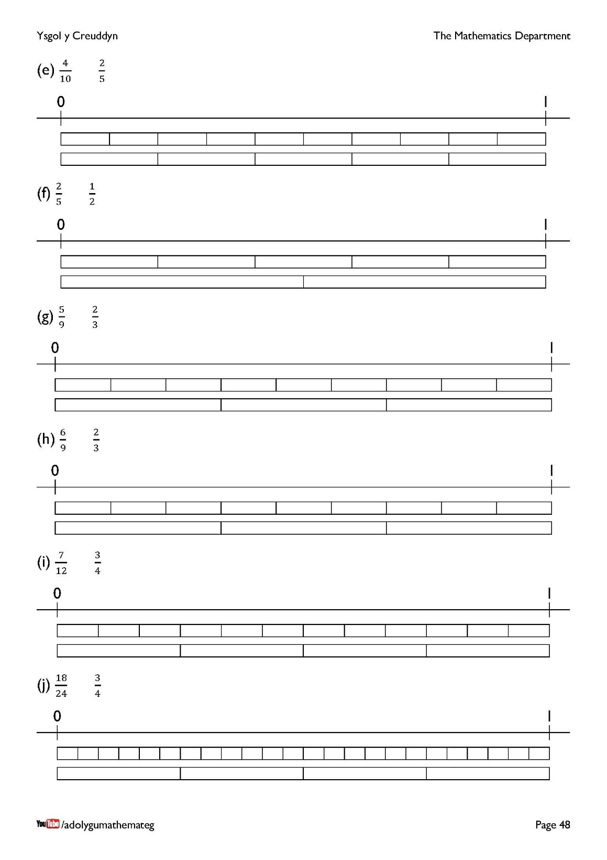
Extension work: using the fraction wall on page 51 to compare the size of different fractions.

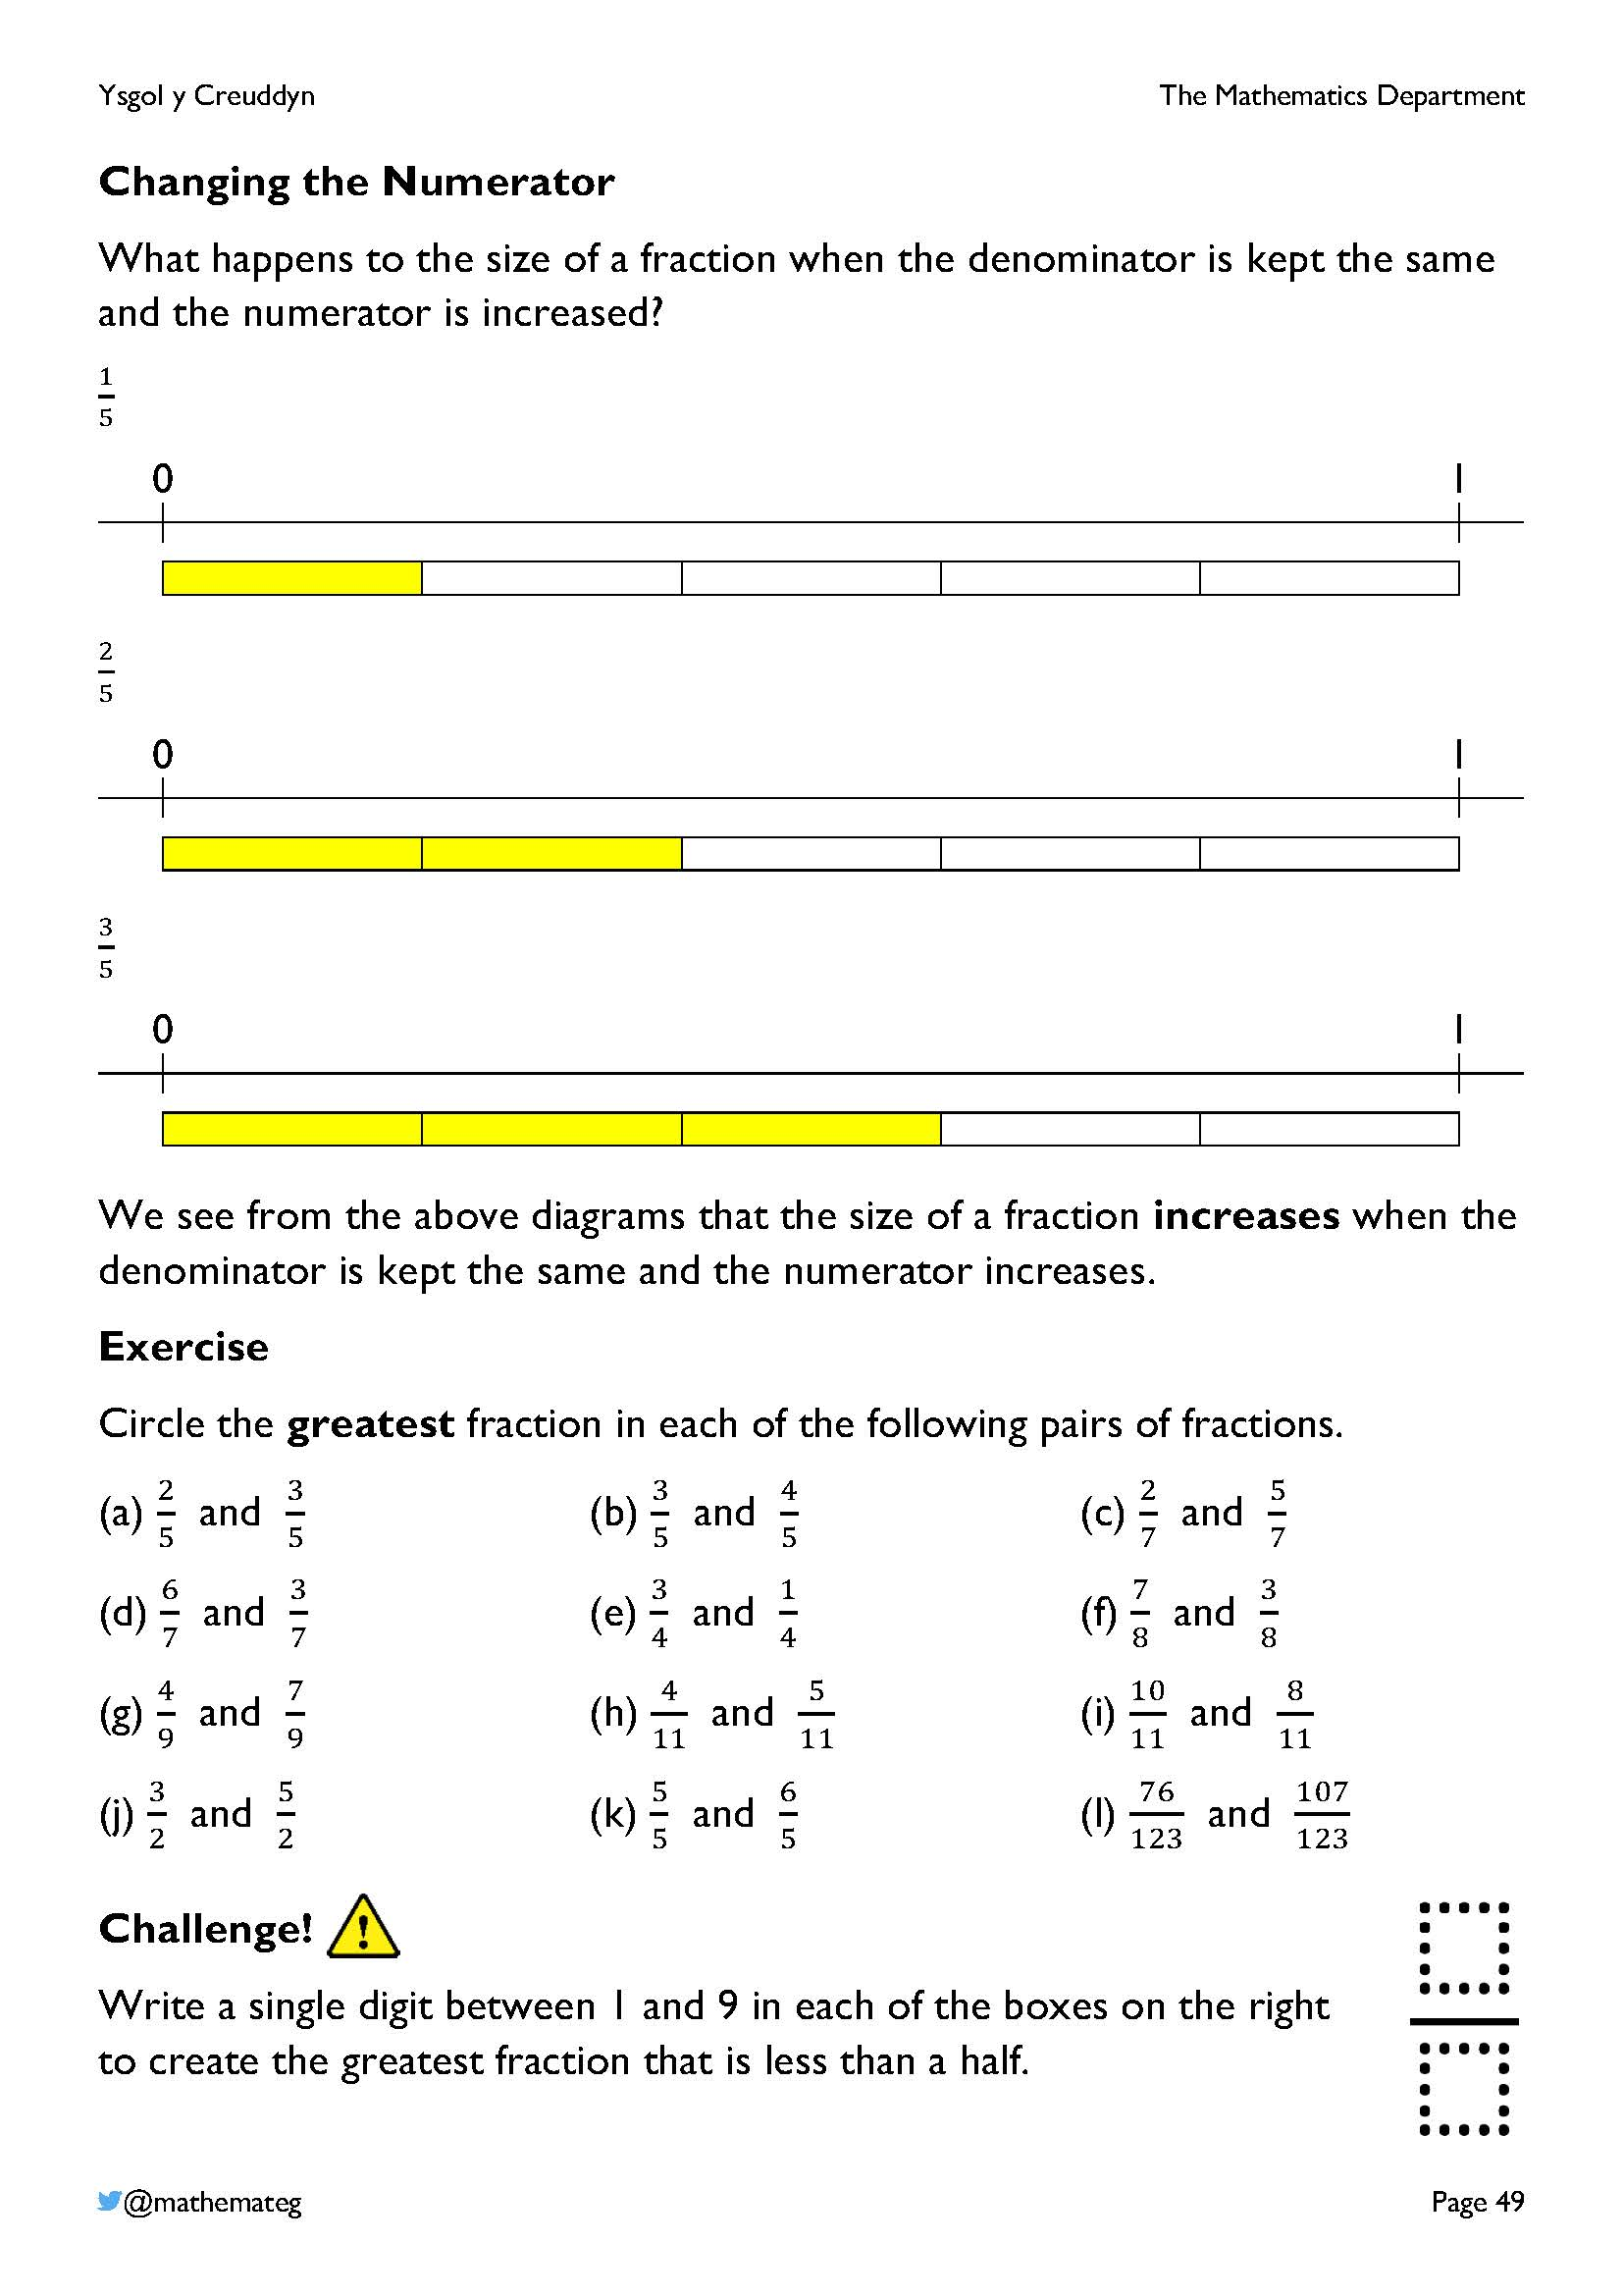
These two pages get to grip with the following description of learning from progression step 3:
RELATIONSHIPS WITHIN THE NUMBER SYSTEM
- I can understand the inverse relation between the denominator of a fraction and its value.
On this page, we investigate the relationship between the value of a fraction and increasing the fraction’s numerator. There is a direct proportion here, which means that the value of a fraction increases as its numerator increases. Thus, in the exercise, the greatest fraction is the one with the greatest numerator.
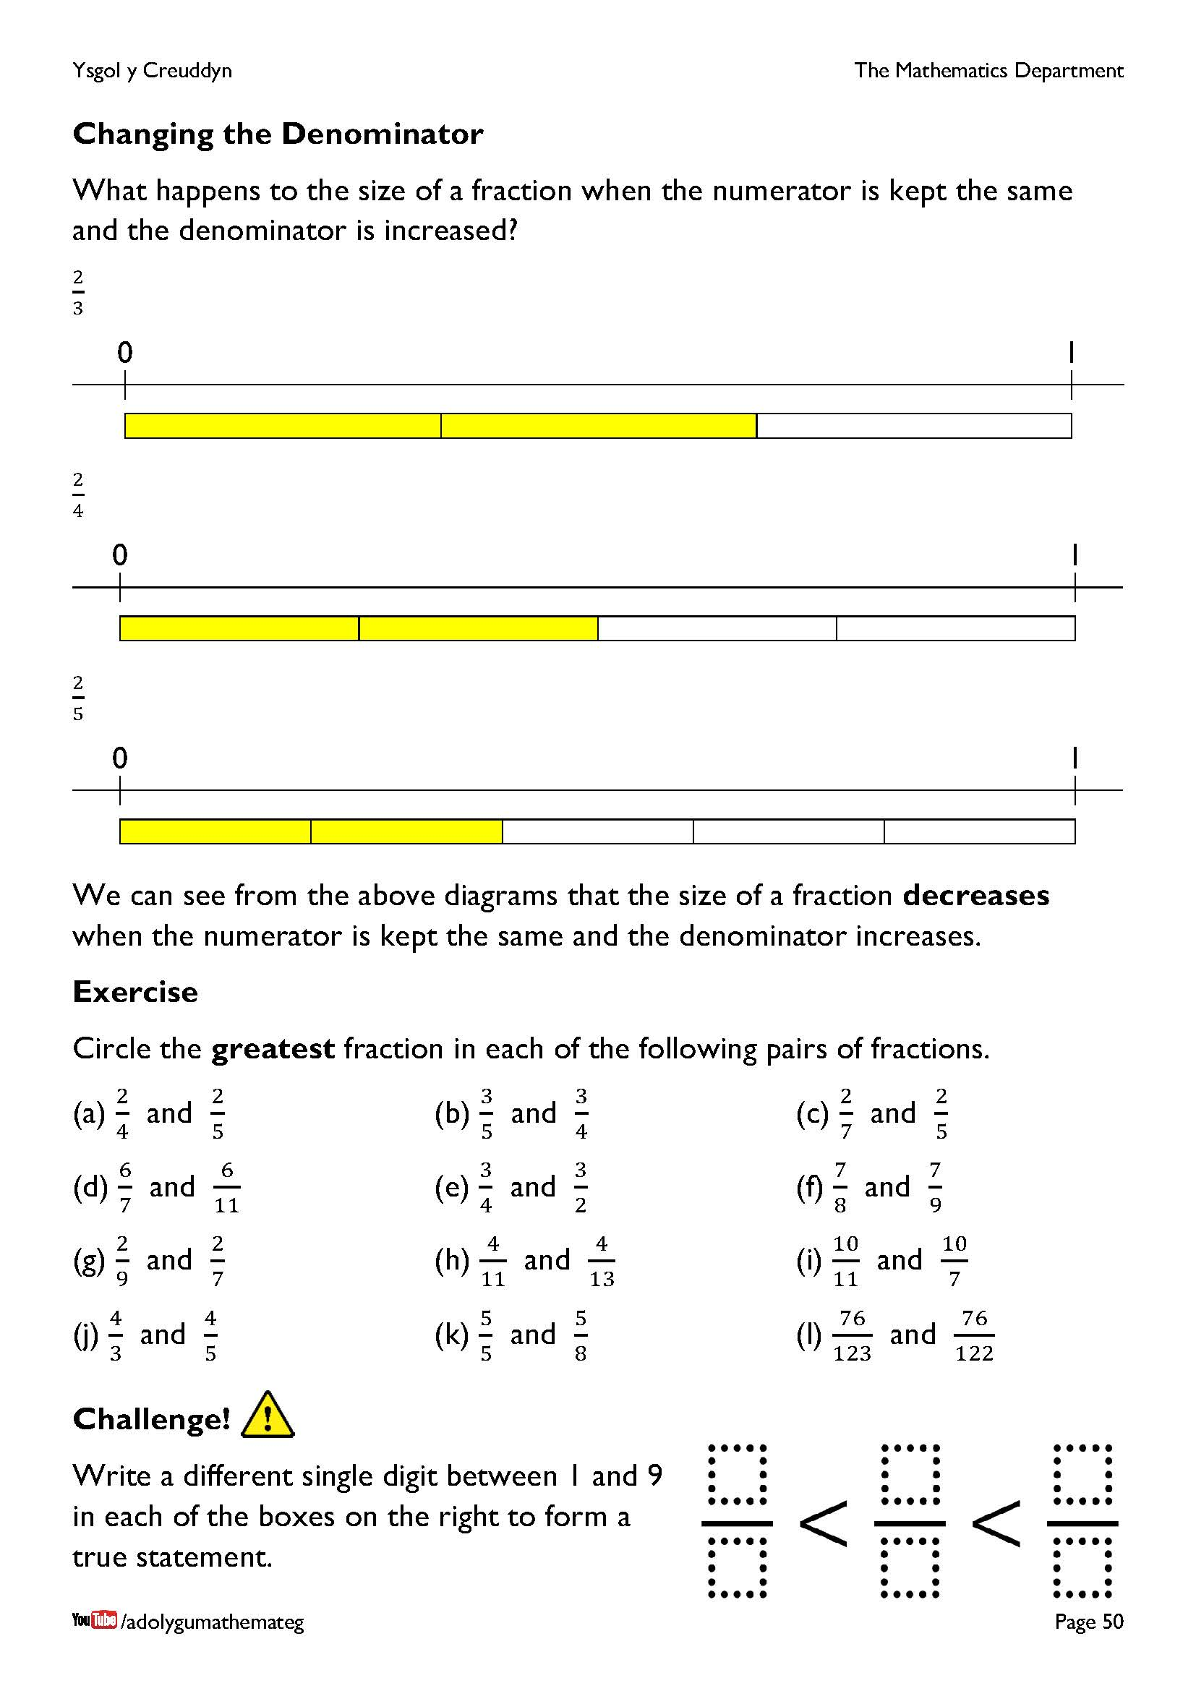
On this page, we investigate the relationship between the value of a fraction and increasing the fraction’s denominator. There is an inverse proportion here, which means that the value of a fraction decreases as its denominator increases. Thus, in the exercise, the greatest fraction is the one with the least numerator.
It is important to develop the relationship between the value of a fraction and how the fraction’s numerator or denominator changes. Here are the results from one experiment asking 14-year-old learners to choose the greatest fraction out of the following pairs of fractions.
Fractions | Percentage choosing the greatest fraction correctly
$\frac{5}{8}$ and $\frac{7}{8}$ | 95%
$\frac{3}{4}$ and $\frac{4}{5}$ | 75%
$\frac{3}{8}$ and $\frac{3}{5}$ | Less than 20%

Source: https://www.dylanwiliam.org/Dylan_Wiliams_website/Papers_files/Devising%20learning%20progressions%20%28AERA%202011%29.doc
As you can see from the table, if the numerator stays the same and the denominator changes, a large percentage of 14-year-old learners choose the greatest fraction incorrectly.
The challenges (on the previous page and on this page) are based on tasks from the Open Middle website. Further similar exercises can be found here: https://www.openmiddle.com/category/grade-4/number-operations-fractions-grade-4/
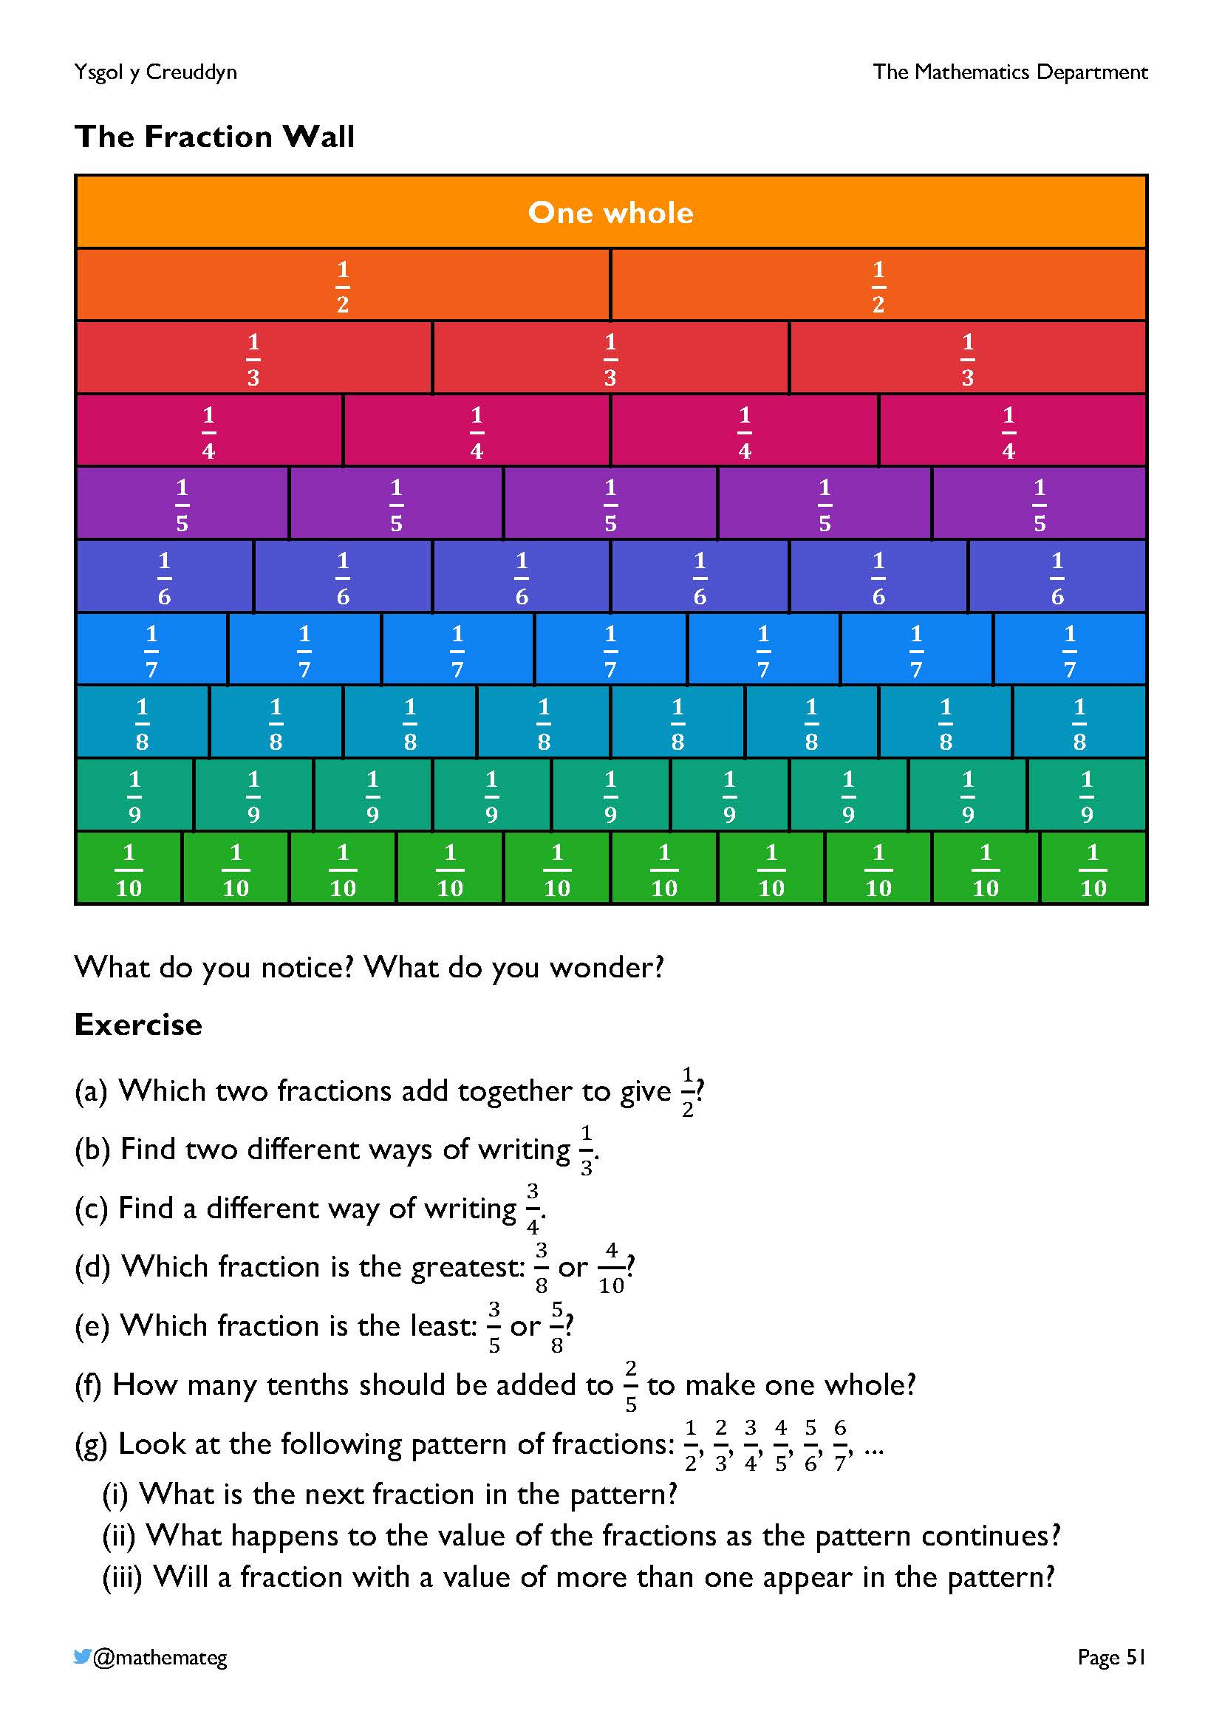
The fraction wall is useful for comparing the size of fractions, and for discussing fractions in general.
Here are some suggestions for further discussion:
- What happens to the unit fractions ($\frac{1}{2}$, $\frac{1}{3}$, $\frac{1}{4}$, ...) going down the wall?
- What would be the value of $1-\frac{1}{2}$, or $1-\frac{1}{3}$, or $1-\frac{1}{4}$, or ...?
- How many different ways of showing $\frac{1}{2}$ can be seen in the wall? What about ones that are not shown in the wall?
- What is the connection between the $\frac{1}{3}$ row and the $\frac{1}{6}$ row? Is there a similar connection between other rows? Why?
For an electronic version of the fraction wall, go to the website https://mathigon.org/polypad, where the colours on the left correspond to the colours on the website. Go to the “Fraction bars” section to see the pieces for the wall, and remember to experiment with the “Split Tiles” and “Rename” buttons.
Another version of the fraction wall is available here: https://mathsbot.com/manipulatives/fractionWall

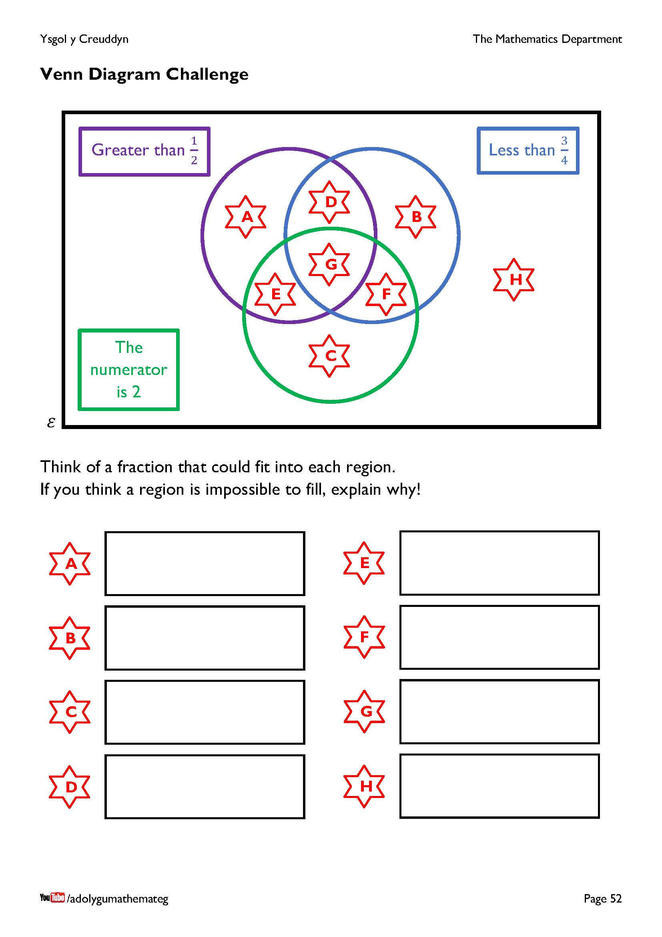
The first task here is to reason what is the requirement for each region. For example, considering region F, we require a fraction that is less than $\frac{3}{4}$ (in the blue region); where the numerator is 2 (in the green region); and where the fraction is not greater than $\frac{1}{2}$ (not in the purple region). Perhaps the following version of the fraction wall will be useful?
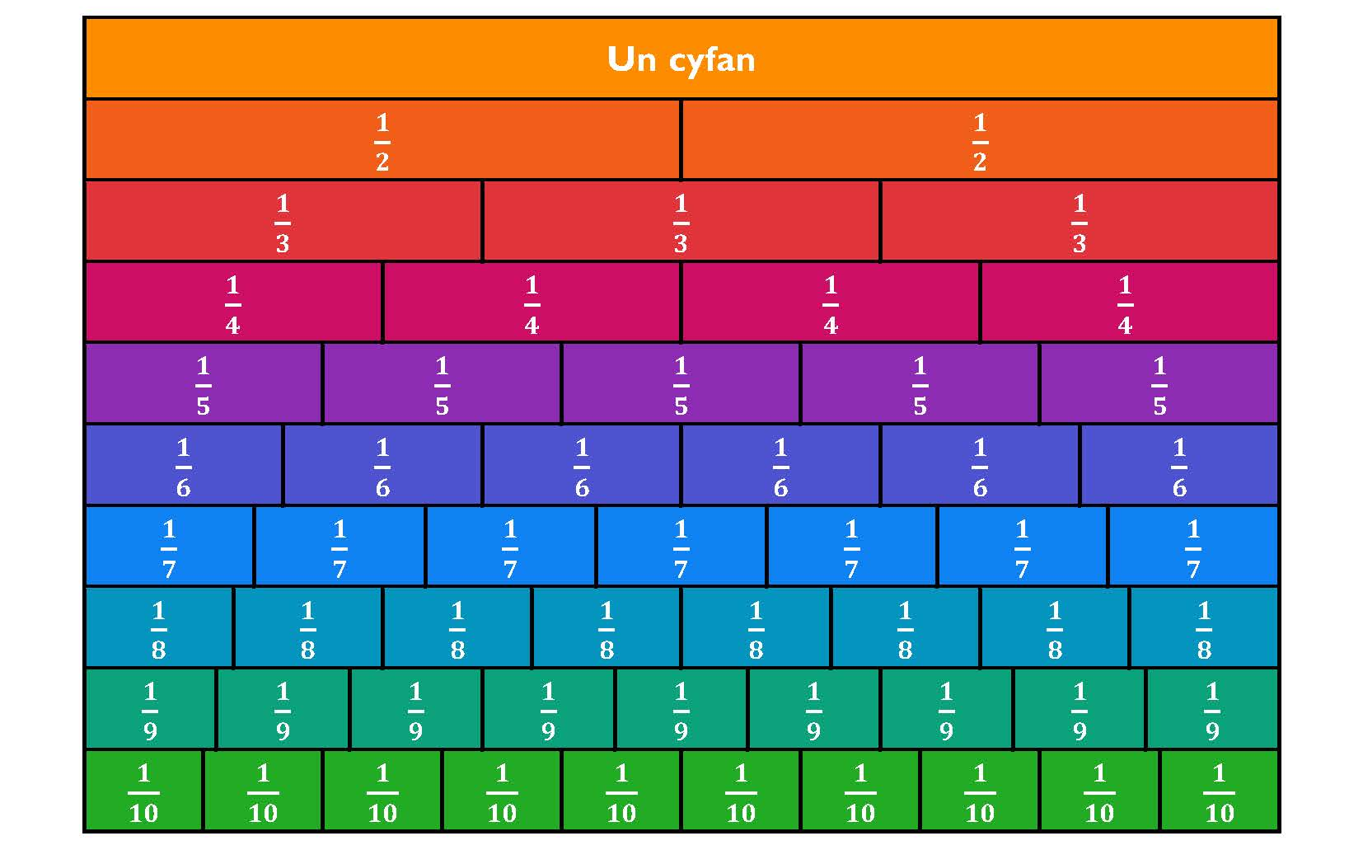
$\frac{1}{2}$ $\frac{3}{4}$
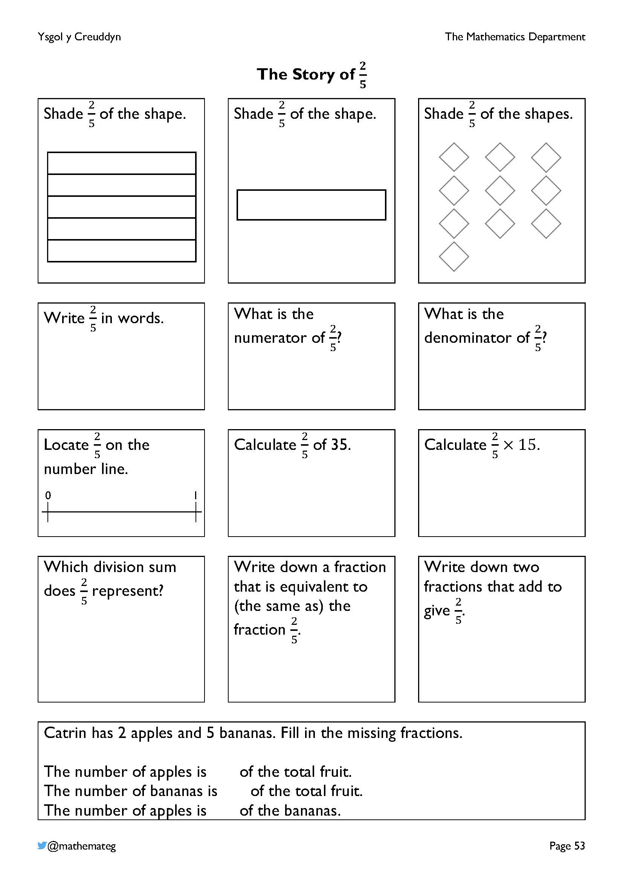
This page brings together many of the ideas from this chapter. It is based upon a task by Chris McGrane, https://startingpointsmaths.com/2020/04/04/fraction-stories-multiple-representations/

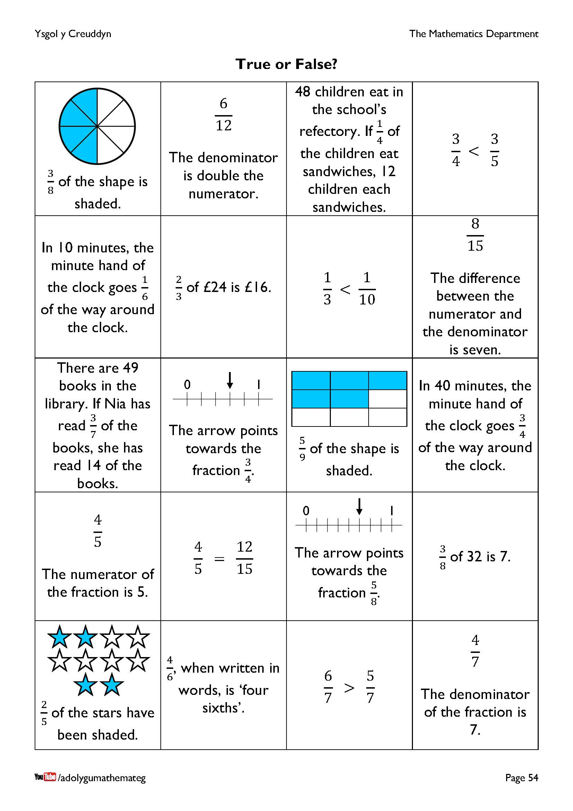
This task is based upon the one from the website https://mhorley.wordpress.com/2015/03/18/uncovering-fraction-misconceptions-through-true-and-false-cards/
As on the previous page, it revises many of the topics introduced in this chapter.

