Old Exam Questions – Old Course
Calculus of Rectilinear Motion
(M2 Summer 2006)
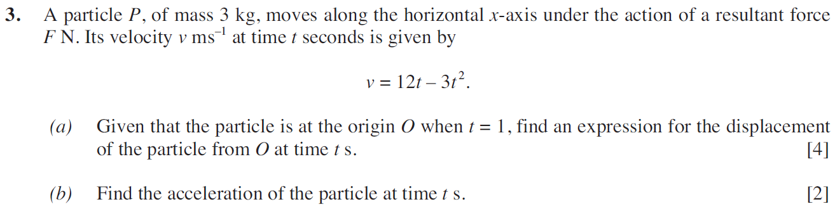
(M2 Summer 2007)
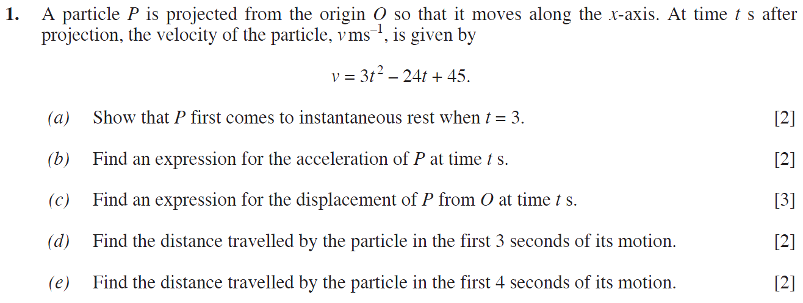
(M2 Summer 2008)
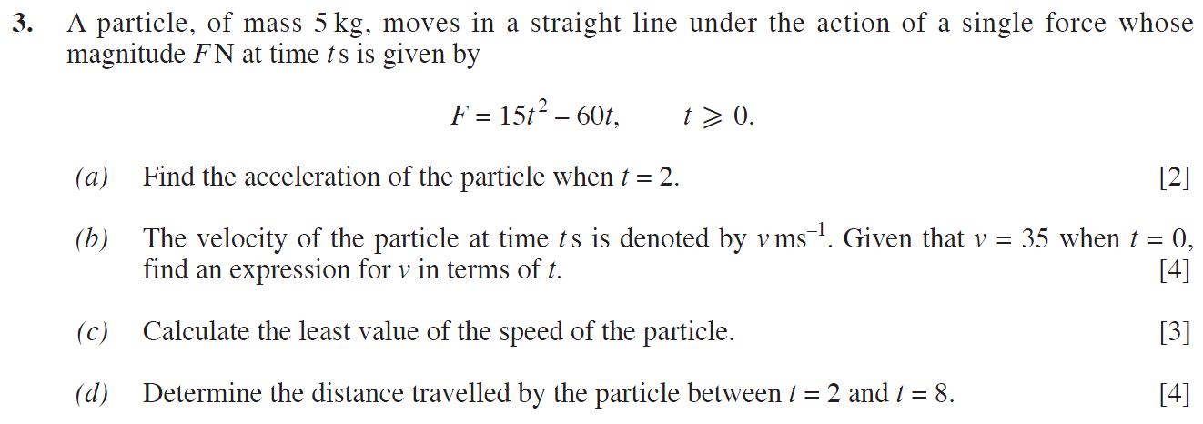

(M2 Summer 2010)
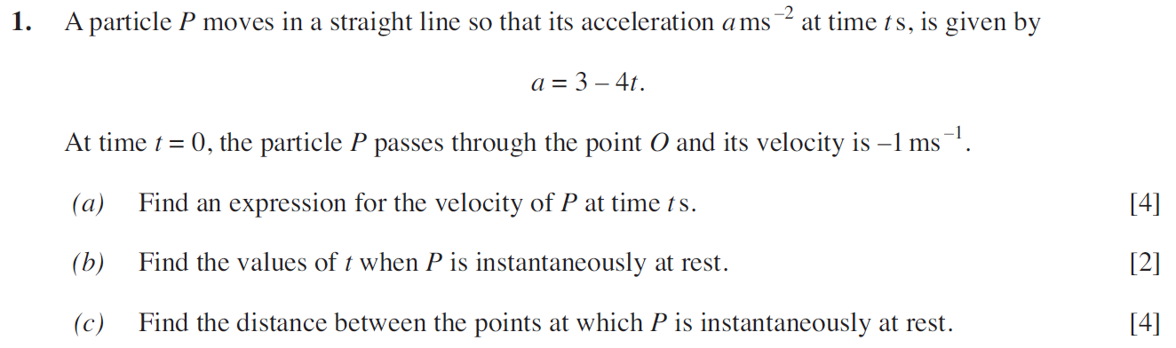
(M2 Summer 2013)
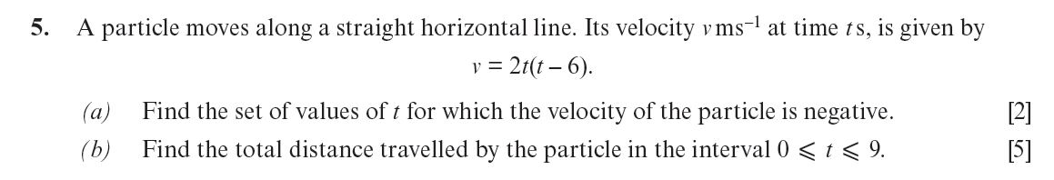
(M2 Summer 2016)
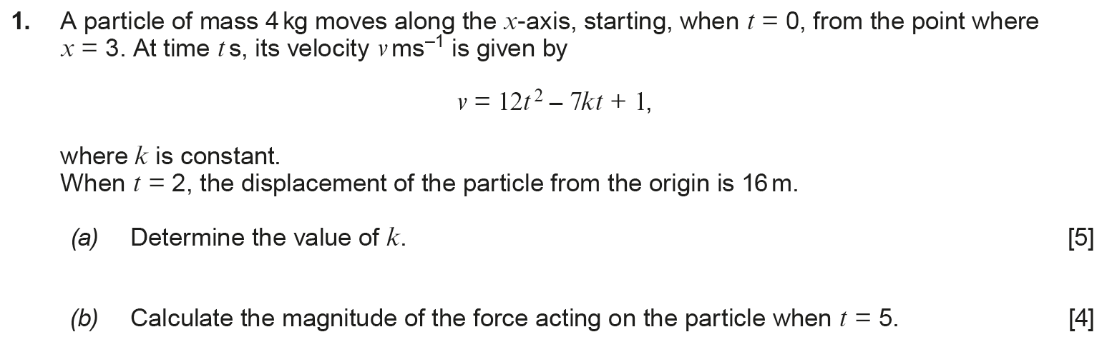

(M2 Summer 2017)
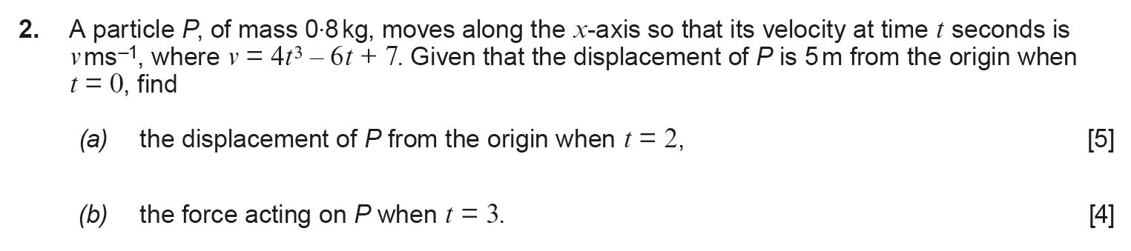
(M2 Summer 2018)
