Hen Gwestiynau Arholiad – Hen Gwrs
Calcwlws Mudiant Unionlin
(M2 Haf 2006)
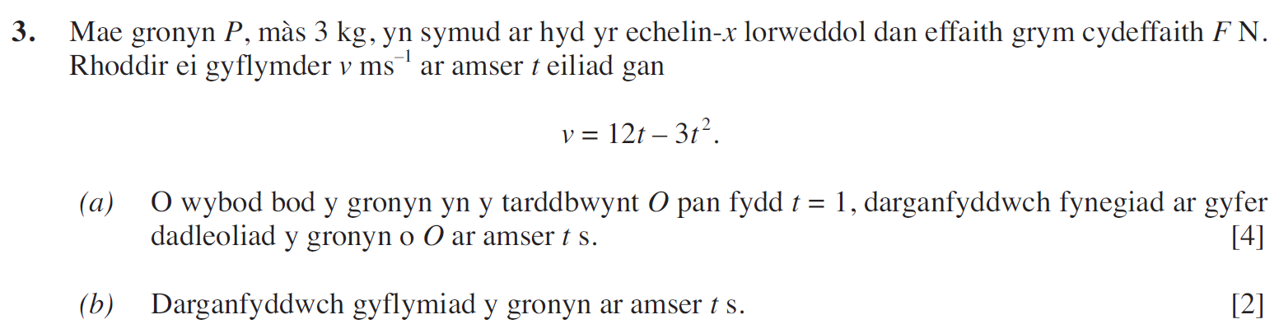
(M2 Haf 2007)
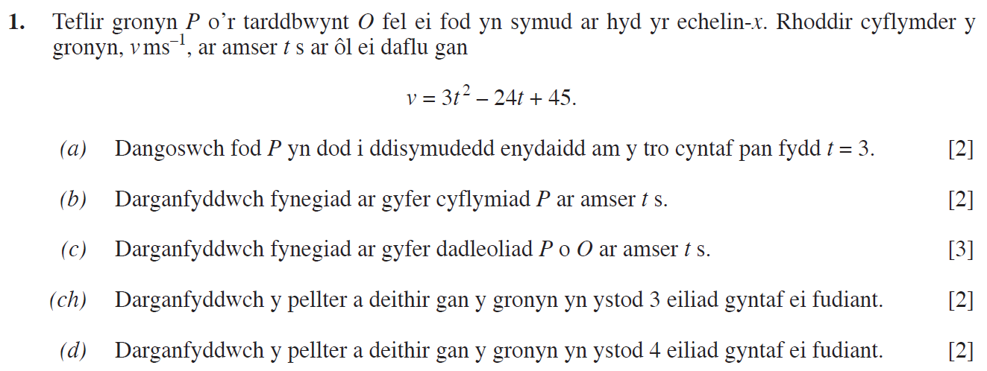
(M2 Haf 2008)
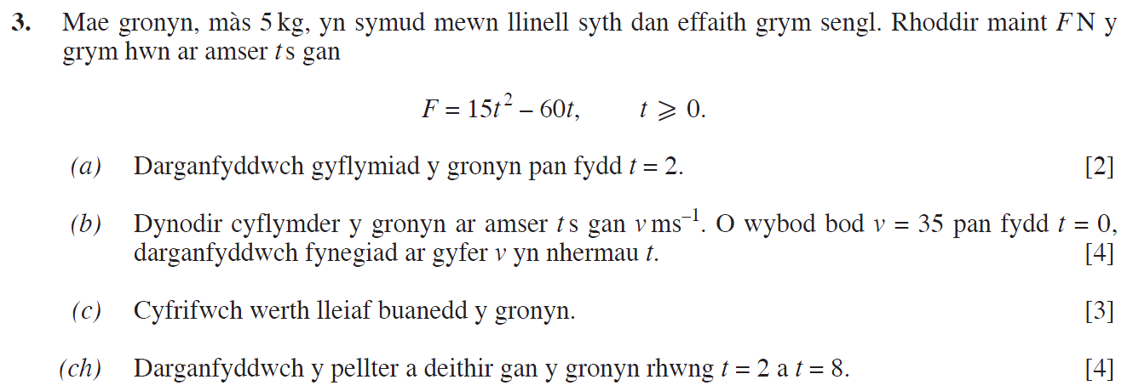

(M2 Haf 2010)
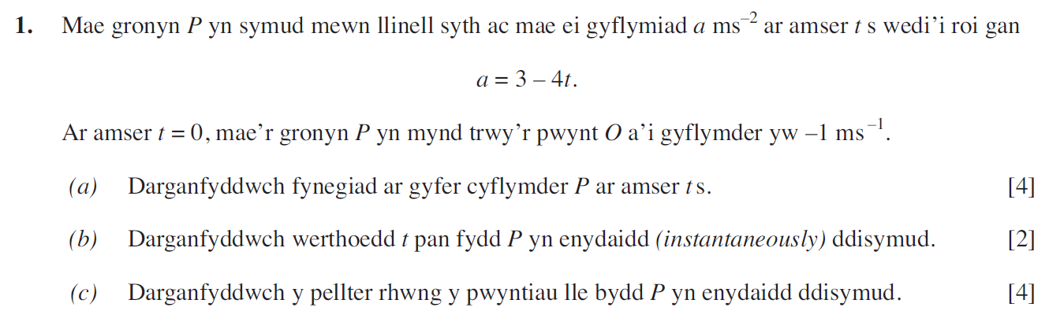
(M2 Haf 2013)
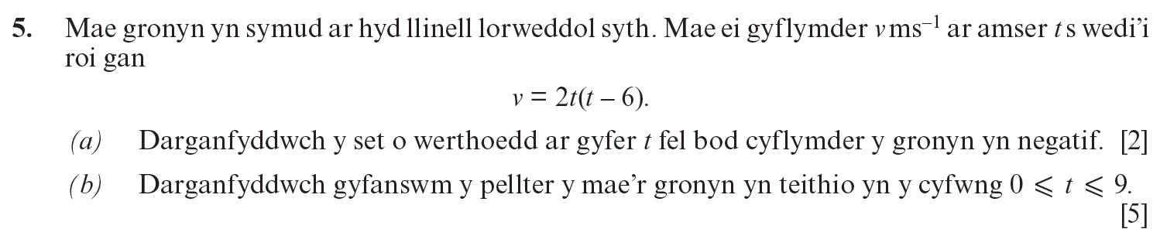
(M2 Haf 2016)
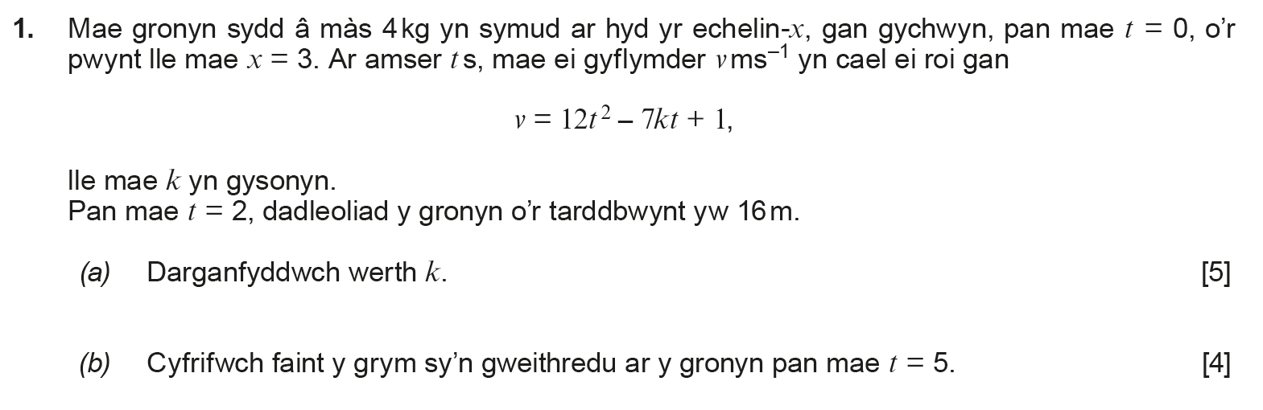

(M2 Haf 2017)
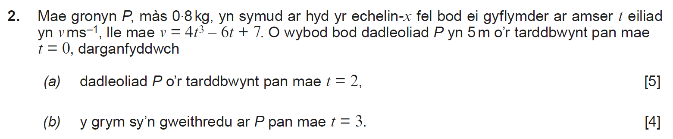
(M2 Haf 2018)
