Old Exam Questions – Old Course
Friction
(M1 Winter 2006)
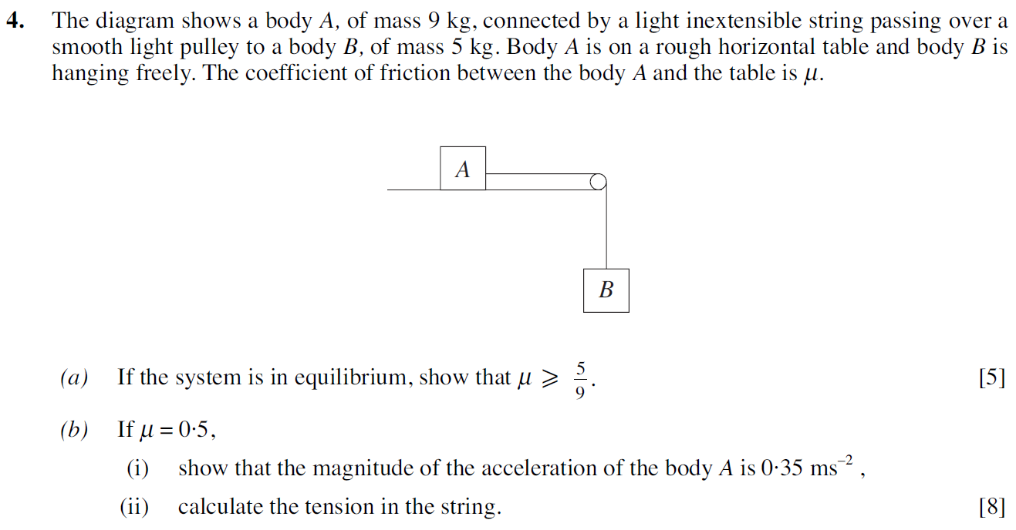
(M1 Summer 2006)
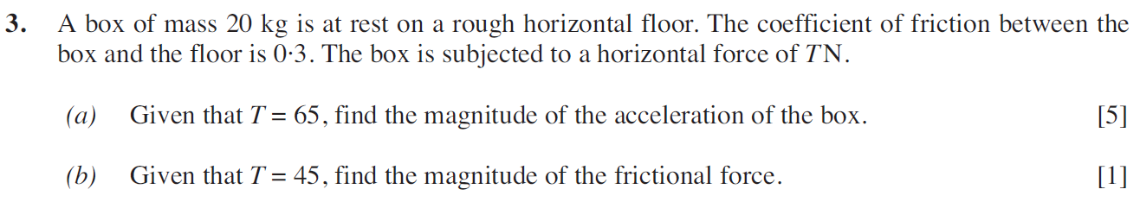
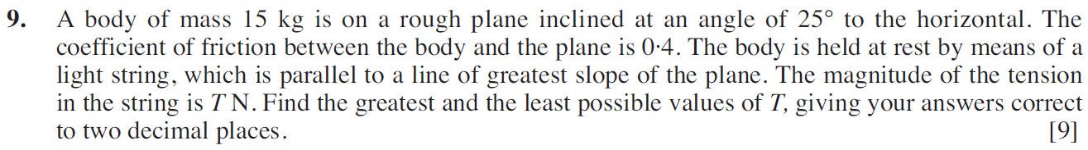
(M1 Winter 2007)
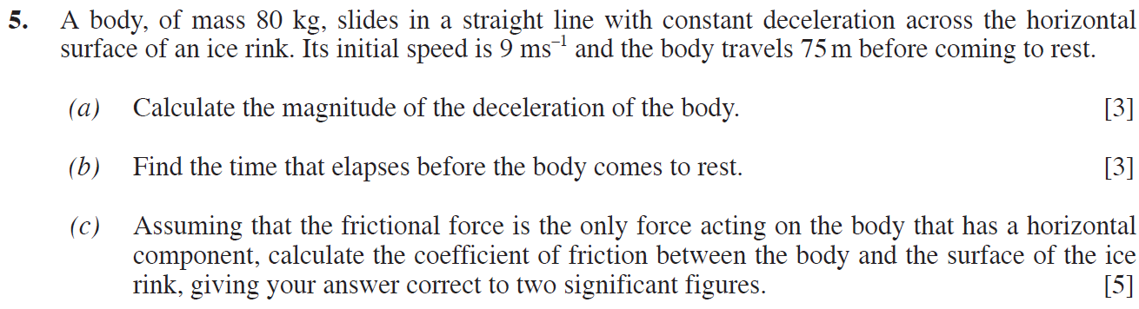

(M1 Summer 2007)
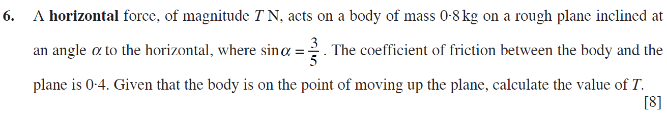
(M1 Winter 2008)
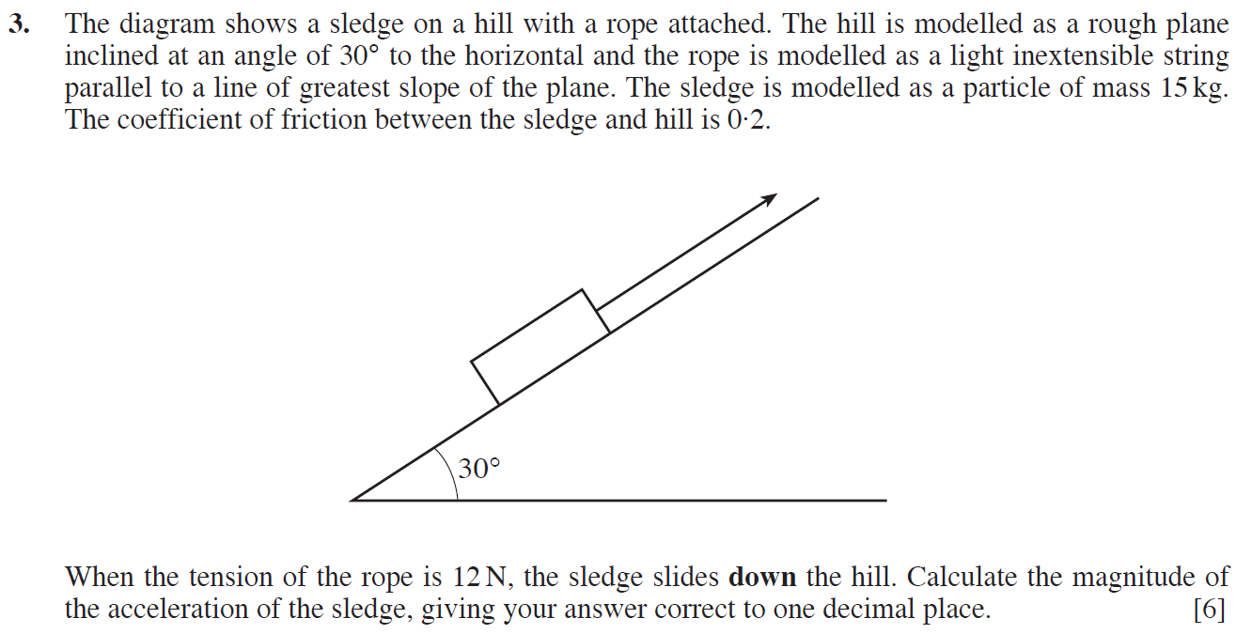
(M1 Summer 2008)
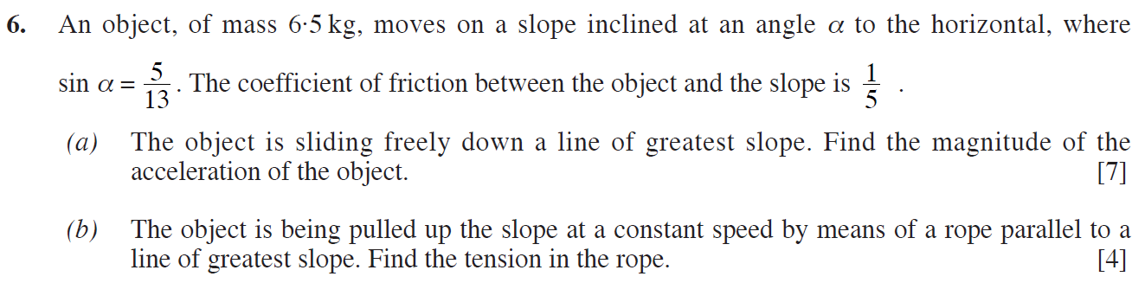

(M1 Winter 2009)
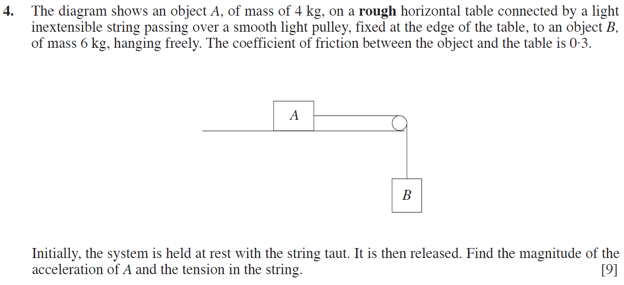
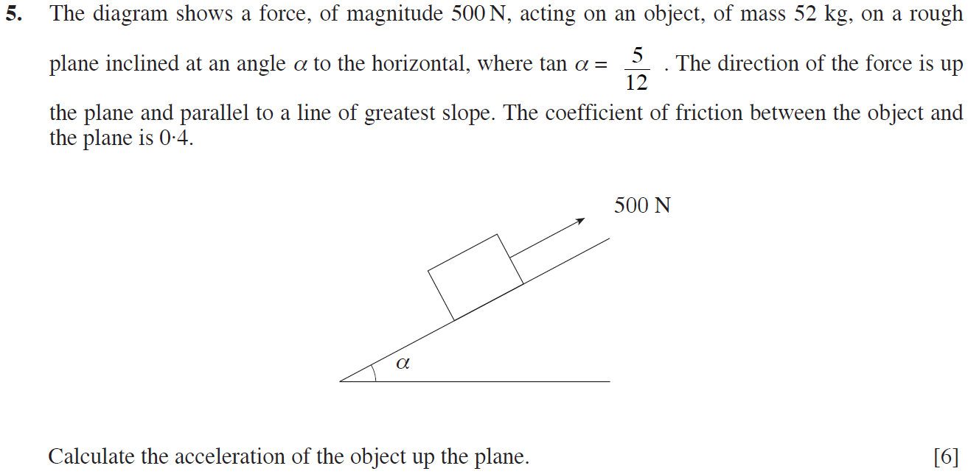
(M1 Summer 2009)
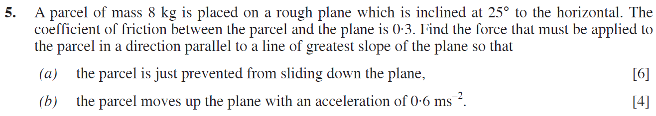

(M1 Winter 2010)
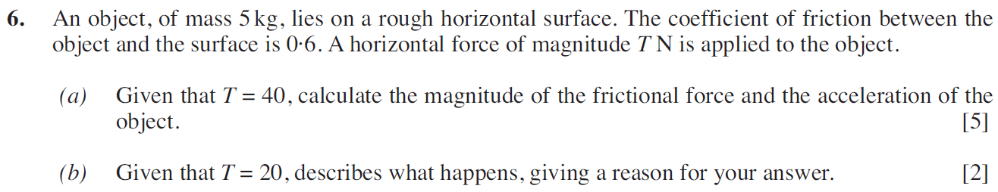
(M1 Summer 2010)
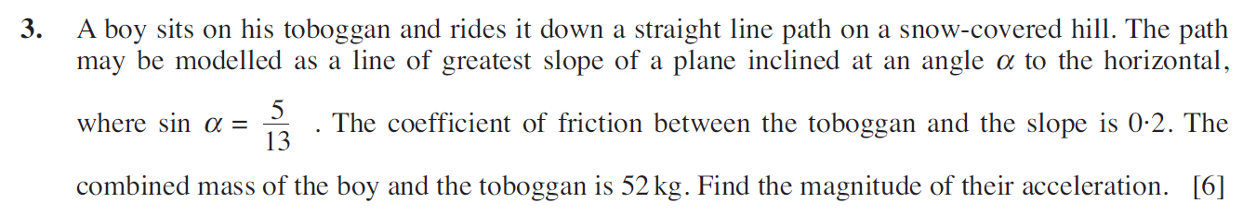
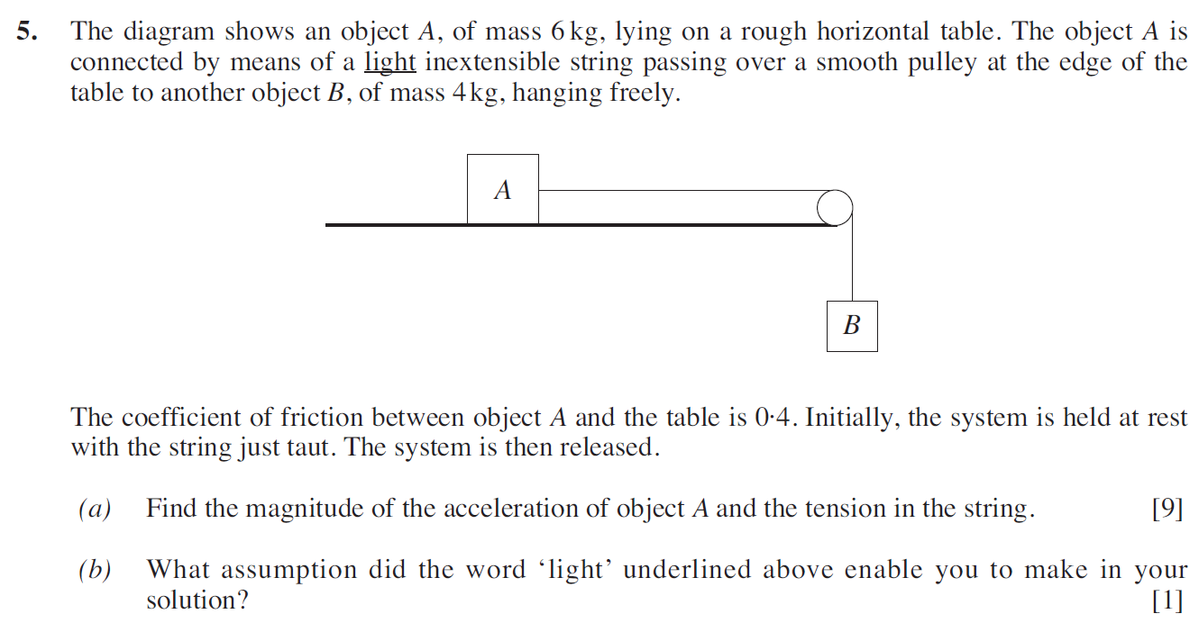

(M1 Winter 2011)
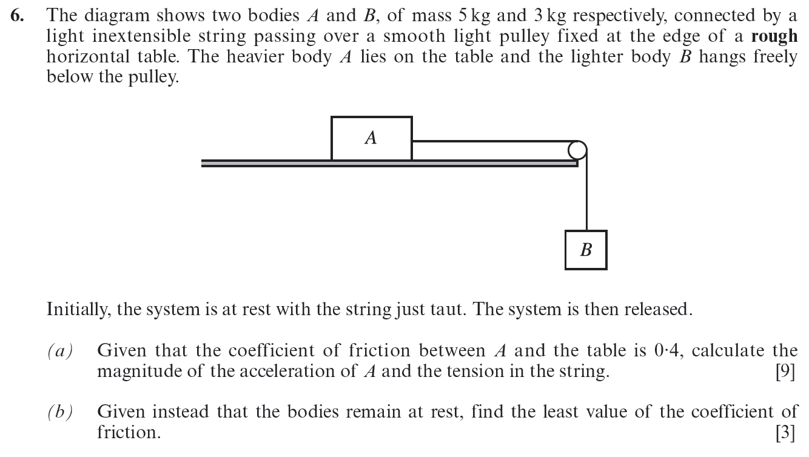
(M1 Summer 2011)
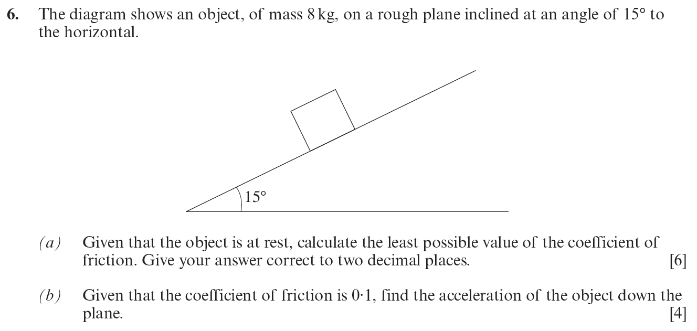

(M1 Winter 2012)
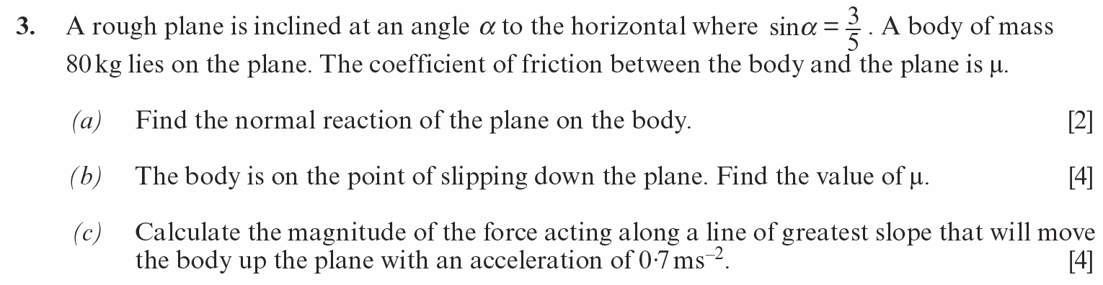
(M1 Summer 2012)
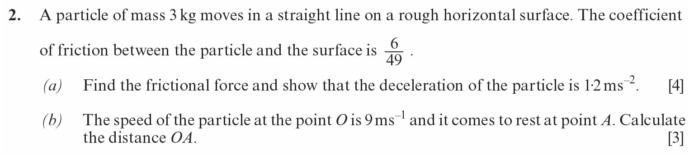
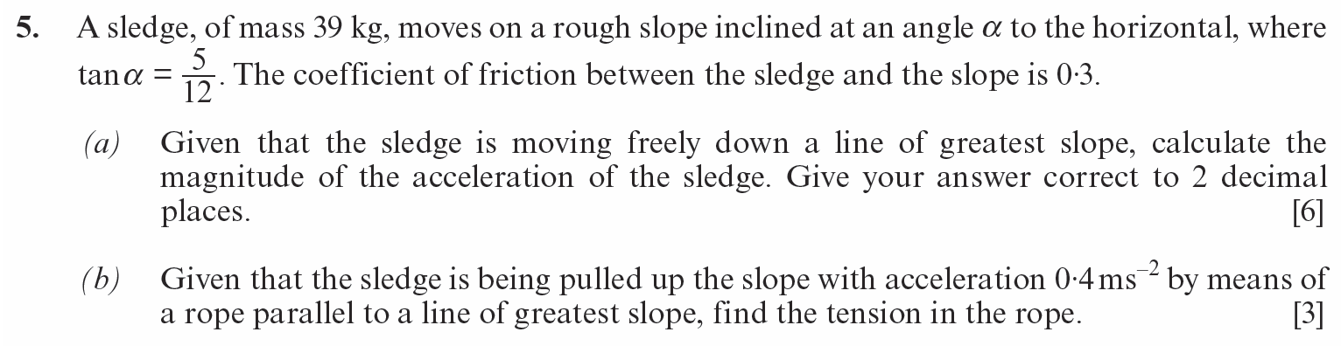
(M1 Winter 2013)
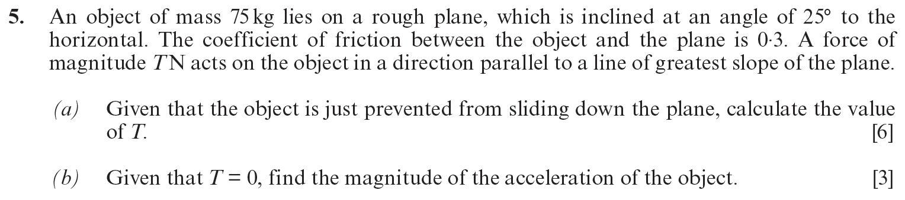

(M1 Summer 2013)
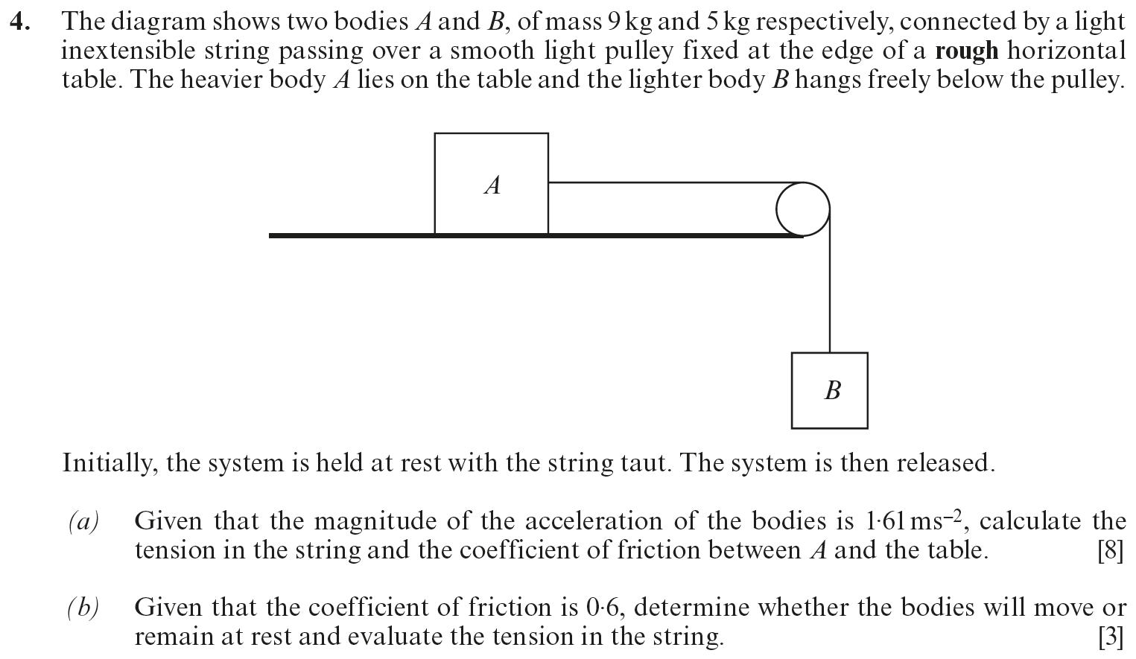
(M1 Winter 2014)
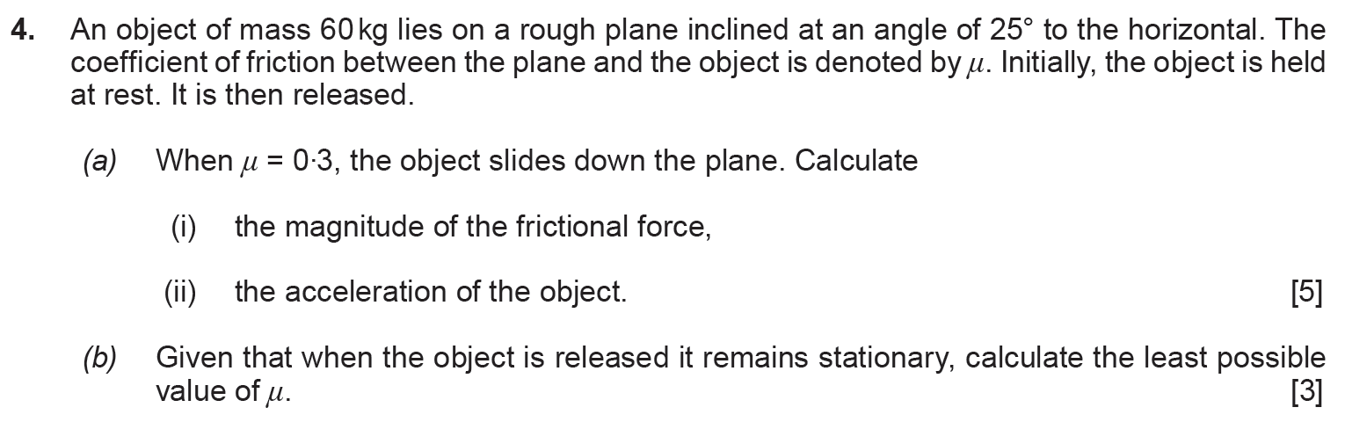

(M1 Summer 2014)
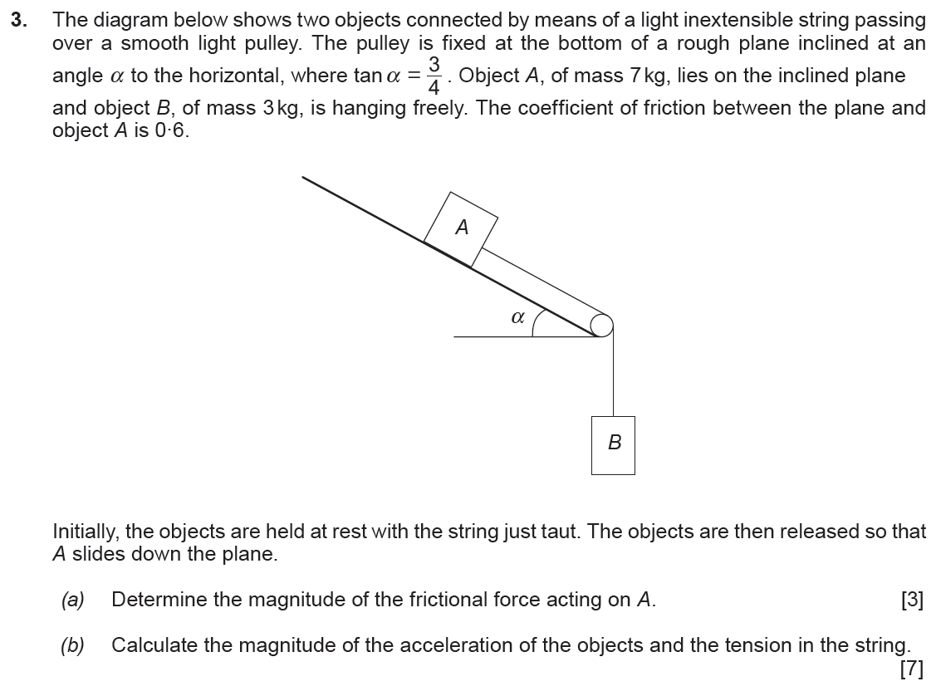
(M1 Summer 2015)
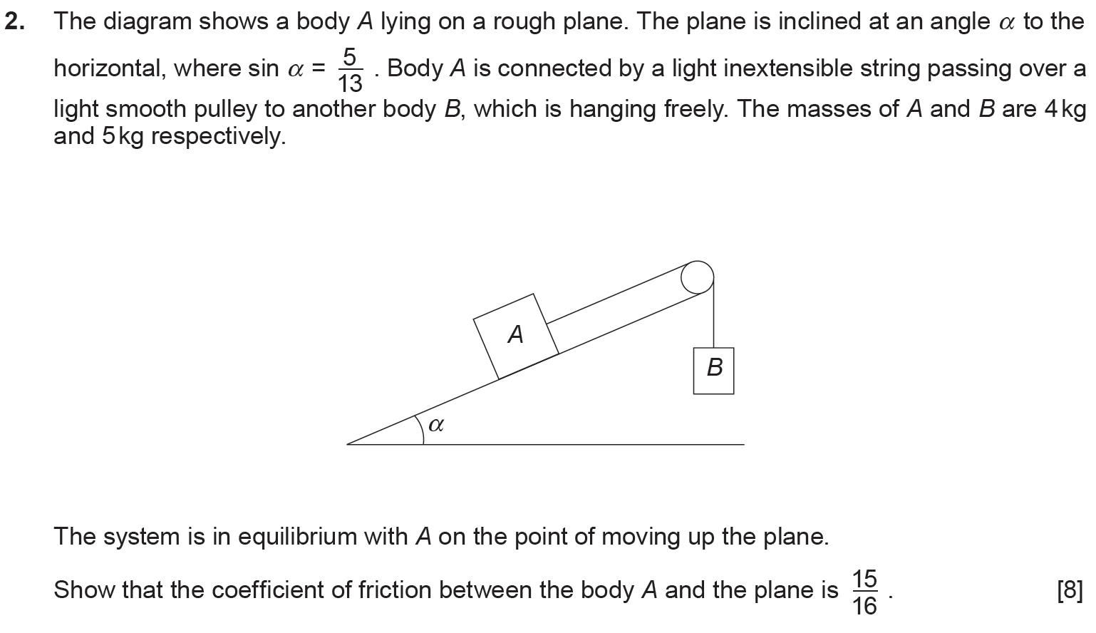
(M1 Summer 2016)
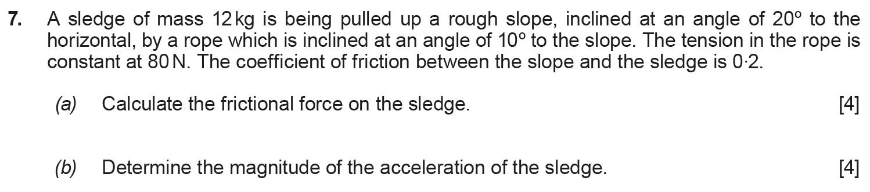
(M1 Summer 2017)
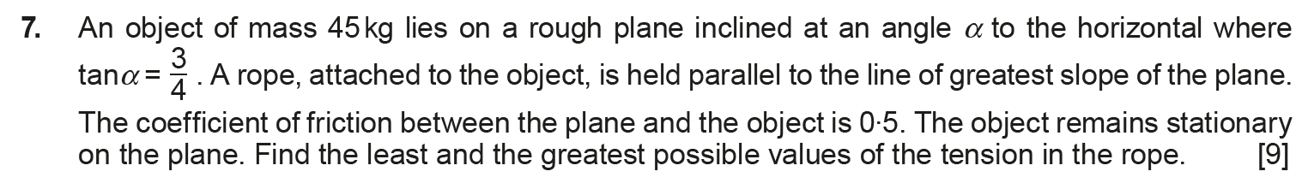
(M1 Summer 2018)
