

Week | Dates | Page | Score
1 | January 6th – January 10th | 4 |  | 11
2 | January 13th – January 17th | 6 |  | 10
3 | January 20th – January 24th | 8 |  | 11
4 | January 27th – January 31st | 10 |  | 11
5 | February 3rd – February 7th | 12 |  | 13
6 | February 10th – February 14th | 14 |  | 12
7 | February 17th – February 21st | 16 |  | 11
Half Term
8 | March 3rd – March 7th | 18 |  | 11
9 | March 10th – March 14th | 20 |  | 12
10 | March 17th – March 21st | 22 |  | 12
11 | March 24th – March 28th | 24 |  | 12
12 | March 31st – April 4th | 26 |  | 11
 |  | Total: |  | 137
March 2025
Su | Mo | Tu | We | Th | Fr | Sa
 |  |  |  |  |  | 1
2 | 3 | 4 | 5 | 6 | 7 | 8
9 | 10 | 11 | 12 | 13 | 14 | 15
16 | 17 | 18 | 19 | 20 | 21 | 22
23 | 24 | 25 | 26 | 27 | 28 | 29
30 | 31

April 2025
Su | Mo | Tu | We | Th | Fr | Sa
 |  | 1 | 2 | 3 | 4 | 5
6 | 7 | 8 | 9 | 10 | 11 | 12
13 | 14 | 15 | 16 | 17 | 18 | 19
20 | 21 | 22 | 23 | 24 | 25 | 26
27 | 28 | 29 | 30

January 2025
Su | Mo | Tu | We | Th | Fr | Sa
 |  |  | 1 | 2 | 3 | 4
5 | 6 | 7 | 8 | 9 | 10 | 11
12 | 13 | 14 | 15 | 16 | 17 | 18
19 | 20 | 21 | 22 | 23 | 24 | 25
26 | 27 | 28 | 29 | 30 | 31

February 2025
Su | Mo | Tu | We | Th | Fr | Sa
 |  |  |  |  |  | 1
2 | 3 | 4 | 5 | 6 | 7 | 8
9 | 10 | 11 | 12 | 13 | 14 | 15
16 | 17 | 18 | 19 | 20 | 21 | 22
23 | 24 | 25 | 26 | 27 | 28

Registration
Class:
Name:
End of KS3 Target:
Half Term 2: Evaluation
Half Term 1: Evaluation
Mathematics Level:
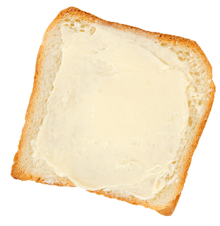
1) 4 × 3 | 2) 87 –21 | 3) 245 + 827
4) 324 to the nearest 10 | 5) 3² | 6) $\frac{1}{4}$ of £20
7) Which number comes next?  1, 2, 4, 8, 16, ____ | 8) 2.5 + 0.8 | 9) 3 – 5

Bread & Butter


Reasoning

There are 28 pupils
in a class. There are
4 more girls than
there are boys in
the class.
How many girls are there in the class?

1) 5 × 4 | 2) 104 – 8 | 3) 274 + 84
4) 535 to the nearest 10 | 5) 5² | 6) $\frac{1}{3}$ of £15
7) Which number comes next?  5, 8, 11, 14, 17, ____ | 8) 1.4 + 0.3 | 9) –2 + 7

Bread & Butter

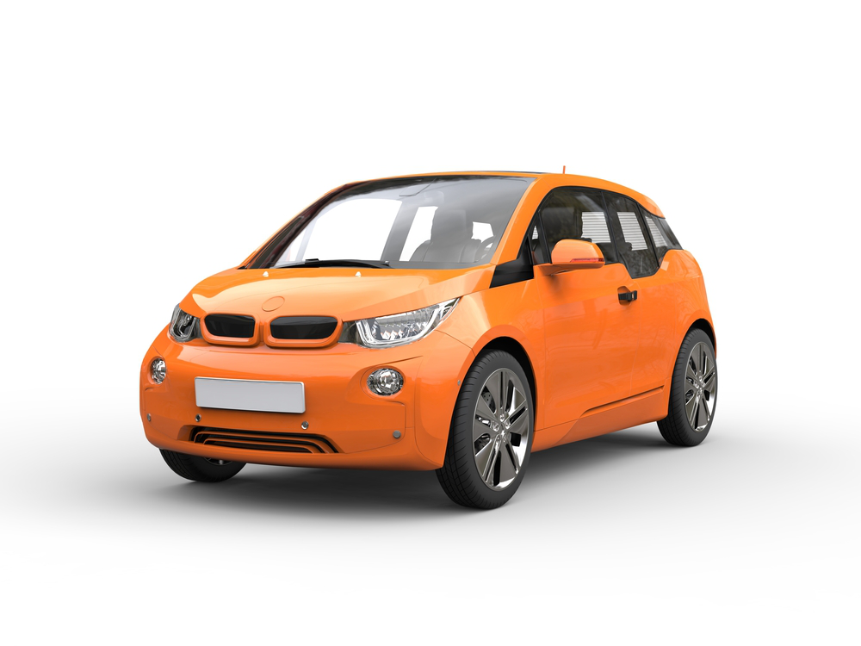

Reasoning

Marc hires a car
for a week,
starting on
November 25th.
On which day
will Marc have to return the car?

1) 7 × 2 | 2) 75 – 28 | 3) 1,034 + 272
4) 734 to the nearest 10 | 5) 8² | 6) $\frac{1}{2}$ of £11
7) Which number comes next?  88, 83, 78, 73, 68, ____ | 8) 3.7 + 2.3 | 9) –5 + 2

Bread & Butter

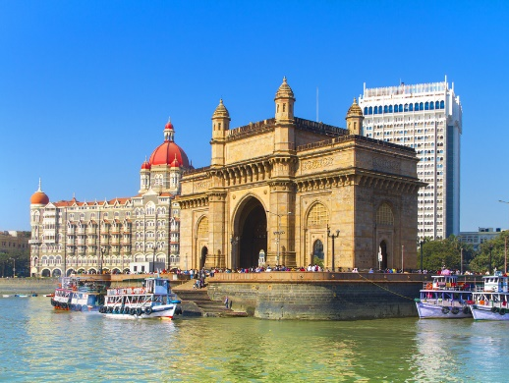

Reasoning

The time difference
between London and
Mumbai, India is
4 hours and a half, with
Mumbai ahead of London.
If the time is 10:45am in London, what is the time in Mumbai?

1) 8 × 4 | 2) 63 – 31 | 3) 924 + 401
4) 468 to the nearest 100 | 5) 2² | 6) $\frac{1}{4}$ of £10
7) Which number comes next?  320, 160, 80, 40, 20, ____ | 8) 6.8 – 1.2 | 9) –6 – 2

Bread & Butter



Reasoning

William’s wage is
currently £2,000 a
month. Today, William
is informed that he is to
receive a 5% pay
rise. What will William’s
wage be next month?

1) 9 × 3 | 2) 124 – 45 | 3) 38 + 2,379
4) 674 to the nearest 100 | 5) 4² | 6) $\frac{1}{3}$ of £36
7) Which number comes next?  1, 3, 5, 7, 9, ____ | 8) 7.4 – 0.6 | 9) 8 – 12

Bread & Butter

Bob’s Café
Tea £1.70
Coffee £1.60
Orange Juice 85p
Apple Juice
90p
Water 70p

Reasoning

The drinks menu for Bob’s Café
is shown on the right. Betsan
and her family go to the café and
order 2 teas, 1 apple juice,
1 water and 3 orange juices.
How much change will Betsan get
from a £10 note?

1) 5 × 6 | 2) 130 – 77 | 3) 928 + 94
4) 959 to the nearest 100 | 5) 6² | 6) $\frac{3}{4}$ of £24
7) Which number comes next?  3, 6, 12, 24, 48, ____ | 8) 4 – 0.3 | 9) –1 – 8

Bread & Butter

Reasoning

One episode of Dylan’s
favourite television show
takes up 2.3Gb of space on
his tablet. If Dylan has
14.6Gb of space left, how
many episodes of the TV
show can Dylan store on his tablet?

1) 2 × 12 | 2) 54 – 48 | 3) 2,384 + 837
4) 2,378 to the nearest 1,000 | 5) $\sqrt{16}$ | 6) $\frac{2}{3}$ of £12
7) Which number comes next?  23, 32, 41, 50, 59, ____ | 8) 7.8 – 1.9 | 9) –4 + 10

Bread & Butter

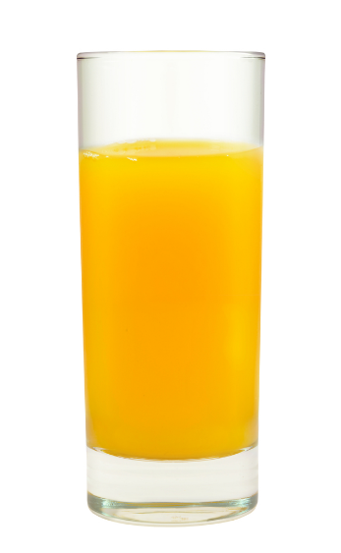

Reasoning

If a glass is three-quarters full of
orange juice, then there is 270 ml
of orange juice in the glass.
How many millilitres of orange
juice would be in the glass if the
glass was full of orange juice?

1) 3 × 10 | 2) 24 – 22 | 3) 263 + 805
4) 8,740 to the nearest 1,000 | 5) $\sqrt{36}$ | 6) $\frac{1}{5}$ of £30
7) Which number comes next?  140, 129, 118, 107, 96, ____ | 8) 5.6 – 1.3 | 9) –12 + 3

Bread & Butter

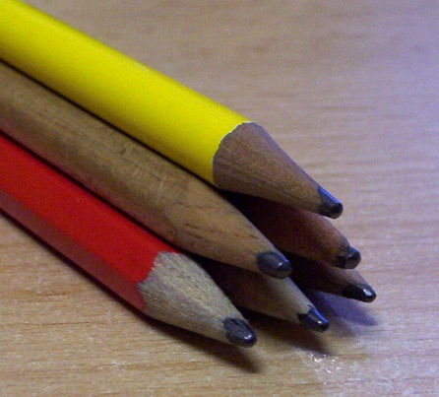

Reasoning

Here is a picture of a
triangular pile of pencils.
There are 3 pencils in the
bottom row and 6 pencils
altogether.
How many pencils would be in a similar pile containing 6 pencils in the bottom row?

1) 4 × 9 | 2) 145 – 46 | 3) 28,353 + 7,439
4) 15,500 to the nearest 1,000 | 5) $\sqrt{81}$ | 6) $\frac{3}{5}$ of £10
7) Which number comes next?  1, 2, 4, 7, 11, 16, ____ | 8) 14.5 + 5.3 | 9) 12 – 15

Bread & Butter



Reasoning

The product of the age
of 3 brothers is 175.
Two of the brothers
are twins.
What is the age of
the third brother?

1) 5 × 7 | 2) 96 – 57 | 3) 928 + 279
4) 5.8 to the nearest unit | 5) $\sqrt{49}$ | 6) $\frac{1}{7}$ of £42
7) Which number comes next?  1, 4, 9, 16, 25, ____ | 8) 18.4 – 2.5 | 9) –4 – 3

Bread & Butter

Reasoning

Today, there is a “30% off” sale
in the clothes shop.
What would be the sale price of
a dress that usually costs £35?

1) 6 × 7 | 2) 214 – 110 | 3) 28 + 2,380
4) 11.4 to the nearest unit | 5) $\sqrt{100}$ | 6) $\frac{4}{7}$ of £28
7) Which number comes next?  1, 1, 2, 3, 5, 8, 13, 21, 34, ____ | 8) 24.8 + 28.7 | 9) –7 + 15

Bread & Butter

Reasoning

How many square
tiles, each measuring
10 cm × 10 cm,
would be required to
tile a rectangular wall
measuring
3 m by 4 m?

1) 7 × 8 | 2) 324 – 279 | 3) 842 + 279
4) 37.5 to the nearest unit | 5) $\sqrt{1}$ | 6) $\frac{7}{8}$ of £24
7) Which number comes next?  1.5, 1.9, 2.3, 2.7, 3.1, ____ | 8) 30 – 14.8 | 9) –14 – 18

Bread & Butter

Reasoning
How many triangles
(of all sizes)
can be seen in
this picture?



@mathemateg /adolygumathemateg
/mathscreuddyn www.mathemateg.com

