

Week | Dates | Page | Score
1 | January 6th – January 10th | 4 |  | 12
2 | January 13th – January 17th | 6 |  | 14
3 | January 20th – January 24th | 8 |  | 12
4 | January 27th – January 31st | 10 |  | 13
5 | February 3rd – February 7th | 12 |  | 12
6 | February 10th – February 14th | 14 |  | 12
7 | February 17th – February 21st | 16 |  | 11
Half Term
8 | March 3rd – March 7th | 18 |  | 14
9 | March 10th – March 14th | 20 |  | 12
10 | March 17th – March 21st | 22 |  | 14
11 | March 24th – March 28th | 24 |  | 13
12 | March 31st – April 4th | 26 |  | 11
 |  | Total: |  | 150
March 2025
Su | Mo | Tu | We | Th | Fr | Sa
 |  |  |  |  |  | 1
2 | 3 | 4 | 5 | 6 | 7 | 8
9 | 10 | 11 | 12 | 13 | 14 | 15
16 | 17 | 18 | 19 | 20 | 21 | 22
23 | 24 | 25 | 26 | 27 | 28 | 29
30 | 31

April 2025
Su | Mo | Tu | We | Th | Fr | Sa
 |  | 1 | 2 | 3 | 4 | 5
6 | 7 | 8 | 9 | 10 | 11 | 12
13 | 14 | 15 | 16 | 17 | 18 | 19
20 | 21 | 22 | 23 | 24 | 25 | 26
27 | 28 | 29 | 30

January 2025
Su | Mo | Tu | We | Th | Fr | Sa
 |  |  | 1 | 2 | 3 | 4
5 | 6 | 7 | 8 | 9 | 10 | 11
12 | 13 | 14 | 15 | 16 | 17 | 18
19 | 20 | 21 | 22 | 23 | 24 | 25
26 | 27 | 28 | 29 | 30 | 31

February 2025
Su | Mo | Tu | We | Th | Fr | Sa
 |  |  |  |  |  | 1
2 | 3 | 4 | 5 | 6 | 7 | 8
9 | 10 | 11 | 12 | 13 | 14 | 15
16 | 17 | 18 | 19 | 20 | 21 | 22
23 | 24 | 25 | 26 | 27 | 28

Registration
Class:
Name:
End of KS3 Target:
Half Term 2: Evaluation
Half Term 1: Evaluation
Mathematics Level:
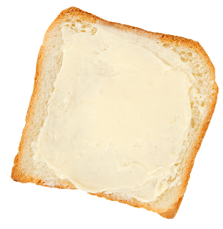
1) $3 × 1\frac{1}{2}$ | 2) Half of $2\frac{1}{2}$ | 3) 10 × (2.1 + ___) = 100
4) 5% of 140 | 5) Round off 8268 to two significant figures. | 6) 10² × ______ = 3000
7) Increase £60 by 25%. | 8) $1\frac{1}{5}$ kg = _____ g | 9) Calculate the circumference of a circle with diameter 10cm. (Use $π=3.14$.)

Bread & Butter

Reasoning

Crisial is a pop group with
four members. The mean
of their ages is 20. A new,
25 year old, member
joins the group. What is
the new mean of the
ages of Crisial?
1) 1 : 4 = ____ : 20 | 2) 45 × 67 | 3) ____% of 300 g = 60 g
4) _____ ÷ 2 + 30 = 100 | 5) 1000 – 28.3 + 35.6 | 6) Write down the fraction that is exactly half way between 50% and 0.7.
7) 300 – 3 × 2² | 8) 20% of 80 = 40% of ______ | 9) $2\frac{1}{10}$ km = ____________ cm

Bread & Butter

Reasoning

The perimeter of a square is
20 cm. Four of these
squares are put together
to make the pattern shown
on the right. (a) What is the
outside perimeter of the pattern?
(b) What is the area of the coloured squares?

1) 5³ | 2) 1% of £200 | 3) 2.4 litres = _______ ml
4) Write down 254,000 in standard form. | 5) 0.1 × 0.6 | 6) 6 ÷ 0.2
7) Find the mean of 9, 2, 4, 0, 1, 4, 5, 3. | 8) What is £44 reduced by 10%? | 9) $2^{11}÷2^{7}$

Bread & Butter



Reasoning

Buses to Betws-y-coed leave a bus station every 16 minutes. Buses to Llandudno leave the same bus station every 20 minutes.
A bus to Betws-y-coed and a bus to Llandudno leave the bus station at 08:15. When is the next time that buses to both places leave the bus station at the same time?

1) 360 ÷ 24 | 2) 40% of £170 | 3) 30 – 4.58
4) Write down the fraction that is exactly half way between $\frac{1}{10}$ and $\frac{2}{5}$. | 5) Write down 0.18 as a fraction, in its simplest form. | 6) ${\left(\frac{3}{4}\right)}^{2}$
7) 10³ ÷ (3² + 4²) | 8) Given that  $\frac{2}{3}=0.\dot{6}$, write down the fraction that is equal to $0.0\dot{6}$. | 9) Calculate the area of a circle with radius 3 cm. (Use $π=3.14$.)

Bread & Butter



Reasoning

Three-quarters of the pupils in a class
own an iPhone. Of these, two-thirds
have received their iPhone within the
last year. Seven pupils in the class own
an iPhone more than 12 months old.
What is the total number of pupils in
the class?

1) £50 – £14.83 | 2) 5.4 + 2.5 × 5 | 3) 8 m = ______ mm
4) $\frac{3}{4} × \frac{2}{3}$ | 5) Round off 8397 to one significant figure. | 6) 15% of $70
7) 32.6 × 4.7 | 8) The reciprocal of $\frac{5}{6}$ is | 9) $3^{5} × 3^{8}$

Bread & Butter

Reasoning

Batteries: £2.50 per pack.
Special offer: Buy one and
get one half price.
Use the special offer to
calculate the cost of buying
6 packets of batteries.

1) –2 + 18 – 4 | 2) 8000 – 2468 | 3) Calculate $\frac{5}{9}$ of £108.
4) Reduce £250 by 35%. | 5) 6,350 mg = _______ g | 6) Divide £45 between Ann and Sue according to the ratio 7:8.
7) $1\frac{1}{2} × 2\frac{2}{3}$ | 8) Dewi travels 28 miles in 2 hours. What is Dewi’s average speed? | 9) 275 × 93

Bread & Butter

Reasoning

Ian and Robin live exactly
500 m from each other.
Ian walks 75 m from his
home. Robin walks 125 m
from his home. What are the possible answers to the question “How far are Ian and Robin from each other”?

1) Write down $\frac{4}{5}$ as a decimal. | 2) 5 + 2 × 4 | 3) If £1 = $1.23, what is the equivalent of £7 in dollars?
4) 0.3 – ______ = 0.18 | 5) 30 × 0.07 | 6) Round off 48.034581 to 3 decimal places.
7) (0.1)² | 8) $2\frac{2}{3}+3\frac{1}{4}$ | 9) Density = Mass ÷ Volume so  Mass =

Bread & Butter



Reasoning

Here is a picture of the
Jones family. The mean
and range of their ages
is 17 and 26,
respectively.
What will be the mean and range of their ages in 5 years’ time?

1) 26 × 3 | 2) Calculate $\frac{2}{3}$ of  42 cm. | 3) Any nonagon has ____ sides.
4) 1.4% of £200 | 5) Write down all the factors of 36. | 6) 7² + 5² – 3²
7) The reciprocal of 8 is | 8) Circle the fractions that are equivalent to recurring decimals.  $$\frac{1}{2} \frac{1}{3} \frac{1}{4} \frac{1}{5} \frac{1}{6}$$ | 9) Which whole number has standard form $5.3 × {10}^{4}$?

Bread & Butter



Reasoning

Delyth cleans her teeth twice a day, and follows her dentists’ advice of cleaning your teeth for at least two minutes every time.
Delyth believes that every year she spends more than a whole day cleaning her teeth. Is Delyth correct in thinking this?

1) 475 – 84.5 | 2) 30% of 150 g | 3) Write down  <, > or = in each space.  30% ____ 0.03  0.9 ____ $\frac{4}{5}$  65% ____ $\frac{13}{20}$
4) Round off 82.82 to two significant figures. | 5) 34 – (4 + 8) × 2 | 6) $5^{4}$
7) Calculate the circumference of a circle with radius  4 cm. (Use $π=3.14$.) | 8) 0.4 × 0.2 | 9) Increase £40 by 0.5%.

Bread & Butter



Reasoning

A 250 GB disk drive can hold
15 hours of high definition
video.
How many hours of high
definition video can a
400 GB disk drive hold?

1) 49 + _______ = 1006 | 2) ______ – 22.4 = 74.9 | 3) Write down $\frac{23}{5}$ as a mixed number.
4) 3 + 3² + 3³ | 5) The fourth root of _____ is 2 | 6) 24.5 × 0.6
7) 2.5% of £240 | 8) Write down 340,000,000 in standard form. | 9) 8.52 ÷ 0.3

Bread & Butter

Reasoning

In a football match between
Liverpool and Everton,
Liverpool had 62% of
the possession. The ball
was in play for 60 minutes of
the match. How many minutes and seconds were Everton in possession of the ball?

1) Calculate $\frac{4}{7}$ of £84. | 2) 32 – 6.78 | 3) 12 ÷ (–2 + 5)
4) Round off 283 to one significant figure. | 5) The reciprocal of $\frac{8}{13}$ is | 6) Write down half of 5% as a decimal.
7) What is the volume of a cube with 6 cm sides? | 8) $7^{5} × 7^{2}$ | 9) 966 ÷ 42

Bread & Butter

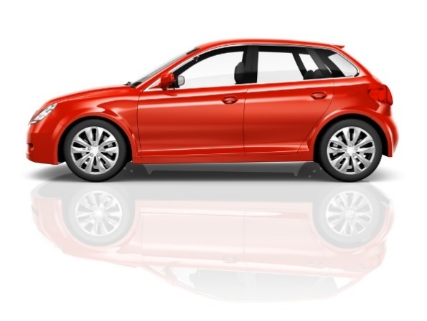

Reasoning

Mrs. Hughes bought a new
car for £14,500.
The car depreciated 12%
during its first year, and
10% during its second year.
What was the value of the car at the end of the second year?

1) 86 mm =  ________ m | 2) Divide £10 between Jim and Lora according to the ratio 1:7. | 3) 45% of £90
4) 0.3 × 0.1 | 5) The reciprocal of $\frac{1}{12}$ is | 6) Write down half a million in standard form.
7) Write down $5\frac{2}{3}$ as a top-heavy fraction. | 8) 624 × 78 | 9) What is a quarter of $16\frac{3}{4}$?

Bread & Butter



Reasoning
During a raffle for a coffee morning, Eifion won a “20% off” voucher for a clothes shop.
When Eifion went to the clothes shop to use his voucher, he noticed that the shop was having a “50% off” sale. “Great!”, Eifion said, “I can now get 70% off all the prices in the shop”. Explain why Eifion was wrong in saying this.



@mathemateg /adolygumathemateg
/mathscreuddyn www.mathemateg.com

