Ysgol y Creuddyn | Yr Adran Fathemateg
Hen Gwestiynau Arholiad
Simple Harmonic Motion
(Haf 2006)
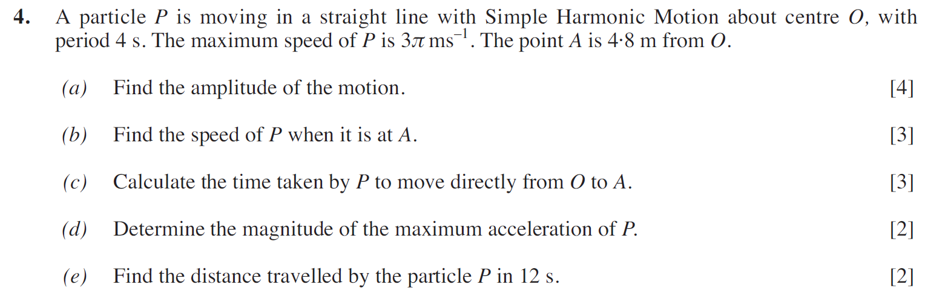
(Haf 2007)
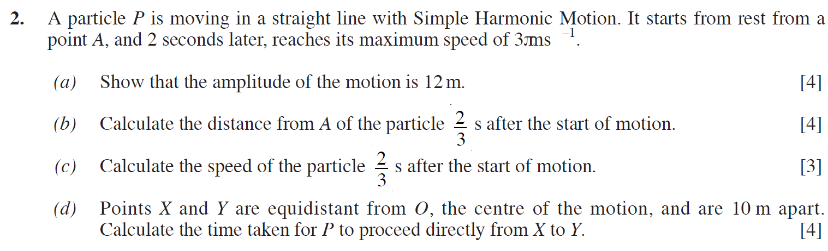
(Haf 2008)
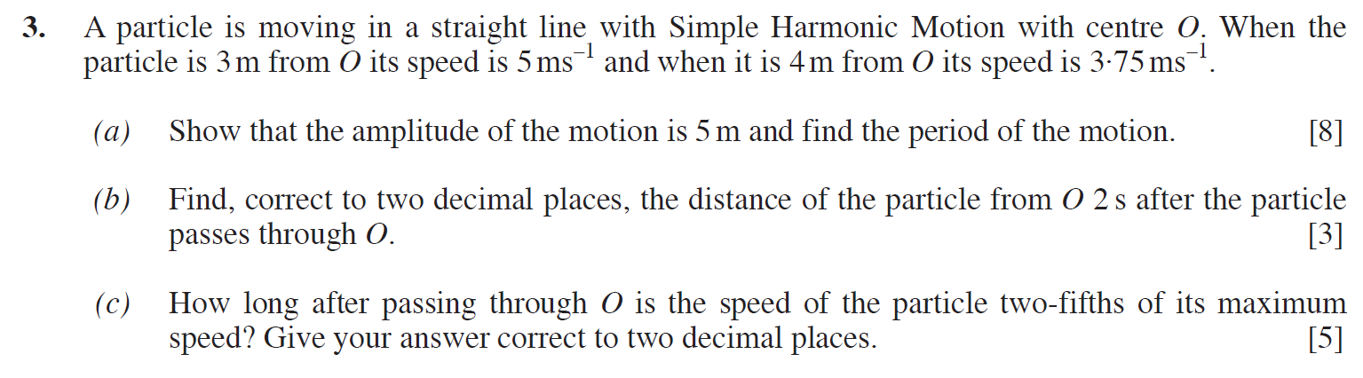

(Haf 2009)
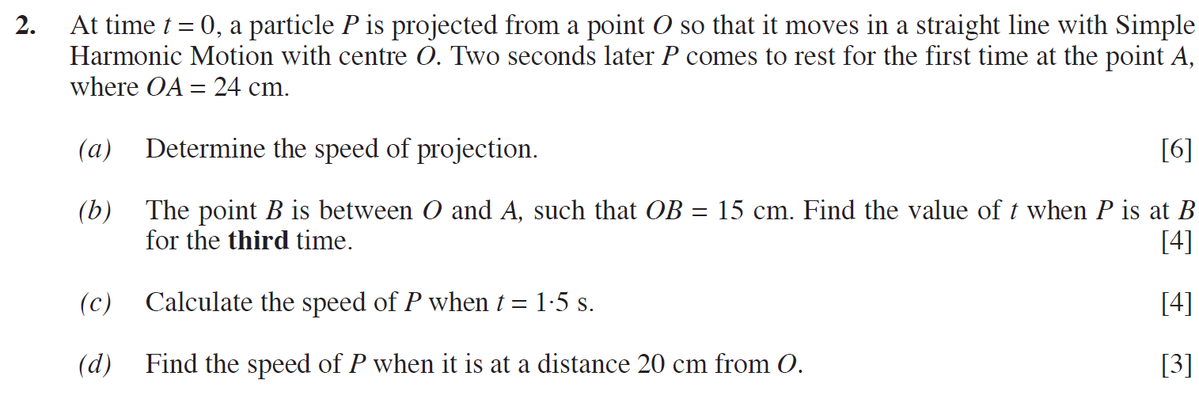
(Haf 2010)
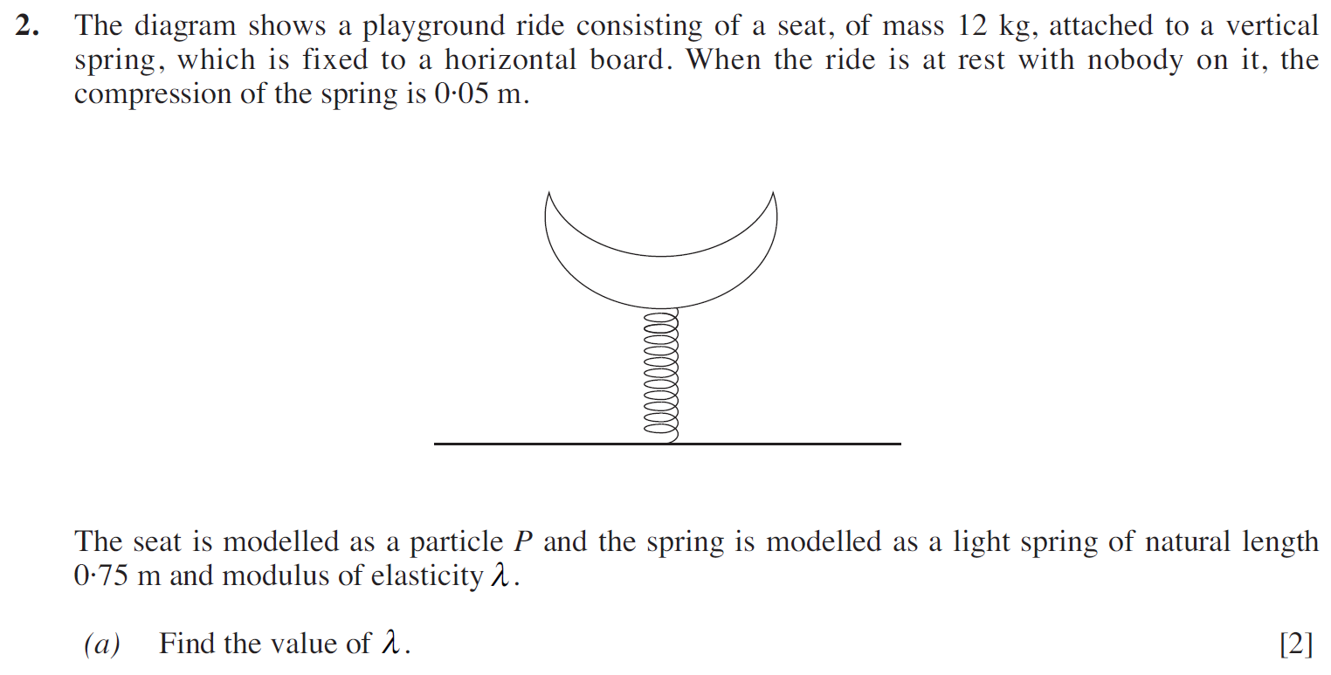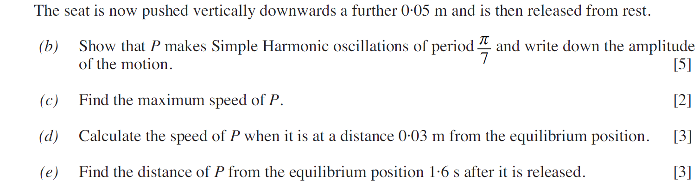

(Haf 2011)
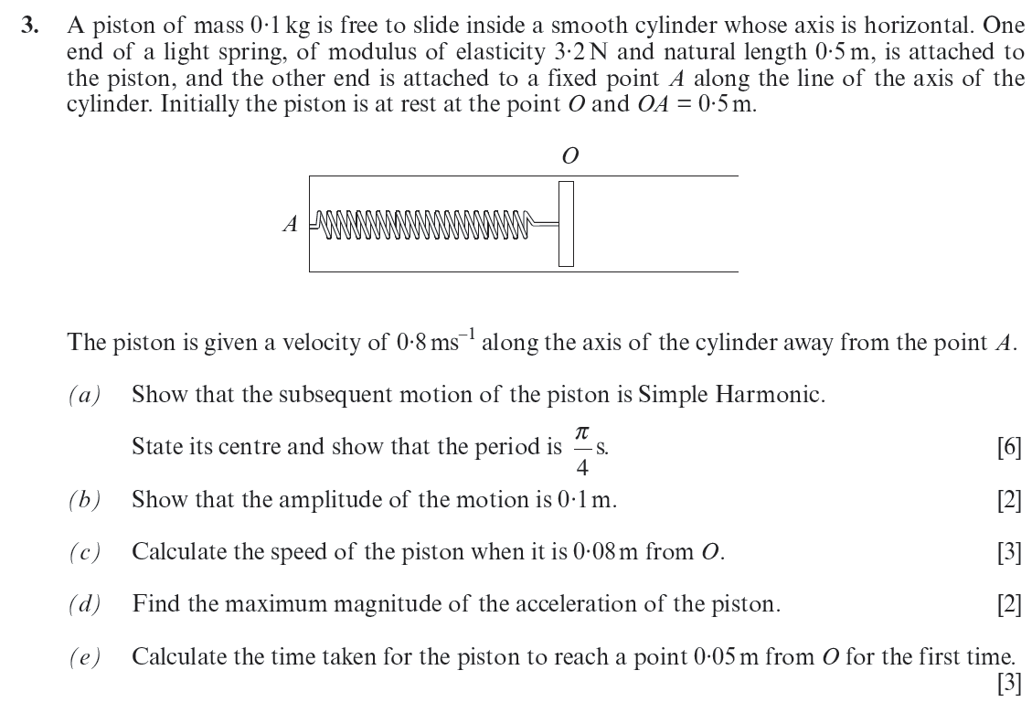
(Haf 2012)
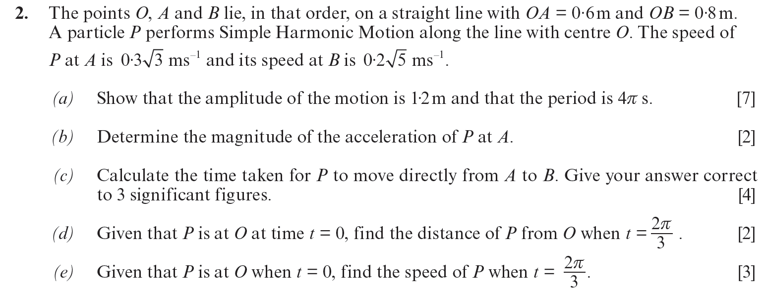

(Haf 2013)
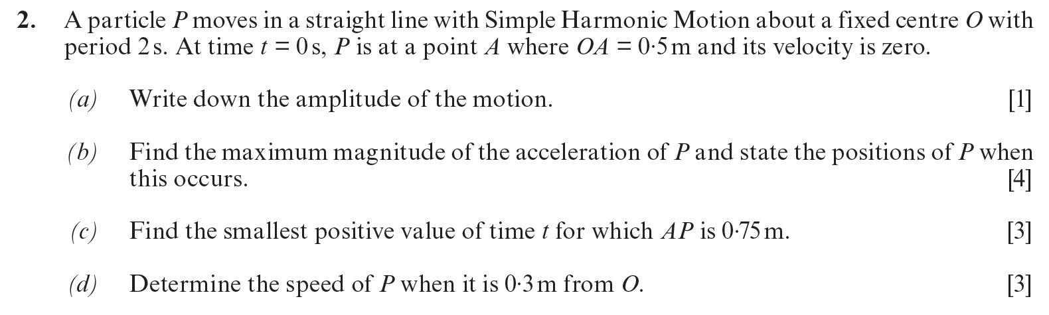
(Haf 2014)
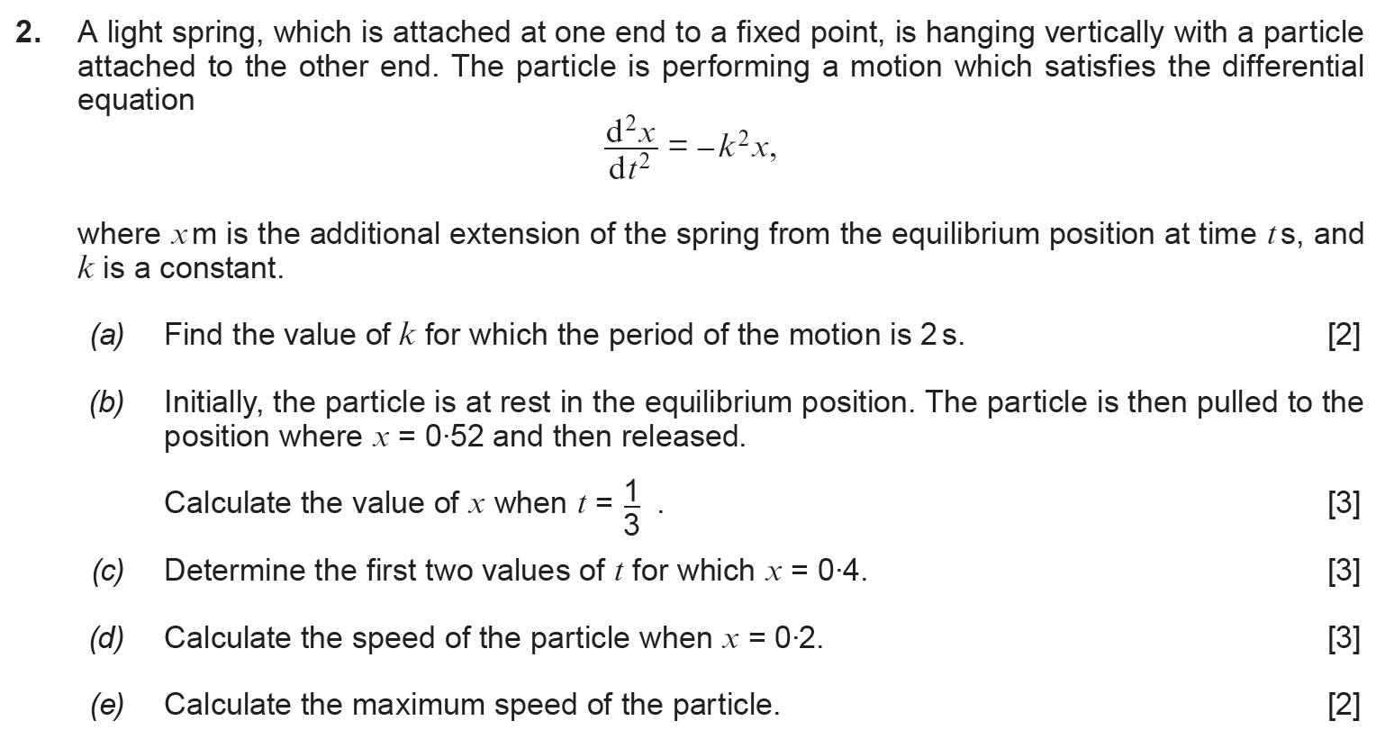

(Haf 2015)
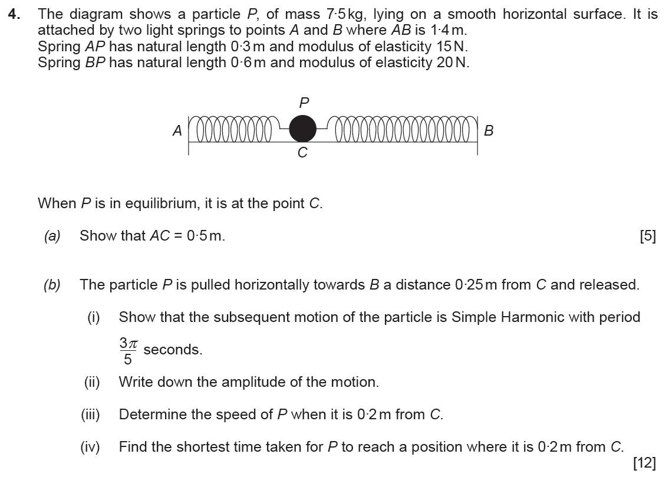
(Haf 2016)
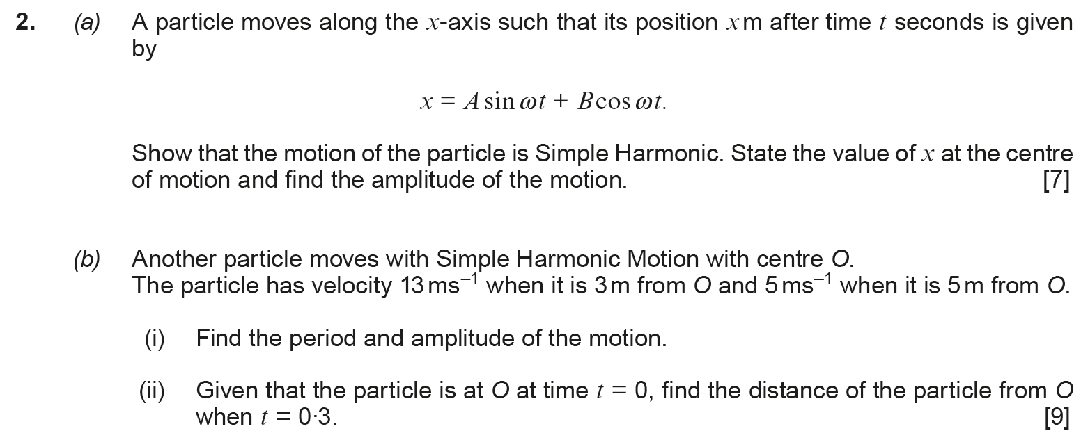

(Haf 2017)
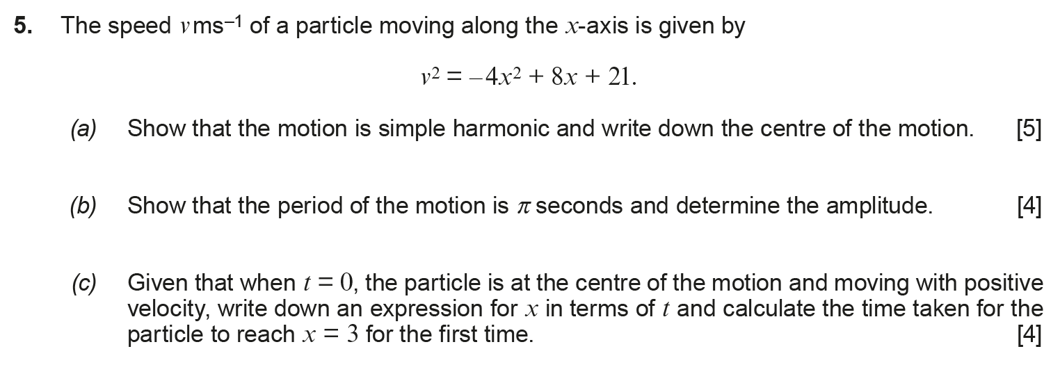
(Haf 2018)
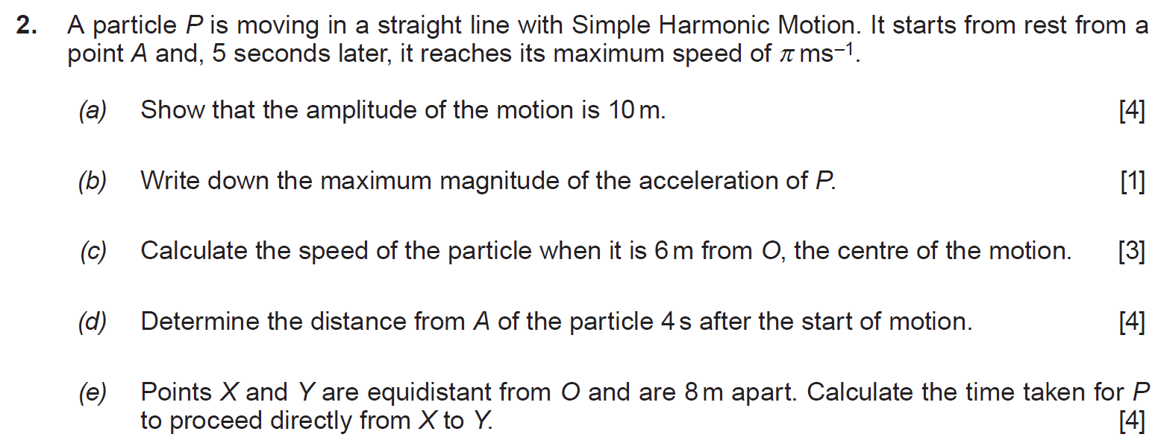
(Haf 2019)
