Ysgol y Creuddyn | Yr Adran Fathemateg
Hen Gwestiynau Arholiad
Llinynnau
(Haf 2006)
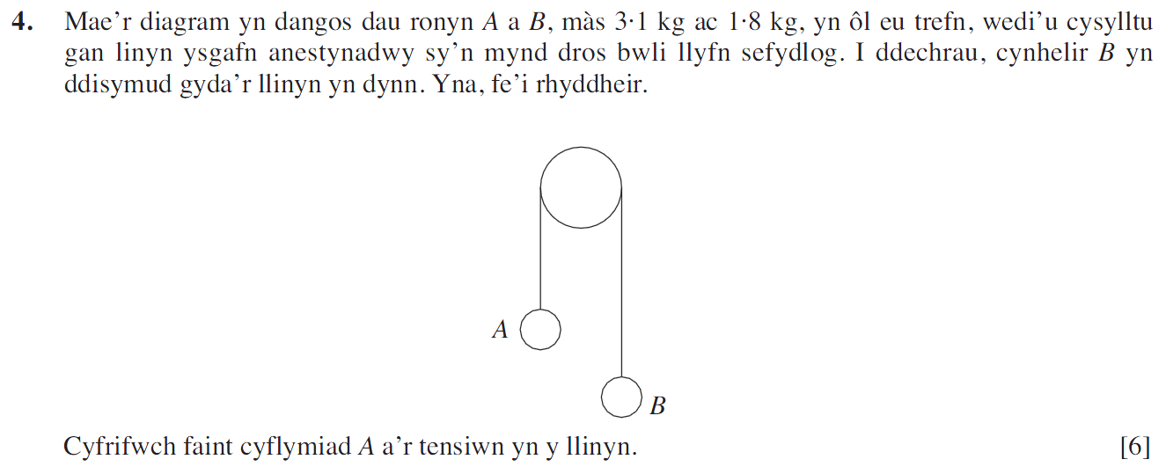
(Haf 2008)
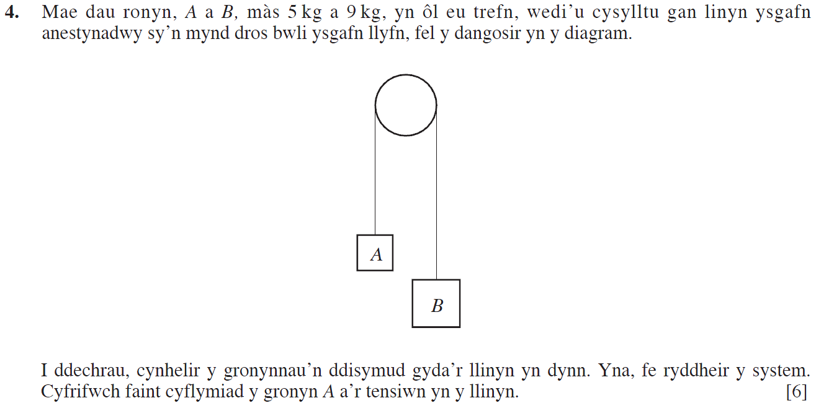

(Haf 2009)
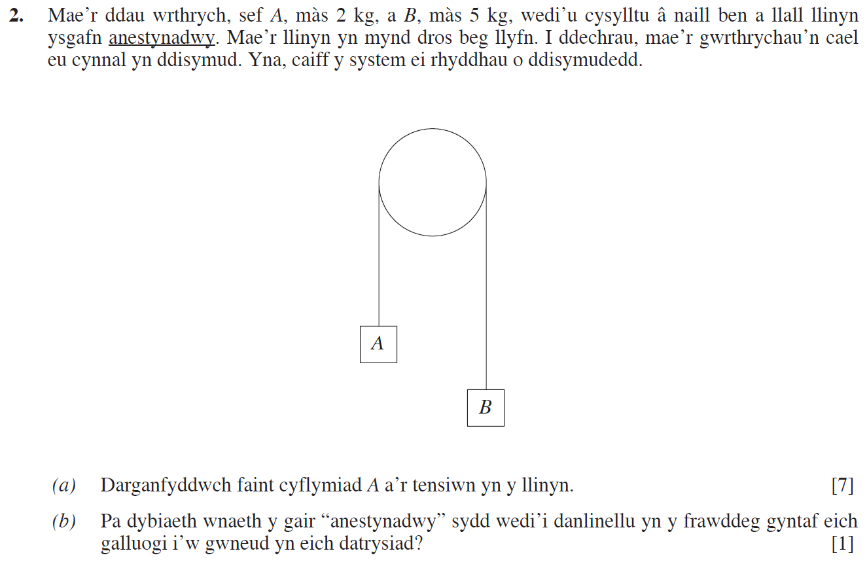
(Gaeaf 2012)
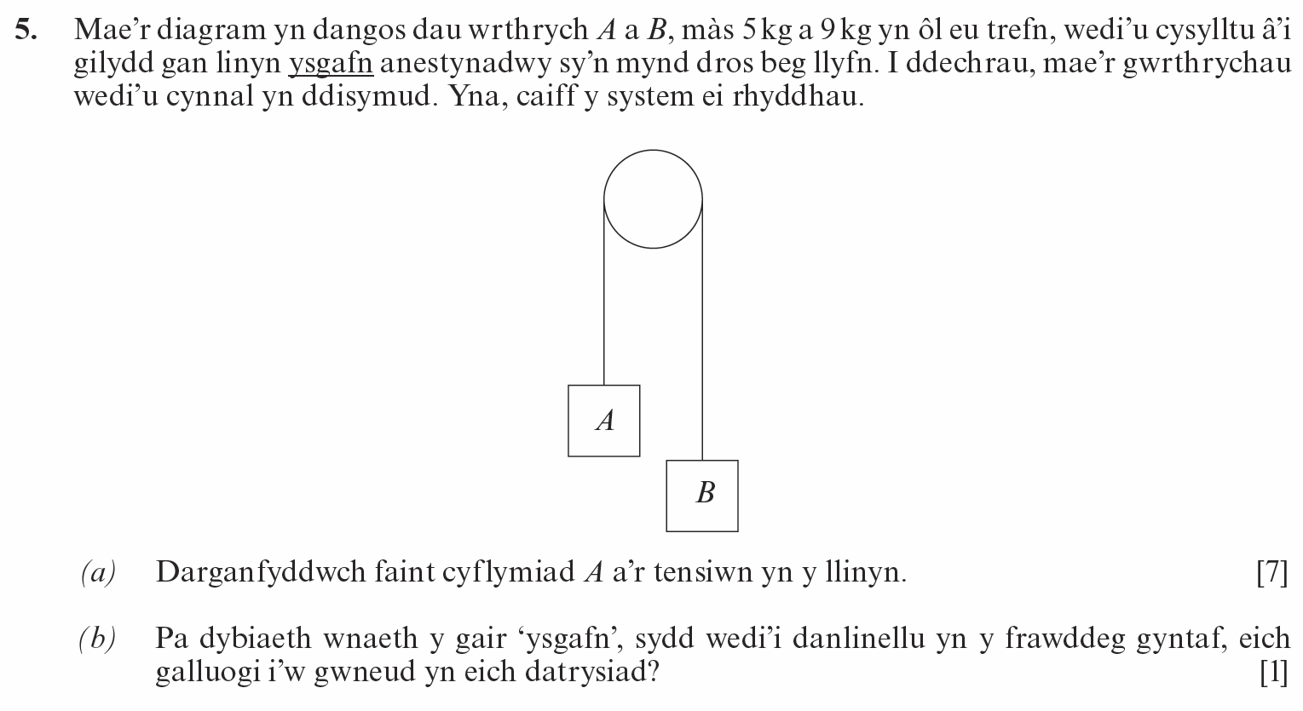

(Haf 2012)
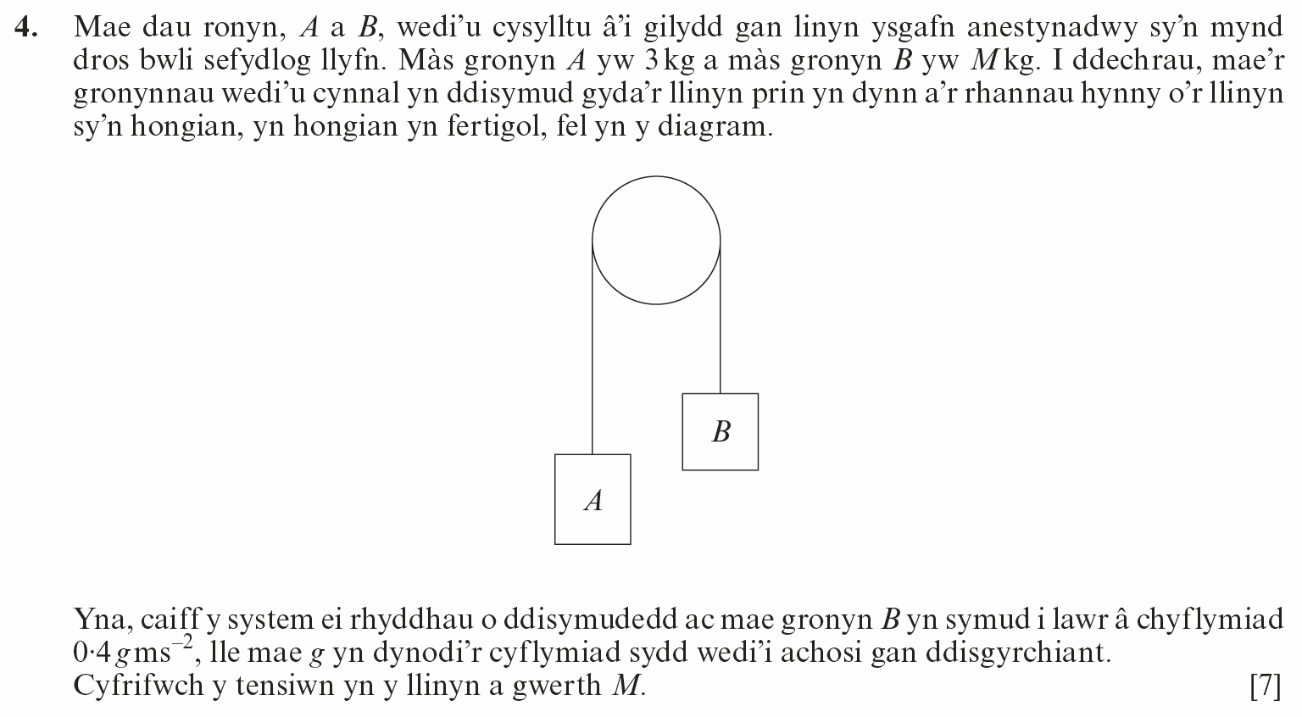
(Gaeaf 2013)
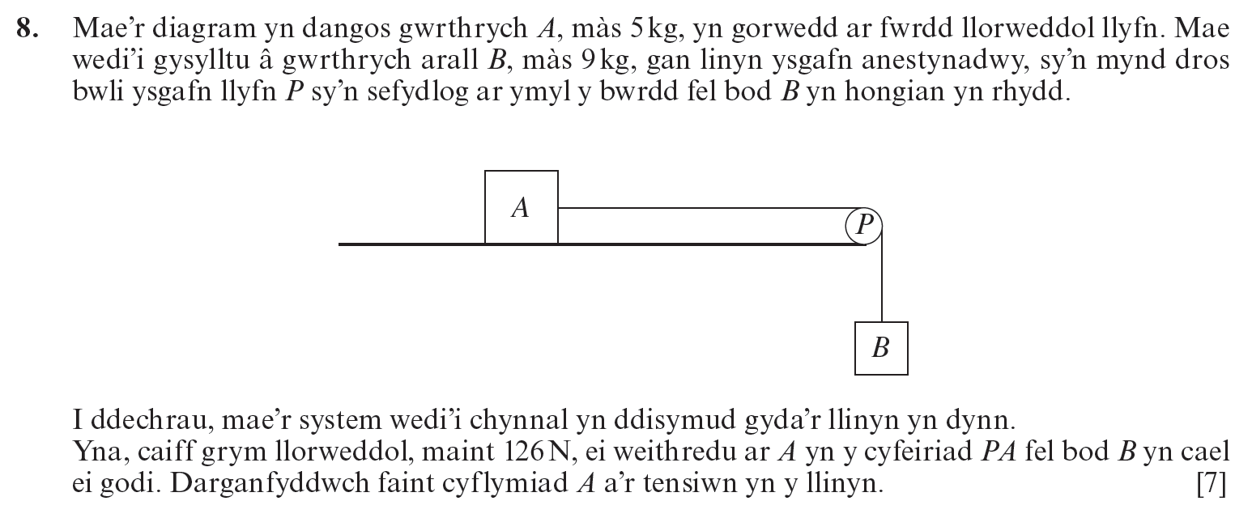

(Haf 2016)
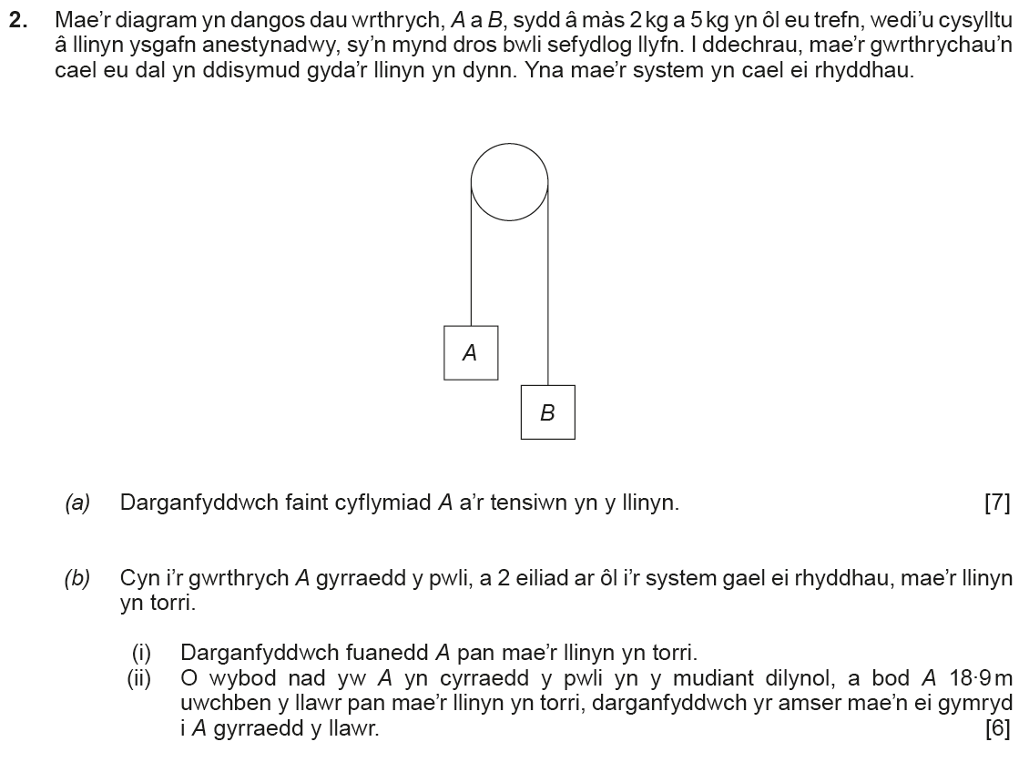
(Haf 2018)
