Ysgol y Creuddyn | Yr Adran Fathemateg
Hen Gwestiynau Arholiad
Dosraniad Binomial
(Gaeaf 2005)
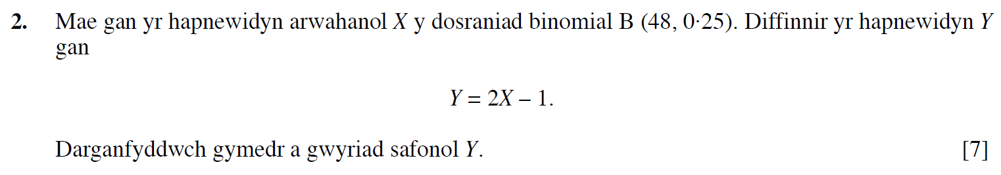
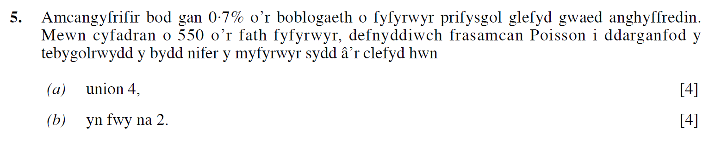
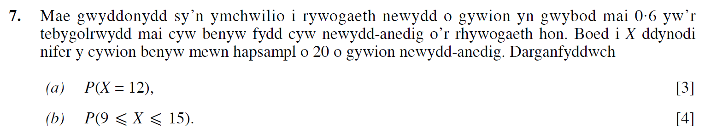
(Haf 2005)
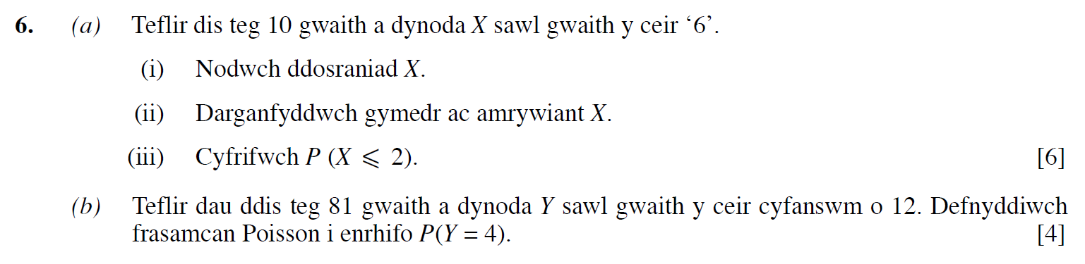

(Gaeaf 2006)
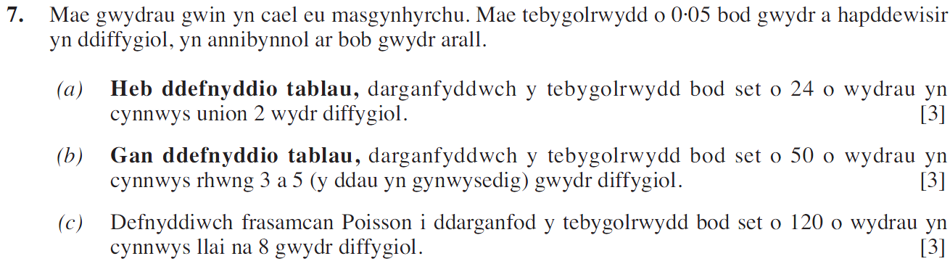
(Haf 2006)
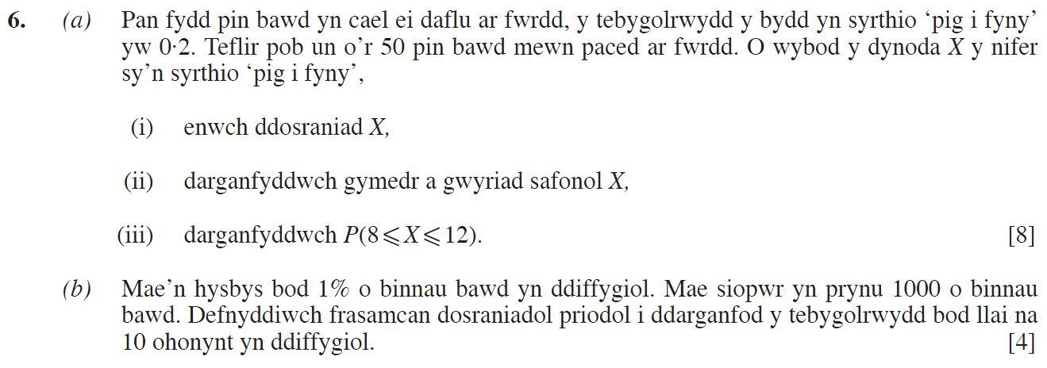
(Gaeaf 2007)
(Haf 2007)
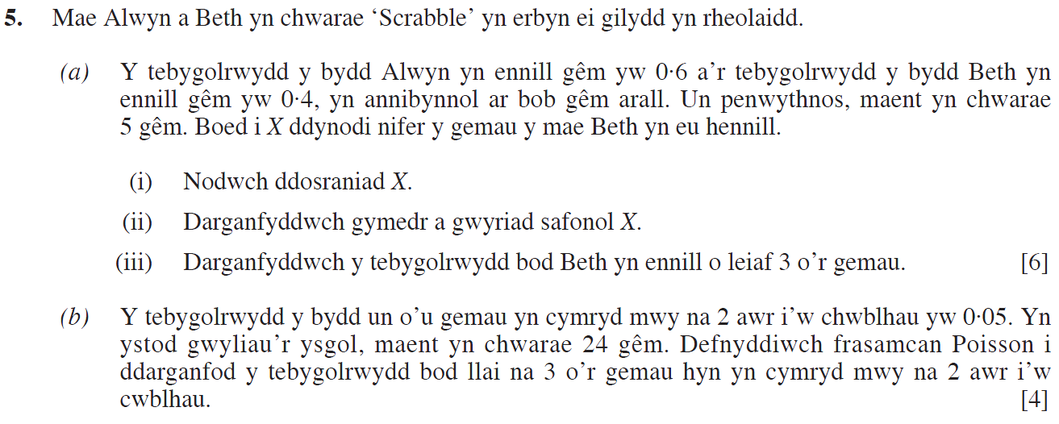
(Gaeaf 2008)
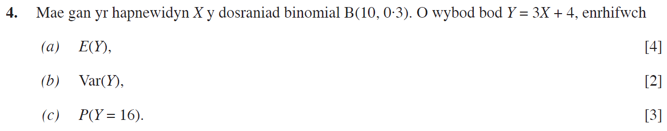
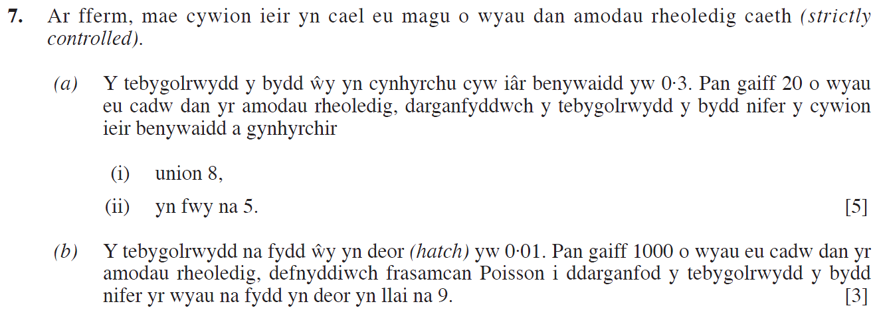
(Haf 2008)
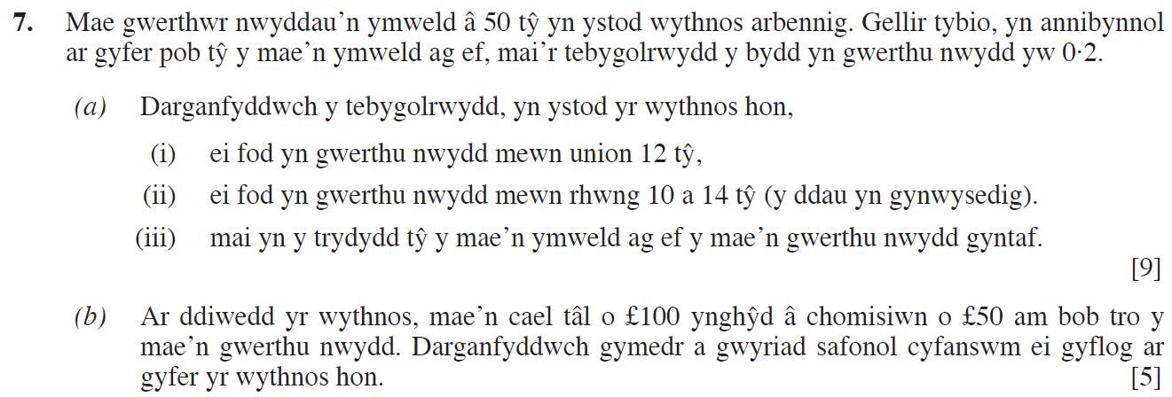
(Gaeaf 2009)
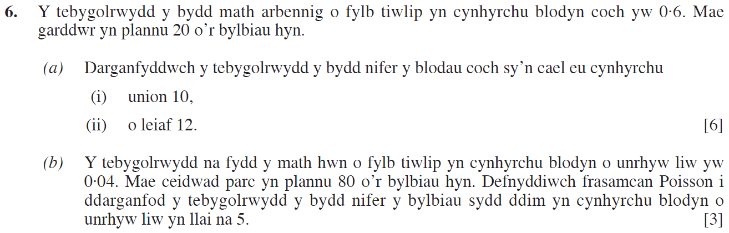

(Haf 2009)
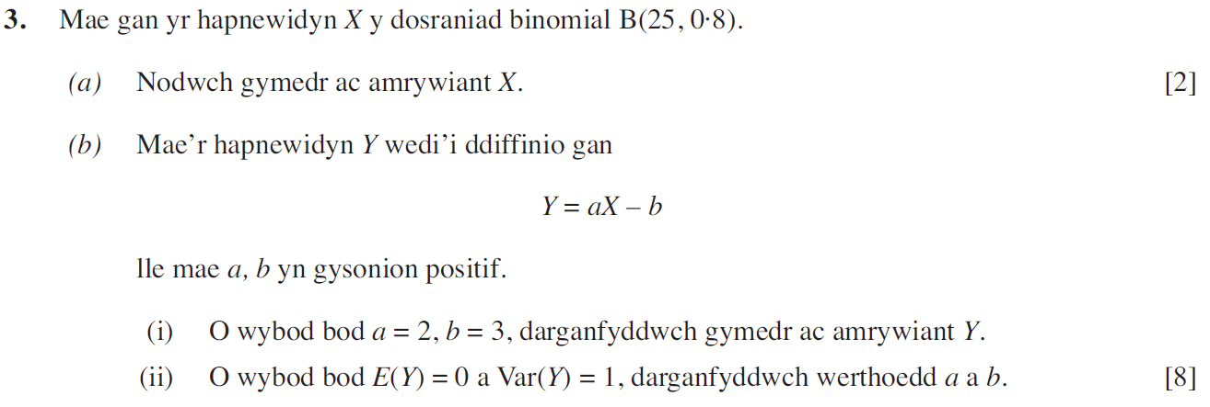
(Gaeaf 2010)
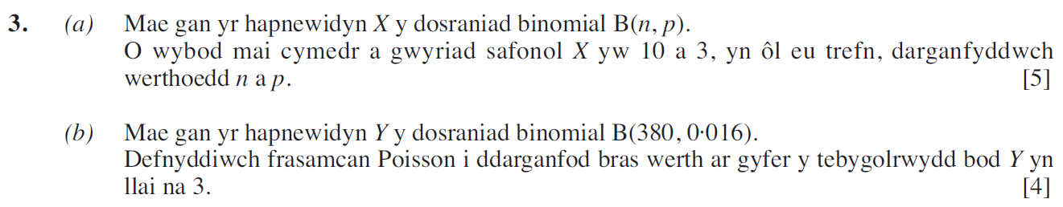
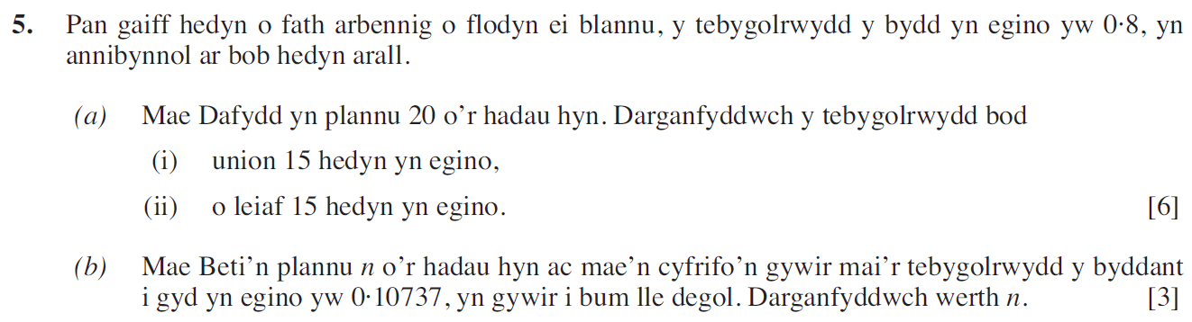
(Haf 2010)
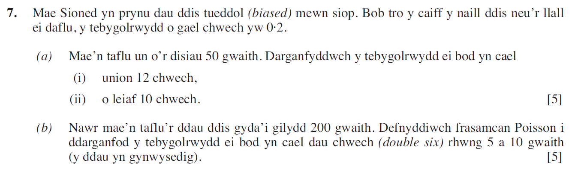

(Gaeaf 2011)
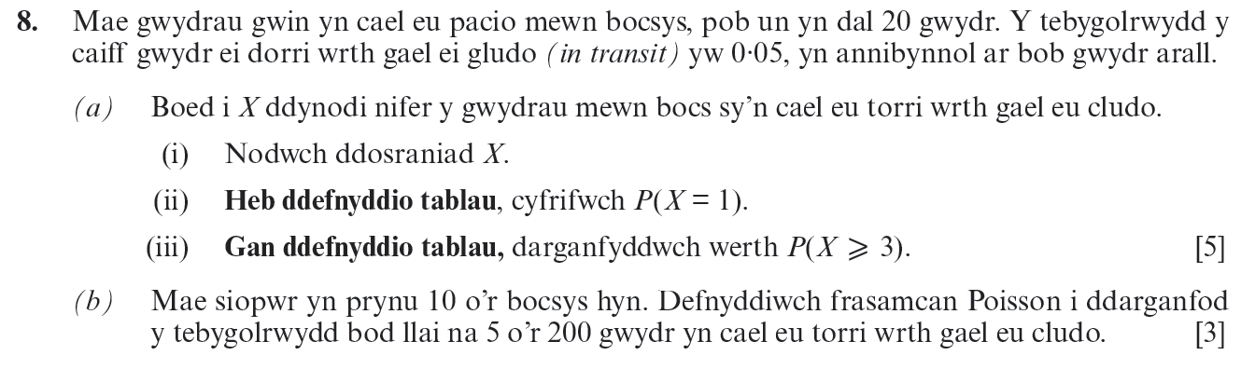
(Haf 2011)
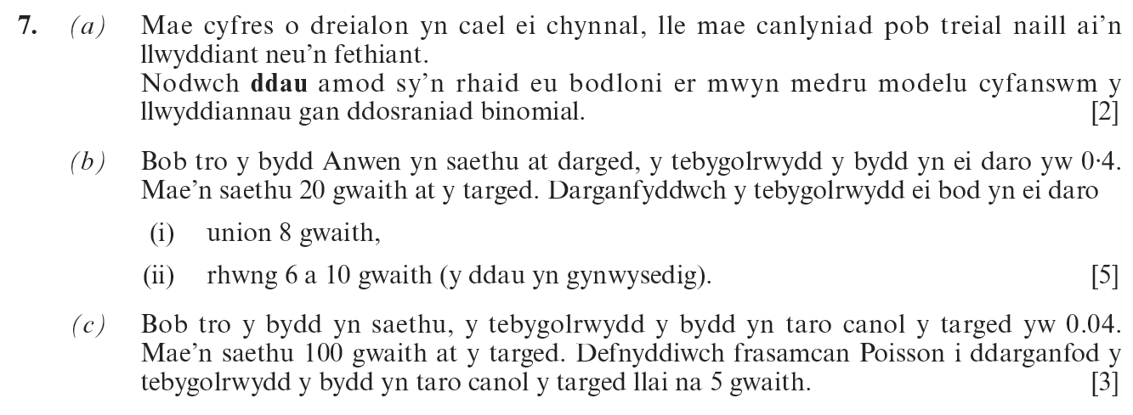
(Gaeaf 2012)
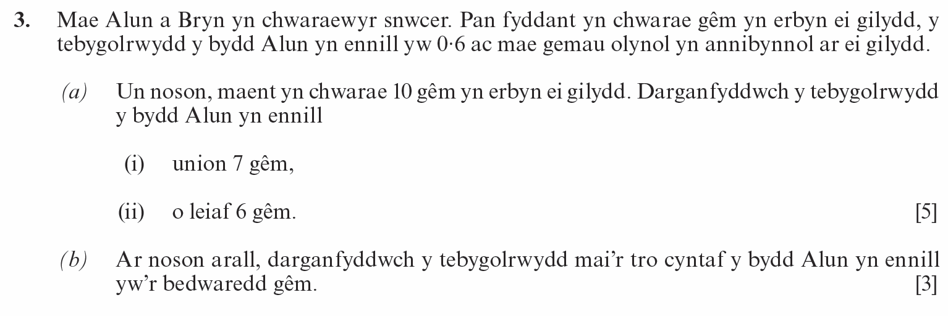
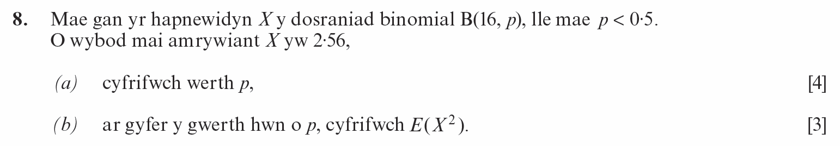
(Haf 2012)
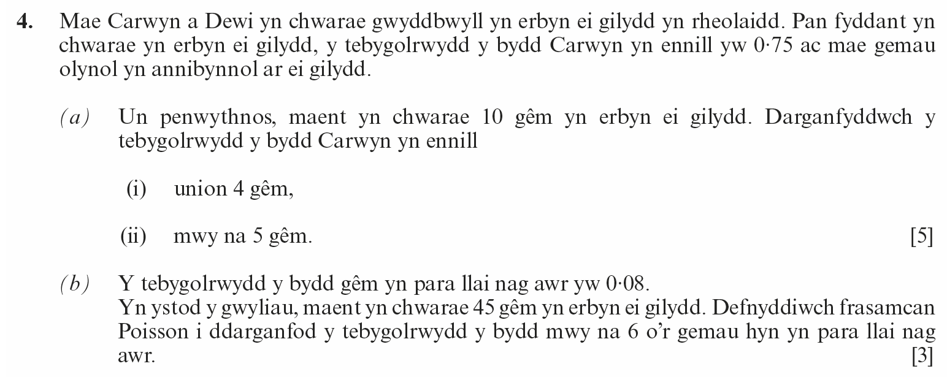
(Gaeaf 2013)
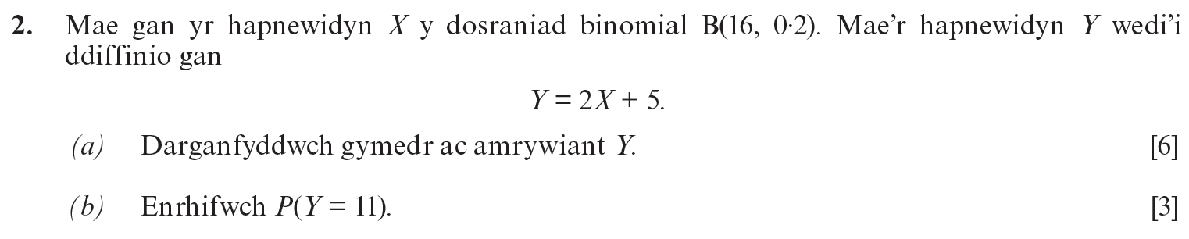
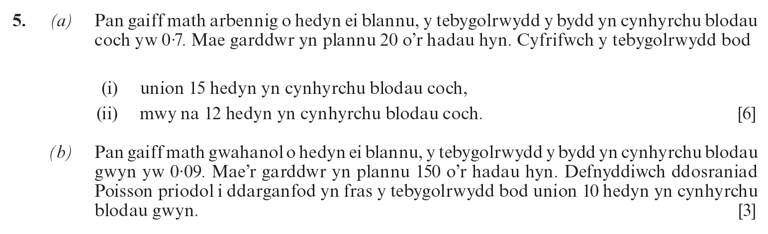
(Haf 2013)
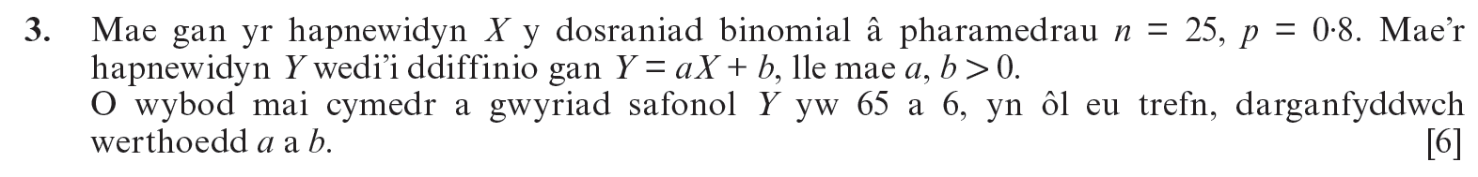
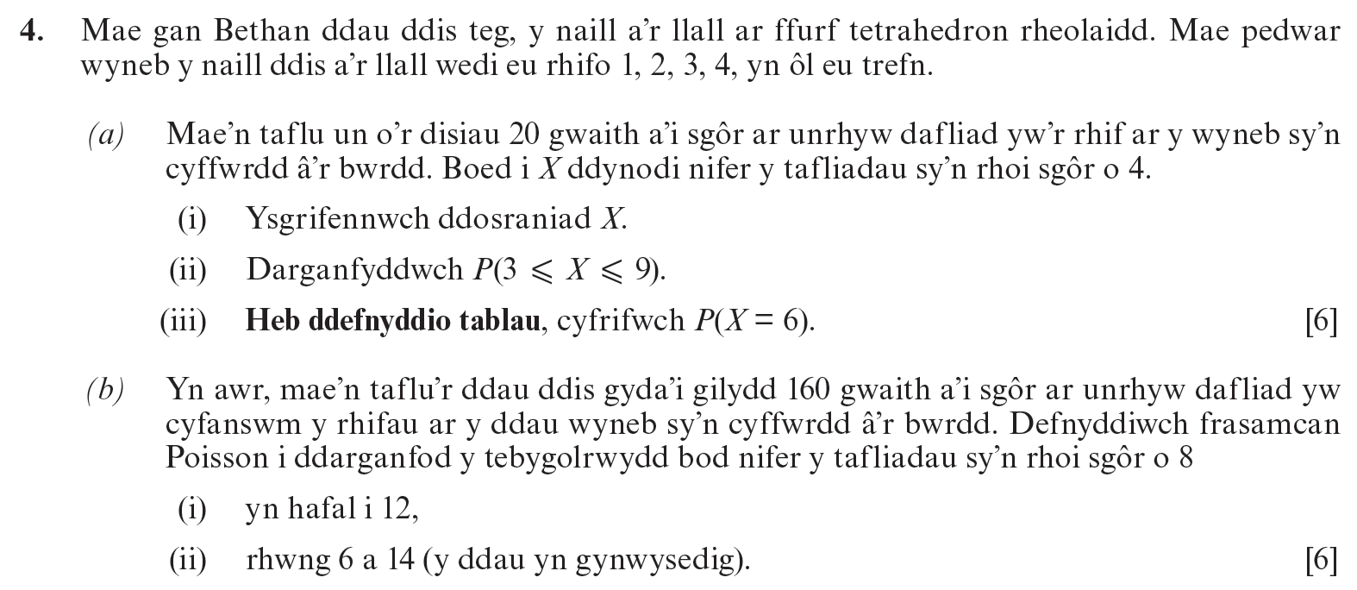
(Gaeaf 2014)
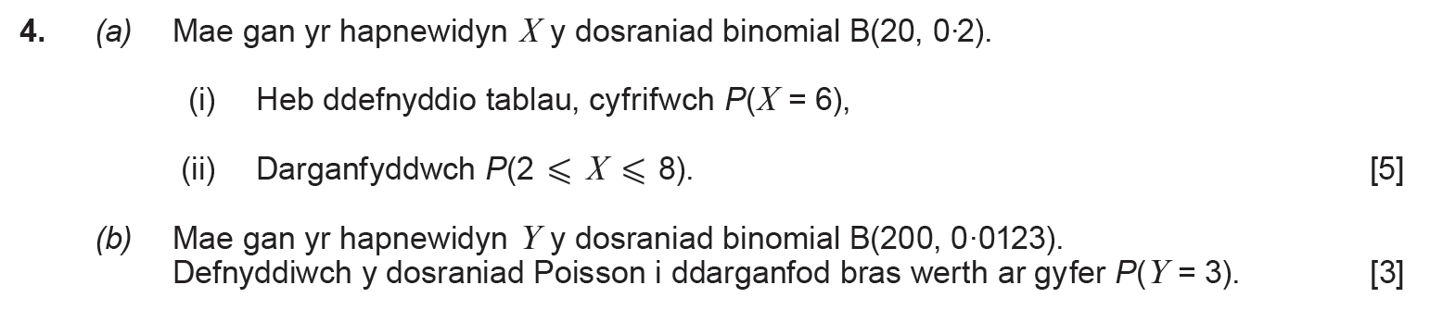
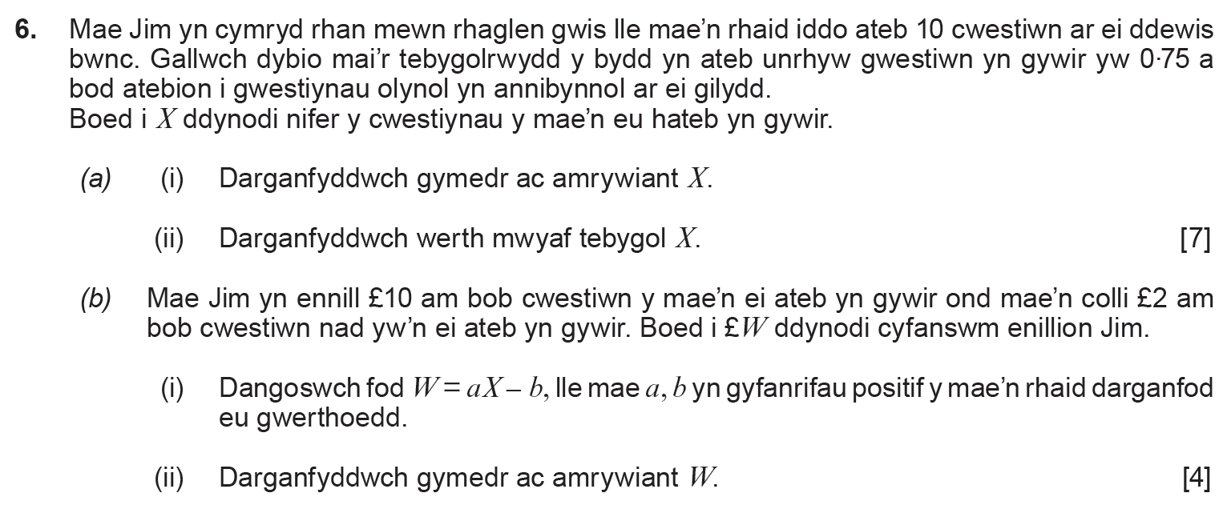
(Haf 2014)
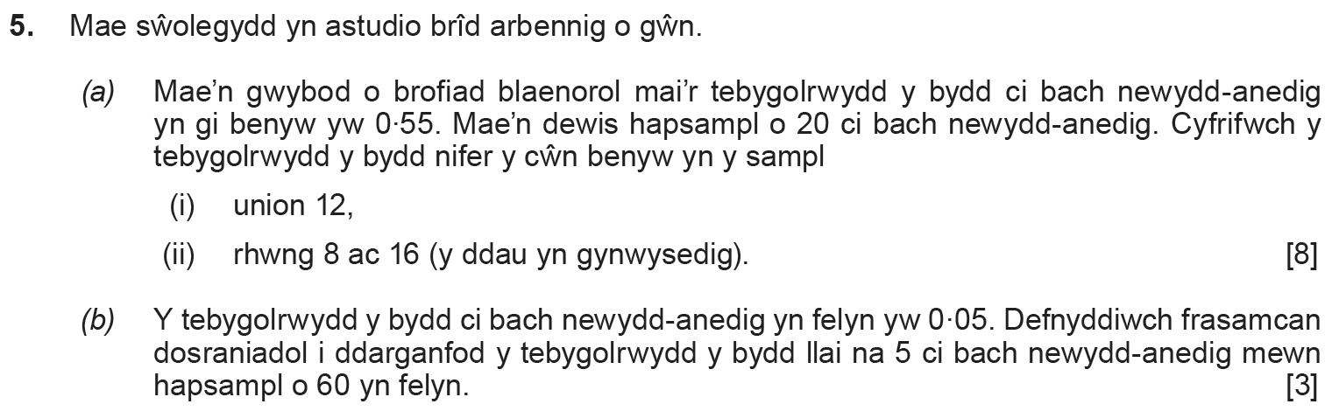
(Haf 2015)
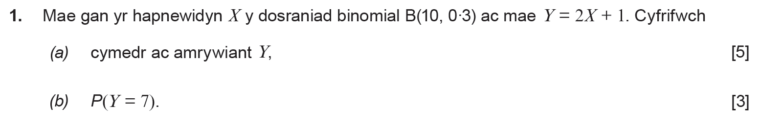
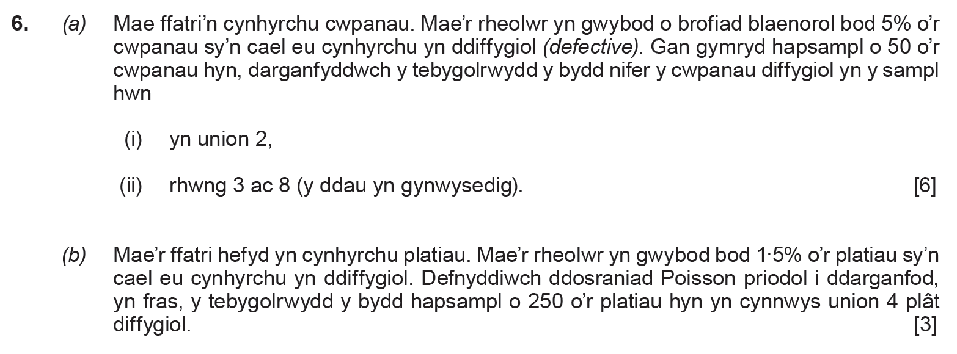
(Haf 2016)
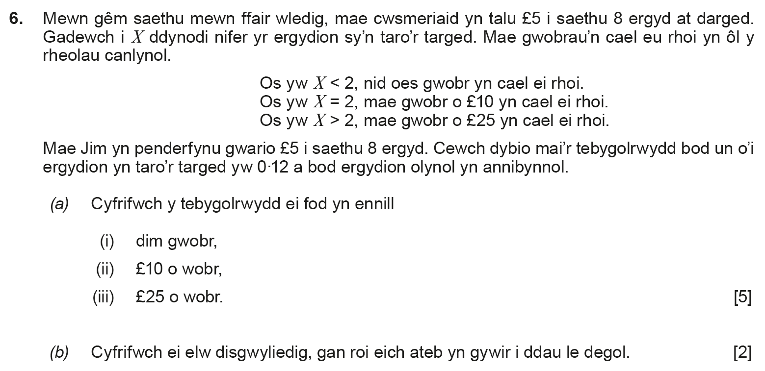
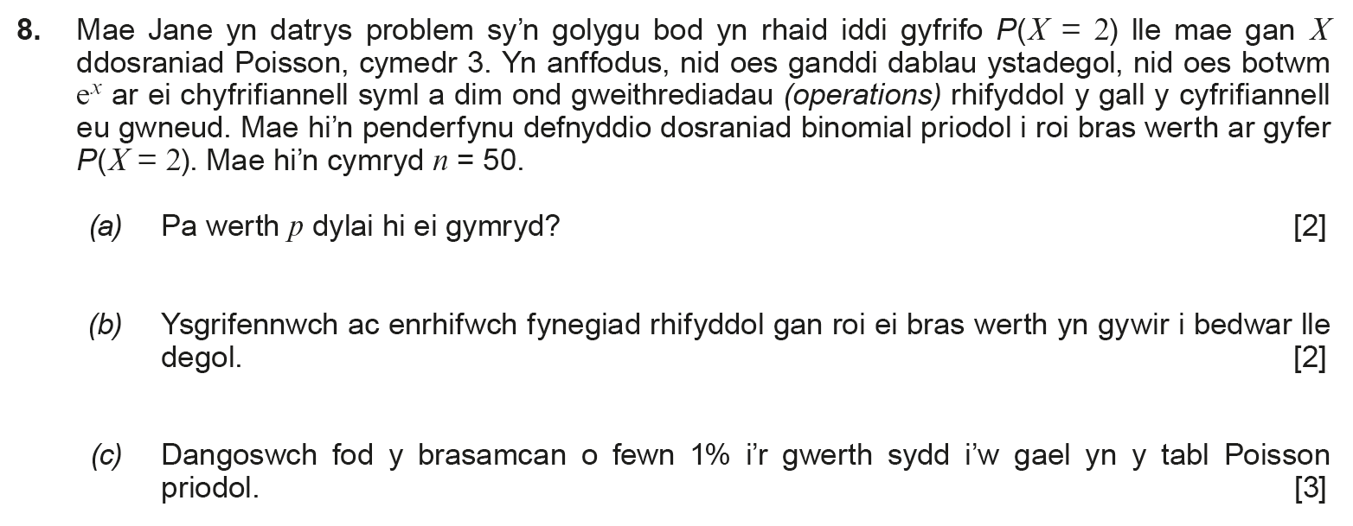
(Haf 2017)
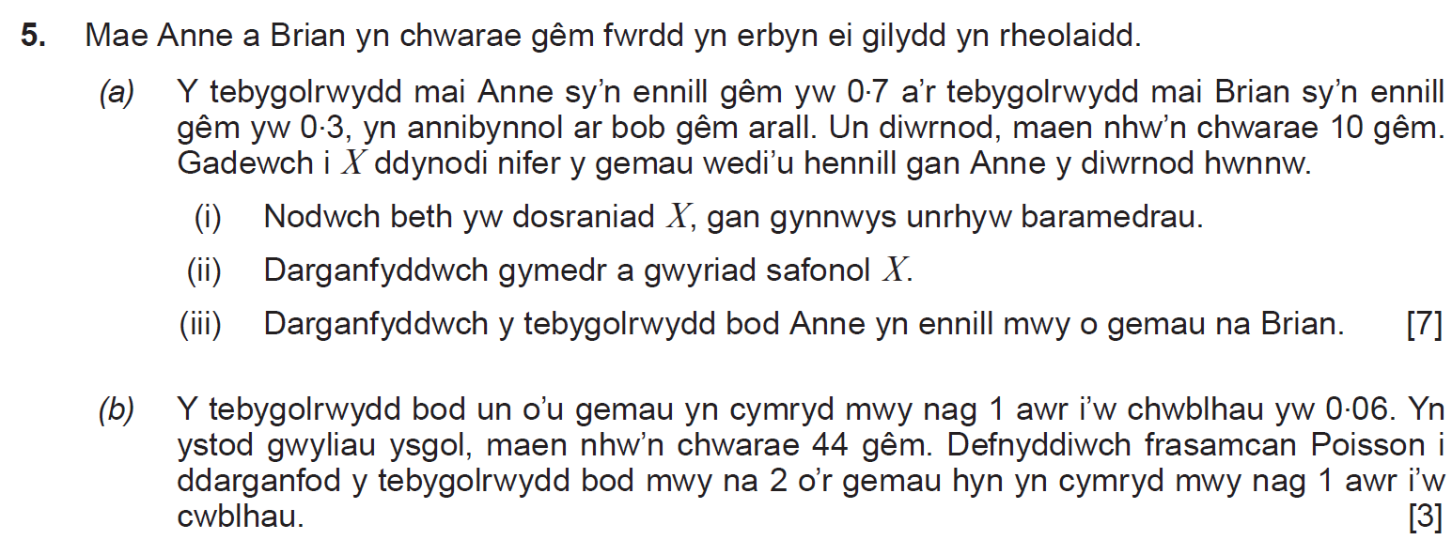
(Haf 2018)
