Ysgol y Creuddyn | Yr Adran Fathemateg
Hen Gwestiynau Arholiad
Cwestiynau Eraill
(Gaeaf 2007)
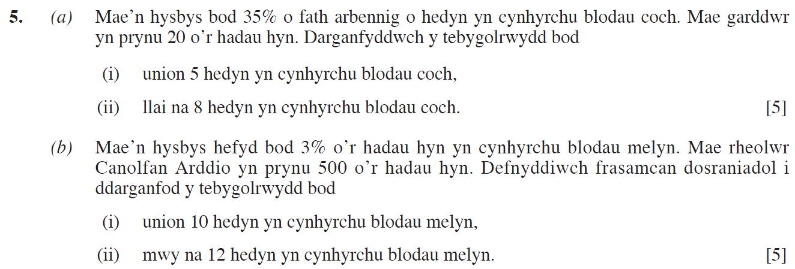
(Haf 2007)
(Haf 2010)
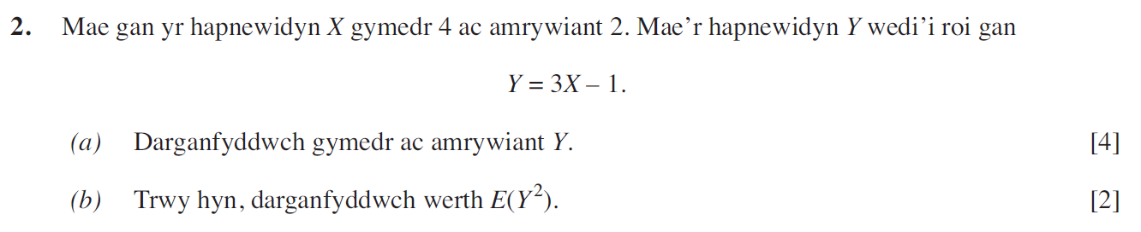
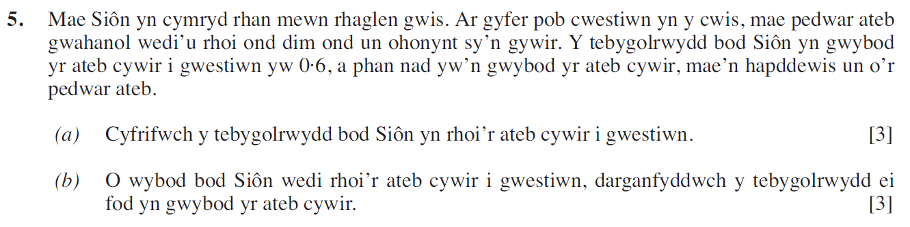
(Haf 2012)
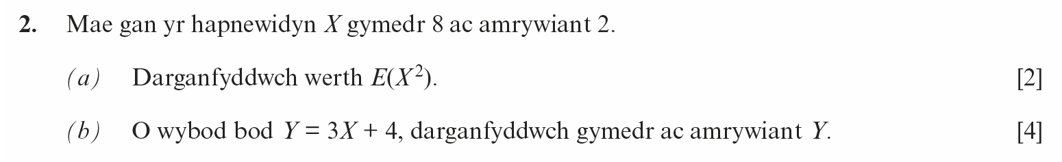
(Haf 2014)
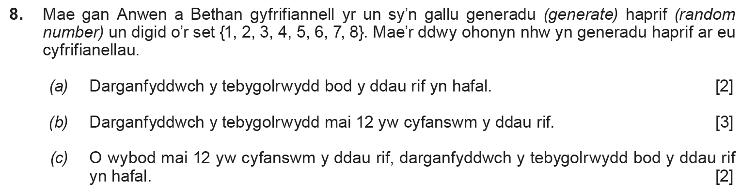
(Haf 2017)
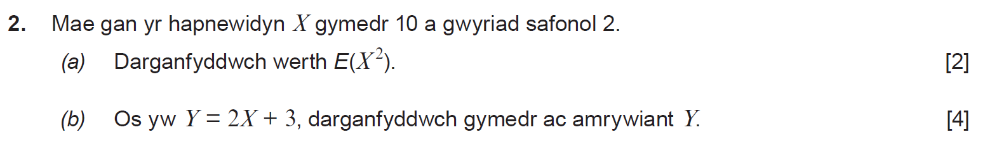
(Haf 2018)
