Ysgol y Creuddyn | Yr Adran Fathemateg
Hen Gwestiynau Arholiad
Y Dosraniad Normal
(Haf 2006)
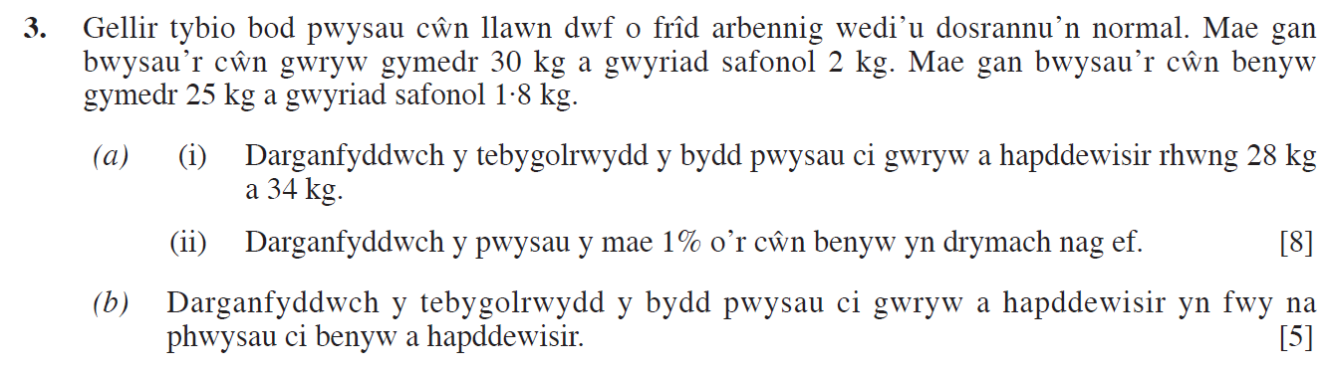
(Haf 2007)
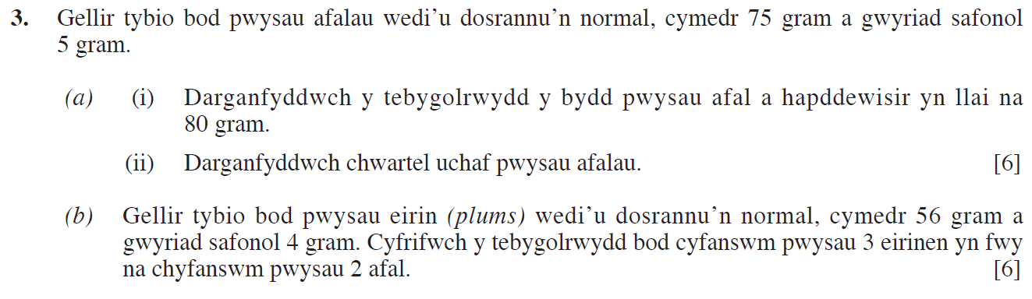
(Haf 2008)
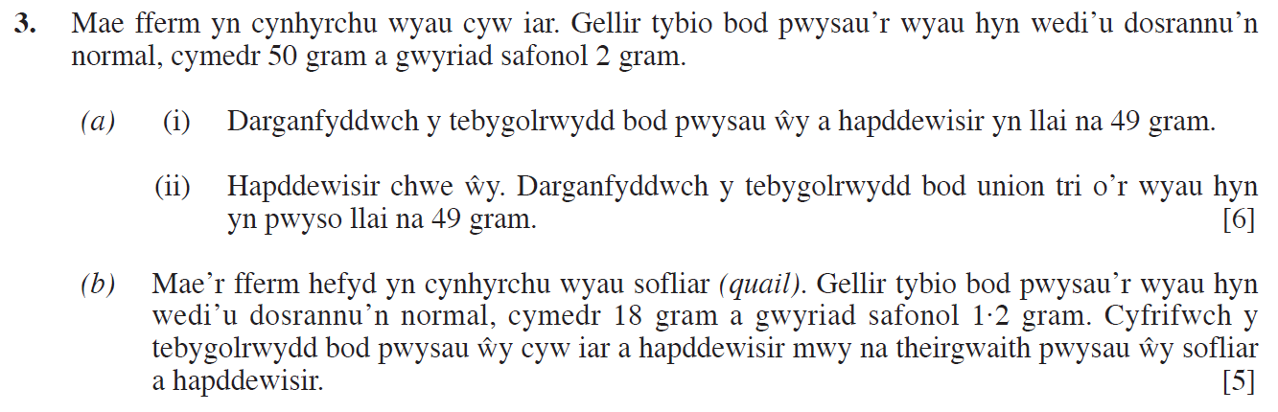

(Haf 2009)
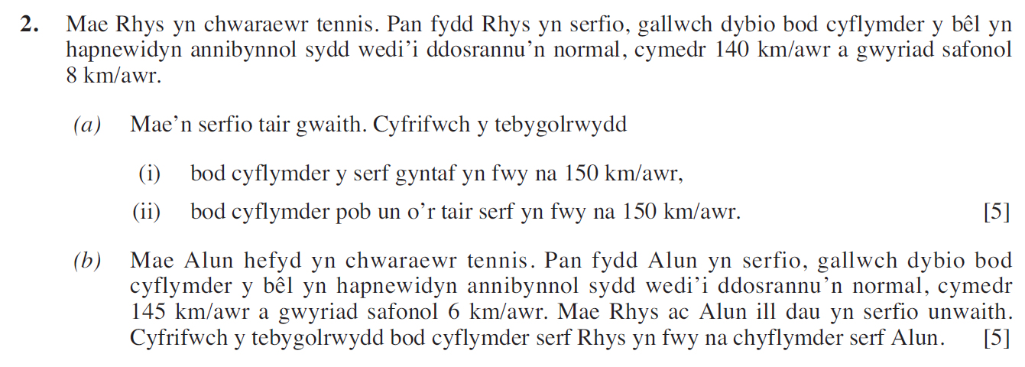
(Haf 2010)
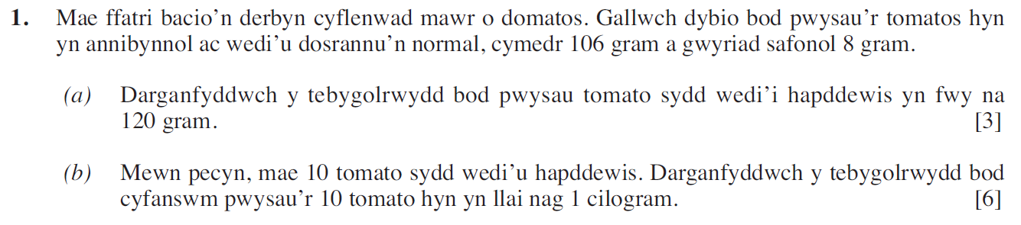
(Haf 2011)
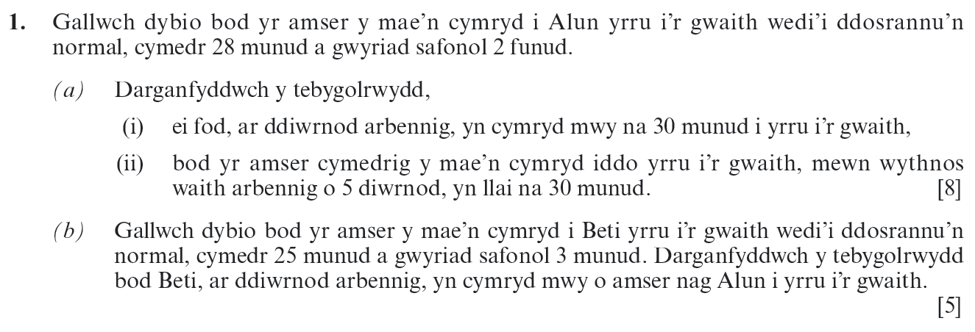

(Haf 2012)
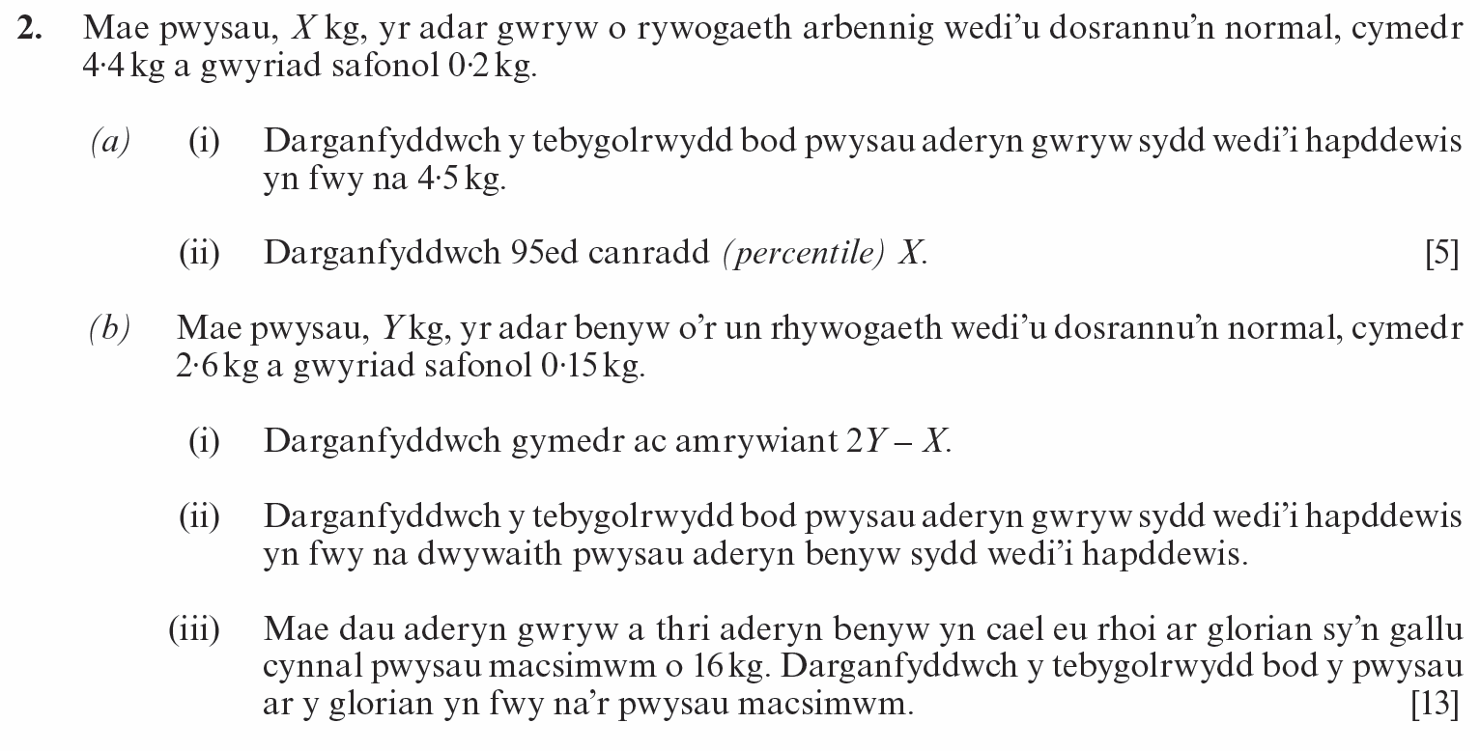
(Haf 2013)
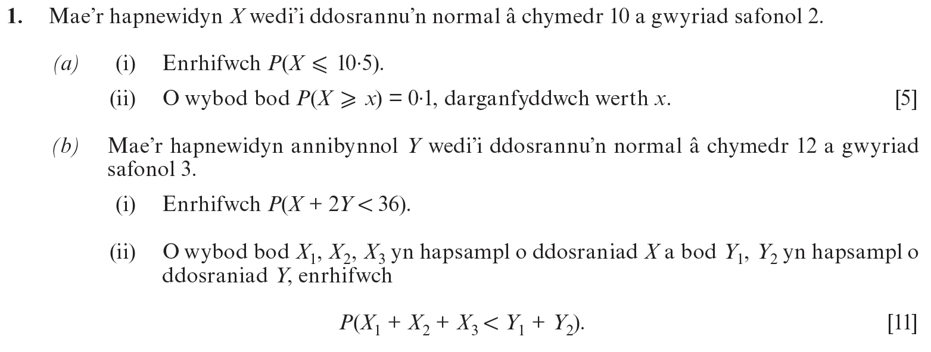
(Haf 2014)
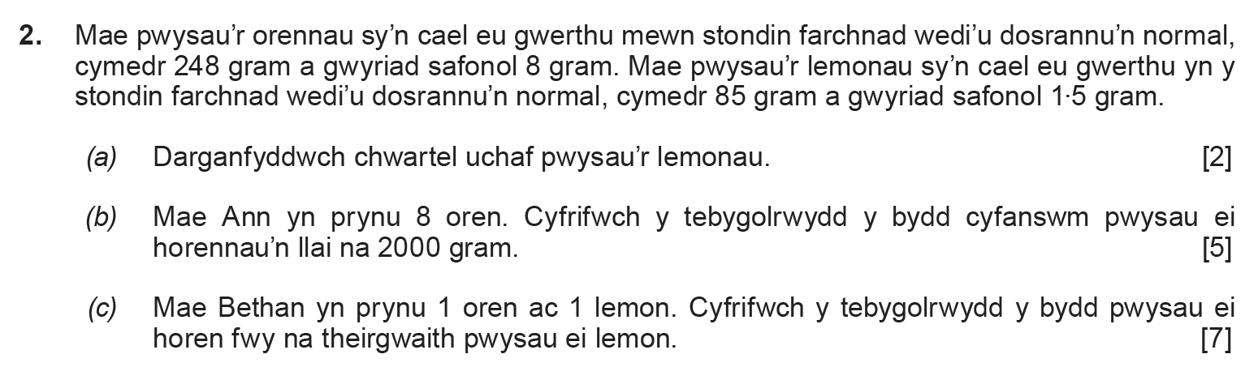

(Haf 2015)
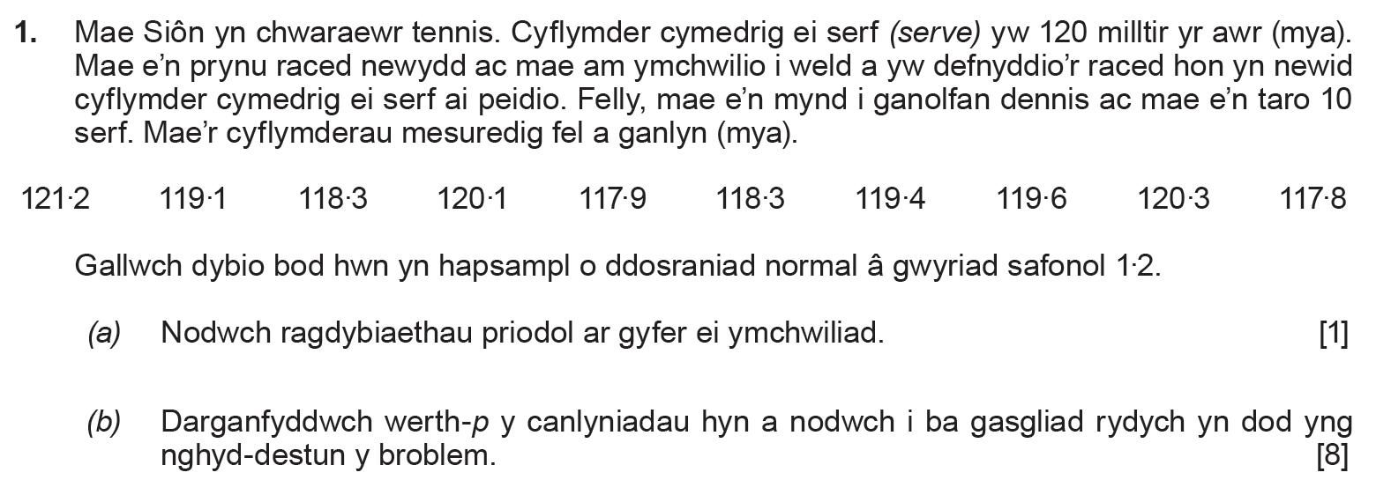
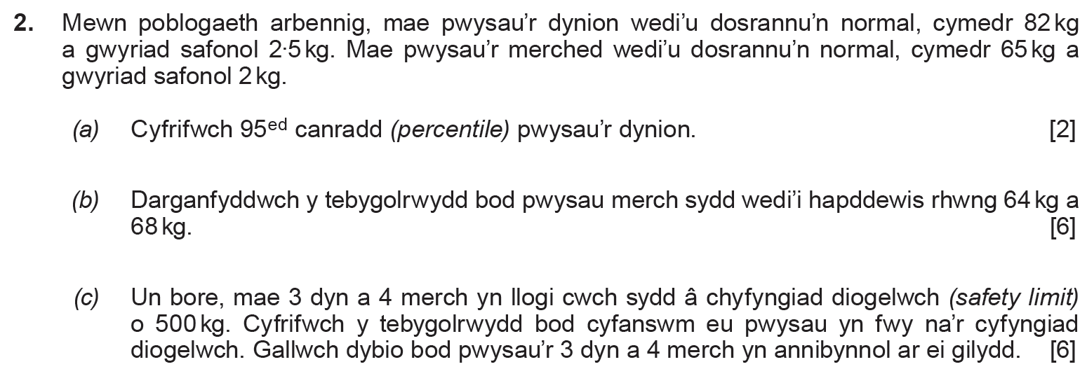
(Haf 2016)
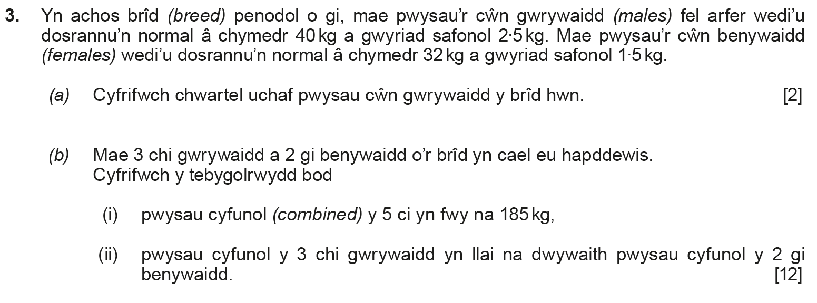

(Haf 2017)
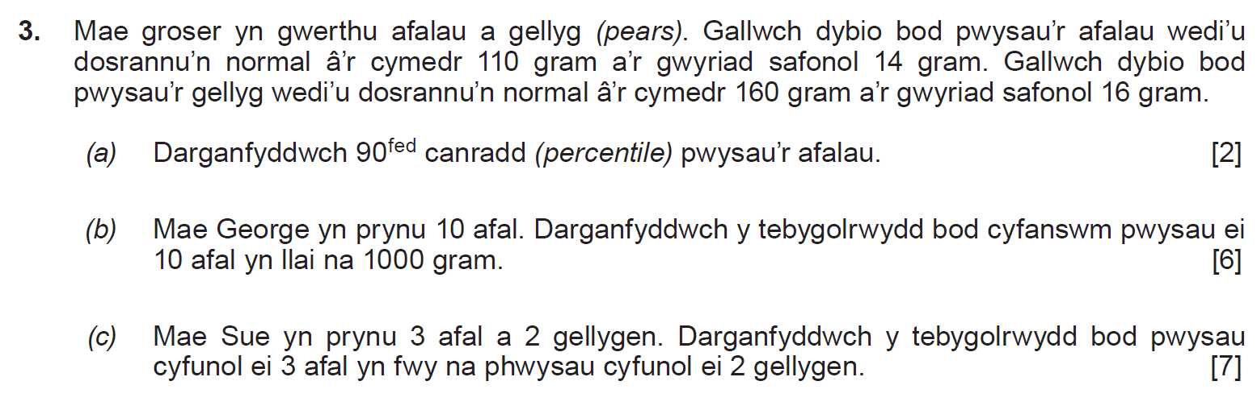
(Haf 2018)
