Ysgol y Creuddyn | Yr Adran Fathemateg
Hen Gwestiynau Arholiad
Terfannau Hyder
(Haf 2005)
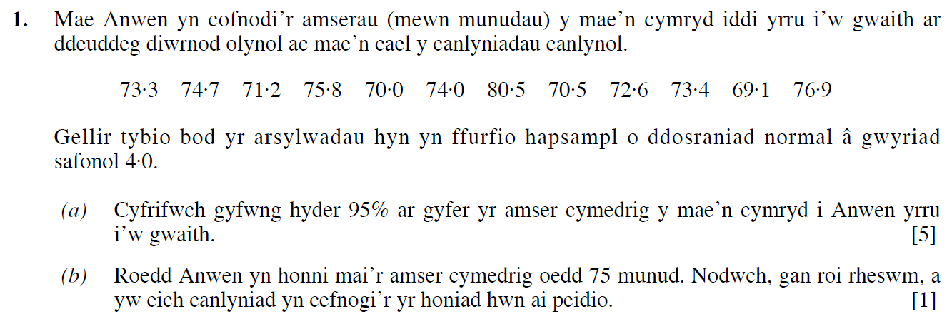
(Haf 2006)
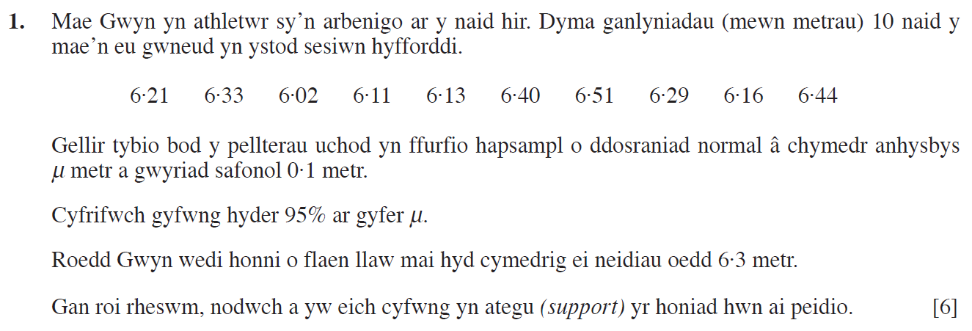
(Haf 2007)
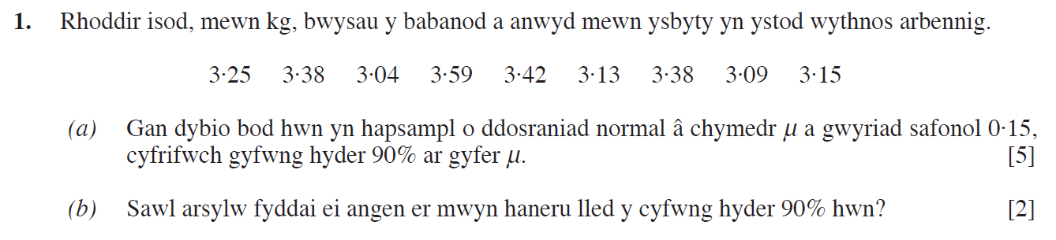

(Haf 2008)
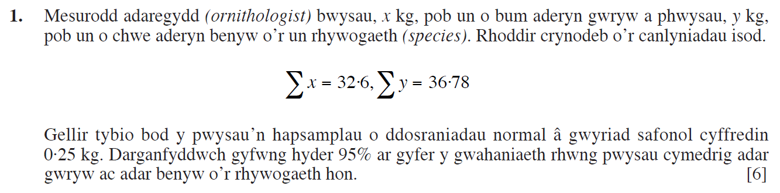
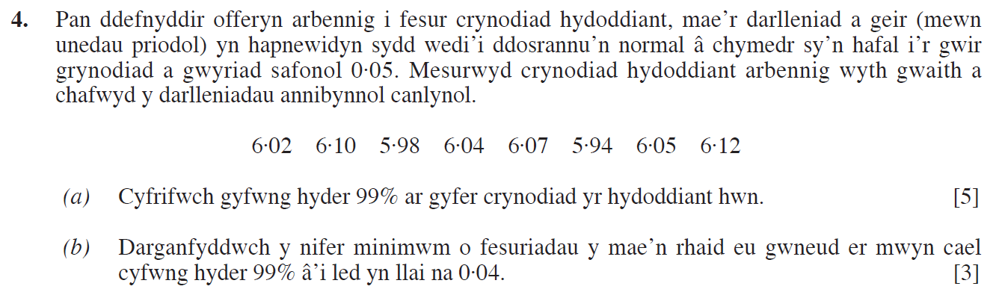
(Haf 2009)
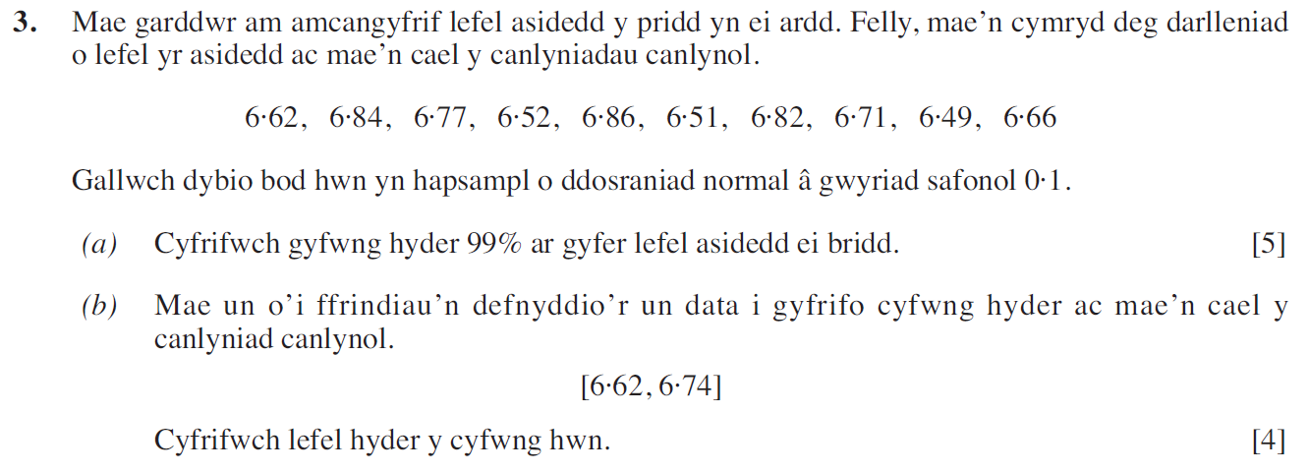
(Haf 2011)
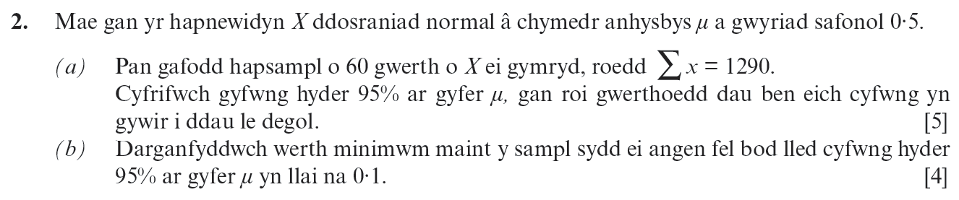

(Haf 2012)
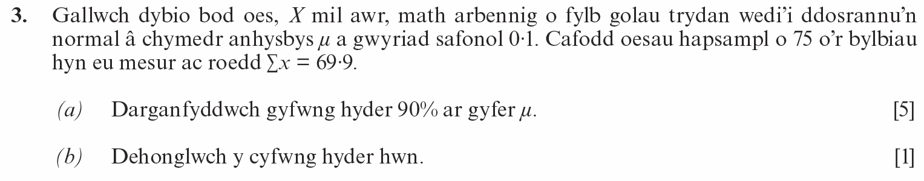
(Haf 2013)
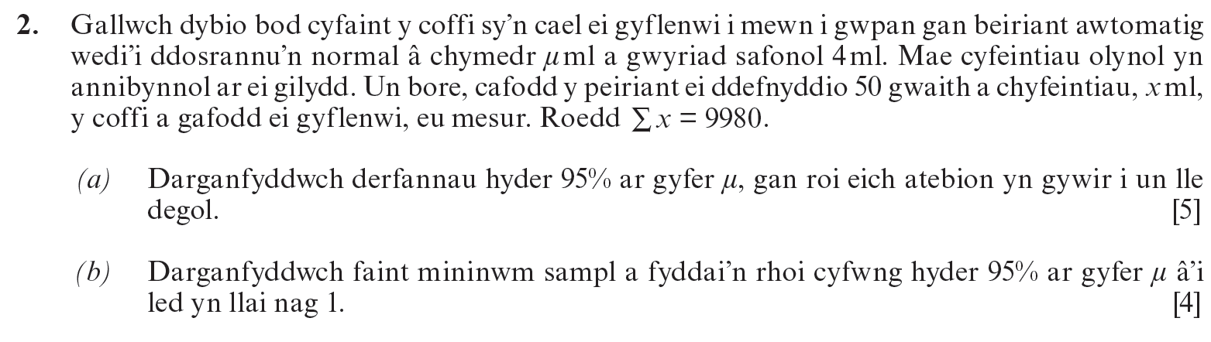
(Haf 2014)
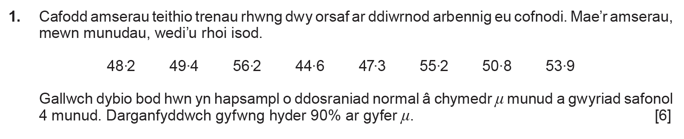
(Haf 2016)
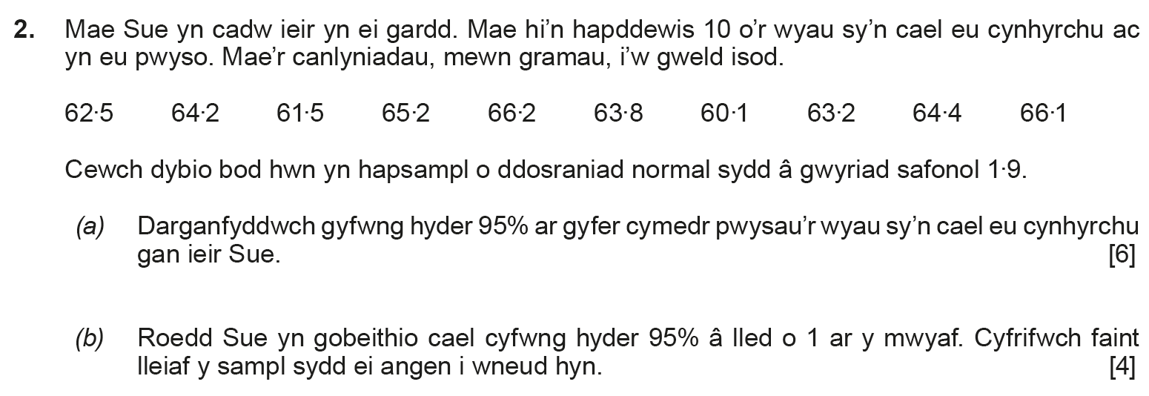

(Haf 2018)
