Ysgol y Creuddyn | Yr Adran Fathemateg
Hen Gwestiynau Arholiad
Differu o Egwyddorion Sylfaenol
(Haf 2005)
(Gaeaf 2006)
(Haf 2006)
(Haf 2007)
(Gaeaf 2009)
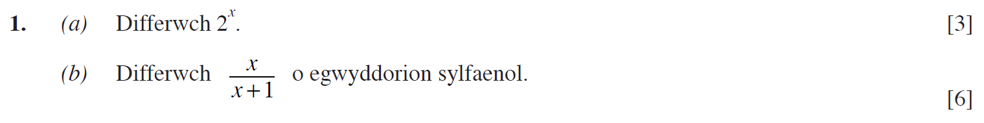
(Haf 2010)
(Haf 2011)
(Gaeaf 2012)
(Gaeaf 2013)

(Gaeaf 2014)
(Haf 2014)
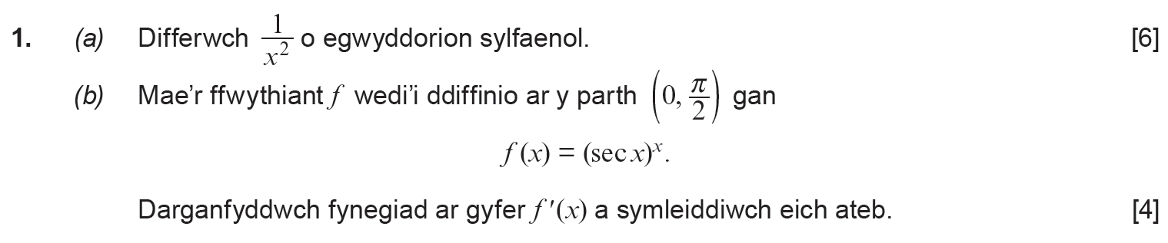
(Haf 2015)
(Haf 2016)
(Haf 2019)

