Ysgol y Creuddyn | Yr Adran Fathemateg
Hen Gwestiynau Arholiad
Stationary Points
(Gaeaf 2006)
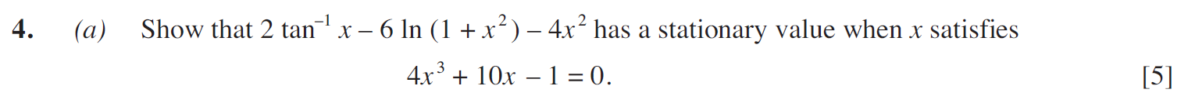
(Gaeaf 2007)
(Haf 2008)
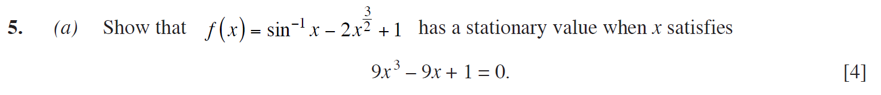
(Haf 2009)
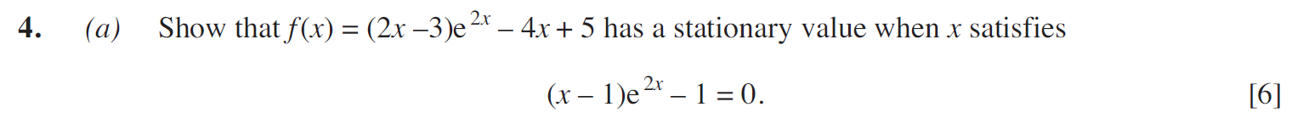
(Haf 2010)
