Ysgol y Creuddyn | Yr Adran Fathemateg
Hen Gwestiynau Arholiad
Other Questions
(Gaeaf 2005)
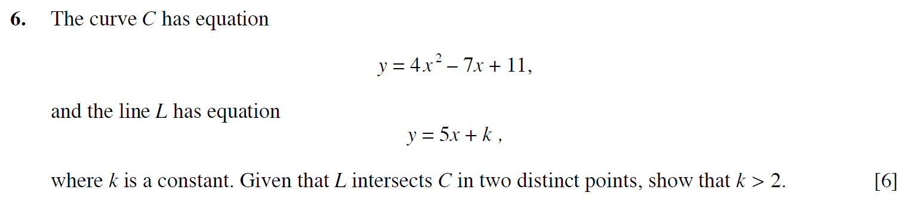
(Haf 2006)
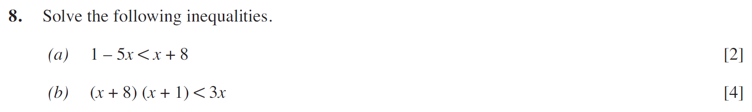
(Gaeaf 2007)
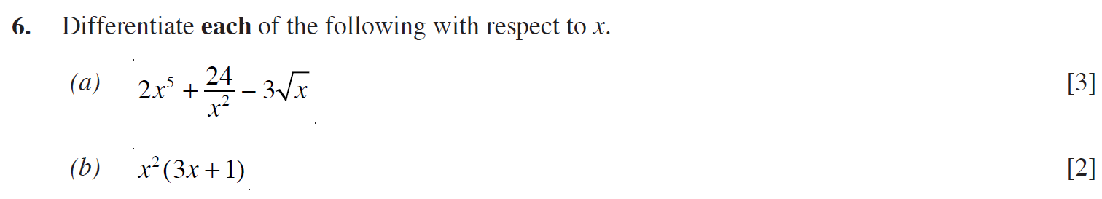
(Haf 2009)
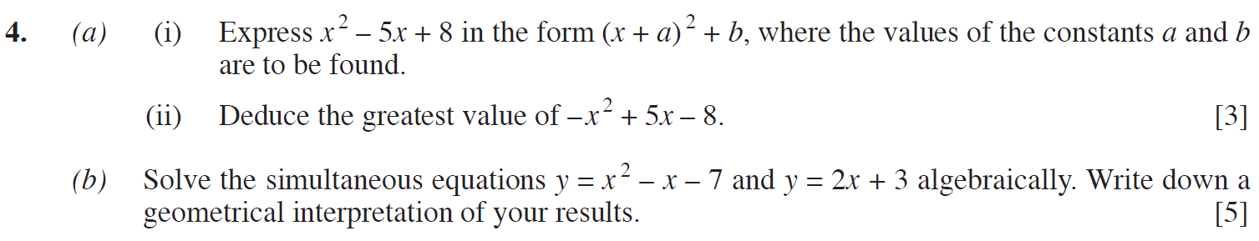
(Gaeaf 2013)
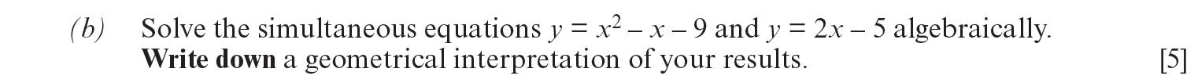
(Haf 2016)
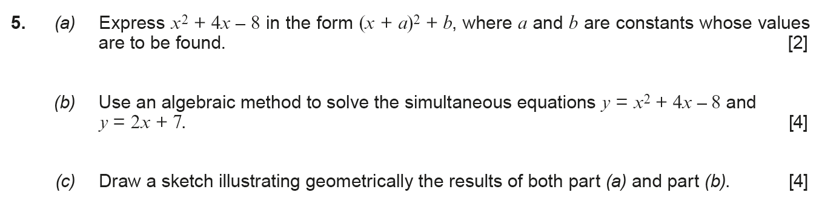
(Haf 2017)
(Haf 2018)
