Numeracy with
the Romans
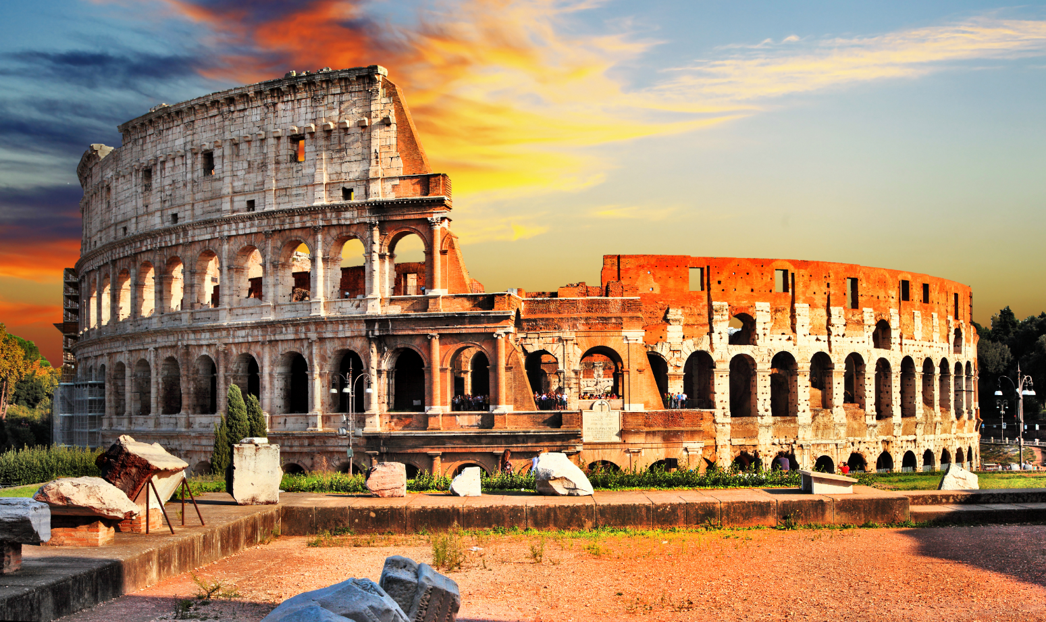


Name: _______________________________
Registration Class: ______________________
Mathematics Teacher: ___________________
Fill in the Roman Numerals:

1 | 2 | 3 | 4 | 5 | 6 | 7 | 8 | 9 | 10
11 | 12 | 13 | 14 | 15 | 16 | 17 | 18 | 19 | 20
21 | 22 | 23 | 24 | 25 | 26 | 27 | 28 | 29 | 30
31 | 32 | 33 | 34 | 35 | 36 | 37 | 38 | 39 | 40
41 | 42 | 43 | 44 | 45 | 46 | 47 | 48 | 49 | 50
51 | 52 | 53 | 54 | 55 | 56 | 57 | 58 | 59 | 60
61 | 62 | 63 | 64 | 65 | 66 | 67 | 68 | 69 | 70
71 | 72 | 73 | 74 | 75 | 76 | 77 | 78 | 79 | 80
81 | 82 | 83 | 84 | 85 | 86 | 87 | 88 | 89 | 90
91 | 92 | 93 | 94 | 95 | 96 | 97 | 98 | 99 | 100
Author: Dr. Gareth Evans, www.mathemateg.com, 29 July 2025
Numeracy with the Romans
Instructions:
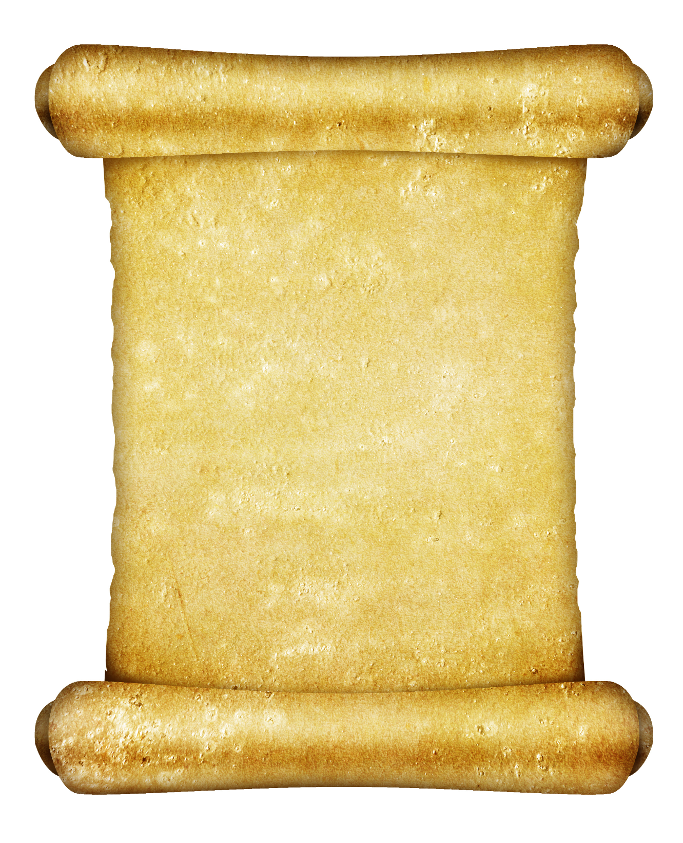
Fill in the boxes before marking your work using the answers provided by the teacher.

Who are you?

0–4 Romulus
5–9 Saint Elen
10–14 Caratacus
15–19 Claudius
20–24 Boudica
25 Magnus Maximus
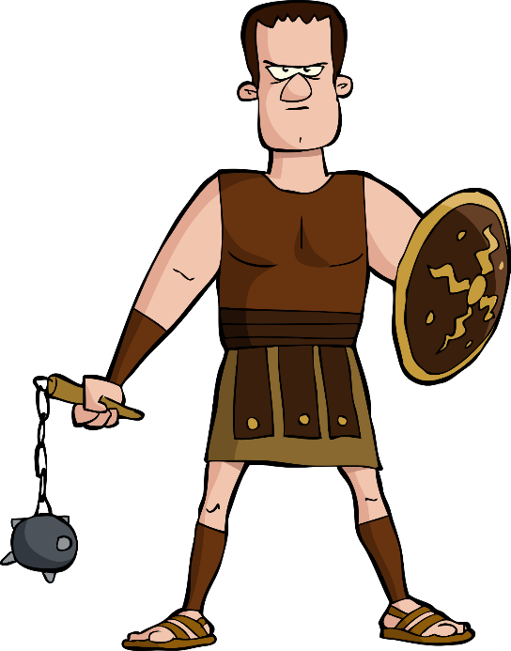


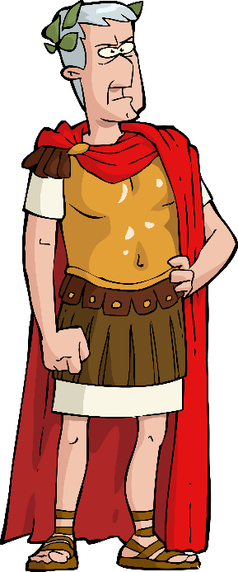
Citizen
Common People
Medium difficulty questions
Gladiator
Slaves
Easy Questions
Emperor
Ruler of the Empire
Difficult Questions
Numeracy with the Romans: Session 01
Score: ____ Who are you? _________________

Gladiator
1) 4 × 7 = | 2) 27 + 34 = | 3) 27 ÷ 3 =
4) 3 m = _________ cm | 5) Subtract 37p  from £1.21 = | 6) $\frac{1}{2}$ hour before 14:03 =
7) Quarter of 24 = | 8) 1.2 + 1.9 = | 9) 50% of 14 =
Citizen
10) How many halves are there in $3\frac{1}{2}$? | 11) The mean of 10, 5, 3 = | 12) The range of 1, 3, 2, 4 =
13) 9.55 to one decimal place = | 14) 8 – 6 ÷ 2 = | 15) 2³ =
16) $\sqrt{16}$ = | 17) 35% as a decimal = | 18) 3 hours = _______ minutes
Emperor
19) 5 × 0.6 = | 20) The reciprocal of $\frac{3}{4}$ is | 21) The area of an 8 cm by 3 cm rectangle is
22) 80 × ______ = 8 | 23) 43 – 68 = | 24) 20% of 14 =
25) A piece of cheese weighing 250 g costs £1.80. How much is the cost per 100 g?
History
The Roman Empire in the year 117 A.D.

Around 2,000 years ago, the city of Rome in Italy was home to a very large Empire extending over Europe, North Africa and Asia.
At its peak, the Empire reigned over 45 million people. Rome grew from being a small town into a very large city.

Numeracy with the Romans: Session 02
Score: ____ Who are you? _________________

Gladiator
1) 2 × 12 = | 2) 63 + 20 = | 3) 30 ÷ 5 =
4) 5 cm = ______ mm | 5) 5² = | 6) A pentagon has ____ sides
7) $\frac{1}{4}$ = _____ % | 8) 14 × 2 = | 9) 50% of 16 =
Citizen
10) The perimeter of an 8 cm by 5 cm rectangle is | 11) The mean of  1, 2, 3, 4, 5 = | 12) The range of  1, 2, 3, 4, 5 =
13) 0.246 to two decimal places = | 14) 2 + 4 × 6 = | 15) 30% of 40 =
16) $\sqrt{36}$ = | 17) 25% as a fraction = | 18) 3 days = ______ hours
Emperor
19) 3 × 2.4 = | 20) (3 + 5) × 4 = | 21) The volume of a cube with sides measuring 3 cm =
22) 4 ÷ 0.5 = | 23) 1.6 – 0.7 = | 24) 253 to one significant figure =
25) How many 49p cakes can Claudius buy with a £5 note?
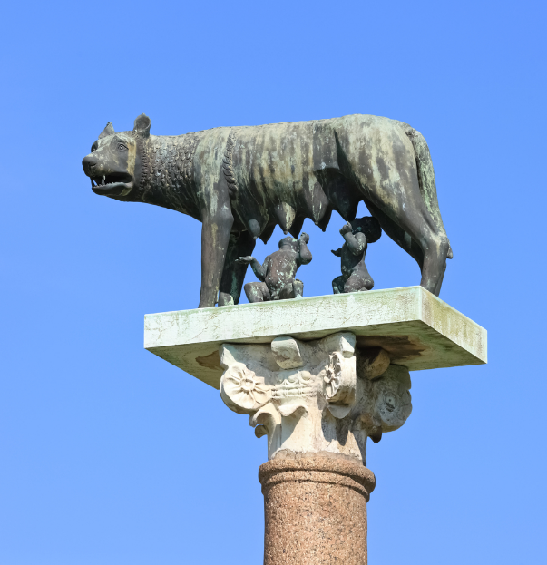
History
According to legend, Rome was established by the twin brothers Romulus and Remus, in the year 753 B.C. The brothers were left to drown in the river Tiber by their evil uncle, but the young boys were saved by wolves (see the statue on the right).
The twin brothers decided to establish a new city, but couldn’t decide where to locate it. During an argument, Remus was killed. Romulus decided to name the new town after him.
Numeracy with the Romans: Session 03
Score: ____ Who are you? _________________

Gladiator
1) 6 × 5 = | 2) 19 + 13 = | 3) 28 ÷ 2 =
4) 1 kg = ______ g | 5) 6² = | 6) 7 – 10 =
7) $\frac{1}{2}$ = _____ % | 8) 13 × 3 = | 9) 10% of 70 =
Citizen
10) The area of a 4 cm by  3 cm rectangle is | 11) The mean of 3, 2, 7 = | 12) The range of 8, 4, 9 =
13) 12.36 to one decimal place = | 14) 4 + 5 × 2 = | 15) 20% of 15 =
16) $\sqrt{9}$ = | 17) 24% as a decimal = | 18) 2 minutes = ____ seconds
Emperor
19) 4 × 0.3 = | 20) The perimeter of a 6 cm by 3.5 cm rectangle is | 21) The volume of a 2 cm by 3 cm by 4 cm cuboid is
22) 2.4 ÷ 0.4 = | 23) 147 – 89 = | 24) 5.208 to the  nearest unit =
25) 49 × 6 =
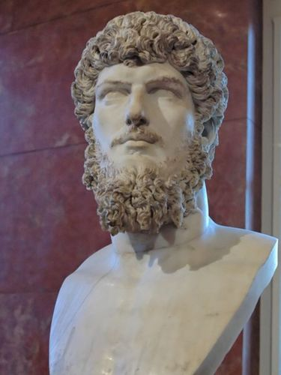
History
In the early days, monarchs reigned over Rome. According to legend, Romulus was the first king.
The last king was Tarquinius Superbus (see the statue on the right), who was expelled by the Romans in the year 509 B.C. A republic was established to take the monarchy’s place. In this system, two consuls were elected each year, so that neither of them could become too powerful.

Numeracy with the Romans: Session 04
Score: ____ Who are you? _________________

Focusing on: Rounding Off
Gladiator
1) 582 to the nearest 10 = | 2) 28 to the nearest 10 = | 3) 389 to the nearest 10 =
4) 283 to the nearest 100  = | 5) 2,829 to the nearest 100  = | 6) 13,532 to the nearest 100  =
7) 4,327 to the nearest 1,000 = | 8) 14,872 to the nearest 1,000 = | 9) 624,239 to the nearest 1,000 =
Citizen
10) 3.27 to the nearest unit  = | 11) 8.06 to the nearest unit  = | 12) 213.81 to the nearest unit =
13) 7.21 to one decimal place = | 14) 82.35 to one decimal place = | 15) 4.98 to one decimal place =
16) 12.372 to two decimal places = | 17) 287.027 to two decimal places = | 18) 1,245.72502 to two decimal places =
Emperor
19) 83 to one significant figure = | 20) 7,622 to one significant figure = | 21) 0.0023 to one significant figure =
22) 278 to two significant figures = | 23) 92,345 to two significant figures = | 24) 0.002352 to two significant figures =
25) Calculate 2 + 7 × 3, giving your answer to one significant figure.
History
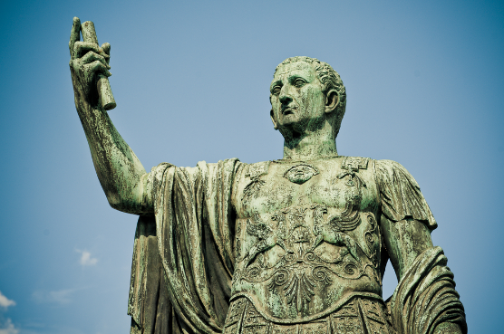
As the Roman Republic grew in power, so did its military force. Neither the two consuls nor the other senators could always control the army. In 49 B.C., Rome’s most powerful general was Julius Caesar. His dream was to rule over Rome as king. The senators disliked this idea, and so Caesar was killed by them in 44 B.C.

Numeracy with the Romans: Session 05
Score: ____ Who are you? _________________

Gladiator
1) 3 × 8 = | 2) Ten minutes after 1:54 p.m. = | 3) 14 + 28 =
4) 1 litre = ______ ml | 5) 15 ÷ 2 = | 6) 0.4 + 0.2 =
7) £1.23 + £0.17 = | 8) June = _____ days | 9) 10% of £200 =
Citizen
10) The area of a 6 cm by  8 cm rectangle is | 11) Median of 3, 2, 7 = | 12) 65% as a decimal =
13) 9.6 to the nearest unit = | 14) 5 – 2 + 3 = | 15) 2 × _____ = 52
16) 7² = | 17) Half of 70 = | 18) 13:42 on the 12 hour clock =
Emperor
19) 5 + 0.2 + 0.14 = | 20) A cube has ____ faces | 21) 3 ÷ 0.25 =
22) $\frac{1}{2}+\frac{1}{4}=$ | 23) Circle the greatest number:  0.23 22% $\frac{1}{4}$ | 24) 23.5 to one significant figure =
25) What is the total of the first ten even numbers, beginning with 2?
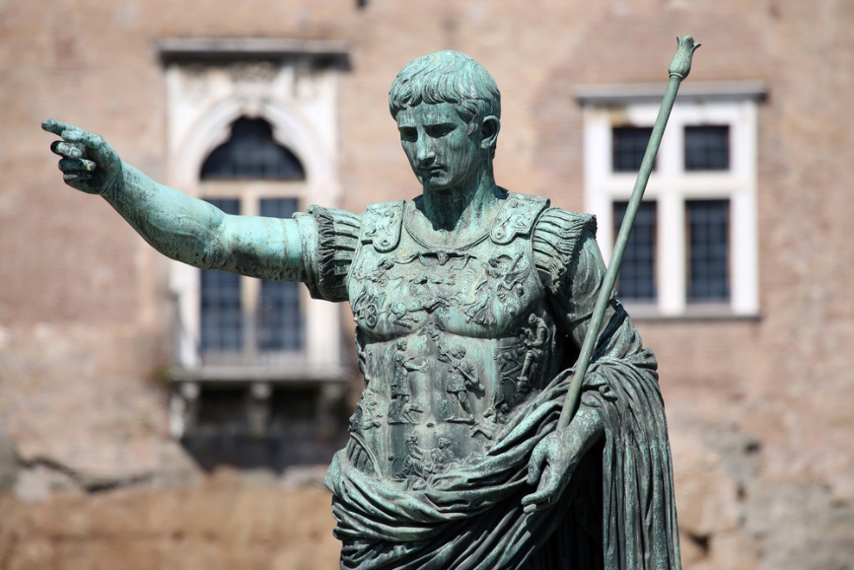
History
Following the murder of Julius Caesar, a civil war broke out in Rome between the republicans and Caesar’s supporters. After a victory near the Gulf of Actium on the shores of Greece, Octavianus, Caesar’s nephew, became Rome’s ruler in 27 B.C. He changed his name to Augustus and he is considered the first Emperor.
Numeracy with the Romans: Session 06
Score: ____ Who are you? _________________

Gladiator
1) ____ + 15 = 24 | 2) 9 × 6 = | 3) 70 ÷ 5 =
4) 2$\frac{1}{2}$ kg = __________ g | 5) 50% of 42 = | 6) January = _____ days
7) $\frac{1}{4}$ = _____ % | 8) 13 + 14 + 15 = | 9) £2.50 × 3 =
Citizen
10) 6 – –2 = | 11) The mode of 3, 2, 7, 2 = | 12) The mean of 6, 5, 4, 3 =
13) 98.7 to the nearest unit  = | 14) $\frac{3}{10}$ of 70 = | 15) _____ + 5.4 = 10
16) 435 + ______ = 1,000 | 17) 0.32 as a percentage = | 18) The area of a triangle with base 4 cm and height 3 cm is
Emperor
19) 7 × 0.8 = | 20) 1.2 ÷ 2 = | 21) $2^{4}=$
22) 7 + 3 × 4 = | 23) 40% of £20 = | 24) 473,204 to two significant figures =
25) Carrots cost 12p per 100 g. What is the cost of 500 g of carrots?
History
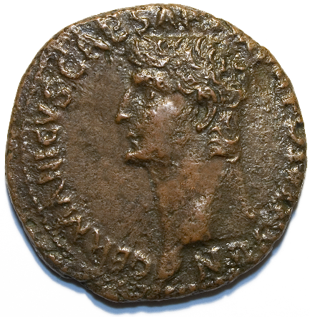
By the year 41 A.D., Claudius was the Roman Emperor. He was the fourth Emperor, and the first to be born outside Italy.
In 43 A.D., he sent four legions to try and conquer Britain. Neither Julius Caesar nor Caligula had previously been able to do this – but Claudius had more success. Following the first campaigns, Claudius himself travelled to Camulodunum (Colchester today) with additional soldiers and war elephants!
Numeracy with the Romans: Session 07
Score: ____ Who are you? _________________

Gladiator
1) 24 + _____ = 31 | 2) 7 × 8 = | 3) 30 ÷ 4 =
4) 1$\frac{3}{4}$ m = ______ cm | 5) 25% of 24 = | 6) April = _____ days
7) $\frac{1}{5}$ = _____ % | 8) 28 – 11 – 7 = | 9) £1.30 × 4 =
Citizen
10) 7 + –3 = | 11) The median of 4, 6, 8, 10 = | 12) The range of 6, 4, 2, 8 =
13) 19.07 to the nearest unit  = | 14) $\frac{7}{10}$ of 60 = | 15) _____ + 2.3 = 10
16) 873 + ______ = 1,000 | 17) 0.86 as a percentage = | 18) The area of a triangle with base 6 cm and height 4 cm =
Emperor
19) 3 × 0.2 = | 20) 3.6 ÷ 3 = | 21) The reciprocal of $\frac{2}{7}$ is
22) 9 – 6 ÷ 2 = | 23) 60% of £50 = | 24) 21,468 to one significant figure =
25) 30.2 – 2.04 =
History
The Deceangli
Claudius’ army attacked Wales around the year 48 A.D., five years after they arrived in Great Britain.
The Ordovices
The Gangani
At the time, Wales as we know it today didn’t exist. Many Celtic Tribes lived in the country, as shown on the map. We don’t know for how long these tribes had been living in Wales before the Romans arrived.
The Demetae
The Silures
Numeracy with the Romans: Session 08
Score: ____ Who are you? _________________

Focusing on: Percentages
Gladiator
1) 50% of 30 = | 2) 50% of 140 = | 3) 50% of 19 =
4) 10% of 60 = | 5) 10% of 170 = | 6) 10% of 85 =
7) 25% of £40 = | 8) 25% of £120 = | 9) 25% of £32 =
Citizen
10) 20% of 40 = | 11) 30% of 80 = | 12) 40% of 40 =
13) 45% as a decimal = | 14) 12% as a decimal = | 15) 4% as a decimal =
16) 99% as a fraction = | 17) 19% as a fraction = | 18) 9% as a fraction =
Emperor
19) 15% of £50 = | 20) 5% of £20 = | 21) 1% of £87 =
22) 3% of $50 = | 23) 150% of 400 = | 24) 0.1% of 600 =
25) There is a 40% price reduction in a sale. Walking shoes usually cost £35.
What will be the price of the walking shoes in the sale?
History
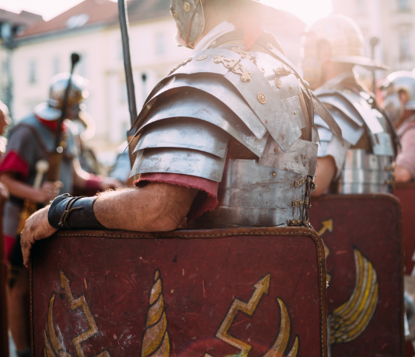
One of those who opposed the Romans’ attack in Wales was Caratacus. King of one of the largest tribes of south-east England, he had escaped as Claudius’ army attacked his lands in 43 A.D. He led the Silures and Ordovices as they rebelled against the Romans, but Caratacus was defeated in a battle in 51 A.D. He and his family were abducted shortly after and sent to Rome.
Numeracy with the Romans: Session 09
Score: ____ Who are you? _________________

Gladiator
1) 4 × 8 = | 2) 4 – 8 = | 3) 4 ÷ 8 =
4) 1 stone = ______ pounds | 5) 1² = | 6) 86 to the nearest 10 =
7) Half of 46 = | 8) Quarter of an hour after 11:50 pm = | 9) 10% of £140 =
Citizen
10) An octagon has ___ sides | 11) Circle the greatest fraction: $\frac{1}{8}$ $\frac{2}{3}$ $\frac{5}{10}$ | 12) Seven less than 20 =
13) 9.5 to the nearest unit = | 14) 18 ÷ (12 – 3) = | 15) 73 + ______ = 100
16) $\sqrt{64}$ = | 17) 3% as a decimal = | 18) 5 minutes = ___ seconds
Emperor
19) 3 × 0.7 = | 20) The perimeter of a 1 cm by 2 cm rectangle is | 21) The cost of 5 pencils which cost 32p each is
22) 0.9 ÷ 0.3 = | 23) Add 2.4 to 29 = | 24) 0.1 × 0.1 =
25) What percentage of 240 is 24?
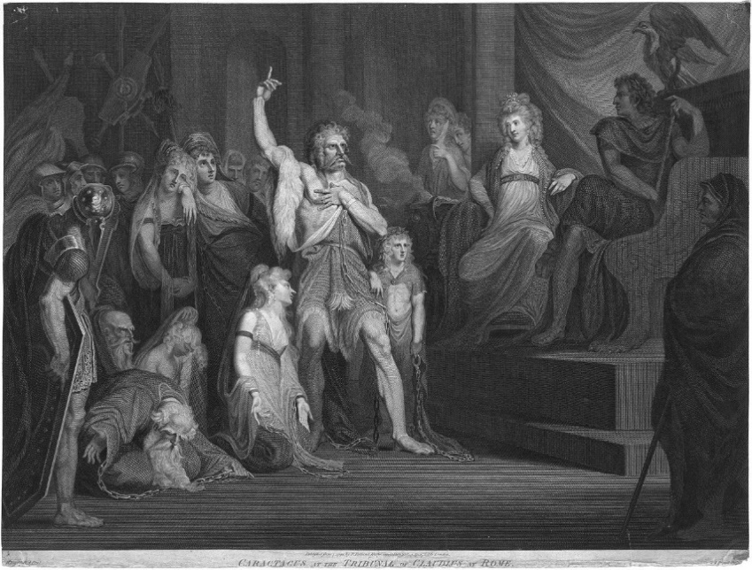
History
After arriving in Rome, Caratacus had the opportunity to speak in front of Claudius in parliament. In a famous speech, he praised the Roman soldiers for capturing him. This speech made such an impression that Caratacus was pardoned and allowed to live freely in Rome for the rest of his life!

Numeracy with the Romans: Session 10
Score: ____ Who are you? _________________

Gladiator
1) 3 × 11 = | 2) 24 + 27 = | 3) 54 ÷ 6 =
4) $\frac{1}{4}$ minute = _____ seconds | 5) 5 × –3 = | 6) 3,450 to the nearest 1,000 =
7) 5:30 pm on the 24 hour clock = | 8) 76° is an ________ angle | 9) 50% of 40 =
Citizen
10) 0.5 + 0.7 = | 11) Add 2.4 to 9 = | 12) The median of 7, 2, 5 =
13) 76.906 to one decimal place = | 14) 16 × (3 + 7) = | 15) 20% of £15 =
16) $\frac{1}{5}$ km = ______ m | 17) $\frac{21}{100}$ as a decimal = | 18) 8 squared =
Emperor
19) 4 hours before 1:34 am  = | 20) 6 × 0 = | 21) 0.5 × 9 =
22) 2.1 ÷ 0.7 = | 23) 264 – 178 = | 24) 43.5 to one significant figure =
25) Romulus and Remus share money according to the ratio 3:2. Romulus receives £24.
How much money does Remus receive?
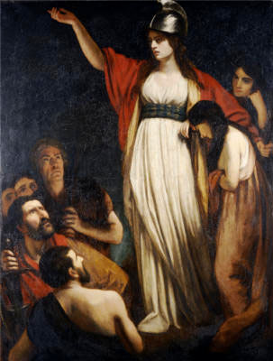
History
After the Romans arrived, the native tribes had to decide between surrendering to the Roman law and pay taxes (keeping their lands), or fight back.
Following years of hard taxes, some Celtic tribes were prepared to rebel. In the year 60 A.D., one leader who did this was Boudica.

Numeracy with the Romans
Write down your scores
for sessions 1–10:
10
9
8
7
5
4
3
2
1
6

What is the total of the above scores? ________________
What is the mean of the above scores? _______________
What is the range of the above scores? _______________
What did you do well / find easy?
_______________________________________________
_______________________________________________
What do you need to improve / find difficult?
_______________________________________________
_______________________________________________
_______________________________________________
Numeracy with the Romans
History Revision

1) How many people lived in the Roman Empire when it was at its peak?
__________________________________________________________
2) When was Rome established by the twin Brothers Romulus and Remus?
__________________________________________________________
3) Who was the last king of the empire?
__________________________________________________________
4) Who was Rome’s most powerful general in 49 B.C.?
__________________________________________________________
5) Who was the Empire’s first Emperor?
__________________________________________________________
6) Which animals did Claudius bring to Britain?
__________________________________________________________
7) How many Celtic tribes were living in Wales before the Romans arrived?
__________________________________________________________
8) When was Caratacus defeated in battle?
__________________________________________________________
Numeracy with the Romans: Session 11
Score: ____ Who are you? _________________

Gladiator
1) 5 × 7 = | 2) 45 – 16 = | 3) 42 ÷ 7 =
4) Circle the correct answer: 26 is an even / odd number. | 5) 4.5 + 2.5 = | 6) 271 to the nearest 100  =
7) 22:31 on the 12 hour clock = | 8) 25 – 0.2 = | 9) 10% of £1.30 =
Citizen
10) The mode of 2, 3, 4, 2  = | 11) The median of 2, 3, 4, 2  = | 12) The range of 2, 3, 4, 2  =
13) 0.26 to one decimal place = | 14) 3 – 2 + 1 = | 15) 90% of £1,000 =
16) $\frac{1}{2}$ litre = ______ ml | 17) $\frac{3}{100}$ as a percentage = | 18) 2 cubed =
Emperor
19) 0.3 × 0.1 = | 20) A cuboid has _______  vertices | 21) 2.3 – 1.05 =
22) $\frac{2}{10}$ of £45 = | 23) 4,527 to one significant figure = | 24) 74.2% as a decimal =
25) Caratacus’ salary is £14 per hour. One day, Caratacus works a 7 hour shift.
What is Caratacus’ salary for that day?
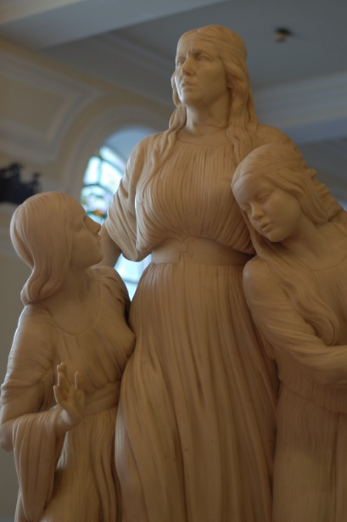
History
In the year 59 or 60 A.D., king Prasutagus, who was Boudica’s husband, died.
According to Roman law, Boudica was not entitled to her husband’s property. When Roman soldiers tried to take this property away Boudica refused, and so Boudica was attacked and her daughters raped. Boudica decided to plot with other tribes to take revenge for this.

Numeracy with the Romans: Session 12
Score: ____ Who are you? _________________

Focusing on: Fractions
Gladiator
1) $\frac{1}{2}$ of 30 = | 2) $\frac{1}{4}$ of 12 = | 3) $\frac{1}{5}$ of £15 =
4) $2\frac{1}{2}$ minutes = ____ seconds | 5) $3\frac{3}{4}$ kg = ______ g | 6) $5\frac{3}{10}$ litres = _______ ml
7) Write $\frac{6}{12}$ in its simplest form. | 8) Write $\frac{14}{21}$ in its simplest form. | 9) Write $\frac{12}{16}$ in its simplest form.
Citizen
10) $\frac{2}{7}+\frac{3}{7}=$ | 11) $\frac{5}{9}-\frac{1}{9}=$ | 12) $\frac{4}{11}+\frac{2}{11}=$
13) $8×\frac{1}{4}=$ | 14) $2÷\frac{1}{2}=$ | 15) $\frac{7}{10}×20=$
16) $\frac{1}{5}$ cm = ______ mm | 17) $\frac{48}{100}$ as a decimal = | 18) $\frac{2}{100}$ as a percentage =
Emperor
19) What is half of a half? | 20) $\frac{2}{3}+\frac{1}{6}=$ | 21) $\frac{2}{3}-\frac{1}{6}=$
22) What is 12.5%  as a fraction? | 23) What is 0.4 as a fraction, in its simplest form? | 24) What is 0.1%  as a fraction?
25) Remus thinks of a number. $\frac{1}{10}$ of his number is 3. What is $\frac{1}{5}$ of his number?
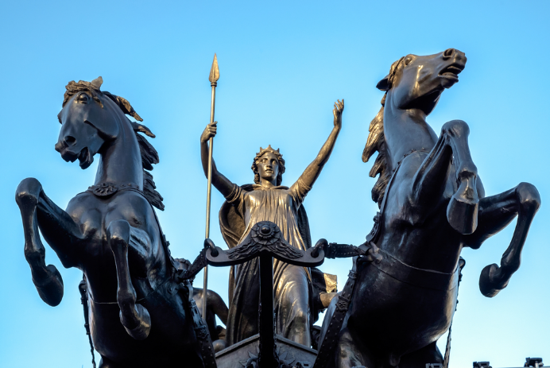
History
In 61 A.D. the Romans travelled to Anglesey to destroy the Druids’ base. Boudica saw her chance – she attacked Camulodunum (Colchester) with her army before marching down to Londinium (London), burning everything on her way!

Numeracy with the Romans: Session 13
Score: ____ Who are you? _________________

Gladiator
1) 4 × 10 = | 2) 4 – 10 = | 3) 10 ÷ 4 =
4) 25% of £20 = | 5) Subtract 0.09 from 0.1 = | 6) 5 × _____ = 60
7) 2:15 am on the 24 hour clock = | 8) 1 foot = ___ inches | 9) 10% of 23 =
Citizen
10) 2.43 + 0.7 = | 11) The mean of 4 and 10 is | 12) The range of 4 and 10 is
13) 0.302 to two decimal places = | 14) (2 + 3) × (8 – 5) = | 15) 1% of £245 =
16) $3\frac{1}{4}$ m = ______ cm | 17) 26% as a decimal = | 18) 4³ =
Emperor
19) The reciprocal of $\frac{1}{2}$ is | 20) 14 × 11 = | 21) 90 × _____ = 9
22) There are ___ thirds in $3\frac{2}{3}$ | 23) 888,888 to three significant figures = | 24) The volume of a 3 cm by  2 cm by 2 cm cuboid is
25) There are about 2.27 litres in 4 pints. How many litres are there in 6 pints?
History
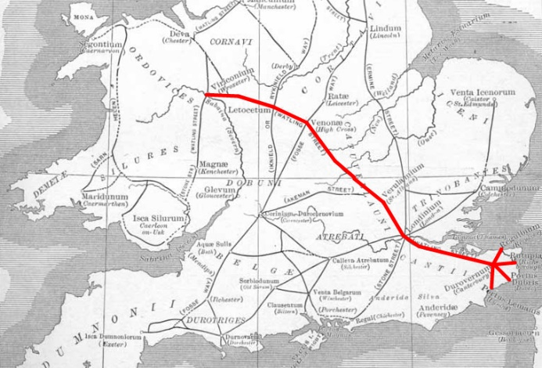
Whilst Boudica was causing riot in England, the Romans were called back from Wales to face them. Boudica’s army was larger in terms of number (around 200,000), but the Romans’ army wore better armour and were well trained.
In a battle somewhere along Watling Street (see the map), Boudica’s army were defeated, putting an end to the resistance against the Romans.
Numeracy with the Romans: Session 14
Score: ____ Who are you? _________________

Gladiator
1) Write out all the factors of 12: | 2) 6 × 8 = | 3) 72 ÷ 8 =
4) £120 – £49.99 = | 5) Half of 300,000 = | 6) 0.15 + ______ = 1
7) 13.45 to one decimal place = | 8) 142° is an _______ angle | 9) 25% of 16 =
Citizen
10) 1.6 + 3.8 = | 11) Add 13.4 to 2 = | 12) The range of –2, 1, 6 is
13) 4 × 3 + 7 × 3 = | 14) 6 ÷ 0.5 = | 15) 1 ÷ 0.2 =
16) 4,300 g = __________ kg | 17) $\frac{3}{5}$ = ______ % | 18) The area of a triangle which has base 7 cm and height 6 cm is
Emperor
19) 132 ÷ 12 = | 20) 13 × 7 = | 21) True or false? 2 is a prime number.
22) 2.7 ÷ 0.9 = | 23) There are ______ days in a leap year | 24) 0.002701 to one significant figure =
25) There are 150 books on a bookshelf. 12% of the books are about history.
How many books are about history?
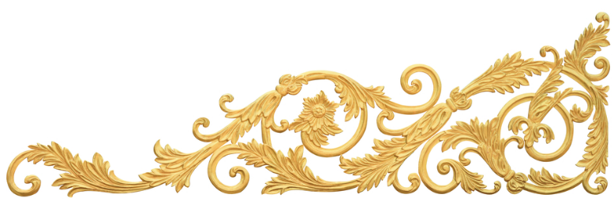
History: Timeline
Numeracy with the Romans: Session 15
Score: ____ Who are you? _________________

Gladiator
1) 7 × 6 = | 2) 96 + 8 = | 3) 112 ÷ 2 =
4) $3\frac{1}{2}$ minutes = ____ seconds | 5) –4 + 9 = | 6) 258 to the nearest 10 =
7) 730cm = _________ m | 8) True or false? 6 is a factor of 3. | 9) 10% of £3 =
Citizen
10) 12% + 3% = | 11) The median of 4, 8, 1, 5  is | 12) One million in figures  =
13) 0.276 to two decimal places = | 14) 7% as a decimal = | 15) £1.87 – 94p =
16) Which is the longest: 1 km or 1 mile? | 17) 15 × 5 = | 18) 1 cubed =
Emperor
19) $3\frac{1}{2}$ hours after 08:20  = | 20) 6 × 0.1 = | 21) 9.6 ÷ 2 =
22) There are _____ hours in a week | 23) ______ + 628 = 1,000 | 24) 421.5 to two significant figures =
25) Boudica puts the chicken in the oven at 1:34p.m. The chicken takes $3\frac{1}{3}$ hours to cook. At what time will the chicken be ready?
History
After Boudica’s revolt, the Romans returned to Wales, finally conquering the Country in 78 A.D. Mineral excavation for gold, copper and zinc began.
Most of the inhabitants of Wales came to accept the Romans’ rule, with the Ordovices in the Welsh midlands most rebellious.

Numeracy with the Romans: Session 16
Score: ____ Who are you? _________________

Focusing on: Decimals
Gladiator
1) 1.2 + 1.5 = | 2) 3 – 0.2 = | 3) £1.48 + £0.50 =
4) 2 × 0.6 = | 5) 2.4 ÷ 2 = | 6) Circle the largest number:  0.208 0.082 0.28
7) 2.5 × 10 = | 8) 164 ÷ 10 = | 9) 5.6 ÷ 100 =
Citizen
10) 0.26 as a percentage = | 11) 0.8 as a percentage = | 12) 0.02 as a percentage =
13) 0.5 as a fraction = | 14) 0.17 as a fraction = | 15) 0.2 as a fraction =
16) 1.24 + 0.41 = | 17) 2.43 – 1.27 = | 18) 0.7 × 11 =
Emperor
19) The reciprocal of 0.5 is | 20) The reciprocal of 0.2 is | 21) The reciprocal of 0.1 is
22) Half of 0.45 = | 23) 0.2 + 0.3 × 2 = | 24) 0.4 × 0.1 =
25) Romulus buys 5 loaves of bread, which cost £1.25 each.
How much does Romulus pay for all the bread?
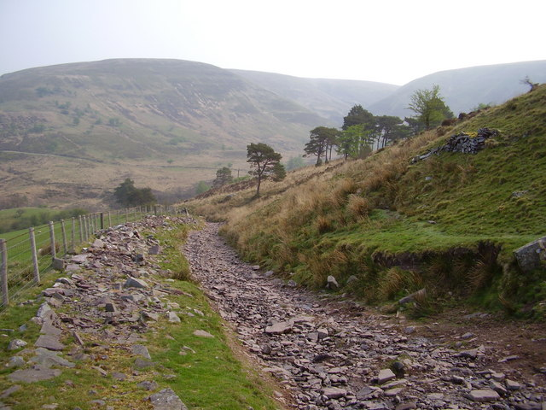
History
The Romans were famous for building roads, and one of the most important roads in Wales was Sarn Helen, which connected the North with the South.
According to legend, Saint Elen ordered the building of the road in the fourth century, but it is likely that the real road existed much earlier.
Numeracy with the Romans: Session 17
Score: ____ Who are you? _________________

Gladiator
1) 3 × 8 = | 2) 38 + 23 = | 3) 32 ÷ 4 =
4) 6 m = _________ cm | 5) Deduct 65p  from £1.36 = | 6) $\frac{1}{4}$ hour before 11:09 =
7) A third of 24 = | 8) 2.4 + 3.7 = | 9) 50% of 222 =
Citizen
10) How many halves are there in 5? | 11) The mean of 9, 2, 4 = | 12) The range of 8, 3, 4, 8 =
13) 14.03 to one decimal place = | 14) 12 – 8 ÷ 4 = | 15) 3³ =
16) $\sqrt{100}$ = | 17) 14% as a decimal = | 18) 4 hours = _____ minutes
Emperor
19) 7 × 0.5 = | 20) The reciprocal of $\frac{4}{5}$ is | 21) The area of a 7 cm by  2 cm rectangle is
22) 60 × ______ = 30 | 23) 105 – 78 = | 24) 30% of £15 =
25) A piece of beef weighing 250 g costs £3.50. How much is the cost per 100 g?
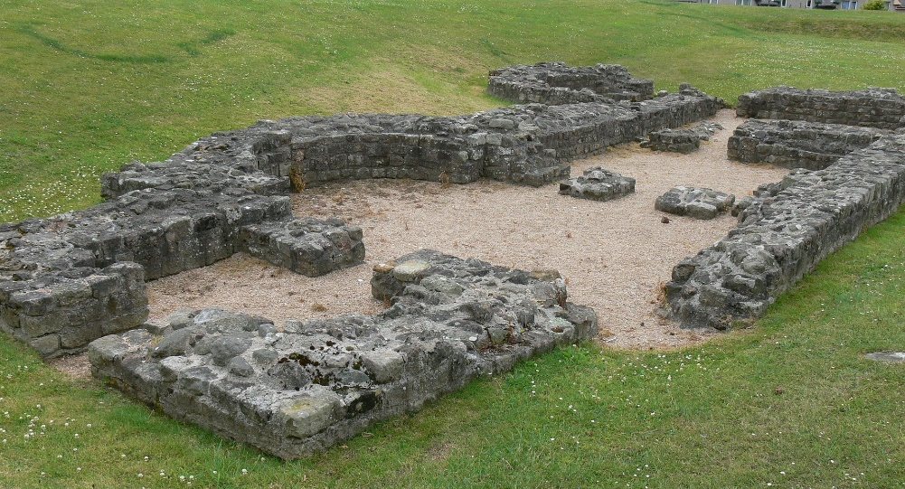
History
Roman Wales was ruled by forts in places such as Deva Victrix (Chester), Isca Augusta (Caerleon) and Segontium (Caernarfon).
The picture on the right shows the ruins of an old bath house in Segontium.
Numeracy with the Romans: Session 18
Score: ____ Who are you? _________________

Gladiator
1) 4 × 14 = | 2) 29 + 54 = | 3) 48 ÷ 8 =
4) 8 cm = ______ mm | 5) 9² = | 6) A heptagon has ____ sides
7) $\frac{1}{5}$ = _____ % | 8) 7 – 0.6 = | 9) 50% of 11 =
Citizen
10) The perimeter of a 3 cm by 4 cm rectangle is | 11) The mode of 1, 3, 2, 1, 3  = | 12) The range of 1, 3, 2, 1, 3  =
13) 0.865 to two decimal places = | 14) 8 + 4 × 3 = | 15) 75% of 40 =
16) $\sqrt{4}$ = | 17) 10% as a fraction = | 18) 4 days = ______ hours
Emperor
19) 8 × 0.1 = | 20) (9 – 5) × 4 = | 21) The volume of a cube with 5 cm sides is
22) 3 ÷ 0.5 = | 23) 9.1 – 3.7 = | 24) 5,702 to one significant figure =
25) How many drinks costing 89p can Elen buy with a £10 note?
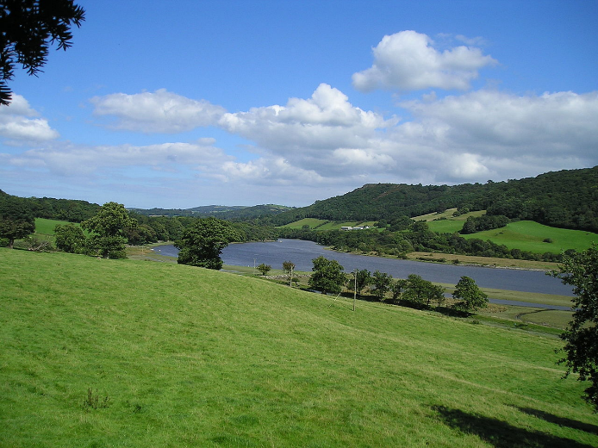
History
The roman fort Canovium was built around 77–78 A.D. This fort was square, made of wood, and located near an important site for crossing the Conwy River (Tal-y-Cafn today).
The site was excavated during the 1920s; a counter game and a tile containing an imprint of a child’s foot were found. These artefacts are to be seen in the Llandudno Museum.
Numeracy with the Romans: Session 19
Score: ____ Who are you? _________________

Gladiator
1) 7 × 7 = | 2) 44 + 51 = | 3) 20 ÷ 4 =
4) 2.5 kg = ___________ g | 5) 2² = | 6) 19 – 21 =
7) The name of the shape with 3 sides: | 8) 1.2 + 3.5 = | 9) 10% of £6 =
Citizen
10) The area of a 9 cm by  7 cm rectangle is | 11) The mean of 1, 1, 1 = | 12) The range of 1, 1, 1 =
13) 87.98 to one decimal place = | 14) 8 – 10 ÷ 2 = | 15) 20% of 60 =
16) Half of 450 = | 17) 30% as a decimal = | 18) $1\frac{1}{2}$ minutes = _____ seconds
Emperor
19) $\frac{1}{20}$ = _____ % | 20) The perimeter of a 3 cm by 1.5 cm rectangle is | 21) The volume of a 2 cm by  2 cm by 5 cm cuboid is
22) 1.6 ÷ 0.8 = | 23) 327 – 29 = | 24) 9.709 to the nearest unit  =
25) 59 × 5 =
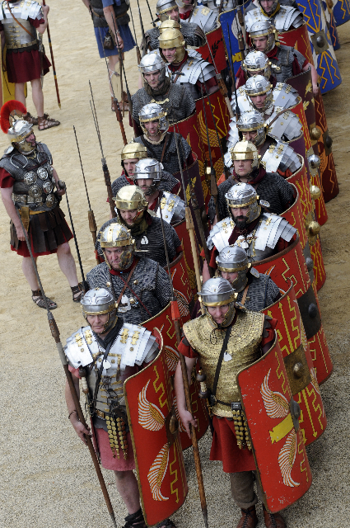
History
The Roman Empire continued to grow following the conquest of Wales in 78 A.D., reaching its peak in 117 A.D. It seemed that Wales was left alone as the Roman soldiers won new lands.
Latin was the Romans’ language, and many Latin words became part of the early Welsh language. For example: pont (‘pons’ in Latin); bresych (‘brassica’ in Latin); and eglwys (‘ecclesia’ in Latin).

Numeracy with the Romans: Session 20
Score: ____ Who are you? _________________

Focusing on: Calculations
Gladiator
1) 6 × 2 = | 2) 6 × 6 = | 3) 6 × 9 =
4) 32 ÷ 4 = | 5) 49 ÷ 7 = | 6) 34 ÷ 2 =
7) 17 + 18 = | 8) 98 + 64 = | 9) 238 + 104 =
Citizen
10) 2 + 3 × 5 = | 11) 8 + 12 ÷ 2 = | 12) 4 × 6 ÷ 2 =
13) 12 – 3 + 4 = | 14) 4 + (2 × 7) = | 15) 10 × 2 + 3 =
16) 1 × 2 + 3 × 4 = | 17) 16 ÷ 2 – 6 ÷ 2 = | 18) 3 + 4 × 5 – 2 =
Emperor
19) 6 + 0.5 = | 20) 6 × 0.5 = | 21) 6 ÷ 0.5 =
22) £4.57 – £1.60 = | 23) £3.35 × 3 = | 24) £1.80 × 10 =
25) What is the difference between five dozens and three eighteens?
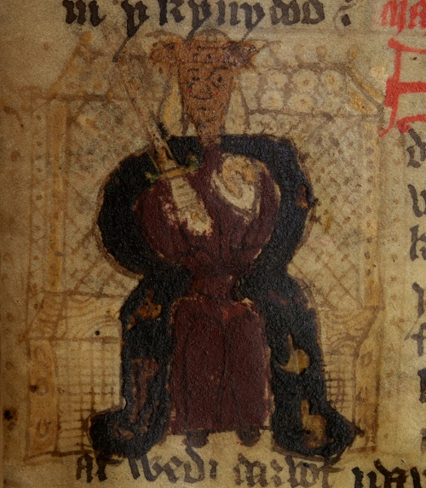
History
By the fourth century, the Romans’ influence on Wales had diminished. There were fewer soldiers to be seen on the streets since they were called to battle in other parts of the empire.
One man’s name has remained alive in terms of the Welsh’s release from the Romans’ rule: Magnus Maximus.
Numeracy with the Romans
Write down your scores
for sessions 19–20:
20
19
18
17
15
14
13
12
11
16

What is the total of the above scores? ________________
What is the mean of the above scores? _______________
What is the range of the above scores? _______________
What did you do well / find easy?
_______________________________________________
_______________________________________________
What do you need to improve / find difficult?
_______________________________________________
_______________________________________________
_______________________________________________
Numeracy with the Romans
History Revision

1) When did Boudica’s husband die?
__________________________________________________________
2) Why did the Romans travel to Anglesey?
__________________________________________________________
3) How many soldiers were there in Boudica’s army?
__________________________________________________________
4) What mineral was excavated at The Great Orme?
__________________________________________________________
5) What was the name of the road that connected North and South Wales?
__________________________________________________________
6) What was the name of the Romans’ fort in Caernarfon?
__________________________________________________________
7) In what year did the Empire reach its peak?
__________________________________________________________
8) Give examples of Welsh words deriving from Latin.
__________________________________________________________

Numeracy with the Romans: Session 21
Score: ____ Who are you? _________________

Gladiator
1) 11 × 8 = | 2) 20 minutes after 11:45 p.m. = | 3) 32 + 48 =
4) 2 litres = _________ ml | 5) 25 ÷ 2 = | 6) 1.9 + 0.4 =
7) £2.37 + £0.08 = | 8) November = ____ days | 9) 10% of $16 =
Citizen
10) The area of a 2.5 cm by  2 cm rectangle is | 11) The median of 15, 12, 19 is | 12) 11% as a decimal =
13) –3.7 to the nearest unit = | 14) 8 – 6 + 1 = | 15) 3 × _____ = 45
16) 4² = | 17) Half of 4,260 = | 18) 00:30 on the 12 hour clock =
Emperor
19) 3 + 0.4 + 0.02 = | 20) A cube has ____ edges | 21) 4 ÷ 0.25 =
22) $\frac{3}{4}+\frac{1}{2}=$ | 23) Circle the largest number:  48% 0.501 $\frac{1}{2}$ | 24) 0.00472 to one significant figure =
25) How many days are there in 4 consecutive years?
History
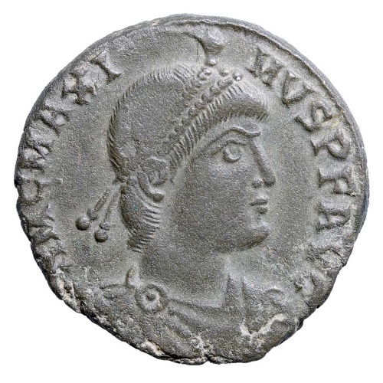
Magnus Maximus was born in the year 325 A.D. It seems he became a famous general serving Africa and along the Danube river. He came to Great Britain in the year 380 A.D., helping to overthrow an attack by the Picts and Scots in 381 A.D.
In 383 A.D., Magnus left Britain with a large proportion of his army to become the Emperor of the West. He issued coins which showed his profile, like the one shown on the right.
Numeracy with the Romans: Session 22
Score: ____ Who are you? _________________

Gladiator
1) ______ + 23 = 34 | 2) 6 × 12 = | 3) 109 – 24 =
4) $1\frac{1}{4}$ kg = _________ g | 5) 50% of 3 = | 6) May = _______ days
7) $\frac{3}{4}$ = _______ % | 8) £1.40 × 4 = | 9) Midnight on the 24 hour clock =
Citizen
10) 7 – –4 = | 11) The mode of 1, 2, 3, 4  = | 12) The mean of 10, 30, 50  =
13) 6.38 to the nearest unit = | 14) $\frac{7}{10}$ of 90 = | 15) _____ + 1.7 = 10
16) 218 + ______ = 1,000 | 17) 0.05 as a percentage = | 18) The area of a triangle with base 1 cm and height 6 cm is
Emperor
19) 9 × 0.6 = | 20) 5 ÷ 0.1 = | 21) $2^{5}=$
22) 4 × 2 + 2 × 3 = | 23) 80% of £30 = | 24) 0.002468 to two significant figures =
25) Magnus faces north. If he turns 90° clockwise, which way will Magnus face?
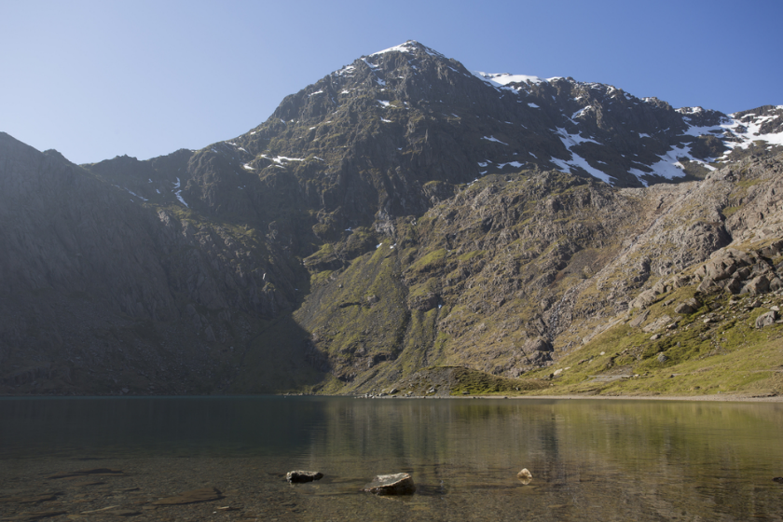
History
The legend The Dream of Emperor Maximus, from the Mabinogion, tells the story of how Magnus met his wife, Saint Elen...
One day whilst hunting, Magnus was overcome with sleepiness. He dreamt that he had travelled over the highest mountain in the world, before arriving at a spectacular fort made of gold and shining precious gems...
Numeracy with the Romans: Session 23
Score: ____ Who are you? _________________

Gladiator
1) 56 + _____ = 81 | 2) 6 × 3 = | 3) 120 ÷ 10 =
4) 57 mm = ______ cm | 5) 25% of 120 = | 6) July = ____ days
7) $\frac{1}{2}+\frac{1}{2}$ = | 8) 1 – 2 + 3 = | 9) £5 – 13p =
Citizen
10) 9 + –2 = | 11) Circle the prime numbers:  1 2 3 4 5 6 7 8 9 10 | 12) The total of 14 and 19 =
13) 8.07 to the nearest unit = | 14) $\frac{2}{5}$ of 10 = | 15) ________ + 9.99 = 10
16) 283 + ______ = 1,000 | 17) 0.04 as a percentage = | 18) A nonagon has ____ sides
Emperor
19) 3 × 0.05 = | 20) 0.3 ÷ 3 = | 21) The reciprocal of $\frac{5}{9}$ is
22) 4 – 1 ÷ 2 = | 23) 15% of £50 = | 24) 834,280 to one significant figure =
25) The time difference between London and Rome is 1 hour. If it is 11:46 p.m. in London, what time is it in Rome?
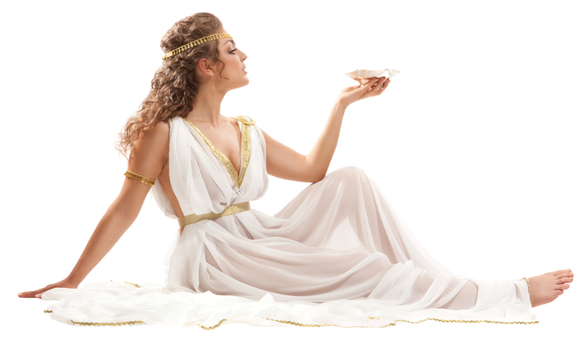
History
After reaching the fort, Magnus saw slaves dressed in black silk playing chess. A noble man sat on a golden throne, and a most beautiful lady sat next to him. Magnus went to embrace the lady but, before they touched, Magnus awoke from his dream...
Numeracy with the Romans: Session 24
Score: ____ Who are you? _________________

Focusing on: Measurements
Gladiator
1) 1 km = __________ m | 2) 1 m = __________ cm | 3) 1 cm = __________ mm
4) 1 metric ton = _____ kg | 5) 1 kg = __________ g | 4) 1 g = __________ mg
7) £1 = __________ p | 8) 1 litre = _________ ml | 9) 1 cl = _________ ml
Citizen
10) 1 yard = ___ feet | 11) 1 foot = ___ inches | 12) 1 inch $≈$ ______ cm
13) 1 tonne = ______ stones | 14) 1 stone = ______ pounds | 15) 1 pound = ______ ounces
16) 1 ounce $≈$ __________ g | 17) 1 gallon = _______ pints | 18) 1 pint = ___ liquid ounces
Emperor
19) 1 mile = ______ yards | 20) 1 gallon $≈$ _______ litres | 21) 1 kg $≈$ ________ pounds
22) 1 mile $≈$ _________ km | 23) 1 yard $≈$ _________ m | 24) 1 litre $≈$ _________ pints
25) 3.5 km = ________________ mm
History
Magnus fell in love with the lady he had seen in his dream. He looked forward to going to sleep so that he could dream of her again! Magnus did not know where she lived, so he sent 13 messengers in search for her.
In three years’ time, Eudaf (the noble man) and Elen (his daughter) were found at Segontium, Wales. She was greeted as the ‘Empress of Rome’, and was asked to travel to Rome to see Magnus. She refused, demanding that Magnus travelled to her...
Numeracy with the Romans: Session 25
Score: ____ Who are you? _________________

Gladiator
1) 9 × 4 = | 2) 4 – 9 = | 3) 9 ÷ 4 =
4) 2 ounces $≈$ ______ g | 5) 0 × 0 = | 6) 235 to the nearest 10 =
7) 160 doubled = | 8) Twenty-five minutes before 12:15 pm = | 9) 10% of £1,040 =
Citizen
10) A decagon has ____ sides | 11) Circle the largest fraction: $\frac{4}{5}$ $\frac{7}{10}$ $\frac{15}{20}$ | 12) The product of 3 and 4  =
13) 0.3 to the nearest unit = | 14) 21 ÷ (9 – 8) = | 15) 12 + ______ = 100
16) $\sqrt{1}$ = | 17) 9% as a decimal = | 18) 20 minutes = ___ seconds
Emperor
19) 6 × 0.2 = | 20) The perimeter of a 1.3 cm by 2.1 cm rectangle is | 21) The cost of 4 biros costing 24p each =
22) 0.8 ÷ 0.4 = | 23) Add 28 to 4.2 = | 24) 0.7 × 0.1 =
25) What percentage of 60 is 15?
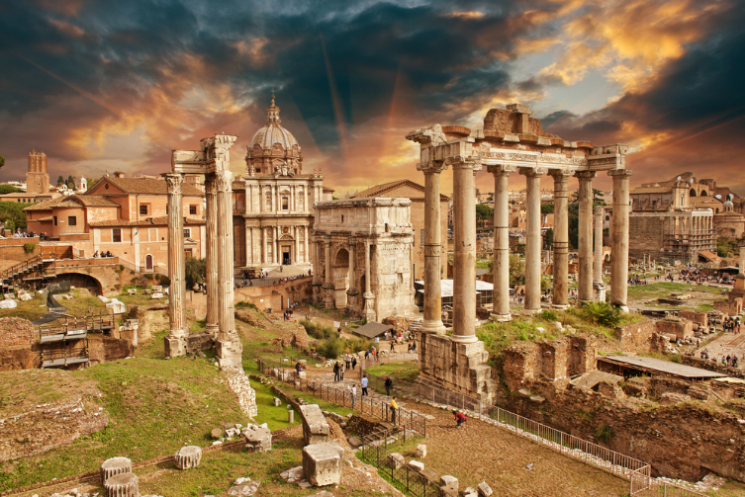
History
The messengers returned to Rome for Magnus. He agreed to go to Wales, where Magnus and Elen were married.
In the second half of the legend, we are told that Magnus built three forts for Elen in Wales, as well as roads connecting them - Sarn (H)elen. The legend ends as Magnus and Elen travel to invade Rome with the support of Cynan and Adeon, Elen’s brothers.
Numeracy with the Romans: Session 26
Score: ____ Who are you? _________________

Gladiator
1) 2 × 12 = | 2) 87 + 19 = | 3) 64 ÷ 8 =
4) $\frac{1}{10}$ minute = _____ seconds | 5) 4 × –5 = | 6) 54,209 to the nearest 1,000 =
7) 3:30 a.m. on the 24 hour clock = | 8) 90° is a ________ angle | 9) 50% of 6 =
Citizen
10) 0.5 + 0.7 = | 11) 96 ÷ 8 = | 12) The median of 6, 4, 10 is
13) 109.42 to one decimal place = | 14) 2 + 3 × 4 + 5 = | 15) 20% of £25 =
16) $4\frac{1}{2}$ km = ______ m | 17) $\frac{11}{50}$ as a decimal = | 18) 5 squared =
Emperor
19) $3\frac{1}{2}$ hours before  12:18 p.m. = | 20) 6 × 0.1 = | 21) The reciprocal of 5 is
22) 3 – 0.24 = | 23) 386 – 190 = | 24) 27,325 to one significant figure =
25) What fraction of 80 is 16?
History: Elen’s Family Tree

Numeracy with the Romans: Session 27
Score: ____ Who are you? _________________

Gladiator
1) 23 + 29 = | 2) 54 – 17 = | 3) 8 × ____ = 72
4) Circle the correct answer: 45 is an even / odd number. | 5) 3 + 7.5 = | 6) 780 to the nearest 100 =
7) 18:54 on the 12 hour clock = | 8) 12 – 0.8 = | 9) 10% of £5.30 =
Citizen
10) The mode of 7, 2, 1, 2 is | 11) The median of 7, 2, 1, 2 is | 12) The mean of 7, 2, 1, 2 is
13) 5.825 to one decimal place = | 14) 12 – 4 + 5 = | 15) 70% of £500 =
16) $\frac{1}{2}$ cm = ______ mm | 17) $\frac{7}{100}$ as a percentage = | 18) 4 cubed =
Emperor
19) 1.4 × 0.1 = | 20) A tetrahedron has  ___________ vertices | 21) 4.6 – 1.24 =
22) $\frac{9}{10}$ of £30 = | 23) 0.0271 to one significant figure = | 24) 29.3% as a decimal =
25) Circle the square numbers: 1 2 3 4 5 6 7 8 9 10
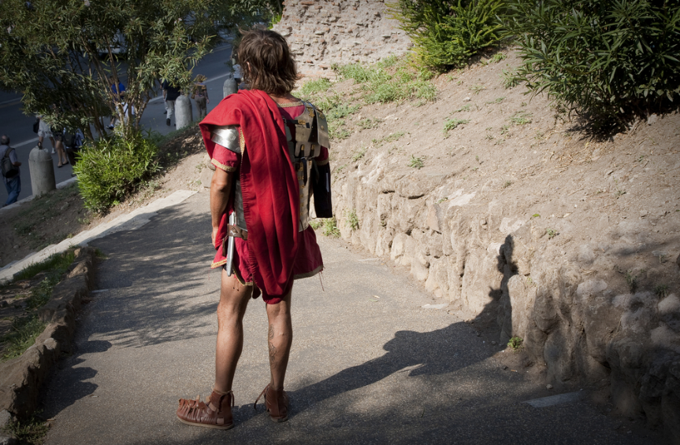
History
Although The Dream of Emperor Maximus is a legend, historians agree that Magnus left Great Britain in 383 A.D. to become Emperor of the West. Following Magnus’s departure, there is no evidence of any Roman military presence in Wales. Magnus is therefore considered to have freed the Welsh from the Romans’ power.
Numeracy with the Romans: Session 28
Score: ____ Who are you? _________________

Focusing on: Shapes
Gladiator
1) Pentagon = _______ sides | 2) Hexagon = _______ sides | 3) Octagon = ________sides
4) _____________ = 7 sides | 5) _____________ = 9 sides | 6) ____________ = 10 sides
7) A cuboid has ____ vertices | 8) A cuboid has ____ sides | 9) A cuboid has ___ faces
Citizen
10) The perimeter of a 5 cm by 4 cm rectangle is | 11) The area of a 5 cm by  4 cm rectangle is | 12) The area of a triangle with base 8 cm and height 4 cm  is
13) The perimeter of a 2.5 cm by 6 cm rectangle is | 14) The area of a 2.5 cm by  6 cm rectangle is | 15) The area of a triangle with base 10 cm and height $\frac{1}{2}$ cm  is
16) The volume of a 3 cm by  2 cm by 2 cm cuboid is | 17) The volume of a 4 cm by  5 cm by 6 cm cuboid is | 18) The volume of a 1 cm by 10 cm by 2.5 cm cuboid is
Emperor
19) A tetrahedron has ______ vertices | 20) A tetrahedron has ______ edges | 21) A tetrahedron has ______ faces
22) The area of a triangle  = | 23) The area of a parallelogram = | 24) The area of a trapezium  =
25) Cynan has a cuboid measuring 5 cm by 6 cm by 3 cm.
What is the surface area of the cuboid?
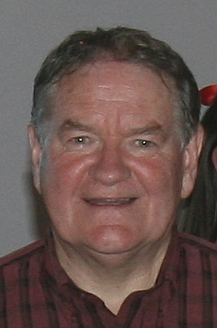
History
The story of Magnus Maximus is recalled in the song “Yma o Hyd” recorded by Dafydd Iwan in 1981:
“But Magnus Maximus of Wales,
left in the year 383,
and left us an entire nation,
and today: here we stand...
“We’re still here!....”
Numeracy with the Romans: Session 29
Score: ____ Who are you? _________________

Gladiator
1) 9 × 6 = | 2) 15 – 19 = | 3) 77 ÷ 11 =
4) 25% of $100 = | 5) Subtract 1.4 from 5 = | 6) 4 × _____ = 100
7) 7:30 a.m. on the 24 hour clock = | 8) 1 pound = _____ ounces | 9) 10% of 350 =
Citizen
10) 6.32 + 7.4 = | 11) The mean of 2, 4, 15 is | 12) The range of 2, 4, 15 is
13) 5.218 to two decimal places = | 14) 4 + 5 × 2 – 1 = | 15) 1% of £30 =
16) $7\frac{3}{4}$ m = _________ cm | 17) 92% as a decimal = | 18) 6³ =
Emperor
19) The reciprocal of 8 is | 20) 18 × 11 = | 21) 120 × ________ = 1.2
22) There are ___ thirds in $4\frac{1}{3}$ | 23) 123,456 to three significant figures = | 24) $1^{4}$ =
25) 2 inches is about 5 cm. Approximately how many cm are there in 5 inches?
History: Timeline
Numeracy with the Romans: Session 30
Score: ____ Who are you? _________________

Gladiator
1) Write down all the factors of 20: | 2) 12 × 11 = | 3) 17 ÷ 2 =
4) £80 – £29.99 = | 5) 240,000 doubled = | 6) 0.2 + ______ = 1
7) 29.87 to one decimal place = | 8) 275° is a _______ angle | 9) 25% of 44 =
Citizen
10) 7.5 + 2.7 = | 11) Add 28.4 to 4 = | 12) The range of –5, 0, 5 is
13) 3 – 2 × 0 + 4 = | 14) 12 ÷ 0.5 = | 15) 2 ÷ 0.2 =
16) 6,400 g = __________ kg | 17) $\frac{4}{5}$ = ______ % | 18) August = _______ days
Emperor
19) 120 ÷ 12 = | 20) 13 × 9 = | 21) True or false? 1 is a prime number?
22) 4 ÷ 0.8 = | 23) The reciprocal of 15 is | 24) 0.000709 to one significant figure =
25) What is a quarter of half a kilogram in grams?
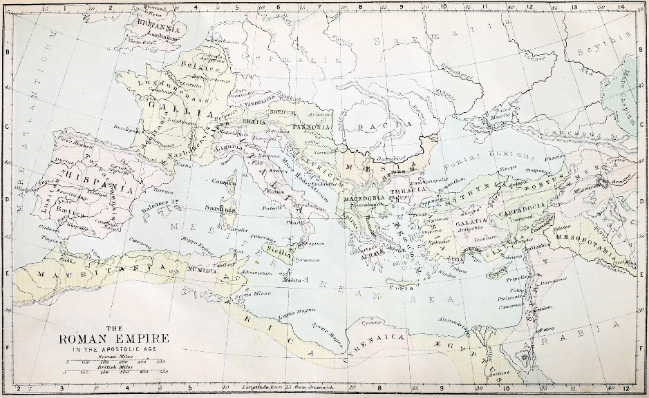
History
There isn’t much evidence to show that the Romans tried to keep hold of Britain following Magnus’s departure in 383 A.D. The rest of the empire also fell into decline, with the western part of the empire lost in 476 A.D.
The Romans retained the eastern part of the empire for another 1,000 years, before the Ottomans took over in the year 1453.
Numeracy with the Romans
Write down your scores
for sessions 21–30:
30
29
28
27
25
24
23
22
21
26

What is the total of the above scores? ________________
What is the mean of the above scores? _______________
What is the range of the above scores? _______________
What did you do well / find easy?
_______________________________________________
_______________________________________________
What do you need to improve / find difficult?
_______________________________________________
_______________________________________________
_______________________________________________
Numeracy with the Romans
History Revision

1) In what year was Magnus Maximus born?
__________________________________________________________
2) In Magnus’ dream, what was the spectacular fort made of?
__________________________________________________________
3) What were the slaves doing in the dream?
__________________________________________________________
4) How many messengers did Magnus send to search for Elen?
__________________________________________________________
5) What were the names of Elen’s brothers?
__________________________________________________________
6) When did Magnus leave Great Britain?
__________________________________________________________
7) What is the name of the song which recalls Magnus Maximus?
__________________________________________________________
8) When was the eastern part of the Roman Empire lost?
__________________________________________________________
Numeracy with the Romans
Picture Soucres

Page | Source
1, 3, 5, 6, 8, 9, 10, 11, 12, 25, 30, 31, 32, 33, 35, 38 | Shutterstock.com
7 | Portrait of Lucius Verus, co-Emperor with Marcus Aurelius (161-169 AD). Marble, between 180 and 183 AD, found at the villa of his wife Lucilla at Acqua Traversa, near Rome. Wikimedia Commons
13 | Andrew Birrell (after Henry Fuseli), Caractacus at the Tribunal of Claudius at Rome (1792). Wikipedia
14 | Boadicea Haranguing the Britons. Wikipedia
17 | A statue of Boudica and her daughters. City Hall, Cardiff. Flickr
18 | Philip Bird LRPS CPAGB / Shutterstock.com
19 | General route of Watling Street overlaid on an outdated map of the Roman road network in Britain. Wikipedia
21 | Map of Wales. Wikipedia
22 | A very steep hill on the not so straight Roman road to Neath. www.geograph.org.uk/photo/405253
23 | Segontium Roman fort (Wales). Fundaments of thermae (bath house). Wikipedia
24 | Caerhun river crossing by Noel Valley. Wikipedia
26 | A crude illustration of Macsen Wledig from a 15th century Welsh language version of Geoffrey of Monmouth’s highly influential Historia Regum Britanniae (‘History of the Kings of Britain’). Wikipedia
29 | Coin of Magnus Maximus Augustus: 383–388. Wikipedia
36 | Dafydd Iwan by Darren Wyn Rees – Aberdare Blog. Wikimedia Commons
42 | GTS Productions / Shutterstock.com

