



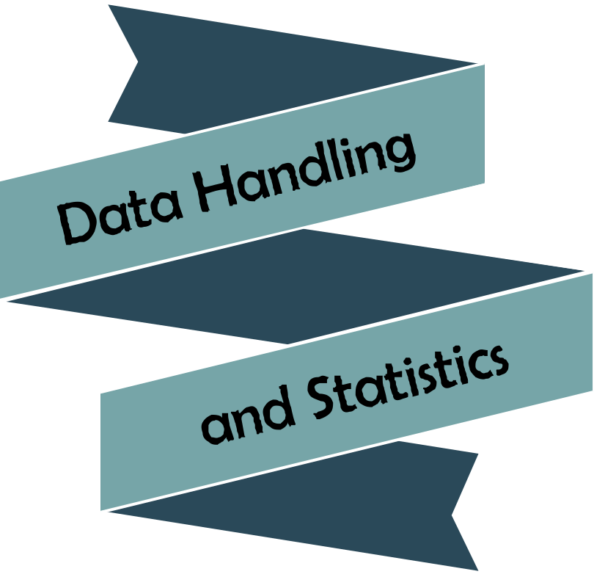





Chapter | Mathematics | Page Number
The Mean | Calculating the mean. Calculating the mean from a table. Comparing two distributions. | 3
The Range | Calculating the range. Comparing two distributions. | 9
Bar Charts | Types of data. Bar charts. Frequency diagrams. Interpreting charts. | 12
Mean of Grouped Data | Estimating the mean from a table. | 20
Pie Charts | Drawing pie charts. Interpreting pie charts. | 25


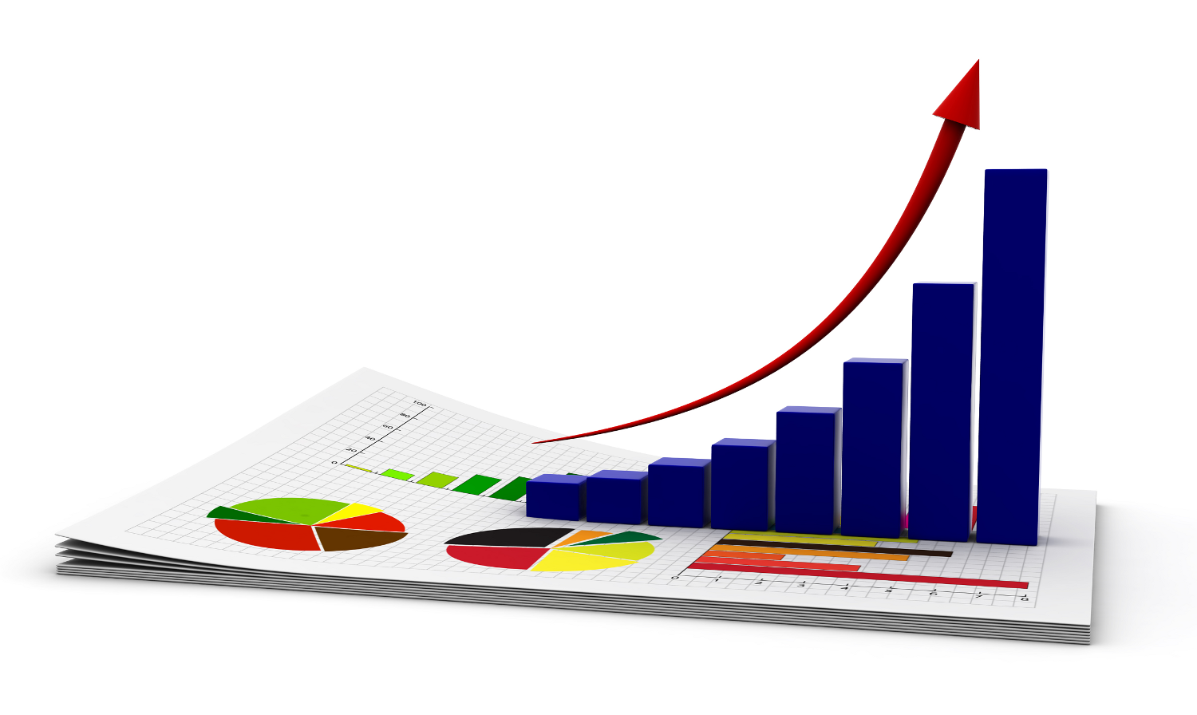



In the qualifying games for Euro 2016, Wales’ football team scored the following number of goals.
2, 0, 2, 0, 3,
1, 1, 0, 0, 2.
Which number would best describe the number of goals scored by Wales per game? When we are looking for a number of this type, we are looking for an average for the data. An average is a number which attempts to represent the typical or middle value of the data. The mean is an example of an average.
Calculating the Mean

In order to calculate the mean of a set of data:
- Find the total of all the data items.
- Divide by the number of data items.
For the data about Wales’ goals, the total of all the data items would be
2 + 0 + 2 + 0 + 3 + 1 + 1 + 0 + 0 + 2 = 11.
It follows that the mean is 11 ÷ 10 = 1.1. This means that, on average, Wales scored around 1 goal per game.

Exercise 1
5
Find the mean number of goals scored by the following football teams
during the first games of the new football season.

(a) Arsenal 5, 0, 2, 0, 4.
(b) Chelsea 0, 2, 1, 2, 3.
(c) Everton 2, 1, 1, 2, 0.
(d) Liverpool 2, 3, 0, 2, 1.
(e) Manchester United 3, 2, 3, 4, 0.
(f) Tottenham Hotspur 2, 0, 0, 4, 1.
Exercise 2
In Exercise 1, which team has the largest mean number of goals?
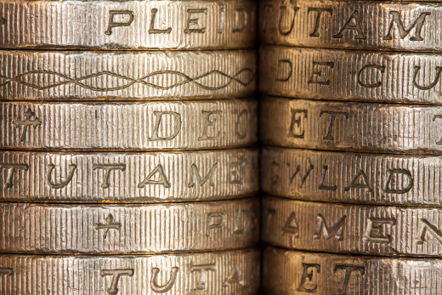
Exercise 3
Sara asked her friends how much pocket money they received.
She wrote down their responses:
£1, £3, £2, £5, £2, £10, £8, £7.
What is the mean amount of pocket money?


Exercise 4
5
Here is some information about five children.
Elin    Height: 132cm  Weight: 45kg  Shoe size: 3 | Hari    Height: 148cm  Weight: 50kg  Shoe size: 5 | Catrin    Height: 136cm  Weight: 39kg  Shoe size: 4 | Siôn    Height: 150cm  Weight: 49kg  Shoe size: 5 | Esyllt    Height: 150cm  Weight: 52kg  Shoe size: 6
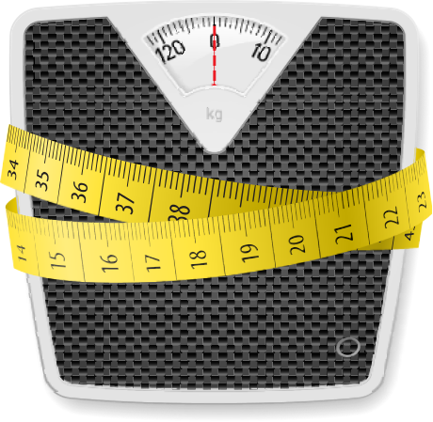
(a) What is the mean height of these children?
(b) Which children are taller than the mean height?
(c) What is the mean weight of these children?
(d) Which children are lighter than the mean weight?
(e) What is the mean shoe size of these children?
(f) Can you buy shoes of mean shoe size?
Exercise 5
Here is some information about four babies.
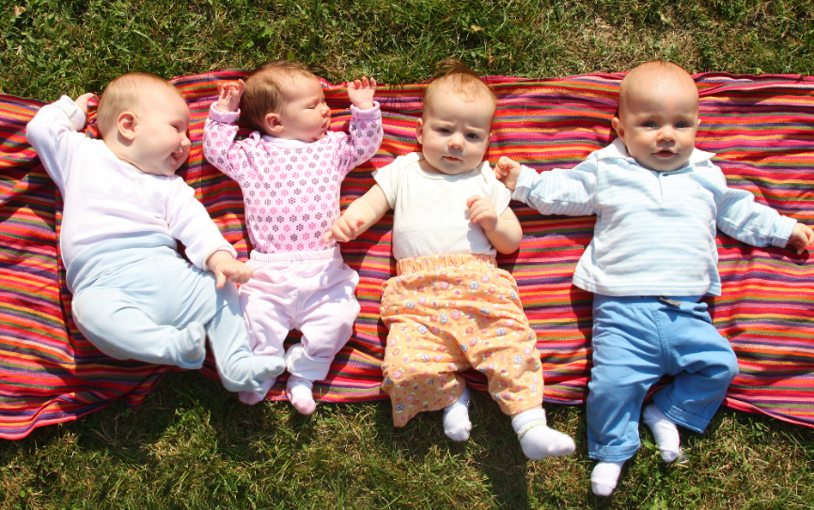
Carwyn
Weight: 8kg Height: 69cm
Bethan
Weight: 5kg Height: 70cm
Eryl
Weight: 7kg Height: 75cm
Osian
Weight: 9kg Height: 77cm

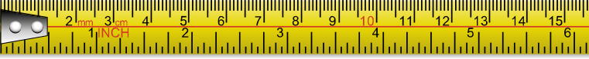
(a) What is the mean weight of these 4 babies?
(b) Which of the babies are heavier than the mean weight?
(c) What is the mean height of these 4 babies?
(d) Which of the babies are taller than the mean height?
Exercise 6
Here is the weekly shopping cost of 15 families.
£75 £86 £83 £62 £86 £78 £64 £94 £101 £79 £91 £71 £59 £91 £95
Find the mean amount spent, per week, by these families.
Exercise 7
Here is some information about ten adults.
Sophie    Age: 32  Height: 154cm  Number of brothers: 2 | David    Age: 38  Height: 163cm  Number of brothers: 1 | Jessica  Age: 18  Height: 145cm  Number of brothers: 3 | Ben  Age: 24  Height: 165cm  Number of brothers: 0 | Ffion  Age: 26  Height: 150cm  Number of brothers: 1
Jack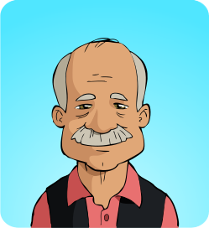  Age: 74  Height: 149cm  Number of brothers: 1 | Jane  Age: 34  Height: 165cm  Number of brothers: 0 | Iwan  Age: 30  Height: 155cm  Number of brothers: 2 | Sara  Age: 44  Height: 139cm  Number of brothers: 1 | Jeff  Age: 48  Height: 153cm  Number of brothers: 0

(a) What is the mean age of these 10 people?
(b) Who is older than the mean age?
(c) What is the mean height of these 10 people?
(d) Who is shorter than the mean height?
(e) What is the mean number of brothers of these 10 people?
(f) How many people have less brothers than the mean amount?
(g) What is the mean age of the males?
(h) What is the mean age of the females?
(i) On average, who is older: the males or the females?
(j) On average, who is taller: the males or the females?
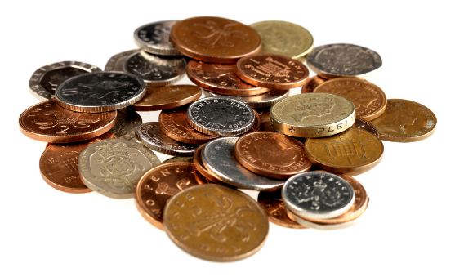
Exercise 8
Dafydd asked his friends how much money they had in their pockets.
He wrote down their responses:
99p, 50p, 25p, 12p, 52p, 32p, 90p, 80p.
What is the mean of this data?
Exercise 9
Here are the times, in seconds, that the females in 7C took to run a 100m race.
14.1, 15.3, 15.5, 15.6, 15.0, 14.7, 13.9, 16.1, 15.8, 14.5, 15.7, 14.6, 16.3, 15.7.
(a) Find the mean time taken to complete the race.
(b) How many females were faster than the mean time?
Calculating the mean from a table
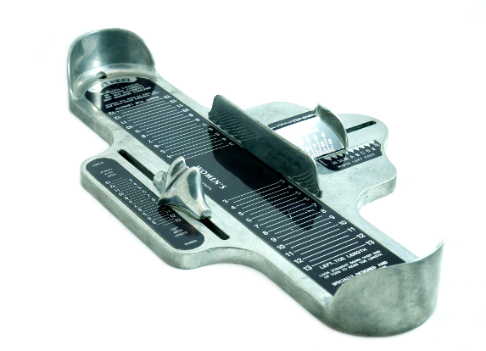
Sometimes, when we have a lot of data, it is easier (and quicker) to use a table to present the data.
Example

The following table shows the shoe size of the learners in 7R.
Shoe size | Number of children
3 | 4
4 | 5
5 | 10
6 | 9
7 | 2
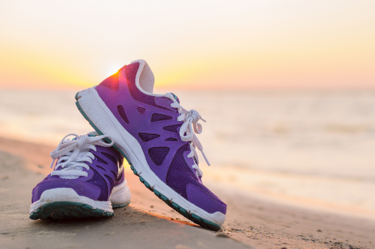
In order to calculate the mean shoe size for 7R, we first need to find the total of all the data values. To do this, we must consider each row in the table in turn. The first row tells us that four pupils in 7R have a shoe size of 3. The total of the shoe sizes of these four pupils would be 3 + 3 + 3 + 3, or 3 × 4. The other rows of the table would also lead to multiplication sums, as shown below.
Shoe size | Number of children | Multiplication
3 | 4 | 3 × 4 = 12
4 | 5 | 4 × 5 = 20
5 | 10 | 5 × 10 = 50
6 | 9 | 6 × 9 = 54
7 | 2 | 7 × 2 = 14
Total | 30 | 150
The total of all the data values would be the total of the final column, namely 12 + 20 + 50 + 54 + 14 = 150.
To find the mean, we must divide this total by the number of data items. In this example, the number of data items is the number of pupils in 7R, which is the total of the second column of the table.
4 + 5 + 10 + 9 + 2 = 30.
It follows that the mean shoe size for 7R is 150 ÷ 30 = 5.
5
Exercise 10

100 packets of Smarties are chosen randomly. The following table shows the number of Smarties in each tube.
Number of Smarties in a tube | Number of tubes
35 | 14
36 | 24
37 | 26
38 | 20
39 | 16
Find the mean number of Smarties in a tube.

Challenge!

Today, the first 30 customers visiting a shop spent a mean total of £4 each. After the next 50 customers had visited the shop, the mean had risen to £6. What was the mean total spent by these 50 customers?


Exercise 11
The following table shows the number of M&Ms in several big packets of M&Ms.
Number of M&Ms in a big packet | Number of big packets
96 | 2
97 | 13
98 | 8
99 | 17
(a) Calculate the mean number of M&Ms in a big packet.
(b) How many packets contained more than the mean value?
(c) How many packets contained less than the mean value?
Exercise 12
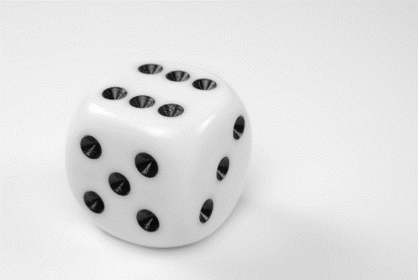
A dice is thrown 100 times.
The scores are listed in the following table.
Score | Number of times the dice was thrown
1 | 14
2 | 17
3 | 16
4 | 18
5 | 17
6 | 18
Calculate the mean score.
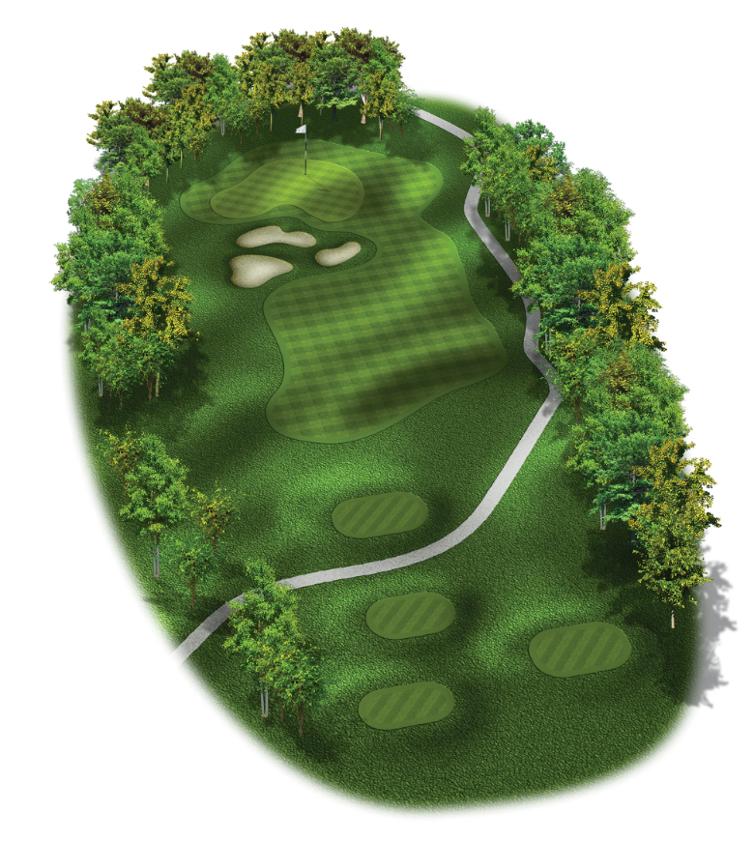
Exercise 13
On a golf course, the hole shown on the right is called a Par 3. This means that the majority of the players are expected to complete the hole in three shots.
The table below shows the number of shots taken by some players in completing the hole.
Number of shots | Number of people
1 | 1
2 | 18
3 | 30
4 | 26
5 | 25
(a) Calculate the mean number of shots needed to complete the hole.
(b) In your opinion, should this hole be called a Par 3? Explain your answer.
Challenge!
The mean age of a pop group with 3 members is 21. What will be the mean age of the group if a new, 25-year-old member joins the group?

Comparing Two Distributions
5

Exercise 14
(a) Two mathematics tests were given to ten students. Here are their results:
Test 1: 42 55 47 61 59 71 49 53 65 61
Test 2: 54 49 63 63 58 48 68 61 48 58
Use the mean to compare the performance of the students in these tests.
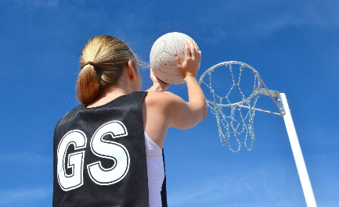
(b) In 8 games, the netball team of Ysgol y Creuddyn scored the following number of goals:
34 41 33 48 42 33 36 38
In 6 games the netball team of Ysgol John Bright scored the following number of goals:
48 29 52 34 42 28
Use the mean to decide, in your opinion, which team is the best team.
(c) The following data shows the golf scores of two players.
Morris: 81 76 79 85 89 78 74 83 74 87
Parry: 79 88 87 76 91 73 74 76
Use the mean to decide, in your opinion, who is the best golfer.
(d) The teachers in the physical education department measure, in seconds, the times taken by the football and rugby teams to complete a 100m race.
The football team: 13, 14, 15, 11, 14, 12, 12, 13, 11, 13, 14.
The rugby team: 12, 13, 14, 11, 12, 14, 15, 13, 15, 14, 11, 16, 14, 15, 13.
Use the mean to decide, in your opinion, which team is quickest over 100 metres.
Challenge!
The mean of 20 numbers is 20. If the mean of the first 4 numbers is 4, what is the mean of the final 16 numbers?


Key Words | Further Questions | What went well? | To reach my target  level I will…
 |  |  | My Level My Target



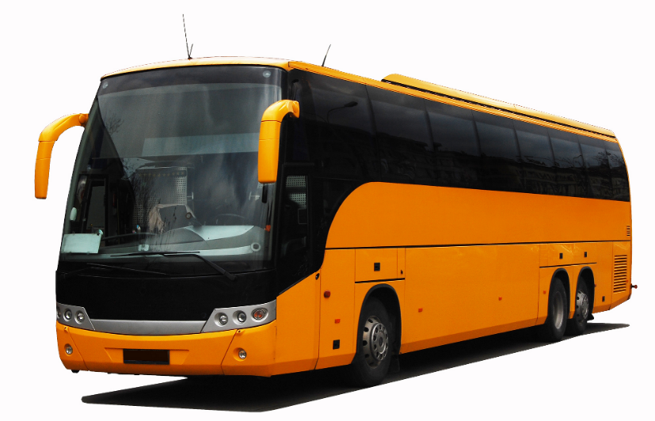
Arwyn and Megan travel to school on different school buses. Over a period of a fortnight, Arwyn and Megan wrote down the times the buses arrived to take them to school.
Arwyn’s Bus
08:13 08:16 08:14 08:15 08:14
08:15 08:14 08:17 08:14 08:15
Megan’s Bus
08:29 08:27 08:33 08:28 08:28
08:33 08:26 08:31 08:34 08:30
Looking at the above times, can you tell which bus is most reliable?
Measures of Spread
In order to discuss which bus is most reliable, we need to measure the spread of the data. A data set has low data spread if the data values are all close to each other. We could depend on a bus with low data spread to reach the bus stop at the same time each day, or close to this time. A bus with high data spread wouldn’t be as reliable.
The Range
The range is one measure of data spread. To calculate the range for a specific data set, find the difference between the greatest data item and the least data item. Usually, this means taking away the least number from the greatest number.
Arwyn and Megan
For Arwyn’s bus, the latest time is 08:17, and the earliest time is 08:13. The difference between these two times is 4 minutes, so the range for Arwyn’s bus is 4 minutes.
For Megan’s bus, the latest time is 08:34, and the earliest time is 08:26. The difference between these two times is 8 minutes, so the range for Megan’s bus is 8 minutes.
Because the range of Megan’s bus is more than the range of Arwyn’s bus, we can say that the data spread of Megan’s bus is higher, and so Megan’s bus is less reliable than Arwyn’s bus.
Exercise 15
5
Find the range of the following data sets.
(a) 4 8 9 10 11 15 16
(b) 1 2 4 8 16 17 19 22
(c) 10,800 15,000 15,500 18,300 21,300
(d) 2.8 3.1 4.9 8.6 14.3 21.6
(e) 7.2 1.3 8.4 2.1 3.6 4.7 9.3 8.4
(f) 5 4 0 2 4
(g) 150 150 141 137 146
(h) 70 69 69 51 80

Exercise 16
(a) The range of a data set is 16. If the largest data value is 26, what is the smallest data value?
(b) Peter collected data from 10 of his friends concerning the weekly pocket money they received. He forgot to write down the final value in his list.
£1 £1.20 £1.15 £1.25 £1 £1.40 £1.90 70c 90c
He remembered that the range of values was £1.40. What could be the final data value?
Exercise 17
Here is some information about five children.
Huw    Height: 150cm  Weight: 52kg  Shoe size: 4 | Erin    Height: 158cm  Weight: 52kg  Shoe size: 6 | William    Height: 150cm  Weight: 50kg  Shoe size: 5 | Lili    Height: 149cm  Weight: 46kg  Shoe size: 4 | Iestyn    Height: 146cm  Weight: 45kg  Shoe size: 3
(a) Who is the tallest pupil?
(b) Who is the shortest pupil?
(c) What is the range of the heights of the pupils?
(d) What is the range of the weights of the pupils?
(e) What is the range of the shoe sizes of the pupils?
5
Exercise 18

Alys and Hywel travel to school on different school buses. Over a period of a fortnight, Alys and Hywel wrote down the times the buses arrived to take them to school.
Alys’ Bus
08:25 08:27 08:24 08:29 08:31
08:30 08:25 08:32 08:26 08:26
Hywel’s Bus
08:09 08:14 08:11 08:12 08:10
08:10 08:09 08:12 08:13 08:10
(a) What is the range of Alys’ times?
(b) What is the range of Hywel’s times?
(c) In your opinion, which bus is most reliable? Explain your answer.

Exercise 19

Two groups of 6 people took part in a quiz.
(a) The 6 members of group A had the following scores.
52 29 78 56 24 37
What was the range of group A’s scores?
(b) The scores for the 6 members of group B are shown in the following table.
Score | Number of people
22 | 2
25 | 2
26 | 1
28 | 1
Which group had the biggest range for their scores? You must give a reason for your answer.
Exercise 20 (Revision)
Here are the ages (in years) of 8 members of an evening class:
36 28 45 24 31 34 27 47
(a) Find the range of the ages of the members of the evening class.
(b) What was the range of the ages exactly one year ago? Give a reason for your answer.
(c) Find the mean age of the members of the evening class.
(d) What was the mean age of the ages exactly one year ago? Give a reason for your answer.
(e) A new, 40-year-old member joins the evening class. Without doing any further calculations, state
(i) Will the range of the evening class increase, decrease or stay the same?
(ii) Will the mean of the evening class increase, decrease or stay the same?

Key Words | Further Questions | What went well? | To reach my target  level I will…
 |  |  | My Level My Target


We use bar charts to display data. The type of bar chart depends on the type of data that has been collected.
Types of Data
It is possible to place data into two categories: qualitative and quantitative.
Qualitative Data | Quantitative Data
Deals with descriptions.  Data that can be observed but not measured.  Examples: Method of travelling to school; eye colour; favourite pet; mobile phone manufacturer. | Deals with numbers.  Data that can be measured.  Examples: The height of a person; temperature; number of brothers; time to complete a race.
Exercise 21
4
State whether the following data is qualitative or quantitative.

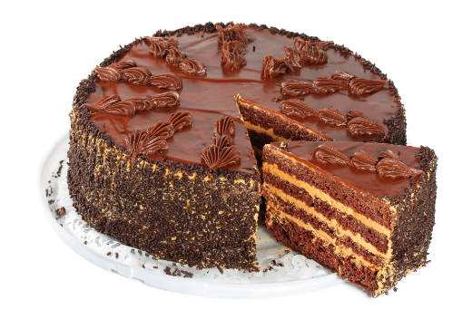
(a) Favourite board game (e.g. Monopoly; Scrabble).
(b) The weight of a cake.
(c) The name of your dentist.
(d) The number of learners in your registration class.
(e) The daily rainfall in Llandudno.
(f) The day of the week (e.g. Monday) that you were born on.
Quantitative Data
It is possible to place quantitative data into two categories: discrete and continuous.
Discrete Data | Continuous Data
Only takes specific values.  Examples: Shoe size; number of songs on an album; the salary of a nurse; number of sisters. | Takes any values within a specific range.  Examples: Length of your foot; the temperature at midday; the time taken to cycle from Rhyl to Abergele.
Exercise 22
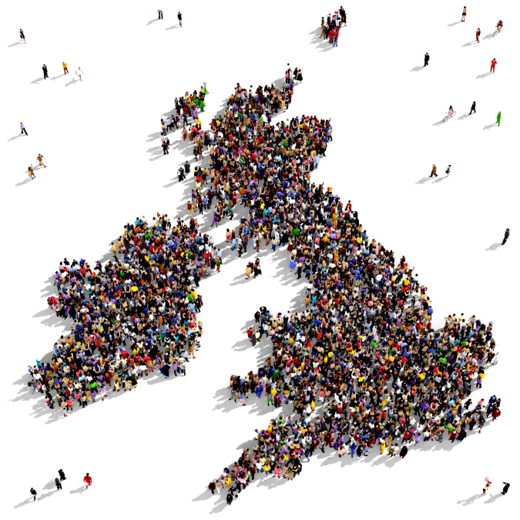
State whether the following quantitative data is discrete or continuous.
(a) Population of the United Kingdom.
(b) The length of your thumb.
(c) The age of women when they marry.
(d) The amount of money earnt for babysitting one night.
(e) The number of cars on sale at a showroom.
(f) The weight of the letters in a postman’s sack.
Summary


Drawing a Bar Chart
We can draw a bar chart for the following types of data.
- Qualitative data.
- Discrete quantitative data that is not grouped.
We need to include a gap between each bar in a bar chart.
Example
Dylan asked each member of 7Dd how they got to school one morning. Here are the results:
Walk 5 Bus 12 Car 4 Bike 1
Dylan drew a bar chart for the data.
Label the axis.
A suitable underlined title.
Frequency
Method of Travelling
Suitable labels below each bar.
Arrow on the end of the axis.
Bars of the correct height. A gap between each bar.
Label the axis.
A suitable scale. Labels on the lines, not in the gaps.
Arrow on the end of the axis.
Walk Bus Car Bike
Exercise 23
3
On a piece of squared paper, draw a bar chart for the following sets of data.

(a) Number of hours of sunshine in Colwyn Bay during one week.
Monday: 3 hours Tuesday: 4 hours Wednesday: 4 hours Thursday: 3 hours
Friday: 8 hours Saturday: 7 hours Sunday: 6 hours
(b) 7C’s favourite pet.
Dog: 8 Cat: 7 Rabbit: 4 Guinea Pig: 2 Snake: 1
(c) 7R’s eye colour.
Blue: 6 Brown: 15 Green: 2
(d) The number of brothers of each member of 7E.
No brothers: 5 One brother: 10 Two brothers: 7 Three brothers: 2

Drawing a Frequency Diagram
We can draw a frequency diagram for the following types of data.
- Discrete quantitative data that has been grouped.
- Continuous quantitative data.
There are no gaps between the bars in a frequency diagram, but the width of each bar must be equal.
Example
Siwan asked each member of 7R which date of the month their birthday fell on. She received the following responses.
1st–5th: 4 6th–10th: 2 11th–15th: 3 16th–20th: 6 21st–25th: 4 26th–30th: 5
Siwan drew the following frequency diagram to show the data.
Date
1st–5th 6th–10th 11th–15th 16th–20th 21st–25th 26th–30th
Frequency
Exercise 24
On a piece of squared paper, draw a frequency diagram for the following sets of data.
6
(a) The number of books the pupils in 7E have bought during the past year.
Zero to four books: 12 Five to nine books: 5 Ten to fourteen books: 6 Fifteen to nineteen books: 1
(b) The number of minutes the dentist spends with each patient.
1–5 minutes: 2 6–10 minutes: 4 11–15 minutes: 9 16–20 minutes: 5
21–25 minutes: 3 26–30 minutes: 3 31–35 minutes: 0 36–40 minutes: 1
(c) The number of days the pupils in 7C were absent from school last term.
0–4 days: 11 5–9 days: 8 10–14 days: 6 15–19 days: 0 20–24 days: 5
(d) Number of words in each sentence during the first 50 sentences of a book.
1–10 words: 2 11–20 words: 9 21–30 words: 14 31–40 words: 7
41–50 words: 4 51–60 words: 8 61–70 words: 6
Grouping Discrete Data
In Exercise 24, we saw that we must use grouped data in order to draw a frequency diagram. We must use a frequency table to group data that is not yet grouped.
Example
Frequency
Here are the exam percentages of 40 pupils in year 7.
56 14 61 67 90 38 47 67
72 75 80 41 21 54 92 44
68 85 43 71 69 19 39 64
83 80 65 42 20 35 27 81
70 75 39 36 71 88 50 79
Let us group this data using the groups
1–20, 21–40, 41–60, 61–80, 81–100.
Group | Tally Marks | Frequency
1–20 | ||| | 3
21–40 | |||| || | 7
41–60 | |||| ||| | 8
61–80 | |||| |||| |||| | | 16
81–100 | |||| | | 6
Total |  | 40
After forming the above frequency table, we can now draw the frequency diagram for the data. This can be seen on the right-hand side of this page.
1–20
21–40
41–60
61–80
81–100
Percentage
6
Exercise 25
(a) Here are the times taken by the pupils in 7E to come to school today, correct to the nearest minute.
15 5 8 22 12 10 30 25 27 22 35 8 18 17 22
15 44 35 45 55 12 28 35 48 48 30 40 19 25 50
Draw a frequency table for the data, using the groups 1–10, 11–20, 21–30 up to 51–60.
Draw a frequency diagram to show the data.

(b) A class measured the arm span of each pupil. Here are the results, to the nearest cm.
132 129 147 127 128 124 134 139 138 136 144
143 133 141 139 130 142 143 140 137 148 136
146 151 123 131 135 135 130 140 138 133
Draw a frequency table for the data, using the groups 120–124, 125–129, 130–134 up to 150–154.
Draw a frequency diagram to show the data.
(c) 7C decided to see how good they were at estimating the length of a minute. Here are the results, correct to the nearest second.
72 70 52 48 52 48 63 71 63 70 61 62 59 62 50
64 46 65 69 65 58 64 61 48 63 68 67 73 55 51
Draw a frequency table for the data, using the groups 46–50, 51–55, 56–60 up to 71–75.
Draw a frequency diagram to show the data.
Grouped Continuous Data
The following frequency table shows the length of the right thumb of the students of a class.
Frequency
Class interval (l mm) | Frequency
30 ⩽ l < 35 | 2
35 ⩽ l < 40 | 2
40 ⩽ l < 45 | 4
45 ⩽ l < 50 | 9
50 ⩽ l < 55 | 10
55 ⩽ l < 60 | 2
We read 30 ⩽ l < 35 as “l is at least 30 but is less than 35” or “l lies between 30 and 35, but can be equal to 30”.
Length (mm)
0 30 35 40 45 50 55 60

The above information is shown in the frequency diagram on the right. Notice the jump in the graph between 0 and 30.
Exercise 26
6
Draw frequency diagrams for the following sets of data.
(a) How much weight the members of (b) The height of 60 pupils. (c) The noise of 60 items of electrical
a weight loss club lost in 6 months. equipment.
  Weight (w kg) | Frequency
  0 ⩽ w < 6 | 4
  6 ⩽ w < 12 | 11
  12 ⩽ w < 18 | 12
  18 ⩽ w < 24 | 7
  24 ⩽ w < 30 | 3
  Height (h cm) | Frequency
  168 ⩽ h < 172 | 2
  172 ⩽ h < 176 | 6
  176 ⩽ h < 180 | 17
  180 ⩽ h < 184 | 22
  184 ⩽ h < 188 | 10
  188 ⩽ h < 192 | 3
  Noise (n db) | Frequency
  15 ⩽ n < 20 | 4
  20 ⩽ n < 25 | 12
  25 ⩽ n < 30 | 15
  30 ⩽ n < 35 | 6
  35 ⩽ n < 40 | 8
  40 ⩽ n < 45 | 3
  45 ⩽ n < 50 | 12
Exercise 27
The following figures give the time, correct to the nearest minute, taken by 50 cross-country runners to complete a race.
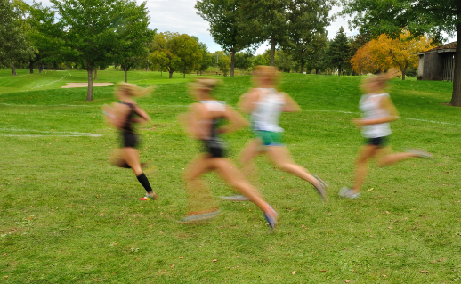
30 37 43 55 52 47 49 36 44 40
41 49 52 53 39 41 46 42 50 49
39 53 54 57 43 59 34 38 40 42
48 53 50 52 37 36 45 53 48 42
52 39 41 46 50 52 38 58 57 46
Time (t minutes) | Tally Marks | Frequency
30 ⩽ t < 35
35 ⩽ t < 40
40 ⩽ t < 45
45 ⩽ t < 50
50 ⩽ t < 55
55 ⩽ t < 60
(a) Complete the frequency table for the data. (Remember that 35 minutes would appear in the class 35 ⩽ t < 40, not 30 ⩽ t < 35.)
(b) Draw a frequency diagram for the data.
Exercise 28
The following data gives the weights of books on a shelf in a library, in grams.
742 241 332 478 1245 832 746 291 160 635 1042 368 760 590
748 800 564 1340 824 683 174 960 236 746 328 387 823 894
(a) Complete a frequency table for the data. (Use the following classes for the weight, w:
0 ⩽ w < 200, 200 ⩽ w < 400, 400 ⩽ w < 600, ...., 1200 ⩽ w < 1400.)
(b) Draw a frequency diagram for the data.
Exercise 29
The following data shows the hand width of several 13-year-old girls, in mm.
171 182 202 164 198 211 164 173 177 173 192 205 232 223
189 186 191 194 197 205 231 207 169 173 184 209 176 181
Draw a frequency diagram for the data. (You will need to complete a suitable frequency table first.)
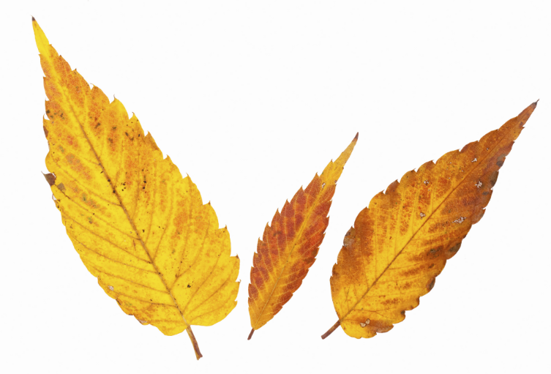
Challenge!
What is wrong with the following frequency table, which shows the length of leaves that fell from a tree one morning? What would you have to do to create a frequency diagram for the data?
Length (l cm) | Tally Marks | Frequency
0 ⩽ l < 5 | |||| || | 7
5 ⩽ l < 10 | |||| |||| | | 11
10 ⩽ l < 20 | |||| |||| | 9
20 ⩽ l < 25 | ||| | 3
25 ⩽ l < 30 | |||| ||| | 8

Interpreting Charts
3
Exercise 30
Frequency
(a) How many pupils chose red?
(b) How many pupils chose yellow?
(c) Which colour was the most popular?
(d) How many pupils are in class 8E?
(e) How many pupils in 8E did not like purple?
Colour
Red Green Blue Yellow Purple Orange

Exercise 31
Frequency
1–10 11–20 21–30 31–40 41–50 51–60
6
(a) How many shelves contain between 11 and 20 books?
(b) How many shelves contain between 31 and 40 books?
(c) How many shelves contain more than 30 books?
(d) How many shelves are there in total in the library?
Number of books
(e) Based on this information, can you state how many shelves in the library contain exactly 20 books? Explain your answer.
Exercise 32
Frequency
Mark
1 2 3 4 5 6 7 8 9 10
5
(a) How many pupils got 7 marks?
(b) How many pupils got less than 5 marks?
(c) How many pupils got more than 6 marks?
(d) How many pupils are there in the class?
(e) What was the total of the class’ marks?
(f) What was the mean of the class’ marks?
(g) What was the mark 3 of the pupils got?
Exercise 33
6
(a) What type of data is shown in Exercises 30, 31 and 32?
(b) Were the graphs in Exercises 30–32 bar charts or frequency diagrams?

Exercise 34
6
(a) How many phone calls lasted between 10 and 15 minutes?
Frequency
0 5 10 15 20 25 30
Time (minutes)
(b) How many phone calls lasted at least 15 minutes?
(c) How many phone calls were there in total during the afternoon?
(d) What type of data is shown here?
(e) Alwen phoned the office during the afternoon. The length of her phone call was 590 seconds. Which bar in the frequency diagram shows this phone call?
Exercise 35 (Revision)
The following list shows the number of complete games a squad of football players played during one season.
16 10 9 3 21 30 4 12 0 36 20 14 12 5 16
0 5 6 14 23 0 0 18 1 38 15 18 3 12 16
(a) What type of data is this?
(b) Draw a frequency table for the data, using the groups 0–4, 5–9, 10–14 up to 35–39.
(c) Draw a frequency diagram for the data.
(d) How many players played more than 25 complete games during the season?
(e) How many players plated less than 10 complete games during the season?
Did you know?
The first person to draw a bar chart was William Playfair, in 1786, to show Scottish exports.

Key Words | Further Questions | What went well? | To reach my target  level I will…
 |  |  | My Level My Target


In the previous chapter, we used a frequency table to group data into equal classes. Given a table of this sort, is it possible to calculate the mean of the original data?

Example

The following table shows the number of music albums the pupils of 10R have bought during November.
Number of albums | Frequency
0–4 | 11
5–9 | 8
10–14 | 5
15–19 | 1
What is the mean number of music albums the pupils of 10R have bought during November? Without access to the original data (before it is grouped), it is impossible to state what is the exact mean, because the frequency table does not give us complete data. For example, the table notes that one person has bought between 15 and 19 albums, but how many exactly? It could be 15, but it could also be 16, 17, 18 or 19. Without this information, we cannot calculate the mean exactly. We can, however, estimate the mean using the frequency table, by using the following method.
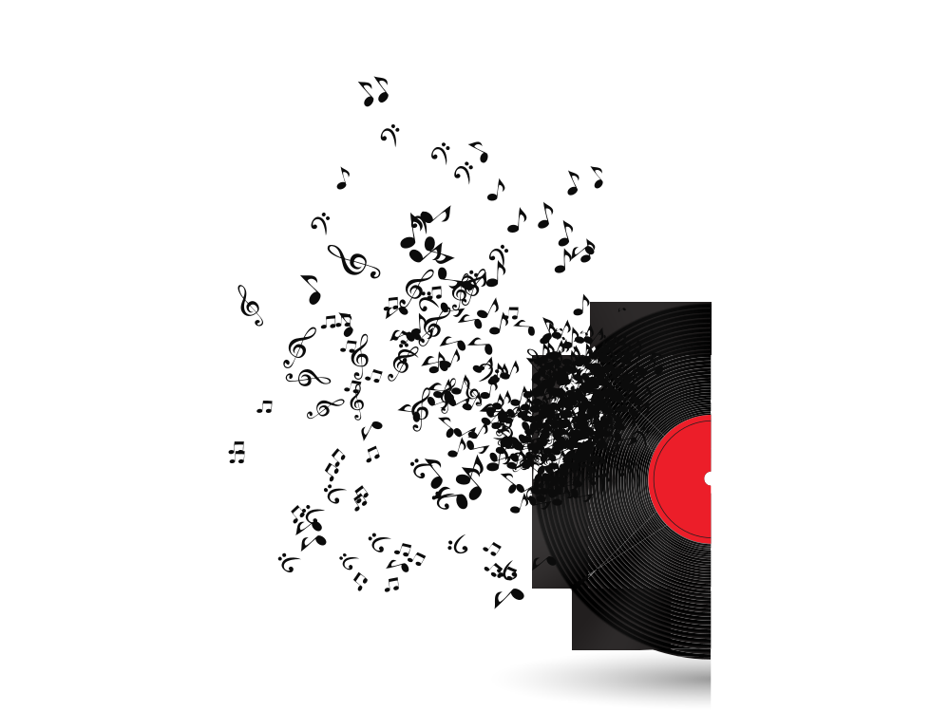
(1) Find the mid-point of each class by adding the two numbers that form the class and halving. For example, the numbers 5 and 9 form the class 5–9. By adding these numbers, we obtain 14. Half of 14 is 7, so the mid-point of the class 5–9 is 7.
Number of albums | Mid-point | Frequency
0–4 | 2 | 11
5–9 | 7 | 8
10–14 | 12 | 5
15–19 | 17 | 1
(2) Because the mid-point of each class gives a single value that represents the class, we can now use the method from page Error! Bookmark not defined. to estimate the mean from the table.
To begin, multiply each mid-point by the frequency of the class.
Number of albums | Mid-point | Frequency | Multiplication
0–4 | 2 | 11 | 2 × 11 = 22
5–9 | 7 | 8 | 7 × 8 = 56
10–14 | 12 | 5 | 12 × 5 = 60
15–19 | 17 | 1 | 17 × 1 = 17
(3) Find the total of the final two columns.
(4) Divide the total of the ‘multiplication’ column by the total of the ‘frequency’ column:
155 ÷ 25 = 6.2. This is the estimate for the mean of this set of data.
Number of albums | Mid-point | Frequency | Multiplication
0–4 | 2 | 11 | 2 × 11 = 22
5–9 | 7 | 8 | 7 × 8 = 56
10–14 | 12 | 5 | 12 × 5 = 60
15–19 | 17 | 1 | 17 × 1 = 17
Total |  | 25 | 155
Exercise 36
7
Find an estimate for the mean of the following data sets.
(a)
  Number of cars sold in a day | Number of days
  0–4 | 18
  5–9 | 11
  10–14 | 6
  15–19 | 4
  20–24 | 1
(b)
  Number of flowers per m² | Number of square metres
  0–14 | 43
  15–29 | 21
  30–44 | 13
  45–59 | 2
  60–74 | 1
(c)
  Height of a horse chestnut tree, in metres | Frequency
  0–3 | 13
  4–7 | 17
  8–11 | 9
  12–15 | 4
  16–19 | 5
  20–23 | 0
  24–27 | 2
(d)
  Number of books sold in a week | Frequency
  100–124 | 1
  125–149 | 9
  150–174 | 8
  175–199 | 5
  200–224 | 2
(e)
  Number of customers in a café | Frequency
  70–74 | 3
  75–79 | 21
  80–84 | 30
  85–89 | 28
  90–94 | 14
  95–99 | 4
(f) | 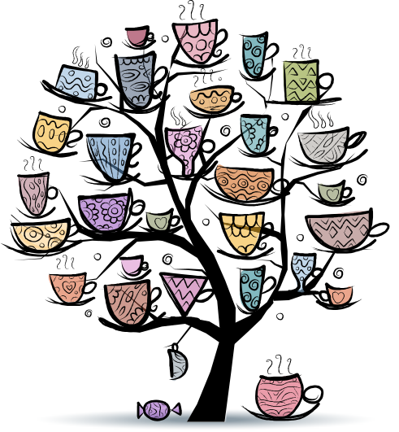    
  Number of sweets in a jar | Frequency
  300–324 | 4
  325–349 | 15
  350–374 | 27
  375–399 | 63
  400–424 | 74
  425–449 | 32
  450–474 | 11
  475–499 | 2


The Range
Let us consider again the data about music from page 20.
Number of albums | Mid-point | Frequency
0–4 | 2 | 11
5–9 | 7 | 8
10–14 | 12 | 5
15–19 | 17 | 1
Is it possible to find the range of the data set using the above table? As with the mean, it is not possible to calculate the range exactly, as the table does not tell us the maximum and minimum data values. The best we can do is to state that the least value is between 0 and 4; and that the greatest value is between 15 and 19. We must use the mid-point of the classes to find an estimate for the range, by taking away the lower mid-point from the higher mid-point. For this data, our estimate for the range is 17 – 2 = 15.
Exercise 37
7
Find an estimate for the range of the data sets from Exercise 36.
Continuous Grouped Data
The methods of estimating the mean and range also work with continuous data that is grouped.

Example
A golfer hits 40 golf balls using one of his clubs. He records the distance that each ball has travelled. The following frequency table shows his results.
Distance travelled, d,  in yards | Frequency
75 ⩽ d < 80 | 4
80 ⩽ d < 85 | 13
85 ⩽ d < 90 | 17
90 ⩽ d < 95 | 6
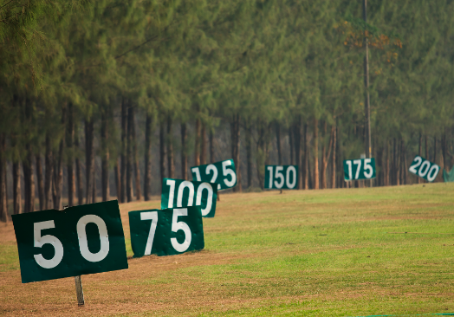
We can find an estimate for the mean of this data by finding the class mid-points; multiplying by the frequency; and finding the total of the final two columns.
Distance travelled, d,  in yards | Mid-point | Frequency | Multiplication
75 ⩽ d < 80 | 77.5 | 4 | 77.5 × 4 = 310
80 ⩽ d < 85 | 82.5 | 13 | 82.5 × 13 = 1072.5
85 ⩽ d < 90 | 87.5 | 17 | 87.5 × 17 = 1487.5
90 ⩽ d < 95 | 92.5 | 6 | 92.5 × 6 = 555
Total |  | 40 | 3425
The estimate for the mean is 3425 ÷ 40 = 85.625 yards.
The estimate for the range is 92.5 – 77.5 = 15 yards.
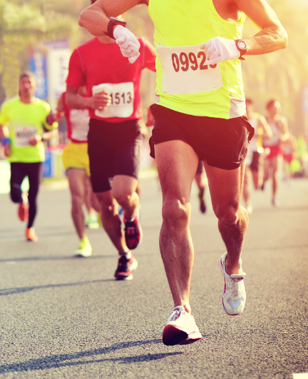
Exercise 38
7
Find an estimate for the mean and range of each of the following data sets.
(a)
  The length of the cars, l, that are parked in a supermarket car park, in metres | Frequency
  3 ⩽ l < 4 | 34
  4 ⩽ l < 5 | 41
  5 ⩽ l < 6 | 5
(b)
  The time, t, taken to complete a race, in minutes | Frequency
  20 ⩽ t < 25 | 5
  25 ⩽ t < 30 | 11
  30 ⩽ t < 35 | 19
  35 ⩽ t < 40 | 12
  40 ⩽ t < 45 | 3
(c)
  The head circumference, c, of people in a factory | Frequency
  50 ⩽ c < 54 | 10
  54 ⩽ c < 58 | 31
  58 ⩽ c < 62 | 16
  62 ⩽ c < 66 | 3
(d)
  The thickness, t, of books in a library, in mm | Frequency
  0 ⩽ t < 10 | 5
  10 ⩽ t < 20 | 16
  20 ⩽ t < 30 | 41
  30 ⩽ t < 40 | 32
  40 ⩽ t < 50 | 6
(e) | 
  The length of phone calls, l, in minutes | Frequency
  0 ⩽ l < 5 | 32
  5 ⩽ l < 10 | 42
  10 ⩽ l < 15 | 24
  15 ⩽ l < 20 | 12
  20 ⩽ l < 25 | 7
  25 ⩽ l < 30 | 2
Exercise 39
Over a period of 50 days, Bethan and Lowri recorded how many minutes per day they
spent on their mobile phones. The data is given in the following frequency tables.
7
Bethan’s time, t, in minutes | Frequency |  | Lowri’s time, t, in minutes | Frequency
0 ⩽ t < 30 | 14 |  | 0 ⩽ t < 30 | 23
30 ⩽ t < 60 | 17 |  | 30 ⩽ t < 60 | 14
60 ⩽ t < 90 | 10 |  | 60 ⩽ t < 90 | 5
90 ⩽ t < 120 | 9 |  | 90 ⩽ t < 120 | 3
120 ⩽ t < 150 | 0 |  | 120 ⩽ t < 150 | 2
150 ⩽ t < 180 | 0 |  | 150 ⩽ t < 180 | 3
(a) Calculate an estimate for Bethan’s mean time and Lowri’s mean time.
(b) Calculate an estimate for Bethan’s range and Lowri’s range.
(c) Who would you say uses their mobile phone the most? Explain your answer.
(d) Who would you say is most consistent in using their mobile phone? Explain your answer.
Exercise 40 (Revision)
7
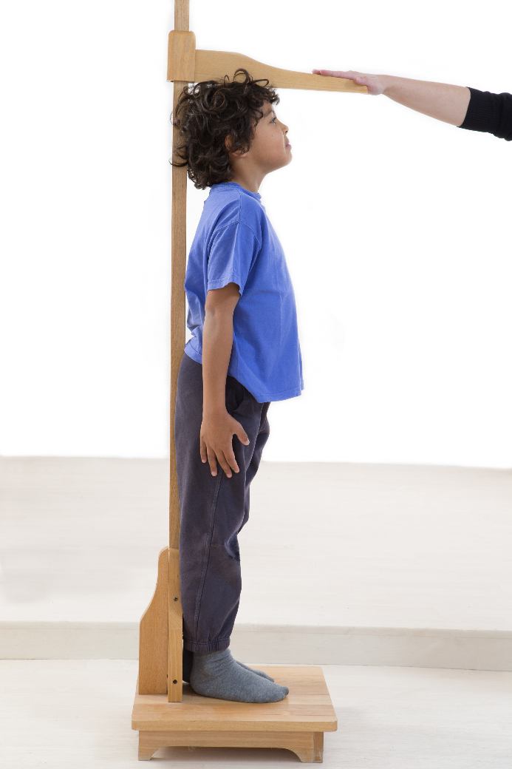
The height of 25 Year 7 learners was measured. The results are given below, correct to the nearest inch.
57 53 59 62 61
66 51 58 59 62
60 62 54 64 59
58 62 64 53 67
61 63 57 48 60
(a) Calculate the mean height of the learners.
(b) Calculate the range of the heights.
(c) What type of data is this?
(d) Complete the following frequency table in order to group the data.
Height, h, in inches | Tally Marks | Frequency
45 ⩽ h < 50
50 ⩽ h < 55
55 ⩽ h < 60
60 ⩽ h < 65
65 ⩽ h < 70
(e) Draw a frequency diagram for the data.
(f) Use the frequency table to find an estimate for the mean and range.
(g) How close were your estimates to the true values?
Challenge!
Repeat the above exercise using the heights of the learners in your class.
Key Words | Further Questions | What went well? | To reach my target  level I will…
 |  |  | My Level My Target


It is possible to display data by dividing a circle into sectors of appropriate sizes. We form a pie chart by doing this.
Example
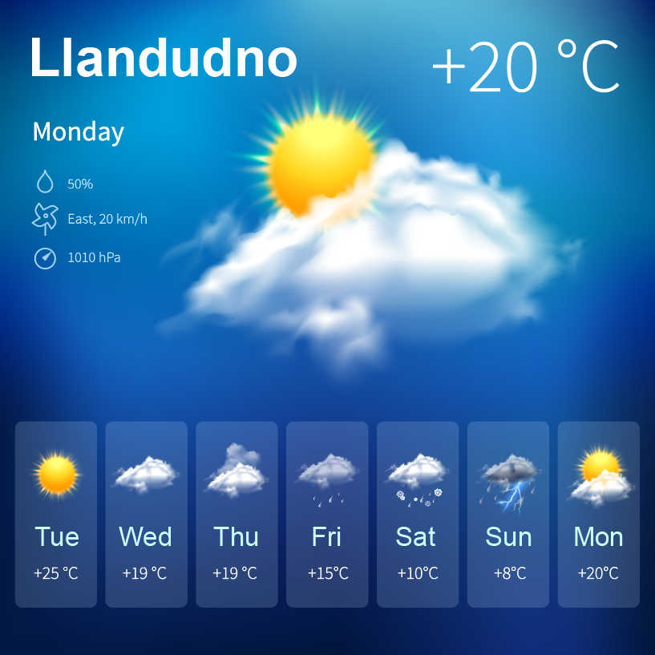
Here is the weather for the 30 days in June.
Rainy days 4
Cloudy days 8
Sunny days 18
In order to draw a pie chart for this data, we need to start by dividing 360° (which is the angle around a point in the centre of a circle) by 30 (which is the number of data items).
360° ÷ 30 = 12°
Next, we multiply the 12° (which is the angle for one day) by the number of days for a particular type of weather.
Rainy days 4 × 12° = 48°
Cloudy days 8 × 12° = 96°
Sunny days 18 × 12° = 216°
To finish, we construct the pie chart itself.
(a) Draw a circle using a compass. Mark the centre of the circle with a dot. Draw a vertical line from the centre of the circle to the top of the circle. | (b) Measure the first angle (48°) using a protractor. Mark the angle using a pencil before drawing a straight line from the centre of the circle to your mark.  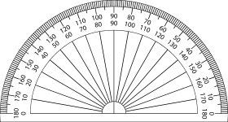
  (c) Draw the next angle (96°) using a protractor. | (d) Label the sectors and add a suitable title to the pie chart.  June’s weather  Rainy  Cloudy  Sunny

Exercise 41
6
Draw a pie chart for the following sets of data.
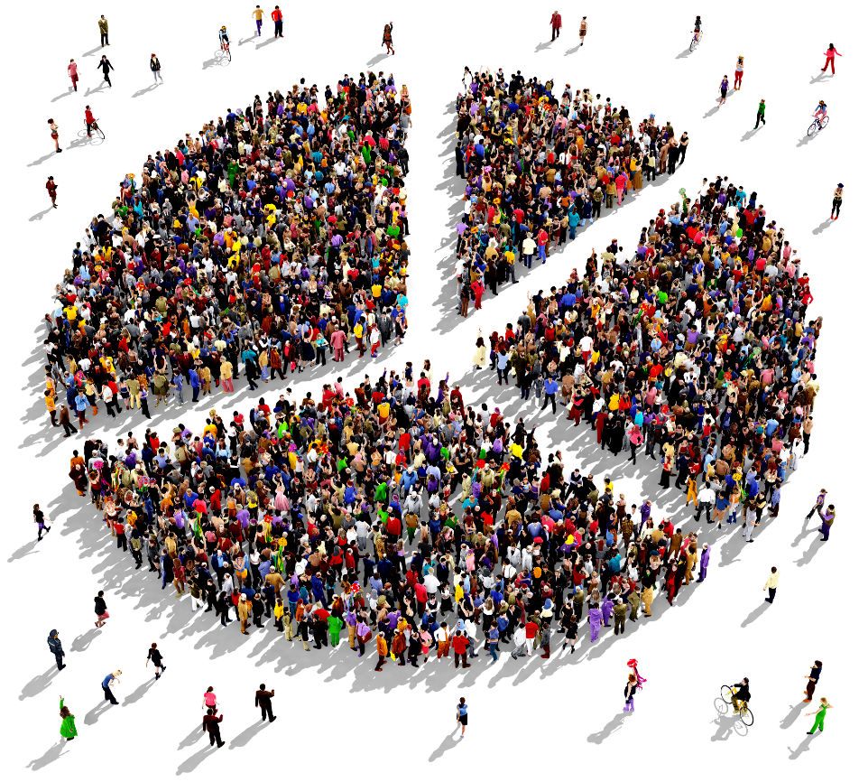
(a) 8C’s favourite fruit.
Apple: 10 Banana: 8
Orange: 4 Strawberry: 2
(b) Year 9’s holiday destinations, for last summer.
Europe: 40 Britain: 70
U.S.A.: 10
(c) Tomos’ typical day (24 hours).
Sleeping: 8 hours Eating: 1 hour
Working: 8 hours Leisure: 6 hours
Travelling: 1 hour
(d) The foods that were eaten in a hotel.
Beef: 7 Lamb: 26
Chicken: 18 Vegetarian: 5
Fish: 14 Duck: 2

(e) Methods of heating a house.
Coal: 7 Electricity: 9
Gas: 11 Oil: 3
(f) How do the pupils of Ysgol y Creuddyn reach school?
Bus: 500 Car: 150
Bike: 50 Walk: 100
(g) The votes in a recent election.
Conservatives: 13,000 Labour: 9,000
Plaid Cymru: 7,000 UKIP: 4,000
Liberal Democrats: 3,000
Favourite Animal
Bear
Dog
Cat
(h) The colour of the cars in a car park.
Red: 8 Blue: 4
Green: 5 Yellow: 7

(i) 8E’s favourite sport.
Football: 13 Rugby: 5
Golf: 2 Other: 3
(j) How many sisters do the learners of 9E have?
None: 7 One: 12
Two: 4 Three: 3
Exercise 42
4
What type of data is given in the questions of Exercise 41?

Interpreting Pie Charts
5
Exercise 43
(a) The pie chart shows how 7C come to school.

(i) What is the most popular method of coming to school?
8 of the pupils come by car.
(ii) How many pupils come by bus?
(iii) How many pupils walk to school?
(b) Paul has drawn a pie chart. It shows when pupils like to complete their homework.
(i) Which time is the most popular?
(ii) What fraction of the pupils like to complete their homework after supper?
There were 20 pupils in the survey.
(iii) How many pupils like to complete their homework before supper?
(iv) How many pupils chose dinner time?
(c) Siân asked her class, 9C, what type of bike they had. There are 32 pupils in Siân’s class.
(i) What is the most popular bike?
(ii) How many pupils do not have a bike?
(iii) Complete the following table.
Bike | Mountain | Racing | Normal | No Bike
Number of pupils

(d) This pie chart shows the favourite colour of 40 boys.
(i) Which fraction liked red?
(ii) How many boys liked red?
(iii) Which fraction liked blue?
(iv) How many boys liked blue?
(v) How many boys did not choose green?
(e) Siôn spends 4 hours on different activities at night.
How much time is spent on
(i) sports;
(ii) watching television;
(iii) reading;
(iv) homework?

Exercise 44
6
(a) This pie chart shows how 24 people travelled to town.
Find how many people
(i) walked to town;
(ii) came in a car;
(iii) came on a motorbike;
(iv) came on a bike.

(b) Llinos surveyed 210 pupils in years 7 and 8.
She asked the pupils which of the following, in their opinion, was most important in their diet.
Fat; Sugar; Protein; Fibre; Vitamins.
The pie chart shows her results.
How many pupils are in each category?
(c) This pie chart shows what several people do in their leisure time.
12 people collect stamps. How many people:
(i) were surveyed in total?
(ii) like gardening?
(iii) enjoy photography?
(iv) Which two hobbies had the same number of
people partaking in them?
(d) This pie chart shows how many people were in a car when surveyed by Siwan.
Siwan looked at a total of 180 cars.
(i) How many cars had 2 people in them?
(ii) How many cars had 3 people in them?
(iii) In how many cars were there 4 people?

(e) This pie chart shows the nutritional value of a packet of crisps weighing 36g.
(i) How much of the crisps is made up of
(i) carbohydrate?
(ii) How much of the crisps is made up of fat?
(Use your protractor to help.)
(iii) How much of the crisps is protein?
Exercise 45 (Revision)
6
(a) Draw a pie chart for the following data showing the manufacturer of 20 cars belonging to teachers.
Ford 5 Vauxhall 4 Toyota 3
Audi 2 Volkswagen 5 Fiat 1
(b) Jessica drew the pie chart shown on the right which shows where a group of people had been on holiday last year.
16 people had been in Scotland.
- Daniel looked at the chart and said “Most of the people had spent their holiday in England”. Jessica said that this was not true. Explain why Daniel is wrong.
- Dafydd looked at the chart and said “Because 16 people have been in Scotland, it must be that 1% represents 4 people”. Is Dafydd correct?
- How many people had been to Spain on their holiday?
Dafydd added that Jessica had surveyed 400 people. Jessica gave two reasons why Dafydd was wrong in saying this. What could these reasons be?
Key Words | Further Questions | What went well? | To reach my target  level I will…
 |  |  | My Level My Target

Puzzle: Pair the solid to its top view.
